**Evaluation of Anti-urolithiatic activity of Ethanolic extract of *Smilax perfoliata* in ethylene glycol induced urolithiasis in rats**

**Abstract**

This study aimed to evaluate the antiurolithiatic activity of ethanolic leaf extract of Smilax perofialta (EESP) Ethylene glycol-induced urolithiasis in Wistar rats. Urolithiasis was induced by administering ethylene glycol (0.75% v/v) o.p while the vehicle control group received saline. The standard group was treated with allopurinol (50mg/kg), and the test groups received low dose (400 mg/kg) p.o , median doses (600 mg/kg) p.o and high dose (800 mg/kg) p.o of EESP.

Phytochemical screening of the extract revealed the presence of various bioactive compounds, indicating its potential therapeutic effects. The study assessed body weight changes and analyzed various urine parameters, including oxalate, calcium, phosphate, and uric acid levels. Additionally, serum parameters such as, creatinine, BUN and uric acid were measured.

Histopathological examination of kidney tissues was performed to evaluate structural changes induced by urolithiasis and the protective effects of Ethanolic plant extract. Results indicated that treatment with EESP significantly reduced urinary oxalate and calcium levels, improved serum biochemistry. Histopathological analysis further demonstrated the protective effects of EESP on kidney morphology. This study concludes that the ethanolic leaf extract of Smilax perfoliata exhibits promising antiurolithiatic properties, potentially due to its ability to modulate oxidative stress and restore kidney function, highlighting its therapeutic potential in managing urolithiasis.

**Keywords**

*Smilax perfoliata*, urolithiasis, ethylene glycol, anti-urolithiatic activity, renal calculi, phytotherapy, ethanolic extract.

**Introduction**

Urolithiasis is a condition where stones form in the urethra or in the urinary system, including the kidney, ureter, and bladder. The Greek words ouron (urine) and lithos (stone) are combined to form the term "urolithiasis."

A significant contributor to morbidity is urolithiasis, one of the most prevalent conditions affecting the urinary tract. Risk factors for stone development include dehydration, excessive intake of animal protein, sodium, refined sugars, fructose and high fructose corn syrup, oxalate, grapefruit juice, squeezed apple, and cola drinks. The main reasons of stone development are microbial infections, foreign objects in the urinary tract, inadequate urine outflow, and a diet high in oxalate [Mawlieh B.et al-2023].

Supersaturation of the urine with salts that form stones results in urolithiasis, sometimes referred to as kidney stones, nephrolithiasis, or renal calculi. It is less frequently caused by a prolonged urinary tract infection with bacteria that produce urease. The complicated process of kidney stone formation includes physicochemical processes such as crystal nucleation, aggregation, and retention in the urinary tract.

This frequent urinary tract condition has a high risk of recurrence and is caused by a combination of low-slung exercise, nutrition, and heredity. The most prevalent type of kidney stone is calcium-containing kidney stones, which develop from crystal aggregation in the urinary tract, followed by the formation of insoluble particles and nucleation that cause discomfort as the stones pass through the tract, obstruction that causes pain, and repeated infection and bleeding [Rani IV.et al-2023],[ Manasa BY.et al-2022].

Calcium oxalate (CaOx) or CaOx combined with calcium phosphate [Ca3(PO4)2] account for almost 80% of urinary stones[Mujeeb U R.et al-2018].Kidney stones raise the risk of cardiovascular disease, diabetes, hypertension, end-stage renal failure, and chronic kidney disease [Nojaba L.et al-2022]. Small kidney stones are often excreted naturally by the body. Unless they result in severe pain or have significant consequences, treatment is not advised. Usually, larger kidney stones are addressed[Treatment options for kidney stones - InformedHealth.org - NCBI Bookshelf (nih.gov)]

Nephrolithiasis currently has no suitable or effective allopathic treatments, and sometimes even surgery is not enough to produce noticeable results. In this instance, natural products are most likely the finest source to assess a safe treatment of the lithiasis disease.

However, no thorough research has been done to support the ethanol extract of Smilax perfoliata's (EESP) antiurolithic qualities. In order to show the effectiveness of the ethanolic EESP's antiurolithiatic properties in a rat model of ethylene glycol-induced urolithiasis, the current study was selected.

**Material and methods Materials**

**Experimental animal Species:** Wistar albino rats.

**Strain:** Wistar

**Sex:** Male or female (Either sex)

**Source:** Vaarunya Biolabs private limited, Bangalore-560074, Karnataka.

**Body weight:** 180-220 g.

**Number of animals:** 6 in each group.

**Acclimatization:** One week in experimental room.

**Selection of animals:** The animals had a thorough examination after acclimatization to make sure the chosen rats were healthy. For the final allocation of the study, rats were chosen at random.

**Environmental condition:** Temperature (20–25 degrees Celsius), relative humidity, air changes every hour, and elimination cycle set to 12 hours of light and 12 hours of dark are all ideal in air-conditioned spaces. In an animal house authorized by the Purpose of Control and Supervision of Experiments on Animals (CPCSEA), the animals were kept in standard conditions. The Mallige College of Pharmacy in Bangalore's Institutional Animal Ethics Committee (IAEC) Office gave its approval to the study protocol.

**Accommodation:** The animals were kept in cages made of polypropylene with a grill top made of stainless steel. Facilities for clean paddy husk bedding, food, and water bottles. To maintain cleanliness and provide the animals the most comfort possible, the husks in the cages were changed three times every week**.**

**Diet:** “Amrut” brand pelleted feed was provided ad libitum.

**Water:** UV purified, and filtered water was provided ad libitum in polypropylene bottles with stainless-steel sipper tubes.

**Table no. 1 Instruments and apparatus:**

List of instruments and apparatus used during experiment:

|  |  |
| --- | --- |
| **SL.NO.** | **NAME OF THE**  **APPARATUS** |
| 1. | Soxhlet apparatus |
| 2. | Centrifuge apparatus and  homogenizer |
| 3. | Auto analyzer |
| 4. | UV-Spectro-photo Meter |
| 5. | Weighing balance |

|  |  |
| --- | --- |
| 6. | pH paper |
| 7. | Metabolic cages |
| 8. | Microscope |

**Methodology:**

**Collection Of Plant Material:**

Smilax perfoiata plant material was gathered from the western ghats, and a specimen was placed in the herbarium. Professor Dr. Madhavachetty of S V University in Tirupathi verified the authenticity of the leaves.

**Preparation of the extract:**

Leaves of S. perfoliata will be separated, weighed, washed and dried in the shade. The dried leaves will be finely powdered and the powdered mass will be weighed and repeatedly extracted with 10 times the volume of solvent for 24 hours by using Soxhlet apparatus. Following filtration, the filtrate will be evaporated to dryness and the dried mass obtained used for the required studies. All ethanolic extracts will be transferred into clean air-tight containers and kept in cool temperature until used for experiments [Jagannath N.et al-2012].

**Acute oral toxicity:**

Acute cytotoxic effect of the rutin compound was demonstrated in accordance with OECD guideline 423. Females are typically chosen when inequities are observed due to their slightly higher sensitivity.

By adjusting the concentration of the dosing preparation, doses should be given in a consistent volume over the range of dosages to be studied. In rodents, the test animal's size determines the maximum amount of liquid that can be given at once. Doses must be made just before administration unless the preparation's stability during the intended usage duration is established and proven to be satisfactory. The test material is gavaged via a stomach tube or an appropriate intubation canula in a single dosage. The dose may be administered in smaller portions over a maximum of 24 hours if a single dose is not feasible. Prior to treatment, animals should fast. Following the administration of the drug, food may be denied for an additional three to four hours in rats or one to two hours in mice. One of four predetermined levels—1000 and 2000 mg/kg body weight—is used to choose the number of animals and dose levels. The

incidence, duration, and intensity of toxic symptoms dictate how long it takes between treatment groups. Until the survival of the already dosed animals is certain, the next dose of treatment should be postponed.

**Screening models:**

The ethanolic extracts of whole plant of Smilax perfoiata was studied for their urolithiasis activities. The study design and groups as follows.

**Table no. 2. Ethylene glycol induced Urolithiasis Model in rats.**

|  |  |  |  |
| --- | --- | --- | --- |
| **SL.NO** | **Group** | **Treatment** | **Duration of treatment** |
| **1.** | Normal group | Normal saline | Daily for 28 days |
| **2.** | Positive control | Ethylene glycol (0.75%) with drinking water  (Toxic control) | Daily for 28 days |
| **3.** | Standard group | Ethylene glycol (0.75%)  with drinking water + allopurinol (50mg/kg) | Daily for 28 days |
| **4.** | EESP  (400mg /kg) | Ethylene glycol (0.75%) in drinking water  +Smilax 49erfoliate  extract (400mg/kg) | Daily for 28 days |
| **5.** | EESP  (600mg/kg) | Ethylene glycol (0.75%) in drinking water  +Smilax 49erfoliate  extract (600mg/kg) | Daily for 28 days |
| **6.** | EESP  (800mg/kg) | Ethylene glycol (0.75%) in drinking water  +Smilax perfoliata  extract (800mg/kg) | Daily for 28 days |

All the animals were treated with suitable drugs/extracts for 28 days respectively as mentioned in above table. On 28th day the rats were evaluated using the following parameters.

1. Urine parameter: calcium, oxalate, phosphate and uric acid .
2. Serum parameter: creatinine, Blood urea nitrogen(BUN) and uric acid.
3. Tissue parameter : Glutathione (GSH) , Superoxide Dismutase (SOD) and Catalase (CAT) will be estimated

# STATISTICAL ANALYSIS

The software Graph Pad Prism version 4 (Graph Pad Inc., USA) was used for statistical analysis. Bonferroni's multiple comparison test was used after the anova. MEAN±SEM was used to present the data. The level of confidence was determined to be 95%

**Results**

# PREPARATION OF EXTRACT

Approximately 400 g of Smilax 7erfoliate whole plant was used for extraction using ethanol. The nature and the extractive value of the extracts are as follows:

**Table NO: 3**

EXTRACT

PREPARATION

|  |  |  |  |
| --- | --- | --- | --- |
| Sl.no | Extract | colour | %Yield |
| 1. | Ethanol extract of  *Smilax perfoliata* | Dark green and  sticky | 8.75 % |

# PHYTOCHEMICAL INVESTIGATION:

Various preliminary chemical tests were conducted for the ethanolic extract Smilax perfoliata to determine the chemical constituents present in the extract. The results are tabled below

**TABLE NO4. Results of preliminary phytochemical tests:**

|  |  |  |
| --- | --- | --- |
| **Sl**  **no** | **Chemical Tests** | **Ethanolic extract of**  **smilax perfoliate** |
| **1.** | Tests for Alkaloids   1. Dragendroff’s test 2. Wagers test 3. Mayers test | **+**  **+**  **+** |
| **2.** | Test for glycosides   1. Killer kilani test 2. Bromine test | **+**  **+** |
| **3.** | Test for tannins   1. Gelatin test 2. Ferric chloride test | **+**  **+** |
|  | c. Bromine test | **+** |
| **4.** | Test for flavonoids   1. Con.sulphuric acid test 2. Lead acetate test 3. Ferric chloride test | **+**  **+**  **+** |
| **5.** | Test for phytosterols   1. Salkowski test 2. Hesse’s test | **+**  **+** |
| **6.** | Test for triterpinoids | **+** |

**ACUTE ORAL TOXICITY STUDY**

An effort was made to determine the EESP's LD50. OECD standards 423 were followed when conducting acute toxicity studies. Animal mortality was not seen when the ELSP was administered at a dose of 2000 mg/kg body weight. As a result, this dosage was considered the highest tested dose among the 400 mg/kg, p.o., 600 mg/kg, p.o., and 800 mg/kg, p.o. doses chosen for the antiurolithiatic activity screening on sodium oxalate-induced urolithiasis.

# URINE MICROSCOPY

The control group was dominated by massive CaOx monohydrate (COM) crystals with either a rectangular habit or sharply edged dendrites. Higher concentrations of EESP and lower quantities of allopurinol itself promoted the production of calcium oxalate dihydrate (COD) crystals with a tetrahedral shape and a smoother appearance. The size and quantity of CaOx crystals were likewise decreased with EESP and allopurinol. The percentage decrease in CaOx crystal size caused by EESP was similar to that caused by allopurinol. EESP significantly decreased the number of CaOx crystals compared to allopurinol.

**MICROSCOPY OF URINE**

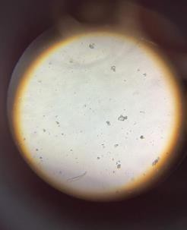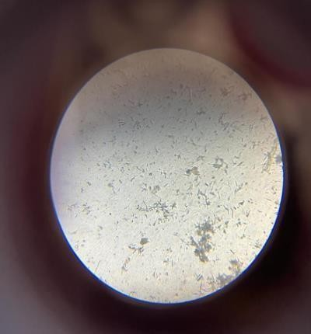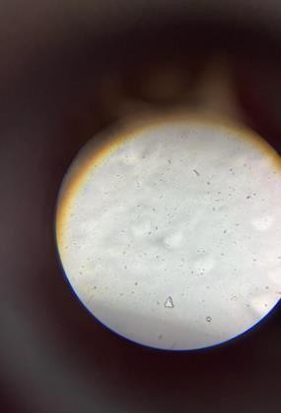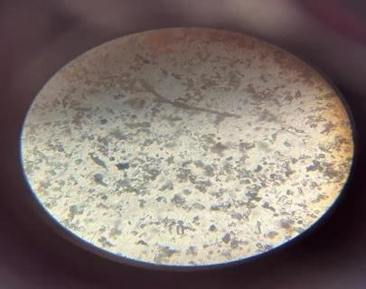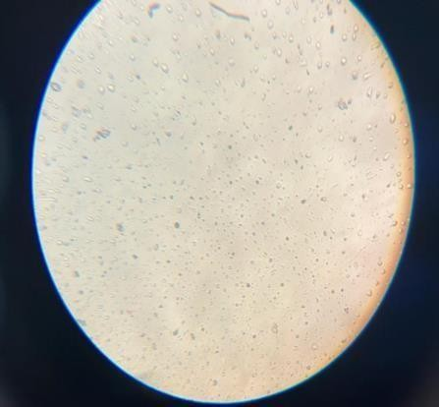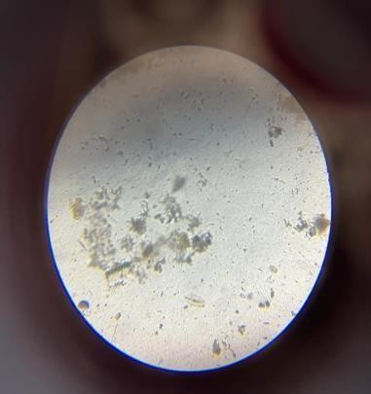

**LOW DOSE**

**STANDARD GROUP**

**POSITIVE CONTROL**

**NORMAL GROUP**

**FIG 1. URINE MICROSCOY**

**PHARMACOLOGICAL EVALUATION**

# ETHYLENE GLYCOL INDUCED UROLITHIASIS MODEL

**a. PHYSICAL PARAMETERS**

General factors, such as body weight increase, were examined in this study. Body weight was recorded for each group at the conclusion of the treatment period. Rats given ethylene glycol were shown to have a significantly lower body weight than rats in the vehicle control group. EESP treatment at 400 mg/kg b.w. p.o., 600 mg/kg b.w. p.o., and 800 mg/kg b.w. p.o. resulted in a considerable increase in body weight when compared to the affected group. Nevertheless, when the treatment groups were compared to the standard control groups, the EESLP at 800 mg/kg p.o. was able to restore the general parameters to levels that were close to the standard control, suggesting that the extract possesses antiurolithiatic properties. Table No. 8 provides a summary of the findings.

**Table no 5:**

**Effect of Ethanolic extract of Smilax perfoliata on body weight in ethylene glycol induced urolithiasis.**

|  |  |  |  |  |
| --- | --- | --- | --- | --- |
| **SL.N0** | **Treatment**  **groups** | **Weight in grams** | | |
| 1st day | 14th day | 28th day |
| 1. | Vehicle  Control | 170.5±  4.10 | 176.3 ± 6.12 | 181.6 ± 3.29 |
| 2. | Disease  control | 169.8±  10.8 | 148.6 ± 5.30 | 153.5 ± 7.41 |
| 3. | Standard | 170.6±  5.88 | 184.5±3.29* | 203.3 ± 7.09** |

|  |  |  |  |  |
| --- | --- | --- | --- | --- |
| 4. | Low dose of EESP  (200mg/kg) | 168.6±2.16 | 156.8 ± 2.91 | 165.6 ± 8.08 |
| 5. | Median dose of EESP (400mg/kg) | 175.8±6.65 | 178.1±5.88* | 183.9 ± 6.48** |
| 6. | High dose  of EESP (800 mg/kg) | 171.2±6.12 | 185.4±10.8* | 188.7 ± 5.30** |

**Graph 1 : showing the effect of Smilax perfoliata on body weight in Ethylene Glycol Induced Urolithiasis**

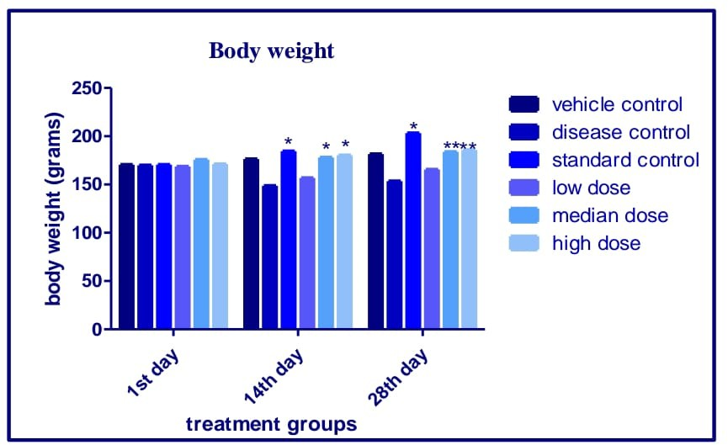

The Figure shows the comparison of the bodyweight on the 1st,14th and 28thday. In the induced group, there is a significant decrease in body weight on the 28th day compared to 1st day. While the rats treated with EESP showed slightly recovery from weight loss.

# URINE PARAMETERS

**Table no 6: Effect of EESP on urine output in ethylene glycol induced urolithiasis**

|  |  |  |  |  |
| --- | --- | --- | --- | --- |
| **Sl.no** | **Treatment**  **groups** | **Urine volume in ml** | | |
| **1st day** | **14th day** | **28th day** |
| **1.** | Vehicle Control | 7.3 ± 0.80 | **7.3 ± 0.11** | **7.3 ± 0.13** |
| **2.** | Disease control | 7.1 ± 0.92 | **6.5± 0.14** | **4.6 ±0.12** |

|  |  |  |  |  |
| --- | --- | --- | --- | --- |
| **3.** | Standard | 7.5 ± 0.80 | **8.5 ±0.11\*** | **9.5 ±0.11\*\*** |
| **4.** | Low dose of EESP  (400mg/kg) | 7.0± 0.81 | **7.2 ± 0.17** | **8.2 ± 0.17** |
| **5.** | Mediandose of EESP (600  mg/kg) | 7.5 ± 0.65 | **7.8 ±0.15\*** | **8.0 ±0.15\*\*** |
| **6.** | High dose of EESP (800  mg/kg) | 7.4 ± 0.90 | **8.9 ±0.15\*\*** | **9.3 ±0.15\*\*** |

**Graph 2 : showing the effect of Smilax perfoliata on urine volume in Ethylene Glycol Induced Urolithiasis**

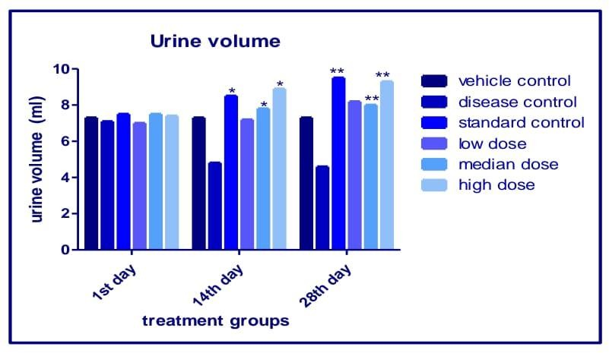

The Figure shows the comparison of the bodyweight on the 1st,14th and 28thday. In the induced group, there is a significant decrease in body weight on the 28th day compared to 1st day. While the rats treated with EESP showed slightly increase in urine volume**.**

**Table no 7: Effect of Ethanolic extract of Smilax perfoliata on urine parameters in ethylene glycol induced urolithiasis**

**a.Estimation of urine calcium**

|  |  |  |  |  |  |  |  |
| --- | --- | --- | --- | --- | --- | --- | --- |
| **Group**  **name** | **1** | **2** | **3** | **4** | **5** | **6** | **Mean ± SEM** |
| **Vehicle**  **control** | 6.3 | 6.2 | 6.2 | 6.3 | 6.2 | 6.4 | 6.27±0.033 |
| **Disease**  **control** | 15.3 | 12.6 | 14.8 | 15.2 | 14.5 | 14.3 | 14.45±0.402## |
| **Standard**  **control** | 10.3 | 9.9 | 9.8 | 9.3 | 10.2 | 10.3 | 9.96±0.158** |
| **low dose**  **400mg/kg** | 14.3 | 11.3 | 13.9 | 14.2 | 13.8 | 13.9 | 13.5 ±0.460 |
| **Median dose 600mg/kg** | 12.3 | 12.1 | 11.8 | 11.9 | 11.7 | 11.2 | 11.83±0.154* |
| **High dose**  **800mg/kg** | 10.5 | 10.4 | 10.3 | 10.1 | 10.5 | 10.7 | 10.42±0.053** |

**Graph 3 : showing the effect of Smilax perfoliata on urine calcium in Ethylene Glycol Induced Urolithiasis**

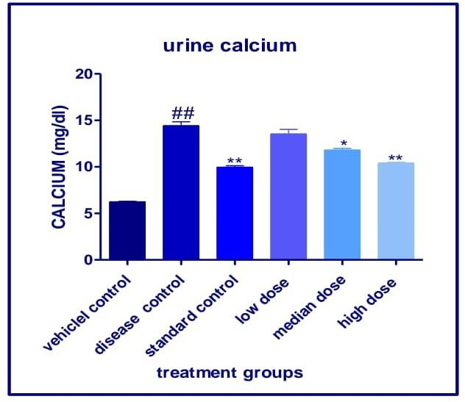

Statistical significance of urine calcium levels was tested by comparing treatment groups with the respective control groups by employing Values are mean ±SEM, n=6 and one way ANOVA ordinary measures followed by Dunnetts multiple comparison test where p*<0.05 when compared with disease control.

1. **Estimation of urine phosphate**

|  |  |  |  |  |  |  |  |
| --- | --- | --- | --- | --- | --- | --- | --- |
| **Group**  **name** | **1** | **2** | **3** | **4** | **5** | **6** | **Mean ± SEM** |
| **Vehicle**  **control** | 3.6 | 3.7 | 3.6 | 3.6 | 3.8 | 3.7 | 3.66±0.033 |
| **Disease**  **control** | 8.7 | 8.3 | 8.7 | 8.7 | 8.4 | 8.7 | 8.58±0.074## |
| **Standard**  **control** | 5.8 | 5.5 | 5.8 | 5.3 | 5.5 | 5.8 | 5.61±0.087** |
| **low dose**  **400mg/kg** | 8.6 | 8.2 | 8.0 | 7.8 | 7.6 | 7.9 | 8.00±0.171 |
| **Median dose 600mg/kg** | 7.7 | 7.8 | 7.9 | 7.6 | 7.8 | 7.9 | 7.78±0.047* |
| **High dose**  **800mg/kg** | 6.0 | 5.9 | 6.2 | 5.9 | 6.1 | 6.2 | 6.05±0.056** |

**Graph 4 : showing the effect of Smilax perfoliata on urine phosphate in Ethylene Glycol Induced Urolithiasis**

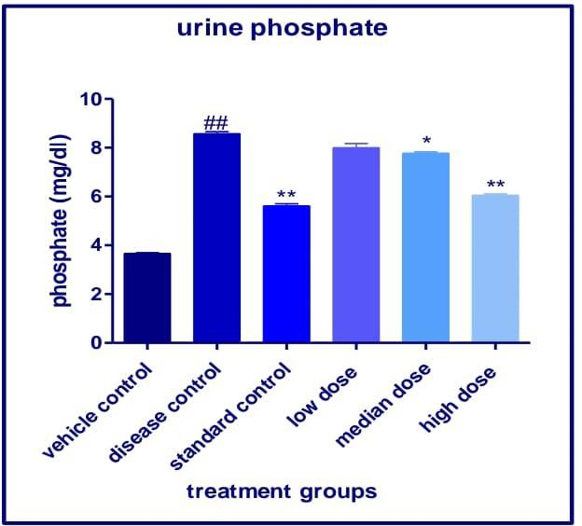

Statistical significance of urine Phosphate levels was tested by comparing treatment groups with the respective control groups by employing Values are mean ±SEM, n=6 and one way

ANOVA ordinary measures followed by Dunnetts multiple comparison test where p<0.05 when compared with disease control.

1. **Estimation of urine oxalate**

|  |  |  |  |  |  |  |  |
| --- | --- | --- | --- | --- | --- | --- | --- |
| **Group**  **name** | **1** | **2** | **3** | **4** | **5** | **6** | **Mean ± SEM** |
| **Vehicle**  **control** | 2.0 | 2.2 | 2.1 | 2.0 | 2.0 | 2.1 | 2.06±0.033 |
| **Disease**  **control** | 4.4 | 4.6 | 4.5 | 4.4 | 4.5 | 4.6 | 4.50±0.036## |
| **Standard**  **control** | 2.1 | 2.2 | 2.2 | 2.1 | 2.0 | 2.2 | 2.13±0.033** |
| **low dose**  **400mg/kg** | 4.3 | 4.3 | 4.2 | 4.1 | 4.2 | 4.2 | 4.21±0.030 |
| **Median dose 600mg/kg** | 3.2 | 3.1 | 3.3 | 3.4 | 3.3 | 3.2 | 3.21±0.030* |
| **High dose**  **800mg/kg** | 2.5 | 2.4 | 2.2 | 2.5 | 2.2 | 2.3 | 2.35±0.05*** |

**Graph 5 : showing the effect of Smilax perfoliata on urine oxalate in Ethylene Glycol Induced Urolithiasis**

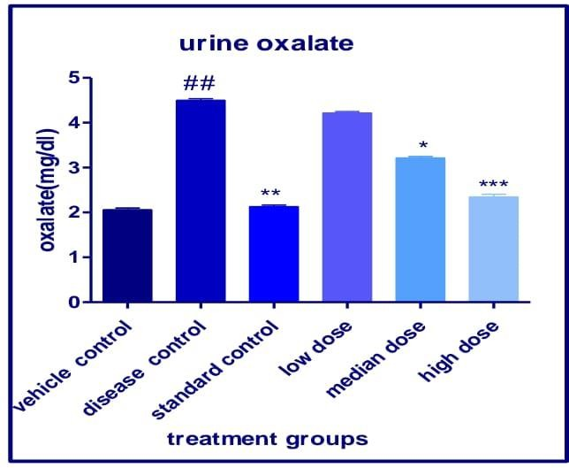

Statistical significance of urine oxalate levels was tested by comparing treatment groups with the respective control groups by employing Values are mean ±SEM, n=6 and one way ANOVA ordinary measures followed by Dunnetts multiple comparison test where p*<0.05 when compared with disease control.

1. **Estimation of urine uric acid**

|  |  |  |  |  |  |  |  |
| --- | --- | --- | --- | --- | --- | --- | --- |
| **Group**  **name** | **1** | **2** | **3** | **4** | **5** | **6** | **Mean ± SEM** |
| **Vehicle**  **control** | 1.8 | 1.9 | 1.7 | 1.5 | 1.8 | 1.5 | 1.70±0.06 |
| **Disease**  **control** | 5.2 | 5.4 | 5.4 | 5.2 | 5.3 | 5.0 | 5.25±0.06## |
| **Standard**  **control** | 2.7 | 2.5 | 2.4 | 3.0 | 2.4 | 2.6 | 2.60±0.09** |
| **low dose**  **400mg/kg** | 4.7 | 4.6 | 4.5 | 4.3 | 4.3 | 4.5 | 4.48±0.06 |
| **Median dose**  **600mg/kg** | 3.6 | 3.5 | 3.7 | 3.6 | 3.5 | 3.6 | 3.58±0.03* |
| **High dose**  **800mg/kg** | 2.5 | 2.7 | 2.8 | 2.9 | 2.7 | 3.0 | 2.76±0.07** |

**Graph 6 : showing the effect of Smilax perfoliata on urine uric acid in Ethylene Glycol Induced Urolithiasis**

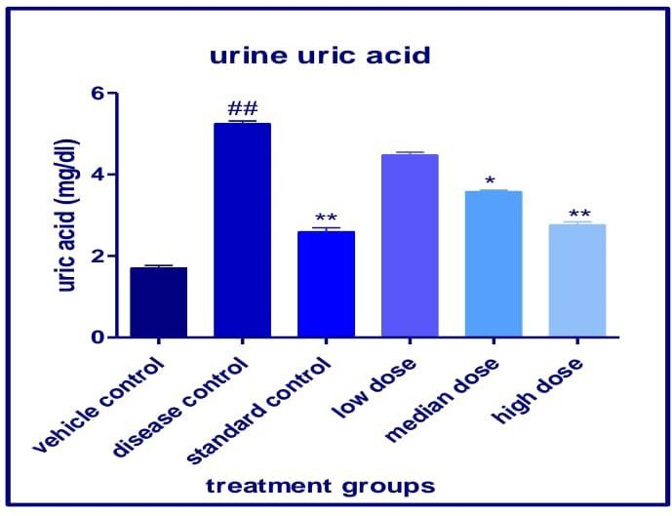

Statistical significance of urine uric acid levels was tested by comparing treatment groups with the respective control groups by employing Values are mean ±SEM, n=6 and one way ANOVA ordinary measures followed by Dunnetts multiple comparison test where p<0.05 when compared with disease control.

**Table 8. Effect of Smilax perfoliata on serum parameters in Ethylene Glycol Induced Urolithiasis**

**a. Estimation of serum creatinine**

|  |  |  |  |  |  |  |  |
| --- | --- | --- | --- | --- | --- | --- | --- |
| **Group**  **name** | **1** | **2** | **3** | **4** | **5** | **6** | **Mean ± SEM** |
| **Vehicle**  **control** | 0.43 | 0.42 | 0.41 | 0.44 | 0.43 | 0.42 | 0.425±0.04 |
| **Disease**  **control** | 1.28 | 1.15 | 1.19 | 1.17 | 1.15 | 1.22 | 1.177±0.010## |
| **Standard**  **control** | 0.71 | 0.82 | 0.72 | 0.81 | 0.91 | 0.99 | 0.826±0.044** |
| **low dose**  **400mg/kg** | 0.99 | 0.97 | 1.00 | 0.98 | 1.02 | 1.09 | 1.008±0.0117 |
| **Median**  **dose 600mg/kg** | 0.86 | 0.84 | 0.89 | 0.88 | 0.90 | 0.99 | 0.893±0.021* |
| **High dose**  **800mg/kg** | 0.88 | 0.85 | 0.86 | 0.89 | 0.87 | 0.88 | 0.871±0.006** |

**Graph 7 : showing the effect of Smilax perfoliata on serum creatinine in Ethylene Glycol Induced Urolithiasis**

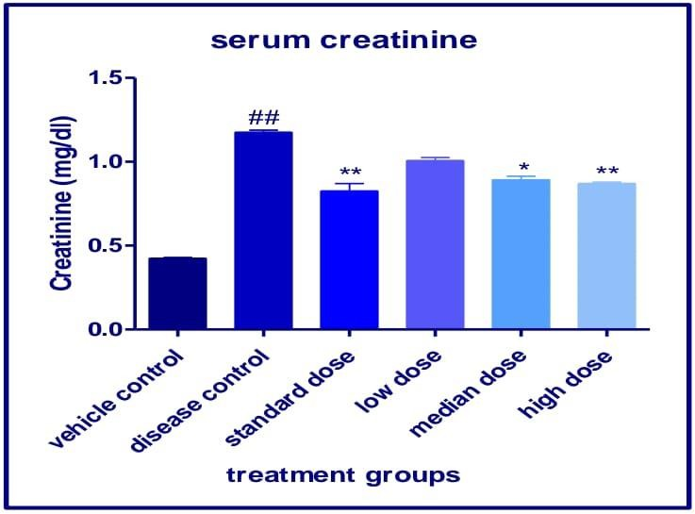

Statistical significance of serum creatinine was tested by comparing treatment groups with the respective control groups by employing Values are mean ±SEM, n=6 and one way ANOVA ordinary measures followed by Dunnetts multiple comparison test where p*<0.05 when compared with disease control.

1. **Estimation of serum BUN**

|  |  |  |  |  |  |  |  |
| --- | --- | --- | --- | --- | --- | --- | --- |
| **Group**  **name** | **1** | **2** | **3** | **4** | **5** | **6** | **Mean ± SEM** |
| **Vehicle**  **control** | 23.5 | 23.1 | 22.9 | 23.1 | 23.4 | 23.4 | 23.23 ± 0.095 |
| **Disease**  **control** | 29.0 | 28.8 | 30.0 | 29.5 | 29.5 | 29.3 | 29.40 ±  0.171## |
| **Standard**  **control** | 22.5 | 22.8 | 22.1 | 22.0 | 22.9 | 29.3 | 22.30 ± 0.071 |
| **low dose**  **400mg/kg** | 28.8 | 28.3 | 28.4 | 28.5 | 28.6 | 28.4 | 28.50 ± 0.073 |
| **Median dose**  **600mg/kg** | 26.5 | 26.4 | 26.3 | 26.5 | 26.5 | 26.6 | 26.43 ± 0.049* |
| **High dose**  **800mg/kg** | 23.0 | 23.0 | 22.9 | 23.0 | 23.1 | 23.0 | 23.00 ±  0.025** |

**Graph 8 : showing the effect of Smilax perfoliata on serum BUN in Ethylene Glycol Induced Urolithiasis**

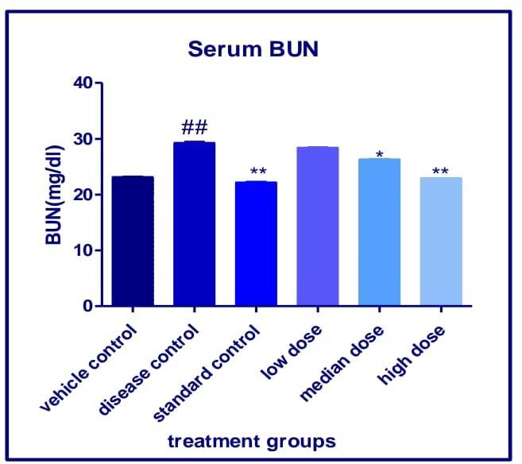

Statistical significance of serum BUN was tested by comparing treatment groups with the respective control groups by employing Values are mean ±SEM, n=6 and one way ANOVA ordinary measures followed by Dunnetts multiple comparison test where p<0.05 5 when compared with disease control.

1. **Estimation of serum phosphate**

|  |  |  |  |  |  |  |  |
| --- | --- | --- | --- | --- | --- | --- | --- |
| **Group**  **name** | **1** | **2** | **3** | **4** | **5** | **6** | **Mean ± SEM** |
| **Vehicle**  **control** | 5.61 | 5.82 | 5.51 | 5.72 | 5.53 | 5.61 | 5.63 ± 0.408 |
| **Disease**  **control** | 10.3 | 10.21 | 9.80 | 10.01 | 10.32 | 9.91 | 10.09 ± 0.088## |
| **Standard**  **control** | 7.61 | 7.52 | 7.83 | 7.75 | 7.53 | 7.82 | 7.677 ± 0.057** |
| **low dose**  **400mg/kg** | 9.99 | 9.97 | 10.0 | 9.98 | 10.02 | 9.00 | 10.01 ± 0.041 |
| **Median**  **dose 600mg/kg** | 8.88 | 8.85 | 8.86 | 8.89 | 8.87 | 8.88 | 8.872 ± 0.006* |
| **High dose**  **800mg/kg** | 7.86 | 7.84 | 7.89 | 7.88 | 7.90 | 7.99 | 7.893 ± 0.021** |

**Graph 9 : showing the effect of Smilax perfoliata on serum phosphate in Ethylene Glycol Induced Urolithiasis**

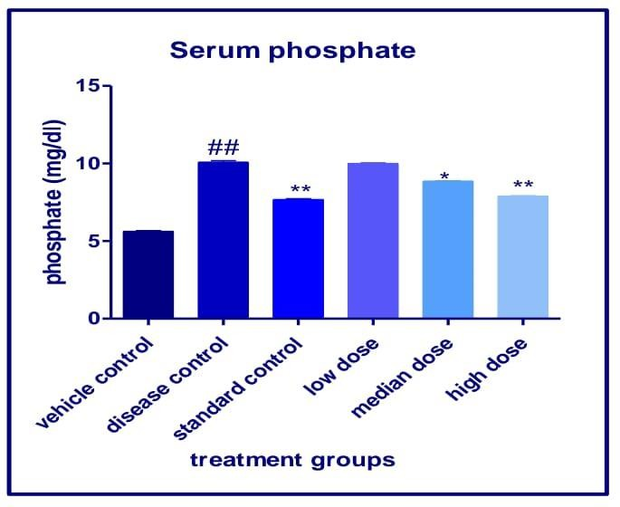

Statistical significance of serum phosphate levels was tested by comparing treatment groups with the respective control groups by employing Values are mean ±SEM, n=6 and one way ANOVA ordinary measures followed by Dunnetts multiple comparison test where p*<0.05when compared with disease control.

**Histopathological findings of Rat Kidney**

**Table no. 9.**

|  |  |  |
| --- | --- | --- |
| **Group** | **Histopathological findings of**  **Rat Kidney** | **Scorings /gradation** |
| **Normal Control** | In cortex -normal glomeruli, tubules were normal – NAD+ In medullary region - loop of Henle  (H) – normal | **NAD+** |
| **Disease control – Ethylene Glycol** (0.75%) | Crystals deposition with Glomerular inflammation with tubular necrosis – moderate 3+ tubular necrosis & inflammation – moderate 3+ medullary region tubular dilatation with Crystals deposition & loop of Henle (H) –  inflammation - Moderate 3+ | **moderate 3+** |
| **Standard drug** Allopurinol  (50mg/kg) | Both cortex & medullary region  showed normal glomeruli, | **NAD+ normal** |
|  | tubules were normal loop of  Henle (H) with flat capillaries |  |
| **Test Drug (LD) Ethanolic extract of smilax perfoliate low dose (400mg/kg)** | normal glomeruli, tubules were normal medullary region showed collecting tubular morphology – normal – with crystal deposition  – mild 2+ | **NAD+mild 2+** |
| **Test Drug (MD) Ethanolic extract of smilax perfoliate mild dose (600mg/kg)** | In cortex -normal glomeruli, tubules were normal – NAD+ I In medullary region - loop of  Henle (H) – normal | **NAD+** |
| **Test Drug (HD) Ethanolic extract of smilax perfoliata high dose (800mg/kg)** | normal glomeruli, tubules were normal – NAD+ medullary region normal collecting tubular Morphology, normal loop of  Henle (H) with flat capillaries | **NAD+ NAD+** |

**Conclusion:**

In **Disease control – Ethylene Glycol** (0.75%) kidneys showed moderate 3+ Crystals deposition with Glomerular inflammation with tubular necrosis – moderate 3+, tubular necrosis & inflammation – moderate 3+, medullary region tubular dilatation with Crystals deposition & loop of Henle (H) – inflammation - **Moderate 3+** Nephroprotective effect of Herbal test drug treated Mid & high dose levels were clear as a renal structural restoration in the kidneys were markedly evident

**NAD+: means No Abnormalities Detected)**

**HISTOPATHOLOGICAL ANALYSIS(fig 2).**

# VEHICLE CONTROL GROUP

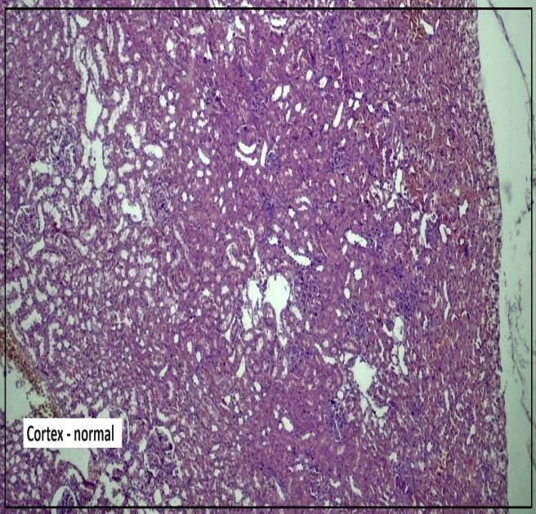

**Vehicle control – Rat Kidney**: showed normal glomeruli, tubules and vessels were normal – NAD+ (X50)

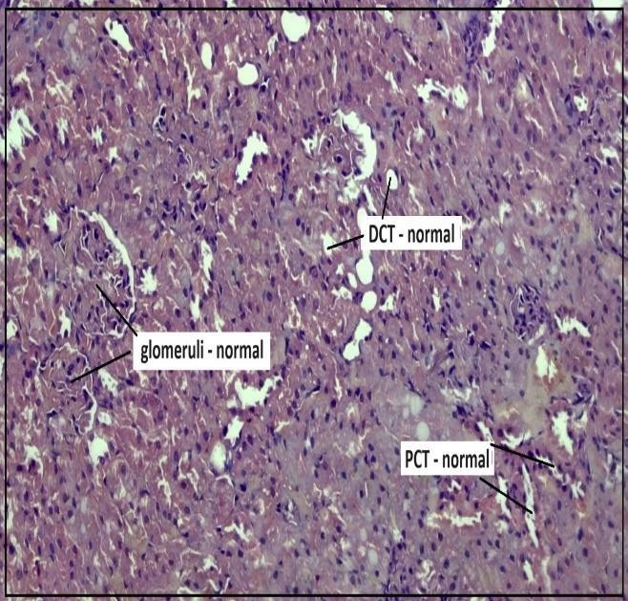

**Vehicle control – Rat Kidney**: showed normal glomeruli, tubules were normal – NAD+ (X100)

**Figure 2: a) Vehicle control group (magnification X50 and X 100)**

# DISEASED CONTROL GROUP

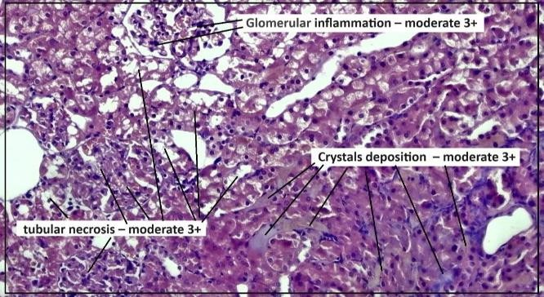

**Diseased control – Rat Kidney**: showed Crystals deposition with Glomerular inflammation with tubular necrosis – moderate 3+ (X50)

**Figure 2: b) disease control group ( magnification X50 and X 100)**

**Diseased control – Rat Kidney**: showed Crystals deposition with tubular necrosssis inflammation – moderate 3+ (X100)

# STANDARD CONTROL

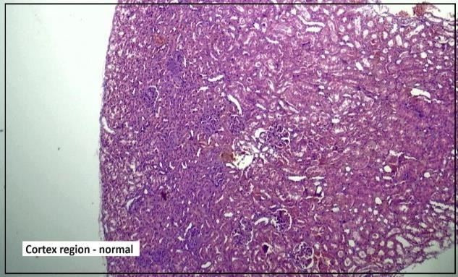

**Std** Allopurinol **treated – Rat Kidney**: showed normal glomeruli, tubules, and vessels – NAD+ (X50)

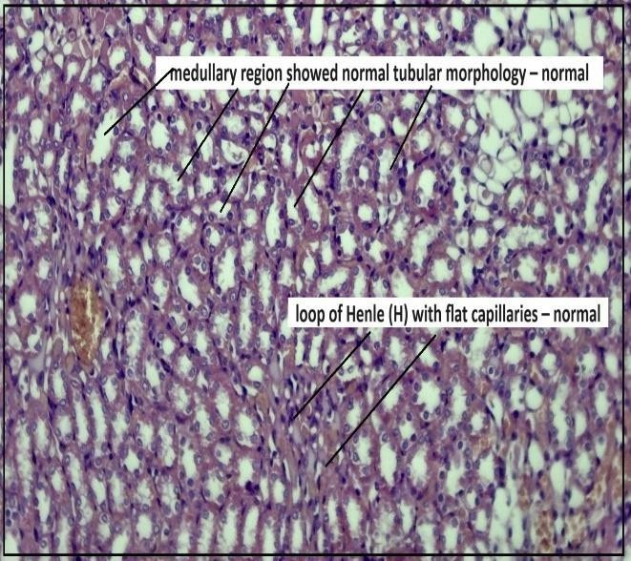

**Std** Allopurinol **treated – Rat Kidney**: showed medullary region showed normal tubular morphology & loop of Henle (H) with flat capillaries – NAD+ (X100)

**Figure 2: c) standard group ( magnification X50 and X 100)**

# LOW DOSE

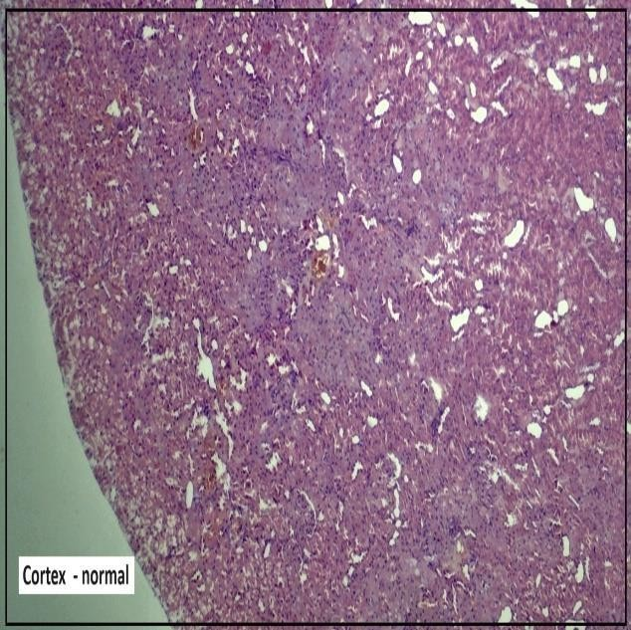

**Test Drug (LD) low dose – Rat Kidney**: showed normal glomeruli, tubules and vessels were evident – NAD+ (X50)

**Figure 2: d) low dose of EESP ( 400mg/kg) ( magnification X50 and X 100)**

**Test Drug (LD) low dose – Rat Kidney**: showed medullary region showed normal tubular morphology & loop of Henle (H) – with crystal deposition – mild 2+ (X100)

# MEDIAN DOSE

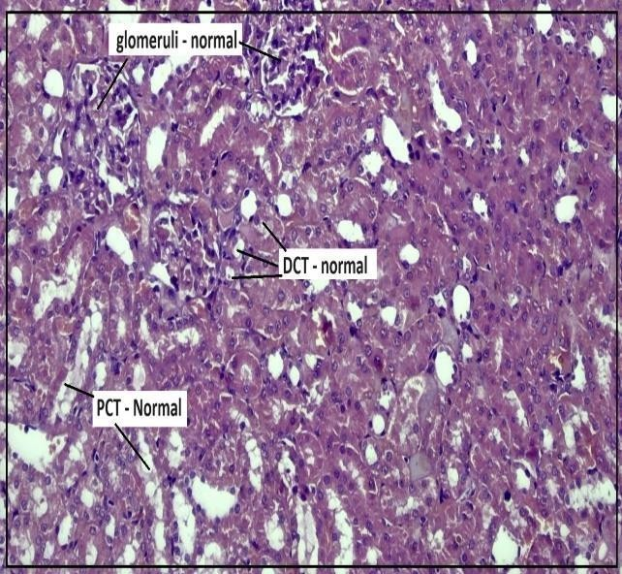

**Test Drug (MD) Mid dose – Rat Kidney**: showed normal glomeruli, tubules were normal – NAD+ (X50)

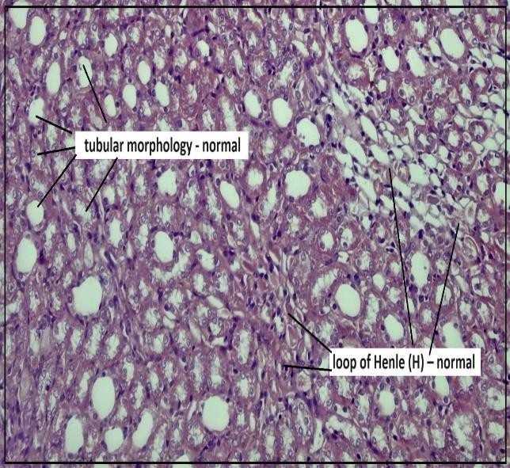

**Test Drug (MD) Mid dose – Rat Kidney**: medullary region showed normal tubular morpholog with loop

of Henle (H) – normal – NAD+ (X100)

**Figure 2: e) median dose of EESP (600mg/kg) (magnification X50 and X 100)**

# HIGH DOSE

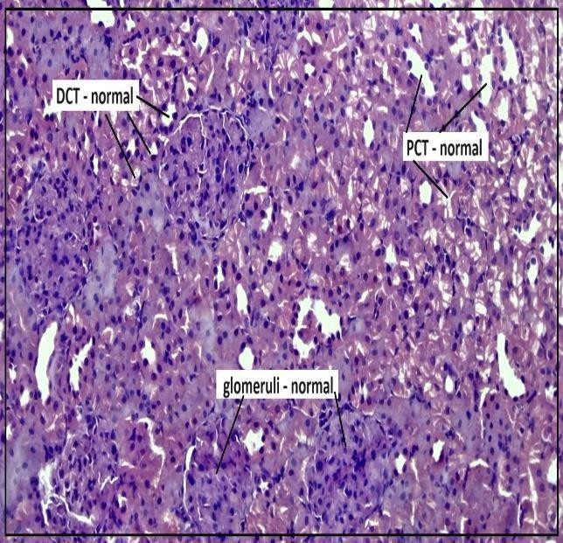

**Test Drug (LD) low dose – Rat Kidney**: showed medullary region showed normal tubular morphology & loop of Henle (H) – with crystal deposition – mild 2+ (X100)

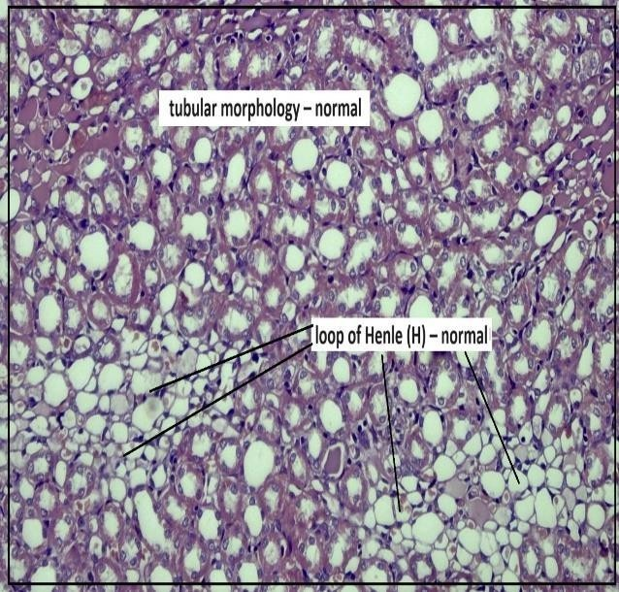

**Test Drug (LD) low dose – Rat Kidney**: showed medullary region showed normal tubular morphology & loop of Henle (H) – with crystal deposition – mild 2+ (X100)

**Figure: 2: f) high dose of EESP ( 800mg/kg) ( magnification X50 and X 100)**

# DISCUSSION

An Urolithiasis, commonly known as kidney stone disease, is characterized by the formation of stones in the urinary system. These stones, primarily composed of calcium oxalate, can cause significant discomfort and lead to severe complications if untreated. Traditional medicine hasexplored the use of various plant extracts to treat and prevent urolithiasis. Smilax perfoliata, a medicinal plant known for its wide range of therapeutic properties, was studied forits antiurolithiatic potential. This study aims to evaluate the antiurolithiatic activity of ethanolic leaves extract of Smilax perfoliata wall on ethylene glycol-induced urolithiasis in Wistar rats. The assessment involved parameters such as body weight, urine and blood serum parameters, and histopathological studies of the kidneys, alongside phytochemical screening of the extract [Türk C.et al-2017].

Phytochemical Analysis of Smilax perfoliata Extract Phytochemical analysis of the ethanolic extract of Smilax perfoliata leaves revealed the presence of several bioactive compounds. These included alkaloids, flavonoids, tannins, carbohydrates, saponins, and triterpenoids, all of which are known to exhibit a wide range of pharmacological activities. Flavonoids are known for their antioxidant properties, which play a vital role in combating oxidative stress a key contributor to urolithiasis. The presence of tannins and saponins further suggests the potential for reducing calcium oxalate stone formation by inhibiting crystal aggregation and improving diuretic activity. The richness of these phytochemicals in Smilax perfoliata supports its traditional use in the treatment of kidney related disorders, including urolithiasis[Shaikh JR.et al-2020]

**Parameters: Body Weight Monitoring**

The body weight of the Wistar rats was monitored throughout the study to assess overall health and any potential side effects of the treatment. Initially, on Day 1, the average body weight of the rats was 170.5 ± 1.62 grams. By Day 28, following the induction of urolithiasis with ethylene glycol, the control group exhibited a slight decrease in body weight to 169.3 ± 4.8 grams, indicating the negative impact of the condition. In contrast, rats treated with the ethanolic leaf extract of Smilax perfoliata not only maintained their body weight but showed a significant increase, reaching 181.17 ± 6.48 grams. By Day 14, the treated group likely continued to increase, reaching around 163.67 ± 6.48 grams in low dose (400mg/kg) and median dose (600mg/kg) 179.9 ± 6.48 and high dose (800mg/kg) 181.17 ± 6.48, which suggests a sustained protective effect of the extractagainst the weight loss typically associated with urolithiasis. This data illustrates that while the control group suffered from weight loss, the extract-treated group demonstrated an impressive improvement in body weight, underscoring the protective benefits of Smilax perfoliata.[ Asija R.et al-2024]

**Urine Analysis**

Urine analysis is critical in assessing the antiurolithiatic activity of any substance. In this study, several urine parameters were measured, including urine volume, calcium, oxalate, phosphate and uric acid levels. Ethylene glycol administration led to a marked decrease in urine volume 5.53 ± 0.03, alongside a significant increase in urinary calcium (14.45 ± 0.033mg/dL), oxalate (4.50 ± 0.036mg/dL), phosphate (8.58 ± 0.074 mg/dL) and uric acid levels (5.25 ± 0.06 mg/dL). This alteration in urinary composition promotes the formation of calcium oxalate stones.

Treatment with Smilax perfoliata extract significantly reversed these changes. In the group treated with 800 mg/kg of the extract, urinary calcium levels were reduced to 10.42 ± 0.053 mg/dL, oxalate to 2.35 ± 0.05 mg/dL, phosphate to 6.05 ± 0.056 mg/dL and uric acid 2.76 ± 0.07 demonstrating the extract's potential to inhibit calcium oxalate crystallization and stone formation. Additionally, urine volume were normalized, with treated rats showing a 9.3 ± 0.15, compared to the induced group. The normalization of these parameters suggests that the plant extract promotes diuresis and prevents the stone formation.

[Gopika S.et al-2024]

**Blood Serum Biochemical Parameters**

Blood serum parameters provide insights into the systemic effects of urolithiasis and the therapeutic efficacy of treatments. Key serum markers of kidney function, including, creatinine, and uric acid levels, were measured. Rats in the induced group showedsignificantly elevated serum creatinine (1.177 ± 0.010 mg/dl) , serum BUN (29.40 ± 0.171 mg/dl) levels and serum phosphate (10.09 ± 0.088 mg/dl) compared to the control group, indicating impaired renal function due to stone formation. However, treatment with Smilax perfoliata extract resulted in a significant reduction in these serum markers. In the high-dose group (800mg/kg), creatinine 0.871±0.006 mg/dl , serum BUN 23.00 ± 0.025 mg/dl and phosphate 7.893± 0.021 mg/dl reflecting a marked improvement in kidney function. These findings suggest that the extract mitigates kidney damage caused by urolithiasis, potentially through its antioxidant and nephroprotective properties. The results further imply that Smilax perfoliatacan prevent the accumulation of waste products in the blood by enhancing renal filtration efficiency[Sumanjali C.et al-2021].

**Histopathological Studies**

Histopathological examination of the kidney tissues provided critical evidence of the protective effect of Smilax perfoliata extract against sodium oxalate-induced urolithiasis. In the untreated urolithiatic group, extensive damage to renal tissue was observed, including tubular dilation, epithelial cell necrosis, and calcium oxalate crystal deposition in the renal tubules. These pathological changes are consistent with the damaging effects of calcium oxalate stones on kidney structure and function.

Conversely, rats treated with Smilax perfoliata extract showed significant improvements in kidney architecture. In the high-dose group, only minimal crystal deposition was observed,and the overall kidney structure remained largely intact. Tubular epithelial cells exhibited reduced necrosis, and there was an absence of tubular dilation. These findings were corroborated by reduced calcium oxalate crystal formation, suggesting that the plant extract not only prevents stone formation but also protects renal tissues from the oxidative stress andinflammation associated with urolithiasis. The histopathological evidence thus confirms the potential of Smilax perfoliata.

The development of stones in the urinary system is a hallmark of urolithiasis, also referred to as kidney stone disease. If left untreated, these stones, which are mostly made of calcium oxalate, can be extremely uncomfortable and result in serious consequences. Numerous plant extracts have been investigated in traditional medicine as potential treatments and preventative measures for urolithiasis. Research was done on the antiurolithiatic potential of Smilax perfoliata, a medicinal herb with several therapeutic uses. The purpose of this work is to assess the antiurolithiatic effect of an ethanolic leaf extract of Smilax perfoliata wall on Wistar rats' urolithiasis caused by ethylene glycol. The evaluation included kidney histopathology tests, body weight, blood serum and urine parameters, and phytochemical screening of the extract [Asija R.et al -2024].

**Conclusion**

The findings from this study suggest that the ethanolic leaf extract of Smilax Perfoliata exhibits significant antiurolithiatic activity. The extract improved general health indicators,normalized urine and blood serum biochemical parameters, and mitigated kidney damage.

The higher dosage of the extract (800 mg/kg) and median dosage of the extract (600 mg/kg) are proved to be more effective in reducing urolithiasis than the Low dose dosage(400 mg/kg), demonstrating a clear dose-dependent effect.

Histopathological examinations further validated these protective outcomes, showing minimal renal injury and well-preserved kidney structure in the treated rats. These results highlight the potential of Smilax perfoliata as a therapeutic option for managing urolithiasis.

Disclaimer (Artificial intelligence)

Option 1:

Author(s) hereby declare that NO generative AI technologies such as Large Language Models (ChatGPT, COPILOT, etc.) and text-to-image generators have been used during the writing or editing of this manuscript.

Option 2:

Author(s) hereby declare that generative AI technologies such as Large Language Models, etc. have been used during the writing or editing of manuscripts. This explanation will include the name, version, model, and source of the generative AI technology and as well as all input prompts provided to the generative AI technology

Details of the AI usage are given below:

1.

2.

3.

**References**

1. Asija R, Swami A, Sharma KR. Evaluation of Anti-Urolithiatic Activity of Ethanolic Extract of Salacia Reticulata against Ethylene Glycol Induced
2. Gopika S, Nisha MK, Devi EG, Rajeswari AR, Vasandhlakshmi R. Evaluation of Antiurolithiatic Potential of Methanolic Stem Extract of Spermacocce articularis Lf: An In vitro and In vivo Approach. Pharmacognosy Journal. 2024;16(4).
3. Jagannath N, Chikkannasetty SS, Govindadas D, Devasankaraiah G. Study of antiurolithiatic activity of Asparagus racemosus on albino rats. Indian journal of pharmacology. 2012 Sep;44(5):576.
4. Manasa BY, Chauhan JB. Evaluation Of Antiurolithiatic Activity Of Methanolic Seed Extracts Of Persea Americana Against Calcium Oxalate Induced Urolithiasis In Rats. Journal of Pharmaceutical Negative Results. 2022 Oct 22:639-46.
5. Mawlieh B, Kalita K, Jyoti Sahariah B, Talukdar A, Sharma Bora N. Design and evaluation of antiurolithiatic effervescent herbal tablets containing hydroalcoholic extract of Bryophyllum pinnatum. Bulletin of Pharmaceutical Sciences. Assiut. 2023 Jun 1;46(1):1-1.
6. Mujeeb U R, Juber K , G. J , Gazala P Antiurolithiatic activity of curcumin against ethylene glycol-induced urolithiasis in male Wistar rats. International Journal of Advances in Pharmacy Medicine and Bioallied Sciences. 2018;6(3)104-110
7. Nojaba L, Guzman N. Nephrolithiasis. [Updated 2021 Aug 11]. In: StatPearls [Internet]. TreasureIsland (FL): StatPearls Publishing; Jan- 2022.
8. Rani IV, Gadicherla V. EVALUATION OF ANTIUROLITHIATIC ACTIVITY OF CANTHIUM DICOCCUM ETHANOLIC EXTRACT IN RATS
9. Shaikh JR, Patil M. Qualitative tests for preliminary phytochemical screening: An overview. International Journal of Chemical Studies. 2020 Mar 1;8(2):603-8.
10. Sumanjali C, Shashidhar M, Sravani M, Babu KR, Tejeswarudu B, Kalyani CD. Anti Urolithiatic Activity of the Ethanolic Extract of Cassia auriculata against Ethylene Glycol Induced Urolithiasis in Experimental Rats. Research Journal of Pharmacy and Technology. 2021;14(10):5207-12.
11. Treatment options for kidney stones - InformedHealth.org - NCBI Bookshelf (nih.gov)
12. Türk C, Knoll T, Petrik A, Sarica K, Skolarikos A, Straub M, Seitz C. Urolithiasis. European association of urology. 2017 Aug 10.

Urolithiasis in Wistar Albino Rats. Asian Journal of Pharmaceutical Research and Development. 2024 Jun 15;12(3):58-65.

