Evaluation of Hepatoprotective activity of Ethanolic extract of *Hopea erosa*

leaves against Paracetamol induced Hepatotoxicity in Rats

Abstract:

The study investigates the hepatoprotective effects of the ethanolic extract of *Hopea erosa* leaves against paracetamol-induced liver toxicity in Wistar albino rats. Liver damage was induced using a high dose of paracetamol (1000 mg/kg), and the therapeutic effects of *Hopea erosa* at two different doses (200 mg/kg and 400 mg/kg) were compared with a standard hepatoprotective drug, silymarin (100 mg/kg). Preliminary phytochemical analysis confirmed the presence of active compounds such as flavonoids, tannins, alkaloids, and steroids in the extract. Acute toxicity studies indicated the safety of the extract up to 2000 mg/kg. The study observed significant biochemical changes in liver enzymes (SGOT, SGPT), alpha-fetoprotein (AFP), and total bilirubin in the paracetamol group, which were reversed with *Hopea erosa* treatment, especially at the higher dose. Histopathological examination showed that liver damage (necrosis, inflammation, cirrhotic nodules) caused by paracetamol was notably reduced in the extract-treated groups, with the high-dose group exhibiting near-normal liver architecture. The findings suggest that the hepatoprotective effect of *Hopea erosa* may be attributed to its antioxidant and anti-inflammatory constituents. This research provides scientific support for the traditional use of *Hopea erosa* in liver-related ailments and suggests its potential for further development into plant-based liver therapeutics, although additional pharmacological and clinical studies are needed to isolate and characterize its active components.

Keywords:

PCM (Paracetamol) , *Hopea erosa,* silymarin, hepatoprotective , Alpha-fetoprotein (AFP), Drug induced liver injury (DILI)

1. Introduction:

The liver is considered to be one of the most important organs in the body because it is necessary for regulating several physiological processes [Jaeschke H.et al-2024]. One multipurpose organ that controls the body's internal chemistry is the liver. Through detoxification and removal, it protects the body from foreign substances by controlling drug metabolism and excretion as well as that of other xenobiotics [Li H.et al-2023]. Liver disease is one of the most dangerous conditions, is caused by the liver's exposure to various toxins that the body produces both internally and externally.[zawa, T et al-2023] Hepatosis, a non inflammatory disease, cirrhosis, a condition caused by liver fibrosis, and acute or chronic liver inflammatory disorders are the three categories of liver illnesses. Among the factors that may increase the risk of liver disease are heavy alcohol consumption, obesity, type 2 diabetes, and a family history of the condition.[ Ghany, M. G.et al-2023] These are mostly brought on by the risk factors mentioned above, which damage the cells of the liver by encouraging lipid peroxidation and other oxidative damages as a result of oxidative stress produced by the liver [Li R.et al-2025]. Paracetamol, often known as acetaminophen, is a widely used antipyretic that has long been recognized to cause liver damage when taken in excess of authorized dosages.[Moura, D et al-2024] Hepatotoxicity from purposeful or inadvertent paracetamol usage is the most common cause of DILI in the United States. overdose, which continues to be an issue globally [Devi M et al-2023]. When taken as prescribed, it is thought to be safe for people up to 4 g per day. High single dosages of paracetamol (usually 15 g or more) damage the liver by producing the poisonous metabolite NAPQI (N-acetyl-p-benzoquinone imine). Drinking alcohol and maybe going hungry cause cytochrome P-450 to be induced, which raises the synthesis of NAPQI. [ Rotundo L et al-2020] Since ancient times, people have been looking for natural ways to alleviate various ailments [Zhou, Ye et al-2023] The use of medicinal herbs was first instinctive, much like with animal. with time, the justification for it was discovered that certain medicinal plants might be used to cure specific illnesses [Saini, A.et al-2020] Numerous medicinal plants are used to treat a variety of illnesses. Hopea erosa is one such medicinal plant that is utilized to cure hepatotoxicity due to its phytoconstituents. Hopea erosa is listed as a severely endangered tree species on the IUCN Red List of Threatened Species[Çekiç, E et al-2022]. The four chemical constituents of plants that protect the liver are lipids, alkaloids, xanthenes, flavonoids, phenols, coumarins, lignans, essential oil, monoterpenes, carotenoids, glycosides, and organic acids. [Kayalı, A et al- 2024] Studies have indicated that extracts obtained from the *Hopea erosa* plant's wood and leaves exhibit antioxidant qualities. *Hopea erosa* leaves have yielded a number of bioactive

substances that have been separated and extracted, such as phenyl compounds, curcumin, colchicine, Myrcene, coumarin, piperonal, scoparone, capsaicin, epigallocatechin, quercetin, isoeugenol, and resveratrol [<https://indiabiodiversity.org/species/show/13265#summary>] Additionally, there is no scientific proof of Hopea erosa leaf extract's hepatoprotective ability against paracetamol-induced liver damage Thus, using rats as an experimental model, the current study aims to assess Hopea erosa's hepatoprotective effects against PILD.

1. **Materials and methods**
   1. . Sources of drugs and chemicals:

Every reagent, solution, chemical, and solvent used in this study was of analytical grade, including the refrigerator from Blue Star, the digital balance from Remi Motors Ltd. in Mumbai, the silymarin from Abbott Laboratories, the sodium chloride from Fischer Scientific, the methanol and chloroform from Fischer Scientific, and PCM from Maruthi Medicals in Bangalore.

* 1. Collection and authentication of plant material:

Leaves of *Hopea erosa* were collected from a forest in Wayanad, Kerala, INDIA. Leaves are identified on the basis of microscopic studies of the sample in the pharmacognosy lab, FRLHT herbarium and raw drug repository of medicinal plants used in Indian system of medicine, FRLHT, Bengaluru. Leaves are authenticated by the taxonomist at the department of herbarium and raw drug repository FRLHT, Bengaluru. A voucher specimen (FRLHT Acc no. 6165) was deposited in the FRLHT for future reference.

* 1. Preparation of *Hopea erosa* extract

The leaves of the *Hopea erosa* were cleansed with running tap water and then distilled water before being laid out on newspaper to dry. Moreover, it is shade-dried. After that, it is ground into a coarse powder using a mixer grinder and then run through sieve number 44. For extraction, roughly 500 g of the medication will be separated. *Hopea erosa* will undergo an 8- hour Soxhlet extraction process using 80% ethanol and a solvent (hydro alcoholic extract). In addition, a rotary flash evaporator will be used to dry the extracted solvent 27 at 45°C after it

has been filtered through muslin cloth, yielding a viscous semi-solid extract [Niu, H et al- 2022]

* 1. Phytochemical analysis of the extract:

The leaf extract of *Hopea erosa* had undergone the initial phytochemical analysis for free amino acids, phenolics, flavonoids, alkaloids, carbohydrates, proteins, and steroids.

* 1. Experimental animals:

The study used 180–220g Wister albino rats in good health. From Mallige College of Pharmacy's animal house, the animals were acquired. For experimental purposes, the Institutional Animal Ethical Committee [IAEC] granted animal clearance. According to the standards set forth by the Committee for the Purpose of Control and Supervision on Animals (CPCSEA), they were kept in a laboratory setting with a regulated temperature and humidity. The rats had a regular food and unlimited water and ethical approval was attached at the end.

* 1. Experimental protocol:

Acute toxicity studies: Acute toxicity study (OECD 423 guidelines) was carried out using female albino wistar rats (170-220g) those maintained under standard husbandry conditions. The maximum upper limit dose 2000mg/kg of Ethanolic root extract of Hopea erosa was administered orally to three female rats. The animals were observed for mortality as well as morbidity, with special attention was given during first 30 minutes to 4 hours till 12 hours followed by everyday till 14 days [OECD guidelines-2001]

Experimental design:

PCT induced Hepatotoxicity: The experimental design for the evaluation of hepatoprotective activity is PCT induced Hepatotoxicity. In this method rats will be randomly assigned in to six groups of 6 animals each are treated as follows, Group I: Serves as control – normal healthy rats with control vehicle i.e., distilled water. Group II: Serves as hepatotoxic control (paracetamol 1000mg/kg) without drug treatment. Group III: Treatment with standard drug (Silymarin-100 mg/kg, p.o.) +paracetamol 1000mg/kg. Group IV: Treatment with low dose of

herbal formulation(200mg/kg) + paracetamol 1000mg/kg. Group V: Treatment with high dose of herbal formulation(400mg/kg)+paracetamol 1000mg/kg.

Paracetamol 1000mg/kg was administered 3 times a week (p.o) and after 72 hrs extract with low and high doses was given (p.o)

* 1. Evaluation of the biochemical and histological characteristics of the liver:

All experimental animals were weighed one day prior to the study and one day prior to the protocol's conclusion. Diethyl ether was used to kill the animals after they had fasted for the whole night, and blood samples were taken using the retro orbital technique of the same animals. After 15 minutes of centrifugation at 3000 rpm, the resulting serum was kept at -20

°C for biochemical analysis

* 1. Histopathological analysis:

At the end of the study, all rats which are used for experiment will be sacrificed humanely by giving diethyl ether as anesthesia and the liver will be dissected out and washed. The other parts of liver tissues will be fixed in 10% neutral buffered formalin and embedded in paraffin wax. Sections of 4 µm thick will be stained with hematoxylin and eosin (H and E) and examined using binocular Olympus CX31 microscope. The slides will be evaluated by a trained veterinary pathologist [Mansour DF.et al-2019]

* 1. Statistical analysis:

The values were be expressed as mean ±SEM. Statistical difference in mean was analyzed using one way ANOVA followed by Dunnets multiple comparison tests. P<0.05 considered to be statistically significant.

Table 1: Preliminary phytochemical analysis of *Hopea erosa*

|  |  |  |
| --- | --- | --- |
| **Test performed** | **Name of the test** | **Results** |
| Test for alkaloids | * Wagner’s test * Dragendorff’s test | +ve  +ve |
| Test for carbohydrates | * Molisch’s test * Benedict’s test | +ve  +ve |
| Test for saponins | * Foam test | +ve |
| Test for sterols | * Liebermann Burchard’s   test   * Salkowski test | +ve  +ve |
| Test for phenolic compounds and flavonoids | * Ferric chloride test * Lead acetate test | +ve  +ve |
| Test for tannins | * Gelatin test | +ve |

+ve denotes the presence and –ve denotes absence of respective class of compound

1. **Results:**

phytochemical analysis of the extract

A preliminary phytochemical examination revealed that the ethanolic extract of Hopea erosa included a variety of bioactive substances, including steroids, tannins, flavonoids, and alkaloids. (Table 1).

* 1. Effects of the extract on body weight and liver weight:

The body weight of each animal was recorded and animals with body weight (200-240gm) were chosen for the study. Initial body weight was recorded on day 1 and change in the body weight of the animal of each group was noted at the end of the experiment. Significant increase in the weight of negative control rats from 211.7±4.77 to 310±5.77 (provided with normal diet ad libitum) was noticed while in the PCT treatment group there was no significant rise in the body weight. In case of Silymarin treatment group, slight decrease in the body weight of the rats from 216.7 ± 6.67 to 208.3±5.43 was noticed at the end of the experiment. In contrast, a slow sluggish growth in the body weight was noticed in Hopea erosa treatment groups. However, the liver of PCT induced animals was enlarged along with presence of focal lesions and nodular tumors. Therefore, there was a marked increase in liver weight 11.75±0.86 compared to negative control 9.76±0.18. The mean body weight of various studied groups on day 1 and at the end of the experiment along with organ weight is shown in the below table 2.

Table 2: Effect of PCT, Silymarin, and Hopea erosa on body weight, liver weight and liver weight by body weight ratio in PCT initiated Hepatotoxicity bearing rats

|  |  |  |  |  |
| --- | --- | --- | --- | --- |
| Groups | Body weight (g) | | Liver  weight(g) | Liver/BW  ratio% |
| Initial | Final |
| Vehicle control | 211.7±4.  7 | 310±5.77 | 9.76±0.18** | 3.15±0.06*** |
| Disease control | 218.3±7.4  9 | 240±5.77 | 11.75±0.86 | 4.91±0.42 |
| Standard (silymarin) | 216.7±6.6  7 | 208.3±5.4  3 | 8.17±0.22*** | 3.93±0.11** |
| Lowdoseof  *Hopeaerosa* | 235±3.42 | 268.3±7.0  3 | 10.06±0.17* | 3.75±0.05** |
| Highdoseof  *Hopeaerosa* | 233.3±3.3  3 | 278.3±6.0  1 | 9.89±0.15* | 3.80±0.14*8 |

All values are expressed as mean ± S.E.M (n=6); statistically significant at P<0.05,

ANOVA,followed by Dunnet’s test when compared to disease control group

Table 3: Effect of *Hopea erosa* on SGOT, SGPT, AFP and Total bilirubin in PCT induced Hepatotoxicity in rats:

|  |  |  |  |  |  |  |
| --- | --- | --- | --- | --- | --- | --- |
| Groups | Treatment | Dose | SGOT(IU/L) | SGPT(IU/L) | AFP  (ng/ml) | Total bilirubin (mg/dL) |
| Group 1 | Vehicle  control | Distilled water  (0.5ml/kg, *p.o.)* | 42.17±1.51 | 39.17±1.42 | 50.67±1.70 | 0.41±0.06 |
| Group 2 | Disease control | PCT  (1000mg/kg)  *p.o.* | 179.0±2.09 | 159.7±2.29 | 203.7±2.99 | 3.35±0.07 |
| Group 3 | Standard | Silymarin(100mg  /k g) after 30 min.PCT(1000m g/k  g) | 59.67±1.72 | 57.0±1.52 | 51.67±1.05 | 0.51±0.04 |
| Group 4 | Low dose of *Hopea erosa* | Ethanolic leaves extract of Hopea erosa (200mg/kg p.o) after 30 min.PCT(1000m  g/kg) | 127.7±1.68 | 111.0±1.52 | 179.2±1.42 | 1.85±0.17 |
| Group 5 | High dose of *Hopea erosa* | Ethanolic leaves extract of Hopea erosa (400mg/kg p.o) after 30min.PCT(1000  mg/kg) | 85.0±1.82 | 80.50±1.66 | 77.0±1.52 | 1.15±0.07 |

All values are expressed as mean ± S.E.M (n=6); Dunnet’s test was used to compare the various group with disease control group; P<0.05 is considered statistically significant.

Table 3 represent the effect of *Hopea erosa* on SGOT, SGPT, AFP and Total bilirubin shows the good results as the valves suggest that for SGOT compared to disease group the low dose and high dose bar graph was less as shown in fig 1

For SGPT as the bar graph represents the decrease in valves compared to disease group for the low and high groups and same for the AFP and total bilirubin as shown in the fig 2,3,4.

Fig 1: Effect of *Hopea erosa* on SGOT level in PCT induced Hepatotoxicity in rats

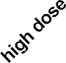

**TREATMENT**

**50**

***

***

**100**

***

**150**

#

**200**

**SGOT**

Fig 2: Effect of *Hopea erosa* on SGPT level in PCT induced Hepatotoxicity in rats

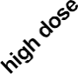

**TREATMENT**

**0**

***

**50**

***

**100**

***

**150**

#

**200**

**SGPT**

Fig 3: Effect of *Hopea erosa* on AFP level in PCT induced Hepatotoxicity in rats

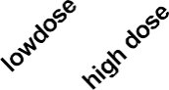

**TREATMENT**

**0**

***

***

**50**

**150**

***

**200**

#

**250**

**AFP**

Fig 4: Effect of *Hopea erosa* on total bilirubin level in PCT induced Hepatotoxicity in rats:

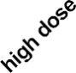

**0**

***

**1**

***

**2**

***

**3**

#

**4**

**total bilirubin**

* 1. Histopathology Results:

A B C

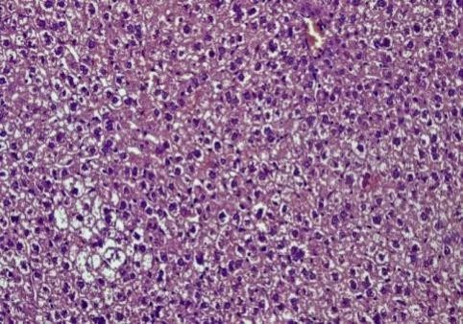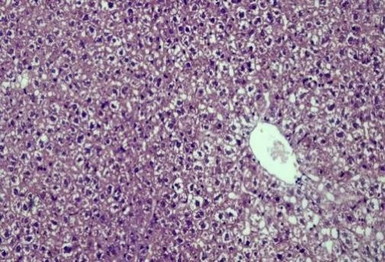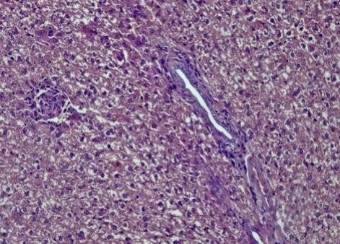

D E

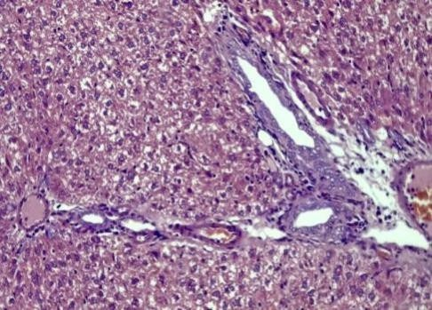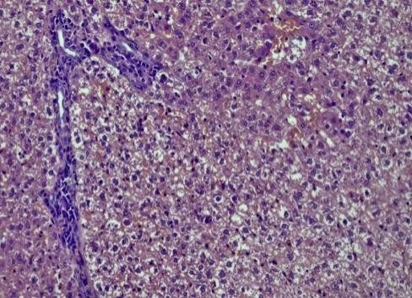

plate 1 : A- Vehicle control , B- disease control (PCT 1000mg/kg) , C- Standard Silymarin(100mg/kg) , D -Low dose of extract 200mg/kg , E- high dose of extract 400mg/kg

GROUP 1 (Negative control): Showing normal histology of rat liver.

Light microscopic investigation of liver section from negative control rat showed normal hepatic architecture with distinct hepatic cells, Regular patterns of central veins, unremarkable central vein and sinusoidal space, absents of inflammation and hepatic necrosis.

GROUP 2 (Positive control): Cirrhotic nodules with portal inflammation, hepatic necrosis with ballooning of hepatocytes around central vein, fibrosis

Animals treated with PCT shows central vein surrounded by extensive necrosis, Degrative hepatosis, sinusoidal congestion presence of clear cell foci, widening of liver sinusoids, lymphocyte infiltration associated with granuloma within the liver parenchyma.

GROUP 3 (Standard): Central vein congestion, regenerating hepatocytes.

Liver specimen of rat treated with standard silymarin showed decrease in the liver inflammation caused initially due to administration of PCT. Decrease in cell necrosis with induction of apoptosis is observed in the photomicrograph

GROUP 4 (Low dose of *Hopea erosa):* N- focal necrosis, extensive portal traid inflammation.

Animals treated with low dose of *Hopea erosa* shows less necrotic hepatocytes compared to positive control and shows mild hepatic necrosis.

GROUP 5(High dose of *Hopea erosa*): mild central vein dilation, mild inflammation.

High dose treatment showed dilation in blood sinusoid, slight vacuolization in the cytoplasm of hepatocytes and less monocytic infiltration.

1. **Discussion:**

The entire work was divided into various phases. In the first phase of the study, Hopea erosa was subjected to phytochemical investigation. The components like alkaloids, glycosides, saponins, carbohydrates, proteins, tannins, phenolic compounds, flavonoids were present. The estimation of Body weight and liver weight was carried out. In the second phase of study, the administration of paracetamol (1g/kg, p.o.) diluted with distilled water (0.5ml/kg) in three separate doses will cause hepatotoxicity. The hepatoprotective activity will be evaluated in male albino Wistar rats weighing between 150 and 200 g. The animals will be maintained at a temperature of 25-28℃ the next phase of the study, estimation of SGOT, SGPT was carried out and it revealed that treated animals have prevented the elevation these enzyme levels at some extent indicating their hepatoprotective activity against PCT induced Hepatotoxicity in rats. A further study shows histopathological studies. It is evident from the histopathological studies that in the vehicle control, rat liver shows normal histology whereas in positive control, the rat liver shows Cirrhotic nodules with portal inflammation, hepatic necrosis with ballooning of hepatocytes around central vein, fibrosis. The animals of standard group showed decrease in the liver inflammation caused initially due to administration of PCT. Further histopathological studies show that the animals treated with low dose of Hopea erosa shows less necrotic hepatocytes compared to positive control and shows improvement in hepatic architecture. High dose treated animals showed dilation in blood sinusoid, slight vacuolization in the cytoplasm of hepatocytes and less monocytic infiltration.

1. Conclusion:

Future research might focus on isolating these active chemicals and investigating their pharmacological properties, as well as performing clinical trials to assess the effectiveness of *Hopea erosa* in humans. Ultimately, the examination of *Hopea erosa’s* hepatoprotective potential highlights the need of introducing natural products into health management programs. As the desire for safer, plant-based therapeutic alternatives continues to increase, this research includes essential insights that may assist in the development of effective therapies for liver protection and treatment of drug-induced hepatotoxicity.

Ethical Approval

Animal Ethic committee approval has been collected and preserved by the author(s)

Disclaimer (Artificial intelligence)

Option 1:

Author(s) hereby declare that NO generative AI technologies such as Large Language Models (ChatGPT, COPILOT, etc.) and text-to-image generators have been used during the writing or editing of this manuscript.

Option 2:

Author(s) hereby declare that generative AI technologies such as Large Language Models, etc. have been used during the writing or editing of manuscripts. This explanation will include the name, version, model, and source of the generative AI technology and as well as all input prompts provided to the generative AI technology

Details of the AI usage are given below:

1.

2.

3.

References:

1. Jaeschke, H., & Ramachandran, A. (2024). Acetaminophen hepatotoxicity: Paradigm for understanding mechanisms of drug-induced liver injury. *Annual Review of Pathology: Mechanisms of Disease, 19*, 453–478. <https://doi.org/10.1146/annurev-pathmechdis-051122-094016>.
2. Li, H., Weng, Q., Gong, S., Zhang, W., Wang, J., Huang, Y., Li, Y., Guo, J., & Lan, T. (2023). Kaempferol prevents acetaminophen-induced liver injury by suppressing hepatocyte ferroptosis via Nrf2 pathway activation. *Food & Function, 14*(4), 1884–1896. <https://doi.org/10.1039/D2FO02716J>.
3. India Biodiversity Portal. (n.d.). *Hopea erosa* Bedd. Retrieved June 1, 2025, from <https://indiabiodiversity.org/species/show/13265#summary>
4. Li, R., Wu, H., Xu, Y., Xu, X., Huang, H., Lv, X., Liao, C., Ye, J., & Li, H.

(2025). Underlying mechanisms and treatment of acetaminophen-induced liver injury: A review. *Molecular Medicine Reports, 31*(4), Article 106. [https://doi.org/10.3892/mmr.2025.13471.](https://doi.org/10.3892/mmr.2025.13471)

1. Mansour, D. F., Abdallah, H. M., Ibrahim, B. M., Hegazy, R. R., Esmail, R. S., & Abdel-Salam, L. O. (2019). The carcinogenic agent diethylnitrosamine induces early oxidative stress, inflammation and proliferation in rat liver, stomach and colon: Protective effect of ginger extract. *Asian Pacific Journal of Cancer Prevention*, *20*(8), 2551–2561. <https://doi.org/10.31557/APJCP.2019.20.8.2551>
2. Devi, M., Verma, K. K., & Kumar, I. (2023). Roles of herbals in paracetamol- induced hepatotoxicity. *Journal of Drug Delivery and Therapeutics, 13*(9), 160–

169. [https://doi.org/10.22270/jddt.v13i9.5961.](https://doi.org/10.22270/jddt.v13i9.5961)

1. OECD. (2002). *Test No. 423: Acute oral toxicity – Acute toxic class method*. OECD Publishing. [https://doi.org/10.1787/9789264071001-](https://doi.org/10.1787/9789264071001-en) [en](https://doi.org/10.1787/9789264071001-en)[OECD+2OECD+2SCIRP+2](https://www.oecd.org/en/publications/2002/02/test-no-423-acute-oral-toxicity-acute-toxic-class-method_g1gh294f.html?utm_source=chatgpt.com)
2. Rotundo, L., & Pyrsopoulos, N. (2020). Liver injury induced by paracetamol and challenges associated with intentional and unintentional use. *World Journal of Hepatology*, *12*(4), 125–136. <https://doi.org/10.4254/wjh.v12.i4.125>[WJGNet+1WJGNet+1](https://www.wjgnet.com/1948-5182/abstract/v12/i4/125.htm?utm_source=chatgpt.com)
3. Çekiç, E. G., Filiz Başaran, N., İlhan Çelik, Ö., Şirin, F. B., Yılmaz, N., & Soydan, G. (2022). The effects of nitric oxide synthase inhibitors in acetaminophen-induced hepatic injury in mice. *Timisoara Medical Journal, 2022*(1), Article 3. [https://www.tmj.ro/article/2022/1/167/htm.](https://www.tmj.ro/article/2022/1/167/htm)
4. Saini, A., Kumar, M., Bhatt, S., Saini, V., & Malik, A. (2020). Cancer causes and treatments. *International Journal of Pharmaceutical Sciences and Research*, *11*(7), 3121–3134.
5. Kayalı, A., Bora, E. S., Acar, H., & Erbaş, O. (2024). Evaluation of the reparative effect of sinomenine in an acetaminophen-induced liver injury model. *Current Issues in Molecular Biology, 46*(1), 923–933. [https://doi.org/10.3390/cimb46010059.](https://doi.org/10.3390/cimb46010059)
6. Niu, H., Atallah, E., Alvarez-Alvarez, I., et al. (2022). Therapeutic management of idiosyncratic drug-induced liver injury and acetaminophen hepatotoxicity in the pediatric population: A systematic review. *Drug Safety, 45*, 1329–1348. [https://doi.org/10.1007/s40264-022-01224-w.](https://doi.org/10.1007/s40264-022-01224-w)
7. Zhou, Y., Li, X., Wang, H., Zhang, Y., & Chen, J. (2023). Advances in the study of acetaminophen-induced liver injury. *Frontiers in Pharmacology, 14*, 10436315. <https://doi.org/10.3389/fphar.2023.10436315>
8. Moura, D. J., Oliveira, R. J., Silva, A. M., & Ferreira, M. F. (2024). Modulation of paracetamol-induced hepatotoxicity by acute and chronic ethanol consumption

in mice: A study pilot. *Toxics, 12*(12), 857.

<https://doi.org/10.3390/toxics12120857>

1. zawa, T., Travlos, G. S., Cortes, R. A., Clayton, N. P., Sills, R. C., & Pandiri, A.

R. (2023). Absence of increased susceptibility to acetaminophen-induced liver injury in a diet-induced NAFLD mouse model. *Toxicologic Pathology, 51*(3), 379–389. <https://doi.org/10.1177/01926233231171101>

1. Ghany, M. G., & Watkins, P. B. (2023). Moving the needle to reduce acetaminophen (paracetamol) hepatotoxicity. *JAMA, 329*(9), 713–715. <https://doi.org/10.1001/jama.2023.1002>