*Lantana camara*: Enhancing and Sustaining Butterfly Diversity in Urban-Industrial Landscape of Kanpur (U.P), India.

ABSTRACT

In essence, butterflies are vital for ecosystem health because they pollinate plants, which are crucial for food chains and biodiversity, and their presence or absence indicates the overall health of an environment. The present study examines the impact of *Lantana camara*, an invasive flowering plant, on butterfly diversity in Kanpur, Uttar Pradesh. This study sheds insight into the approach for the conservation of Butterfly species in urban areas of the city. Many Field surveys were conducted over a period of a year in various vegetation-rich places like Allen Forest, Chandrashekhar Azad University, and Shyam Nagar to document the butterfly species visiting Lantana camara as a nectar source. The study recorded 19 butterfly species from five major families as Papilionidae, Pieridae , Nymphalidae , Lycaenidae and Hesperiidae . Results indicate that *Lantana camara* provides a continuous nectar source, attracting a diverse range of butterfly species. However, as an invasive species, it poses ecological concerns by competing with native flora. The study highlights the need for balanced conservation strategies to support butterfly populations while managing the spread of *Lantana camara.*

Keywords: Butterfly Diversity, *Lantana camara*, Kanpur, Pollinators, Invasive species, Conservation.

INTRODUCTION

Natural vegetation plays a crucial role in the survival and life cycle completion of butterflies within a given habitat (Uniyal & Mathur, 1998, Rana & Joshi, 2007). The intrinsic value of biodiversity extends beyond ecological function to ethical and aesthetic realms (Ehrlich & Ehrlich, 1992). Urbanization significantly impacts butterfly diversity, with species assemblages showing clear gradients from urban to rural zones (Blair & Launer, 1997).

Butterflies rely on specific plant species for egg-laying, larval development, and as nectar sources. However, in recent decades, floral and faunal diversity has undergone a dramatic decline across the globe. The primary factors contributing to this biodiversity loss include rapid urbanization, industrialization, and extensive habitat alteration due to excessive anthropogenic activities (McKinney, M.L., 2002, McKinney, M.L., 2006, Pocewicz et al., 2009). These human-induced changes have led to the expansion of techno-ecosystems at the cost of shrinking natural habitats, severely impacting native flora and fauna.

Butterflies are highly sensitive to microclimatic variations such as temperature fluctuations, solar radiation, humidity, rainfall, and the availability of host plants necessary for their survival (Thomas et al., 1998; Kunte, 2000). Ecosystem services, such as pollination, water purification, and climate regulation, are foundational to human survival and well-being (Daily, 1997). Even slight disruptions in these environmental factors can hinder their reproductive cycles, population stability, and migratory patterns. As essential pollinators, butterflies contribute significantly to plant reproduction, ensuring genetic diversity and ecosystem stability (Bonebrake et al., 2010, Vijayan and Anbalagan, 2023, Segre et al., 2023). Additionally, their presence and diversity serve as bio-indicators, reflecting the overall health and stability of an ecosystem (Ehrlich & Hanski, 2004). The decline in butterfly populations signals broader environmental degradation, necessitating urgent conservation measures.

One of the major challenges affecting butterfly diversity in India, including Kanpur, is the proliferation of *Lantana camara*, an invasive flowering species (Sharma et al., 2005). *Lantana* *camara* has rapidly spread across various landscapes, outcompeting native plant species and altering ecosystem dynamics. While its flowers provide an abundant nectar source that attracts butterflies, its aggressive growth suppresses indigenous vegetation, leading to reduced availability of native larval host plants (Dogra et al., 2010). This displacement of native flora can negatively impact butterfly species that depend on specific host plants for larval development, ultimately reducing their population and diversity.

The study aims to evaluate the impact of *Lantana camara* on butterfly diversity in Kanpur. It will assess the species’ role as a nectar source while examining its broader ecological implications, particularly its effects on native plant communities and butterfly population dynamics. Understanding these interactions is crucial for developing conservation strategies that balance the benefits and threats posed by *Lantana camara* to butterfly diversity and overall ecosystem health. Conservation biology integrates scientific understanding with practical action to preserve biodiversity and ecosystem integrity (Primack, 2006).

METHODOLOGY

The study was conducted in Kanpur, Uttar Pradesh, India, a highly urbanized and industrial city with fragmented green spaces. Surveys were carried out in public parks, botanical gardens, roadside vegetation patches, and university campuses, where *Lantana camara* is commonly found.

These locations were selected based on their accessibility to butterfly populations and varying levels of urban disturbance. The climate of Kanpur is tropical monsoon, characterized by distinct summer, monsoon, and winter seasons, which significantly influence butterfly activity. The study areas (Chandra Shekhar Azad University, Shyam Nagar & Allen Forest) represent a mix of natural and anthropogenic environments, making it ideal for assessing Lantana’s role in butterfly conservation.

Field surveys were conducted during the morning (8:00 AM – 11:00 AM) and evening (3:00 PM – 5:00 PM) when butterflies are most active (Kehimkar, 2008).

Butterfly species were identified using field guides and online databases (Kunte, 2010). Observations focused on butterfly visits to *Lantana camara*, recording species diversity and frequency of nectar feeding.

Species richness and their existence were observed (Magurran, 2004) prominently every month throughout out year from January 2024 to December 2024. The impact of *Lantana camara* was evaluated based on butterfly visitation rates and its dominance in the local flora (Dogra et al., 2010).

RESULTS AND DISCUSSION

*Lantana camara* flowers attract butterflies due to their bright colours, small clustered blooms, and continuous flowering throughout the year (Kunte, 2000). The plant serves as a significant nectar source, supporting butterfly populations, especially in urbanized and disturbed areas (Sharma et al., 2005). While *Lantana camara* benefits butterflies, it poses ecological risks by outcompeting native plant species, reducing floral diversity, and altering habitat structure (Dogra et al., 2010). Many city dwellers enjoy seeing butterflies around Lantana camara, a common garden plant. Interestingly, it may actually help increase butterfly numbers in urban spaces (Mukherjee et al., 2015). Conservation efforts should focus on controlling *Lantana camara* growth while promoting native flowering plants that support butterfly diversity (Magurran, 2004). *Lantana camara* to preserve overall ecosystem health (Pullin, 1997).

The present study recorded a rich diversity of butterflies on *Lantana camara* in Kanpur city. A total of 19 butterfly species from five families were recorded during visits to sites that feed upon *Lantana camara*. These species were frequently found throughout the study period, which used this plant as a nutrient source.

The family-wise description of butterflies includes 7 species of Nymphalidae (*Danaus chrysippus*, *Danaus genutia*, *Tirumala limniace*, *Euploea core*, *Junonia emonias*, *Junonia orithya*, *Phalanta phalantha* - fig. 1), 5 species of Pieridae (*Delias eucharis*, *Catopsilia pomona*, *Eurema hecabe*, *Belenois aurota*, *Catopsilia pyranthe -*fig. 2), 3 species of Papilionidae (*Papilio polytes*, *Papilio demoleus*, *Pachliopta aristolochiae* - fig. 3), 2 species of Lycaenidae (*Zizina otis*, *Lampides boeticus -* fig. 4) and 2 species of Hesperiidae (*Pelopidas mathias*, *Suastus gremius -* fig. 5)

Among these, the Nymphalidae family was the most diverse and abundant, representing 36.8% of the total species observed. This was followed by Pieridae (26.3%), Papilionidae (15.8%), and the remaining families at 10.5% each. Peak butterfly abundance was recorded during post-monsoon and early winter months (September – November), with a notable decline during summer and late winter. The highest diversity was observed in mixed vegetation areas containing native flora and large flourished patches of *Lantana camara* (flourished throughout the year). *Lantana camara* provided a consistent nectar source, attracting several species, particularly from the Nymphalidae and Pieridae families. Species such as *Delias eucharis* (Common Jezebel) and *Junonia orithya* (Blue Pansy) were mainly found in less disturbed habitats, suggesting their potential as bio-indicators of ecological quality. Conversely, species like *Danaus chrysippus* (Plain Tiger) were more ubiquitous and adapted to a variety of conditions.

The recorded species richness underscores the ecological value of semi-natural and less disturbed habitats, which support a greater diversity of butterflies due to the availability of both nectar sources and larval host plants. One of the most important outcomes was the identification of *Lantana camara* as a consistent and abundant nectar source. Its extended blooming period and high floral density made it particularly attractive to a wide range of butterfly species. In urbanized areas where native vegetation has been heavily altered or lost*, Lantana camara* effectively supplements the nectar requirements of adult butterflies, supporting their survival and reproductive success.

The seasonal trend in butterfly abundance, with peaks observed during the post-monsoon, aligns with previous studies (Kunte, 2000), indicating that favorable microclimatic conditions and floral abundance are crucial for butterfly activity. Declines during extreme climatic periods, such as summer or winter, reflect the butterflies’ sensitivity to temperature, humidity, and rainfall variability.

*Lantana camara* was observed to be a double-edged sword in butterfly ecology. While it served as a major nectar source for generalist species, its dominance resulted in the suppression of native vegetation, thereby reducing the availability of specific larval host plants essential for specialist butterflies. This aligns with the findings of Dogra et al. (2010), which noted similar impacts of Lantana on native floral communities and dependent fauna.

Moreover, the presence of indicator species in undisturbed areas further validates the role of butterflies as bio-indicators of ecological health (Ehrlich & Hanski, 2004). Their restricted occurrence in areas with rich native vegetation suggests that habitat quality remains a primary driver of butterfly diversity.

Overall, the present study emphasizes the need for habitat restoration, control of invasive species, and conservation of native flora to sustain butterfly diversity in urban and semi-urban landscapes. Future conservation strategies should prioritize maintaining native plant diversity and monitoring butterfly populations as part of broader biodiversity management practices.

CONCLUSION

This study shows that *Lantana camara* plays both beneficial and concerning roles to concerning support the butterfly life in Kanpur. On the positive side, it provides nectar almost throughout the year, which attracts many butterfly species, especially in city areas where native plants are disappearing. Its flowers give butterflies a reliable food source, which helps them survive in tough, urban environments. But at the same time, Lantana camara is not a native plant—it spreads very fast and often pushes out local plants that butterflies need for laying eggs and raising caterpillars. So, while adult butterflies may benefit from its flowers, the next generation might struggle if host plants disappear. Because of this, we need to be careful. We shouldn’t fully depend on Lantana camara to support butterfly diversity. Instead, it’s better to find a balance, keeping some of it for nectar, but also protecting and replanting native species that butterflies have relied on for generations.

In simple terms, we can say that Lantana camara can be helpful in various aspects of a conservative approach, but only if we manage it wisely. By combining it with native plants and keeping our natural habitats healthy, we can give butterflies a better chance to survive and thrive—even in our growing cities.

Disclaimer (Artificial intelligence)

Option 1:

Author(s) hereby declare that NO generative AI technologies such as Large Language Models (ChatGPT, COPILOT, etc.) and text-to-image generators have been used during the writing or editing of this manuscript.

Option 2:

Author(s) hereby declare that generative AI technologies such as Large Language Models, etc. have been used during the writing or editing of manuscripts. This explanation will include the name, version, model, and source of the generative AI technology and as well as all input prompts provided to the generative AI technology

Details of the AI usage are given below:

1.

2.

3.

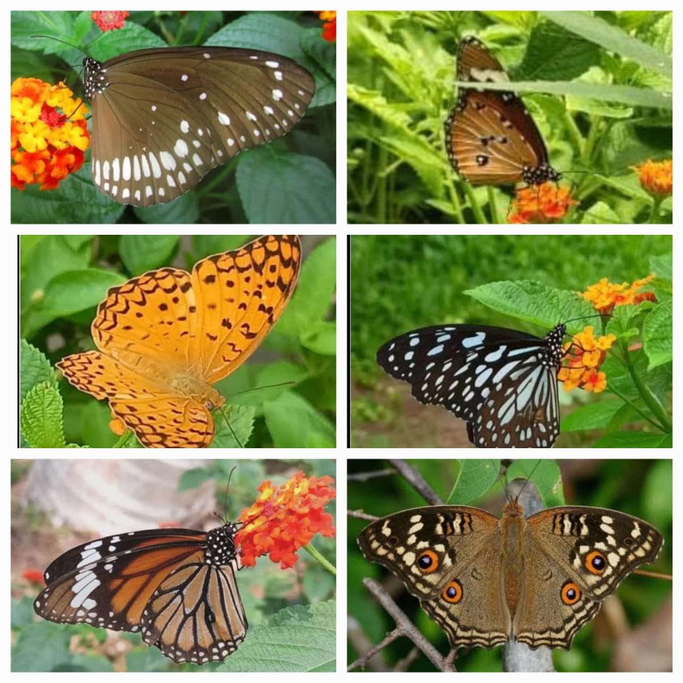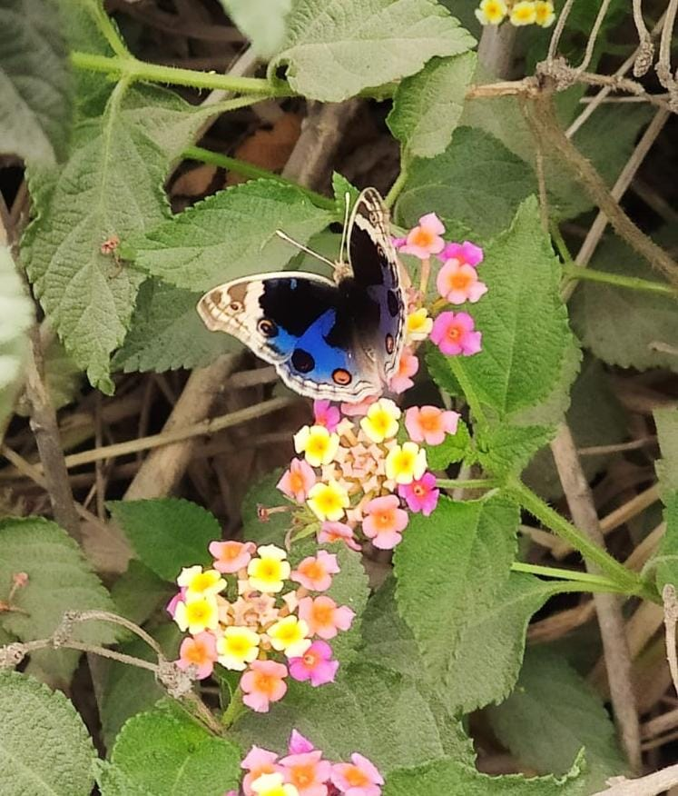

Fig-1: Microphotographs of Family: Nymphalidae (7 species): *Euploea core*, *Danaus chrysippus*, *Phalanta phalantha, Tirumala limniace*, *Danaus genutia*,  *Junonia lemonias*, *Junonia orithya*

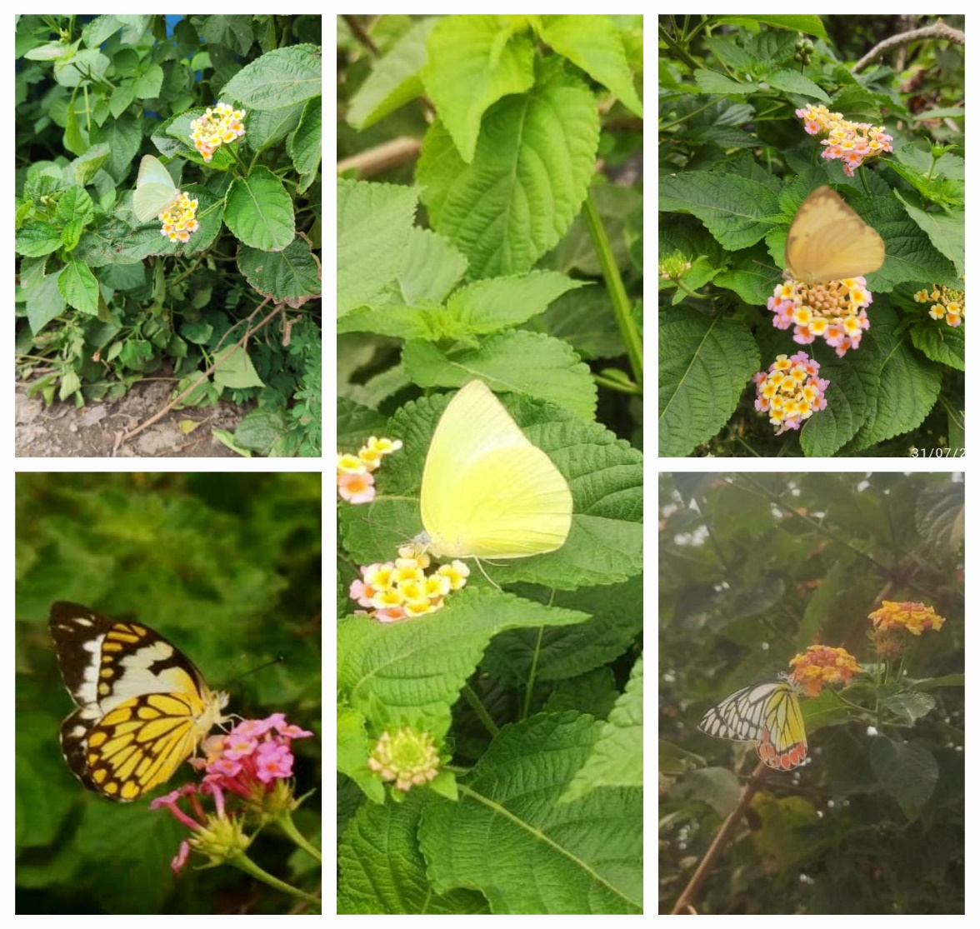

Fig -2 : Microphotographs of Family Pieridae (5 species): *Delias eucharis*, *Catopsilia pomona*, *Eurema hecabe*, *Belenois aurota*, *Catopsilia pyranthe*

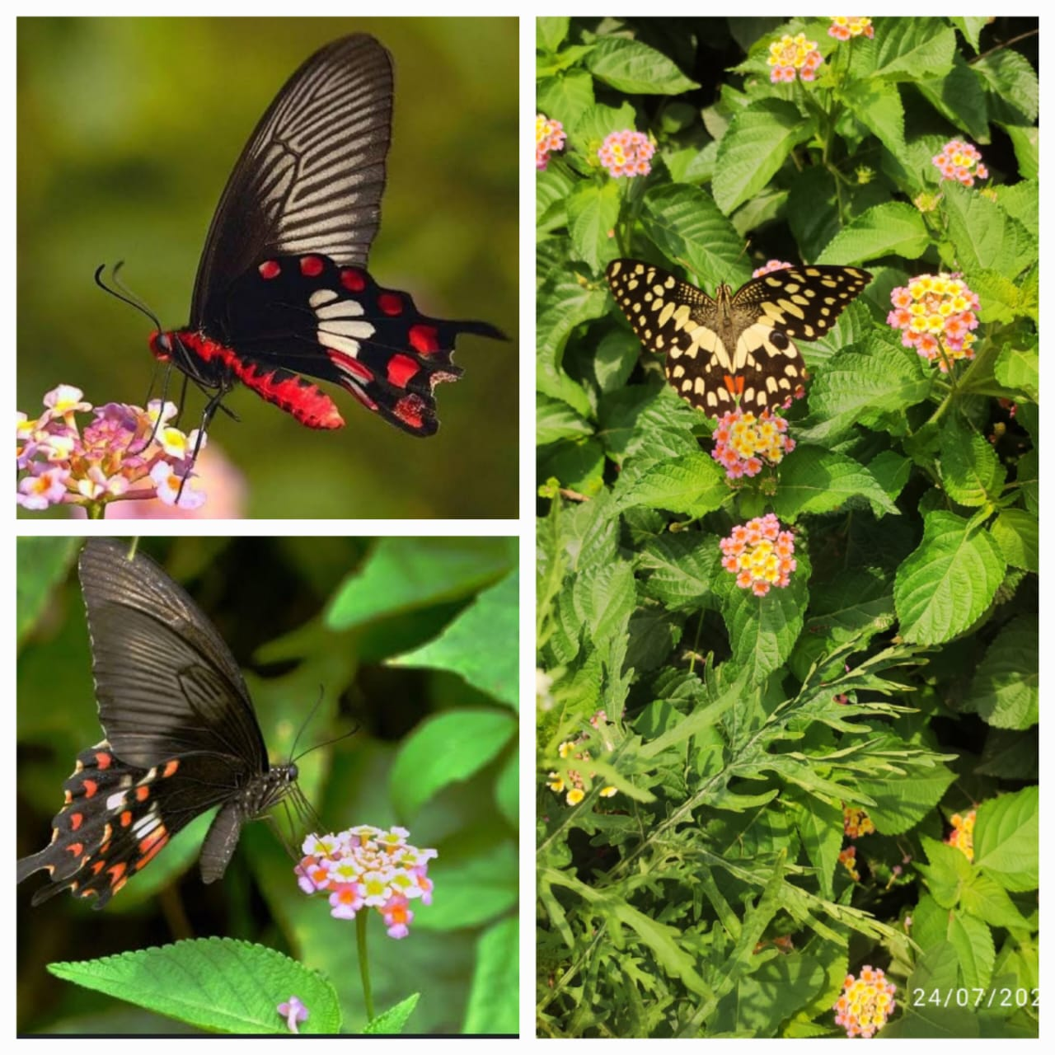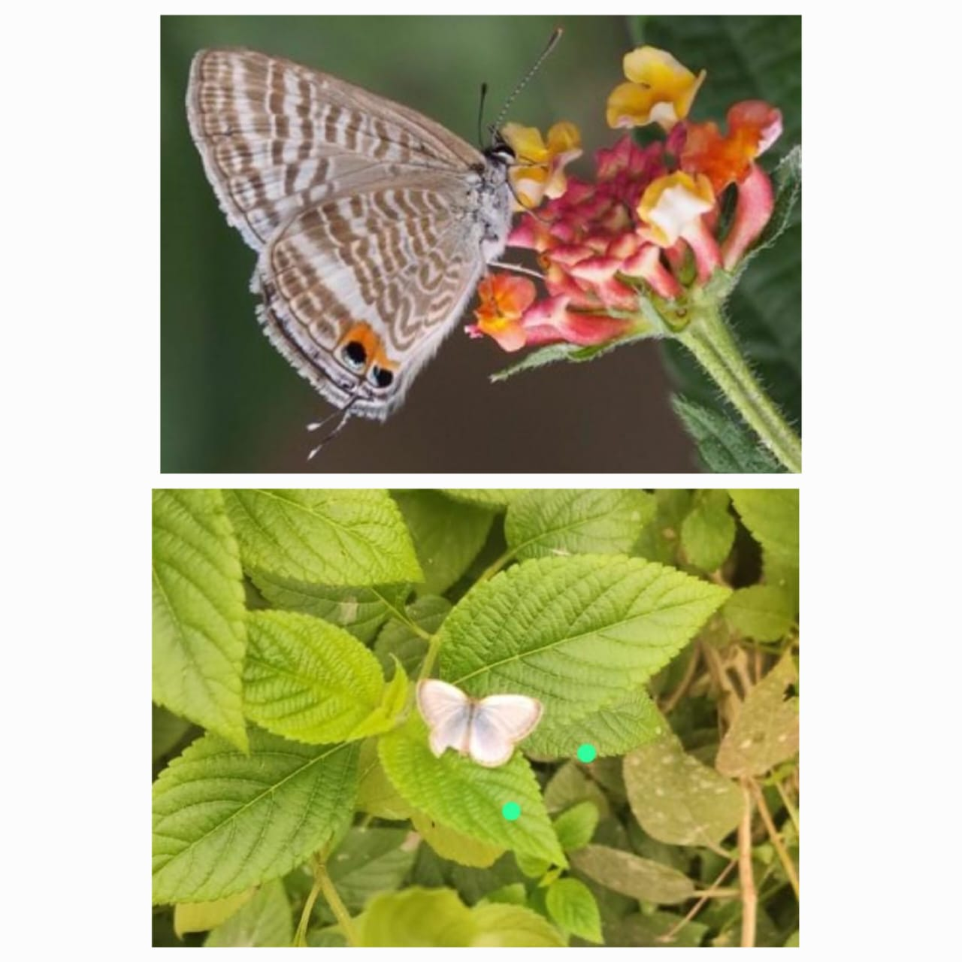

Fig -3 & 4 Microphotographs of Family Papilionidae (3 species): *Papilio polytes*, *Papilio demoleus*, *Pachliopta aristolochiae &* Lycaenidae (2 species): *Zizina otis*, *Lampides boeticus*

*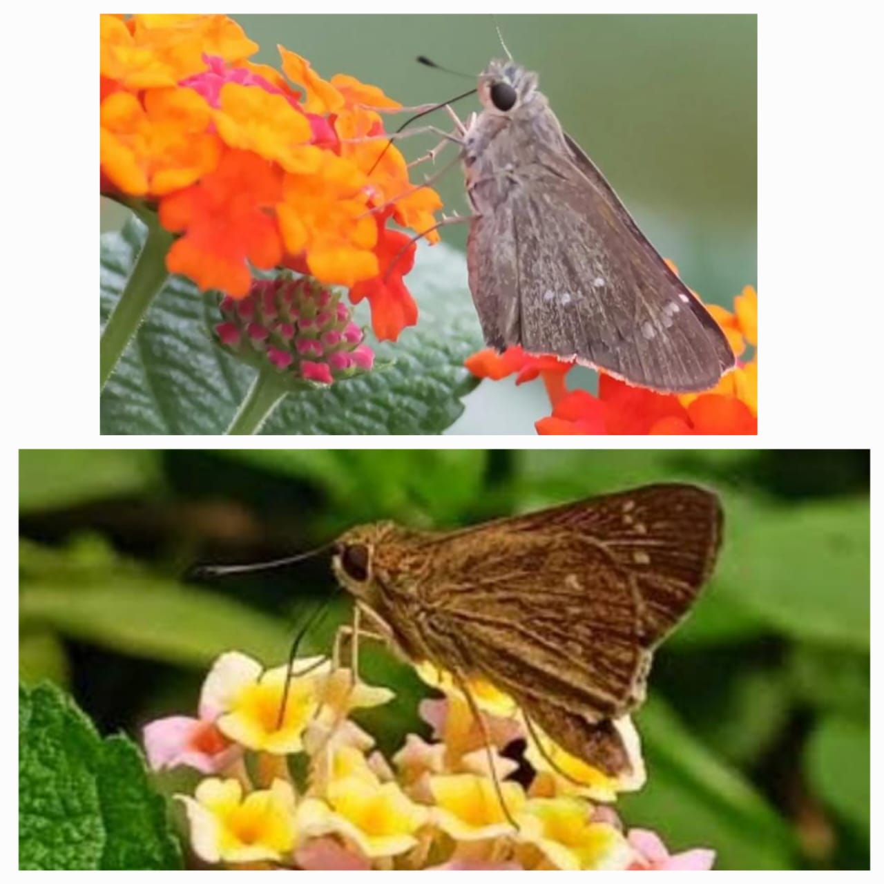*

Fig – 5: Microphotographs of Family Hesperiidae (2 species): *Pelopidas mathias*, *Suastus gremius*

References

1. Blair, R.B. & Launer, A.E. (1997). Butterfly diversity and human land use: species assemblages along an urban gradient. *Biological Conservation*, 80(1), 113-125.
2. Bonebrake, T.C., Ponisio, L.C., Boggs, C.L., & Ehrlich, P.R. (2010). “More than just indicators: A review of tropical butterfly ecology and conservation.” *Biological Conservation,* 143(8), 1831-1841.
3. Dogra, K.S., Sood, S.K., & Dobhal, P.K. (2010). “Alien plant invasion and their impact on biodiversity: A review.” *Journal of Ecology and the Natural Environment*, 2(9), 175-186.
4. Ehrlich PR, Raven PH. (1964). “Butterflies and Plants: A Study in Co evolution,” *Evolution*, 18(4), 586-608.
5. Ehrlich, P.R., & Hanski, I. (2004). On the Wings of Checkerspots: A Model System for Population Biology. Oxford University Press.
6. Gay Thomas, Kehimker Isaac, David, & Punetha Jagdish Chandra (1992). An, Common Butterflies of India, published FOR World Wide Fund, Oxford University press Bombay.
7. Groombridge B, (ed.) (1992). Global Biodiversity. Status of the Earth's Living Resources. A Report. London, Glasgow, New York, Tokyo, Melbourne, Madras: Chapman & Hall. Price £29.95 (hard covers). ISBN 0412 47240 6, 1992, 132.
8. Hila Segre, David Kleijn, Ignasi Bartomeus, Michiel F. WallisDeVries, Mark de Jong, Maarten Frank van der Schee, Jacinto Román, Thijs P.M. Fijen (2023). Butterflies are not a robust bioindicator for assessing pollinator communities, but floral resources offer a promising way forward, Ecological Indicators, Volume 154, 110842, ISSN 1470-160X, <https://doi.org/10.1016/j.ecolind.2023.110842>.
9. Kehimkar, I. (2008). The Book of Indian Butterflies. Bombay Natural History Society.
10. Kunte K. (2000). Butterflies of Peninsular India, Universities Press Limited Hyderabad India 254.
11. Kunte, K. (2010). Butterflies of India – A Comprehensive Field Guide. Indian Foundation for Butterflies.
12. Laurance, W.F & Bierregaard RO. (1997). Preface - A crisis in the making. In: Laurance W. F. and R. O Bierregaard (Eds.). Tropical forest remnants – ecology, management and conservation of fragmented communities. Chicago: Chicago University Press, 1997.
13. Magurran, A.E. (2004). Measuring Biological Diversity. Blackwell Publishing.
14. McKinney, M.L. (2002). Urbanization, Biodiversity and Conservation. *Bio Science,* *52(10),* 883-890.
15. McKinney, M.L. (2006). Urbanization as a major cause of biotic homogenization. *Biological Conservation*, 27(3), 247-260.
16. Mukherjee, S., Banerjee, S., Basu, P., Saha, G.. & Aditya, G. (2015). Lantana Camara and Butterfly Abundance in an Urban Landscape: Benefits for Conservation or Species Invasion?. *Ekológia (Bratislava)*, *34*(4), 2015. 309-328. <https://doi.org/10.1515/eko-2015-0029>
17. Pocewicz A, Morgan P, & Eigenbrode SD. (2009). Local and landscape effects on butterfly density in northern Idaho grasslands and forests. *Journal of Insect Conservation,* 13, 593601.
18. Pullin, A.S., (1997). Butterflies and Climate Change. Cambridge University Press.
19. Rana, S., & Joshi, M. (2007). Role of native vegetation in supporting butterfly diversity and survival in Himalayan ecosystems. Environmental Ecology and Conservation, 13(2), 101–108.
20. Sharma, G.P., Raghubanshi, A.S., & Singh, J.S. (2005). “Lantana invasion: An overview.” *Weed Biology and Management*, 5(4), 157-165.
21. Thomas, J.A., (2005). Monitoring change in the abundance and distribution of insects using butterflies and other indicator groups. Philosophical Transactions of the Royal Society B. 360:339-357.
22. Uniyal, V.P., and Mathur, R.K. (1998). Diversity of butterflies in the great Himalayan National park, Western Himalaya. *Indian Journal of Forestry*, 2(12), 150-155.
23. Vijayan, Suruliyandi & Sankarappan, Anbalagan. (2023). A current and annotated inventory of the faunal diversity found on the Anna University campus in Tamil Nadu, India. *International Journal of Agricultural and Applied Sciences*. 4. 128-134. 10.52804/ijaas2023.4217.