**BIODIVERSITY OF INTRAMURAL DUST MITES FROM OSMANABAD DISTRICT, MAHARASHTRA, INDIA**

UNDER PEER REVIEW

# ABSTRACT:

The Study investigated the mites fauna obtained from dust of poultry and houses located at osmanabad district (Maharashtra state). The impact of changes in environmental parameters like humidity, temperature and rainfall in three different seasons on the population of mites was studied. This study revealed 6 different species of mites are found which are *Dermatophagoides farinae Leiodinychus krameri, Prodinychus sp.(deutonymph,) Dermanyssus gallinae*, *and Urodiaspis tecta Dermatophagoides pteronyssinus.* The impact of changes in environmental parameters on these mites population in three different seasons of monsoon, summer and winter were recorded in the course of this study. It was observed that weather significantly impacts the prevalence of mites the dust of poultry and houses. Maximum numbers of mites were found during monsoon as compared to both winter and summer.

**Keywords:** Biodiversity**,** Dust Mites, Osmanabad , Intramural

## INTRODUCTION

Mites are arachnids belonging to the phylum arthropoda and are minute in size and are about 85% of animal kingdom. They are characterized by the presence of four pairs of legs, and are cosmopolitan in distribution. Mites are usually minute creatures of 0.6mm to 2.0mm in length,and are difficult to detect with unaided eyes.

Biodiversity is the crucial part of life on earth and is essential for the functioning ecosystem which describe the variety of life on earth. It is essential for the functioning of

ecosystem which provides us with products and services without which we couldn’t live. Biological diversity is a term used to describe the variety of life on earth. It refers to the wide variety of ecosystem and living organism: animals, plants, their habitats and their genes.We depend on it for our security and health, that affects our social relations and gives us freedom and choice.

UNDER PEER REVIEW

Dust is a fine, dry powder consisting of the earth tiny particles.They include dust in our homes, offices human and animal hairs, textile, fibres and human skin cells. The most common allergy causing mites that occur in homes HDM are correlated with the development of asthma and other allergic disorders (Arlian *et al,2002*). The pyroglyphidae mites are allergenic mites, but non pyroglyphidae mites such as stored grain mites, also have clinical importance (Van Hage Hamsten and Johansson ,1998)

Mites are closely related to insects, birds and to mammals and are easily distinguished from them by having one extra pair of legs in adults rather than having 3 pairs (Hughes, 1976). Hofesetter *et al*( 2013) had reported that about 50,0000- 1000000 species of mites exist on earth in which only 45000 species are named .All ecosystem which are present on this globe have there own kind of acari fauna.They are found in the hot desert of the Sahara to the arctic tundra , from cold bed of pacific ocean to our eyebrows hair follicle (Krantz and Alter,2009). They have been found in underneath stores in antartica and other temperate countries (Jogdand 2007).

Major research is carried out on easily visible and higher animals and plants.Comparatively, less attention has been given to microscopic animals such as mites which are less than 1 mm in size and are not visible to naked eyes. Mites play important role as a scavengers in the ecosystem for recycling forest litter and other organic matter in the detritus ecosystem. Hence, they act as a bioresource for the conservation and sustainable development of an ecosystem (Jogdand, 20007).Some ectoparasites such as mites and ticks transmit poultry diseases like fowl pox ,chlamydia and newcastle diseases ( Nnadi and George,2010).

Diversification in poultry mites disclosed the various habitats,predatory, deteritivorous and parasitic mites (Brady, 1970). Saviour infestation of mites in chickens leads to retard growth, low vitality, damaged plumage, reduction in egg production and sometimes causes death

( Bishopp, 1942).

1. **MATERIAL AND METHODS:**

**1 ) Survey of study area located in Omerga Taluka.**

1. **Preparation of glycerine jelly**
2. **Collection of Dust**: Dust collected from different places of the poultry farm. Dust collected from lower layer below surface level, from different corners and central part of poultry. And also from the houses located in district.
3. **Isolation of mites**: Sieving of dust performed in laboratory using mesh sieve in petri plate. Observation of petri plate was done using dissecting microscope, mites were picked up with the help of needle with its tip dipped in lactic acid.

## Slide Preparation:

Mites kept in cavity blocks containing lactic acid were left overnight. Lactic acid used for the killing, and clearing of mites which help in the dissolution of the cuticle causing them to be transparent.This was followed by addition of freshly melted glycerine jelly before mounting. The mites were then mounted on slides with ventral side facing upward. The total number of mites per gram of dust was determined, and the average number of mites per gram of dust was calculated. Permanent slides were prepared and observed under the binocular research microscope for identification.

## Ecological parameter

The temperature and humidity (max/min) were measured using a mini temperature humidity meter HD-303 on the sampling site. Total rainfall record of the sampling site was obtained from the mahavedh project ( https://maharani.maharashtra.gov.in)

Measurement calculated by image j software.

## 

## 3.RESULT AND DISCUSSION

## 

## The dust of poultry revealed urodiaspis , it has long pedipalp. Depression at the region of articulation of legs is found on the ventral surface. Grooves for the legs are well developed. Prodinchus species are also found in the poultry dust. It has long pedipalp . grooves of the legs well developed and rusty brown in colour. Leiodinychus krameri also found in a poultry dust. chelicerae usually extended. It has a cavity called camerostome. Dermanyssus gallinae is a poultry mite .it is important pest of chicken and show harmful effects on growth of birds. Has a long chelicerae. 2 mites species were found in house dust named as Dermatophagoides pteronyssinus body is small and oval ,broder in middle and narrow at both ends. Body has fine striation.The first pair of leg is directed forward. Dermatophagoides farinae is also a house dust mite. It is common in floor dust found by Jogdand S.B. in 1995. The body of female mite is large in size and globular in shape while male mite is small and globular.

## Table 1: Measurements of mites species

|  |  |  |  |  |  |  |
| --- | --- | --- | --- | --- | --- | --- |
| **Appendages** | | | **Legs**  µm | | | |
|  | **Species:** | **Length**  **µm** | **Width**  **µm** | **Gnathosoma**  **µm** | **Pedipalp**  **µm** | **Chelicerae**  **µm** | **I** | **II** | **III** | **IV** |
| 1 | ***Urodiaspis tecta*** | 1333 | 1011 | 235 | 234 | 230 | 520 | 408 | 480 | 404 |
| 2 | ***Prodinychus sp.***  UNDER PEER REVIEW  deutonymph | 1495 | 882 | 120 | 250 | 300 | 674 | 461 | 445 | 575 |
| 3 | ***Leiodinychus krameri*** | 648 | 449 | 80 | 100 | 120 | 155 | 196 | 189 | 180 |
| 4 | ***Dermanyssus gallinae*** | 1015 | 418 | 258 | 463 | 280 | 773 | 501 | 566 | 737 |
| 5 | ***Dermatophagoides pteronyssinus*** | 2463 | 1315 | 339 | 391 | 341 | 669 | 651 | 662 | 724 |
| 6 | ***Dermatophagoides*** *farinae* | 246 | 131 | 76 | 280 | 320 | 167 | 157 | 167 | 121 |

**Table 2: List of species found during study**

|  |  |  |  |  |  |  |
| --- | --- | --- | --- | --- | --- | --- |
| **Species** | **Locality of collection** | **Body shape** | **Colour** | **Legs** | **Chelicerae** | **Peculiar characteristics** |
| ***1.Urodiaspis tecta***  ***(*Urodiaspidae**) | Poultry farm  Omerga taluka | Globular | Dark reddish brown | Short,stout,&  Look curved | Extend into idiosoma | Gnathosoma & tritosternum enclosed in a cavity called Camerostome. It is reduced. |
| ***2 Prodinychus sp.***  **Deutonymph**  **(prodinychidae Berlese, 1917)** | Poultry  Kallam taluka | Oval &long | Brownish | Long extended | long | Depression of legs found on ventral surface & it is extended |
| ***3. Leiodinychus krameri***  **(Uropodidae Kramer , 1881**) | Poultry  Lohara  taluka | Globular | Dark yellowish | Long and curved.depression of legs on ventral side. | extended | Anterior ventral position of the body is excavated so that it is enclosed in a cavity called camerostome. |
| ***4. Dermanyssus gallinae***  ***(pyroglyphidae Cunliff, 1958)*** | Poultry  Tuljapur  taluka | Cylindrical oblong &broder at posterior end | Grey | Long &extend  forward | Long whip like | It is essential pest of birds.feed during night. During day found in the nests, cracks of roosts |
| ***5.Dermatophagoides pteronyssinus***  ***(*Pyroglyphidae Cunliffe, 1958 Sensu Fain ,1965)**  UNDER PEER REVIEW | House dust  Washi taluka | Small, oval ,broder in middle &narrow at both ends. | Brownish | 1st pair of leg directed forward.idiosoma bears 1st and 2nd & metapodosoma bears bears 3rd and 4th pair of legs. | Long | Body has fine striations, eyes are absent. |
| ***6.Dermatophagoides farinae***  (**Pyroglyphidae Cunliffe, 1958 Sensu Fain ,1965)** | House dust  Bhoom taluka | oval | brownish | All legs are equal in size.1st pair is directed forward  & 2 nd pair is directed backward |  | In male st pair of legs are thicker than  2nd |

**Graphs 1:**

UNDER PEER REVIEW

UNDER PEER REVIEW

**Graph 2:**

UNDER PEER REVIEW

.

## Figure. 1 Figure.2

UNDER PEER REVIEW

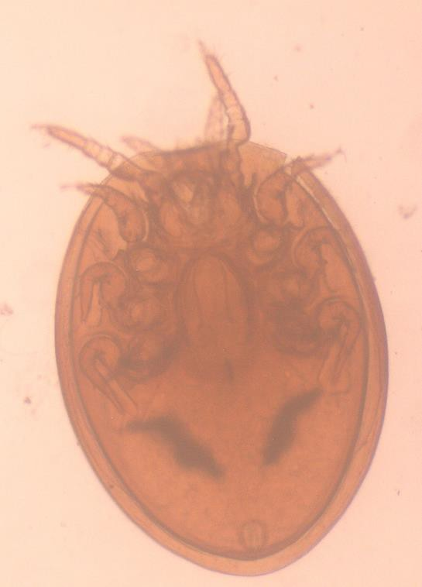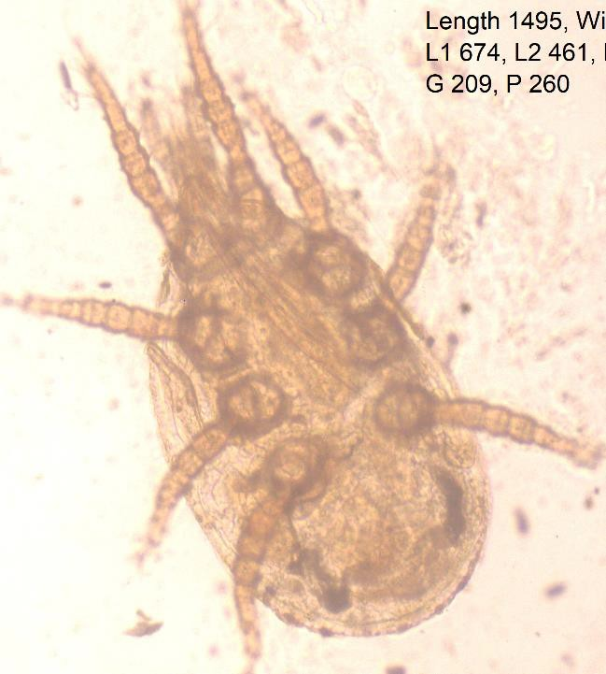

***Urodiaspis tecta Prodinychus sp. (Deutonymph)***

***Figure.3 (i) Figure. 3(ii)***

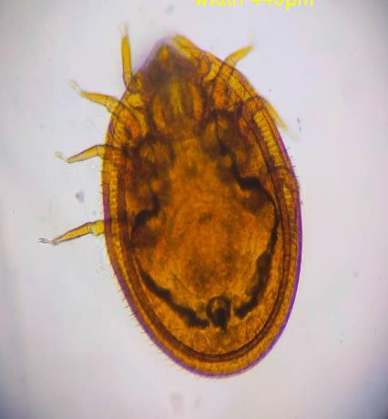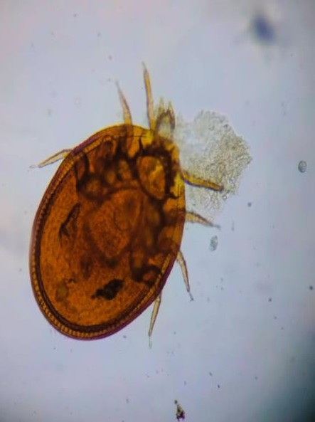

***Leiodinychus krameri Male Leiodinychus krameri Female***

## Figure. 3(iii ) Figure.4

UNDER PEER REVIEW

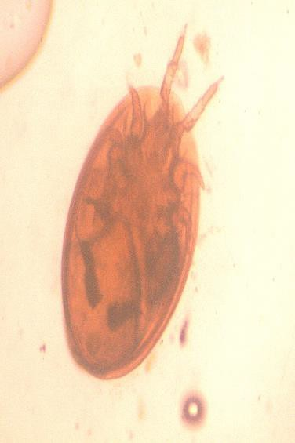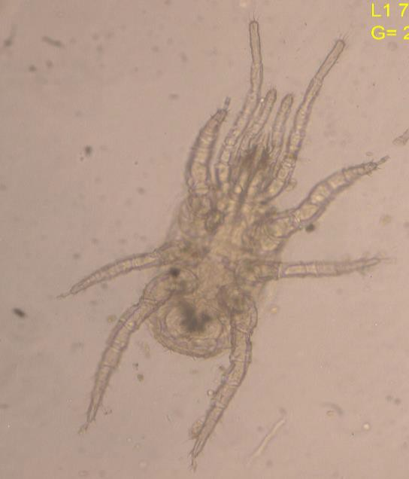

***Leiodinychus Krameri Dermanyssus gallinae Deutonymph***

***Figure.5***

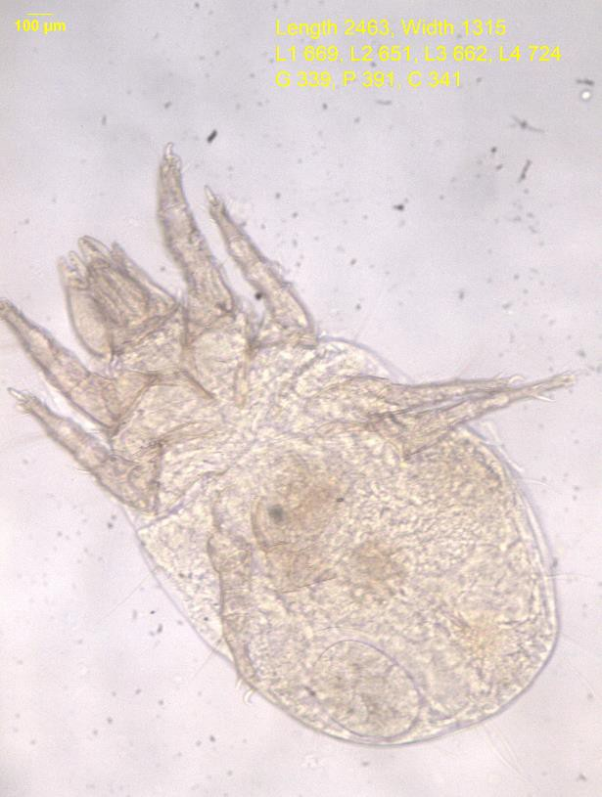

***Dermatophagoides pteronyssinus***

***Figure .6 Figure.7***

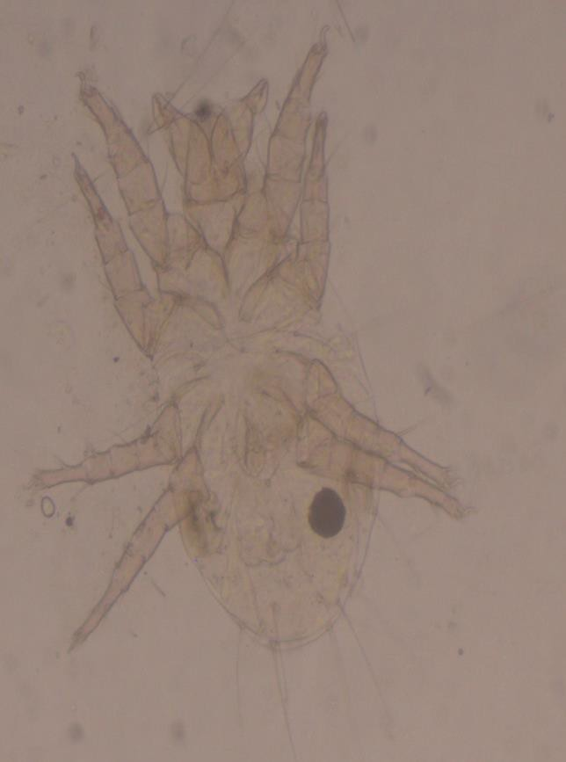

|  |  |
| --- | --- |
| ***C:\Users\owner\Desktop\New Resolution\Dermatophagoides farinae female.jpg*** |  |

***Dermatophagoides farinae female Dermatophagoides farinae male***

# 4.conclusion

# In present investigation 6 species of mites was observed in the poultry farms and house dust. Morphological identification revealed 6 mite species belonging to 5 families and 3 orders . The 6 species of mites recovered under 3 families from poultry litter and house dust are as follows:

# 1.*Dermatophagoides farinae,(*Family*:* Pyroglyphidae)

# *2. Dermatophagoides pteronyssinus,(*Family*:* Pyroglyphidae)

# *3.urodiaspis tecta,(*Family*:*

# *4.leiodinchus krameri,(*Family*:Uropodidae)*

# *5.Prodinchus sp.(*Family*:* prodinychidae)

# *6.Dermatophagoides gallinae* (Family: Pyroglyphidae)

It was found that suitable environmental condition is rainy season where relative humidity around 85% and temperature 24ºC .The number of mites progressively increase in rainy season per gram of dust from june to octomber.Number of species gets decrease in summer season due to higher temperature.

Disclaimer (Artificial intelligence)

Option 1:

Author(s) hereby declare that NO generative AI technologies such as Large Language Models (ChatGPT, COPILOT, etc.) and text-to-image generators have been used during the writing or editing of this manuscript.

Option 2:

Author(s) hereby declare that generative AI technologies such as Large Language Models, etc. have been used during the writing or editing of manuscripts. This explanation will include the name, version, model, and source of the generative AI technology and as well as all input prompts provided to the generative AI technology

Details of the AI usage are given below:

1.

2.

3.

**5.REFERENCES**

**Abdussalam M.(1939).** On a new feather mite *Rivultasia karmellahie5i* parasitic on Indian

domestic fowl (*Gallus hankiva*).Vet.J.95:39-42.

**Ancona.G.Asma(1923**). Epidemica da pediculoides Ventricosus Policlinico Sez Med

35:45-70.

**Arlian L.G. and et.al.** (1984) .Cross antigens and allergenic proportion of the HDM *D.*

*farinae* and the storage mite *Tyrophagus putrescentiae* Allergy Clin Immunol 74

pp*:*172-79.

**Axtell,R.C. and J.J Arends**.(1990) .Ecology and management of arthropod pests of poultry.

Annual review of Entomology.35:101-26.

**Bansod V.M. and Sunita N.Borde.(**2011). Diversity of Intramural (poultry) Dust Mites

from pune Journal of Association of Zoologist ,India ISSN 2229-6549 vol.4 (1) 18.

**Bornehag,C.G.(2004**). Indoor Air,International Journal of Indooir Envt and Health-

Vol.14,Issue 4: 243-57.

**Calloff, M.J. (1998**).Taxonomy and identification of dust mites.Allergy,53:712.

**Edward W. Baker, G.W.Wharton**(1952).An introduction to Acarology

**Jogdand S.B.(1996**).Extramural mites found in intramural ecosystem

,Res.J.PI.Environment,12:81-84.

**Keith R. Snow** (1970).The Arachnids an Introduction pub Routledge and kegan paul ltd.,

London.vol 1 pg- 1

**Kern (1921**) Dust sensitiation in bronchial asthma M.Clin.N.America 5:751-758.

**Hirst S.(1922** M)ites injuries to domestic animals. Trustees of British

Museum,London.1-168.

UNDER PEER REVIEW

**Spieksma F. et al.(1997).** Domestic mites from an Acarologic perspective Allergy 52:360-368.

**S.S Jadhav , L.S. Matkar(2020). S**tudy of Acari (Arthopoda: Arachnida) fauna from rodent

cages in pune, Maharashtra, India. P-ISSN 2349-5138 Vol.7

**Tilak and Jogdand (1989)**HDM Annals of allergy,63:392-397.

**Tilak S.T. and Jogdand S.B. (1989**) House Dust Mites Annals of Allergy 63:392-397

**Oudemans,H.C.(1906).**Tijd.V.Ent. 49:237.

**Vaishali Bansod (2011).** Biodiversity of dust mite Ezine Article (online)

**Voorhorst R.,and et.al. (1969**).Recent progress in the HDM problem Actta Allerrgol

(kbh) 24:115-23.

UNDER PEER REVIEW