***Review Article***

**First study of the improving egg productivity by an early selection of the Syrian local hens in the coastal region**

**ABSTRACT**

The aim of this research was to study the most important productivity traits of the Syrian costal local hens, this study was conducted in the Animal Production Research Center Fideo, Faculty of Agriculture, Lattakia Tishreen University. An early selection was apply on 1281 local hens eggs. So, two generations were selected during 150 days, the number of the first generation F1 hens were included 163 hens (F1), whereas the second generation F2 were included 169 (F2) to improvement egg production traits. The results of this research showed that the percentage of the egg shape index for the initial flock were 75.8 %. And the fertility of the initial flock record 89.8 and for F1 and F2 hens were recorded 88.7 and 88.2 % respectively, while the hatchability were 75, 82.65, 83.44 % respectively and the hatching rate were 65.54, 68.6, 69.3 % respectively. While for the average egg weight were 50.85, 50.26, 49.75 g respectively, egg number (quantity) were 14.61, 16.22, 17.39 egg/ month respectively. The selection efficiency was increase in the average egg production of the two selected generations by 5.84 eggs. And the percentage of egg production were 49, 54, 58% respectively, egg mass were 24.58, 27.02, 28.72 g/hen/day respectively, and the average of egg productivity were 0.49, 0.54, 0.58 egg/hen/day respectively. The feed conversion ratio recorded 4.6, 4.2, 3.9 (kg feed/kg egg) respectively. In addition, the eggshell color of the produced egg varied from white to light brown gradually. However, the average age of sexual maturity recorded 206, 202, 195 days respectively. These results showed that the selected hens of the two generations F1 and F2 were with superior than the initial flock.

**Keywords:** Local hen, Fertility, Hatchability, Hatching rate, Egg weight, Egg number, Feed conversion ratio (FCR), Sexual maturity age.

**1. INTRODUCTION**

The local hen is consider one of the genetic origins of the domesticated animals that are adapted to the environment and resistant to harsh environmental conditions and diseases. This domestic species has received scientific and research attention in many countries for decades with the aim of improving it and raising its production rates (1). Local hens are consider a means of reducing poverty in rural communities because their requirements for the labor and capital are low comparison to other animal production projects (2). In Kenya local hens contribute about 47 % of egg production (3,4) and in Malaysia it was 70 %, while in Bangladesh this percentage reached to 90 % respectively (5). Moreover, the characteristics of adaptation to environmental conditions and resistance to diseases have played a major role in pushing breeders to include it in breeding programs to preserve it through the genetic improvement works with the aim of raising and improving its production rates (6,7,8). In Syria, the local hens is spread throughout all Syrian regions and constitutes an animal species with diverse genotype and phenotype compositions, it has genetic compositions that give it excellent properties in disease resistance and adaptation to local environmental conditions. just like the local hens in many countries of the world (9). The nutrition of this hen depends mostly on the waste of rural household food and on what it picks up in the nature during its free scavenging. The eggs of local hens are a food item rich in protein and have a higher monetary value in cities compared to the eggs of hybrid hens raised in the intensive breeding conditions (10). However, this important Syrian domestic hens species has remained unknown and have not addressed it on any of the production researches in the coastal region in Syria, and not received sufficient attention to preserve them as a genetic resource that has existed for thousands of years. This reality has led to the genetic compositions of the local hens that are spread throughout all Syrian regions becoming a genetic mixture to a very large degree with the boundaries between birds specialized in production being lost. In addition to breeding of egg laying hens with meat hens and dual purpose hens with other phenotypes and colours and mixed in an unstudied percentage. While the most countries of the world have studied and preserved and improved their local hens species through genetic resource conservation and improvement programs, with the aim of preserving the genetic habitats.

**2. The Importance and Aims of Study**

The importance of this study that in view of the scarcity or absence the academic researches that related of studying of the eggs production indicators of the Syrian coastal local hens to apply selection programs to improving the indicators of these traits. Which has never studied before in the coastal region in Syria, and this led to not been able fully express their potential because neglected and excluded from scientific breeding and feeding methods and genetic improvement programs. This has led to the deterioration of all egg production indicators and the loss of the identity of this local hens species.This study was conducted as a first step in a research project for the genetic improvement of the Syrian coastal local hens at Lattakia Tishreen University. In cooperation with the Arab Center for the Studies of Arid Zones and Dry Lands (ACSAD), and conducted for the first time in this study by hosting the genetic improvement project for local hens at the Animal Production Research Center Fideo, affiliated with the Faculty of Agricultural Engineering at Lattakia Tishreen University. To study the eggs production indicators within an academic and applied genetic improvement program that meets the requirements of national scientific research in preserving and improving local genetic resources. The main aim of this study was to apply an early selection on the trait of egg number during 150 days, at the Syrian coastal local hens. To study the indicator of the egg shape index, percentage of the fertility %, the hatchability %, the hatching rate (chicks hatchability) %, age of the sexual maturity, the egg weight, the egg number (quantity), the egg mass, the egg productivity, the feed conversion ratio (FCR), the eggshell colour. To provide data on egg production indicators that express its potential and production characteristics, as a step towards establishing a long term program for the care and genetic improvement of these indicators. Because their genetic compositions are highly mixed and have not been subjected to any type of genetic improvement, this will form the basis for starting to collect the largest amount of genes responsible for egg production in individuals that will form a specialized nucleus for egg production in the future.

**3. The Study Site**

This study was conducted in the coastal region located on the southeast of Lattakia Governorate, Syria, 35°35′N 36°01′E. And the altitude ranges from 1000 to 1100 m above sea level as shown in (Fig. 1), in the Animal Production Research Center Fideo, Faculty of Agriculture, Lattakia Tishreen University as shown in (Fig. 2), in cooperation with the Arab Center for the Studies of Arid Zones and Dry Lands (ACSAD), during the period of 2007 to 2011. When the climatic conditions of the temperature ranged between +15°C and + 32°C, and the relative humidity ranged between 66 to 80%.

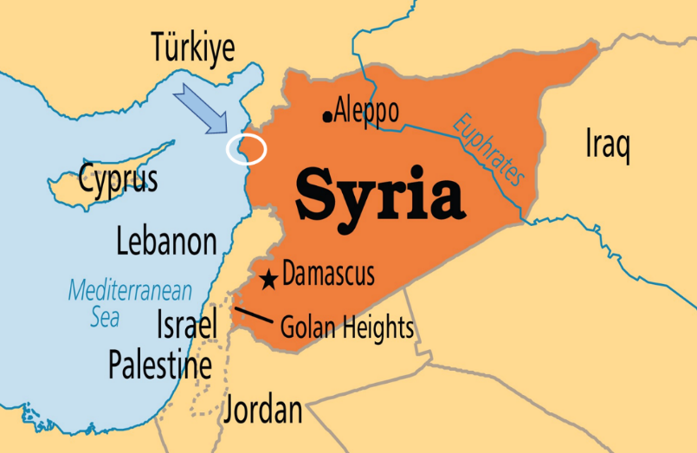

Fig. 1. The location of the study area in the coastal region in Lattakia Syria

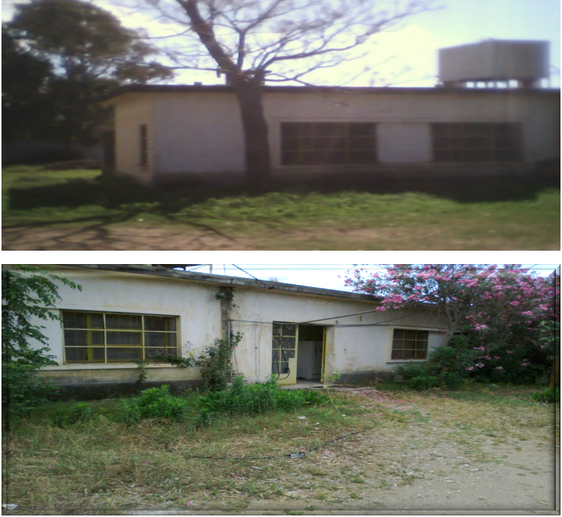

Fig. 2. The animal droduction research center Fideo at the coastal region in Latakia Syria

**4. Egg collection**

In February 2007, repeated field visits were conducted in several coastal villages in Latakia Governorate following areas: Al-Qanjarah, Fideo, Khirbet Al-Jawziyya, Hmeymim, Al-Qalou, Al- Berjane, Hareissoun, Arab Al-Mulk, Al-Zahraa Rouaimiye. To identify local chicken breeders households per village and agree with them on collecting local fresh eggs. The research included 1281 eggs, 865 eggs were selected for incubate them from the total number of the collected eggs as shown in (Fig. 3), and the percentage of the eggs that suitable for hatching were 67.53 %.

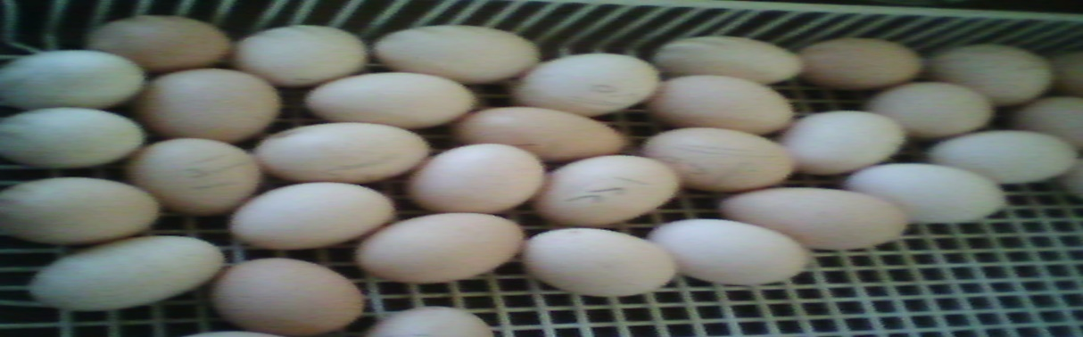

Fig. 3. The Syrian coastal local hens eggs were collected from several coastal villages for the research

**5. Egg storage**

The fresh eggs were stored successively in the refrigerators of the research centre before placing them in the incubator at the average of the temperature between 6 to 9°C and the humidity percentage between 75 to 80 %, for 5-7 days (11).

**6. Selection of hatching eggs**

Hatching eggs selected depending on the intact shells and oval shape. Then cleaned with dry cloths, and if necessary with wet cloths without damaging the cuticle layer, and each egg were numbered and each egg weights were measured by using a digital scale with an accuracy of 0.1 grams for each egg. The average weights of the collected eggs ranged between a minimum of 40.74 g, and a maximum of 67.6 g, meaning that the difference between the minimum and maximum values ​​reached to 26.86 g (9). Therefore this is a big difference, when compared to the differences of the average egg weight of the international and hybrid strains laying hens that ranged from 4 to 5 g (12). This difference in the egg weight can reducing by applying selection and genetic improvement of egg weight trait and improving care conditions, so, the selected average egg weight for the study sample was 50.2 g (9) as shown in (Fig. 4)

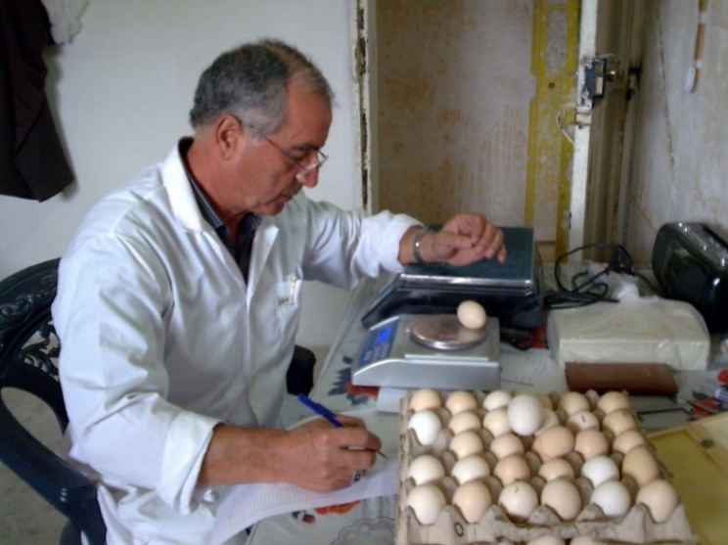

Fig. 4. Selection of hatching eggs

**7. The Egg shape index**

Egg length and breadth were measured using a vernier caliper to measure both the minor and major diameters of each egg, and calculate the shape index as shown in (Fig. 5) according to the following formula:

|  |  |  |
| --- | --- | --- |
| 100× | Minor diameter (Breadth) | The egg shape index = |
| Major diameter (Length) |

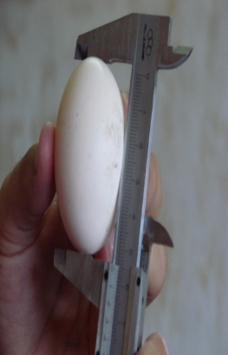

Fig. 5. Measure the egg shape index by vernier caliper

The shape index of the studied Syrian coastal local hens eggs was 75.8 % for the initial flock (9), and this shape index were within the acceptable range for laying hens egg index 73-80 % and for the broiler egg index 76 - 80 (11,13).

**10. Birds and Housing**

During the period from 2009 to 2011 was applied the early selection of egg production over a period of five months, from the start of the egg laying cycle on the roosters and the hens from the initial flock to study its egg production indicators. Which selected based on phynotically and productively. Then early selection applied on the initial flock to obtain the first generation F1 hens. To obtain the second generation F2 hens, the F1 hens were subjected to an early selection program, and selected all hens eggs laying rate were 50 % or higher over a five month period were selected. Mating nests were formed, with the selected F1 hens distributed among the nests at a rate of 6 to 8 hens per rooster, after one month of the mating nests were formed collected the hatching eggs for produce the F2 hens to study the differences of the productivity traits between the F1 and F2 generations. The total number of the first generation F1 were 163 one hundred sixty three birds while the second generation F2 were 169 one hundred sixty nine birds of the Syrian coastal local hens. The research hens belong to the three lines derived phenotype from the initial flock based on colour (Brown, Black, Grey striped) and based on the productivity which the percentage of eggs production exceeding 50 % as shown in (Fig. 6,7,8).

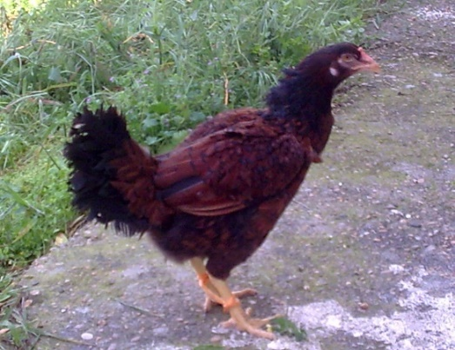

Fig. 6. The Brown pattern of the Syrian local hen

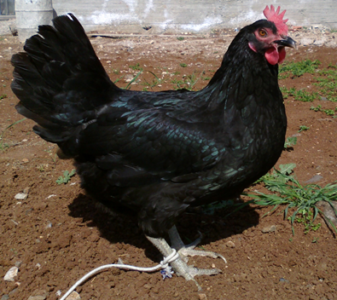

Fig. 7. The black pattern of the Syrian local hen

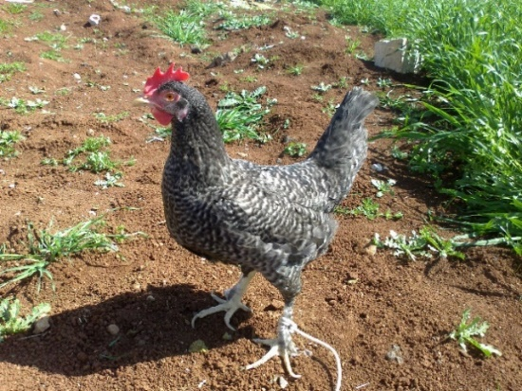

Fig. 8. The Gray striped pattern of the Syrian local hen

The hens house follows a semi enclosed care system with open natural aeration through windows. The photoperiod program was provided (light 12: dark 12) then increased to 14 hours in the fifth month of production. Every bird distributed in individual numbered battery cages with size (60 x 60 x 60 cm) to records of individual the production during the five month of production, the cages provided with the equipped of the feeders and drinkers as shown in (Fig. 9)

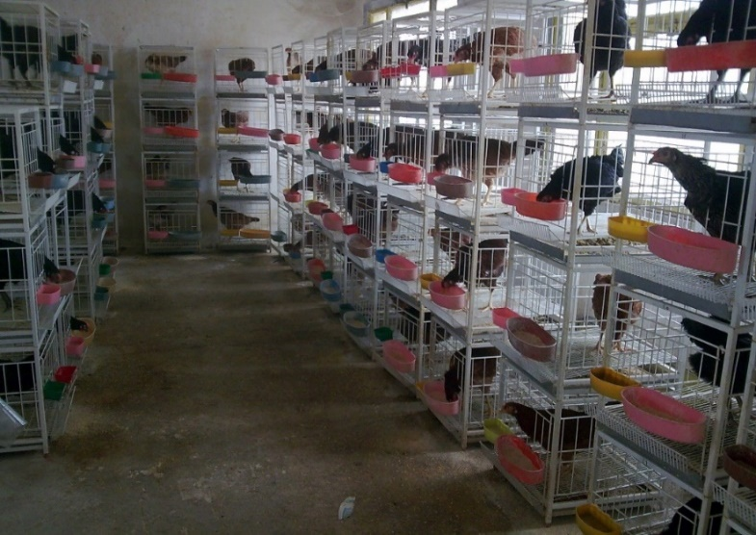

Fig. 9. The Syrian local hens in the individual numbered battery cages

**8. The Incubation Environment**

Automatic incubator made in Latakia, Syria, was calibrated using a digital standard thermometer and hygrometer before incubation, and both of the temperature (°C) and relative humidity (RH%) of the incubation was maintained as the following:

From the 1th day to the 18th day 37.7 °C and 55% productivity, and from the 19th to the 21th day 37 °C and 70 % productivity. While for the eggs turning, from the 1th day to the 19th day turned once every two hours, then stooped turning from the 19th day to the 21th day as shown in (Fig. 10) (14).

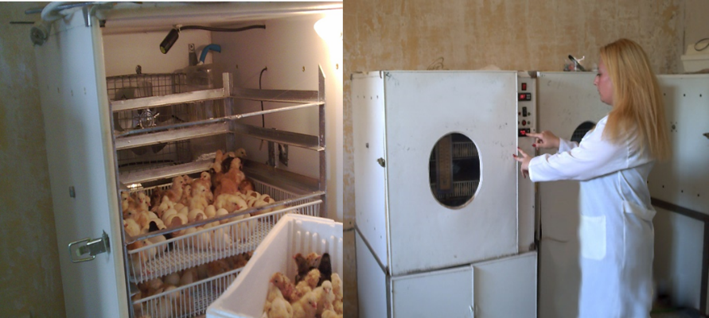

Fig. 10 Automatic egg incubator

**9. The Candling Incubated Eggs**

Eggs were candled at different stages of the embryonic development during the incubation period on the days 7, 11 and 19, by hand made egg candlingdevice as shown in (Fig. 11). The first light candling checking on the 7th day, was conducted to determine whether the eggs fertile or non-fertile and to check the growth and development of the live embryos as shown in (Fig. 12). And the second light examination was conducted on the 11th day to check the normal growth and development of the embryos as shown in (Fig. 13). While the third examination made on the 19th day to check the embryos mortality and evaluated the live embryos development as shown in (Fig. 14) (15).



Fig. 11. Egg candling device

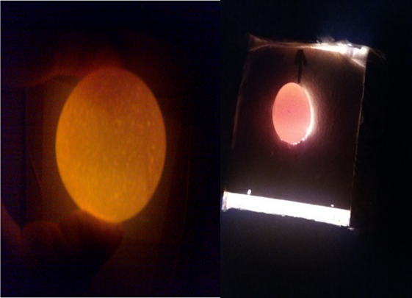

Fig. 12. Non-fertile egg on the 7th day during the incubation period

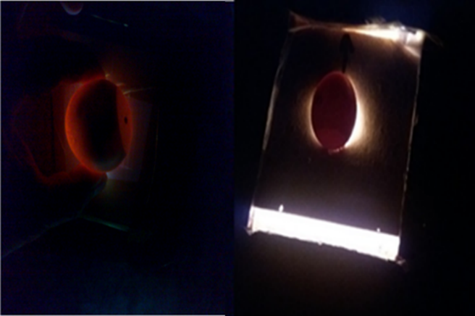

Fig. 13. Normal growth and development of the embryo on the 11th day during the incubation period



Fig. 14. Embryo mortality on the 19th day during the incubation period

**11. The Studied traits**

This research studies the following indicators:

**11. 1. Fertility Percentage**

Egg fertility depends on many factors as the physiological condition, health status, age if the birds, the ratio of roosters to hens, feeding and rearing conditions of the flock and the genetic factors (11). The percentage of the fertility (%) was determined as the ratio of the total fertile eggs number divided by the total incubated eggs number and calculated by the following formula:

|  |  |  |
| --- | --- | --- |
| ×100 | Total fertile Eggs number | fertility %= |
| Total incubated eggs number |

Figure 15. shows results of the percentage of the fertility of the initial flock were 89.8 % (9) and for F1 and F2 hens were recorded 88.7 % and 88.2 % respectively (16). These results showed that the initial flock hens were with outperformed than the selected hens of the two generations F1 and F2 the by 1.1 % and 1.6 % respectively, because the fertility at F1 and F2 hens decreased than the value of the initial flock. Moreover, as mentioned above, the egg fertility depends on many factors as the physiological condition, health status, feeding and rearing conditions of the flock and the genetic factors (11).

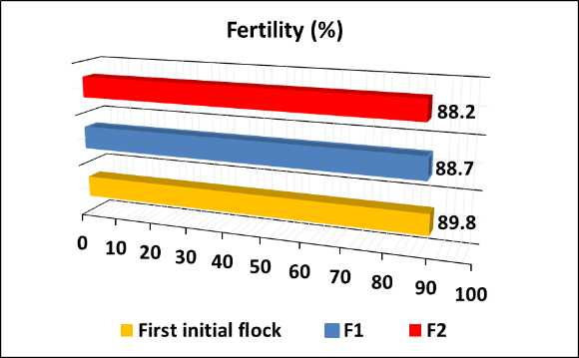

Fig.15. The percentage of the fertility (%) of the initial flock and the F1 and F2 generation of the Syrian coastal local hen

In general, the required values ​​for this indicator range between 95 % and 97 % (17). The Syrian coastal local hens was not far from the breed Cornish in this indicator (9), but rather showed outperformed of many local breeds in South Asia Black Bengal 86 %, Desi 81 %, Naked neck 80 % (15). And all local breeds in Ethiopia Melata 60 %, Kei 57 %, Tukur 56 %, Netch 56 %, Gebsima 53 % (18).

**11. 2. Hatchability Percentage**

The percentage of the hatchability (%) or the hatchability of fertile eggs was determined as the ratio of the hatched eggs number divided by the total fertile eggs number and calculated by the following formula:

|  |  |  |
| --- | --- | --- |
| ×100 | Hatched Eggs Number | hatchability % = |
| Total fertile eggs number |

Figure 16. shows results of the hatchability of the initial flock record 75 % (9) and for F1 and F2 hens were recorded 82.65 % and 83.44 % respectively (16). These results showed that the selected hens of the two generations F1 and F2 were with outperformed on the initial flock by 7.65 % and 8.44 % respectively.

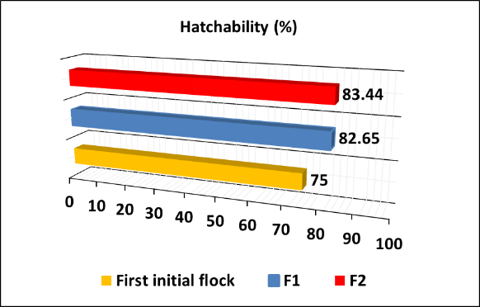

Fig.16. The percentage of the hatchability (%) of the initial flock and the F1 and F2 generation of the Syrian coastal local hens

From the above results, the hatchability at F1 and F2 increased on the value of the initial flock. And it was not far from the global average hatchability rate witch reach to 95 % for egg laying hens and 93 % for broiler (13). And the Syrian coastal hens outperformed on the local hens in the Republic of Mali 60-70% (19). And on the local hens breeds in South Asia as Black Bengal 68 %, Kadak anath 61 %, Naked neck 61 %, Desi 55 %, Aseel 45 % (15), and on all the studied breeds in Ethiopia local hens as Kei 44 %, Tukur 42 %, Melata 42 %, Gebsima 39 %, Netch 39 % (18).

**11. 3. Hatching Rate**

The Hatching Rate (chicks hatchability) (%) was determined as the ratio of the hatching chicks number divided by the total incubated eggs number and calculated by the following formula:

|  |  |  |
| --- | --- | --- |
| ×100 | Hatched Chicks Number | Hatching Rate % = |
| Total incubated Eggs Number |

The hatching rate actually translates the results of the incubation process, this percentage is generally lower than the hatchability. Figure 17. shows results ofthe hatchability rate at the initial flock record 65.54 % (9), and for F1 and F2 hens were recorded 68.6 % and 69.3 % respectively (16). These results showed that the selected hens of the two generations F1 and F2 were with outperformed on the initial flock by 3.06 % and 3.76 % respectively. From the above results, the hatching rate at F1 and F2 increased on the value of the initial flock.

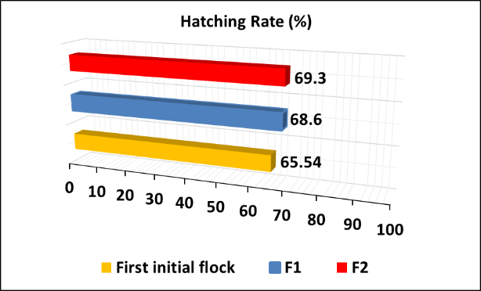

Fig.17. The percentage of the hatchability rate (%) of the initial flock and the F1 and F2 generation of the Syrian coastal local hens

This study results come lower than the global average required rates for this indicator in egg breeds 82 % and meat breeds 78 % (13), and it was much less than the minimum required for laying hens 78 % and equal to the minimum required for broiler hens 65 % (17). In the Leghorn breed this percentage reached to 80 % (13), and as for the Cornish meat breed it was 75 %. And from the previous results for the hatchability percentage were 75 % and the hatching rate 65.54 % of the initial flock of the Syrian coastal hens, showed that they were modest compared to the global required rates (9), Because the heritability were low of these traits h2 = 3 – 20 % (13,17). This means that the role of environmental factors influencing the variation in these traits is very significant. Therefore, improving breeding conditions will certainly lead to an increase in these two indicators. This was confirmed by this research results of this study on the first and second generations, as a result of an early selection works on Syrian coastal local hens (16).

**11. 4. Egg Weight**

The average egg weight was calculated three times a month, to calculate the monthly average of an egg weight of the initial flock, and the F1 and the F2 hens eggs for 150 day as shown in (Fig. 18).

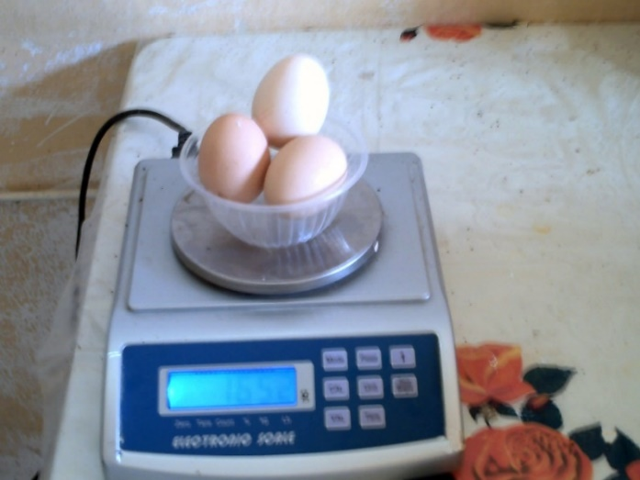

Fig. 18. The average egg weight

Table 1. shows the average egg weight during the study period for the initial flock hens were 50.85 g (20) and for the F1 and F2 50.26 g, 49.75 g respectively (16,21). These results showed that the initial flock hens were with outperformed than the selected hens of the two generations F1 and F2 the by 0.59 g and 1.1 g respectively. And the average egg weight of the F2 hens decreased by 0.51 g from the egg weight of the F1 hens, and this is a normal relationship between the weight and the number of eggs in the flock as a whole (16,21).

Table 1. The monthly averages of egg weight (g) of the initial flock and the F1 and F2 generation of the Syrian coastal local hens

|  |  |  |  |  |  |  |
| --- | --- | --- | --- | --- | --- | --- |
| **Monthly averages of egg** weight (g) | | | | | | |
| Average | 5 | 4 | 3 | 2 | 1 | Month |
| 50.85 | 54.13 | 53.12 | 51.33 | 49.47 | 46.2 | Initial Flock |
| 50.26 | 53.13 | 52.53 | 51.21 | 48.64 | 45.79 | F1 |
| 49.75 | 52.85 | 51.91 | 50.86 | 48.11 | 45.02 | F2 |

It is known that a hen lays a small sized eggs at the beginning of laying egg period, and this increases with age, and egg weight becomes similar in the second and third years of age, but it surpasses the others in the first year of production in about 3 to 4 g (17). In addition, the flock as a whole reduces an egg weight with the increase of eggs number (12). However, the egg mass which expresses both number and weight of the egg F2 superior to the initial flock hens and on the F1 hens (16). The average weight of research hens eggs was low compared to some international and hybrid strains, it was 60 - 62 g for white Leghorn, and 62 g for hybrid white Hisex, and 60 g for Rod Island meat breed, 58 - 60 g for white Plymouth Rock dual purpose (14). It noticed that the value of this indicator for the local Syrian hens higher compared to the average of local Egyptian strain Alfayoumi 45.9 g (22), and Al- Mamoura and the Silver Muntazah 48.37 g (23). In addition, the research hens outperformed concerning the average of egg weight the Tanzanian local strains as Kuchi 45 g and Medium 42 g (24). Nevertheless, lower than the Nigerian local hens 56.36 g (25). The genetic factors play an important role in the observed variations in this characteristic, the heritability h2 ranges between 0.5 and 0.7 which means that the role of environmental factors in these variations is between 0.3 and 0.5 (13). For that, can confirmed that the implementation of serious and continuous selection programs will achieve certain successes for Syrian local chickens in raising their average egg weight (16).

**11. 5. Egg Number (Quantity):**

The number of the produced eggs calculated monthly for the whole period, for every individual bird, and for the whole flock from the production records of the individual numbered cages (batteries) during the first five month as shown in (Fig. 19).

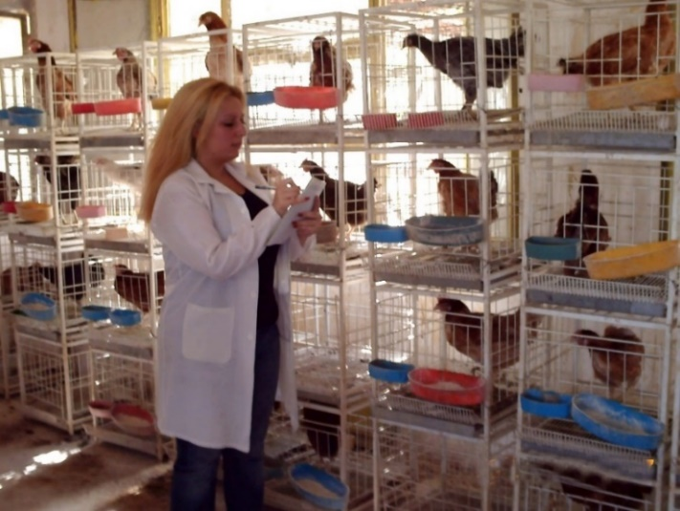

Fig. 19. Egg number (quantity)

Table 2. shows the total number eggs during 150 days were 73.04 eggs for the initial flock (20), and for F1 hens 81.1 eggs and for F2 hens 86.94 eggs (16,21,26). And the monthly average of the number eggs were 14.61, 16.22, 17.39 eggs respectively (20,16,21,26). These results showed that the selected hens of the two generations F1 and F2 were with outperformed on the initial flock by 8.06 egg and 13.9 egg respectively for the whole period 150 day. While for the monthly average by 1.61 egg and 2.78 egg respectively. And the selected F2 hens outperformed superior on the F1 hens by 5.84 eggs during 150 day and 1.17 egg monthly average. From the above results, the number eggs at F1 and F2 increased on the value of the initial flock. The selection efficiency was 3,89 egg/year of the two selected generations (16,21,26).

Table 2. The monthly averages of egg number (quantity) (egg) of the initial flock and the F1 and F2 generation of the Syrian coastal local hens

|  |  |  |  |  |  |  |  |
| --- | --- | --- | --- | --- | --- | --- | --- |
| **Monthly averages of egg number (quantity) (Egg)** | | | | | | | |
| Average | | Total | 5 | 4 | 3 | 2 | 1 | Month |
| 14.61 | | 73.04 | 10.77 | 12.62 | 15.51 | 18.53 | 15.61 | Initial Flock |
| 16.22 | | 81.1 | 13.06 | 13.79 | 17.25 | 19.95 | 17.05 | F1 |
| 17.39 | | 86.94 | 13.95 | 15.63 | 19.03 | 21.04 | 17.29 | F2 |

Improved international egg breeds such as the white Leghorn lay between 280 to 300 eggs (13), while the dual purpose breeds as Plymouth Rock lay between 180 to 200 eggs, but the meat production strains Rod Island breed lay less rates of eggs from 200 to 220 eggs (27). And compared with the Egyptian local hens, it was noticed that the egg amount of the Syrian coastal local hens was less than the average of two Egyptian local strains, which were Al- Mamoura and the Silver Muntazah whose average production was 89.9 eggs during 5 months, and monthly average of 17.99 eggs (23). Also shows less monthly eggs amounts comparison with the Nigerian local hens 20.2 eggs (25).

**11. 6. Egg production percentage (%)**

This indicator, shows the average eggs production as percentage and calculated by the following formula:

|  |  |  |
| --- | --- | --- |
| × 100 | Average of hen production during a period | The egg production = |
| Days of the period |

Figure 20. shows results of the percentage of the egg production for the Syrian coastal local hens for the initial flock was 49 % (20) and for F1 54 % and for F2 58 % respectively (16,26). These results showed that the selected hens of the two generations F1 and F2 were with outperformed on the initial flock by 5 % and 9 % respectively. From the above results, the percentage of the egg production at F1 and F2 increased on the value of the initial flock.

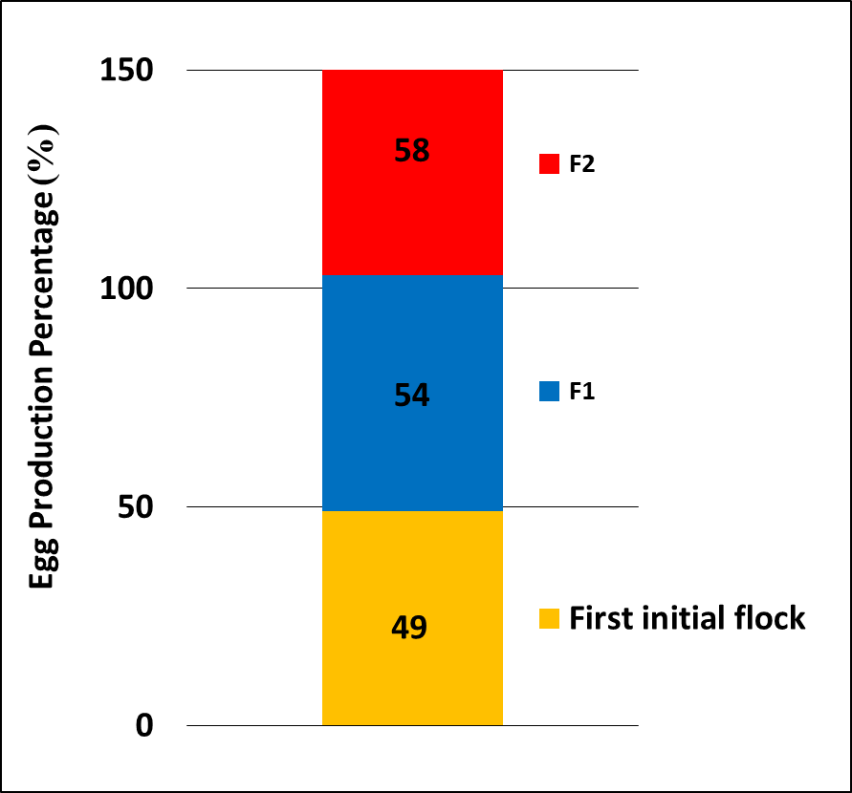

Fig.20. The percentage of the egg production (%) of the initial flock and the F1 and F2 generation of the Syrian coastal local hens

The Syrian coastal local hens percentage of the egg production was less than the percentage average of the Saudi local poultry 61.64 % (28), and more compared to the percentage average of the Egyptian local strain Al-Salam which recorded 53.85 % (29).

**11. 7. Egg Mass**

The egg mass increases to reach its maximum peak within 8 to 12 weeks of the production period, then begins to decrease gradually as the hens get older (23). This indicator refers to the number of the grams of the eggs that produced by a hen per day, and expressed as a mean g/hen/day (13). Egg mass and weight were used to calculating this indicator by the following formula:

|  |  |  |
| --- | --- | --- |
|  | Average of egg weight during a period × Average of produced eggs number | The egg mass = |
| Days of the period |

Table 3. shows the average that the average of eggs mass of the initial flock was 24.58 g/hen/day (20) and for F1 27.02 g/hen/day and for F2 28.72 g/hen/day (16). These results showed that the selected hens of the two generations F1 and F2 were with outperformed on the initial flock by 2.44 g/hen/day and 4.14 g/hen/day respectively. From the above results, the eggs mass at F1 and F2 increased on the value of the initial flock.

Table 3. The monthly averages of egg mass (g/hen/day) of the initial flock and the F1 and F2 generation of the Syrian coastal local hens

|  |  |  |  |  |  |  |
| --- | --- | --- | --- | --- | --- | --- |
| Monthly averages of egg mass (g/hen/day) | | | | | | |
| Average | 5 | 4 | 3 | 2 | 1 | Month |
| 24.58 | 19.43 | 22.35 | 26.54 | 30.56 | 24.04 | Initial Flock |
| 27.02 | 23.13 | 24.15 | 29.45 | 32.35 | 26.02 | F1 |
| 28.72 | 24.58 | 27.05 | 32.26 | 33.74 | 25.95 | F2 |

When compared the egg mas of the Egyptian local strain Al- Salam witch was 26.77 g/hen/day with this study, it were noised that the egg mass of the Syrian local initial flock hens were less than the Al-Salam hens. In contrast, the F1 and the F2 selected hens of the Syrian hens of surpassed on the Egyptian local strain Al-Salam (29). Also Syrian local hens shows less egg mass than the average of two local strains Al- Mamoura and the Silver Muntazah 31.01 g/hen/day (23), and it was less than for the SIRO-CB hybrid in which the average was 52.4 g/hen/day (30).

**11. 8. Egg Productivity**

The egg productivity indicator express the daily productivity of eggs per hen egg/hen/day and this indicator calculating by the following formula:

|  |  |  |
| --- | --- | --- |
|  | Average of produced eggs during a period | The egg Productivity = |
| Days of the period |

Table 4. shows the average of egg productivity was 0.49 egg/hen/day for the initial flock (20) and for the F1 and the F2 were 0.54 and 0,58 egg/hen/day respectively (16,26). These results showed that the selected hens of the two generations F1 and F2 were with outperformed on the initial flock by 0.05 egg/hen/day and 0.09 egg/hen/day respectively. From the above results, the egg productivity at F1 and F2 increased on the value of the initial flock.

Table 4. The monthly averages of egg productivity (egg/hen/day) of the initial flock and the F1 and F2 generation of the Syrian coastal local hens

|  |  |  |  |  |  |  |
| --- | --- | --- | --- | --- | --- | --- |
| Monthly averages of egg production (egg/hen/day) | | | | | | |
| Average | 5 | 4 | 3 | 2 | 1 | Month |
| 0.49 | 0.36 | 0.42 | 0.52 | 0.62 | 0.52 | Initial Flock |
| 0.54 | 0.44 | 0.46 | 0.58 | 0.67 | 0.57 | F1 |
| 0.58 | 0.47 | 0.52 | 0.63 | 0.70 | 0.58 | F2 |

In general, the egg productivity of the Syrian local hens less compared to the hybrid ISA Brown 0.94 egg/hen/day (31) and of the Leghorn hens 0.84 egg/hen/day (32). Also less than the hybrid (egg breed) Hisex brown 0.83 egg/hen/day (33) and the Saudi local hens 0.61 egg/hen/day (28). However, the F1 and F2 hens egg productivity were higher comparison to the Egyptian local strain Al-Salam 0.53 egg/hen/day (29). And the Syrian local hens of the initial flock and the F1 and F2 hens shows more egg productivity compared to the local hens in Kenya 0.43 egg/hen/day (3).

**11. 9. Feed Conversion Ratio (FCR)**

This indicator explained the amount of the consumed feed (kg) necessary to produce (kg) of eggs per hen kg feed/kg egg), and this indicator calculating by the following formula:

|  |  |  |
| --- | --- | --- |
|  | Average of consumed feed during a period | The feed Conversion Ratio = |
| Weigh of produced eggs |

Figure 21. shows the feed conversion ratio for the Syrian coastal local hens for the initial flock was 4.6 kg feed/kg egg (20) and for F1 was 4.2 kg feed/kg egg and for F2 was 3.9 kg feed/kg egg (16). These results showed that the selected hens of the two generations F1 and F2 were with outperformed on the initial flock by 0.4 kg feed/kg egg and 0.7 kg feed/kg egg respectively. From the above results, the feed conversion ratio at F1 and F2 increased on the value of the initial flock.

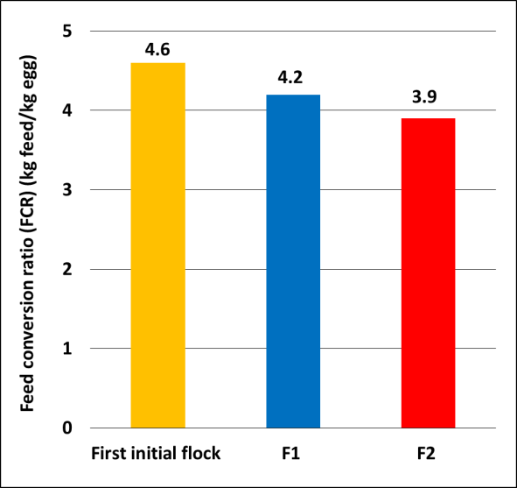

Fig.21. Feed conversion ratio (FCR) (kg feed/kg egg) of the initial flock and the F1 and F2 generation of the Syrian coastal local hens

It is clear that the Syrian local hens consumes a higher amount of feed to produce 1 kg of eggs compared to the high productivity hybrids white Lohman which consumed between 2.2 to 2.3 kg feed for every kg of eggs, while for the white hybrid Hisex egg breed the conversion ratio was 2.2 (13). And the brown hybrid Hisex was 2.3 kg feed/kg egg (33) and for the Leghorn strain was 2.2 kg feed/kg egg (32). The Saudi local hens has a better feed conversion ratio 4.0 kg feed/kg egg compared to the Syrian coastal local hens feed conversion ratio (28) and the Syrian coastal local hens shows better ratio than the two local hens strains in Indonesia as Kampung 4.9 and Pelung 7.1 kg feed/kg egg respectively (34).

**11. 10. Eggshell colour**

The color of the eggshells of hens breeds ranges from white to cream, light brown, and brown. And the source of eggshell colour contributed to a chemical substance called pigment found in to the hen blood, passed from the hen to the eggshell (14). Figure 22. shows the eggshell colour for the Syrian coastal local hens for the initial flock and the F1 and F2 hens which also ranged from white to cream, and light brown and brown. And the Syrian local hens considered a heterogeneous mixture morphologically and genetically (9,16). In the White Leghorn breed and Minorca and Blue Andalusian and Ancona, the eggshell colour is white (13), while in the Plymouth Rock breed it ranges from cream to light brown, in the Australorp breed it is light brown. And in the Brahma and Cochin and in the Sussex breed and in the New Hampshire breed it is brown (13,27).

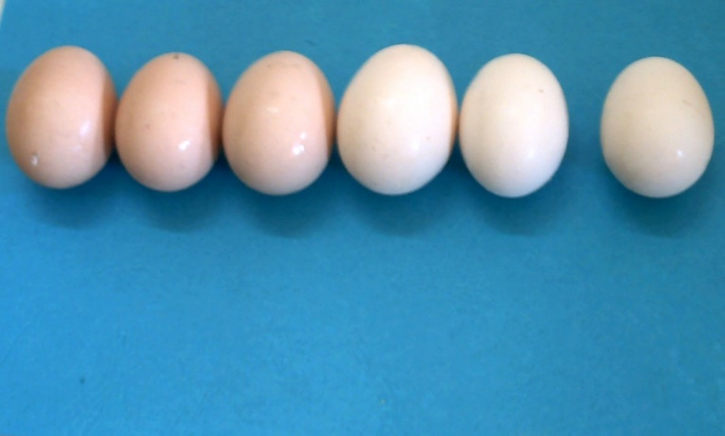

Fig.22. Eggshell colour of the initial flock and the F1 and F2 generation of the Syrian coastal local hens

**11. 11. Sexual Maturity Age**

Sexual maturity age of a hen is determined from the period of the date of her hatching until the date of her first day of laying an egg. And for a flock, the sexual maturity age is determined from the period of hens hatching day until the egg production percentage is 50 % for two consecutive days. The age of sexual maturity varies according to the breed, line, cross, and depended on stats within each of these hens, in addition to the role of environmental factors in shortening or lengthening this period (12). Figure 23. shows the average of the sexual maturity age for the Syrian coastal local hens for the initial flock and the F1 and F2 hens. The sexual maturity age was so different between the initial flock individuals, and the values ranged between the lowest limit 168 days and the highest limit 250 days, and the average was 206 days (20). And its values recorded at the F1 hens were 165 days and 245 days and 202 days respectively. While at the F2 hens were 160 days and 230 days and 195 days respectively (16,21,26). These results showed that the age of sexual maturity decreased of the F1 hens by 4 days and of the F2 hens by 11 days compared to the initial flock after applying an early selection on the initial flock (16,21,26).

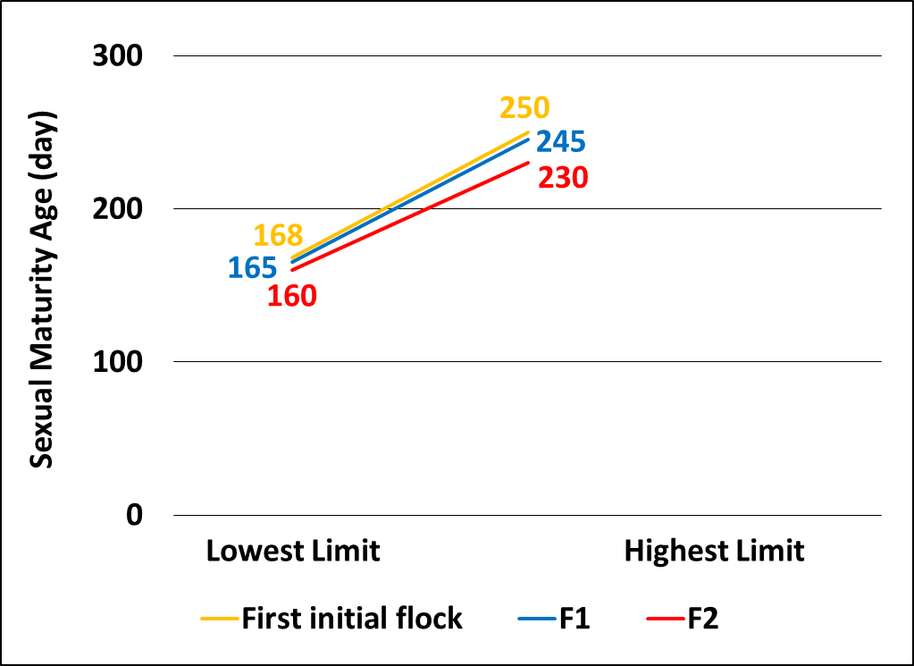

Fig.23. Age of sexual maturity of the initial flock and the F1 and F2 generation of the Syrian coastal local hens

The non-genetically improved local hens are considered late sexual maturity age, which may reached to 250 days or more and this lead to decrease the egg production (35), and the age of sexual maturity is an important indicator used to evaluate the flock hens during the selection process (36). When compared with the developed international strains and hybrids and local hens with this study results, it notice that the value of this indicator at the Syrian local hens was too late. The age of sexual maturity for the White Leghorn strain egg breed was 119- 126 days (13), but for Corniech meat breed was 168 days for (13). With local Tswana strain in Botswana recorded 180 days (37) and in Morocco 168 days (38). But in this study the Syrian coastal local hens at the F1 hens shows almost similar sexual maturity age when compared to the local Egyptian strain Alfayoumi in which their the sexual maturity age was 201 days (39).

**12. Conclusions**

The study showed that the egg production traits of the Syrian costal local hens lower compared with the international breeds and crosses. In addition, this study showed that the selected hens of the two generations F1 and F2 were with outperformed than the initial flock. Applying program of genetic selection with good care over a period of five months resulted in the selection efficiency was increase in the average egg production of the two selected generations by 5.84 eggs. Remembering that global achievements in this field has been made over more than a century, we anticipate even greater achievements in the coming decades, especially if more than one trait is subjected to simultaneous improvement and selection. Therefore, the genetic and morphological variations in these hens considered fertile raw material for selection and genetic improvement works by establishing a stations for the genetic improvement of coastal local hens to continuity of growing the local hens and subject it to the genetic development of the productive and body characteristics.

Disclaimer (Artificial intelligence)

Option 1:

Author(s) hereby declare that NO generative AI technologies such as Large Language Models (ChatGPT, COPILOT, etc.) and text-to-image generators have been used during the writing or editing of this manuscript.

Option 2:

Author(s) hereby declare that generative AI technologies such as Large Language Models, etc. have been used during the writing or editing of manuscripts. This explanation will include the name, version, model, and source of the generative AI technology and as well as all input prompts provided to the generative AI technology

Details of the AI usage are given below:

1.

2.

3.

**References**

1. Sil G.C, Das P.M, Islam M.R, Rahman M.M. Management and disease problems of cockerels in some farms of Mymensingh, Bangladesh. International Journal of Poultry Science. 2002; 1(4):102-105. <https://scholar.google.com/scholar?hl=en&as_sdt=0%2C5&q=1.%09Sil+G.C%2C+Das+P.M%2C+Islam+M.R%2C+Rahman+M.M.+Management+and+disease+problems+of+cockerels+in+some+farms+of+Mymensingh%2C+Bangladesh.+International+Journal+of+Poultry+Science.+2002%3B+1%284%29%3A102-105.&btnG>
2. Reta D. Understanding the role of indigenous chickens during the long walk to food security in Ethiopia. Livestock Research for Rural Development. 2009; 21(8):116. <https://scholar.google.com/scholar?hl=en&as_sdt=0%2C5&q=2.%09Reta+D.+Understanding+the+role+of+indigenous+chickens+during+the+long+walk+to+food+security+in+Ethiopia.+Livestock+Research+for+Rural+Development.+2009%3B+21%288%29%3A116.&btnG>
3. Kingori A.M, Tuitoek J.K, Muiruri H.K, Wachira A.M. Effect of dietary crude protein levels on egg production, hatchability and post-hatch offspring performance of indigenous chickens. International Journal of Poultry Science. 2010a; 9(4):324-329. <https://scholar.google.com/scholar?hl=en&as_sdt=0%2C5&q=3.%09Kingori+A.M%2C+Tuitoek+J.K%2C+Muiruri+H.K%2C+Wachira+A.M.+Effect+of+dietary+crude+protein+levels+on+egg+production%2C+hatchability+and+post-hatch+offspring+performance+of+indigenous+chickens.+International+Journal+of+Poultry+Science.+2010a%3B+9%284%29%3A324-329.&btnG>
4. Kingori A.M, Wachira A.M, Tuitoek J.K. Indigenous chicken production in Kenya: A Review. International Journal of Poultry Science. 2010b; 9(4):309-316. <https://scholar.google.com/scholar?hl=en&as_sdt=0%2C5&q=4.%09Kingori+A.M%2C+Wachira+A.M%2C+Tuitoek+J.K.+Indigenous+chicken+production+in+Kenya%3A+A+Review.+International+Journal+of+Poultry+Science.+2010b%3B+9%284%29%3A309-316.&btnG>
5. Aini I. Indigenous chicken production in Southeast Assia. World's poultry science journal. 1990; 46:51-57. <https://scholar.google.com/scholar?hl=en&as_sdt=0%2C5&q=5.%09Aini+I.+Indigenous+chicken+production+in+Southeast+Assia.+World%27s+poultry+science+journal.+1990%3B+46%3A51-57.&btnG>
6. Brannang E. Perason S. Ethiopian animal husbandry. Uppsala. Sweden. 1990; 127. <https://scholar.google.com/scholar?hl=en&as_sdt=0%2C5&q=6.%09Brannang+E.+Perason+S.+Ethiopian+animal+husbandry.+Uppsala.+Sweden.+1990%3B+127.&btnG>
7. Malago J.J, Baitilwake M.A. Egg traits, fertility, hatchability and chick survivability of Rhode Island Red, local and crossbreed chickens. Tanzania Veterinary Journal. 2009; 26(1):24-36. <https://scholar.google.com/scholar?hl=en&as_sdt=0%2C5&q=7.%09Malago+J.J%2C+Baitilwake+M.A.+Egg+traits%2C+fertility%2C+hatchability+and+chick+survivability+of+Rhode+Island+Red%2C+local+and+crossbreed+chickens.+Tanzania+Veterinary+Journal.+2009%3B+26%281%29%3A24-36.&btnG>
8. Grobbelaar J.A.N, Sutherland B, Molalakgotla N.M. Egg production potentials of certain indigenous chicken breeds from South Africa. Animal Genetic Resources. 2010; 46:25-32. <https://scholar.google.com/scholar?hl=en&as_sdt=0%2C5&q=8.%09Grobbelaar+J.A.N%2C+Sutherland+B%2C+Molalakgotla+N.M.+Egg+production+potentials+of+certain+indigenous+chicken+breeds+from+South+Africa.+Animal+Genetic+Resources.+2010%3B+46%3A25-32.&btnG>
9. Hmeshe M. Study some of incubation eggs traits of Syrian local poultry in coastal conditions under scavenging management systems. [Lattakia Tishreen University Journal for Research and Scientific Studies - Biological Sciences Series](https://journal.tishreen.edu.sy/index.php/bioscnc/issue/view/584). 2009; (2):37-50. <https://journal.tishreen.edu.sy/index.php/bioscnc/article/view/5992/5743>
10. Wirsity E.F, Fonba E.S. Strategy for improving local poultry production in rural communities. 2005. http://[www.freewebs.com/abdallahdarwiche555/local](http://www.freewebs.com/abdallahdarwiche555/-local) poultry
11. Sergeeva A.M. Evaluation of egg quality indicators. Book. Ross Selkhozizdat, Moscow. 1984; 72.
12. Bogoluobsky S.E. Selection of agricultural economic fowls, Book. Agroprom Izadat, Moscow. 1991; 26:41:43.
13. Bessarabov B.F, Bondarev Y.Y, Stolyar T.A. Poultry farming and egg and meat production technology. Book. Lan, Sankt Petersburg, Moscow, Krasnodar. 2005; 346-396.
14. Bondarev Y.Y. Theatrical breeding of poultry. Book. Moscow, A.S.T. Esterel, Prom Izdat. 2005; 254.
15. Acharya and Kumar. Desi means "local" (as in Bangladeshi).1984.[WWW.FREEWEBS.COM/ABDALLAHDARWICHE-LOCAL](http://WWW.FREEWEBS.COM/ABDALLAHDARWICHE-LOCAL) POULTRY
16. Jilenkerian B.K. An early selection for improving egg production of Syrian local hens in coastal Conditions. (Master Thesis). 2011. Department of Animal Production (Ruminants - Poultry), Faculty of Agriculture Engineering, Lattakia Tishreen University. Lattakia, Syria. <https://scholar.google.com/scholar?hl=en&as_sdt=0%2C5&q=%22Jilenkerian+B.K.+An+early+selection+for+improving+egg+production+of+Syrian+local+hens+in+coastal+Conditions.+%28Master+Thesis%29.+2011.+Department+of+Animal+Production+%28Ruminants++Poultry%29%2C+Faculty+of+Agriculture+Engineering%2C+Lattakia+Tishreen+University.+Lattakia%2C+Syria.%22&btnG>
17. Tsarinko P.P. Improvement of poultry products quality, Agroprom Izdat. Liningrad. 1988; 76:85:86. <https://scholar.google.com/scholar?hl=en&as_sdt=0%2C5&q=%22Tsarinko+P.P.+Improvement+of+poultry+products+quality%2C+Agroprom+Izdat.+Liningrad.+1988%3B+76%3A85%3A86.%22&btnG>
18. Shanawany and Banerjee. 1991. http://[www.freewebs.com/abdallahdarwiche555/local poultry](http://www.freewebs.com/abdallahdarwiche555/-local%20poultry.)
19. Sonaiya E.B. Water fowl production in Nigeria in proceedings of an expert consultation on waterfowl production in Africa, Accra, Ghana. July 2-5 AAO Rome. 1990.[WWW.FREEWEBS.COM/ABDALLAHDARWICHE-LOCAL](http://WWW.FREEWEBS.COM/ABDALLAHDARWICHE-LOCAL) POULTRY
20. Hmeshe M. study of some production indicators of Syrian local poultry in coastal conditions. International Journal of Poultry Science. 2012; 11(2):108-113. <https://scholar.google.com/scholar?hl=en&as_sdt=0%2C5&q=%22Hmeshe+M.+study+of+some+production+indicators+of+Syrian+local+poultry+in+coastal+conditions.+International+Journal+of+Poultry+Science.+2012%3B+11%282%29%3A108-113.%22&btnG>
21. Hmeshe M, CHilinkirianB.K. Study some of the indicators of egg productivity and age of sexual maturity of the second selected generation (F2) of Syrian local poultry under coastal conditions.  [Lattakia Tishreen University Journal for Research and Scientific Studies - Biological Sciences Series](https://journal.tishreen.edu.sy/index.php/bioscnc/issue/view/584). 2011a; 33(6):173-187. http://www.journal.tishreen.edu.sy/index.php/bioscnc/article/view/6221/5971
22. Madkour Y.H., Mahmoud T.H, and Mohanna N.Z.   
    A comparative study on egg cycle in relation to egg production of the Fayoumi and R.I.R. fowl. Agricultural research review. 1982; 57:127-134. <https://scholar.google.com/scholar?hl=en&as_sdt=0%2C5&q=%22Madkour+Y.H.%2C+Mahmoud+T.H%2C+and+Mohanna+N.Z.++A+comparative+study+on+egg+cycle+in+relation+to+egg+production+of+the+Fayoumi+and+R.I.R.+fowl.+Agricultural+research+review.+1982%3B+57%3A127-134.%22&btnG>
23. Zatter O.M, Nofal M.E. Comparisons of laying performance curves for Al- Salam and silver Montazah local chicken strains. Egypt. poult. Sci. 2009; 29(1):191-203. <https://scholar.google.com/scholar?hl=en&as_sdt=0%2C5&q=%22Zatter+O.M%2C+Nofal+M.E.+Comparisons+of+laying+performance+curves+for+Al+Salam+and+silver+Montazah+local+chicken+strains.+Egypt.+poult.+Sci.+2009%3B+29%281%29%3A191-203.%27&btnG>
24. Lwelamira J, Kifaro G.C, Gwakisa P.S. On station and on-farm evaluation of two Tanzania chicken ecotypes for body weights at different ages and for egg production. African journal of agricultural research. 2008; 3(12): 843-851. <https://scholar.google.com/scholar?hl=en&as_sdt=0%2C5&q=%22Lwelamira++J%2C+Kifaro+G.C%2C+Gwakisa+P.S.+On+station+and+onfarm+evaluation+of+two+Tanzania+chicken+ecotypes+for+body+weights+at+different+ages+and+for+egg+production.+African+journal+of+agricultural+research.+2008%3B+3%2812%29%3A+843-851.%22&btnG>
25. Ojo O.A, Olusanya O. Biological control of aflatoxin on egg production performance of laying hens. Asian Journal of Advances in Agricultural Research. 2020; 13(1):13-23. <https://journalajaar.com/index.php/AJAAR/article/view/260>
26. Hmeshe M, CHilinkirian B.K. Study of the sexual maturity indicators, egg quantity and productivity of the first selected generation (F1) of Syrian local poultry under coastal conditions. [Lattakia University Journal for Research and Scientific Studies - Biological Sciences Series](https://journal.tishreen.edu.sy/index.php/bioscnc/issue/view/584). 2011b; 33 (2):183-195. <https://www.researchgate.net/publication/370602286_Study_of_the_Sexual_Maturity_Indicators_Egg_Quantity_and_Productivity_of_the_First_Selected_Generation_F1_of_Syrian_Local_Poultry_under_Coastal_Conditions>
27. Zeber A.F. Taking care of parents flock, and egg incubation in growing meat producing chicks. Book. A.S.S. Stalker, Moscow. 2005; 5-14.
28. Basiouni G., Najib H, Zaki M.M, AL-Ankari A.S. Influence of extra supplementation with arginine and lysine on overall performance, ovarian activities and humoral immune response in local Saudi hens. International journal of poultry science. 2006; 5(5): 441-448. <https://scholar.google.com/scholar?hl=en&as_sdt=0%2C5&q=%22Basiouni+G.%2C+Najib+H%2C+Zaki++M.M%2C+AL-Ankari+A.S.+Influence+of+extra+supplementation+with+arginine+and+lysine+on+overall+performance%2C+ovarian+activities+and+humoral+immune+response+in+local+Saudi+hens.+International+journal+of+poultry+science.+2006%3B+5%285%29%3A+441-448%27&btnG>
29. Radwan N.L, Hassan R.A, Qota E.M, Fayek H. M. Effect of natural antioxidant on oxidative stability of eggs and productive and reproductive performance of laying hens. International Journal of poultry science. 2008; (2):134-150. <https://scholar.google.com/scholar?hl=en&as_sdt=0%2C5&q=%22Radwan++N.L%2C+Hassan+R.A%2C++Qota+E.M%2C+Fayek+H.+M.+Effect+of+natural+antioxidant+on+oxidative+stability+of+eggs+and+productive+and+reproductive+performance+of+laying+hens%22&btnG>
30. Perez-Maldonado R.A, Mannion P.F, Farell, D.J. Optimum inclusion of field peas, faba beans, chick peas and sweet lupins in poultry diets. 1. chemical composition and layer experiments. British poultry science. 1999; 40:667-673. <https://scholar.google.com/scholar?hl=en&as_sdt=0%2C5&q=%22PerezMaldonado+R.A%2C+Mannion+P.F%2C+Farell%2C+D.J.+Optimum+inclusion+of+field+peas%2C+faba+beans%2C+chick+peas+and+sweet+lupins+in+poultry+diets.+1.+chemical+composition+and+layer+experiments.+British+poultry+science.+1999%3B+40%3A667-673.%22&btnG>
31. Boorman K.N, Gunaratne S.P. Dietary phosphorus supply, egg-shell deposition and plasma inorganic phosphorus in laying hens. British Poultry Science. 2001; 42:81-91. <https://scholar.google.com/scholar?hl=en&as_sdt=0%2C5&q=%22Boorman+K.N%2C+Gunaratne+S.P.+Dietary+phosphorus+supply%2C+eggshell+deposition+and+plasma+inorganic+phosphorus+in+laying+hens.+British+Poultry+Science.+2001%3B+42%3A81-91.%22&btnG>
32. Rezaei M. Use of sunflower meal in layer retions. British poultry science. 2001; 42:S103-S104. <https://scholar.google.com/scholar?hl=en&as_sdt=0%2C5&q=%22Rezaei+M.+Use+of+sunflower+meal+in+layer+retions.+British+poultry+science.+2001%3B+42%3AS103-S104.%27&btnG>
33. Inal F, Coskun B, Gulsen N, Kurtoglu V. The effects of withdrawal of vitamin and trace mineral supplements fore layer mineral diets on egg yield and trace mineral composition. British poultry, science. 2001; 42:77-80. <https://scholar.google.com/scholar?hl=en&as_sdt=0%2C5&q=%22Inal+F%2C+Coskun+B%2C+Gulsen+N%2C+Kurtoglu+V.+The+effects+of+withdrawal+of+vitamin+and+trace+mineral+supplements+fore+layer+mineral+diets+on+egg+yield+and+trace+mineral+composition.+British+poultry%2C+science.+2001%3B+42%3A77-80.%27&btnG>
34. Creswell D.C, Gunawan B. Indigenous chicken in Indonesia: production characteristics in an improved environment. Research report. Research institute for animal production. 1982.<https://scholar.google.com/scholar?hl=en&as_sdt=0%2C5&q=%22Creswell+D.C%2C+Gunawan+B.+Indigenous+chicken+in+Indonesia%3A+production+characteristics+in+an+improved+environment.+Research+report.+Research+institute+for+animal+production.+1982.%22&btnG>
35. Horst P. Native fowl as reservoir for genomes with direct and indirect effects on productive adaptability. Proceedings of 18th World’s Poultry Congress. Nagoa, Japan. 1988; 99-105.<https://scholar.google.com/scholar?hl=en&as_sdt=0%2C5&q=%22Horst+P.+Native+fowl+as+reservoir+for+genomes+with+direct+and+indirect+effects+on+productive+adaptability.+Proceedings+of+18th+World%E2%80%99s+Poultry+Congress.+Nagoa%2C+Japan.+1988%3B+99-105.%22&btnG>
36. El-Dlebshany A.E. The relationship between age at sexual maturity and some productive traits in local chickens strain. Egypt POULT. Sci. 2008; 28:1253-1263. <https://scholar.google.com/scholar?q=%22ElDlebshany+A.E.+The+relationship+between+age+at+sexual+maturity+and+some+productive+traits+in+local+chickens+strain.+Egypt+POULT.+Sci.+2008%3B+28:1253-1263.%27&hl=en&as_sdt=0,5>
37. Aganga AA, Tshwenyane S.O, Molefhe L. Influence of feed type on egg production of Tswana laying chicken. International journal of poultry science. 2003; 2(4):256-258. <https://scholar.google.com/scholar?hl=en&as_sdt=0%2C5&q=%22Aganga+AA%2C+Tshwenyane+S.O%2C+Molefhe+L.+Influence+of+feed+type+on+egg+production+of+Tswana+laying+chicken.%22&btnG>
38. Benabdeljelil K, Arfaoui T, Johnston P. Traditional poultry farming in Morocco. Livestock community and environment. Proceedings of the 10th conference of the association of institutions for tropical veterinary medicine, Copenhagen, Denmark. 2001.

<https://scholar.google.com/scholar?hl=en&as_sdt=0%2C5&q=%22Benabdeljelil+K%2C+Arfaoui+T%2C+Johnston+P.+Traditional+poultry+farming+in+Morocco.+Livestock+community+and+environment.+Proceedings+of+the+10th+conference+of+the+association+of+institutions+for+tropical+veterinary+medicine%2C+Copenhagen%2C+Denmark.+2001.%27&btnG>

1. Bekele F, Adnoy T, Gjoen H.M, Kathle J, Abebe G. Production performance of dual purpose crosses of two indigenous with two exotic chicken breeds in sub-tropical environment. International journal of poultry science. 2010; 9(7):702-710. <https://scholar.google.com/scholar?hl=en&as_sdt=0%2C5&q=%22Bekele+F%2C+Adnoy+T%2C+Gjoen+H.M%2C+Kathle+J%2C+Abebe+G.+Production+performance+of+dual+purpose+crosses+of+two+indigenous+with+two+exotic+chicken+breeds+in+sub-tropical+environment%22&btnG>