**Design and Characterisation of Anticancer Drug-Loaded Microspheres for Controlled Release**

**Abstract:**

Microspheres refer to microparticles composed of a homogeneous mixture of active compounds and raw materials. Microsphere is a synonym of microparticle. Rectal drug delivery is an effective substitute for the oral and parenteral route of administration in partial avoidance of first-pass metabolism and protein peptide drug delivery. The rectum offers a relatively constant environment for drug delivery, provided the drug is presented in a well-absorbable form. The purpose of the present investigation was to prepare flutamide-loaded microspheres for a rectal drug delivery system with the aim of improving solubility, avoiding first-pass metabolism and enhancing residence time. Flutamide (FLT) was a gift sample from Cipla Pvt. Ltd. (Bangalore, India). Mucilage is extracted from *Ocimum basilicum* seeds (basil seed) in the laboratory, PEG4000, and Methanol. Flutamide is an anticancer drug that exhibits poor water solubility, poor dissolution and poor wetting. Flutamide encapsulated Mucoadhesive microsphere prepared by a simple one-step spray drying method using mucilage extracted from seeds of *Ocimum basilicum* as a natural polymer. The mucoadhesive microspheres were evaluated by different parameters such as percentage production yield, encapsulation efficiency study, particle size analysis, Differential Scanning Calorimeter (DSC), scanning electron microscopy(SEM), X-ray diffraction analysis(XRD), *ex vivo* mucoadhesive test, and *in vitro* drug release stability study. The microspheres were spherical with a size of 2.53µm. The encapsulation efficiency was observed from 57.44% to 69.67%, while the percentage of mucoadhesion was observed from 70.68% to 89.01%. The microsphere releases around 88.28 % of the drug in 7 hours. The DSC and XRD studies show that FLT was molecularly dispersed. It was concluded that *Ocimum basilicum* mucilage microsphere-based suppository could be used to deliver FLT to rectal drug administration for improving solubility, bioavailability, and avoiding first-pass metabolism.

**Keywords:** *Mucoadhesive microsphere; Ocimum basilicum; flutamide; rectal delivery.*

**Introduction:**

“Rectal drug delivery is an effective substitute to the oral and parenteral route of administration in partial avoidance of first-pass metabolism and protein peptide drug delivery. The rectal route is an effective route for the local and systemic delivery of active pharmaceutical ingredients” (Rathi et al.,2022). “This route allows both local and systemic therapy with drugs. The rectal route is also preferred if the drug is extensively metabolised or deactivated by liver enzymes” (Shalaby et al.,2019). **“**The rectal drug delivery includes: rapid absorption of many low molecular weight drugs, partial avoidance of first pass metabolism, potential for absorption into the lymphatic system, retention of large volumes, possibility of rate-controlled drug delivery and absorption enhancement. the rectal drug delivery shows possible pathways for a drug to permeate across the rectal mucosa by two transport routes transcellular route and the paracellular route through the rectal epithelium. In a rectal drug delivery system, the blood is drained in the inferior vena cava and bypasses the liver before entering the general circulation”[1]. “The rectum offers a relatively constant environment for drug delivery, provided the drug is presented in a well-absorbable form. The rate-controlled dosage forms, resulting in a constant steady-state concentration of drugs in plasma, are selected for therapeutic indications”[2]

“A microsphere is a spherical particle with a diameter in micrometre range The range of particle size is 1 um to 1000 um. Microspheres are usually prepared by a polymer matrix in which a small amount of drug is encapsulated. ‘‘Microspheres’’ refers to microparticles composed of a homogeneous mixture of active compound and raw material. Microsphere is a synonym of microparticle”[3]. Various different methods are used for the preparation of microparticles, such as emulsification[4], ionic gelation[5], coacervation[6], solvent evaporation technique[7], and spray drying method[8]. “Among all methods, spray drying is highly attractive due to its fast particle formation process, single step, simple and easy scale up”[9].

“The Mucoadhesive drug delivery increases the residence time of the drug at the absorption site and attachment of the drug along with a suitable carrier to the mucous membrane by forming a bond with the mucosal surface”[10]. “The aim of this work was to study the possible application of *Ocimum basilicum* mucilage(OBM) for the preparation of mucoadhesive microparticles using for spray drying method for rectal administration of flutamide and to improve the solubility of the drug to avoid the first pass metabolism in the existing study. Spray drying is a well-established drying process traditionally used for thermolabile materials. It is a versatile technology that has been applied widely in the chemical, food, and, most recently, pharmaceutical industries” (Baumann et al.,2021; Jayaprakash et al.,2023)**.** “It has been used successfully in the pharmaceutical industry to produce products of defined physical and chemical properties. In this study, we investigated spray drying as a potential method for the production of micron-sized particles. Spray drying is widely used for the microencapsulation of drugs due to reliability, reproducibility and possible control of particle size and drug release. In addition, it has the advantage of being a continuous process which is easy to scale up. Another important advantage is the fact that microsheres obtained by spray drying are usually free of organic solvents, whereas other methods often result in particles contaminated with organic solvents, which may be toxic. The spray drying technique consists of spraying a solution or suspension of polymer and drug through the nozzle of a spray dryer apparatus. The solvent evaporates very quickly, leaving behind solid microparticles”[11].

“ The present drug delivery system has been developed based on *Ocimum basilicum* mucilage used as the mucoadhesive polymer. The polymer was extracted from basil (*Ocimum basilicum*) seed. Basil is an herbaceous plant popularly grown in India, Iran, and some warm regions of Africa. The extracted mucilage is a heteropolysaccharide which contains glucomannan, xylan and glucan” [12][13]. “After the extraction of the polymer characterized its solubility, appearance, melting point, ash value, pH, swelling index, carbohydrate test and used as Mucoadhesive polymer for the development of Mucoadhesive formulation”[14][15].

“[Flutamide](https://www.sciencedirect.com/topics/pharmacology-toxicology-and-pharmaceutical-science/flutamide) (FLT) is an antagonist of testosterone, an essential hormone in male reproduction (Tanyapanyachon et al.,2023).FLT is a non-steroidal compound with antiandrogenic properties. It is used in the palliative treatment of prostatic carcinoma”[16]. “FLT occurs as a pale yellow, crystalline powder of acicular particle shape categorised under BCS class II” [17], “and half half-life of FLT is 6 hours. It is practically insoluble in water but is freely soluble in methanol and ethanol. Due to the poor solubility in water, flutamide is a potential candidate for a drug substance with limited dissolution rate and bioavailability” [18]. “The low bioavailability of FLT after oral formulations may be due to poor wettability, low aqueous solubility, poor permeability, rapid first-pass hepatic metabolism and low concentration at the absorption surface. Therefore, developing novel formulations that mitigate solubility and dissolution will produce higher concentrations of FLT in solution at the absorption site and hence may overcome the solubility-mediated poor bioavailability. Hence, it will be a good candidature to do the work on the solubility enhancement area and avoidance of hepatic first pass metabolism by some appropriate techniques”[19].

In the present experiments, were aim was to use basil seed mucilage as a mucoadhesive polymer. And formulate OBM mucilage-based spray-dried mucoadhesive microspheres in order to optimise the formulation. After optimisation, the optimised microsphere was incorporated in a suppository based on PEG 4000 and formulated suppository of a Mucoadhesive microsphere as rectal drug delivery and characterised.

The novelty of the experiment was first used as OBM as Mucoadhesive polymer for formulation of microsphere and improvement of solubility, bioavailability and avoiding the first pass metabolism of FLT.

**Material and Method:**

Flutamide (FLT) was a gift sample from Cipla Pvt. Ltd.,( Bangalore, India), mucilage is extracted from *Ocimum basilicum* seeds (basil seed) in the laboratory, PEG4000, Methanol. All other reagents used were of analytical grade.

**Extraction of mucilage from basil seeds:**

“The seeds were soaked and swelled in distilled water at 68 ± 1C and a water/seed ratio of 65:1(100 gm seed in 6.5 lit water). The mixture was stirred with a mechanical stirrer (Remi motor, Remi Elektrotechnik Ltd.) until the seeds were completely swelled (4 hrs agitation, 500 rpm). The swelled seeds were passed through a high-speed homogeniser at 6000 rpm (Remi motor, Remi Elektrotechnik Ltd.) to separate the gum layer from the seed surface. Then the total mixture is squeezed manually by hand through (40#) muslin cloth so that seeds get separated from gum, and then gum is washed with acetone to remove any soluble impurities. The precipitated OBM was separated, vacuum dried in an oven at 30- 40 °C, powdered and passed through a sieve (80#) and Characterisation of mucilage(**Table 1)** was then stored in tightly closed containers under dry and cool conditions”[14][20][15].

**Preparation of microspheres by spray drying:**

“The Flutamide loaded microspheres were prepared at Drug: Polymer ratio (mg:mg) of 0.5 : 1 to 1 : 5 by the spray drying method. Subsequently, the mucilage of the seeds of *Ocimum basilicum*. was solubilised in distilled water by continuous stirring and gradual heating until a homogeneous solution was obtained. The drug was added to the polymer solution slowly with continuous stirring. Microspheres were obtained by spraying the feed with a spray drier (LU222, Labultima, India) using a standard 0.7 mm nozzle. The dispersion was fed to the nozzle with a peristaltic pump, atomised by the force of compressed air and blown together with heated air to the drying chamber, where the solvent in the droplets was evaporated. The dried microspheres were harvested from the apparatus collector. The process conditions of the spray drying were inlet temperature 107°C; outlet temp 90 °C; pump setting of 4 to 7 ml/min; spray pressure 2 kg/cm2”[21].

**Preparation of microsphere-based suppository:**

“The suppository was prepared by the fusion method. In this method, we take base (PEG4000) in a beaker and melt it at 400C on the water bath. After accurately weighing the amount of microsphere, and were incorporated into the melted base with continuous stirring. The appropriate suppository mould is lubricated with glycerine. The melted mass was poured into the mould and then refrigerated. After that, remove the suppository and characterise for various parameters” [22].

**Characterisation of microspheres:**

**Differential Scanning Calorimetry (DSC):**

“Differential scanning calorimetry (DSC) of pure drug and drug loaded microspheres were conducted using differential scanning calorimeter (METTLER DSC 30 S, Mettler Toledo India Pvt. Ltd) at heating rate of 10°C /min over a temperature range of 40 to 300 °C under an inert atmosphere flushed with nitrogen at a rate of 30 mL/min”[23].

**Infrared Spectroscopy:**

“The IR spectrum of the drug was recorded in the solid state as a KBr disc pellet method by using an FTIR spectrophotometer (Shimadzu 8400S, Japan). The samples were previously ground and mixed thoroughly with anhydrous IR grade potassium bromide, an infrared transparent matrix at 1:10 (sample:KBr) ratio, respectively. The KBr discs were prepared by compressing the powders under a force of 15 tonnes for 5 min in a motorised pellet press (Kimaya engineers, India). The IR spectrum of Flutamide is presented in the results and discussion”[24].

**X-ray diffraction study (XRD):**

**“**The X-ray diffraction (XRD) patterns, i.e. crystallinity of plane drug, polymer and drug-loaded microsphere, were recorded on an X-ray diffractometer (Brucker Axs, D8 Advance, Germany). The samples were irradiated with monochromatized Cu Kα radiation and analysed between 3 and 80° (2θ). The voltage and current used were 30 kV and 30 mA, respectively”[25].

**Production Yield:**

“The microparticle yield was determined by the ratio of the weight of microparticles collected at the dryer exit and the initial weight of the dispersion taken for drying. The results were calculated as the percentage ratio of the final mass of microparticles to the initial mass of raw material (dry basis; %w/w) using the following definition (Eq.01)”: [26]

Production Yield = $\frac{mass of microparticles}{mass of raw material} ×10……(1)$

**Actual drug content and encapsulation efficiency:**

Accurately weighed 25mg of microspheres, triturated with 10 mL of water, allowed to stand for 10 min. Methanol was added to produce 50 mL and sonicated for 3 min. The solution was then filtered, diluted suitably and analysed for drug content spectrophotometrically at 229 nm using a spectrophotometer (UV-1601, Shimadzu, Japan). Actual drug content and encapsulation efficiency were calculated by using Eqs. (2) and (3), respectively:[27].

Drug loading = $\frac{Mactual}{Weighed quantity of powder of microspheres} ×100….(2)$

Entrapment efficiency = $\frac{Mactual}{Mtheoretical}$ $×100$…..(3)

Where *Mactual* is the actual Flutamide content in microspheres, and *Mtheoretical* is the theoretical amount of Flutamide in microspheres calculated from the quantity added in the process.

**Scanning Electron Microscopy (SEM):**

“The morphology of optimised formulation (MBF5) was examined by SEM (JSM 6390®, Japan). Samples of microspheres were dusted onto double-sided tape on an aluminium stub and coated with gold using a cold sputter coater to a thickness of 400 Å, and then imaged using a 20 kv electron beam”[28].

**Particle size analysis:**

“A microscopically image analysis technique for the determination of microsphere size distribution was applied. The morphology and particle size distributions (based on the numbers of particles) were determined in a Motic DMWB2-223 digital microscope (Motic Instruments Inc., China) equipped with a 1/399 CCD camera imaging accessory. The microspheres were dispersed on a microscope slide. A microscopic field is scanned by a video camera. The images of the scanned fields are digitised and analysed by the software (Motic images 2000, 1.3 versions, China). In all measurements, at least 3000 particles were examined. The images of microspheres were analysed for their average diameter and different shape factors”.[29].

**Mean Particle size and Polydispersity index:**

“The MPS and PDI were determined by PCS with a Malvern Zetasizer (Nano ZS 90, Malvern Ltd., UK). The measurement using PCS is based on the light scattering phenomena in which the statistical intensity fluctuations of the scattered light from the particles in the measuring cell are measured. Prior to the measurements, each samples were diluted with double-distilled water to produce a suitable scattering intensity. The z-average and PDI values were obtained at an angle of 90° using disposable polystyrene cells having 10 mm diameter cells at 25°C, which were equilibrated for 120 seconds”.(Ige et al. 2018)

**Zeta potential measurement:**

The microspheres were dispersed in deionised water. Then this dispersion was filled in the zeta cell and placed in the Zeta Sizer (Nano ZS, Malvern Instruments, UK).

***In-vitro* mucoadhesion study:**

“An in vitro mucoadhesion test performed using the falling liquid film technique was used to determine the mucoadhesive property of microspheres. A freshly cut piece, 5cm long, of sheep lung mucosa obtained from a local abattoir within 1 hour of killing the animal was cleaned by washing with isotonic saline solution. An accurate weight (100 mg) of microspheres was placed on mucosal surface, which was attached over a polyethylene plate that fixed in an angle of 45° relative to the horizontal plane, and 6.8 buffer solution in water warmed at 37°C was peristaltically pumped at a rate of 5 mL/min over the tissue. After 1 hour, the concentration of the drug in the collected perfusate was spectrophotometrically determined. The microspheres amount corresponding to the drug amount in the perfusate was calculated. The adhered microspheres amount was estimated from the difference between the applied microspheres and the amount of microspheres that flowed. The per cent mucoadhesion was determined using the following equation ( 4 )” [30].

$Drug loading (\%)=\frac{Amount of drug in washout liquid}{Actual amount of drug in applied microspheres}x 100$…….(4)

***In- vitro* drug release studies:**

Microspheres equivalent to 20 mg of Flutamide of the respective batch were filled into the dialysis bag, and the drug release was determined using USP XXVI paddle (Type II) apparatus 4 (TDT-08L plus, Electrolab, Mumbai, India). The paddle was then immersed in the 6.8 pH phosphate buffer maintained at 37 ± 50 C and was rotated at a speed of 50 rpm. Sample aliquots of 5 ml were withdrawn at every hour up to 07 hours and the withdrawn samples were estimated spectrophotometrically at 302 nm[31].

**Kinetics of *In Vitro* Drug Release:**

Amongst all the batches, only one optimised formulation batch i.e. **(MBF10),** To study the release kinetics for *In-vitro* drug release. the data of the above optimised batch was applied to kinetic models such as zero order, first order, Higuchi and Korsmeyer-Peppas equations.

**Zero order**

*C =* ***K0t*** *………………*(6)

Where *K0* is the zero-order rate constant expressed in units of concentration/time, and t is the time in hours.

**First order**

Log C = Log C0 – Kt / 2.303 ……………… (7)

Where C0 is the initial concentration of drug, K is the first-order constant, and t is the time in hours.

**Higuchi.**

*Qt=Kt1/2 ………………* (9)

where Qt is the amount of drug release in time t, K is the kinetic constant, and t is the time in minutes.

**Korsmeyer Peppas method for non-Fickian diffusion process**

*Mt/M∞=Kt ………………………………..* (8)

Where, Mtis the amount of the released drug at time t, M∞ is the overall amount of the drug (whole dose), *K* is the constant incorporating structural and geometric characteristics of the controlled release device, and *n* is the release exponent indicative of the drug release mechanism. If the exponent n = 0.5, then the drug release mechanism is Fickian diffusion. If n < 0.5, the mechanism is quasi-fickian diffusion, and if 0.5 < n < 1.0, then it is non-fickian or anomalous diffusion, but when n = 1.0, then the mechanism is non-fickian case II diffusion. If n is > 1.0 mechanism is so-called non-Fickian super case II.

**Stability studies**

Stability studies were carried out for optimised formulations (MBF10) as per ICH guidelines by placing the formulations at 40 °C±2 °C/75% RH±5% RH for 3 months. The samples were evaluated for drug content and particle size analysis at a 1-month interval, using the same methods as mentioned earlier.

**Characterisation of suppository:**

**Visual characterisation:**

“The randomly selected suppositories (six suppositories from each batch) were cut longitudinally and examined with the naked eye (subjective evaluation) to assess the verified the homogeneity of surface appearance and colour of suppositories by absence of fissuring, fat blooming, exudation and absence of migration of active ingredients. This test is best accomplished by taking a longitudinal section of the suppository to verify the homogeneity of the active ingredient(s) within the mass”[32].

**Length and width**

“Ten suppositories were selected randomly from each batch, their length and width was measured using vernier callipers and screw micrometer respectively”[33].

**Weight variation**

“Ten suppositories were weighed, and the average weight was calculated. Each suppository was then individually weighed using a digital balance. Not more than 2 of the individual masses deviate from the average mass by more than 5% and do not deviate by more than twice that %”[34]

**Hardness of suppository**

“The physical characteristics, such as the hardness test, were determined. The hardness of a cylindrical portion (9.6 mm thickness) of the suppository, which was obtained by cutting the middle portion of the suppository, was measured in its diameter direction with a Monsanto hardness tester”[35].

**Friability**

Ten suppositories were weighed and placed in the plastic chamber of the Roches Friabilator. The chamber was then rotated for 4 minutes at 25 rpm (a total of 100 revolutions). During each revolution, suppositories fall from a distance of 6 inches. After 100 revolutions, the suppositories were removed and weighed again. Calculate in eq(5)

Friability (%) Wi Wr / Wi x 100 ……..(5)

Where Wi was the initial weight of the suppositories before friability testing, and Wr was the weight of the suppositories after the testing[36].

**Melting point**

“The macro melting range test is performed with the whole suppository. A suppository from each formulation was placed in a beaker with Phosphate Buffer pH 6.8 maintained at constant temperature 37± 0.5℃. The time required by the whole suppository to melt or disperse in the media was noted. The melting time plays a crucial role in the release of the active ingredient”[37].

**Disintegration test**

“The disintegration test was performed by using disintegration tester ED-3 PO Electrolab. Three suppositories were randomly chosen from each formulation and placed in the disintegration apparatus, and the temperature was maintained at 37°C”[34]

**Differential Scanning Calorimetry (DSC) :**

Differential scanning calorimetry (DSC) of microspheres based suppository were conducted using differential scanning calorimeter (METTLER DSC 30 S, Mettler Toledo India Pvt. Ltd) at heating rate of 10°C /min over a temperature range of 40 to 300 °C under an inert atmosphere flushed with nitrogen at a rate of 30 mL/min[38]

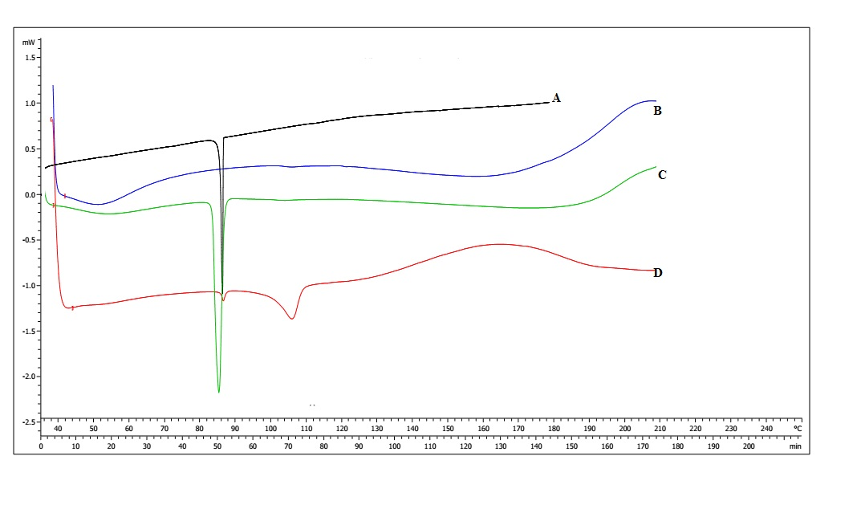

**Fig 01: DSC thermograph of (A) Flutamide,(B) OBM mucilage,(c) Physical mixture of drug and polymer,(D) Flutamide loaded microsphere**

***In-vitro* dissolution of suppositories**

In vitro drug release from suppositories was determined using the USP XXII paddle method (500 ml, pH 6.8 phosphate buffer solution, 37ºC±0.5, 100 rpm). At appropriate intervals (15 to 420 min), 5 ml samples were taken and the content of flutamide microsphere was assayed spectrophotometrically at 302 nm[39][40][35].

**Result and Discussion:**

Spray drying method described here is a suitable and simple technique to prepare *Ocimum basilicum* mucilage containing microspheres loaded with flutamide. It is a single-step process, easy to handle and a fast process. it combines drying of the feed and embedding of the drug into a one-step operation.

**Formulation of microspheres**

Ten formulation batches of flutamide-loaded microspheres were prepared by the spray drying technique using a drug and polymer ratio at different concentrations. Polymer and drug concentration was 0.5 : 1 to 1:5, and the microspheres.

**Characterization of microspheres**

**Differential Scanning Calorimeter :**

In the following fig peak A is Flutamide, peak B is mucilage, peak C is physical mixture, and peak D is Optimised Batch. Observed peak of Flutamide-loaded microspheres was found to be less intense. Thus, there was molecular dispersion of flutamide in a polymer. Shows in **fig no01**

**Infrared Spectroscopy**

The IR spectrum was recorded for drug + polymer to observe the interaction between drug and polymer; however, it was found that no interaction occurred in drug + polymer spectra, because all the ranges were found almost the same as their previous spectra of individual drug and polymer, respectively. Hence polymer was compatible with the drug for formulation.Shows in **fig no02**.

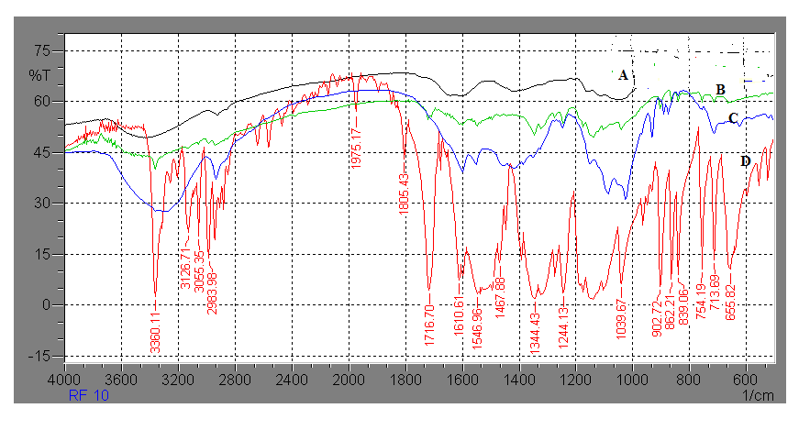

**Fig 02 : IR graph of (A)OBM mucilage,(B)Physical mixture,(C)Flutamide loaded microsphere,(D)Flutamide.**

**X-Ray Diffraction study:**

**“**Powder x-ray diffraction study was used to qualitatively detect the material with long-range or sharper diffraction peaks indicating more crystalline material. The absence of crystalline peaks of polymer in drug-loaded microspheres confirmed that the drug was molecularly dispersed in the polymer, and conversion of a crystalline form of polymer into the amorphous form was achieved. The **figure no3.** depicts the overlay in the XRD spectrum of pure drug, polymer and the optimised formulation”. (Ige et al. 2018)

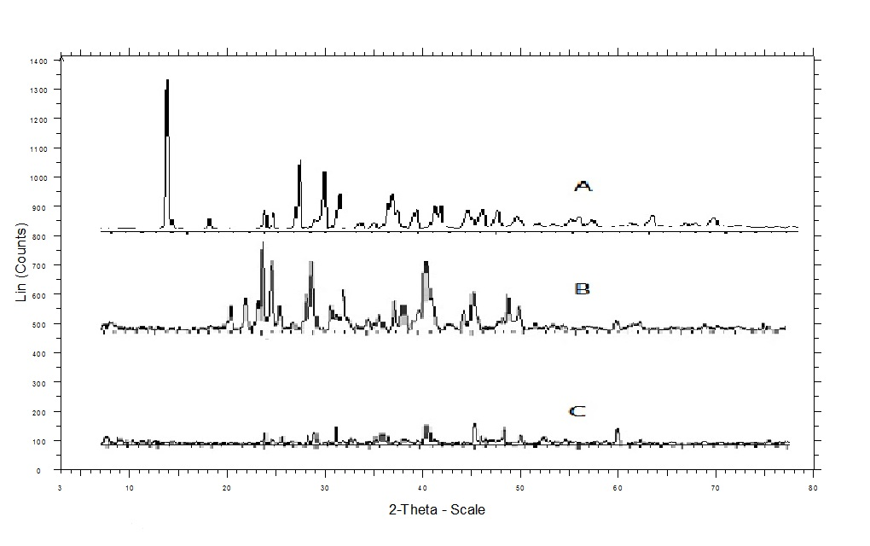

**Fig 03: X-Ray Diffractrogram of (A) Flutamide, (B) OBM mucilage, (C) Flutamide loaded microsphere.**

**Production Yield:**

“The production yield ranged between 6.66 to 17.91%, as shown in **table no02.** The production yields of microspheres were gradually increased with respect to an increase in the drug: polymer ratio. The low production yield can be attributed to the low quantity of materials used for spray drying, to the loss of the smaller particles through the exhaust of the spray-dryer during the manufacturing process and to the adherence of some liquid droplets extensively inside the glass wall of the cyclone”. (Ige et al. 2018)

**Actual drug content and encapsulation efficiency:**

“The actual drug content was found between 38.02 to 11.06%and encapsulation efficiency is 57.44 to 69.67% Drug loading is inversely related to polymer concentration and decreases with an increase in drug-to-polymer ratio. As the drug: polymer ratio increases, there is an increase in encapsulation efficiency, while a decrease in actual drug content. As shown in **Table no2” (Ige et al. 2018)**

***In vitro* mucoadhesion studies:**

“Mucoadhesion studies were carried out to ensure the adhesion of the formulation to the mucosa for a prolonged period of time at the site of absorption. The results of in vitro mucoadhesion **(Table no 2 )** showed that all the batches of microspheres had satisfactory mucoadhesive properties, ranging from 70.68 to 89.01. The results also showed that, with increasing polymer ratio, higher percentages of mucoadhesion were obtained. This could be attributed to the availability of a higher amount of polymer for interaction with mucus”. (Ige et al. 2018)

**Scanning electron microscopy (SEM):**

The shape and surface morphologies of drug-loaded microspheres were investigated using scanning electron microscopy. Surface morphology of microspheres for optimised formulation **(MBF5)** was studied using scanning electron microscopy. External morphology and surface texture of microspheres were shown in **fig no4.** the external morphology shows that well-spherical particles are produced through spray drying, while the surface texture of the microspheres shows that they were sufficiently porous in nature. In **fig no4,** image A is an optimized microsphere showing a spherical particle, as compared to image B is an unoptimized formulation.

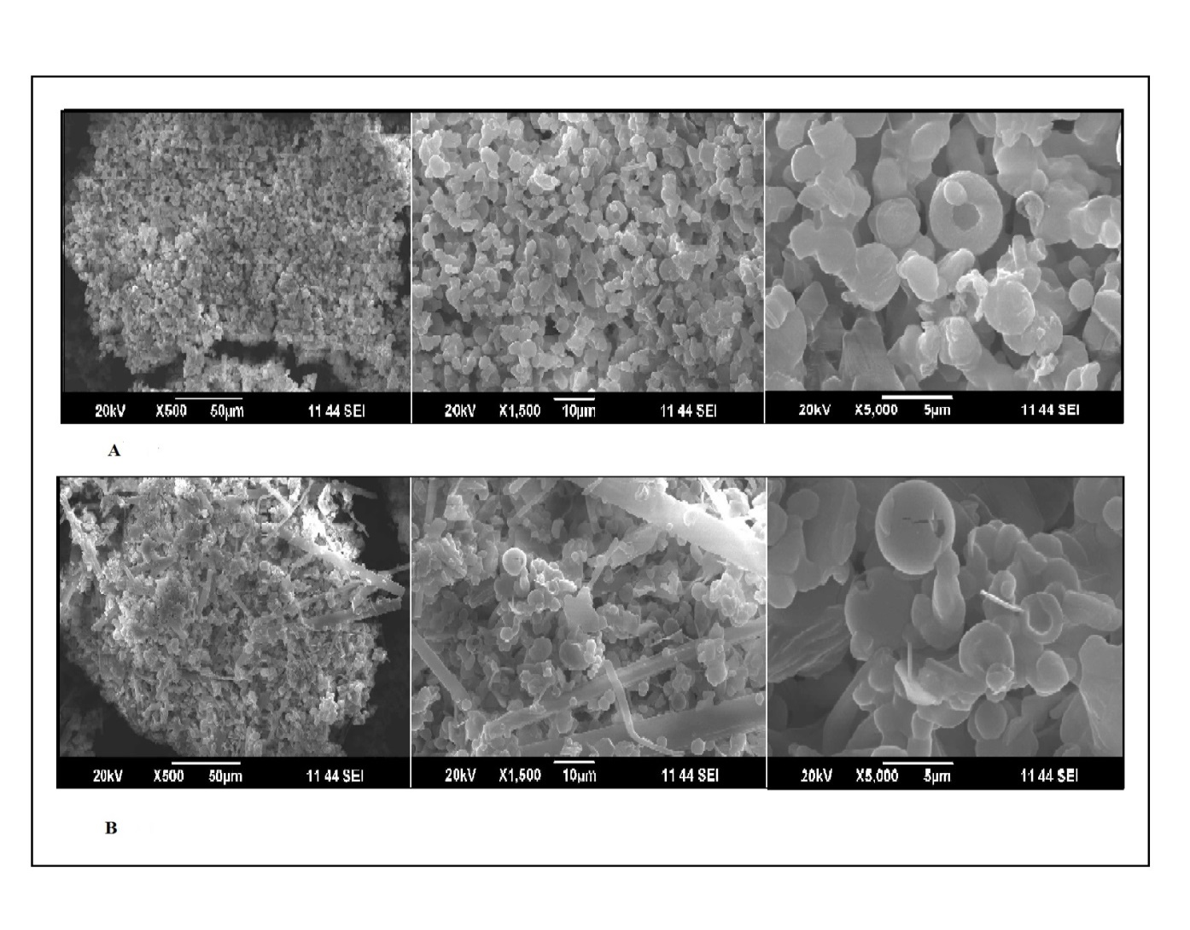**Fig 04: SEM image of (A) Optimised formulation,(B)Unoptimized formulation.**

**Particle size analysis:**

“Average particle size values of microspheres were found to be between 2.53 to 11.92 as seen in **Table no2**. It was found that the polymer: drug ratio of microspheres had a significant effect on the particle size of microspheres. Increasing feed-flow rate also contributed to the increased particle size, but not significantly, and this may be due to the narrower range being selected to focus on this parameter. Optimised and unoptimized batch images show in **fig no05”**. (Ige et al. 2018)

**Particle size and Polydispersity index (PDI)**

The particle size is a crucial factor because it determines the rate and extent of drug release as well as drug absorption. The smaller droplet size provides a larger interfacial surface area for drug absorption. Also, the calculation of polydispersity index takes into account the particle mean size, the refractive index of the solvent, the measurement angle and the variance of the distribution.The particle sizeof the microsphere and PDI of the microsphere are as shown in **Figure no5**

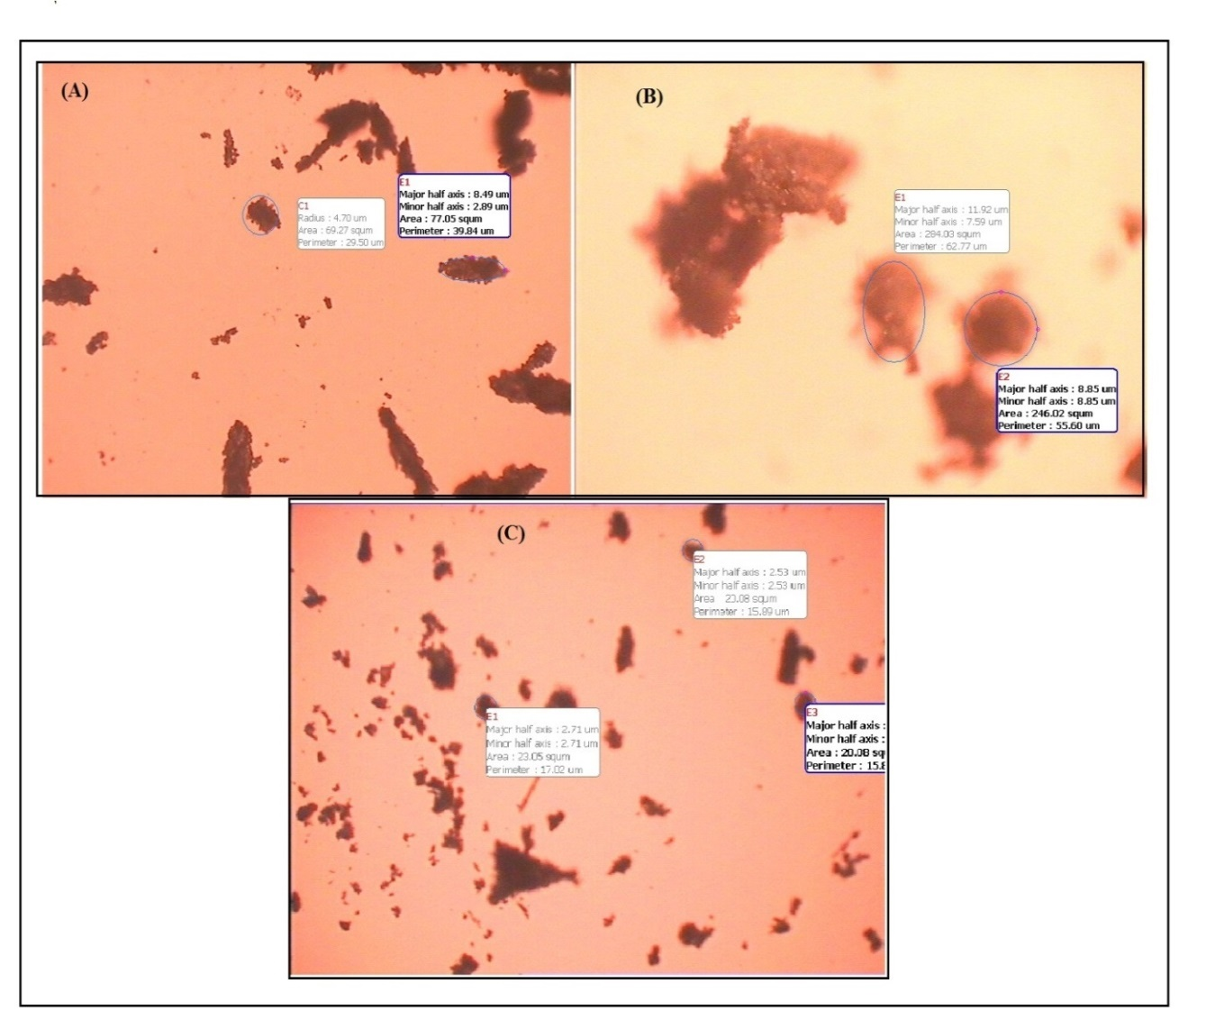

**Fig 05: Particle size image of (A) (B) Unoptimized formulation,(C) Optimised formulation.**

**Zeta potential measurement:**

The OBM microspheres prepared were negatively charged, indicating the presence of OBM at the surface of all microspheres. The zeta potential drug drug-loaded microspheres was mV **(Figures )**. The studies have shown that polymers with charge density can serve as good mucoadhesive agents.

***In- vitro* drug release studies:**

The *In- vitro* drug release study of flutamide-loaded microspheres was carried out using a USP XXVI paddle (Type II) apparatus. The release profile of optimised batch MBF10 after 7 hours in 6.8 pH phosphate buffer solution is shown in **Figure no06**. Optimised formulation shows 88% release after 7 hours as compared to other formulations in the following figure. The release pattern of all the formulations appears to be slow release with a negligible burst effect.

**Fig 06:*****In –vitro* release study of Flutamide from microsphere.**

**Kinetics of *In-vitro* Drug Release:**

“The *In-vitro* drug release kinetics of **MBF10** microspheres were best fitted by the Higuchi kinetic model. The plot shows shows highest linearity and R2 = 0.976. The corresponding plot of log cumulative percentage drug release vs log time of the Korsmeyer–Peppas equation indicated a good linearity of regression coefficient(R2 =  0.973). The release exponent (n) of the Korsmeyer–Peppas equation, was found to be 0.745. Then-value indicated that the optimised formulation (F1) followed the non-Fickian or anomalous diffusion mechanism of drug release”. (Ige et al. 2018)

**Characterisation of suppository:**

**Visual characterization**

In visual characterisation the randomly selected suppository was cut longitudinally and taken section and examined with the naked eye. The suppository shows absence of fissuring, fat blooming, exudation and absence of migration of active ingredients.

**Length and width**

The ten suppositories were selected for the present investigation, and their length and width were calculated. The average length and width of suppositories is 260 ±4mm and 80 ±2mm **( table no03**)

**Weight variation**

The ten suppositories were selected for the present investigation and the average wt calculated. The average average wt of suppositories is 935±6 mg ( **table no03** ) The wt variation test conformsto the British pharmacopoeia with a standard deviation of less than 5%

**Hardness of suppository**

The formulated rectal suppositories were smooth and fine in texture with mechanical strength (hardness), i.e the formulated suppository shows the hardness of less than 5%(**Table no03**)

**Friability**

“The crushing or breaking strength was determined for measuring fragility or brittleness of the suppositories, which assess whether the suppositories will be able to withstand the hazards of packaging, transporting and normal handling or not. The friability was found to be within acceptable limits (less than 1%). (**Table no03**)” (Ige et al. 2018)

**Melting point**

The time required for the suppository to melt was 40min in 6.8 pH buffer solution maintained at a constant temp 37± 0.5℃. After 40 minutes the suppository is completely dispersed in the buffer solution. It plays a crucial role in the release of the active ingredient in the suppository.(**Table No. 03)**

**Disintegration test**

The disintegration test showed that suppositories of microshere disintegrated at 35 min respectively. formulations soften and disintegrate within the standard limits and are found satisfactory. Shows in **table no. 03**

**Differential Scanning Calorimetry (DSC):**

In **Fig. no07**, peak **A** shows the graph of PEG 4000, and peak B shows the graph of microsphere-loaded suppository. The observed peak B shows the molecular dispersion of microsphere in the suppository base, shown in **Fig. no07**.

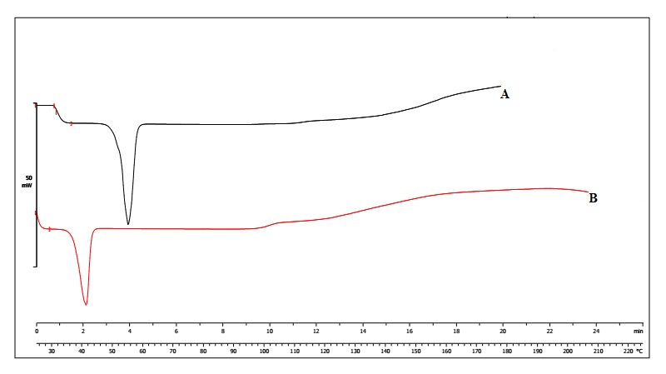

**Fig 07: DSC thermograph of (A) PEG4000, (B) microsphere-based suppository.**

***In-vitro* dissolution of suppositories**

“In vitro drug release from suppositories was determined using the USP XXII paddle method (500 ml, pH 6.8 phosphate buffer solution, 37ºC±0.5, 100 rpm). The release profile of microsphere-loaded suppository is shown in **Figure no08** . The suppository shows 90.46% release after 7 hours”. (Ige et al. 2018)

**Fig 08: *In –vitro* release study of microsphere based suppository.**

**Stability study of microsphere**

“Formulation (MBF10) showing optimum particle size, entrapment efficiency and highest drug release was subjected to stability studies. As per ICH guidelines, the selected formulation was stored at 40C temperature and 75% relative humidity (RH) for a period of 3 months. Formulations were evaluated for particle size, entrapment efficiency and in vitro mucoadhesion at an interval of 1 month. The particle size is 4.51, Entrapment efficiency is 68.01%, and in vitro mucoadhesion is 86.21%The changes were negligible enough to conclude that the drug was retained within the microspheres and formulation was found to be stable throughout the stability period”. (Ige et al. 2018)

**Conclusion:**

Flutamide-loaded OBM microspheres were successfully prepared by the spray drying technique. Spray drying is a suitable technique for the preparation of mucoadhesive microspheres. By selecting and evaluating the process parameter, it might be possible to prepare microspheres with desired properties, such as uniform particle size, high entrapment efficiency and improved surface properties. The most prominent advantage of the microsphere as free flowing powder for rectal drug administration. This feature is satisfactory for the convenience of administration for the patient. This study concludes that the microsphere based on OBM to be considered as a promising rectal delivery system for the administration of flutamide.

Disclaimer (Artificial intelligence)

Option 1:

Author(s) hereby declare that NO generative AI technologies such as Large Language Models (ChatGPT, COPILOT, etc.) and text-to-image generators have been used during the writing or editing of this manuscript.

Option 2:

Author(s) hereby declare that generative AI technologies such as Large Language Models, etc. have been used during the writing or editing of manuscripts. This explanation will include the name, version, model, and source of the generative AI technology and as well as all input prompts provided to the generative AI technology

Details of the AI usage are given below:

1.

2.

3.

**References:**

1. L.J. Prasanna , B. Deepthi, R.N. Rao , Rectal drug delivery: A promising route for enhancing drug absorption, Asian J Res Pharm Sci vol 2, (2012), 143-149.
2. P. Baviskar , A. Bedse, S. Sadique, V. Kunde, S. Jaiswal, Drug delivery on rectal Absorption: Suppositories, Int. J Pharm Sci Rev Res, 21(1), (2013), 13, 70-76.
3. E. Campos, J. branquinho, A. S. Carreira, A. Carvalho, P. Coimbra, P. Ferreira, M. H. Gil,Designing polymeric microparticle for biomedical and industrial application,European polymer journal 49(2013),2005-2021.
4. M. Licciardi, M.D. Stefano, E.F. Craparo, G. Amato, G. Fontana, G. Cavallaro, G. Giammona, International journal of pharmaceutics, 433, (2012), 16-24.
5. A.C. Rodriguez-llimos, D. Chiappetta, M.E. Szeliga, A. Fernandez, C. Bregni, Microparticulas de alginatoconteniendoparacetamol, ArsPharmaceutica, 44:4, (2003), 333-342.
6. S. Dhanasingh, S. K. Nallaperumal, Chitosan/casein microparticles : Preparation , characterization and drug release studies, World academy science engineering and technology, 44, (2010).
7. P. B. O’ Donnell, J. W. Mcginity, Preparation of microspheres by the solvent evaporation technique, Advanced drug delivery reviews, 28, (1997), 25-42.
8. T. Kristmundsdottir, O.S. Gudmundsson, K. Ingvarsdottir, Release of diltiazem from eudragitmicroparticles prepared by spray- drying, International journal of pharmaceutics, 137, (1996), 159-165.
9. W. Liu, W. D. Wu, C. Selomulya, X.D. Chen, Uniform chitosan microparticles prepared by a novel spray dryingtechnique, Hindawi publication corporation, (2010), 1-7.
10. P. Tangri, S. Khurana, N.V. Satheesh Madhav, Mucodhesive drug delivery: Mechanism and method of evaluation, International journal of pharma and bio sciences vol 2, (2011), 458-467.
11. N. Motlekar, B.B. Youan, Optimization and experimental parameters for the production of LMWH- loaded polymeric microspheres, Drug design development and therapy, 2, (2008), 39-47.
12. A. Rafe, S.M.A. Rozavi, R. Farhoosh, Rheology and microstuctured of basil seed gum and b-lactoglobulin mixed gel, Food hydrocolloids, 30, (2013), 134-142.
13. J.P. Osano, S.H. Hosseini-Parvar, L. Matia-Merino, M. Golding, Emulsifying properties of a novel polysaccharides extracted from basil seed ( Ocimum bacilicum L.) Effect of polysaccharides and protein content, Food hydrocolloids, 37, (2014), 40-48.
14. S. Chaudhari, M. Bawaskar, A. Shirsat, Formulation and evaluation of bilayer floating tablet of carvedilol phosphate, Journal of drug delivery and therapeutics, 2(5), (2012), 9-19.
15. K.R. Khandelwal, practical pharmcognosy, nirali prakashan,pune.34-38.
16. Y. Aizawa, I. Ikemoto, K. Kishimoto, T. Wada, H. Yamazaki, Y. Ohishi, H. Kiyota, N. Furata, H. Suzuki, M. Ueda, Flutamide induced hepatic dysfunction in relation to steady- state plasma concentrations of flutamide and its metabolites, Kluwer academic publishers, 252, (2003), 149-156.
17. W.M. Samy, Class II drug; a dissolution / bioavailability challenge: Flutamide- loaded spray dried lactose for dissolution control, International journal drug development and research vol 4, 4(2), (2012), 195-204.
18. J. Posti, K. Katila, T. Kostaiainen, Dissolution rate limited bioavailability of flutamide, and in vitro- in vivo correlation, European journal of pharmaceutics and biopharmaceutics, 49, (2000), 35-39.
19. N. Elgindy, K. Elkhodairy, A. Molokhia, A. Elzoghby, Lyophilization monophase solution technique for improvement of the physiochemical properties of an anticancer drug, flutamide, European journal of pharmaceutics and biopharmaceutics, 74, (2010), 397- 405.
20. D.M. Patel, D.G. Prajapati, N.M. Patel, Seed mucilage form Ocimum americanum linn as disintegrant in tablets: Separation and evaluation, Indian journal of pharmaceutical sciences, (2007), 431- 435.
21. H.S. Mahajan, B.V. Tatiya, P.P. Nerkar, Oandestron loaded pectin based microspheres for nasal administration: On vitro and in vivo studies, powder technology, 221, (2012), 168- 176.
22. S. Pugunes, R.E .Ugander, Formulation and evaluation of natural palm oil based diclofenac sodium suppositories, International journal of pharmaceutical sciences and research, 4(2), 2013, 617-621.
23. R.M. Martins, S.V. Pereira, S. Siqueira, W.F. Salomao, L.A. Pedro Freitas, Curcuminoid content and antioxidant activity in spray dried microparticles containing turmeric extract, Food research international, 50, (2013), 657-663.
24. L.M. XU, Q.A. Zhang ,Y. Zhou , H. Zhao , J.X. Wang , J.F. Chen , Engineering drug ultrafines particles of beclomethasone dipropionate for dry powder inhalation, International journal of Pharmaceutics, 2012, 436, 1-9.
25. S.A .Jain, D.S. Chauk, H.S. Mahajan, A.R. Tekade, S.G. Gattani , Formulation and evaluation of nasal mucoadhesive microsphere for sumitripton succinate , Journal of microencapsulation , 26(8), (2009), 711-721.
26. R. Ghaderi, P. Artursson, J. Carlfors, A new method for preparing biodegradable particles and entrapment of hydrocortisone in DL-PLG microparticles using supercritical fluids, European journal of pharmaceutical sciences, 10, (2000), 1-9.
27. C.V. Pardeshi, P.V. Rajput, V.S. Belgamwar, A.R. Tekade, Formulation, optimization and evaluation of spray dried mucoadhesive microspheres as intranasal carriers for valsartan, informa healthcare, 29(2), (2012), 103-114.
28. P.P Ige, S.G. Gattani, Design and *In vitro* and *In vivo* characterization of mucoadhesive matrix pellet of metformin hydrochloride for oral controlled release: A Technical Note, 35(3), (2012), 487-498.
29. S. Patil, A. Babbar, R. Mathur, A. Mishra, K. Sawant, Mucoadhesive chitosan microspheres of carvedilol for nasal administration, Journal of drug targeting, informa healthcare, 18(4), (2010), 321- 331.
30. H.S. Mahajan, S.A. Gundare, Preparation characterization and pulmonary pharmacokinetics of xyloglucan microspheres as dry powder inhalation, Carbohydrate polymers, 102, (2014), 529-536.
31. H.A. Garekani, Z.F. Moghaddam, F. Sadeghi, Organic solution versus aqueous dispersion of Eudragit RS in Preparation of sustained release microparticles of theophylline using spray drying, Colloids and surfaces B: Biointerfaces, 108, (2013), 374-379.
32. R. Shegokar, K. Singh, In vitro release of paracetamol from suppocire suppositories: Role of additives, Malaysian journal of pharmaceutical sciences, 1, (2010), 57-71.
33. H.M. Varsheney, A. Chatterjee, Formulation evaluation and in vitro release characteristics of Zaltoprofen suppositories, Asian journal of pharmaceutical and clinical research, 4, (2012), 235-238.
34. Brtish pharmacopoeia,1988,vol-II.
35. H.A. Liberman, M. M. Ringer, G. S. Banker,Pharmaceutical dosage form dispersed system. vol 3, revised and expanded.
36. H.M. Varshney, Y.S. Tanwar, Designing , release characteristics and in vitro evaluation of flurbiprofen sodium suppositories, International journal of pharmaceutical and clinical research, 1(1), (2009), 31-34.
37. L. Lachman, H. A. Liberman, The theory and practice of industrial pharmacy,special edition 2009, 568.
38. E. M. Samy, M.A. Hassan, S.S Tous, C.T. Rhodes, Improvement avalaibility of allopurinol from pharmaceutical dosage forms I- suppositories, European journal of pharmaceutics and biopharmaceutics, 49, (2000), 119-127.
39. A.H. Baria, R.P. Patel, A.M. Suthar, R.B. Parmar, Formulation development and evaluation of sustained release Aceclofenac suppository, International journal of pharmaceutical sciences and drug research, 1(2), (2009), 71-73.
40. R. Yahagi, H. Onishi, Y. Machida, Preparation evaluation of double-phased mucoadhesive suppositories of lidocaine utilizing carbapol and white beeswax, Journal of controlled release, 61, (1999), 1-8.
41. Rathi, R., Sanshita, Kumar, A., Vishvakarma, V., Huanbutta, K., Singh, I., & Sangnim, T. (2022). Advancements in rectal drug delivery systems: clinical trials, and patents perspective. *Pharmaceutics*, *14*(10), 2210.
42. Shalaby, K., M. Samy, A., Kassem, A., F. Ibrahim, M., K. Alruwaili, N., M. Ali, H., & Elmowafy, M. (2019). Formulation, in vitro and Bioavailability Assessments of Ranitidine Rectal Suppositories. *Journal of Pharmaceutical Research International*, *30*(1), 1–10.
43. Baumann, J. M., Adam, M. S., & Wood, J. D. (2021). Engineering advances in spray drying for pharmaceuticals. *Annual review of chemical and biomolecular engineering*, *12*(1), 217-240.
44. Jayaprakash, P., Maudhuit, A., Gaiani, C., & Desobry, S. (2023). Encapsulation of bioactive compounds using competitive emerging techniques: Electrospraying, nano spray drying, and electrostatic spray drying. *Journal of Food Engineering*, *339*, 111260.
45. Tanyapanyachon, P., Dana, P., Thumsongsiri, N., Chonniyom, W., & Saengkrit, N. (2023). Interrupting the blood-testis barrier with a flutamide-loaded nanostructured lipid carrier: A novel nonsurgical contraceptive approach for male animals. *Theriogenology*, *206*, 96-105.
46. Ige, P. P., Badgujar, R. R., Nerkar, P. P., Mahajan, H. S., Sonawane, R. O., & Surana, S. J. (2018). Study of physicochemical properties of flutamide-loaded Ocimum basilicum microspheres with ex vivo mucoadhesion and in vitro drug release. *Particulate Science and Technology*, *36*(5), 583-591.