***Original Research Article***

**Identification, Characterization and Quantification of Lipid Peroxidation Products in Re-used Deep Fried Oil from Food Vendors in South Eastern Nigeria**

**Abstract**

This research work aims to identify, characterize and quantify the presence of cytotoxic lipid peroxidation products in re-used deep fried culinary oil collected from different fast food vendors within (Enugu, Ebonyi, Anambra, Abia and Imo) States in Eastern Nigeria. Hundred milliliter (100 mL) of re-used deep fried vegetable oil collected from different fast food vendors within these States, were subjected to characterization, and further identification and quantification of end products of lipid peroxidation level using thiobarbituric acid reactive substances (TBARS) method, slightly modified ferrous oxidation-xylenol orange assay method (FOX2 assay) and GC-MS analysis. Our findings indicate significant (p<0.05) increase in aldehyde groups, lipid hydroperoxide concentrations, saponification values, rancidity, percentage free fatty acid values, acid values, and remarkable decrease in iodine values in comparison with fresh refined vegetable oil. Our result from Gas chromatography-mass spectrometry analysis of methylated re-used deep fried vegetable oil detected, Cholest-5-en-3-ol (3β)-propanoate an already established inducer of echinocytic transformation of human erythrocytes. The failure of methylation process to capture very short chain hydrocarbons necessitated the use of derivitazation method, which was able to detected already established cytotoxic product namely; trans, trans-2,4-decadienal, a highly reactive and pro-apoptotic α, β-unsaturated aldehyde capable of initiating nitrative/oxidative stress.

**Introduction**

Palm oil, which consists of red palm and palm kernel oil are indispensable products in the developing countries where it is used mostly for cooking. It is very useful in making consumable products, detergents, cosmetics and, to some extent, biofuel. Nigeria spent approximately N300billion on importation of palm oil between 2007 and 2022, since the then local production level could not cope with the demand. This implies that Nigeria spends an average of N50billion per annum on importation of these products, knowing fully well that Nigeria used to be the world’s major producer of the commodity in the 1960s. Currently, we were producing approximately 1.4 C:\Users\FRANK\AppData\Local\Temp\ksohtml11152\wps83.jpg 109 kg against the 3.0 C:\Users\FRANK\AppData\Local\Temp\ksohtml11152\wps84.jpg 109 kg consumed locally (Adegbyega, 2023). However, based on the hash economic situation in the country coupled with the current removal of fuel subsidy, which translated to increase in inflation, all the ready-made deep-fried fast food vendors asked confirmed that they do not discard oil after re-using it many times. Instead, they add fresh oil to the re-used deep fried oil. Discarding vegetable oil after re-using it many times was strange to all the food vendors interviewed. Many of them said that it would be practically impossible for them to engage in the practice of discarding their oil without re-using them considering the economic cost. Recently discovered increase in distortion of most biochemical homeostasis, with health complications such as inflammation of the vascular system, disorders, hematological complications and premature death, among Nigerians, may partly be attributed to increased rate of consumption of highly oxidized lipids unknowingly via intake of deep-fried food (Ezenwali, 2022). The all-inclusive well-being of the cells of an organism determines the total well-being of an organism which is central to its quality of life. Maintenance of good public health requires critical identification of potential exogenous sources of free radicals especially via research analysis and conscious avoidance of such, coupled with mitigation policies. The membrane lipids represent the first line of attack by lipid peroxidation products/oxidative free radicals, since they constitute the outer most part of body cells. Unsaturated fatty acids (omega-9, -6 and -3 series), which are the major constituents of membrane lipids serve as good substrates for free radical attacks because of the presence of active bis-allylic methylene groups. The carbon-hydrogen bonds on these activated methylene units have lower bond dissociation energies, making these hydrogen atoms more easily abstracted during free radical reaction/attack (Brash, 2000).The unpaired electron on the carbon, undergoes molecular rearrangement of the double bond to form a conjugated diene which then combines with oxygen to form a peroxyl radical (Halliwell & Gutteridge, 1984). This reaction generates a variety of toxic compounds, including reactive oxygen species (ROS) and lipid peroxidation products (Yin, *et al*., 2011), which can distort most biochemical homeostasis (including endoplasmic reticulum homeostasis).However, some of these products of lipids peroxidation have been confirmed to have mutagenic (Rekhadevi & Rajagopal, 2016), carcinogenic ((Pelucchi *et al*., 2014) cytotoxic and genotoxic (Srivastava, *et al*., 2010a; Srivastava, *et al.,* 2010b)) properties and constitute risk factors to overall health of body cells. Although, over five decades now the pathophysiological, nutritional and toxicological effects of re-used deep fried oil have been the subject of intensive researches (Dobarganes & Márquez-Ruiz, 2015), but the difficulties in reaching thorough conclusions has been partly the disparities in total concentration of products of lipid peroxidation generated in fried oil and the heating conditions used. This was estimated using the formula which states that the sum total of products of lipid peroxidation in deep fried fast food sample is equals the total concentration of volatile and non-volatile products of lipid peroxidation of fried oil absorbed by the deep-fried fast food plus the total concentration of intrinsic volatile and non-volatile products of lipid peroxidation constituents of the deep-fried food} (Ezenwali, 2022). With regard to epidemiological studies, no research work has so far linked normal culinary use of frying oil and distorted biochemical homeostasis (Dobarganes & Márquez-Ruiz, 2015), coupled with the fact that, fried food diets are crucial constituents of Mediterranean diet, which is strongly linked with a reduced risk of cardiovascular events. The number and concentrations of toxic lipid peroxidation compounds thus formed in fried Mediterranean diets are significantly low, since their oil are subjected to normal culinary practices. The health benefits of Mediterranean fried foods (diets) should not be attributed to frying but to the nutritional composition of the oil. However, oxidative free radicals have been implicated in the distortion of biochemical homeostasis resulting in health impairments. One of the most commonly known markers of oxidative/nitrative stress and antioxidant status in cancerous patients is malondialdehyde level (Stefan Gawel, *et al*., 2004). The aim of this research work is to identify, characterize and quantify the presence of cytotoxic lipid peroxidation products in re-used deep fried culinary oil collected from different fast food vendors within (Enugu, Ebonyi, Anambra, Abia and Imo) States in Eastern Nigeria.

**2. Materials and Methods**

**2.1 Materials**

**2.1.1 Equipment**

Precision weighing balance, refrigerator, water bath (U-Clear England), spectrophotometer (U-Clear England), incubator (U-Clear England), Rotary evaporator (Eyla N-1000, Japan), desiccator, centrifuge (Hanil, MF-80, Korea) and Shimadzu GC–MS QP2010 Ultra equipment (Japan).

**2.1.2 Chemicals and Reagents**

Thiobarbituric acid (TBA) (Molychem India); malondialdehyde tetrabutyl ammonium salt (MDA salt), 2, 4-Dintrophenlyhydrazine 98%, Methanol (CDH), and Chloroform (Lab-Chem), Butylated Hydroxyl Toluene (Lobachemie). All other chemicals and reagents were of analytical standard with high purity.

**2.2 Methods**

**2.2.1 Reagent Preparations**

**2.2.1.1 Butylated Hydroxyl Toluene**

To prevent further oxidation of the sample during the actual analysis, Butylated Hydroxyl Toluene (0.01%) was prepared by dissolving 0.01g of BHT in 100 mL double distilled/deionized water.

**2.2.1.2 Preparation of Methanol KOH**

A known quantity (22.40 g) of KOH was dissolved in 200 ml of analytical standard methanol.

**2.2.1.3 Collection of Re-used deep fried vegetable oil from food vendors**

A known volume (100 mL) of re-used deep fried oil were collected from different fast food vendors within the five states in Eastern Nigeria. However, re-used deep fried oil were subjected to characterization, quantification of levels of products of lipid peroxidation using thiobarbituric acid reactive substances (TBARS) assay method, and determination of concentrations of lipid hydroperoxide using slightly modified FOX-2 assay method. In the first phase of GC-MS analysis, the raw, untreated re-used deep fried oil was used, in the second phase methylated re-used deep fried oil was used, while in the third phase derivatized re-used deep fried oil was used. Finally, the untreated raw re-used deep fried oil, methylated and derivatized oil samples were further subjected to GC-MS analysis.

**2.2.2 Characterization of re-used oil**

**2.2.2.1 Percentage Free fatty acid value**

Free fatty acid value which indicates the measure of fatty acids hydrolyzed from esterification bond with glycerol were determined using the method of Association of Analytical Chemists (2015). A known weight of the oil 1.00g was accurately weighed into a neatly washed and dried 250 mL Erlenmeyer flask using a precision weighing balance. A known volume (2.00 mL) of phenolphthalein indicator and 50 mL of neutralized ethanol were added, with proper shaken to form homogenous mixture. The homogenous mixture was titrated with standard base (0.1N NaOH), with vigorous but constant shaking until the endpoint, indicated by a slight pink colour change that persists for 30s, was reached. The titrant volumes were recorded.

FFA value was calculated using the formula;

Percent free fatty acid (as Oleic acid) = C:\Users\FRANK\AppData\Local\Temp\ksohtml11152\wps85.jpg

**Where** v = titer value of the base

**2.2.2.2 Saponification Value**

The saponification value, which represent the amount of alkali needed to saponify a given amount of oil, expressed as mg KOH to saponify 1 g sample, was determined using the method of AOCS (2009). A known weight of the oil 5.0g was accurately weighed into a neatly washed and dried 250 mL Erlenmeyer flask using a precision weighing balance. This was followed by the addition of 50 mL of alcoholic potassium hydroxide into the flask. Duplicate blank samples were prepared with just 50 mL of alcoholic potassium hydroxide in 250 mL Erlenmeyer flasks without samples. Few boiling beads were added to the flasks with oil sample and were connected .to condenser. These were gently but steadily heated on a hot plate until the sample is clear and homogenous, indicating complete saponification, then the samples were allowed to cool to room temperature after disconnecting the flask from condenser. A known volume (1ml) of phenolphthalein indicator was added into the samples/blank and titrated with 0.5 *N* HCl until the pink colour disappeared. The volumes of titrants used were recorded.

Saponification Value = C:\Users\FRANK\AppData\Local\Temp\ksohtml11152\wps86.jpg

**Where;**

Saponification value = mg KOH per g of sample

B = Volume of titrant (ml) for blank

S = Volume of titrant (ml) for sample

N = Normality of HCl (mmol/ml)

56.1 = Molecular weight (MW) of KOH (mg/mmol)

W = Sample mass (g)

**2.2.2.3 Iodine Value**

The iodine value (or number) which represent the level of unsaturation is the amount in grams of iodine absorbed per 100g sample, was determined using the method of AOCS (2009).A known weight of the oil 0.5g was accurately weighed into a neatly washed and dried 500 mL glass-stoppered conical flask using a precision weighing balance, followed by addition of 10 ml chloroform to dissolve the oil. Two blank samples were prepared by adding only 10 ml chloroform to 500 ml glass-stoppered flasks. With pipette, 25 ml Wijs iodine solution was added into the sample and blank flasks and were left to stand for 30 min in the dark with occasional shaking. After incubation in the dark, 20 ml potassium iodide solution was added to each flask and were thoroughly shaken. Hundred milliliters (100 mL) of freshly boiled and cooled water was used to wash down any free iodine on the stopper. The final solution was gradually titrated with standard sodium thiosulfate, with constant and vigorous shaking until the yellow colour disappears, and finally followed by the addition of 1ml of starch indicator. The titration continued until the blue colour entirely disappeared. The volumes of titrants used were recorded.

Iodine Value = C:\Users\FRANK\AppData\Local\Temp\ksohtml11152\wps87.jpg

Where;

Iodine value = g iodine absorbed per 100 g of sample

B = volume of titrant (ml) for blank

S = volume of titrant (ml) for sample

N = normality of Na2S2O3 (mol/1000 ml)

126.9 = MW of iodine (g/mol)

W = sample mass (g)

**2.2.2.4 Peroxide values**

Peroxide value, the mill equivalents of the amount of peroxide or hydroperoxide groups per kilogram of oil sample, was determined using the method of AOCS, 2009. A known weight of the oil 5.0g was accurately weighed into a neatly washed and dried 250 mL Erlenmeyer flask using a precision weighing balance, followed by the addition of 30 mL of acetic acid-chloroform solution and was vigorously shaken to dissolve the oil. The blank sample containing only 30 mL of solvent solution, without sample was also prepared. A known volume 5 mL of saturated KI solution was added to both samples and the blank, followed by shaking for 1 min. Distilled/deionized water (30 mL) was added before titration with 0.1N sodium thiosulfate solution, with vigorous shaking until yellow colour disappeared. A known volume 0.5 mL of 1% starch solution was added before continue the titration with vigorous shaking to release all iodine from chloroform layer, until blue colour disappeared. The volumes of titrants used were recorded.

Peroxide Value = C:\Users\FRANK\AppData\Local\Temp\ksohtml11152\wps88.jpg

**Where;**

Peroxide value = mEq peroxide per kg of sample

S = volume of titrant (ml) for sample

B = volume of titrant (ml) for blank

N = normality of Na2S2O3 solution (mEq/ml)

1000 = conversion of units (g/kg)

W = sample mass (g)

**2.2.2.5 Specific gravity/Density of oil samples**

The density of the oil sample was measured using a clean dry 25ml capacity density bottle with empty weight of (Y0). It was later filled with the oil sample, stopper inserted and reweighed to give (Y1). It was later washed clean and dried using oven. The clean dry 25ml capacity density bottle was filled with sample oil, stopper inserted and reweighed to give (Y2) Specific gravity = (Y1-Y0)/(Y2-Y0) = weight of the sample/weight of equal volume of water.

Density = (Y1-Y0)/25

**2.2.3 Lipid Peroxidation Products**

**2.2.3.1** **Determination of malonaldehyde concentrations in samples using TBARS assay**

The malonaldehyde (MDA) levels in the oil samples were measured using the slightly modified method of Zeb and Ullah (2016). One milliliter of malonaldehyde solution was mixed with 1 mL of TBA in five different test tubes for each different concentrations of the standard MDA. These were heated in water bath maintained at 95∘C for a duration of 1hr. The absorbance was read at 532nm using UV-visible spectrophotometer, after cooling to room temperature. A blank sample (n = 5) consists of equal volume of extraction solvent in place of standard or sample. A known volume (1 mL) of each of the oil samples were mixed with 1mL TBA reagent and the above procedure was repeated (n = 5). The TBARS was determined using the formula as μM/g of the sample:

TBARS (μM/g) = (Ac × *V*)/*W* . . . . . . Equation- 1

**Where;**

Ac is the amount determined from the calibration curve

W is the weight of the sample taken

V is volume in mL or dilution factor of the total extract prepared.

**2.2.3.2 Lipid Peroxidation Assay (negative control).**

A slightly modified thiobarbituric acid reactive substances (TBARS) assay method of Janero, (1990); Zhanyuan and William (1992), was used for this assay. In this assay method egg yolk homogenate (10% in distilled water, v/v) was used as lipid source and free radicals were produced by 0.07M Fenton reagent (FeSO4/H2O2). In brief, 1mL reaction mixture containing 0.95 mL egg yolk homogenate was mixed with 0.05mL Fenton reagent and incubated for 30min to induce lipid peroxidation. Free radical generated by Fenton reagent ruptures the lipid bilayer to form malonaldehyde as a secondary product. Immediately after incubation 1 mL of TBA was added into the mixture. The mixture was heated for 1 hour in a water bath maintained at 95∘C. However, after heating for 1 hour, the test tubes were cooled at room temperature and absorbance read at 532nm. The TBARS was calculated using the formula in equation (1) above.

**2.2.3.3 Determination of lipid hydroperoxide concentrations in samples by FOX-2 assay**

A slightly modified ferrous oxidation-xylenol orange assay method of Lapennaet al*.* (2001), in conjunction with triphenylphosphine (TPP) was used to measure the level of Lipid hydroperoxides (ROOH). Known aliquots (180μl) of sample were transferred into ten centrifuge tubes (vials). Then 20 μL of 10 mmol TPP in methanol was added to five of the tubes (vials) to reduce ROOHs, thereby generating a quintuplicate of blanks. Methanol (20 μL) was added to the remaining five (vials) to produce a quintuplicate of the test samples. All the tubes were then vortexed and incubated at room temperature for 30 min prior to the addition of 1800 μL of FOX-2 reagent methanol. The working reagent was routinely calibrated against H2O2 of known concentrations). After mixing, the samples were incubated at room temperature for another 30 min and the tubes were centrifuged at 8000 rpm for 10 min. Absorbance of supernatant was measured at 560 nm. The ROOH concentrations in samples were calculated using the mean absorbance difference between quintuplicate of test samples and the blank samples. Hydroperoxide content was determined by using a molar absorbance co-efficient of 4.3 C:\Users\FRANK\AppData\Local\Temp\ksohtml11152\wps89.jpg 104 M-1 CM-1 in reference to H2O2 standard curve.

**2.2.4 GC-MS Analysis**

**2.2.4.1 Methylation Procedure**

Methylation method according to Wang *at al*. (2015) was used. Hundred microliter (100 μL) of the oil sample was vortex mixed (Biocote Stuart, model R00010, Korea) with 3 mL of methanolic potassium hydroxide (methanolic-KOH) and finally heated in a water bath at 70ºC for 15 min. Immediately, after heating three drops of H2SO4 was added, this was followed by 3 ml of distilled water and 3 ml of n-hexane. The whole mixture was centrifuged (Hanil, MF-80, Korea) for 15 min at 3000 rpm, the supernatant was collected and the vialed supernatant was injected into the GC–MS system (Schimadzu, Japan).

**2.2.4.2 Derivatization method**

A slightly modified derivatization method according to Custodio-Mendoza *at al*., 2022 was used. A known volume (0.5 mL) of the sample (or sample solution described above) was vortex mixed (Biocote Stuart, model R00010, Korea) with 1.3 mL Acetonitride (ACN) (disperser solvent) for 1 min and centrifuged (Hanil, MF-80, Korea) for 2 min at 3500 rpm. Ninety microliters of chloroform (extraction solvent) was mixed with the supernatant, to form a cloudy solution and the resultant mixture was immediately injected into a conical tube containing 0.5 mL derivatization reagent {2, 4-Dintrophenylhydrazine (DNPH) (0.5 g L-1 in 72.916 g L-1 HCl)}, and 4.00 mL ultrapure H2O. The tube was placed in an ultrasound bath (Branson 2510, Bransonic 2510 Spain) maintained at 60 ◦C for 5 min and centrifuged at 4000 rpm for 2 min to form an extract drop at the bottom of the tube. This drop, containing the hydrazine derivation products, was collected using a 100 μL micro syringe (Hamilton, Denmark) and injected into the GC–MS system.

**2.2.4.3 GC–MS analysis**

Separation and molecular identifications of the analytes were carried out with Shimadzu GC–MS QP2010 Ultra equipment (Japan), with injector temperature at 250⁰C and using an ultra-inert double taper liner in splitless mode. (RESCEK RXITM –MS Column, USA (60m x 0.23mmlD x 0.25μm df) was used with a carrier gas (helium) flow rate of 1.88 mL min-1. The temperature started at 100⁰C and increased, with a ramp of 100⁰C min- 1, to 230⁰C; this temperature was maintained for 8.0 min and then increased, using a 35⁰C min-1 ramp, to a final temperature of 280 ⁰C, maintained for 9.50 min. The transfer line, set at 280⁰C, connects the column to an electronic impact source in positive mode (EI+) programed at 250⁰C and 70 eV.

**2.2.5 Statistical Analysis**

The data analyzed by SPSS were recorded as means ± standard deviation. ANOVA procedures were used for One-way analysis of variance. Duncan’s multiple range tests were used to determine significant differences between means. p < 0.05 was regarded as significant and p > 0.05 was non-significant.

**3.0 Results**C:\Users\FRANK\AppData\Local\Temp\ksohtml11152\wps90.png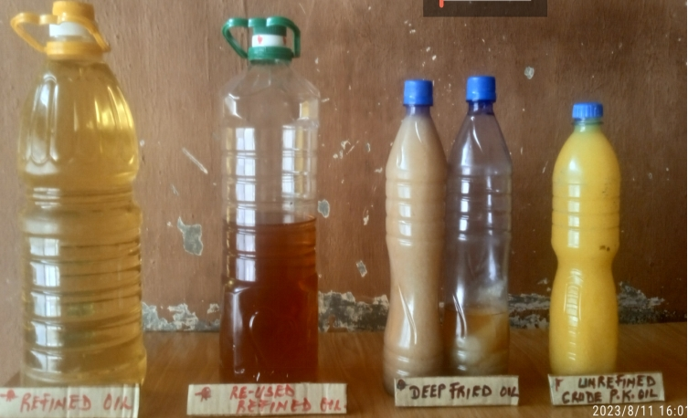

Both re-used refined vegetable oil and re-used deep-fried crude vegetable oil exhibited varied colour changes from pale yellow to amber and tan colours respectively. The observed solidification of both re-used deep-fried crude vegetable oil and un-used/unrefined crude vegetable oil at room temperature in comparison with refined vegetable oil and used refined vegetable oil that are liquid states indicates a significant change in the physical states.

* **Table-1: Characterization values of random oil samples collected from five states in Eastern Nigeria**

|  |  |  |  |  |  |  |  |  |
| --- | --- | --- | --- | --- | --- | --- | --- | --- |
| S/N | Sample | %FFA (Mg/KOH/g) | Iodine-Value (gl/100g) | Peroxide Value | Saponification Value  (mg KOH per g) | Density (g/mL) | Lipid-Hydroperoxides Value(µmol/L) | TBARS  Mean ± S.D (µM/g) |
| 1. | Area-1 | 03.95±0.040 | 14.05±0.000 **β** | 061.41±0.000 **β** | 306.93±0.010 **β** | 0.919±0.050 | 0.0185±0.000 **β** | 0.063±0.030 **β** |
| 2. | Area-2 | 11.28±0.061**β** | 07.36±0.020 **β** | 125.52±0.005 **β** | 312.52±0.005 **β** | 0.931±0.000 **β** | 0.0405±0.002 **β** | 0.229±0.000 **β** |
| 3. | Area-3 | 10.72±0.032 **β** | 06.05±0.052 **β** | 124.46±0.000 **β** | 286.69±0.062 **β** | 0.927±0.001 **β** | 0.0105±0.000 **β** | 0.479±0.005 **β** |
| 4. | Area-4 | 11.56±0.025 **β** | 06.90±0.000 **β** | 069.35±0.013 **β** | 318.27±0.080 **β** | 0.925±0.021 **β** | 0.0540±0.015 **β** | 0.351±0.000 **β** |
| 5. | Area-5 | 05.08±0.010 **β** | 14.00±0.050 **β** | 045.18±0.019 **β** | 254.35±0.001 | 0.919±0.015 | 0.0575±0.008 **β** | 0.118±0.011 **β** |
| 6. | Area-6 | 06.20±0.019 **β** | 14.00±0.009 **β** | 070.66±0.002 **β** | 286.63±0.005 **β** | 0.929±0.004 **β** | 0.1660±0.000 **β** | 0.178±0.001 **β** |
| 7. | Area-7 | 11.84±0.041 **β** | 09.00±0.010 **β** | 100.28±0.006 **β** | 307.41±0.011 **β** | 0.925±0.035 **β** | 0.0149±0.021 **β** | 0.334±0.000 **β** |
| 8. | Area-8 | 05.92±0.000 **β** | 09.20±0.000 **β** | 103.71±0.043 **β** | 278.26±0.060 **β** | 0.935±0.000 **β** | 0.2305±0.004 **β** | 0.207±0.001 **β** |
| 9. | Area-9 | 08.74±0.052 **β** | 12.05±0.020 **β** | 057.39±0.014 **β** | 256.88±0.020 | 0.933±0.010 **β** | 0.0280±0.000 **β** | 0.274±0.032 **β** |
| 10. | Area-10 | 09.59±0.025 **β** | 07.52±0.004 **β** | 123.68±0.000 **β** | 285.79±0.062 **β** | 0.914±0.002 | 0.1064±0.006 **β** | 0.185±0.009 **β** |
| 11. | Area-11 | 10.43±0.060 **β** | 10.15±0.006 **β** | 105.62±0.000 **β** | 292.15±0.000 **β** | 0.908±0.000 | 0.0605±0.000 **β** | 0.207±0.010 **β** |
| 12. | Area-12 | 11.00±0.000 **β** | 06.21±0.025 **β** | 120.04±0.015 **β** | 285.79±0.004 **β** | 0.921±0.013 **β** | 0.1054±0.003 **β** | 0.385±0.000 **β** |
| 13. | Area-13 | 09.02±0.015 **β** | 09.00±0.003 **β** | 104.14±0.008 **β** | 310.12±0.031 **β** | 0.924±0.026 **β** | 0.1555±0.012 **β** | 0.219±0.008 **β** |
| 14. | Area-14 | 04.51±0.006 **β** | 14.20±0.019 **β** | 059.64±0.021 **β** | 312.91±0.002 **β** | 0.922±0.011 **β** | 0.1500±0.015 **β** | 0.062±0.022 **β** |
| 15. | Area-15 | 08.74±0.042 **β** | 12.00±0.001 **β** | 086.35±0.040 **β** | 292.53±0.014 **β** | 0.926±0.017 **β** | 0.1078±0.000 **β** | 0.237±0.002 **β** |
| 16. | Area-16 | 11.84±0.005 **β** | 08.04±0.021 **β** | 128.62±0.000 **β** | 275.55±0.008 **β** | 0.922±0.000 **β** | 0.0815±0.000 **β** | 0.346±0.006 **β** |
| 17. | Area-17 | 10.43±0.050 **β** | 08.00±0.005 **β** | 107.41±0.010 **β** | 315.15±0.001 **β** | 0.921±0.000 **β** | 0.2155±0.006 **β** | 0.198±0.0012 **β** |
| 18. | Area-18 | 09.59±0.000 **β** | 12.16±0.008 **β** | 094.72±0.000 **β** | 274.60±0.000 **β** | 0.928±0.010 **β** | 0.0460±0.000 **β** | 0.278±0.000 **β** |
| 19. | Area-19 | 03.95±0.006 | 15.00±0.001 **β** | 034.05±0.003 | 255.76±0.060 | 0.921±0.002 **β** | 0.0166±0.025 **β** | 0.016±0.001 **β** |
| 20. | Area-20 | 03.81±0.000 | 16.84±0.020 | 031.63±0.001 | 272.89±0.005 **β** | 0.925±0.010 **β** | 0.0525±0.001 **β** | 0.013±0.000 **β** |
| 21 | Refined Oil | 03.04±0.040 | 19.00±0.015 | 025.55±0.000 | 250.20±0.004 | 0.912±0.010 | 0.000±0.000 | 0.004±0.000 |
| 22. | -ve.. Control | -- | -- | -- | -- | -- | -- | 0.834±0.058 **β** |

**Results are expressed in mean ± SD; n = 4**

**The mean values with beta (β) as superscripts across the column compared with (Refined Oil) are considered significant (P<0.05)**

**Table 2: Identified Compounds from GC-MS Chromatogram of Untreated Raw Re-used Deep Fried Oil**

|  |  |  |  |  |
| --- | --- | --- | --- | --- |
| **Retention Time** | **% Area** | **Molecular**  **Formula** | **Compound’s Name** | **Molecular Structure** |
| **05.694** | 00.030 | C18H36O2 | Octadecanoic acid | C:\Users\FRANK\AppData\Local\Temp\ksohtml11152\wps92.jpg |
| **05.830** | 00.050 | C23H36O4 | Phthalic acid, butyl undecyl ester | C:\Users\FRANK\AppData\Local\Temp\ksohtml11152\wps93.jpg |
| **06.028** | 01.330 | C16H32O2 | n-Hexadecanoic acid | C:\Users\FRANK\AppData\Local\Temp\ksohtml11152\wps94.jpg |
| **06.598** | 00.150 | C21H42O3 | Methoxyacetic acid, octadecyl ester | C:\Users\FRANK\AppData\Local\Temp\ksohtml11152\wps95.jpg |
| **07.403** | 00.110 | C19H40O | n-Nonadecanol-1 | C:\Users\FRANK\AppData\Local\Temp\ksohtml11152\wps96.jpg |
| **08.034** | 00.100 | C22H42O2 | Erucic acid | C:\Users\FRANK\AppData\Local\Temp\ksohtml11152\wps97.jpg |
| **08.399** | 00.530 | C18H36O2 | Octadecanoic acid | C:\Users\FRANK\AppData\Local\Temp\ksohtml11152\wps98.jpg |
| **09.530** | 00.150 | C20H36O4 | 2-Butenedioic acid (E)-, bis(2-ethylhexyl) ester | C:\Users\FRANK\AppData\Local\Temp\ksohtml11152\wps99.jpg |
| **11.288** | 01.250 | C22H42O4 | Hexanedioic acid, bis(2-ethylhexyl) ester | C:\Users\FRANK\AppData\Local\Temp\ksohtml11152\wps100.jpg |
| **12.740**  **13.506** | 08.390  24.160 | C27H52O5 | Dodecanoic acid, 1-(hydroxymethyl)-1,2-ethanediyl | C:\Users\FRANK\AppData\Local\Temp\ksohtml11152\wps101.jpg |
| **15.142** | 22.180 | C24H38O4 | 1,3-Benzenedicarboxylic acid, bis(2-ethylhexyl | C:\Users\FRANK\AppData\Local\Temp\ksohtml11152\wps102.jpg |
| **17.955** | 00.900 | C29H50O | beta.-Sitostero | C:\Users\FRANK\AppData\Local\Temp\ksohtml11152\wps103.jpg |
| **18.628** | 00.520 | C30H60O2 | Hexadecanoic acid, tetradecyl ester | C:\Users\FRANK\AppData\Local\Temp\ksohtml11152\wps104.jpg |
| **18.989** | 05.570 | C27H50O6 | Glycerol tricaprylate | C:\Users\FRANK\AppData\Local\Temp\ksohtml11152\wps105.jpg |
| **19.261** | 00.960 | C31H60O5 | Tetradecanoic acid, 2-hydroxy-1,3-propanediyl | C:\Users\FRANK\AppData\Local\Temp\ksohtml11152\wps106.jpg |
| **23.189** | 00.600 | C30H60O2 | Octadecanoic acid, dodecyl ester | C:\Users\FRANK\AppData\Local\Temp\ksohtml11152\wps107.jpg |

**Table 3: Identified Compounds from GC-MS Chromatogram of Methylated Re-used Deep Fried Oil**

|  |  |  |  |  |
| --- | --- | --- | --- | --- |
| **Retention Time** | **% Area** | **Molecular**  **Formula** | **Molecular Name** | **Chemical Structure** |
| **08.123** | **00.88** | C11H22O2 | Decanoic acid, 2-methyl-ester | C:\Users\FRANK\AppData\Local\Temp\ksohtml11152\wps108.jpg |
| **10.974** | **25.01** | C13H26O2 | Dodecanoic acid, methyl ester | C:\Users\FRANK\AppData\Local\Temp\ksohtml11152\wps109.jpg |
| **13.965** | **13.68** | C15H30O2 | Methyl tetradecanoate | C:\Users\FRANK\AppData\Local\Temp\ksohtml11152\wps110.jpg |
| **16.727** | **10.06** | C17H34O2 | Hexadecanoic acid, methyl ester | C:\Users\FRANK\AppData\Local\Temp\ksohtml11152\wps111.jpg |
| **18.842** | **00.38** | C19H34O2 | n-Propyl 9,12-hexadecadienoate | C:\Users\FRANK\AppData\Local\Temp\ksohtml11152\wps112.jpg |
| **18.914** | **16.41** | C19H36O2 | 11-Octadecenoic acid, methyl ester | C:\Users\FRANK\AppData\Local\Temp\ksohtml11152\wps113.jpg |
| **19.262** | **04.89** | C19H38O2 | Methyl stearate | C:\Users\FRANK\AppData\Local\Temp\ksohtml11152\wps114.jpg |
| **20.677** | **25.47** | C27H46O | Cholesterol | C:\Users\FRANK\AppData\Local\Temp\ksohtml11152\wps115.jpg |
| **21.075** | **00.49** | C32H54O2 | Ergost-5-en-3-ol, 22,23-dimethyl-, acetate, | C:\Users\FRANK\AppData\Local\Temp\ksohtml11152\wps116.jpg |
| **21.557** | **00.37** | C25H52 | -methyltetracosane | C:\Users\FRANK\AppData\Local\Temp\ksohtml11152\wps117.jpg |
| **21.877** | **00.17** | C13H26O2 | Undecanoic acid, 10-methyl-, methyl ester | C:\Users\FRANK\AppData\Local\Temp\ksohtml11152\wps118.jpg |
| **22.859** | **00.27** | C28H58 | Octacosane | C:\Users\FRANK\AppData\Local\Temp\ksohtml11152\wps119.jpg |
| **24.117** | **00.26** | C44H90 | Tetratetracontane | C:\Users\FRANK\AppData\Local\Temp\ksohtml11152\wps120.jpg |
| **27.603** | **00.29** | C24H50 | Tricosane, 2-methyl- | C:\Users\FRANK\AppData\Local\Temp\ksohtml11152\wps121.jpg |
| **27.815** | **00.65** | C30H50 | Squalene | C:\Users\FRANK\AppData\Local\Temp\ksohtml11152\wps122.jpg |
| **28.948** | **2.59** | C30H50O2 | Cholest-5-en-3-ol (3.beta.)-, propanoate | C:\Users\FRANK\AppData\Local\Temp\ksohtml11152\wps123.jpg |

**Table 4a: Identified Compounds from GC-MS Chromatogram of Derivatized Re-used Deep Fried Oil**

|  |  |  |  |  |
| --- | --- | --- | --- | --- |
| Retention Time | % Area | Molecular  Formula | Molecular Name | Molecular Structure |
| 3.551 | **0.10** | C10H18O | 2-Decenal, (E)- | C:\Users\FRANK\AppData\Local\Temp\ksohtml11152\wps124.jpg |
| 3.619 | **0.04** | C10H16O | 2,4-Decadienal | C:\Users\FRANK\AppData\Local\Temp\ksohtml11152\wps125.jpg |
| 3.767 | **0.05** | C13H24O | 2-Tridecenal, (E)- | C:\Users\FRANK\AppData\Local\Temp\ksohtml11152\wps126.jpg |
| 4.122 | **0.04** | C10H20O2 | n-Decanoic acid | C:\Users\FRANK\AppData\Local\Temp\ksohtml11152\wps127.jpg |
| 4.258 | **0.10** | C12H24O2 | Dodecanoic acid | C:\Users\FRANK\AppData\Local\Temp\ksohtml11152\wps128.jpg |
| 4.953 | **0.58** | C19H40 | Pentadecane, 2,6,10,14-tetramethyl- | C:\Users\FRANK\AppData\Local\Temp\ksohtml11152\wps129.jpg |
| 5.064 | **2.09** | C14H28O2 | Tetradecanoic acid | C:\Users\FRANK\AppData\Local\Temp\ksohtml11152\wps130.jpg |
| 5.405 | **0.25** | C26H44O5 | Ethyl iso-allocholate | C:\Users\FRANK\AppData\Local\Temp\ksohtml11152\wps131.jpg |
| 5.635 | **0.27** | C15H30O2 | Pentadecanoic acid | C:\Users\FRANK\AppData\Local\Temp\ksohtml11152\wps132.jpg |
| 5.834 | **0.11** | C18H35Cl | cis-1-Chloro-9-octadecene | C:\Users\FRANK\AppData\Local\Temp\ksohtml11152\wps133.jpg |
| 6.055 | **1.06** | C16H32O2 | n-Hexadecanoic acid | C:\Users\FRANK\AppData\Local\Temp\ksohtml11152\wps134.jpg |
| 6.231 | **3.91** | C16H30O2 | Palmitoleic acid | C:\Users\FRANK\AppData\Local\Temp\ksohtml11152\wps135.jpg |
| 6.295 | **0.53** | C16H30O2 | 9-Hexadecenoic acid | C:\Users\FRANK\AppData\Local\Temp\ksohtml11152\wps136.jpg |
| 6.388 | **11.61** | C16H32O2 | n-Hexadecanoic acid | C:\Users\FRANK\AppData\Local\Temp\ksohtml11152\wps137.jpg |
| 6.799 | **0.07** | C16H30O | cis-9-Hexadecenal | C:\Users\FRANK\AppData\Local\Temp\ksohtml11152\wps138.jpg |
| **Table 4b: Total ionized compounds found in derivatized Re-used deep fried oil** | | | | |
| 6.917 | **0.14** | C20H35F3O2 | Oleyl alcohol, trifluoroacetate | C:\Users\FRANK\AppData\Local\Temp\ksohtml11152\wps139.jpg |
| 7.126 | **0.09** | C16H30O2 | 9-Hexadecenoic acid | C:\Users\FRANK\AppData\Local\Temp\ksohtml11152\wps140.jpg |
| 7.351 | **0.09** | C20H40O2 | Eicosanoic acid | C:\Users\FRANK\AppData\Local\Temp\ksohtml11152\wps141.jpg |
| 8.044 | **0.56** | C18H32O2 | 9,12-Octadecadienoic acid (Z, Z)- | C:\Users\FRANK\AppData\Local\Temp\ksohtml11152\wps142.jpg |
| 8.091 | **0.88** | C24H36Cl2Rh2 | Rhodium, bis[5,6-bis(eta.2-ethenyl) cyclooctene | C:\Users\FRANK\AppData\Local\Temp\ksohtml11152\wps143.jpg |
| 8.150 | **0.67** | C18H34O2 | 9-Octadecenoic acid, (E)- | C:\Users\FRANK\AppData\Local\Temp\ksohtml11152\wps144.jpg |
| 8.214 | **1.61** | C18H32O2 | 9,12-Octadecadienoic acid (Z,Z)- | C:\Users\FRANK\AppData\Local\Temp\ksohtml11152\wps145.jpg |
| 8.321 | **5.76** | C18H34O2 | 9-Octadecenoic acid, (E)- | C:\Users\FRANK\AppData\Local\Temp\ksohtml11152\wps146.jpg |
| 8.370 | **1.00** | C18H34O2 | cis-Vaccenic acid | C:\Users\FRANK\AppData\Local\Temp\ksohtml11152\wps147.jpg |
| 8.501 | **0.22** | C18H34O2 | Oleic Acid | C:\Users\FRANK\AppData\Local\Temp\ksohtml11152\wps148.jpg |
| 8.646 | **0.44** | C18H36O2 | Octadecanoic acid | C:\Users\FRANK\AppData\Local\Temp\ksohtml11152\wps149.jpg |
| 9.943 | **0.37** | C14H29NO | N,N-Dimethyldodecanamide | C:\Users\FRANK\AppData\Local\Temp\ksohtml11152\wps150.jpg |
| **Table 4c: Total ionized compounds found in derivatized Re-used deep fried oil** | | | | |
| 10.492 | **0.24** | C21H32O2 | 5,8,11,14,17-Eicosapentaenoic acid, methyl ester | C:\Users\FRANK\AppData\Local\Temp\ksohtml11152\wps151.jpg |
| 10.889 | **0.28** | C18H35NO | 9-Octadecenamide, (Z)- | C:\Users\FRANK\AppData\Local\Temp\ksohtml11152\wps152.jpg |
| 11.116 | **2.66** | C27H46O | Cholesterol | C:\Users\FRANK\AppData\Local\Temp\ksohtml11152\wps153.jpg |
| 11.364 | **0.97** | C30H50 | Olean-18-en | C:\Users\FRANK\AppData\Local\Temp\ksohtml11152\wps154.jpg |
| 11.575 | **0.56** | C18H34O2 | 9-Octadecenoic acid, (E)- | C:\Users\FRANK\AppData\Local\Temp\ksohtml11152\wps155.jpg |
| 11.650 | **0.51** | C20H39NO | 9-Octadecenamide, N, N-dimethyl- | C:\Users\FRANK\AppData\Local\Temp\ksohtml11152\wps156.jpg |
| 12.307 | **4.68** | C19H38O4 | Hexadecanoic acid, 2-hydroxy-1-(hydroxymeth | C:\Users\FRANK\AppData\Local\Temp\ksohtml11152\wps157.jpg |
| 13.236 | **0.74** | C19H26O2 | Androstenedione | C:\Users\FRANK\AppData\Local\Temp\ksohtml11152\wps158.jpg |

**4.0 Discussion**

These data were obtained from re-used deep fried oil from fast food vendors collected via Food Inspection Services procedures, a realistic experimental condition for sampling of used fried oil. The results in figure 1 depict the observed physical states of various oil (refined vegetable oil, used refined vegetable oil, re-used deep-fried crude vegetable oil and un-used/unrefined crude vegetable oil) sampled in the course of this analysis. Both re-used refined vegetable oil and re-used deep-fried crude vegetable oil exhibited varied colour changes from pale yellow to amber and tan colours respectively. The observed variation in colours of these oils especially the unique tan colour of re-used deep-fried crude vegetable oil should be attributed to oxidation of the oil due to extreme high temperature and increased duration of heating. The observed solidification of both re-used deep-fried crude vegetable oil and un-used/unrefined crude vegetable oil at room temperature in comparison with refined vegetable oil that is in liquid state, could be attributed to (high concentrations/amounts of both saturated fatty acids and lipid peroxidation products) and (high concentrations of both saturated fatty acids and impurities) respectively. The relatively straight hydrocarbon chains of short-chain saturated fatty acids allow for efficient packing and crystallization, leading to a solid state, with a relatively high melting point (Ghotra, Dyal, & Narine, 2002). Most Nigerian deep-fried fast food vendors operate mainly from 6.00 to 11.00 am in the morning (phase-I) and from 4.00 to 10.00 pm in the evening time (phase-II). Within these time frames, once the oil is set on fire for frying, a constant temperature is applied continually till the end of each phase. This is to enable consistent frying of different batches (sets) of deep-fried fast foods. This indicates that on an average, a given volume of frying oil is subjected to a constant and high temperature of approximately 300 ⁰C for 10h per day. In re-used oil, fatty acids constituents of the triacylglycerols are modified via oxidative, hydrolytic, polymerization and isomerization reactions which eventually results in lipid peroxidation (Choe & Min, 2007) and generation of wide spectrum of volatile or non-volatile compounds, including free fatty acids, alcohols, aldehydes, ketones, hydrocarbons, *trans* isomers, cyclic and epoxy compounds (Kaviyan *et al*., 2014; Zhang *et al*., 2012). The observed colour changes from pale yellow to amber and tan colours, increased viscosity, off-flavour, enhanced foaming observed in samples in figure 1 above could be attributed to end products of lipid peroxidation reactions. .Our observed results from re-used deep fried oil characterization showed significant (p<0.05) increase in saponification values, peroxide values, percentage free fatty acid values, aldehyde groups, TBARS levels, lipid hydroperoxide concentrations, and significant (p<0.05) reduction in iodine values in comparison with fresh refined vegetable oil, with exception of areas {(1, 19 and 20)}, {(19 and 20)} and {(5, 9 and 19)} that exhibited non-significant increase in percentage free fatty acid values, peroxide values and saponification values respectively and area 20 that exhibited non-significant increase in iodine value. These observed changes could be attributed to increased lipid peroxidation level/free radical attack during frying, while the observed discrepancies in some of the oil from different areas could be due to variations in duration of heating, topping uptime and whether the oil being used was the continuation of the previous day’s oil sample. However, these deep-fried fast foods are either washed in water and salted or dissolved with little volume of water to make paste coupled with addition of salt for taste before frying. When these water and salt coupled with metal ions which may be an intrinsic constituent of the food sample or contaminates from wears and tears of the milling machine comes in contact with the extreme hot oil, generation of free radicals is initiated. Unsaturated fatty acids (omega-9, -6 and -3 series) serve as good substrates for free radical attacks because of the presence of carbon-hydrogen bonds on the active bis-allylic methylene groups (Brash, 2000). They possess lower enthalpy change, making these hydrogen atoms very easy to abstract during free radical attack, leading to fragmentation of the long hydrocarbon chain into fragments. High number of double bonds result in increased free radical attack, which decreases the iodine value, but invariably increases the degree of saturation and fragmentation leading to significant increase in saponification value, peroxide value, percentage free fatty acid, acid value and aldehyde groups. The above assertion is in total agreement with our findings.

Our result from GC-MS analysis of methylated re-used deep fried oil shows the presence of 16 compounds representing 100% of the total oil. The chemical names, molecular structures, retention time (RT) and relative percentage areas of compounds detected by Gas chromatography-mass spectrophotometry are presented in Table 3. One of the already established cytotoxic compounds detected in methylated re-used deep fried oil was Cholest-5-en-3-ol (3β)- propanoate (2.59%), an already established inducer of echinocytic transformation of human erythrocytes that further causes decrease in osmotic fragility of red blood cells. However, the failure of methylation process to capture very low short chain hydrocarbons further necessitates the derivatization method that was able to detected hazardous compounds. An already established cytotoxic product among these compounds is trans-2-trans-4-decadienal, apro-apoptotic and highly reactive α, β-unsaturated aldehyde capable of inducing nitrative/oxidative stress. (2E)-dec-2-enal, with molecular formula (C10H18O) and net charge of zero has been considered hazardous by the 2012 OSHA Hazard Communication Standard (CQA, 2012). It causes serious eye and skin irritation. Information on Eco toxicity revealed that (2E)-dec-2-enal, is very toxic to aquatic organism. Beta-sitosterol (β-sitosterol), a saturated phytosterol similar to cholesterol, is widely distributed among plant kingdom (vegetable oil, nuts and avocados). It helps to reduce cholesterol level by inhibiting its absorption and causes reduction in swelling of enlarged prostate (Benign prostatic hyperplasia), and further possess strong inhibitory activities against both aromatase and 5-alpha-reductase enzymes (David, 2018). Intake of β-sitosterol is one of the many reasons eating vegetables is good for human health. However, another important compound isolated in the course of this analysis is erucic acid, a monounsaturated omega-9 fatty acid denoted as 22:1 n-9, mainly found in rape seeds oil and in repeatedly used oil, inhibits NF-κB and p38 MAPK (Kazmi, *et al*., 2024; Liang, *et al*., 2020), causes lipidosis, raises blood cholesterol and impairs myocardial conductance (cardiac injury) at high concentration (Burrows & Tyrl, 2013). Our result from total ionized compounds in raw untreated re-used deep fried oil indicates the presence of 2-butenedioic acid (E)-; bis(z-ethylhexyl) ester a by-product of condensation reactions between C4H4O4butenedioic acid and two z-ethylhexyl ester, which justified the fact that condensation reaction is one of the predominant reactions during deep frying of vegetable oil. The observed partial hydrolysis of fatty acids esterified to glycerol in Dodecanoic acid, 1-(hydroxymethyl)-1,2-ethanediyl and Glycerol tricaprylate may have justify the fact that fresh oil samples were added to re-used oil by the vendors in the course of frying. (2E)-dec-2-enal, a dec-2-enal in which the olefinic double bond has E configuration, with molecular formular (C10H18O) and net charge of zero was also detected. This compound when released by an injured organism signals the presence of danger to other organisms. Cetene, the most highly reactive hexadecane isomers with chemical formula of C16H32, belongs to the class of organic compounds known as unsaturated aliphatic hydrocarbons, widely used as a surfactant in lubricating fluid and drilling industry was also detected.

However, current literature indicates no available information on its biological bioactivities and interactions, and no available information on its organoleptic roles in food. Although, cetene has been identified as one of the major constituents of ethyl acetate fraction of *Loxostylisalata* extract that exhibited an *in-vitro* antibacterial activity against *salmonella species* (Gado, *et al*., 2021). Arafa *et al*. (2022) identified Cetene, Heneicosane and Hexadecane,2,6,11,15-tetramethyl in *Pimpinella anisum* L. Callus Cultures as affected by yeast and phenylalanine application (Arafa *et al*., 2022), while both Heneicosane and Hexadecane,2,6,11,15-tetramethyl were found to exhibit {Microbicide activities} and {Antifungal, antitumor, antibacterial, larvicidal, antimicrobial, and cytotoxic activities} respectively. 1-nonadecanol, an extremely weak acidic compound, with chemical formula of C19H400 and an average molecular weight 284.5203g, a member of the class of compounds known as long chain fatty alcohols, which is practically insoluble in water, but found in black elderberry and potato was also detected.

**Conclusion**

In our own opinion, this current observed *in-vitro* presence of already established toxicological compounds in re-used deep fried vegetable oil demands that consumption of food samples prepared via re-used deep fried vegetable oil should rather be avoided for now, until *in-vivo* experiment in animal models indicate otherwise. Further research should be particularly directed towards verification of re-use deep fried vegetable oil toxicity and {*in-vivo* and *in-vitro*} cytotoxic screening of the newly isolated aldehydes and carbonyl on wide panel of cells of different organs.

**Disclaimer (Artificial intelligence)**

Author(s) hereby declare that NO generative AI technologies such as Large Language Models (ChatGPT, COPILOT, etc.) and text-to-image generators have been used during the writing or editing of this manuscript.

**References**

Adegbyega, T. (2023). *Sweeter than crude*. The National newspaper, Ltd, April 9.

AOAC Official method 940.28 Fatty acid (Free) in Crude and Refined Oils. 2015 AOAC International.

AOCS (2009) Official methods and recommended practices of the AOCS, 6th edn. American Oil Chemists’ Society, Champaign, IL.

AOCS. (2009). Official methods and recommended practices of the AOCS, 6th edn. American Oil Chemists’ Society, Champaign, IL.

Arafa, M.N., Moawad, M. & Aly, I.U. (2022). Gas Chromatography-Mass spectrometry Analysis of Phytocomponents Present in *Pimpinella anisum*L. Callus Cultures as Affected by Yeast and Phenylalanine Application. *Egypt. J. Chem.* Vol. **65**, No. SI: 13, pp. 667 - 675.

Arafa, M.N., Moawad, M. & Aly, U.I. (2022). Gas Chromatography-Mass spectrometry Analysis of Phytocomponents Present in *Pimpinella anisum*L.Callus Cultures as Affected by Yeast and Phenylalanine Application. *Egyptian Journal of Chemistry*, **65**(13), 667-675.

Brash, A.R. (2000). Autoxidation of methyl linoleate: identification of the bis-allylic 11-hydroperoxide. *Lipids*, **35,**947–952.

Burrows, G.E. &Tyrl, R. J. (2013). *Toxic plants of North America*, 2ndedn., pp: 535-541, Wiley-blackwell, Ames, IA.

Choe. E. and Min, D.B. (2007). Chemistry of deep-fat frying oils. *Journal of Food Sci.,* **72,** R77-86.

CQA, A. B. K. (2012). Going global: OSHA revises hazard communication standard. *Journal of Protective Coatings & Linings*, 1.

Custodio-Mendoza, J.A., Caama˜no-Fernandez, C., Lage, M.A., Almeida, P.J., Lorenzo, R. A. & Carro, A.M. (2022). GC–MS determination of malondialdehyde, acrolein, and 4-hydroxy-2-nonenal by ultrasound-assisted dispersive liquid-liquid microextraction in beverages, *Food Chemistry.* 384, 132530.

David, R. (2018). *Benign Prostatic uyperplasia*, Integrative Medicine Fourth Edition).

Dobarganes, C. & Márquez-Ruiz, G. (2015). Possible adverse effects of frying with vegetable oils. *British Journal of Nutrition,***113**(2),S49-S57.

Ezenwali, M.O**.** (2022). Determination of Concentrations of Lipid Peroxidation Products in Roasted and Deep-Fried Fast Foods sold in South-Eastern Nigeria. *Asian Journal of Advances in Research,* **17**(1), 28-37.

Ezenwali, M.O. (2022b). A Study on the Concentrations of Lipid Peroxidation Products in Roasted and Deep-Fried Fast Foods sold in South-Eastern Nigeria. In Handy, M.A. *Current Overview on Science and Technology Research***(1st ed., 8)**. [**https://youtu.be/nUrFxqcDuLw**](https://youtu.be/nUrFxqcDuLw)

Gado, D.A., Ali Abdalla, M., Ahmed, A.S., Madikizela, B., Nkadimeng, S/ M., Ehlers, M.M. and McGaw, L.J. (2021). *In vitro* antibacterial activity of *Loxostylisalata* extracts and isolated compounds against *Salmonella species*. *BMC Complementary Medicine and Therapies*. 21,121.

Gawel, S., Wardas, M., Niedworok, E. & Wardas, P. (2004). Malondialdehyde (MDA) as a lipid peroxidation marker. *WiadLek*, **57** (9-10), 453-5.

Ghotra, B. S., Dyal, S. D., &Narine, S. S. (2002). Lipid shortenings: a review. *Food research*

Halliwell, B. & Gutteridge, J.M.C. (1984). Oxygen toxicity, oxygen radicals, transition metals and disease. *Biochemical Journal*, **218**: 1-14, ISSN: 0264-6021.

Janero, D.R. (1990). Malondialdehyde and thiobarbituric acid reactivity as Diagnostic indices of Lipid Peroxidation and Peroxidative Tissue Injury. *Free Radical Biology and Medicine.* 9, 515-540.

Kaviyani, M., Ghazi, N.M., Shariati, M.A. &Atarod, S. (2014). The study of frying oils properties. *Int J Adv Eng Res Tech.,* **2,** 90-96.

Kazmi, I., Afzal, M., Al-Abbasi, F. A., AlGhamdi, S. A., Alghamdi, A. M., Alzarea, S. I.& Sayyed, N. (2024). Review of the potential pharmacological role of erucic acid: a monounsaturated omega-9 fatty acid. *Naunyn-Schmiedeberg's Archives of Pharmacology*, *397*(6), 3663-3674.

Lapenna, D., Ciofani, G., Pierdomenico, S.D., Giamberardino, M.A. & Cuccurullo, F. (2001). Reaction conditions affecting the relationship between thiobarbituric acid reactivity and lipid peroxidesin human plasma. *Free Radical Biology and Medicine*,31(3), 331-335.

Leong, X.F., Ng, C.Y., Jaarin, K.& Mustafa, M.R. (2015).Effects of Repeated Heating of Cooking Oils on Antioxidant Content and Endothelial Function, *Austin Journal of Pharmacology and Therapeutics*, **3**(2), 1-6.

Liang X, Huang Y, Pan X, et al. (2020). Erucic acid from *Isatisindigotica* Fort. suppresses influenza A virus replication and inflammation in vitro and in vivo through modulation of NF-κB and p38 MAPK pathway. *J Pharm Anal*, 10(2), 130-146.

O’Keefe, S.F. & Pike, O.A. (2010) *Fat characterization*, Ch. 14. In: Nielsen SS (ed) *Food analysis*, 4th edn. Springer, New York.

Pelucchi, C., Bosetti, C., Galeone, C. & La Vecchia, C. (2014).Dietary acrylamide and cancer risk: An updated meta-analysis. *International Journal of Cancer*, **138**(12), 2912-2922.

Rekhadevi, P.V. & Rajagopal, S. (2016). Evaluation of the deleterious health effects of consumption of repeatedly heated vegetable oil. *Toxicology Reports,***3,** 636-643.

Srivastava, S., Singh, M., George, J. &Bhui, K. (2010a). Genotoxic and Carcinogenic risks associated with the dietary consumption of repeatedly heated coconut oil. *Br J Nutr,* **104**(9), 1343-1352.

Srivastava, S., Singh, M., George, J. &Bhui, K. (2010b). Genotoxic and carcinogenic risks associated with the consumption of repeatedly boiled sunflower oil. *J Agric Food Chem,***58**(20), 11179-11186.

Wang, J.U.N., Wu, W., Wang, X., Wang, M.I.n. & Wu, F. (2015). An effective GC method for the determination of the fatty acid composition in silkworm pupae oil using a two-step methylation process. *Journal of Serbian Chemical Society*, 80 (1), 9 -20.

Yin, H., Xu, L. & Porter, N.A. (2011). “Free radical lipid peroxidation: mechanisms and analysis,” *Chemical Reviews*, **111** (10): 5944–5972.

Zeb, A. & Ullah, F. (2016). A simple spectrophotometric method for the determination of thiobarbituric acid reactive substances in fried fast foods. *Journal of Analytical Methods in Chemistry*, 2016, Article ID 9412767, 5 pages <http://dx.doi.org/10.1155/2016/9412767>.

Zhang, Q., Saleh, A.S., Chen, J. & Shen, Q. (2012). Chemical alterations taken place during deep-fat frying based on certain reaction products: a review. *Chem Phys Lipids*, 165, 662-681.

Zhanyuan, D. & William, J.B. (1992). Modified thiobarbituric acid assay for measuring lipid oxidation in sugar-rich plant tissue extracts. *Journal of Agric. Food Chem*, **40**(9), 1566-1570.

**Figure 2: Total ionized compounds found in methylated re-used deep fried oil**

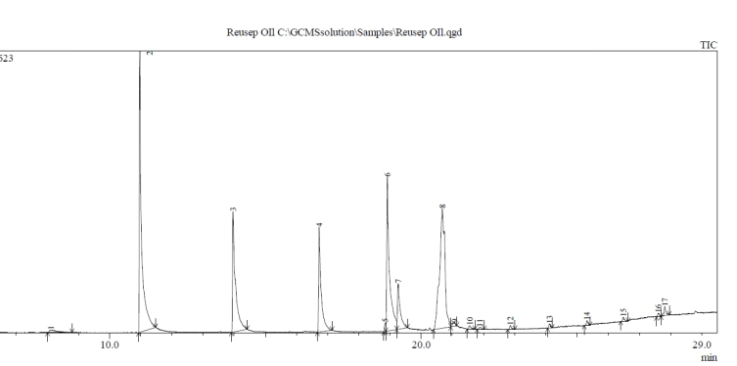

**Figure 3: Total ionized compounds found in derivatized Re-used deep fried oil**

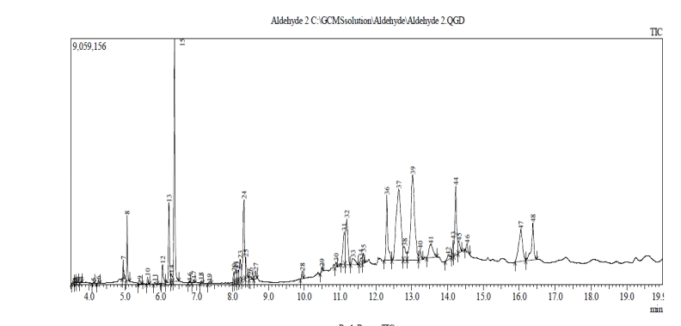

**Figure 4: Total ionized compounds found in raw Re-used deep fried oil**

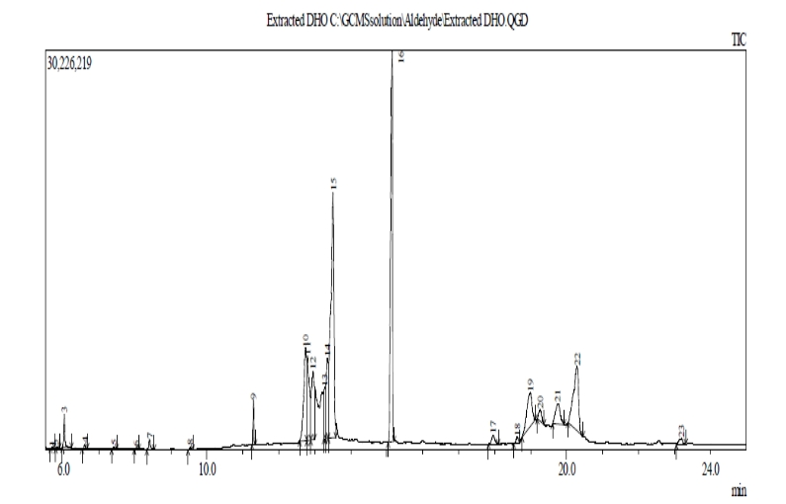

**Table 5: Total ionized compounds found in raw Re-used deep fried oil**

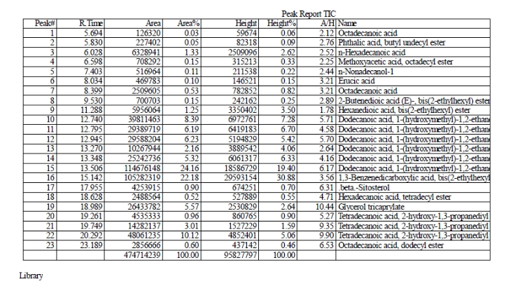

**Table 6: Total ionized compounds found in Methylated Re-used deep fried oil**

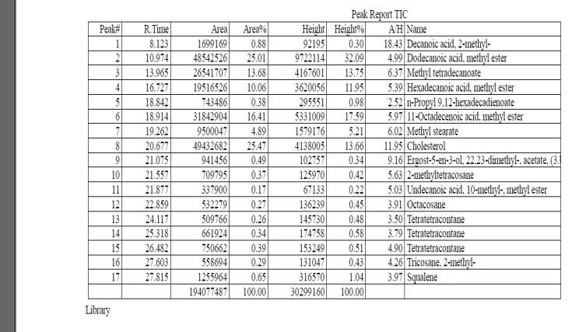

**Table 7: Total ionized compounds found in Derivitized re-used deep fried oil**

