Comparative gross and biometrical studies on the heart of Gaddi sheep and Gaddi goats

ABSTRACT
This study presents a comparative gross and biometrical analysis of the heart in Gaddi sheep and Gaddi goats of Himachal Pradesh. Sixteen heart samples (eight from each species) were collected from healthy adult animals at a local abattoir. Gross anatomical observations revealed that the heart of both species was located ventrally within the mediastinum extending from the third to the sixth intercostal space. The heart of the goat appeared more conical as compared to the relatively less tapered heart of the sheep. In both species the heart exhibited a triangular shape with a blunt apex entirely formed by the left ventricle. A considerable amount of epicardial fat was observed on the surface of heart in both the species. Biometric analysis demonstrated that the mean heart weight was 107.5 ± 2.54g in Gaddi sheep and 113.8 ± 2.85 g in Gaddi goats. The mean length of the anterior border (base to apex) measured 68.0 ± 4.4 mm in sheep and 72.7 ± 2.2 mm in goats. The mean heart diameter was recorded as 174.0 ± 17.6 mm in sheep and 176.0 ± 3.0 mm in goats. Additional parameters including circumference at the coronary groove, thicknesses of the ventricular walls and moderator band and external diameters of the aorta and vena cava were also assessed. The comparative data indicated that most biometrical parameters were greater in Gaddi goats than in Gaddi sheep highlighting species-specific anatomical differences that may have physiological and clinical relevance.
Key words: Biometry; Gaddi; goat; gross; heart; sheep.
INTRODUCTION
Sheep and goats were among the earliest domesticated ruminants which continued to play a vital role in livestock-based economies. In India, these species contribute significantly to agricultural productivity and contributes approximately 2–3% of global wool production and ranking among the top wool-producing countries (Add reference). Additionally, sheep alone contribute about 7.68% to India’s total meat output emphasizing the economic importance of small ruminants in the country (Add Reference). As a vital component of the circulatory system, the heart functions as a muscular pump to maintain systemic and pulmonary circulation. Detailed anatomical and biometrical understanding of the heart is critical for identifying structural and functional disorders (Sisson & Grossman, 1975; Nickel et al., 1981). Several researchers have explored the cardiac anatomy in domestic animals and highlighted species-specific anatomical features like Panditrao (2014) in sheep, Sathapathy et al. (2013) in goats, Gupta et al. (2012) in buffaloes and Crick et al. (1998) in pig (Add reference of Suri et al., 2025 in non-descript goats of Jammu). Although similar data exist for other breeds but there is a distinct lack of published information on the heart morphology and biometrics in Gaddi sheep and goats. This lack of data hinders the ability to accurately recognize cardiac abnormalities and develop appropriate surgical treatment strategies. Therefore, a detailed investigation of the gross anatomical and biometric characteristics of the heart in Gaddi sheep and goats of Himachal Pradesh is both necessary and relevant.
Materials and Methods
The present study was conducted on a total of 16 heart specimens, comprising 8 Gaddi sheep and 8 Gaddi goats, irrespective of sex. All specimens were collected from apparently healthy adult (mention age) animals at local slaughter houses in the Palampur region of Himachal Pradesh. Immediately after collection, the hearts were thoroughly scrubbed and washed under running tap water to remove blood clots and tissue debris. Gross examination was performed to assess external features and morphological differences between the two species. For biometrical analysis, various instruments were employed, including a metric scale, a non-stretchable nylon thread for curved measurements and a digital Vernier caliper with a resolution of 0.01 mm and accuracy of ± 0.03 mm. The recorded measurements were subjected to routine statistical analysis. The data were expressed as Mean ± Standard Error (S.E.) for comparative evaluation between Gaddi sheep and goats.

Results and discussion

Topography and External Morphology of the Heart

The heart was positioned in the lower ventral part of the middle mediastinal space between the third and sixth intercostal spaces in both Gaddi sheep and goats. It was characterised by a wide base that was orientated dorsally and a sharply pointed apex (pointed or blunt, as in abstract it is mentioned that apex was blunt, clearify?) that was positioned just above the terminal part of the sternum and directed caudoventrally. These findings were in agreement with those reported by Panditrao (2014) in sheep, Gumansing (2015) in goats and Bhasin (2017) in buffalo. The hearts of Gaddi sheep were observed to be reddish-brown while those of goats appeared dark brown, aligning with the findings of Shahida et al. (2007) in water buffalo. In contrast to the present findings, Martin et al. (2009) reported a red-colored heart in the Western Grey kangaroo emphasizing species-specific variations. A broader lateromedial width was observed in Gaddi sheep whereas Gaddi goats exhibited a greater anteroposterior width at the base of the heart. In both species heart was found to possess distinct right and left surfaces along with anterior and posterior borders. The right surface was mainly formed by the right ventricle with a smaller portion from the left ventricle while the left surface consisted of about one-third right ventricle and two-thirds left ventricle. The anterior border was prominently convex whereas the posterior border was convex near its origin and became straight distally aligning itself with the anterior edge of the sixth rib in both species. These structural characteristics were in line with the findings reported by Archana et al. (2010) and Panditrao (2014) in sheep, Gumansing (2015) in goat, Bhasin (2017) in buffalo and Sandhu (2021) in sheep. Both species exhibited a triangular-shaped heart with a distinctly pointed or blunt??? apex which was consistent with the observations of Archana et al. (2010) in sheep. In comparison, cattle, pigs and kangaroos were reported to have cone-shaped, valentine-shaped and globe-shaped hearts respectively as documented by Raghavan (1964), Dyce et al. (1996), Crick et al. (1998) and Martin et al. (2009), highlighting the morphological variations across different species. In both the species, a prominent transverse coronary groove encircling the hearts and separating the atria from the ventricles and contained fat and coronary vessels. This observation aligns with the findings of Malik et al. (1978), Schummer et al. (1981), Panditrao (2014), Bhasin (2017), Sisson & Grossman (1975), and Dyce et al. (1996).. Three longitudinal grooves (right, left and intermediate) were identified in both species. Among these the left longitudinal groove was most prominent in Gaddi goats. The right groove originated from the coronary groove beneath the posterior vena cava whereas the intermediate groove appeared shallow and short, extending along the left posterior border. These observations were aligned with those of Dyce et al. (1996) and Pasquini et al. (2007).
Internal Cardiac Architecture: The right atrium was located anteriorly at the base of heart and consisted of the sinus venarum and auricle. It received openings of the cranial and caudal venae cavae along with the coronary sinus. The cranial and caudal venae cavae were observed entering at the level of the fourth and fifth ribs,. The coronary sinus was found just beneath the posterior vena cava, consistent with the findings of Bari (2013) in sheep. A meshwork of pectinate muscles was observed on the wall of the right atrium, similar to the findings of Getty (1975). The right atrioventricular orifice guarded by crescent-shaped fibrous tricuspid valves (anterior, posterior and medial) opened into the right ventricle in both species which was in consistent with the observations of Archana et al. (2010), Bhasin (2017) and Sandhu (2021) in which species??. (Mention in biometry sub-section). Within the right ventricle, trabeculae carneae, papillary muscles and chordae tendineae were evident along with a prominent moderator band in Gaddi goat (What about sheep?). Semilunar valves located at the origin of the pulmonary artery in both species found preventing backflow of blood. These observations were in agreement with the findings of Raghavan (1964), Getty (1975), Dyce et al. (2002) and Ghosh (2006) (mention species). The interventricular septum which constituted the posterior wall of the right ventricle showed a slight concavity towards the left and had a thickness similar to that of the left ventricle.. The left atrium situated caudo-dorsally behind the aorta and pulmonary artery and superior to the left ventricle, received four pulmonary veins in both species and communicated with the left ventricle via a triangular atrioventricular opening guarded by a bicuspid (mitral) valve. The mitral valve in both the species were larger than the right-sided valve corroborating with the observations of Archana et al. (2010) and Sandhu (2021) in sheep, although Bari (2013) documented a smaller left opening in sheep. The left ventricle formed the caudal region of the heart near the sixth intercostal space was observed to have a thicker wall than the right and extended from the transverse groove to the apex in both species. The left ventricle of the Gaddi goat showed more prominent trabeculae carneae and thicker chordae tendineae.
Biometrical Comparison of the Heart:
The average heart weight was recorded 107.5±2.54 g in Gaddi sheep and 113.8±2.85 g in goats. These values were comparable to those of Archana et al. (2010) in sheep but were lower than those reported in deer by Malik et al. (2000). Hussain and Qureshi (2007) documented weights of heart as 160.6±53.86 g in juvenile and 256.1±71.57 g in adult Nili-Ravi buffalo. The anterior border measured 72.7±2.2 mm in Gaddi goats and 68.0±4.4 mm in Gaddi sheep. Lengths of posterior border were 61.25±3.0 mm in Gaddi goats and 56.6±3.0 mm in Gaddi sheep. These findings were consistent with the reports of Bari (2013 in sheep and Shahida et al. (2007) in buffalo. The circumference at the coronary groove was greater in Gaddi goats (72.0±1.0 mm) than in Gaddi sheep (67.4±1.8 mm)which was in accordance with from the findings of Sathapathy et al. (2013) in goats and Shahida et al. (2007) in buffalo. Slightly larger heart diameters were observed in Gaddi goats (176.0±3.0 mm) as compared to Gaddi sheep (174.0±6.0 mm), supporting the findings by Archana et al. (2010) and Bari (2013). Lateromedial width was greater in Gaddi sheep (93.4±4.0 mm) whereas Gaddi goats showed a greater antero-posterior width (83.0±3.0 mm), corroborating with the findings of Archana et al. (2010) and Bari (2013). The right atrial wall thickness was 7.3±0.4 mm in Gaddi sheep and 7.9±0.3 mm in Gaddi goats. Higher values were reported in Nili-Ravi buffalo by Hussain and Qureshi (2007), while Bari (2013) found lower values in sheep. Left atrial wall thickness was 7.1±0.4 mm in Gaddi sheep and 7.7±0.2 mm in Gaddi goats. This was in parallelism with higher values documented in sheep and buffalo by Bari (2013) and Hussain and Qureshi (2007) respectively. Right ventricular wall thickness was recorded as 8.7±0.5 mm in Gaddi sheep and 7.9±0.3 mm in Gaddi goats which was in agreement with Archana et al. (2010) and Bari (2013) in sheep. Left ventricular wall thickness was 16.0±0.8 mm in Gaddi sheep and 17.7±0.03 mm in Gaddi goats. The interventricular septum thickness was measured as 13.4±0.5 mm in Gaddi sheep and 15.2±0.3 mm in Gaddi goats, comparable to the 15.0 mm reported in deer by Malik et al. (2000). Aortic circumference was 32.5±1.0 mm in Gaddi sheep and 35.3±1.66 mm in Gaddi goats, and aortic wall thicknesses were 3.3±0.1 mm and 4.0±0.1 mm, respectively and found consistent with findings of Archana et al. (2010) and Bari (2013) in sheep. Moderator band length was 25.9±1.0 mm in Gaddi sheep and 26.6±0.6 mm in Gaddi goats, while thickness of moderator band was 5.2±0.3 mm and 5.678±0.3 mm respectively. The angle between the anterior and posterior vena cava was 125.4±1.8° in Gaddi sheep and 127.8±1.02° in Gaddi goats, aligning with Archana et al. (2010) and Bari (2013) in sheep. Simon et al. (1998) reported a right angle between the anterior and posterior vena cava in pigs and a straight line in humans. Circumference of Pulmonary artery was 34.3±0.7 mm in sheep and 35.6±0.7 mm in Gaddi goats, while wall thicknesses of pulmonary artery reported 3.2±0.2 mm and 3.3±0.1 mm respectively. This was in correspondence with the findings of Archana et al. (2010) and Bari (2013) in sheep.
Conclusion
The present study revealed the comparable gross anatomical and biometrical features of the heart of Gaddi sheep and goats with evident significant morphometric differences. The goat heart was consistently larger across most parameters, indicating possible physiological variations between the two species. These findings offer valuable comparative anatomical information with potential implications for species-specific clinical and veterinary practices.
Table 1. Statistical analysis of the biometrical observations of various parameters of the heart of Gaddi sheep and goat (values in mm except weight in gm and angle in degrees)
Sr. No. | Parameters | Gaddi Sheep (Mean ± SE) | Gaddi Goat (Mean ± SE)
1. | Weight of heart (gm) | 107.5 ± 2.54 | 113.8 ± 2.85
2. | Length of anterior border from base to apex (mm) | 68.0 ± 4.4 | 72.7 ± 2.2
3. | Length of posterior border from base to apex (mm) | 56.6 ± 3.0 | 61.25 ± 3.0
4. | Circumference at coronary groove (mm) | 67.4 ± 1.8 | 72.0 ± 1.0
5. | Diameter of heart (mm) | 174.0 ± 6.0 | 176.0 ± 3.0
6. | Latero-medial width (mm) | 93.4 ± 4.0 | 83.0 ± 2.9
7. | Antero-posterior width (mm) | 77.2 ± 2.0 | 83.0 ± 3.0
8. | Wall thickness of right atrium (mm) | 7.3 ± 4.4 | 7.9 ± 0.3
9. | Wall thickness of right ventricle (mm) | 8.7 ± 0.5 | 7.3 ± 0.3
10. | Wall thickness of left atrium (mm) | 7.12 ± 0.4 | 7.7 ± 0.2
11. | Wall thickness of left ventricle (mm) | 16.0 ± 0.8 | 17.7 ± 0.3
12. | Thickness of interventricular septum (mm) | 13.4 ± 0.5 | 15.2 ± 0.3
13. | Circumference of aorta (mm) | 32.5 ± 1.0 | 35.3 ± 1.66
14. | Wall thickness of aorta (mm) | 3.3 ± 0.1 | 4.0 ± 0.1
15. | Length of moderator band (mm) | 25.9 ± 1.0 | 26.6 ± 0.6
16. | Thickness of moderator band (mm) | 5.2 ± 0.3 | 5.7 ± 0.3
17. | Angle between anterior and posterior vena cava (°) | 125.4 ± 1.8 | 127.8 ± 1.02
18. | Circumference of pulmonary artery (mm) | 34.3 ± 0.7 | 35.6 ± 0.7
19. | Wall thickness of pulmonary artery (mm) | 3.2 ± 0.2 | 3.3 ± 0.15

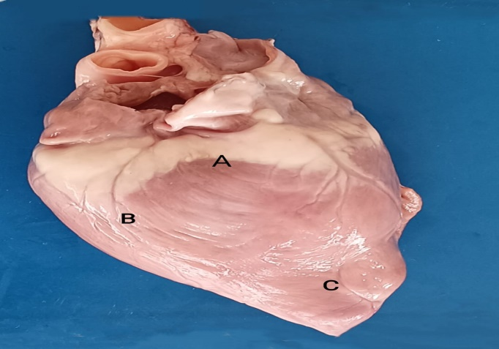  Plate 1: Photograph of the Goat heart showing A. base of heart. B. left ventricle C. apex of heart. | 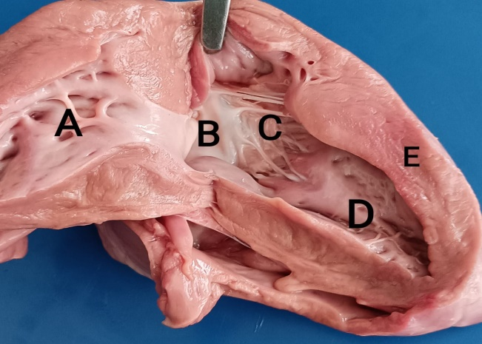  Plate 2: Photograph of Goat heart showing A. right atrium B. cups C. chordae tendineae D. papillary muscle E. thick wall of left ventricle
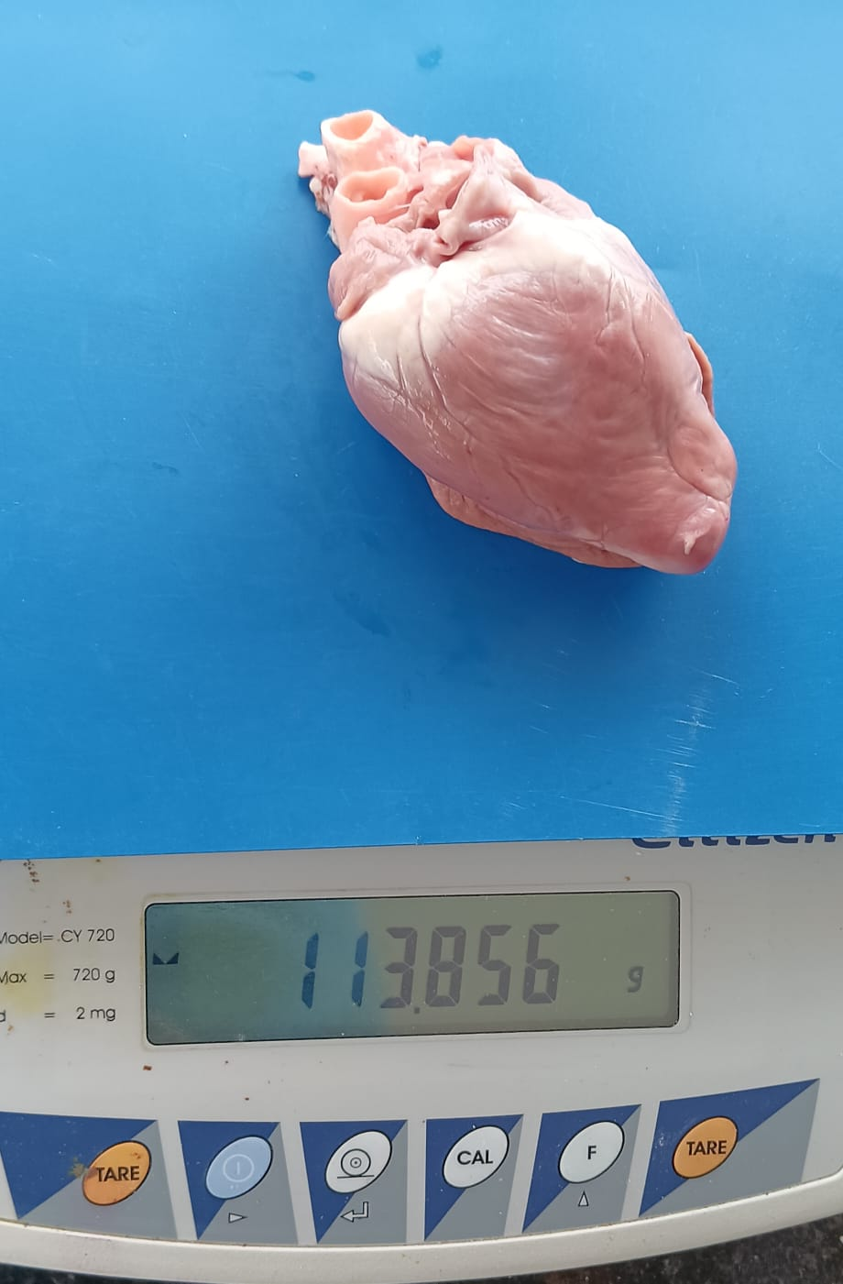  Plate 3: Showing the weight of the goat heart. | 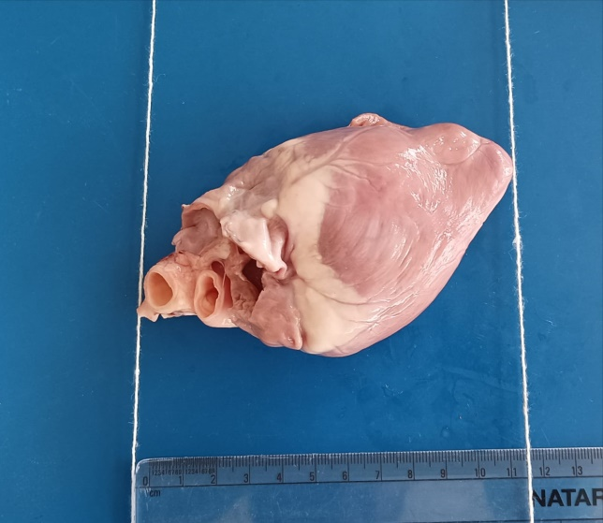  Plate 4: Showing measurement of length of the sheep heart.
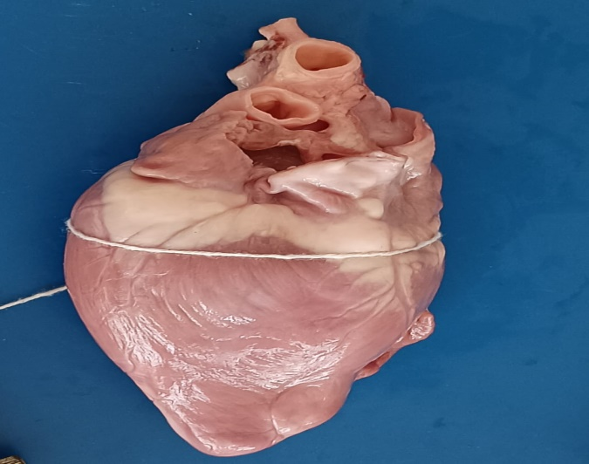  Plate 5: Showing the circumference of sheep heart measured with thread and scale. | 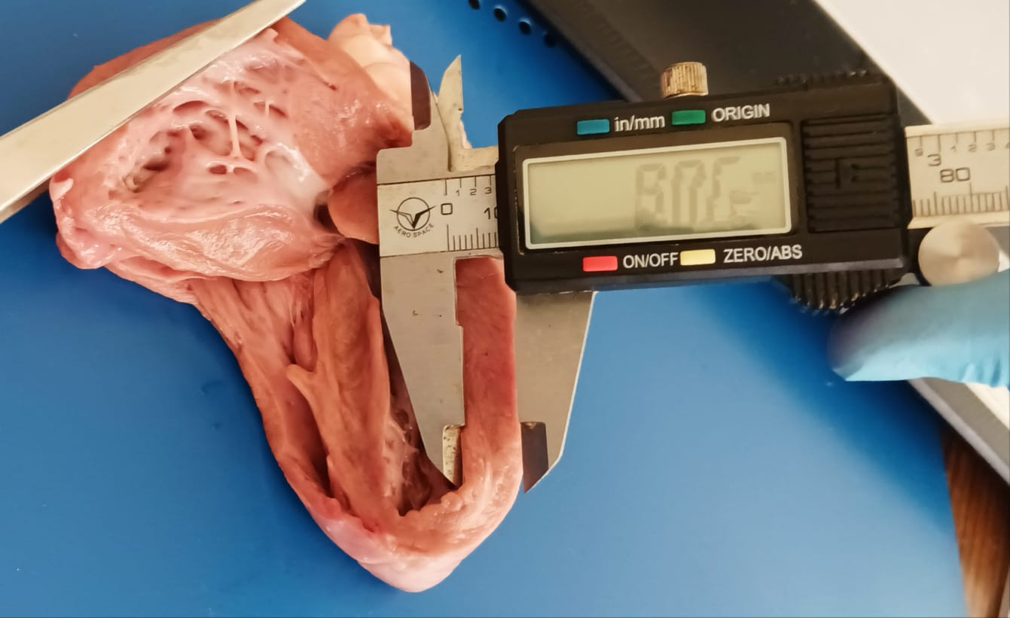  Plate 6: Showing the measurement of wall thickness of left ventricle of goat heart.
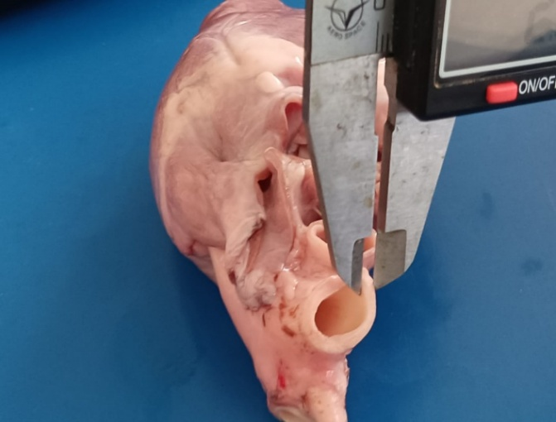  Plate 7: Showing measurement of thickness of aorta of goat heart. | 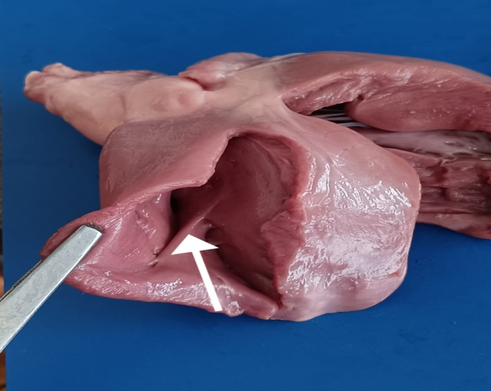  Plate 8: Photograph of the sheep heart showing moderator band (arrow) of right ventricle.

References
Archana, Kumar, P. and Kumar, P. (2010). Anatomy and biometry of heart of sheep (Ovis aries) of Jammu region. Indian Journal of Veterinary Anatomy. 22(1): 12–14.
Bari, U. (2013). Gross anatomical and biometrical study of the heart of adult sheep (Ovis aries). MVSc Thesis, Maharashtra Animal and Fishery Sciences University, Nagpur, India.
Bhasin, H. (2017). Gross anatomical and ultrasonographic studies on heart of buffalo (Bubalus bubalis). MVSc Thesis, Guru Angad Dev Veterinary and Animal Sciences University, Ludhiana, India.
Crick, C.J., Sheppard, M.N., Ho, S.Y., Gebstein, L. and Anderson, R.H. (1998). Anatomy of the pig heart: comparison with normal human cardiac structure. Journal of Anatomy. 193: 105–119.

Dyce, K.M., Sack, W.O. and Wensing, C.J.G. (1996). Textbook of Veterinary Anatomy. 2nd edn., W.B. Saunders Co., Philadelphia, pp. 229–232.
Dyce, K.M., Sack, W.O. and Wensing, C.J.G. (2002). Textbook of Veterinary Anatomy. 3rd edn., W.B. Saunders Co., Philadelphia.
Getty, R. (1975). In: Sisson and Grossman’s The Anatomy of Domestic Animals. 5th edn., W.B. Saunders Co., Philadelphia.
Ghosh, R.K. (2006). Primary Veterinary Anatomy. 4th edn., Current Books International, Kolkata.
Gupta, V., Archana, Prakash, A. and Farooqui, M.M. (2012). Gross anatomical and biometrical studies on the heart and its associated blood vessels in buffalo (Bubalus bubalis) of Mathura region. Indian Journal of Veterinary Anatomy. 24: 80–81.
Gumansing, B.K. (2015). Gross anatomical and histomorphological studies on atria of goat (Capra hircus). MVSc Thesis, Maharashtra Animal and Fishery Sciences University, Nagpur, India.

Hussain, R. and Qureshi, A.S. (2007). Age related changes in the morphometric parameters of the heart, kidneys and adrenal glands of Nili-Ravi buffalo (Bubalus bubalis). Journal of Animal Science. 6(2): 995–998.
Malik, M.R., Shrivastava, A.M. and Thakur, M.S. (1978). A note on the biometry of caprine heart. Indian Journal of Animal Sciences. 48(9): 686–687.
Malik, M.R., Jain, N.K., Parmar, M.L. and Taluja, J.S. (2000). Morphometry of the heart of deer. Unpublished manuscript.
Martin, L., Virginia, M. and William, P. (2009). Gross anatomy of the heart in the Western Grey Kangaroo (Macropus fuliginosus). Unpublished manuscript.
Nickel, R., Schummer, A. and Seiferle, E. (1981). The Viscera of the Domestic Mammals. Vol. 3, Verlag Paul Parey, Berlin.
Panditrao, K.V. (2014). Gross anatomical and histomorphological studies on ventricles of heart in sheep (Ovis aries). MVSc Thesis, Maharashtra Animal and Fishery Sciences University, Nagpur, India.
Pasquini, C., Spurgeon, T. and Pasquini, S. (2007). Anatomy of Domestic Animals. 11th edn., Sudz Publishing, USA, pp. 381–403.
Raghavan, D. (1964). Anatomy of Ox. 1st edn., ICAR Publication, New Delhi.
Sandhu, D. (2021). Comparative anatomical and echocardiographic studies on heart of buffalo, sheep and goat. PhD Thesis, Guru Angad Dev Veterinary and Animal Sciences University, Ludhiana, Punjab, India.
Sathapathy, S., Khandate, S.P., Dalvi, R.V., Charjan, R.Y. and Salankar, A.M. (2013). Biometry of the heart and its vessels in young and adult of local non-descript goats (Capra hircus) of Vidarbha region. Indian Journal of Veterinary Anatomy. 25(2). Add page number.
Schummer, A., Wilkens, H., Vollmerhaus, B. and Habermehl, K.H. (1981). The Circulatory System, the Skin and the Cutaneous Organs of the Domestic Mammals. 1st edn., Verlag Paul Parey, Berlin, pp. 15–70.
Shahida, P.P., Rind, M., Khan, H., Tufail, M., Rind, B. and Rindi, R. (2007). Gross anatomical studies on normal heart of buffalo (Bubalus bubalis). International Journal of Agriculture and Biology. 9(1): 162–166.
Simon, J.C., Siew, Y.H., Lior, G. and Anderson, R.H. (1998). Anatomy of the pig heart: comparisons with normal human cardiac structure. Journal of Anatomy. 193: 105–119.
Sisson, S. and Grossman, J.D. (1975). The Anatomy of the Domestic Animals. W.B. Saunders Co., Philadelphia.
Add reference
Suri, S., Sasan, J.S., Sarma, K. and Mahajan, V. (2025). Regression model and correlation analysis of different heart parameters of non-descript goats of Jammu region. AATCC Review, 13(01): 178-184.

