**BIODIVERSITY OF INTRAMURAL DUST MITES FROM OSMANABAD DISTRICT, MAHARASHTRA INDIA**

# ABSTRACT:

The Study has been carried out to revealed and investigate the mites fauna from dust of poultry and houses located at osmanabad district (M.S). The impact of changes in environmental parameter like humidity, temperature and rainfall in three different seasons on the population of mites has studied.Fortnightly regular study has been carried out for 3 years .

In this study 6 Different species are found , these are *Dermatophagoides farinae Leiodinychus krameri, Prodinychus sp.(deutonymph,) Dermanyssus gallinae*, *and Urodiaspis tecta Dermatophagoides pteronyssinus.*The impact of changes in environmental parameters on this mite population in three different seasons i.e. monsoon , summer ,and winter were recorded during this study. It found that weather parameters significantly on the prevalence of mites in dust of poultry and house. Maximum number of mites are found during monsoon followed by winter and summer.

**Keywords:** Biodiversity**,** Dust Mites, Osmanabad , Intramural

## INTRODUCTION

Mites are arachnids belong to phylum Arthropoda which are minute in size .85% of animal They are characterized by the presence of four pairs of legs, cosmopolitan in distribution.Mites are usually minute (0.6 to 2.0mm in length ) creatures, difficult to detect by the unaided eye.

Biodiversity is the crucial part of life on the earth which is essential for the functioningecosystem and describe the variety of life on the earth. It is essential for the functioning of

ecosystem which provides us with products and services without which we couldn’t live. Biological diversity is a term used to describe the variety of life on the earth.it refers to the wide variety of ecosystem and living organism: animals, plants, their habitats and their genes. we depend on it for our security and health; it strongly affects our social relations and gives us freedom and choice.

Dust is fine, dry powder consisting of tiny particles of the earth, dust in homes, offices and human and animal hairs, textile, fibres, human skin cells. The most common allergy causing mites that occur in homes HDM are correlated with the development of asthma and other allergic disorders (Arlian et al,2002). The pyroglyphidae mites are allergenic mites, but non pyroglyphidae mites such as stored grain mites, also have clinical importance (Van Hage Hamsten and Johansson ,1998)

Mites are closely related to insects ,birds and to mammals and are easily distinguished from them by having one extra pair of legs in adults rather than having 3 pairs (Hughes, 1976). There were 50,0000- 1000000 sps. of mites exist on the earth ,out of these only 45000 sprcies are named (Hofesetter et. Al 2013). All ecosystem which are present on this globe have there own kind of acari fauna. They are found in the hot desert of the Sahara to the arctic tundra , from cold bed of pacific ocean to our eyebrows hair follicles ( Krantz & Walter, 2009). They have been found in underneath stores in Antartica and other temperate countries (Jogdand , 2007).

Major research is carried out on easily visible and higher animals, plants .comparatively less attention has been given to microscopic animals such as mites which is less than 1 mm in size which is nit visible to naked eyes. Mites plays important role as a scavengers in the ecosystem for recycling forest litter and other organic matter in the detritus ecosystem. Hence they act as a bioresource for the conservation and sustainable development of an ecosystem (Jogdand, 20007). Some ectoparasites like mites and ticks, transmit poultry diseases like fowl pox , Chlamydia and Newcastle diseases ( Nnadi & George , 2010).

Diversification in poultry mites disclosed the various habitat, predatory, deteritivorous and parasitic mites (Brady, 1970). Saviour infestation of mites in chickens leads to retard growth, low vitality, damaged plumage, reduction in egg production and sometimes causes death

( Bishopp, 1942).

1. **MATERIAL AND METHODS:**

**1 ) Survey of study area located in Omerga taluka.**

1. **Preparation of glycerine jelly**
2. **Collection of Dust**: Dust collected from different place of the poultry farm. dust collected from lower layer below surface level, from different corners and central part of poultry. And also from the houses located in district.
3. **Isolation of mites**: 3 Sieving of dust performed in laboratory using mesh sieve in petri plate. observation of petri plate was done using dissecting microscope, mites were picked up with the help of needle with its tip dipped in lactic acid.

## Slide Preparation:

Mites kept in cavity blocks containing lactic acid were left overnight. Lactic acid used for killing and clearing of mites and dissolution of cuticle thud making them transparent. By putting freshly melted glycerine jelly mounting was done. The mites were then mounted on slides with ventral side up. Total number of mites per gram of dust was determined fortnightly

. average number of mites per gram of dust was found out. Permanent slides were prepared

.These slides were observed under binocular research microscope for identification.

## Ecological parameter :

The temperature and humidity (max/min ) were measured using a mini temperature humidity meter HD- 303 on the sampling site. Total rainfall record of the sampling site was obtained from the mahavedh project ( https// maharani.maharashtra.gov.in)

Measurement calculated by image j software.

## RESULT AND DISCUSSION:

The dust of poultry revealed *urodiaspis* , it has long pedipalp. Depression at the region of articulation of legs is found on the ventral surface. Grooves for the legs are well developed. *Prodinchus* species are also found in the poultry dust. It has long pedipalp . grooves of the legs well developed and rusty brown in colour. *Leiodinychus krameri* also found in a poultry dust. chelicerae usually extended. It has a cavity called camerostome. *Dermanyssus gallinae* is a

poultry mite .it is important pest of chicken and show harmful effects on growth of birds. Has a long chelicerae. 2 mites species were found in house dust named as *Dermatophagoides pteronyssinus* body is small and oval ,broder in middle and narrow at both ends. Body has fine striation.The first pair of leg is directed forward. *Dermatophagoides farinae is also a house dust mite. It is common in floor dust found by Jogdand S.B. in 1995. The body of female mite is large in size and globular in shape while male mite is small and globular.*

1. ***Urodiaspis tecta* Kramer*, 1876*** Mesostigmata Canestrini,1891 Urodiaspidae Tragardh, 1944

*Urodiaspis Berlese, 1916*

**Locality of collection** : *poultry farm*

**Date of collection:** The individuals of this species were collected fortnightly in the year 2022 to 2025

## Measurements:

The mites measures, 1333µm in length, and 1011µm in width . The gnathosoma measure 235µm and pedipalp 234, the legs are short, stout and curved and present in grooves. The first pair of leg measures, 520, II nd pair of legs measures 408, IIIrd pair of legs 480 and IV measures 404 , pedipalp measures 234 in length (fig.1)

## Description:

Mites has peculiar dark reddish brown colour, has a globular body. Arrangement of gnathosoma is a peculiar characteristic ,it is reduced has a long pedipalp. Gnathosoma and tritosternum enclosed in cavity called camerostome.Legs are short and stout and look curved. Found abundance in rainy season and in winter season found in very less amount. Absent in summer season. Depression for the legs are found on the ventral surface so that the short legs are folded compactly against the body .The chelicerae usually extend for some distance into the idiosoma (Fig.1)

1. ***PRODINYCHUS SP. (DEUTONYMPH):***

**Family:** prodinychidae Berlese, 1917 **Genus** : Prodinychus Berlese , 1917 **Habitat / Host:** poultry

**Date of collection:** The indivisual of this species ere collected fortnightly in the year (2022- 23)

**Measurement:** The indivisuals of this species range 1495µm in length and width 882µm

**Legs:** I 674, II 461, III 445, IV 575 (Fig.2)

1. ***Leiodinychus krameri:***

**Family**: Uropodidae Kramer , 1881 **Genus** : *Leiodinychus* Berlese, 1917 **Host/ Habitat**: Poultry litter

**Locality of collection:** Taluka lohara dist. osmanabad

**Date of Collection:** The individuals of this species were collected fortnightly in the year

june 2022 to oct 2024

## Male

**Measurements**: length of the male 648 µm and 449µm in width **Legs**: all legs with claw I 155, II – 196, III- 189, IV- 180µm in length G**nathosoma** : 80 µm (Fig.3)

## Description:

The anterior ventral position of the body is excavated so that gnathosoma and tritosternum are enclosed in a cavity called camerostome. The male genital opening is in the centre of the sternal plate. Depression for the legs are found on the ventral surface . The chelicerae usually extend for some distance (Fig.3)

## Female:

Measurement: female length 696µm and 490µm in width

**Legs:** I – 235µm,II -230µm, III-191µm, IV- 250 µm in length

**Gnathosoma:** measures 82µm.(Fig.3 ii)

## Protonymph:

Protonymph measures 1319µm in length and 886µm in width. Legs ; I -465µm, II – 446µm, III- 365µm, IV – 480µm

Gnathosoma- 255µm (Fig.3 iii)

1. ***Dermanyssus gallinae:***

**Family**: *pyroglyphidae Cunliff, 1958* **Genus** *: Dermanyssus, Duges, 1834* **Host :** poultry litter

**Locality:** Taluka tuljapur located in osmanabad district.

**Date of collection:** The individuals of this species were collected fortnightly in the year june 2022 to oct 2024

**Description:** is an essential pest of birds especially chickens and pigeons **,** heavy infestations causes , lower egg productivity and poor growth. The mites normally feed during night and infest the host only at this time. During the day they are found in the cracks of roosts, nests. Mite is gray in colour, gnathosoma is cylindrical. It is oblong and broader at posterior end . single dorsal plate is present. Chelicerae are long whip like. The legs are long . The shape is oblong. First pair of leg is long and extend forward. (Fig.4)

## Measurement:

**Female :** The body measures, 1015µm in length and 418µm in width .

**Legs:** I – 773µm, II – 501µm, III- 566µm, IV - 737µm in length.

**Gnathosoma:** 258µm in length, pediplap measures 463µm , chelicerae : 280µm in length.(Fig.4)

1. ***Dermatophagoides pteronyssinus:***

**Family**: Pyroglyphidae Cunliffe, 1958 Sensu Fain ,1965

**Genus** : Dermatophagoides Bogdanov, 1864

**Species:** *Dermatophagoides pteronyssinus* Troussart, 1897

**Host**: House dust

**Locality of Collection**: Bhoom dist, osmanabad

**Date of collection:** The individuals of this species were collected fortnightly in the year june 2022 to oct 2024

## Female:

**Measurement:** The body measures 2463µm in length and 1315µm in width

**Legs:** L1 669, L2 651, L3662, L4 724µm in length(Fig.5)

**Gnathosoma:** 339µm in length(Fig.5)

**Pedipalp:** 391µm in length

**Chelicerae :** 341µm in length (Fig.5)

## Description:

* It is common house dust mite, body is small and oval ,broder in middle and narrow at both ends.
* Body has fine striations.
* Body structure has two parts- Gnathosoma and Idiosoma.
* Eyes are absent ,gnathosoma has pedipalp.
* The first pair of leg is directed forward.
* Region of idiosoma bears I and II pair of legs are present.
* Where metapodosoma where III and IV pair of legs present .(Fig.5)

1. ***Dermatophagoides farinae:***

**Family**: Pyroglyphidae Cunliffe, 1958 Sensu Fain ,1965

**Genus** : Dermatophagoides Bogdanov, 1864 **Species:** *Dermatophagoides farinae* **Locality**: House dust

**Locality of Collection**: Bhoom dist, osmanabad

**Date of collection**: The individuals of this species were collected fortnightly in the year june 2022 to oct 2024

## Male:

**Measurement:** The male measures 246µm in length and 131µm in width

**Legs:** L1 167, L2 157, L167, L4 121µm in length(Fig.6)

**Gnathosoma:** 76µm in length(Fig.6)

**Female:** The female body measures 337.5 µm in length and 162.5 µm in width

**Legs**: L1 87.5, L2 88.5, L3 & L4 75 µm

**Gnathosoma: 75** µm in length (Fig.7 )

**Description:** The present form comes closer to *Dermatophagoides* in having oval shaped body and uniform legs. All legs of equal size. First and second pair of legs is directed forward, Third and Fourth pair of legs is directed backwards. First pair of legs is expanded laterally. In males legs first thicker than second leg.

## Fig. 1 Fig.2

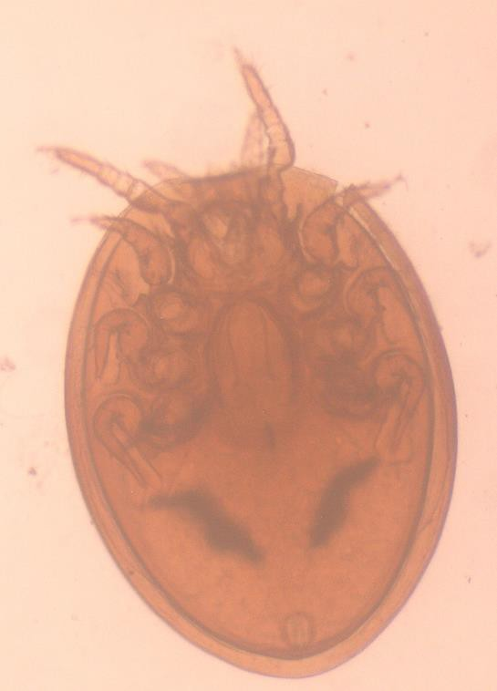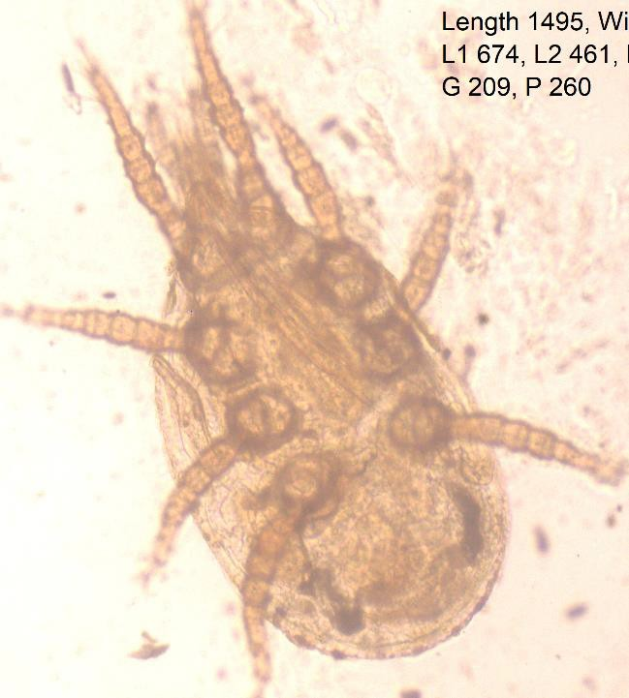

***Urodiaspis tecta Prodinychus sp. (Deutonymph)***

***Fig.3 (i) Fig. 3(ii)***

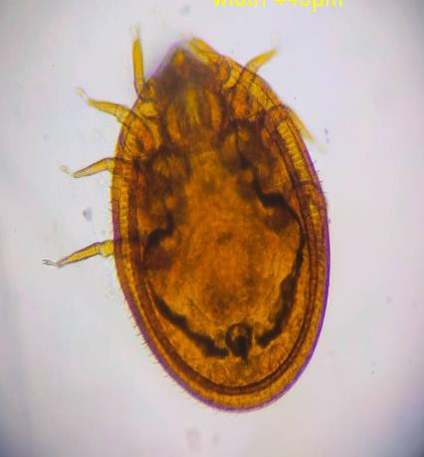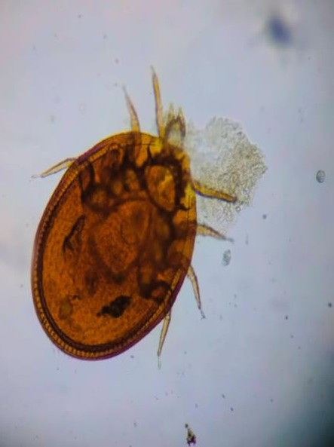

***Leiodinychus krameri Male Leiodinychus krameri Female***

## Fig. 3(iii ) Fig.4

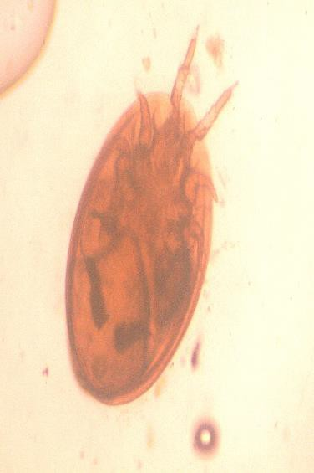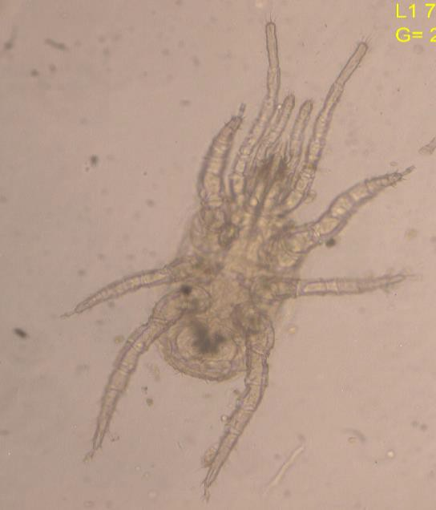

***Leiodinychus Krameri Dermanyssus gallinae Deutonymph***

***Fig.5***

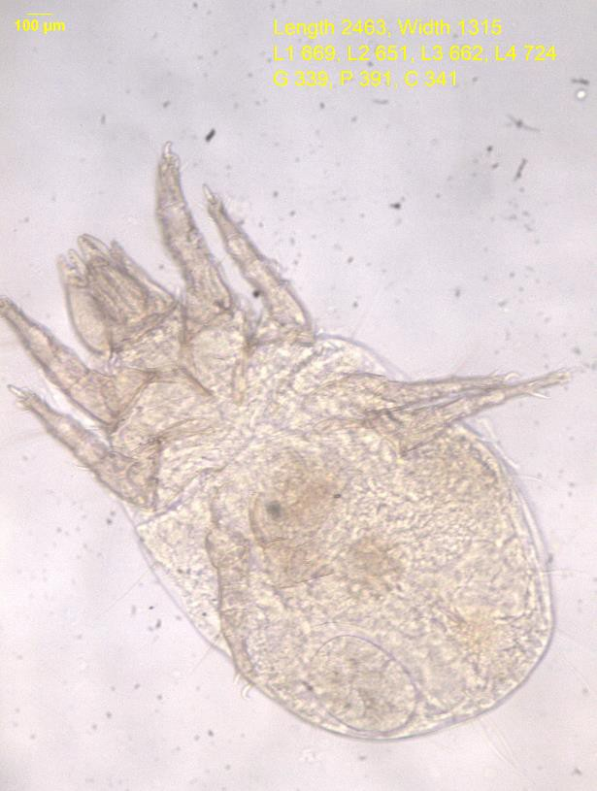

***Dermatophagoides pteronyssinus***

***Fig.6 Fig.7***

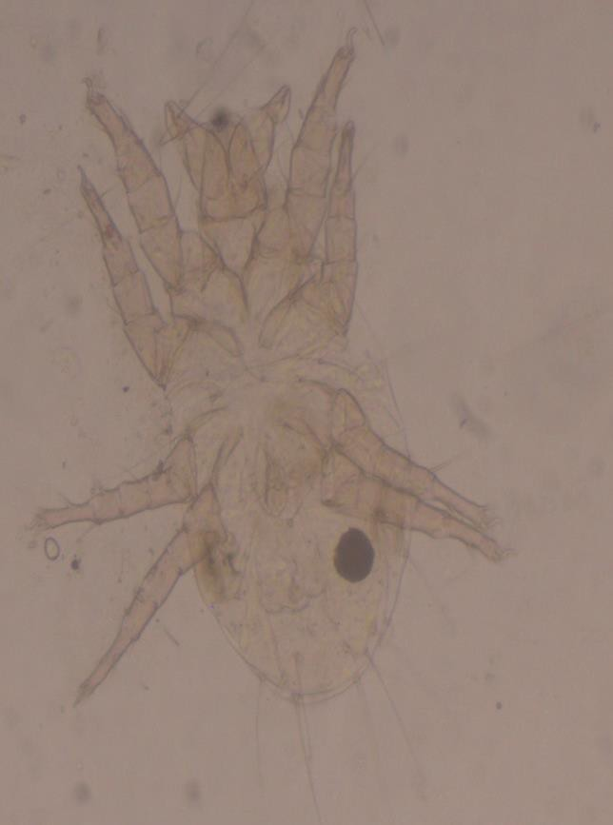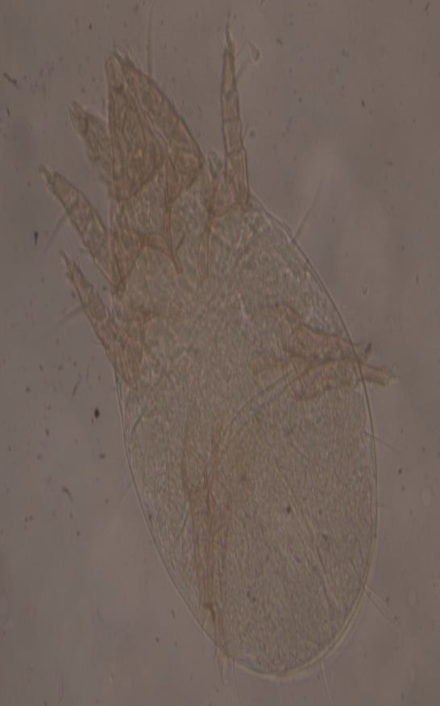+

***Dermatophagoides farinae Male Dermatophagoides farinae Female***

# conclusion :

Mites are member of arachnid.These mites species are found almost every habitat. These are minute enough that they are suspended in air; therefore study of mites also forms an important part in the field of Aerobiology. Most of the mites are ectoparasites.In present investigation 7 species of mites was observed in the poultry farms and house dust.they belong to family Pyroglyphidae , Uropodidae, prodinychidae of mesostigmatid, Astigmatid and Prostigmatid order. The mites then mounted in glycerine jelly after treating it with lactic acid. It is found that suitable environmental condition is rainy season where relative humidity around 85% and temperature 24ºC . the number of mites progressively increase in rainy season per gram of dust from june to october.

# 6. REFERENCES:

* **. Abdussalam M.(1939):**On a new feather mite *Rivultasia karmellahie5i* parasitic on Indian domestic fowl (*Gallus hankiva*).Vet.J.95:39-42.
* 2. **Ancona.G.Asma(1923**): Epidemica da pediculoides Ventricosus Policlinico Sez Med 30 pp:45-70.
* 3. **Arlian L.G. and et.al.** (1984): Cross antigens and allergenic proportion of the HDM

*D. farinae* and the storage mite *Tyrophagus putrescentiae* Allergy Clin Immunol 74 pp*:*172-79.

* 4. **Axtell,R.C. and J.J Arends**.(1990): Ecology and management of arthropod pests of poultry. Annual review of Entomology.35 pp:101-26.
* 5.**Bansod V.M. and Sunita N.Borde.(**2011): Diversity of Intramural (poultry) Dust Mites from pune Journal of Association of Zoologist ,India ISSN 2229-6549 vol.4 (1) 18.
* 6. **Bornehag,C.G.(2004**): Indoor Air,International Journal of Indooir Envt and Health- Vol.14,Issue 4,pages 243-57.
* 7**. Calloff, M.J. (1998**): Taxonomy and identification of dust mites.Allergy,53:712.
* 8. **Dekker H.(1928)** : Asthma and milben. MMW 75:515-16.
* 9. **Edward W. Baker, G.W.Wharton**(1952): An introduction to Acarology
* 10. **Jeppson et .al (1975**): pp.327-591.
* 11. **Jogdand S.B. (1996**):Extramural mites found in intramural ecosystem

,Res.J.PI.Environment,12:81-84.

* 12. **Keith R. Snow** (1970): The Arachnids an Introduction pub Routledge and kegan paul ltd., London.vol 1 pg- 1
* 13**. Kern (1921**) :Dust sensitiation in bronchial asthma M.Clin.N.America 5:751-758.
* 14. **Hirst, S.(1922)** : Mites injuries to domestic animals. Trustees of British Museum,London.1-168.
* 15. **Neumann L.G.(1905) :** A treatise on parasites and parasitic diseases
* **16.Spieksma F.TH.M (1997)**: Domestic mites from an Acarologic perspective Allergy 52 pp:360-368.
* 17. **Tilak and Jogdand (1989):** HDM Annals of allergy,63:392-397.
* 18 **Tilak S.T. and Jogdand S.B. (1989**) : House Dust Mites Annals of Allergy 63 pp

:392-397.

* 19. **Oudemans,H.C.(1906):** Tijd.V.Ent. 49,237.
* 20. **Trouessart E.L (1915)** : Bull.Soc.Ent.Fr. 40:207.
* 21.**Vaishali Bansod (2011):** Biodiversity of dust mite Ezine Article (online)
* 22. **Voorhorst R.,and et.al. (1969**) : Recent progress in the HDM problem Actta Allerrgol (kbh) 24 pp:115-23.
* 23. **S.S Jadhav , L.S. Matkar(2020: S**tudy of Acari (Arthopoda: Arachnida) fauna from rodent cages in pune, Maharashtra, India. P-ISSN 2349-5138 Vol.7, Issue 1