MOLECULAR IDENTIFICATION OF INDIAN BOVINE GENETIC RESOURCES THROUGH DNA-BASED BAR CODE AND QR CODE

ABSTRACT
Objective: The objective of this study was to map Indian Bovine species based on DNA Barcoding and Big data analytics.
Methods: 5 Indian Bovine species blood samples were collected and performed molecular study. The whole DNA was isolated and the mitochondrial CoX gene was amplified in each species using Universal primers. The generated sequences were submitted to the BOLD Database to generate DNA Barcodes. The data was examined by the database and the respective DNA Barcodes were generated. Based on DNA Barcodes, using Python code, unique QR codes were generated. Further, based on the Morphological features, molecular features, DNA Barcodes, QR codes, and image data analysis were performed.
Results: The isolated DNA was validated using Agarose Gel Electrophoresis. The PCR conditions for mitochondrial CoX gene amplification were standardized and purified followed by DNA Sequencing. 5DNABarcodes for Indian Bovine species were generated and uploaded to the BOLD database. QR codes were generated and Bid data analysis was performed using models for authenticated identification of Bovine species.
Conclusion: In conclusion, the molecular mapping of Indian bovine genetic resources using DNA-based techniques such as bar coding, QR code technology, and big-data analysis provides a powerful framework for understanding and conserving the genetic diversity of bovine populations in India. The integration of DNA barcoding enables precise identification and classification of bovine breeds, while QR code technology offers an ovel and efficient means of tracking and monitoring genetic data in real time. The application of big-data analysis further strengthens the ability to detect patterns of genetic variation, assess breed composition, and identify areas of genetic erosion or introgression, which are crucial for breed conservation and improvement programs.
Keywords: Indian Bovine Species; DNA Bar coding; Big data; Genetic diversity.
1. INTRODUCTION
1.1 Indian Bovine Species
India has the largest bovine population in the world with 199 million cattle and 105 million buffaloes. TheNation has 14% of the world's cattle population and 53 % of the world's buffalo population. Water buffaloesare endemic to the Indian subcontinent. The country has 166 million Indigenous cattle. About 80% of theIndigenous cattle are non-descript and only 20% of Indigenous Breeds are recognized by the NationalBureau of Genetic Resources. The bovine genetic resource of the country comprises 37 recognisedIndigenous Breeds of cattle and 13 breeds of buffaloes.
Indigenous animals are sturdy and are endowed with the quality of heat tolerance, resistance to diseases and ability to thrive under extreme climatic conditions. Exotic species, like Holstein- Friesian and Jersey- and Crossbred cattle although more productive, tend to wilt under Indian conditions of extreme and harsh climatic conditions. Exotic breeds and Crossbred cattle are susceptible to tropical diseases while the Indigenous Breeds are hardier, being both disease and tick-resistant. Furthermore, Crossbred and Exotic cattle perform optimally only under a high-cost input Farm Management System. The Indian Farm Management System is typically Low Input Low Output, with most of the animals being raised by poor farmers. There are centers like National Kamdhenu Breeding Centres (NKBC) which are being established as Centre of Excellence to develop and conserve Indigenous Breeds in a holistic and scientific manner.At NKBC, Chintaladevi, Andhra Pradesh, Cattle breeds such as Deoni, Gir, Kankrej, Red Sindhi, Sahiwal, Rathi, Tharparkar, Punganur, Ongole, Krishna Valley, MalnadGidda, Kangeyam and Buffalo breeds that include Pandharpuri, Jaffarabadi, Banni, Mehsana and Murrah are maintained from which the sample collection of Bovine samples was taken.
1.2 DNA Bar coding – tool for molecular identification
The multidisciplinary effort of DNA Bar coding and gene-based QR coding will bring forth a significantcontribution to support, and conserve the Indigenous breeds, exotic and crossbreeds or lines of existing bovine livestock of India and augment the biodiversity conservation, gene mapping of the bovine germplasm resources. Accelerating the inventory and quick analysis of the diversity; Identification of the newspecies; analysis of their molecular phylogeny: Traditional Knowledge and conservation; and bio piracyelimination.
Genetic diversity studies form a basis for developing innovative measures and strategies for the conservationof natural diversity existing among indigenous, exotic and crossbreeds. This knowledge will also help inrecognizing significant breeds of farm livestock, which leads the way to identifying and evolving promisingpotential breeds to design successful breeding programs to enhance milk productivity androbustness.Utilization and conservation of bovine breed genetic resources will provide legal protection forbreeds or lines of the existing livestock.
1.3 Big Data Analytics - Image Data Analysis and Cloud Computing
Image data analysis can be employed to identify various species of bovines. Using machine learning models, such as convolutional neural networks (CNNs), can help classify species based on features like body size, shape, horn configuration, and coat patterns.Big data refers to the massive volumes of data generated from various sources like satellite imagery, camera traps, drones, environmental sensors, and wildlife tracking devices. The role of big data analysis in the conservation of bovine species involves several key areaslike Data Integration and Synthesis,Predictive Analytics,Behavioral and Ecological Insights.Cloud computing provides the infrastructure and resources for managing and analyzing large datasets without the need for physical data storage or high-performance computing hardware on-site.
Therefore, the objective of the current study was to identify and catalogue bovine genetic diversity through DNA bar coding, utilise QR codes to link individual animals to their genetic and phenotypic profiles. Further, this study generates a molecular map to understand genetic resources andvariationsby leveraging image data analysis for phenotypic classification and breed recognition. This would also support conservation efforts for endangered or indigenous bovine breeds and enhance breeding programs with genetic insights.
2. MATERIALS AND METHODS
2.1 Sample Collection and DNA Isolation
2.1.1. Sample Collection
Bovine blood samples were collected from the National Kamadhenu Breeding Centre, Chintaladevi village, Nellore. The bovine breeds include Gir, Ongole, Sahiwal, Malnad Gidda, Red Sindhi, Punganuru, Rathi, Kankrej, Tharparkar, Deoni, Khangayam, Killari, Krishnavalley, Pandarpuri, Banni, Murrah, Massena, and Jaffarbadi.
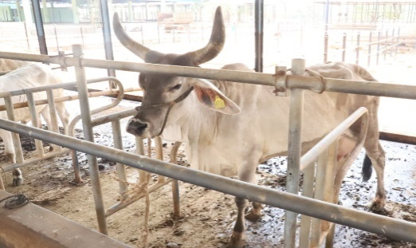 | 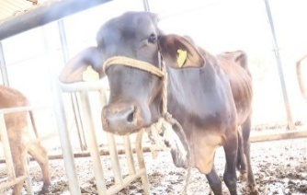
Malnad Gidda Deoni

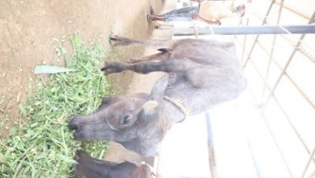 | 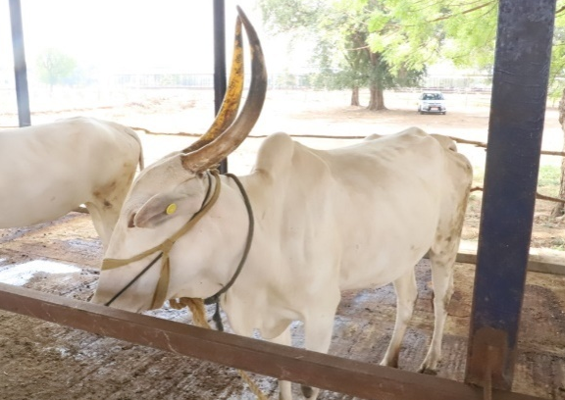
KrishnavalleyBanni
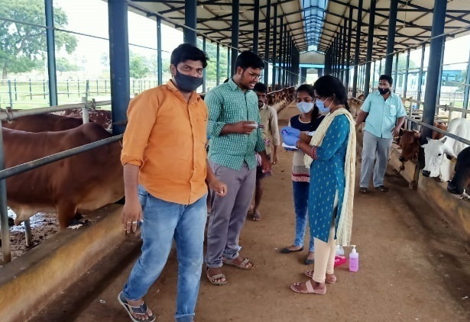 | 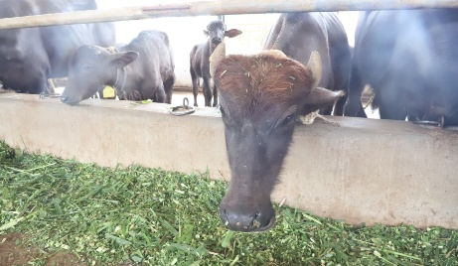
Murrah
Fig: 1 Selected Bovine Breeds
2.1.2 Genomic DNA Isolation
The fresh samples were processed for Genomic DNA isolation using the CTAB method. The sample was transferred to a fresh microcentrifuge tube and pre-warmed CTAB and Beta-Mercaptoethanol and SDS were added. The reagents were mixed and proteinase K was added. Centrifugation was performed at 14,000 rpm for 10 min. The pellet was discarded and to the supernatant, equal volumes of Phenol:Choloroform:Isopropanol was added and vortexed.
The mixed sample was kept at -20°C for one hour, followed by centrifugation at 10,000 rpm for 10 min. The supernatant was discarded and 70% chilled ethanol with ammonium acetate was added to the pellet. The mix was centrifuged at 10,000 rpm for 10 minutes. The supernatant was discarded and TE buffer was added to the dried pellet.
2.2 Mitochondrial CoX-IGene Amplification, purification and Sequencing
2.2.1. Gene Amplification
The selection of suitable primers is essential for successful gene amplification. To amplify the mitochondrial CoX-I gene, 3 pairs of species-specific primers were used (Table 1). Cytochrome Oxidase subunit I gene (COX-I) sequences of various species belonging to different orders were amplified using the primers retrieved from the BOLD database.
Table: 1 Details of primer sequences used in the amplification of the CoX-I gene.
S.No | Primer Name | Direction | Sequence description
1 | SNLF | Forward | 5’ GGTCAACAAATCATCATAAAGATATTGG 3’
2 | SNHR | Reverse | 5’ TAAACTTCAGGGTGACCAAAAAACAT 3’
3 | SNVF | Forward | 5’ TTCTCAACCAACCACAARGAYATYGG 3’
4 | SNVR | Reverse | 5’ TAGACTTCTGGGTGGCCRAARAAYCA 3’
5 | SNZF | Forward | 5’ TCTCAACTAAYCAYAAAGAYATYGG 3’
6 | SNZR | Reverse | 5’ TAAACTTCRGGGTGACCAAARAATCA 3’

The partial mitochondrial COX-I gene was amplified amongcattle Breeders for their molecular Identification and molecular phylogeny studies.PCR components used are tabulated in Table 2 and PCR Conditions (Table 3) for the gene amplification were standardized by applying different annealing temperatures using Gradient Master Cycler Nexus (Applied Bio systems) thermocycler.
Table:2PCR Components
Components | Quantity/sample
Trehalose (10%) | 16.95µl
dNTPs (2.5mM) | 2.00µl
MgCl2 (25mM) | 0.40µl
Forward Primer (10 PM) | 1.00µl
Reverse Primer (10pM) | 1.00µl
Taq Polymerase (5unit/l) | 0.15µl
Buffer (10X) | 2.5µl
Template | 1.00µl
Total Volume | 25.00 µl

Table:3 PCR Conditions
Process | Temperature | Time | Cycles
Initial Denaturation | 94°C | 3 mins | 1 cycle
Denaturation | 94°C | 1 min | 35 cycles
Annealing | 48°C | 40 sec | 35 cycles
Extension | 72°C | 3 mins | 35 cycles
Final Extension | 72°C | 7mins | 1 cycle
Termination of reaction | 4°C | ∞ | -

2.2.2 Purification
The extra nucleotides, primer residues and buffer salts were removed in the PCR product cleanup process and ethanol precipitation. Exo-SAP Digestion was performed to remove excess primers and nucleotides in the reaction mixture, 2.5µl of PCR product was treated with 0.25µl Exonuclease-I (1U/µl) and 0.5µl (1U/ µl) of Shrimp alkaline phosphatase (SAP). Later 10X SAP buffer was added and kept the reaction for incubated at 37°C for 45 minutes. The samples were re-incubated at 80°C for 15 minutes to inactivate Exonuclease-1 and SAP enzymes. The volume of the reaction mixture was set to 10µl (Hajibabaei, et al., 2005) and the composition was mentioned in Table 4.
Table:4Reagents and volume of Cycle sequencing reaction
Reagent | Concentration | Volume/reaction
Ready Reaction Mix | 2.5X | 0.50 µl
Dilution buffer | 5X | 1.75µl
Primer | 1 pm | 2.00µl
MilliQ water | - | 4.75µl
Template DNA | 5-20ng | 1.00µl
Total Volume |  | 10µl

Table 5: Thermal conditions of EXO-SAP PCR digestion
S.NO | I cycle | II cycle
1 | 37^{O}C | 80^{O}C
2 | 45min | 15min

Cycle sequencing was performed to amplify the PCR products prior to sequencing. Sequencing primers with 0.8 PM concentration were used in each PCR reaction and obtained products were purified by cleanup process.
Table:6Cycle sequencing master mix protocol
S.No | Chemical | Quantity
1 | 5X buffer | 1.75 µl
2 | RR mix | 0.5 µl
3 | Nuclease free water | 4.75 µl
4 | Primer | 2 (1 PM)
Total master mix |  | 9 µl /per sample
PCR product |  | 1 µl (20ng/ µl)
Total volume |  | 10 µl

Table: 7Temperature conditions for cycle sequencing reaction
S. No | Stage-1 | Stage-2 | Stage-3 | Stage-4 | Stage-5
1 | 96 ^{O}C | 96 ^{O}C | 50 ^{O}C | 64 ^{O}C | 4 ^{O}C
2 | 5 min | 30 sec | 15 sec | 4 min | ∞

Cycle Sequencing Cleanup
The samples obtained from cycle sequencing were purified by following the cleanup step as shown in Table to eliminate ddNTPs, leftover primers and salts in the product by Big Dye (R) X Terminator (Big Dye Terminator v3.1 clean up Applied Biosystems, USA). The composition of the cleanup process is shown in Table 8.
Table: 8 Components needed for cleanup of cycle sequencing products
S.NO | MI | Reaction | MII | Reaction
1 | EDTA (0.125mM) | 2 µl | Absolute ethanol | 50 µl
2 | Nuclease Free Water | 10 µl | 3mM Sodium acetate | 2 µl
Total volume |  | 12 µl | Total volume | 52 µl

2.2.3 Gene Sequencing
The Big Dye (R) X Terminator (Big Dye Terminator v3.1 clean up Applied Biosystems, USA) was vortexed at ~2500 rpm for 45 minutes due to its viscous nature. The samples were kept for centrifugation at 1000 X G for 2 minutes prior to pipetting in the sequencer (AB3130, USA). The sequencer contains four capillary tubes with a length of 50cm. POP7(R) (AB1, USA) polymer was added to the reaction. Finally, the templates were digested with HiDi-formamide and sequenced using an 'ABI 3130 genetic' bidirectional sequencer.DNA Sequences in the Chromatogram file were generated by (ABI Sequencer) through Sangers Dideoxy sequencing.
2.3. Submission to BOLD database
2.3.1 Bioinformatic Analysis
The amplified sequences were edited using Codon code aligner &MEGA software and submitted to BOLD (Barcode of Life Database). The trace files were edited by using “CodonCode aligner" software to remove ambiguous bases, and noisy peaks. The trace files of the sequences obtained were in different lengths. Hence, it is compulsory to delete noisy or messy peaks and ambiguity codes. The ends of trace files were trimmed from each sequence to remove primers. ‘N’s is placed in the position of low-quality bases. Later, raw sequence information was drawn from each trace file. Forward and reverse sequences of each specimen were combined. The consensus sequence was retrieved from the combined sequence which specifies the complete contig of individual Bovine breeds.
The Sequence analysis of corrected CoX-I gene sequences of Bovidae species was carried out in MEGA (Molecular Evolutionary Genetics Analysis) (Tamura, et al., 2011) software. It is a Windows-based user-friendly program with graphical user interface. It also contains the multiple alignment program Clustal-W to identify the conservation between the sequences. Comparative studies of CoX-I sequences were studied through multiple sequence alignment. The ends of the alignments were clipped to remove flanking regions. The edited sequences were again compared using Clustal-W in the MEGA server to get more accurate alignment sets. These sequences were further corrected manually and adjusted where needed to avoid alignment errors.
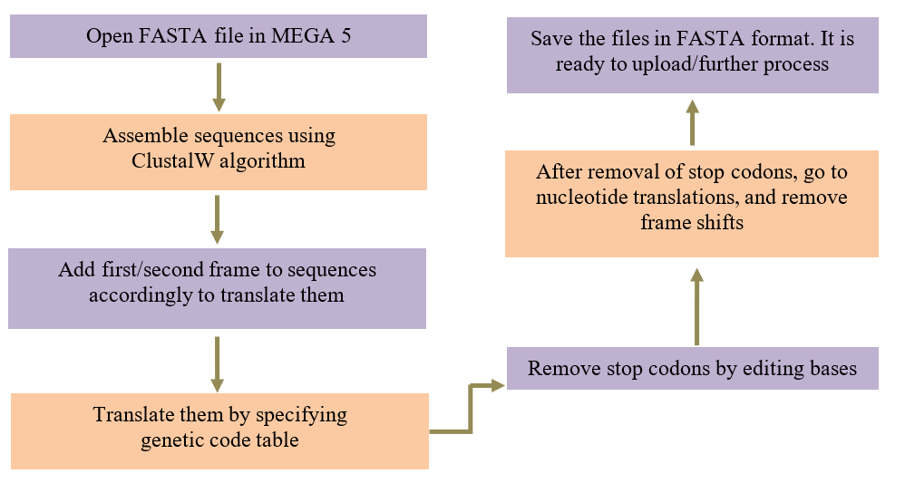
Fig:2Sequence analysis using MEGA - Protocol
For comparative studies,the BLAST (Basic local alignment search tool) (Altschul, S.F., et al., 1997& 1999) tool has been used and it compared two sequences by identifying similar local regions.BLAST-N algorithm was executed to identify the closely related species to the query sequences of each cattle specimen, and compared against the reference database with nucleotide-nucleotide evaluation (BLAST-N) by customizing the settings.
2.3.2 Submissions
Genbank and the Barcode of life data systems (BOLD) are two major publicly available databases to access and submit DNA barcode data of animals and plants. After comparative studies using BLAST search, the accurate annotated CoX-I gene sequences of Bovidae species belonging to eight different orders are made ready for submission to the BOLD (The Barcode of Life Data Systems) database for the creation of DNA barcodes.
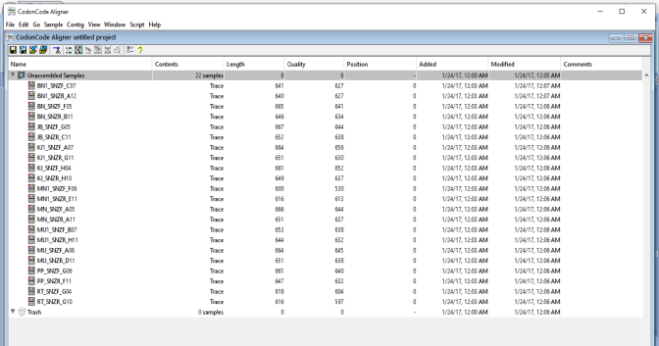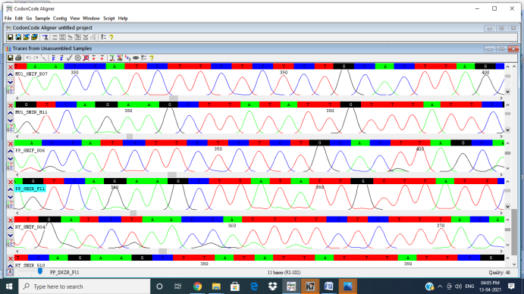
Fig: 3 Codon Code Aligner and MEGA Software Analyses
To get an authenticated and validated barcode for a sequence, numerous files namelythe Voucher data file, Taxonomy file, Specimen data file, Collection data fileand details are prepared and generated. For each partial mitochondrial CoX-I sequence, name of the species, voucher data, institution where it was processed, details of catalogues, collection data, specimen identifier, information of sequence (~650bps), primer sequence and raw sequence particulars must be provided.
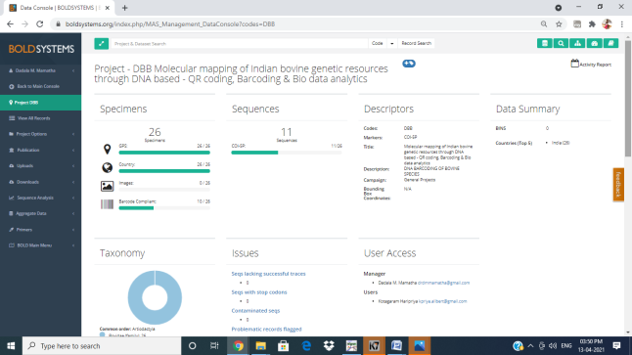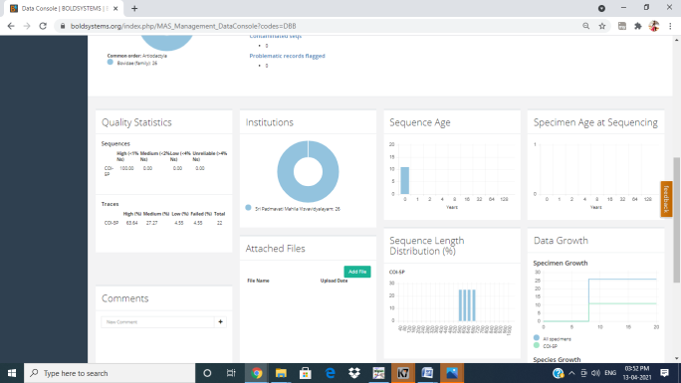
Fig:4 Sequence Submission to BOLD
2.4 QR code generation
Based on the DNA Barcodes generated, Quick Reading (QR) codeswere developed for each Bovidae species selected for this study for their automatic identification. Python program was used for QR code creation. QR code has the best compression efficiency in encoding DNA barcode sequences than the other 2D codes (Matrix). The open-source QR Code Library in the Jupyter-Python kernel version (Anaconda) was adapted for developing a program to encode the DNA sequences. Upon scanning the QR code, the complete details of the Cattle breed along with its DNA Barcode, breed characteristics and image will be displayed. The steps involved in creating DNA-based QR codes are shown in Figure 5.
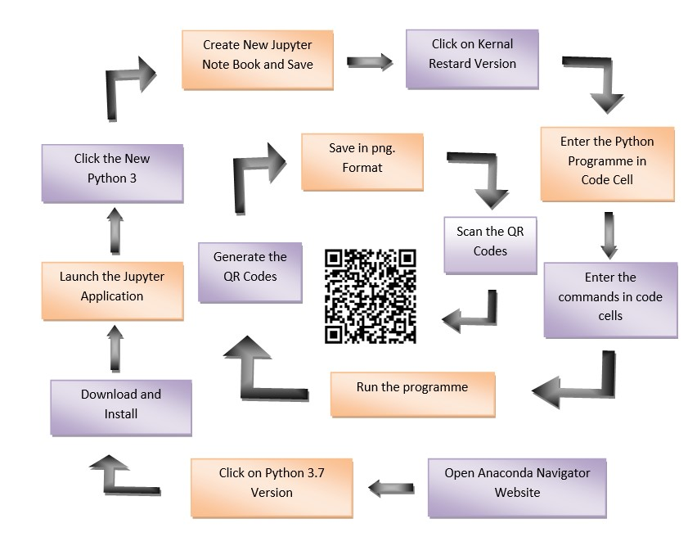
Fig:5. DNA Barcode based QR Code generation using Python

3. RESULTS
The isolated Genomic DNA was checked by performing 2% Agarose Gel Electrophoresis. The quantification of DNA was done using a Nano spectrophotometer, calculating the absorbance at 260 nm.
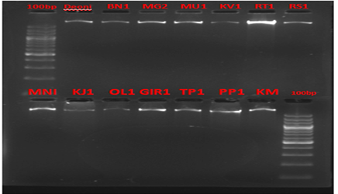
Fig:6 Genomic DNA - Agarose Gel Electrophoresis
Table: 9 Concentration and purity values of total genomic DNA extracted from Blood samples
S.No | Sample ID | Breed Name | Concentration  (ng/µl) | A260/280 | 260/230
1. | DEONI | Deoni(M) | 177.326 | 1.8 | 1.91
2. | BN | Banni | 116.74 | 1.91 | 1.97
3. | MG | Malanad Gidda | 256.4 | 1.98 | 2.15
4. | MU | Murrah | 812.30 | 1.82 | 1.99
5. | KV | Krishna valley | 720.47 | 1.86 | 1.99

The PCR products were observed on 1.5% agarose gel (Sigma, Low EEO) to check the gene amplification.200bp DNA ladder (TAKARA) was used as the DNA standard. 25 µl of each PCR sample was mixed with 3 µl of 6X gel loading dye and loaded and run at 100V for 60 min. The amplified bands were visualized by using the Gel doc system as shown in Figure 7.

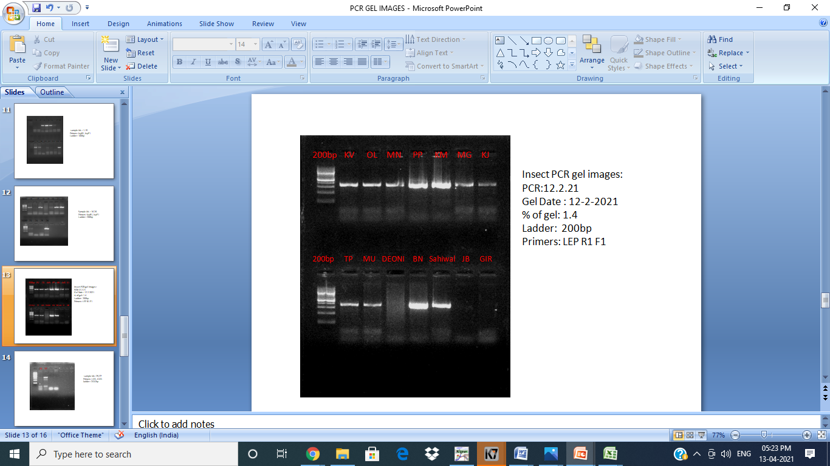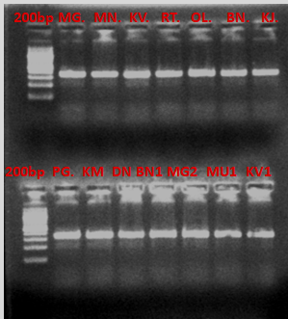
Fig:7. Mitochondrial CoX-I gene amplification in Bovine breeds
The PCR products were subjected to the Exo-SAP digestion and cleanup process. The purified amplified gene was sequenced. The obtained DNA sequences were trimmed, edited, and aligned using Codon Code Aligner and MEGA tools. The output is shown in Figure 8.
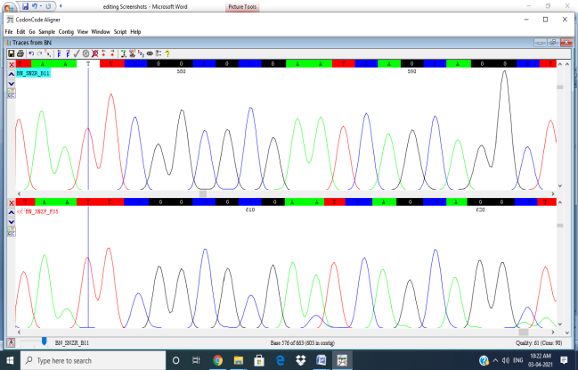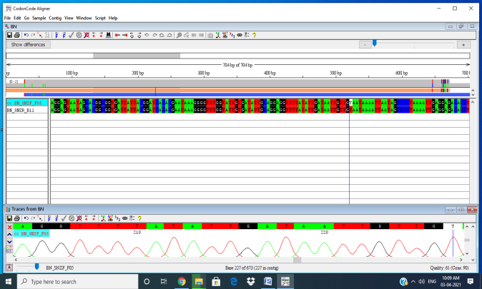
Fig:8 Chromatogram of Sequences and Sequence Editing - MEGA
The final sequences were submitted to BOLD with the respective trace files and the taxonomy files. BOLD Database reviewed and has generated DNA Barcodes for the selected Bovine species. The directory of Indian Bovine species’ DNA Barcodes in the BOLD database is the first of its kind (Fig:9). The DNA Barcodes for the selected Bovine breeds were tabulated in Table No. 10
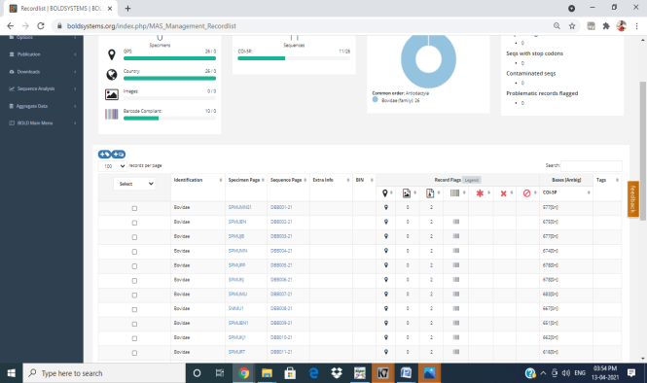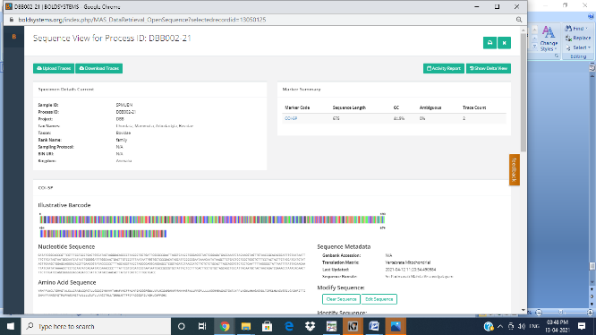
Fig:9BOLD database – Bovine Breeds – DNA Barcodes Directory

Table:10 CoX-I gene sequence and respective DNA Barcodes of Selected Bovine Species
S.NO | SAMPLE ID | SEQUENCE | BARCODE
1 | SPMUDEONI | GCTTGGGGCCGGAAGTAGGAACAGCTTTAAGCCTTCTAATTCGCGCTGAATTAGGCCAAC  CCGGAACTCTGCTCGGAGACGACCAAATCTACAACGTAGTTGTAACCGCACACGCATTTG  TAATAATCTTCTTTATAGTAATACCAATCATAATTGGAGGGTTCGGTAACTGACTTGTTC  CCCTAATAATTGGTGCTCCCGATATAGCATTTCCCCGAATAAATAATATAAGCTTCTGAC  TTCTCCCCCCCTCATTCCTACTACTCCTCGCATCCTCTATAGTTGAAGCTGGGGCAGGAA  CAGGCTGAACCGTGTACCCTCCCTTAGCAGGCAACCTAGCCCATGCAGGAGCTTCAGTTG  ATCTAACCATTTTCTCTTTACACTTAGCAGGAGTTTCCTCAATTTTAGGAGCCATCAACT  TCATTACAACAATTATCAACATAAAGCCCCCCGCAATGTCACAATACCAAACCCCTCTAT  TCGTATGATCCGTAATAATTACCGCCGTACTACTACTACTCTCGCTCCCTGTATTAGCAG  CCGGCATCACAATGCTATTAACAGACCGGAACCTAAATACAACTTTCTTCGACCCGGCAG  GAGGAGGAGATCCTATTCTATACCAACACTTATTCTGATTCTTTGGTCACCCGGAAGTTT | 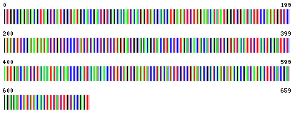
2 | SPMUBN1 | TCACATCGGCACCCGTTGCGTTGGTGCCTGACTGGCATAGTAGGGACAGCCCTAAGCCTG  CTGATTCGCGCCGAATTAGGTCAACCTGGGACCCTACTCGGAGATGACCAAATCTACAAC  GTAGTTGTAACCGCACACGCATTTGTAATAATTTTCTTCATAGTAATGCCAATCATAATT  GGGGGATTTGGCAACTGACTTGTCCCTTTAATAATTGGTGCTCCCGACATAGCATTCCCC  CGAATAAACAATATAAGCTTCTGACTCCTCCCTCCCTCTTTCCTACTACTTCTAGCATCA  TCTATAGTTGAAGCTGGAGCAGGGACAGGTTGAACCGTATACCCCCCTTTAGCAGGTAAC  CTAGCCCACGCAGGAGCCTCGGTAGATCTAACCATCTTCTCTCTGCACTTAGCAGGTGTC  TCCTCAATTTTAGGGGCTATTAATTTTATTACAACAATTATCAATATAAAACCTCCTGCA  ATATCACAATACCAAACCCCTTTATTCGTGTGATCCGTAATAATCACCGCCGTGCTATTA  CTCCTTTCACTTCCTGTGCTAGCAGCTGGCATTACAATGCTACTAACAGATCGAAACCTA  AACACAACTTTCTTTGATCCAGCGGGGGGACAACTTGATTCTTTGGTCACC | 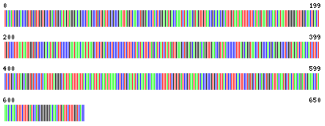
3 | SPMUMG | TTTGCTTGGGGCCGGTATAAGGGAACAGCTTTAAGCCTTCTAATTCGCGCTGAATTAGGC  CAACCCGGAACTCTGCTCGGAGACGACCAAATCTACAACGTAGTTGTAACCGCACACGCA  TTTGTAATAATCTTCTTTATAGTAATACCAATCATAATTGGAGGGTTCGGTAACTGACTT  GTTCCCCTAATAATTGGTGCTCCCGATATAGCATTTCCCCGAATAAATAATATAAGCTTC  TGACTTCTCCCTCCCTCATTCCTACTACTCCTCGCATCCTCTATAGTTGAAGCTGGGGCA  GGAACAGGCTGAACCGTGTACCCTCCCTTAGCAGGCAACCTAGCCCATGCAGGAGCTTCA  GTTGATCTAACCATTTTCTCTTTACACTTAGCAGGAGTTTCCTCAATTTTAGGAGCCATC  AACTTCATTACAACAATTATCAACATAAAGCCCCCCGCAATGTCACAATACCAAACCCCT  CTATTCGTATGATCCGTAATAATTACCGCCGTACTACTACTACTCTCGCTCCCTGTATTA  GCAGCCGGCATCACAATGCTATTAACAGACCGGAACCTAAATACAACTTTCTTCGACCCG  GCAGGAGGAGGAGATCCTATTCTATACCAACACTTATTCTGATTCTTTGGTCACCCCGAA  GT | 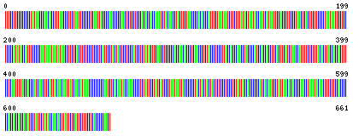
4 | SMMU1 | TCATAAAGATATCGGCACCCGTTTGCTGTTTGGGCGCTGGCATAGTAGGGACAGCCCTAA  GCCTGCTGATTCGCGCCGAATTAGGTCAACCTGGGACCCTACTCGGAGATGACCAAATCT  ACAACGTAGTTGTAACCGCACACGCATTTGTAATAATTTTCTTCATAGTAATGCCAATCA  TAATTGGGGGATTTGGCAACTGACTTGTCCCTTTAATAATTGGTGCTCCCGACATAGCAT  TCCCCCGAATAAACAATATAAGCTTCTGACTCCTCCCTCCCTCTTTCCTACTACTTCTAG  CATCATCTATAGTTGAAGCTGGAGCAGGGACAGGTTGAACCGTATACCCCCCTTTAGCAG  GTAACCTAGCCCACGCAGGAGCCTCGGTAGATCTAACCATCTTCTCTCTGCACTTAGCAG  GTGTCTCCTCAATTTTAGGGGCTATTAATTTTATTACAACAATTATCAATATAAAACCTC  CTGCAATATCACAATACCAAACCCCTTTATTCGTGTGATCCGTAATAATCACCGCCGTGC  TATTACTCCTTTCACTTCCTGTGCTAGCAGCTGGCATTACAATGCTACTAACAGATCGAA  ACCTAAACACAACTTTCTTTGATCCAGCGGGGGGAGGAGTACACTTATTTTGATTCTTTG  GTCACCC | 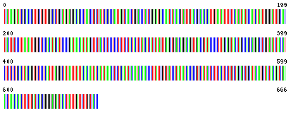
5 | SPMUKV | CTTGGGGCCGGTATAGTAGGAACAGCTTTAAGCCTTCTAATTCGCGCTGAATTAGGCCAA  CCCGGAACTCTGCTCGGAGACGACCAAATCTACAACGTAGTTGTAACCGCACACGCATTT  GTAATAATCTTCTTTATAGTAATACCAATCATAATTGGAGGGTTCGGTAACTGACTTGTT  CCCCTAATAATTGGTGCTCCCGATATAGCATTTCCCCGAATAAATAATATAAGCTTCTGA  CTTCTCCCTCCCTCATTCCTACTACTCCTCGCATCCTCTATAGTTGAAGCTGGGGCAGGA  ACAGGCTGAACCGTGTACCCTCCCTTAGCAGGCAACCTAGCCCATGCAGGAGCTTCAGTT  GATCTAACCATTTTCTCTTTACACTTAGCAGGAGTTTCCTCAATTTTAGGAGCCATCAAC  TTCATTACAACAATTATCAACATAAAGCCCCCCGCAATGTCACAATACCAAACCCCTCTA  TTCGTATGATCCGTAATAATTACCGCCGTACTACTACTACTCTCGCTCCCTGTATTAGCA  GCCGGCATCACAATGCTATTAACAGACCGGAACCTAAATACAACTTTCTTCGACCCGGCA  GGAGGAGGAGATCCTATTCTATACCAACACTTATTCTGATTCTTTGGTCACCGGAAAGAA  A | 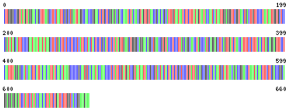

QRcodes were generated based on the obtained DNA Barcodes using Python Code. Each characteristic of the breed is also linked with the QR code. Upon scanning, the morphological and molecular parameters of bovine species would be displayed. The output page for the QR code shows the cattle image, DNA Barcode and Characteristics as shown in Fig.10.
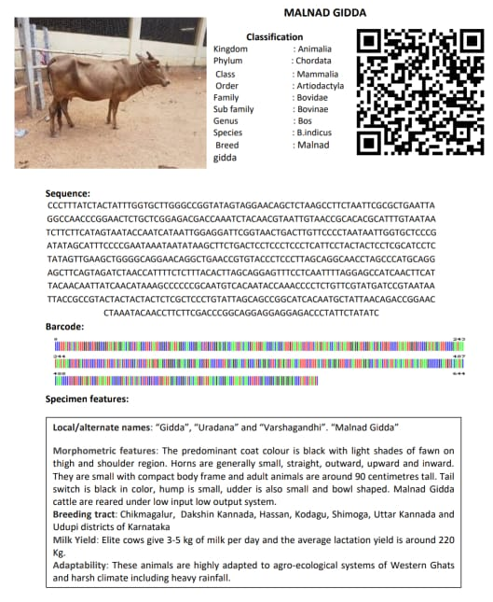
Fig: 10 QR Code scan – Output page – showing the characteristics of a Breed
4. DISCUSSION
5 Bovine Breed species were selected and studied for Molecular Mapping using DNA Bar coding, and QR code techniques. One of the primary applications of DNA bar coding in bovine breeds is its role in accurate breed identification. Traditional methods of breed classification often rely on phenotypic characteristics, but these can be misleading due to environmental influences, crossbreeding, and shared traits across breeds. DNA bar coding provides a more reliable and objective way to classify and verify the identity of bovine breeds at a molecular level.A study by Jin et al. (2020) showed that DNA bar coding using the mitochondrial cytochrome c oxidase subunit I (COI) gene could differentiate between various cattle breeds, facilitating breed verification and maintaining breed purity.
DNA bar coding helps assess the genetic diversity within and between different bovine breeds. This is crucial for understanding the health, adaptability, and long-term sustainability of cattle populations. By analyzing variations in the barcode region, scientists can estimate the genetic variation, which is essential for improving breeding programs and preventing inbreeding depression.Zhao et al. (2021) conducted a study on the genetic diversity of cattle breeds in China using mitochondrial DNA bar coding, finding significant variation within local breeds that could inform breeding strategies and conservation.
With the increasing global demand for beef and dairy products, traceability has become a key concern. DNA bar coding allows for the traceability of animal products from farm to table, helping prevent mislabeling or fraud in meat products, such as misrepresentation of breed or geographic origin. This ensures transparency and improves consumer confidence in product authenticity.DNA bar coding has been used to authenticate beef products and prevent fraud in the market, particularly where premium beef varieties like Kobe beef or Wagyu are sold. Smith et al. (2018) demonstrated the effectiveness of DNA bar coding in verifying beef authenticity.
In addition, Image processing techniques allow for automated breed classification, reducing the need for human experts to visually inspect cattle. By analyzing images, machine learning models are trained to recognize patterns associated with different bovine breeds. These models can process large datasets of images to classify animals rapidly and accurately.Hussain et al. (2020) study developed a deep learning model using convolution neural networks (CNNs) to classify bovine breeds based on visual characteristics like body shape and color patterns. This approach demonstrated high accuracy in differentiating breeds such as Holstein, Jersey, and Brahman.Image processing can be used in real-time systems to monitor herds, track cattle movements, and identify specific breeds. Cameras installed on farms or drones can capture images of cattle from different angles and conditions. Image processing algorithms can then analyze these images for breed recognition, behaviour tracking, and health monitoring.Kim et al. (2019) used image processing techniques in combination with computer vision algorithms to identify cattle breeds in real time using images captured by drone-mounted cameras. This approach is especially useful for monitoring large herds in remote or extensive pasturelands.
Ultimately, the combination of these innovative molecular techniques with DNA Barcode data sets promises to improve our understanding of bovine genetics, facilitate better decision-making in breeding programs, and contribute to the broader goals of livestock sustainability and food security in India. Future research should continue to focus on refining these technologies, enhancing database interoperability, and incorporating multi-disciplinary approaches to further optimize the use of molecular resources in bovine genetic conservation and development.
5. CONCLUSION
By combining DNA-based genetic techniques, digital tools (QR codes), and advanced image analysis, this project aims to build a cutting-edge framework for the molecular identification and conservation of Indian bovine genetic resources. This interdisciplinary approach supports biodiversity conservation while promoting sustainable livestock management practices.
REFERENCES
- Hebert, S. Ratnasingham, J. R. DeWaard, Barcoding animal life: cytochrome c oxidase subunit 1 divergences among closely related species, Proc. R. Soc. Lond. B (Suppl.), 270 (2003) 96–99.
- D. N. Hebert, A. Cywinska, S.L. Ball, J.R. deWaard, Biological identifications through DNA barcodes, Proc. Biol. Sci. 270 (2003) 313-321.
- Librado, J. Rozas, DnaSP v5: a software for comprehensive analysis of DNA polymorphism data, Bioinformatics, 25 (2009) 1451-1452
- Folmer, M. Black, W. Hoeh, R. Lutz, R. Vrijenhoek, DNA primers for amplification of mitochondrial cytochrome c oxidase subunit I from diverse metazoan invertebrates, Mol Mar Bio Biotech, 3(1994)294–299.
- Kim, J. S. Bae, H. D. Sohn, P. D. Kang, K. S. Ryu, B. H. Sohn, W. B. Jeong, B. R. Jin, Genetic homogeneity in the domestic silkworm, Bombyxmori, and phylogenetic relationship between B. mori and the wild silkworm moth, B. mandarina, using mitochondrial COI gene sequences. International Journal of Industrial Entomology, 1(2000)9–17.
- Kumar, G. Stecher, M. Li, C. Knyaz, K. Tamura, MEGA X: molecular evolutionary genetics analysis across computing platforms, MolBiolEvol, 35(6) :(2018)1547–1549.
- Nicole, Biodiversity analysis through DNA barcoding; application in agri-food and seafoods products [dissertation], Padova: Universita' DegliStudi Di Padova(2010).7. Ratnasingham, P. D. N. Hebert, Bold: The Barcode of Life Data System (http:// www.barcodinglife.org), Molecular Ecology Notes 7 (3) :(2007)355-364.
- A. Hall, BioEdit: A User-Friendly Biological Sequence Alignment Editor and Analysis Program for Windows 95/98/NT. Nucleic Acids Symposium Series, 41(1999), 95-98.
- C. Narendran, Taxonomic entomology: Research and education· in India, Current Science, 81 (5) :(2001)445-447.
- J. Kress, D. L. Erickson, A two-locus global DNA barcode for land plants: the coding rbcL gene complements the non-coding trnH-psbA spacer region. PloS one, 2(6) :(2007)508.
- Mehrdad Hajibabaei, M. Alex Smith, Daniel H. Janzen, Josephine J. Rodriguez, James B. Whitfield, Paul D. N. Hebert- A minimalist barcode can identify a specimen whose DNA is degraded. https://doi.org/10.1111/j.1471-8286.2006.01470.x.
- Koichiro Tamura , Glen Stecher , Sudhir KumarMEGA11: Molecular Evolutionary Genetics Analysis. Molecular Biology and Evolution, Volume 38, Issue 7, July 2021, Pages 3022–3027, https://doi.org/10.1093/molbev/msab120.
- S F Altschul ¹, T L Madden, A A Schäffer, J Zhang, Z Zhang, W Miller, D J Lipman,
- Gapped BLAST and PSI-BLAST: a new generation of protein database search programs.
- PMID: 9254694, PMCID: PMC146917, DOI: 10.1093/nar/25.17.3389.
- 14.Yuefei Jin ¹, Haiyan Yang ¹, WangquanJi ¹, Weidong Wu ², Shuaiyin Chen ¹, Weiguo Zhang ¹ ³, GuangcaiDuan ¹,Virology, Epidemiology, Pathogenesis, and Control of COVID-19
- PMID: 32230900 ,PMCID: PMC7232198, DOI: 10.3390/v12040372.
- .Sultana et al. (2017). DNA Barcoding: A Powerful Tool for Species Identification.
- Hebert, P. D. N., Cywinska, A., Ball, S. L., &deWaard, J. R. (2003). Biological identifications through DNA barcodes. Proceedings of the Royal Society B: Biological Sciences, 270(1512), 313-321.
- www.barcoding.si.edu (Barcode of Life Data Systems)
- Teletchea, F. (2009). Molecular identification methods of fish species: reassessment and possible applications. Reviews in Fish Biology and Fisheries, 19(3), 265-283.
- Dalin et al. (2016). DNA barcoding for meat authentication: A review. Food Control, 66, 247-255.

