Original Research Article
Impact of Human Elephant Conflict: A case study from Northern West Bengal, India.

ABSTRACT:
Human wildlife conflict (HWC) refers to the conflict between human and wildlife mostly in the edges of protected areas resulting in negative impact on both sides. With time such conflicts are increasing raising major concern. Elephants are one animal responsible for HWC. Northern part of West Bengal encounters large number of instances of Human elephant conflict (HEC). The present work is a case study of a Chauhaddi village, particular area of Jalpaiguri district of North Bengal with reference to HEC. The losses on the human side due to HEC have been studied for 14 months. Our results show a massive damage of different types of crops in field during the study period. We also documented instances of house damage and damage of stored food grains by the elephants. in a nutshell, HEC results in massive loss of crop and property in North Bengal and proper mitigation measures are necessary to address this problem.
KEYWORDS: Human Elephant conflict, North Bengal, Chauhaddhi, Crop damage, raids.

1. INTRODUCTION
Human wildlife conflict (HWC) is commonly described as friction between wild animal and humans (Monney et al., 2010). HWC is one of the major challenges in sustainable development. This is particularly applicable when ecologically and economically important wildlife impact human livelihood (Braczkowski et al., 2023). HWC includes incidents like crop and property damage, livestock and human injury and fatalities and harm or death of wild animals (Gandiwa et al., 2013; McGuinness & Taylor, 2014). HWC involves a diverse array of animals, ranging from large herbivores (like elephants) to smaller carnivorous species (Paudel et al. 2024, Woodroffe et al., 2005). These animals contribute to HWC in various ways: herbivores typically cause crop and property damage and occasional human injuries, while carnivores are more often responsible for livestock depredation and attacks on humans (Jenks et al., 2013).
Among HWC, Human elephant conflict (HEC) is a significant one specially in India. IUCN has listed the Asian Elephant (Elephas maximus) as ‘endangered’ animal. However, loss of habitat, Human elephant conflict and illegal killing serves as major threats to the survival of elephants (Lenin & Sukumar, 2011). HEC results in adverse effect on the local peoples in form of damage of crop and property and sometimes loss of lives (Kamdar et al., 2022). Understanding HEC and knowledge about the spatial-temporal pattern of HEC can help in planning the mitigation measures in the affected areas (Naha et al., 2019). Mitigating HEC is crucial for the conservation of elephants as well as social justice (Kamdar et al., 2022)
According to the latest estimates by Government of India, about 27000 (All India Synchronized Elephant Population Estimation, 2017) elephants spread across an area of about 109,500 sq Km in 23 states (Lenin & Sukumar, 2011). In such areas HEC are common resulting in damage of crop, property and lives. The government needs to spent substantial amount of fund for controlling such damages and paying ex gratia/compensation (Bist, 2002).

In India, more than 50% of the elephant population occurs in small groups within fragmented landscape with extensive overlap with the humans (Naha et al., 2019). Dooars located in the northern part of West Bengal is one such fragmented landscape with about 500 elephant spread over an area of 2000 sq Kms (All India Synchronized Elephant Population Estimation. 2017). A large number of cases of HEC are reported from North Bengal every year and majority of such cases occurs outside the protected areas (Chowdhury et al., 1998).

Although in most of the cases the Human animal conflict or HEC are typically portrayed from the animal centric perspective focusing on the population decline and death of wildlife, there has been significant rise in human casualties and property and crop damage in recent years. The present case study intends to investigate the damage of property and crop in Chauhaddi village of Dhupguri block, Jalpaiguri district with reference to elephant raids over 14 months time. we have also documented the frequency and time of elephant raids.

2. STUDY AREA AND METHODOLOGY
2.1 Study area
The study was conducted in a specific area in Northern West Bengal where there is frequent incidence of Human elephant conflicts. The area selected for the present study was Chauhaddi village in Dhupguri block of Jalpaiguri district of West Bengal. This area lies in close proximity to Gorumara national park and Chapramari wild life sanctuary. Chauhaddi has a population of about 2205 (as per 2011 census) and 491 household. The percentage of male and females are respectively 47.8% and 52.2% , with a total literacy rate of 58.7%. Chauhaddi has a total area of 230.7 hectares. Dhupguri, located 15 kms from chauhaddi is the nearest town.

2.2 Data collection and field visits

Regular field visits were conducted in the study area throughout the study period to gather information regarding human elephant conflict in the area. We obtained verbal approval from the local community heads/ village headmen for conducting the study. Primary data were collected through Household (HH) questionnaire survey and Key Informant Interviews (KII). Survey was conducted using semi-structured questionnaires. The questionnaire included both open-ended and closed-format questions. We inquired about the details of such incidents from family members of conflict victims, companions, local people who were present. A person was interviewed only after verbal consent was taken and once they agreed to share the details. The form submitted by the villagers for compensation for loss / damage of property crop were also looked into for documentation of the area of crop field damaged.

3. RESULTS:
3.1 Number and time of raids by elephants
The instances of elephant raids in the study site were documented over the entire 14 months of study period. Our result reveals that there was a total of 161 cases of elephant raids in the area. The mean number of elephant raids was 11.4 per month during the study time. The month wise instances have been presented graphically in Fig. 1A. Our data revealed maximum cases of elephant raids on February 2025 and a minimum number of cases in April 2024. We also documented a visual increase in the number of raids from September 2024 to February 2025.
We also investigated the time at which the elephants raid the human habitat. Most of the incidents were found to occur between 6PM to 6 AM. Within this span of time, maximum (42%) raids occurred between 12AM to 3AM whereas only 5% cases occurred between 6PM to 9PM (Fig. 1B and 1C)

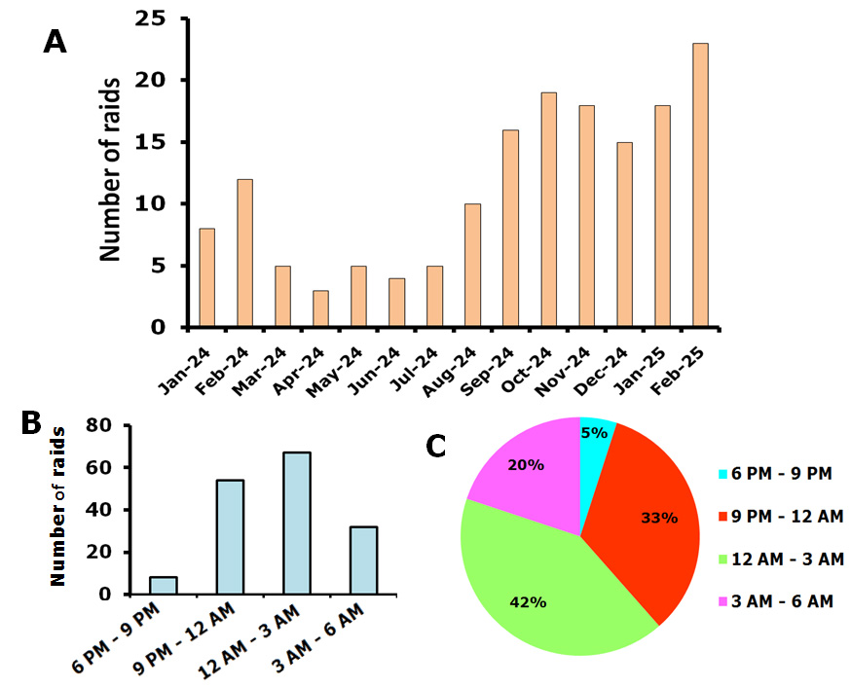
Fig 1:Number and time of raids by elephant in the study area. A. Graphical representation of number of elephant raids, month wise from January 2024 to February 2025. B. Graphical representation of number of elephant raids with respect to time. C. Graphical representation of percentage of Elephant raids between 6 PM to 9 PM, 9 PM to 12 AM, 12 AM to 3AM and 3AM to 6AM.

3.2 Amount of crop field damaged
The elephant raids in the study area resulted in damage of crop in fields. The different crops and area of cultivated field that were damaged were documented in the present study. Our result revealed that fields of 17 different types of crops were damaged. The crops were Potato, Paddy, Cabbage, Cucumber, Tomato, Pointed gourd, Radish, Eggplant, Cauliflower, Garlic, Beans, Mustard, Jute, Lady finger, Gourd, Banana and onion. It was documented that the maximum damage occurred in the Paddy field (2695 sq mt.) which was 28% of the total damaged agricultural field, followed by cabbage (1613 sq mt. ) and potato fields (about 1519 sq mt ) (Fig. 2). The least affected crop was Banana (55 sq mt.) and onion (76 sq mt.). Next we investigated the month wise damage of each crop in field due to the elephant raids. Our results show that, maximum damage of paddy fields occurred during October 2024 to December 2024, potato occurred during December 2024 and January 2025 and maximum damage of cabbage occurred during October 2024 (Fig. 3A). Our results also revealed that Jute and gourd fields were maximally damaged during August 2024 and September 2024 respectively (Fig. 3B). Maximum damage of Radish and eggplant occurred in October 2024 and that of cauliflower occurred in November 2024. Tomato fields and pointed gourd fields were maximally affected during February 2024 and January 2025 respectively (Fig. 3C).

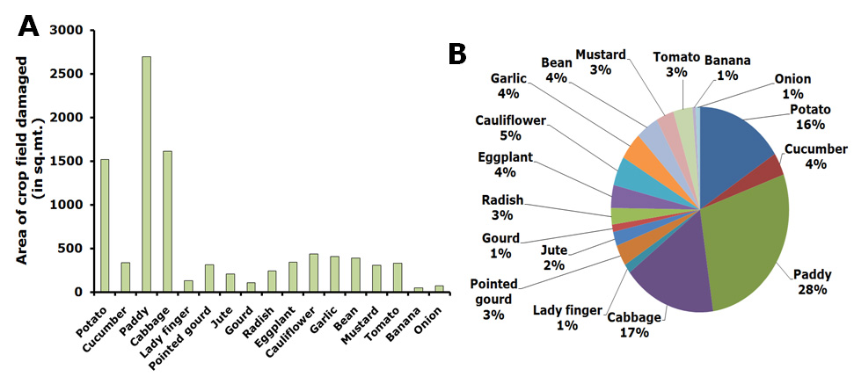
Fig 2: A. Graphical representation of the area of cropfields damaged (17 different crops are shown). B. Graphical representation of the percentage of different types of crops damaged in field in the study area.

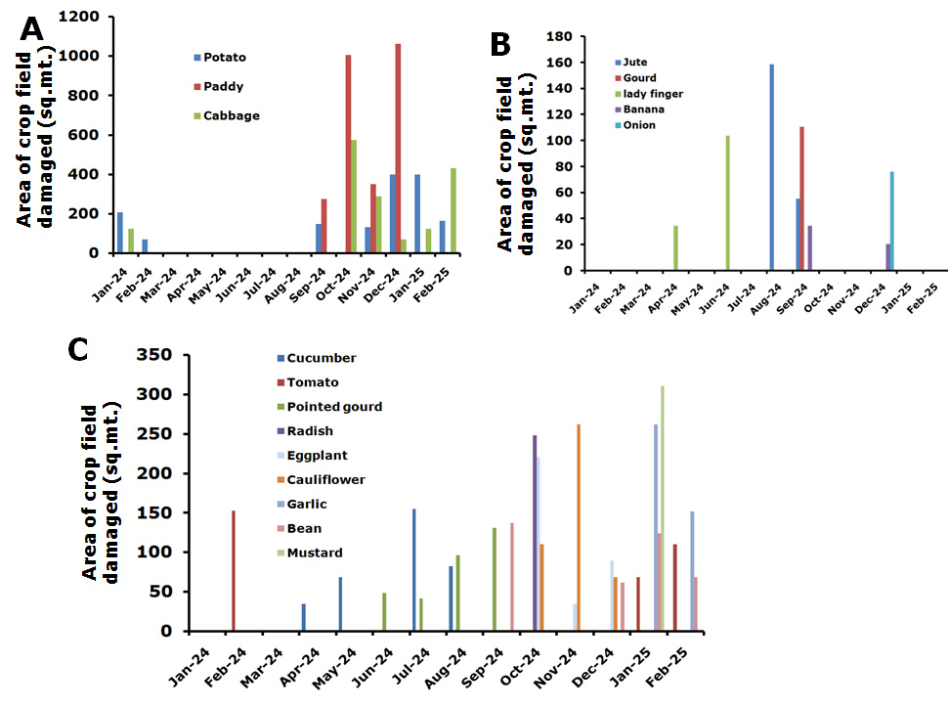
Fig 3: Graphical representation of area of crop field damaged monthwise by the elephants from January 2024 to February 2025. A. graphical representation of Potato, paddy and Cabbage fields damaged monthwise. B. graphical representation of Jute, gourd, lady finger, banana and onion fields damaged monthwise. C. graphical representation of Cucumber, Tomato, Pointed gourd, Radish, Eggplant, Cauliflower, Garlic, Beans and mustard fields damaged monthwise.

3.3 Instances of house damage and damage of stored grains
Apart from the crop field damage, the elephants also cause house damage and damage of the store food grains whenever they enter human habitat. In the study area a large number of instances of house damage and damage of stored food grain was documented (Fig. 4). A total of 63 cases of house damage and 46 cases of damage of stored food grain was documented in the study area within the 14 month of study time. maximum instances were documented between September 2024 and January 2025.

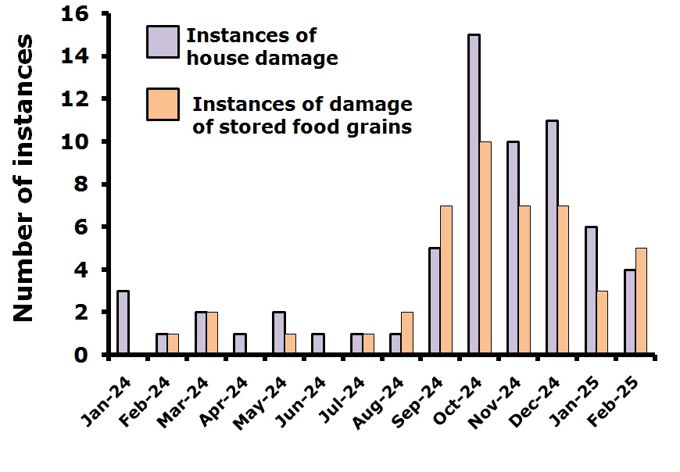
Fig 4: Graphical representation of the number of instances of house damage and instances of damage of stored grains in the study area by the elephants during the study period.

4. DISCUSSION:
As per the government records the total number of human deaths due to HEC in India is within 390-420 during 2013-2016 (Ministry of Environment, Forest and Climate Change, Elephant Menace Report. 2017). Of the entire elephant population in the country North Bengal houses about 1.8% of the elephants. However this small percentage of elephant population is responsible for about 12% of human casualties of the entire country resulting from HEC (Naha et al., 2019), implying the magnitude of problem. Reports also suggests that elephants come in this area from neighboring states like Assam resulting in seasonal usage of this area (Sukumar et al., 2003).This place also has a high human population (about 500-700 per sq Km) as per census2011. This results in frequent HEC in his area.

Studies have reported an increase of about 44% of area under human settlement and a slight increment of forest area between 2008 to 2018. Establishment of Teesta barrage in 1980 near Siliguri has disrupted the traditional migratory routes of elephant from east to west causing habitat fragmentation (Sukumar, 1989).

The present study focuses on the HEC in a particular area of North Bengal, West Bengal, India. In his study the damage of crop and property has been documented over 14 months of time. Our result revealed massive loss of crops in field due to elephant raids. A study from Africa had reported that the elephants cause damage in same area every year indicating a spatial pattern and repetitive behavior (Naughton-Treves L, 1998). Thus the areas raid by elephant this year is likely to be raid every year with a higher frequency. Clustering of crop damage location indicates the long term memory of elephants (Sitati NW et al., 2003). This may be a reason why we found a increased number of raids in our study area in January and February 2025 compared to January and February 2024. Our result also indicates a general trend of increasing number of raids with time during our study period.
Previous reports suggests that inspite of availability of resources in protected areas, the elephant, during the crop harvesting season raids the adjacent areas for the accessibility of abundant food (Stewart-Cox & Ritthirat, 2007). We in our study also found that most of the raids were done during the harvesting time of the respective crops.

Reports suggest that majority of elephant raids occur after dark in night (Naha et al., 2019). Telemetry data also indicates that elephants are nocturnal here (Sukumar et. al., 2003). These reports corroborate well with our present finding where we have found that most of the elephant raids occurred after evening and maximum during night. In previous reports as well as in our present study, the local peoples have informed that the elephants regularly damage households to seek stored grains including locally brewed alcohol.

It is important to note that the protected areas in this region are about 10-20 Sq Km, whereas report indicates that a herd of elephant need habitat patch of 250-300 sq km for sustenance (Desai & Riddle, 2015).
One possible way to address this is the proper maintenance of the wildlife corridors for the free movement of animals. Anthropogenic activities in this areas needs to be controlled, specially construction of walls, dams, railway tracts and roads.

We in this study found that most of the crops grown in the study area and subjected to elephant raids are palatable crops. Growing comparatively unpalatable crops like ginger, chillies etc could be a short term measure to control elephant raids on crop field.

Elephants prefer to live in large areas and confining them in small fragmented forested area will only intensify the problem resulting in more human elephant conflict and damage of crop and property. Proper maintenance of elephant corridors and other mitigation measures both from Government, non government and locals could reduce the issues of Human elephant conflict in the area.

CONCLUSION
The conservation initiatives has resulted in an increase in the wildlife population in protected areas of north Bengal. Simultaneously the increase in human population and increase of land use around he protected areas are resulting in frequent human wildlife conflict including HEC. Even though most of the reports highlight the losses of the wildlife, the damage and losses suffered by the humans also needs to be addressed. This study highlights the massive damage of property and crop resulting from HEC in Chauhuddi area of North Bengal. Such incidents will increase the chances of retaliatory effects among locals, which may pose challenge to conserve wild life in nature. Initiatives should be taken to minimize such conflicts.

DISCLAIMER (ARTIFICIAL INTELLIGENCE)

Author(s) hereby declaresthat NO generative AI technologies such as Large Language Models (ChatGPT, COPILOT, etc) and text-to-image generators have been used during writing or editing of this manuscript.

REFERENCE

All India Synchronized Elephant Population Estimation. Ministry of Environment, Forest and Climate Change, Report. 2017.

Bist SS. (2002) An Overview of Elephant Conservation in India. Indian Forester. 128.

Braczkowski, A.R., O’Bryan, C.J., Lessmann, C., Rondinini, C., Crysell, A.P., Gilbert, S., Stringer, M., Gibson, L., & Biggs, D.(2023) The unequal burden of human-wildlife conflict. Commun Biol 6, 182.

Chowdhury, S., Khalid, M.A., Roy, M., Singh, A.K., & Singh, R.R. (1998) Management of elephant populations in West Bengal for mitigating man-elephant conflicts. Wildlife Institute of India, Dehradun, India, Report.

Desai, A.A., and Riddle, H.S. (2015) Human-Elephant Conflicts in Asia, US Fish and Wildlife Service, Asian Elephant Support, Report.

Jenks, K.E., Songsasen, N., Kanchanasaka, B., Bhumpakphan, N., Wanghongsa, S., & Leimgruber,P. (2013). Community attitudes toward protectedareas in Thailand. Natural History Bulletin of the SiamSociety, 59(2), 65-76.

Kamdar, A., H. Kumar Baishya, H. Nagendra, J. Ratnam, D. Smith & Sekar, N. (2022) Human–elephant conflict mitigation as a public good: what determines fence maintenance? Ecology and Society, 27(3),24

Lenin, J., and Sukumar, R. (2011) Action Plan for the mitigation of human-elephant conflict in India. Asian Nature Conservation Foundation, Report.

Ministry of Environment, Forest and Climate Change, Elephant Menace Report. 2017.

Naha, D., Sathyakumar, S., Dash, S., Chettri, A., & Rawat, G.S. (2019) Assessment and prediction of spatial patterns of human-elephant conflicts in changing land cover scenarios of a humandominated landscape in North Bengal. PLoS One, 14(2), e0210580

Naughton-Treves L. (1998) Predicting patterns of crop damage by wildlife around Kibale National Park, Uganda. Conservation Biology. 12.

Paudel, P., Rai, M., Gurung, S., & Raut N. (2024) Status of Human-Wildlife Conflict and mitigation measures adopted bylocals in Shivapuri Nagarjun National Park, Kathmandu Nepal. Nep J Environ Sci, 12(2), 47-58

Sitati, N.W., Walpole, M.J., Smith, R.J., & Williams, L. N. (2003) Predicting spatial aspects of human-elephant conflict. Journal of Applied Ecology. 40.

Stewart-Cox, B., and Ritthirat, J. (Eds.) (2007) Mitigating human-elephant conflict in Asia: a new initiative in Thailand. In: Walpole M and Linkie M Mitigating Human Elephant Conflict: Case Studies from Africa and Asia. Fauna and Flora International, Cambridge, UK.

Sukumar R. (1989) The Asian Elephant: ecology and management. Oxford University Press, Cambridge, UK.

Sukumar, R., Venkataraman, A., Cheeran, J.V., and Mujumdar, P.P. (2003) Study of elephants in Buxa Tiger Reserve and adjoining areas in northern West Bengal and preparation of conservation action plan. Centre for Ecological Sciences, Indian Institute of Science, Bangalore.
Woodroffe, R., Thirgood, S., & Rabinowitz, A. (Eds.).(2005). People and wildlife, conflict or co-existence? (Vol.9). Cambridge University Press.

