Short communication
First report of Paracanthocobitis abutwebi (Singer & Page, 2015) from Tizit river, Nagaland, India.

ABSTRACT
Paracanthocobitis abutwebi Singer & Page, 2015 is reported first from the Tizit River, a tributary of the Brahmaputra river in Nagaland. Paracanthocobitis abutwebi is distinguished from all other Paracanthocobitis species in having combination of complete lateral line; absence of the axillary pelvic lobe; pattern of dark specks on the upper side between small dorsal saddles; 4-5 black bands on the caudal fin; commonly 12 dorsal-fin rays; 10-13 branched pectoral-fin rays; and alternating large and small dark patch along the lateral line; 8 pelvic fins rays and 6-7 anal-fins rays.

Keywords: Nemacheilidae, Paracanthocobitis, Tizit river, Burmaputra drainage, Nagaland.

- INTRODUCTION
The genus Paracanthocobitis is geographically widespread and species rich group of Nemachilid fish in South East Asia (Shangningam et al.,2019). The genus is distinguished from all other genera of the family Nemacheilidae by the combination of lower lip with a large papillated pad on either side of a medial interruption, upper lip with 2–5 rows of papillae and continuous with lower lip, conspicuous black spot with ocellus on upper half of caudal-fin base (Kottelat 2012, Singer & Page 2015) and distinguished from Acanthocobitis in having an emarginate or truncate (vs. pointed) caudal fin; patch (vs. no patch) of adipose tissue on anterior end of lateral line; 9-15 (vs. 17-19) branched dorsal-fin rays, and a rounded (vs. more triangular-shaped) head (Singer, R.A. 2013))
During the investigation, 8 specimens of Paracanthocobitis abutwebi (Singer & Page, 2015) were collected from the Tizit river and reported for the first time from the state of Nagaland, India.

- MATERIALS AND METHODS
The specimen was collected using traditional methods and cast net from the Tizit River, Brahmaputra drainage in Nagaland. Morphometric measurements were made on the left side of the specimens with vernier calliper to the closest 0.1 mm. Meristic counts and measurements were followed after the Kottelat (1990). The number of scales and fin rays were counted using a Carl Zeiss 508 stereo-zoom microscope. The measurements of specimens are expressed as a ratio of head length (HL) and standard length (SL). In the field the specimens was fixed in 5% formaldehyde as per Joshi and Sreekumar (2015), later preserved in 70% ethanol and deposited in the Freshwater and Fish Biology Research lab at the Department of Zoology, Kohima Science College, Jotsoma.
2.1 STUDY SITE DESCRIPTION
Tizit river is located in Tizit a sub-division of Mon district of Nagaland with latitude 26.902278⁰ and longitude 95.070209⁰. The river is a fast-flowing and has rough river-bed with stone and gravel. It exhibits seasonal fluctuation in water volume and movement. It flows toward Arunachal Pradesh and confluence with Brahmaputra River at Assam.
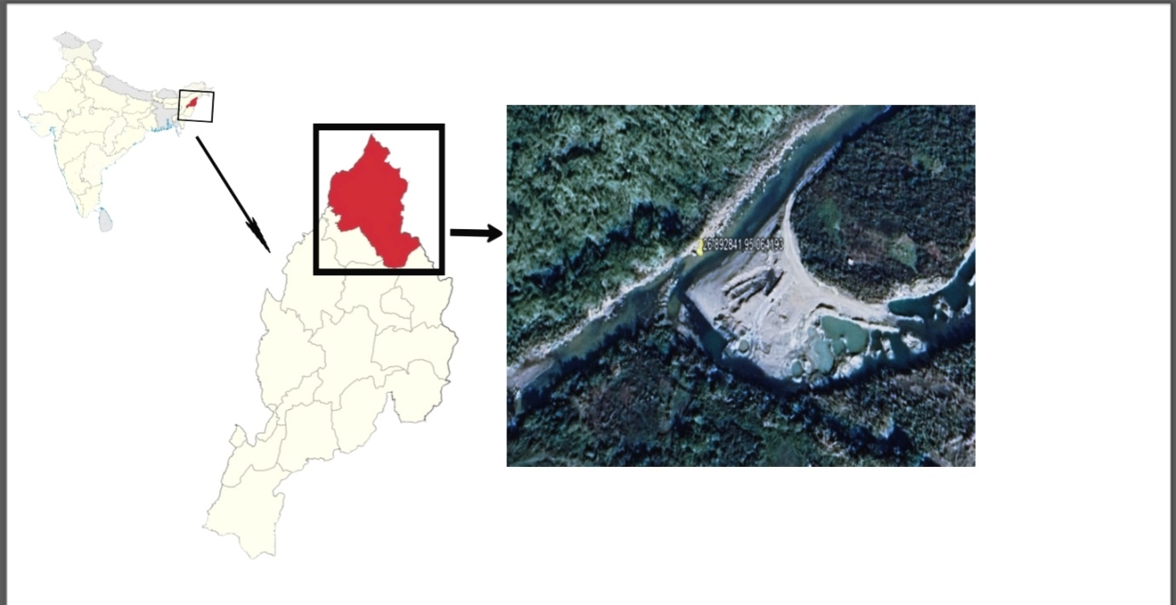

Fig.1. Map showing the study area of Paracanthocobitis abutwebi.

- DESCRIPTION
Morphometric data are in Tables 1. Body depth slightly deeper at dorsal-fin origin; branched dorsal-fin rays 12-13 (usually 12); branched pectoral-fin rays 10-13; pelvic-fin rays 8; anal-fin rays 6-7 (usually 7); branched caudal-fin rays 9+9; transverse bands in caudal fin 4-5; suborbital flap in male; axillary pelvic lobe absent; lateral line complete with 86-104 pores. Maximum SL = 68.0 mm female.

3.1 COLOURATION
A prominent black patch with a white edge on upper half of caudal fin base. Alternate large and small patches along the lateral line; 10 – 13 small dorsal saddles not extending to lateral line and closer together towards the head. 10-16 dark patches along lateral line, spots not extending onto venter. Speckled pattern on upper side and extending to the lateral line.

3.2 DIAGNOSIS
Paracanthocobitis abutwebi is distinguished from all other Paracanthocobitis species by an alternate large and small dark patch along the lateral line, a pattern of dark specks on the upper side between small dorsal saddles, 4-5 dark bands on the caudal fin, a complete lateral line and the absence of an axillary pelvic lobe.

3.3 DISTRIBUTION
Paracanthocobitis abutwebi is known from the Karnaphuli, Meghna, and lower Brahmaputra and Ganges river drainages of Bangladesh (Singer & Page) and In India, it is known from the Tizit River, Nagaland a tributary of the Brahmaputra River (Fig.1).

- DISCUSSION.
Paracanthocobitis abutwebi is a species of ray-finned fish commonly known as the hill stream zipper loach. Species of Paracanthocobitis appear to be commonly found in areas with slow to moderate river flow, where the river bottom is primarily consist of pebbles and rocks. Paracanthocobitis abutwebi was first reported in Karnaphuli, Meghna, and lower Brahmaputra and Ganges river drainages of Bangladesh by Singer & Page in (2015). However, the original description considered only few morphological parameters so in this study more additional morphological parameters were considered which will be of useful for other researchers in the same field.
The distribution of Paracanthocobitis includes Cambodia and Laos in the Mekong basin, as well as Pakistan in the Indus basin (Menon, 1987; Rainboth et al., 2012). This work attempts to report the distribution of Paracanthocobitis abutwebi in the Tizit River, a tributary of the Brahmaputra River since, there is little published information on the species

Table 1: Morphometric data of Paracanthocobities abutwebi (Singer & Page, 2015)
Morphometric characters | P. abutwebi |  |  | P. abutwebi after  Singer & Page (2015)
 | Range | Mean | SD | Range
Standard length (SL) (mm) | 49.0-68.0 |  |  | 31.4-53.3
In % of Standard Length (SL)
Predorsal length | 40.9-53.3 | 26.6 | 3 | 40.2-47.4
Preanal length | 72.9-88.9 | 46.2 | 3.5 | 69.1-80.7
Prepelvic length | 48.0-69.4 | 33.4 | 4.5 | 45.5-50.9
Prepectoral length | 21.3-32.0 | 14.6 | 2.4 | Not evaluated
Pectoral fin length | 17.8-21.3 | 11 | 0.7 | 17.1-24.4
Length of dorsal fin base | 17.8-19.5 | 10.6 | 0.5 | Not evaluated
Length of anal fin base | 7.1-8.9 | 4.8 | 0.4 | Not evaluated
Pelvic fin length | 8.9-17.8 | 7.6 | 2.5 | 13.6-19.9
Caudal fin length | 19.5-33.8 | 14.6 | 3.6 | Not evaluated
Depth of caudal peduncle | 10.6-16.0 | 7.2 | 1.3 | 9.8-13.2
Body depth at anus | 14.2-17.8 | 9 | 0.7 | 12.6-18.0
Head length | 21.3-30.2 | 13.8 | 2.1 | 17.5-22.1
Head width | 12.4-17.8 | 8.4 | 1.5 | Not evaluated
Snouth length | 8.9-16.0 | 6.8 | 1.6 | 5.5-10.0
Head depth | 12.4-16.0 | 8.4 | 0.8 | Not evaluated
In % of Head Length (HL)
Snouth length | 36.2-65.2 | 6.8 | 1.6 | Not evaluated
Interorbital distance | 28.9-36.2 | 4.2 | 0.4 | 20.1-35.4
Eye diameter | 21.7-36.2 | 4.2 | 0.8 | 24.7-40.9

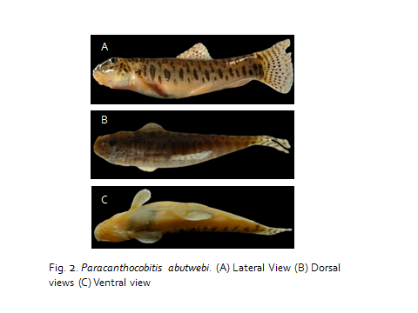

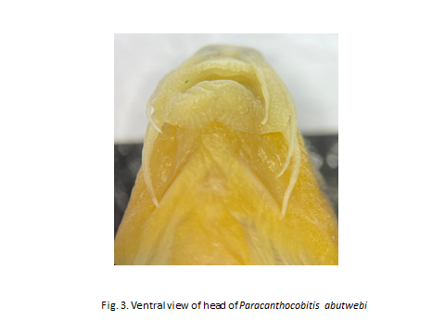

CONCLUSION
The documentation of this fish species represents a critical step in understanding its distribution, ecology, and potential contributions to biodiversity. Further research will be necessary to confirm its population dynamics, reproductive behavior, and any potential threats to its conservation. The findings serve as a foundation for future studies and contribute to the growing knowledge of aquatic biodiversity, emphasizing the importance of continued exploration and preservation of aquatic ecosystems.
Disclaimer (AI)
We the authors hereby declared that no AI technologies were employed for this research paper.
REFERENCES
Joshi, K. K., & Sreekumar, K. M. (2015). Basics of sample collection, preservation and species identification of finfish.
Kottelat, M. (1990). Indochinese namacheilines. A revision of nemacheiline loaches (Pisces: Cypriniformes) of Thailand, Burma, Laos, Cambodia and southern Viet Nam., 262.
Kottelat, M. (2012). Acanthocobitis pictilis, a new species of loach from Myanmar and Thailand (Teleostei: Nemacheilidae). Zootaxa, 3327(1), 45-52.
Menon, A. G. K. (1987). The fauna of India and the adjacent countries. Pisces. Vol. IV. Teleostei–Cobitoidea. Part 1.Homalopteridae. Zoological Survey of India.
Rainboth, W. J., Vidthayanon, C., & Yen, M. D. (2012). Fishes of the greater Mekong ecosystem with species list and photographic atlas.
Shangningam, B., Rath, S., Chowdhury, B. R., & Laishram, K. (2019). First report of Paracanthocobitis botia (Hamilton 1822) from Bihar with a note on variation. International Journal of Fisheries and Aquatic Studies, 7(5), 533-535.
Singer, R. A. (2013). Taxonomic Revision of the Genus Acanthocobitis (Teleostei: Nemacheilidae) with Recognition of the Genus Paracanthocobitis (Teleostei: Nemacheilidae) and the Description of Four New Species (Doctoral dissertation, University of Florida).
Singer, R. A., & Page, L. M. (2015). Revision of the zipper loaches, Acanthocobitis and Paracanthocobitis (Teleostei: Nemacheilidae), with descriptions of five new species. Copeia, 103(2), 378-401.

