PHYSICAL AND CHEMICAL CHARACTERISTICS OF WATER IN SELECTED LOCATION KILIYUR LAKE, TIRUCHIRAPPALLI, TAMIL NADU, SOUTHERN INDIA

Abstract:
Lakes play a vital role in the economy of a region of country and significant for various scholarly, societal, and economic reasons. They act as natural water reservoirs, storing large amounts of water that can be utilized for drinking, industrial processes, and irrigation, and other purposes, including hydropower generation. The quality of lake water is a critical concern for surrounding environment and the survival of living organisms. The aim of this investigation was to explore the physico-chemical characteristics of Kiliyur Lake water. Physico-chemical parameters or factors are essential for determining water quality and identifying contaminants in specific water sources. Changes in these parameters reveal aspects of continuous change, so we must expect permanent alterations in the physical and chemical features of the lake over both spatially and temporally. As a result, describing the environment can be challenging. In our study, we divided the lake into four sites and observe the annual variations in physico-chemical parameters for the years 2022 and 2023. In the present study to examined the annual variations of physicochemical parameters such as pH, temperature, salinity, dissolved oxygen, ammonia, phosphate, nitrate, nitrite, and chloride levels. This findings from this qualitative study on the physico-chemical parameters will be invaluable for policy makers precautionary measures to protect the wetland.

Keywords: Lake, Tiruchirappalli, Water quality, Physico-chemical parameters, Annual variations

Introduction
Water is prime natural resources fulfilling our needs in a precisious assets. Water is essential for life on earth without it, life cannot exist (Saad et al., 2017; Mishra, 2023). Due to its strong solvent properties, water is constantly threatened to become polluted easily. The require for clean water across all forms of lives, from non-microorganisms to human, presents serious challenge today (Hossain, 2015; Singh et al., 2020). This is largely because our water resources are in crises, a situation exacerbated by unplanned urbanization and industrialization. The aquatic water bodies, Lakes, as key aquatic ecosystems, play a significant role in the economy and overall prosperity of humanity (Ho and Geothals, 2019). They are used for various purposes, including domestic and industrial water supplies, irrigation, transportation, waterborne commerce, mineral extraction, waterfowl habitat, fishing, aquaculture, recreation, and waste assimilation (Aladin et al., 2005; Jones et al., 2006; Reddy et al., 2018). Many of the world’s large lakes serve as international boundaries and renowned for their aesthetic appeal and stunning beauty.
The quality of aquatic ecosystem is essential for life on earth, includes variety of habitats, organisms and their interactions that play a crucial role in the planets ecological balance (Nath, 2023). Aquatic ecosystem depends on the biotic and abiotic components and provides presence of available resource for sustaining life in the ecosystem. Interaction between physico chemical parameters play a crucial role in abundance, composition, distribution, diversity, growth, reproduction, and the movements of aquatic organisms including planktons (phytoplanktons and zooplanktons) (Usman et al., 2017).
The physico chemical parameters are important components to understanding and maintaining the essential conditions, quality, safety and function of various materials, substance, and ecosystem (Dey et al., 2021, Mohanraj and Pandiyan, 2022). Monitoring of physicochemical parameters describe the quality of water resources, environmental health, industrial efficiency, and human well-being. And used to control pollution, product quality assurance, and scientific advancement (Khanam et al., 2023; Singh et al., 2024). For the aquatic environmental health, majorly studied physicochemical parameters are pH, temperature, salinity, dissolved oxygen, ammonia, phosphate, nitrate, nitrite, and chloride (Verma et al., 2022).
In the study, we observe the physicochemical parameters, phytoplanktons and zooplanktons species in Kiliyur lake, Tiruchirappalli. Previous research did not report on the physicochemical parameters, phytoplankton, and zooplankton species in our selected area.
The analysis of the physico-chemical parameters of water, along with richness, abundance, evenness, dominance, diversity of phytoplanktons and zooplanktons, was conducted to understand the intermediate relationship between the water quality and aquatic organisms in kiliyur lake, Tiruchirappalli. Seasonal variations and correlations between physico-chemical parameters were also examined in the selected zone of kiliyur lake. The results indicate the richness of the aquatic environment, which can be useful for managing aquaculture practices.
MATERIALS AND METHODS
Study area
The selected study area is Kiliyur lake in Thiruverambur place at Tiruchirappalli district Tamil Nadu, India. This lake is located to the east of the Tiruchirappalli headquarters. The geographical coordinate system of Kiliyur lake are Latitude- 10.9077204, Longitude- 79.3441774, covering an area of 860.94 Hectares on earth. Sampling stations were divided into four site which includes north, east, west, and south of the Kiliyur lake.
Sample collection and analysis
Study Site:
For the analysis of physico-chemical parameters the water sample were collected from four sites (Site 1= North, Site 2 = East, Site 3 =West and Site 4 = South) of the Kiliyur at Tiruchirappalli. Collected water sample were stored in the sterilized reagent bottle (250 mL quantity) to protect from the direct sunlight and immediately transported to the laboratory.
Collection of water sample
For the analysis of physico-chemical parameters, the surface water samples were collected in four different sites (Site 1= North, Site 2 = East, Site 3 =West and Site 4 = South) in same lake using sterilized 250 ml reagent bottles. Samples were protected from direct sun light and immediately transported to the laboratory for analyses. The collected samples were analysed within three days during which samples were kept in cold storage (Kulshrestha et al., 1991) according to methods suggested by Golterman (1975), American Public Health Association (APHA, 1976) and National Environmental Engineering Research Institute (NEERI, 1986).
Qualitative analysis of water sample
Temperature and pH of the water sample were measured at the time of sample collection using Thermometer and pH meter. While other selected parameters such as salinity, dissolved oxygen, phosphate, nitrate, nitrite, and chloride were estimated using the APHA guideline (standard procedures).
RESULTS
Lakes are essential to the ecosystem and contribute to the survival of living organisms on earth. Unlike rivers, oceans, and lakes have limited material mobility, leading to the gradual accumulation of sediments at their bottoms. A sustainable ecosystem, characterized by biological, chemical, and physical factors, fosters optimal growth conditions for life. Aquatic ecosystems are valuable for industrial, municipal, and recreational use. This research focused on sampling and analysing the surface water of Kiliyur lake from 2022 to 2023, using physicochemical indices based on various measured parameters.
Figure 1 illustrates the pH values for 2022 and 2023 at selected sites (1, 2, 3, and 4) of freshwater Kiliyur Lake. In 2022, the highest pH values were recorded in June (ranging from 8.4 to 9) and July (ranging from 8.2 to 8.8). Meanwhile, in 2023, the highest pH values were observed in April (ranging from 8.0 to 8.3) and May (ranging from 8.1 to 8.4). The average pH values from January to December 2022 were as follows: Site 1 had 7.86 ± 0.40, Site 2 had 7.77 ± 0.37, Site 3 had 8.16 ± 0.52, and Site 4 had 8.02 ± 0.46. In contrast, the average pH values for 2023 from January to December were 7.35 ± 0.49 for Site 1, 7.33 ± 0.51 for Site 2, 7.35 ± 0.54 for Site 3, and 7.35 ± 0.56 for Site 4. Notably, the highest pH recorded was 9.0 at Site 4 in June 2022, while the lowest pH was 7.4 at Site 2 in August, September, and October 2022. Similarly, in 2023, the highest pH was 8.4 at Site 4 in May, and the lowest pH was 6.5 at Site 1 in October.
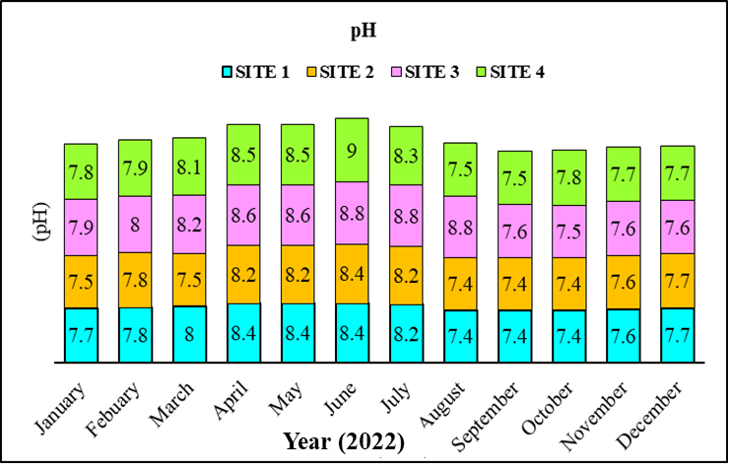
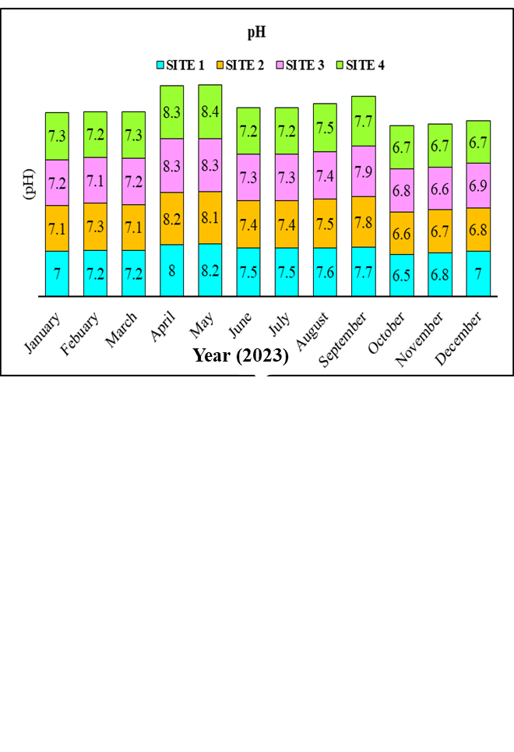
Figure 1: Analysis of pH in freshwater Kiliyur lake
Figure 2 illustrates the atmospheric temperature (°C) values for 2022 and 2023 at the selected sites (1, 2, 3, and 4) around Kiliyur Lake, a freshwater body. In both 2022 and 2023, the highest atmospheric temperature was recorded in June, ranging from 32°C to 34°C. During the period from January to December 2022, the average atmospheric temperatures were as follows: Site 1: 27.16 ± 3.06°C, Site 2: 28.5 ± 3.28°C, Site 3: 28 ± 3.54°C, and Site 4: 27.58 ± 3.84°C. For the same period in 2023, the averages were: Site 1: 28.5 ± 3.28°C, Site 2: 28.58 ± 4.12°C, Site 3: 28 ± 3.54°C, and Site 4: 27.58 ± 3.84°C. Comparing the sites, the highest atmospheric temperature recorded was 34°C at Site 2 in June 2022, while the lowest was 21°C at Site 4 in December 2021. In 2023, the highest temperature reached 35°C at Site 2 in May, and the lowest again was 21°C at Site 4 in December.

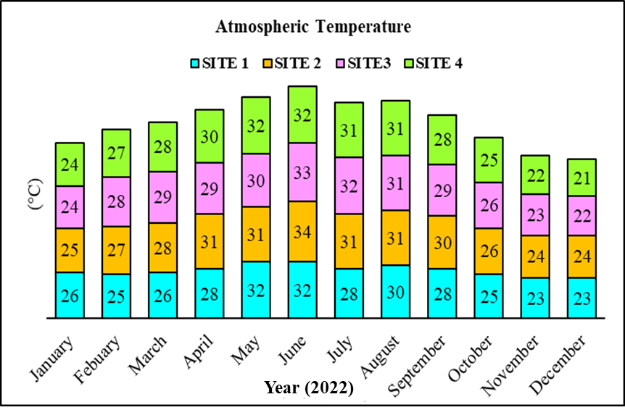
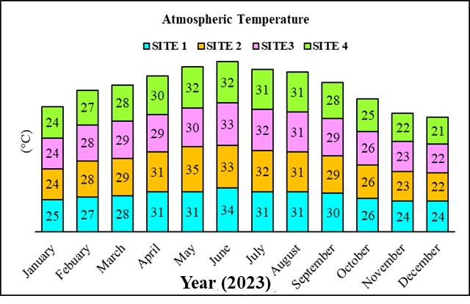
Figure 2: Analysis of Atmospheric temperature in freshwater Kiliyur lake
Figure 3 illustrates the surface water temperature (°C) values for the years 2022 and 2023 at the selected sites (1, 2, 3, and 4) of Kiliyur freshwater lake. In both 2022 and 2023, the highest surface water temperatures were recorded from June (30 to 32°C) to July (30 to 32°C). The average surface water temperature for 2022 was 28.12±3.07°C at Site 1, 27.70±2.84°C at Site 2, 26.66±3.33°C at Site 3, and 27.54±3.05°C at Site 4. In 2023, the average values were 28.12±3.07°C at Site 1, 27.41±3.14°C at Site 2, 26.75±2.66°C at Site 3, and 27.16±2.88°C at Site 4. The sites with the highest surface temperatures reached 32°C during June, July, and August of 2022, while the lowest temperatures—22°C—were recorded in December and January of the same year. Similarly, in 2023, the maximum surface temperature of 31°C occurred in June and July, whereas the minimum of 21°C was noted in November and December.
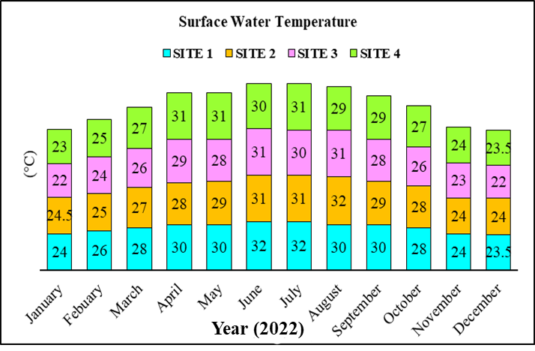
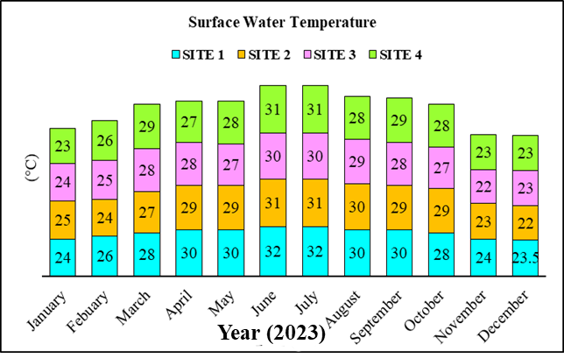
Figure 3: Analysis of Surface water temperature in freshwater Kiliyur lake
Figure 4 illustrates the salinity (in parts per thousand, or ppt) values for the years 2022 and 2023 at the selected sites (1, 2, 3, and 4) of the freshwater lake Kiliyur. In 2022, the highest salinity value was recorded in December, ranging from 0.46 to 0.51 ppt. In 2023, the peak salinity was observed in April, with values ranging from 0.46 to 0.49 ppt. The average salinity values for the year 2022 (from January to December) were as follows: Site 1 had an average of 0.46 ± 0.03 ppt, Site 2 had 0.46 ± 0.02 ppt, Site 3 had 0.45 ± 0.02 ppt, and Site 4 had 0.44 ± 0.01 ppt. In contrast, the average salinity values for 2022 were: Site 1 at 0.44 ± 0.04 ppt, Site 2 at 0.43 ± 0.04 ppt, Site 3 at 0.43 ± 0.04 ppt, and Site 4 at 0.43 ± 0.03 ppt. Among the various sites, Site 1 recorded the highest salinity in July 2022 at 0.49 ppt, while the lowest salinity for Site 1 was noted in April 2021 at 0.40 ppt. In 2023, Site 1 reached its highest salinity in May with a value of 0.48 ppt, whereas Sites 1 and 2 both had the lowest salinity in October 2023, measuring 0.30 ppt.
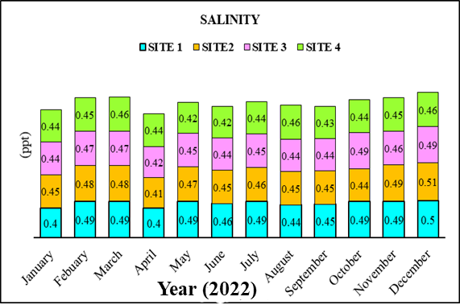
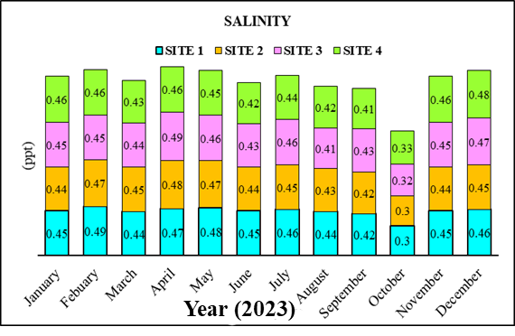
Figure 4: Analysis of Salinity in freshwater Kiliyur lake
Figure 5 illustrates the dissolved oxygen (ppm) values for the years 2022 and 2023 at the selected sites (1, 2, 3, and 4) in Kiliyur Lake. In 2022, the highest dissolved oxygen levels were recorded in November (ranging from 6.1 to 6.6 ppm) and December (ranging from 6.1 to 6.7 ppm). In 2023, the peak levels were observed in April, with values between 6.0 and 6.3 ppm. The average dissolved oxygen values from January to December 2022 were as follows: Site 1 at 5.35 ± 0.85 ppm, Site 2 at 5.60 ± 0.71 ppm, Site 3 at 5.16 ± 0.82 ppm, and Site 4 at 5.36 ± 0.69 ppm. For the same period in 2023, the averages were: Site 1 at 5.20 ± 0.46 ppm, Site 2 at 5.20 ± 0.53 ppm, Site 3 at 5.08 ± 0.50 ppm, and Site 4 at 5.00 ± 0.56 ppm. Notably, Site 2 recorded the highest dissolved oxygen level in December 2021 at 6.7 ppm, while the lowest levels (4 ppm) were noted at various sites in July and August 2022. In 2023, Sites 2 and 4 reached the highest dissolved oxygen levels in April at 6.3 ppm, while Site 4 recorded the lowest level in October at 4 ppm.
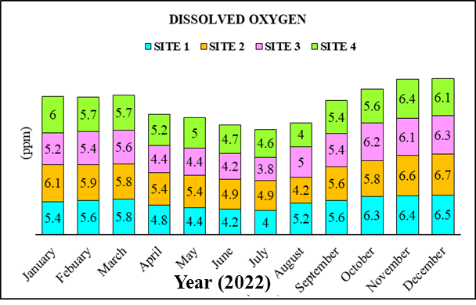
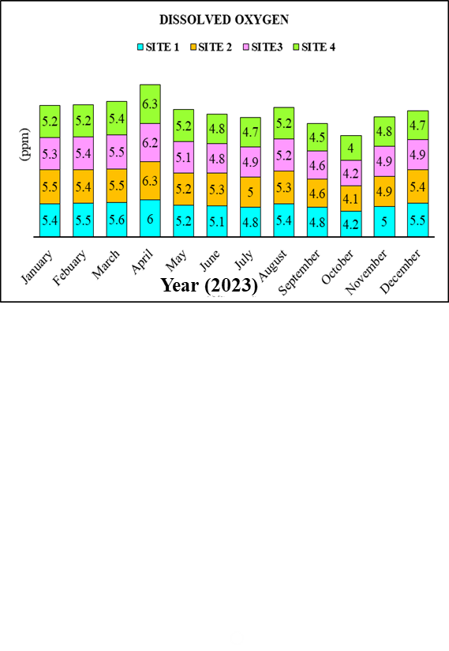
Figure 5: Analysis of Dissolved oxygen in freshwater Kiliyur lake
Figure 6 shows the ammonia (ppm) values for 2022 and 2023 at the selected sites (1, 2, 3, and 4) of freshwater Lake Kiliyur. In 2022, the highest salinity value was recorded in May (ranging from 0.55 to 7), while the ammonia levels peaked in April 2023 (ranging from 0.41 to 0.45). The average ammonia values for 2022 (from January to December) were as follows: Site 1 - 0.27±0.15, Site 2 - 0.26±0.11, Site 3 - 0.25±0.11, and Site 4 - 0.24±0.10. In 2023, the average ammonia values were slightly lower: Site 1 - 0.25±0.08, Site 2 - 0.24±0.08, Site 3 - 0.24±0.07, and Site 4 - 0.24±0.07. Among the sites, the highest ammonia concentration of 0.7 ppm was recorded at Site 1 in May 2022, while the lowest concentration of 0.11 ppm was observed at Site 3 in April 2021. Similarly, in April 2023, Site 3 registered the highest ammonia level at 0.42 ppm, and Site 2 recorded the lowest at 0.10 ppm in October 2022.
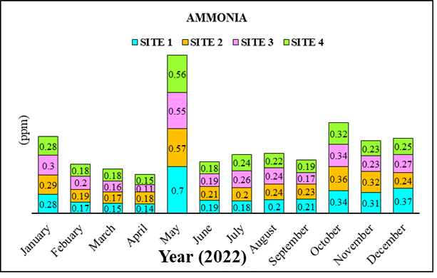
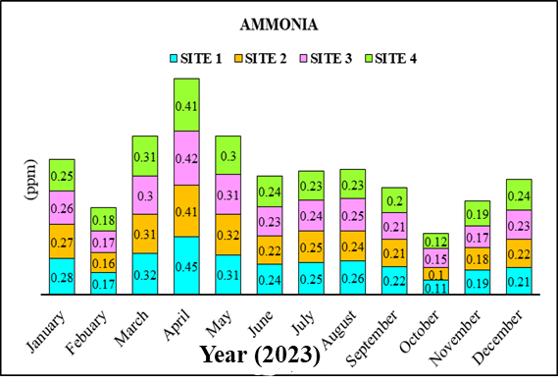
Figure 6: Analysis of Ammonia in freshwater Kiliyur lake
Figure 7 illustrates the phosphate (ppm) values for the years 2022 and 2023 in the selected sites (1, 2, 3, and 4) of freshwater Kiliyur Lake. In 2022, the highest phosphate value was recorded in November, ranging from 1 to 1.2 ppm. In contrast, the peak phosphate value in 2023 occurred in January, with a range of 0.72 to 0.74 ppm. The average phosphate values from January to December 2022 were 0.70±0.23 ppm (Site 1), 0.74±0.20 ppm (Site 2), 0.72±0.24 ppm (Site 3), and 0.69±0.21 ppm (Site 4). For the year 2023, the average phosphate values were lower, with measurements of 0.50±0.10 ppm (Site 1), 0.49±0.10 ppm (Site 2), 0.50±0.10 ppm (Site 3), and 0.50±0.11 ppm (Site 4). In November 2022, Sites 2 and 4 recorded the highest phosphate levels at 1 ppm, while Sites 3 and 4 registered the lowest levels at 0.42 ppm in May 2022. Similarly, in January 2023, Sites 1 and 4 had the highest phosphate value of 0.74 ppm. Conversely, Site 1 recorded the lowest phosphate level of 0.30 ppm in October 2023.
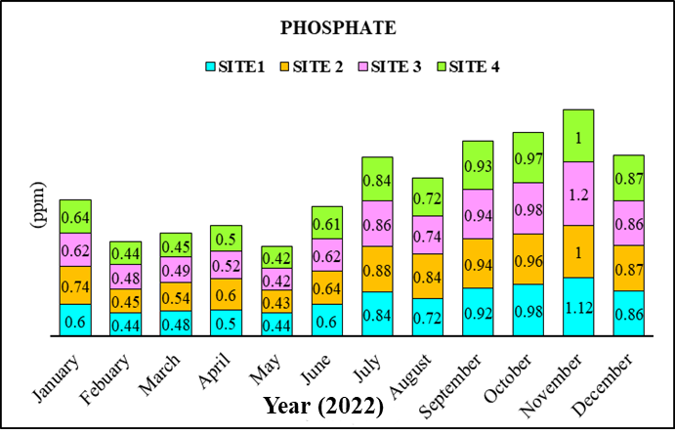
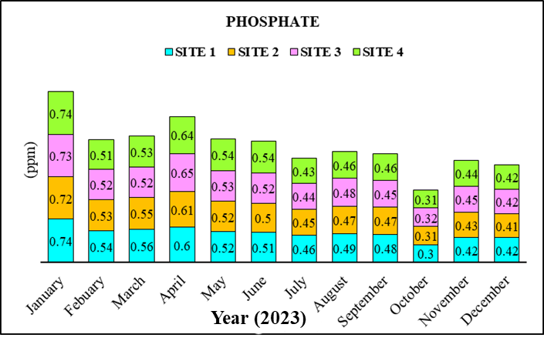
Figure 7: Analysis of Phosphate in freshwater Kiliyur lake
Figure 8 illustrates the nitrite (ppm) values for 2022 and 2023 at selected sites (1, 2, 3, and 4) in freshwater Kiliyur Lake. In 2022, the highest nitrite concentration was recorded in May, ranging from 0.51 to 0.54 ppm, while in 2023, the peak value was observed in April, with a range of 0.50 to 0.55 ppm. During the period from January to December 2022, the average nitrite levels were as follows: Site 1 had 0.36 ± 0.09 ppm, Site 2 had 0.38 ± 0.08 ppm, Site 3 also had 0.38 ± 0.09 ppm, and Site 4 had 0.37 ± 0.09 ppm. In 2023, the average nitrite levels during the same period were: Site 1 had 0.40 ± 0.07 ppm, Site 2 had 0.40 ± 0.07 ppm, Site 3 had 0.39 ± 0.08 ppm, and Site 4 had 0.39 ± 0.07 ppm. The site with the highest nitrite level in 2022 was Site 3 in May, with a concentration of 0.54 ppm, while Site 1 recorded the lowest level in August 2022 at 0.2 ppm. Likewise, in April 2023, Site 3 again recorded the highest nitrite level of 0.55 ppm, and the lowest level was observed at Site 3 in October 2023, with a value of 0.22 ppm.
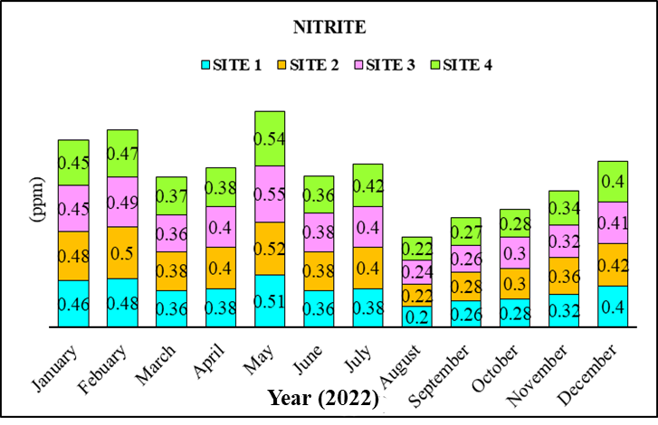
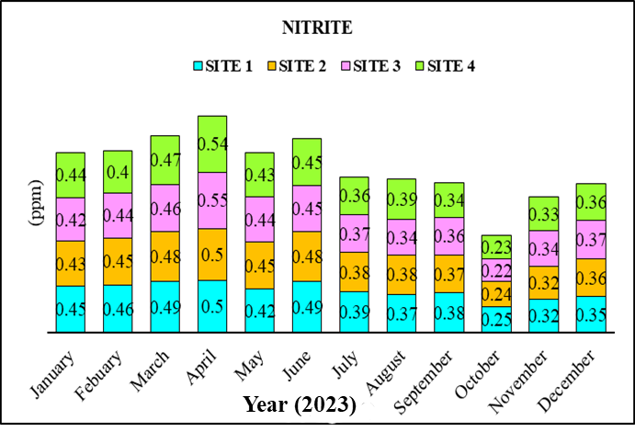
Figure 8: Analysis of Nitrite in freshwater Kiliyur lake
Figure 9 illustrates the nitrate (ppm) values for the years 2022 and 2023 at selected sites (1, 2, 3, and 4) in the freshwater lake Kiliyur. In 2022, the highest nitrate value, ranging from 0.56 to 0.66 ppm, was recorded in May, while in 2023, the peak nitrate value, varying from 0.56 to 0.59 ppm, occurred in July. The average nitrate values for 2022 (from January to December) were as follows: Site 1: 0.41 ± 0.09 ppm, Site 2: 0.43 ± 0.10 ppm, Site 3: 0.41 ± 0.08 ppm, and Site 4: 0.41 ± 0.08 ppm. In contrast, the average nitrate values for 2023 were: Site 1: 0.47 ± 0.09 ppm, Site 2: 0.48 ± 0.08 ppm, Site 3: 0.48 ± 0.08 ppm, and Site 4: 0.48 ± 0.07 ppm. Among the various sites, the highest nitrate level of 0.66 ppm was found at Site 2 in May 2022, while the lowest level of 0.26 ppm was recorded at Sites 1 and 3 in September 2022. Similarly, the highest nitrate concentration of 0.59 ppm was observed at Site 2 in July 2023, whereas the lowest concentration of 0.30 ppm was noted at Site 1 in October 2023.
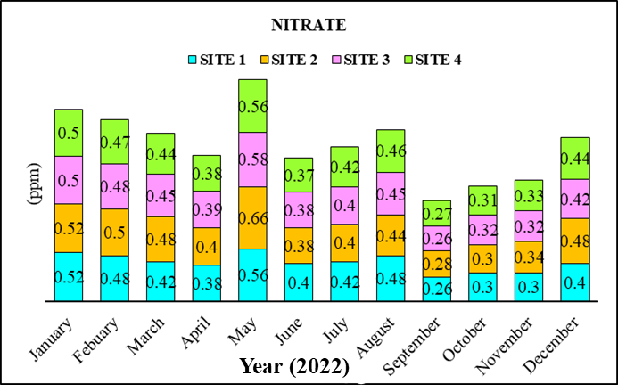
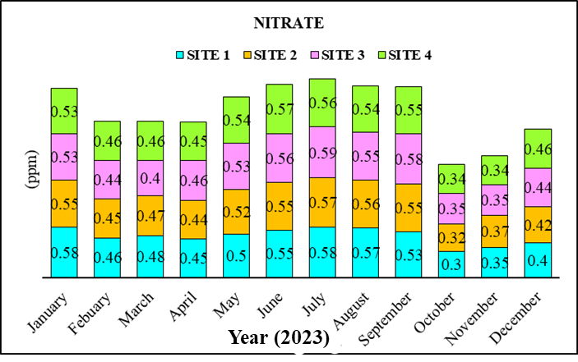
Figure 9: Analysis of Nitrate in freshwater Kiliyur lake
Figure 10 presents the chloride concentration (in ppm) for 2022 and 2023 at selected sites (1, 2, 3, and 4) of freshwater Kiliyur Lake. In 2022, the highest chloride level was recorded in November, ranging from 99.5 to 106.6 ppm. In 2022, the peak chloride value occurred in April, measuring between 88 and 86 ppm. The average chloride concentrations for 2022 (January to December) were as follows: Site 1 had 73.55 ± 18.27 ppm, Site 2 had 73.51 ± 16.89 ppm, Site 3 had 76.05 ± 17.92 ppm, and Site 4 had 73.59 ± 17.77 ppm. In 2022, the average chloride values were: Site 1 at 71.91 ± 21.66 ppm, Site 2 at 75.58 ± 7.77 ppm, Site 3 at 76.75 ± 7.37 ppm, and Site 4 at 76.50 ± 7.82 ppm. In November 2022, Site 3 exhibited the highest chloride level at 106.3 ppm, while Site 1 recorded the lowest level in April 2022 at 44.5 ppm. In April 2023, Sites 1 and 4 both reported the highest chloride levels at 88 ppm, whereas Site 2 had the lowest chloride concentration in May 2023, measuring 64 ppm.
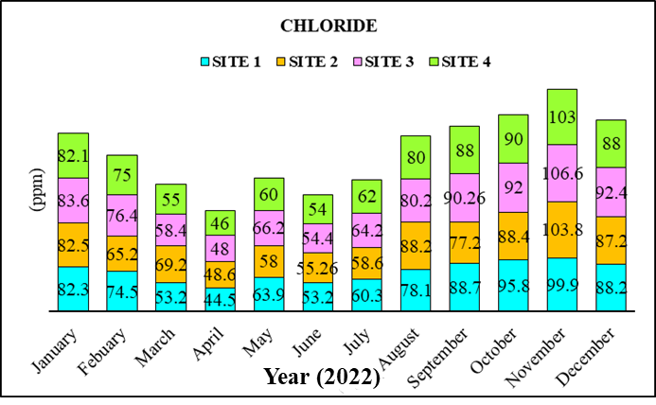
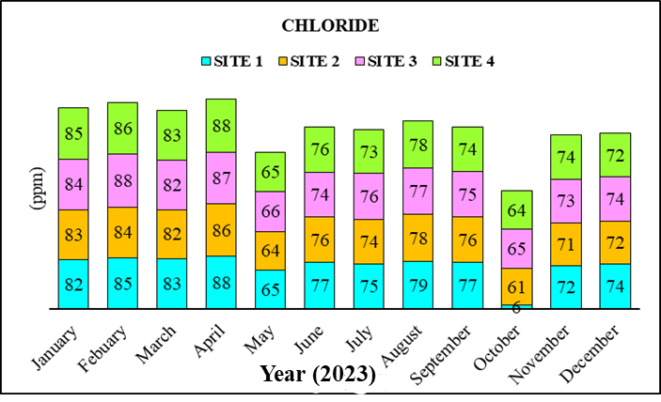
Figure 10: Analysis of Chloride in freshwater Kiliyur lake
DISCUSSION
All living organisms on Earth require water for survival and growth, and they need good quality water to thrive (Westall and Brack, 2018; Roy and Kizhakkethottam, 2024). The quality of surface water is influenced by a balance of physical, chemical, and biological characteristics of the surrounding environment, and it constantly changing due to daily, seasonal, and climatic conditions. Therefore, regularly monitoring of water quality is essential. Contaminated drinking water can lead to various waterborne diseases in the human population (Pal et al., 2018). Understanding biological phenomena can be complex, but the chemistry of water provides significant insights into the metabolism of ecosystems and elucidates the general hydro-biological relationships (Simpi et al., 2011). Physico-chemical indicators serve as valuable tools for assessing the behaviour of aquatic systems. While these indicators can help identify sources of problems, they offer limited information regarding the full impact of pollutants on aquatic fauna and flora (Kumari et al., 2020). Changes in the ecological quality of lake ecosystems and their rates of water restoration can have significant ecological and social consequences, as these ecosystems are crucial for both human needs and aquatic life. Additionally, variations in water temperature can affect the physicochemical and natural characteristics of lakes. Within lake structure, thermal stratification plays a critical role in ecological and water quality processes (Abd Ellah, 2020).
In the present study, various locations around Kiliyur Lake were analyzed between 2022 and 2023. Elevated pH values observed in the lake water during the rainy season may results from increased decomposition activities among both biotic and abiotic components of the lake. Conversely, the lower pH levels recorded at all sites during the dry season are likely due to the concentration of dissolved substances attributed to evapotranspiration (Silas et al., 2018). The pH results from this investigation are comparable to those reported by Adefemi and Awokunmi (2010), who studied the physicochemical parameters of water samples in the Itaogbolu area of Ondo State, Nigeria. It is important to note that plumbing and hot water cylinder corrosion can decrease their lifespan, and in some cases, the presence of dissolved metals in the water can pose health risks (Giovanardi et al., 2020).
Temperature plays a crucial role in influencing the chemistry and biological reactions of organisms in water (Kazmi et al., 2022). In this study, we analyzed the temperature variations at various sites in Kiliyur Lake from 2022 to 2023. We observed an increase in temperature during May and June, which can be attributed to clear atmosphere, low water level, high atmosphere temperature, high solar radiation. Conversely, a decrease in temperature was noted in December, likely due to the cold condition, shorter photoperiod, low temperature. Similar findings were reported by Verma et al., (2013) in Nikol late Ahmedabad, Gujarat. The fluctuations in temperatures observed in Kiliyur Lake can be attributed to seasonal changes, thermal stratification, changes of weather conditions, geographic and physical factors.
Salinity refers to the concentration of dissolved salts in water, brine, or bittern (Bagastyo et a., 2021). It plays a key role in determining the chemistry of natural waters, as well as biological processes that occur within them, and the physical characteristics of water (Sharma and Naik, 2024). During both years of study, salinity levels were low in monsoon season due to heavy rainfall and increased land runoff. Conversely, salinity levels were high in the summer months, attributed to reduced rainfall, limited freshwater inflow, and rising temperatures in the estuary.
In estuarine environments, salinity is one of the key elements that significantly influences the distribution and abundance of various plant and animal species, that depend on freshwater inflow and ambient temperatures. The low salinity observed during the monsoon season was primarily due to substantial freshwater inflow and rainfall. Therefore, the main factors affecting salinity variations were rainfall and freshwater intrusion.
Dissolved oxygen (DO) refers to the amount of free, non-compound oxygen present in water (Wang et al., 2024). In the present study, the maximum level of dissolved oxygen was observed in December may due to the low temperature and water turbulence that facilitating the diffusion of atmospheric oxygen. Conversely, the minimum dissolved oxygen levels were recorded in August, likely due to higher temperature, and increased salinity. The levels of dissolved oxygen in the water are influenced by a variety of physical, chemical, and biochemical processes occurring within the water body. Similar findings were reported by Karthika et al., (2017) and Qureshimatva Umerfaruq and Solanki et al., (2015).
The structure and function of the aquatic food web can be significantly impacted by ammonia, a common pollutant in aquatic ecosystems resulting from human activities both directly and indirectly (Malik et al., 2020). In this study, we observed that the highest concentration of ammonia (0.7ppm) occurred at site 1 of May 2022, while the lowest concentration (0.11 ppm) was recorded at site 3 in April 2022. Additionally, in April 2023, site 3 recorded a highest ammonia level of 0.42 ppm, with site 2 having the lowest level (0.10 ppm) in October 2023. The variations in ammonia concentration in Kiliyur Lake may be attributed to factors such as organic wastes, agricultural fertilizers, surface runoff, sewage discharge and intensive livestock operations, and abundant vegetation that promotes plankton growth. Similar findings were reported by Pandit and Solanki, (2004). In aquatic environment, the elevated ammonia levels can lead to increased level of CO₂ and decreased dissolved oxygen (DO). Furthermore, toxicity tends to rise at lover pH levels.
Animal and human bones and teeth requires phosphates for growth and maintenance (Zhao et al., 2025). Additionally organophosphates are essential for all processes involving the production of nuclear DNA (deoxyribonuclieic acid) and RNA (ribonucleic acid) (Yadav et al., 2024; Pyambri et al., 2025). In the present study, high levels of phosphate was observed in November 2022 and January 2023. While lower levels were noted in May 2022 and October 2023 may be due to the increased uptake by macrophytes, which flourish during those month. Similar results was reported by Rao et al., (2014).
Nitrites and nitrates are form of nitrogen compound play an important role in maintaining aquatic ecosystems (Chamoli et al., 2024). The maximum levels of nitrites and nitrates were observed in May 2022 and April 2023, as well as in May 2022 and July 2023 respectively. Average levels of both nitrites and nitrates were monitored from January to December in 2022 and 2023. In the present study, observed fluctuations in the levels of nitrites and nitrates may be due to organic waste, fertilizers, sewage discharge and high vegetation. Similar findings were reported by Karthika et al., (2017).
Chloride is naturally occurring ion found in freshwater ecosystems and is one of the key parameters used to assess water quality (Singh et al., 2024). It typically appears in the forms of salts sodium chloride, calcium chloride, or magnesium chloride. While chloride in drinking water is generally not harmful, elevated levels can lead to a salty taste (Dietrich et al., 2024). Research indicates that Chemical Oxygen Demand (COD) increases with higher concentration of chlorides in lake water (Lv et al., 2024). This is often due to various sources, including sewage disposal and industrial waste (Dan Wu et al., 2021). In the current study, the highest concentration of chloride was observed in November 2022 and April 2023 and also lowest concentration of chloride was observed in April 2022 and May 2022. Similar findings were reported by Josephine Sharmila and Rajeswari (2015) as well as Sirajudeen and Abdul Vahith (2014). A higher concentration of chlorides indicative of a greater presence of organic pollutant. Significant chloride content was detected in Ukkadam, Singanallur and Selvachinthamani lake in Coimbatore, Tamilnadu (Kumar et al., 2004; Mohan and Prabha, 2024). These elevated chloride levels may result from poor environmental management around the water resources and the absence of an adequate underground drainage system.
CONCLUSION
The Physico Chemical Parameters of Kiliyur Lake clearly indicate significant ongoing contamination and deteriorating. In 2023, water quality has degraded more severely than in 2022 likely due to increase in pollutant from anthropogenic activities that are being discharged into the lake. The values of different parameters, demonstrate that lake’s water is polluted and poses threats to aquatic life as well as to other animals. Over the past few years, the water chemistry of kiliyur lake has changed dramatically. Comparing this year’s data to that of the previous years. It is evident that water quality continuous decline. It is essential to periodically assess the physico-chemical parameters of Kiliyur lake to implement preventive and treatment measures.

Reference

Saad, A.S., Massoud, M.A., Amer, R.A. and Ghorab, M.A. (2017). Assessment of the physicochemical characteristics and water quality analysis of Mariout Lake, Southern of Alexandria, Egypt. Journal of Environmental & Analytical Toxicology, 7(1), 421. 10.4172/2161-0525.1000421
Mishra, R.K. (2023). Fresh water availability and its global challenge. British Journal of Multidisciplinary and Advanced Studies, 4(3), 1-78. https://doi.org/10.37745/bjmas.2022.0208
Hossain, M.Z. (2015). Water: The most precious resource of our life. Global Journal of Advanced Research, 2(9), 1-11.
Singh, J., Yadav, P., Pal, A.K. and Mishra, V. (2020). Water pollutants: Origin and status. Sensors in Water Pollutants Monitoring: Role of Material, 5-20. https://doi.org/10.1007/978-981-15-0671-0_2
Ho, L.T. and Goethals, P.L. (2019). Opportunities and challenges for the sustainability of lakes and reservoirs in relation to the Sustainable Development Goals (SDGs). Water, 11(07), 1462. https://doi.org/10.3390/w11071462
Aladin, N., Read Barker, D., Beltram, G., Brouwer, J., Davidson, N. and Duker, L., 2005. Inland water systems. Millennium Ecosystem Assessment.
Jones, B.E., Scott, D. and Gossling, S., 2006. Lakes and streams. In Tourism and global environmental change, 76-94. Routledge.
Reddy, M.T., Sivaraj, N., Kamala, V., Pandravada, S.R., Sunil, N. and Dikshit, N. (2018). Classification, characterization, and comparison of aquatic ecosystems in the landscape of Adilabad District, Telangana, Deccan Region, India. Open Access Library Journal, 5(4), 1-49. doi: 10.4236/oalib.1104459.
Nath, N. (2023). A study on: aquatic ecosystem, its features, functions & threats. Jamshedpur Research Review, 9(59), 57-65.
Usman, L.U., Namadi, S. and Nafiu, S.A. (2017). Effects of physico-chemical parameters on the composition and abundance of phytoplankton in Ajiwa Reservoir Katsina State, north western Nigeria. Bayero Journal of Pure and Applied Sciences, 10(2), 16-24. https://doi.org/10.4314/bajopas.v10i2.3
Dey, S., Botta, S., Kallam, R., Angadala, R. and Andugala, J. (2021). Seasonal variation in water quality parameters of Gudlavalleru Engineering College Pond. Current Research in Green and Sustainable Chemistry, 4, 100058. https://doi.org/10.1016/j.crgsc.2021.100058
Mohanraj, S. and Pandiyan, J. (2022). Annual Variations of Physico-chemical Properties of the Periyakulam Lake, Tiruchirappalli, Tamil Nadu, Southern India. European Journal of Environment and Earth Sciences, 3(2), 55-60. https://doi.org/10.24018/ejgeo.2022.3.2.269
Khanam, Z., Sultana, F.M. and Mushtaq, F. (2023). Environmental pollution control measures and strategies: an overview of recent developments. Geospatial Analytics for Environmental Pollution Modeling: Analysis, Control and Management, 385-414. https://doi.org/10.1007/978-3-031-45300-7_15
Singh, N., Chaudhary, U.A., Khan, M.A., Fatima, N., Hasan, M. and Hussain, A., 2024. Comprehensive Analysis of Groundwater Quality: Multidimensional Perspective. NVEO-Natural Volatiles Essential. Oils Journal. 11, 1-13.
Verma, D.K., Satyaveer, N.K.M., Kumar, P. and Jayaswa, R., 2022. Important water quality parameters in aquaculture: An overview. Agriculture and Environment, 3(3), 24-29.
Westall, F. and Brack, A. (2018). The importance of water for life. Space Science Reviews, 214, 1-23. https://doi.org/10.1007/s11214-018-0476-7
Roy, A. and Kizhakkethottam, J.J. (2024). Real time water quality monitoring of River Pamba (India) using Internet of Things. In E3S Web of Conferences, 477, 00093. EDP Sciences. https://doi.org/10.1051/e3sconf/202447700093
Pal, M., Ayele, Y., Hadush, M., Panigrahi, S. and Jadhav, V.J., 2018. Public health hazards due to unsafe drinking water. Air Water Borne Disease, 7(1000138), 2. DOI: 10.4172/2167-7719.1000138
Simpi, B., Hiremath, S. M., Murthy, K. N. S., Chandrashekarappa, K. N., Patel, A. N., & Puttiah, E. T. (2011). Analysis of water quality using physico-chemical parameters Hosahalli Tank in Shimoga District, Karnataka, India. Global Journal of Science Frontier Research, 11(3), 31-34.
Kumari, D. and Paul, D.K., 2020. Assessing the role of bioindicators in freshwater ecosystem. Journal of Interdisciplinary Cycle Research, 12(9), 17.
Abd Ellah, R. G. (2020). Physical properties of inland lakes and their interaction with global warming: A case study of Lake Nasser, Egypt. Egyptian Journal of Aquatic Research, 46(2), 103-115. https://doi.org/10.1016/j.ejar.2020.05.004
Ioryue, I. S., Wuana, R. A., & Augustine, A. U. (2018). Seasonal variation in water quality parameters of river Mkomon Kwande local government area, Nigeria. International Journal of Recent Research in Physics and Chemical Sciences, 5(1), 42-62.
Adefemi, S.O. and Awokunmi, E.E., 2010. Determination of physico-chemical parameters and heavy metals in water samples from Itaogbolu area of Ondo-State, Nigeria. African Journal of Environmental Science and Technology, 4(3). https://doi.org/10.5897/AJEST09.133
Giovanardi, R., Bononi, M., Messori, M., Bargellini, A., Paduano, S., Borella, P. and Marchesi, I., 2020. Corrosion resistance of commonly used plumbing materials for water distribution systems exposed to disinfection treatments. Corrosion Engineering, Science and Technology, 55(3), 224-231. https://doi.org/10.1080/1478422X.2020.1721806
Kazmi, S.S.U.H., Wang, Y.Y.L., Cai, Y.E. and Wang, Z., 2022. Temperature effects in single or combined with chemicals to the aquatic organisms: an overview of thermo-chemical stress. Ecological Indicators, 143, 109354. https://doi.org/10.1016/j.ecolind.2022.109354
Verma P.U., Chandawat D.K. and Solanki H.A. (2013). Pollution Status of Nikollake located in Eastern Ahmedabad, Gujarat- India. International Journal of Innovative Research in Science, Engineering and Technology, 2(8), 3603-3609.
Bagastyo, A.Y., Sinatria, A.Z., Anggrainy, A.D., Affandi, K.A., Kartika, S.W.T. and Nurhayati, E., 2021. Resource recovery and utilization of bittern wastewater from salt production: a review of recovery technologies and their potential applications. Environmental Technology Reviews, 10(1), 295-322. https://doi.org/10.1080/21622515.2021.1995786
Sharma, L.K. and Naik, R., 2024. Salinology. In Conservation of Saline Wetland Ecosystems: An Initiative towards UN Decade of Ecological Restoration Singapore: Springer Nature Singapore. (77-96).
Wang, L.Y.K., Bong, J.W., Eng, Y.X. and Wong, W.S., 2024, August. IoT Based Wastewater Dissolved Oxygen and Total Dissolved Solids Monitoring with Data Analytics. In 2024 11th International Conference on Future Internet of Things and Cloud (FiCloud) (98-103). IEEE. https://doi.org/10.1109/FiCloud62933.2024.00023
Karthika, M., Shabana, S., & Ramasubramanian, V. (2017). Assessment of water quality and zooplankton diversity in the freshwater ecosystem (Lake)-In India. Int Res J Env Sci, 6, 23-33.
Qureshimatva Umerfaruq and Solanki H.A. (2015). Physico-chemical parameters of water in Bibi Lake, Ahmedabad, Gujarat, India. Journal of Pollution Effects & Control, 3, 134.
Malik, D.S., Sharma, A.K., Sharma, A.K., Thakur, R. and Sharma, M., 2020. A review on impact of water pollution on freshwater fish species and their aquatic environment. Advances in environmental pollution management: wastewater impacts and treatment technologies, 1, 10-28. DOI: 10.26832/aesa-2020-aepm-02
Pandit B.R. and Solanki H.A. (2004). Drinking water quality and techniques for recharging urban water system for the industrial city of Gujarat, India. In: Innovative Modeling of Urban Water Systems, Monograph No. 12 Canada.
Zhao, S., Ni, X., Zhou, J., Zhao, X., Wen, X., Wang, X., Cao, M., Zhao, Y., Shao, C., Lu, L. and Chen, Y., 2025. The impact of dietary phosphorus levels on growth, slaughter, and digestive metabolism in growing sheep. Frontiers in Veterinary Science, 12, 1489948. https://doi.org/10.3389/fvets.2025.1489948
Yadav, B., Kaur, S., Yadav, A., Verma, H., Kar, S., Sahu, B.K., Pati, K.R., Sarkar, B., Dhiman, M. and Mantha, A.K., 2024. Implications of organophosphate pesticides on brain cells and their contribution toward progression of Alzheimer's disease. Journal of Biochemical and Molecular Toxicology, 38(3), e23660. https://doi.org/10.1002/jbt.23660
Pyambri, M., Jaumot, J. and Bedia, C., 2025. Toxicity Assessment of Organophosphate Flame Retardants Using New Approach Methodologies. Toxics, 13(4), 297. https://doi.org/10.3390/toxics13040297
Madhusudhana Rao R., Krishna P.V., Jyothirmayi V. and Hemanth Kumar V. (2014). Biodiversity of zooplankton communities in a perennial pond at Lake Kolleru Region of Andhra Pradesh, India. International Journal of Advanced Research, 2(7), 33-41.
Chamoli, A., Bhambri, A., Karn, S.K. and Raj, V., 2024. Ammonia, nitrite transformations and their fixation by different biological and chemical agents. Chemistry and Ecology, 40(2), 166-199. https://doi.org/10.1080/02757540.2023.2300780
Singh, N., Chaudhary, U.A., Khan, M.A., Fatima, N., Hasan, M. and Hussain, A., 2024. Comprehensive Analysis of Groundwater Quality: Multidimensional Perspective. Natural Volatiles & Essential Oils Journal., 11, 1-13.
Dietrich, A.M., Ma, X., Adams, H. and Ikehata, K., 2024. Sweet and Salty Drinking Water Coming to a Tap Near You. Opflow, 50(8), 22-25. https://doi.org/10.1002/opfl.2008
Lv, Z., Ran, X., Liu, J., Feng, Y., Zhong, X. and Jiao, N., 2024. Effectiveness of chemical oxygen demand as an indicator of organic pollution in aquatic environments. Ocean-Land-Atmosphere Research, 3, 0050. https://doi.org/10.34133/olar.0050
Noortheen, A., Nagarajan, N., & Umarani, S. (2016). Study on physicochemical parameters of water samples in and around Salem district, Tamil Nadu, India. International Journal of Current Science Research, 2(1), 219-227.
Kanimozhi, K., & Arjun, P. (2017). Analyze the water quality of ground water in three different area of (New bus stand, old bus stand and medical college) Thanjavur city, Tamil nadu.
Sadhasivam, M., Devi, S. K., Arumugham, N., Swathika, M., Sivakumar, C., & Sameena, Y. (2023). Research of Physical-Chemical and Ecological Characteristics of Ukkadam Lake Water Coimbatore District, Tamil Nadu, India. Journal of Advanced Zoology, 44(4). DOI:10.17762/jaz.v44i4.1347
Mohan, B. and Prabha, D., 2024. Evaluation of trophic state conditions in the three urban perennial lakes of the Coimbatore district, Tamil Nadu: Based on water quality parameters and rotifer composition. HydroResearch, 7, 360-371. https://doi.org/10.1016/j.hydres.2024.06.003

