THE STUDY OF INDIGENOUS ORNAMENTAL FISH DIVERSITY FROM WETLAND OF MANJHAUL, BEGUSARAI BIHAR

ABSTRACT :
The present study work goals to reveal the status of indigenous ornamental fish diversity of kabartal wetland of Manjhaul subdivision of Begusarai district in Bihar. A collectin of fishes was made from period of January 2024 to December 2024. In this investigation work different types of local fishing equipments like jhang, aanta, aarsi, bari, kanra were used by fishermen. Many type of nets of different mesh size as bag net, scoop net, cast net and gill net were used to caught the fishes. In this study 48 type of fishes were informed out of which 20 fish species belongs to ornamental potential. They belong to 7 order, 13 families, 14 genera and 20 species. Cypriniformes was the most abundant fish order represented by 5 families, 6 genera and 8 species. Out of 20 fish species it was observed that 12 fiish species have high ornamental potential and 8 are of both ornamental as well as nutritional value. The study work shows moderate piscine diversity.
Keywords : Wetland, Indigenous, ornamental fish, diversity, cyprinids.
1. INTRODUCTION :
Fishes are one of the most significant and diversified groups which are correlated with the advantage of Individuals. India is one of the mega biodiversity nations in the world and possesses 9th position as far as fresh water mega biodiversity. Goswami T.K., Goswai M.M. (2006). Indian rivers preserve a rich variety of fish species, which supports to the commercial fisheries Biligrami K.S. (1988). ornamental fisheries is a rising sector having strength to increase economy of rural communities poors and down trodens. Ornamental fishes are the most popular pets in the world. The fishes have socio economic, nutritional and aesthetic value and also important for upkeep of environment, ornamental fishes play an important role in the world trade in fish and fishery products, which is valued about us $ 9.0 billion (FAO, 2000) in which India's share is about 1%. The information about their pattern, arrangement, behaviour, population diversity, captive breeding is insufficient. Due to pollution, population development and climate change, the fresh water habitat has recently become one of the most fragile habitats in the world (pacheco et al, 2021). Water quality and bio diversity in fresh water ecosystems have been greatly impacted by human activities such as land use changes, excessive sediment extraction and chemical inputs (Mohd Izam et al, 2021). Many pioneer worked on ornamental fish diversity including mills et al, 1990, Talwar et al, 1991, madhu et al, 1996, Mahapatra et al, 1998, swain et al, 2002, Das et al, 2006, Mahapatra et al, 2006.
Many comprehensive and precious work done in the filed of ornamental fisheries. Many of the workers made their important contribution includes those by AIfred and Ramakrishnan stated about fish diversity of kabar lake wetland ecosystem. Anon (1997) studied management action plan for kanwar wetland. Bakalial et. at, stated about ornamental fishes of hill stream channels of subansiri drainage of north east. Chandra et al 2021 noticed a gradual increase in air breathing fish species recorded by CIFRI. Cristopher, 1999. Discussed about ornamental fish trade and conservation efforts. Das et al, 2010 stated about studies of loaches an ornamental fish of wetland of north Bihar and its export potential. Das et al, 2015 worked on status of ornamental fish diversity in jhang wetland in Kusheshwar asthan, Darbhanga and reported 35 fish species among them perciformes was the dominant order. Ghos et al, 2003 stated about ornamental fish farming and aqua business in India. Jayaram K.C., 2006 worked on cat fishes of India. His research work focusses on taxonomy, ecology and conservation of cat fishes. Kumar et al, 2014 described about status, conservation and management of wetlands of Begusarai Bihar. Munshi et al, 1988 described about systematics of fresh water fishes of India. Monticini p, 2010 described about ornamental fish trade its production and commerce. Pandey and Mandal, 2017 stated about present status challenges and scope of ornamental fish trade in India. Raut et al, 2020 recorded 50 species of fish in the flood plain lakes of North Bihar out of them 28 identified as potential ornamental fishes. Swain et al, 2010 descirbed about present scenario of ornamental fish farming. Tlusty (2002) described the benefits of aqua culture production of ornamental fish and risks about this.
2. METHODOLOGY :
A collection of fishes was made by using different types of nets as drag net, gill net, cast net and other fishing gears as hooks and lines, traps, arsis, bari, birti, kanra and sahat was used by the experienced fishermen. Collected fishes were preserved in 10% formalin solution. Identification was done by using standard books like The fishes of India.
(Francis Day 1878) and Fish and Fisheries of India Jhingran 1991). Statistical data was performed by shannon-weiner diversity index (H) and shimpson's index (S).
2.1 The Study Area
Kanwar lake is Asia's largest fresh water ox-bow lake. It is a protected area and winter capital of migratory birds in 1989 under provision of Indian wild life protection Act 1972 kanwar is identified as bird sanctuary. It was declared first Ramsar site of Bihar and 39th Ramsar site of India in 2020. It lies between latitude 25015’N, and 25045’N and longitude 85045’E and 86036’E in North part of Bihar. Kanwar lake is located 22 km north west of Begusarai town. It is in Manjhaul sub-division of Begusarai district. Kanwar wetland convers 2620 hectares area of Indo-Gangetic Plains. A depression is made between Burhi Gandak and palaea channel of Bagmati that forms this ox-bow lake. During monson it connects if 17 related water bodies and spread to area approx 6700 hectare but shrinks to 600ha after monson. Directory of Asian wetlands refers kanwar lake extend to be around 7400 ha (scott 1989). Area under inundation reported to be shrunk to 6043 ha (Ghosh et al, 2004).
The kanwar lake has been classified as wetland type 19 due to presence of habitat (scott, 1989)
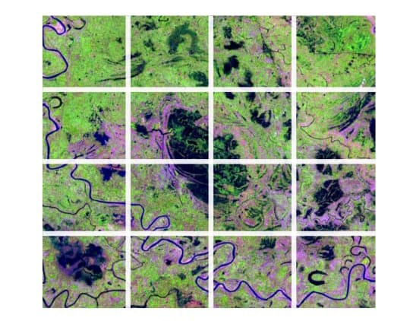
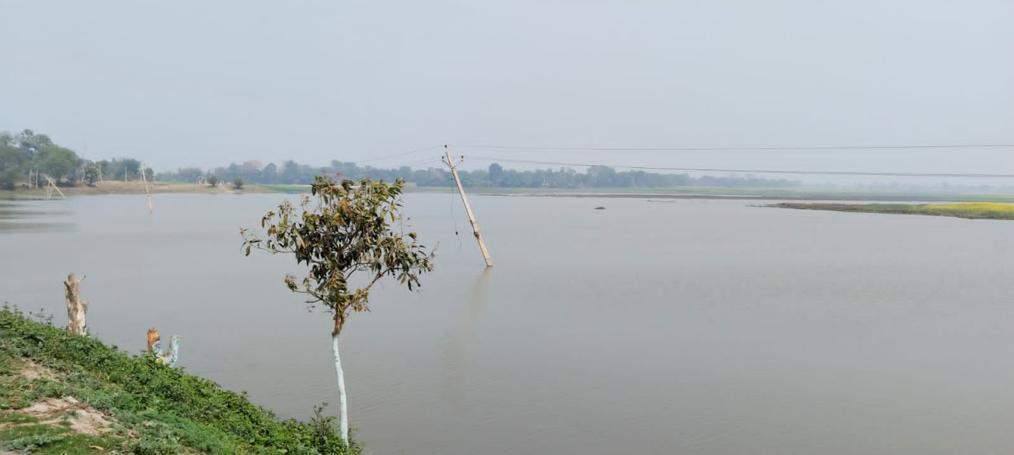
Picture 1 : Map of Kanwar Lake Picture 2 : Study Area Kanwar Lake

3. RESULTS AND DISCUSSION:
The result of this study work confirms presence of 48 species of fishes during investigation period January 2024 to December 2024 out of which 20 species of fishes belongs to ornamental potential. They belongs to 07 order 13 families, 14
genera and 20 species. These 7 orders were cypriniformes, Channiformes, mastacembeliformes, perciformes, Beloniformes, symbranchiformes and clupeiformes. Order cypriniformes shows highest diversity accounting for 40% of

the total fish species collected from kanwar lake. It was followed by perciformes with 5 species (25%) channiformes (10%) and mastacembeliformes (10%) with 2 species each. The rest three orders with one species each constituted (5%) of the

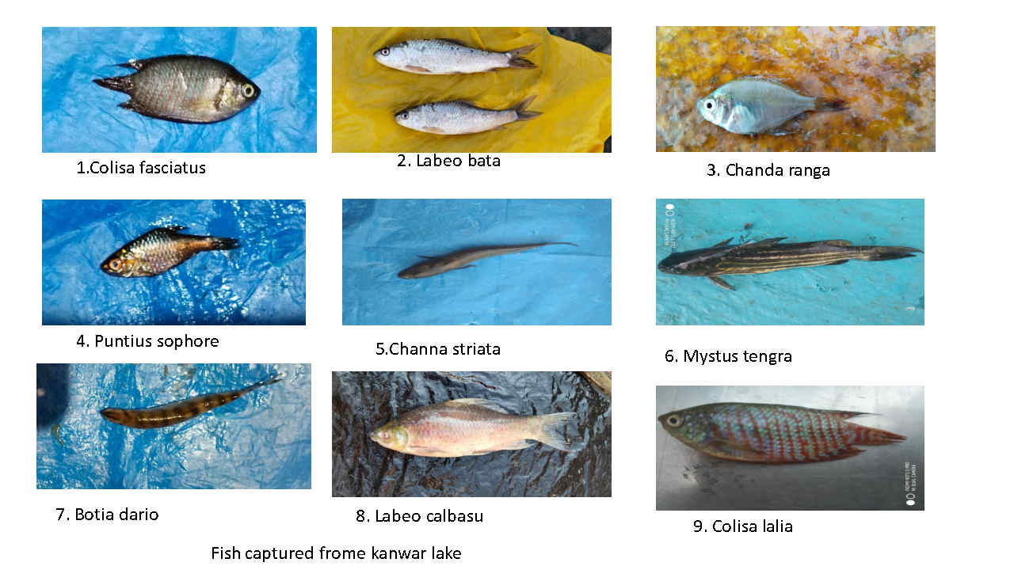
total fish documented in the kanwar lake.
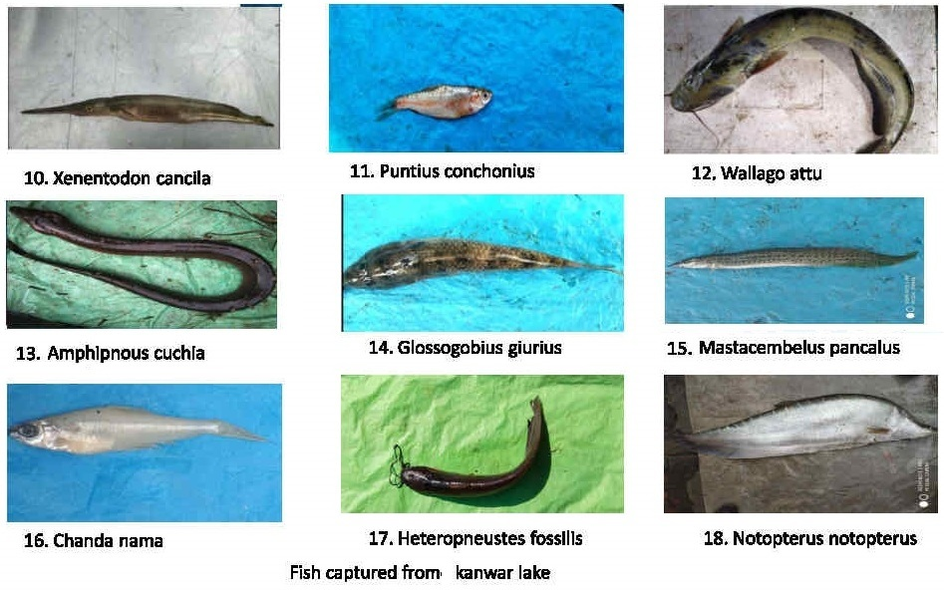
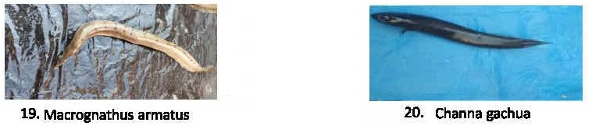
Plate 1. 20 species collected from the kanwar lake.
In a survey work by Archana Sinha and Akhtar Jamal (2015) 79 species of ornamental fishes were reported from Bihar. Anon (2004) reported more them 41 species of commercially valuable fishes from the kanwar lake. These species matches with the present findings assessment of CIFRI (2007, 2011) reported presence of 54 species from river Gandak out of which 50 species reported in Kanwar (vass et al, 2010, Srivastava, 2013) out of them 26 species mainly belongs to cypriniformes, siluriformes, Beloniformes, Channiformes, perciformes, symbranchiformes and mastacembeliformes. Presence of 35 fish species recorded through out the year and also extra 15 species when river connects to wetland in rainy season (Sinha and Jha 1997), ZSI 2002, Tiwary et al 2009. A gradual increase in air breathing fish species as clarias batrachus, Heteropneustes fossilis Anabas testudineus was recorded by CIFRI, (chandra et al, 2021). In mahalaya and kochalaya region of Kanwar lake presence of wallago attu was confirmed by local fishermen. Fresh water shining barb variety has been released for ornamental fish culture (swain et al, 2016)

Table 1 : List of collected fish species with their common name and local name.
Order Family Scientific Name |  | Common Name Local Name
Cypriniformes Cyprinidae Puntius sophore |  | Spotfin Swamp barb Pothia
 | Puntius conchonius | Rosy barb | Lal Pothi
 | Labeo calbasu | Calbasu | Basari
 | Labeo bata | Bata | Bata
 | Cobitidae Botia dario | Necktic loach | Baghi
 | Siluridae Wallago attu | Fresh Water Shark | Boari
 | Heteropneustidae Heteropneustes fossilis | Stinging Cat fish | Singhi
 | Bagridae Mystus tengara | Tiger Zebra Catfish | Tengara
Channiformes | Channidae Channa gachua | Pigmy snake head | chenga
 | Channa striatus | Kobra snake head | Shaura
Mastacembe- | Mastacem- Mastacembelus Pancalus Spiny eel |  | Katgaichi
liformes | belidae Mastacembelus armatus Long eel |  | Bami
Perciformes | Gobiidae Glossogobius giuris Tank goby |  | Bulla
 | Centropomidae Chanda nama Elongated glassperchlet |  | Chanari
 | Chanda ranga Glass fish |  | Channa
 | Anabantidae Colisa Fasciatus Giant gourami |  | Khesra
 | Colisa lalia Dwarf gourami |  | Khalisa
Beloniformes | Belontiidae Xenentodon cancila Fresh water gar fish Kauwa Machhli
Symbranchiformes Symbranchidae Amphipnous cuchia Mud eel Anhawa
Clupeiformes Notopterus Notopterus notopterus Knife fish Bhuna

4. CONCLUSION
The increasement of the fisheries sector by adding ornamental fish culture and its trade could be a big support to local people and fishermen. Present study work provides important in sights into the ichthyodiversity of the kanwar lake. This investigation work may add skeletal information about diversity and ornamental potential of fishes.

DISCLAIMER
Author hereby announce that no generative AI technologies as lare language models (COPILOT, chat GPT etc) and text-to-image generator have been used during writing.

5. REFERENCES :
1. Alfred J.R.B and Ramakrishnan 2002 Kabar lake wetland an - overview. Fauna of Kabar lake (Bihar) wetland ecosystem series, 4 (zoological survey of India kolkata) PP. I - 14.
2. Anon : Management action plan for Kanwar lake 2004-2005 to 2008-2009, Department of Environment & Forest, Govt. of Bihar, 2004.
3. Anna mercy, Gopalkrishnan & Lakra, Ornamental fishes of the western ghats of India 2007: 2:35 P
4. Bhumika, U, Shaha S.K. and mitra A, (2000) the fifth Indian fisheries science congress, Abstract 21-23 sept. 2000 PP 133.
5. Bakalial B ; S. Borah and Hazarika ornamental fishes from hill stream channels of subansiri drainage. Books on rivers and streams of north east India 2011, PP 14 3 - 150.
6. Chandra et al 2021, Faunal diversity in Ramsar Wetlands of India PP. 1-292.
7. Cristopher Andrews the ornamental fish trade and fish conservation. journal of fish biology 37, PP 53-59 1999.
8. Dayal R. and Kapoor D ; 2000 survey on existing data base for endangered fish species of penisular India. PP 192 - 193.
9. Das J.P.L. Kolay S.R. and Rahmatullah 2015 worked on status of ornamental fish diversity in jhang - A wetland of Kusheshwarsthan chaur 2 (4) : 142-146.
10. Ghosh et al ornamental fish farming successful small-scale aqua business in India. Aquaculture Asia 2003; 8 (3) : 14-16
11. Jayaram K.C. 2006 catfishes of India, Narendra Publishing House Delhi - 110006 XI plates + 383P
12. Kanwar Jheel : An integrated management action plan for conservation and wise use. Wetland International south Asia February 2016 147 P
13. Khan M.A. An account of fishes of uttar pradesh plains (2000) 98 (part-I) 101-121
14. Munshi, J.S. Dutta & Srivastava 1988 National history of fishes and systematics of fresh water fishes of India. Narendra Publishing house New Delhi 403 PP.
15. Mishra K.S. an aid to the identification of the common commercial fishes of India and Pakistan Res Indian mus 1959 ; 57 (1-4) : 320
16. Monticini, P 2010 The ornamental fish trade production and commerce of ornamental fish FAO, 102, 7.
17. Pandey, P.K. and mandal S.C. Present Status Challenges and scope of ornamental fish trade in India, conference Aqua Aquaria India 2017.
18. Raja K, Anand P, Padmavathy S, Stephan J, Kumar S; present and future market trends of Indian ornamental fish sector 2019 : 7 (2) : 06-15
19. Raut et al : 2020 potential and opportunity for ornamental fishes in North Bihar. Research Today 2 (7) : 677-679.
20. Swain et al 2010 ornamental fish farming present scenario. In : ornamental fish farming Indian council of Agricultural Research, New Delhi. PP 54-62.
21. Tlusty, M. 2001. The benefits and risks of aqua cultural production for the aquraium trade. Aquaculture 205 : 203 - 215.
22. Tejaswini et. al : The ornamental fish species in the river Bhima Maharashtra India 2014 Issue-2 Volume - II PP 167-174.

