Probiotic Intervention in Cyprinus carpio culture: Evaluating Water Quality Dynamics, Fish Health and Sustainable Pond Management

Abstract
Probiotics are beneficial microorganisms that enhance water quality and fish health offer a sustainable alternative to conventional water treatment methods. This study evaluated the impact of probiotic-enhanced Biofloc technology on water quality and growth performance of Cyprinus carpio fingerlings. Two treatments were compared T1 (Biofloc without probiotics) and T2 (Biofloc with probiotics), across eight months. Key water quality parameters, including pH, turbidity, dissolved oxygen (DO), carbon dioxide (CO₂) and ammonia were monitored. T2 consistently demonstrated slightly improved DO levels and reduced ammonia concentrations compared to T1, suggesting better water quality stability. Growth performance parameters revealed enhancement in T2. The final body weight of fingerlings in T2 reached 15.50 ± 1.1 g compared to 8.20 ± 1.0 g in T1. Specific growth rate (SGR) was substantially higher in T2 (3.70 ± 0.22 %) than in T1 (2.10 ± 0.15 %) and feed conversion ratio (FCR) improved from 1.45 ± 0.10 in T1 to 0.80 ± 0.06 in T2. Survival rate was also better in the T2 (93 ± 0.9 %) compared to the T1 (90 ± 1.2 %). The findings indicate a strong positive correlation between probiotic biofloc application and enhanced water quality and superior growth performance in C. carpio culture.
Keywords: Aquaculture; Cyprinus carpio; Probiotics; Growth; Water quality; Uttarakhand.
Introduction
Aquaculture the farming of aquatic organisms such as fish, mollusks, crustaceans, and algae in both coastal and inland areas has emerged as a crucial food-producing sector globally, contributing significantly to food security, economic growth, and employment. In 2022, it contributed 50.9% to the combined output of global fisheries and aquaculture, which totaled 185.4 million tons (MT) Of the 94.4 MT produced through aquaculture alone, fish accounted for the largest share at 65.2%, followed by mollusks (20.0%) and crustaceans (13.5%) (FAO, 2024). Over the years, fish production has played a pivotal role in driving the growth of the aquaculture industry (FAO, 2024).
Fish are a vital source of diverse nutrients, offering high-quality animal protein suitable for human consumption. They are rich in essential vitamins, omega-3 fatty acids, and important micronutrients such as phosphorus, iron, and selenium (Badoni et al., 2021). Given their nutritional value, promoting the cultivation of fish with enhanced growth potential is critical to meeting the food demands of a growing global population, which reached 8 billion in 2022 and is projected to rise to 10.4 billion by 2100 (Amillano-Cisneros et al., 2025).
Despite the substantial increase in aquaculture production in recent years, the sector faces several significant challenges. Among the most pressing are sudden disease outbreaks, whether locally originated or introduced through imports, which result in estimated global economic (Dewali et al., 2025). These outbreaks are attributed to a wide array of pathogens, including viruses (e.g., white spot syndrome virus, yellowhead virus, infectious salmon anemia virus, salmonid alphavirus, Tilapia lake virus, iridoviral disease, kidney necrosis virus), bacteria (e.g., Aeromonas spp., Edwardsiella spp., Flavobacterium spp., Streptococcus spp., Vibrio spp.), fungi (e.g., Achlya spp., Aphanomyces spp., Saprolegnia spp., Batrachochytrium spp., Branchiomyces spp., Ichthyophonus spp., Fusarium spp.), and parasites from various taxa (e.g., Amyloodinium spp., Ichthyobodo spp., Ichthyophthirius spp., Myxobolus spp., Tetracapsuloides spp., Tetrahymena spp., Trichodina spp., Trypanoplasma spp., Trypanosoma spp., Uronema spp.) (Amillano-Cisneros et al., 2025).
The combination of disease outbreaks and inadequate disease management practices can severely impact aquaculture productivity. These impacts include reduced growth rates, elevated mortality, and environmental degradation (Yasin et al., 2025). Infected organisms may act as vectors, facilitating the spread of pathogens to neighboring farms or even to wild aquatic populations, where these diseases may not naturally occur, thereby posing a risk to native species and biodiversity (Thrush et al., 2011; Bouwmeester et al., 2021; Dewali et al., 2025)
Intensive aquaculture systems, due to high stocking densities, often subject aquatic organisms to chronic stress. This stress compromises immune responses, rendering fish more susceptible to opportunistic infections caused by viruses, fungi, bacteria, and parasites. Such infections can spread rapidly, leading to high mortality rates and substantial economic losses. In response, aquaculture producers frequently rely on a wide range of antibiotics to treat disease outbreaks, and in some cases, even use them prophylactically on healthy organisms. Although a list of approved antibiotics exists for aquaculture [39], their indiscriminate application in aquatic environments poses serious risks. These include the persistence of antibiotic residues, development of antibiotic-resistant pathogens, and potential transmission of these resistant strains to humans via the food chain, compromising public health (Amillano-Cisneros et al., 2025).
One promising and sustainable approach is the use of beneficial microorganisms in fish diets to enhance growth, health, and disease resistance. Kenis et al. (2019) define microorganisms as protozoa, fungi, bacteria, viruses, or other microscopic self-replicating entities. Shams et al. (2024) further note that microorganisms are not strictly defined but generally include rapidly reproducing microscopic organisms from all three domains of life: Archaea, Bacteria, and Eukarya. Since their initial observation by Anton van Leeuwenhoek in the 17th century, microorganisms have been continually studied for their diversity and functions.
The term microbiota refers to the collective community of microorganisms (including viruses, bacteria, archaea, yeasts, and protozoa) inhabiting a specific ecosystem, such as the gastrointestinal tract, skin, water, or soil (Margolles and Suarez, 2021; Hassan et al., 2025). In fish, gut microbiota perform crucial roles, including protection against pathogens, modulation of the immune system, and synthesis of essential metabolites such as vitamins, minerals, short-chain fatty acids, and amino acids all of which contribute to optimal growth and development (Ringo et al., 2022; Dewali at el., 2025).
Numerous studies have examined the composition and functions of intestinal microbiota in fish and their role in promoting health and productivity. Fish are a key component of global aquaculture, contributing over 65% to total aquaculture production, and are a critical nutritional and economic resource (Tacon et al., 2025; Bisht et al., 2025). However, most research tends to focus on bacteria, yeasts, and viruses individually, without integrating their potential synergistic effects.
This work aims to underscore the importance of a comprehensive and integrative understanding of the use of Probiotic bacteria in fish (Cyprinus carpio) diets as a sustainable alternative to current practices. These bacteria can be sourced from various environments, including fermented terrestrial foods, soil, aquatic sediments, water, different host species or taxa, and even from the same species of fish. Their application represents a promising strategy to enhance cultivation conditions and reduce reliance on antibiotics.
Materials and Methods
The present study was conducted in 2024 at the Department of Zoology, DSB Campus, Nainital, Uttarakhand, India, to evaluate the impact of probiotics on water quality parameters in Cyprinus carpio culture ponds. Two ponds were selected one served as a control pond without probiotic treatment, while the other was designated as an experimental pond where a commercially available probiotic formulation (Refit Aqua Prob+) was applied. Cyprinus carpio was chosen for this study due to its economic significance in freshwater aquaculture and its sensitivity to environmental fluctuations. The culture period lasted six months, during which water quality parameters were regularly monitored. Water samples were collected monthly from both ponds at four predetermined locations to ensure representative measurements. The parameters analyzed included temperature, pH, salinity, dissolved oxygen (DO), alkalinity, hardness and ammonia. Temperature was recorded on-site using a mercury thermometer with an accuracy of 0.1°C, as temperature fluctuations influence fish metabolism, microbial activity, and dissolved oxygen levels. The pH of the water was measured using a digital pH meter to determine its acidity or alkalinity, which plays a crucial role in nutrient availability and fish health. Salinity was assessed using a hand-held refractometer since variations in salinity can impact fish osmoregulation and microbial community composition. DO, total ammonia, alkalinity, and hardness were analyzed in the laboratory following standard procedures recommended by the American Public Health Association (APHA) to ensure accuracy and reliability.
Pond water levels were maintained between 1.0 and 1.2 meters, and continuous aeration was provided throughout the study period. In the control pond, no probiotics were applied, and a 10–20% water exchange was carried out every 15 days for the first 90 days, followed by a 70% water exchange weekly until harvest to maintain water quality. In contrast, the experimental pond was treated with probiotics at the recommended dosage, and only 5–10% water exchange was performed, as probiotics were expected to enhance microbial balance, improve nutrient cycling, and reduce ammonia accumulation, thereby minimizing the need for frequent water exchange. Probiotics were used based on their well-documented benefits in aquaculture, including their ability to promote beneficial microbial communities, suppress pathogenic bacteria, enhance water quality and support fish health. Ethical guidelines for aquaculture research were strictly followed throughout the study to ensure the well-being of the cultured fish.
Growth Performance Every week, five fish were selected randomly from each group and sedated using MS222 at 20 mgL 1 buffered with two parts sodium bicarbonate prepared in a 4 L aquarium. Once the fingerling was slightly sedated, each fish was brought out to measure its weight (g) using a laboratory scale. Once measured, each fish was transferred into a clean freshwater tank with aeration provided to recover and moved back into its respective group. The growth performance of the tilapia fingerlings was calculated using the following equations.
$$weight Gain \left(\%\right)=\frac{Mean final Weight-Mean initial Weight}{Mean final Weight}×100$$
$$Specific Growth Rate\left(\%\right)=\frac{Mean final Weight-Mean initial Weight}{Number of cultured Days}×100$$
Total Feed Intake (g) =Total amount of consumed Food in each group within experimental Weeks
$$Feed Conversion Ratio (FCR) =\frac{Total food intake(g)}{Total weight gain(g)}$$
$$Survival Rate (\%)=\frac{Total numbers of harvested fish}{numbers of stocked fish}×100$$

Result and Discussion
Table 1: comparison between the control tank (T1) and the probiotic-treated tank (T2), showing the potential benefits of probiotic supplementation for maintaining water quality parameters that are essential for the optimal growth and health of Cyprinus carpio.

Physical parameters | May |  | June |  | July |  | Aug |  | Sep |  | Oct |  | Nov |  | Dec
Tanks | T1 | T2 | T1 | T2 | T1 | T2 | T1 | T2 | T1 | T2 | T1 | T2 | T1 | T2 | T1 | T2
pH | 7.2 | 7.4 | 7.2 | 7.4 | 7.2 | 7.4 | 7.2 | 7.4 | 7.2 | 7.4 | 7.2 | 7.4 | 7.2 | 7.4 | 7.2 | 7.4
Turbidity (NTU) | 15 | 15 | 15 | 20 | 20 | 20 | 20 | 20 | 15 | 15 | 15 | 20 | 20 | 20 | 20 | 20
Chloride (mg/L) | 30 | 30 | 30 | 30 | 30 | 30 | 30 | 30 | 30 | 30 | 30 | 30 | 30 | 30 | 30 | 30
Total hardness(mg/L) | 150 | 160 | 150 | 160 | 160 | 160 | 150 | 150 | 150 | 160 | 150 | 160 | 160 | 160 | 150 | 150
Floride(mg/L) | 0.2 | 0.2 | 0.2 | 0.2 | 0.2 | 0.3 | 0.2 | 0.2 | 0.2 | 0.2 | 0.2 | 0.2 | 0.2 | 0.3 | 0.2 | 0.2
Nitrate(mg/L) | 95 | 95 | 95 | 55 | 95 | 100 | 95 | 95 | 95 | 95 | 95 | 55 | 95 | 100 | 95 | 95
Iron(mg/L) | 0.3 | 0.3 | 0.3 | 0.3 | 0.3 | 0.3 | 0.3 | 0.3 | 0.3 | 0.3 | 0.3 | 0.3 | 0.3 | 0.3 | 0.3 | 0.3
Residual Chlorine(mg/L) | 0 | 0 | 0 | 0 | 0 | 0 | 0 | 0 | 0 | 0 | 0 | 0 | 0 | 0 | 0 | 0
DO (mg/L) | 5.0 | 5.8 | 5.2 | 5.8 | 5.0 | 5.8 | 5.0 | 4.5 | 5.0 | 5.8 | 5.2 | 5.8 | 5.0 | 5.8 | 5.0 | 4.5
CO₂(mg/L) | 4.1 | 4.1 | 4.0 | 4.1 | 4.1 | 4.1 | 4.0 | 4.1 | 4.1 | 4.1 | 4.0 | 4.1 | 4.1 | 4.1 | 4.0 | 4.1
Ammonia (mg/L) | 0.5 | 0.1 | 0.5 | 0.1 | 0.5 | 0.2 | 0.5 | 0.2 | 0.6 | 0.2 | 0.6 | 0.2 | 0.7 | 0.2 | 0.7 | 0.2

pH: Both tanks (T1 and T2) maintained stable pH levels throughout the period, with T2 showing a slightly higher pH (7.4). This minor difference could be attributed to the effects of probiotics in stabilizing water conditions. Turbidity (NTU): Turbidity remained constant at 15 NTU in both tanks during May, but T2 (probiotic-treated tank) exhibited higher turbidity (20 NTU) from June to December. This is likely a result of the increased microbial activity from the probiotics, which enhances Biofloc formation. Chloride and Total Hardness: Both parameters were stable across months for both tanks. There was a slight increase in total hardness in T2, possibly due to the mineralization and increased Biofloc activity in the probiotic-treated system. Fluoride: Fluoride levels remained constant at 0.2 mg/L in both tanks during most of the months, with T2 showing a slight increase to 0.3 mg/L in June and December. This could be linked to water chemistry changes due to probiotics or Biofloc microorganisms. Nitrate: Both tanks showed fluctuation in nitrate levels (Table 1). T2 had slightly lower nitrate levels during the months of August and December, possibly due to improved nitrogen cycling facilitated by the probiotics, which may help in denitrification. Iron and Residual Chlorine: Both parameters were stable and within normal ranges throughout the study period, showing no significant impact from the probiotic treatment. DO (Dissolved Oxygen): DO levels were higher in T2 (probiotic-treated tank) during most months, indicating that probiotics and Biofloc systems can improve oxygenation due to increased microbial and planktonic activity. However, DO in T2 dropped slightly in November and December, possibly due to higher organic load from Biofloc. CO₂: CO₂ levels remained consistent between tanks, although slight fluctuations were observed due to the microbial and biological processes in the biofloc system. The findings of our study align with the referenced work, where probiotic treatment in fish ponds stocked with Pangasius sutchi, Catla catla, and Labeo rohita led to improved water quality, with reduced ammonia, nitrite, and orthophosphate levels. fish yield was higher in treated ponds (37.35 and 37.00 t/ha/year) than in the control (32.47 t/ha/year), attributed to increased beneficial bacteria and zooplankton, and reduced Pseudomonas. Both studies confirm that probiotics enhance water quality and fish performance in intensive aquaculture systems (Sunitha and Padmavathi, 2013).
Ammonia is a critical water quality parameter in aquaculture systems because it directly impacts fish health, growth, and survival. Ammonia, primarily in its toxic un-ionized form (NH₃), is produced from fish excretion, feed decomposition, and microbial activity. Mohammed A. E. Naiel (2022) demonstrated that the use of probiotic water additives significantly decreased the range and median concentration of unionized ammonia (NH₃) in the aquatic environment compared to untreated controls. Additionally, analysis of the body chemical composition of tilapia revealed that fish raised in water treated with a high concentration of Bacillus toyonensis had significantly higher levels of crude protein and fat, along with reduced ash content, indicating improved nutritional quality compared to the control group. Accumulation of ammonia can lead to stress, immune suppression, and even mortality in fish. In the control tank (T1), ammonia levels progressively increased from 0.5 mg/L in May to 0.7 mg/L in December (Table 1). El-Kady et al. observed a significant reduction in toxic nitrogenous compounds such as TAN (Total Ammonia Nitrogen), NH₃, and NO₂ in probiotic-treated groups, which directly improved water quality. Similarly, in our biofloc-based system, though water quality parameters were not directly measured, the improved survival rate (93% in T2 vs. 90% in T1) indirectly suggests better water conditions (El-Kady et al., 2022). Biofloc systems, especially when enriched with probiotics, are known to biologically convert waste products into microbial protein, thereby reducing harmful nitrogenous compounds.This rise is typical in clear water systems, where nitrogen cycling can be inefficient without additional treatment or biofiltration. In the probiotic-treated tank (T2), ammonia levels were consistently lower, starting at 0.1 mg/L in May and reaching 0.2 mg/L in December. The probiotics used in T2 help enhance the microbial community's ability to convert ammonia to less toxic forms like nitrate, a process known as nitrification. This results in lower ammonia concentrations, leading to healthier water conditions and reducing the risk of toxicity. Elevated ammonia levels, as seen in T1, can lead to stress and gill damage in fish, reducing their overall growth performance and survival. In T2, the lower ammonia levels due to the probiotic treatment are beneficial as they promote better fish health, increased oxygen utilization, and more efficient nutrient uptake. The probiotic treatment in T2 helps optimize the nitrogen cycle by increasing beneficial bacteria that convert ammonia to less toxic compounds. This not only improves water quality but also supports sustainable aquaculture by minimizing the need for frequent water changes, which are necessary in systems with high ammonia concentrations. the presence of probiotics in T2 significantly improves ammonia management, contributing to healthier water and better growth conditions for Cyprinus carpio fingerlings, which is crucial for sustainable aquaculture practices.

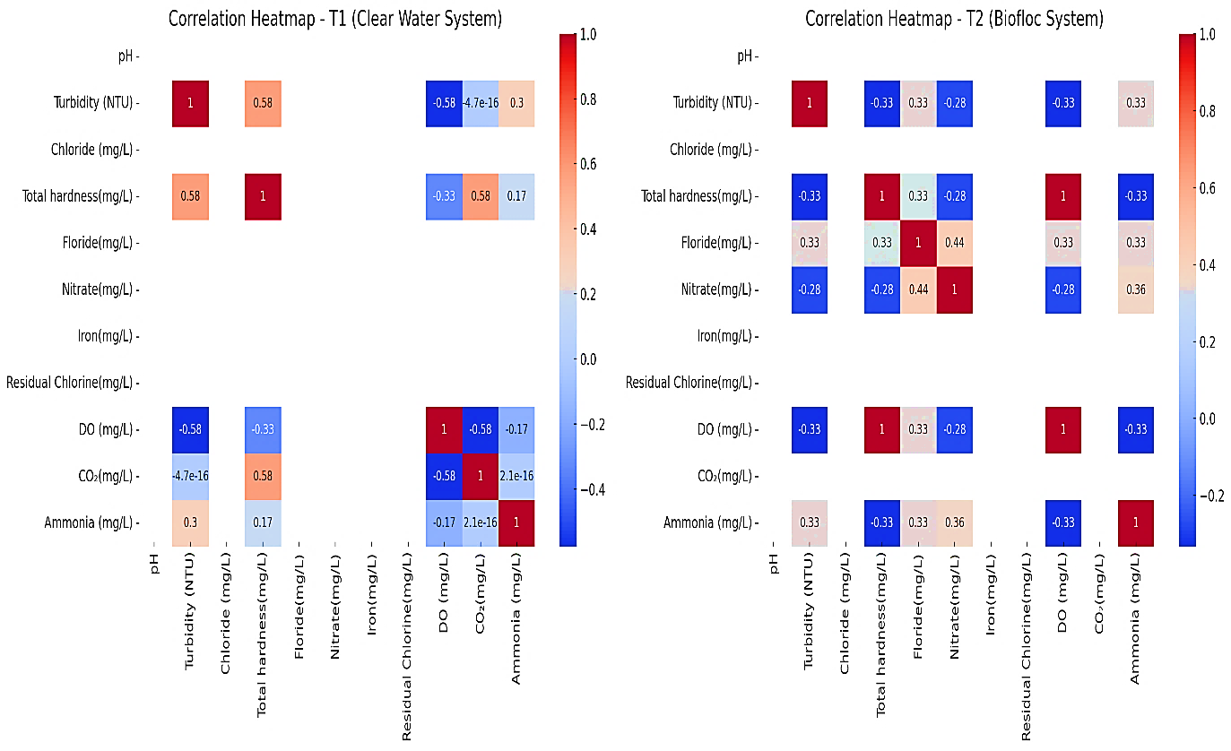
(a) (b)
Figure1: correlation heatmaps for the physical water quality parameters across months in both tanks T1(a) and T2(b).
T1 (without probiotic treated System) shows a stronger correlation between ammonia and total hardness, and moderate correlations among DO, CO₂, and ammonia. T2 (probiotic treated System) exhibits notable correlations between turbidity and nitrate and between fluoride and ammonia (Figure 2). Ghorbani Koutanaei (2024) evaluated the effects of Bio-Aqua® probiotic as a water additive on water quality, growth, proximate composition, hematology, and biochemistry in common carp (Cyprinus carpio). Four groups were tested: control (0 g/ha), T1 (250 g/ha), T2 (350 g/ha), and T3 (450 g/ha). Probiotic treatments significantly improved water quality by reducing NH₃, COD, TDS, TSS, BOD, nitrite, and phosphate, especially at higher doses. Growth parameters (weight gain, length gain, SGR, CF) and feed efficiency (FCR) improved dose-dependently, with T3 showing the best results. The T3 group also had increased crude protein and lipid, decreased ash and moisture, and enhanced hematological indices (RBC, Hct, Hb, WBC, neutrophils, eosinophils, monocytes, lymphocytes). Biochemical markers (LDH, ALP, albumin, globulin, total protein) increased significantly in probiotic-treated groups. Overall, Bio-Aqua® significantly boosts pond water quality, fish growth, and health, supporting its use as a beneficial aquaculture additive.

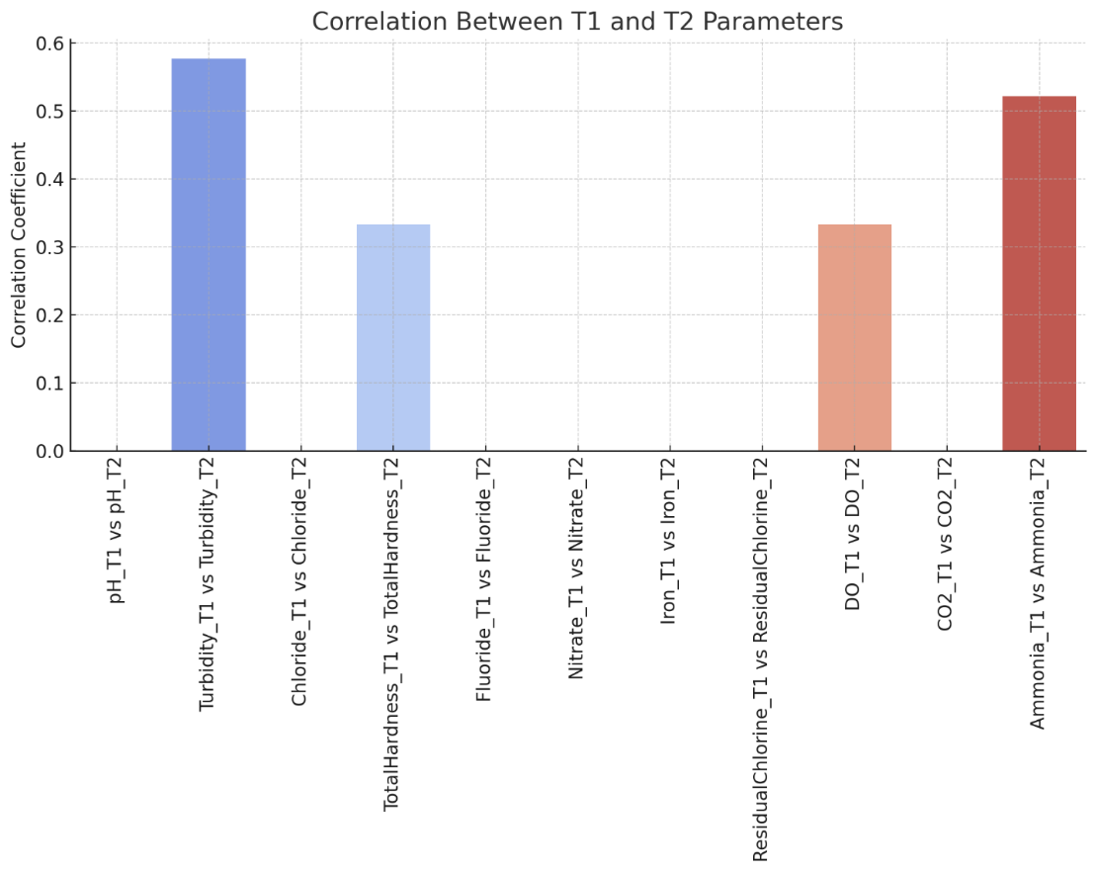
Figure2: The correlation graph between T1 and T2
The correlation graph showing how closely the physical parameters from Tank 1 (T1) and Tank 2 (T2) relate to each other across different months. A correlation coefficient close to 1 indicates a strong positive correlation, meaning the values in T1 and T2 rise and fall together (Figure2). Sharna (2025) highlighted probiotics as a promising alternative to synthetic agrochemicals in Bangladeshi aquaculture, where most probiotics are imported and sometimes ineffective due to incompatibility with local environments. This study isolated and identified five native probiotic strains from the gut of Asian stinging catfish: Bacillus safensis (HF8), Bacillus altitudinis (HF10), Bacillus pacificus (HF19), and two Bacillus cereus strains (HF20, HF21). These isolates showed varying antibiotic susceptibility and, individually or combined, exhibited antagonistic activity against Aeromonas hydrophila, with HF8 being the most effective. A probiotic consortium (1.15 × 10⁹ to 2.3 × 10⁹ CFU/kg feed) significantly enhanced growth, hepatosomatic index, relative intestine weight, and improved intestinal and liver morphology in catfish over 60 days. Hematobiochemical responses varied, while gonadosomatic index and ovarian development improved with probiotic treatment. The study recommends multi-location field trials before commercial application to boost ecofriendly fish production in Bangladesh.
Table 2: Growth parameters of Cyprinus carpio fingerlings cultured in T1 (without Probiotic Biofloc System) vs. T2 (Probiotic Biofloc System).
Parameters | T1 | T2
Survival (%) | 90 ± 1.2 | 93 ± 0.9
Initial Body Weight (g) | 0.52 ± 0.03 | 0.51 ± 0.04
Final Body Weight (g) | 8.20 ± 1.0 | 15.50 ± 1.1
Specific Growth Rate (%/day) | 2.10 ± 0.15 | 3.70 ± 0.22
Feed Conversion Ratio (FCR) | 1.45 ± 0.10 | 0.80 ± 0.06
Table 2 presents a comparative analysis of the growth performance of Cyprinus carpio fingerlings cultured under two different systems: T1 (without Probiotic Biofloc System) and T2 (with Probiotic Biofloc System). The data clearly indicate that the probiotic biofloc system (T2) significantly enhances the growth parameters of the fish.
The survival rate in T2 was slightly higher (93 ± 0.9%) than in T1 (90 ± 1.2%), suggesting that the probiotic biofloc system contributed to better water quality and health management, thereby reducing stress and mortality. The initial body weights of fingerlings in both treatments were comparable, confirming that both groups started at similar baselines. However, a marked difference was observed in the final body weights, where fish in T2 reached an average of 15.50 ± 1.1 g compared to only 8.20 ± 1.0 g in T1. This substantial weight gain under T2 indicates that the biofloc system enhanced nutrient availability and improved digestion and assimilation of feed, possibly due to the probiotic action. Correspondingly, the Specific Growth Rate (SGR) was significantly higher in T2 (3.70 ± 0.22%/day) compared to T1 (2.10 ± 0.15%/day), reinforcing the superior growth efficiency under probiotic biofloc conditions. Wijayanti (2025) studied probiotics—microbes that modify fish gut bacteria and improve health—to prevent Aeromonas hydrophila infection in striped snakeheads (Channa). The study tested four groups: control (P0), Bacillus sp. (P1), Streptomyces sp. (P2), and a combination of both (P3), each at 10 ml/kg feed. Variables measured included bacterial count, infection prevalence, fish growth, survival rate, and water quality. The combination treatment (P3) showed significantly higher survival, growth, and feed efficiency, with the lowest infection prevalence of 2.38%. Finally, the Feed Conversion Ratio (FCR), which reflects how efficiently feed is converted into body mass, was considerably better in T2 (0.80 ± 0.06) than in T1 (1.45 ± 0.10). A lower FCR indicates more efficient feed utilization, further supporting the hypothesis that the probiotic biofloc system improves feed digestibility and nutrient uptake. Mohammad Farkan (2025) conducted research at Rhee Royal Vannamei, Sumbawa, Indonesia, from September 2023 to February 2024. Vannamei shrimp were reared for 96 days in a 3,433 ± 157 m² pond at a stocking density of 133 ± 5 shrimp/m². Probiotics were applied every 3 days at 0.5 ppm for 60 days, then 1–1.5 ppm until day 96. Using a randomized design with two treatments and six replications, data were collected through observation and laboratory analysis. Although the T-test showed no significant difference between probiotic and non-probiotic treatments, probiotic ponds were more stable and produced 29.58% more shrimp. Probiotics also improved water quality, with a carrying capacity of 21,354 kg/ha.
the data strongly justify the application of probiotic biofloc systems in aquaculture as a sustainable and efficient approach to enhancing fish growth and survival.

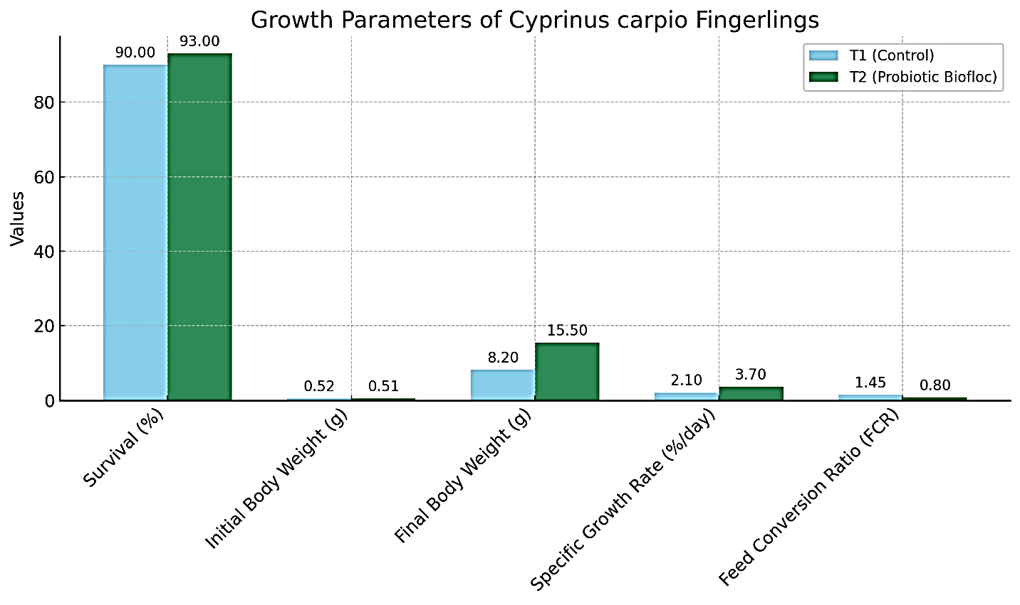
Figure 3 Growth Metrics of Cyprinus carpio under two culture systems T1 (Control, without Probiotic Biofloc) and T2 (Probiotic Biofloc).
The bar graph (Figure 3) visually supports the data presented in Table 2 by comparing the growth performance of Cyprinus carpio fingerlings under two culture systems T1 (Control, without Probiotic Biofloc) and T2 (Probiotic Biofloc). Each parameter shown in the graph reaffirms the advantages of the probiotic biofloc system over the conventional system. While the initial body weights were nearly identical in both groups (approximately 0.5 g), fingerlings in the T2 system achieved a final body weight of 15.5 ± 1.1 g, nearly double that of the T1 group (8.2 ± 1.0 g). This substantial increase in biomass is further reflected in the specific growth rate (SGR), which was 3.70 ± 0.22% per day in T2 tank fish, compared to 2.10 ± 0.15% per day in T1 fish. The elevated SGR indicates enhanced metabolic activity and nutrient assimilation, primarily due to the synergistic effects of beneficial probiotic strains and biofloc microbial communities that aid in digestion and improve water quality.
Additionally, the feed conversion ratio (FCR) was markedly better in the T2 (0.80 ± 0.06) compared to T1 (1.45 ± 0.10), suggesting that fish in the probiotic biofloc system required significantly less feed to gain body mass. This improved feed efficiency not only reduces production costs but also minimizes nutrient waste in the environment. The survival rate was also slightly higher in the T2 group (93%) than in T1 (90%), reflecting improved health and stress resistance likely conferred by the probiotics' immunomodulatory effects. Collectively, these findings strongly support the use of mixed probiotics in biofloc systems as a sustainable strategy to enhance growth, feed utilization, and survival in aquaculture practices for Cyprinus carpio.
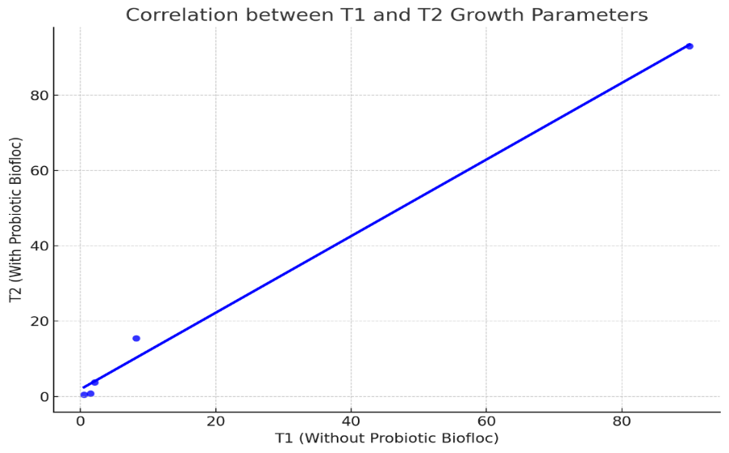
Figure 4: correlation coefficient between T1 and T2 growth parameters is approximately 0.973, indicating a strong positive correlation.
The Figure 4 represents the relationship between growth metrics of Cyprinus carpio fingerlings under two culture systems: T1 (Without Probiotic Biofloc) and T2 (With Probiotic Biofloc). The X-axis shows values of different growth parameters recorded under T1 (Control). The Y-axis shows corresponding values of the same parameters under T2 (Probiotic Biofloc). Each blue dot represents a pair of corresponding values for a particular growth parameter (e.g., survival rate, final body weight, specific growth rate, etc.) under T1 and T2. The blue line indicates a positive linear correlation, suggesting that as the value of a parameter increases in T1, it tends to increase in T2 as well. However, most T2 values are higher, which is why the dots lie above the 45° diagonal line (if it were drawn). This reflects the superior performance of the probiotic biofloc system.
Although the correlation is linear, the slope is greater than 1, meaning that for each unit value in T1, the corresponding T2 value is typically larger. This supports the conclusion that the probiotic biofloc system enhances growth outcomes compared to the control. this graph confirms a strong, positive correlation between the two systems while clearly illustrating that the probiotic biofloc system (T2) consistently outperforms the conventional method (T1) in terms of all key growth parameters.
Conclusion
The present investigation underscores the efficacy of probiotic-enriched biofloc technology in enhancing the water quality and growth performance of Cyprinus carpio fingerlings. Comparative analysis between the control T1 (Without Probiotic Biofloc) and T2 (With Probiotic Biofloc). across eight months revealed that the integration of probiotics led to marked improvements in key physicochemical parameters and fish growth indices. Water quality assessment showed that ammonia levels, a critical toxicant in aquaculture, remained substantially lower in the T2 system (ranging from 0.1–0.2 mg/L) compared to the T1 system (0.5–0.7 mg/L). This reduction can be attributed to enhanced nitrification processes and microbial assimilation facilitated by the probiotic consortia. Dissolved oxygen (DO) levels were also consistently higher in T2 (up to 5.8 mg/L), indicating improved microbial respiration and reduced organic load. While pH, chloride, iron, and residual chlorine remained within optimal ranges in both systems, the biofloc environment helped stabilize fluctuations, especially in nitrate and turbidity, supporting a more balanced ecosystem. The probiotic treatment translated into significant biological gains. The final body weight in T2 was nearly double that of T1 (15.50 ± 1.1 g vs. 8.20 ± 1.0 g), with a corresponding increase in specific growth rate (SGR) to 3.70 ± 0.22% per day in T2, compared to 2.10 ± 0.15% per day in T1. Furthermore, the feed conversion ratio (FCR) was notably better in T2 (0.80 ± 0.06), suggesting more efficient feed utilization, likely due to improved gut microbiota and nutrient bioavailability. The survival rate also improved slightly in the T2 tank indicating enhanced stress tolerance and disease resistance. the application of mixed probiotics in a Biofloc system effectively regulates water quality, particularly ammonia, enhances nutrient recycling, and promotes superior growth and survival in Cyprinus carpio. These findings advocate the implementation of probiotic Biofloc systems as a cost-effective, sustainable, and environmentally responsible strategy for modern freshwater aquaculture.
Data Availability
The data supporting the findings of this study are available from the corresponding author.
Disclosure Statement
The author(s) declare no conflicts of interest related to this work.

References
FAO The State of World Fisheries and Aquaculture 2024. Blue Transformation in Action. 2024. https://openknowledge.fao.org/server/api/core/bitstreams/66538eba-9c85-4504-8438-c1cf0a0a3903/content/cd0683en.html.
Badoni, P., Nazir, I., Aier, M., Maity, P. B., Samanta, S., & Das, A. (2021). Significant role of fish nutrients with special emphasis to essential fatty acid in human nutrition. Int. J. Curr. Microbiol. Appl. Sci, 10, 2034-2046.
Amillano-Cisneros, J. M., Fuentes-Valencia, M. A., Leyva-Morales, J. B., Savín-Amador, M., Márquez-Pacheco, H., de Jesús Bastidas-Bastidas, P., ... & Badilla-Medina, C. N. (2025). Effects of microorganisms in fish aquaculture from a sustainable approach: a review. Microorganisms, 13(3), 485.
Dewali, S., Parveen, N., Kathayat, N., Rawat, G., Bora, S., Sharma, N. P., ... & Bisht, S. S. (2025). Biological Cleansing: Probiotic Strategies for Tackling Contaminants in Water and Wastewater. In Emerging Contaminants in Water and Wastewater: Sources and Substances (pp. 255-279). Cham: Springer Nature Switzerland.
Yasin, I. S. M., Mohamad, A., Azzam-Sayuti, M., Saba, A. O., & Azmai, M. N. A. (2025). Disease Management in Aquaculture. Management of Fish Diseases, 437-464.
Thrush, M. A., Murray, A. G., Brun, E., Wallace, S., & Peeler, E. J. (2011). The application of risk and disease modelling to emerging freshwater diseases in wild aquatic animals. Freshwater biology, 56(4), 658-675.
Bouwmeester, M. M., Goedknegt, M. A., Poulin, R., & Thieltges, D. W. (2021). Collateral diseases: aquaculture impacts on wildlife infections. Journal of Applied Ecology, 58(3), 453-464.
Kenis, M., Hurley, B. P., Colombari, F., Lawson, S., Sun JiangHua, S. J., Wilcken, C., ... & Sathyapala, S. (2019). Guide to the classical biological control of insect pests in planted and natural forests.
Shams, A., Fischer, A., Bodnar, A., & Kliegman, M. (2024). Perspectives on Genetically Engineered Microorganisms and Their Regulation in the United States. ACS synthetic biology, 13(5), 1412-1423.
Margolles, A., & Suárez, J. E. (2021). The human microbiota: general concepts, composition, distribution and functions. Journal of Spanish Society of Anti-Aging Medicine and Longevity and Latin-American Federation of Anti-Aging Medicine Societies, 8.
Ringo, E., Harikrishnan, R., Soltani, M., & Ghosh, K. (2022). The effect of gut microbiota and probiotics on metabolism in fish and shrimp. Animals, 12(21), 3016.
Hassan, E. K., Abdalla, S., Abdellah, A., Azab, M., Ramadan, M., & Adel Ibrahim, K. (2025). Smoking and Obesity: A Microbial Perspective on Oral and Gut Microbiome Alterations. ERU Research Journal, 4(1), 1990-2037.
Tacon, A. G., Levy, J., Coelho, R., Machado, T. M., Neiva, C. R., & Lemos, D. E. (2025). Fish for health: role of fish in global food and animal protein supply. Reviews in Fisheries Science & Aquaculture, 33(2), 319-333.
Bisht, H. C. S., Bhatt, P., Sharma, N. P., Dewali, S., Melkani, D. C., & Bisht, S. S. (2025). Enhancing cold-water fish biomass: The synergistic role of water quality and probiotics in sustainable aquaculture. Journal of Biological Research and Reviews, 2(1), 56-56.
Naiel, M. A., Abdelghany, M. F., Khames, D. K., Abd El-hameed, S. A., Mansour, E. M., El-Nadi, A. S., & Shoukry, A. A. (2022). Administration of some probiotic strains in the rearing water enhances the water quality, performance, body chemical analysis, antioxidant and immune responses of Nile tilapia, Oreochromis niloticus. Applied Water Science, 12(9), 209.
Sunitha, K., & Padmavathi, P. (2013). Influence of probiotics on water quality and fish yield in fish ponds. Int. J. Pure Appl. Sci. Technol, 19(2), 48-60.

Farkan, M., Novriadi, R., Sektiana, S. P., Lathifah, F., Margono, M., Ilhamdi, I., ... & Sumandiarsa, I. K. (2025). Analysis of Probiotic Application, Water Quality, Carrying Capacity and Production of Penaeus vannamei Vaname Shrimp Culture in Ponds. Aquaculture Studies, 25(3).
Wijayanti, M., Sasanti, A. D., Jubaedah, D., & Citra, N. (2025). Impact of Probiotic Swamp Bacteria on the Prevention of Aeromonas hydrophila Infection in Striped Snakehead (Channa striata). Journal of Fish Health, 5(2), 224-236.
El-Kady, A. A., Magouz, F. I., Mahmoud, S. A., & Abdel-Rahim, M. M. (2022). The effects of some commercial probiotics as water additive on water quality, fish performance, blood biochemical parameters, expression of growth and immune-related genes, and histology of Nile tilapia (Oreochromis niloticus). Aquaculture, 546, 737249.
Ghorbani Koutanaei, H., Changizi, R., Ghobadi, S., Moghaddasi, B., & Manouchehri, H. (2024) The Effect of Probiotic Bio-Aqua® on Growth Performance, Hematological and Biochemical Parameters of Fry Common Carp (Cyprinus Carpio). Reza and Ghobadi, Shayan and Moghaddasi, Babak and Manouchehri, Hamed, The Effect of Probiotic Bio-Aqua® on Growth Performance, Hematological and Biochemical Parameters of Fry Common Carp (Cyprinus Carpio).
Sharna, S. N., Nur, K. F., Rahman, A., Das, N. C., Akter, J., Khatun, M., ... & Taslima, K. (2025). Multi-strain Native Probiotics from the Asian Stinging Catfish (Heteropneustes fossilis) Enhance Growth, Blood Health, and Organ Morphology in the Host. Probiotics and Antimicrobial Proteins, 1-24.

