**Spatial distribution of penaeid and palaemonid prawns with special reference to salinity in Subarnarekha estuary, east coast of India**

**Abstract**

Subarnarekha estuary is important for edible faunal diversity (fish, crab and prawn) in East Coast of India. Prawns are collected throughout the year from January 2023 to December 2024 at two sites Kumbhirgari/Kirtania (S-I) and Dogra (S-II) of the river. Variant environment provides different prawn community resources. Commercially important adult penaeid prawns are found at S-II and both juvenile and adult penaeid as well as palaemonid prawns are found at S-I. These two different salinity gradient environments are formed mainly due to tidal activity as a result of lunar cycle. Salinity range at S-I and S-II are (0.1-29) ppt and (14-32) ppt respectively. Total 12 species of penaeid and 3 palaemonid prawns were identified from S-I whereas the respective penaeid and palaemonid species are 8 and 1at S-II. Most abundant prawns at S-I are *M. Ensis* (41.3%), *P. merguiensis (*13.2%), *M. lysianassa (*11.6%), *M. rosenbergii (*8.2%), *P. sculptilis* (6.9%), *M.brevicornis* (6.3%), *E. stylifera* (5.8%), *P. japonicus* (2.5%), *M. affinis* (1.2%), *M. equidense (*1.1%), *P. s. coromendelica* (0.7%) and at S-II are *P. s. coromendelica* (56.3%), *E. stylifera* (17.2%), *P. merguiensis (*8.6%), *M. brevicornis* (6.9%), *H. hardwickii* (3.7%), A. uncta (3.4%), *M. lysianassa (*3.2%). Sorensen’s quotient of similarity is 0.43 indicate habitats possesses moderately dissimilar prawn community structure. Diversity index like Shanon-Weiner’s index (H՜), Simpson’s index (D) and Pielou’s evenness index (J) values are 1.9, 1.4, 0.8, 0.6, 0.7, and 0.6 at S-I & S-II respectively indicate that the environment is moderately stable for both sites, high diversity and species distribute more evenly at S-I rather than S-II respectively. Such type of study informed to the distribution and availability of prawns in the lower reaches of the river will certainly be helpful to the fisherman community and to take decision if any degradation occur due to natural or anthropogenic activity to protect and sustainable management restoration of the natural environment and its resources for future developing necessity.

**Key Words**: Subarnarekha estuary, prawns, Salinity, Diversity index.

**1. Introduction**

In Odisha Subarnarekha River extending mainly northeast region of Baleshwar district flows 79 km of which the length of estuary extremity is 53km (google earth length measurement in polygon) around 4 blocks namely Jaleswar, Basta, Baliapal and Bhograi (DSR of Baleswar District) finally joins with the Bay of Bengal near Chaumukh. Bichitrapur ecotourism mangrove tourist nature camp situated near the mouth of the Subarnarekha estuary. Estuaries are transitional environment between two system like freshwater and marine water that provide highly variable and support a rich biodiversity, of which fish (larvae, juveniles, and adults) one of the most important components (Yáñez-Arancibia et al.,1993; Whitfield, 1994, 1999). From the upper to lower reaches selected two study sites are Kumbhirgari/Kirtania and Dogra. Most tidal activity reaches selected sites during the post monsoon and premonsoon season rather than the monsoon period which is determined through water salinity value measurement. If the salinity value increases 0.5 ppt the sample water is saline i.e. marine water comes and mixes with freshwater make it more nutrient reach environment, suitable for many juveniles and preadult penaeid and palaemonid development. Therefore, more tolerable species are available with this variant abiotic environment (Blaber,1981, Whitfield, 1999). Some species of freshwater prawns migrate into the brackish water temporarily due to breeding purpose (Kemp,1915). Tidal activity influencing change salinity regime produces a mixed chemical environment which is unlike the two adjacent environments i.e. marine and river system (Reid and Wood, 1976).

Prawns are the most delicious highly demandable Decapod crustacean available both in freshwater and saline water habitat. Distribution and movement of juvenile prawns are governed by the ecological conditions, adaptability and habitat preference of the size groups is very important for this habitat. During the present study, an attempt was made to observe the distribution pattern of prawns in the rivers on an eco-physiological basis mainly salinity of aquatic environment. Odisha coast is characterized by the opening of various rivers like Subarnarekha, Budhabalanga, Baitarani, Bramhini, Mahanadi, Rushikulya and Bahuda into the Bay of Bengal. Local people are engaged in fishing activity through beda jal, khanchi fishing bait, drag net etc. gathered both adult and juvenile prawns of penaeid and palaemonid resources. Total 18 number of prawn species were identified among which 12 species are belonging to Family Penaeidae and 3 species belonging to Family Palaemonidae at S-I and 8 species are belonging to Family Penaeidae and 1species belonging to Family Palaemonidae at S-II. Main aim is to be study the spatio-temporal distribution of prawns in relation to water salinity. These informative research studies will be helpful for further research on prawns.

**2. Materials and methods**

**2.1 Study sites**

In the downstream of the river Subarnarekha, two sites have been selected for the present study. These two sites are Kumbhirgari / kirtania (21°36ʹ19ʹʹN, 87°20ʹ17ʹʹE; Site-I) which is 22.38 km apart from river mouth and Dogra (21°55ʹ29ʹʹN, 87°30ʹ17ʹʹE; Site-II) which is located all most in the river mouth (fig1 and photo plate 1). The physiography of S-I shows that the river basin is enriched with sand and the riverbank is composed of muddy flat and mangrove trees, whereas S-II has sand base coastal environment.

C:\Users\SANTU\Desktop\mp.tifFig1: Location map of the river.

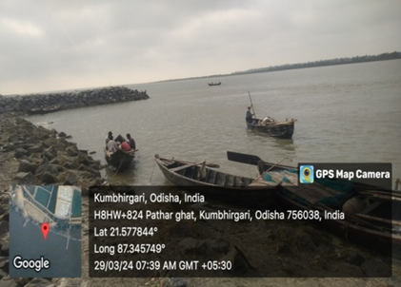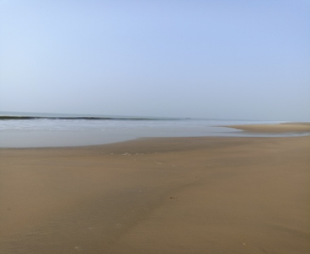

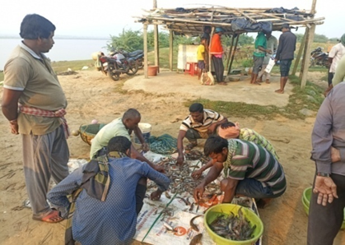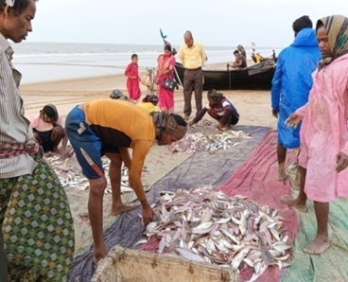

S-I S-II

Photo plate 1: Study sites (site views and collection of fish)

**2.2 Sample collection, preservation and identification**

Prawn samples are collected mainly on a cluster basis every month on each site and preserved them adding 1-2% formalin in the collection spot. Fish, prawn and crab samples were collected by traditional fishing gear of the study site like beda net, drag net with the mess size 2cm both length and breadth and 2.2 cm length, 1.3 cm breath respectively after high tide activity they gathered them at the riverbank during early morning to morning time. Samples were taken to the laboratory and finally preserved in 5-10% formalin (Arumugam, 2012) solution. Later they were examined, identified and counted. Per netting caught about 300g to more and ultimately within 2 hours it reaches up to 3-4kg and vary in temporal condition from early morning to morning time. Sample water is also collected each month for water salinity measurement with the help of the thermometer Brix Hand R (0-55 Brix range)-ERMA to make digital handheld refractometer. Identification of specimen were done on the basis of their meristic and morphological characteristics with the help of related literature, FAO identification sheet fishing area 51 (1984), Farfante & Kensley, 1997, Laxmi Pillai, notebook on penaeid (2013) & Chanda (2016).

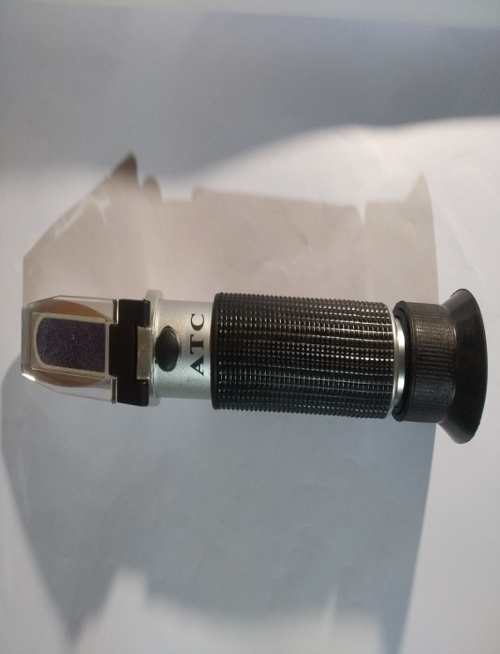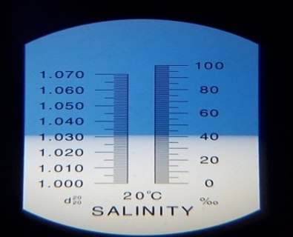

Refractometer (0-55 Brix range) Salinity range (0-100) ppt

**Salinity range(ppt) Water type**

<0.5 Freshwater

0.5-17 Brakish water

upto 30 Some estuary

1-35 Coastal Salt marsh

30-40 Sea water

Fig2: Salinity meter

**2.3 Differentiation of the two prawn Families**

|  |  |
| --- | --- |
| Penaeidae | Palaemonidae |
| Prominent dorsal carination on last 3 dorsal  abdominal Segment. | No carination at the last dorsal abdominal Segment. |
| 1-3rdpair of pereopods have chelate form. | 1st&2ndpair of pereopods have chelate form. |
| Presence of postrostral carina. | No such type of post rostral carina |
| Presence of prominent hepatic spine. | Generally post-antennal spine present. |
| G:\preregistration\photo\sept. 23\p coro..jpg | G:\preregistration\photo\sept. 23\M. equidense.jpg |

Fig 3 : Prawn (Family: Penaeidae) Fig 4 : Prawn (Family: Palaemonidae)

**2.4 Biodiversity assessment:** Biodiversity assessment calculated by diversity index value determine the habitat stability, species evenness, and how to diversify within this dynamic ecosystem. Species diversities are analyzed by Simpson’s index (D), Shanon-Weiner’s index (H՜), Pielou’s evenness index(J) these are following-

**2.4.1 Shanon diversity index (H՜) (Shanon,1948)**

H՜ **=** -∑pi ln pi, Value range in between 1-3(high value related to high diversity and low value indicate less diversity). It provides a measure of overall diversity.

**2.4.2 Simpson’s index by Simpson, 1949 (D):**

D=1-∑ni(ni-1)/N(N-1), Where ni = Individual number of ith species of the community. ‘D’ ranges between 0-1, greater value indicates greater diversity.

**2.4.3 Pielou Evenness index by Pielou’s, 1966 (J)-**

J = H՜/ ln (S), Where H՜ is the Shannon diversity index, ln S is the maximum diversity for Shannon diversity index and S is the richness of a community. Value range between 0-1 (1’ means perfect evenness and decreases to ‘0’).

**2.4.4 Sorensen’s (1948) quotient of similarity (Q.S.),** to show how much similarity of species between two sites on the basis of value range-

>0.71 is strongly similar.

0.61 – 0.70 moderately similar

0.51 – 0.61 slightly similar

0.41 – 0.50 moderately dissimilar

<0.40 strongly dissimilar (Chanda,2014).

Cluster analysis on seasonal relative abundance of prawn samples between two sites. Data analysis will be done by MS Excel 2007 and Past 4.03 software.

**3. Result & Discussion**

Lower reaches of river have variant environment gradient as a consequence of tidal activity that provides nutrient rich environment for developing prawns. List of prawn species with spatial distribution is given in table1 and identified species on photo plate 2. Total number of prawn species are 18, belonging to 2 Families and 8 Genus, the number of penaeid and palaemonid prawn species are 15 and 3 respectively where as S-I comprises with 12 and 3, S-II comprises with 7 and 1respectively, the genus number of the S-I and S-II is 6 and overlapping species is 5 showing in table2 and fig5. S-I is dominated by preadult or juvenile species of Genus like Metapenaeus like *M. ensis* (41.3%), *M. lysianassa (*11.6%), *M. brevicornis* (6.3%), *M. dobsoni (*1.24%) and Parapenaeopsis like *P. s .coromendelica* (0.7%) and *K. cornuta* (0.03%) both preadult and adult species of *P. merguiensis (*13.2%), *P. monodon* (2.89%), *P. sculptilis* (6.9%), *E. stylifera* (5.8%), *M. equidense (*1.1%) adult species of *M. rosenbergii (*8.2%), *P. japonicus* (2.5%), *M. affinis* (1.2%) & *P. indicus* (0.02%). S-II are dominated with adult penaeid prawns like *P. s. coromendelica* (56.3%), *P. merguiensis (*8.6%), *P. semisulcatus* (0.6%), *M. brevicornis* (6.9%), *H. hardwickii* (3.7%), *A. uncta* (3.4%), *M. lysianassa (*3.2%) and juvenile species of palaemonid like *E. stylifera* (17.2%) at fig 6.

Most commercial prawns available in the study sites are *M. rosenbergii, followed by P. monodon* ≥ *P. sculptilis* ≥ *P. merguiensis, M. lysianassa, M. brevicornis, M. affinis, P. japonicas* ≥ *P. s. coromendelica, H. hardwickii, A. uncta* ≥. *P. merguiensis, M. ensis, M. lysianassa, M. brevicornis M. equidense, E. stylifera*.

**Table 1: List of prawn Species at two sites of lower reaches in Subarnarekha estuary.**

|  |  |  |  |  |  |  |
| --- | --- | --- | --- | --- | --- | --- |
| **Family** | | **Genus** | | **Species name** | **Common name** | **Distribution** |
| Penaeidae | | Alcockpenaeopsis | | *A. uncta* Alcock, 1905 | Uncta / khayra Shrimp | S-I, S-II |
| Helleropenaeopsis | | *H. hardwickii* (Miers, 1878) | Spear / sukna Shrimp | S-I, S-II |
| *H. sculptilis* (Heller, 1862*)* | Rainbow / matkaprawn | S-I |
| Kishinouyepenaeopsis | | *K. cornuta* (Kishinouye, 1900) | Coral Shrimp | S-I |
| Metapenaeus | | *M. affinis* H. Milne Edwards, 1837 | Jinga Prawn | S-I |
| *M. brevicornis* (Milne Edwards, 1837) | Yellow / harina Shrimp | S-I, S-II |
| *M. dobsoni* (Miers, 1878) | Kadal Shrimp / Flower-Tail Prawn | S-I, S-II |
| *M. ensis* (De Haan, 1844) | Greasyback Shrimp / Tania prawn | S-I |
| *M. lysianassa* (De Man, 1888) | Bird Shrimp | S-I, S-II |
| Parapenaeopsis | | | *P. stylifera coromandelica,* Alcock, 1906 | Kiddy Shrimp | S-I, S-II |
| Penaeus | | | *P. japonicas* Bate, 1888 | Kuruma prawn or Japanese tiger prawn | S-I |
| *P. merguiensis* De Man, 1888 | Banana prawn | S-I, S-II |
| *P. monodon* Fabricius, 1798 | Giant Tiger Prawn | S-I |
| *P. semisulcatus* De Haan, 1844 | Green Tiger Prawn | S-I, S-II |
| *P. indicus* H. Milne Edwards, 1837 | Indian White Shrimp | S-I |
| Palaemonidae | | Exopalaemon  Macrobrachium | *E. styliferus* (H. Milne Edwards, 1840) | Roshna Prawn | S-I, S-II |
| *M. rosenbergii* (De Man, 1879**)** | Giant River Prawn | S-I |
| *M. equidens* (Dana, 1852) | Rough River Prawn | S-I |

**Table 2: Spatial distribution of prawn species.**

|  |  |  |  |  |  |  |  |  |  |  |
| --- | --- | --- | --- | --- | --- | --- | --- | --- | --- | --- |
| **Total no. of species** | **No. of species at S-I** | **No. of species at S-II** | **Total no. of Genus** | **No. of Genus at S-I** | **No. of Genus at S-II** | **No. of species under families in S-I** | | **No. of species under families in S-II** | | **Common/Overlapping species** |
| **Penaeidae** | **Palaemonidae** | **Penaeidae** | **Palaemonidae** |
| **18** | **15** | **8** | **8** | **6** | **6** | **12** | **3** | **7** | **1** | **5** |

Fig 5: Callumn chart of species composition between two sites

**Yearly relative abundance of species distribution at two sites**

Fig 6: Pie chart

Sorensen’s (1948) quotient of similarity (Q.S.) of the species between two selected sites of the Subarnarekha estuary is calculated by the following formula –

Q. S= 2C/a+b, where a is the number of species at S-I, b is the number of species at S-II and C is the number of species common at both sites.

Q. S= 0.43, value represents that the Sorensen’s quotient of similarity of species between two sites of the river in between (0.41-0.5) indicates Q.S is moderately dissimilar.

Prawn species diversity index, values and respective comments are given in fig7 and table 2.

Table 3: Prawn species diversity index at two sites of the estuary.

|  |  |  |  |
| --- | --- | --- | --- |
| **Diversity index** | **S-I** | **S-II** | **Inference** |
| Shanon-Weiner’s index (H՜) | 1.9 | 1.4 | Both values remain within the 1-3 range, so habitat is moderately stable. |
| Simpson’s index (D) | 0.8 | 0.6 | Range is (0-1), greater value= greater diversity, so S-I is more diverse than S-II. |
| Pielou’s evenness index(J) | 0.7 | 0.6 | Value range is (0-1), greater value= more evenness, so, S-I is more evenness than S-II. |

Fig7: Diversity index between two sites

We observed seasonal variation of prawn species at two sites. Abundant prawn species of S-I during PM are *M. ensis* (28.5%), *M. brevicornis* (17.4%)*, M. lysianassa* (18.5%)*, M. rosenbergii* (9.98%) moderately diversified species are *P. merguiensis* (5.7%), *P. sculptilis* (8.5%), *E. stylifera* (4.3%) *and less abundant species are M. affinis* (1.4%)*, P. s. coromendelica* (3.1%), *P. monodon* (0.4%). During M highly abundance species are *M. ensis* (36.9%), *M. lysianassa* (16.5%)*, P. merguiensis* (13.2%) *moderately abundant are M. affinis* (2.1%)*, M. brevicornis* (1.3%), *P. japonicas* (2.6%), *P. sculptilis* (8.2%)*, E. stylifera* (6.5%)*, M. rosenbergii* (9.9%) *and less abundant species are M. equidens* (0.8%), *M. dobsoni (*1.3%), *P. s. coromendelica* (0.2%), *P. monodon* (0.1%). During POM, most abundant species are *M. ensis* (50.8%), *P. merguiensis* (15.5%); moderate abundant species are *M. brevicornis* (9.4%)*, M. lysianassa* (3.01%), *P. japonicas*(3%), *P. sculptilis* (4.7%)*, E. stylifera* (5.2%), *M. equidens* (1.5%) and *M. rosenbergii* (5.6%) *and less abundant species are P. s. coromendelica* (0.7%), *P. monodon* (0.3%) at S-I whereas S-II comprises of prawn species during PM highly abundant are *P. s. coromendelica* (40.5%), *P. merguiensis* (17.6%), *E. stylifera* (20.3%), moderately abundant species are *H. hardwickii* (9.4%), *M. brevicornis* (6.7%), *M. lysianassa* (2.7%), *A. uncta* (2.7%). During M the abundant species are *M. brevicornis* (30.4%), *P. s. coromendelica* (45.6%), *M. lysianassa* (13%), *P. merguiensis* (10.9%) and during POM season more abundant species are *P. s. coromendelica* (62.2%), *E. stylifera* (19.3%) and less abundant prawn species are *M. lysianassa* (1.3%), *A. uncta* (4.3%), *H. hardwickii* (2.6%), *P. merguiensis* (5.1%), *P. semisulcatus* (0.8%) were shown in fig-8 and fig 9. Significant differences of the factor (water Salinity) at two sites where S-I is more saline during POM and less saline during M, the value ranges from 0.1ppt to 19 ppt and S-II, the coastal region of the river mouth, also fluctuate its salinity, highest value during PM, moderate during M and nearest high during POM (32,14 and 29ppt respectively, at fig10).

Fig 8: Seasonally species RA at S-I (Premonsoon: PM, Monsoon: M & Postmonsoon: POM, Relative abundance of premonsoon: RAOPM, RAOM: Relative abundance of monsoon, RAOPM: Relative abundance of postmonsoon).

Fig 9: Seasonally species RA at S-II. (Premonsoon: PM, Monsoon: M & Postmonsoon: POM, Relative abundance of premonsoon: RAOPM, RAOM: Relative abundance of monsoon, RAOPM: Relative abundance of postmonsoon).

Fig 10: Seasonal fluctuation of salinity at two sites.

This study reveals the existence of 15 species & 8 species at S-I & S-II respectively. The relative abundance of these species of both S-I & S-II correlates with salinity gradients having perfectly positive, positive, near zero, negative and more negative (table 4 and table 5).

Both cluster analysis showed into two clusters in Algorithm, paired group (UPGMA) on Bray-Curti’s similarity index, one grouped and other is ungrouped cluster in fig11. In case of S-I RAOM2 and RAOPM1 season species having a group representing strong similarity than the RAOPOM3, whether in S-II RAOPOM3 and RAOPM1 season species having a group representing strong similarity than RAOM2.

A total of 4258 crustacean species have been recorded from India and 646 species enumerated from Odisha coast, represents 14.39% of the total crustacean fauna recorded from the country (Dev Roy, 2015). Dev Roy (2015) recorded 35 species of prawns from the Odisha coast. Out of 35 prawn species 23 were under family Penaeidae and 12 under Palaemonidae. Rath & Roy (2011) enlisted 8 penaeid and 3 palaemonid prawn species from Bahuda estuary, Ganjam in Odisha. Suresh *et. al*., (2018) recorded 5 from penaeid and 3 from palaemonid prawn species from Chilka lake. Rao & Rath, (2014) reported out of 23 species 15 are penaeid and 8 are palaemonid from Brahmini-Baitarani estuary in Odisha. Rath & Roy (2016) enlisted 25 penaeid and 14 palaemonid species from Godavari estuary. Rana and Chanda, (2024) listed 17 species of penaeid prawns from Subarnarekha estuary. Subarnarekha estuary rich in biological resources which serves as economic source to local fisherman is a major commodity to maintain their livelihood. Estuaries provide a dynamic ecosystem with constantly changing its physico-chemical environment and its fauna due to daily tidal activities, floods and seasonal changes.

Table 4: Correlation matrix between prawn species seasonal relative abundance with salinity for S-I.

|  |  |  |  |  |  |  |  |  |  |  |  |  |  |  |  |  |
| --- | --- | --- | --- | --- | --- | --- | --- | --- | --- | --- | --- | --- | --- | --- | --- | --- |
|  | sp1 | sp2 | sp3 | sp4 | sp5 | sp6 | sp7 | sp8 | sp9 | sp10 | sp11 | sp12 | sp13 | sp14 | sp15 | Site1 |
| sp1 | 1 |  |  |  |  |  |  |  |  |  |  |  |  |  |  |  |
| sp2 | -0.338 | 1 |  |  |  |  |  |  |  |  |  |  |  |  |  |  |
| sp3 | 0.891 | -0.728 | 1 |  |  |  |  |  |  |  |  |  |  |  |  |  |
| sp4 | 0.899 | 0.108 | 0.603 | 1 |  |  |  |  |  |  |  |  |  |  |  |  |
| sp5 | -0.755 | -0.362 | -0.375 | -0.966 | 1 |  |  |  |  |  |  |  |  |  |  |  |
| sp6 | -0.945 | 0.011 | -0.693 | -0.993 | 0.928 | 1 |  |  |  |  |  |  |  |  |  |  |
| sp7 | 0.058 | 0.920 | -0.402 | 0.488 | -0.699 | -0.381 | 1 |  |  |  |  |  |  |  |  |  |
| sp8 | 0.189 | 0.861 | -0.277 | 0.599 | -0.787 | -0.5 | 0.991 | 1 |  |  |  |  |  |  |  |  |
| sp9 | -0.311 | -0.791 | 0.154 | -0.695 | 0.858 | 0.605 | -0.967 | -0.992 | 1 |  |  |  |  |  |  |  |
| S10 | -0.404 | -0.724 | 0.054 | -0.764 | 0.905 | 0.681 | -0.936 | -0.974 | 0.995 | 1 |  |  |  |  |  |  |
| s11 | -0.5 | 0.984 | -0.839 | -0.071 | -0.191 | 0.189 | 0.836 | 0.756 | -0.668 | -0.590 | 1 |  |  |  |  |  |
| s12 | 0.919 | 0.060 | 0.640 | 0.999 | -0.952 | -0.997 | 0.446 | 0.560 | -0.660 | -0.732 | -0.119 | 1 |  |  |  |  |
| s13 | 0.416 | -0.996 | 0.784 | -0.023 | 0.282 | -0.096 | -0.884 | -0.814 | 0.735 | 0.663 | -0.996 | 0.025 | 1 |  |  |  |
| s14 | -0.836 | 0.799 | -0.994 | -0.512 | 0.270 | 0.610 | 0.5 | 0.381 | -0.262 | -0.164 | 0.893 | -0.552 | -0.847 | 1 |  |  |
| s15 | 0.938 | 0.010 | 0.679 | 0.995 | -0.935 | -0.999 | 0.400 | 0.518 | -0.621 | -0.696 | -0.169 | 0.999 | 0.075 | -0.594 | 1 |  |
| Se1 | -0.991 | 0.206 | -0.821 | -0.951 | 0.837 | 0.981 | -0.193 | -0.321 | 0.438 | 0.525 | 0.377 | -0.964 | -0.288 | 0.753 | -0.976 | 1 |

Footnote: The matrix is formed on a 3D scale where the lower value is -1, neutral value is ‘0’, highest value is +1 and the respective selected colors are red, yellow and green. Here, green: perfectly positive, positive: light green, near zero: greenish yellow, negative: yellowish red combination and more negative is denoted as red.

Table 5: Correlation matrix between prawn species seasonal relative abundance with salinity for S-II.

|  |  |  |  |  |  |  |  |  |  |
| --- | --- | --- | --- | --- | --- | --- | --- | --- | --- |
|  | *sp1* | *sp2* | *sp3* | *sp4* | *sp5* | *sp6* | *sp7* | *sp8* | *Site2* |
| sp1 | 1 |  |  |  |  |  |  |  |  |
| sp2 | 0.999649 | 1 |  |  |  |  |  |  |  |
| sp3 | -0.95718 | -0.96452 | 1 |  |  |  |  |  |  |
| sp4 | -0.65294 | -0.63264 | 0.405725 | 1 |  |  |  |  |  |
| sp5 | -0.37111 | -0.39558 | 0.624029 | -0.46101 | 1 |  |  |  |  |
| sp6 | 0.041722 | 0.06818 | -0.32917 | 0.72951 | -0.94326 | 1 |  |  |  |
| sp7 | -0.57031 | -0.59187 | 0.783677 | -0.24979 | 0.974419 | -0.84451 | 1 |  |  |
| sp8 | -0.99195 | -0.98824 | 0.912813 | 0.743606 | 0.250516 | 0.085153 | 0.46168 | 1 |  |
| Site2 | -0.97147 | -0.96484 | 0.861215 | 0.813946 | 0.140283 | 0.196436 | 0.359211 | 0.993682 | 1 |

Footnote: The matrix is formed on a 3D scale where the lower value is -1, neutral value is ‘0’, highest value is +1 and the respective selected colors are red, yellow and green. Here, green: perfectly positive, positive: light green, near zero: greenish yellow, negative: yellowish red combination and more negative is denoted as red.

**S-I S-II**

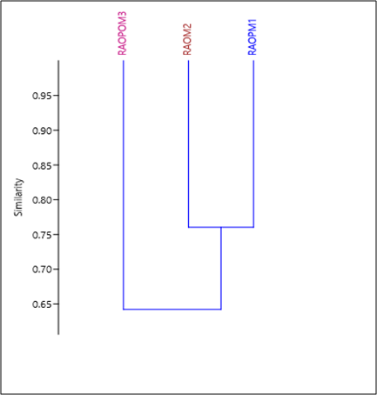 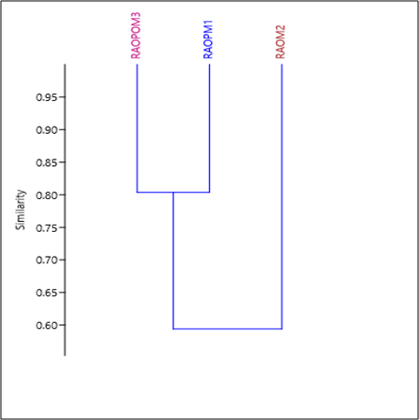

Fig11: Cluster analysis for S-I and S-II on RA (relative abundance) of seasonal species. Here, Cluster analysis basis on Bray-Curtis similarity at S-I and S-II representing RAOPM1 means relative abundance of premonsoon species, RAOM2: relative abundance of monsoon species and RAOPOM3: relative abundance of postmonsoon species at S-I and S-II.

**Photo plate 2 :** Species of penaeid and palaemonid prawn diversity

|  |  |  |
| --- | --- | --- |
| *E:\Gita Ph.D\picture of prawns\penaeid\parapenaeopsis uncta(female)15.jpg* | E:\Gita Ph.D\picture of prawns\penaeid\parapenaeopsis uncta(male).jpg | G:\feb,15\IMG20250201150407.jpg |
| *Parapenaeopsis (Alcockpenaeopsis) uncta* | | *H. hardwickii* |
| *G:\feb,15\IMG20250125131314.jpg* | E:\Gita Ph.D\picture of prawns\penaeid\Parapenaeopsis cornuta 8.jpg | G:\Iden.phto\1693995919827.jpg |
| *H. sculptilis* | *K. cornuta* | *M. affinis* |
| *C:\Users\SANTU\Downloads\1683349945617.jpg* | E:\Gita Ph.D\picture of prawns\gita\Metapenaeus dobsoni 6.jpg | G:\feb,15\IMG20250125130808.jpg |
| *M. brevicornis* | *M. dobsoni* | *M. ensis* |
| *G:\feb,15\IMG20250125132039.jpg* | G:\feb,15\IMG20250125131452.jpg | G:\feb,15\IMG20250125130922.jpg |
| *M. lysianassa* | *P. stylifera coromandelica* | *P. japonicas* |
| *G:\feb,15\IMG20250125131227.jpg* | G:\feb,15\IMG20250125130207.jpg | E:\Gita Ph.D\picture of prawns\penaeid\penaeus semisulcatus (2)18.jpg |
| *P. merguiensis* | *P. monodon* | *P. semisulcatus* |

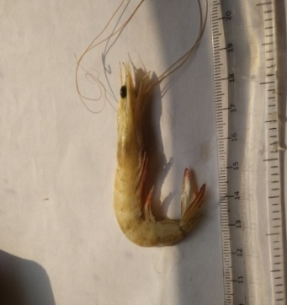 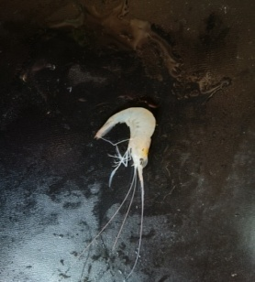 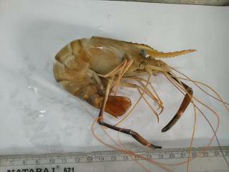 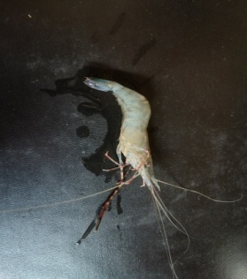 *P. indicus E. styliferus M. rosenbergii M. equidense*

**4. Summary & Conclusion:** Distribution of prawn diversity in any estuary of Orissa coast depend upon habitat selection that recruit them further development and the ecological conditions that fluctuate synchronously (Pillai et al. 1986). Estuary acts as a hotspot for many benthic animals’ larval forms, they wonder here for a few months of the year for their further development then returning to benthic mode of coastal habitat (Morgan, 1995; Shanks, 1995). Due to the mixing zone of two aquatic systems, freshwater and marine ecosystems, estuaries always face a strong physicochemical fluctuation of aquatic environment at spatio- temporal scale and the fluctuations of physicochemical parameters are more evident in the estuarine environment than in other aquatic systems (David et al., 2016). Subarnarekha estuary shows dynamic environment here we noted the fluctuation of salinity on seasonal basis which is suitable for the recruitment of both penaeid and palaemonid community. Lower reaches of the estuary meet with the Bay of Bengal from north to south at Talsari, Chandrabali and Dogra. Seasonally S-I gives a more diverse prawns resource for both juvenile and adult than S-II near Dogra. Salinity fluctuation is dominant at S-I due to tidal activity and seasonal effect and dominant species are under Genus Metapenaeus, Penaeus, Macrobrachium and Exopalaemon Where as S-II, the coastal line possesses >30 ppt salinity having dominant species are under Genus Parapenaeopsis, Penaeus and Metapenaeus. Therefore, salinity is the more important factor for nurising both families of prawns at both sites but dynamic at S-I rather than S-II.

It is evident from the current study that the status of the diversity of the prawn fauna at lower reaches of the Subarnarekha estuary is moderately stable, adequate for earning system and the environment is full of beauty of nature containing mangrove trees, muddy flats, Bheri all over landscape areas, shore muddy flats is the habitat of Porcelain fiddler crab, coastal areas with sand dunes, coastal trees, shore ghost crab habitation, living resource catches with the help of boat, trawler and netting system and flowing a free fresh aeration on this river side. Sustainable management and conservation if needed for planned ways to increase production, to save the endangered species and improve the local people’s skill of the estuarine areas the authority of the government should take monitoring and adopt policies.

**References:**

Arumugam, S., 2012. Distribution and seasonal availability of freshwater prawn Macrobrachium spp. In kodayar river in Tamil Nadu, India. *Universal Journal of Environmental Research and Technology.,* Vol 2(4): 247- 253.

Blaber, S. J. M.,1981. The zoogeographical affinities of estuarine fishes in southeast Africa. *S. Afr. J. Sci*. 77: 305–307.

Chanda, A., 2014. A systematic study on prawns (Crustacea: Decapoda: Caridea: Palaemonidea: Palaemonidae) in riverine system of Paschim Medinipur, West Bengal. *The International Journal of Science & Technoledge*. 2(5): 366-373.

Chanda A., 2016. A Study on Newly Described Genera Alcockpenaeopsis, Batepenaeopsis, Helleropenaeopsis, Kishinouyepenaeopsis and Parapenaeopsis from Indian Water. *Poult. Fish. Wild. Science.* 4: 147*.*

David et. al., 2016. Estuarine habitats structure zooplankton communities: Implications for the pelagic trophic pathways. *Estuarine, coastal, Shelf science*. 179: 99-111.

Dev Roy, M. K. 2015. Conservation concerns on crustacean fauna of India. *J. Environ. & Sociobiol*. 12(1): 77-98, tabs. 1-3.

Fischer W, Bianchi G. 1984. FAO species identification sheets for fishery purposes. Western Indian Ocean; (Fishing Area 51). Prepared and printed with the support of the Danish International Development Agency (DANIDA). Food and Agricultural Organization of the United Nations, Rome. 513: 1- 6.

Jose, J and Pillai, SL., (2013). Taxonomy and identification of commercially important crustaceans of India. A Manual note book from CMFRI, ICAR, Kochi, Kerala, India.

Kemp, S., 1915. Fauna of the Chilka lake: Crustacea, Decapoda. *Memo. Ind. Mus*., 5.

Morgan, S.G., 1995.The timing of larval release. Ecology of marine invertebrate larvae. Florida, pp. 157-191.

Pérez Farfante I, Kensley B. 1997. Penaeoid and Sergestoid Shrimps and Prawns of the World. Keys and Diagnoses for the Families and Genera. *Mem Mus natd’Histnat*175: 1-233.

Pielou, E. C. 1966. Species diversity and pattern diversity in the study of ecological succession. *J Theore Biol*. 3:131-144.

[Pillai](https://www.semanticscholar.org/author/S.-M.-Pillai/48610287), S. M., [Rajyalakshmi](https://www.semanticscholar.org/author/T.-Rajyalakshmi/13853551), T & [Ravichandran](https://www.semanticscholar.org/author/P.-Ravichandran/89609336), P., 1986. An ecological interpretation on the distribution of early stages of penaeid prawns along orisha coast. *National Conference on Natural Heritage Conservation*.

Rana, G and Chanda, A., 2024. A Study on Penaeid Prawns of Subarnarekha Estuary*. Research Journal of Agricultural Sciences*. 15 (03): 818–823.

Rao, D.V. and Sivananda Rath, 2014. Fauna of Brahmani-Baitarani Estuarine complex, Odisha, Bay of Bengal, w.s.r. to ichthyofauna and crustaceans. *Estuarine Ecosystem Series*. 7 : 1-120.

RATH, S & Roy, M.K.D., 2011. Crabs and prawns (Crustacea: Decapoda) of

Bahuda estuary, Ganjam, Odisha. *Rec. zool. Surv. India:* 111(Part-l): 47-61.

Rath, S., Dev Roy, M & Ghosh, B., 2016. Penaeid and Palaemonid Prawns of Godavari Estuary, Andhra Pradesh with Some New Records.  *Biological Forum – An International Journal 8*(1): 179-189.

Reid, GK & Wood, RD., 1976. Chap. 5. Estuaries. In: Ecology of inland waters and estuaries. Van Nostrand, New York, pp 93-107.

Shanks, A. L., 1995. Mechanisms of cross-shelf dispersal of larval invertebrates and fish

 Ecology of marine invertebrate larvae. Florida, pp. 323-367.

Shannon C.E., 1949. Communication in the presence of noise. *Proc. Inst. Radio Eng*. 37: 10– 21.

Shannon C.E & Weaver, W. 1963. University of Illinois Press, Urbana, IL: The Mathematical Theory of Communications. p. 125.

Simpson E.H., 1949. Measurement of diversity. *Nature*. 163: 688.

Sorensen, T., 1948. A method of stabilizing groups of equivalent amplitude in plant sociology based on the similarity of species content and its application to analysis vegetation of Danish Commons. *Biol. Skr*. 5: 1- 34.

Suresh et al. 2019. fish and shellfish diversity and its sustainable management in Chilika Lake. Bhubaneswar, ICAR- Central Inland Fisheries Research Institute. PP: 1-368

Whitfield, A. K., 1994. Fish species diversity in Southern African estuarine system: an evolutionary perspective. *Envir. Biol. Fish*. 40, 37-48.

Whitfield, A. K., 1999. Ichthyofaunal Assemblages in Estuaries: A South African Case study. *Reviews in Fish Biology and Fisheries*. 9, 151-186.

Yáñez-Arancibia A., A. L. Lara-Domínguez y J. W. Day, Jr., 1993. Interaction between mangrove and sea grass habitat mediated by estuarine nekton assemblages: coupling of primary and secondary production. *Hydrobiologia*, 264: 1 12.