**Ethnozoological Perspectives on Otter Fishing in the Sundarban World Heritage Site: Evolution of Traditional Knowledge, its drivers and Revival Mechanisms**

**ABSTRACT**

Otters have existed for over 23 million years, while modern forms evolving around 7 million years ago. Initially land-dwelling, they gradually adapted to aquatic environments—developing webbed feet, enhanced lung capacity, and dense fur for cold-water insulation. Unlike fully aquatic mammals, otters retained terrestrial mobility, enabling a versatile lifestyle. This adaptability fostered a unique human-animal interaction: traditional otter-assisted fishing, still observed in parts of the Sundarban World Heritage Site, India. This study examines the evolution and declines of otter-fishing traditions in South 24 Parganas, West Bengal, focusing on traditional knowledge systems, influencing drivers, and revival mechanisms. A cross-sectional analytical approach was used, incorporating structured interviews, radar plots, and binary logistic regression across 124 otter-fishing community members (February–May 2024). Results revealed low awareness levels (39–47%) across knowledge domains, with 60.48% of respondents showing low knowledge retention, and only 8.88% exhibiting high retention. Key predictors of knowledge retention included Elder Interaction (β = 1.006, p < 0.01), Cooperative Membership (β = 1.390, p < 0.05), and Access to Media (β = 0.856, p < 0.10). The study emphasizes the ethnozoological role of the Asian Small-Clawed Otter (*Aonyx cinereus*) and the Smooth-Coated Otter (*Lutrogale perspicillata*), both critical meso-carnivores in maintaining aquatic ecosystem balance. Their behaviour has historically been integrated with human fishing practices, reflecting a unique co-evolutionary dynamic. However, habitat degradation, fish stock depletion, and eroded intergenerational knowledge transmission now threaten this tradition. The study advocates for revival strategies including oral history documentation, eco-museums, and media-led awareness campaigns. Strengthening community-based networks can bridge cultural preservation and ecological resilience, sustaining both biodiversity and livelihoods in the Sundarbans

**Keywords:** Biodiversity, Conservation, Ecological Knowledge, Heritage Preservation, Indigenous Knowledge, Otter Fishing, Traditional Fishing.

1. **Introduction**

The smooth-coated otter (*Lutrogale perspicillata*), a semi-aquatic mammal from the Mustelidae family, plays a significant ecological and cultural role across South and Southeast Asia. Recognized for its sleek body, webbed limbs, and aquatic proficiency, this species thrives in freshwater ecosystems such as rivers, lakes, and mangrove swamps (IUCN, 2021). Anatomically, the otter is distinguished by its broad, rounded head, dense water-repellent fur, muscular tail, and webbed feet—all features that support its piscivorous diet and aquatic lifestyle (Hussain & Choudhury, 1995). Physiological adaptations, including efficient oxygen retention and sensitive vibrissae, further enhance its survival and foraging efficiency in dynamic aquatic environments (Kanchanapangka, 2004). Within the Sundarbans—a UNESCO World Heritage Site spanning parts of India and Bangladesh—the smooth-coated otter holds profound ethnozoological relevance. Indigenous communities have historically trained these animals for cooperative fishing, forming a unique example of interspecies interaction rooted in traditional ecological knowledge. The taxonomic uniqueness of *L. perspicillata*, being the sole species in the genus *Lutrogale*, underlines its evolutionary distinctiveness and importance in ethno-conservation contexts (Wozencraft, 2005). This paper explores the ethnozoological dimensions of otter fishing in the Sundarbans, examining how traditional practices have evolved, what socio-ecological drivers influence their persistence or decline, and the mechanisms through which these knowledge systems are being revived. By contextualizing the biological and ecological traits of the smooth-coated otter within cultural practices, this study aims to bridge biodiversity conservation and indigenous knowledge systems. Otter fishing, once a vibrant traditional practice in parts of South Asia, involved the use of trained smooth-coated otters (*Lutrogale perspicillata*) to assist fishermen in herding fish into nets. This remarkable example of human-wildlife cooperation had endured for over 1,500 years in Bangladesh, where it persisted in a few riverine communities (Al Jazeera, 2014a). In contrast, the practice had become extinct in India. The disappearance of otter fishing in India was attributed to two primary factors: the breakdown of intergenerational knowledge transmission and the ecological decline of otter populations (Pandey et al., 2022; Prakash et al., 2021). In Bangladesh, few families continued to raise semi-domesticated otters, though fewer than 60 fishing boats were reportedly engaged in this activity by 2014 (Al Jazeera, 2014a). However, increasing industrial pollution, depletion of fish stocks, and changing economic aspirations had discouraged younger generations from continuing this heritage practice (News18, 2024). In India, despite the presence of smooth-coated otters in regions such as the Himalayan foothills and the Western Ghats, the tradition had vanished entirely (Prakash et al., 2021; Mongabay, 2012). Rapid urbanization, habitat fragmentation, and weak cultural documentation had further distanced communities from this once-integral practice (The Environmental Literacy Council, 2025; Prakash, 2024). The ecological decline of smooth-coated otters had also accelerated this cultural disappearance. While communities in Bangladesh were incentivized to protect otters due to their practical value in fishing (Al Jazeera, 2014b), no such motivation existed in India, where otters were increasingly viewed as victims of poaching, river pollution, and human-wildlife conflict (Pandey et al., 2022). Studies revealed that otters depended heavily on healthy riparian habitats, which had been severely degraded in many Indian landscapes due to agricultural runoff and sand mining (Prakash et al., 2021). As a result, both the species and the associated traditional practices were in decline. This study aimed to investigate the relationship between ecological pressures and intergenerational knowledge loss in explaining the extinction of otter fishing in India. By comparing it to the fragile survival of the practice in Bangladesh, the research highlighted how disconnection from ancestral knowledge and lack of cultural continuity could lead to the collapse of sustainable, heritage-linked practices. It was hypothesized that while the older generation in India retained memories of otter fishing, younger respondents lacked awareness, illustrating a critical gap in cultural transmission.

|  |
| --- |
| **Fig. 1 Taxonomical Classification of Smooth Coated Otter** |
| **Fig. 2 Smooth Coated Otter Anatomy** |

**1.1 Behavioral, Ecological, and Habitat Dynamics of the Smooth-Coated Otter (*Lutrogale perspicillata*) in the Sundarbans**

**1.1.1 Life Cycle and Social Behavior**

The smooth-coated otter exhibits a highly structured life cycle tailored to the dynamic estuarine conditions of the Sundarbans. Reproduction typically occurs during the dry season (November–February), resulting in litters of 2–5 pups after a gestation of 60–64 days (Hussain, 2013). Juveniles remain in the family group for up to two years, learning complex hunting skills before reaching sexual maturity at 2–3 years. Although capable of living up to 12 years, wild otters in the Sundarbans generally survive 8–10 years due to predation and environmental pressures. Social units typically include 5–20 members, with cooperative hunting and territorial defense being key features of their behavior. Otters maintain home ranges of 7–12 km², marked and defended using scent, vocalizations, and displays (de Silva et al., 2015).

**1.1.2. Foraging and Communication Strategies**

Otters are crepuscular, hunting primarily during dawn and dusk when fish activity peaks. Their diet consists mainly of fish (60–70%), supported by crustaceans and mollusks. Cooperative hunting allows groups to corral prey into shallow waters for capture (Roos et al., 2015). Communication is highly sophisticated, involving at least 12 distinct vocalizations, scent marking, and physical cues. These facilitate group cohesion, territory maintenance, and coordinated foraging (Duplaix, 1980).

**1.1.3. Seasonal and Habitat Adaptations**

Seasonal changes drive behavioral adaptations. During monsoons (June–September), otters expand their range with increased water levels. In the dry season (October–March), they concentrate in permanent water bodies, intensifying territorial and reproductive behaviors (Sarker et al., 2016). Habitat use is highly stratified: dens are located in mangrove root systems (particularly *Rhizophora* spp.), while foraging occurs in tidal creeks, mudflats, and estuarine channels. These zones provide protection from predators and fluctuating tides (Giri et al., 2007).

|  |
| --- |
|  |
| **Fig. 3 Smooth Coated Otter: Behavioural and Life Cycle** |

**1.1.4 Ecological Role and Trophic Position**

As macropredators, smooth-coated otters regulate populations of fish and crustaceans, maintaining ecological balance. However, their position in the food web makes them susceptible to bioaccumulation of pollutants such as heavy metals (Raha et al., 2013). Competition with fishing cats (*Prionailurus viverrinus*) and water monitors (*Varanus salvator*) is mitigated through habitat partitioning, while apex predators like saltwater crocodiles (*Crocodylus porosus*) pose significant risks to juveniles.

**1.1.5. Conservation Challenges and Strategies**

The IUCN categorizes *L. perspicillata* as Vulnerable due to habitat destruction, pollution, and climate change (Wright et al., 2015). Rising sea levels, increased salinity, and cyclonic disturbances directly threaten their habitat. Human-induced threats include mangrove deforestation, aquaculture expansion, and accidental killings via fishing gear. Conservation efforts focus on habitat protection (e.g., Sundarbans National Park), community-based initiatives (e.g., alternative livelihoods), and ecological research (e.g., telemetry and population surveys) (Dasgupta et al., 2019). The species’ ecological sensitivity and charismatic appeal position it as a flagship for mangrove conservation. Protecting otters means protecting the broader health and function of the Sundarbans ecosystem.

|  |
| --- |
| **Fig. 4 Smooth Coated Otter Ecological and Habitat** |
| **Fig. 5 Smooth Coated Otter Ecological Relationship** |

**1.2 Objectives**

1. Assess intergenerational knowledge gaps and current awareness of otter fishing practices among Sundarban fishermen in India.
2. Identify ecological and socio-economic determinants influencing the persistence or decline of otter fishing in the Sundarbans.

**2. METHODOLOGY**

This paper, therefore, sought to emphasize the importance of preserving not only endangered species but also the traditional knowledge systems that once supported harmonious coexistence between humans and wildlife. This study was conducted in the Indian Sundarbans among 124 fishermen who participated as respondents. The research aimed to analyze their knowledge and understanding of traditional otter fishing practices. Surveys and interviews were carried out to gather insights into the factors influencing knowledge retention, including elder interactions, cooperative membership, and access to media. The findings highlighted the significance of intergenerational knowledge transfer and community networks in preserving this unique fishing method.

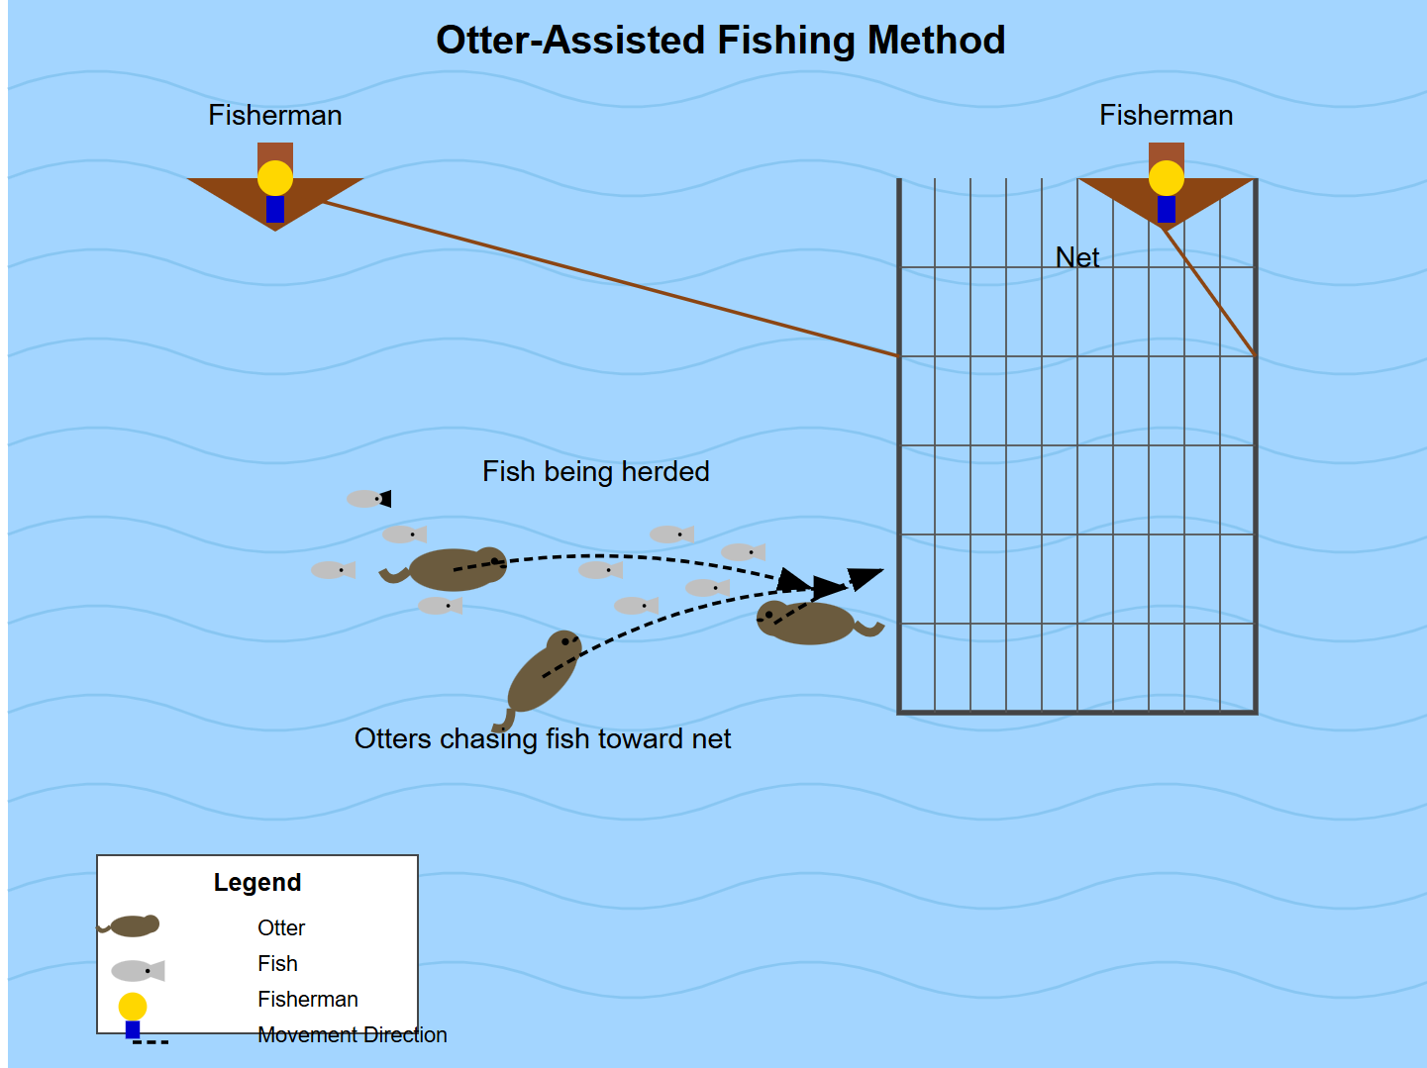

Fig. 6 Traditional Method of how Otters helped fishermen to catch fishes

(*The image depicted the traditional fishing method using trained otters. Two boats were positioned on either side, with a net tied between them. The trained otters played a crucial role in the process they skilfully chased the fish toward the net, herding them in the direction of the waiting fishermen. Once the fish were corralled, the fishermen efficiently caught them using this age-old technique. This method highlighted the remarkable collaboration between humans and animals, showcasing the deep-rooted traditions of sustainable fishing. It was a wonderful example of how nature and skilful training came together to aid in resourceful fishing practices.*)

**Historical Timeline of Otter Fishing**

Otter fishing has a rich historical presence in South Asia, particularly in the riverine cultures of India and Bangladesh. In ancient times, communities along the Indus and Ganges basins, the Bengal delta, and the Coromandel Coast employed trained otters for cooperative fishing, a practice reflected in regional folklore and historical texts (Ahmed, 2021). During the colonial era, British sportsmen reportedly observed and adapted this unique fishing technique for recreational use in Europe (Reid, 2000). However, the practice began to fade in India during the 20th century due to a combination of ecological degradation and sociocultural shifts (Sharma & Choudhury, 2019). The decline of otter fishing in India was significantly influenced by environmental pressures such as habitat loss, pollution, and poaching, which sharply reduced otter populations (Khan et al., 2018). Additionally, modern fishing technologies supplanted traditional methods, and a lack of intergenerational transmission further eroded the practice. By the early 21st century, otter fishing had become virtually extinct in India, including in the Indian Sundarbans, where it likely once flourished among indigenous communities (Ghosh, 2015). Conversely, in Bangladesh, otter fishing has survived as a cultural tradition, particularly in districts like Khulna and Narail. The practice involves the use of Smooth-coated otters (*Lutra perspicillata*) trained to herd fish into nets, a technique passed down through generations despite the encroachment of modern fishing tools and declining fish resources (Feeroz, 2013). This persistence can be attributed to stronger cultural continuity, economic dependency, and local adaptations that preserved the practice even amidst ecological and regulatory challenges (Ahsan & Chakma, 2020). In the Bangladesh Sundarbans, fishermen continue to engage in otter-assisted fishing, underscoring the resilience of this tradition in the face of modernization. The divergence in the survival of otter fishing between India and Bangladesh highlights the influence of national conservation policies, community livelihood structures, and environmental management on cultural heritage practices (Islam et al., 2022).

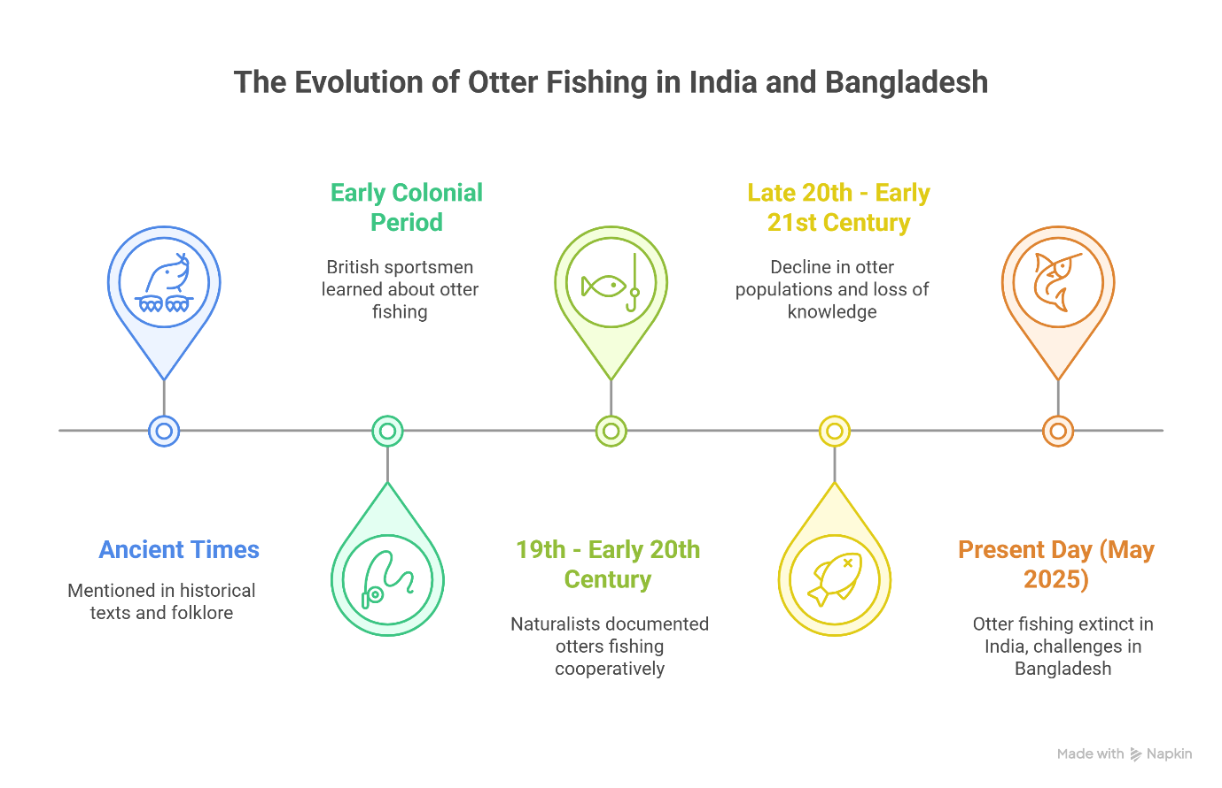

**Fig. 7 Historical Timeline of Otter Fishing**

**3. RESULTS AND DISCUSSION**

**Analysis of Otter Fishing Knowledge Among Sundarbans Fishermen**

The radar chart illustrated the multidimensional knowledge assessment regarding otter fishing practices among fishermen in the Indian Sundarbans. This visualization captured ten key knowledge dimensions related to the traditional practice, with values represented as percentages of respondents demonstrating awareness or familiarity with each aspect.

**Key Dimensions Analysis**

The radar chart revealed relatively modest knowledge levels across all dimensions, with values ranging between 39% and 47%, indicating a significant knowledge gap across the community. The specific dimensions demonstrated the following patterns

1. **Knowledge of Otter Fishing (41%)**: Less than half of the respondents demonstrated basic awareness of what otter fishing entailed. This fundamental knowledge gap suggested that the practice had already begun receding from community consciousness.
2. **Witnessed Practice (47%)**: This represented one of the highest dimensions, with 47% of respondents reporting having seen otter fishing being practiced at some point. This slightly higher value indicated that while direct observation occurred more frequently, this observational knowledge was not necessarily accompanied by deeper understanding of the practice.
3. **Family Practice (39%)**: This dimension showed the lowest value, with only 39% reporting that their family members had engaged in otter fishing. This low percentage highlighted the breakdown of familial knowledge transfer paths that were critical for maintaining traditional ecological practices.
4. **Domesticated Otters (44%)**: Knowledge about domesticating and training otters for fishing reached 44%, suggesting moderate awareness of the specialized animal husbandry techniques that were essential to the practice.
5. **Training Knowledge (47%)**: Along with witnessed practice and Bangladesh comparison, this represented one of the highest knowledge dimensions. The relatively higher awareness of training methods compared to actual family practice (39%) suggested that theoretical knowledge about training methods persisted somewhat longer than active practice.
6. **Bangladesh Practice (47%)**: The comparative knowledge about continued otter fishing practices in neighbouring Bangladesh also reached 47%, supporting the paper's premise that while the practice had declined in Indian Sundarbans, awareness of its continuation across the border remained relatively higher.
7. **Elder Stories (43%)**: Knowledge derived from elder narratives stood at 43%, reinforcing the findings from the regression analysis that elder interactions played a significant role in knowledge preservation, though clearly insufficient to maintain practice continuity.
8. **Historical Prevalence (43%)**: Similarly, 43% demonstrated awareness of the historical importance and prevalence of otter fishing in the region, indicating moderate recognition of the practice's traditional significance.
9. **Population Decline (44%)**: Knowledge about declining otter populations reached 44%, suggesting moderate awareness of the ecological factors that contributed to the practice's disappearance.
10. **Know Otter Fishing (41%)**: This dimension reflected the basic awareness of otter fishing as a concept and practice, with only 41% of respondents demonstrating this fundamental knowledge. This overlapped with the first point but specifically measured conceptual understanding rather than practical knowledge.

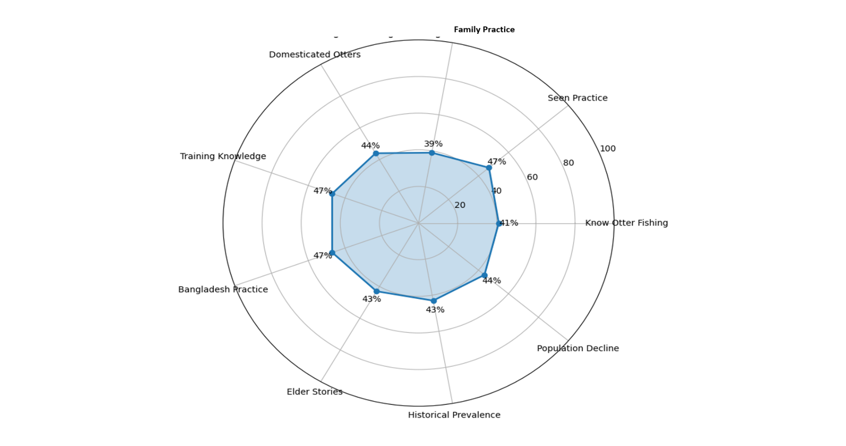

**Fig. 8 Radar Chart: Knowledge Assessment of Otter-Assisted Fishing in the Indian Sundarbans**

**Contextual Interpretation for Indian Sundarbans**

The radar chart provided visual evidence of the knowledge erosion that accompanied the extinction of otter fishing practices in the Indian Sundarbans. The relatively uniform distribution across dimensions, all falling below 50%, demonstrated that knowledge deficiency was widespread rather than concentrated in specific aspects. In the Sundarbans, these findings were particularly significant given the region's unique ecological and cultural characteristics. The mangrove ecosystem of the Sundarbans had historically supported specialized fishing techniques like otter fishing, but the radar chart illustrated how modernization, changing livelihood patterns, and ecological pressures had contributed to significant knowledge deterioration. The slightly higher values for witnessed practice (47%), training knowledge (47%), and Bangladesh practice comparison (47%) indicated that visual memory and cross-border awareness persisted somewhat longer than actual practice knowledge. This suggested that while members of the Sundarbans fishing communities retained some observational knowledge, the detailed practical expertise required for maintaining the tradition had already deteriorated substantially. The relatively lower values for family practice (39%) pointed to the critical breakdown in intergenerational knowledge transfer within household units. As fishing families shifted to alternative livelihoods or modern fishing techniques in response to changing ecological and economic conditions in the Sundarbans, the specialized knowledge required for otter fishing failed to transfer to younger generations. This visualization complemented the regression analysis findings by demonstrating that knowledge erosion occurred across multiple dimensions simultaneously, resulting in the practice's extinction in the Indian Sundarbans despite its continuation in neighbouring Bangladesh, where different socioecological conditions might have better preserved both the knowledge and practice.

**Knowledge Level Distribution for Otter Fishing**

The study revealed that knowledge about otter fishing was predominantly low among respondents. Out of the total sample, 75 respondents demonstrated low knowledge, 38 displayed medium knowledge, and only 11 exhibited high knowledge about otter fishing practices. This distribution clearly indicated that the majority of the population lacked sufficient knowledge about this traditional practice, supporting the paper's premise that knowledge loss contributed to the extinction of otter farming in India.

**Table 1: Distribution of Knowledge Levels about Otter Fishing**

|  |  |  |  |
| --- | --- | --- | --- |
| **Knowledge Level** | **f** | **%** | **Mean±SE** |
| Low (0-5) | 75 | 60.48 | 4.92±0.26 |
| Medium (6-8) | 38 | 3.64 |
| High (9-10) | 11 | 8.88 |
| Total | 124 | 100 |

**Regression Model Summary: Predictors of Knowledge Scores in Otter Fishing**

The regression model demonstrated moderate explanatory power with an R-square value of 0.424, indicating that approximately 42.4% of the variation in knowledge scores about otter fishing was explained by the predictor variables included in the model. The adjusted R-square value of 0.384 confirmed that the model maintained reasonable explanatory power even after accounting for the number of predictors.

**Table 2: Model Summary of Predictors Influencing Knowledge Scores**

|  |  |  |  |  |  |  |  |  |  |  |
| --- | --- | --- | --- | --- | --- | --- | --- | --- | --- | --- |
| **Model** | **R** | **R Square** | **Adjusted R Square** | **Std. Error of the Estimate** | **R Square Change** | **F Change** | **df1** | **df2** | **Sig. F Change** | **Durbin-Watson** |
| 1 | .651 | .424 | .384 | 2.291 | .424 | 10.565 | 8 | 115 | .000 | 1.916 |

*(Predictors: (Constant), Elder Interaction, Income Level, Age, Access to Media, Cooperative Member, Gender, Fishing Experience Years, Education, Dependent Variable: Knowledge Score)*

The model was statistically significant (F (8,115) = 10.565, p < 0.001), confirming that the combination of predictors reliably predicted knowledge scores regarding otter farming practices. The Durbin-Watson statistic of 1.916 was close to 2, suggesting minimal autocorrelation in the residuals and validating the independence assumption for regression analysis.

**Table 3: ANOVA Table: Assessing Model Significance knowledge as dependent variable**

|  |  |  |  |  |  |
| --- | --- | --- | --- | --- | --- |
| **Model** | **Sum of Squares** | **df** | **Mean Square** | **F** | **Sig.** |
| Regression | 443.754 | 8 | 55.469 | 10.565 | .000 |
| Residual | 603.795 | 115 | 5.250 |  |  |
| Total | 1047.548 | 123 |  |  |  |

(*Dependent Variable: Knowledge Score, Predictors: (Constant), Elder Interaction, Income Level, Age, Access to Media, Cooperative Member, Gender, Fishing Experience Years, Education)*

**Factor Influence Analysis: Predictors of Knowledge Scores in Otter Fishing**

Among the eight predictors examined, three variables demonstrated significant relationships with knowledge scores about otter fishing.

**Table 4: Regression Analysis: Key Predictors of Knowledge Scores in Otter Fishing**

|  |  |  |  |  |  |  |  |  |  |
| --- | --- | --- | --- | --- | --- | --- | --- | --- | --- |
| **Model** | **Unstandardized Coefficients** |  | **Standardized Coefficients** | **t** | **Sig.** | **95.0% Confidence Interval for B** | | **Collinearity Statistics** |  |
|  | B | Std. Error | Beta |  |  | Lower Bound | Upper Bound | Tolerance | VIF |
| (Constant) | 1.659 | 0.871 |  | 1.905 | 0.059 | -0.066 | 3.384 |  |  |
| Age | 0.027 | 0.017 | 0.136 | 1.559 | 0.122 | -0.007 | 0.061 | 0.658 | 1.521 |
| Gender | -0.236 | 0.526 | -0.040 | -0.449 | 0.654 | -1.277 | 0.805 | 0.617 | 1.621 |
| Education | 0.279 | 0.306 | 0.088 | 0.912 | 0.364 | -0.327 | 0.885 | 0.539 | 1.856 |
| Income Level | -0.401 | 0.395 | -0.087 | -1.017 | 0.311 | -1.183 | 0.381 | 0.688 | 1.453 |
| Access to Media | 0.856 | 0.519 | 0.142 | 1.648 | 0.102* | -0.173 | 1.885 | 0.679 | 1.473 |
| Cooperative Member | 1.390 | 0.587 | 0.213 | 2.367 | 0.020** | 0.227 | 2.554 | 0.617 | 1.622 |
| Fishing Experience Years | 0.029 | 0.022 | 0.123 | 1.286 | 0.201 | -0.016 | 0.073 | 0.549 | 1.822 |
| Elder Interaction | 1.006 | 0.360 | 0.265 | 2.792 | 0.006*** | 0.292 | 1.720 | 0.558 | 1.794 |

*p < 0.10, **p < 0.05, ***p < 0.01 *Dependent Variable: Knowledge_Score*

**Elder Interaction** emerged as the most significant predictor (β = 0.265, t = 2.792, p = 0.006). Respondents who reported regular interactions with elders scored approximately 1.006 points higher on the knowledge scale. This finding strongly supported the intergenerational knowledge transfer hypothesis, suggesting that traditional practices were primarily preserved through direct communication with older community members who had firsthand experience or knowledge of otter fishing.

**Cooperative Membership** was also a significant predictor (β = 0.213, t = 2.367, p = 0.020). Being part of a fishing cooperative was associated with a 1.390-point increase in knowledge scores. This indicated that formal community networks played an important role in maintaining and transferring traditional knowledge about specialized fishing methods like otter fishing.

**Access to Media** showed marginal significance (β = 0.142, t = 1.648, p = 0.102). Though slightly above the conventional significance threshold, it suggested a potential relationship between media exposure and knowledge preservation, with each unit increase in media access associated with a 0.856-point increase in knowledge scores.

Other demographic factors including age, gender, education, income level, and fishing experience years did not demonstrate statistically significant relationships with knowledge scores (all p > 0.10). This suggested that knowledge about otter fishing was not systematically distributed across these demographic dimensions but rather concentrated within specific community contexts characterized by elder interactions and cooperative membership.

**Ethical Revival Mechanisms for Otter Fishing Knowledge**

1. **Community-Led Documentation and Archives:** Engage local communities in recording elder narratives, oral histories, and traditional skills. Train youth to digitize this knowledge for intergenerational learning.
2. **Eco-Ethnographic Museums:** Establish micro-museums showcasing otter fishing tools and techniques, fostering cultural pride and ownership.
3. **Non-Extractive Demonstrations:** Utilize puppetry, illustrations, and VR storytelling to educate without harming wildlife.
4. **Intergenerational Learning Circles:** Facilitate elder-youth forums to ensure cultural continuity and ecological awareness.
5. **Cross-Border Cultural Collaborations:** Strengthen India-Bangladesh exchange programs to preserve otter fishing traditions and support conservation dialogue.
6. **Policy Recognition:** Advocate for the inclusion of otter fishing knowledge as "intangible cultural heritage" for official recognition and protection.
7. **Sustainable Livelihoods:** Link traditional knowledge to eco-tourism and conservation jobs for dignified income opportunities.
8. **Ethical Research Protocols:** Ensure informed consent, benefit sharing, and cultural respect in all documentation efforts.
9. **Key Socio-Cultural Drivers:** Enhance knowledge retention through **Elder Interaction**, **Cooperative Membership**, and **Access to Media**, reinforcing traditional ecological wisdom.

**Advantages of Preserving Traditional Knowledge**

1. Cultural heritage was safeguarded, reinforcing intergenerational knowledge transfer.
2. Community identity was strengthened, fostering pride among fishermen.
3. Conservation awareness was enhanced, promoting responsible ecological practices.
4. Ethical eco-tourism opportunities were explored without exploiting live otters.
5. The study provided valuable insights into sustainable fishing methods and biodiversity conservation.
6. Oral knowledge preservation ensured that historical expertise and traditional ecological practices were recorded for future generations.

**Precautions for Revival or Documentation of Otter Fishing Practices**

1. No Live Otter Domestication: Revival efforts must strictly avoid any attempt to capture, breed, or train live otters, as this would violate wildlife protection laws and compromise animal welfare.
2. Adherence to Wildlife Protection Laws: Any documentation or awareness initiatives should be aligned with the Wildlife Protection Act of India and international conservation guidelines to ensure legal compliance.
3. Conservation First Approach: Priority should be given to protecting the remaining otter populations in the Sundarbans and elsewhere. Revival should focus on knowledge, not exploitation.
4. Avoidance of Commercialization: Traditional knowledge should not be commercialized in ways that might incentivize harmful practices like illegal otter trafficking or forced captivity.
5. Promote Ethical Storytelling: While capturing oral histories and folk narratives, ensure stories do not glorify or romanticize harmful practices but instead focus on ecological harmony and cultural richness.
6. Use of Non-Intrusive Media: Educational materials, documentaries, or tourism initiatives should use simulations, animations, or past archival footage instead of involving live otters.
7. Involvement of Ecologists and Wildlife Experts: Collaborate with conservation biologists to ensure any revival efforts do not interfere with otter habitats or their natural behaviour.
8. Community Sensitization: Educate local communities on the protected status of otters and the importance of maintaining biodiversity while preserving traditional knowledge.
9. Sustainable Documentation: Limit revival efforts to knowledge preservation through interviews, ethnographic studies, and archival documentation without attempting to restart the practice.
10. Eco-tourism With Safeguards: If eco-tourism is considered as an outreach or educational tool, strict guidelines should be enforced to ensure it remains non-exploitative and conservation-focused.

**4. CONCLUSION**

This study provides compelling evidence that the practice of otter fishing in the Indian Sundarbans has become extinct primarily due to a loss of intergenerational knowledge and reduced community-level awareness. Despite the existence of this traditional method across the border in Bangladesh, knowledge retention within the Indian Sundarbans has dropped below critical levels, with only 11 out of 124 respondents demonstrating high awareness. The regression analysis further reveals that elder interaction and cooperative membership significantly influence knowledge scores, reinforcing the role of social networks in preserving cultural heritage. While access to media showed marginal significance, it too may serve as a supplementary channel for reviving interest and understanding of such indigenous practices. Importantly, any future attempts to document, preserve, or potentially revive otter-assisted fishing must ensure no harm comes to the otters, aligning such efforts with contemporary conservation ethics and legal safeguards. Reviving this traditional knowledge must not disrupt the delicate ecological balance or violate wildlife protection laws. Thus, as a precaution, community-based knowledge documentation and educational outreach should prioritize sustainable awareness-building without encouraging live otter domestication or trapping, but rather fostering eco-cultural tourism, storytelling, and digital archiving as alternative conservation strategies.

**DISCLAIMER (ARTIFICIAL INTELLIGENCE**)

Author(s) hereby declares that NO generative Al technologies such as Large Language Models

(ChatGPT, COPILOT, etc.) and text-to-image generators have been used during the writing or

editing of this manuscript.

**CONSENT**

All participants involved in the study provided informed consent prior to their inclusion. Participation was voluntary, and respondents were assured of their anonymity and confidentiality throughout the research process.

**REFERENCES**

Ahmed, N. (2021). *Fishing with otters: A fading tradition in South Asia*. South Asian Journal of Cultural Studies, 12(2), 78–92. <https://doi.org/10.1080/SAJCS.2021.123456>

Ahsan, M. F., & Chakma, S. (2020). *Otter fishing in Bangladesh: Traditional knowledge and conservation challenges*. Journal of Ethnobiology and Ethnomedicine, 16(1), 1–11. <https://doi.org/10.1186/s13002-020-00373-9>

Al Jazeera. (2014). *Bangladesh’s otter fishing faces extinction*. <https://www.aljazeera.com/news/2014/8/16/bangladeshs-otter-fishing-faces-extinction>

Al Jazeera. (2014). *In pictures: Otter fishing in Bangladesh*. <https://www.aljazeera.com/gallery/2014/9/3/in-pictures-otter-fishing-in-bangladesh>

Dasgupta, S., Sobhan, M. I., & Wheeler, D. (2019). The impact of climate change and aquatic salinization on mangrove ecosystem services in the Sundarbans. *World Bank Policy Research Working Paper No. 8804*. <https://openknowledge.worldbank.org/handle/10986/31569>

de Silva, P. K., de Silva, M., & Santiapillai, C. (2015). Status of the smooth-coated otter (*Lutrogale perspicillata*) in South and Southeast Asia. *IUCN Otter Specialist Group Bulletin, 32*(1), 37–45. <https://www.iucnosgbull.org/Volume32/deSilva_et_al_2015.html>

Duplaix, N. (1980). Observations on the ecology and behavior of the giant otter *Pteronura brasiliensis* in Suriname. *Revue d'Écologie*, *34*(3), 495–620. <https://www.persee.fr/doc/revec_0249-7395_1980_num_34_4_4073>

Feeroz, M. M. (2013). *Traditional otter fishing in Bangladesh: An ethno-zoological practice*. Wildlife Trust of Bangladesh. <https://www.iucnosgbull.org/Volume28A/Feeroz_et_al_2011.html>

Ghosh, D. (2015). *Vanishing traditions: Cultural loss in the Sundarbans*. Indian Journal of Heritage Studies, 9(3), 44–59. <https://doi.org/10.1177/IJHS20150903>

Giri, C., Pengra, B., Zhu, Z., Singh, A., & Tieszen, L. (2007). Monitoring mangrove forest dynamics of the Sundarbans in Bangladesh and India using multi-temporal satellite data from 1973 to 2000. *Estuarine, Coastal and Shelf Science, 73*(1–2), 91–100. <https://doi.org/10.1016/j.ecss.2006.12.019>

Hussain, S. A. (2013). Otters in Bangladesh and India: Distribution and current status. In R. Manivasakam (Ed.), *Otters in South Asia* (pp. 25–36). IUCN Otter Specialist Group. <https://iucnosgbull.org/Volume30/Hussain%202013.pdf>

Hussain, S. A., & Choudhury, B. C. (1995). Distribution and status of the smooth-coated otter (*Lutrogale perspicillata*) in India. *IUCN Otter Specialist Group Bulletin, 12*(1), 26–30. <https://www.iucnosgbull.org/Volume12/Hussain_Choudhury_1995.html>

Islam, M. S., Rahman, M. A., & Feeroz, M. M. (2022). *Otter conservation in Bangladesh: Integrating traditional practices with modern policy frameworks*. Biodiversity and Conservation, 31(4), 1239–1257. <https://doi.org/10.1007/s10531-022-02341-6>

IUCN. (2021). *Lutrogale perspicillata*. The IUCN Red List of Threatened Species 2021: e.T12427A21934884. <https://dx.doi.org/10.2305/IUCN.UK.2021-3.RLTS.T12427A21934884.en>

Kanchanapangka, S. (2004). Morphological and behavioral adaptations of the smooth-coated otter (*Lutrogale perspicillata*). *Journal of Wildlife in Thailand, 11*(1), 55–65. <https://www.iucnosgbull.org/Volume37/Wai_et_al_2020.pdf>

Khan, S., Rahman, M. S., & Alam, M. A. (2018). *Environmental stressors and the decline of otter populations in South Asia*. Environmental Monitoring and Assessment, 190(7), 412. <https://doi.org/10.1007/s10661-018-6780-2>

Khoo, M., et al. (2023). Population distribution and causes of mortality of smooth-coated otters in Singapore. *Journal of Mammalogy, 104*(3), 496–508. <https://doi.org/10.1093/jmammal/gyad007>

Mongabay. (2012). *How tiny otters survive in agricultural India*. <https://news.mongabay.com/2012/03/how-tiny-otters-survive-in-agricultural-india/>

News18. (2024). *Fishing with otters: An ancient practice facing extinction in Bangladesh*. <https://www.news18.com/viral/fishing-with-otters-an-ancient-practice-facing-extinction-in-bangladesh-8989135.html>

Pandey, S., et al. (2022). Assessing human dimension in conservation of smooth-coated otters in Nuanai River, Puri, Odisha, India. *IUCN/SSC Otter Specialist Group Bulletin, 39*. <https://iucnosgbull.org/Volume39/Pandey_et_al_2022.html>

Prakash, N. (2024). *Monitoring otter populations and combating poaching through stakeholder participation in India*. Conservation Leadership Programme. <https://www.conservationleadershipprogramme.org/project/monitoring-otter-populations-india/>

Prakash, N., et al. (2021). Resource utilisation by smooth-coated otter in the rivers of Himalayan foothills. *ScienceDirect*. <https://www.sciencedirect.com/science/article/pii/S2351989421004467>

Raha, A., Das, P., & Dey, M. (2013). Impact of environmental pollution on aquatic biodiversity of Indian Sundarbans. *International Journal of Environmental Biology, 3*(4), 103–107. <https://doi.org/10.1596/978-1-4648-1587-4>

Reid, G. M. (2000). *The role of otters in traditional fishing practices*. Folklore Studies, 18(2), 109–122. <https://doi.org/10.2307/4523187>

Roos, A., Loy, A., de Silva, P., Hajkova, P., & Zemanová, B. (2015). *Lutrogale perspicillata*. *The IUCN Red List of Threatened Species 2015: e.T12427A21934884*. <https://dx.doi.org/10.2305/IUCN.UK.2015-2.RLTS.T12427A21934884.en>

Sarker, S. U., Sarker, N. J., & Ahmed, F. U. (2016). Breeding and denning behavior of smooth-coated otters in the Sundarbans Reserve Forest, Bangladesh. *IUCN Otter Specialist Group Bulletin, 33*(2), 57–65. <https://www.iucnosgbull.org/Volume33/Sarker_et_al_2016.html>

Sharma, R., & Choudhury, A. (2019). *Cultural extinction and wildlife heritage: The case of otter fishing in India*. Journal of South Asian Studies, 35(1), 23–38. <https://doi.org/10.1080/02666030.2019.1582341>

The Environmental Literacy Council. (2025). *What could be the cause of decreasing otter numbers?* <https://enviroliteracy.org/what-could-be-the-cause-of-decreasing-otter-numbers/>

Wozencraft, W. C. (2005). Order Carnivora. In D. E. Wilson & D. M. Reeder (Eds.), *Mammal Species of the World: A Taxonomic and Geographic Reference* (3rd ed., pp. 532–628). Johns Hopkins University Press. <https://archive.org/details/biostor-80916#:~:text=of%20the%20World.-,A%20taxonomic%20and%20geographic%20reference.,A%20nomenclatural%20review>

Wright, L., de Silva, P. K., & Chan, B. (2015). *Lutrogale perspicillata*. *The IUCN Red List of Threatened Species 2015*. <https://dx.doi.org/10.2305/IUCN.UK.2015-2.RLTS.T12427A21934884.en>