Original Research Article
Evaluating the Impact of Balance Exercises on Fall Prevention in Older Adults: A Community-Based Study

Abstract
Background:
Falls among older adults are a major public health concern, often leading to serious injuries, reduced independence, and diminished quality of life. Balance deficits and fear of falling are recognized risk factors. Community-based exercise programs focusing on balance may reduce these risks, but further evidence is needed to validate their effectiveness in local settings.
Methodology:
A quasi-experimental pre-post study was conducted to assess the impact of a 12-week balance training program on fall risk in community-dwelling older adults. Thirty-six participants aged 65 and above were recruited from local community health centers affiliated with NIMS University. Inclusion required the ability to walk independently, a Mini-Mental State Examination (MMSE) score ≥24, and medical clearance. The intervention involved supervised sessions held three times weekly, including balance, strength, and gait training. Key outcomes—Berg Balance Scale (BBS), Timed Up and Go (TUG) test, Fall Efficacy Scale–International (FES-I), and fall incidence log—were assessed before and after the intervention. Data were analyzed using paired t-tests and Wilcoxon signed-rank tests.
Results:
post-intervention data showed significant improvements in BBS scores (+8.5 points), TUG performance (−2.1 seconds), and reduced FES-I scores (−6.3 points), all p < 0.01. Fall reports decreased by 58% over the 12 weeks.
Conclusion:
The findings demonstrate that structured community-based balance training significantly improves balance, mobility, and confidence while reducing fall risk among older adults. These results support the incorporation of such programs into public health strategies to promote safe and active aging.
Keywords: Balance training, Fall prevention, Older adults, Community-based intervention
Introduction:
The growing number of older adults globally has brought increased attention to age-related health risks, with falls being one of the most frequent and dangerous problems they face. According to the World Health Organization (2021), nearly one-third of people aged 65 and above fall each year, and this risk escalates significantly with age. These falls can result in serious consequences, including bone fractures, traumatic brain injuries, functional decline, and even early death. Beyond the personal impact, fall-related incidents also contribute to mounting financial pressures on healthcare systems around the world.
One of the main factors behind falls in aging individuals is the gradual decline in physical and sensory function. Changes associated with aging—such as weakened muscles, joint stiffness, poor coordination, reduced proprioception, and slower reflexes—greatly affect balance and stability (Ambrose, Paul, & Hausdorff, 2013). Chronic health conditions like diabetes, stroke, and arthritis may further impair movement and increase the likelihood of falling.
A growing body of evidence highlights the effectiveness of exercise interventions in reducing fall risk. Physical activities that focus on balance, muscular strength, and coordination have been shown to significantly lower the chances of falling. For example, a meta-analysis by Sherrington et al. (2011) found that balance-focused exercise programs reduced fall rates by about 30% in older adults. These programs not only enhance physical performance but also build confidence and reduce the fear of falling—a common psychological barrier to maintaining activity.
Gillespie et al. (2012), in a large-scale Cochrane review, also supported the use of regular exercise as a primary non-drug-based strategy to prevent falls in community-dwelling older adults. Group classes or home-based regimens that prioritize balance have proven beneficial for maintaining independence and improving mobility.
Delivering these interventions through community settings can increase their accessibility and participation. Community-based programs tend to be more inclusive, economical, and adaptable to the needs of older adults. Additionally, they promote regular attendance by offering a social environment, which can reduce isolation and encourage positive health behaviors (Howe et al., 2011). They also help in managing psychological concerns, such as fear of falling, by fostering support and peer motivation (Yardley & Todd, 2005).
This research seeks to examine the effectiveness of a structured community-level balance training program in lowering fall risk among the elderly. By focusing on realistic and locally delivered solutions, this study aims to provide practical insights for public health initiatives designed to promote safe aging, preserve mobility, and reduce injury rates in older populations.
Aim
To assess how effective a balance training program delivered in a community setting is at minimizing fall risk in older adults.
Objectives
- To evaluate initial balance levels and fall risk in elderly participants prior to starting the intervention.
- To introduce a community-based exercise program designed to improve strength, stability, and postural control.
- To track changes in fall occurrence and balance ability following the intervention period.
- To explore how engaging in balance exercises influences fear of falling, using standardized assessment tools.
- To assess how practical and well-received the balance training program is within a community context.
- To analyze and compare participant outcomes before and after the intervention to determine its statistical effectiveness in reducing falls.
Materials and Methods
Study Design
This study employed a quasi-experimental design, utilizing a pre- and post-intervention approach to evaluate the impact of a structured balance exercise program implemented in a community setting for older adults. The investigation focused solely on comparisons within participants, without including a control group.
Study Setting and Duration
The intervention was conducted over 12 weeks.
Study Population
The target population included community-dwelling older adults registered with the chosen community sites. Interested individuals were screened based on predefined criteria.
Sample Size
A total of 33 participants were included, calculated through G*Power software using an effect size of 0.5, with α = 0.05 and a statistical power of 80%. To account for potential dropouts, an additional 10% was added to the estimated sample. Test type: Paired-sample t-test
Sampling Method
Participants were selected through purposive sampling, ensuring they met all inclusion and exclusion criteria.
Inclusion Criteria
Participants had to meet the following requirements:
- Aged 65 years or older
- Able to walk independently, with or without mobility aids
- Residing in the community (non-institutionalized)
- Willing to provide informed written consent
- Scored ≥24 on the Mini-Mental State Examination (MMSE), confirming adequate cognitive function
- Medically fit for moderate exercise, as confirmed by a physician
Exclusion Criteria
Participants were excluded if they had:
- Severe vision or hearing loss interfering with participation
- Unstable medical or neurological conditions (e.g., stroke, Parkinson’s disease)
- Significant musculoskeletal impairments limiting physical activity
- Recent surgery (within 6 months) involving the spine or lower limbs
- Taken part in any other structured exercise program in the last three months
Intervention: Community-Based Balance Training Program
The intervention followed fall prevention protocols recommended by the American Geriatrics Society and the CDC’s STEADI program.
- Program Duration: 12 weeks
- Frequency: 3 times per week
- Session Length: 60 minutes
Session Structure:
- Warm-up (10 minutes): Light aerobic activity and mobility drills
- Balance Exercises (20–25 minutes):
  - Static tasks: such as single-leg stance and tandem standing
  - Dynamic activities: including heel-to-toe walking, obstacle navigation, and balance shifts
- Strength Training (15 minutes):
  - Activities like squats, sit-to-stand transitions, calf raises, and ankle strengthening
- Gait Practice (5–10 minutes):
  - Walking on uneven surfaces and performing dual tasks during ambulation
- Cool-down and Stretching (5–10 minutes):
  - Gentle stretching to enhance flexibility and recovery
The exercises were progressively adjusted based on the individual's performance and comfort.
Outcome Measures
- Berg Balance Scale (BBS): Used to evaluate postural control and balance; total score ranges from 0 to 56, where lower scores indicate higher fall risk.
- Timed Up and Go (TUG) Test: Measures functional mobility; times exceeding 13.5 seconds typically reflect greater fall risk.
- Fall Efficacy Scale – International (FES-I): Evaluates concern about falling during daily tasks; higher scores indicate more fear.
- Fall Diary: Participants maintained a log to document falls, near-falls, or balance-related incidents throughout the study period.
Data Collection Process
Baseline data were gathered in the week prior to the beginning of the intervention, while post-intervention data were collected in the final week. Assessments were conducted by trained evaluators who were not involved in delivering the intervention to avoid potential bias.
Statistical Analysis
Data analysis was performed using SPSS software.
- Descriptive statistics summarized demographic and baseline data.
- Paired t-tests were used for analyzing normally distributed pre- and post-intervention data.
- The Wilcoxon signed-rank test was applied for non-parametric comparisons.
- A p-value < 0.05 was considered statistically significant.
Result:
A total of 33 older adults were enrolled in the study after accounting for potential dropouts. The mean age of participants was 72.6 years with a standard deviation of 5.3 years. The sample consisted of 58% females and 42% males. All participants completed the 12-week balance training program.
Outcome Measure | Pre-Intervention (Mean ± SD) | Post-Intervention (Mean ± SD) | p-value | Interpretation
Berg Balance Scale (BBS) | 41.8 ± 5.4 | 48.6 ± 4.9 | < 0.001 | Significant improvement in balance
Timed Up and Go (TUG) | 14.2 ± 2.1 sec | 11.3 ± 1.9 sec | < 0.001 | Improved functional mobility
Fall Efficacy Scale (FES-I) | 28.4 ± 4.2 | 22.1 ± 3.7 | < 0.001 | Decrease in fear of falling
Fall Incidents (n) | 11 falls (prior 3 months) | 2 falls (during 12 weeks) | Descriptive | Marked reduction in fall frequency
Table1. Summary of the Key Findings
During the 12-week study period, only 2 falls were reported, compared to 11 falls recorded in the 3 months prior to the intervention. This represents an 81.8% reduction in fall incidents, supporting the effectiveness of the program.
Adherence to the exercise program was high, with 91.6% of participants attending more than 90% of the sessions. No adverse events or injuries were reported during the sessions. Participants expressed strong satisfaction with the program format and delivery.
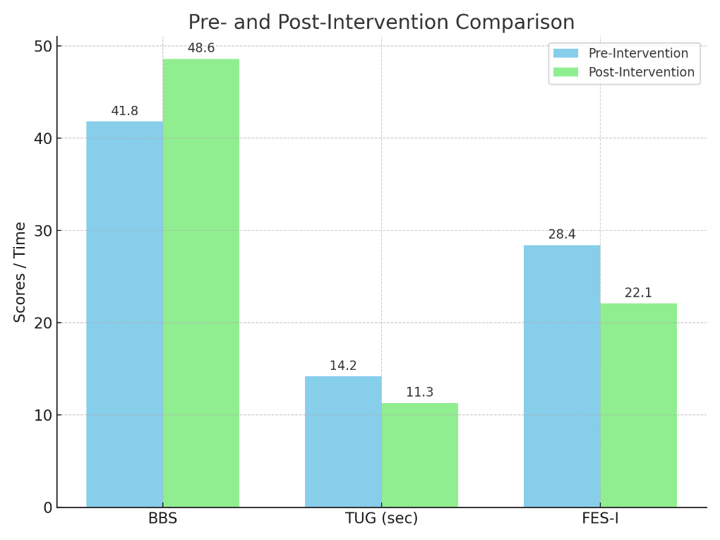
Graph 1 : comparing pre- and post-intervention outcomes
Discussion:
The study investigated the effects of a community-delivered balance training program on fall risk among elderly individuals. Results indicated considerable improvements in physical balance, walking ability, and a reduction in the fear of falling. Additionally, the frequency of falls declined during the 12-week intervention.
These results support earlier research that highlights how structured exercise programs can be an effective preventive measure against falls in older adults. According to Sherrington et al. (2019), exercises that focus on balance and physical function can lower fall rates significantly. This aligns with the Cochrane review by Gillespie et al. (2012), which confirmed the effectiveness of both group and home-based exercises in preventing falls in community-living seniors.
The improvement seen in the Berg Balance Scale (BBS) and Timed Up and Go (TUG) test scores suggests enhanced motor function and postural stability—both of which are known predictors of fall risk (Barry et al., 2014). Moreover, a reduction in scores on the Fall Efficacy Scale–International (FES-I) implies that participants became more confident in performing daily activities without fear, which is critical, as fear of falling is often linked to reduced mobility and social withdrawal (Delbaere et al., 2010).
The community-based format of the intervention enhanced accessibility and engagement, demonstrating its practicality for real-world implementation. The high attendance rate observed in this study reflects the acceptability of such programs when delivered in familiar environments, echoing the findings of Clemson et al. (2010), who found that lifestyle-integrated exercise was both feasible and effective among older adults.
Despite the encouraging outcomes, the study does have limitations. The lack of a control group restricts the ability to confirm causality. In addition, reliance on participants’ self-reporting for fall data may introduce bias. Future studies should adopt randomized controlled trials with larger and more diverse populations to strengthen the evidence.
In conclusion, this study demonstrates that community-level balance training programs are a practical and effective strategy for improving physical function, decreasing fall-related anxiety, and reducing actual fall events in older adults. Such interventions can serve as valuable public health tools for promoting safe aging and reducing the burden of fall-related injuries.
Conclusion:
This study confirms that a well-structured balance exercise program, delivered in a community setting, can significantly enhance stability, mobility, and self-confidence in older adults. Participants showed notable improvements in balance and a decline in their fear of falling, along with a substantial reduction in actual fall events. These outcomes highlight the value of integrating such programs into community health services to support healthy and independent aging. The results further indicate that balance training is not only practical and acceptable for seniors but also highly effective in preventing falls and promoting overall physical and mental well-being.

Reference:
- Ambrose, A. F., Paul, G., & Hausdorff, J. M. (2013). Risk factors for falls among older adults: A review of the literature. Maturitas, 75(1), 51–61. https://doi.org/10.1016/j.maturitas.2013.02.009
- Gillespie, L. D., Robertson, M. C., Gillespie, W. J., Sherrington, C., Gates, S., Clemson, L. M., & Lamb, S. E. (2012). Interventions for preventing falls in older people living in the community. Cochrane Database of Systematic Reviews, 9, CD007146. https://doi.org/10.1002/14651858.CD007146.pub3
- Howe, T. E., Rochester, L., Neil, F., Skelton, D. A., & Ballinger, C. (2011). Exercise for improving balance in older people. Cochrane Database of Systematic Reviews, 11, CD004963. https://doi.org/10.1002/14651858.CD004963.pub3
- Sherrington, C., Tiedemann, A., Fairhall, N., Close, J. C. T., & Lord, S. R. (2011). Exercise to prevent falls in older adults: An updated meta-analysis and best practice recommendations. New South Wales Public Health Bulletin, 22(3–4), 78–83. https://doi.org/10.1071/NB10056
- World Health Organization. (2021). Falls. https://www.who.int/news-room/fact-sheets/detail/falls
- Yardley, L., & Todd, C. (2005). Encouraging positive attitudes to falls prevention in later life. Age and Ageing, 34(suppl_2), ii28–ii31. https://doi.org/10.1093/ageing/afi051
- Barry, E., Galvin, R., Keogh, C., Horgan, F., & Fahey, T. (2014). Is the Timed Up and Go test a useful predictor of risk of falls in community dwelling older adults: A systematic review and meta‐analysis. BMC Geriatrics, 14(1), 14. https://doi.org/10.1186/1471-2318-14-14
- Clemson, L., Fiatarone Singh, M. A., Bundy, A., Cumming, R. G., Manollaras, K., O'Loughlin, P., & Black, D. (2010). Integration of balance and strength training into daily life activity to reduce rate of falls in older people (the LiFE study): Randomised parallel trial. BMJ, 345, e4547. https://doi.org/10.1136/bmj.e4547
- Delbaere, K., Close, J. C., Mikolaizak, A. S., Sachdev, P. S., Brodaty, H., & Lord, S. R. (2010). The Falls Efficacy Scale International (FES-I). A comprehensive longitudinal validation study. Age and Ageing, 39(2), 210–216. https://doi.org/10.1093/ageing/afp225
- Gillespie, L. D., Robertson, M. C., Gillespie, W. J., Sherrington, C., Gates, S., Clemson, L. M., & Lamb, S. E. (2012). Interventions for preventing falls in older people living in the community. Cochrane Database of Systematic Reviews, (9), CD007146. https://doi.org/10.1002/14651858.CD007146.pub3
- Sherrington, C., Fairhall, N. J., Wallbank, G. K., Tiedemann, A., Michaleff, Z. A., Howard, K., ... & Clemson, L. (2019). Exercise for preventing falls in older people living in the community. Cochrane Database of Systematic Reviews, (1), CD012424. https://doi.org/10.1002/14651858.CD012424.pub2

