Short Research Article
Indigenous Adaptive Techniques for Effective Ericulture in Kokrajhar District, BTR, Assam, India.

Abstract
The success of ericulture, a vital sericulture practice in North-East India, hinges on precise rearing techniques and strategic management. The current study in Kokrajhar district, Assam, reveals that while ericulture is a dominant practice among local farmers (64.06%), they face significant challenges, including scarcity of food plants, diseases, pest infestations, and climate fluctuations. Despite the traditional reliance on Ricinus communis (Castor) as a primary food plant, this research identifies potential new host plants, such as Ailanthus excels (14.40%), Ficus racemosa (44.92%), and Oroxylum indicum (23.12%), which could enhance sustainability and resilience in ericulture. However, modern biocontrol methods, including bio-fumigation and bio-disinfection, are adopted as measures for different challenges like microbial and pest infestation. These innovations are tactically adopted and are still limited, underscoring the need for increased awareness and training among seri rearers. By highlighting these challenges and opportunities, our study provides valuable insights for policymakers, researchers, and farmers seeking to improve productivity, quality, and sustainability in ericulture, ultimately contributing to the growth and development of the sericulture industry.
Key words: Phagostimulants, malnutrition, microbial infestation, physiology.
- Introduction
The Eri silkworm (Samia ricini), a member of the Saturniidae family, is one of India's most commercially exploited and domesticated non-mulberry silkworm varieties. North-East India predominantly contributes to India's eri silk industry, accounting for approximately 90% of the total eri silk production (Baishya et al., 2019). Among the northeastern states, Assam stands out as the prime producing state. Eri silkworms are multivoltine and polyphagous, feeding on various food plants. Ricinus communis and Heteropanax fragrans are considered primary food plants, while other alternative hosts include Ailanthus grandis, Ailanthus excelsa, Manihot esculenta, Plumeria acutifolia, Gmelina arborea, Evodia flaxinifolia, Carica papaya, and Jatropa curcas (Kumar and Elangovan, 2010; Gogoi et al., 2024; Hussain and Rasid, 2024). The quality and quantity of food plants significantly impact the growth and development of eri silkworms, ultimately influencing cocoon yield and silk quality. However, the silkworm industry faces numerous challenges, including diseases caused by protozoans, bacteria, viruses, and fungi. Temperature, humidity, ventilation, and unhygienic conditions can also adversely affect silkworm physiology, leading to disease susceptibility and mortality (Gupta and Dubey, 2005; Kumar et al., 2021). In Assam, various diseases such as Pebrine, Flacherie, Grasserie, and Muscardine affect eri silkworms, resulting in significant annual losses (approximately 60-70% of the crop). Moreover, unhealthy and diseased leaves, as well as insect pests and microbes, can impact silkworm growth, cocoon yield, and silk quality. To tackle these challenges, it is crucial to develop effective disease management strategies and explore innovative rearing techniques. This study, thus, aims to investigate various challenges and techniques associated with ericulture and focusing on new adaptations that can ease the process of rearing, ensure safe ericulture, and increase production rates.
- Methodology
The list of Seri villages was obtained from the Directorate of Sericulture in Kokrajhar. A total of 40 villages in the Kokrajhar district of Assam were selected, located near three protected areas: Chakrashila Wildlife Sanctuary, Raimona National Park, and Sikhna Jhwhlao National Park (Fig. 1). All these families were interviewed using a scheduled survey method, and the records were documented.
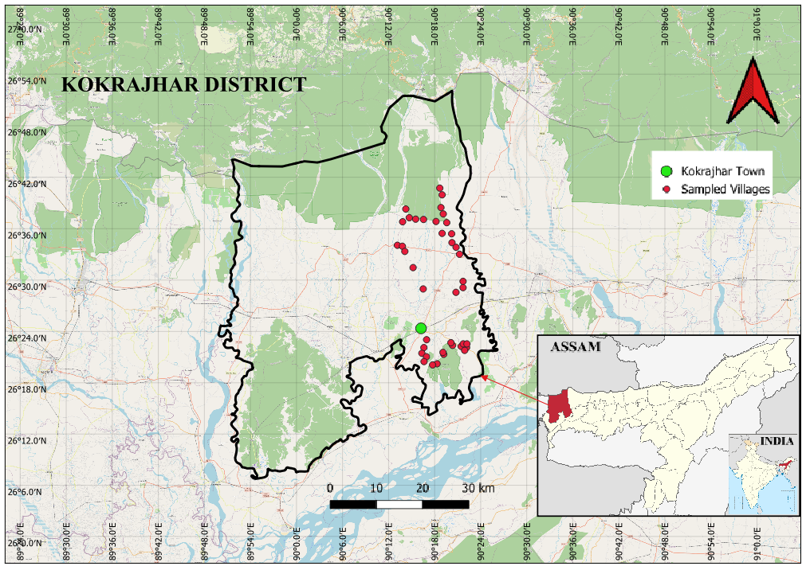
Fig. 1: Map of Kokrajhar District showing the locations of the sampled villages
- Results and Discussion
The selected fourth villages were under the Nayekgaon, Beswargaon, Beswargaon West, and Rainadabri circles of the Titaguri Development Block. Out of 3,230 families in these villages, 2,444 were involved in sericulture. Specifically, 2,069 families were exclusively engaged in eri culture, while 375 families participated in eri and muga culture. The sericulture industry plays a pivotal role in the rural economy of many countries, providing millions of people with employment and income opportunities. For the people of North-East India, both eri and mugaculture are integral parts of their cultural heritage, involving small and large-scale rearers. However, the industry faces numerous challenges, including pest and microbial infestations, scarcity of food plants, malnutrition, and poor management practices, which discourage rearers and lead to the discontinuation of rearing. To overcome these issues, many rearers have adopted innovative techniques to ease the rearing process and contribute to quality production. This study investigated these creative techniques and the current scenario and challenges that sericulture farmers face in the sampled villages within Kokrajhar district, Assam. The findings revealed that 64.06% of respondents practiced Ericulture, while 11.60% practiced both Eri and Muga culture (Fig. 2). This indicated the popularity of ericulture over mugaculture within the sampled villages. Earlier studies within Kokrajhar district also reported a higher percentage of households involved in eri culture (94%) compared to mugaculture (4%) (Brahma, 2015). Similarly, Brahma et al. (2019) found that eri culture was the primary sericulture practice (94%) among the sampled population, while mugaculture was practiced by only 14% of the respondents. The prevalence of ericulture in these villages can be attributed to the traditional cultural heritage of the Bodo community and their daily household activities (Teotia and Bajpeyi, 2009; Boro, 2016). The sampled villages, predominantly inhabited by tribal communities such as Bodo, Rabha, and Garo, practiced eri culture not only as a means of livelihood but also as an integral part of their daily lives. To achieve quality production and enhanced silk yield, these communities employed various rearing methods, showcasing their resourcefulness and dedication to this traditional practice.

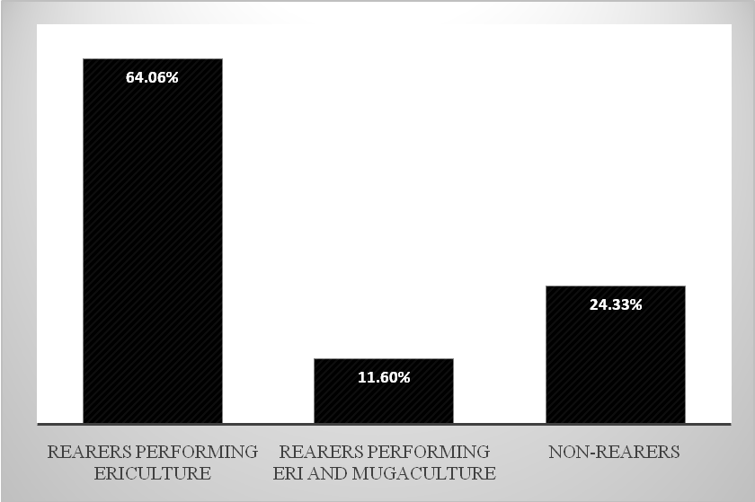
Fig. 2: Percentage of families involved in sericulture
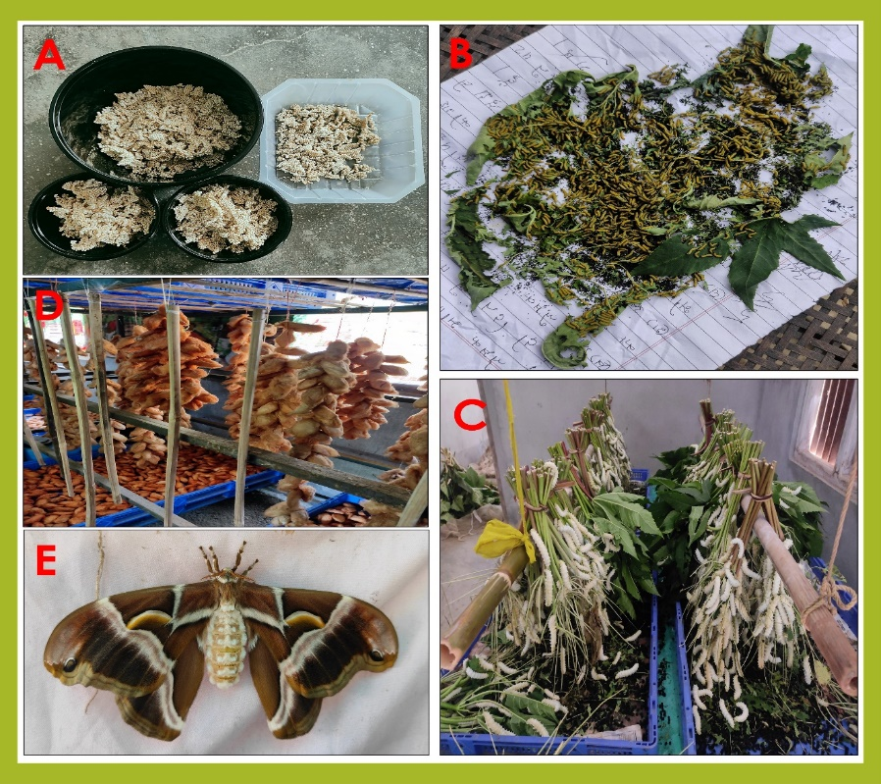
Fig. 3: Rearing of S. ricini on primary host plant R. communis
The success of the ericulture is intricately linked to the nutritional uptake and dietary requirements of the silkworms. As a polyphagous species, eri silkworms can be fed various food plants, but rearing parameters are significantly enhanced when they are reared on R. communis (castor). Castor promotes luxuriant growth in eri silkworms, and in this study, 64.06% of rearers used R. communis for ericulture (Fig. 4). Notably, all rearers preferred R. communis due to its gustatory stimulants and nutritional content, which attract silkworms to feed on its leaves. The juiciness, nutritional value, and moisture retention capacity make Castor leaves an ideal food source for S. ricini (Mahesh et al., 2022). The suitability of castor leaves for eri silkworm growth and development was well-documented, with many researchers highlighting its role in better grainage performances (Singh and Das, 2006; Narayanamma et al., 2013; Sarker et al., 2015; Deuriet al., 2017; Borah et al., 2020; Mahesh et al., 2022; Tulu et al., 2022). Apart from R. communis, other food plants were also used by rearers in the sampled villages, including Heteropanax fragrans (63.47%), Manihot esculenta (64.06%), Gmelina arborea (49.53%), and Ailanthus grandis (43.34%) (Fig. 4). The effectiveness of these plants as alternatives had been documented in previous studies (Chutia et al., 2014; Sarkar et al., 2015; Kumari and Sharma, 2017; Deuri et al., 2017; Mossie et al., 2023; Borah et al., 2020; Gogoi et al., 2024). Interestingly, this study also revealed the use of new host plants, such as Ailanthus excelsa, Ficus racemosa, Oroxylum indicum, Plumeria obtusa, and Musa sp., which had not been previously reported in the study area. F. racemosa showed a higher response rate (44.92%), followed by O. indicum (23.12%) and A. excelsa (14.40%). P. obtusa (0.74%) and Musa sp. (1.02%) were used less frequently, primarily to feed chawki larvae during scarcity (Fig. 5, 6). These new host plants were mainly used during the monsoon and winter seasons and were readily available in the sampled villages, showcasing their potential to support eri culture.
In the realm of ericulture, the adaptability of host plants plays a pivotal role in mitigating malnutrition caused by leaf scarcity. To ensure a steady supply of nutrients, it's essential to identify and screen suitable alternative host plants that can satiate the silkworms' nutritional needs. The suitability of these plants hinges on their acceptance, feeding response, and survivability rates, which ultimately influence rearing parameters. Plants are veritable treasure troves of nutrients, holding the key to quality production. Leaves of some plants contain higher amounts of gustatory stimulants, also known as phagostimulants, which tantalize the larvae's taste buds and trigger a feeding response. These chemical cues, often in the form of volatile organic compounds or plant secondary metabolites like terpenoids, phenolics, polyacetates, and glucosinolates, are the factors behind silkworms' voracious appetite (Schoonhoven et al., 2005; Shields Vonnie, 2023). The diverse array of plant species used in eri culture is a testament to their suitability and acceptance by the silkworms. However, the intricate relation between these plant species and the silkworms' physiological and developmental responses remains a fascinating area of exploration. Unravelling the mysteries of this complex relationship could hold the key to optimizing eri culture practices and unlocking the full potential of these remarkable insects.

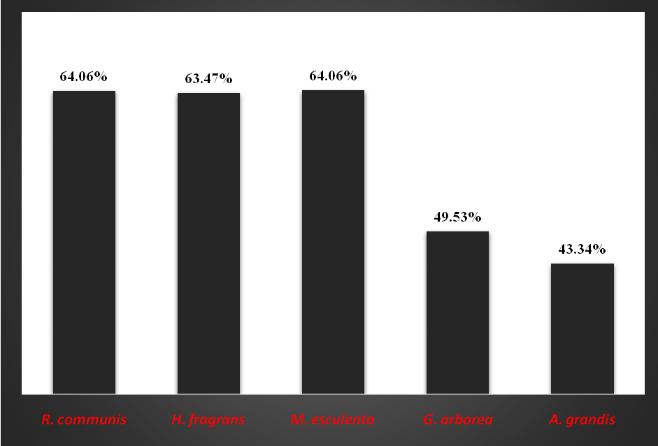
Fig. 4: Percentage of host plants used in the sampled villages

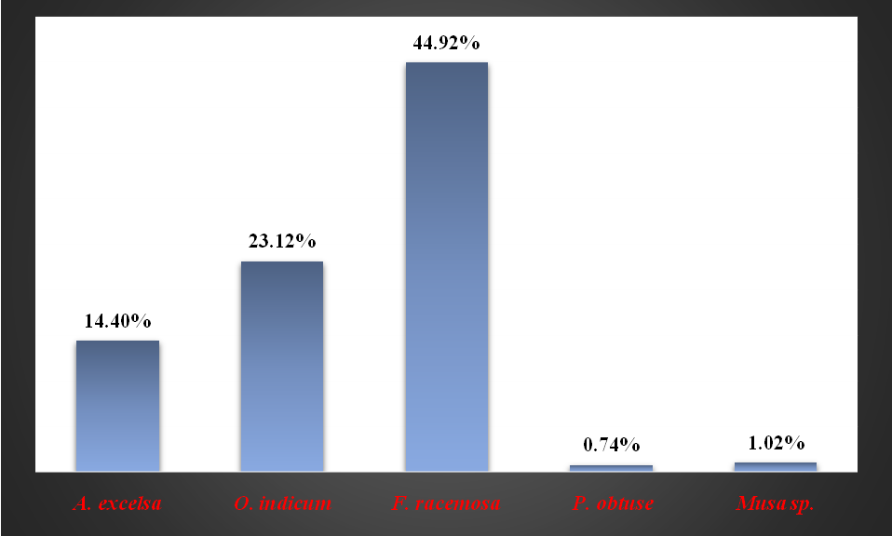
Fig. 5: Percentage of new host plants adopted by rearers
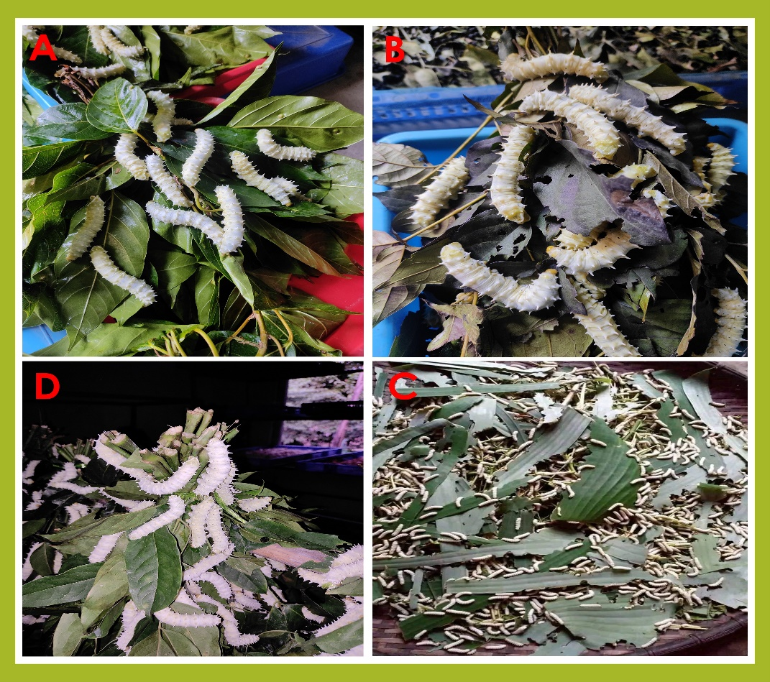
Fig. 6: Rearing of S. ricini in new food plants. A. Rearing in F. racemosa B. Rearing in O. indicum C. Rearing in Musa sp. D. Rearing in A. excelsa
The present study highlighted the challenges faced by eri rearers in the sampled villages. A staggering 99.84% of respondents reported degraded leaf quality and leaf scarcity as major challenges (Fig. 7). This finding was consistent with existing literature, which emphasizes the significance of adequate and high-quality leaf supply in eri culture (Gupta and Dubey, 2021; Ahmed Wani and Jaiswal, 2011; Thrilekha et al., 2024). Leaf scarcity couldbe attributed to various factors, including unorganized plantation sites, pest attacks, diseases like leaf blight, and environmental stresses such as drought and nutrient deficiencies (Atta et al., 2021). This scarcity had led to many rearers discontinuing eri culture, a trend also reported by De and Das (2010) and Kumari and Sharma (2017).
Adequate plantation space is crucial for ericulture, as silkworms require a steady supply of leaves. However, our study reveals that 93.70% of rearers face limited space for plantation, forcing them to rely on external sources. This constraint, coupled with high demand during peak seasons, poses significant challenges for marginalized rearers, potentially leading to reduced economic returns and discontinuation of rearing practices. Strategic land management and innovative solutions are essential to address this critical issue. This is consistent with the previous report of Sarma et al. (2024), who reported land scarcity as one of the challenges encountered by the rearers of Udalguri district, Assam.
In ericulture, temperature and humidity are crucial factors that have a marked influence on the success of silkworm rearing. These poikilothermic organisms are highly sensitive to environmental fluctuations, which can significantly impact their survival, growth, larval parameters, cocoon parameters, and overall productivity (Thrilekha et al., 2024). Optimal temperature and humidity ranges are essential to prevent stress, disease, and impaired development. While temperatures above 30°C can lead to hyperthermia and increased disease susceptibility, excessive humidity above 80% can foster fungal and bacterial growth, causing devastating diseases (Gupta and Dubey, 2021). Conversely, low humidity below 60% can cause dehydration, reduced feeding efficiency, and high humidity above 80% can encourage pathogenic infestation of fungi and bacteria (Oripovich and Ramazonovich, 2020). The interplay between temperature and humidity is complex, and understanding this dynamic is key to optimizing silkworm comfort and productivity. By managing these physical factors effectively, farmers can improve the quality and yield of ericulture crops. However, poor management and maintenance remain significant challenges, with 93.33% of rearers citing these as major issues (Fig. 7).

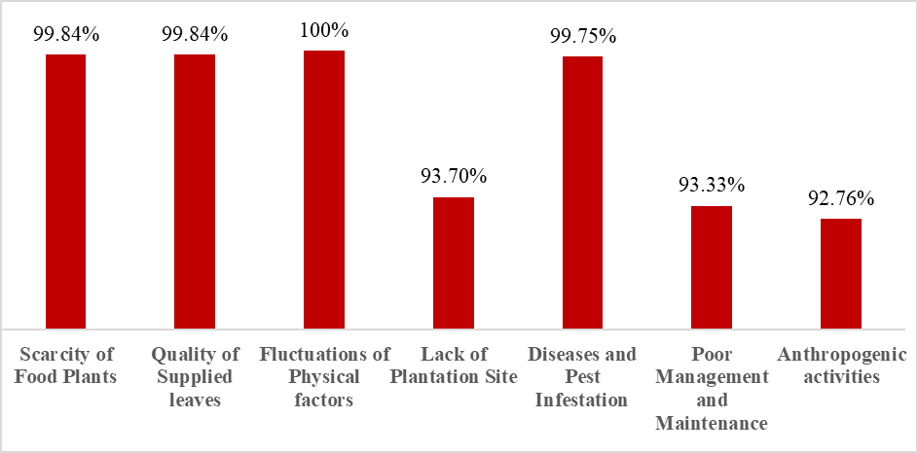
Fig. 7: Different challenges faced by the rearers of the sampled villages
The present study also reveals a relation between disease occurrence and rearing management practices in ericulture. The traditional management approaches employed by farmers, limited to cleaning, discarding infected larvae, and netting, are insufficient to mitigate disease incidence. Fluctuations in physical factors, outdoor rearing, unhygienic conditions, leaf scarcity, and frequent leaf changes exacerbate disease susceptibility. Notably, bacterial flacherie (75.90%), myiasis (83.06%), and grasserie (43.17%) were prevalent diseases reported by respondents (Fig. 8). However, some innovative farmers have adopted herbal formulations, fortification, and non-traditional host plants, which have shown promising results in disease management. These tactics, designed and implemented by the farmers themselves, have yielded satisfactory outcomes, highlighting the potential for integrated and sustainable disease management strategies in ericulture. Bio-fumigation, bio-disinfection, and herbal fortification are innovative methods of disease and pest management along with traditional and physical methods (Fig. 9). This study highlights the application of 16 various plants and plant products for the innovative management practices within the sampled villages (Table 1, Fig. 10).
Traditional methods played a vital role in maintaining a healthy environment for silkworm rearing, including regular bed cleaning, washing and sun drying of appliances, burning of cloth pieces, and applying nets to rearing beds. These techniques were widely used among all rearers in the sampled areas. However, biofumigation and biodisinfection techniques were less common, with only 1.43% and 3.36% of rearers practicing these methods, respectively (Fig. 9). Biofumigation involved preparing a powdered blend of shade-dried plant parts, which was mixed with dry cow dung, Sal Dammar/Dhuna (derived from Shorea robusta resin), and coconut husk, and then burned to fumigate rearing houses, appliances, and plantation sites. For disinfection purposes, decoctions, poultices, and soft pastes were prepared from plant parts and applied to rearing houses, plantation sites, and appliances. Fortification methods involve dusting fine powders of A. indica and M. oleifera onto the foliage of R. communis or H. fragrans, chopping leaves of O. indicum and F. racemosa for chawki silkworms, and providing bunches of O. indicum and F. racemosa tied with R. communis and H. fragrans bunches for late-stage rearing. These innovative methods demonstrated the resourcefulness of sericulture practitioners in maintaining a healthy environment for silkworm rearing. Although novel, the application of these methods was restricted among a few rearers (fortification: 14%, biofumigation: 1.43%, and biodisinfection: 3.36%) (Fig. 9), necessitating detailed analysis and exploration for potential adoption as a green solution for quality production and disease resistance. The limited adoption of modern biocontrol methods may constrain productivity and quality improvements in sericulture, which need to be uplifted for quality production and better yield.

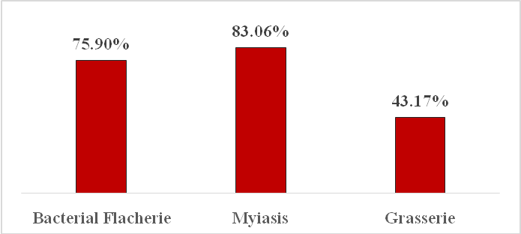

Fig. 8: Percentage of Microbial and Pest infestation

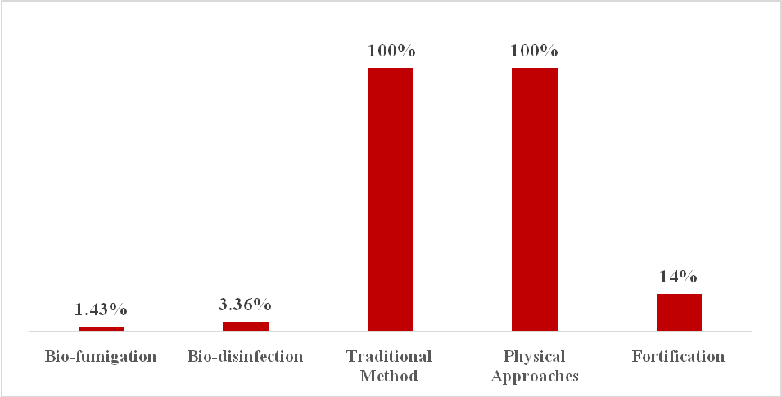
Fig. 9: Different methods for tackling the challenges
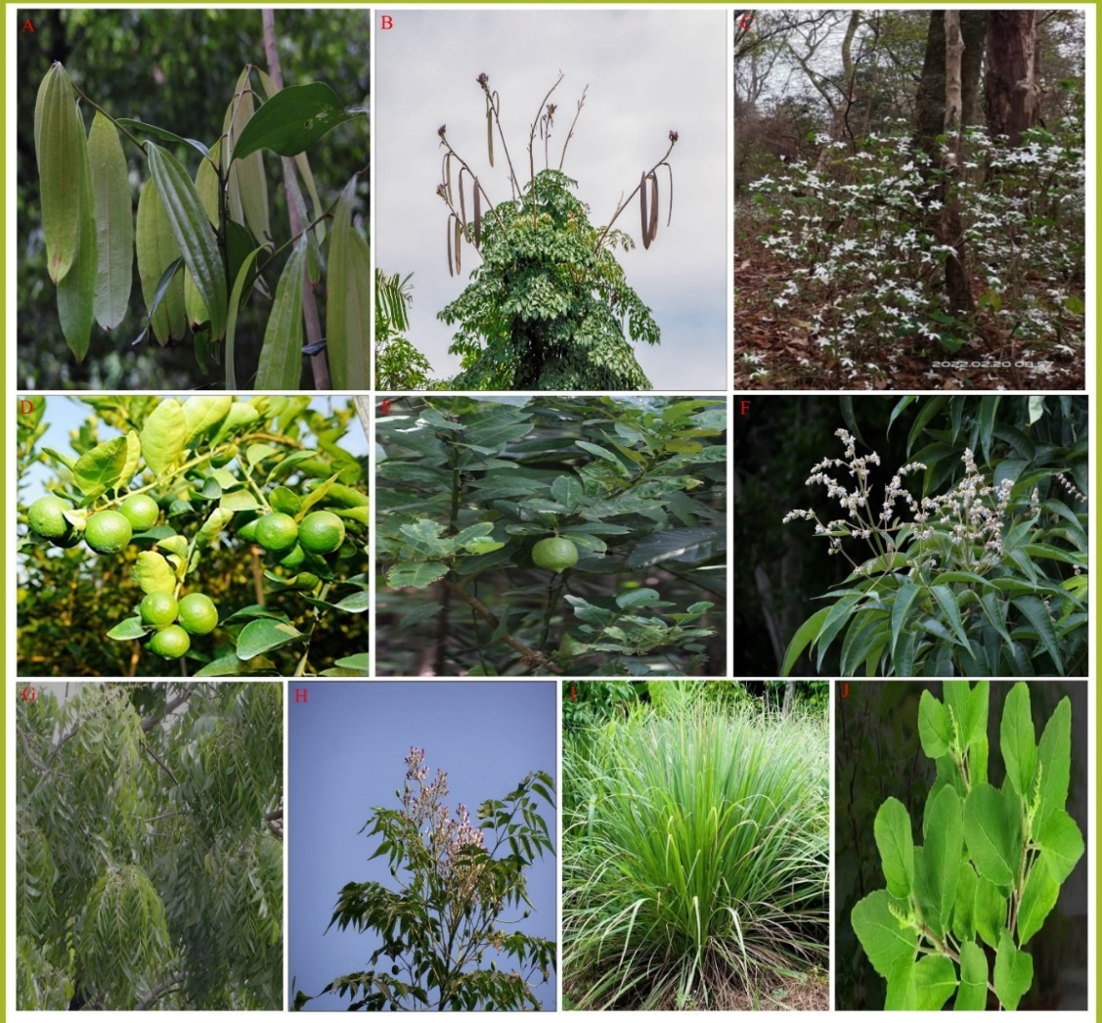

Fig. 10: Different plants used for bio-fumigation, bio-disinfection, and fortification. A. C. tamala, B. O. indicum, C. C. benghalensis, D. C. lemon, E. C. aurantifolia, F. V. peduncularis, G. A. indica, H. M. azadirachta, I. C. flexuosus, J. O. sanctum
Table 1: Plant and plant products used for bio-fumigation, bio-disinfection, and herbal fortification
Name of the Plant | Family | Part Used | Application
1. Cinnamomum tamala | Lauraceae | Leaf | Fumigation
2. Coffea benghalensis | Rubiaceae | Flower | Fumigation
3.Citrus limon | Rutaceae | Leaf, Fruit, Peel | Fumigation
4.Citrus jambhiri | Rutaceae | Leaf, Fruit, Peel | Fumigation
5.Citrus aurantifolia | Rutaceae | Leaf, Fruit, Peel | Fumigation
6. Cymbopogon flexuosus | Poaceae | Whole plant | Fumigation, Disinfection,
7. Ocimum sanctum | Lamiaceae | Leaf | Fumigation, Disinfection,
8. Zingiber officinale | Zingiberaceae | Rhizome, leaf | Fumigation, Disinfection,
9. Curcuma longa | Zingiberaceae | Rhizome, leaf | Fumigation, Disinfection,
10. Allium sativum | Amaryllidaceae | Bulb | Fumigation, Disinfection,
11. Melia azadirachta | Meliaceae | Leaf, Fruit | Fumigation, Disinfection,
12. Vitex peduncularis | Lamiaceae | Leaf | Fumigation, Disinfection,
13.Azadirachta indica | Meliaceae | Leaf | Fumigation, Disinfection, Fortification
14. Oroxylum indicum | Bignoniaceae | Bark, Flower | Fumigation, Disinfection, Fortification
15.Moringa oleifera | Moringaceae | Leaf | Fortification
16. Ficus racemosa | Moraceae | Leaf | Fortification

- Conclusion
The present study provides valuable insights into the challenges and innovative techniques employed by sericulture farmers in the Kokrajhar district of Assam. The findings highlight the significance of R. communis as a primary food plant for eri silkworms and the potential of new host plants in supporting eri culture. However, the study also reveals major challenges faced by eri rearers, including degraded leaf quality, leaf scarcity, and physical factors such as temperature and humidity fluctuations. To overcome these challenges, farmers adopt various management strategies, including bio-fumigation, bio-disinfection, and herbal fortification. Although these innovative methods demonstrate the resourcefulness of sericulture practitioners, their limited adoption necessitates detailed analysis and exploration for potential adoption. These findings underscore the need for improved management practices, awareness of modern techniques, and adoption of sustainable sericulture practices to enhance quality and productivity. By promoting these practices and exploring new avenues for innovation, sericulture can continue to play a vital role in the rural economy and cultural heritage of North-East India.

- Disclaimer (Artificial Intelligence)
Authors hereby declare that no generative AI technologies, such as Large Language Models (ChatGPT, COPILOT, etc.), and text-to-image generators have been used during the writing or editing of this manuscript.

- References

Ahmad Wani, K., &Jaiswal, Y.K. (2011). Health Hazards of Rearing Silk Worms and Environmental Impact Assessment of Rearing Households of Kashmir, India. Nature Environment and Pollution Technology, 10(1), 85-90. https://neptjournal.com/upload-images/NL-21-17-(17)-B-163.pdf.

Atta, K., Sing, P.A., Adhikary, S., Mondal, S., & Dewanjee, S. (2021). Drought Stress: Manifestation and Mechanisms of Alleviation in Plants. In Drought Impacts and Management, (1-24). Intech Open. DOI:10.5772/intechopen.102780.

Baishya, M., Barman, H., & Rahman, S. A. S. (2019). Present Status of Eri-Muga Culture in NE Region and Related Biodiversity Resources as Tool for Sustainable Economic Uplifting of Seri-Stakeholders. SSR Institute of International Journal of Life Sciences, 5(3): 2284-2290. DOI: https://doi.org/10.21276/SSR-IIJLS.2019.5.3.3.

Borah, D. S., Saikia, M., & Boro, P. (2020). Rearing performance of two selected eco-races of eri silkworm (Samia ricini Donovan) fed with Castor and Borpat leaves during spring and autumn seasons in Assam. Journal of Entomology and Zoology Studies, 8(3): 2024-2028.https://www.entomoljournal.com/archives/2020/vol8issue3/PartAI/8-3-386-206.pdf.

Boro, I. (2016). Dress Andornaments of the Bodos: A Brief Study. Indian Streams Research Journal, 6(11): 1-4. https://oldisrj.lbp.world/UploadedData/9360.pdf.

Brahma, D. (2015). Current Status of Ericulture in Kokrajhar District: A Survey Report. Bio-Science Letters, 1(1): 27-32.
https://www.researchgate.net/publication/292605404_Current_Status_of_Ericulture_in_Kokrajhar_District_A_Survey_Report.

Brahma, S., Sarma, R., & Nath, R. (2019). Livelihood Improvement through Sericulture in Kokrajhar District of Assam - A Key for Women Empowerment. International Journal of Current Microbiology and Applied Sciences, 8(12): 2762-2766.
DOI: https://doi.org/10.20546/ijcmas.2019.812.323.

Chutia, P., Kumar, R., & Khanikar, P. D. (2014). Host plants relationship in terms of cocoon colour and compactness of eri silkworm (Samia ricini). Biological Forum-An International Journal, 6(2): 340-343.
https://www.researchtrend.net/bfij/bf12/55%20DR%20RAJESH%20KUMAR%20JORHAT.pdf.

De, K. U., & Das, M. (2010). Scope of Ericulture in Assam: A micro-economic analysis. Journal of Agricultural Extension and Rural Development, 2(6): 106-115.
https://academicjournals.org/journal/JAERD/article-full-text-pdf/78EA1CB40526.

Deuri, J., Barua, P.K., Sarmah, M.C., & Ahmed, S.A. (2017). Biochemical attributes of castor and tapioca leaves, the promising food plants of eri silkworm (Samia ricini Donovan). International Journal of Ecology Ecosolution, 4(4): 1- 4.
DOI:10.30918/IJEE.41.17.012.

Gogoi, D., Bora, N., Singha, Th. A., & M, M. (2024). Impact of host plants on growth, development, and economic characters of Eri silkworm (Samia ricini Boisd.). Journal of Advances in Biology and Biotechnology, 27(9): 1229-1235. https://doi.org/10.9734/jabb/2024/v27i91393.

Gupta, S.K., & Dubey, R.K. (2021). Environmental factors and rearing techniques affecting the rearing of silkworm and cocoon production of Bombyx mori Linn. Acta Entomology and Zoology, 2(2): 62-67. DOI: https://doi.org/10.33545/27080013.2021.v2.i2a.46.

Hussain, Md. A., & Rasid, S. S. (2024). Exploring the impact of food plants on the life cycle of Samia ricini: A study on Eri silkworm rearing. Journal of Entomology and Zoology Studies, 12(1): 33-37. DOI: https://doi.org/10.22271/j.ento.2024.v12.i1a.9276.

Kumar, A. U., Parasuramudu, M., Nandhini, K., & Praveen Reddy, Y. (2021). Optimizing Silkworm Rearing: The Impact of Environmental Factors and Advanced Technologies on Silk Quality and Production. Research Biotica,3(4): 195-202.
DOI: https://doi.org/10.54083/ResBio/3.4.2021/195-202.

Kumar, R., & Elangovan, V. (2010). Assessment of volumetric attributes of Eri silkworm (Philosamia ricini) reared on different host plants. International Journal of Science and Nature,1(2): 156-160.
https://www.researchgate.net/publication/257466988_Assessment_of_the_volumetric_attributes_of_eri_silkworm_Philosamia_ricini_reared_on_different_host_plants.

Kumari, P., & Sharma, S. (2017). Eri Silkworm (Philosamia ricini) Rearing & Comparative Analysis of its Economic Parameters Based on Different Food Plants in Deosal village, Mayong Block, Morigaon District, Assam, India. International Journal of Science and Research, 6(5): 1737-1740.https://www.ijsr.net/archive/v6i5/9051705.pdf.

Mahesh, D.S., Hazarika, S., Hazarika, J.D., Mishra, R.J., Arunkumar, K.P., Shabnam, A.A., Luikham, R., & Vijaya Kumari, K.M. (2023). Selection of Castor (Ricinus communis) cultivar suitable for commercial eri chawki rearing. Plant Archives, 23(1): 105-110. DOI: https://doi.org/10.51470/PLANTARCHIVES.2023.v23.no1.018.

Mossie, T., Worku, H., & Biratu, K. (2024). Evaluation of Cassava (Manihot esculenta Crantz) genotypes and their feeding values on the rearing performance of Eri-silk worm in southwestern Ethiopia. Cogent Food & Agriculture, 10(1).
DOI:10.1080/23311932.2024.2313681.

Narayanamma, L. V., Reddy, D. K., & Reddy, V. A. (2013). Castor Genotypes on Rearing and Cocoon Parameters of Eri Silkworm, Samia cynthia ricini. Indian Journal of Plant Protection, 41(2): 127-131.
https://www.researchgate.net/publication/324943062_Castor_Genotypes_on_Rearing_and_Cocoon_Parameters_of_Eri_Silkworm_Samia_cynthia_ricini.

Oripovich, O.O., & Ramazonovich, U.S. (2020). Influence of feeding of silkworms in Uzbekistan on cocoon yield and variety. International Journal of Agriculture Extensionand Social Development, 3(2): 09-12.
https://www.extensionjournal.com/article/view/49/3-1-16.

Sarker, B. N., Sarmah, M. C., & Giridhar, K. (2015). Grainage performance of eri silkworm Samia ricini (Donovan) fed on different accession of castor food plants. International Journal of Ecology and Ecosolution, 2(2): 17-21.
https://www.netjournals.org/pdf/IJEE/2015/2/15-014.pdf.

Sarma, J., Brahma, D., Narzary, R. P., Rajkhowa, A., Bora, K. S., Saikia, D., & Das, B. (2024). Study on the challenges encountered by Eri silkworm rearers in Tapioca cultivation and Eri rearing in Udalguri District of Assam. Journal of Scientific Research and Reports, 30(6): 183-190. https://doi.org/10.9734/jsrr/2024/v30i62032.

Schoonhoven, L.M., Van Loon, J.J., & Dicke, M. (2005). Insect-Plant Biology. Oxford University Press (2nd ed.). New York.
https://www.researchgate.net/publication/31846359_Insect-Plant_Biology.

Shields Vonnie, D.C. (2023). Chapter- Deterrents and their effects on the feeding behavior and sensory physiology of Insects. In Arthropods- New Advances and Perspectives, (1-16). Intech Open. DOI: https://doi.org/10.5772/intechopen.112735.

Teotia, R.S., & Bajpeyi, C.M. (2009). Potentialities and prospects of Muga and Eri Silk Industry in Bodoland, Assam. Indian Silk, 48(3): 14-18.
https://www.researchgate.net/publication/294307203_Potentialities_and_prospects_muga_eri_silk_industy_in_bodoland_Assam.

Thrilekha, D., Harshita Mala, P., Gowthami, B., & Chethan Kumar D. S. (2024). Influence of temperature on growth and development of bivoltine silkworm breeds and hybrids: A comprehensive review. International Journal of Research in Agronomy, 7(6): 590-597.
DOI: https://doi.org/10.33545/2618060X.2024.v7.i6Sh.2072.

Tulu, D., Aleme, M., Mengistu, G., Bogale, A., Shifa, K., & Mendesil, E. (2022). Evaluation of Castor (Ricinus communis L.) genotypes and their feeding values on rearing performance of Eri Silkworm (Samia cynthia ricini Boisduval) (Lepidoptera: Saturniidae) in Southwest Ethiopia. Psyche: A Journal of Entomology,7 pages.
DOI:10.1155/2022/1556776.

