**A physiological Study to Compare the Effect of Catechin and lovastatin on Obesity through Histological Examination of the liver in Albino Rats**

**Abstract**

Obesity is a serious, intricate, long-term illness. Obesity is largely caused by a fatty diet. It is well established that a number of chronic illnesses, including “Non-Alcoholic Fatty Liver Disease” (NAFLD), are led to obesity. catechin as anti-obesity effects are very diverse. given orally for four weeks1.7 mg/kg. lovastatin 40mg/kg**.** Results show liver of control positive group rats’ Severe necrosis of hepatocytes lead to formed large spaces filled with severe hemorrhage and necrotic debris. Also, the fatty change as vacuoles. liver post catechin treatment group rats Mild fatty change appeared as vacuoles was observed. liver post lovastatin treatment group rats Mild fatty change as vacuoles with inflammatory cells infiltration as cluster. But normal hepatic tissue histology and the liver of the control negative group. Observe the configuration of acini and hexagonal lobules. We concluded through our current research that obesity, which is a metabolic disorder that we created by providing a high-fat diet, causes the deposition of fatty tissue in liver cells, as well as necrosis, bleeding, and destruction of liver cells. The use of catechin reduced the lesions in liver tissue and its effectiveness is at the same level as that of lovastatin, but rather better because it does not have the side effects of lovastatin.

**Key words:** *catechin, lovastatin, liver, Obesity*

**Introduction**

Obesity is an epidemic disease that threatens to inundate health care resources by increasing the incidence of diabetes, heart disease, hypertension, and cancer. (bray *et al*., 2004).

Plant polyphenols, such as the catechins in tea, have antioxidant qualities that can lower inflammation and reactive oxidative stress (ROS) levels in obese individuals. (Basu *et al*., 2023)

The mechanisms of catechin as anti-obesity effects are very diverse. These mechanisms include increased fat oxidation, stimulation of sympathetic nervous system activity, upregulation of mRNA level of fat Î²-oxidation genes, downregulating expression of enzymes involved in fat synthesis, and increased expression of adipose tissue uncoupling proteins. (Akhlaghi et al., 2018)

GTC treatment Genes linked to fatty acid oxidation, VWAT, SWAT, and peroxisome proliferator-activated receptor-delta (PPAR-d) were all expressed more when GTC was administered. levels in brown adipose tissue. These results show that by altering the PPAR signaling system, GTC has an anti-obesity effect (Liew *et al*., 2023).

Found that the catechin moiety disrupts the colon's biliary micelle system, resulting in the formation of insoluble cholesterol precipitates and an increase in the amount of cholesterol excreted in the stool. This significant decrease in the liver's absorption and concentration of cholesterol encourages the activation and expression of low-density lipoprotein (LDL) receptors. Most cells, especially hepatic cells, have this receptor on their top surface. It has the ability to eliminate low-density lipoproteins from the bloodstream that contain cholesterol. According to a recent in vitro study, catechin is a strong and specific inhibitor of squalene epoxidase, an enzyme that limits the rate at which cholesterol is produced. Serum total and LDL concentrations are considerably reduced by catechin. Singh and colleagues (Shikha *et al*., 2024).

These findings suggested that tea polyphenols could be effective in the prevention of obesity. It has been proposed that tea reduces body weight increase by decreasing lipid and carbohydrate absorption, boosting lipid and carbohydrate utilization, and decreasing lipogenesis; however, the mechanism of tea's anti-obesity actions is still uncertain (Liu *et al*., 2025).

The green tea catechins were given orally for four weeks between the ages of eleven and fifteen weeks. Green tea catechin was distilled in water and given orally at a dosage of 1.7 mg/kg, which is half of the 200 mg/60 kg human-effective concentration (Khateeb and Taha, 2024). Boost the circulation of adiponectin in rats given various diets (Marinovic *et al*., 2022).

One common medication used to lower blood lipid levels and treat hypercholesterolemia is lovastatin, a secondary metabolite that was identified from fungi. It shares structural similarities with HMG-CoA. The hypolipidemic effect of lovastatin is caused by its significant competition with HMG-CoA reductase (HMGR) and inhibition of substrate binding to the enzyme. Its safety has also been verified both in vitro and in vivo. Additionally, lovastatin possesses neuroprotective, anti-inflammatory, and anti-cancer properties. (Xie *et* *al*., 2021)

The angiotensin converting enzyme (ACE) inhibitor enalapril has been widely used to treat hypertension and other cardiovascular conditions. The native plant Coccinia indica is widely employed in Ayurvedic, Siddha, and Unani traditional medicine systems. This study sought to determine the hepatoprotective potential of C. indica leaf extract against the harmful effects of enalapril. (Vinothkumar *et* *al*., 2021)

A pro-drug called lovastatin is in vivo activated by hydrolyzing the lactone ring to produce β-hydroxy acid. The agent can bind to HMG-CoA reductase at an affinity 20,000 times higher than its natural substrate because the hydrolyzed ring resembles the tetrahedral intermediate that the reductase produces (Bizukojc & Ledakowicz). Lovastatin is both a substrate and inhibitor of cytochrome P450 isoform 3A4 and P-gp. Chong and associates. The enzyme 3-hydroxy-3-methylglutaryl coenzyme A. The rate-limiting step in the manufacture of cholesterol and other isoprenoids is the four-electron oxidoreduction that is catalyzed by (HMG-CoA) reductase, which converts HMG-CoA to mevalonate. (Sharaf *et al*., 2021).

Furthermore, it has been consistently demonstrated that statin treatments lower mortality and morbidity from consequences like strokes or despite their general advantages, statins are nevertheless known to have a number of negative side effects, including coenzyme Q10, atorvastatin, temozolomide, and renal insufficiency, hepatic dysfunction, muscular breakdown and malfunction, and an elevated risk of diabetes mellitus18. Furthermore, other compounds that might be implicated in cell survival (Amadasu *et al*., 2024).

Disturbances in food metabolism linked to obesity result in an excessive buildup of fat in the liver. Consequently, it gets harmed, and nonalcoholic fatty liver disease (NAFLD) develops. NAFLD is associated with biotoxicity that causes hepatocyte apoptosis and even necrosis, as well as an increase in oxidative stress and inflammation, according to patient observations and research done in an animal model. (Ognik *et al*., 2021)

The Aim of Study Determine how obesity effects on the liver and to determine whether catechin is a better treatment for obesity than lovastatin based on tissue alterations seen when the liver organ it using throw examination of histological sectioning

**Materials and Methods**

**Experimental substances**

Vegetable edible oil for hyperlipidemia to induced an experimental model rat, catechin as anti-obesity effects (1.7) mg /kg. day (Nakadate *et al.*, 2025), lovastatin (40) mg /kg. Day as anti- hyperlipidemia (Bai *et al*., 2024).

**Experimental animals**

There were 20 adult albino rats “four months old” in this experiment used, “weighing between 150 and 200 g”. Animals were Sacrificed after anesthesia used xylazine and ketamine for collection of liver tissue to histological examined in the laboratory of physiological's Department and Faculty of Veterinary Medicine. The animal house at the University of Kufa had a 12-hour cycle of light and dark and a moderate temperature.

**Distribution the experimental rats**

Experiment design included Twenty adult female rats are used in this investigation. The animals were split into two groups at random, one with five animals and the other with fifteen. Five animals made up the first group, which served as a negative control group in the first experiment and was fed a balanced natural diet. 15 animals were included in the high-fat diet that was provided to the second group

The remaining ten animals were divided into two groups, the first was given catechin and the other Lovastatin. for 30 days

Experimental animals’ group:

G1: control negative 5 animals given normal sealine for a month

G2 control positive5 animals was received a high-fat diet Vegetable edible oil for a month

G3 animals was received catechin 1ML per day for a month by dosage

G3 animals was received lovastatin 1ML per day for a month by dosage

The animals were dissected after the end of the experiment period for the purpose of taking liver samples from all the previously mentioned groups and they were preserved in plastic boxes containing formalin at a concentration of 10% for the purpose of histological examination

**Histopathological study**

Organ samples were collected, preserved for 48 hours in 10% formalin, and then transferred to a fresh formalin solution 24 hours later. Organ samples were cut into 0.5-cm-thick slices and, placed “in plastic cassettes to be dehydrated and clarified by the automated tissue processor (Histo-Line ATP700, Italy) before being paraffin embedded using the standard paraffin embedding technique of the tissue embedding system (HESTION TEC2800-C, China). The organ samples were then cut and sectioned at a thickness of 4 mm using a semi-automatic microtome (Histo-Line MRS3500, Italy). “A hot plate (K&K HYSH11, Korea) was used to mount the organ pieces on glass slides after they had been carefully placed in a water bath (FALC BI, Italy). used Hematoxylin and Eosin stain.

Finally, the portions were dehydrated again using xylene and the graded IMS. DPX (distyrene, a plasticizer, and xylene) mounting material was used to attach coverslips to the slides. A light microscope was used to view the slides. and images were acquired using the Hamamatsu Nano-Zoomer Digital Slide Scanners (Leica).

**Results**

The results of this study were demonstrated through histological examination of the livers of different groups of rats. All slides were stained with hematoxylin-eosin to identify routine histological structures. In the positive control group, i.e., the group treated with a high-fat diet, severe necrosis of hepatocytes led to the formation of large spaces filled with severe hemorrhage and necrotic debris. Also, fatty changes in vacuoles were observed in the affected area of ​​hepatic tissue. As shown in Figure No. (2). Compared to liver tissue taken from a group of animals with a normal balanced diet, which appeared under the microscope liver tissue histology in normal conditions. Observe the configuration of acini and hexagonal lobules. The central vein is where the hexagonal lobules are located. as shown and indicated in Figure (1)., which represents the negative control group. When comparing the liver tissue of the group of animals that were dosed with catechin liver post catechin treatment group (rats) with the positive control group, we noticed through our results that mild fatty change appeared only as vacuoles were observed in affected area of ​​hepatic tissue. However, the rest of the lesions such as severe hemorrhage and necrotic disappear due to the effect of catechin, and Figure No. (3). indicates that. The effect of lovastatin was also very clear in the results of this study, which was shown to us by the histological examination of the liver of the group of animals treated with lovastatin. The results indicate that mild fatty change as vacuoles with inflammatory cells infiltration as a cluster was observed in the affected area of ​​hepatic tissue when compared to the positive control group shown in Figure No. (4). On the other hand, when comparing both the catechin and lovastatin group with the negative control group, the examinations showed an effect of obesity, but the improvement after treatment with catechin and lovastatin.

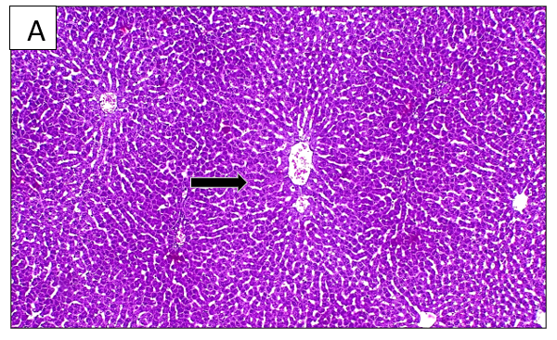 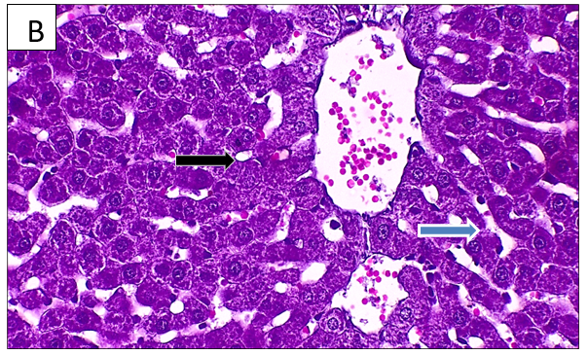

**Figure (1): Photomicrograph of** **liver of control negative group A&B/Normal histology of hepatic tissue. Note the arrangement of hexagonal lobules (black arrow) and acini (blue arrow). Hexagonal lobules are centered on the central vein (arrow head). Hematoxylin and Eosin.A:100X and B:400X.**

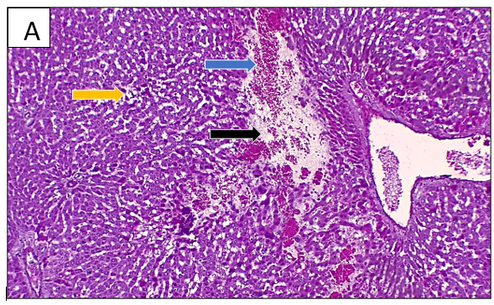

**Figure (2): Photomicrograph of** **liver of control positive group rats A&B/Severe necrosis (black arrow) of hepatocytes lead to formed large spaces filled with severe hemorrhage (blue arrow) and necrotic debris. Also, the fatty change as vacuoles (yellow arrow) was observed Hematoxylin and Eosin in the hepatic tissue that is impacted. B:400X and A:100X.**

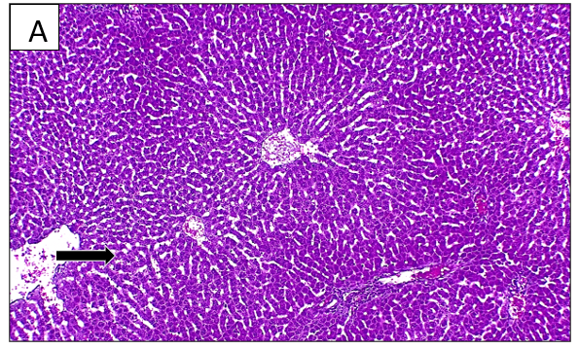

**Figure (3): Photomicrograph of** **liver post catechin treatment group rats A&B/Mild fatty change (black arrow) appeared as vacuoles was observed in affected area of hepatic tissue. Hematoxylin and Eosin.A:100X and B:400X**

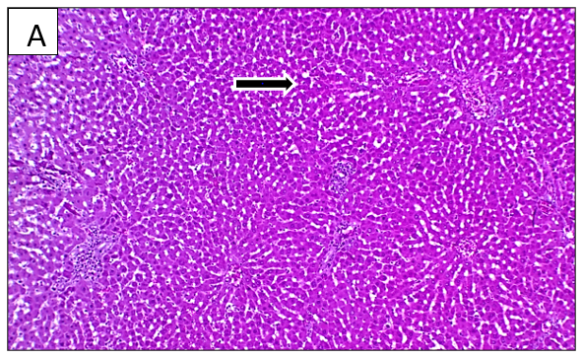

**Figure (4): Photomicrograph of liver post lovastatin treatment group ratsA&B/Mild fatty change as vacuoles (black arrow) with inflammatory cells infiltration (blue arrow) as cluster was observed in affected area of hepatic tissue Hematoxylin and Eosin.A:100X and B:400X**

**Discussion**

A well-known condition in patients with extreme obesity is liver steatosis, which is particularly linked to visceral adiposity and diabetes Some patients may develop cryptogenic cirrhosis and steatohepatitis as a result (Quek *et al*., 2025). It is currently unknown what the histology mechanism of non-alcoholic fatty liver disease (NAFLD) is Increases in hepatic triglyceride levels lead to hepatic steatosis in many obese individuals (Chiriacò *et al*., 2024). Examining the histological effects of a high-fat diet on non-alcoholic fatty liver disease was the aim of this investigation. To this end, an obese rat model was created and fed a fatty diet. Numerous articles on this topic were published before to this study. A high-fat diet may lead to aberrant mitochondria and mononuclear inflammation, according to some experts (Zhong *et al*., 2024). Hepatocellular ballooning, pericellular fibrosis, portal fibrosis, and lobular inflammation to be the results of oxidative stress and mitochondrial failure in NAFLD As shown in the results of this study

We believe that the ongoing impact of eating that is high in fat was the cause of the gradual rise in the dilatation level of portal artery throughout the experiment. We found infiltrations of mononuclear cells surrounding dilated arteries and in between hepatocyte plates. Regarding the underlying cause of this problem, some studies assert that cytokine release from fatty meals is the cause of this inflammation area, which can manifest as diffuse or focal forms Furthermore, according to some studies, inflammation happens in reaction to hepatocyte injury which is similar to the study (Dash *et al*., 2021). hormone metabolism, glucose synthesis and storage, lipid turnover, cholesterol metabolism, endobiotic and xenobiotic detoxification, and plasma protein secretion are just a few of the essential functions the liver plays in maintaining systemic homeostasis. Hepatocytes, parenchymal cells that make up 60% of the liver's cellular makeup and 80% of its bulk, perform the majority of these tasks. One Along with hepatocytes, there are at least six distinct types of liver cells, including biliary epithelial cells, sinusoidal endothelial cells, stellate cells, dendritic cells, macrophages, and other immune cell types.. These cells accompany hepatocytes in three-dimensional anatomical units known as liver lobules, which are hexagonal columns that support hepatocellular function Two blood sources perfuse the liver lobules: oxygenated blood from the hepatic artery and portal venous blood, which is low in oxygen but high in nutrients, toxins, and compounds acquired from the gut microbiota. These afferent blood arteries create capillary-sized capillaries called sinusoids that eventually empty into a central vein after entering the lobules from the corners of the hexagonal formations, also known as the portal nodes. (Berasain *et al*., 2023) In this study, the results of liver tissue examination of animals with obesity resulting from a high-fat diet were also obtained Simple fat accumulation (steatosis) is the result of insulin resistance-mediated failure of" fatty acid β-oxidation, de novo lipogenesis, and lipid synthesis", which causes excessive fat deposition in NAFLD may worsen into steatohepatitis (NASH), a more complex condition, if the liver has reached the level of steatosis. Although it is still unclear exactly what causes the subsequent hits after insulin resistance, accumulating evidence has pointed to the likely underlying mechanisms that lead to the development of NASH, which is brought on by oxidative stress-induced inflammatory cascades through adipokine production and cytokine activation, from steatosis. Catechin was used, which played an effective role in improving the changes seen in the liver and reducing the fatty tissue deposited on the liver cells through: Polyphenols, commonly known as catechins, are abundant in green tea. "(−)-epigallocatechin (EGC), (−)-epicatechin-3-gallate (ECG), (−)-epicatechin (EC), and (−)-epigallocatechin-3-gallate (EGCG)" were identified as catechins in green tea. The main antibacterial substances against a variety of harmful organisms include catechins, such as EGC, ECG, and EGCG. The two main chemicals found in green tea, epigallocatechin-3-gallate and epigallocatechin, are eliminated in bile. Furthermore, "green tea exhibits antibacterial qualities against urinary bacterial infections", as evidenced by the ultimate excretion of EGC in the urine. By controlling the lipid metabolism of hepatocytes in mice with alcoholic fatty liver disease, catechin may prevent ethanol-induced liver At the catechin can protect cells and the body by influencing intracellular signaling pathways through interactions with functional proteins such as transcription factors (TFs), intracellular According to reports, quercetin reduces oxidative stress by up-regulating nuclear factor-erythroid-2-related factor-2 (Nrf2)/HO-1 and inhibits inflammation by down-regulating nuclear factor-κB (NF-κB)/NLRP3 expression There are previous studies similar to the results of the current study, such as: (Alkufeidy et al., 2024), (Guan et al., 2025). The histological changes that appeared on the liver samples of the group of animals treated with lovastatin showed improvement and the liver returned to the normal tissue arrangement with the appearance of a very slight fatty tissue. This explains the effect of lovastatin due to: The primary rate-limiting enzyme in the synthesis of cholesterol, hepatic 3-hydroxy-3-methylglutaryl-coenzyme A (HMG-CoA) reductase, is inhibited by the oral medication Lovastatin, like other medications in its family (the "statins"), reduces the levels of (LDL) and total serum cholesterol, which lowers the risk of atherosclerosis and its consequences, such as myocardial infarction and stroke (Amin *et al*., 2022). The effect of catechin is similar to that of lovastatin in this study, as a result of the improvement observed in tissue changes and the treatment of obesity or improvement of lesions resulting from the damage to the liver from obesity.

**Conclusion**

The metabolic disorder that we created by providing a high-fat diet, causes the deposition of fatty tissue in liver cells, as well as necrosis, bleeding, and destruction of liver cells. However, the use of catechin reduced the lesions in liver tissue and its effectiveness is at the same level as that of lovastatin, but rather better because it does not have the side effects of lovastatin.

**Recommendations**

The investigate the effect of obesity on other body tissues, as well as using plants other than catechin, and examining changes in blood components and other biological parameters.  
**Ethical Approval**

Animal Ethic committee approval has been collected and preserved by the author(s)

Disclaimer (Artificial intelligence)

Option 1:

Author(s) hereby declare that NO generative AI technologies such as Large Language Models (ChatGPT, COPILOT, etc.) and text-to-image generators have been used during the writing or editing of this manuscript.

Option 2:

Author(s) hereby declare that generative AI technologies such as Large Language Models, etc. have been used during the writing or editing of manuscripts. This explanation will include the name, version, model, and source of the generative AI technology and as well as all input prompts provided to the generative AI technology

Details of the AI usage are given below:

1.

2.

3.

**References**

Akhlaghi, M., & Kohanmoo, A. (2018). Mechanisms of anti-obesity effects of catechins: a review. International Journal of Nutrition Sciences, 3(3), 127-132.‏

Alkufeidy, R. M., Altuwijri, L. A., Aldosari, N. S., Alsakabi, N., & Dawoud, T. M. (2024). Antimicrobial and synergistic properties of green tea catechins against microbial pathogens. Journal of King Saud University-Science, 36(8), 103277.‏

Amadasu, E., Kang, R., Usmani, A., & Borlongan, C. V. (2022). Effects of lovastatin on brain cancer cells. *Cell Transplantation*, *31*, 09636897221102903.

Amin, M. B., & Tickoo, S. K. (2022). *Diagnostic Pathology: Genitourinary E-Book: Diagnostic Pathology: Genitourinary E-Book*. Elsevier Health Sciences.

Bai, Y., Chen, K., Liu, J., Wang, Y., Wang, C., Ju, S., ... & Zheng, C. (2024). Activation of AMPK pathway by low‑dose donafenib and atorvastatin combination improves high‑fat diet‑induced metabolic dysfunction‑associated steatotic liver disease. *Molecular Medicine Reports*, *29*(3), 51.

Berasain, C., Arechederra, M., Argemí, J., Fernández-Barrena, M. G., & Avila, M. A. (2023). Loss of liver function in chronic liver disease: An identity crisis. Journal of hepatology, 78(2), 401-414.‏

Bray, G. A. (2004). Medical consequences of obesity. The Journal of clinical endocrinology & metabolism, 89(6), 2583-2589.

Chiriacò, M., Nesti, L., Flyvbjerg, A., Golay, A., Nazare, J. A., Anderwald, C. H., ... & Natali, A. (2024). At any level of adiposity, relatively elevated leptin concentrations are associated with decreased insulin sensitivity. *The Journal of Clinical Endocrinology & Metabolism*, *109*(2), 461-470.

Dash, P. K., Mohan, P. V., Mohanty, N. R., & Jena, S. K. (2021). Association between Severity of Ultrasonographic Nonalcoholic Fatty Liver Disease and Cardiometabolic Risk in a Tertiary Care Teaching Hospital. *Journal of Datta Meghe Institute of Medical Sciences University*, *16*(4), 667-671.

Guan, D., Xu, H., Huang, Y. C., Jing, C., Tsujimoto, Y., Xu, X., ... & Shao, Z. (2025). Operando studies redirect spatiotemporal restructuration of model coordinated oxides in electrochemical oxidation. Advanced Materials, 37(7), 2413073.‏

Khateeb, S., & Taha, E. F. (2024). Comparative study of the anti-inflammatory activity of etoricoxib and Matcha green tea against acute kidney injury induced by gamma radiation in rats. *International Journal of Radiation Biology*, *100*(6), 940-964.

Liew, F. F., Visuvanathan, T., & Vellasamy, S. (2023). Fenugreek (Trigonella foenum-graecum L.) Modulates Energy Metabolism and Anti-inflammatory Response in Obesity via Combinatorial Analysis. *The Natural Products Journal*, *13*(8), 79-104.

Liu, X., Ju, Y., Zeng, H., Wen, S., Wang, C., Jiang, M., ... & Liu, Z. (2025). Green tea fermented by Ganoderma lucidum presented anti-obesity properties via enhanced thermogenesis in vitro and on C57BL/6J mice. *Food Research International*, 116092.

Marinovic, M. P., Sousa-Filho, C. P. B., Batista, F. A. H., Avelino, T. M., Cogliati, B., Figueira, A. C. M., ... & Rodrigues, A. C. (2022). Green tea extract increases adiponectin and PPAR α levels to improve hepatic steatosis. *The Journal of Nutritional Biochemistry*, *103*, 108957.‏‏‏‏‏

Nakadate, Y., Yamada, M., Kusuyama, N., Ishii, R., Sato, H., Schricker, T., & Tanaka, M. (2023). Effect of intranasal insulin administration on postoperative delirium prevention in elderly cardiac surgery patients: study protocol for a multicenter, double-blind, randomized, controlled trial. *Trials*, *24*(1), 822.

Ognik, K., Dworzański, W., Sembratowicz, I., Fotschki, B., Cholewińska, E., Listos, P., & Juśkiewicz, J. (2021). The effect of the high-fat diet supplemented with various forms of chromium on rats body composition, liver metabolism and organ histology Cr in liver metabolism and histology of selected organs. Journal of Trace Elements in Medicine and Biology, 64, 126705.‏

Quek, J., Chan, K. E., Wong, Z. Y., Tan, C., Tan, B., Lim, W. H., ... & Ng, C. H. (2023). Global prevalence of non-alcoholic fatty liver disease and non-alcoholic steatohepatitis in the overweight and obese population: a systematic review and meta-analysis. *The lancet Gastroenterology & hepatology*, *8*(1), 20-30.

Sharaf, A., El-Shazly, K. A., Abd El Latif, A. M. E. R. A., Abdelkawy, K. S., & Elbarbry, F. (2021). Comparative Evaluation of the Effects of Atorvastatin and Lovastatin on the Pharmacokinetics of Aliskiren in Rats. *Sains Malaysiana*, *50*(3), 829-837.

Shikha, D., Singh, A., Rangra, N. K., Monga, V., & Bhatia, R. (2024). Insights to therapeutic potentials, pharmaceutical formulations, chemistry and analytical methods of catechin. *Phytochemistry Reviews*, 1-42.

Vinothkumar, G., Venkataraman, P., Vinodhini, V. M., Lavanya, R., & Sathishkumar, D. (2019). Effect of Coccinia indica leaf extract on angiotensin converting enzyme (ACE) inhibitor induced hepatotoxicity in wistar albino rats. *Clinical Nutrition Experimental*, *24*, 24-33.‏

Xie, L., Zhu, G., Shang, J., Chen, X., Zhang, C., Ji, X., ... & Wei, Y. (2021). An overview on the biological activity and anti-cancer mechanism of lovastatin. Cellular Signalling, 87, 110122.

Zhong, H., Dong, J., Zhu, L., Mao, J., Dong, J., Zhao, Y., ... & Ding, G. (2024). Non-alcoholic fatty liver disease: pathogenesis and models. *American Journal of Translational Research*, *16*(2), 387.