Seasonal Dynamics and Diversity Analysis of Phytoplankton in Lakshmipuram Lake, Anakapalli district, Andhra Pradesh, India

Abstract
Phytoplankton play a vital role in aquatic ecosystems as primary producers, and their diversity serves as a key indicator of water quality and ecological health. The present study investigates the phytoplankton diversity of Lakshmipuram Lake, located in Anakapalli district of Andhra Pradesh, over a one-year period from January 2024 to December 2024. Phytoplankton samples were collected from three different sites across three seasons—pre-monsoon (March–May), monsoon (June–September), and post- monsoon (October–December)—using standard methods outlined in Standard Methods for the Examination of Water and Wastewater. Collections were conducted in the morning between 7:00 am and 9:00 am using a 5 μm mesh phytoplankton net and preserved in 3% formaldehyde solution. The samples were examined under an optical microscope, and species identification was carried out using standard identification keys and reference guides.
A total of 29 genera belonging to three major classes—Chlorophyceae (15 genera), Cyanophyceae (8 genera), and Bacillariophyceae (6 genera)—were identified. Among these, Chlorophyceae was the dominant class, contributing 51.7% of the total genera; Cyanophyceae (27.6%) and Bacillariophyceae (20.7%). Seasonal variations revealed that phytoplankton abundance was highest during the pre-monsoon due to increased levels of salinity, temperature, pH, alkalinity, TDS, hardness, chlorides, nitrates, phosphorus and lowest during the monsoon season due to high rainfall, reduced salinity, pH, temperature. Diversity indices indicated moderate diversity and evenness across the lake. The Shannon-Wiener diversity index ranged from 1.0363 to 1.0483 with an average

of 1.043, while the Evenness index (Pielou’s J′) ranged from 0.3077 to 0.3113 with an average of 0.310, showing a moderately stable and evenly distributed phytoplankton community.
The study concludes that Lakshmipuram Lake supports a diverse and moderately productive phytoplankton community, which varies significantly with seasonal changes. The findings provide valuable baseline data for future ecological assessments and contribute to the effective conservation and management of this freshwater ecosystem.

Keywords
Phytoplankton Diversity; Abundance; Seasonal variation; Lakshmipuram Lake.

Introduction
Lakes are essential freshwater ecosystems that support diverse aquatic life. It provides significant water resources for household, commercial, and agricultural uses. Phytoplankton are microscopic autotrophic organisms that form the base of aquatic food webs and play a crucial role in biogeochemical cycles. They are particularly noteworthy due to their ability to serve as bioindicators that quickly respond to changes in environmental conditions (Mani & Sebastian, 2023). The Phytoplankton community on which the whole floodplain population depends is largely influenced by a number of physicochemical factors (Acharjee et al., 2021). Evaluating physico chemical parameters are generally used in assessing the quality of water bodies and pollution (Pratap et al., 2025). Regular assessment of phytoplankton’s species is essential for pure water bodies and for such a balanced ecosystem (Verma et al., 2025). It is an efficient bio-indicator for water quality assessment and maximum production of phytoplanktons are obtained when physio-chemical factors are at optimum level. Monitoring the plankton is important because some of the plankton can be an indicator for the healthy environment of the water body. It also has a relationship with productivity in ecology (Effendi et al., 2016).
Lakshmipuram Lake is a vital water body used for domestic purposes and irrigation. This study was conducted to assess the phytoplankton diversity of Lakshmipuram Lake, Anakapalli Dist., Andhra Pradesh, India by analysing its species composition, abundance. Understanding the phytoplankton community structure will help in formulating appropriate conservation and management strategies.

Material and Methods

Study area
Lakshmipuram Lake is situated in the village of Lakshmipuram in the Anakapalli district, Andhra Pradesh, India. Its 650 acres with a capacity of 195 million cubic meters are

highly helpful to all the farmers in the nearby areas. Every year, about 1500 acres are successfully farmed beneath this lake. It is close to national highway 16 and has a road transit facility. Its average elevation is 30 meters above sea level, and its coordinates are 22.090N, 82.150E. The region has a tropical climate, with reported average temperature and humidity ranging from 24.2ºC to 30ºC and 61% respectively. The ichthyofaunal diversity of Lakshmipuram Lake found good potential with a variety of freshwater fish fauna (Pratap et al., 2025).

Sampling
The collection of plankton was done using standard methods outlined in Standard Methods for the Examination of Water and Wastewater. Water samples were collected from three different seasons, viz., pre-monsoon (March-May), monsoon (June- September), post-monsoon (October-December) at three different sites from the lake in a regular interval of one year from January 2024 to December 2024. Samples were collected in the morning between 7 am to 9 am using phytoplanktons net of 5 mironmeter mesh size, preserved in 3% formaldehyde solution and they were left a side to allow the phytoplankton to settle down.
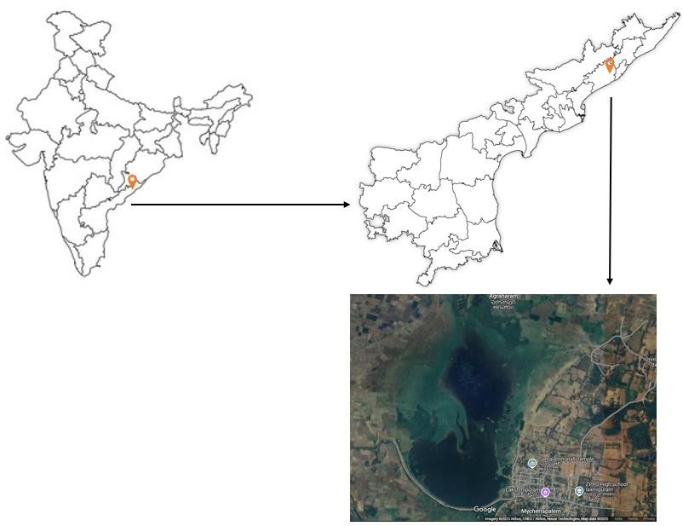

Image 1: A map of Lakshmipuram Lake, Lakshmipuram village, Anakapalli district, Andhra Pradesh, India. Image credits to Google Maps and BurningCompass.Com website

  - Physico-Chemical analysis
Physico-Chemical parameters such as temperature, pH, turbidity, conductance, salinity, alkalinity, total dissolved solids, hardness, BOD, COD, total suspended solids, chlorides, magnesium, nitrates and phosphates were analyzed in field and laboratory based on standard methods for the examination of water and wastewater during Jan 2024 to Dec 2024 (Pratap et al., 2025).

Phytoplankton analysis
The sample was examined thoroughly under an optical microscope for taxonomic analysis. The systematic identification of phytoplankton up to the species level was carried out using standard keys, standard textbooks, guides such as Edmondson (1959), Schumacher and Raleigh (1973), Palmer (1980) and Prescott (2008). Three diversity indices were used to obtain estimation of species diversity, species richness and species evenness.

Species Richness (S)
It gives the total number of species present in a sample.

Shannon-Wiener Diversity Index (Hˈ)
s
Hˈ = ̶ ⅀p_{i} ln p_{i} i= 1

where:
p_{i}: n_{i}/N
n_{i}: Number of individuals of species i
N: Total number of individuals of all species

This index accounts for both abundance and evenness.

Pielou’s Evenness Index (Jˈ)

Jˈ= Hˈ/ ln S
It measures how evenly individuals are distributed among species.

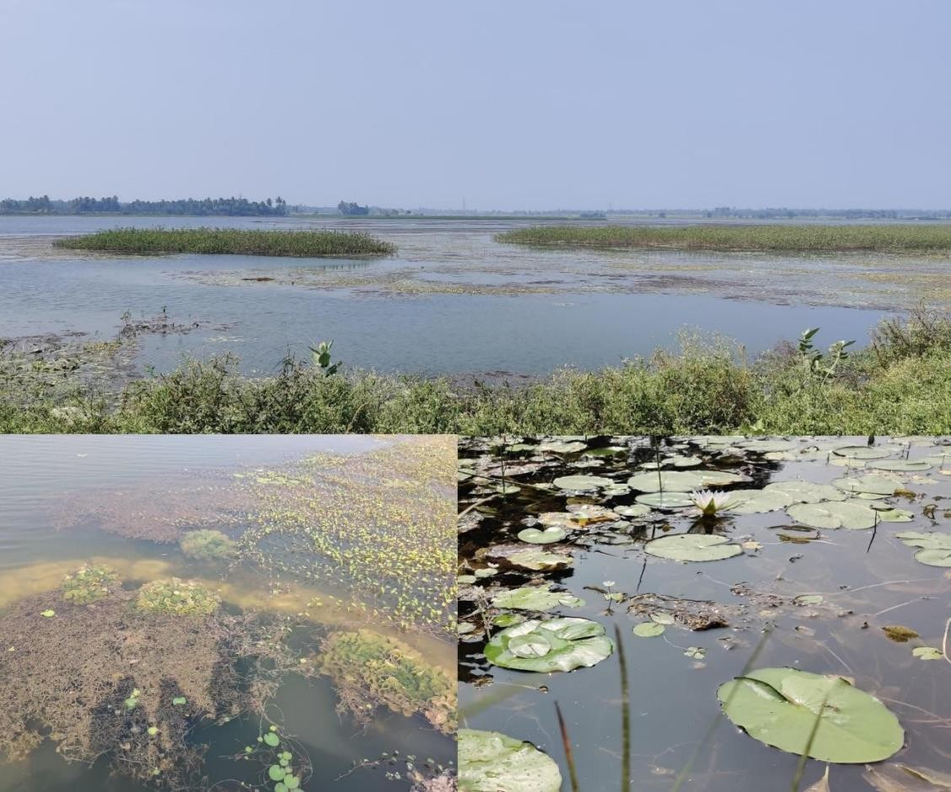
Image 2: Sampling sites of Lakshmipuram Lake, Anakapalli district, Andhra Pradesh, India

Results and Discussion
The present study analysed the phytoplankton diversity in Lakshmipuram lake between January 2024 to December 2024. Microscopic examination of phytoplankton revealed that there were classes consisting of 29 genera of phytoplankton belongs to Bacillariophyceae (6 genera), Chlorophyceae (15 genera) and Cyanophyceae (8 genera). List of species observed in the lake were given in Table 1.
The species observed were: Navicula sp., Pinnularia sp., Synendra sp., Diatoma sp., Cymbella sp. and Fragilaria sp., (Bacillariophyceae); Volvox sp., Eudorina sp., Pandorina sp., Chlamydomonas sp., Cosmariam sp., Spirogyra sp., Closterium sp., Spirogonium sp., Scendesmus sp., Ankistrodesmus sp., Pediastrum sp., Oocystis colonie sp., Oedogonium sp., Mougeotia sp., Rhizoclonium sp., (Chlorophyceae); Microcystis sp., Chroococcus sp., Oscillatoria sp., Spirulina sp., Nostoc sp., Anabaena sp., Rivularia sp., Gloeotrichia sp., (Cyanophyceae).

Table 1: Species Composition of Phytoplankton in Lakshmipuram Lake
S. NO | Class | Order | Genera
1 | Bacillariophyceae | Diatoms | Navicula sp.
2 | Bacillariophyceae | Diatoms | Pinnularia sp.
3 | Bacillariophyceae | Diatoms | Synendra sp.
4 | Bacillariophyceae | Diatoms | Diatoma sp.
5 | Bacillariophyceae | Diatoms | Cymbella sp.
6 | Bacillariophyceae | Diatoms | Fragilaria sp.
7 | Chlorophyceae | Volvocales | Volvox sp.
8 | Chlorophyceae | Volvocales | Eudorina sp.
9 | Chlorophyceae | Volvocales | Pandorina sp.
10 | Chlorophyceae | Volvocales | Chlamydomonas sp.
11 | Chlorophyceae | Congugales | Cosmariam sp.
12 | Chlorophyceae | Congugales | Spirogyra sp.
13 | Chlorophyceae | Congugales | Closterium sp.
14 | Chlorophyceae | Congugales | Spirogonium sp.
15 | Chlorophyceae | Chlorococcales | Scendesmus sp.
16 | Chlorophyceae | Chlorococcales | Ankistrodesmus sp.
17 | Chlorophyceae | Chlorococcales | Pediastrum sp.

18 |  |  | Oocystis colonie sp.
19 |  | Oedogoniales | Oedogonium sp.
20 |  | Oedogoniales | Mougeotia sp.
21 |  | Oedogoniales | Rhizoclonium sp.
22 | Cyanophyceae | Chroococcales | Microcystis sp.
23 | Cyanophyceae | Chroococcales | Chroococcus sp.
24 | Cyanophyceae | Hormogoniales | Oscillatoria sp.
25 | Cyanophyceae | Hormogoniales | Spirulina sp
26 | Cyanophyceae | Nostocales | Nostoc sp.
27 | Cyanophyceae | Nostocales | Anabaena sp.
28 | Cyanophyceae | Nostocales | Rivularia sp.
29 | Cyanophyceae | Nostocales | Gloeotrichia sp.

A number of previous year studies focused on phytoplankton diversity reported that there were 48 taxa phytoplankton belonging to Bacillariophyceae, Dinophyceae, Chlorophyceae and Cyanophyceae identified in Mahakam Delta, East Kalimantan (Effendi et al., 2016); a total of 42 genera of phytoplankton were observed and identified belongs to Chlorophyceae, Bacillariophyceae, and Myxophyceae in Kondakarla Lake, Andhra Pradesh (Vinay Sagar & Kameswara Rao, 2019); 36 taxa were identified in which 19 belonged to Chlorophyceae, 10 to Cyanophyceae, 6 to Bacillariophyceae and 1 to Euglenophyceae in Chatla Floodplain Lake, Assam (Acharjee et al., 2021); a total of 54 phytoplankton species include 38 diatoms, 9 dinoflagellates, 3 green algae, and 4 blue- green algae in Swarnamukhi River Estuary, Nellore, India (Ratnam et al., 2022); 58 species of microalgae belonging to 4 classes such as Chlorophyceae, Bacillariophyceae, Cyanophyceae and Euglenophyceae in Kasipatnam Temple Stream, Kasipatnam,

Anathagiri Mandal, Visakhapatnam (Dist), Andhra Pradesh, India (Ponnaganti et., 2023); a total of 39 species belonging to 5 taxonomic groups were identified: Chlorophyceae, Bacillariophyceae, Cyanophyceae, Euglenophyceae, and Xanthophyceae in Downstream Region of Meenachil River, Kerala (Mani and Sebastian 2023); a total of 39 species belonging to 5 taxonomic groups were identified: Chlorophyceae, Bacillariophyceae, Cyanophyceae, Euglenophyceae, and Xanthophyceae in Midstream Region of Meenachil River, Kerala (Mani and Sebastian 2023); a total of 50 genera of planktons were found belongs to Chlorophyta, Cyanophyta, and Bacillariophyta in Bornadi River Basin, Assam (Pathak et al., 2025); a total of 3 groups of phytoplankton were found such as Chlorophyceae, Cyanophyceae, and Bacillariophyceae in Devarjan Reservoir, Udgir (Nagpurne Vinay S. and Allapure R. B. 2025); a total of 3 groups of phytoplankton were found such as Cyanophyceae, Chlorophyceae, and Bacillariophyceae in Ranchi Lake (Verma and Nag 2025).
In this present study, the number and percentage composition of order and genera under different classes is shown in Table 2 . Among three classes, the class Chlorophyceae has dominated with 4 orders and 15 genera contributing to 50% and 51.7% respectively followed by Cyanophyceae with 3 order and 8 genera contributing to 37.5% and 27.6% respectively and Bacillariophyceae with 1 order and 6 genera contributing to 12.5% and 20.7% respectively.

Table 2: The number and percentage composition of order and genera under different classes

Sl. No | Class | Order | Genera | Order % | Family %
1 | Bacillariophyceae | 1 | 6 | 12.5 | 20.7
2 | Chlorophyceae | 4 | 15 | 50 | 51.7
3 | Cyanophyceae | 3 | 8 | 37.5 | 27.6

In this present investigation, the phytoplankton fluctuates seasonally and its productivity was high during pre-monsoon and low in monsoon (Image 3). Chlorophyceae is dominated in pre-monsoon (854) and least in monsoon (344) with a total of 1798 including post-monsoon contributing 43.17% of total phytoplanktons. Next followed by Cyanophyceae: pre-monsoon (729), monsoon (344) and post-monsoon (600) with a total of 1586 contributing 38.00%; Bacillariophyceae: pre-monsoon (382), monsoon (154) and post-monsoon (247) with a total of 783 contributes to 18.80% of total phytoplanktons during the study period. The high concentration of phytoplankton during pre-monsoon season can be due to increased levels of salinity, temperature, pH, alkalinity, TDS, hardness, chlorides, nitrates and phosphorus. The low concentration of phytoplankton

can be due to high rainfall, reduced salinity, pH, temperature (Pratap et al., 2025). During the pre-monsoon season, Chlorophyceae dominated the phytoplankton community, likely due to higher temperatures, increased light penetration, and nutrient availability that favored photosynthetic activity and algal growth. In contrast, the monsoon season Bacillariophyceae recorded the lowest phytoplankton abundance. This decline can be attributed to increased turbidity from surface runoff, reduced light availability, and dilution of nutrients due to heavy rainfall. However, under these stress conditions, Cyanophyceae showed increased representation, as they are more tolerant to low light and fluctuating DO levels. The post-monsoon period witnessed a recovery in phytoplankton diversity and abundance, with Chlorophyceae once again becoming dominant, accompanied by an increased presence of Cyanophyceae and Bacillariophyceae.
Studies reported that the summer is the most suitable season for the growth of phytoplankton in freshwater lakes because of long duration of light, increased salinity, pH and trophotropic activities . Conversely, in late summer and monsoon season, the production of phytoplankton reduced because of heavy rainfall, high turbidity, reduced salinity, temperature and pH (Saravanakumar et al., 2008).

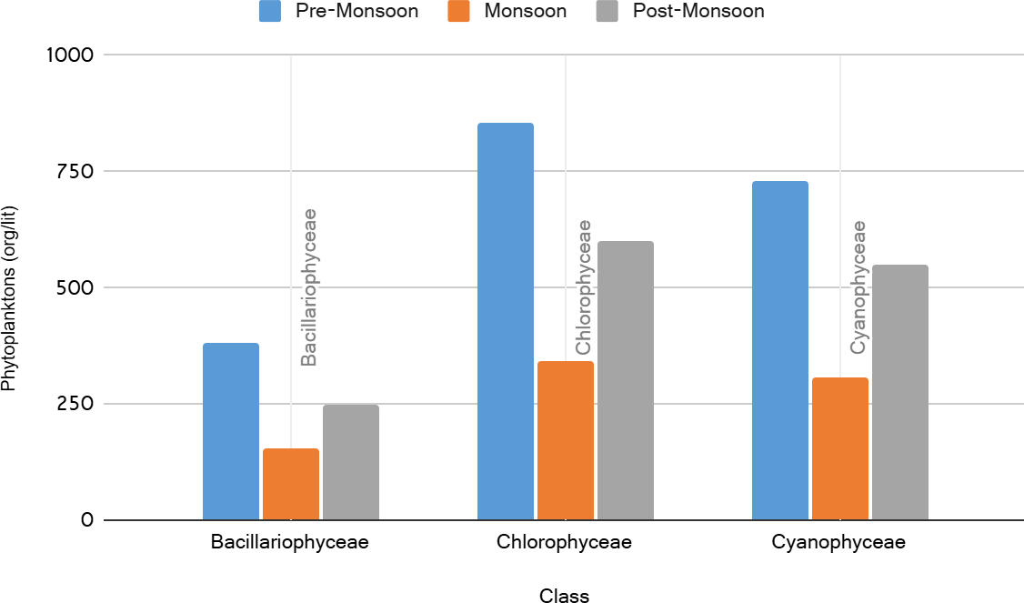

Image 3: Graphical representation of seasonal variations of phytoplanktons (orgs/liter) at Lakshmipuram Lake during Jan 2024 to Dec 2024
Similar observations are recorded in Riwada Reservoir, Visakhapatnam with a dominated phytoplankton high during pre-monsoon and low in monsoon (Kaparapu J. and Rao M.

N. G. 2013); a study revealed that the pre-monsoon season had a higher abundance of phytoplankton with 39 species, while the monsoon season had only 27 species in Midstream Region of Meenachil River, Kerala (Mani and Sebastian 2023); Maximum growth of phytoplankton population was recorded in post-monsoon and minimum during monsoon period at freshwater wetlands of Birbhum district, West Bengal (Garai et al., 2022).
Diversity indices results indicate that, among the three seasons pre-monsoon has highest diversity index (Hˈ= 1.0483) and highest evenness index (Jˈ= 0.31131); post-monsoon has highest species richness (S= 25), lowest diversity (Hˈ= 1.0363) and lowest evenness (Jˈ= 0.3077); Monsoon has lowest species richness (S= 20), (Hˈ= 1.0473), (Jˈ=0.3110). The average (Hˈ= 1.043) shows that phytoplanktons exhibiting moderate diversity and (Jˈ= 0.310) shows moderate evenness in Lakshmipuram Lake.

Table 3: Seasonal variations of phytoplanktons, biodiversity indices at Lakshmipuram Lake during Jan 2024 to Dec 2024

S. No | Diversity Index | Pre-Monsoon | Monsoon | Post-Monsoon | Average
1 | Species Richness (S) | 22 | 20 | 25 | 22.33
2 | Shannon-Wiener  diversity index (Hˈ) | 1.0483 | 1.0473 | 1.0363 | 1.043
3 | Pielou's Evenness  Index (Jˈ) | 0.31131 | 0.31102 | 0.30775 | 0.310

- Conclusion
The present study offers a comprehensive assessment of phytoplankton diversity and seasonal variations in Lakshmipuram Lake over the period of one year (January to December 2024). A total of 29 genera belonging to three major classes Chlorophyceae, Cyanophyceae, and Bacillariophyceae were recorded, with Chlorophyceae emerging as the dominant group both in terms of diversity and abundance. Seasonal analysis revealed that phytoplankton productivity peaked during the pre-monsoon, likely due to favorable physicochemical conditions, and declined during the monsoon season.
The study also demonstrates notable seasonal fluctuations in diversity indices, where pre-monsoon recorded the highest Shannon-Wiener diversity (Hˈ=1.0483) and evenness (Jˈ=0.3113), suggesting a more stable and balanced phytoplankton community during this period. Although post-monsoon had the highest species richness (S=25), it showed

lower diversity and evenness, indicating a less uniform distribution of taxa. On the whole, the average diversity (Hˈ=1.043) and evenness (Jˈ=0.310) reflect a moderate level of phytoplankton diversity and distribution uniformity in the lake ecosystem.
These findings highlight the ecological significance of Lakshmipuram Lake as a moderately productive freshwater body that supports diverse phytoplankton communities, which are vital for the lake's trophic structure and overall ecological functioning. The seasonal variations observed emphasize the need for continuous monitoring, especially in the context of climatic and anthropogenic pressures, to safeguard the lake’s ecological balance and productivity.

DISCLAIMER (ARTIFICIAL INTELLIGENCE)
Author(s) hereby declares that NO generated AI technologies such as Large Language Models (ChatGPT, COPILOT, etc.,) and text-to-image generators have been used during writing or editing of this manuscript.

Reference

- Acharjee, B., Laskar, S. B., & Choudhury, A. H. (2021). Diversity Analysis of Phytoplankton Community in Relation to Physicochemical Characteristics of Chatla Floodplain Lake of District Cachar, Assam, North East India. Uttar Pradesh Journal of Zoology, 42(24), 672–682.
- Edmondson, W.T. (1959) Freshwater Biology. John Wiley and Sons Inc., New York, 1248 p.
- Effendi, H., Kawaroe, M., Lestari, D.F., Mursalin., and Permandi, T. (2016). Distribution of phytoplankton diversity and abundance in Mahakam Delta, East Kalimantan. Procedia Environmental Science, 33, 496-504.
- Garai, S., Bose, R., and Pal, R. (2022). Seasonal Variation in Phytoplankton Diversity of Freshwater Wetlands of Birbhum District, West Bengal. J. Botan. Soc. Bengal. 76(2), 25- 42.
- Jenkins, S. H. (1982). Standard Methods for the Examination of Water and Wastewater.
- Water Research, 16(10), 1495–1496.

- Kaparapu J. and Rao M. N. G. (2013). Seasonal Distribution of Phytoplankton in Riwada Reservoir, Visakhapatnam, Andhra Pradesh, India. Notulae Scientia Biologicae. 5(3), 290-295.
- Mani, R. R., & Sebastian, S. (2023). Assessment of Phytoplankton Diversity in Downstream Region of Meenachil River, Kerala, During the Pre-monsoon and Monsoon Season. International Journal for Multidisciplinary Research, 5 (2), 1-5.
- Mani, R. R., & Sebastian, S. (2023). Phytoplankton Diversity in Midstream Region of Meenachil River, Kerala During Premonsoon And Monsoon Season. Uttar Pradesh Journal of Zoology, 44(5), 10-14.

Nagpurne Vinay S. and Allapure R. B. (2025). Studies on Phytoplankton Diversity in Devarjan Reservoir, Udgir (Maharashtra). Journal of Emerging Technologies and Innovative Research, 8(12), 137–141.
Ponnaganti, P. R., Kumar, P. R. & Geddada M. N. R. (2023). A Study on Diversity of Phytoplankton and Ecological Features of Temple Stream of Kasipatnam, Visakhapatnam (Dist), Andhra Pradesh, India. International Journal of Research and Review, 10(9), 560–568.
Palmer, M. C. (1977). Algae and Water Pollution: An Illustrated Manual on the Identification, Significance, and Control of Algae in Water Supplies and in Polluted Water. Municipal Environmental Research Laboratory, Office of Research and Development,
U.S. Environmental Protection Agency, 77(36), 124 p.

Pathak, D., Bhattacharya, A., & Sarkar, P. (2025). Plankton Diversity of Bornadi River Basin with Special Reference to Indo-Bhutan Landscape, BTR, Assam, India. Uttar Pradesh Journal of Zoology, 46(7), 306–318.
Pratap, G. V., Rao, T. B., Krishna, B., Lakshman, P., & Keerthana, B. (2025). Assessment of Physico-Chemical Characteristics of Lakshmipuram Lake, Anakapalli Dist., Andhra Pradesh, India. Uttar Pradesh Journal of Zoology, 46(5), 9–25.
Pratap, G. V., Rao, T. B., Prabha, Y. S., Keerthana, B., & Lakshman, P. (2025). A Study of Freshwater Ichthyofaunal Diversity of Lakshmipuram Lake in Anakapalli District of Andhra Pradesh, India. Uttar Pradesh Journal of Zoology, 46(8), 307–316.
Prescott, G. W. (2008). Algae of the western Great Lakes area.

Ratnam, K., Mol, L., Venkatnarayanan, N. S., Kumar, D., Dharani, N. G., & Devi, P. (2022). Seasonal variations influencing the abundance and diversity of plankton in the Swarnamukhi River Estuary, Nellore, India. Journal of Threatened Taxa, 14(2), 20615– 20624.
Saravanakumar, A., Rajkumar, M., Thivakaran, G.A., Serebiah, J.S. 2008. Abundance and Seasonal Variation of Phytoplankton in the Greek waters of Western Mangrove of Kachchh-Gujarat. J. Environ. Biol. 29, 271-274.
Schumacher, G. J., & Raleigh, N. (1973). A manual of fresh water algae. LA Whitford. Segunda Edición. Universidad de New York. Estados Unidos.
Verma, A. K., & Nag, A. K. (2025). Seasonal Dynamics of Phytoplankton Diversity in Ranchi Lake: Indicators of Water Quality and Ecosystem Health. Uttar Pradesh Journal of Zoology, 46(3), 32–39.

Vinay Sagar, B., & Kameswara Rao, K. (2019). An Assessment of Phytoplankton Diversity and Pollution Index Using Palmer’s Index in “Kondakarla Ava” Lake, Andhra Pradesh, India. Journal of Emerging Technologies and Innovative Research, 6 (5), 199- 211.

