RECENT RECORD OF GREATER FALSE VAMPIRE BAT
(LYRODERMALYRA, E. GEOFFROY,1810) IN THE LOWER SOUTH BANK PLAIN OF THE BRAHMAPUTRA VALLEY, ASSAM,INDIA.

Abstract:
The study of bats in India is often viewed as limited and underexplored. In 1810, French scientist E. Geoffroy published the first scientific description of the bat fauna of India, focusing on Lyroderma lyra sp. also known as Greater false vampire bat from Madras.This account is deemed the first documentation of the bat species present in the country. Subsequently, Hinton and Lindsay (1926) and Sinha (1999) reported sightings of the species in the few localities of Assam. The current research pinpointed three distinct roost sites (S-A; S-B; S-C) where L. lyra has been observed to roost in varied habitats. The species recorded from three distinct locations exhibits an average forearm length of 68.1±1.76 mm and an average body mass of 55.6±4.04 g. Lyroderma lyra is recognized by its bifid tragus and a long, upright, and simple noseleaf measuring 10. 8± 0.7 mm, which is significantly larger than the 6.5 mm noseleafin comparision to M. spasma(the other species in the Megadermatidae family). L. lyra, part of the Megadermatidae family, uses vision and passive listening to hunt prey, even in complete darkness.It plays a crucial role in pest and bio-resource management, regulating insect populations in forests and agro-ecosystems.
Keywords:Chiroptera, Megadermatidae, Morphometrics, Distribution,Assam.

Introduction

Chiroptera, a term coined by Blumenbach in 1779, refers to bats, which have true wings and are the only mammalian group capable of powered flight. Bats' development of wings is accompanied by structural changes in their musculoskeletal system, reflecting their volant lifestyle and upside-down roosting posture (Hill and Smith, 1984). Chiroptera, often known as bats, constitute one of the 29 existing orders of mammals (Wilson and Reeder, 2005) and represent a significant group in terms of evolutionary and zoogeographic considerations.Chiroptera are the most diverse and ubiquitous mammalian orderswith approximately 1400 extant species and more than 200 genera, accounts for 20-25% of all mammalian species and is second only to Rodentia in terms of species richness (Talmale and Saikia, 2018; Hutson et al., 2001). They live all throughout the world, with the exception of the Arctic, Antarctica, and some marine islands. The evolution of their wings has led to significant adaptations in their musculoskeletal structure, which supports their flying lifestyle and unique roosting behaviour of hanging upside down (Hill and Smith, 1984). Chiroptera is categorized into two suborders: Microchiroptera, which includes microbats, and Megachiroptera, comprising megabats. Microbats tend to be smaller in size and possess intricate laryngeal echolocation mechanisms that allow them to emit, detect, and interpret ultrasonic sounds. In contrast, megabats, often referred to as Old World fruit-bats, have superior vision and typically do not utilize echolocation, although a few species employ a distinct form of echolocation that relies on tongue-clicks (Springer et al. 2004). The Megadermatidae family is regarded as quite ancient, with fossil evidence indicating its existence around 37 million years ago. This family includes medium to large bats, ranging from 6.5 to 14.0 cm in head and body length. Commonly known as 'false vampires' or yellow-winged bats, they are easily recognized by their prominent, upright nose-leaf and large oval ears. Echolocation is a vital navigation technique for these bats, allowing them to produce high-frequency sounds that bounce off objects, providing crucial spatial awareness. The wings of Megadermatidae are generally short and broad, leading to a low aspect ratio and a relatively large surface area that improves their maneuverability. The second wing digit has a single phalanx, while the third digit has two. Bats in this family can roost in various settings, such as caves, rock crevices, buildings, or trees, and their roosting habits can be solitary or colonial. While many species are predominantly brown, some exhibit shades of white, bluish-grey, or olive-green, which helps them blend into their environments. Their diet mainly consists of insects, but they also eat a range of small vertebrates (Kunz, 1988, Sinha 1999; Salim et al. 2014; Shahbaz et al. 2020).
The revised inventory of bat species in India now lists a total of 134 species (Srinivasulu et al., 2024), of which over 74 of these species are recorded in Northeast India. India represents more than 90% of the bat diversity found in South Asia, while neighboring regions show less than 50% diversity (Molur et al., 2002). Specifically, Assam is home to 39 species across 16 genera, which comprise 5 megabats and 34 microbats (Ali, 2022; 2023). Recent studies have identified seven new species from Assam within the suborder Microchiroptera. A field survey in the Baksa district of Western Assam uncovered species such as Taphozousmelanopogon, Myotis muricola, Myotis horsfieldii, and aTylonycteris sp. Rahman and Choudhury (2017) documented six bat species in the Cachar District of western Assam, including Pteropusgiganteus, Cynopterus sphinx, Eonycterisspelaea, Megaderma lyra, Scotophilusheathii, andPipistrelluscoromandra. Furthermore, Talukdar and Choudhury (2017) recorded 26 bat species in the Patharia Hills Reserve Forest of southern Assam, indicating that some species may be less common than others based on secondary data. Additionally, Ali A. (2010) investigated the population dynamics of the Indian Flying Fox in Assam and later, in 2022, conducted a study on bat diversity in the region, highlighting the critical need for species conservation. The initial documentation of species distribution in Assam was carried out in Guijan, Tinsukia (Sinha, 1999), Polahbari (Hinton & Lindsay, 1926), and Dhubri (Ali, 2022) within the Brahmaputra Valley, as well as in the Cachar district (Rahman et al.,2020) of the Barak Valley. It is noteworthy that many of the newly identified species had previously been reported from various other states in Northeast India, with Bates and Harrison (1997) and Sinha (1999) providing detailed accounts of these findings. This study represents a pioneering effort to present an updated distribution record in the study area (Goalpara and South Kamrup) along with detailed morphological descriptions of the bat L. lyra.The new distribution records of L.lyra observed in the present study suggest the possibility of other similar species roosting along the lower southern bank plain of the Brahmaputra Valley in Assam.

Materials and Methods
Study Area
The Brahmaputra Valley comprises six distinct agroclimatic zones: the North Bank Plain Zone, Upper Brahmaputra Valley Zone, Central Brahmaputra Valley Zone, Hills Zone, Barak Valley Zone, and Lower Brahmaputra Valley Zone. Within the Lower Brahmaputra Valley Zone, there are subdivisions known as the Lower North Bank Plain and the Lower South Bank Plain. The Lower South Bank Plain encompasses three districts: Goalpara, South Kamrup (Rural), and South Salmara-Mankachar. The selection of Goalpara and a part of South Kamrup as the study area was primarily influenced by factors such as bat intensity and flight patterns, the extent of forest cover, and the proximity of these districts to the northern foothills of Meghalaya. The varied altitudinal landscape of the region fosters a rich diversity of natural vegetation and dense forests. Geographically, Goalpara is situated between 25°33' and 26°12' North latitude and 90°07' to 91°15' East longitude, whereas South Kamrup is located at 25.46° to 26.49° North latitude and 90.48° to 91.50° East longitude. Both districts are characterized by a sub-tropical humid climate, which features moderate temperatures during winter and hot conditions in summer. The onset of rainfall occurs in April, with summer temperatures fluctuating between 25 and 38°C, while winter temperatures range from 15 to 25°C.
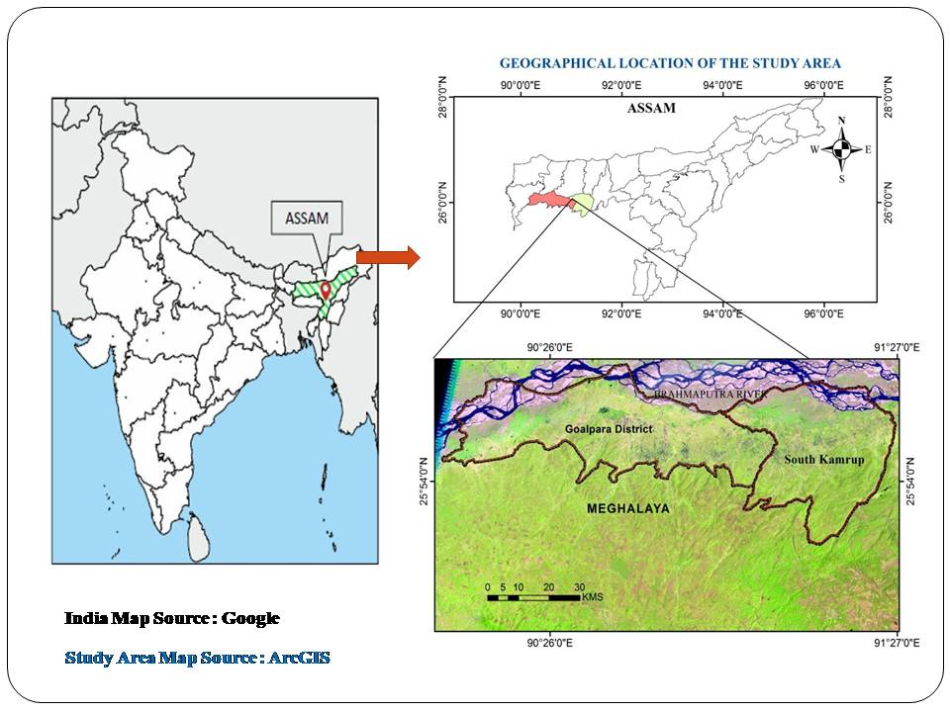

Fig.1. Illustrating the locational map of the study area (Goalpara& South Kamrup)
Data collection and analysis
A key informant provided information regarding the presence of the bat species (L. lyra) in the specified localities. The roosting sites were determined through site visits, during which photographs were captured to document the bats' behavior within these roosts. Three separate locations (S-A, S-B, and S-C) were identified as permanent and temporary habitats for the bats, and their geographical coordinates have been recorded. Hand net was used at Site-A (irrigation tunnel) by covering the entrance of the tunnel during the evening. For site B(under tin roof) and Site C (ceiling of House) a long butterfly net ( Extendable Handle – 59 inch and Net ring/ Net Dept- 12 inch/ 20 inch ) was used to capture bat. No bats were killed during the study and the specimen were left free after the required morphometric measurements were taken. All the measurements were done following Bates and Harrison(1997). Capturing was essential to record the necessary external morphometric measurements including body mass, head and body length, forearm and hind arm lengths,body width, ear length and width, tragus width, Nose-leaf and lengths of the second, third,fourth, and fifth metacarpals (Table 2) were measured using a digital millimeter caliper (Zhart :0- 300 mm) with an accuracy of up to 0.01 mm. A digital weighing scale was used to measure the weight of each specimen. The comprehensive acronyms for the morphometric measurements are represented in (Table 2). The mean and standard deviation are calculated for studied specimens, indicating the diversity or variability in the data set. Low standard deviations indicate data points are close to the mean, while high standard deviations indicate greater variability.The mean or average value for the measurement range is initially calculated, followed by the standard deviation, which is then calculated using an online software tool (calculator.net). These finding were also compared with Bates and Harrison (1997), Roberts (1997) and Srinivasalu et al. (2010).
Result and Discussion
L. lyra was recorded at three distinct roosting locations within the surveyed region of Assam. The data presented in Table 1 illustrates the presence and distribution of L. lyra across these sites (S-A, S-B, and S-C). This marks the first documentation of the species' distribution in these study area, highlighting the potential for discovering additional species that may flourish in the diverse habitats of this region. This constitutes a new distribution record for the species in the lower southern bank plain of the Brahmaputra valley.
Table 1:Depicts the Geographical locations of the Survey site ( S-A, S-B and S-C)
and the roosttypes of L. lyra.

Site | Village | Revenue Circle of Goalpara& South Kamrup district | Lattitude& Longitude | Roost types.
S-A | Khara Pt-2 | Dudhnoi | 26.0009° N, 90.7794° E | Irrigation Tunnel
S-B | Doshara Korea | Lakhipur | 26.0956° N, 90.3595° E | Under the Tin Roof
S-C | Malancha | Nagarbera | 22.5005° N, 88.7674° E | Ceiling of House

From table 1.Site (S-A) serves as the permanent roost for the species, while Sites (S-B and S-C) are temporary roosts with sporadic sightings. The greater false vampire bat, also referred to as the gleaning bat, generally employs a 'sit and wait' approach when foraging. Due to their wing structure, continuous flight is energy-intensive. They tend to catch prey from the ground and water surfaces. L. lyra employs various hunting methods, capturing approximately 85% of its prey during brief searching flights while hovering about half a meter above the ground. This bat relies on echolocation during its attacks, but at emission rates significantly lower than those of other gleaning bats (Vanitharani et al., 2015). The specimens observed in this study were all located roosting near human habitation at Site (S-A) and within the human campus at Sites (S-B and S-C).

Table 2: Body mass (g), external morphometrics (mm),Mean and Standard deviation
of Lyroderma lyra captured from the distinct survey sites (S-A; S-B ;S-C).

Body Parameters | Site 1  (S-A) | Site 2  (S-B) | Site 3  (S-3) | Mean ± S.D
External measurements | (mm) | (mm) | (mm) | (mm)
Body mass (g) | 52 | 55 | 60 | 55.6 ± 4.04
Head and body | 80.7 | 84.8 | 85.3 | 83.6 ± 2.52
Ear | 35.5 | 38.19 | 39.5 | 37.7 ± 2.03
Forearm length | 67.3 | 66.9 | 70.14 | 68.1 ± 1.76
Hindfoot | 18 | 16.7 | 18.9 | 17.8 ± 1.10
Thumb length | 11 | 10.5 | 11.7 | 11.06 ± 0.60
Length of 3rd metacarpal | 52.3 | 51.8 | 53.2 | 52.4 ± 0.70
1st phalanx on 3rd metacarpal | 31.7 | 33.5 | 35.1 | 33.4 ± 1.70
2nd phgalanx on 3rd metacarpal | 39.3 | 39.9 | 40.2 | 39.8 ± 0.45
Length of 4th metacarpal | 55.1 | 55.7 | 56.8 | 55.8 ± 0.86
1st phalanx on 4th metacarpal | 20.9 | 21.4 | 22 | 21.4 ± 0.55
2nd phalanx on 4th metacarpal | 23.8 | 22.2 | 24.7 | 23.5 ± 1.26
Length of 5th metacarpal | 60.7 | 61.12 | 62.6 | 61.4 ± 0.99
1st phalanx on 5th metacarpal | 21.1 | 22.3 | 23.5 | 22.3 ± 1.2
2nd phalanx on 5th metacarpal | 20.3 | 20.8 | 21.6 | 20.5±0.25
Tibia length | 34.6 | 35.2 | 35.91 | 35.2 ± 0.65
Nose leaf | 10 | 11.1 | 11.3 | 10.8 ± 0.7
* Acronyms of the measurements are in mm and S.D= Standard Deviation

Detailed morphometric parameters from table 2 reveals that measuring an average of 68.1 mm (ranging from 67.3 to 70.14 mm), this bat species is notably large within the study area. Its significant size distinguishes it from the closely related M. spasma. L. lyra features large, rounded ears that meet just above the forehead, adorned with a fringe of white hairs. The noseleaf, measuring 10.8 mm, is simple and upright, considerably larger than the 6.5 mm found in M. spasma.The fur is soft, displaying a lighter shade on the back and a mouse gray color on the underside. This species is characterized by the absence of a tail, yet it features a well-formed interfemoral membrane along with long, fine, and silky fur. The average body weight of the specimens (n=3) is noted to be 55.6 ± 4.04mm. Distinctive traits of this species include a bifid tragus, a rounded anterior noseleaf, large well-developed oval ears that are joined above the forehead, a forked tragus, and a significant interfemoral membrane, while it notably lacks a bony tail (Bates & Harrison, 1997; Wilson & Reeder, 2011).
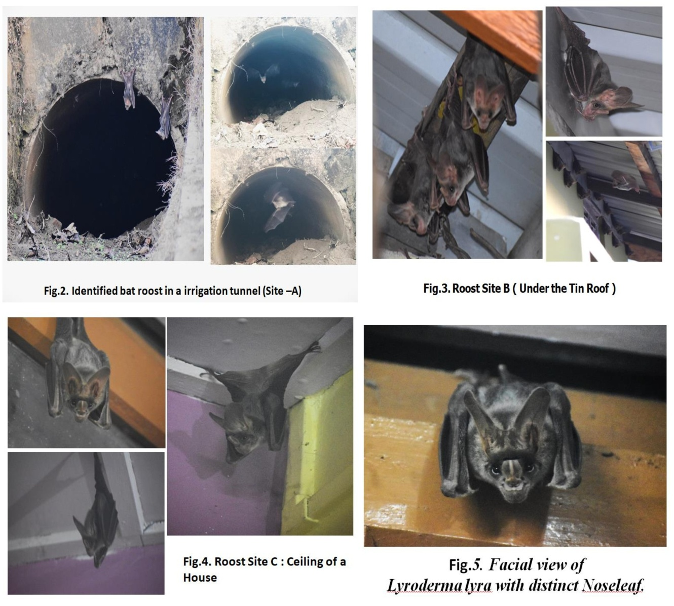

Fig.2. Illustrating the presence of L lyra at different roost sites (Site A; Site B & Site C)

Table 3: Diagnostic morphological characteristics of the species L. lyra are compared to
previously published important literature on bats by Bates and Harrison
(1997), Robert (1997), and Srinivasulu et al. (2010).

Body Parameters | Present Study  (n=3) |  | Bates and Harrison, 1997 | Srinivasulu et al., 2010 | Robert, 1997
Body Parameters | Mean± S.D | Ranges | Mean (Range) | Range | Range
Body mass | 55.6 ± 4.04 | (52 - 60) | ----------- | ----------- | -----------
Head and body | 83.6± 2.52 | (80.7-85.3) | 82.8 (70.0-95.0) | 70.0-95.0 | 76-94
Ear | 37.7± 2.03 | (35.5-39.5) | 37.9( 31.5-45.0) | 31.5-45.0 | 33-40
Forearm length | 68.1± 1.76 | (67.3-70.14) | 66.4( 56.0-71.5) | 56.0-71.5 | 65-72
Hindfoot | 17.8± 1.10 | (16.7-18.9) | 16.7( 14.0-20.0) | 14.0-20.0 | -----------
Thumb length | 11.06± 0.60 | (10.5-11.7) | ----------- | ----------- | -----------
Length of 3rd metacarpal | 52.4± 0.70 | (51.8-52.3) | ----------- | ----------- | -----------
1st phalanx on 3rd metacarpal | 33.4± 1.70 | (31.7-35.1) | ----------- | ----------- | -----------
2nd phalanx on 3rd metacarpal | 39.8± 0.45 | (39.3-40.2) | ----------- | ----------- | -----------
Length of 4th metacarpal | 55.8± 0.86 | (55.1-56.8) | ----------- | ----------- | -----------
1st phalanx on 4th metacarpal | 21.4± 0.55 | (20.9-22) | ----------- | ----------- | -----------
2nd phalanx on 4th metacarpal | 23.5± 1.26 | (22.2-24.7) | ----------- | ----------- | -----------
Length of 5th metacarpal | 61.4± 0.99 | (60.7-62.6) | ----------- | ----------- | -----------
1st phalanx on 5th metacarpal | 22.3± 1.2 | (21.1-23.5) | ----------- | ----------- | -----------
2nd phalanx on 5th metacarpal | 20.56± 0.25 | ( 20.3-21.6) | ----------- | ----------- | -----------
Tibia length | 35.2±0.65 | (34.6-35.91) | ----------- | ----------- | -----------
Nose leaf | 10.8±0.7 | (11.6-12.8) | ----------- | ----------- | -----------

The findings presented in Table 3 clearly indicate that the data for all morphometric parameters observed in this study fall within the ranges established by Bates and Harrison (1997), Srinivasulu et al. (2010) and Robert (1997). The greater false vampire being the gleaning bat, most of the time they prefer ‘sit and wait’ method of foraging. They prefer to capture prey from ground and water surfaces. L. lyra is mostly carnivorous, with a diet consisting of large insects, spiders, and small vertebrates such as bats, birds, rodents, and small fishes (Vanitharani et al. 2015).
In brief searching flights, the prey captures roughly 85% of its prey while hovering about half a meter over the ground. It also waits for victims by perching two meters or so above the ground using a sit-and-wait tactic. This bat uses echolocation throughout attacks but at emission rates much lower than those of other gleaning bats.L. lyra forages and devours insects throughout its accessible range and their echolocation ability enables it to capture and handle prey effectively. Wings morphology and variability in flight style is also a good indicator of a bat diet inclination (Francis, 2008).Variety of habitats including lowland rainforests and dry forests. It seems to be fairly tolerant of disturbance and often occurs near human disturbed areas.
India, Nepal, Pakistan, and Sri Lanka are among the countries in the worldwide distribution. With the exception of the high Himalayas, it is found all throughout India. The distribution of the species in Assam was first recorded in Tinsukia (Sinha, 1999); Polahbari (Hinton & Lindsay, 1926), and Dhubri (Ali, A., 2022) within the Brahmaputra valley, as well as in the Cachar district (Rahman et al., 2020) of the Barak Valley. Nevertheless, most of the newly identified species had been previously documented in several other states of Northeast India, with Bates and Harrison (1997) and Sinha (1999) offering comprehensive insights into these observations. The current study (Table 1) also includes records from the Goalpara district and South Kamrup district located in the lower south bank plain of the Brahmaputra valley.

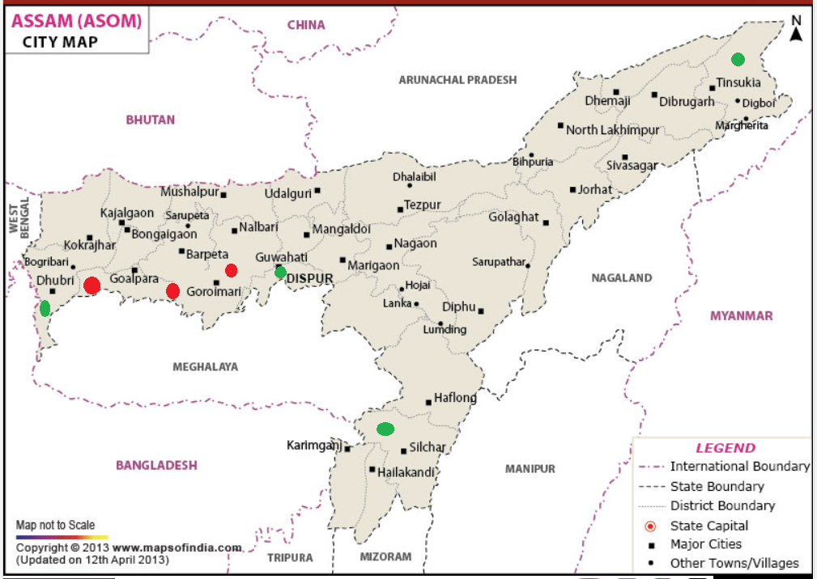

Fig.3. Red oval-shaped dots on the map indicate the new distribution records from the current study, whereas green oval-shaped dots represent the previous distribution records in Assam.

Conclusion:
Research on the ecological roles of bats has been limited until recently, and their macroecological dynamics in the South Bank Plain of the Brahmaputra Valley in Assam remain inadequately explored, despite their diversity and importance as ecological indicators and providers of ecosystem services. The resurgence of Lyroderma lyra in the lower South Bank Plain of the Brahmaputra Valley highlights the species' adaptability to various habitats and its critical role in pest and insect control. This study aims to bridge the knowledge gap regarding species presence and habitat diversity, thereby enhancing our understanding of the ecological responses of this species to roosting and potentially fostering greater species diversity in the region. Such information is vital for assessing vulnerability and formulating effective conservation strategies. The population status and prevalence of bats in the study area can inform evaluations of species diversity and public attitudes towards bat conservation. Members of the Megadermatidae family are pivotal in managing insect populations within forest and agro-ecosystems. While Lyroderma lyra may significantly contribute to pest management, further investigation is necessary to evaluate its potential as a biocontrol agent, as this insectivorous bat provides ecological advantages in both agricultural and urban environments by preying on arthropod pests.
Disclaimer (Artificial intelligence)
Author(s) hereby declare that NO generative AI technologies such as Large Language Models (ChatGPT, COPILOT, etc.) and text-to-image generators have been used during the writing or editing of this manuscript.
References
Ali, A. (2022). Species diversity of bats (Mammalia: Chiroptera) in Assam, Northeast India.
Journal of Wildlife and Biodiversity , 6,115-125.https://doi.org/10.5281/zenodo.6603976
Ali, A. (2023). First distributional record of Greater false vampire bat (Lyroderma lyra Geoffroy, 1810) from the Dhubri district of Assam, Northeast India. Journal of Wildlife and Biodiversity, 7( 3),1-9.
Bates,P.J.J.,& Harrison, D.L. (1997). Bats of the Indian Subcontinent, Harrison Zoological
Museum Publications, Sevenoaks, UK: 1- 258
Bat Conservation International, (BCI).(2022). An Unlikely Hero with Global Impact,
Available online: https://www.batcon.org/about-bats/bats-101/
[Accessed on 25 March 2023].

Boro, A., Saikia,P.K.,& Saikia, U. (2015). A preliminary assessment of bat diversity and
people's attitude towards their conservation in Baksa district, Western Assam.
KeaneanJournal of Science, 4: 3-8.

Boro,A., Saikia, P.K., Saikia, U. (2018). New records of bats (Mammalia: Chiroptera) from
Assam, Northeastern India with a distribution list of bat fauna of the state.Journal of
Threatened Taxa. 10 (5) :11606–11612.

Brosset, A. (1963). The bats of Central and Western India. Part IV. J. Bombay nat. Hist. Soc.
60 (2): 337 – 355.

Csorba, G., and Bates, P.J.J. (1995). A new subspecies of the Horseshoe bat Rhinolophus
macrotis from Pakistan (Chiroptera, Rhinolophidae). Acta Zoologica Academy
ScientorumHungaricae, 41(3): 285-293.

Corbet, G.B., and Hill,J.E.(1992). The Mammals of the Indomalayan Region. British
Museum (Natural History)/ Oxford University Press, London, 488.

Francis,C.M.(2008). A Field Guide to the Mammals of Southeast Asia. New Holland
Publishers (UK) Ltd, London, 392.

Hill, J.E., and Smith, J.D. (1984). Bats:A Natural History, British Museum (NaturalHistory),
London.

Hinton, M.A.C., Lindsay,H.M.(1926). Report No 41: Assam and Mishmi Hills. Bombay
Natural History Society’s Mammal Survey of India, Burma and Ceylon, Journal of the
Bombay Natural History Society, 31 : 383-403.

Hutson, A.M., Mickleburgh, S.P., and Racey, P.A.(2001). Microchiropteran Bats, Global Status
Survey and Conservation Action Plan, IUCN/SSC chiroptera specialist group, IUCN,
Gland, Switzerland.
Kock, D., Bhat, H.R. (1994). Hipposideroshypophyllus n. sp. of the H. bicolor-group from
peninsular India (Mammalia: Chiroptera: Hipposideridae), Senckenbergianabiologica,
73(2), 25-31.

Kunz, T.H., and Parsons,S. (1988). Ecological and behavioural methods for the study of bats.
1st ed. Smithsonian Institution Press, Washington, D.C,1-920.

Pradhan,M.S.(2008). Mammals In Fauna of Goa State, State Fauna Series, Publ.: Director,
Zool. Survey. India, Kolkata, 16 : 431-496.

Rahman, A., Choudhury, P. (2017). Status and population trend of chiropterans in Southern
Assam, India, Biodiversity International Journal, 1(4):121-132.

Roberts, T.J. (1977). The Mammals of Pakistan. Ernest Benn Ltd : 361.

Srinivasulu, C., Srinivasulu,B.(2020). "Lyroderma lyra". IUCN Red List of Threatened Species.

Srinivasulu, C., Srinivasulu,A., & Srinivasulu, B. (2024). Checklist of the bats of India (v1.5). Journal of threatened taxa.

Salim, M., Hassan, M.M. (2014). Description of the first record of the Indian false vampire
bat (Megaderma lyra) E. Geoffroy, 1810 (Rhinopomatidae: Chiroptera) captured from
northwestern Pakistan. The Journal of Animal and Plant Sciences, 24(5):1374- 1379.

Shahbaz, M., Ullah, H., Khan, W., and Javid, A. (2020). Morphometrics of the indianfalse
vampire bat (Megaderma lyra) from district Jhelum, Pakistan. Brazilian Journal of
Biology (8).

Saikia,U. (2018). A review of Chiropterological studies and a distributional list of the Bat
Fauna of India, Rec. Zool. Surv. India, 118(3), 242-280.

Saikia,U.(2019). Demystifying bats from enigma to science, MOEF, Zoological Survey of
India, Shillong-Meghalaya, 1-13.

Saikia,U.,Reudi, M., Chakravarty, R., and Chaudhary,H.C.(2021). Bats of Meghalaya,
Published:Forest& Env. Department, Govt. of Meghalaya and Zoological survey
of India,Shillong : 180.

Sinha, Y.P. (1999). Contribution to the knowledge of Bats (Mammalia: Chiroptera) of
North Eastern Hills, India. Rec. Zool. Survey of India, Occ. Paper No. 174 :1-52.

Talmale, S.S,and Saikia,U.(2018). Fauna of India Checklist: A Checklist of Indian Bat
Species (Mammalia: Chiroptera), Zoological Survey of India :1-17

Vanitharani, J., Ponmalar,S.(2015). Indian False Vampire Bats (Carnivore), the
Health Managers of Forest and Agroecosystems, Scrutiny International Research
Journal of Biological and Environmental Science,2(8).

Wilson, D.E., and Reeder, D.M. (2011). Class Mammalia Linnaeus, 1758. In: Zhang, Z.-Q.
(Ed.) Animal biodiversity:An outline of higher-level classification and survey of
taxonomicrichness. Zootaxa, 3148: 56–60.

