Case report
SURGICAL MANAGEMENT OF CERVICO-VAGINAL PROLAPSE CONCURRENT WITH PYOMETRA IN A SIX-AND-A-HALF-YEAR-OLD LABRADOR CROSSBRED BITCH

ABSTRACT
A-six-and-half-year-old female Labrador crossbred dog was presented to the Veterinary Clinical Complex, Lakhimpur College of Veterinary Science, Assam Agricultural University, Joyhing with a two-day history of prolapsed mass visible through the vaginal route. The client revealed that, the animal exhibited straining followed by the appearance of a reddish, elongated mass protruding from the vaginal opening accompanied by sticky or milky discharge during the later stages of straining. Additionally, the dog had reduced appetite, frequent vomiting, and intermittent straining episodes. Clinical examination confirmed cervico-vaginal prolapse, with the protruded mass appearing edematous and hyperemic, though the urinary bladder was not involved. Further assessment included hemato-biochemical evaluation, along with ultrasonographic examinations of the abdominal and pelvic cavities. Imaging findings revealed anechoic spaces in the pelvic region, suggestive of pyometra. An exploratory laparotomy was performed through a caudal mid-ventral incision. During surgery, the prolapsed mass was repositioned into the pelvic cavity by gently pulling the uterine horn, following lubrication of the tissue with coconut oil to minimize trauma. Upon exploration, the uterus was confirmed to have open pyometra, necessitating a panhysterectomy (complete removal of the uterus and ovaries). The bitch recovered well post-operatively. Skin sutures were removed on the 14th day, and the surgical wound healed without complications. In this rare case of cervico-vaginal prolapse with pyometra, diagnostic imaging and hemato-biochemical analysis enabled accurate diagnosis. Prompt surgical intervention proved effective, preventing complications and ensuring a favorable prognosis.

Keywords: Bitch, Cervico-vaginal Prolapse, Pyometra, Panhysterectomy

- INTRODUCTION
Vaginal prolapse, also known as vaginal hyperplasia, hypertrophy, estrual hypertrophy, vaginal eversion, vaginal protrusion, or vaginal fold prolapse (VFP), is a condition characterized by the protrusion of edematous vaginal tissue through the vulva. This condition arises due to an exaggerated response of the vaginal mucosa to elevated estrogen levels. Although cervico-vaginal prolapse is relatively uncommon compared to other vaginal conditions, such as vaginal or urethral tumors that can obstruct the vaginal canal, it remains a significant clinical concern in female dogs (Manothaiudom and Johnston, 1991).Vaginal prolapse can occur in bitches of any breed or age, although it predominantly affects younger females under 2 to 3 years of age (Rani et al., 2004). There is also a noted hereditary predisposition, particularly in certain breeds, including brachycephalic breeds, Drahthaar, Kurzhaar, Caucasian Shepherd, and Doberman (Basera et al., 2020). This genetic susceptibility may be linked to inherent weaknesses in the perivulvar connective tissue (Feldman and nelson, 2004; Mostachio et al., 2007). Although precise data on the incidence of vaginal prolapse in bitches is limited, studies suggest that 8-12% of cases occur periparturient, while a majority (approximately 73-86%) occur during proestrus and estrus, with only sporadic cases reported during diestrus (Johnston et al., 2001). The occurrence of prolapse has also been associated with various factors, including prolonged labor (up to 48 hours post-parturition), pelvic muscle relaxation, physical trauma, severe tenesmus, and increased intra-abdominal pressure. Additional predisposing factors may include uterine disease, genetic influences, rough handling during delivery, abnormal connective tissue metabolism, constipation, or forced separation during coitus (Purswell, 2000). Interestingly, the condition is rarely observed during diestrus, anestrus, or normal pregnancy (Rani et al., 2004; Johnston et al., 2001)
Vaginal hyperplasia often resolves spontaneously during diestrus, but recurrence is frequent, with rates ranging from 66% to 100% in subsequent estrus cycles (Johnston et al., 2001). The treatment approach depends on the severity of the prolapse and the breeding potential of the affected bitch (Pettit, 1986). In some instances, owners may prefer a conservative approach, avoiding surgical intervention. However, ovariohysterectomy is widely recommended to prevent recurrence and is regarded as the best clinical practice (Haji et al., 2018). In severe cases, surgical intervention becomes necessary, with options including amputation of the prolapsed tissue or spaying. Such interventions aim not only to resolve the immediate condition but also to prevent recurrence and manage complications such as tissue necrosis and infection.
Pyometra is characterized by the accumulation of purulent exudate in the uterine lumen and is the most prevalent reproductive disease in canines (Hagman, 2018). Despite the high incidence of canine pyometra, its pathogenesis remains inadequately understood. It is evident, however, that this pathogenesis is multifactorial, involving bacterial infection, hormonal changes (or a favorable endocrine environment), genetic predisposition, and pre-existing uterine lesions (Santana & Santos, 2021). While the disease often begins with mild local symptoms, it can escalate into peritonitis, sepsis, and multi-organ dysfunction, thereby posing a significant threat to life. It's important to note that while cervical-vaginal prolapse can occur in dogs, its association with pyometra is rare and often involves underlying hormonal imbalances or tumors. Prompt veterinary evaluation and appropriate surgical intervention are crucial for a favorable outcome.

- CASE HISTORY

The owner reported that his six-and-a-half-year-old female crossbred Labrador had been mated approximately 65 days earlier. About 30 to 34 hours before presentation, the bitch began straining, after which reddish, elongated rounded mass was seen protruding from the vaginal opening. She was initially taken to a pet clinic in Itanagar and subsequently referred to the Veterinary Clinical Complex (VCC), LCVSc, AAU, Joyhing for further evaluation. On arrival, around prolapsed mass was visible through the vaginal route. Taking consideration of the anamnesis, on close observation and physically examined of the bitch, where it revealed the prolapsed part is containing vaginal floor, cervix and a little part of uterine body. The owner also reported that during the later part of straining, before prompting out of prolapsed mass some amount of sticky cloudy/milky type of discharges came out. Additionally, the bitch had reduced appetite, refusing solid or semi-solid food, and exhibited an increased tendency to emesis along with alternating episodes of straining. The bitch had a body weight of 22 kg, and showed anxiety with towards higher margin of normal values physiologic parameters that included rectal temperature (39.6˚C; reference: 37.5˚C - 39.2˚C), pulse rate (133 beats/min; reference: 80 - 120 beats/min) and respiratory rate (36 breaths/min; reference: 10 - 30 breaths/min). The lung sounds were normal following auscultation.
Considering the anamnesis and clinical observation and ultrasonographic examinations of the pelvic and abdominal region were performed to assess the alteration of uterine content and fetal health. Ultrasonographic imaging modalities (Sonosite, M-Turbo C, United States) revealed anechoic, circular spaces within the ventral and pelvic abdominal cavity, confirming the potential case of open pyometra. Further, 5 ml of blood samples were collected from cephalic vein for hemato-biochemical and hormonal analyses. The findings raised the possibility of either pyometra (accumulation of infected fluid within the uterus) or devitalization of fetal tissues. Hence, it was decided to go for exploratory laparotomy through caudal mid ventral incision.

- RESULT AND DISCUSSION

  - Management:

Prior to the procedure, informed consent was obtained from the client. The surgical site was aseptically prepared along the linea alba. The anesthetic regimen included Atropine sulfate at a dosage of 0.06 mg/kg body weight administered subcutaneously as a pre-anesthetic agent. Induction of anesthesia was achieved with a combination of Xylazine (1 mg/kg) and Ketamine (5 mg/kg) administered intramuscularly. Surgical anesthesia was maintained with supplementary intravenous doses of a Ketamine and Diazepam mixture, administered volume-to-volume as needed throughout the procedure. On exploration of the abdominal cavity it was found that the bitch was having swollen edematous pus containing uterus, confirming the case to be an open pyometra. Now the prolapsed mass was pushed back by lubricating the prolapsed mass with coconut oil into the pelvic cavity with simultaneously pulling of the uterine horn through the incision. The cervix was removed by transfixation ligature securing the cervical blood vessel ventrally positioned to the cervix followed by removal of both the ovaries with transfixation ligature securing ovarian artery and vein one by one along with transfixation ligature of the broad ligament’s blood vessels. The peritoneal cavity was thoroughly observed and examined to confirm no subsequent hemorrhage and the intestinal loops and the urinary bladder was placed in normal in situ. While manipulating the stressed urinary bladder and bringing back to its normal in situ which was distended with urine is simultaneously evacuated by normal micturition. The abdominal cavity was sprinkle with (Ceftriaxone & sulbactum antibiotic powder) as a precaution to avoid peritonitis. The surgical abdominal opening was secured by suturing with 5-0 poly galactin 910. Initially suturing the peritoneum separately followed by double layered suturing of the linea alba, along with additional layer suturing of rectus abdominis muscle, and subcuticular suturing of the dermis and fascia. The surgical incision was finally secured with lock stitch pattern suturing of the epidermal skin layer. The suture line was secured with antibiotic ointment application under sterile gauge bandage and adhesive tape cover. The patency of the intravenous route for drug administration was maintained with continuous infusion of normal saline and ringer’s lactate solution, and all the essential medication required following surgery like broad spectrum antibiotic (Ceftriaxone &sulbactum @15mg/kg body wt.), vitamin B complex, Antihistaminic and Analgesic were injected intravenously on the completion of the operation.

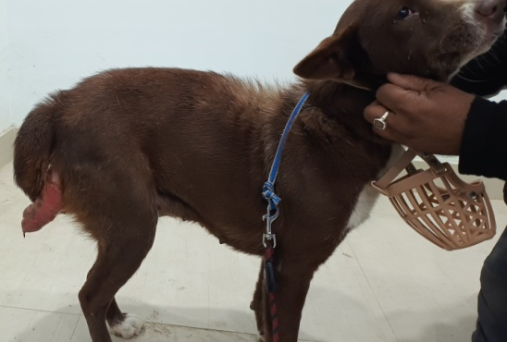  Fig: A | 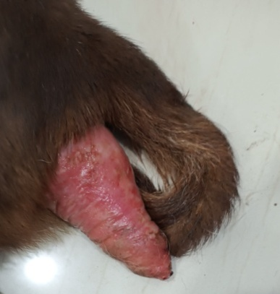  Fig: B
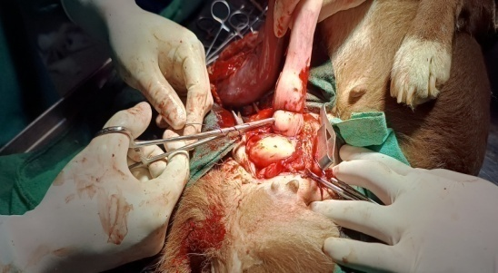  Fig: C | 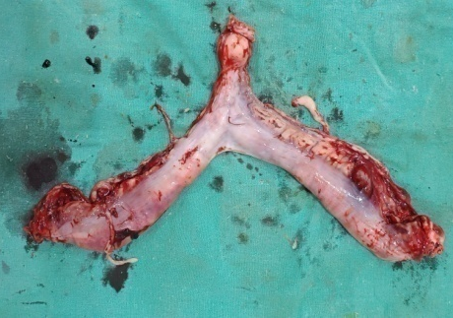  Fig: D
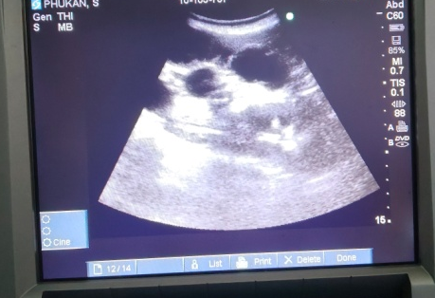
Fig: E

Fig A & B: Cervico-Vaginal Prolapse; Fig C: Surgical procedure of panhysterectomy (trasfixation ligature of cervix); Fig D: Removed uterine gland (pyometra); Fig E: USG confirming pyometra

The post operative course of above medication was maintained up to 7th day along with required fluid therapy by intravenous route. The surgical wound was treated with regular antiseptic dressing using antimicrobial ointment (Kiskin ointment) up to removal of the skin suture on complete and proper healing of the surgical wound up to 14 days post operatively. The bitch was maintained under easily digestible high energy and high protein diets of soft consistency along with oral supplementation of mineral & vitamin syrup (calcium, Phosphorus, Iron, Zinc, Vitamin D and B complex) one tsf orally twice daily for 15 days. On 14th day the skin suture was removed and the suture line was again secured with antimicrobial ointment for another 3-5 days to avoid any subsequent skin infection. To avoid further any post surgery complication like self mutalization of surgical wound by securing the bitch with an Elizabeth collar immediately after surgery and advice to remove when complete healing of the suture site is achieved. The whole surgical procedure recovered the animal successfully well during the post operative period and regained its healthy status post operatively.

  - Hematology:
Hematological study (Table: 1) revealed mild anemia as a result of low level of hemoglobin and Total Eosinophil Count (TEC) value. Anemia in the affected dog can result from red blood cell loss through diapedesis into the uterine lumen, in addition to reduced feed intake and impaired red blood cell production (erythropoiesis) under toxemic conditions in severe cases, as noted in previous studies (Dabhi et al., 2009; Jena et al., 2013). The PCV (packed cell volume) level was observed to be lower in dogs with pyometra, concurrent with the findings in other studies (Dabhi et al., 2009; Jena et al., 2013), potentially due to concurrent dehydration (Verstegen-Onclin & Verstegen, 2008). Significant neutrophilic, leukocytosis was detected, as the severe bacterial infection of pyometra stimulates the bone marrow to release additional neutrophils into circulation to fight the infection (Fransson et al., 1997). The percentages of lymphocytes and monocytes were reduced, likely due to the immunosuppression associated with pyometra (Faldtna et al., 2001).

Table: 1- Hemato-biochemical alteration in bitch
Parameters | Observed value | Normal Range
Hemoglobin (g/dl) | 9.82 | 11.9-18.9
TEC (10⁶/ mm³) | 4.76 | 5.5-8.5
PCV (%) | 29.05 | 35-57
Platelets (10⁵/ mm³) | 1.25 | 1.2-6
TLC (10³/ mm³) | 24.22 | 6-17
Neutrophil (10³/ mm³) | 21.20 | 3-11.5
Lymphocyte (10³/ mm³) | 1.87 | 1.0-4.8
Monocyte (10³/ mm³) | 0.63 | 0.2-1.3
Eosinophil (10³/ mm³) | 0.52 | 0.1-1.2
Creatinine (mg/dl) | 1.65 | 0.5-1.5
Urea (mg/dl) | 70.7 | 18-55
AST (U/L) | 65.5 | 9-49
ALT (U/L) | 55.4 | 8-57
ALP(U/L) | 125 | 10-90
Total protein (g/dl) | 7.8 | 5.4-7.1
Serum progesterone ( ng/mL) | 10.36 | 5 - 8
Serum estradiol (pg/mL) | 17.42 | < 10
(Sources: Merck Veterinary Manual & University of Prince Edward Island)

  - Biochemical analysis
In the present study biochemical parameters revealed slightly elevated Blood Urea Nitrogen (BUN) and creatinine level in serum which was in agreement with the findings of Bigliardi et al., 2004. Elevated BUN and creatinine might be due to toxaemia, in turn leading to decomposition of body protein as a result of suppurative process and reduced renal perfusion and dehydration as reported by (Gaykawad et al., 1999; Nath et al., 2009). Alkaline Phosphate (ALP) and Aspartate aminotransferase (AST) level in serum were found to be elevated in the bitch which might be due to hepatocellular damage caused by septicaemia and endotoxaemia, diminished hepatic circulation and cellular hypoxia due to dehydration in the bitches (Verstegen-Onclin & Verstegen, 2008). In this case, hyperproteinemia was suggested to be a result of the acute-phase response in the dog with pyometra (Gaykawad et al., 1999; Singh et al., 2006).
Additionally, the serum progesterone and estradiol levels were 10.36 ng/mL (reference range: >5 to 8 ng/mL) and 17.42 pg/mL (reference range: <10 pg/mL), respectively. In this study, the serum progesterone concentration (10.36 ng/mL) was typical of levels seen during diestrus, while the serum estradiol concentration (17.42 pg/mL) was similar to that of a female dog in estrus. Elevated serum estrogen during diestrus may have predisposed the dog in this report to developing pyometra. Estrogens enhance the endometrial response to progesterone by sensitizing progesterone receptors and amplifying progesterone's effects (Niskanen & thrusfield, 1998). Furthermore, since no treatments with estrogen or progesterone were administered to this dog, the pyometra could only have been triggered by endogenous estrogen production. The exact cause of cervico-vaginal prolapse is not fully understood; however, it tends to occur in dogs during periods of estrogenic stimulation (schutte, 1967; Johnson, 1998). Thus, cervico-vaginal prolapse in female dogs is generally associated with proestrus and estrus, though it can occasionally occur at the end of pregnancy (Johnston et al., 2001).

- Conclusion
In this uncommon instance of cervico-vaginal prolapse accompanied by pyometra, diagnostic imaging techniques and hemato-biochemical analyses proved essential for an accurate diagnosis. Appropriate surgical intervention was effective in managing the condition and preventing both trans-operative and post-operative complications. Timely diagnosis and surgical correction facilitated a positive prognosis, mitigating the risk of postoperative complications and potential mortality.

- Disclaimer (Artificial intelligence)
Author(s) hereby declare that NO generative AI technologies such as Large Language Models (ChatGPT, COPILOT, etc.) and text-to-image generators have been used during the writing or editing of this manuscript.

- References:

Basera, A., Pasha, A., Kumar, B., Agrawal, J.K., & Saxena, A. (2020). Management of vaginal prolapse in late gestation associated with difficult birth in a young bitch. Research Journal for Veterinary Practitioners, 8(3): 26-28.
Bigliardi, E., Parmigiani, E., Cavirani, S., Luppi, A., Bonati, L., & Corradi, A. (2004). Ultrasonography and cystic hyperplasia-pyometra complex in the bitch. Reproduction in Domestic Animals, 39(2), 136–140.
Dabhi, D. M., Dhami, A. J., Parikh, P. V., & Patil, D. B. (2009). Comparative evaluation of haematological parameters in healthy and pyometra affected bitches. Indian Journal of Animal Reproduction, 30(1), 70–72.
Faldyna, M., Laznicka, A., & Tomas, M. (2001). Immunosuppression in bitches with pyometra. Journal of Small Animal Practice, 42(1), 5–10.
Feldman, E. C., & Nelson, R. W. (2004). Vaginal defects, vaginitis and vaginal infection. In Canine and Feline Endocrinology and Reproduction (3rd ed., pp. 901–918). W. B. Saunders.
Fransson, B., Lagerstedt, A. S., Hellmen, E., & Jonsson, P. (1997). Bacteriological findings, blood chemistry profile and plasma endotoxin levels in bitches with pyometra or other uterine diseases. Journal of Veterinary Medicine, 44(7), 417–426.
Gayakawad, S. G., Ranganath, N., Jayadevappa, Srinivas, C. L., & Krishnaswamy. (1999). Observation on biochemical changes in canine pyometra. Indian Veterinary Journal, 76, 289–290.
Hagman, R. (2018). Pyometra in Small Animals. Veterinary Clinical Small Animal Practices 48(4), 639–661.
Haji, M. M., Borpujari, D., Talukdar, D. J., Ahmed, F. A., Lalrintluanga, K., & Sarma, K. (2018). Cystic endometrial hyperplasia – open pyometra complex in a female pug. Indian Journal of Animal Reproduction, 39(1), 63–65.
Jena, B., Rao, K. S., Reddy, K. C. S., & Raghavender, K. B. P. (2013). Comparative efficacy of various therapeutic protocols in the treatment of pyometra in bitches. Veterinarni Medicina, 58(5), 271–276.
Johnson, C. A. (1998). Disorders of the vagina and uterus. In R. W. Nelson & C. G. Couto (Eds.), Small Animal Internal Medicine (2nd ed., pp. 863–873). Mosby Inc.
Johnston, S. D., Kustritz, M. V. R., & Olson, P. N. S. (2001). Canine and Feline Theriogenology. W. B. Saunders Company.
Manothaiudom, K., & Johnston, S. D. (1991). Clinical approach to vaginal and vestibular masses in the bitch. Veterinary Clinics of North America: Small Animal Practice, 21(3), 509–521.
Merck Veterinary Manual. (n.d.). Hematologic reference ranges. Merck & Co., Inc.
Mostachio, G. Q., Vicente, W. R. R., Cardilli, D. J., Pires, E. A., &Toniollo, G. H. (2007). Anovulvar cleft and vaginal prolapse-hyperplasia in a bitch. Journal of Small Animal Practice, 48(12), 713–715.
Nath, K., Tiwari, S. K., Sharda, R., Garg, S., & Kalim, M. O. (2009). Pyometra induced biochemical changes in bitches. Indian Veterinary Journal, 86(8), 853–855.
Niskanen, M., & Thrusfield, M. V. (1998). Associations between age, parity, hormonal therapy and breed, and pyometra in Finnish dogs. Veterinary Record, 143(18), 493–498.
Pettit, G. D. (1986). Vagina and vulva. In D. A. Morrow (Ed.), Current Therapy in Theriogenology (Vol. 2, pp. 476–481). W. B. Saunders.
Purswell, B. J. (2000). Vaginal disorders. In S. J. Ettinger & E. C. Feldman (Eds.), Textbook of Veterinary Internal Medicine (pp. 1566–1571). W. B. Saunders Company.
Rani, R. U., Kathiresan, D., & Sivaseelan, S. (2004). Vaginal fold prolapse in a pregnant bitch and its surgical management. Indian Veterinary Journal, 81(12), 1390–1391.
Santana, C. H., & Santos R. L. (2021). Canine Pyometra—An Update and Revision of Diagnostic Terminology. Brazilian Journal of Veterinary Pathology, 14(1), 1–8.
Schutte, A. P. (1967). Vaginal prolapse in the bitch. Journal of the South African Veterinary Medical Association, 38, 197–203.
Singh, S., Dachich, H., & Sharma, G. D. (2006). Haemato-biochemical studies in cystic endometrial hyperplasia pyometra complex in canine. Indian Journal of Veterinary Pathology, 30, 46–48.
University of Prince Edward Island. (n.d.). Hematology – Reference intervals. Atlantic Veterinary College, Diagnostic Services.
Verstegen-Onclin, K., & Verstegen, J. (2008). Endocrinology of pregnancy in the dog: A review. Theriogenology, 70(3), 291–299.

