**Study on inter co-relation among aquatic insect diversity to vegetation and physico chemical parameter of lakes on Kaas Plateau, World Natural Heritage Site, Western Ghats, Maharashtra, India**

**Abstract**

Aquatic biodiversity plays a major role in maintaining the health of the ecosystem. Kass Plateau is one of the major biodiversity hotspots in the western ghats. The insects are sensitive to change, and alterations in chemical and physical factors in their habitat structure can impact their diversity. The present study investigated the interrelation between aquatic insect diversity and physiochemical parameters in four different lakes namely Kas Lake, Gay Talav, Sarwar/Kumudini Talav, and Bhadar Talav on the Kass Plateau. A total of 75 species belong to three orders. Odonata is being most dominant order with 42 species followed by the order Coleoptera with 25 species and the order Hemiptera accounting for 8 species. The water bodies also show the presence of aquatic plants foster environment. Additionally, physiochemical parameters of water such as temperature, pH, electrical conductivity, dissolved oxygen, hardness, turbidity, total dissolved solids (TDS) and alkalinity were recorded. The result concluded that unpolluted water bodies significantly contributed to the richness of aquatic insects.

**Key Words:** Aquatic insects, Physiochemical parameters, Kass Plateau, Ecological Indicators, Aquatic plants.

**Introduction:**

Aquatic biodiversity plays a major role in maintaining the health of the ecosystem. Aquatic insects stand out vital component thereby contributing to the cycling of nutrients, supplying food webs, and serving as bioindicators of water quality. It comprises order Trichoptera, Ephemeroptera, Odonata, Hemiptera, Coleoptera (Achuthan *et al.,* 2015). The aquatic ecosystem comprises freshwater bodies, marine water (salt) bodies, and those in between. Freshwater bodies include ponds, streams, rivers, lakes, and saltwater bodies (seas and oceans). While estuaries and lagoons fall in between (Adu & Oyeniyi, 2019). These water bodies are made up of living and non-living components interacting with each other for nutrients (nitrogen and phosphorus) and shelter (P. D., R. 2024). Compared to common and uncommon species, bioindicators are more tolerant to environmental change. They are sensitive enough to detect environmental change thanks to their tolerance, but they are also resilient enough to deal with some variability and represent the overall biotic response (Holt & Miller, 2011; Khan & Butt, 2022). Around the world, aquatic insects inhibit a variety of aquatic habitats such as rivers, fast-flowing streams, ponds and lakes (Chainey, 2004; Alkhayata *et al*., 2024). The insects are sensitive to change, and alterations in chemical and physical factors in their habitat structure can impact their diversity. In western ghats, various studies on aquatic insects have been carried out. The recent literature records of 33 species of Trichoptera (Pandher *et al.,* 2020), 3 species of Plecoptera (Babu and Subramanian 2020) and 17 species of Ephemeroptera (Sivaramakrishnan *et al.,* 2020), 63 species of aquatic and semi-aquatic Hemiptera (Basu et al., 2019) were reported to Maharashtra. Some researchers studied aquatic bugs and beetles in Maharashtra. A study conducted by (Sheth *et al*., 2018) reviewed the genus *Copelatus* in Maharashtra and reported 3 species from Kass Plateau. (Sheth *et al*., 2024) studied aquatic Coleoptera of Northern Western Ghats in which they recorded 69 species out of which 25 species were enlisted to Satara district so far. (Pawar *et al*., 2024; Payakka & Prommi, 2014) observed prey-predator diversity of paddy field, and recorded *Cybister sugillatus* Erichson, 1834 as a predator. (Kulkarni and Zade, 2020) Investigated 16 different species of insects and their feeding habitat in Ramala reservoir, Chadrapur. (Thaware *et al*., 2022) studies the role of aquatic insects in balancing food webs and enlisted 11 insects from Karadkhed Dam, Nanded. (Bhandare *et al*., 2022), recorded 16 species of insects belonging to 6 different orders from Ingale Pazar Lake, Sangali. (Rathod, 2022; Jarjees et al., 2019) observed the ecological role of aquatic insects in Vasant Sagar Reservoir in the Yavatamal district showcasing 7 species of aquatic insects. (Garg, 2022) investigated the role of physiochemical parameters in the diversity of coleopteran and hemipteran insects. (Deb *et al*., 2023) investigated aquatic beetles along with physiochemical parameters of Khadkwasla dam, Pune and enlisted 15 species of aquatic beetles. (Deb *et al.,* 2023) recorded 31 aquatic beetles along with water quality parameters of Indrayani River, Pune. Whereas, Maharashtra comprises 109 species of odonates out of 203 reported from western ghats (Subramanian *et al*., 2020; Komolafe & Imoobe, 2020). In Satara district (Sayyed, 2016) recorded 10 species of odonates belonging to 2 families. (Bhakare *et al*., 2021) discovered two new species of the damselfly of genus Euphaea from Thoseghar, Satara also observed by them in Kass Lake.

Kass Plateau is one of the major biodiversity hotspots in the western ghats. It is an example of a unique ecological niche famous for its seasonally blooming flowers. The plateau is an ideal grassland and higher elevated volcanic plateau formed of lateritic rock found in the Western Ghats supporting natural as well as man-made waterbodies. The plateau showcases one perennial Kass reservoir with a capacity of 1.2 TMC water storage which is used for domestic, drinking and irrigation purposes (Pawar and Sonawane, 2012) and several seasonal reservoirs such as Sarwar Talav, Bhadar Talav and Gay Talav along with some water bodies formed during monsoon. Previous studies have highlighted the importance of these water bodies as (Pawar and Sonawane 2012; Yadav, 2015) studied the zooplankton diversity of the Kass reservoir. These hydrological landscapes contributed to the aquatic freshwater diversity of Kass. (Shinde *et al*., 2014) recorded environmental issues regarding the Kass plateau and lake. Despite this, there are no studies have been done on aquatic across various habitats of the Kass plateau. On that account aim of this study is to assess the diversity of insects.

**Material And Methods**:

**Study area:** Kass Plateau is situated in the ranges of Sahyadri, 22 km away from Satara district. It is one of the important Sada’s at an average elevation of 1000 m between 17°43′12″N longitude 73°49′22″E latitude. The total area of 1,792 hectares.

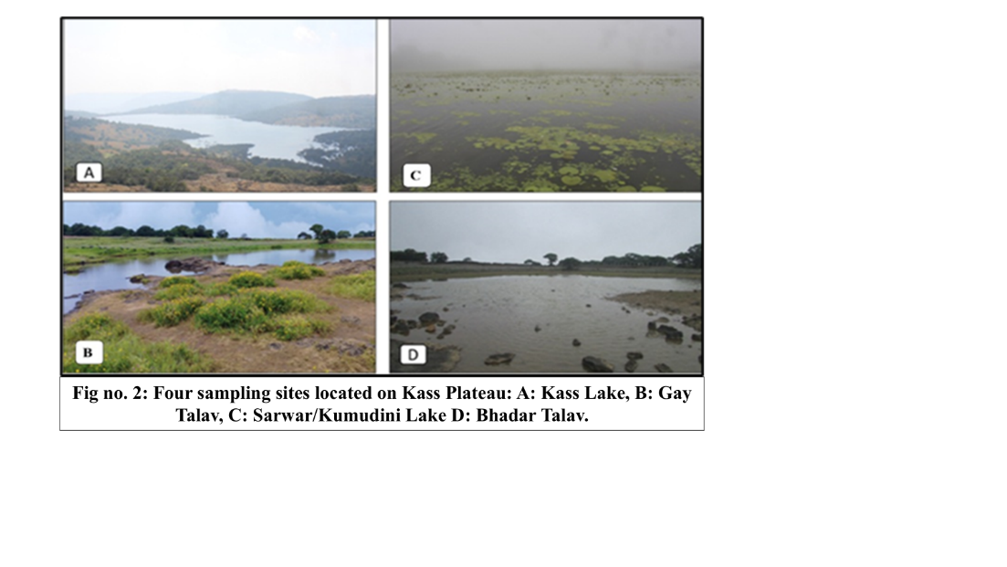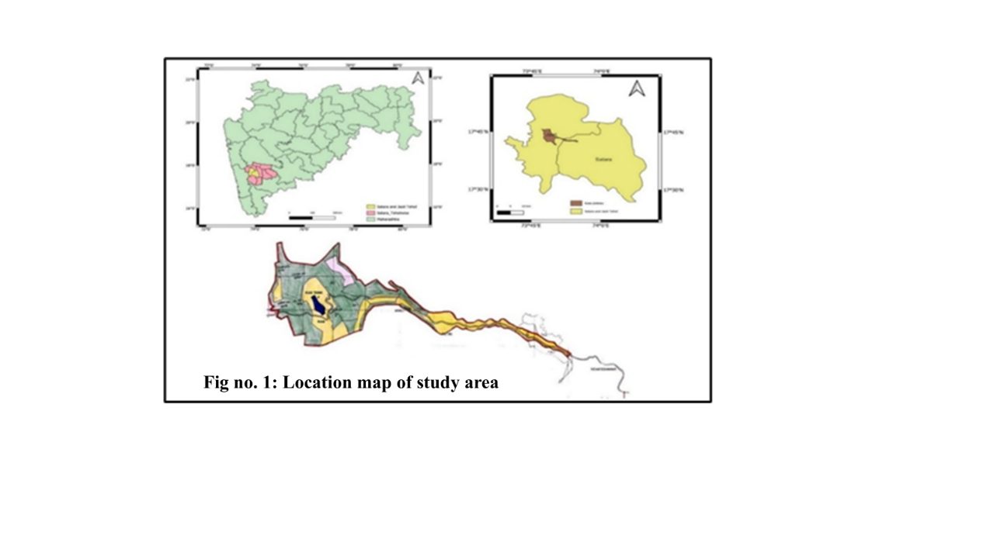

Material examined:Aquatic insect samples were collected from four locations namely Kass Lake (17°43'21.19"N & 73°48'39.49"E; Altitude 1153m). Gay Talav (17°44'33.10"N & 73°47'43.42"E; Altitude 1280m), Sarwar/Kumudini Talav (17°44'8.09"N & 73°48'47.46"E; Altitude 1260 m), Bhadar Talav (17°43'9.92"N & 73°49'26.13"E; Altitude 1265m) of Kass Plateau thought the year 2024. The hand net with a dimension of 30 × 30 cm, 50 cm length and 200μm mesh was used for sampling of aquatic insects. Many of them are only photographed during field visits. After the collection, the insects were preserved and identified using taxonomic identification keys (Pederzani, 1995; Gulati, 2012; Nasserzadeh and Komarek 2017, Subramanian, 2018).

**Water quality parameter analysis:** Physiochemical parameters of four different lakes located on the Kass plateau were studied during this time. The parameters of water quality like temperature, pH, electrical conductivity, dissolved oxygen, hardness of water, turbidity, Total Dissolved Solids (TDS) and alkalinity tests were analysed using standard methods and procedures.

**Observation tables:**

**Table 1:** Checklist of aquatic insects found in four different locations of Kass Plateau.

|  |  |  |  |  |  |
| --- | --- | --- | --- | --- | --- |
| **Family** | **Scientific Name** | **(A)** | **(B)** | **(C)** | **(D)** |
| Order: Coleoptera | | | | | |
| Dytiscidae | *Hydaticus vittatus* (Fabricius, 1775) | **+** | **+** | **-** | **-** |
| *Hydaticus satoi* Wewalka, 1975 | **-** | **-** | **+** | **-** |
| *Hydaticus luczonicus* Aubé, 1838 | **-** | **+** | **-** | **+** |
| *Hydaticus incertus* Régimbart, 1888 | **-** | **-** | **-** | **+** |
| *Hydaticus fabricii* (W.S. MacLeay, 1825) | **-** | **+** | **-** | **-** |
| *Cybister sugillatus* Erichson, 1834 | **+** | **-** | **-** | **-** |
| *Cybister tripunctatus* (Olivier, 1795) | **+** | **+** | **-** | **+** |
| *Cybister (Meganectes) cognatus* Sharp, 1882 | **-** | **-** | **-** | **+** |
| *Cybister (Melanectes) convexus* Sharp, 1882 | **-** | **+** | **-** | **-** |
| *Sandracottus dejeani* (Aube, 1838) | **-** | **-** | **+** | **-** |
| *Sandracottus festivus* (Illiger, 1802) | **-** | **+** | **-** | **-** |
| *Sandracottus mixtus* (Blanchard, 1843) | **+** | **-** | **-** | **+** |
| *Peschetius toxophorus* Guignot, 1942 | **-** | **+** | **-** | **-** |
| *Copelatus neelumae* Vazirani, 1973 | **-** | **-** | **+** | **-** |
| *Laccophilus sharpi* Régimbart, 1889 | **+** | **+** | **-** | **-** |
| *Laccophilus flexuosus* Aubé, 1838 | **-** | **-** | **+** | **-** |
| *Eretes sticticus* (Linnaeus, 1767) | **+** | **-** | **-** | **+** |
| Hydrophilidae | *Sternolophus rufipes* (Fabricius, 1792) | **-** | **+** | **-** | **-** |
| *Coelostoma sp.* | **+** | **-** | **-** | **-** |
| *Hydrophilus olivaceous* (Fabricius, 1781) | **+** | **+** | **-** | **-** |
| Gyrinidae | *Dineutus indicus* Aube, 1838 | **-** | **+** | **-** | **-** |
| *Dineutus (Cyclous) unidentatus* Aubé, 1838 | **+** | **-** | **+** | **-** |
| *Orectochilus discifer* (Walker, 1859) | **+** | **-** | **-** | **+** |
| *Patrus limbatus* (Regimbart, 1883) | **-** | **+** | **-** | **+** |
| *Patrus sp.* | **-** | **-** | **-** |  |
| Order: Hemiptera | | | | | |
| Notonectidae | *Notonecta glauca* (Linnaeus, 1758) | **+** | **+** | **+** | **+** |
| Nepidae | *Laccotrephes griseus* (Guérin-Méneville, 1835) | **+** | **-** | **-** | **-** |
| *Laccotrephes ruber* (Linnaeus, 1764) | **-** | **+** | **-** | **-** |
| *Ranatra elongata* Fabricius, 1790 | **+** | **-** | **-** | **+** |
| Gerridae | *Ptilomera sp.* | **+** | **-** | **+** | **-** |
| *Limnogonus sp.* | **-** | **-** | **+** | **-** |
| Belostomatidae | *Diplonychus rusticus* (Fabricius, 1781) | **+** | **+** | **+** | **-** |
| *Diplonychus annulatus* (Fabricius, 1781) | **-** | **+** | **-** | **-** |
| Order: Odonata | | | | | |
| Lestidae | *Lestes elatus* Hagen in Selys, 1862 | **-** | **+** | **+** | **+** |
| *Lestes umbrinus* Selys, 1891 | **+** | **-** | **-** | **-** |
| *Lestes viridulus* Rambur, 1842 | **-** | **-** | **+** | **+** |
| Coenagrionidae | *Aciagrion occidentale* Laidlaw, 1919 | **+** | **-** | **-** | **-** |
| *Aciagrion pallidum* Selys, 1891 |  | **+** | **-** | **-** |
| *Agriocnemis splendidissima* Laidlaw, 1919 | **+** | **+** | **-** | **+** |
| *Ceriagrion coromandelianum* (Fabricius, 1798) | **-** | **-** | **+** | **-** |
| *Ischnura aurora* (Brauer, 1865) | **+** | **+** | **-** | **-** |
| *Pseudagrion decorum* (Rambur, 1842) | **-** | **+** | **-** | **-** |
| *Pseudagrion indicum* Fraser, 1924 | **+** | **-** | **-** | **+** |
| *Pseudagrion microcephalum* (Rambur, 1842) | **-** | **+** | **-** | **+** |
| *Pseudagrion rubriceps* Selys, 1876 | **-** | **+** | **-** | **-** |
| Platystictidae | *Protosticta hearseyi* Fraser, 1922 | **+** | **-** | **-** | **-** |
| Calopterygidae | *Vestalis apicalis* Selys, 1873 | **-** | **-** | **+** | **+** |
| *Vestalis gracilis* (Rambur, 1842) | **+** | **-** | **-** | **+** |
| Chlorocyphidae | *Heliocypha bisignata* (Hagen in Selys, 1853) | **+** | **-** | **-** |  |
| *Libellago lineata* (Burmeister, 1839) | **-** | **+** | **+** | **+** |
| Platycnemididae | *Polycanthagynancura ramburi* (Fraser, 1922) | **+** | **-** | **-** | **-** |
| *Copera marginipes* (Rambur, 1842) | **-** | **+** | **-** | **+** |
| Aeshnidae | *Anax immaculifrons* Rambur, 1842 | **+** | **-** | **-** | **-** |
| Gomphidae | *Ictinogomphus rapax* (Rambur, 1842) | **-** | **-** | **+** | **-** |
| Libellulidae | *Acisoma panorpoides* Rambur, 1842 | **-** | **+** | **-** | **+** |
| *Brachythemis contamata* (Fabricius, 1793) | **-** | **-** | **+** | **-** |
| *Bradinopyga geminata* (Rambur, 1842) | **-** | **+** | **-** | **+** |
| *Cratilla lineata* (Brauer, 1878) | **+** | **-** | **-** | **-** |
| *Crocothemis servilia* (Drury, 1770) | **+** | **-** | **-** | **-** |
| *Diplacodes trivialis* (Rambur, 1842) | **+** | **-** | **+** | **-** |
| *Indothemis carnatica* (Fabricius, 1798) | **-** | **+** | **-** | **-** |
| *Neurothemis fulvia* (Drury, 1773) | **-** | **-** | **+** | **+** |
| *Neurothemis intermedia* (Rambur, 1842) | **+** | **+** | **-** | **-** |
| *Orthetrum chrysis* (Selys, 1891) | **+** | **-** | **-** | **-** |
| *Orthetrum glaucum* (Brauer, 1865) | **-** | **+** | **-** | **+** |
| *Orthetrum luzonicum* (Brauer, 1868) | **+** | **-** | **-** | **-** |
| *Orthetrum sabina sabina* (Drury, 1770) | **-** | **-** | **+** | **-** |
| *Orthetrum taeniolatum* (Schneider, 1845) | **-** | **+** | **-** | **-** |
| *Tramea limbata* (Desjardins, 1832) | **+** | **-** | **-** | **+** |
| *Trithemis aurora* (Burmeister, 1839) | **+** | **-** | **+** | **-** |
| *Trithemis festiva* (Rambur, 1842) | **-** | **-** | **-** | **+** |
| *Trithemis kirbyi* Selys, 1891 | **+** | **-** | **+** | **-** |
| *Trithemis pallidinervis* (Kirby, 1889) | **+** | **-** | **-** | **-** |
| Macromiidae | *Epophthalmia vittata* Burmeister, 1839 | **+** | **-** | **-** | **+** |
| *Macromia cingulata* Rambur, 1842 |  | **+** | **-** | **-** |

**(Four sampling sites located on Kass Plateau: A: Kass Lake, B: Gay Talav, C: Sarwar/Kumudini Lake D: Bhadar Talav.**

**Table 2: Physiochemical parameters of four different lakes located on the Kass plateau**

|  |  |  |  |  |
| --- | --- | --- | --- | --- |
| **Parameters** | **Kass Lake** | **Gay Talav** | **Sarwar/Kumudini Lake** | **Bhadar Talav** |
| **Mean ± SD** | **Mean ± SD** | **Mean ± SD** | **Mean ± SD** |
| Water Temperature (°C) | 18.58 ± 1.45 | 19.26 ± 2.75 | 18.33 ± 1.15 | 19.84 ± 1.11 |
| pH | 7.17 ± 0.06 | 6.7 ± 0.37 | 6.40 ± 0.43 | 6.49 ± 0.28 |
| Electrical Conductivity (μs/Cm) | 352.21 ± 0.70 | 402.18 ± 0.27 | 442.66 ± 2.04 | 357.07 ± 0.88 |
| Dissolved Oxygen (Mg/L) | 6.37 ± 0.32 | 6.24 ± 0.35 | 4.38 ± 0.45 | 6.13 ± 0.25 |
| Total Hardness of water | 79.66 ± 1.52 | 66.33 ± 2.08 | 52.36 ± 4.54 | 78.03 ± 1.15 |
| Turbidity | 0.30 ± 0.03 | 0.97 ± 0.43 | 2.9 ± 0.04 | 0.63 ± 0.047 |
| Total Dissolved Solids (TDS) (Ppm) | 139.79 ± 0.6 | 177.33 ± 2.0 | 198.34 ± 0.9 | 243.02 ± 0.65 |
| Alkalinity (Mg/L) | 40.01± 0.32 | 44.65± 0.70 | 38.90± 0.35 | 41.34± 0.08 |

**Result and discussion:**

The present study recorded the diversity of aquatic insects found in four different aquatic habitats of Kass Plateau. The total 75 species (Table 1, Fig 1) recorded belonging to three orders such as Odonata, Coleoptera and Hemiptera. Site A, Kaas Lake recorded the highest richness with 36 species of aquatic insects (12 Odonata, 5 Hemiptera, 10 Coleoptera). Followed by Site B Gay Talav listed 32 species (8 odonata, 4 hemiptera, 12 coleoptera). Site D Bhadar Talav harboured 26 species (8 Odonata, 2 Hemiptera, 8 Coleoptera). While site C Sarwar/Kumudini Lake represents less diversity with just 21 species (7 Odonata, 4 Hemiptera, 5 Coleoptera). In addition to observing the diversity, this study also analysed several water parameters such as temperature, pH, electrical conductivity, dissolved oxygen, hardness, turbidity, total dissolved solids (TDS) and alkalinity (Table 2). In the research lab at Lal Bahadur Shastri College of Arts, Science and Commerce during Study period some of the above tests were carried out. These parameters insights into the current status of water quality from four sites of the Kass Plateau. The temperature was observed between 18.33oC to 19.84 oC, pH was recorded as 6.40 to 7.17, and electrical conductivity was recorded between 352.21 μs/Cm to 442.66 μs/Cm. The dissolved oxygen varies from 139.79 mg/L to 243.02 mg/L, total hardness ranges from 52.36 mg/L to 79.66 mg/L and turbidity ranges from 0.30 to 2.9, total dissolved solids values vary from 139.79 ppm to 243 ppm whereas alkalinity was ranged from 38.90 mg/L to 44.65 mg/L. Kass Lake experiences some serious anthropogenic activities throughout the year by tourists from worldwide like plastic waste and food waste disposal. Physiochemical parameters of the given four lakes are within the permissible limit from the observed data (Table 2). It might significantly contribute to the richness of aquatic insect diversity. Order Odonata is dominant amongst all comprising 10 families, 27 genera and 42 species. The dominance of populations of damselflies and dragonflies indicates good health of the ecosystem. As odonates are known for their sensitivity to environmental changes, thrive only in unpolluted water. Odonates are carnivore species that helps in the regulation of small aquatic organisms including aquatic beetles and bugs essential for maintaining a balance of food webs within aquatic habitat. Followed by the order Coleoptera comprising 3 families, 13 genera and 25 species. The beetle species included are naturally adapted to various feeding habitats they are carnivores which act as predators for smaller invertebrates, scavengers consuming dead and decaying material whereas some of them are herbivores and benthivores a unique adaptation specializing in feeding on substrate organisms. This dietary behaviour allows them to be an integral part of nutrient cycling. These aquatic beetles help in regulating populations of small dipterans. This habit overlaps dietary niches of odonates creating competition between them. And order Hemiptera shows less diversity comprising 4 families, 6 genera and 8 species. Unlike water beetles water bugs also show different feeding habits from predation to herbivores. In addition to this, they do different respiratory strategies like plastron formation which helps them to survive in submerged environments. In this study we also identified the presence of some aquatic plants such as *Persicaria glabra, Asclepias curassavica, Sphaeranthus indicus, Rotala floribunda (*Vulnerable*), Rotala ritchiei* (Endangered), *Phyla nodiflora, Cyathocline purpurea,* found in all the 4 water bodies whereas *Nymphoides indica*, *Aponogeton satarensis* (Endangered) and *Pogostemon deccanensis* were found in all locations except kaas lake. These aquatic plants play a pivotal role in shaping these water bodies by making favourable breeding grounds, shelter and hiding spots from predators for these insects. They also act as food sources for various insects including some bugs and beetles as they feed on plant saps and tender leaves. Furthermore, these plants also contribute to the organic matter of water bodies enhancing habitat quality making them favourable for thriving aquatic organisms whereas the insects felicitate propagation and pollination of plants which reflects mutual relationships between them.

**Conclusion:**

The present study concludes that the presence of aquatic insects along with diverse vegetation creates a dynamic balance for a clean, well-balanced aquatic ecosystem. These might foster the mutual relationship between the organism and their environment which collectively contributes to maintaining ecological balance and can sustain the resilient aquatic ecosystem.

Disclaimer (Artificial intelligence)

Option 1:

Author(s) hereby declare that NO generative AI technologies such as Large Language Models (ChatGPT, COPILOT, etc.) and text-to-image generators have been used during the writing or editing of this manuscript.

Option 2:

Author(s) hereby declare that generative AI technologies such as Large Language Models, etc. have been used during the writing or editing of manuscripts. This explanation will include the name, version, model, and source of the generative AI technology and as well as all input prompts provided to the generative AI technology

Details of the AI usage are given below:

1.

2.

3.

**References**:

1. Alkhayata, F. A., Ahmada, A. H., Rahim, J., Imran, M., & Sheikh, U. A. A. (2024). Distribution and diversity of aquatic insects in different water bodies of Qatar. *Brazilian Journal of Biology, 84*, e255950. https://doi.org/10.1590/1519-6984.255950
2. Babu, R., & Subramanian, K. A. (2020). Insecta: Plecoptera. In K. Chandra (Ed.), *Faunal Diversity of Biogeographic Zones of India: Western Ghats* (pp. 257–260). Zoological Survey of India, Kolkata.
3. Bhakare, S. D., Nair, V. P., Pawar, P. A., Bhoite, S. H., & Sadasivan, K. (2021). Two new species of *Euphaea* Selys, 1840 (Odonata: Zygoptera: Euphaeidae) from northern Western Ghats, India. *Journal of Threatened Taxa, 13*(5), 18200–18214. https://doi.org/10.11609/jott.6579.13.5.18200-18214
4. Chainey, J. (2004). *Freshwater Invertebrates of the Malaysian Region* (pp. 786–790). Kuala Lumpur: Academy of Sciences Malaysia.
5. Deb, R., Takawane, P., & Subramanian, K. A. (2023). Sacred river of Pune: Boon or bane for the diversity of aquatic beetles (*Insecta*: Coleoptera). *Journal of Threatened Taxa, 15*(10), 24043–24053. https://doi.org/10.11609/jott.8514.15.10.24043-24053
6. Deb, R., Takawane, P., Morey, R., Pokale, S., Baidya, B., & Bagade, A. (2023). Diversity of aquatic beetles in relation to water quality from Khadakwasla Dam, Pune. *Indian Journal of Entomology.* https://doi.org/10.55446/ije.2023.1513
7. Kulkarni, R. R., & Zade, S. B. (2020). Role of aquatic insects in the enhancement of biodiversity of a freshwater reservoir, Ramala, Chandrapur, Maharashtra. Environment Conservation Journal, 21(3), 89–92. https://doi.org/10.36953/ecj.2020.21310
8. Nair, G. A., Morse, J. C., & Marshall, S. A. (2015). Aquatic insects and their societal benefits and risks. Journal of Entomology and Zoology Studies, 3(3), 171–177.
9. Nasserzadeh, H., & Komarek, A. (2017). Taxonomic revision of the water scavenger beetle genus Sternolophus Solier, 1834 (Coleoptera: Hydrophilidae). Zootaxa, 4282(2), 201–254. https://doi.org/10.11646/zootaxa.4282.2.1
10. Pandher, M. S., Kaur, S., & Garima, D. (2020). Insecta: Trichoptera. In K. Chandra (Ed.), Faunal Diversity of Biogeographic Zones of India: Western Ghats (pp. 509–517). Zoological Survey of India, Kolkata.
11. Pawar, G. N., Bendre, N. N., & Bhoite, S. H. (2024). Entomofaunal diversity and prey-predator relationship associated with organic paddy field at Mahadare Conservation Reserve, Satara District, Maharashtra. Journal of Entomology and Zoology Studies, 12(3), 20–28.
12. Pawar, S., & Sonawane, S. (2012). Zooplankton diversity in three water bodies of Satara District (M.S.) India. Environment Conservation Journal, 13(1), 129–132. https://doi.org/10.36953/ecj.2012.131224
13. Pawar, S. M., & Sonawane, S. R. (2012). Water quality profile of Kas Reservoir of Satara District, Maharashtra, India. Nature Environment and Pollution Technology, 11(1), 173–176.
14. Pederzani, F. (1995). Keys to the identification of the genera and subgenera of adult Dytiscidae (sensu lato) of the world (Coleoptera: Dytiscidae). Atti Dell’Accademia Roveretana degli Agiati: Contributi della Classe di Scienze Matematiche, Fisiche e Naturali, 7(4B), 5–83.
15. Sayyed, A. (2016). Faunal diversity of Satara District, Maharashtra, India. Journal of Threatened Taxa, 8(13), 9537–9561. https://doi.org/10.11609/jott.3162.8.13.9537-9561
16. Sheth, S. D., Ghate, H. V., & Hájek, J. (2018). Copelatus Erichson, 1832 from Maharashtra, India, with description of three new species and notes on other taxa of the genus (Coleoptera: Dytiscidae: Copelatinae). Zootaxa, 4459(2), 235–260.
17. Sheth, S. D., Padhye, A. D., & Ghate, H. V. (2024). Faunal inventory and illustrated taxonomic keys to aquatic Coleoptera (Arthropoda: Insecta) of the Northern Western Ghats of Maharashtra, India. Journal of Threatened Taxa, 16(3), 24854–24880. https://doi.org/10.11609/jott.5821.16.3.24854-24880
18. Thaware, V. H. (2023). Study of aquatic insects, their role in improving biodiversity and balancing the food web of a freshwater ecosystem at Karadkhed Dam in Nanded, Maharashtra. Journal of Entomology and Zoology Studies, 11(1), 173–176.
19. Yadav, P. P. (2015). Studies on biodiversity of zooplankton in Kass Lake during rainy and winter seasons. International Journal of Researches in Biosciences, Agriculture and Technology, 3(II), 399–402.
20. P. D., R. (2024). Distribution and Economic Importance of Aquatic Macro Invertebrates: A Review. Asian Journal of Fisheries and Aquatic Research, 26(6), 88–95. <https://doi.org/10.9734/ajfar/2024/v26i6778>
21. Adu, B. W., & Oyeniyi, E. A. (2019). Water quality parameters and aquatic insect diversity in Aahoo stream, southwestern Nigeria. The Journal of Basic and Applied Zoology, 80, 1-9.
22. Payakka, A., & Prommi, T. (2014). Aquatic insects biodiversity and water quality parameters of receiving water body. Current World Environment, 9(1), 53-58.
23. Jarjees, F. Z., Hanna, N. S., & Toma, J. J. (2019). Biodiversity of aquatic insects in relation to physico-chemical parameters of Shekh Turab stream. Passer Journal of Basic and Applied Sciences, 1(2), 12-16.
24. Komolafe, B. O., & Imoobe, T. O. T. (2020). Aquatic insects diversity and water quality assessment of a tropical freshwater pond in Benin city, Nigeria. Journal of Applied Sciences and Environmental Management, 24(7), 1129-1136.

**Fig. 1: Aquatic insects found in four different lakes of Kass plateau**

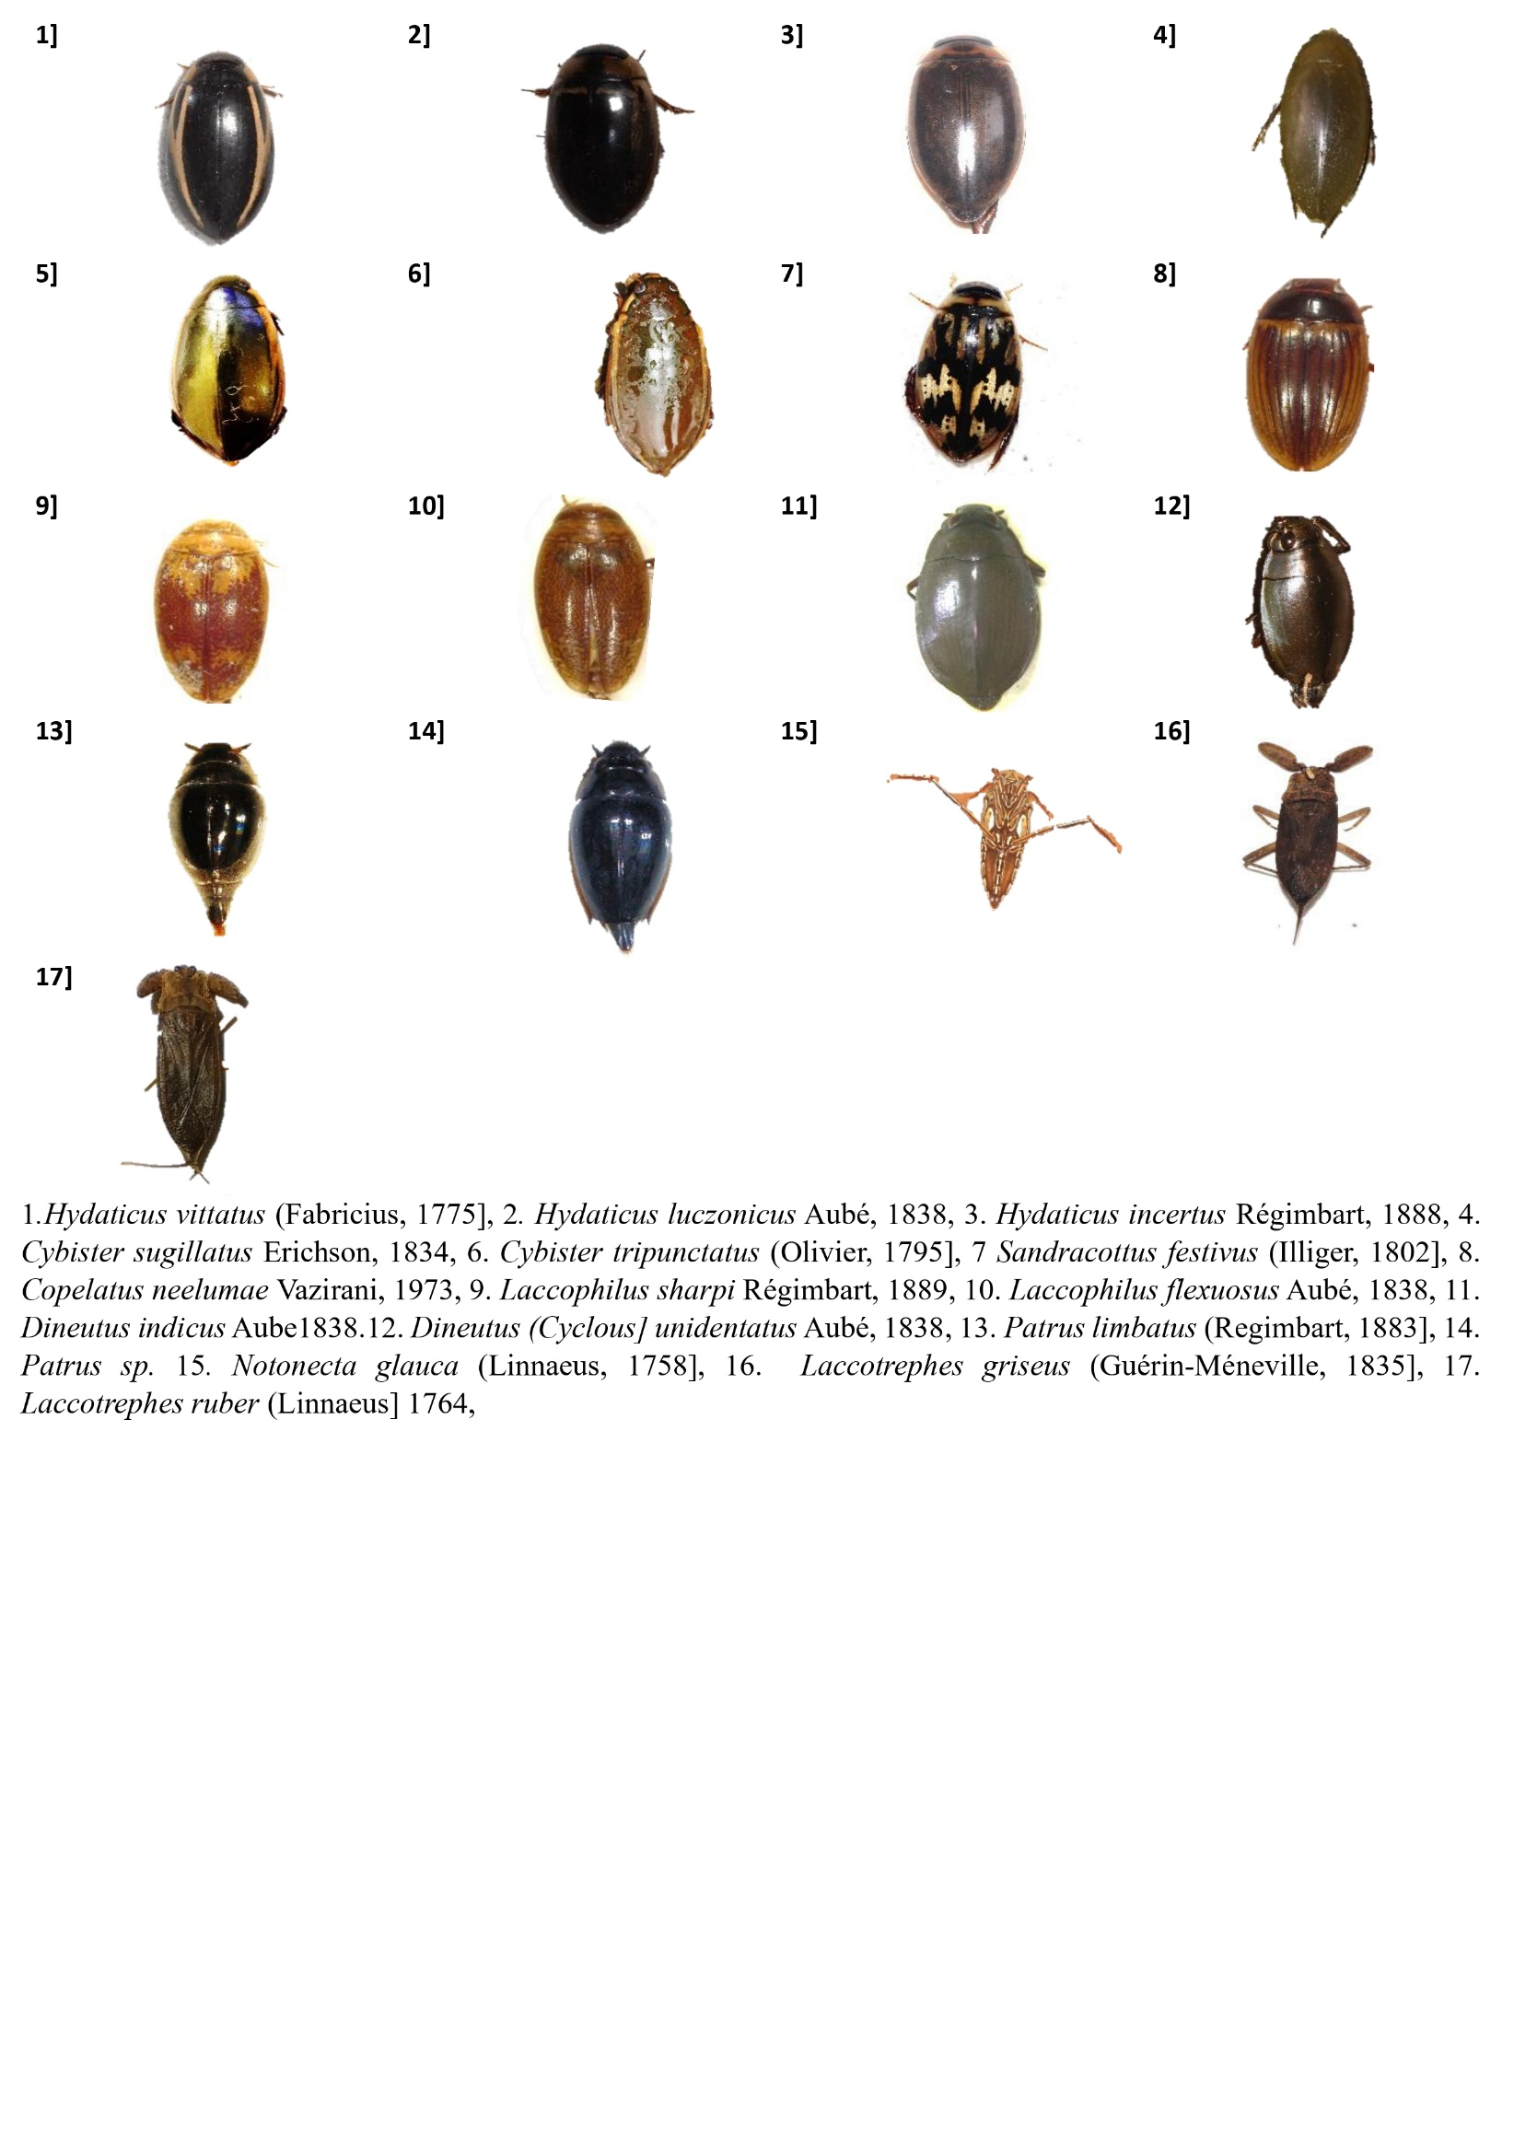

Plate 1 : Microphotographs of insects

