Terminalia catappa L. (Tropical almond tree) Leaf Extract: A Natural Way to Improve Tilapia Nutrition

ABSTRACT
This study investigated the potential benefits of using Terminalia catappa leaf extract (TLE) as a natural feed additive in tilapia (Oreochromis niloticus) culture, exploring its effects on the fish. A 40-day feeding trial demonstrated that TLE-2% supplementation in the tilapia diet significantly enhanced growth performance and feed utilization efficiency. Phytochemical screening of aqueous, ethanol, and ethyl acetate leaf extracts revealed various secondary metabolites. GC-MS analysis of the ethanol extract identified bioactive compounds, including neophytadiene and squalene, which exhibited antimicrobial properties. The antibacterial activity of TLE was evaluated using the disc diffusion method, showing maximum zones of inhibition against Vibrio cholerae (18±1.5 mm). Analysis of digestive enzymes from the fish gut revealed increased activities of protease, amylase, and lipase, indicating improved digestive capacity. The results suggest that T. catappa leaf extract can be an effective natural feed additive to promote growth performance and digestive enzyme activity in tilapia. The findings in this study indicate that the TLE diet has a dual property of growth promoter and immunostimulant and can be a sustainable and cost-effective alternative to traditional aquaculture practices.
Keywords: Terminalia catappa, antibacterial activity, growth performance, digestive enzymes, tilapia.
1. INTRODUCTION
Aquaculture is increasingly familiar as a key solution to enhance income and nutrition by providing livelihood opportunities for farmers and improving access to fish proteins for food-insecure populations (Gonzalez Parrao et al., 2021). Tilapia is an economically significant species, offering high-quality protein and the potential for sustainability in both the nutrition and aquaculture sectors (Arumugam et al., 2023). Tilapia is a vital aquaculture species, with global production expected to reach 7 million metric tonnes by 2024, marking a 4.2% increase from 2023 (FAO, 2022). Intensive production systems for Nile tilapia require enhanced nutritional strategies to meet the metabolic demands of high-density farming practices (Lertwanakarn et al., 2023). While such systems aim to maximize production, they often lead to fish stress, disease, and system failure due to resource limitations and challenging rearing conditions. Stress reduces feeding, weakens physiological health, impairs digestion, and diminishes immunity (Dawood et al., 2021). The vulnerability of tilapia to bacterial infections, including Aeromonas hydrophila and Streptococcus iniae, emphasizes the need for effective natural prophylactic approaches (Haenen et al., 2023).
Herbal immunostimulants offer a promising alternative to antibiotics, providing antimicrobial benefits, sustainability, and minimal side effects while enhancing growth performance (Elumalai et al., 2020). One such alternative is Terminalia catappa, commonly known as the Indian almond tree. Its leaves, rich in bioactive compounds like alkaloids, tannins, flavonoids, phenols, saponins, and coumarins (Ben et al., 2024), are traditionally used in folk medicine. In aquaculture, Terminalia catappa leaves contribute to aquarium maintenance through their tannin-rich, antimicrobial properties, benefiting water quality, fish health, and ecosystem balance (Perera, 2023), as well as controlling algae and microbial growth (Giang et al., 2023). Studies have shown that aqueous extracts of T. catappa leaves enhance growth and disease resistance in fish species like Heterobranchus longifilis (Orisasona et al., 2024) and improve immune function in Litopenaeus vannamei postlarvae under disease challenges (Haridevamuthu et al., 2024). This study highlights the phytochemical composition and importance of Terminalia catappa leaf extract in tilapia nutrition, aiming to advance sustainable and efficient aquaculture practices.
2. MATERIALS AND METHODOLOGY
2.1 Extraction process
The leaves of Terminalia catappa were collected from St. Xavier's College campus, Palayamkottai. Powdered leaves were used to prepare aqueous, ethyl acetate, and ethanol extracts. The extraction process employed the cold extraction method, where 50 g of powdered material was soaked in respective solvents: ethyl acetate, ethanol (95%), and water. The solvents were removed using a rotary vacuum evaporator at 60°C in a water bath. The resulting concentrated extracts were then frozen until further use.
2.2 Phytochemical screening and (GC-MS) analysis of Terminalia catappa leaf extract
The presence of major bioactive compounds and secondary metabolites like alkaloids, flavonoids, steroids, saponins, and phenols were analysed using standard method (Harborne, 1998). The chemical composition of ethanol extract was determined by Gas chromatography–mass spectrometry.
2.3 Fish pathogen
The Aeromonas hydrophila, Aeromonas caviae, Vibrio cholerae, V. harveyi, Staphylococcus aureus strains were grown in nutrient broth at 32 °C for 24 h and sub cultured, stored at 4 °C.
2.4 Antibacterial activity and Minimum inhibitory concentration of Terminalia catappa leaf extract
The antimicrobial activity of T. catappa leaf extracts (aqueous, ethanol and ethyl acetate) were tested using the disc diffusion method (Kamble et al., 2022). Bacterial suspension (20 µL, 1×10⁷ CFU/mL) was inoculated on MHA agar, followed by placement of 6 mm sterile paper disks loaded with 100 µL of extract (10mg/mL). Streptomycin and DMSO served as controls. Plates were incubated at 35±2°C for 24 hours in triplicate. The Minimum Inhibitory concentration (MIC) was determined by micro-dilution method (Alade and Irobi, 1993), with extract concentrations ranging from 3000 to 5.8. (3000, 1500, 750, 375, 187.5, 93.7, 46.8, 23.4, 11.7, 5.8 µg/mL) in nutrient broth inoculated with bacterial suspension (1×10⁷ CFU/mL). After incubation, 20 µL of MTT solution (5mg/mL) was added and incubated for 4 hours at 37°C. The MIC was defined as the lowest concentration preventing visible growth.
2.5 Feed preparation
The study used a randomized design with four diets containing different levels of Terminalia leaf extract (TLE): Diet 1 (control, 0% TLE), Diet 2 (0.5% TLE), Diet 3 (1% TLE), and Diet 4 (2% TLE). All diets contained identical ingredients (fish meal, soybean meal, groundnut oil cake, wheat bran, oils, vitamins, and minerals). The feed was prepared by mixing dry ingredients for 30 minutes, adding fish oil for 5 minutes, then adding 30% distilled water to form a dough. This was pelletized using a 1.2 mm mould, dried in sunlight, and stored at -20°C in air-tight bags (Cunniff & Washington, 1997).
Table 1. Feed ingredients (100g) used for the preparation of experimental diets
Feed Ingredients | TLE – 0% | TLE –0.5% | TLE –1% | TLE –2%
Fish meal | 18 | 18 | 18 | 18
Soyabean meal | 26 | 25.5 | 25 | 24
Groundnut oil cake | 20 | 20 | 20 | 20
Wheat bran | 31.5 | 31.5 | 31.5 | 31.5
Fish oil | 1 | 1 | 1 | 1
Sunflower oil | 1.5 | 1.5 | 1.5 | 1.5
Vitamin | 1 | 1 | 1 | 1
Mineral | 1 | 1 | 1 | 1
TLE | 0 | 0.5 | 1 | 2
Total | 100 g | 100g | 100g | 100g

2.6 Experimental fish and design
The freshwater fish Oreochromis niloticus (average weight 10±1g) was obtained from a local farmer in Tirunelveli District. Fish were acclimatized for 2 weeks in glass tanks with groundwater (temperature 26.43±0.52°C, dissolved oxygen 6.37±0.52mg/L, pH 6.9±0.5), fed commercial feed two times daily. The 40-day experiment was done with four groups (15 fish each) in triplicate: three groups received diets with 0.5%, 1%, and 2% Terminalia catappa leaf ethanol extract (TLE), while one control group received 0% TLE.
2.7 Assessment of growth and feed utilization efficacy
At the end of the feeding experiment, fish's growth and feed utilization efficiency were weighted to calculate final weight, weight gain, specific growth rate, feed intake, feed conversion ratio and survival rate were calculated according to the following equations. (Tekinay & Davies, 2001).
WG [g/fish] = $\frac{FW(g)}{IW(g)}$
SGR (%/day) = $\frac{\left[ln \left(FW\right)-ln \left(IW\right)\right] }{days}×100$
FI (kg) = $\frac{Total feed intake(g)}{NO. of fishes}$
$FCR=\frac{FI(g)}{WG}$
Survival rate (SR %) = $\frac{(N0. of fish surviving after feeding trail}{No. of fish stocked} ×100$

2.8 Assay of digestive enzyme activity
Digestive enzyme activities (protease, amylase, and lipase) were measured at the beginning and end of the feeding experiment. For each treatment, 7 fish from each tank were randomly selected, and their whole digestive tracts were removed. The tracts were homogenized in ice-cold double-distilled water and centrifuged at 15,000 rpm for 10 minutes at 4°C using a high-speed cooling centrifuge. The supernatant served as a crude enzyme extract. Protease activity was determined using the casein-hydrolysis method, amylase by the starch-hydrolysis method, and lipase by the titrimetric method, with all activities expressed as U/mg (Furne et al., 2005).
2.9 Statistical analysis
Data including growth performance, feed utilization, antibacterial activity, digestive enzyme activity were given as mean ± SD were calculated for the data. Significant differences among experimental and control groups were determined at P < 0.05. Data analyzed using one-way ANOVA and Duncan's multiple range test (Montgomery, 1984).
3. RESULTS AND DISCUSSION
3.1 Phytochemical screening of TLE
The current study contributes to enhancing research studies on the potential in vitro antibacterial properties of medicinal plants in aquaculture to improve growth promotion and digestive enzyme activity. The results of this study demonstrate that O. niloticus diets supplemented with T. catappa leaf extract improved growth performance, feed utilization of digestive enzyme efficiency. The results obtained from the phytochemical screening studies of TLE are rich in various bioactive metabolites such as alkaloids, steroids, saponins, tannins, flavonoids, reducing sugar, carotenoids and summarised in the Table. 2. The T. catappa leaf extract was nitrogen free content rich in crude protein, fibre, ash, and moisture content. This proximate composition value made it suitable as a partial supplement for fish diet in the experiment (Vijaya et al., 2012).
Table 2. Phytochemical screening of Terminalia catappa leaf extract
S. No | Phytochemical tests | Plant extracts
S. No | Phytochemical tests | Aqueous | Ethanol | Ethyl acetate
1 | Test for Alkaloids | + | + | -
2 | Test for steroids | + | + | -
3 | Test for tannins | + | ++ | +
4 | Test for saponins | + | + | +
5 | Test for flavonoids | ++ | ++ | -
6 | Test for carotenoids | + | +. | -
7 | Test for cardiac glycosides | + | +. | -
8 | Test for terpenoids | - | + | -
9 | Test for reducing sugar | - | + | +
10 | Test for phenols | ++ | ++ | -
11 | Test for flavonol glycosides | - | + | -
'+' presence '++' strong presence '-' absence
3.2 GC-MS analysis of TLE leaf extract
Terminalia catappa leaf ethanolic extracts were phytochemically analyzed using GC-MS to detect their chemical composition as shown in Fig. 1. T. catappa contained 8 chemical compounds. The highest percentage was for Squalene (36.18%), followed by Neophytadiene (32.08% across three peaks) Phytol (14.13%), n-Hexadecanoic acid (11.43%). The chemical structures of the major phytochemical compounds. Minor constituents included 3,7,11,15-Tetramethylhexadec-2-ene, Dibutylphthalate and Docosanoic acid, ethyl ester derivatives, each comprising less than 2% of the total composition. These compounds of supplemented feed can be attributed to the distinct nutritional profile of the T. catappa being rich in dietary fibers, protein, carbohydrates along with several bioactive compounds such as flavonoid, hydrolysable tannins and phenolic content that have been reported to actively promote growth and feed utilization in tilapia (Yakubu et al., 2023).
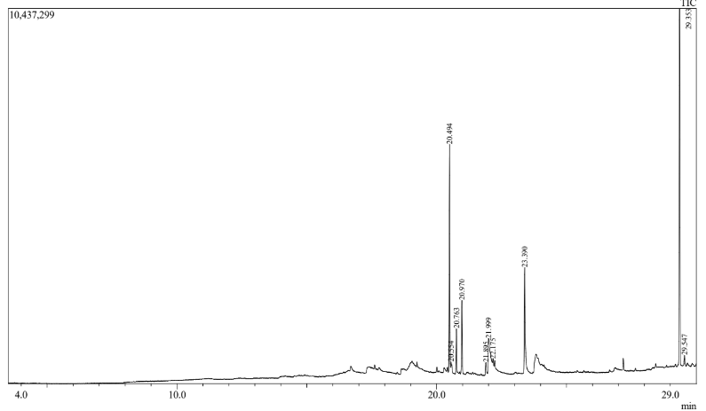
Fig. 1. GC-MS spectrum of ethanol extract of Terminalia catappa leaf
3.3 Antibacterial activity of TLE
The antimicrobial activity of T. catappa revealed varying degrees of inhibition in different solvent extracts against selected fish pathogens (Table 3). The ethanol extract displayed broad antibacterial activity, inhibiting the growth of bacteria compared to aqueous and ethyl acetate extracts, with maximum zones of inhibition against V. cholerae (18±1.5 mm) and A. hydrophila (17±1 mm), corresponding to high MIC values of 82.11% and 84.48%, respectively. The aqueous extract showed moderate activity, with inhibition zones ranging from 12.0±1.15 mm to 15.66±0.57 mm, with high MIC value of 80.1% in S. aureus while ethyl acetate extract exhibited the lowest antibacterial activity zones between 8±1 mm and 12±1.15 mm and minimum inhibitory concentration in the tested extracts, Among the tested pathogens, V. cholerae and A. hydrophila showed higher susceptibility to the extracts, while V. harveyi demonstrated relatively lower susceptibility across all solvent extractions.
The presence of flavonoids, alkaloids, saponins, coumarins and steroids exhibit a wide range of biological activities including antimicrobial, antioxidant in the T. catappa extract suggests antimicrobial capability that may explain the better feed and growth efficiency due to potential inhibition of pathogens and thus the increased beneficial microbial activity leading to improved feed digestibility and nutrient absorption as well as better resistance of fish pathogens in intensive culture method (Mwangi et al., 2024). Constituents such as alkaloids inhibit bacterial cell division by intercalating with DNA in both Gram-negative and Gram-positive bacteria, while steroids form complexes with membrane lipids, causing membrane leakage (Odongo et al., 2023).
Table 3. Antibacterial activity and Minimum inhibitory concentration of TLE
Pathogens | Aqueous |  | Ethanol |  | Ethyl acetate |  | Positive | Negative
Pathogens | Zone of Inhibition (mm) | MIC value (%) | Zone of Inhibition (mm) | MIC value (%) | Zone of Inhibition  (mm) | MIC value (%) | Zone of Inhibition  (mm) | Zone of Inhibition (mm)
A.hydrophila | 14.33±2.1 | 63.57 | 17±1 | 84.48 | 12±1.15 | 61.22 | 23.66±2.0 | 0
A.caviae | 13.66±1.5 | 62.90 | 15.66±0.5 | 80.23 | 10±1 | 53.28 | 27±3 | 0
V. cholerae | 15.66±0.57 | 75.27 | 18±1.5 | 82.11 | 11.33±1.5 | 63.97 | 25.66±0.5 | 0
V. harveyi | 12.33±0.50 | 69.98 | 15±1 | 72.33 | 9±1 | 57.33 | 20.0±3.0 | 0
S.aureus | 12.0±1.1 | 80.1 | 15.33±1.2 | 50.6 | 8±1 | 59.30 | 24.33±3.0 | 0
Values are means ±SD; MIC – Minimum inhibitory concentration

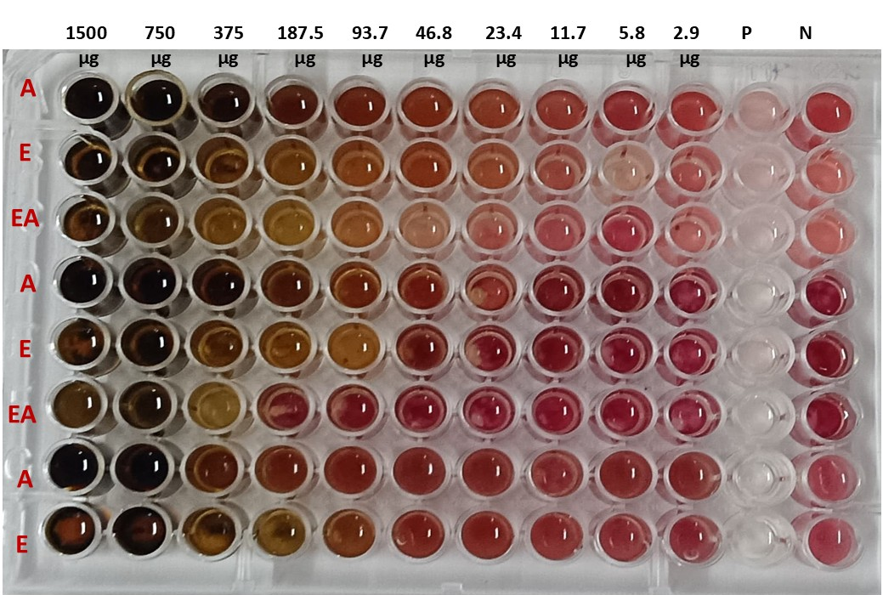
Fig. 2. Determination of the MIC values for the TLE against pathogenic bacteria A-Aqueous, E-ethanol, EA-ethyl acetate extract
3.4 Growth Performance and feed utilization efficiency of tilapia fed diets supplemented with ethanol TLE
The growth performance of the tilapia fed diets supplemented with TLE-2% group showed significantly (p < 0.05) higher FW, WG, and SGR compared to the control, TLE-0.5 and TLE-1g (Table 4). The highest weight gain (18.03±1.04g) was noticed in tilapia fed on diet incorporated with 2g of TLE. The survival rate at the end of the feeding trial control group differs significantly (p > 0.05) compared to experimental diets. Regarding Feed utilization, the TLE-2% group exhibited a significantly (p < 0.05) lower FCR and higher compared to the control, TLE-0.5% and TLE-1%. Additionally, the Feed Intake of TLE 1% was significantly (p > 0.05) different among the experimental diets. In a similar study conducted on possible alternatives to fish meal has also reported a better growth performance of Oreochromis niloticus fingerlings when fed on a diet supplemented with T. catappa leaf ethanol extract it’s a rich source of phytobiotic that are believed to enhance gut biotic populations that affect intestinal enteric metabolism and physiology, leading to the synthesis and release of various beneficial biomolecular substances exhibited a sparing effect of carbohydrate and protein utilization (Lawal et al., 2021). T. catappa leaves has been reported as a growth promoter (Hussain et al., 2021), an antimicrobial agent (Mwangi et al., 2024), as well as an enhancer for reproductive performance (Sung et al., 2020).
The current study proved the effect of TLE dietary supplementation at different concentrations on growth performance, feed utilization and digestive enzyme efficiency for growth status in tilapia, O. niloticus. Feeding intake of TLE supplemented diet revealed significant growth performance in all the parameters (FW, WG, and SGR) in fish fed with 2g TLE diet compared with the control groups. However, fish fed with 0.5, 1g TLE diet revealed non-significant growth and digestive enzymes compared to fish fed with 2g TLE diet. T. catappa effectively promoted O. niloticus health by functioning as an immunostimulant, higher survival rates and enhancing growth, suggesting it improves health status as a growth promoter. Our findings align with several recent studies in T. catappa leaves (TCL) as a natural plant product-based dietary supplement for tilapia growth parameters and digestive enzyme activity in Shrimp (Haridevamuthu et al., 2024).
Table 4. Growth performance of O. niloticus after 40 days exposed to different concentrations of dietary TLE

T  Treatments | IW (g/fish)  (g/fish) | FW ((g/fish)  g/fish) | WG  (g/fish)  G (g/fish | SGR (%/day) | FI (Kg) | FCR F | SR (%)
Control | 9.54±0.21ª | 21.55±1.23ª | 12.01±1.02ª | 2.04±0.09ª | 1.01±0.22ª | 1.27±0.09^{b} | 88.9±3.81ª
TLE- 0.5% | 10.44±0.37^{b} | 23.42±2.32^{ab} | 12.98±2.01ª | 2.01±0.16ª | 1.11±0.04^{b} | 1.30±0.18^{b} | 95.53±3.87^{ab}
TLE- 1% | 11.62±0.14^{c} | 26.45±0.35^{bc} | 14.83±0.29^{b} | 2.06±0.04ª | 1.23±0.01^{b} | 1.25±0.23^{b} | 95.53±3.87^{ab}
TLE- 2% | 10.79±0.09^{b} | 28.82±1.09^{c} | 18.03±1.04^{c} | 2.44±0.10^{b} | 1.15±0.01^{bc} | 0.96±0.05ª | 97.76±3.87^{b}
Values are means ±SD; The same superscript within the same column indicates no significant difference(P> 0.05) (g/fish) Treatments Control, TLE- 0.5%, ALE-1%, ALE- 2% diet containing 0.5, 1, and 2g TLE in respectively. IW, initial weight; FW, final weight; weight gain, WG; SGR, specific growth rate; FI, feed intake; FCR, food conversion ratio; SR, survival rate.

Fig. 3. Growth performance of tilapia fed diets supplemented with TLE in different diets. Data represent the mean ± SD (n=15)

Fig. 4. Feed utilization of tilapia fed diets supplemented with TLE in different diets. Data represent the mean ± SD (n=15)
3.5 Digestive enzyme study
Digestive enzyme activities (protease, amylase, and lipase) were significantly elevated (P<0.05) in fish fed with 0.5-2% TLE diets compared to the control after 40 days. Protease activity was highest (41.32±1.2 U/mg) in the TLE-2% group, with no significant difference between TLE-0.5% and TLE-1% groups. Amylase activity showed no significant differences across all diets. Lipase activity was highest (24.46±3.01 U/mg) in the TLE-2% group, while TLE-0.5% showed a significant decrease compared to other groups (Table 5). All TLE diets produced statistically significant differences in enzyme activity compared to the control, with enzyme response varying by TLE concentration. Recently, Omosowone et al. (2022) also clarified that O. niloticus fingerlings fed on TLE containing diet showed an enhanced growth performance by digestive enzyme efficiency. Additionally, Emam et al. (2024) indicated that M. oleifera had improved the food digestibility and absorption capacity of O. niloticus. On the contrary, Yakubu et al. (2023) reported a considerable reduction in feed intake, feed utilization, and fish digestive performance after receiving dietary Terminalia catappa leaf extracts.
The fish utilize feed nutrients through digestive enzymes, enhancing feed efficiency. In this study, digestive enzymes (protease, amylase, and lipase) were significantly improved protease in TLE- 2% supplemented diets, with amylase showing the enhancement. This indicates that T. catappa supplementation promotes digestive enzyme secretion, improving nutrient digestibility, utilization, and gut physiology at 1.0-1.5% inclusion levels compared to the control diet (Wang et al., 2024). Similarly, administration of TCL diet in the tiger shrimp showed significant improvement in the activity of digestive enzymes (Haridevamuthu et al., 2024). Amer et al. (2024) demonstrated inclusion of M. oleifera increased the amylase and protease digestive enzyme activities in O. niloticus.
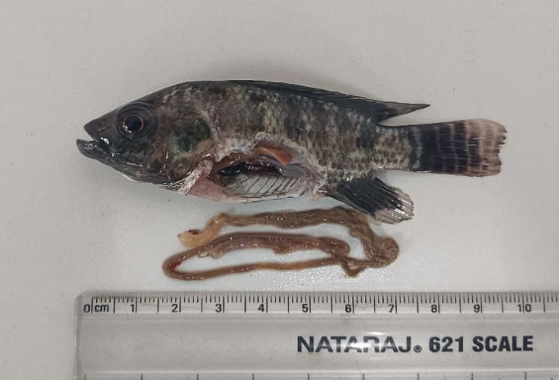
Fig. 5. Dissection of tilapia gut carried out for digestive enzyme analysis
Table 5. Digestive enzyme activity of tilapia diets supplemented with TLE
Treatments | Protease (U/mg) | Amylase (U/mg) | Lipase (U/mg)
Control | 31.69±2.21ª | 112.66±21.04ª | 23.65±1.29^{b}
TLE- 0.5% | 38.14±1.54^{b} | 125.91±5.4^{ab} | 14.24±1.75ª
TLE- 1% | 39.22±0.69^{bc} | 131.3±5.01^{ab} | 22.22±2.6^{b}
TLE- 2% | 41.32±1.2^{c} | 138.86±5^{b} | 24.46±3.01^{b}
Values are means ±SD; The same superscript within the same column indicates no significant difference(P> 0.05) (g/fish) Treatments Control, TLE- 0.5%, TLE-1%, TLE- 2% diet containing 0.5, 1, and 2g TLE in respectively.

Fig. 6. Digestive enzyme activity of tilapia fed diets supplemented with TLE diets
Interestingly, T. catappa leaf extract effectively inhibited algal growth and controls pathogenic microorganisms in Tilapia farming water, with 0.25 g L⁻¹ recommended from early cultivation stages. Despite production costs requiring consideration against alternatives like antibiotics, this extract significantly improved water quality parameters during the experiment (P < 0.05) offers a sustainable approach to pathogen control during the growth study without compromising water quality and fish health (Malawa et al., 2022). T. catappa leaf supplementation boosts the immunity and disease resistance against Aeromonas hydrophila in infection in fishes (Nugroho et al., 2016). A reduction in mortality was observed in those treated with T. catappa leaf 62.5 mg/kg dose of methanol extract, which showed the greatest mortality reduction, with relative survival rate. This study shows that the methanol extract of T. catappa leaf could enhance the immune response in tilapia (Yakubu et al., 2020).
4. CONCLUSION
Antibacterial properties, growth performance and digestive enzyme activity findings of the current study revealed that dietary Terminalia catappa at a dose of 2% in tilapia aquaculture has a good effect. The bioactive compounds in T. catappa mediate growth and feed utilization benefits through complex digestive enzyme efficiency and antibacterial mechanisms. So, this study recommends using dietary supplementation of T. catappa leaf extract as contribute a bearable alternative to aquaculture strategies.
Disclaimer (Artificial intelligence)
Author(s) hereby declares that NO generative AI technologies such as Large Language Models (ChatGPT, COPILOT, etc.) and text-to-image generators have been used during the writing or editing of this manuscript.

REFERENCES
Alade, P. I., & Irobi, O. N. (1993). Antimicrobial activities of crude extract of Acalypha wilkesiana. Journal of Ethnopharmacol, 39, 171–174.
Amer, S. A., Rahman, A. N. A., ElHady, M., Osman, A., Younis, E. M., Abdel-Warith, A. W. A., ... & Ibrahim, R. E. (2024). Use of moringa protein hydrolysate as a fishmeal replacer in the diet of Oreochromis niloticus: effects on growth, digestive enzymes, protein transporters and immune status. Aquaculture, 579, 740202.
Arumugam, M., Jayaraman, S., Sridhar, A., Venkatasamy, V., Brown, P. B., Abdul Kari, Z., ... & Ramasamy, T. (2023). Recent advances in tilapia production for sustainable developments in Indian aquaculture and its economic benefits. Fishes, 8(4), 176.
Ben, E. E., Beshel, J. A., Owu, D. U., Palacios, J., Nwokocha, M., Bórquez, J., ... & Nwokocha, C. R. (2024). Identification of phytochemicals and assessment of hypoglycemic and haematological potentials of Terminalia catappa Linn leaf extract in alloxan-induced diabetic Wistar rats. Cardiovascular & Hematological Agents in Medicinal Chemistry (Formerly Current Medicinal Chemistry-Cardiovascular & Hematological Agents), 22(2), 139-150.
Cunniff, P., & Washington, D. (1997). Official methods of analysis of AOAC International. J. AOAC Int, 80(6), 127A.
Dawood, M. A. (2021). Nutritional immunity of fish intestines: Important insights for sustainable aquaculture. Reviews in Aquaculture, 13(1), 642-663.
Elumalai, P.; Kurian, A.; Lakshmi, S.; Faggio, C.; Esteban, M.A.; Ringø, E. Herbal immunomodulators in aquaculture. Rev. Fish. Sci. Aquac. 2020, 29, 33–57
Emam, M. A., Shourbela, R. M., El-Hawarry, W. N., Abo-Kora, S. Y., Gad, F. A. M., Abd El-latif, A. M., & Dawood, M. A. (2024). Effects of Moringa oleifera aqueous extract on the growth performance, blood characteristics, and histological features of gills and livers in Nile tilapia. Aquaculture and Fisheries, 9(1), 85-92.
Food and Agriculture Organization (FAO). Regional Review on Status and Trends in Aquaculture Development in Sub-Saharan Africa (2020); FAO: Rome, Italy, 2022.
Furne, M., Hidalgo, M. C., Lopez, A., Garcia-Gallego, M., Morales, A. E., Domezain, A., ... & Sanz, A. (2005). Digestive enzyme activities in Adriatic sturgeon Acipenser naccarii and rainbow trout Oncorhynchus mykiss. A comparative study. Aquaculture, 250(1-2), 391-398.
Giang, L. V., Duong, D. V., Hang, D. T. T., Tuyet, L. T. H., Hai, L. N., & Tran, T. (2023, December). Terminalia catappa leaf solution: an eco-friendly approach to managing color, algae, and microbial activity in aquaculture systems. In IOP Conference Series: Earth and Environmental Science (Vol. 1267, No. 1, p. 012072). IOP Publishing.
Gonzalez Parrao, C.; Shisler, S.; Moratti, M.; Yavuz, C.; Acharya, A.; Eyers, J.; Snilstveit, B. Aquaculture for improving productivity, income, nutrition and women’s empowerment in low-and middle-income countries: A systematic review and meta-analysis. Campbell Syst. Rev. 2021, 17, e1195.
Haenen, O. L., Dong, H. T., Hoai, T. D., Crumlish, M., Karunasagar, I., Barkham, T., ... & Bondad‐Reantaso, M. G. (2023). Bacterial diseases of tilapia, their zoonotic potential and risk of antimicrobial resistance. Reviews in Aquaculture, 15, 154-185.
Harborne, A. J. (1998). Phytochemical methods a guide to modern techniques of plant analysis. springer science & business media.
Haridevamuthu, B., Chandran, A., Raj, D., Almutairi, B. O., Arokiyaraj, S., Dhanaraj, M., ... & Arockiaraj, J. (2024). Growth performance and immunomodulatory effect of Terminalia catappa L. diet on Litopenaeus vannamei against Vibrio parahaemolyticus challenge. Aquaculture International, 32(3), 2549-2570.
Hussain, S. M., Nisar, S., Jamil, M., Bashir, F., Arslan, M. Z., Tabassum, S., ... & Sharif, A. (2021). Effects of almond meal (Terminalia catappa) based diets on nutrient utilization, growth and hematology of Labeo rohita fingerlings. JAPS: Journal of Animal & Plant Sciences, 31(6).
Kamble, M.T.; Rudtanatip, T.; Soowannayan, C.; Nambunruang, B.; Medhe, S.V.; Wongprasert, K. Depolymerized fractions of sulfated galactans extracted from Gracilaria fisheri and their antibacterial activity against Vibrio parahaemolyticus and Vibrio harveyi. Mar. Drugs 2022, 20, 469.
Lawal, M. O., Aderolu, A. Z., & Gafari, W. A. (2021). Effects of Terminalia catappa, Chromolaena odorata and Psidium guajava Leaf Extracts on Growth, Biochemical And Haematology of Clarias gariepinus. FUW Trends in Science & Technology Journal, 6(2), 327-332.
Lertwanakarn, T., Purimayata, T., Luengyosluechakul, T., Grimalt, P. B., Pedrazzani, A. S., Quintiliano, M. H., & Surachetpong, W. (2023). Assessment of Tilapia (Oreochromis spp.) Welfare in the Semi-Intensive and Intensive Culture Systems in Thailand. Animals, 13(15), 2498.
Malawa, S., Nuntapong, N., Suanyuk, N., & Thongprajukaew, K. (2022). Addition of different concentrations of Indian almond (Terminalia catappa) leaf extract to aquarium water resulted in improved water quality and increased bubble nest formation by male Siamese fighting fish (Betta splendens) without having any consistent negative effects on growth metrics and blood chemistry. Aquaculture International, 30(6), 3269-3288.
Mwangi, W. C., Waudo, W., Shigwenya, M. E., & Gichuki, J. (2024). Phytochemical characterization, antimicrobial and antioxidant activities of Terminalia catappa methanol and aqueous extracts. BMC Complementary Medicine and Therapies, 24(1), 137.
Nugroho, R.A., Manurung, H., Nur, F.M., Prahastika, W., 2017. Terminalia catappa L. Extract improves survival, hematological profile and resistance to Aeromonas hydrophila in Betta sp. Arch. Polish Fish. 25, 103–115.
Odongo EA, Mutai PC, Amugune BK, Mungai NN, Akinyi MO, Kimondo J. “Evaluation of the antibacterial activity of selected Kenyan medicinal plant extract combinations against clinically important bacteria. BMC Complement Med Ther. 2023; 4:1–9.
Omosowone, O. O., & Adebayo, A. N. (2022). Efficacy of Terminalia catappa leaf as an alternative to synthetic antibiotics in the diet of Oreochromis niloticus challenged with Salmonella typhi. Asian J Fish Aquat Res, 16(4), 34-42.
Orisasona, O., Adekanmbi, A. O., Akinrinade, B. P., & Taiwo, O. O. (2024). Aqueous almond (Terminalia Catappa) leaf extract enhanced growth performance, immunocompetence and resistance of Heterobranchus longifilis to Pseudomonas Aeruginosa. Nigerian Journal of Animal Production, 2015-2018.
Perera, H. A. U. I. (2023). Benefits of using catappa leaves (Terminalia catappa) in a freshwater aquarium. Journal of Research Technology and Engineering, 4(4), 141-143.
Sung, Y. Y., & Abol-Munafi, A. B. (2020). Terminalia catappa leaf extract is an effective rearing medium for larviculture of gouramis. Journal of applied Aquaculture, 32(2), 175-185.
Tekinay, A. A., & Davies, S. J. (2001). Dietary carbohydrate level influencing feed intake, nutrient utilization and plasma glucose concentration in the rainbow trout, Oncorhynchus mykiss. Turkish Journal of Veterinary and Animal Sciences, 25, 657 –666.
Vijaya P, Vijayalakshmi K. Evaluation of proximate composition and phytochemical analysis of Terminalia catappa L. from Nagapattinam region. International Journal of Science Resources. 2012; 3:358–362.
Wang, X., Taufek, N. M., & Arshad, N. M. (2024). Recent advances of Terminalia catappa and its application in fish culture: A review. Reviews in Aquaculture, 16(4), 1741-1765.
Yakubu, Y., Ahmad, M. T., Chong, C. M., Ismail, I. S., & Shaari, K. (2023). Phenolic content of Terminalia catappa L. leaf and toxicity evaluation on red hybrid tilapia (Oreochromis sp.). Journal of Fish Biology, 102(2), 358-372.
Yakubu, Y., Talba, A. M., Chong, C. M., Ismail, I. S., & Shaari, K. (2020). Effect of Terminalia catappa methanol leaf extract on nonspecific innate immune responses and disease resistance of red hybrid tilapia against Streptococcus agalactiae. Aquaculture Reports, 18, 100555.

