Study of the Hematological and Histopathological changes induced by Cypermethrin in *Anabas testudineus* (Bloch, 1792)

**Abstract**

The present study was attempted to understand about the effects of Cypermethrin, a common pyrethroid insecticide used in agricultural fields, on *Anabas testudineus*. The impacts focused on this study were the hematological and histopathogical parameters after inducing the fishes with lethal concentrations of the insecticides. Live specimens of *Anabas* sp. of equal length and weight were taken for the study, and after administration of the insecticide, blood & tissue samples were taken at different time intervals. Changes were clearly observed with different concentrations of Cypermethrin in all blood parameters. Reduction in blood volume, the appearance of shrunken blood cells, and enlarged nuclei were observed during the blood parameter studies. The gill tissue observed for changes after the insecticide administration showed a wide change in colour and structure with respect to the control group. Significant gill lesions, including epithelial lifting, desquamation, necrosis, and hyperplasia of epithelial cells, hemorrhage were observed in the gill lamellae. It is quite evident from the study that Cypermethrin, an actively used insecticidal ingredient in the agricultural fields and has a deteriorating effect on the fishes which can be create adverse effects on humans as well upon fish consumption.

**Keywords:** Cypermethrin, insecticide, blood, gill, histopathology, *Anabas* sp.

**Introduction**

Insecticides are chemicals practiced for averting and monitoring pests, containing trajectories of humanoid or animal infections. They have been practiced for regulating undesirable floras or faunas triggering injury to the manufacture, handling, storing, advertising of foodstuff, agronomic possessions, timber goods, animal materials, which might be given to animals for controlling pests or additional insects attached to their bodies (WHO, 2002). Assessing the physiological status of lower vertebrates, including fish, amphibians, reptiles, and birds, often involves the examination of haematological parameters and blood chemistry profiles. The hemogram evaluation encompasses crucial measures such as total erythrocyte count, total white blood cell count (WBC), haematocrit (PCV), haemoglobin concentration (Hb), erythrocyte indices, WBC differential count, and the examination of stained peripheral blood films (Witeska *et al.,* 2023). Fish blood parameters exhibit species-specific variations in cellular counts and biochemical values. Despite systematic diversity, all fish possess two types of blood cells: erythrocytes (red cells) and leucocytes (white cells). Approximately one-third to one-half of the total blood volume in fish consists of blood cells, with the remainder being fluid plasma. Fish blood plasma majorly comprises globulin, including antibodies like immunoglobulin (Michel Kaiser, 2022). A healthy fish's peripheral blood serum shows a predominance of erythrocytes, accompanied by other cells such as lymphocytes, neutrophils, monocytes, eosinophils, basophils, and thrombocytes or platelets (Xie *et al*., 2023). The studies conducted by Akinrotimi *et al.,* 2012, Ambedkar & Muniyan 2011, and Babu Velmurugan *et al.,* 2014 provide insights into the haematological changes induced by cypermethrin exposure in African catfish (*Clarias gariepinus*) and climbing perch (*Anabas testudineus*). These investigations reveal significant reductions in red blood cell (RBC) counts, hematocrit (Hct), hemoglobin (Hb) levels, and other blood parameters, suggesting impairment of erythropoietic tissue and potential disruption of immune responses.

Furthermore, studies by Kumar 2014 and Nandan *et al.,*, 2021 delves into the sub-lethal effects of copper and cypermethrin on teleost fish, respectively. The findings underscore the vulnerability of fish to environmental contaminants, with observable changes in haemoglobin levels, erythrocyte counts, and histopathological alterations in response to toxic exposures. The impact of synthetic pyrethroids, including cypermethrin, on haematological parameters is not limited to specific fish species. Atamanalp *et al.,* 2002 emphasizes the broader implications of cypermethrin exposure on various fish species, highlighting alterations in red and white blood cell counts, haemoglobin concentration, and erythrocyte sedimentation rates. This underscores the need for a comprehensive understanding of the ecological risks posed by these pesticides, considering species-specific responses. While cypermethrin is recognized for its insecticidal properties, studies such as those by Kannan *et al.,* 2014 and Zorriehzahrah and Ullah, 2014 broaden the scope by examining its impact on olfactory responses, oxidative stress, and physiological changes in fish. These investigations highlight the potential for disruption in fish health, immune responses, and even reproductive functions, suggesting far-reaching consequences for aquatic ecosystems. The investigations by Neelima *et al.,* 2016, Ranjeet *et al.,* 2013, and Kumar *et al.,* 2018 on *Cirrhinus mrigala, Anabas testudineus,* and *Anabas testudineus* in the Buckingham Canal, respectively, further reinforce the ecological implications of altered blood parameters in fish. These studies underscore the importance of haematological assays as bio-indicators of environmental contamination, aiding in the detection of physiological and metabolic stress responses in fish populations exposed to pollutants. As the literature suggests, pesticides not only induce haematological changes *but* also contribute to histopathological alterations in various organs of fish. The work by Velmurugan *et al.,* 2023 on the hepatotoxic effects of cypermethrin in *Anabas testudineus* exemplifies the linkage between biochemical assays, histopathological assessments, and the identification of biomarkers for assessing chemical risk in aquatic environments.

Freshwater fish species face increasing susceptibility to diazinon toxicity, prompting extensive research into histopathological changes in vital organs. Gills, liver, heart, intestine, and kidneys exhibit noteworthy alterations, emphasizing the pivotal role of fish pathology in environmental monitoring and aquaculture (Khan *et al*., 2018). Fish pathologists encounter diagnostic challenges due to anatomical diversity, necessitating advanced understanding for both environmental and biomedical applications. Recent investigations highlight the adverse impact of pesticides, notably Furadan, on fish morphology and physiology, indicating injuries such as hemorrhage, necrosis, and functional disruptions (Yadav *et al*., 2019). Ensuring safe pesticide levels is crucial for preserving aquatic ecosystems, while the accumulation of uric acid crystals underscores the need to correlate clinical signs with environmental conditions for accurate diagnoses. The present study has been designed to understand the affect of Cypermethrin, as common agricultural insecticide in the gills and blood of *Anabas testudineus*.

**Materials and Method**

## Test chemical

Cypermethrin was chosen as the test chemical, likely due to its common usage and effectiveness as a pesticide. The fact that it was purchased in the form of an emulsified concentrate (EC) implies that the cypermethrin is formulated as a liquid concentrate that can be easily diluted with water for application. EC formulations often consist of the active ingredient (cypermethrin in this case) along with emulsifiers and other additives to improve stability and dispersibility in water. The use of cypermethrin in agriculture is extensive, as it provides effective control against a variety of pests, including those that attack crops. Synthetic pyrethroids like cypermethrin work by targeting the nervous system of insects, leading to paralysis and ultimately their death.

## Water maintenance

The quality of water was maintained at a suitable stable range of range of pH and temperature. Water was changed regularly to maintain cleanliness and to ensure that required oxygen was available to fishes. Live freshwater fishes of *Anabas testudineus* of equal length & weight were collected from a local fish market. The collected fishes were kept in laboratory condition for acclimatization in tap water for 3 days prior to actual experiment.

## Experimental design

The fishes were divided into 4 groups of 6 fishes each and were kept in large buckets. Each of the buckets were filled with 5 litres of water and the fishes were treated with lethal concentration of cypermethrin added to the water in 3 different concentration groups (microliter/litre of water) and one group 6 fishes were kept as control. The concentration of cypermethrin is as follows - 0.03 µL, 0.04 µL & 0.05 µL.

**Estimation of Median Lethal Concentration**

The median lethal concentration (LC50) is usually described as the concentration of chemical in the water that cause death to the 50% of the animals in a given population under a defined set of experimental condition. Acute lethality studies were essential for characterizing the toxic effects of chemicals. The method employed in the present investigation for the estimation of LC50 was Trimmed Spearman Karber Method (Pandit and Jaiswal, 2020). Several sets of experiments were designed to generate the raw data for the determination of LC50 after 96 hours of the exposure period. The 4 concentrations were selected in logarithmic ratio (i.e. 0, 0.06, 0.07, 0.08, 0.09 µL). In each experiment 6 fishes were subjected to the test chemical and a close watch kept over their behavioural activities. Fish mortality was recorded at a regular interval. Each experiment was repeated thrice to judge its authenticity. The median lethal concentration (LC50) of cypermethrin was found 0.06 µL for the batch of fishes exposed.

## Procedure for hematological & histopathological changes of *Anabas testudineus*

1. Healthy specimens of *Anabas testudineus* from a homogeneous group to ensure consistency in our experimental outcomes.
2. Stock solutions of Cypermethrin were prepared and then diluted to desired experimental concentrations: 0.03µL, 0.04µL and 0.05 µL.
3. Fish were kept in a controlled environment by allowing them to acclimatize to laboratory conditions well in advance of the commencement of our experiment.
4. The fishes were divided into four groups, with a control group and three treatment groups corresponding to each of our cypermethrin concentrations. This ensured that each group contains at least six fish for statistical significance.
5. Cypermethrin solutions were introduced to the appropriate tanks, carefully exposing the fishes to sub-lethal concentrations. Tanks were maintained under constant observation, adjusting any environmental parameters necessary to keep the conditions stable.
6. On the 24hrs, 48hrs, and 72hrs, the fishes were anesthetized for collection of blood samples, taking great care during the process to minimize stress to the individuals.

* Sample Collection: The tail ends of the fishes were cut and blood was taken from it.
* Blood Smear Preparation: The collected blood is then smeared onto clean glass slides to create thin layers of blood suitable for microscopic examination.
* Fixation: To preserve the blood smear, it is fixed with methanol. Fixation helps to preserve the cells and tissues in their current state, preventing degradation or changes that might occur after collection.
* Staining: The fixed blood smear is stained using Giemsa stain. Giemsa staining is a common technique in haematology for highlighting cellular components, particularly useful for identifying and differentiating between various types of blood cells.
* Mounting: After staining, the slides are mounted with DPX to protect the smear and to prepare it for microscopic examination.
* Microscopic Examination: The prepared slides are then observed under a microscope (Gina Conroy, *et al*., 2009)

1. Analyzing the blood samples: We run the collected blood samples through our chosen haematological assays. Quantification of Red Blood Cell, White Blood Cell counts and platelets count were done.
2. After the exposure period, gill tissue samples were collected for histological examination. The tissue samples were processed by fixing, embedding, sectioning, and staining them for microscopic examination.
3. Observation and analysis of data was performed (Kumar *et al.,* 2018).

**RESULTS**

Under sub-lethal concentrations of cypermethrin, the blood cells of *Anabas testudineus* show significant deterioration. The following sections detail the observed hematological changes at different exposure times.

**Hematological Changes Observed After 24 Hours of Cypermethrin Exposure**:

* Shrinkage of Blood Cells: The blood cells showed a slight shrinkage, indicating early signs of stress or damage due to the chemical exposure:
* Hematocrit Level Changes: There were observable changes in the hematocrit levels, which might indicate a reduction in the volume percentage of red blood cells in the blood.

**Hematological Changes Observed After 48 Hours of Cypermethrin Exposure**:

* + - Alteration in Cell Shape: The shape of the blood cells began to change slightly. This morphological alteration suggests progressive cellular damage.
    - Nuclear Enlargement: The nuclei of the blood cells appeared slightly enlarged. This can be a sign of cellular stress or a response to toxic exposure. Careful observation under a microscope was necessary to detect these changes.

**Hematological Changes Observed After 72 Hours of Cypermethrin Exposure:**

* Crenation of Blood Cells: The blood cells were crenated, meaning they developed a scalloped or notched appearance. This is often a response to osmotic imbalance or membrane damage.
* Nuclear Enlargement: The enlargement of the nuclei was more apparent compared to earlier observations, indicating continued or increased cellular stress.
* Reduction in Cell Volume: There was a noticeable reduction in the overall volume of blood cells, which could imply cell lysis or a decrease in cell size due to prolonged exposure to the toxin.

*Table* 1: Changes observed in RBC at different concentrations of insecticide

|  |  |  |  |
| --- | --- | --- | --- |
| **Sl.**  **No** | **Concentration** | **Hour** | **RBC count** |
| 1 | 0.03 µL | 24 hour | 1.412×107 M cells/mm3 |
| 48 hour | 1.160×107 M cells/mm3 |
| 72 hour | 5.54×106 M cells/mm3 |
| 2 | 0.04 µL | 24 hour | 1.325×107 M cells/mm3 |
| 48 hour | 1.075×107 M cells/mm3 |
| 72 hour mm3 | 7.45×106 M cells/mm3 |
| 3 | 0.05 µL | 24 hour | 1.132×107 M cells/mm3 |
| 48 hour | 8.34×106 M cells/mm3 |
| 72 hour | 4.67×106 M cells/mm3 |

*Table* 2: Changes observed in WBC at different concentrations of insecticide

|  |  |  |  |
| --- | --- | --- | --- |
| **Sl. no** | **Concentration** | **Hour** | **WBC count** |
| 1 | 0.03 | 24 hour | 4.7505 × 104 cells/mm3 |
| 48 hour | 3.679× 104 cells/mm3 |
| 72 hour | 1.965× 104 cells/mm3 |
| 2 | 0.04 | 24 hour | 2.5882× 104 cells/mm3 |
| 48 hour | 1.0350 × 104 cells/mm3 |
| 72 hour | 1.0048× 104 cells/mm3 |
| 3 | 0.05 | 24 hour | 1.4543× 104 cells/mm3 |
| 48 hour | 9.428 × 103 cells/mm3 |
| 72 hour | 8.832× 103 cells/mm3 |

*Table* 3: Changes observed in Thrombocyte at different concentrations of insecticide

|  |  |  |  |
| --- | --- | --- | --- |
| **Sl. no** | **Concentration** | **Hour** | **Platelets count** |
| 1 | 0.03 µL | 24 hour | 8.32×105 µL |
| 48 hour | 6.1×105 µL |
| 72 hour | 7.72×105 µL |
| 2 | 0.04 µL | 24 hour | 7.85×105 µL |
| 48 hour | 5.35×105 µL |
| 72 hour | 3.72×105 µL |
| 3 | 0.05 µL | 24 hour | 4.82×105 µL |
| 48 hour | 4.64×105 µL |
| 72 hour | 3.0×105 µL |

*Table* 4: Changes observed in Haemoglobin at different concentrations of insecticide

|  |  |  |  |
| --- | --- | --- | --- |
| **Sl. no** | **Concentration** | **Hour** | **Hb level** |
| 1 | 0.03 µL | 24 hour | 15 g/d L |
| 48 hour | 14 g/d L |
| 72 hour | 12 g/d L |
| 2 | 0.04 µL | 24 hour | 15 g/d L |
| 48 hour | 15 g/d L |
| 72 hour | 14 g/d L |
| 3 | 0.05 µL | 24 hour | 16 g/d L |
| 48 hour | 13 g/d L |
| 72 hour | 12 g/d L |

The impact of cypermethrin on the blood cells of *Anabas testudineus*, although significant, was somewhat constrained by the limited exposure periods of 24, 48, and 72 hours. It's possible that longer exposure durations or higher concentrations of cypermethrin might have led to more varied and severe hematological changes. This study highlights the need for extended exposure studies to fully understand the chronic effects of cypermethrin on fish hematology.

**Effect of Cypermethrin on the gills of *Anabas testudineus***

The normal gill exhibits well-structured cartilage, primary lamellae, pillar cells, and secondary lamellae, which are all critical for efficient respiration. The gill arches of *Anabas testudineus* in the control group showed normal structure. Typical gill Leisons, Epithelial lifting desquamation and necrosis and, hyperplasia of epithelial cells, haemorrhage and fusion of the secondary lamellae were observed in the gills after exposure to cypermethrin. (Akter *et al,* 2024*).* The structure of the gills has changed by the effect of cypermethrin in different concentration. The colour changed into dark reddish brown. There is slight degeneration in the gill tissues, the lamella is ruptured.

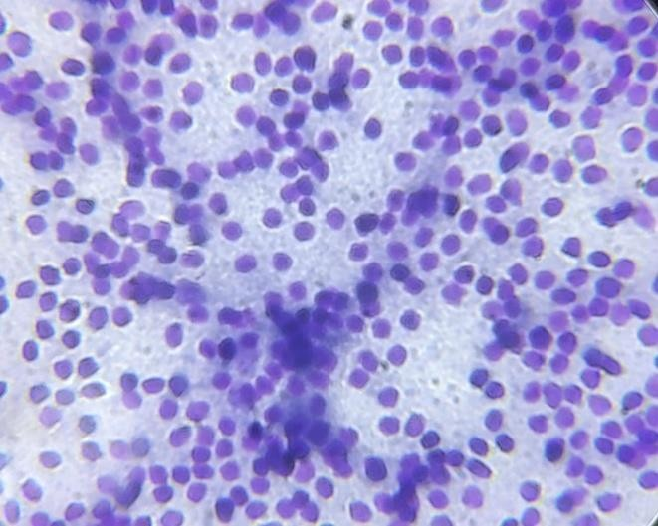 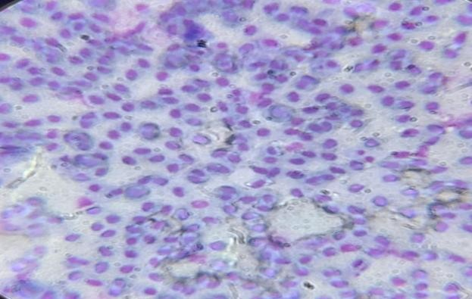

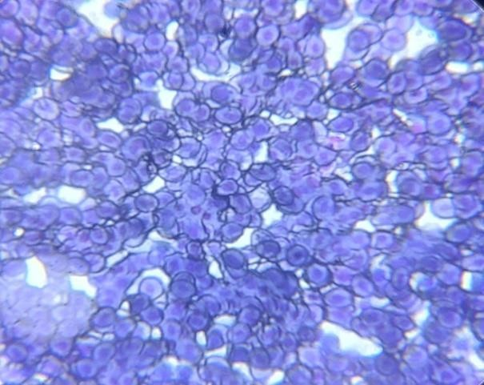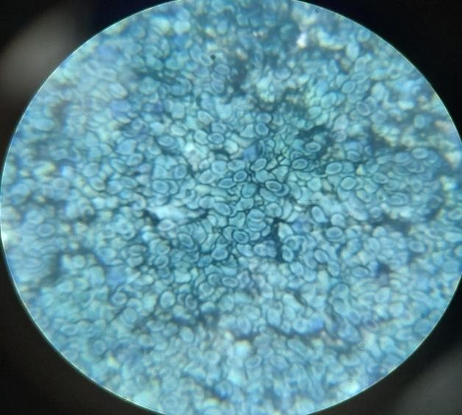A B

C D

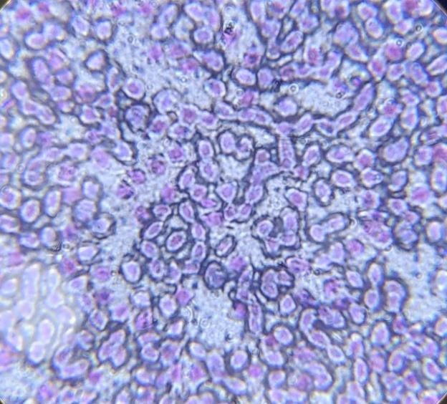E

*Figure*.1. Photographic plate – Blood cells induced in different concentration of Cypermethrin at different time intervals of *Anabas testudineus*. A. Blood cells of control group; B. 0.03 µL of water at 24 hrs; C. 0.03 µL of water at 48 hrs; D. 0.03 µL of water at 72 hrs; E. 0.04 µL of water at 24 hrs.

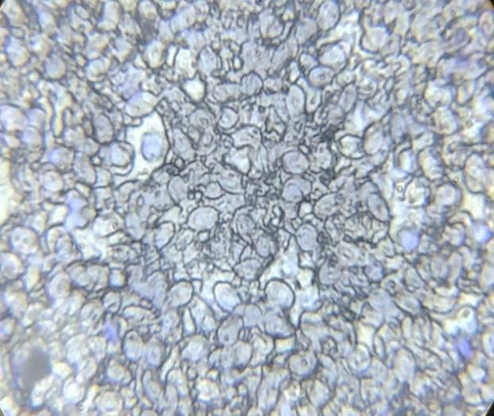 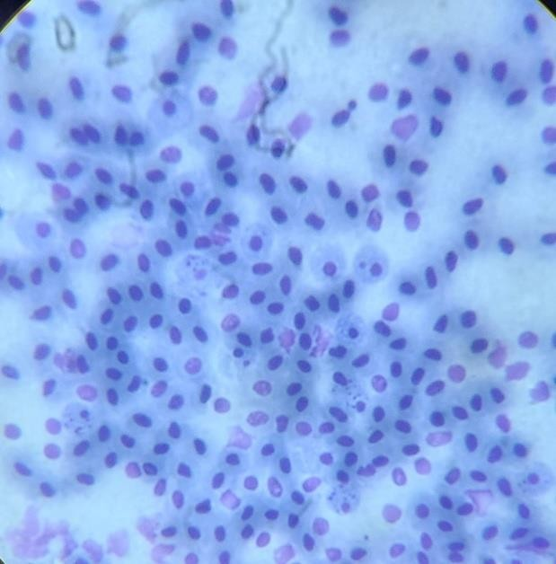

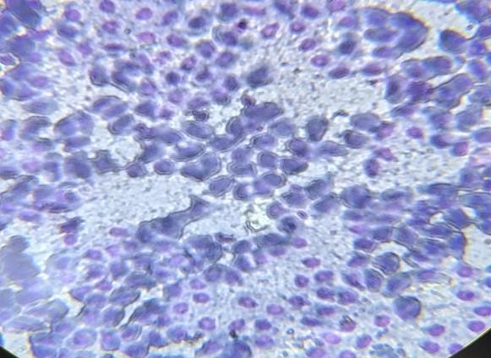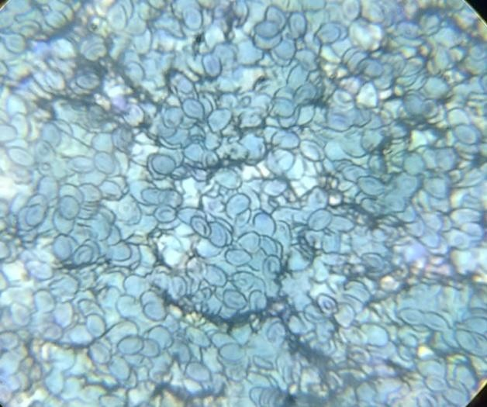 A B

C D

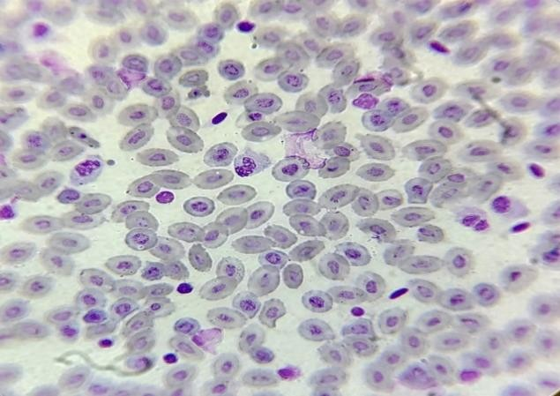E

*Figure*.2. Photographic plate – Blood cells induced in different concentration of cypermethrin at different time intervals of *Anabas testudineus*. A. 0.04 µL of water at 48 hrs; B. 0.04 µL of water at 72 hrs; C. 0.05 µL of water at 24 hrs; D. 0.05 µL of water at 48 hrs; E. 0.05 µL of water at 72 hrs.

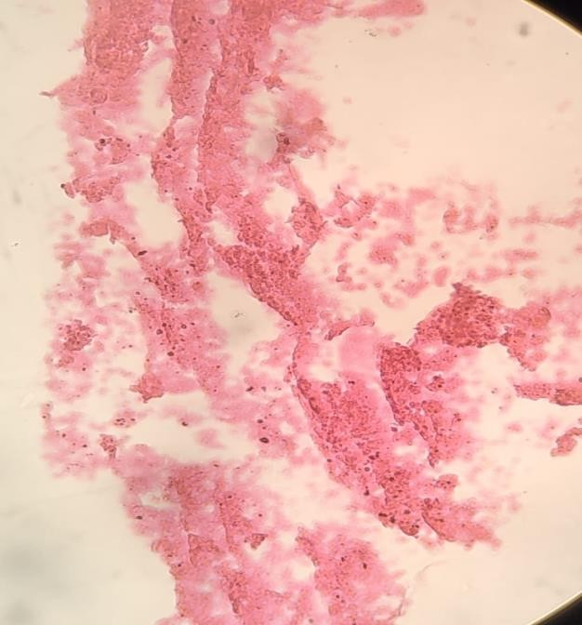 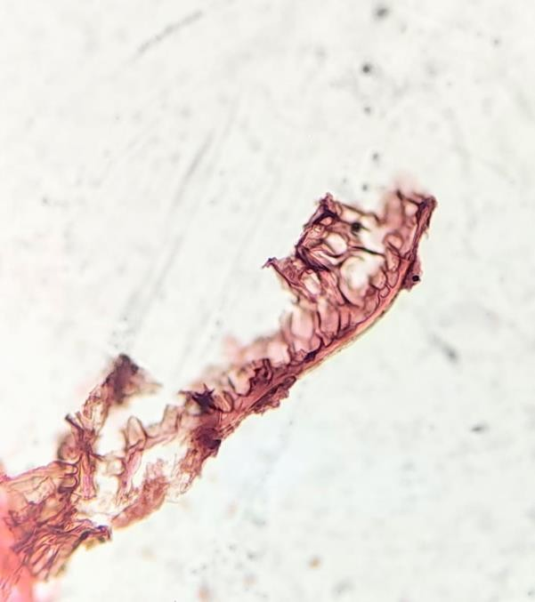

A B

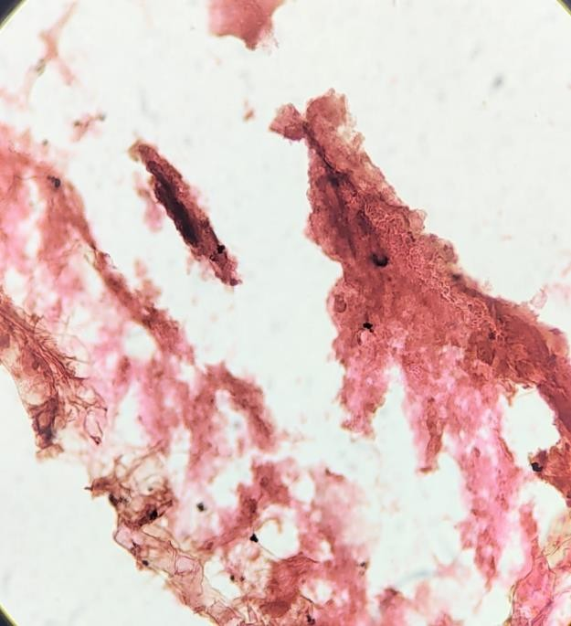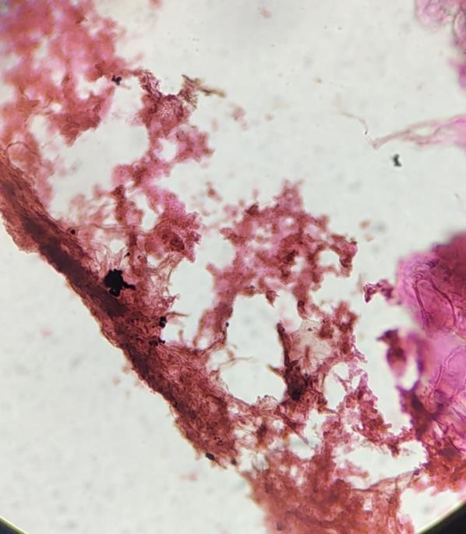

C D

*Figure*.3. Photographic plate – Gills are induced in different concentration of cypermethrin at different time intervals of *Anabas testudineus*. A. Gill tissues of control group; B. 0.03 µL of water at 96 hrs; C. 0.04 µL of water at 96 hrs; D. 0.05 µL of water at 96 hrs.

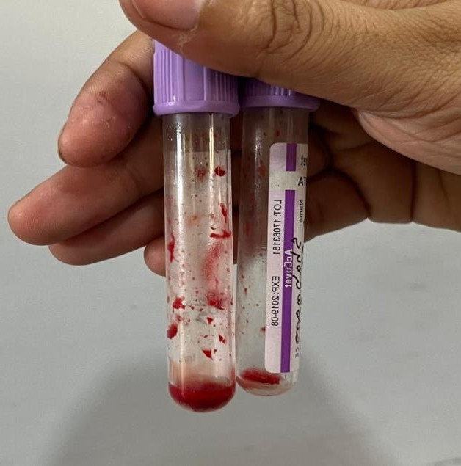 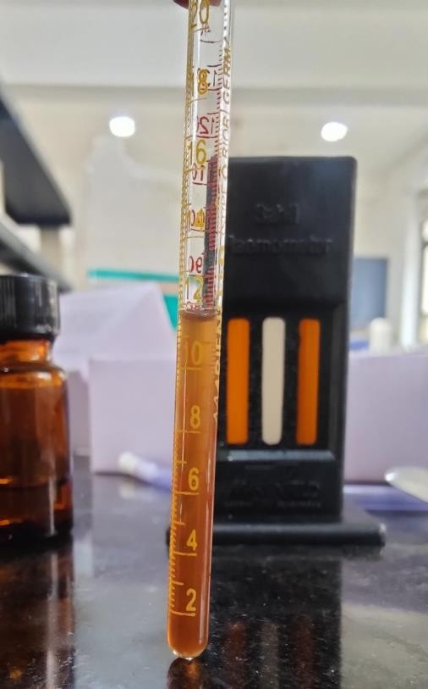

A B

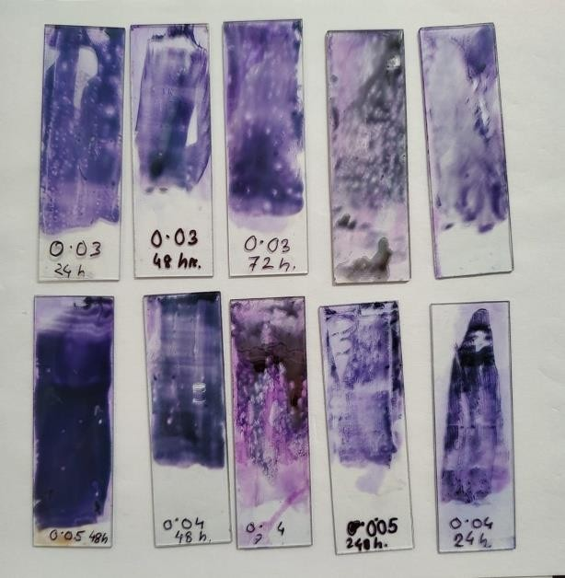

C

*Figure*.4. Photographic plate- Assessment alterations in blood parameters of *Anabas testudineus* exposed to Cypermethrin in different concentration. A. Blood stored in EDTA tube; B. Haemoglobin estimation in Haemocytometer; C. Preparation of Blood smear slide.

**DISCUSSION**

Exposure to both lethal and sub-lethal concentrations of various pesticides can result in numerous biochemical, physiological, histological, and hematological changes in aquatic organisms. This study specifically observed the impact of sub-lethal doses of cypermethrin on the blood of *Anabas testudineus*. The results indicated that cypermethrin exposure led to significant hematological changes, including a reduction in blood volume, the appearance of crenated (shrunken) blood cells, and enlarged nuclei. The result obtained on the hematology parameters of *A. testudineus* exposed to cypermethrin on 24hr, 48hr, 72 hr showed significant changes compared to the control group. There was significant reduction in RBC, WBC, thrombocytes count and haemoglobin with the exposure of the fish to cypermethrin. My findings are slightly similar to previous studies conducted by (Velmurugan *et al., 2016)* in which they found reduction of RBC, WBC, haematocrit, haemoglobin level after induced to different concentrations of Cypermethrin.

The study observed that histopathological changes of gills of *Anabas testudineus* exposure to cypermethrin caused significant gill lesions, including epithelial lifting, desquamation, necrosis, and hyperplasia of epithelial cells, hemorrhage, and fusion of the secondary lamellae (Akter *et al., 2024).* The gill structure was altered at different concentrations of cypermethrin, with the gills turning dark reddish-brown and showing slight degeneration and ruptured lamellae. These changes indicate that cypermethrin exposure adversely affects gill morphology and function in *Anabas testudineus.* Significant pathological changes, including epithelial lifting, lamellar swelling, hyperplasia, gill bridging, necrosis, and lamellar fusion. Similar findings has been observed in *Oreochromis mossambicus* (Ahmed *et al*., 2013).

**CONCLUSION**

Changes in the blood parameter and gills tissue were observed in different concentration at different time intervals induced by cypermethrin. The reason behind selecting Cypermethrin, a synthetic pyrethroid that is a broad-spectrum pesticide frequently employed in agricultural fields for management of variety of insects and pests. This chemical can enter into the fish habitat water bodies and can have hazardous effect on production, reproduction and survivability of living aquatic organisms, such as aquatic plants, algae and fish species. When these effected fishes are consumed by human beings or other organisms consume, they may also suffer harmful and severe effects. Cypermethrin may cause severe damage to the gill, liver and kidney, which may potentially result in respiratory trouble and other physiological disorders of the fish (Majumder and Kaviraj, 2022).

**ACKNOWLEDGEMENTS**

The authors are thankful to the Head, Department of Zoology, University of Science & Technology Meghalaya for providing the necessary laboratory facilities during the work. We are also highly thankful to the editors and reviewers of the journal for fine review of our manuscript to make it more scientifically accurate.

Disclaimer (Artificial intelligence)

Option 1:

Author(s) hereby declare that NO generative AI technologies such as Large Language Models (ChatGPT, COPILOT, etc.) and text-to-image generators have been used during the writing or editing of this manuscript.

Option 2:

Author(s) hereby declare that generative AI technologies such as Large Language Models, etc. have been used during the writing or editing of manuscripts. This explanation will include the name, version, model, and source of the generative AI technology and as well as all input prompts provided to the generative AI technology

Details of the AI usage are given below:

1.

2.

3.

## REFERENCES

1. Agbohessi, P., Olowo, L., Degila, B., Houedjissi, G., Imorou Toko, I., Mandiki, S. N., & Kestemont, P, 2023. Comparative assessment of acute toxicity and histological changes in liver of African catfish Clarias gariepinus exposed to cotton insecticides. *Journal of Environmental Science and Health, Part B*, *58*(1), 31-44.
2. Akhtar, N., Khan, M. F., Tabassum, S., Ahmad, M. S., & Badshah, K. D, 2021. Effects of cypermethrin on the hematological parameters, biochemical components of blood and histopathological changes in different organs of chirruh snow trout (Schizothorax esocinus). *Pakistan journal of zoology*, *53*(3), 943.
3. Ambedkar, G., & Muniyan, M, 2011. Bioaccumulation of some heavy metals in the selected five freshwater fish from Kollidam River, Tamilnadu, India. *Advances in Applied Science Research*, *2*(5), 221-225.
4. Asadullah, S., Ahmed, M. S., Roy, D., Sultana, Z., & Sarower, M. G, 2010. Effect of agricultural pesticide (Cypermethrin) on Labeo rohita. *Khulna University Studies*, 89-98.
5. Atamanalp, M., Yanik, T., Haliloglu, H. Ï., & Aras, M. S, 2002. Alterations in the hematological parameters of rainbow trout, Oncorhynchus mykiss, exposed to cypermethrin.
6. Docan, A., Grecu, I., & Dediu, L, 2018. Use of hematological parameters as assessment tools in fish health status. Journal of Agrolimentary Processes and Technologies, 24, 317-324.
7. Farag, M. R., Alagawany, M., Bilal, R. M., Gewida, A. G., Dhama, K., Abdel-Latif, H. M., ... & Naiel, M, 2021. An overview on the potential hazards of pyrethroid insecticides in fish, with special emphasis on cypermethrin toxicity. *Animals*, *11*(7), 1880.
8. Gabriel, U. U., & Ugbomeh, A. P, 2016. Effects of cypermethrin on haematological parameters of African freshwater catfish, *Clarias gariepinus.* J. Aquat. Sci, 31(2B), 433- 442.
9. Habiba, B., & AR, Y. G, 2012. *Butachlor induced alterations in haematological parameters of Schizothorax niger Heckel* (Doctoral dissertation, Dissertation of Master of Philosophy (M. Phil.) in Environmental Science. Department of Environmental Science University Of Kashmir Hazratbal, Srinagar, J and K, India).
10. Kannan, M., Muthusamy, P., & Venkatachalam, U, 2014. Response of synthetic pyrethroid cypermethrin (10% EC) induced stress in biochemical and haematological parameters of Indian major carp Catla catla (Hamilton, 1822). World J Pharm Res, 3(4), 1976-1996.
11. Khan, N., Tabassum, S., Ahmad, M. S., Norouz, F., Ahmad, A., Ghayyur, S., ... & Khan, M. F, 2018. Effects of sub-lethal concentration of cypermethrin on histopathological and hematological profile of rohu (Labeo rohita) during acute toxicity. *Int. J. Agric. Biol*, *20*(3), 601-608.
12. Kumar, B. G., Nandan, S. B., Kumari, T. A., & Sajeevan, K, 2014. Curative effect of Vitamin C on the variation in Biochemical and Histopathological Parameters Induced by Copper exposure in the Teleost Fish, Anabas testudineus (Bloch, 1792). *IOSR Journal of Environmental Science, Toxicology and Food Technology*, *8*, 28-35.
13. Kumar, S. V., Pascal, L. F., Tennyson, S., Pandeeswari, M., Dhinamala, K., Persis, D., & Meeran, M, 2018. Haematological studies of *Anabas testudineus* Bloch 1792 on exposure to aquatic toxicants of Buckingham canal, Chennai, Tamil Nadu, India.
14. Kumar, S. V., Pascal, L. F., Tennyson, S., Pandeeswari, M., Dhinamala, K., Persis, D.,... & Meeran, M, 2018). Changes in the biochemical profile of Anabas testudineus Bloch 1792 on exposure to aquatic toxicants of Buckingham canal. Chennai, Tamil Nadu, India. International Journal of Fisheries and Aquatic Studies, 6(4), 81-86.
15. M.O. Lawal and O.B. Samuel, 2010. The acute toxicity of Pirimiphosmethyle in freshwater fish. 6,567-570.
16. Mohammed Jalil Zorriehzahrah and Sana Ullah, 2014 The effects of pesticides induced toxicity in freshwaterfishes.3,87-93.
17. Neelima, P., Govinda Rao, K., Krishna Ch, S. M., & Chandra Sekhara Rao, J, 2016. Haematotoxicity of Cypermethrin (25% EC) to white carp (Cirrhinus mrigala). International J. of Life Sciences, 4(2), 207-213.
18. Neelima, P., Kumar, L. C. A., Rao, N. G., & Rao, J. C. S, 2013. Studies on activity levels of aspartate amino transferase (ASAT) and alanine aminotransferase (ALAT) in the tissues of Cyprinus carpio (Linn.) exposed to cypermethrin (25% EC). Int J Pharm Pharm Sci, 5(3), 566-570.
19. Rahman, M. M., Sarker, J. K., & Rahman, M. M, 2020. Effects of cypermethrin and sumithion exposure on the hematological profiles of a minor carp, Labeo bata (H).
20. Sahar Masud and I.J. Singh, 2013. Effect of cypermethrin on some hematological parameters and prediction in freshwater fish.11, 1020-1025.
21. Samanta, P., Pal, S., Mukherjee, A. K., Senapati, T., & Ghosh, A. R, 2014. Effects of almix herbicide on metabolic enzymes in different tissues of three teleostean fishes *Anabas testudineus*, *Heteropneustes fossilis* and *Oreochromis niloticus*. International Journal of Scientific Research in Environmental Sciences, 2(5), 156.
22. Sharmin Akter , Md. Abdullah-Al Mamun , Md. Sabbir Hossain , Arman Hossain, Md. Zobayer Rahman , Sarker Mohammed Ibrahim Khalil , Md. Moshiur Rahman , M. Mahbub Alam Pandit, D. N., & Jaiswal, A, 2020. Evaluation of acute toxicity, stress and safe level of chloramphenicol and ginger to an Indian air-breathing fish, *Channa punctatus* (Bloch). J Entomol Zool Stud, 8(2), 247-251.
23. Ullah, S., & Zorriehzahra, M. J, 2015. Ecotoxicology: a review of pesticides induced toxicity in fish. Advances in Animal and Veterinary Sciences, 3(1), 40-57.
24. Velmurugan, B., Satar, E. I., Yolcu, M., & Uysal, E, 2023. Effects of Cypermethrin on Serum Biochemistry and Liver Histopathology of Anabas testudineus. Journal of Chemical Health Risks.
25. Yadav, S., Haldar, S., & Mohapatra, A. K, 2019. Monocrotophos induced histopathological and biochemical Changes in gills, stomach and intestine of Anabas testudineus (Cuvier). Journal of Applied and Natural Science, 11(2), 534-544.