Review Article
Contagious Ecthyma in Goat and Sheep: A Review of Current Status and Future Perspectives

ABSTRACT: Contagious ecthyma is a viral skin disease that affects sheep, goats, and different other domestic and wild ruminants worldwide. It is acute, contagious, and economically significant. It is a non-systematic eruptive skin condition that is significant for public health. Other names for the condition include orf disease, scabby mouth, infectious pustular dermatitis, and sore mouth. Proliferative pustules on the mouth and palate are characteristic features. These lesions normally disappear in 1-2 months. Localized proliferative and persistent skin nodule lesions, which are the hallmark and pathognomonic lesion of orf disease, come in three different types: generalized, labial, and mammary or vaginal. It can show up in either benign or malignant forms. The latter kind of orf typically leads to a significant outbreak among small ruminant populations and can be chronic and frequently lethal. The disease is brought on by orf virus-like species of the genus Parapoxvirus from the Poxviridae family. The variola virus is the biggest DNA virus and the most well-known parapoxvirus that causes smallpox. Orf virus genomes typically include 64% G+C and certain derivative patterns can be detected in particular genomic areas. Despite clinical symptoms of orf disease, a laboratory-based diagnosis is required for validation and epidermal studies. Orf disease has become more significant due to its zoonotic nature. A comprehensive understanding of the disease's various aspects could benefit the scientific community and policymakers in disease control and eradication. This review aims to provide the latest information on orf disease for effective management and a significant reduction in economic losses.

Keywords: Contagious ecthyma; Etiology; Host response; Parapoxvirus; Precaution.

- INTRODUCTION
Sheep, goats, and numerous other farmed wild ruminants are susceptible to the acute, infectious, fatal, and economically pertinent zoonotic infectious skin disease known as contagious ecthyma. As stated by Mondal et al. (2006), it is a non-systematic eruptive cutaneous illness affecting people all over the world. The disorder is also known as contagious pustular dermatitis, sore mouth, and scabby mouth (Thomas et al., 2003). The condition known as orf, an infection-related manifestation that affects epithelial cells, is brought on by the Orf virus (ORFV). It belongs to the family Poxviridae and subfamily Chordopoxvirinae of the genus Parapoxvirus. The Pseudo Cowpox Virus (PCPV), the Squirrel Parapoxvirus (SPPV), the Bovine Papular Stomatitis Virus (BPSV), and the Parapoxvirus of Red Deer in New Zealand are also included in this family (Zhang et al., 2010). Hosamani et al. (2006) claims that the zoonotic infections ORFV, PCPV, and BPSV induce nodular lesions on the fingers and forearms of individuals close to the animals that are impacted. The disease is prevalent across the world and mostly affects sheep and goats. However, reports of the contamination of various domestic and wild ruminants have recently emerged in several locations around the world (Spyrou & Valiakos, 2015). Skin abrasion is the primary method of transmission. The affected animals exhibit proliferative lesions after an incubation period of 8–14 days, which usually manifest on the lips, snout, ears, eyelids, tongue, and nostrils. On occasion, the disease spreads to non-woolly tissues such as the legs, feet, and udders. As per Peralta et al. (2018), the illness progresses from redness, blisters, bumps, and crusts to sores that gradually improve for one to two months. Epidemiological evidence has indicated that although the mortality rate associated with orf disease is generally low, morbidity is substantial. Orf is a zoonotic disease that may spread from animals to humans, according to the World Organisation for Animal Health (Nadeem et al., 2010). With multiple enzootic regions across the world, the disease is prevalent over all continents. The affliction exhibits a broad range of distribution and affects not solely ovine and caprine species but also diverse canine and camelid varieties in locations where these creatures are frequent. Incidences of ecthyma have been widespread in many nations, such as Ethiopia, Korea, Brazil, and South Africa. Bangladesh, Iran, India, and China have all recently experienced outbreaks of Orf virus (ORFV), according to documented cases. Several investigations conducted in Malaysia have provided evidence confirming the existence of ORFV in ovine and caprine species from different geographic regions and at different times through seroprevalence and molecular classification using partial gene amplification techniques (Bala et al., 2020). As per the findings of Jesse et al. (2018), a study has revealed that sheep and goats from a small ruminant farm in Selangor had infection rates of 36.7% and 7.8%, respectively. Thus, there is a pressing need for the identification and analysis of ORFV, as this may signify the migration of viral strains.

- ETIOLOGY
The genus Parapoxvirus and family Poxviridae contain the orf virus, which causes the highly infectious blisters known as orf in many species of small ruminants, including sheep and goats. The parapoxvirus virus of red deer in New Zealand (PVNZ) and the bovine popular stomatitis virus (BPS) are both members of the same genus. The parapoxviruses share comparable appearances, genomic configurations, and virulence mechanisms and connect genetically and anatomically (Fleming et al., 1993). The virions possess ball-shaped, long membrane tubules that are 260 nm long and 160 nm wide that resemble long threads. The virus's DNA structure is a linear double-stranded molecule of roughly 140 kilobase pairs. This virus's genome is believed to be one of the shortest in the Poxviridae family due to the presence of closed hairpin loop ends and genes arranged in a bidirectional manner on both strands of the molecule. An inverted terminal repeat (ITR) is formed by the final 3 kbp of DNA at each end (Robinson et al., 1982). The genome's extremities are where most genetic alterations occur, while the central area typically contains well-preserved genes. This was not stumbled upon via any investigation carried out by Gassmann et al. (1985) and Fraser et al. (1990). Orf viruses, like all other poxviruses, duplicate within the cytoplasm of their host cells and hold the essential machinery for DNA replication. As reported by Li et al. (2012), orf is a 138 kb dsDNA virus with around 64% G+C content. A pictorial representation of orf virus is shown in Fig. 1.
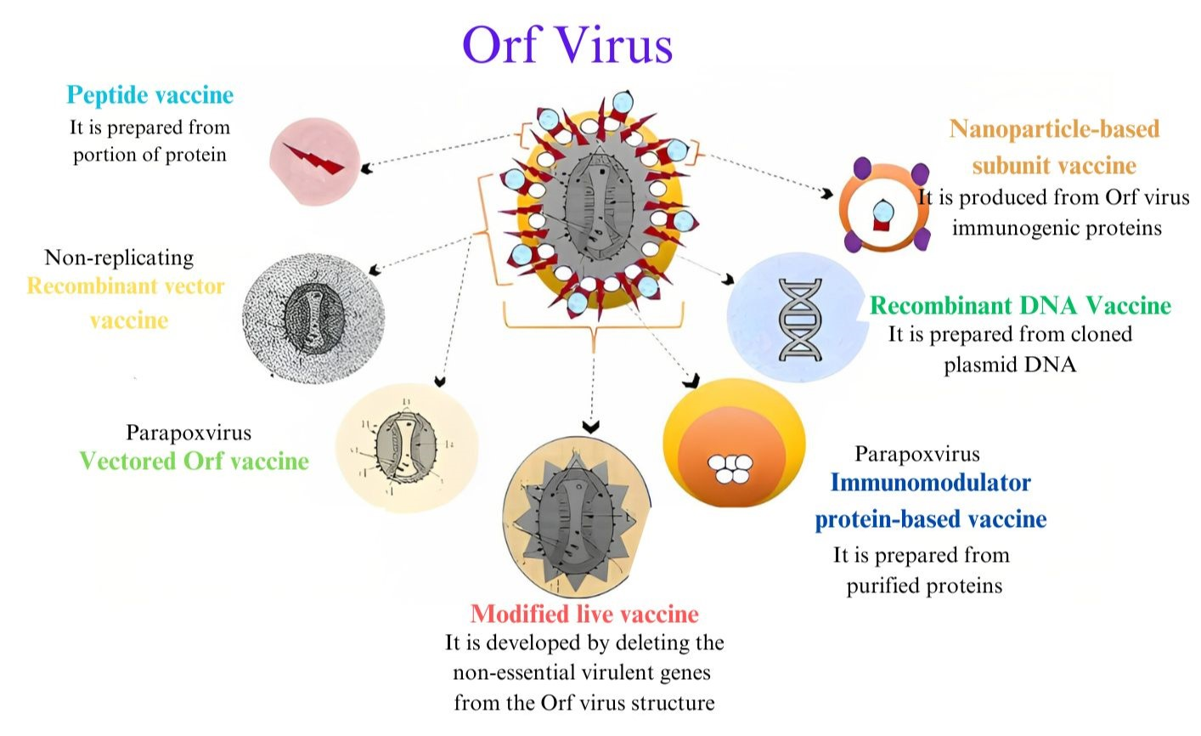
Fig. 1. Diagrammatic representation of orf virus

2.1 Physico-chemical properties
Parapoxviruses can endure for numerous months in a cold, arid habitat and exhibit significant resistance to ether. Nevertheless, they are vulnerable to high and exceedingly low temperatures, wetness, as well as UV radiation, as indicated by McKeever and Reid (1986). The inverted terminal repeats of the parapoxvirus, which are situated at the ends of the genome in opposing directions, are indistinguishable sequences between 1.2 and 4.0 kbp in length. When the scab is exposed to sunlight, it preserves its infectiousness for a more extended duration than the orf virus on shaded land. The infectiousness of the virus may remain for up to 15 years at room temperature. According to Buxton and Fraser (1977), the virus is vulnerable to chloroform, benzene, and toluene but exhibits resistance to glycerol.

2.2 Host range
According to Oksanen and Norberg (1994), contagious ecthyma can affect sheep, goats, cattle, camels, deer, reindeer, and even seal squirrels and humans. The virus usually enters its host through skin wounds such as cuts or abrasions, where it results in erythema, papules, or pustules before eventually causing brownish-dry scabs. Ndikuwera et al. (1992) found that Boer goats are particularly susceptible to orf virus infection and experience severe lesions. According to the findings of Abu-Elzein et al. (2004), sheep have been proven to be resistant to contracting the camel orf virus and vice versa.

2.3 Epidemiology
Ecthyma is contagious and more prevalent in the latter summer, autumn, and winter on grasslands and cattle farms. Compared to kids and lambs, adults have a lower chance of getting sick. The orf virus can persist in arid environments for weeks or even years, but it may have a shorter life cycle there. Skin that is fractured, scarred, or damaged permits the orf virus to enter and spread throughout epidermal cells. Contact between susceptible and sick animals is the primary method of disease transmission. The disease can affect a variety of sheep and goat breeds. According to Ndikuwera et al. (1992), animals with immunological deficiencies and animals that are chronically infected are significant contributors to the preservation of the orf virus. Recurring infections are less deadly and heal more quickly, and they can appear one to three months later. Preparations for ecthyma virus developed in cell culture are less effective at producing immunity than those grown in sheep.

2.4 Pathogenesis
The primary location of prediction and an important factor in the emergence and growth of lesions is the skin. The epidermal cells that are formed from the outermost layer of the wool follicle are where the virus first begins to multiply. When the animal is grazing, the dried stemmy and prickly feed may scratch the tissues of the lips, nostrils, mouth, and stomach. The typical lesions that are brought on by the virus are papules, vesicles, scabs, and resolution. Within a few days, pustules form. Although the pathophysiology of orf is straightforward, the subsequent bacterial infection causes it to become complicated. Sometimes it can be difficult to accurately diagnose orf because of the invasion by Dermatophilus congolensis. Furthermore, buccal mucosal lesions caused by Fusobacterium necrophorum can disseminate viscera. The granulomatous lesions and hoof shedding are caused by the visceral lesions that go down the digestive tract. The formation of ulcers at the vulva is a symptom of the disease's general form, which is linked to F. necrophorum. The immunity of sick animals lasts for eight months to a year after clinical recovery. Even while humoral immunity accounts for a significant portion of the immune response to viral infection, cell-mediated immunity is crucial for the recuperation process (Mckeever et al., 1987).

2.5 Host response to virus infection
The dynamics of immune response cells, antibodies, and cytokine activity determine the type and extent of orf virus infection. For limiting the rate of orf virus growth, the host immune response is crucial. Sheep infected with the orf virus develop antibodies to five immunodominant antigens. These antigens are incredibly helpful for distinguishing between various para-poxviruses. An infection with the orf virus triggers a robust cutaneous immunological response. However, several immune-modulatory/pathogenesis-related genes that the virus has acquired work to reduce the efficiency of host immunity. The analysis of this dynamic mechanism will offer crucial insights into virus pathogenesis and the host skin immunological response to infection with the advent of the virus genomic sequence.
The host's reaction to orf virus infection is characterized by the primary influx of neutrophils and subsequent buildup of dendritic cells, CD4+ T cells, CD8+ T cells, and B cells close to virus-infected epidermal cells. The speed and strength of these cellular modifications in the dermis are associated with the presence of the virus and the clinical signs of the medical condition. It is improbable that CD8+ T cells outnumber CD4+ T cells at the site of damage, despite some subgroups becoming active following infection (Fig. 2). The host's immune system relies heavily on Tc CD8+ cells and the MHC class 1 pathway to defend against viral infections (Haig et al., 1999).
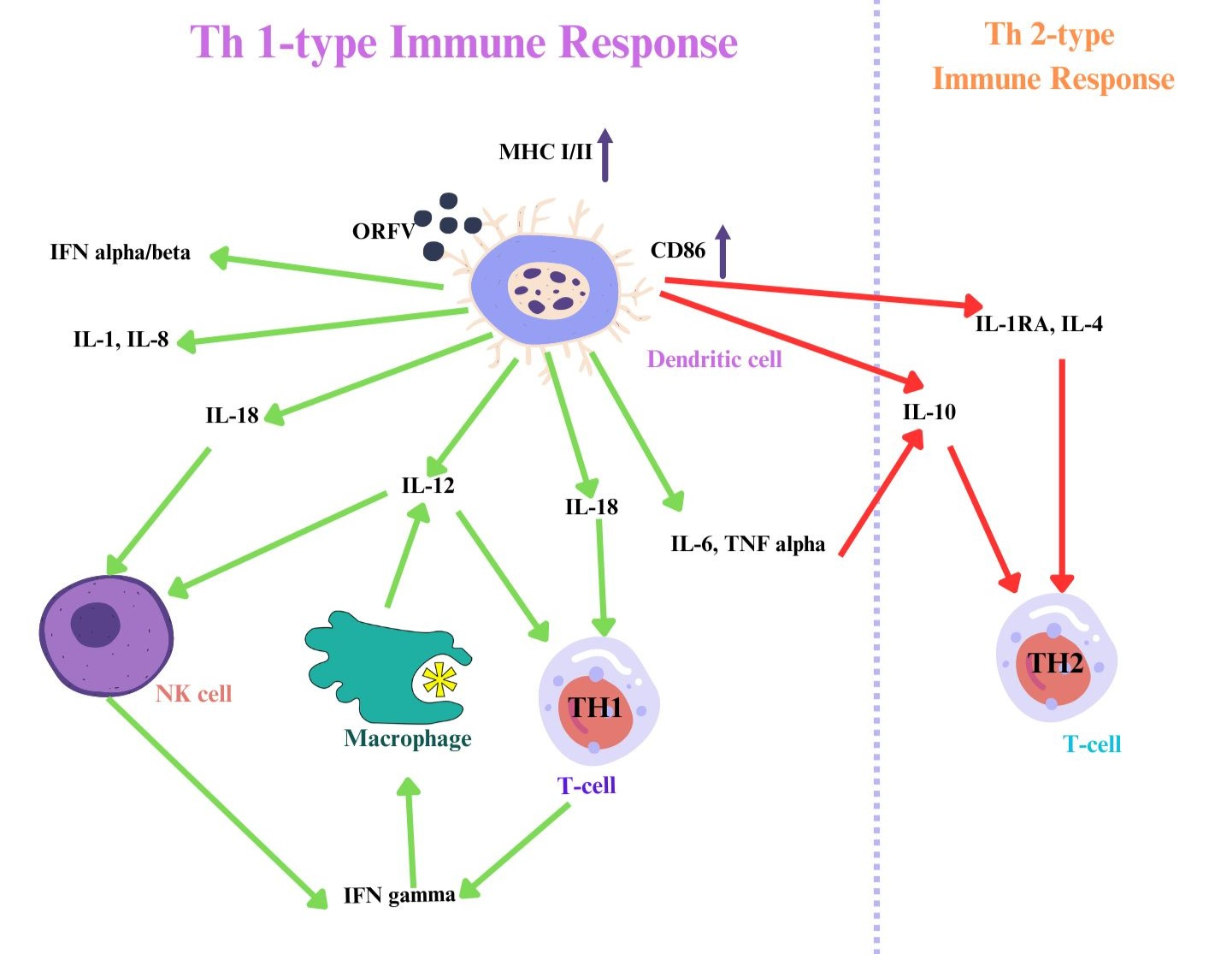
Fig. 2. Host immune response of orf virus

2.6 Factors affecting virus virulence and evasion of host immunity
The orf virus frequently re-infects and multiplies in animals, even after sheep recover from the first infection. This occurrence has a wide range of interpretations. Before host anti-viral compounds termed effector molecules get to the site of infection, the virus first infects epidermal cells and replicates for a brief period. Second, the virus is far less likely to induce apoptosis in the cells by selecting to target regenerated epidermal cells. The potential of the virus to obstruct the components of the immune system's protective response was further illustrated by the identification of numerous immunomodulating virus genes (Alcami & Smith, 1995). The virulence of the orf virus is primarily attributed to the endothelial growth factor (VEGF), as well as the ovine gene encoding the cytokine IL-10, the interferon resistance gene (OVIFNR), and a gene that obstructs the inflammatory cytokine GM-CSF. These insights have been proposed by several sources, including Haig et al. (1999).

2.7 Clinical manifestations
The illness's incubation period varies between 4 and 8 days and is characterized by an initial increase in body temperature, the appearance of papules and pustules, primarily on the lips, nose, and skin surrounding the oral commissures, and then a thick, sticky, and inflammatory condition. The illness often lasts between three and four weeks. In some locations, lesions in the oral cavity, particularly those on the gums, change from dry to wet, reddish-brown to extremely hyperemic (Samuel et al., 1975). Lambs and small children who have been impacted suffer greatly as a result of the restrictions on grazing and nursing (Chan et al., 2007). The scabs are thin and therefore susceptible to bleeding. Ecthyma lesions are painful, and infectious, and can lead to anorexia followed by starvation.

2.8 Histopathological changes
On the tongue, mouth, throat, rumen, abomasum, necrotic foci, and ulcers may occasionally develop as a result of secondary infection. Liver abscesses can occasionally be seen. The onset of pneumonia in a severe phase of the sickness may result in the death of the affected animal. The lesion's developmental stage of propagation determines the histological alterations. Lesions on the skin and mucosa may appear as a widespread vesicular-papular rash. Although orf lesions rarely exceed 5 cm in diameter, those that progress through the various etiology and clinical stages typically have a diameter greater than 1 to 3 cm (McElroy & Bassett, 2007)). Histologically, the lesions display prominent rete ridges, substantial parakeratotic and ortho-keratotic hyperkeratosis, and considerable epidermal hyperplasia.

- DIAGNOSIS
Based on distinctive lesions on the anatomic areas of preference, infectious ecthyma can be diagnosed. It should be diagnosed differently from ulcerative dermatosis, sheep pox, and foot and mouth disease (FMD) (Wilson et al., 2002). However, the main clinical trait that enables a distinction between orf and FMD is that, in contrast with FMD, proliferative lesions are produced by the orf virus. The lower part of the gums and the tongue are where oral lesions caused by FMD in sheep are most probable to appear. Ulcerative dermatosis causes the skin of the face, foot, and genitalia to become inflamed and form crusts. Sheep and goat pox, on the other hand, are lethal contagious diseases that are marked by elevated papules throughout the body.
Laboratory examinations that are often employed consist of electron microscopy (EM), serologic assessments such as agar gel precipitation test (AGPT), agglutination assessment, complementary fixation assessment (CFT), serum neutralization assessment (SNT), enzyme-linked immunosorbent assays (ELISAs), and nucleic acid base assessments, which comprise polymerase chain reaction (PCR) and restricted fragmented length polymorphism (RFLP) analysis.

3.1 Electron microscopy (EM)
The fastest technique for diagnosing and distinguishing poxvirus infections in humans and animals is the electron microscope (Nandi et al., 2011). When examined with an electron microscope, parapoxvirus has an ovoid shape with exterior tubules that display a crisscross pattern resembling a ball of yarn, which is indistinguishable from the orf (Hosamani et al., 2009). Because the virion's morphology can be distinguished from that of other poxvirus genera and all other viruses, this approach works well for the initial diagnosis of parapoxviruses (Nagington, 1964). Although it cannot be used to speciate viruses, electron microscopy is especially helpful in the diagnosis of Parapoxvirus, which frequently grow slowly and irregularly (Hosamani et al., 2009). The method's limitations include low cost, limited sensitivity (requires a minimum of 106 particles per ml), and a lack of EM facilities with competent people, in addition to the inability to identify viruses at the species level.

3.2 Enzyme-linked immunosorbent assay (ELISA)
When samples are placed on 96-well microtiter plates coated with pure orf viral antigens and antibodies, peroxidase-conjugated protein A, or protein AG, the ELISA approach allows for fast screening of a large number of samples (Inoshima et al., 1999). Although not biased against parapoxvirus species, ELISA has proven effective in diagnosing ORFV infections in humans (Yirrell et al., 1989) and parapoxvirus infections in California lions (Nollens et al., 2006).

3.3 Polymerase chain reaction (PCR)
For ORFV diagnostics, the polymerase chain reaction (PCR) technique that targets certain DNA fragments of ORFV has been routinely employed. The two genes that are most frequently employed for diagnosis are B2L (ORFV011) and FIL (ORFV059). A new strand of DNA can be created over repeated cycles of heat denaturation, annealing, and extension thanks to thermostable DNA polymerase. Specific oligonucleotide primers that are complementary to the target DNA define the target sequence, allowing the appropriate region to be amplified. Sanger sequencing produces billions of copies of the original sequence as the amount of target DNA is doubled in each cycle. The validation of the amplified product's identity can be completed through DNA hybridization, as mentioned in the works of Inoshima et al., (2000).

3.4 Real-time PCR
Real-time PCR studies are occasionally employed in place of traditional PCR procedures. Real-time PCR tracks the buildup of the PCR product during the amplification reaction, making it possible to recognize the cycles throughout the production of the nearly logarithmic PCR product. In other words, the assay may be used to accurately determine how much DNA is present in a particular sample. The intriguing possibility of these approaches being employed for the quick diagnosis of disease outbreaks in the fields has been raised by the recent development of portable real-time PCR devices and assays. Real-time PCR (Gallina et al., 2006) based on pan-parapox-specific PCR (Inoshima et al., 2000) was recently developed and uses the major envelope gene (B2L), a structural protein of ORFV.

3.5 Cell culture isolation
According to Inoshima et al. (1999) and Delhon et al. (2004), primary lamb testis, lamb kidney, fetal lamb dermis, fetal lamb muscle, fetal bovine muscle, fetal bovine lung cells, cell line MDBK, MDOK, and Vero cells are typically used for orf virus isolation. According to Kruse and Weber (2001), CPE typically shows up as significant ballooning, rounding, and cell degeneration after 1-2 passes.

3.6 Virus neutralization test
After a natural infection or vaccination, a viral neutralization test (VNT) is performed to measure the presence of virus-specific antibodies. This method involves the neutralization of viruses through unique antibodies, which protect cells against viral infections (Krešić et al., 2020). However, due to the predominant cell-mediated immunological responses to ORFV infection and low concentrations of neutralizing antibodies, a serum neutralization test is not commonly utilized for ORFV diagnosis (Fig. 3). Serum neutralization tests often consider titers of 8 or higher to be positive according to Hosamani et al. (2009).

Fig. 3. Instruments used for diagnosis of orf virus

- MANAGEMENT OF DISEASED ANIMALS
When flocks or herds experience epidemics of contagious ecthyma, it is essential to isolate fresh animals before integrating them into the new herd. After feeding the herd, sick animals should be kept apart, nourished, and treated. Ceftriaxone and Tazobactum should be administered to the affected goats. Herbal injections or aerosol sprays can be freely applied to the afflicted area. Milk from animals with sores on their teats should not be consumed. When handling sick animals and administering vaccinations, gloves and facemasks should be worn because people can catch the disease from them. It is not advisable to administer a live virus vaccine on a farm where an outbreak has previously occurred because the live virus could infect the surrounding area (Singh et al., 2024).

4.1 Vaccination
The only way to properly manage orf virus infection is by vaccination, as there is no specific antiviral therapeutic regimen for the disease. Although antiviral medication can mitigate the severity of the illness, it cannot cure the infected animal. Supportive care, including the use of antibiotics, may help to prevent or treat secondary bacterial infections. Thus far, immunization has proven to be the most dependable alternative to antibiotics and antiviral medications. While several viruses can induce orf illness, live attenuated vaccines are invariably deemed superior to other varieties and are presently employed in various regions worldwide where it is endemic. By triturating the scab material in saline and adding penicillin/streptomycin, an autologous vaccine can be produced. The face or legs cannot be scarified with a vaccination drop, only the inner thigh or other suitable regions. Infected farmers should employ vaccines to prevent further spread. According to Nettleton et al. (1996), a live attenuated tissue culture vaccine effectively lessens the severity of the illness. After a single injection, attenuated vaccinations typically produce long-lasting immunity, negating the need for further boosters. One effective live attenuated vaccination against infection in sheep and goats is the ORFV D1701 strain. The vaccine's biggest drawback, however, is that it can spread the vaccine virus, which can spread disease and cannot provide a strong defense against reinfection (Buddle & Pulford, 1984).

4.2 Prevention
Although vaccination is highly effective and affordable in preventing orf virus infections, it is important to supplement it with proper zoo sanitation practices and disinfection procedures. Additionally, isolating affected animals can greatly limit the spread of the disease. To safeguard new animals against the orf virus, they should be confined before being housed with other farm animals. To avoid the possibility of mouth or muzzle wounds, animals shouldn't be allowed to eat plants, scratchy straws, or feed. Furthermore, it should be illegal for animals to move from one location to another. Humans must use caution when handling vaccines since they can spread infection. To mitigate the risk of human ailments, it is highly recommended to utilize impermeable gloves, routinely cleanse the hands with warm, soapy water, or employ hand sanitizer for 20 seconds following any interaction with sheep or goats (Nandi et al., 2011).

4.3 Public health importance
The acute, extremely contagious, and economically vital infectious disease known as contagious ecthyma affects the skin of sheep, goats, and various other farmed and wild ruminants. Orf has been documented in some people from different countries due to its high contagiousness (Dupre et al., 1978) (Leavell et al., 1968). Shepherds, vets, farmers' spouses who bottle-feed newborn lambs, slaughterhouses, and meat porters in particular are susceptible to catching the virus from coming into touch with sick animals (Arranz et al., 2000). It is crucial to educate farmers and those who work with animals or animal products about the virus's clinical symptoms and modes of transmission. The likelihood of infection recurrence as a result of recurrent viral exposure should also be made known to the public. Although the virus doesn’t infect muscle tissues of the infected animal, utmost care should be taken when handling their carcasses, as the transmission to humans occurs through direct contact with lesions. When the meat of the infected animal is thoroughly cooked, it is safe to consume (Nandi et al., 2011). In areas where the virus is endemic, surveillance implementations, and confirmation of the existence of the virus from human or animal lesions, and vital to use by integrating the public health of both human and animal sectors.

- CONCLUSION
The import of infected animals is the most efficient method for the orf virus to spread to a new location. Before entering non-endemic areas, animal products must go through proper disinfection measures. If a new case is detected, it is crucial that the animal is separated and any contaminated creatures are put down humanely. Additionally, the surroundings must be meticulously sanitized to avoid the transmission of the illness. The best method of managing a disease that has already spread over a big area is vaccination. Some sheep and goats that don't exhibit any orf signs could serve as carrier animals. Once more, the virus may linger on the infected property for months. To stop the spread of disease, farms and other locations with exposed or infected animals must impose quarantines. Massive vaccination campaigns and restrictions on animal movement out of the area offer a workable and ideal plan to first manage orf, and then eventually eradicate it if the disease has spread widely.
Despite the economic losses in the majority of developing countries growing sheep and goats, there hasn't been enough surveillance, epidemiological data, or effective control measures for the disease up to this point because of the symptoms and their associated effects. As a result, the prevention of orf infection depends greatly on the deployment of adequate surveillance and infection control methods. Even then, it has a very extensive host range, a high potential for zoonotic transmission, and short-term immunity. Since there are currently no recombinant antigen-based diagnostics, this presents a significant challenge in diagnosing and differentiating the ORFV. The ascertainment of molecular epidemiology and phylogenetic relationship between the various constituents of the genus is likely to contribute to the genetic characterization of virulence genes. These investigations are expected to aid in the determination of the epidemiological distribution of ORFV in India, owing to the identification of genetic relatedness. Furthermore, the establishment of sensitive and accurate diagnostics is deemed mandatory for the differential diagnosis of disease and the formulation of control strategies. Additionally, cost-effective, innocuous, and traditional vaccines must be supplied to regulate the spread of the ailment in the forthcoming times.

Availability of Data and Materials
Not Applicable.

Disclaimer (Artificial Intelligence)
Author(s) hereby declare that NO generative AI technologies such as Large Language Models (ChatGPT, COPILOT, etc.) and text-to-image generators have been used during the writing or editing of this manuscript.

REFERENCES

Abu Elzein, E. M. E., Housawi, F. M. T., Al-Afaleq, A. I., Ramadan, R. O., Gameel, A. A., & Al-Gundi, O. (2004). Clinicopathological response of dromedary camels and sheep to cross-experimental infection with two virulent orf viruses originating from camels and sheep. Journal of Camel Practice and Research, 11(1), 15–19.

Alcami, A., & Smith, G. L. (1995). Cytokine receptors encoded by poxviruses: a lesion in cytokine biology. Immunology Today, 16(10), 474–479. https://doi.org/10.1016/0167-5699(95)80030-1

Arranz, F. R., Arias, C. A., Rub, J. F. P., & Abu-Elzein, E. M. E. (2000). Infection por virus orf. Piel, 15(6), 367–371.

Bala, J. A., Balakrishnan, K. N., Jesse, F. F. A., Abdullah, A. A., bin Noorzahari, M. S., Ghazali, M. T., et al. (2020). Identification of strain diversity and phylogenetic analysis based on two major essential proteins of Orf viruses isolated from several clinical cases reported in Malaysia. Infection, Genetics and Evolution, 77, 104076. https://doi.org/10.1016/j.meegid.2019.104076

Buddle, B. M., & Pulford, H. D. (1984). Effect of passively acquired antibodies and vaccination on the immune response to contagious ecthyma virus. Veterinary Microbiology, 9(6), 515–552. https://doi.org/10.1016/0378-1135(84)90013-0

Buxton, A., & Fraser, G. (1977). Animal Microbiology (Vol. 1, pp. 121–126). Oxford: Blackwell Scientific Publications.

Chan, K. W., Lin, J. W., Lee, S. H., Liao, C. J., Tsai, M. C., Hsu, W. L., & Shih, H. C. (2007). Identification and phylogenetic analysis of orf virus from goats in Taiwan. Virus Genes, 35(3), 705–712. https://doi.org/10.1007/s11262-007-0144-6

Delhon, G., Tulman, E. R., Afonso, C. L., Lu, Z., de la Concha-Bermejillo, A., Lehmkuhl, H. D., Piccone, M. E., Kutish, G. F., & Rock, D. L. (2004). Genomes of the parapoxviruses ORF virus and bovine papular stomatitis virus. Journal of Virology, 78(1), 168–177. https://doi.org/10.1128/jvi.78.1.168-177.2004

Dupre, A., Auvergnat, J., Durand, R., & Catala, D. (1978). Orf and milker’s nodule. Annales de Dermatologie et de Vénéréologie, 105(3), 213–214.

Fleming, S. B., Blok, J., Fraser, K. M., Mercer, A. A., & Robinson, A. J. (1993). Conservation of gene structure and arrangement between vaccinia virus and orf virus. Virology, 195, 175–184. https://doi.org/10.1006/viro.1993.1358

Fraser, K. M., Hill, D. F., Mercer, A. A., & Robinson, A. J. (1990). Sequence analysis of the inverted terminal repetition in the genome of the parapoxvirus, orf virus. Virology, 176(1), 379–389. https://doi.org/10.1016/0042-6822(90)90008-f

Gallina, L., Dal Pozzo, F., McInnes, C. J., Cardeti, G., Guercio, A., Battilani, M., Ciulli, S., & Scagliarini, A. (2006). A real-time PCR assay for the detection and quantification of orf virus. Journal of Virological Methods, 134(1–2), 140–145. https://doi.org/10.1016/j.jviromet.2005.12.014

Gassmann, U., Wyler, R., & Wittek, R. (1985). Analysis of parapoxvirus genome. Archives of Virology, 83(1–2), 17–31. https://doi.org/10.1007/bf01310961

Haig, D. M., Hopkins, J., & Miller, H. R. P. (1999). Local immune responses in afferent and efferent lymph. Immunology, 96(1), 155–163. https://doi.org/10.1046/j.1365-2567.1999.00681.x

Hosamani, M., Bhanuprakash, V., Scagliarini, A., & Singh, R. K. (2006). Comparative sequence analysis of major envelope protein gene (B2L) of Indian orf viruses isolated from sheep and goats. Veterinary Microbiology, 116, 317–324. https://doi.org/10.1016/j.vetmic.2006.04.028

Hosamani, M., Scagliarini, A., Bhanuprakash, V., McInnes, C. J., & Singh, R. K. (2009). Orf: an update on current research and future perspectives. Expert Review of Anti-infective Therapy, 7(7), 879–893. https://doi.org/10.1586/eri.09.64

Inoshima, Y., Murakami, K., Yokoyama, T., & Sentsui, H. (2000). Genetic heterogeneity among parapoxviruses isolated from sheep, cattle, and Japanese serows (Capricornis crispus). Journal of General Virology, 81(5), 1215–1220. https://doi.org/10.1099/0022-1317-82-5-1215

Inoshima, Y., Shimizu, S., Minamoto, N., Hirai, K., & Sentsui, H. (1999). Use of protein AG in an enzyme-linked immunosorbent assay for screening for antibodies against parapoxvirus in wild animals in Japan. Diagnostic Laboratory Immunology, 6(3), 388–391. https://doi.org/10.1128/cdli.6.3.388-391.1999

Jesse, F. F. A., Hambali, I. U., Abba, Y., Lin, C. C., Chung, E. L. T., Bitrus, A. A., et al. (2018). Effect of dexamethasone administration on the pathogenicity and lesion severity in rats experimentally inoculated with Orf virus (Malaysian isolates). Comparative Clinical Pathology, 27, 1227–1236. https://doi.org/10.1007/s00580-018-2726-1

Krešić, N., Šimić, I., Bedeković, T., Acinger-Rogić, Ž., & Lojkić, I. (2020). Evaluation of serological tests for detection of antibodies against lumpy skin disease virus. Journal of Clinical Microbiology, 58(9), 10–1128. https://doi.org/10.1128/jcm.00348-20

Kruse, N., & Weber, O. (2001). Selective induction of apoptosis in antigen-presenting cells in mice by parapoxvirus ovis. Journal of Virology, 75(10), 4699–4704. https://doi.org/10.1128/jvi.75.10.4699-4704.2001

Leavell, U. V., MacNamara, M. J., Muelling, R., Talbert, W. M., Rucker, R. C., & Dalton, A. J. (1968). Orf: Report of 19 human cases with clinical and pathological observations. Journal of the American Veterinary Medical Association, 153(2), 204–216. https://doi.org/10.1001/jama.1968.03140210011003

Li, W., Ning, Z., Hao, W., Song, D., Gao, F., Zhao, K., et al. (2012). Isolation and phylogenetic analysis of orf virus from the sheep herd outbreak in northeast China. BMC Veterinary Research, 8, 1–13. https://doi.org/10.1186/1746-6148-8-229

McElroy, M. C., & Bassett, H. F. (2007). The development of oral lesions in lambs naturally infected with orf virus. Veterinary Journal, 174(3), 663–664. https://doi.org/10.1016/j.tvjl.2006.10.024

McKeever, D. J., & Reid, H. W. (1986). Survival of orf virus under British winter conditions. Veterinary Record, 118(24), 613–614.

McKeever, D. J., Reid, H. W., Inglis, N. F., & Herring, A. J. (1987). A qualitative and quantitative assessment of humoral antibody response of sheep to orf virus infection. Veterinary Microbiology, 15(3), 229–241. https://doi.org/10.1016/0378-1135(87)90077-0

Mondal, B., Bera, A. K., Hosamani, M., Tembhurne, P. A., & Bandyopadhyay, S. K. (2006). Detection of orf virus from an outbreak in goats and its genetic relation with other Parapoxviruses. Veterinary Research Communications, 30, 531–539. https://doi.org/10.1007/s11259-006-3270-z

Nadeem, M., Curran, P., Cooke, R., Ryan, C., & Conolly, K. (2010). Orf: contagious pustular dermatitis. Irish Medical Journal, 103(5), 152–153.

Nagington, J. (1964). Electron microscopy in differential diagnosis of pox virus infections. British Medical Journal, 2(5418), 1499–1500. https://doi.org/10.1136/bmj.2.5423.1499

Nandi, S., De, U. K., & Chowdhury, S. (2011). Current status of contagious ecthyma or orf disease in goat and sheep — a global perspective. Small Ruminant Research, 96(2–3), 73–82. https://doi.org/10.1016/j.smallrumres.2010.11.018

Ndikuwera, J., Odiawa, G. O., Usenik, E. A., Koch, N. D., Ogaa, J. S., & Kuiper, R. (1992). Chronic contagious ecthyma and caseous lymphadenitis in two Boer goats. Veterinary Record, 131(26), 584–585.

Nettleton, P. F., Brebner, J., Pow, J., Pow, I., Gilray, J. A., Bell, G. D., & Reid, H. W. (1996). Tissue culture-propagated orf virus vaccine protects lambs from orf virus challenge. Veterinary Record, 138(8), 184–186. https://doi.org/10.1136/vr.138.8.184

Nollens, H. H., Jacobson, E. R., Gulland, F. M. D., et al. (2006). Pathology and preliminary characterization of a parapoxvirus isolated from a California sea lion. Journal of Wildlife Diseases, 42(1), 23–32. https://doi.org/10.7589/0090-3558-42.1.23

Oksanen, A., & Norberg, H. (1994). Smittsom munnskurv. Reindriftsnytt, 3, 13–17.

Peralta, A., Robles, C. A., Micheluod, J. F., Rossanigo, C. E., Martinez, A., Carosio, A., et al. (2018). Phylogenetic analysis of Orf viruses from five contagious ecthyma outbreaks in Argentinian goats. Frontiers in Veterinary Science, 5, 134. https://doi.org/10.3389/fvets.2018.00134

Robinson, A. J., Ellis, G., & Balassu. (1982). The genome of orf virus: restriction endonuclease analysis of viral DNA isolated from lesions of orf in sheep. Archives of Virology, 71(1), 43–55. https://doi.org/10.1007/bf01315174

Samuel, W. M., Fij, G. A., Chalmers, W. J. G., Stelfox, I. A., Loewen, W., & Thomsen, J. J. (1975). Contagious ecthyma in bighorn sheep and mountain goat in Western Canada. Journal of Wildlife Diseases, 11(1), 26–31. https://doi.org/10.7589/0090-3558-11.1.26

Singh, S., Singh, N., Tyagi, M., Sarma, J., Singh, R., Gangwar, V., et al. (2024). Successful therapeutic management of contagious ecthyma (Orf) in non-descript goat: A case report. International Journal of Veterinary Sciences and Animal Husbandry, 9(6), 84–86.

Spyrou, V., & Valiakos, G. (2015). Orf virus infection in sheep and goats. Veterinary Microbiology, 181(1), 178–182. https://doi.org/10.1016/j.vetmic.2015.08.010

Thomas, K., Tompkins, D. M., Sainsbury, A. W., Wood, A. R., Dalziel, R., Nettleton, P. F., et al. (2003). A novel poxvirus lethal to red squirrels (Sciurus vulgaris). Journal of General Virology, 84, 3337–3341. https://doi.org/10.1099/vir.0.19464-0

Wilson, D. J., Scott, P. R., Sargison, N. D., Bell, G., & Rhind, S. M. (2002). Effective treatment of severe facial dermatitis in lambs. Veterinary Record, 150(2), 45–46. https://doi.org/10.1136/vr.150.2.45

Yirrell, D. L., Reid, H. W., Norval, M., & Howie, S. E. (1989). Immune response of lambs to experimental infection with orf virus. Veterinary Immunology and Immunopathology, 22(4), 321–332. https://doi.org/10.1016/0165-2427(89)90168-2

Zhang, K., Lu, Z., Shang, Y., Zheng, H., Jin, Y., He, J., et al. (2010). Diagnosis and phylogenetic analysis of Orf virus from goats in China: a case report. Virology Journal, 7, 1–5. https://doi.org/10.1186/1743-422X-7-78

