Study on the Effect of B. Serrata and Bovine follicular fluid on hydroxyproline content in Achilles tendon defect in dogs

Abstract
Background: Calcaneal tendon (Achilles tendon) consists of multiple tendons from several muscles of the posterior limb and represent as strongest tendon in body. Traumatic injury is the most common affection of the Achilles tendon which may cause tendon damage lead the foot to fall flat – much like humans walk. Objective: the present study is designed to compare the efficacy of B. Serrata extract and bovine follicular fluid on tendon healing and regeneration process in dog. Material and Methods: Twenty-seven adult local breed dogs, weighing 18-20 kg. Dogs were categorized into three equal groups (9 dogs), as control,,treated 1 and treated 2. Surgical site was prepared under aseptic technique, After Achilles tendon exposure, tendon defect was induced as a core lesion in all dogs by penetrating tendon using 16-gauge needle. Tendon defect was treated with local application of autologous PRF in controls group. Tendon defect in treated group1 was treated via local usage of autologous PRF and B. Serrata extract. While in treated group 2 the tendon defect was treated by Autologous PRF and Bovine Follicular Fluid via local application. The surgical site was closed routinely and the animals were evaluated clinically, macroscopically, microscopically, and hydroxyproline test was performed along study period. Results: Clinically, redness and swelling of the surgical site were less and disappeared in treated groups as a compare with control group. While lameness was significantly disappeared in B. Serrata group in 9 days' post-surgery when compared with bovine follicular fluid and control groups. Hydroxyproline content of Achilles tendon was significantly increase in B. serrata group as a compare with Bovine follicular fluid and control group after 30-day post-surgery. on the other hand, Bovine FF group exhibited a high level of hydroxyproline when contrast with control group at the same period. Conclusion: B. serrata extract and bovine follicular fluid can enhance tendon healing and regeneration process but B. Serrata showed the most effective results in tendon rebuilding process.
Keywords: -Hydroxyproline, Achilles tendon, B. Serrata, Bovine follicular fluid, Dog

Introduction
The tendon of the Achilles is a strong tendon within the musculoskeletal system of dogs, composed of various closely units of linked tendon that is unified at heel, a tendon of Superficial digital flexor muscle, gastrocnemius muscle insertion tendon, the common tendons of semitendinosus muscle, a biceps femoris muscle, and gracilis muscles (Lamb and Duvernois 2005; Sylvestre 2019). Injuries of the Achilles tendon may arise from an acute trauma caused by laceration, fall, significant pulling or stretching, traumatic blunt force, or a perforating injury, as well as from chronic repetitive wounds that are severely not enough to induce acute damage or that result in chronic stretching and tendon degeneration. Partial and total thickness ruptures of the Achilles tendon, together with failures in its biomechanical qualities, are prevalent injuries among athletes involving a big tendons affection (Dal- Bó, et al., 2016). Although the current strategies of treatment based on biomaterials have demonstrated the efficacy for healing of tendon, future study and clinical application must concentrate on discovering ideal integrations of regenerative factors with optimum biomaterials for restoration of tendons (Kim and Park, 2019). The smaller case fluid has been distinguished as a source of biomaterial factors that can be as indicator of oocytes quality and contains various significant secretory components, such as large number of hormones, including FSH, LH, prolactin, oxytocin and vasopressin, estrogens and progestogens, and also a number of other substances such as proteins, enzymes, polysaccharides, a variety of stimulatory and inhibiting factors (Fortune, 1994). Insulin-like growth factor I (IGF-I) is the important content found in follicular fluid which is a 70 amino acid polypeptide that affects mitogenesis as well as differentiation of a variety of cells (Hasbi, et al. 2017). Frankincense or Boswellia serrata (B. Serrata) is obtained from trees of genus Boswellia. The resin is widely used as aphrodisiac and fertility promoter. It comprises boswellic acid and other cyclic chemicals that function as steroids, reducing lipid profiles and blood sugar levels in obese patients. It possesses various therapeutic activities such as bactericidal and anti-inflammatory properties (Pengzong, et al., 2019 and Qurishi, et al., 2010).

Hydroxyproline is an essential unique amino acid formed proline via hydroxylation of proline in proteins and play an important role in collagen synthesis (Kumar, et al., 2016). Hydroxyproline is present in all tissues and all collagen genetic types and can be obtained through breakdown of collagen. Since tendon extracellular matrix (ECM) is consist of collagen type 1 which is the most abundant ingredient, we depend on hydroxy proline assay was used for evaluation of tendon healing process. Our The present study was designated to evaluate B. serrata extract effect and Bovine follicular fluid effect on hydroxyproline content of injured Achilles tendon and investigate B. serrata extract efficacy on hydroxyproline level in tendon defect and compare it with the effect of Bovine follicular fluid. Also, we PRF was used PRF directly on Achilles tendon defect created in control, treated 1, and treated 2 groups since PRF can be used as a scaffold for tendon healing because platelet concentrates was were used previously in treated treatment of tendon defect other tissues (Abd Al-Hussein et al 2023 and Jasim et al 2025)

Materials and Methods

Animals and area of the study:
The present study was conducted during from November 2024 to April 2025. Twenty-seven adult local breed dogs weighing between 18 to 20 kg were use in this study. The animals of the current study were housed in the animal house of collage of veterinary medicine/ University of Basrah in individual cages and supplied by free food and purified tap water (Alrafas, et al., 2023) and distribute divided into three equal groups (9 each): Group of control, in which Achilles tendon defect was only treated by local application of PRF, Treated group 1: Achilles tendon defect was treated with B. serrata extract (1.5ml) and PRF via local rout, and Treated group 2 in which Achilles tendon defect treated locally with bovine follicular fluid (1.5ml) and PRF.
Bovine follicular fluid (Bovine F.F.) preparation
Collect of the ovaries was from the slaughterhouse in Basrah and transported to the laboratory in a refrigerated container within a standard time frame. Upon arrival, the ovaries were placed in a kidney-shaped dish containing 9% physiological saline solution to remove blood and impurities.
The follicular fluid was then obtained from the mature follicles through aspiration using a 20-gauge needle. A 10 ml syringe was used to transfer the fluid into a test tube. (Figure 1). The sample was centrifuged twice at 1000 revolutions per minute for 15 minutes for cellular debris removal. (Figure 2). The supernatant was carefully carried to the glass beaker and incubated at (50°C) for (30 m) in water bath to facilitate heat inactivation. The follicular fluid was subsequently filtered using a 0.22 um syringe filter and stored in a 1.5 ml tube at -2 °C until used in the experiment (Alsalim, et al.,2021). 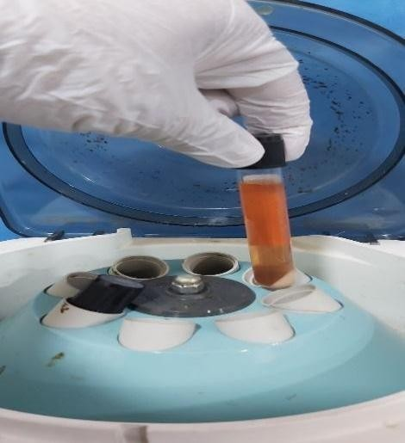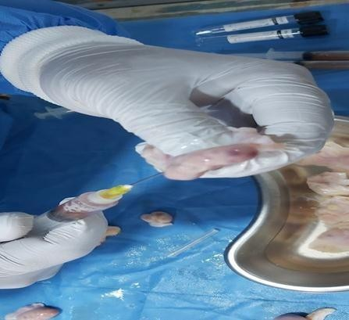

Figure

(1):

)Show

aspiration of follicular

fluid.

Figure (2) Show centrifugation of

bovine follicular fluid.

Frankincense:
Frankincense (oleogum resin of Boswellia arteria) was purchased from Oman, 1.5 ml used locally on the defect of Achilles tendon.

Preparation of Autologous plate let -rich fibrin (PRF)
Preoperatively, blood was collected from cephalic vein by utilizing needle 18 gauge and a plastic syringe (figure 3). Then the collected blood was transport immediately to 10 ml PRF tube and centrifuged at (1500 rpm) for 14 minutes. A preparation process involves separation of the platelets from red blood cells. Final sample consist of three layers; the upper layer contains fibrin, while lower layer is consisting of red blood cells, which are discarded.
(Figure4) (Al-Hussein, etal.,2023).

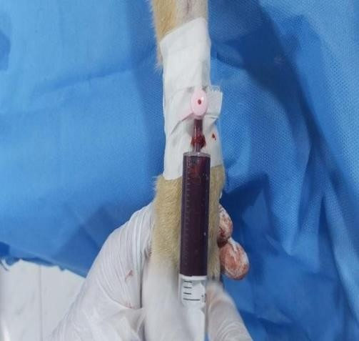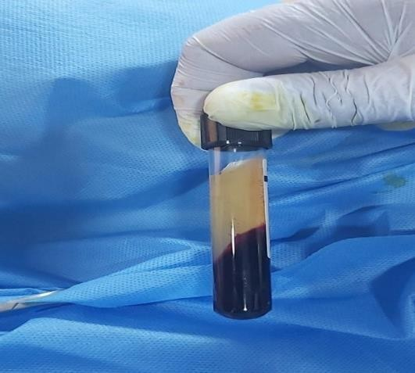
Figure (3) Showed Blood drawn from Figure (4) Showed PRF isolation after the cephalic vein. centrifugation.

Surgical procedure to induce tendon defect

The animals were put unconscious using a combination of xylazine 5mg/Kg B.W and ketamine 10 mg/Kg B.W. After preparation of the surgical site, midline skin incision was made and extended through the subcutis and fascia approximately (1 cm) superior to calcaneus and (1 cm) distal to gastrocnemius muscle. Following the exposure of the Achilles tendon, defect (core lesion) was created in all animals by penetrating the tendon using needle 16 gauge (Figure 5). Stay sutures were positioned above and below the tendon defect to delineate the area of the defect. (Figure 6). Subsequently, the tendon defect in all animals who received local treatment was as follows, for control group the defect was treated only by using PRF, while defect of an treated by using B. Serrata extract and PRF. In treated group 1 (Figure 7), But in treated group 2 the tendon defect treated by bovine F.F with PRF. (Figur8). After that, the skin was closed routinely, then dressing by using of casting splint.

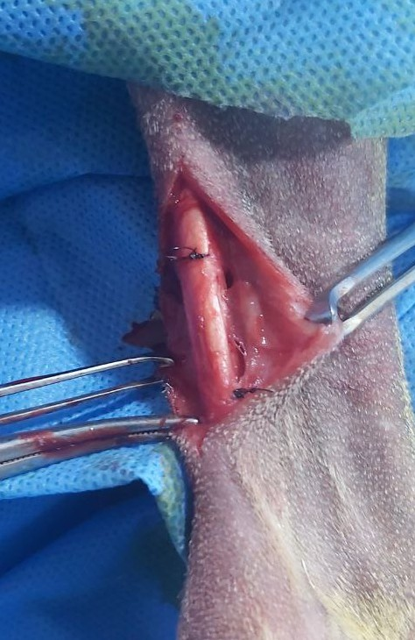





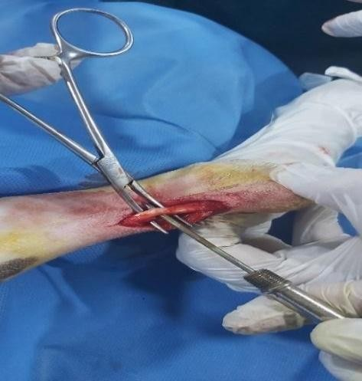


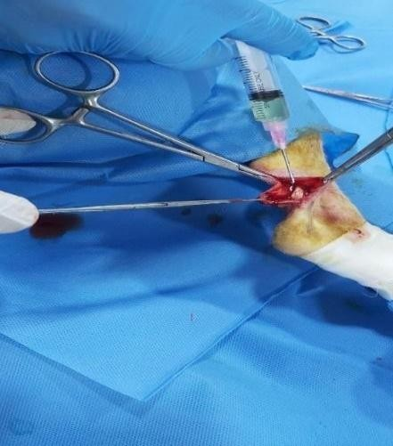
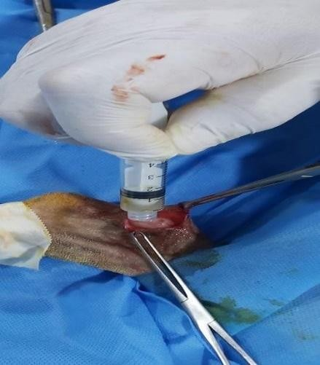
The animals were evaluated clinically and by hydroxyproline assay after one month forhealing assessment and regeneration of Achilles tendon defect during experimental interval.

Figure (

5

)

Inducing of core defect

by using 16 G needle

Figure (

6

)

Showed applying of stay

suture to mark the tendon lesion.

Figure (7) Application of PRF and B. Figure (8) Application of PRF and Bovine serrata extract on tendon defect F.F. on tendon defect

Clinical evaluation
The dogs were evaluated daily for indications of inflammation at the surgery site (redness, swelling, and temperature), gait, lameness, and bearing of the weight base on system score table (1) (Nganvongpanit, et al., 2013; Ibrahim et al.,2020; Jassim et al.,2023).

Table 1. Clinical lameness scoring system for assessing dogs

Criterion |  |  | Time after treatment
Criterion |  | Criterion | Grade Clinical evaluation
 |  | Lameness | 1 and 2 | Normally walks and Slightly lame when walking
 |  | Lameness | 3 and 4 | Moderately lame when walking and Severely lame when walking
 |  | Lameness | 5 | Reluctant to rise and will not walk more than five paces
 |  | Pain of palpation | 1 and 2 | None and Mild signs; dog turns head in recognition
 |  | Pain of palpation | 3 and 4 | Moderate signs; dog pulls limb away and Severe signs; dog vocalizes or becomes aggressive
 |  | Pain of palpation | 5 | Dog will not allow palpation
 |  | Weight bearing | 1 and 2 | Equal on all limbs standing and walking and Normal standing; favors affected limb when walking
 |  | Weight bearing | 3 and 4 | Partial weight-bearing standing and walking, Partial weight-bearing standing; non-weightbearing walking
 |  | Weight bearing | 5 | Non-weight-bearing standing and walking

An evaluation of tendon hydroxyproline content
Achilles tendon samples were collected on 30th day postoperatively to monitor the hydroxyproline level. To determine hydroxyproline content of Achilles tendon, a high-performance liquid chromatography with reverse phase column (4.6 mm internal diameter×250 mm length, TSK-gel, ODS80TM) was used. Column was eluted using 0.4% ammonium acetate (pH 7.4) and 75% acetonitrile at flow rate of (2 mL/min) via the isocratic pump. A fluorescence detector was employed to measure hydroxyproline concentration in each specimen, integrating data from the retention time and the area beneath the eluting peak. The data were standardized according to the protein concentration in each sample.

Results
Clinically, the dogs of all groups showed swelling, redness, and lameness immediately after surgery. Redness and swelling slightly disappeared in treated groups when compared with control group. Lameness significantly (1.00±0.00 Ab) disappeared in treated group with PRP and B. serrata extract in 9 days' post-surgery when compared with treated group with PRP and bovine F.F. (1.20± 0.11Ac) and control group (1.20 ±0.16Ac) (Figure 9 and table 2). Assessment of the hydroxyproline content of the Achilles tendon in group treated with PRF and B. serrata extract 30 days post-operatively revealed significant increase of hydroxyproline level (64.50 ±2.69 ) when compared with group treated with PRF and bovine follicular fluid (56.57 ±2.13) and group treated only with PRF (49.87) (Figure 10 and table 3). On the other hand, group treated with PRF and bovine follicular fluid showed increase hydroxyproline level as a compared with group treated with PRF only.

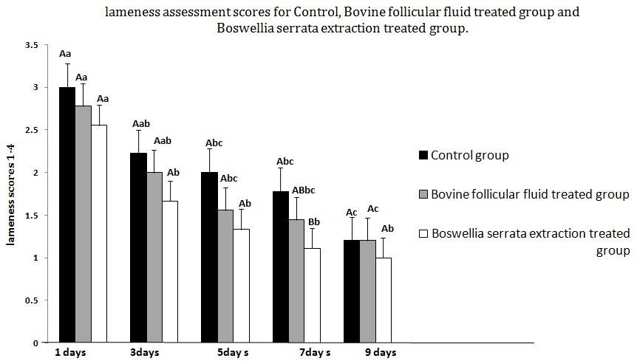

Figure 9: lameness score assessment for Control, Bovine follicular fluid treated group and B. Serrata extraction treated group after 1, 3, 5, 7and 9 days post- surgery. ABC Different letters among groups indicates significant differences (P<0.05). abc Different letters within group indicates significant differences (P<0.05).

Table 2: lameness score assessment for Control, Bovine follicular fluid treated group and B. Serrata extraction treated group after 1, 3, 5, 7and 9 days' post operation. (Means and standard errors).ABC Different letters among groups indicates significant differences (P<0.05). abc Different letters within group indicates significant differences (P<0.05).
Groups | 1day | 3 days | 5 days |  | 7 days | 9 days
Control (-) | 3.00±0.28  Aa | 2.22±0.22^{Aa} b |  | 2.00±0.23^{Ab}  c | 1.77±0.14  Abc | 1.20±0.16  Ac
Bovine follicular fluid | 2.77±0.27  Aa | 2.00±0.23  Aab |  | 1.55±0.17  Abc | 1.44±0.17  ABbc | 1.20±0.11  Ac
B. Serrata extraction | 2.55±0.24 Aa | 1.66±0.23  Ab |  | 1.33±0.16  Ab | 1.11±0.11  Bb | 1.00±0.00  Ab

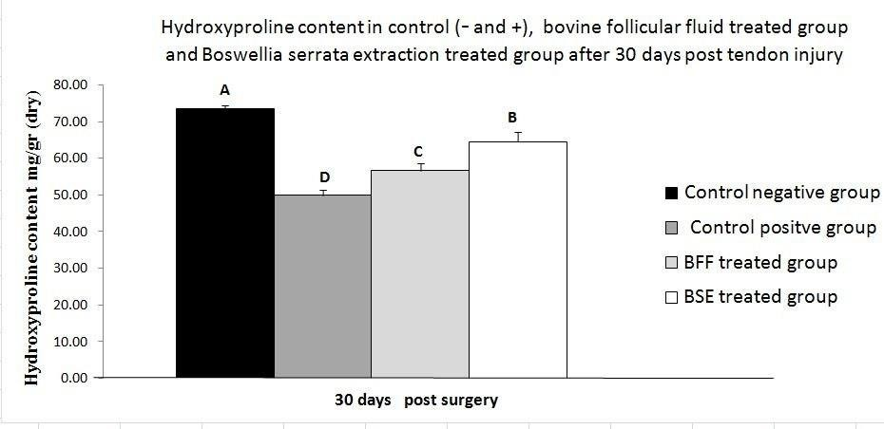
Figure 10: Biochemical study, hydroxyproline content of tendon tissues in control (+ and -), bovine follicular fluid treated group and B. Serrata extraction treated group after 30 days' post tendon injury. ABC Different letters among groups indicates significant differences (P<0.05).

Table 3: Biochemical study, tendon tissues content of hydroxyproline in control (+ and -), bovine follicular fluid treated group and B. Serrata extraction treated group after 30 days post tendon injury (means and standard errors). ABC Different letters among groups indicates significant differences (P<0.05).

Groups | Control (-) | Control (+) | Bovine  follicular fluid | B. Serrata extraction
hydroxyproline  content of the tendons after 30 days mean ± S. E. | 73.53± 2.49  A | 49.87± 1.53  D | 56.57±2.13  C | 64.50±2.69  B

Discussion
In this study, hydroxyproline measurement was utilized as an indicator for assessment of Achilles tendon healing because it is a basic composition of the protein collagen and also play key roles for collagen stability. B. serrata extract and bovine follicular fluid mixed with PRF was used directly on Achilles tendon defect. Clinical finding of the present study revealed that lameness gradually decreases during study period till disappear in Boswellia serrata group in 9 days' post-surgery as a compared with bovine follicular fluid and control groups. This outcome may be due the properties of Boswellia serrata which include increase the collagen synthesis (hydroxyproline and collagen-1), angiogenesis, inhibition of oxido-inflammatory markers, increased collagen synthesis (hydroxyproline and collagen-1) promoting growth factors, and an inhibition of apoptosis, analgesic, and inhibition of oxido-inflammatory markers and the properties of anti-inflammatory (Pengzong, et al., 2019 and Qurishi, et al., 2010).
This result is with the study established by Zapata and Fernández (2023), they found that Boswellia serrata produce benefits in pain and reduced clinical signs of osteoarthritis (OA) in dogs. Boswellia serrata been studied as diet supplement for joint health in dog and horse through several clinical trials by administration of Boswellia serrata with the meal and in multi-ingredient dietary supplements and most these studied demonstrated favorable tolerability and overall benefits of the tested supplements in pain relief and reduction of clinical signs of osteoarthritis and joint inflammation (Biagi, et al., 2023). Also, improvement of tendinopathy symptoms t was reported in patient a medical of pharmaceutical grade food supplement containing both the Curcuma longa and B. serrata extracts (Henrotin, et al., 2021). present study revealed increase in hydroxyproline level of tendon treated with combination of PRF and the B. serrata extract due to healing potential of B. serrata extract include increase collagen synthesis, inhibition of oxido-inflammatory markers, promoting of growth factors, and inhibition of apoptosis to accelerate tendon healing (Pengzong, et al., 2019). The most important of B. serrata extract is boswellic acid which is widely utilized for treatment of acute and chronic inflammatory diseases. It can be used topically for treatment of osteoarthritis (OA) in mice and found to have potential as the disease-modifying agent in OA (Wang, et al., 2014). B. serrata was applied to the wounds of rats, resulting in a considerable enhancement of wound contraction through the manipulation of the oxido-nitrosative stress and increase in the hydroxyproline levels at wound site (Zhang, et al., 2019).

Conclusion:
In conclusion, this study revealed that topical application of Boswellia serrata extract in conjunction with PRF in Achilles tendon injury was highly effective and enhanced hydroxyproline content in the treated tendon. Also, application of bovine follicular fluid with PRF locally on tendon defect will be useful and effective in tendon healing but less effective when compared with Boswellia serrata extract and PRF. Nevertheless, further investigations are required to investigate the efficacy of an amalgamation of Boswellia serrata extract and bovine follicular fluid with PRF on Achilles tendon defect.

Ethical Approval:
The current experiment was carried out according to the rules and guidelines of the Animal Care and Use Committee / College of a Veterinary Medicine, University of Basrah (Approval number: 63/37/2025).

Disclaimer (Artificial intelligence)

Author(s) hereby declare that NO generative AI technologies such as Large Language Models (ChatGPT, COPILOT, etc.) and text-to-image generators have been used during the writing or editing of this manuscript.

References
Abd Al-Hussein, S. S., Al-Dirawi, A. A., & Al-Khalifah, R. M(2023). Histopathological Study of the Effect of Xenogeneic Platelet-Rich Fibrin on Achilles Tendon Healing in Rabbit. Bionatura 2 ( 8) 1-10 http://dx.doi.org/10.21931/RB/CSS/2023.08.02.24
Abduljaleel, M. R. (2024). Xylazine-Ketamine Outperforms Diazepam-Ketamine in Rabbit Anesthesia. Academia Open, 9(2), 10-21070.‏
Al-Hussein, S. S. A., Al-Dirawi, A. I., & Al-Khalifah, R. M. N. (2023). Assessment of hydroxyproline content in rabbit Achilles tendon treated with platelet rich fibrin (PRF).
Alrafas HR, Alahmed JAS, Essa IM, Kadhim SZ, AlTameemi HM, et al., (2023). Role of anti-inflammatory interleukin 10 in asymptomatic heartworm infection (Dirofilariasis) in dogs. Adv. Life Sci. 10(3): 412-417.
Alsalim, H. A., Habeeb, I. A., & Abdulameerc, A. (2021). The effect of follicular fluid supplementation on embryo development in Iraqi buffalo. Systematic Reviews in Pharmacy, 12(1), 100-106.
Biagi, M., Rigillo, G., Sarill, M., Collotta, D., Di Giacomo, S., Di Sotto, A., ... & Testai, L. (2023). From preclinical to clinical evidence: Exploring the multiple perspectives and healing power of B. Serrata Roxb. ex Colebr. Pharmadvances, 5(1), 29-53.
Dal-Bó, ísis Dos Santos et al. 2016. “Tenorrhaphy of the Common Calcaneal Tendon in Dogs and Cats.” Acta Scientiae Veterinariae 44(1): 7.
Fortune JE. Ovarian follicular growth and development in mammals. Biology of reproduction. 1994 50(2): 225- 232.
Ghanaati, S., Booms, P., Orlowska, A., Kubesch, A., Lorenz, J., Rutkowski, J., ... & Choukroun, J. (2014). Advanced platelet-rich fibrin: a new concept for cell-based tissue engineering by means of inflammatory cells. Journal of Oral Implantology, 40(6), 679-689.
Henrotin, Y., Dierckxsens, Y., Delisse, G., Seidel, L., & Albert, A. (2021). Curcuminoids and B. Serrata extracts combination decreases tendinopathy symptoms: Findings from an open-label post-observational study. Current Medical Research and Opinion, 37(3), 423430.
Hasbi, H et al. 2017. “Insulin-Like Growth Factor-I Concentration in the Follicular Fluid of Bali Cattle and Its Role in the Oocyte Nuclear Maturation and Fertilization Rate.” 40(April): 7–13.
Ibrahim, A. A., Naeem, L. A., & Naeem, R. M. (2020) Histopathological Study of the Efficacy of Alpha Lipoic Acid and H2O2 on Early Stage of Fracture Healing in Rabbits.‏

Jasim, M. M., Naeem, R. M., Abduljaleel, M. R., Sanad, N. H., Ibrahim, A. A., & Alrafas, H. R. (2025). Efficacy of autogenic, allogenic and heterogenic platelet rich plasma (PRP) on Avulsion skin wounds in rabbit model. Advancements in Life Sciences, 12(1), 91-97.
Jassim, M. M., Abduljaleel, M. R., Abdulkareem, Z. B., Sanad, N. H., & Alrashid, I. M. (2023). Study the effect of the magnetic field on the healing of bone fracture after implant avian bone in femoral bone in rabbits. Advances in Animal and Veterinary Sciences, 11(11), 1779-1784.
‏
Joy, S., Deshmukh, B. T., Dhaware, S. D., & Borkar, S. D. (2015). Follicular fluid protein profile in buffalo. Veterinary Science Research Journal, 6(2), 71-79.
Kim, Sung Eun, Jae Gyoon Kim, and Kyeongsoon Park. 2019. “Biomaterials for the Treatment of Tendon Injury.” Tissue Engineering and Regenerative Medicine 16(5): 467–77.
Kline, Paul. 2019. “Isolation, Structure Elucidation, and Immunostimulatory Activity of Polysaccharide Fractions from Boswellia Carterii Frankincense Resin Najlaa A. Hosain.”
Kumar Srivastava, A., Khare, P., Kumar Nagar, H., Raghuwanshi, N., & Srivastava, R. (2016). Hydroxyproline: a potential biochemical marker and its role in the pathogenesis of different diseases. Current Protein and Peptide Science, 17(6), 596-602.
Lamb, C. R., & Duvernois, A. (2005). Ultrasonographic anatomy of the normal canine calcaneal tendon. Veterinary Radiology & Ultrasound, 46(4), 326-330.
Nganvongpanit, K., Boonsri, B., Sripratak, T., & Markmee, P. (2013). Effects of onetime and two-time intra-articular injection of hyaluronic acid sodium salt after joint surgery in dogs. Journal of veterinary science, 14(2), 215-222.
Pengzong, Z., Yuanmin, L., Xiaoming, X., Shang, D., Wei, X., Zhigang, L., ... & Xia, L. (2019). Wound healing potential of the standardized extract of B. Serrata on experimental diabetic foot ulcer via inhibition of inflammatory, angiogenetic and apoptotic markers. Planta Medica, 85(08), 657-669.
Qurishi, Y., Hamid, A., Zargar, M. A., Singh, S. K., & Saxena, A. K. (2010). Potential role of natural molecules in health and disease: Importance of boswellic acid. J Med Plants Res, 4(25), 2778-2785.
Revelli, A., Piane, L. D., Casano, S., Molinari, E., Massobrio, M., & Rinaudo, P. (2009). Follicular fluid content and oocyte quality: from single biochemical markers to metabolomics. Reproductive biology and endocrinology, 7, 1-13.
Sylvestre, Anne M. 2019. “Tarsal Joint.” Fracture Management for the Small Animal Practitioner.
Wang, Q., Pan, X., Wong, H. H., Wagner, C. A., Lahey, L. J., Robinson, W. H., & Sokolove, J. (2014). Oral and topical boswellic acid attenuates mouse osteoarthritis. Osteoarthritis and Cartilage, 22(1), 128-132.
Zapata, A., & Fernández-Parra, R. (2023). Management of Osteoarthritis and Joint Support using Feed Supplements: A Scoping Review of Undenatured Type II Collagen and B. Serrata. Animals, 13(5), 870.
Zhang PengZong, Z. P., Li YuanMin, L. Y., Xiong XiaoMing, X. X., Deng Shang, D. S., Xiong Wei, X. W., Lang ZhiGang, L. Z., ... & Li Xia, L. X. (2019). Wound healing potential of the standardized extract of B. Serrata on experimental diabetic foot ulcer via inhibition of inflammatory, angiogenetic and apoptotic markers.

