***Short Research Article***

**A STUDY ON POLLINATING INSECT DIVERSITY IN SELECTED AREAS OF PUDUNAGARAM VILLAGE, PALAKKAD, KERALA, INDIA**

**Abstract**

The present study on Pollinating insect diversity of selected areas of Pudunagaram village, Palakkad, Kerala was conducted for a period of six months from January 2022 – June 2022. Two sites were selected which are diverse in habitats; one is Mangode, the home garden where floral plants were cultivated, and the second is Karippode, the forest area with wild plants. Visual observation and hand- picking methods were used for collection. A total of 49 species belonging to 5 orders and 15 families were recorded of which Order Lepidoptera was dominant with 29 species. In site-1 family Nymphalidae and in site-2 Apidae was dominant. The Shannon diversity index study revealed that insect diversity is slightly higher in site-1 (2.313) as compared to site-2(2.25).

**Key words**

Pollinating insects, lepidoptera, Nymphalidae, Karipode, Mangode, The Shannon diversity index, Conservation

**Introduction**

Insects are the primary pollinators of most of the plants. The pollinating insects include all families of bees, most aculeate wasps, ants, numerous fly families, various families of butterflies and moths (lepidopterans), and many beetle families. Insects show an astonishing taxonomic diversity and are abundant in almost all environments across the globe (Nigel *et al.,* 2015). Insect pollination is a globally essential ecosystem service, offering substantial economic, aesthetic, and cultural benefits to human society while supporting crucial ecological processes in terrestrial ecosystems. Insect pollinators such as bees, butterflies, flies, beetles, and moths are essential for plant reproduction and the overall functioning of ecosystems. The diversity of insect pollinators is crucial for effective pollination, enhances genetic variability in plants, fostering adaptation and resilience. Additionally, it supports healthy ecosystems by maintaining balance within the food web and increasing environmental stability.

Several studies have been conducted on different aspects of pollination and insect visitors till date. According to the report by Divija *et al.,* (2002), a study on the diversity and foraging behavior of floral visitor assemblages in onion (Allium cepa) revealed that the pollinator community consists of 30 hymenopteran species, 16 dipteran species, 8 lepidopteran species, 4 hemipteran species, and 1 coleopteran species. Pandurangan (2003) conducted studies on the rescue and restoration of endemic, rare, and threatened medicinal plants in the Agasthya Malai, Kulamavu, and Wayanad medicinal plant conservation areas of the Western Ghats in Kerala. His findings revealed that bees play a significant role in pollinating many of these plants.

Similarly, Sasidharan and Kunchikannan (2010) studied bee faunal diversity in the Nilgiris region of the Western Ghats, Tamil Nadu, documenting the occurrence of approximately 92 bee species. Thakur and Mattu (2010) studied the role of butterflies as flower visitors and pollinators in the Shiwalik Hills of the Western Himalayas. They recorded 87 butterfly species visiting 51 flowering plant species, with Nymphalids and Pierids visiting 18 species each, Lycaenids visiting 13, Hesperiids visiting 8, and Papilionids and Danaids visiting 4 species each. Flowers from the Asteraceae family attracted the highest number of butterfly species. Rianti *et al.,* (2010) studied the diversity and effectiveness of insect pollinators of Jatropha curcas (Euphorbiaceae) and identified nine species from three orders: Hymenoptera, Lepidoptera, and Diptera. Among these, four Hymenoptera species—Prenolepis, Apis dorsata, Xylocopa confusa, and Apis cerana—were the most abundant. Bees, particularly X. confusa, A. cerana, and A. dorsata of the Apidae family, were the most effective pollinators due to their high visitation frequency.

In Kerala, there have been only a few studies on the insect pollinators of specific plants and their ecological requirements. Chaudhary and Kumar (2000) studied floral biology, foraging behavior, and honeybee pollination in Elettaria cardamomum at Kadasikadavu, Idukki District, Kerala, identifying Apoidea as the dominant flower visitors, comprising over 99% of the total. Binoy *et al.,* (2014) studied insect pollinators and foraging patterns in Catharanthus roseus and Pentas lanceolata in Thrissur District, Kerala. They identified eight pollinator species from two orders and five families, including five Lepidoptera species and three Hymenoptera species. Bijoy *et al.,* (2019) recorded 37 solitary non-Apis bees from 19 species, 7 genera, and 3 families in Chittur Taluk, Palakkad, highlighting their role in pollinating wind-pollinated rice plants. Unni *et al.,* (2021) found that Apis cerana was the primary pollinator of pumpkin flowers (92%) in Kasaragod, with Apis dorsata contributing 8%. Nine ant species also visited the flowers after anthesis. Vinaya and Bijoy (2022) conducted research on the foraging activity and breeding system of Avicennia officinalis L. (Avicenniaceae) in Chettuwa, Thrissur, Kerala, identifying 15 foraging insect species from three orders: Hymenoptera, Diptera, and Lepidoptera.

Diversity studies are increasingly important as many species are lost each year due to habitat destruction, land use changes, deforestation, pollution, climate change, invasive species, and pesticide use. Therefore, biodiversity studies serve as valuable references for guiding conservation programs.

**Materials and Methods**

The present study was conducted between January and June 2022, from 6:30 AM to 6:30 PM, in Pudunagaram village, located in the Palakkad district. Most butterfly activity was recorded between 10:00 AM and 3:00 PM. The survey of pollinating insect diversity was carried out at two sites: Site 1- Mangode and Site 2 - Karippode. Observations were made exclusively on sunny days, with temperatures ranging from 30°C to 35°C.Butterflies were counted using the transect method. A 500-meter transect was established at each site and divided into five sectors of 100 meters each.

**Study Area**

The study was conducted in Pudunagaram village located in Chittur taluk, Palakkad district. Pudunagaram is a town and gram panchayat in the Palakkad district, of Kerala. Two sites were selected for this study which are, 1. Mangode - Diversity of pollinating insects in home garden (Picture-1). 2- Karippode- Diversity of pollinating insects in wild region (Picture-2). Mangode, 5.8 km from Pudunagaram, is a residential area with some agricultural land. Despite its housing focus, it supports diverse pollinators due to abundant ornamental and vegetable plants in home gardens, making it ideal for pollinator diversity studies. Karippode is another study site located 5.5 km away from Pudunagaram and 2.6 km away from Mangode. Diversity studies were carried out in this site with special consideration to wild flower pollinators.

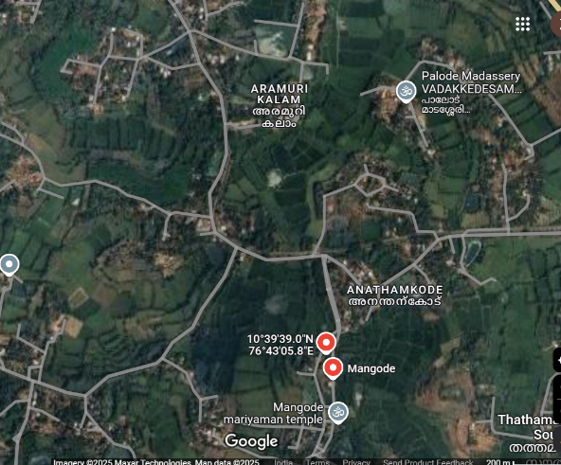 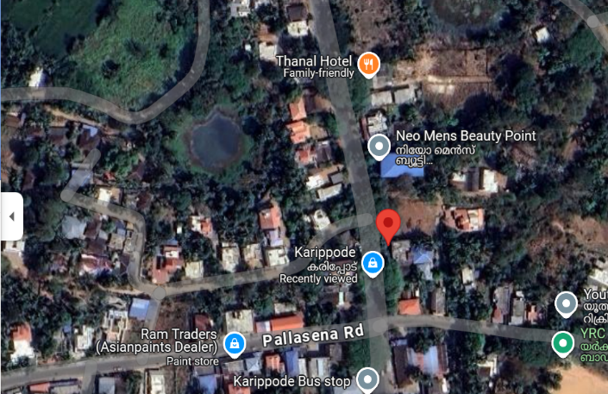

**10°39'38.6"N 76°41'18.6"E**

**Picture-1 Mangode (Site-1)** **Picture-2 Karippode (Site-2)**

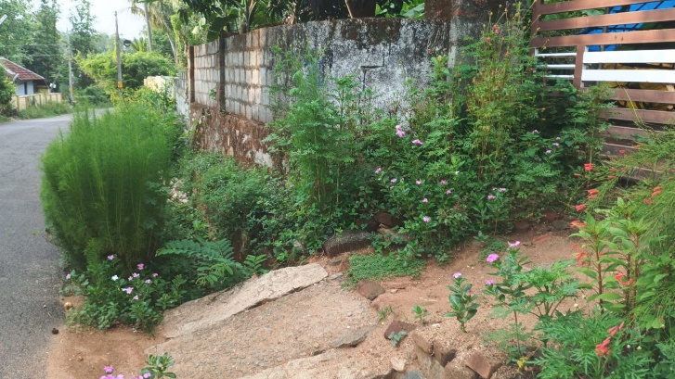 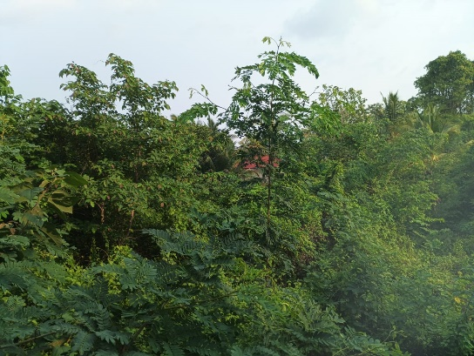

**Sampling Site 1- Mangode** **Sampling Site 2- Karippode**

**Methods Used**

Visual observation, hand-picking, and photography were the methods used for insect collection. Butterflies were identified using standard references, including A Naturalist’s Guide to the Butterflies of India by Peter Smetacek and the e-book Butterflies of the Western Ghats by Dr. Raju Kasambe, with additional assistance from entomology experts.

**Statistical Analysis of data**

The Shannon-Wiener Index was used to calculate the diversity index. Shannon Weiner Index- A diversity index, taking in to account the number of individuals as well as number of taxa. Varies from 0 for communities with only a single taxon to high values for communities with many taxa, each with few individuals.

* It shows the species richness in a community.
* If the community is dominated by one species, then the diversity will be low

The Shannon-Weiner index, or Shannon diversity index, is calculated using the formula:

 H' = -∑ (pi * ln (pi)), where pi is the proportion of individuals belonging to species i, and ln is the natural logarithm.

**Results and Discussion**

In the present study, conducted over a six-month period from January 2022 to June 2022 in two locations within Pudunagaram village, Palakkad district, Kerala, observations were systematically recorded.

A total of 49 insect species belonging to 5 orders and 15 families were documented from the selected sites in Pudunagaram village (Plate 1-6). The observed orders included Hymenoptera, Coleoptera, Lepidoptera, Diptera, and Heteroptera. In Hymenoptera, three families Apidae, Formicidae, and Megachilidae were recorded, with Apidae being most abundant in site 2, where wildflowers were present. Coleopteran families Coccinellidae and Chrysomelidae were noted as flower visitors. Lepidoptera was represented by seven families, with Nymphalidae showing the highest abundance in site 1. The family Nymphalidae was found to be the most dominant group in most of the studies, as reported by Nandana & Roopavathy (2019), Dalie *et al.,* (2023), Siny &Nandini (2023), and Jayasree *et al.,* (2023). Other Lepidopteran families included Hesperiidae, Pieridae, Lycaenidae, Papilionidae, Crambidae, and Sphingidae. Similar reports were found in the study by Deeksha *et al.,* (2022). In Diptera, Tephritidae and Syrphidae were observed, both showing low abundance along with Alydidae from the order Heteroptera. One vulnerable species, Tirumala limniace, belonging to the family Nymphalidae, and one Near Threatened species, Euchrysops cnejus, from the family Lycaenidae, both under the order Lepidoptera, were also documented in the present study.Table -1 presents the list of pollinating insect species recorded from the two sites, along with their order, family, common name, and IUCN status.

Site- 1 has diverse floral vegetation, including various ornamental, garden, and vegetable crop flowers. The study period coincided with the cultivation period of several vegetable crops, which attracted a variety of insects to the site. A total of 35 species were documented at Site 1, including 23 Lepidoptera species, 8 Hymenoptera species, 3 Diptera species, and 1 Heteroptera species. Ornamental and garden plants have bright, colorful flowers that attract many insects. These insects help in pollination and, in return, get nectar as food. Some plants also have pleasant scents that attract insects. Hymenopterans, especially bees from the Apidae family, visited vegetable crop flowers more frequently than garden flowers. This may be due to higher nectar content and better flower synchrony, which makes nectar collection easier for them. Three species of Formicidae (ants) were observed on flowers, while Coleopterans (beetles) were not found at this site. Other butterfly species recorded included 4 species of Hesperiidae, 3 species of Pieridae, and 3 species of Papilionidae. Moth pollination was rarely observed, likely because the study was conducted between 6:00 AM and 6:00 PM and usually moths are nocturnal in habit. Still, two moth families Crambidae and Sphingidae were recorded. Figures 1 and 2 show pie diagrams illustrating the numerical abundance of pollinating insects from different families at Site 1 and Site 2, respectively.

Site- 2 focuses on wildflower pollinators, which play a key role in maintaining the effective functioning of ecosystems. A total of 29 species were recorded, including 15 species of Lepidoptera, 10 species of Hymenoptera, 3 species of Coleoptera, and 1 species of Diptera. The area had less human activity, which allowed more wild plants to grow. Most of these had smaller, less visually attractive flowers compared to garden plants. Observing these small flowers requires careful attention. It was noted that many butterflies preferred visiting tree flowers over shrub flowers, while bees were seen pollinating both. At this site, the Apidae family was observed in the highest numbers (24%), followed by the butterfly families Hesperiidae and Nymphalidae (13% each). Three species of Coleopterans were recorded, including one species from the family Coccinellidae and two from Chrysomelidae. One moth species from the family Crambidae was also recorded. Additionally, *Bactrocera dorsalis*, a member of the Dipteran family Tephritidae, was observed. Food availability and habitat changes are believed to influence variations in species abundance. The conservation of honey bees, other domesticated bees, wild bees, and additional pollinators is a critical issue in the global context of sustainable agriculture and ecosystem productivity.

Documenting the diversity and geographic distribution of pollinators across various regions of India is crucial for developing effective strategies to conserve and enhance their populations (Tandon *et al.,* 2020). India is home to more than 700 bee species with only five are classified as social bees (Orr *et al.,* 2021), highlighting the vast unexploited potential of alternative pollinators to enhance agricultural productivity. As per the studies of Shivana (2002) understanding the habitat and floral preferences of solitary bees is crucial for replicating natural habitats and promoting pollinator diversification within agricultural systems. Several studies have demonstrated a significant increase in crop yield resulting from enhanced pollinator assemblages in agricultural fields located near forest patches (Aizen and Feinsinger, 2003; Vergara and Badano, 2009). Restoration of fragmented forests can not only enhance pollinator diversity but also improve foraging efficiency which has a direct effect on improving fruit and seed production. (Blüthgen and Klein, 2011).

Rianti *et al.,* (2010) investigated the insect pollinators of Jatropha curcas (Barbados nut) and found a positive correlation between pollinator abundance and the number of flowers, leading to increased fruit and seed set production. Insect visitor diversity was highest in the morning and afternoon compared to noon. Mukherjee *et al.,* (2015) found a positive correlation between butterfly density and flower density, highlighting Lantana camara as an important resource for butterflies. Similarly, Siregar *et al.,* (2016) observed that higher flower density attracted more insect pollinators in rubber and oil palm plantations compared to jungle rubber. Plant–insect interactions are crucial for the pollination process and for improving yield in both wild and cultivated plants. Binu *et al.,* (2022) studied butterfly-plant diversity in the Malappuram District of Kerala and found that approximately 33 plant species, belonging to 18 families and 29 genera, were pollinated by various kinds of butterflies.

In the present study, Fig. 3 shows that both the numerical abundance of pollinators and the Diversity Index are higher at Site 1 (2.313), which is rich in a variety of flowering plants, compared to Site 2 (2.25). Pollinator insect diversity tends to be greater in areas with abundant food sources and more attractive flowers.

**Table- 1. List of Pollinating insect species obtained from two sites with Order, Family, and Common name and IUCN status**



LC - Least Concern VU -Vulnerable NT -Near Threatened

NE- Not Evaluated DD- Data Deficient

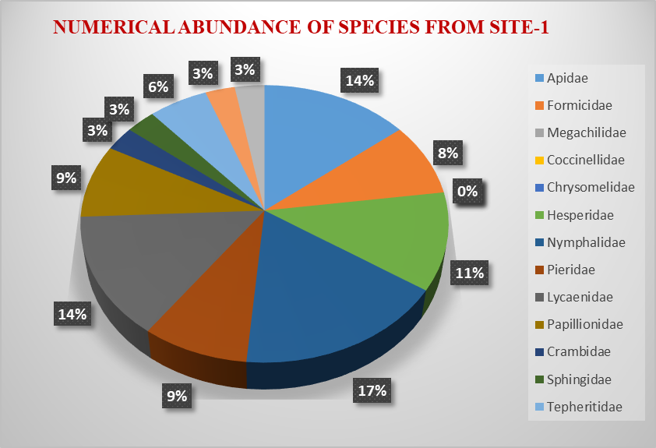

**Fig. 1. Pie diagram showing the numerical abundance of pollinating insets of different families from site -1**

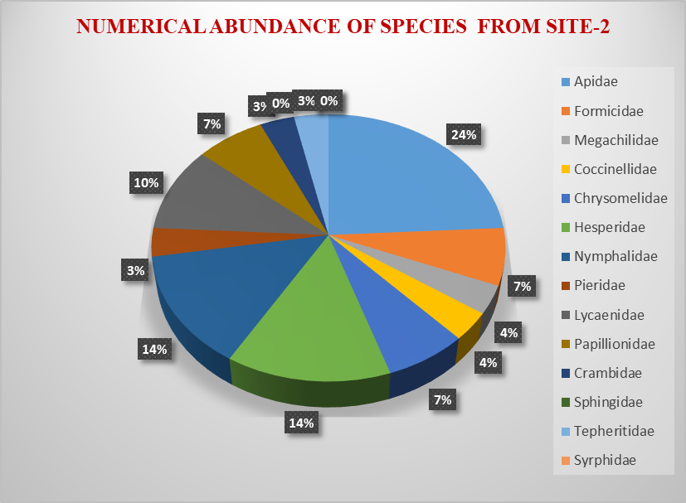

**Fig. 2. Pie diagram showing the numerical abundance of pollinating insets of different families from site -2**

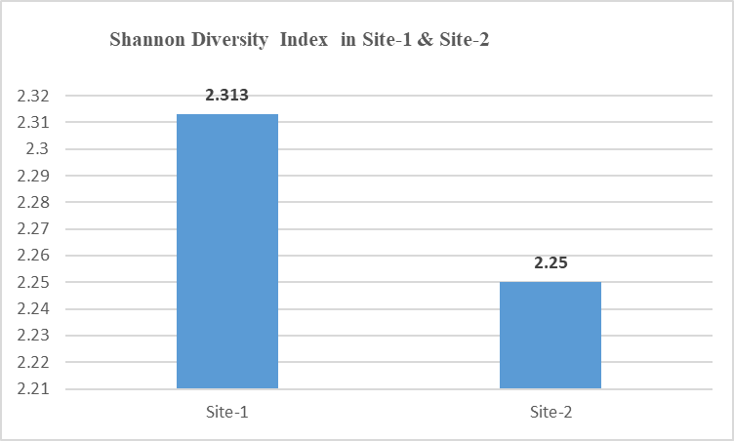

**Figure 3: Bar Diagram Showing Difference in Shannon Diversity Index**

**PLATE-1 Microphotographs of insects (Order: Hymenoptera)**

**ORDER: HYMENOPTERA**

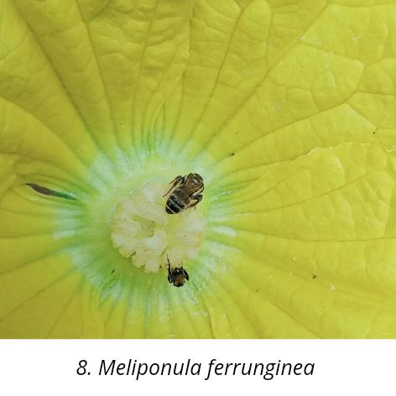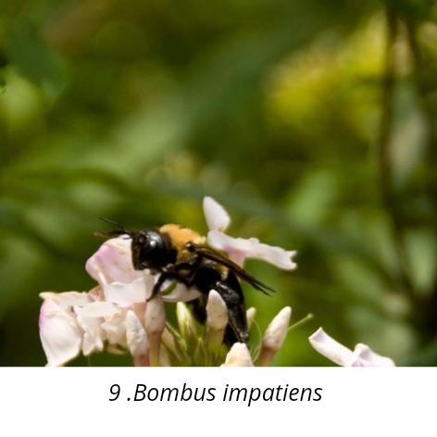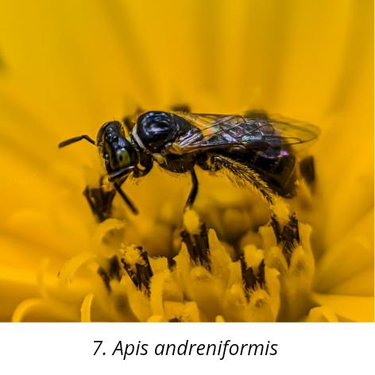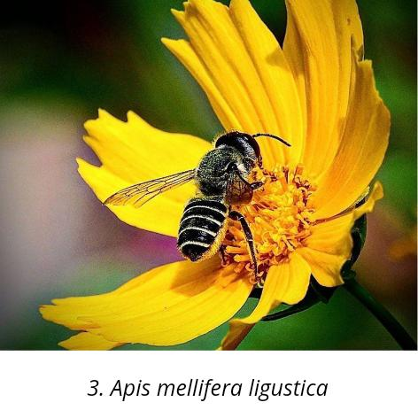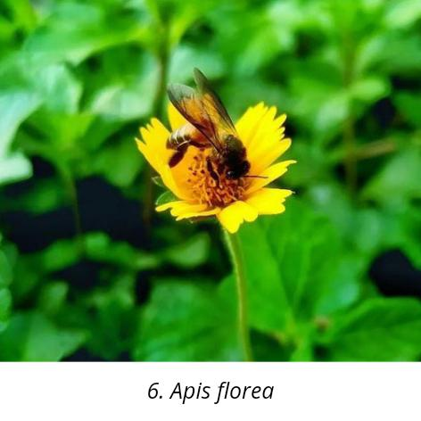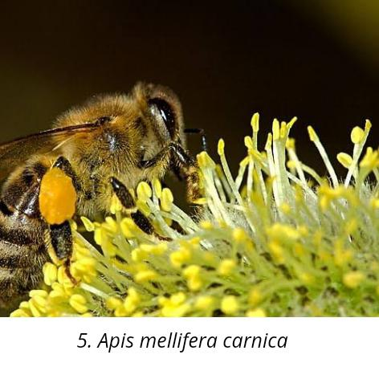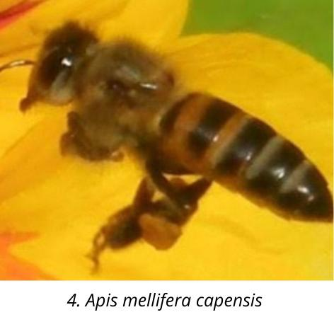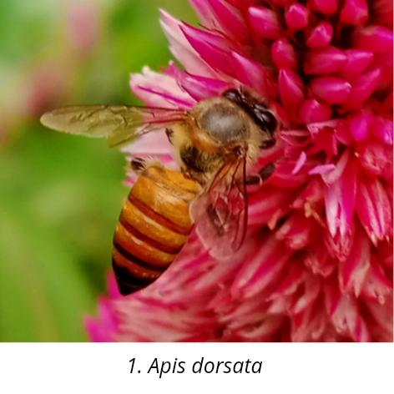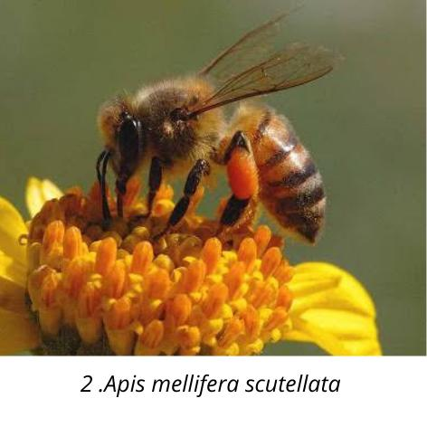

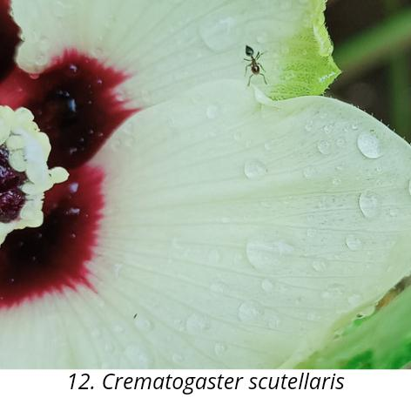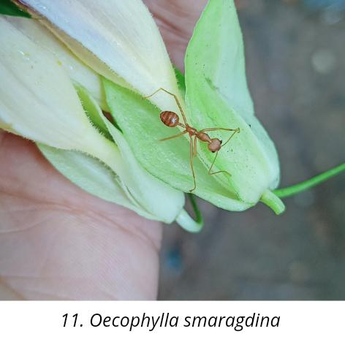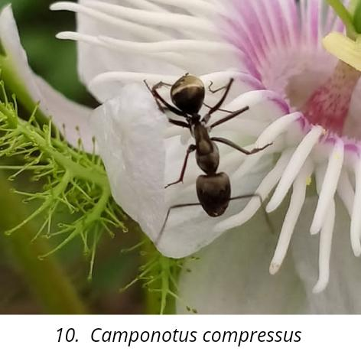**PLATE-2** **Microphotographs of insects (Order: Coleoptera)**

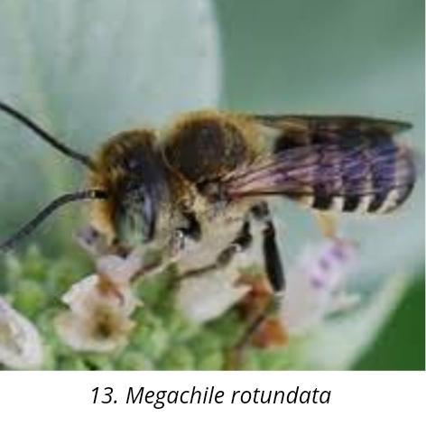

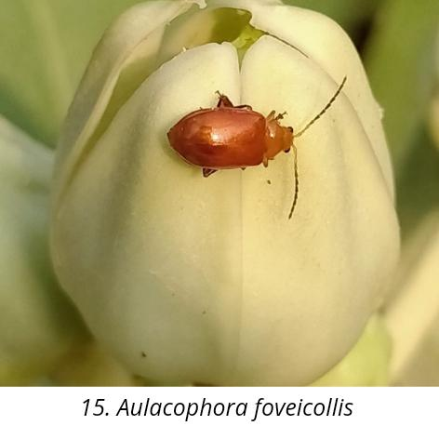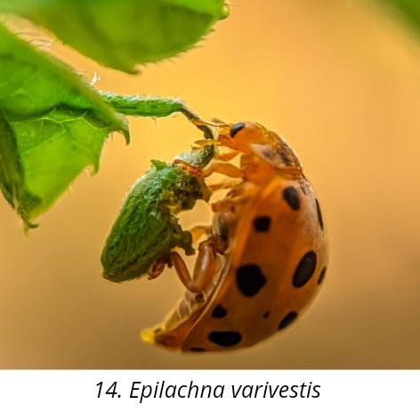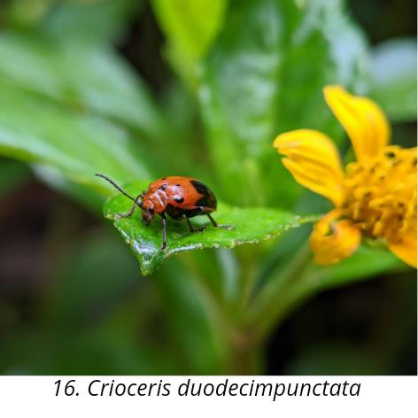

**PLATE-3** **Microphotographs of insects (Order: lepidoptera)**

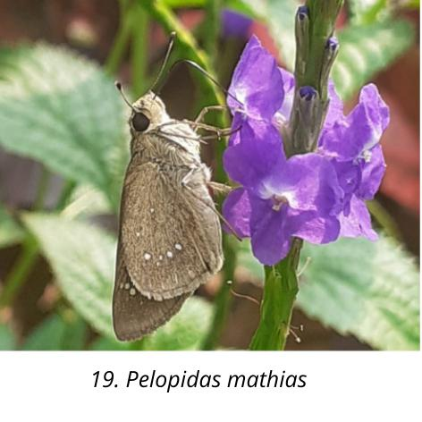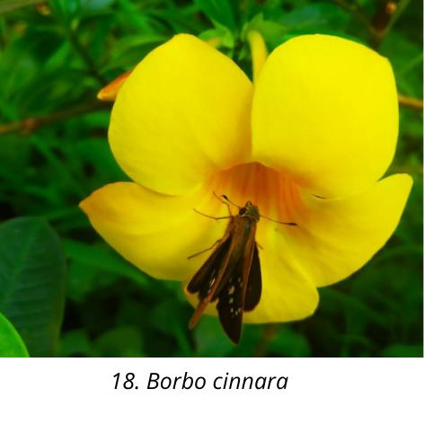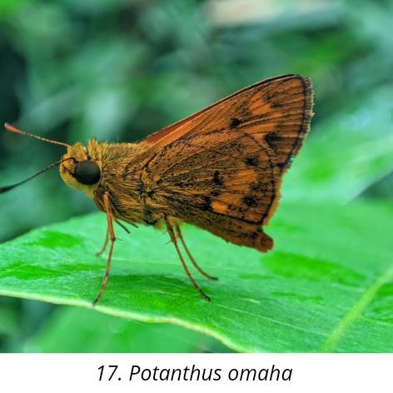

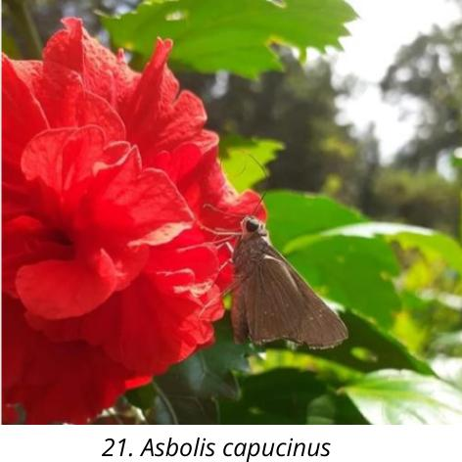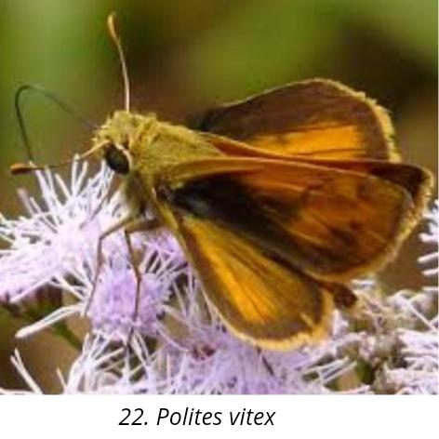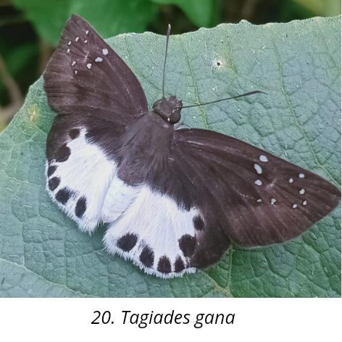

21. Choranthus capucinus

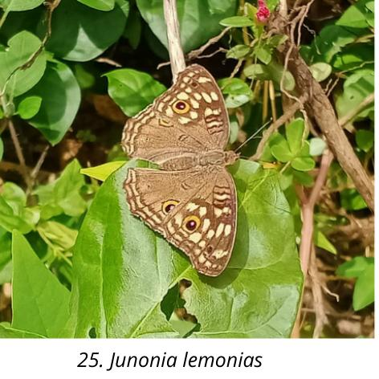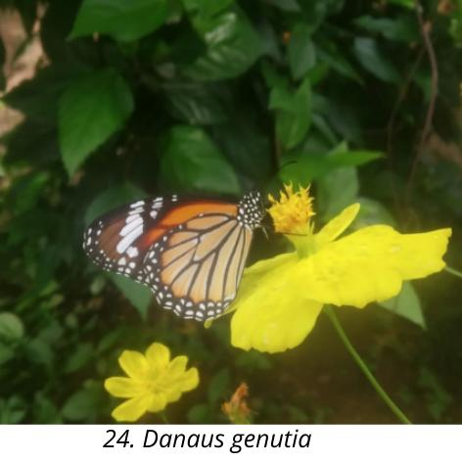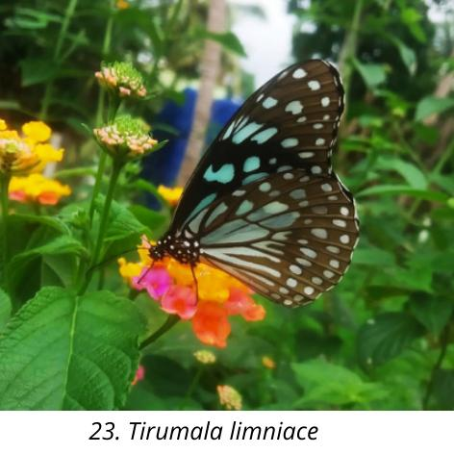

**PLATE-4 Microphotographs of insects (Order: lepidoptera)**

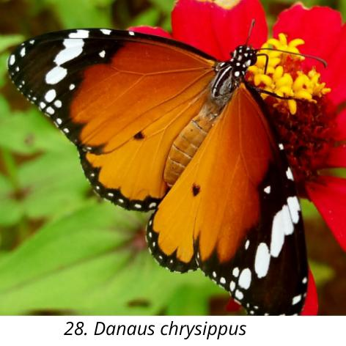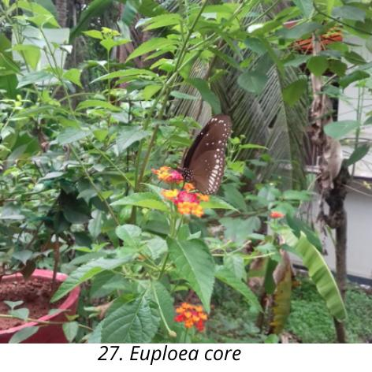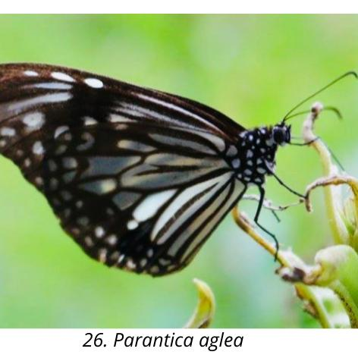

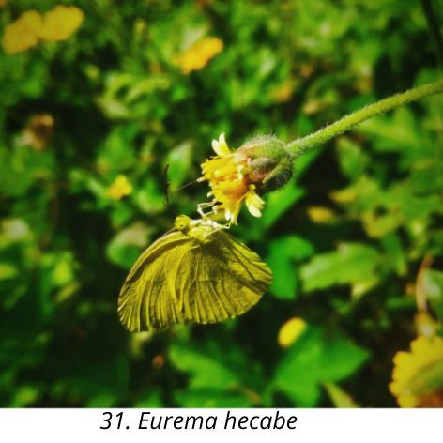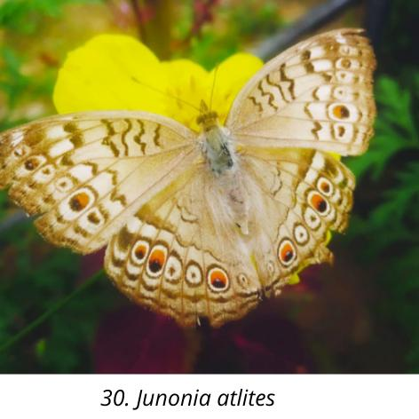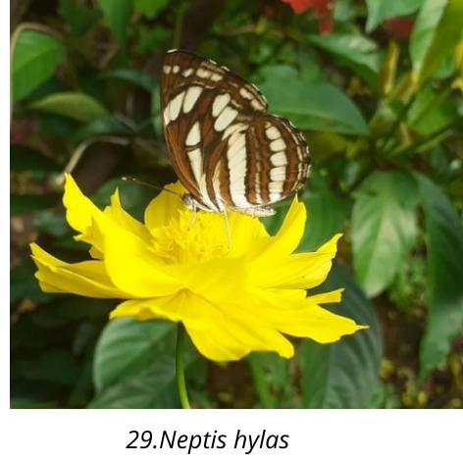

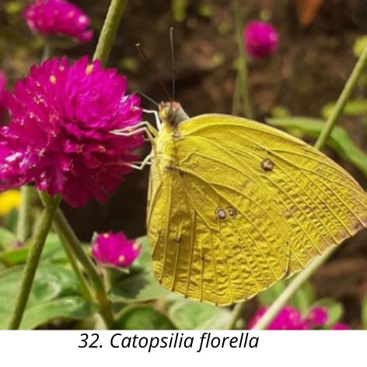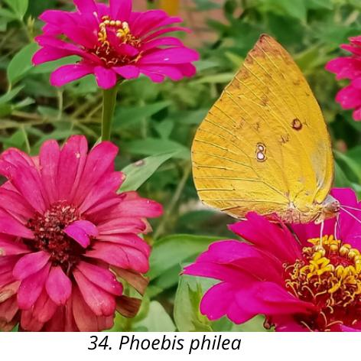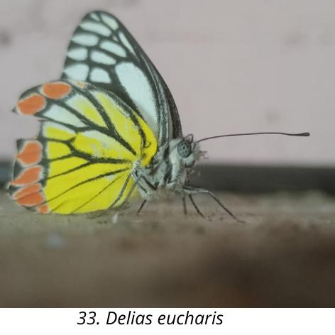

**PLATE-5** **Microphotographs of insects (Order: Diptera)**

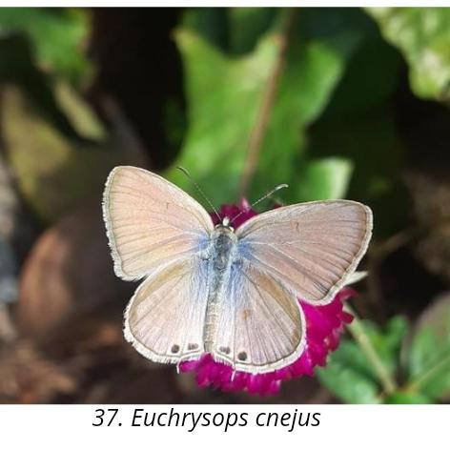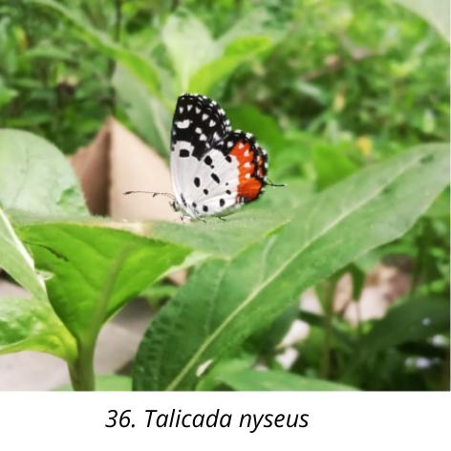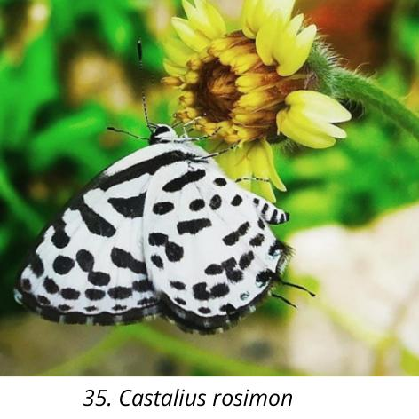

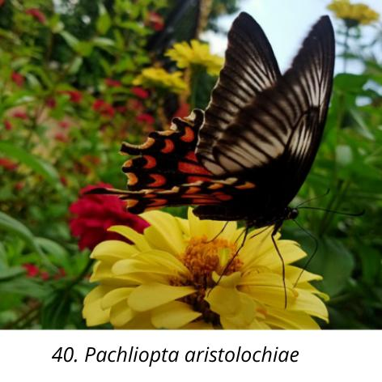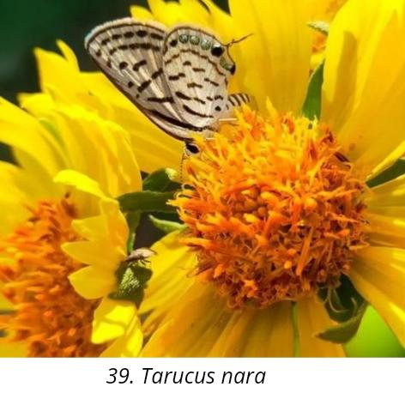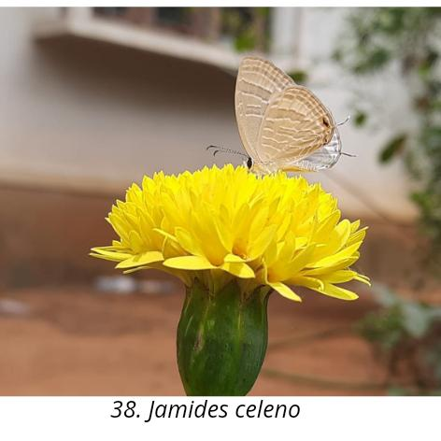

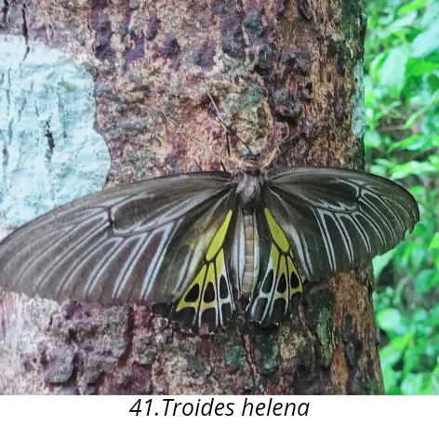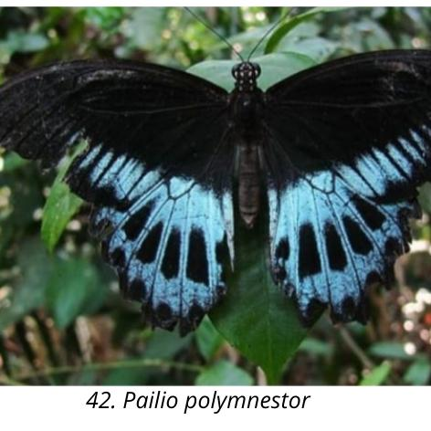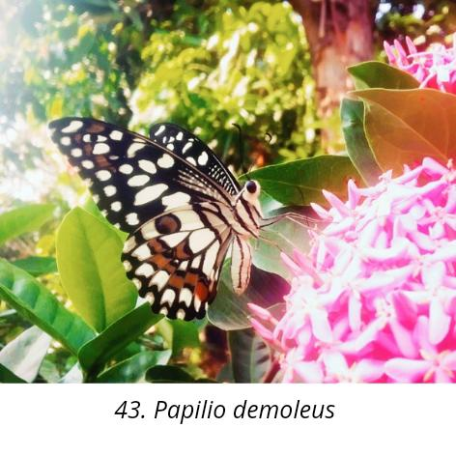

**PLATE-6** **Microphotographs of insects (Order: Heteroptera)**

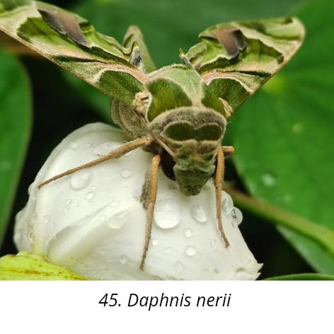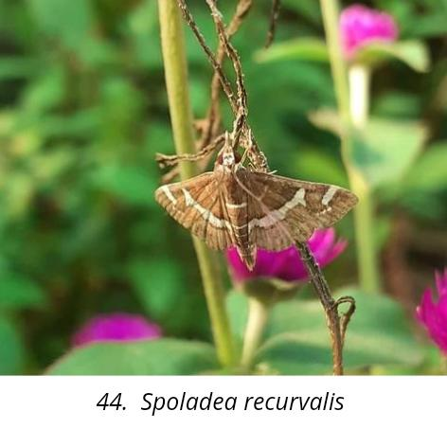

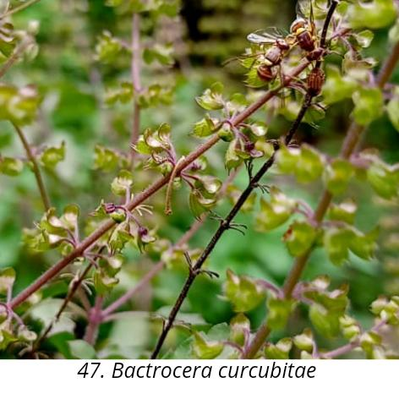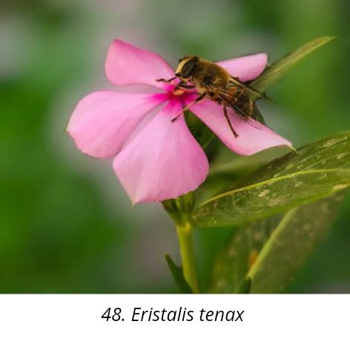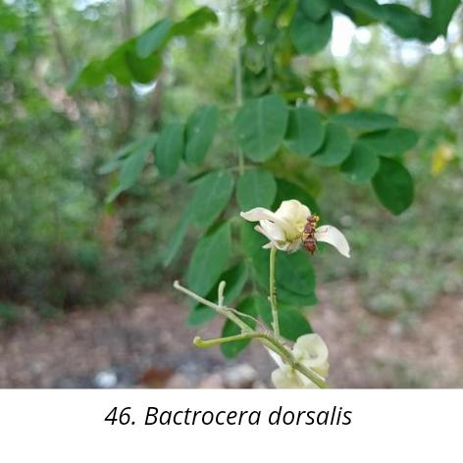

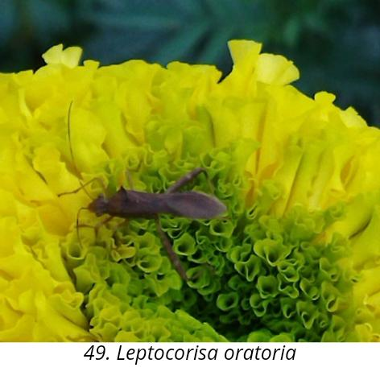

**Conclusion**

Insect pollination maintains genetic diversity in plant populations and provides benefits such as increased fruit quality and quantity, along with improved seed production and fertility, which enhances the vigor of the next generation (Kearns *et al.,* 1998; Albrecht *et al.,* 2012). It also holds significant economic value for humans by boosting the yield and health of cultivated crops, underscoring its importance for global agriculture. (Lautenbach *et al.,* 2012). Additionally, insect pollination contributes to the aesthetic and cultural value of landscapes by supporting diverse floral ecosystems (Wratten *et al.,* 2012). Several reports indicate that habitat loss, climate stress, invasive species, chemical pesticide use, competition, and starvation are major threats to pollinator populations. Conservation efforts and integrated pest management (IPM) strategies positively impact insect pollinator populations in India. However, further studies are needed to integrate practices such as public awareness programs, pollinator-friendly approaches, climate-smart agriculture, disease management, natural pest control, and reduced pesticide use.

**Disclaimer (Artificial intelligence)**

Author(s) hereby declare that NO generative AI technologies such as Large Language Models (ChatGPT, COPILOT, etc) and text-to-image generators have been used during writing or editing of this manuscript.

**References**

Aizen, M.A. & Feinsinger, P. (2003) Bees not to be? Responses of insect pollinator faunas and flower pollination to habitat fragmentation. In: G.A. Bradshaw & P.A. Marquet (Eds.) *How landscapes change: human disturbance and ecosystem fragmentation in the Americas*. Berlin, Heidelberg: Springer, pp. 111–129.

Bijoy, C., Rajmohana, K., Jobiraj, T. & Gnanakumar M. (2019). Diversity of Non-apis bees in rice ecosystems — case study from Kerala. *Envis Newsletter*. ZSI. Vol. 25, 1-4

Binoy, C.F., Mary Sruthy Wilson., Kiran, V. Ollukkaran & Bini, C.B. (2014). Foraging Pattern of Insect Pollinators in *Pentas lanceolata* (forssk.) Deflers *and Catharanthus* *roseus* (L.) G. DON in Thrissur district, Kerala, India. *International Journal of Science, Environment and Technology*, Vol. 3, No 5, 2014, 1731 – 1737

Binu, T., Hima A., Hariprasad N., & Mariya,J.(2022): Butterfly-Plant Diversity in Malappuram District Of Kerala, India: A Way of Plant -Pollinator Communications. *International Journal of Scientific Research in Biological Sciences* .9(2). Pp.58-66

Blüthgen, N., & Klein, A.M. (2011) Functional complementarity and specialisation: the role of biodiversity in plant–pollinator interactions. *Basic and Applied Ecology*, **12**, 282–291.

Chaudhary,P and Rakesh Kumar.(2000). Studies on honeybee foraging and pollination in cardamom (*Elettaria cardamomum* Maton). *Journal of Spices and Aromatic Crops* 9 (1) : 37-42.

Dalie, D,.A .,& Swapana,J. (2023). Evaluation of Butterfly Fauna of Ammadam, Thrissur, Kerala. *International Journal of Ecology and Environmental Sciences* .49: 443-446.

Deeksha ,A., Deepika,G., Shikha, B., Rekha,Y & B, R. Kaushal. (2022). Diversity of butterfly pollinators in agroecosystems of Kumaun region.  *Indian Journal of Entomology*. DoI.: 10.55446 /IJE.2021.359.

Divija, S.D., Kamala Jayanthi, P.D., Belavadi, V.V., & Yogeesha, H.S. (2022). Diversity and foraging behaviour of floral visitors assemblages in onion *Allium cepa* .L. *J. Apic. Res.* 1–3. https://doi.org/10.1080/00218839.2022.2034259

Jayasree, S., Vyshnavy,P., Jithisha, T.U., Akshaya,P., Arya,R., Afrin, P. A., Ardra, R., Aryamol., Drisya, T. S., Susmitha, K .S., & Vishnupriya, P.( 2023 ). *International Journal of Research Publication and Reviews*. 4(12). 2975-2987.

Kearns, C.A., Inouye, D.W., Waser, N.M. (1998). Endangered mutualisms: the conservation Conservation Biology. *BioScience* 47, 297–307. https://doi.org/10.2307/1313191

Lautenbach, S., Seppelt, R., Liebscher, J., Dormann, C.F. (2012). Spatial and temporal trendsof Global Pollination Benefit. *PLOS one* 7(4) e35954.

[Mukherjee](https://sciendo.com/search/filterData?commonSearchText=Mukherjee%2C+Swarnali), S., Banerjee, S., Basu,P.,Saha,G.K., & Adithya.G. (2016).*Lantana Camara* and Butterfly Abundance in an Urban Landscape: Benefits for Conservation or Species Invasion? *Ekologia (Bratislava).* 34(4). 309- 328

Nandana,P.K., & J , Roopavathy.(2019). A survey of the butterfly diversity in Kannur District Kerala. International Journal for Science and Advance Research in Technology.  5 (3). 795-798.

Nigel, E. Stork., James, McBroom., Claire , Gely., &Andrew, J. Hamilton. (2015). New approaches narrow global species estimates for beetles, insects, and terrestrial arthropods. *Proceedings of the National Academy of Sciences*.112 (24) 7519-7523.

Orr, M.C., Hughes, A.C., Chesters, D., Pickering, J., Zhu, C.D. & Ascher, J.S. (2021). Global patterns and drivers of bee distribution. *Current Biology*, 31, 451–458.

Pandurangan, A.G. (2003). Rescue & Restoration of endemic and RET medicinal plants of Agasthyamalai, Kulamavu and Wayanad MPCAs, Kerala, India. *Final Proj.* *Rep. Trop. Bot. Gard. Res. Inst.* Thiruvananthapuram.

Rianti, P., Suryobroto, B., &Atmowidi, T. (2010). Diversity and Effectiveness of Insect Pollinators of *Jatropha curcas L*. (Euphorbiaceae). *HAYATI J*. *Biosci.* 17, 38–42. https://doi.org/10.4308/hjb.17.1.38

Sasidharan, K.R., & Kunhikannan, C. (2010). Bee faunal diversity in the Nilgiris part of the Western Ghats, Tamil Nadu. In: Raju A.J.U.(Eds.), *Ecol. Pollen Fungal Spore* pp. 1–16.

Shivanna, K.R. (2022). The plight of bees and other pollinators, and its consequences on crop productivity. *Resonance*, **27**, 785–799.

Siny ,G .B., & Nandini, N.J.(2023): Diversity of butterflies in All Saint’s CollegeCampus, Thiruvananthapuram, Kerala. *Mapana - Journal of Sciences.* 22(4).123-137.

Siregar.E.H.,  Atmowidi .T&  Kahono,S. (2016**).** Diversity and Abundance of Insect Pollinators in Different Agricultural Lands in Jambi, Sumatera.*HAYATI Journal of Biosciences*.23 (1). 13-17

Tandon, R., Koul, M. & Shivanna, K.R. (2020). Reproductive ecology of flowering plants: An introduction. In: R. Tandon, K.R. Shivanna & M. Koul (Eds.) *Reproductive ecology of flowering plants: patterns and processes*. Singapore: Springer, pp. 1–24.

Thakur, M.S., &Mattu, V.K. (2010). The Role of Butterfly as Flower Visitors and Pollinators In Shiwalik Hills of Western Himalayas 1, 4.

Unni, A.P., Mir, S.H., Rajesh, T.P., Ballullaya, U.P., Jose, T., & Sinu, P.A. (2021). Native and invasive ants affect floral visits of pollinating honey bees in pumpkin flowers (*Cucurbita maxima*). *Science Reports*. 11, 4781.

Vergara, C.H., & Badano, E.I. (2009) Pollinator diversity increases fruit production in Mexican coffee plantations: the importance of rustic management systems. *Agriculture, Ecosystems & Environment*, **129**, 117–123.

Vinaya, K. & C.F. Binoy (2022). Foraging activity and breeding system of *Avicennia* *officinalis L*. (Avicenniaceae) in Kerala, India. Journal of Threatened Taxa. 14(11): 22098–22104.

Wratten, S.D., Gillespie, M., Decourtye, A., Mader, E., & Desneux, N.(2012). Pollinator habitat enhancement: benefits to other ecosystem services. *Agr. Ecosyst. Environ*.159, 112–122.

……………………………