ASSESSMENT OF ACUTE TOXIC EFFECTS OF TETRABROMOBISPHENOL A ON BRINE SHRIMP AND CHLORELLA sp.

ABSTRACT

Tetrabromobisphenol A (TBBPA) is a common brominated flame retardant used in multiple consumer products, such as electronic devices, textile materials, and plastics. Its's high utilization makes it widespread in aquatic ecosystems which raising concerns regarding its possible impacts on the environment. Due to its serious threats to human health and the environment, it has become a major concern for the entire population. The objectives of this study were thereby to morphologically investigate the acute toxicity of TBBPA on two aquatic organism brine shrimp and Chlorella sp. The results indicated that the addition of TBBPA noticeably inhibited the growth of Chlorella sp. with inhibition rates between 40 at the concentration of 6 mg/L. Additionally, TBBPA disrupted the intracellular chloroplast structure at the individual level. Subsequently, Artemia salina was treated with TBBPA, which resulting a moderate mortality rate of 58% after 24 hours. The LC₅₀ and LC₉₀ were measured as 128.21 μg/mL (range: 107.86–182.17 μg/mL) and 189.58 μg/mL (range: 150.43–299.35 μg/mL), respectively. This result demonstrates the toxicity of TBBPA against Artemia salina and chlorella sp. further it can pose a higher risk to aquatic environment.
Key words: - Brine shrimp, TBBPA, Emerging pollutant, Chlorella sp.

1. Introduction
Emerging pollutants are synthetic or naturally occurring chemicals that are not commonly monitored in the environment but have the potential to enter into the human body and cause adverse ecological and human health effects (Pereira et al., 2015). The world is facing problems with a wide variety of pollutants and contaminants from various developmental activities. The population explosion in the world has resulted in more widespread water pollution. The concern about the quantity and quality of waste generated and discharged into natural water bodies has recently indicated the need for different strategies to address water quality challenges in the regions (Akhtar et al., 2021). Pollutants enter the environment from different human activities and spread across environmental matrices. Significant progress has been reached in the detection and analysis of trace pollutants in recent decades, due to the ongoing development and refinement of specific techniques. However, there are many different harmful substances that we still haven't found, and we need to identify and measure them in different parts of the environment and in living organisms. These pollutants can be movable and persistent in water, air, soil and sediments, even at low concentrations. Comprehensive data regarding their destiny and behavior in the ecosystem, together with dangers to ecological and human health, remain insufficient. Moreover, the ecotoxicological significance of some emerging micropollutants like Tetrabromobisphenol A (TBBPA) are remains largely unknown, because satisfactory data to determine their risk often do not exist (Gavrilescu et al., 2015).
Pharmaceuticals, pesticides, flame retardant, veterinary and personal care products, nanoparticles (NPs), and nanomaterials (NMs) all fall under the broad category of emerging pollutants. These are commonly derived from municipal, agricultural, and industrial wastewater sources and pathways. They pose a growing threat to both surface and groundwater quality, and there is an urgent need to better understand their environmental behaviors. Significant research has been performed worldwide in attempts to obtain information regarding their occurrence, fate, and effects on health (Rasheed et al., 2019). Statistics published by EUROSTAT in 2023 revealed that around 68 million tonnes of the manufactured chemicals are environmentally harmful. Over 70% of these are chemicals with significant environmental impact (Duarte et al., 2021). Furthermore, human activities have resulted in contamination of water resources with biological micropollutants, such as viruses and bacteria. These agents, known as emerging or reemerging pathogens, have sparked renewed awareness due to their potential pathogenicity. Biological micropollutants, such as enteric bacteria, mycoplasmas, viruses, and protozoa, are the source of many waterborne diseases and remain a major cause of death worldwide (Olaolu et al., 2014).
The European Commission (ECB, 2006) and the WHO (1995) have previously deemed exposure to TBBPA to be insignificant. Which is unregulated brominated flame retardant produced in large quantities and used in numerous consumer products. TBBPA exposure is believed to be much below the predicted no-effect thresholds (Colnot et al., 2014). Many studies have revealed that small amounts of TBBPA can disrupt the, thyroid hormones and endocrine system (Yu et al., 2019). The National Toxicology Program (NTP) conducted a recent two-year cancer bioassay of chronic TBBPA treatment in female Wistar Han rats and found a link between TBBPA exposure and an increased frequency of uterine epithelial cancers (NTP, 2014). Based on significant evidence of cancer development in experimental animals, the International Agency for Research on Cancer (IARC) has lately reclassified TBBPA as category 2A, meaning it is "Probably carcinogenic to humans" (IARC, 2018). Studies have thus raised questions about the possible negative effects of TBBPA exposure on people and animals. This study aimed to look at the morphological changes in Chlorella sp. and brine shrimp and assess the ecotoxicological impact after being exposed to TBBPA and uncover how it causes harm to primary producers.

2. Materials and Methods
2.1 Chemicals and Glassware’s
Tetrabromobisphenol A (TBBPA) (>99%) was purchased from Sigma ALDRICH®. Glass wares used for this work, like conical flasks and test tubes (7 mL and 15 mL), were purchased from Glassco®. Centrifugation Falcon tubes (15 mL) and microfuge tubes (1.5 mL and 2 mL) were purchased from TARSONS®. Other glasswares like Petri dishes and conical flasks were purchased from BOROSIL®. All the other chemicals used in this study were analytical grade.
2.2 Sample collection
Algal samples were collected at midday, a time when photosynthetic activity is considered to be at its highest level during rainy season in sterile glass containers from the Kaveri River in Erode; where much factory wastewater is released.
2.3 Isolation and identification of Chlorella sp.,
The algal samples were gathered in clean bags filled with chu10 medium and then the samples were spun in a centrifuge at 10,000 rpm for 10 minutes to collect the cell pellet. A 100 µL sample was taken with a micropipette and spread over the Chu 10 media in a petri dish aseptically to avoid contamination (Rippka et al., 1979). The petri dishes were then placed in the Germplasm (DMBB laboratory) to grow under a light and dark cycle of 16 hours of light and 8 hours of dark using white fluorescent tubes. The plates were checked after 2-3 days for algae growth, examined under a microscope, and the single pure algal colonies were picked with sterile toothpicks and inoculated into sterile glass test tubes that contained about 1 mL of sterilized Chu's 10 medium. Then again, the inoculated tubes were incubated in germplasm for 3–4 days and checked under a microscope for purity, and the same culture was transferred to fresh, sterile tubes to maintain its purity. All the isolated pure cultures were photo-documented under an inverted light microscope (Micros-MCX300LED, Austria).
2.4 Artemia hatching
The Department of Marine Science, Bharathidasan University, provided the Artemia salina eggs. The hatching of Artemia salina eggs was done by creating the culture medium having seawater with salinity range from 32-35 ppt. Furthermore, weighing A. salina cysts as much as 0.5 g and was put into sea water and that functioned as a culture medium for the eggs to hatch (pH 8.4; light 16:8 h; temperature 26 ± 2 °C). Mixing was done carefully to avoid the harm of the cysts. Aerator and the light have been installed to increase the light and dissolved oxygen in the culture container.
2.5 Preliminary toxicity assay
A preliminary cytotoxic assay is also called the Artemia salina lethality assay. Artemia salina cysts were cultured in salt-water under ideal circumstances with constant aeration in order to perform the experiment. Twenty-Five healthy nauplii were moved to separate 24-well plate with varying concentrations of the compound (20, 40, 60, 80 & 100 µg/mL of TBBPA) after they had hatched from the cysts. After 24 h of the incubation, the mortality rate was recorded using abbott's formula, which presented in 1925, to determine the assay's fatality %.
$$Mortality (\%) = X/Y*100$$
Y denotes the quantity of deceased larvae post-treatment, while X signifies the count of viable larvae in the control group.

2.6 Acute toxicity of TBBPA to Chlorella sp.
The experiment was conducted using a 250 mL sterile conical flask. The experimental flasks were sterilized, and 90 mL of Chus 10 medium was added to each flask. Once the optical density reached 0.2, 10 mL of Chlorella sp. was added to each flask along with varying amounts of TBBPA (2, 4, 6, 8, and 10 mg/L) to test for toxicity at regular intervals (0, 3, 6, 9, 12, and 15 days).
3. Results and Discussion
3.1 Sample Collection & Identification
Isolation and identification of Chlorella sp. from the Kaveri River bed (11.358668, 77.747271) in Erode, Tamil Nadu (Fig 1). The cells were isolated, non-motile, and spherical, measuring around 4–6 µm in diameter, and included a conspicuous cup-shaped chloroplast. The cell walls consisted of a singular smooth layer. The strain displayed morphology characteristic to the genus Chlorella. Morphological characterization using microscopic images of the pure strain has verified the species of Chlorella sp. (Fig 2).
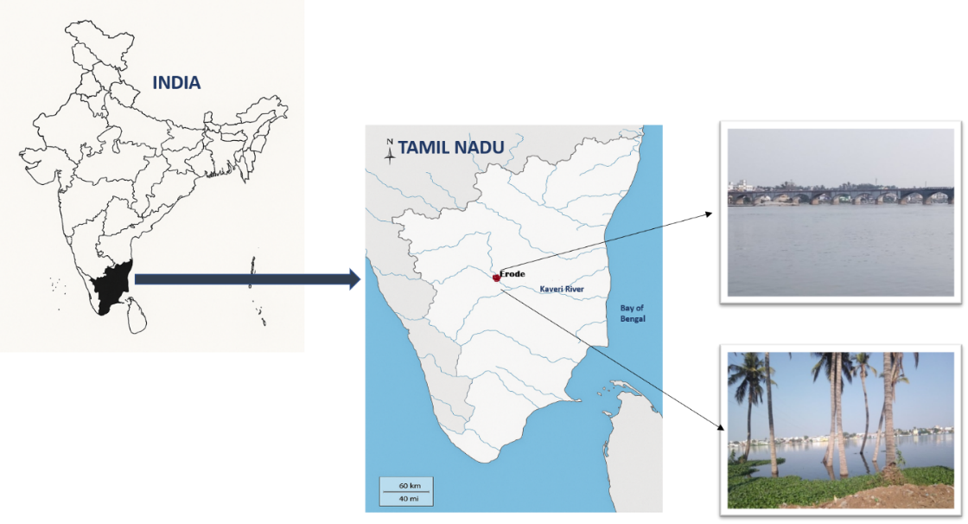

Fig 1. Sample collection from River Kaveri at Erode.

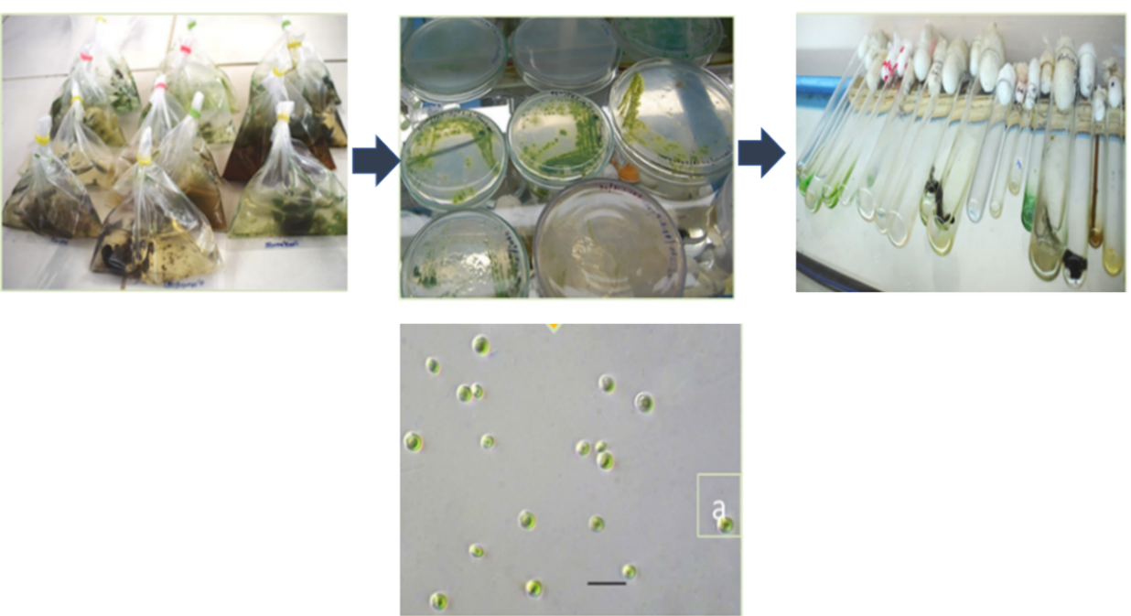

Fig. 2 Process of Isolation and Microscopic images of isolated strains of Chlorella sp., (Photomicrograph of 40X magnification)

3.2 Acute toxicity of TBBPA pollutant against Chlorella sp.
Fig.3 Shows the concentration of chlorella sp. in the treatment groups was considerably lower than that in the control group, whereas algal cells exhibited minimal growth when TBBPA concentrations touched 4 mg/L. As the amount of TBBPA increased, it slowly hindered the growth of Chlorella sp., showing that TBBPA negatively influences the proliferation of Chlorella sp. The growth of Chlorella sp. was better than the control sample when the TBBPA dose was lower at 2 mg/L (Bingxin Fang et al., 2017). These results are similar to earlier studies that found low amounts of ibuprofen help the growth of the freshwater diatom Navicula sp. In the same way, Kurade et al. (2016) observed that between the second and tenth days, there was an increase in the number of cells, indicating a positive interaction between Chlorella sp. and DBP at lower concentrations. According to these findings, chlorella sp. growth was reduced at higher DBP concentrations (50 and 100 mg/L) but stimulated at low concentrations (5–20 mg/L). The most noticeable indication of physiological damage brought on by pollution is the suppression of microalgal growth (Zhao et al., 2017). The exposure of Chlorella sp. to TBBPA concentrations of 8 and 10 mg/L led to significant pigment degradation and subsequent cell mortality, demonstrating severe toxicity at these concentrations.
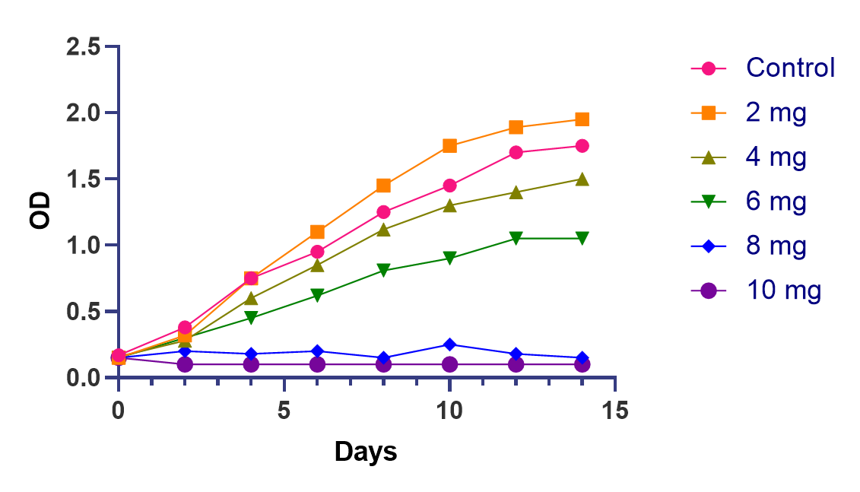
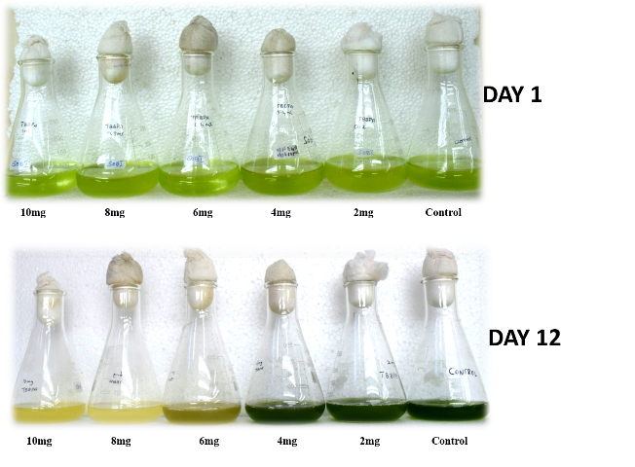

Fig 3. Dose–response growth curve of the Chlorella sp. to TBBPA with different concentration.

3.3 Morphological change in Chlorella Sp.
To explore morphological differences between the chlorella cells in the control group and those exposed to TBBPA treatments, a light microscope (Micros, Austria) was used. The structure of healthy Chlorella sp. is spherical (2–5 μm); however, the structure and size of Chlorella sp. can change due to exposure to toxic substances such as NPs (Khoshnamvand et al. 2021). As can be seen in the control (Fig. 4), micro-algae are round and separate, having a good density, and their sizes seem appropriate. C. vulgaris exposed to TBBPA (6 mg/L) showed a decrease in cell density and started losing pigments. The culture started to decline and the medium's color reduced by the second day following the addition of TBBPA. From the third day onwards, growth was observed only at 6 mg/L of TBBPA. However, at higher concentrations (10 mg/L), the culture color diminished by the second day post-inoculation in all culture flasks containing TBBPA. Under the light microscope (Micros-MCX300LED, Austria), the cell morphology (Chlorella Sp.) in the control and 2 mg/L flask remained unchanged. At a higher concentration of 10 mg/L TBBPA, the culture medium was totally faded, the cells were dead and ruptured, and no chlorophyll content was detected in all the high concentrations (8mg and 10mg) of TBBPA. (Fig 4). Similarly, C. vulgaris has greater sensitivity to fludioxonil than Scenedesmus acutus, Scenedesmus obliquus, Lemna minor, and other aquatic organisms (Verdisson et al., 2001; Dewez et al., 2005). In comparison to other pollutants, including spherical mancozeb, chlorothalonil, and pyrimethanil, fludioxonil exhibits a more potent growth inhibiting effect on C. vulgaris (Xi et al., 2019). The inhibitory effects on the growth of C. vulgaris linked to elevated TBBPA concentrations in aquatic ecosystems necessitate additional investigation.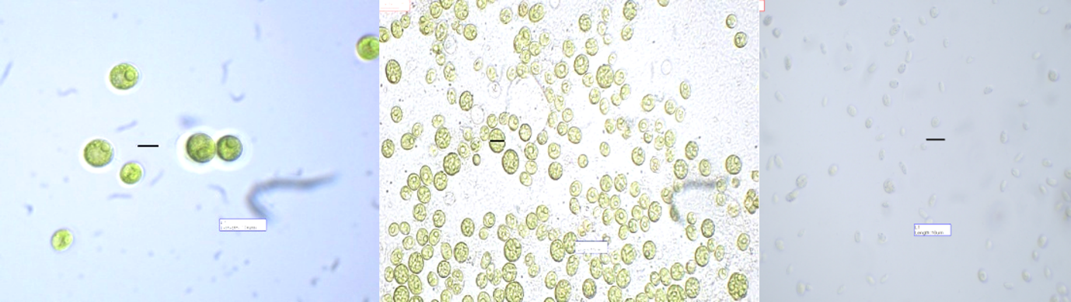
6 mg/L
10 mg/L
Control
Fig 4. Cell morphology of Chlorella sp. After exposed to TBBPA with different concentrations

3.4 Toxicity assay
The toxicity assay on Artemia salina demonstrated moderate mortality rates of 58% after 24 hours. No structural damage was detected in the nauplii. The mortality of brine shrimp after a 24-hour treatment yielded LC₅₀ and LC₉₀ values of 128.21 μg/mL (range: 107.86–182.17 μg/mL) and 189.58 μg/mL (range: 150.43–299.35 μg/mL) (Table 1).
Table 1. Non-toxicity bioassay of TBBPA on Artemia salina (Brine shrimp
Animal name | Sample | LC₅₀ µg/mL  (LCL – UCL) | LC₉₀ µg/mL  (LCL – UCL) | χ ²
Artemia salina | TBBPA | 128.21  107.86 – 182.17 | 189.58  150.43 – 299.35 | 2.907
LCL lower confidence limit, UCL upper confidence limit, χ² Chi square test, p<0.05, level of significance, values are mean ± SD of three replicates.
The morphological effects of TBBPA on Artemia salina were photo documented using light microscope (Micros, Austria) and are presented in figure 5. Differences between the control and treated were observed. In control group artemia salina showed morphologically healthy body structure, including clearly visible eyes(E), straight and intact tail region (TL) and a clear undistorted gut (GUT). In the treated group, TBBPA caused morphological abnormalities in the species. The nauplii showed deformation in the tail region and swelling. The Gut region appeared possible damage to digestive processes. This structural deformity indicates that TBBPA showed a toxic impact on the A.salina early development, which affected the physiological and digestive function.

Fig 5. Toxicity bioassay of TBBPA on Artemia nauplii (A. salina).

4. Conclusion
This study looked at how TBBPA affected the growth of Chlorella sp. and Artemia salina, showing different levels of growth slowdown in both during the exposure. We also observed that TBBPA affected the shape of Chlorella sp. and Artemia salina, leading to a 58% death rate within 24 hours. In aquatic environments, Chlorella sp. and A. salina are important primary producers that are utilized as an energy source, while TBBPA, which is commonly found, raises concerns about its toxicity to the environment. Consequently, it is essential to examine the harmful impacts of TBBPA on aquatic organisms. The results show that TBBPA is a serious environmental threat to water ecosystems, emphasising the need for stricter rules and more studies on the ecological risks of brominated flame retardants.
DISCLAIMER (ARTIFICIAL INTELLIGENCE)
Author(s) hereby declares that NO generative AI technologies such as Large Language Models (ChatGPT, COPILOT, etc) and text-to-image generators have been used during writing or editing of this manuscript.
COMPETING INTERESTS
Authors have declared that no competing interests exist.

Data Availability Statement
The data that support the findings of the study are available from the corresponding author upon responsible request

References
Abbott, W. S. (1925), “A Method for Computing the Effectiveness of an Insecticide,” Journal of Economic Entomology, 18, 265–267. https://doi.org/10.1093/jee/18.2.265a
Akhtar, N., Syakir Ishak, M. I., Bhawani, S. A., & Umar, K. (2021). Various natural and anthropogenic factors responsible for water quality degradation: A review. Water, 13(19), 2660. https://doi.org/10.3390/w13192660
Aravinth, A., Perumal, P., Rajaram, R., Dhanasundaram, S., Narayanan, M., Maharaja, S., & Manikumar, A. (2023). Isolation and characterization of 2, 4-di-tert-butyl phenol from the brown seaweed, Dictyota ciliolata and assessment of its anti-oxidant and anticancer characteristics. Biocatalysis and Agricultural Biotechnology, 54, 102933. http://dx.doi.org/10.1016/j.bcab.2023.102933
Colnot, T., Kacew, S., & Dekant, W. (2014). Mammalian toxicology and human exposures to the flame retardant 2, 2′, 6, 6′-tetrabromo-4, 4′-isopropylidenediphenol (TBBPA): implications for risk assessment. Archives of toxicology, 88, 553-573. https://doi.org/10.1007/s00204-013-1180-8
Dewez, D., Geoffroy, L., Vernet, G., & Popovic, R. (2005). Determination of photosynthetic and enzymatic biomarkers sensitivity used to evaluate toxic effects of copper and fludioxonil in alga Scenedesmus obliquus. Aquatic toxicology, 74(2), 150-159. https://doi.org/10.1016/j.aquatox.2005.05.007

Ding, T.; Yang, M.; Zhang, J.; Yang, B.; Lin, K.; Li, J.; & Gan, J (2017). Toxicity, degradation and metabolic fate of ibuprofen on freshwater diatom Navicula sp. J. Hazard. Mater, 330, 127–134. https://doi.org/10.1016/j.jhazmat.2017.02.004
Duarte, B., Gameiro, C., Matos, A. R., Figueiredo, A., Silva, M. S., Cordeiro, C., ... & Cabrita, M. T. (2021). First screening of biocides, persistent organic pollutants, pharmaceutical and personal care products in Antarctic phytoplankton from Deception Island by FT-ICR-MS. Chemosphere, 274, 129860. https://doi.org/10.1016/j.chemosphere.2021.129860.
Fang, B., Shi, J., Qin, L., Feng, M., Cheng, D., Wang, T., & Zhang, X. (2018). Toxicity evaluation of 4, 4′-di-CDPS and 4, 4′-di-CDE on green algae Scenedesmus obliquus: growth inhibition, change in pigment content, and oxidative stress. Environmental Science and Pollution Research, 25, 15630-15640. https://doi.org/10.1007/s11356-018-1749-0
Gavrilescu, M., Demnerová, K., Aamand, J., Agathos, S., & Fava, F. (2015). Emerging pollutants in the environment: present and future challenges in biomonitoring, ecological risks and bioremediation. New biotechnology, 32(1), 147-156. https://doi.org/10.1016/j.nbt.2014.01.001
Khoshnamvand, M., Hamidian, A. H., Ashtiani, S., Ali, J., & Pei, D. S. (2024). Combined toxic effects of polystyrene nanoplastics and lead on Chlorella vulgaris growth, membrane lipid peroxidation, antioxidant capacity, and morphological alterations. Environmental Science and Pollution Research, 31(19), 28620-28631. https://doi.org/10.1007/s11356-024-33084-5
Kurade MB, Kim JR, Govindwar SP, & Jeon BH (2016). Insights into microalgae mediated biodegradation of diazinon by Chlorella vulgaris: microalgal tolerance to xenobiotic pollutants and metabolism. Algal Res 20:126–134. https ://doi.org/10.1016/j. algal.2016.10.003
Ntomi, D. D., Sime, G. D., Nyemeck II, N. M., Zintchem, A. A. A., Yousouf, S., Ihsan, U. H., ... & Pegnyemb, D. E. (2025). In vitro antioxidant activity and toxicity assay of some chemical constituents from Landolphia violaceae lianas (Apocynaceae). Fitoterapia, 183, 106483. http://dx.doi.org/10.1016/j.fitote.2025.106483
Olaolu, D. T., Akpor, O. B., & Akor, C. O. (2014). Pollution indicators and pathogenic microorganisms in wastewater treatment: implication on receiving water bodies. International Journal of environmental protection and policy, 2(6), 205-212. doi: 10.11648/j.ijepp.20140206.12
Pereira, L. C., de Souza, A. O., Bernardes, M. F. F., Pazin, M., Tasso, M. J., Pereira, P. H., & Dorta, D. J. (2015). A perspective on the potential risks of emerging contaminants to human and environmental health. Environmental Science and Pollution Research, 22, 13800-13823. https://doi.org/10.1007/s11356-015-4896-6
Rasheed, T., Bilal, M., Nabeel, F., Adeel, M., & Iqbal, H. M. (2019). Environmentally-related contaminants of high concern: potential sources and analytical modalities for detection, quantification, and treatment. Environment international, 122, 52-66. https://doi.org/10.1016/j.envint.2018.11.038
Rippka, R.; Deruelles, J.; Waterbury, J.B.; Herdman, M.; & Stanier, R.Y. (1979). Generic assignments, strain histories and properties of pure cultures of cyanobacteria. J. Gen. Microbiol,111, 1–61. https://doi.org/10.1099/00221287-111-1-1
Verdisson, S., Couderchet, M., & Vernet, G. (2001). Effects of procymidone, fludioxonil and pyrimethanil on two non-target aquatic plants. Chemosphere, 44(3), 467-474. https://doi.org/10.1016/S0045-6535(00)00468-9
Xi, J., Shao, J., Wang, Y., Wang, X., Yang, H., Zhang, X., & Xiong, D. (2019). Acute toxicity of triflumizole to freshwater green algae Chlorella vulgaris. Pesticide biochemistry and physiology, 158, 135-142. https://doi.org/10.1016/j.pestbp.2019.05.002
Yu, Y., Yu, Z., Chen, H., Han, Y., Xiang, M., Chen, X., ... & Wang, Z. (2019). Tetrabromobisphenol A: disposition, kinetics and toxicity in animals and humans. Environmental pollution, 253, 909-917. https://doi.org/10.1016/j.envpol.2019.07.067
Zhao, Y., Wang, Y., Li, Y., Santschi, P.H., & Quigg, A., (2017). Response of photosynthesis and the antioxidant defense system of two microalgal species (Alexandrium minutum and Dunaliella salina) to the toxicity of BDE-47. Mar. Pollut. Bull. 124, 459–469. https://doi.org/10.1016/j.marpolbul.2017.07.038.

