Population Dynamics of Butterflies from Two Selected Areas of South Goa.

ABSTRACT.
Biodiversity issues are very crucial in preventing the permanent extinction of variety of species on the planet earth. Butterflies, moths and the skippers are included in the order Lepidoptera. There are about 10% butterfly species of Lepidoptera. Butterflies are well known for their diversity in shape, size and beautiful wing colours, having slender bodies and slender antennae with club-like tips. In general, the wings are held vertically when at rest. They are cosmopolitan in distribution, found everywhere around the world except near the Poles. They are diurnals. Our Country is gifted with rich butterfly diversity but due to various anthropogenic activities, they are gradually depleting from certain habitats. We have to take appropriate measures to bring them back to optimum level. For this, protection, preservation and propagation are the most sought activities. First and foremost, the important act in this direction is making an inventory of butterfly diversity in the selected and significant habitats. Present investigation is aimed to understand the status of butterfly diversity in the State of Goa, one of the smallest States of the Indian Union and exploring conservation practices. Hence, the present study was undertaken to provide baseline information on the checklist of butterflies and their diversity in Quepem and Sanguem talukas of South Goa. In Quepem, Grey County and Brush-footed Butterfly recorded least relative abundance of 2.991, Grey pansy recorded maximum relative abundance of 6.196. In Sanguem, Nymphalid butterfly, Statira sulphur recorded maximum relative abundance of 3.835 and White peacock recorded least relative abundance of 2.191. Total butterfly abundance at different selected sites of Quepem is Borimal; 31.19, Xeldem; 26.70, Nanda Lake; 20.08, Palacio do deao; 22.00 and Sanguem is Selaulim dam; 25.47, Pattem; 21.09, Kotto ;27.67, Vorcotto; 25.75 during the survey period.
Key words: Biodiversity, Butterflies, Lepidoptera, Sanguem, Quepem.
Introduction.
Butterflies play a crucial role in the ecosystem, as good source of food, pollinators, pollution indicators, and have aesthetic importance (Syaripuddin et al., 2015). Butterflies provide crucial services such as nutrients recycling, food resources and pollination within the ecosystem. Butterflies are valuable ecological indicators of climatic conditions and also serve in formulating strategies for conservation. Animal pollination is important to the sexual reproduction of many crops and the wild plants (Larson & Barrett 2000; Ashman et al., 2004) and there is direct relation between flora and fauna in the ecosystem, decline of pollinator species leading to a proportionate decrease of flora (Biesmeijer et al., 2006). Several studies have made significant contributions towards the understanding of biogeography, behaviour, conservation, development, global warming, adaptations and speciation ( Kozak et al., 2015, Wang Wei et al., 2016, Van Bergen et al., 2017).
Pahari et al., (2018) reported less diversity and evenness indices of butterfly diversity in Haldia industrial zone when compared with the adjacent rural butterflies. Several researchers adopted conservation approach for butterflies at the habitat level for assessing processes such as land use and habitat degradation. Fleishman and Murphy (2009). And Singh, A. P. (2012).
Two important factors, relative humidity and temperature regulate the distribution and assemblage of butterfly species (Gupta et al., 2019). Caterpillars and adult butterflies are dependent on foliage, nectar and pollen as their food respectively on specific host plants (Nimbalkar et al., 2011), facilitating pollination.
Anthropogenic environmental stresses such as rising human land use and global climate change are altering natural ecosystems (Tilman et al., 2001). Urbanization is the major contributor for anthropogenic impact globally. (Nagendra et al., 2001). Rapid ecological changes threaten local and regional biodiversity (De Cáceres et al., 2010), thus the establishment of a monitoring system to address diverse environmental challenges is very crucial. These activities highly influence the diversity and distribution of faunal and floral species in any habitat. Informed decision-making requires assessment of the biodiversity of a site (α-diversity) and comparisons of biodiversity between sites (ß-diversity) (Martin, etal., 2005).
Goa is blessed with rich biodiversity and considerable literature on butterfly diversity is available. Borkar and komarpant (2004) reported 97 butterfly species from Bondla wildlife Sanctuary. Rangnekar and Dharwadkar (2009) added White banded awl Hosara taminatus (hubner), Black vein sergant Athmya ranga moore, Coon psolos fuligo (mabille) three new butterfly species , thus making a total of 254 species to the butterfly fauna of Goa. Gaude and Janarthanam (2015) studied butterflies from four sacred groves of Goa, viz.,Nirankarachi Rai, Alvatinichi Rai ,Mharinginichi Rai and Azobachi Rai. Other studies on butterfly diversity includes Taleigao plateau (Bowalkar et al., 2017), and well-known tourist destination (Kulkarni et al., 2021) of Goa.
Recent urbanization and tourism-related activities have an impact on biodiversity. However, no report is available on the biodiversity of the fast-developing suburbs of Quepem and Sanguem, famous for beautiful rivers (kushavati) and other tourist destinations such as Salaulim dam, Rivona caves, Zambaulim temple.
There is a need for the documentation of butterfly species from Goa due to environmental changes both natural and due to anthropogenic activities like agriculture, urbanization, industrialization, construction of roads etc. Hence, the present investigation was carried out to prepare the checklist of butterflies and their diversity in the study area.
Methodology
A study was carried out at four selected places from Quepem Taluka as well as from Sanguem Taluka under South Goa district, located in the central part of Goa State in India.
Quepem.
The lat. long.of Quepem are 15.22N 74.07 E, and the height of this city from sea level is 21m, 47km south-east side from Panjim Capital of Goa .
The four selected places from Quepem were Borimil, Xeldem and Nanda Lake and Palacio do deao.
Site 1-Borimol is a village located in the Quepem taluka of Goa. The region is known for its biodiversity and is home to a wide variety of plants and animal species. Borimol is also known for its rich flora, the region is also home to several medicinal plants, such as Indian gooseberry, Neem tree, etc.
Site 2-Xeldem is a very large beautiful and scenic village situated in Quepem Taluka of South Goa, known for sugarcane, paddy, coconut farms on large scales.
Site 3-Nanda lake is critically significant for it ecosystem services and biodiversity values. The freshwater of Nanda Lake moors organisms which are ecologically as well as economically important.
Site 4- Palacio deao is situated 14 km from Margao, on the banks of wildly beautiful Kushavati River in the taluka of Quepem. It has an outstanding lush gardens that have still managed to preserve their historical features and since old times known as the most beautiful pleasure garden in Goa.
Sanguem is located at 15.23N 74.17E. It has an average elevation of 22 metres. Sanguem is the municipal council in south Goa district. The study range was divided into 4 different study sites Salaulim dam, Pattem, Kotto and Vorcotto. The survey was based on different types of butterfly seen in this particular area.
Site 1-Salaulim dam is located on the selaulim river, a tributary of the zuari river in Goa India. It is about 5 kms from sanguem town it is the biggest man made dam in Goa .
Site 2- Pattem is a village situated near old fish market in Sanguem taluka on the banks of Pattem River, the village is covered with many trees and is rich in biodiversity.
Site 3-Kotto is a village situated in the Sanguem taluka. This area is next to Pattem village. The same rivers flows through this village.
Site 4- Vorcotto is situated in dendo Sanguem. It has a vast variety of Cashew, Coconut, Mango etc. plantations.
Map 1 : Study Area
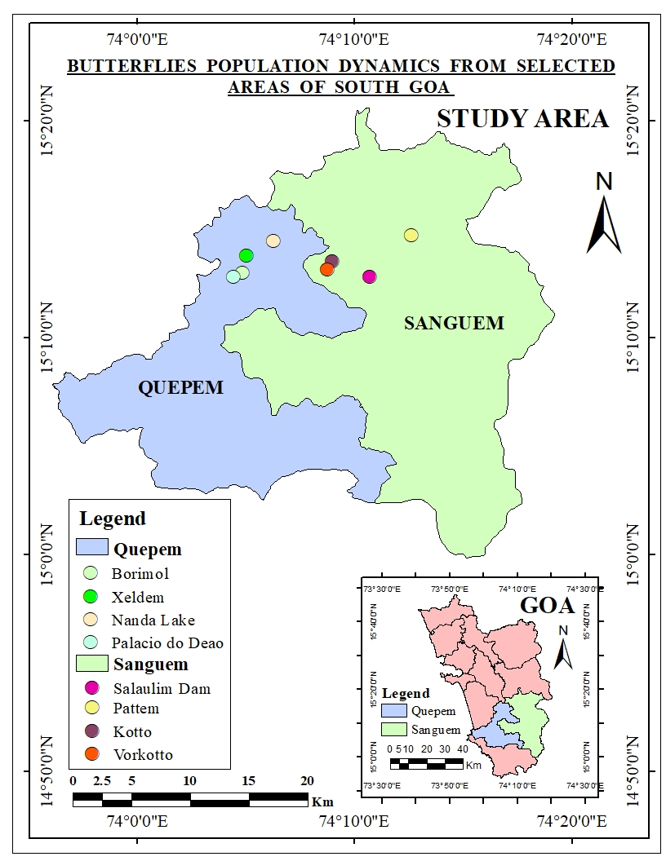

The Field surveys were carried out on every Sunday for a period of 6 months from August 2022 to January 2023 from 7.00 am to 11.00 am in the morning.
The butterflies were documented by employing the visual count method and capture method and were identified by using field guide such as , Guide to Butterflies of Western Ghats (India) by Bhakare, S. & Ogale.H. and Butterflies of Goa by Parag Rangnekar.
From the primary data relative abundance was carried out using the formula
Total number of individual species
Relative abundance = ------------------------------------------------------------- x 100
Total individuals of all the species recorded

Results
Grey County and Brush-footed Butterfly recorded least relative abundance 2.991, Grey pansy recorded maximum relative abundance of 6.196 in Quepem. Lemon pansy, Immaculate snow flat are very rare, Common five ring , Common crow , The psyche and Common jezebel are very common. (Table 1(a).
Table 1(a).Relative abundance and status of butterflies of different Families in Quepem area.
Sr.no | Family | Scientific name | Common name | Numerical abundance | Relative abundance | Status
1 | Nymphalidae | Orositriaena medus | Smooth eyed bush brown | 22 | 4.700 | C
2 |  | Hypolimnas bolina | Blue moon butterfly | 20 | 4.273 | R
3 |  | Junonia lemonias | Lemon pansy | 22 | 4.700 | VR
4 |  | Ypthima heubneri | Common five ring | 23 | 4.914 | VC
5 |  | Tirumala limniace | Blue tiger | 21 | 4.487 | R
6 |  | Junonia atlites | Grey pansy | 29 | 6.196 | NR
7 |  | Acrae terpsicorre | Tawny coster | 17 | 3.632 | NR
8 |  | Cethosia biblis | Red lacewing | 22 | 4.700 | -
9 |  | Danaus genutia | Common tiger | 28 | 5.982 | NR
10 |  | Tanaecia lepidea | Grey county | 14 | 2.991 | R
11 |  | Neptis columella | Short banded sailor | 19 | 4.059 | NR
12 |  | Taygetis ypthima | Brush-footed Butterfly | 14 | 2.991 | -
13 |  | Euplea core | Common crow | 22 | 4.700 | VC
14 | Hesperiidae | Tagiades gana | Immaculate snow flat | 19 | 4.059 | VR
15 |  | Cymaenes tripunctus | Three-spotted skipper | 26 | 5.555 | -
16 |  | Potanthus omaha | Lesser dart | 22 | 4.700 | -
17 | Papilinodae | Triodes helena | Common bird wing | 22 | 4.700 | R
18 |  | Papilo polymnestor | Blue Mormon | 25 | 5.341 | NR
19 | Pieridae | Leptosia nina | The psyche | 18 | 3.846 | VC
20 |  | Delias eucharis | Common jezebel | 21 | 4.487 | VC
21 | Lycaenidae | Castalius rosimon | Common pierrot | 23 | 4.914 | NR
22 |  | Talicada nyseus | Red pierrot | 19 | 4.059 | R
 |  | Total |  | 468

In Sanguem, Nymphalid butterfly, Statira sulphur with 3.835 have maximum relative abundance and White peacock is having least relative abundance 2.191, Common cerulean, Mime are very rare. Dark evening brown, chocolate pansy, four ring, Common evening brown, Common crow, Nymphalid butterfly, Jezebel , Common grass yellow, Common wanderer are very common. Table.1 (b)

Table 1. (b). Relative abundance and status of butterflies of different Families in Sanguem area.
Sr No. | Family | Scientic name | Common name | Numerical abundance | Relative abundnance | Status
1 | Nymphalidae | Melanitis phedIma | Dark evening brown | 12 | 3.287 | VR
2 |  | Juninia iphita | Chocolate pansy | 13 | 3.561 | VC
3 |  | Ypthima huebneri | Four ring | 13 | 3.561 | VC
4 |  | Hypolimnas bolina | Blue moon butterfly | 11 | 3.013 | R
5 |  | Nymphatis entrpa | Mourning cloak | 10 | 2.739
6 |  | Orsotriaena medus | Bush brown | 11 | 3.013 | C
7 |  | Parantica aglea | Glassy tiger | 09 | 2.465 | NR
8 |  | Melanitis leda | Common evening brown | 11 | 3.013 | VR
9 |  | Euploea core | Common crow | 10 | 2.739 | VC
10 |  | Anartia jatrophae | White peacock | 08 | 2.191
11 |  | Danaus gilippus | Queen butterfly | 10 | 2.739
12 |  | Anaea aidea | Tropical leaf wing | 13 | 3.561
13 |  | Danaus chrysippus | Plain tiger | 11 | 3.013 | NR
14 |  | Mycalesis perseus | Dingy bushbrown | 11 | 3.013
15 |  | Cirrochroa | Yeomen | 11 | 3.013
16 |  | Maniola jurtina | Nymphalid butterfly | 14 | 3.835
17 |  | Mycalesis visala | Meadow brown | 13 | 3.561
18 |  | Discophora sondaica | Common duffer | 13 | 3.561
19 |  | Neptis hylas | Long brand bush brown | 11 | 3.013
20 |  | Tanacia julii | Common sailor | 13 | 3.561 | NR
21 |  | Euthalia aconthea | Common baron | 11 | 3.013
22 | Pieridea | Delias eucharis | Jezebel | 11 | 3.013 | VC
23 |  | Phoebis sennae | Cloundless sulphur | 11 | 3.013
24 |  | Aphrissa statira | Statira sulphur | 14 | 3.835
25 |  | Leptiosia nina | Psyche | 12 | 3.287 | VC
26 |  | Eurema hecaba | Common grass yellow | 13 | 3.561 | VC
27 |  | Pareronia valeria | Common wanderer | 09 | 2.465 | VC
28 | Lycaenidae | Jamides celeno | Common cerulean | 11 | 3.013 | VR
29 |  | Talicade nyseus | Red pierrot | 10 | 2.739 | R
30 |  | Castalius rosimon | Pierrot | 12 | 3.287 | NR
31 | Papilionidae | Papilio clytia | Mime | 10 | 2.739 | VR
32 |  | Papilio demoleus | Swallowtail butterfly | 13 | 3.561 | R
 |  | Total |  | 365

Table 2(A).Total butterfly abundance at different sites during the survey period.
Area | Numerical abundance | Relative abundance | Total
Quepem |  |  | 468
Site-1 Borimol | 146 | 31.19
Site-2 Xeldem | 125 | 26.70
Site -3 Nanda lake | 094 | 20.08
Site-4 Palacio do deao | 103 | 22.00
Sanguem |  |  | 365
Site -1 Salaulim dam | 093 | 25.47
Site-2 Pattem | 077 | 21.09
Site -3 Kotto | 101 | 27.67
Site-4Vorcotto | 094 | 25.75

Fig 1
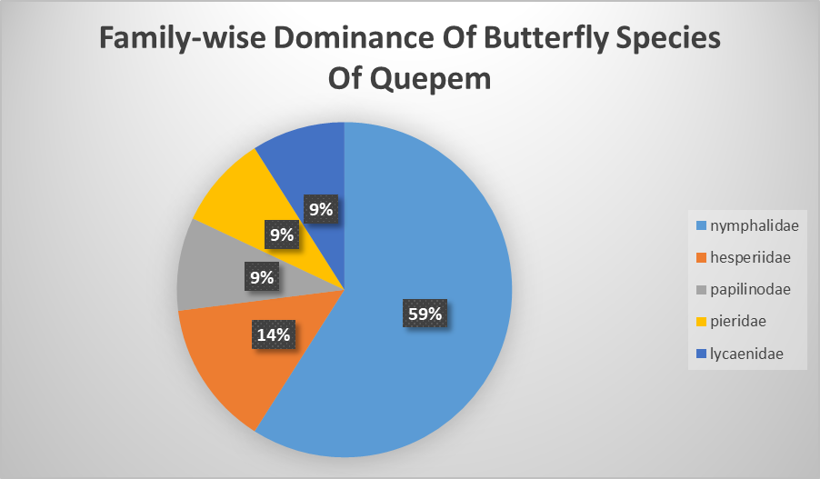
Fig 2
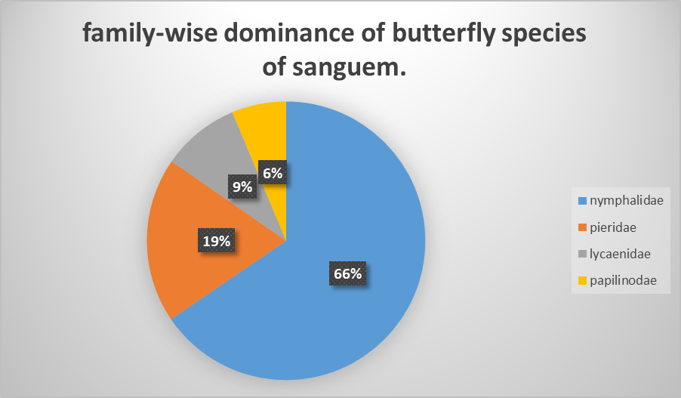

Fig 3

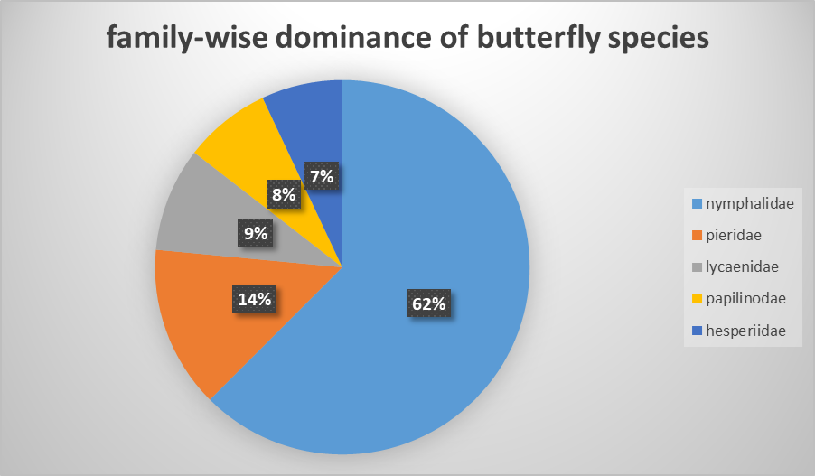

Plate 1- Butterflies of Quepem.
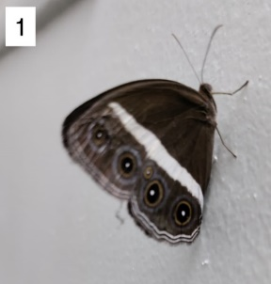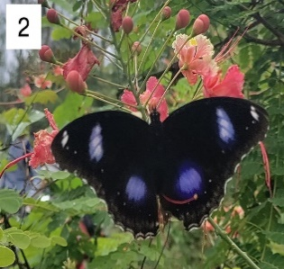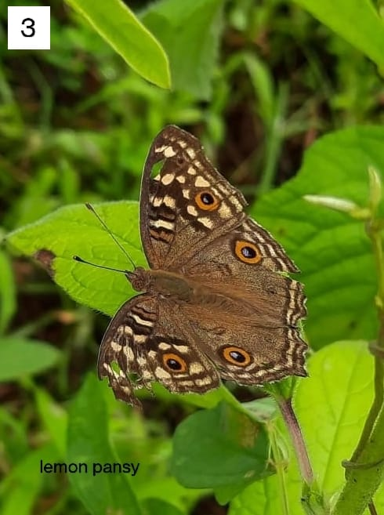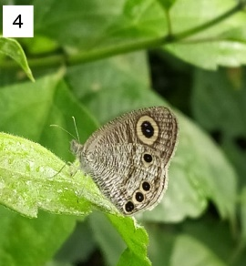

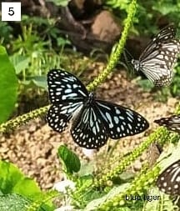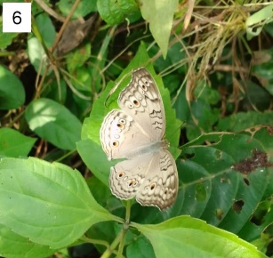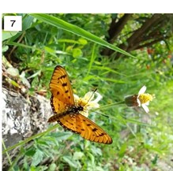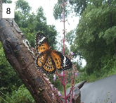
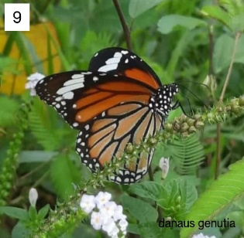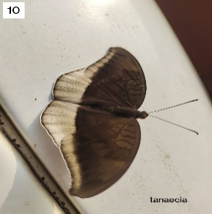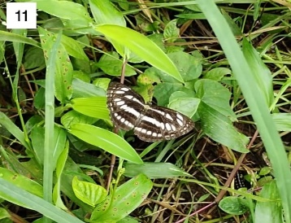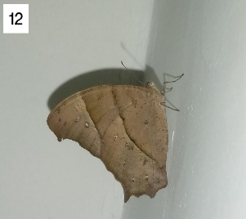
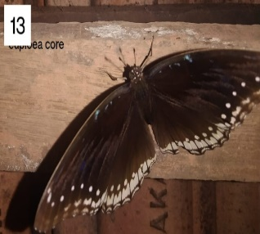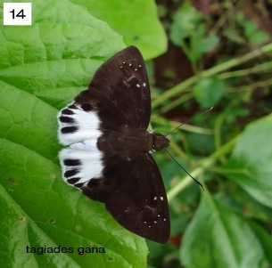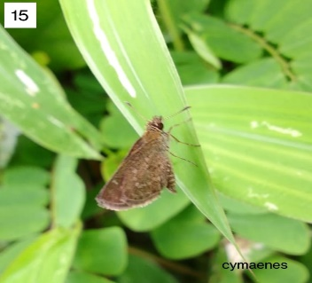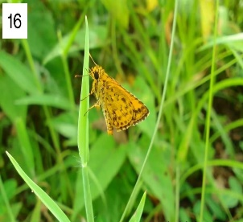
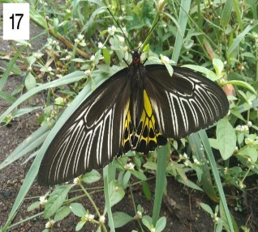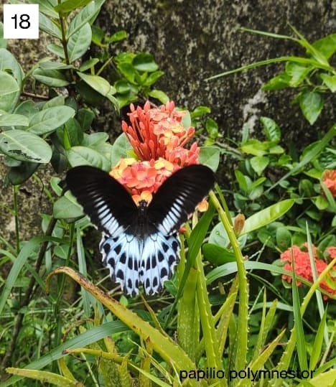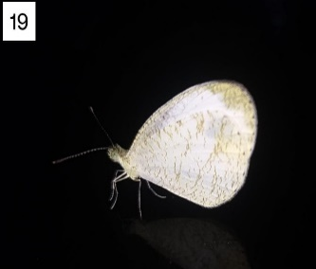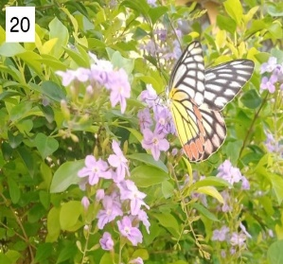
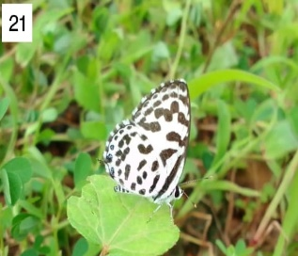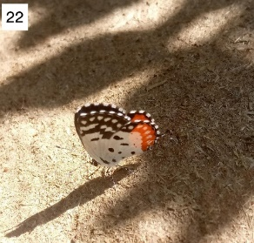
1.Orositriaena medus, 2.Hypolimnas bolina, 3.Junonia lemonias, 4.Ypthima heubneri, 5.Tirumala limniace, 6.Juninia atlites, 7.Acrae terpsicorre, 8.Cethosia biblis, 9.Danaus genutia, 10.Tanaceia lepidea, 11.Neptis columella, 12.Taygetis ypthima, 13, Euplea core, 14.Tagiades gana, 15.Cymaenes tripunctus, 16.Potanthus Omaha, 17.Triodes Helena, 18.Papilio polymnester, 19.Leptosia nina, 20.Delias eucharis, 21.Castalius rosimon, 22.Talicada nyseus.
- Plate 2 : Butterflies of Sanguem-
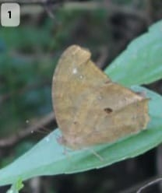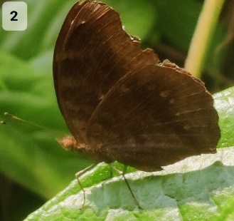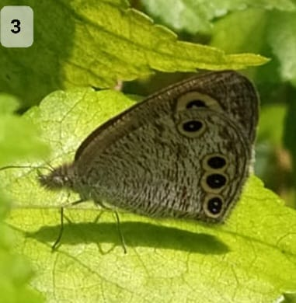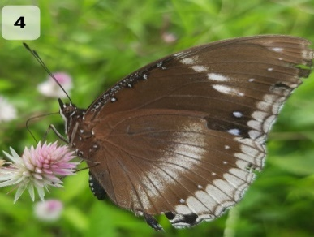

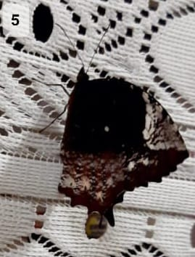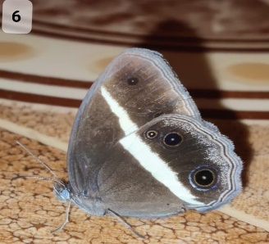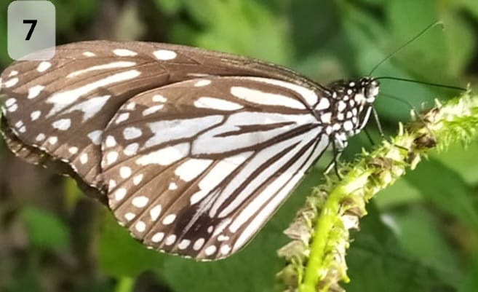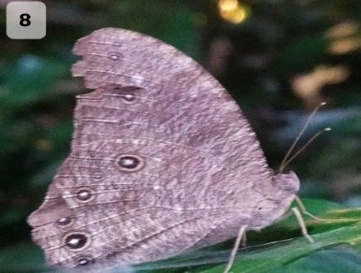
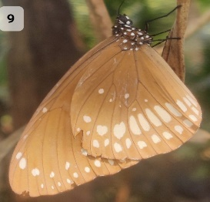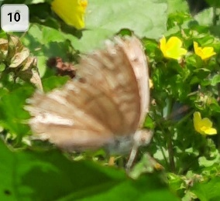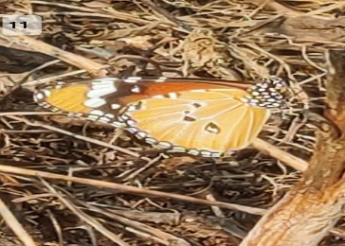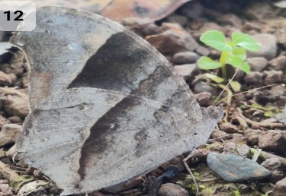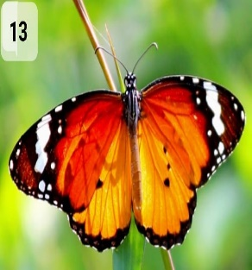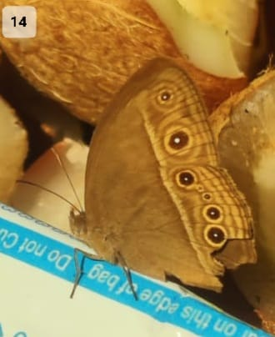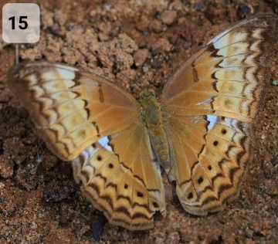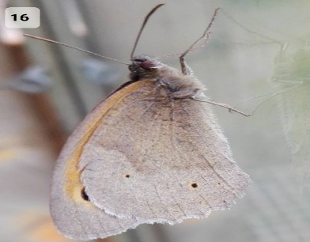
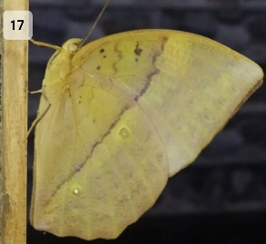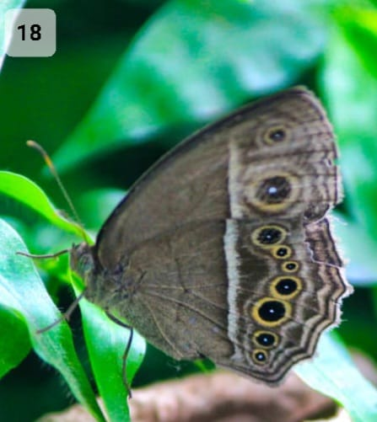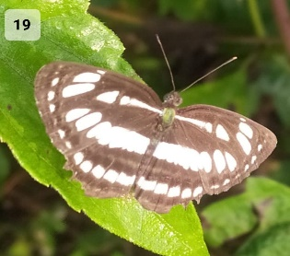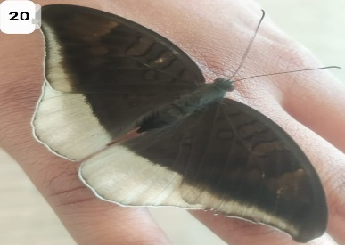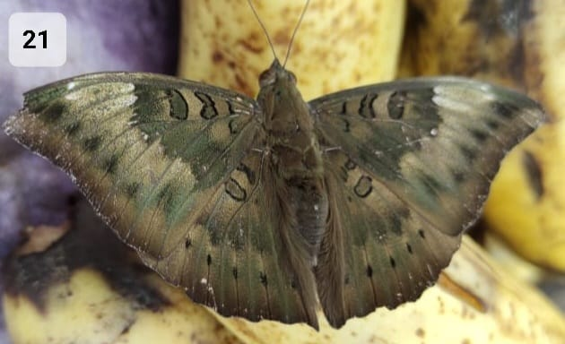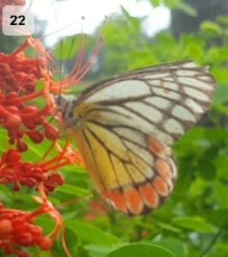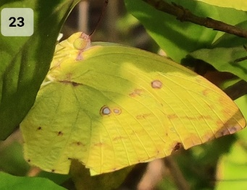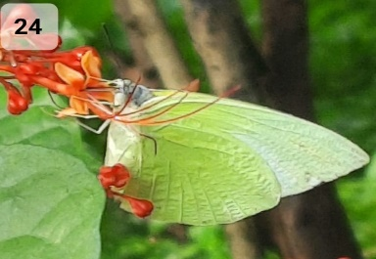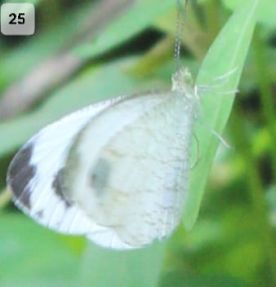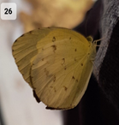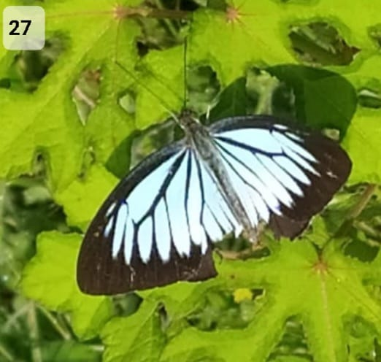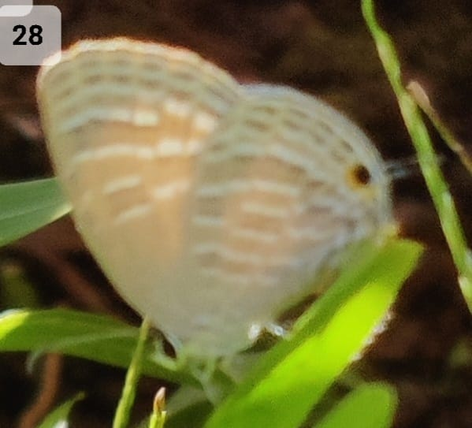
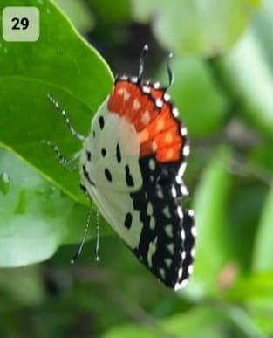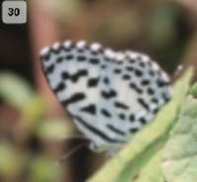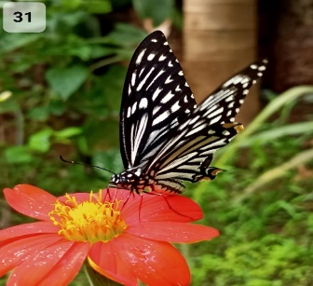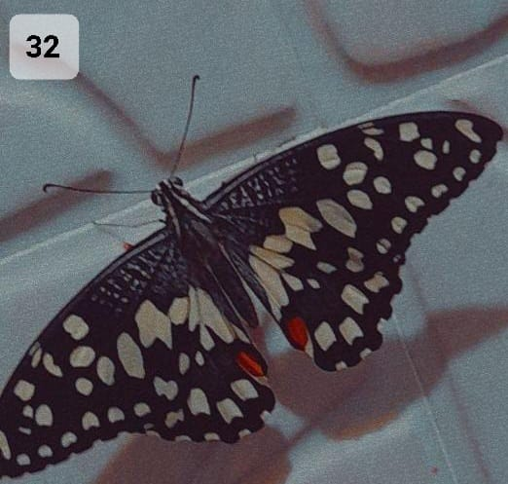

1. Melanitis phedimaa, 2.Junonia iphita, 3.Ypthima heubneri, 4.Hypolimnas bolina, 5.Nymphatis entiopa, 6.Orostriaena medus, 7.Parantica agleas, 8.Melanitis leda, 9.Euplea core, 10.Anartia jatrophae, 11.Danaus gilippus, 12. Anaea aidea, 13.Danaus chrysippus, 14.Mycalesis perseus, 15.Cirrochroa, 16.Maniola jurtina, 17.Discophora sondiaca, 18.Mycalesis visala, 19.Neptis hylas, 20.tanaecia julii, 21.Euthalia aconthea, 22.Delias eucharis, 23.Phoebis sennae, 24.Aphrissa statira, 25.Leptosia nina, 26.Eurema hecaba, 27.Pareronia valeria, 28.Jamides celeo, 29.Talicada nyseus, 30.Castalius rosimon, 31.Papilio cytia, 32.Papilio demolus.
Discussion.
Gutierrez & Mendez (1995) suggested that the abundance of butterflies is more related to the availability of food plants and is not affected by altitudes. Vegetation in any given habitat has a very crucial role in increasing the butterfly diversity and their abundance. Extensive studies on butterflies of Western Ghats, South India, were carried out by Gaonkar (1996), which was the first study that took into account all the 331 species in 166 genera belonging to five families recorded from this mountain range and the adjacent areas Maximum butterfly diversity and abundance were reported on plantation biotope, followed by forest and scrub biotope. Grassland and interestingly botanical and nursery gardens are not rich biotopes for butterfly population; heavy grazing pressure on grassland and use of pesticides in gardens have adversely affected diversity of butterflies in these biotopes. The presence or absence of butterflies depends on the existence of host plants. The Western Ghats are rich in plant diversity. The evergreen and semi-evergreen forests in the region have a wide variety of host plants which support abundant butterfly population. The diverse assemblages of host plants in the coastal Western Ghats ensure survival of a diverse butterfly fauna in the region.
Butterflies are well adapted to their habitat and react quickly to anthropogenic activities resulting in modifications of their landscape (Mora et al., 2011). They are an excellent ecological indicator for the general ecological impact assessments and in continued monitoring of ecological health. (Basset et al., 2013; Ramadevi et al., 2020a; b; Naik et al., 2022).
An attempt is made to understand how the distribution and butterfly diversity variation is influenced by the changes in ecological parameters of habitats in the Quepem and Sanguem talukas. The distribution of many species is changing, in response to climate change and habitat deterioration (Lenoir et al. 2010).
Another important role that they play in the ecosystem is that of being a vital link in the food chain. They constitute a significant percentage of food for many species including spiders, birds and reptiles. Some caterpillars play host to young ones of parasitic wasps. Many areas are quickly urbanizing, resulting in increased deforestation and vegetation fragmentation (Nagendra et al., 2001). Mapping and estimating population dynamics is the first step in systematic biodiversity conservation planning (Margules & Pressey 2000). Abideen et al. (2015) recorded 57 species of butterfly in University of Ibandan Botanical Garden, Nigeria. Many studies have been documented on the butterflies of India in recent years (Sengupta et al., 2014; Acharya and Vijayan, 2015; Ghosh and Saha, 2016; Bowalkar et al., 2017; Kulkarni et al., 2021.Bepari et al., 2023;Sharma et al., 2023).
Anthropogenic events like construction of highways, influx of tourists, grazing pressure, use of pesticides and change in land use pattern are mainly responsible for both butterflies and plants diversity loss .Diversity and abundance of butterflies from family Lycaenidae is affected by the grazing activity of the cattle as they largely feed on grasses.
In the present study, 365 species of butterflies were identified from 4 families. Butterflies from family Nymphalidae showed maximum species diversity with 239 species followed by family Pieridae with 70 than the lowest families were Lycaenidae with 33 and Papilionidae 23 species were seen. Nymphalidae was the richest family that comprised (269 and 62%) of the total species of butterfly recorded in the study area followed by Pieridae (109 and 14 %), and the lowest families were Lycaenidae (75 and 9%) Papilionidae (71 and 8%) and hesperiidae(66 and 7%).The study area is rich in butterfly diversity. Present findings are more important for improving and defining conservation strategies to improve host plant diversity and butterfly diversity.
Conclusion
Butterflies have an intimacy with host plants and their lives are interlinked which lead to different patterns in their distribution depending on the availability of their food plants ,thus degree of diversity depends on availability of host plants and adaptability to the micro habitat. For conservation practices of declining butterfly populations habitat protection is very important and crucial for which first identification of habitats with high butterfly abundance and diversity is very important. Toughest conservation practices and protection measures should be implemented.
Acknowledgements.
Authors are thankful to Former Principal Prof. Joydeep Bhattacarjee and Present Principal Dr. Pravina Kerkar for their constant support and encouragement, Shri. Kiran P Naik, Assistant Professor in Geography for GIS mapping of study sites.
Authors’ contributions; This work was carried out in collaboration among all authors. All authors read and approved the final manuscript.

Disclaimer (Artificial intelligence)
Option 1:
Author(s) hereby declare that NO generative AI technologies such as Large Language Models (ChatGPT, COPILOT, etc.) and text-to-image generators have been used during the writing or editing of this manuscript.

REFERENCES
Abideen, A.A., James, K.O. and Georgina, S.M. (2015). Butterfly Species Diversity and Abundance in University of Ibadan Botanical Garden, Nigeria, Open Journal of Ecology, 5: 352-360
Acharya, B.K. and Vijayan, L. 2015. Butterfly diversity along the elevation gradient of Eastern Himalaya, India. Ecol. Res., 30, 909–919
Alexandra-Maria Klein
1,
*
, Bernard E. Vaissie
`
re
2
, James H. Cane
3
,
Ingolf Steffan-Dewenter
1
, Saul A. Cunningham
4
, Claire Kremen
5
and Teja Tscharntk
Alexandra-Maria Klein
1,
*
, Bernard E. Vaissie
`
re
2
, James H. Cane
3
,
Ingolf Steffan-Dewenter
1
, Saul A. Cunningham
4
, Claire Kremen
5
and Teja Tscharntk
Alexandra-Maria Klein
1,
*
, Bernard E. Vaissie
`
re
2
, James H. Cane
3
,
Ingolf Steffan-Dewenter
1
, Saul A. Cunningham
4
, Claire Kremen
5
and Teja Tscharntk
Alma, E.N., Alma, B.M., Grecebio Jonathan, D.A. (2015). Diversity and distribution of Butterflies in the open and close canopy forests of Cadaclan, San Fernando La union botanical garden of North Luzon, the Philippines, Journal of Biodiversity and Environmental Sciences, 6(1): 169-177
Ashman TL, Knight TM, Steets JA, et al. (20040 Pollen limitation of plant reproduction: ecological and evolutionary causes and consequences. Ecology.; 85:2408–2421
Basset, Y., Eastwood, R. O., Sam, L., Lohman, D. J., Novotny, V., Treuer, T. I., Miller, S. E., Weiblen, G. D., Pierce, N. E., Bunyavejchewin, S. and Sakchoowong, W. (2013). Cross-continental comparisons of butterfly assemblages in tropical rainforests: Implications for biological monitoring. Insect Conserv. Divers., 6(3), 223–233.
Bepari Sania , Rupali Pandit , Mangirish Dharwadkar and Kulkarni Rajender Rao et al.(2023) Uttar Pradesh J. Zool., vol. 44, no. 19, pp. 163-173,; Article no.UPJOZ.277
Bhakare, Shriram & Ogale, Hemant. (2018). A Guide To The Butterflies Of Western Ghats(India). Milind Bhakare, 2018, ISBN 9353115426, 9789353115425, 496 Pp.
Biesmeijer J.C, et al.2006 Parallel declines in pollinators and insect-pollinated plants in Britain and the Netherlands. Science. 313, 351–354
Borkar, M.R. and Komarpant, N. 2004. Diversity, abundance and habitat association of butterfly species in Bondla Wildlife Sanctuary of Goa, India. Zoos Print J., 19(10), 1648–1653
Bowalkar, D., Michael, N.A.G, Gaude, K. and Pai, I.K. 2017. A checklist of butterflies (Insect Lepidoptera) from Taleigaon Plateue Goa. J. Threat. Taxa, 9(8), 10626–10630.
De Cáceres, M., Legendre, P. and Moretti, M. 2010. Improving indicator species analysis by combining groups of sites. Oikos, 119, 1674–1684.
Fleishman E and Murphy DD. 2009. A realistic assessment of the indicator potential of butterflies and other charismatic taxonomic groups. Conserv Biol 23: 1109– 16.
Gaonkar, H. (1996). Butterflies of the Western Ghats, India including Sri Lanka - A Biodiversity Assessment of a Threatened Mountain System. A report submitted to the Centre for Ecological Sciences, Bangalore, India, 86 pp.
Gaude, K. & M.K. Janarthanam (2015). The buery (Insecta: Lepidoptera) diversity of four sacred groves of Goa, India. Journal of Threatened Taxa 7(12):
7927–7932; hp://dx.doi.org/10.11609/JoTT.o4228.7927-32
Gaude, K. & M.K. Janarthanam (2015). The buery (Insecta: Lepidoptera) diversity of four sacred groves of Goa, India. Journal of Threatened Taxa 7(12): 7927–7932
Ghosh, S. and Saha, S. 2016. Seasonal diversity of butterflies with reference to habitat heterogeneity, larval host plants and nectar plants at Taki, North 24 Parganas, West Bengal, India. World Sci. News, 50, 197–238
Gupta, Himanshu & Tiwari, Chandranshu & Diwakar, Swati. (2019). Butterfly diversity and effect of temperature and humidity gradients on butterfly assemblages in a sub-tropical urban landscape. Tropical Ecology. 60. 10.1007/s42965-019-00019-y.
Gutierrez, D. &amp; R. Mendez (1995). Phenology of butterflies in a mountain area in northen Iberian Peninsual. Ecography 18: 209–2196.
Kozak, K.M., Wahlberg, N., Neild, A., Dasmahapatra, K.K., Mallet, J. & Jiggins, C.D. 2015. Multilocus species trees show the recent adaptive radiation of the mimetic Heliconius butterflies. Syst. Biol. 64: 505–524.
Kulkarni, R.R., Naik, S., Patil, N., Rodrigues, G., Naik, A. and Akshata, N. 2021. Assessment of butterfly (Lepidoptera: Rhopalocera) diversity and relative abundance in Rivona near the Foothills of Western Ghats-Goa. J. Himalayan Ecol. Sustain. Dev., 16, 69–85.
Larson BMH, Barrett SCH. 2000. A comparative analysis of pollen limitation in flowering plants. Biological Journal of the Linnean Society; 69:503–520.
Lenoir, J., Gégout, J.-C., Guisan, A., Vittoz, P., Wohlgemuth, T., Zimmermann, N. E., Dullinger, S., Pauli, H., Willner, W., & Svenning, J.-C. (2010). Going against the flow: Potential mechanisms for unexpected downslope range shifts in a warming climate. Ecography, 33, 295– 303.
Margules, C.R. & R.L. Pressey (2000). Systematic conservation planning. Nature 405: 243–253.
Martin, L. M., Moloney, K. A. and Wilsey, B. J. 2005. An assessment of grassland restoration success using species diversity components. Journal of Applied Ecology 42:327-336
Mora C, Tittensor DP, Adl S, Simpson AGB and Worm B. (2011), How Many Species Are There on Earth and in the Ocean? PLoS Biology, 9(8), e1001127. doi:10.1371/journal.pbio.1001127
Nagendra, H., Nagendra, S., Paul, S. and Pareeth, S. 2001. Graying, greening and fragmentation in the rapidly expanding Indian city of Bangalore. Landscape Urban Plan., 105, 400–406.
Naik, D., Rao, R., Kunte, K. and Mustak, M. S. 2022. Ecological monitoring and indicator taxa: Butterfly communities in heterogeneous landscapes of the Western Ghats and Malabar coast, India. J. Insect Conserv., 26, 1–13.
Nimbalkar, R.K., S.K. Chandekar & S.P. Khunte (2011). Butterfly diversity in relation to nectar food plants from Bhor Tahsil, Pune District, Maharashtra, India. Journal of Threatened Taxa 3(3): 1601-1609.
Pahari, P.R., N.P. Mishra, A. Sahoo, and T. Bhattacharya. 2018. A study on the butterfly diversity of Haldia industrial belt and adjacent rural area in Purba Medinipur District, West Bengal, India. World Scientific News 97: 207–224.
Rangnekar, P. (2007). A Photographic Guide to Butterflies of Goa. (also
includes butterflies of other ranges of the Western Ghats & Southern India).
Mineral Foundation of Goa, 66pp
Rangnekar, P. (2007). A Photographic Guide to Butterflies of Goa. (alsoincludes butterflies of other ranges of the Western Ghats & Southern India).Mineral Foundation of Goa, 66pp
Rangnekar, P. & O. Dharwadkar (2009). Three additions to the knownbutterfly (Lepidoptera: Rhopalocera and Grypocera) fauna of Goa, India. Journalof Threatened Taxa 1(5): 298-299
Remadevi, O. K., Vinaya Kumar, K. H., Kakkar, R. and Singh, R. K. 2020a. Karnataka Butterflies a Field Guide. Excel India Publishers, New Delhi, p. 130.
Sharma , B., Choudhary , R., Sharma , V., Dutta, S., & Chandra , S. (2023). Community Composition and Dynamics of Butterflies in Different Microhabitats of Central Aravalli Hill Regions of Ajmer District, Rajasthan, India. Asian Journal of Biology, 19(3), 13–20. https://doi.org/10.9734/ajob/2023/v19i3368
Sengupta, P., Banerjee, K.K. and Ghorai, N. 2014. Seasonal diversity of butterflies and their larval food plants in the surroundings of upper Neora Valley Natonal Park, a subtropical broad leaved hill forest in the eastern Himalayan landscape, West Bengal, India. J. Threat. Taxa, 6(1), 5327–5342
Singh, A.P. (2012) Lowland Forest Butterflies of the Sankosh River Catchment, Bhutan. Journal of Threatened Taxa, 4, 3085-3102.
Syaripuddin, K., Sing, K. W. and Wilson. J. J. 2015. Comparison of butterflies, bats and beetles as bioindicators based on four key criteria and DNA barcodes. Tropical Conservation Science Vol.8 (1): 138-149.
Tilman, D., Fargione, J., Wolff, B., D’Antonio, C., Dobson, A., Howarth, R., Schindler, D., Schlesinger, W. H., Simberloff, D. and Swackhamer, D. 2001. Forecasting agriculturally driven global environmental change. Science, 292, 281–284
Van Bergen, E., Osbaldeston, D., Kodandaramaiah, U. et al. (2017). Conserved patterns of integrated developmental plasticity in a group of polyphenic tropical butterflies. BMC Evol Biol 17, 59 https://doi.org/10.1186/s12862-017-0907-1
Wang Wei J, Lee BPY-H, Bing Wen L(2016) Citizen Science and the Urban Ecology of Birds and Butterflies —A Systematic Review. PLoS ONE 11(6): e0156425. doi:10.1371/

