NUTRITIONAL EVALUATION OF SEA GRASS AND FISH MEAL AS AN ALTERNATIVE FEEDING INGREDIENT FOR SUSTAINABLE AQUACULTURE DEVELOPMENT

ABSTRACT
The current research emphasizes the dietary importance of Sea grass species that exist in abundance along the coastal areas. “The wealth out of waste” idea advocates for a sustainable feed derived from these sea grass species, which possess a high nutritional composition and proximate makeup of protein, lipid, carbohydrate, ash, and fiber that are crucial for sustainable fish farming. An alternative feeding ingredient using Sea grass and fish meal mixed in the ratio 1:1 ratio was formulated to compare the nutrition present in the formulated (mixed feed) along with the control (Commercial feed) which is available in the market. The results indicate the amounts of macro and micro nutrients and the proximate composition found in the sea grass species. By assessing the levels of Carbohydrates, Glucose, lipids, proteins, ash, moisture, and anti-oxidants present in the blended feed that contains an equal ratio of Sea grass and fish meal, it demonstrates a high level of nutrition for growth when compared to the commercial feed, which is available in the common markets. The findings imply that the seagrasses possess significant nutritional value and may serve as an excellent dietary supplement for aquatic animals. The insights into the nutrient composition of the seagrass identified in this study can be further utilized as a foundation to examine the absorption in aquatic animals, to create nutritional information guidelines, and for other advanced research regarding sea grass.
Keywords: Nutritional composition, seagrass, micronutrients, macronutrients

INTRODUCTION

The global demand for fish as a source of high-quality protein is steadily increasing due to its essential role in human nutrition and its relatively low environmental footprint compared to other animal proteins. As a result, aquaculture has emerged as one of the fastest-growing sectors in global food production. According to the Food and Agriculture Organization (FAO), over 50% of the fish consumed worldwide is produced through aquaculture, making it a crucial contributor to food security and nutrition (FAO, 2020). However, the rapid expansion of

aquaculture comes with its set of challenges, particularly concerning the sustainability of fish farming practices, which are largely dependent on the quality and availability of feeds (Tacon, 1995). Feed is the most significant input in aquaculture, often accounting for up to 50-60% of production costs (Tacon & Metian, 2015). The quality of fish feed has a direct influence on the growth performance, health, and disease resistance of farmed species. Therefore, it is essential to formulate fish feeds that are nutritionally balanced and economically viable while minimizing environmental impacts (Aya, 2017). Traditional fishmeal and fish oil, which have been the cornerstone of aquaculture feed formulations, are under increasing pressure due to their limited availability, high cost, and environmental concerns related to overfishing and the depletion of marine resources (Tacon et al. , 2021; Ganzon-Naret, 2013). This necessitates the development of alternative feed ingredients to ensure the industry's long-term sustainability.
“To optimize fish growth and health, aquaculture feeds must meet the specific nutritional requirements of different fish species. These requirements include appropriate levels of proteins, lipids, carbohydrates, vitamins, and minerals, which vary depending on the life stage, species, and environmental conditions” (National Research Council, 2011; Fan et al., 2022).
The sustainability of aquaculture is closely connected to the sustainability of fish feed. The requirement for sustainable feed ingredients is influenced by environmental issues such as overfishing, habitat destruction, and resource depletion. As the aquaculture sector grows, the need for feed ingredients that are nutritionally sufficient and ecologically sound becomes increasingly crucial. Sustainable aquaculture growth necessitates a balance among economic feasibility, environmental responsibility, and social accountability (Hussain et al., 2024). In this regard, the creation of supplementary fish feeds that are not only nutritionally adequate but also derived from sustainable sources will be essential for ensuring the long-term sustainability of the aquaculture industry.
“The idea of sustainable aquaculture extends beyond minimizing the environmental impact of

fish feed ingredients; it also includes broader environmental issues, such as decreasing greenhouse gas emissions, conserving water supplies, and enhancing biodiversity. Investigation into alternative feed ingredients, such as insect larvae, algae, and by-products from food processing, is being spurred by the need to mitigate the environmental effects linked to traditional fishmeal and fish oil production” (Ravindra et al., 2020). The aquaculture sector can lessen its reliance on marine resources and foster a more sustainable global food system by procuring protein and other nutrients from less resource-heavy and more sustainable sources.
The main aim of this study is to assess the nutritional quality of formulated supplementary fish feed using Sa grass as a feed additive along with fish meal in equal ratio intended for sustainable aquaculture development by comparing it with the commonly available commercial feed. (Fiorenza, E.A., Abu, N., Feeney, W.E., Limbong, S.R., Freimark, C.B., Jompa, J., Harvell, C.D., & Lamb, J.B. 2024). Specifically, the study examines the ways these feeds fulfill the nutritional requirements of fish species, their impact on growth performance, feed efficacy, and overall health, along with their potential to lessen dependence on conventional feed ingredients. By determining the most effective components and formulations, this study seeks to aid in developing more sustainable feeding techniques in aquaculture, thus promoting the long-term growth and sustainability of the sector.

MATERIALS AND METHODS

This section outlines the materials and methods used in the study to evaluate the nutritional quality of formulated supplementary fish feed designed for sustainable aquaculture development. The focus of the study was to assess the feed's ability to meet the nutritional requirements of farmed fish, enhance growth performance, and ensure overall health, all while promoting sustainable aquaculture practices. The methodology incorporates a combination of feed formulation, laboratory analyses, to assess the nutritional value of the formulated feed comparing with the general commercial feed.

Feed Formulation and Composition

Formulated supplementary fish feed were designed based on the nutritional requirements of the fish species. The formulation process aims to minimize the reliance on conventional fishmeal and incorporate alternative protein sources, such as sea grass (Tacon et al., 2021). The feed formulations were prepared by combining the mixed combinations of Sea grass and fish

meal in the 1:1 ratio. The nutritional profiling of the Mixed feed - MF (formulated with sea grass and fish meal) was done and compared with the standard commercial feed available readily as pellets in the market.

The sea grass was collected from the shores of Rameshwaram, Mandapam Coast, Tamil Nadu. The feed formulations were mixed and pelleted to ensure uniformity in size and texture. The pelleted feeds were then dried and stored in a cool, dry place until use in the feeding trials.

The experimental design was a completely randomized design (CRD) with three different feed treatments:

  - SET 1: A control feed consisting of a standard commercial fish feed with a high fishmeal content.
  - SET 2: A formulated mixed feed - MF consisting of both Sea grass and fish meal in the ratio 1:1

The following nutritional profiling was done in both sets of feeds and was compared for efficacy.

ESTIMATION OF CARBOHYDRATE BY ANTHRONE METHOD

Principle

Carbohydrates are dehydrated by conc.H2SO4 to form furfural. Active form of the reagent is anthranol, the enol tautomer of anthrone, which reacts by condensing with the carbohydrate furfural derivative to give a green colour in dilute and a blue colour in concentrated solutions, which is determined colorimetrically. The blue - green solution shows absorption maximum at 620 nm.

Reaction

  - Hydrolysis to monosaccharides

Disaccharide Monosaccharide

  - Dehydration to product is a furfural

Monosaccharide Furfural

  - Reaction of furfural with anthrone

Furfural + Anthrone reagent Blue green complex

Materials required

Eliza plate reader, Vortex mixer, Mantle heater, Anthrone Reagent, Glucose, Test tube, Beaker and Test sample.

Reagents

    - Anthrone reagent: Dissolve 50mg of Anthrone in 25ml of concentrated H2SO4.
Use freshly prepared reagent for the assay

    - Glucose stock solution: 50mg glucose per mL distilled water.

Table 1: Standard preparation for the estimation of carbohydrate

Standards | S1 | S2 | S3 | S4 | S5 | S6 | S7 | S8
Dist .H2O | 900µl | 500µl | 500µl | 500µl | 500µl | 500µl | 500µl | 500µl
Serial dilution of Glucose | 100µl from the  stock | 500µl | 500µl | 500µl | 500µl | 500µl | 500µl | 500µl
Conc. of  standards | 5  mg/ml | 2.5  mg/ml | 1.25  mg/ml | 0.625  mg/ml | 0.312  mg/ml | 0.156  mg/ml | 0.078  mg/ml | 0.039  mg/ml

Procedure

      - Pipette out into a series of test tubes different volumes of glucose solution from the supplied stock solution (50 mg/ml) and make up the volume to 1 mL with distilled water.
      - To take 100 µl of test sample mix with 200 µl of 75% H2SO4.

      - To each tube add 400 µl of the Anthrone reagent (supplied) and mix well by vortexing and Cool the tubes.
      - Cover the tubes with Caps on top and incubate at 90º C for 17 minutes or boiling water bath for 10 minutes.
      - Cool to room temperature and measure the optical density at 620 nm against a blank.

      - Prepare a standard curve of absorbance vs glucose.

ESTIMATION OF REDUCING SUGAR BY BENEDICT’S METHOD

AIM:
To estimate the amount of glucose present in the given unknown solution using
Benedict's quantitative reagent.

PRINCIPLE:
“Benedict’s quantitative reagent is a modification of qualitative. It contains copper sulphate, sodium acetate and sodium corbonate. It also contains potassium thio cyanate and small amount of potassium ferricyanide. The inclusion of acetate prevents the precipitation of copper carbonate by chelating Cu³⁺ion. The thiocyanate causes the precipitation of white cuprous thio cyanate rather than red cupric oxide. On reduction of Cu³⁺ ions which enables the end point of the titration ie., the transition from blue to white to be readily observable. Methylene blue will be used as an additional indicator. The small amount of potassium ferricyanide prevents the re-oxidation of copper. A non-stoicheometric reaction is on which does not follow a defined pathway and cannot be described by an equation either quantitatively or qualitatively. The reduction of Cu³⁺ ions by sugar is a non-stoicheometric equation and is only constant over a small range of sugar concentration. To obtain accurate results the volume of sugar added must be with in 6- 12 ml for 10 ml of Benedict's reagent. If the preliminary titre value Falls outside this range the sugar solution must be titrations are repeated”. (Nepolean et al.2023)

REAGENTS REQUIRED: STANDARD GLUCOSE SOLUTION
Glucose 10 mg/ml

BENEDICT’S QUANTITATIVE REAGENT
100 ml of solution acetate, 37.5 g of sodium carbonate and 62.5 g of potassium thiocyanate were dissolved in 300 ml of distilled water by warming gently and filtered. 9 g of copper sulphate is dissolved in 50 ml of water, added with continuous stirring. 2.5 ml of potassium ferricyanide is added and the volume is made upto 500 ml with water.

Table 2: Standard preparation for the estimation of reducing sugar

Standards | S1 | S2 | S3 | S4 | S5 | S6 | S7 | S8
Dist .H2O | 900µl | 500µl | 500µl | 500µl | 500µl | 500µl | 500µl | 500µl
Serial dilution of  glucose | 100µl | 500µl | 500µl | 500µl | 500µl | 500µl | 500µl | 500µl
Conc. of  standards | 1  mg/ml | 0.5  mg/ml | 0.25  mg/ml | 0.125  mg/ml | 0.0625  Mg/ml | 0.03125  mg/ml | 0.015625  mg/ml | 0.0078125  mg/ml

Procedure
  - Added 10 µl of each standard solution and samples to the 96 well plate.
  - Benedict’s reagent (200 µl) was added to the standards and samples.
  - All the samples and standard were done in triplicates to avoid any error.
  - The plate was heated for 10 minutes.
  - The absorbance was measured at 595nm in an Elisa reader.
  - From this the value of unknown concentration is found out.

ESTIMATION OF PROTEIN BY BRADFORD’S METHOD PRINCIPLE
The most widely used Bradford method was developed by M. Bradford. It is based on the observation of a shift in wavelength from 465nm to 595nm for Coomasssie Brilliant Blue G-250 dye in an acidic solution as it binds to a protein. When the dye is bonded to the protein it is in the anionic form and has a maximum absorbance around 595nm. When the dye is not bound, it is in the cationic form and has a maximum absorbance around 470nm. The dye interacts with both hydrophobic and basic amino acids of the protein. With increasing protein

concentration, the dye changes colour brown to blue to darker shades of blue. The dye appears to bind more readily to arginine residues (but not to the free amino acid) of the protein. Hence the absorbance of light by the dye-protein complex at 595 nm is proportional to the amount of protein bound (over a limited range); i.e., there is a linear relationship between absorbance and the total protein concentration of the sample over a narrow range.

MATERIALS REQUIRED

Bradford’s reagent and BSA was purchased from Sigma Aldrich. 96 well plate was purchased from Tarson, India.
BSA standard stock 50mg/ml

Table 3: Standard preparation for the estimation of protein

Standards | S1 | S2 | S3 | S4 | S5 | S6 | S7 | S8
Dist .H2O | 900µl | 500µl | 500µl | 500µl | 500µl | 500µl | 500µl | 500µl
Serial dilution of BSA | 100µl from the stock | 500µl | 500µl | 500µl | 500µl | 500µl | 500µl | 500µl
Conc. of standards | 5  mg/ml | 2.5  mg/ml | 1.25  mg/ml | 0.625  mg/ml | 0.312  mg/ml | 0.156  mg/ml | 0.078  mg/ml | 0.039  mg/ml

PROCEDURE

- Added 10 µl of each standard solution and test samples to the Elisa titter plate.

- Then, 100µl of Bradford’s reagent was added to the standards and test samples.
- All the samples and standard were done in triplicates to avoid any error.

- The plate was incubated for a minimum of 10 minutes at dark.

- The absorbance was measured at 595nm in a microplate reader.

- From this the value of unknown concentration is found out.

ESTIMATION OF LIPID BY VANILLIN METHOD

Principle

Lipids react with sulfuric acid to form carbonium ions which subsequently react with the vanillin phosphate ester to yield a purple complex that is measured photometrically at 540 nm. The intensity of the colour is proportional to the Total lipids concentration.

MATERIALS REQUIRED

Chloroform, Methanol, cholesterol, H2So4, sulfo-phosphoric-vanillin acid agent, 96 well plate was purchased from Tarson, India and cholesterol standard stock 10 mg/ml.

Table 4: Standard preparation for the estimation of lipid

Standards | S1 | S2 | S3 | S4 | S5 | S6 | S7 | S8
Chloroform and Methanol (2:1) | - | 500µl | 500µl | 500µl | 500µl | 500µl | 500µl | 500µl
Serial dilution of cholesterol | 1ml from  the stock | 500µl | 500µl | 500µl | 500µl | 500µl | 500µl | 500µl
Conc. of standards | 10  mg/ml | 5  mg/ml | 2.5  mg/ml | 1.25  mg/ml | 0.625  mg/ml | 0.312  mg/ml | 0.156  mg/ml | 0.078  mg/ml

Prepare the standard sample solution

- Prepare the solvent, chloroform: methanol=2:1;

- Mix cholesterol in solvent at predetermined concentration, for instance 5mg/ml or 10 mg/ml.
- Vary volume of the standard sample to assign different amount of cholesterol in different tubes.

PROCEDURE

Prepare the samples

- Dissolve the samples in water at a predetermined concentration;

- Vary the volume of mucins to assign different amount of samples in different tubes.

Measure background absorbance

- Add 100 ul concentrated sulfuric acid into each tube and incubating at 90 C for 10 min ( on a dry heating bath);
- Cooling to room temperature and measuring background absorbance at 540nm;

Measure the absorbance after color development

- Prepare the sulfo-phosphoric-vanillin acid agent: 0.2 mg vanillin per ml 17% phosphoric acid) for color development;
- Add 50 ul sulfo-phosphoric-vanillin acid agent for color development;

- Measuring absorbance at 540 nm after 5 min of color development.

ESTIMATION OF CRUDE FIBRE

Procedure

The material was ground and 1 g of it is extracted with petroleum ether to remove fat (initial boiling temperature 35-38°C and final temperature 52°C) and dried at 80qC to constant weight. If fat content is below 1%, extraction is not required. Dried material (2 g) was boiled with 200 mL of 1.25% (w/v) sulphuric acid for 30 min with bumping chips, filtered through muslin cloth and washed with boiling water until washings are no longer acidic. Then, the material was boiled with 200 mL of 1.25% (w/v) sodium hydroxide solution for 30 min, filtered through muslin cloth again and washed with 25 mL of boiling 1.25% (w/v) H2SO4, 50 mL x 3 portions of water and 25 mL alcohol.
The residue was removed and transferred to ashing dish (preweighed dish W1). Again, the residue was dried for 2 h at 130±2°C. Then, the dish was cooled in a desiccator and weighed

(W2), ignited for 30 min at 600±15°C. Finally, the material was cooled in a desiccator and reweighed (W3).

(W2-W1)(W3-W1)× 100

Crude fibre (%) =

W

Where W is the mass of sample.

ESTIMATION OF TOTAL ASH PRINCIPLE
Decomposition of organic matter from a test portion by incineration, and weighing of the ash obtained.

APPARATUS

  - Analytical balance.

  - Muffle furnace, electrically heated, thermostatically controlled, and provided with a pyrometer. The furnace, when set at 550 ^{O}C, shall be capable of being controlled in such a way that the temperature in the places where the incineration dishes will be placed will not differ by more than 20 ^{O}C from this set temperature.
  - Drying oven, capable of being controlled at 103 k 2 ºC.

  - Hot-plate or gas burner.

  - Incineration dish of platinum or platinum-gold alloy (for example 10% Pt, 90 % Au) or of other material unaffected by the conditions of the test, preferably rectangular with a surface area of about 20 cm and a height of about 2,5 cm.
  - NOTE – For samples which are inclined to swell on carbonizing, use dishes with a surface area of about 30 cm and a height of about 3 cm.
  - Desiccator, provided with an effective desiccant.

Store the sample in such a way that change in composition are prevented.

PROCEDURE

Weigh, 1 g of the test sample(MF) into the incineration dish, previously heated for at least 30 min in the muffle furnace at 550 ºC, cooled in the desiccator and weighed to the nearest
0.001 g.

Determination

Place the incineration dish containing the test portion on a hot-plate or over a gas burner and heat progressively until the test portion has carbonized. Transfer the dish
into the muffle furnace, previously set at 550 ‘C, and leave it for 3 h.

Inspect visually whether the ash is free from carbonaceous particles. If it is not, replace the dish in the furnace and heat another 1 h. If carbonaceous particles are still visible, or if there is doubt as to whether they are present, allow the ash to cool, moisten with distilled water, evaporate carefully to dryness in the oven, controlled at 10312 “C, replace the dish in the furnace and heat for another 1 h.
Allow the dish to cool in the desiccator to room temperature and weigh rapidly to the nearest 0.001 g.
NOTE – The crude ash obtained by the above procedure may be used subsequently for the determination of ash insoluble in hydrochloric acid (ISO 5985- Procedure A). Duplicate determination was carried out for the selected sample.

Method of calculation and formula

The crude ash, expressed as a percentage test sample, is equal to by mass of the100

(m2 –mo) x ml —MO

where,

m. is the mass, in grams, of the empty dish;

ml is the mass, in gram’s, of the dish containing the test portion;

m2 is the mass, in grams, of the dish and the crude ash.

Take as the result the arithmetic mean of the two determinations, provided that the requirement for repeatability is satisfied. Report the result to the nearest 0,1 % (m/m).

Repeatability

The difference between the results of two determinations carried out simultaneously or in rapid succession by the same analyst shall not exceed:
0,3 (absolute value) for crude ash yields lower than 3 % (m/m); 10% of the mean value for crude ash yields from 3 to 5 % (m/m); 0,5 (absolute value) for crude ash yields from 5 to 20% (m/m);
2,5 % of the mean value for crude ash yields from 20 to 40 % (m/m); 1 (absolute value) for crude ash yields of 40 % (m/m) or more.

ESTIMATION OF TOTAL MOISTURE

The moisture content of the MF sample was determined by the following method suggested by Tandon (2005) with little modifications. The sample 1.00 g was transferred into a sterilized Petri dish. The beaker was closed with a lid and kept in a hot air oven at 50⁰C for four hours. Then, it was cooled in desiccators and weighed. The loss in weight represents the moisture content of the samples.
100 (B - C) Moisture (%) = --------------
B - A

RESULTS AND DISCUSSION


Graph 1: ESTIMATION OF CARBOHYDRATE
Glucose standard
3.5
3
2.5
2
1.5
1
0.5
0
y = 0.5124x + 0.3793 R² = 0.9768
Mean value
Linear (Mean value)
0 1 2 3 4 5 6
Concentration of Glucose (mg/ml)
OD value at 620 nm

Nam e of the samp  le | OD  value at 620 nm | Total Carbohydra te content | Mean value of total Carbohydra te content  (mg/ml)
MF | 1.006 | 1.22306791 | 1.25429352
 |  | 6 | 1
 | 1.13 | 1.46506635
 |  | 4
 | 0.93 | 1.07474629
 |  | 2

Nam e of the  sam ple | OD  value at 620 nm | Total Carbohydr ate content | Mean value of total Carbohydr  ate content (mg/ml)
CON TRO L  (Co mme rcial Feed  ) | 0.761 | 0.3449718  12 | 0.8008811  987
CON TRO L  (Co mme rcial Feed  ) | 1.02 | 1.1782390  23 | 0.8008811  987
CON TRO L  (Co mme rcial Feed  ) | 0.52 | 0.8794327  61 | 0.8008811  987

Table 5: The total Carbohydrate content present
in the extracted sample (MF) Table 6: The total Carbohydrate content
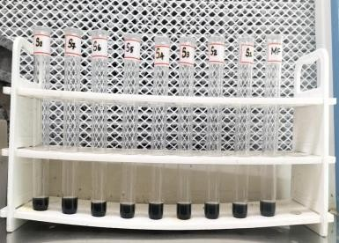
was found to be 1.254 mg/ml. present in the Control (Commercial feed) was found to be 0.800 mg/ml
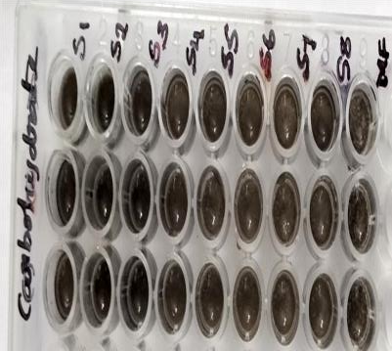
Fig.1(A-B) : the estimation of total carbohydrates present in the supplementary feeds

Graph 2: ESTIMATION OF REDUCING SUGAR
Glucose standard
1.6
1.4
1.2
1
0.8
0.6
0.4
0.2
0
y = 0.1864x + 0.0991 R² = 0.9491
Series1
Linear (Series1)
0 1 2 3 4 5 6
Concentration of Glucose (mg/ml)
OD value at 595 nm

Name of the sample | OD  value at 595 nm | Total sugar content | Mean value of total sugar content
MF | 0.228 | 0.691523605 | 0.61462804
MF | 0.202 | 0.552038627 | 0.61462804
MF | 0.211 | 0.600321888 | 0.61462804

Name of the sample | OD  value at 595  nm | Total sugar content | Mean value of total sugar content
Control (Comm. Feed) | 0.145 | 0.541367218 | 0.4923072943
Control (Comm. Feed) | 0.182 | 0.436902316 | 0.4923072943
Control (Comm. Feed) | 0.204 | 0.498652349 | 0.4923072943

Table 7: The total sugar content Table 8: The total sugar content present in the
present in the extract sample (MF) Control (Commercial feed) was found
was found to be 0.614 mg/ml. to be 0.492 mg/ml
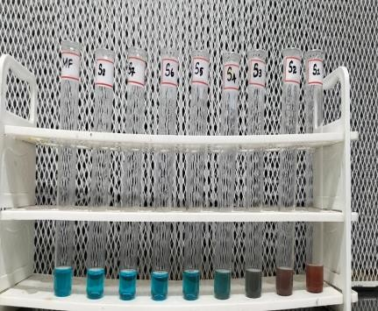
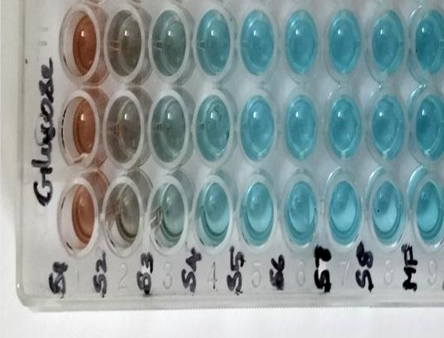
Fig:2(A-B) the estimation of total sugar content present in the fish feed supplements

Graph 3: ESTIMATION OF PROTEIN
Concentration of BSA (mg/ml)
6
5
4
3
2
1
0
0.1
0
Mean value
Linear (Mean value)
0.5
0.4
0.3
0.2
y = 0.0504x + 0.2585 R² = 0.5596
0.6
BSA standard
OD value at 595 nm

Name of the sample | OD  value at 595  nm | Total protein content | Mean value of total protein content (mg/g)
MF | 0.412 | 3.045634921 | 2.880291005
MF | 0.437 | 3.541666667 | 2.880291005
MF | 0.362 | 2.053571429 | 2.880291005

Name of  the sample | OD  Value at 595 nm | Total  protein content | Mean value of  total protein content (mg/g)
Control (Comm. Feed) | 0.412 | 2.940345626 |  | 2.8585543223
Control (Comm. Feed) | O.419 | 3.056876398 |  | 2.8585543223
Control (Comm. Feed) | 0.387 | 2.578440943 |  | 2.8585543223

Table 9: The total protein content present
in the extracted sample (MF) Table 10: The total protein present in the Control (Commercial feed) is 2.858 mg/g
was found to be 2.880 mg/g.

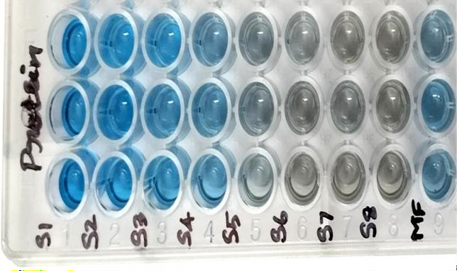

Fig 3: Estimation of total protein content present in the fish feed supplements


Graph 4 : ESTIMATION OF LIPID
Concentration of Cholesterol (mg/ml)
12
10
8
6
4
2
0
0.5
0
Series1
Linear (Series1)
2.5
2
1.5
1
y = 0.2074x + 0.4702 R² = 0.9472
3
Cholesterol standard
OD value at 540 nm

Name of the sample | OD  value at 540  nm | Total Lipid content | Mean value of total Lipid content (mg/ml)
MF | 0.929 | 2.212150434 | 2.165541626
MF | 0.925 | 2.192864031 | 2.165541626
MF | 0.904 | 2.091610415 | 2.165541626

Name of the sample | OD  value at 540  nm | Total Lipid content | Mean value of total Lipid content (mg/ml)
Control (Comm. Feed) | 0.347 | 1.832521056 | 2.159450146
Control (Comm. Feed) | 0.281 | 2.098546782 | 2.159450146
Control (Comm. Feed) | 0.480 | 2.547282601 | 2.159450146

Table 11: The total lipid content present Table 12: The total lipid content found in the Control
(Commercial feed) is 2.159 mg/ml
in the extracted sample (MF) was found to be 2.165 mg/ml
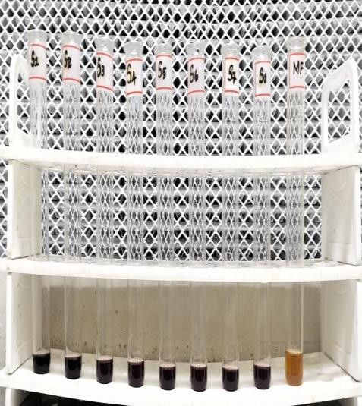
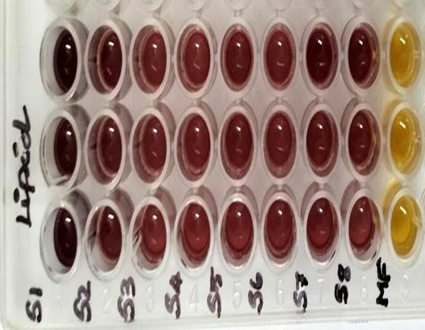

Fig 4(A-B) : Estimation of total lipid content present in the extracted sample in the fish feed supplements

plate 1 : ESTIMATION OF CRUDE FIBRE
Level of Crude Fibre in the Mixed Feed (Prepared Supplementary feed) (%) = 45% Level of Fibre in the Control (Commercial Feed) (%) = 48%
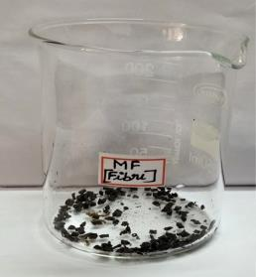  1g of test sample | 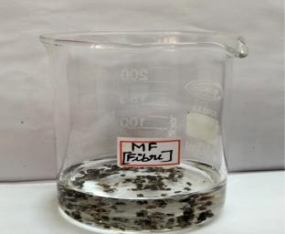  1.25% sulphuric acid
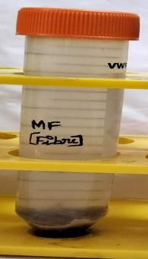  Centrifugation of the materials | 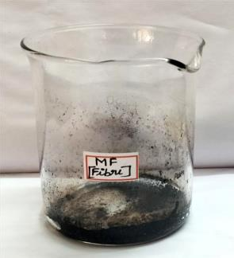  Final product of fibre

Table 13: ESTIMATION OF TOTAL ASH

S. No. | Name of the sample | Sample Quantity (gm) | Total ash content (gm)
1. | MF | 1 | 0.05
2. | Control (Commercial Feed) | 1 | 0.03

The natural total ash content of the selected sample (MF) is 1.00 g. The percentage of the ash found to be 5%.

The natural total ash content of the Control (Commercial Feed) is found to be about 3%
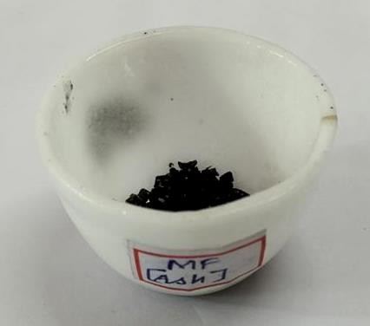
Fig 5 : Measurement of total ash content

8.ESTIMATION OF TOTAL MOISTURE MF
A - Weight of empty Beaker (g) = 17.62
B - Weight of empty Beaker with sample before drying (g) = 20.45
C - Weight of empty Beaker with sample after drying (g) = 19 Moisture (%) = MF- 10%
Total Moisture in % in Control Commercial Feed = 12%

Plate 2 : Estimation of total moisture before and after drying

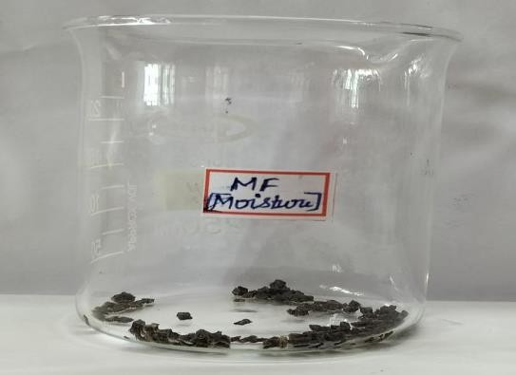  Before drying | 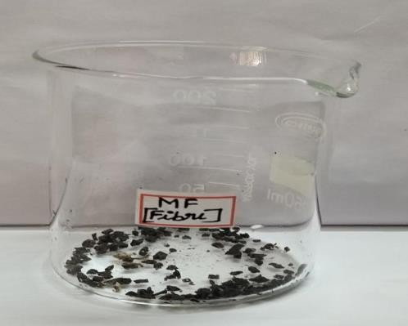  After drying

SUMMARY AND CONCLUSION

The study on the nutritional evaluation of a formulated supplementary fish feed for sustainable aquaculture development was designed to compare the nutritional content and performance of a newly formulated feed, using a 1:1 ratio of sea grass and fishmeal, against a commercially available standard feed. The focus was on evaluating key nutrients such as protein, carbohydrates, lipids, and glucose levels, alongside the growth performance and health status of the fish.
The formulated mixed feed, composed of an equal ratio of sea grass and fishmeal, showed significantly higher levels of proteins, carbohydrates, lipids, and glucose compared to the commercially available control feed. The protein content of the formulated feed was notably elevated, providing the essential amino acids required for muscle development and overall growth. This increase in protein content is critical for enhancing the growth rates of farmed fish, especially in high-protein species such as tilapia and trout (Tacon et al., 2021).

In addition to protein, the carbohydrate content in the formulated feed was also significantly higher. This was primarily due to the high carbohydrate content of sea grass, which provided a balanced energy source to support metabolic needs. The increase in carbohydrates is particularly important as it helps support the fish’s growth by supplying a readily available source of energy (Zhang et al., 2020). Furthermore, the lipid content of the formulated feed was elevated compared to the commercial feed, due to the inclusion of fishmeal, which is rich in essential fatty acids, particularly omega-3s. These fats are essential for supporting the immune system, promoting healthy growth, and improving feed utilization (Fantatto et al., 2024).

The glucose levels in the formulated feed were higher as well, which can be attributed to the elevated carbohydrate levels from the sea grass. Glucose is a primary energy source in fish and plays a vital role in metabolic processes, particularly in maintaining energy during periods of rapid growth (Fantatto et al., 2024). The higher glucose content in the formulated feed is beneficial in providing a steady energy supply, which is essential for maintaining high growth rates and feed conversion efficiency.

Regarding growth performance, the fish fed with the formulated mixed feed showed superior growth rates, with higher specific growth rates (SGR) and better feed conversion ratios (FCR) than those fed with the commercial feed. This suggests that the higher nutrient content of the formulated feed, especially the protein and lipid levels, contributed to more efficient feed utilization and accelerated fish growth. Additionally, the fish fed the formulated feed exhibited better overall health, with fewer signs of disease and a higher condition factor (CF), indicating that the feed provided essential nutrients to support optimal fish health and immunity.

CONCLUSION

In conclusion, the results of this study indicate that the formulated supplementary fish feed, containing an equal ratio of sea grass and fishmeal, offers superior nutritional benefits over the commercially available standard feed. The higher levels of proteins, carbohydrates, lipids, and glucose in the formulated feed contributed to enhanced growth performance, better feed efficiency, and improved overall health in the farmed fish. These findings support the potential of using locally available and sustainable ingredients like sea grass, alongside fishmeal, to create balanced, cost-effective, and nutritionally adequate feeds for aquaculture.

The inclusion of sea grass as a key ingredient in the feed formulation not only provided essential nutrients but also contributed to the sustainability of aquaculture by reducing the reliance on conventional fishmeal, which has environmental and economic limitations. The results highlight the viability of alternative ingredients and demonstrate that a blend of fishmeal and sea grass can serve as an effective and sustainable solution for feeding farmed fish, supporting both economic and environmental sustainability in aquaculture.

Furthermore, the incorporation of high-quality protein sources like fishmeal, combined with the carbohydrate and lipid-rich sea grass, provides a nutritionally balanced feed that improves feed conversion and promotes healthy growth in farmed fish. The positive impact of this feed formulation on fish growth and health underscores its potential as a practical alternative to traditional fish feeds in aquaculture.

In conclusion, this study emphasizes the importance of innovative feed formulations that combine locally available, sustainable ingredients for aquaculture. Further research is needed to explore the long-term effects of sea grass-based feed formulations on fish health and

performance, as well as their potential for large-scale commercial applications in the aquaculture industry.

Disclaimer (Artificial intelligence)
Option 1:
Author(s) hereby declare that NO generative AI technologies such as Large Language Models (ChatGPT, COPILOT, etc.) and text-to-image generators have been used during the writing or editing of this manuscript.
Option 2:
Author(s) hereby declare that generative AI technologies such as Large Language Models, etc. have been used during the writing or editing of manuscripts. This explanation will include the name, version, model, and source of the generative AI technology and as well as all input prompts provided to the generative AI technology
Details of the AI usage are given below:
1.
2.
3.

References:

- David T. Plummer (1990) An Introduction to Practical Biochemistry,179 Third Edition
- FAO. (2020). The State of World Fisheries and Aquaculture 2020: Sustainability in Action. Food and Agriculture Organization of the United Nations.
- Fantatto, R. R., Mota, J., Ligeiro, C., Vieira, I., Guilgur, L. G., Santos, M., & Murta, D. (2024). Exploring sustainable alternatives in aquaculture feeding: The role of insects. Aquaculture Reports, 37, 102228.
- Fiorenza, E.A., Abu, N., Feeney, W.E., Limbong, S.R., Freimark, C.B., Jompa, J., Harvell, C.D., & Lamb, J.B. (2024). Seagrass ecosystems reduce disease risk and economic loss in marine farming production. Proceedings of the National Academy of Sciences, 121(52), e2416012121.
- Jones, B.L., Nordlund, L.M., Unsworth, R.K.F., Jiddawi, N.S., & Eklöf, J.S. (2021). Seagrass structural traits drive fish assemblages in small-scale fisheries. Frontiers in Marine Science, 8, 640528
- National Research Council. (2011). Nutrient Requirements of Fish and Shrimp. National Academies Press.
- Tacon, A. G. (1995). Feed ingredients for carnivorous fish species: alternatives to fishmeal and other fishery resources. Sustainable fish farming, 89-114.
- Aya, F. A. (2017). Utilizing alternative ingredients in aquafeeds for sustainable aquaculture. Fish for the People, 15(3), 37-44.
- Ganzon-Naret, E. S. (2013). The use of green pea (Pisum sativum) as alternative protein source for fish meal in diets for Asian sea bass, Lates calcarifer. Aquaculture, Aquarium, Conservation & Legislation, 6(4), 399-406.
- Fan, Z., Li, C., Wu, D., Li, J., Wang, L., Cao, D., ... & Xie, S. (2022). Evaluation of four novel protein sources as alternatives to soybean meal for two specifications of cage-farmed grass carp (Ctenopharyngodon idellus) deeds: Effect on growth performance, flesh quality, and expressions of muscle-related genes. Frontiers in Marine Science, 9, 935651.
- Hussain, S. M., Bano, A. A., Ali, S., Rizwan, M., Adrees, M., Zahoor, A. F., ... & Naeem, A. (2024). Substitution of fishmeal: Highlights of potential plant protein sources for aquaculture sustainability. Heliyon, 10(4).
- Nepolean.R, Ilango.U, Akash.B, Manikandan.K, Elangovan.S, Anbarasu.D(2023). Formulation and Evaluation of Probiotic Health Drink by using Carrot and Beetroot. International Journal of Pharmacy and Analytical Research (IJPAR). 12(1):2320-2831

