Inhalation of Formalin Vapors During Gestation: Effects on Placental Integrity and Fetal Viability in Rats

Abstract
Formalin, a commonly used preservative and disinfectant, presents significant risks to biological systems, particularly through inhalation exposure. This study aimed to investigate the teratogenic effects of prenatal exposure to formalin vapors on fetal development in Sprague-Dawley rats. Eighteen pregnant rats were divided into three groups: Group I: a control group (no exposure), Group II: a 3-hour exposure group, and Group III: a 6-hour exposure group, Group II and Group III received daily exposure to 10% formalin vapor throughout gestation. The results demonstrated notable developmental impairments in the fetuses and placentas of the exposed groups, including placental discoloration, subcutaneous hematomas, and skin abnormalities in the fetuses. Furthermore, multiple stillborn and poorly developed fetuses were observed, and some placentas were underdeveloped, with no visible fetus associated. These findings highlight the potential teratogenic risks of formalin inhalation during pregnancy, underscoring the need for reassessment of occupational and environmental exposure standards to safeguard maternal and fetal health.
Keywords: Formalin, Teratogenic effects, Prenatal exposure, Fetal development, Placental abnormalities, rats
1. Introduction
Formalin, an aqueous solution of formaldehyde, is widely used across laboratories and various industries. It serves as a powerful disinfectant and is commonly employed to preserve biological specimens for histological and pathological examination (Subasi 2020). In embalming fluids, formalin acts as a preservative to delay decomposition. Though regulated due to health concerns, formaldehyde is also found in small amounts in certain antiseptics, medicines, cosmetics (Malinauskiene et al. 2015), and even some food products as a preservative (Nayak et al. 2024). In research and education, formalin is essential for preserving tissues, organs, and entire specimens, allowing for detailed microscopic study and display (Arora 2014). Beyond its biological applications, formaldehyde—the active component of formalin—is a critical ingredient in the production of polymers such as Bakelite and urea-formaldehyde resins (Fabris and Knauss 1989), which are used in making household and industrial products (Tang et al. 2009). Additionally, formaldehyde has some niche uses, including treating warts (Ahmad, Abdel-Azim, and Abdel-Aziz 2018), controlling external parasites in aquariums (Buchmann 2022), and being incorporated into fertilizers to protect plants and prevent disease (Guo et al. 2023). However, its potential teratogenic effects when inhaled, particularly during pregnancy, raise significant health concerns (Haffner et al. 2015). Exposure to formalin has been associated with respiratory problems, carcinogenicity, and reproductive toxicity.
The laboratory rat was the first mammalian species domesticated for scientific research, becoming a cornerstone model in biomedical studies. Inbred rat strains were initially developed by Helen Dean King almost a century ago, and these rats have since been instrumental in researching a wide range of human conditions and diseases, including addiction, aging, autoimmunity, cardiovascular disease, hypertension, metabolic disorders, and cancer. Due to their thoroughly understood physiology and the ease with which they can be experimented on, rats are also extensively used in the pharmaceutical industry to evaluate both the effectiveness and safety of drugs. Rats are a widely used animal model in toxicological studies, particularly for general toxicity, reproductive toxicology, and carcinogenicity studies.
The placenta, though a temporary organ during pregnancy, plays a crucial role in fetal development. It serves as the vital interface between the mother and the growing embryo or fetus, performing a wide range of essential functions (Furukawa, Tsuji, and Sugiyama 2019). Acting as the liver, lungs, gastrointestinal tract, kidneys, and both endocrine and exocrine glands for the fetus, the placenta facilitates critical processes such as anchoring the fetus to the uterine wall, supporting maternal immune tolerance, producing hormones, absorbing nutrients, eliminating waste, and enabling gas exchange through the maternal blood supply (Bauer et al. 1998). Additionally, it acts as a protective barrier against chemical harm to the fetus. Any dysfunction or injury to the placenta can negatively impact pregnancy maintenance and fetal health (Sankaran and Kyle 2009). After reviewing the existing literature on formalin exposure to animals, it was noted that studies specifically investigating the effects of formalin exposure on pregnant rats are limited.
After a thorough review of the existing literature on formalin exposure in animal models, it was observed that there is a noticeable lack of studies specifically addressing the effects of formalin inhalation during pregnancy in rats. To address this gap, the present study was carefully designed to investigate the potential impact of maternal exposure to formalin vapors throughout the gestational period. Particular attention was given to assessing changes in placental integrity and fetal viability. The findings from this research aim to contribute valuable data for toxicological risk assessments and help inform public health guidelines regarding formalin exposure during pregnancy.
2. Materials and Methods
2.1 Animals and Housing
Male and female Sprague-Dawley rats, each aged approximately five months and weighing between 300 to 350 grams, were procured specifically for the study. These animals were housed in the animal facility located within the Faculty of Veterinary and Animal Sciences (FVAS) at the Rajiv Gandhi South Campus (RGSC), Banaras Hindu University (BHU), India.
Throughout the study duration, the animals were maintained under standard laboratory conditions designed to minimize stress and ensure their physiological stability. These conditions included a controlled ambient temperature, typically maintained between 22°C and 25°C, and a regulated 12-hour light/12-hour dark cycle. The animal housing rooms were well-ventilated to ensure proper air circulation and hygiene.
All rats had unrestricted access to clean drinking water and a nutritionally balanced commercial rodent chow, which was provided ad libitum. This setup ensured that the animals' basic physiological and nutritional needs were consistently met throughout the course of the experiment. Animal care and housing were conducted in accordance with established institutional guidelines and ethical standards for the humane treatment of laboratory animals.
2.2 Ethical Considerations
All procedures were conducted in accordance with the guidelines of the Committee for Control and Supervision of Experiments on Animals (CCSEA), Government of India, and approved by the Institutional Animal Ethics Committee (IAEC) of Rajiv Gandhi South Campus.
2.3 Mating and Gestation
Animals were allowed to acclimate for 7 days prior to mating. Female rats were placed with males in a 3:1 ratio (three females to one male) overnight. The presence of sperm in vaginal smears the next morning was considered as day 0 of gestation.
2.4 Experimental Design
Eighteen confirmed pregnant rats were randomly assigned to three groups (n=6 per group):
- Group I (Control): No exposure to formalin.
- Group II (3h Exposure): Exposed to 10% formalin vapor for 3 hours daily.
- Group III (6h Exposure): Exposed to 10% formalin vapor for 6 hours daily.
Exposure was administered via inhalation chambers throughout the gestation period.
2.5 Sacrifice and Examination
At term, all pregnant rats were humanely sacrificed. Placenta and offspring were examined for morphological developmental anomalies.
3. Results
3.1 Morphological Anomalies
Prenatal formalin exposure significantly impacted fetal development in both exposed group-II and group-III. And following observations were recorded:
- The colour of placenta and conceptus were dark black coloured.
- A reduced number of conceptuses per uterus was observed in exposed groups.
- Multiple ill-developed, stillborn fetuses were recorded.
- Some placentas were underdeveloped with no visible associated fetus.
- Increased numbers of dead fetuses and presence of two or more resorption sites per uterus were noted.
- Gross deformities included subcutaneous hematomas and depletion of subcutaneous fat.
- Corrugated skin appearance was a distinct morphological anomaly observed in several neonates.
The above-mentioned anomalies were more pronounced in 6h Exposure (group-III).

Table:1 Showing comparison of different groups of rats

Parameter | Control Group | 3h Exposure | 6h Exposure
Avg. no. of conceptuses/uterus | High | Moderate | Low
Stillbirths | None | Few | Many
Fetal resorptions | None | 1-2 | ≥2 per uterus

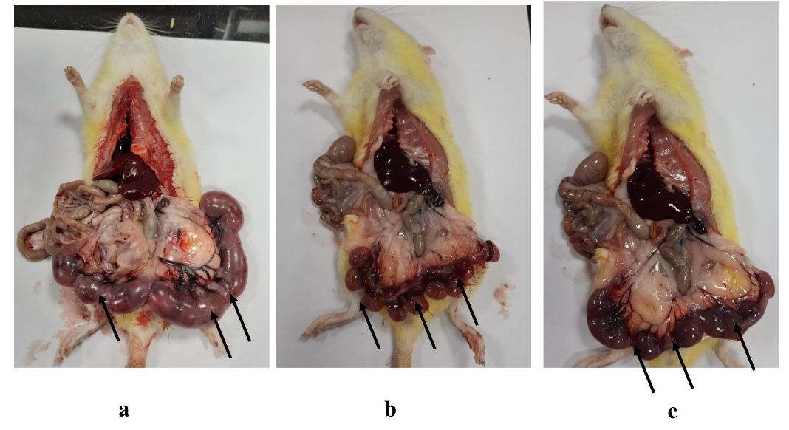
Figure 1: Uterine Examination Following Formalin Exposure (arrows)
(a) Control Group: Healthy, well-developed fetuses uniformly distributed along the uterine horns. No signs of hemorrhage or resorption.
(b) 3h Formalin Exposure: Slight discoloration of placental tissues and the presence of resorption sites. Reduced number of visible conceptuses.
(c) 6h Formalin Exposure: Multiple underdeveloped, darkened fetuses with pronounced resorption zones and abnormal uterine contents. Signs of fetal demise are evident
3.2 Visual Confirmation of Anomalies
Photographic evidence supports the recorded data, clearly illustrating the increasing severity of developmental anomalies with longer exposure durations:
- Control group (Figure 1a) showed uniformly developed fetuses with normal uterine anatomy.
- 3h exposure group (Figure 1b) displayed mild signs of fetal resorption and slightly darkened placental regions.
- 6h exposure group (Figure 1c) revealed substantial fetal resorption, placental atrophy, and presence of abnormal dark tissues, suggesting intrauterine death.
These images visually reinforce dose-dependent teratogenic impact of formalin vapors.
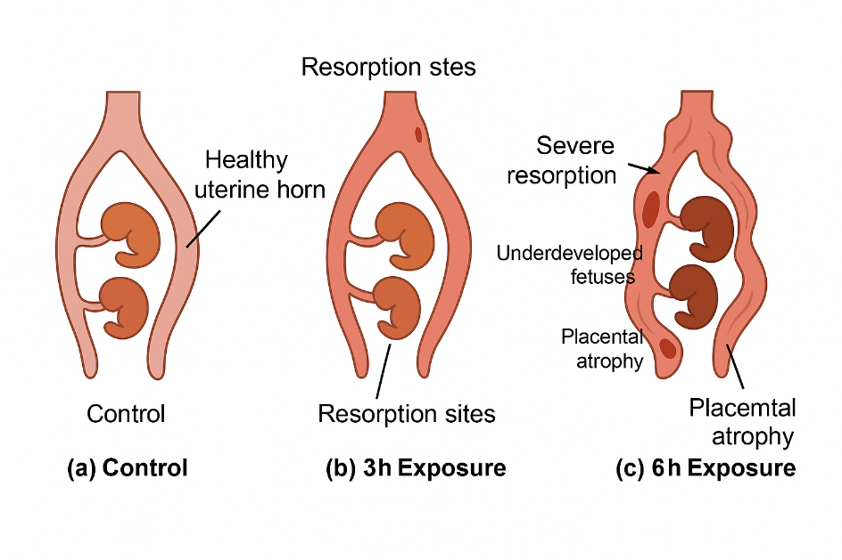
Diagram 1: Uterine exposure to formalin at different intervals
4. Discussion
The placenta is vital for fetal growth and survival, taking on critical roles of many organs before birth (Cindrova-Davies and Sferruzzi-Perri 2022; Woods, Perez-Garcia, and Hemberger 2018). Disruptions to its function can lead to impaired fetal growth, developmental issues, malformations, or stillbirth. There is growing evidence that some long-term conditions, particularly neurologic disabilities, may stem from prenatal placental injury (Baergen, Gersell, and Kraus 2018).
Formaldehyde is a well-known environmental toxicant and a potent teratogen. An aqueous solution of the formaldehyde is formalin. The exposure of formalin in female rat is showing a toxicological profile that is impairing both maternal and fetal health. The slow elimination of formaldehyde in the fetus (Katakura et al. 1993; Thrasher and Kilburn 2001) may result in higher exposure and toxicity in the developing embryo, leading to an increase in embryo mortality (Martin 1990), as well as pre- and post-implantation deaths. Additionally, hypoplasia of the uterus and ovaries (Maronpot et al. 1986) in animals suggests that the reproductive system itself might be malformed or less functional due to developmental disruptions caused by formaldehyde exposure, further contributing to the negative reproductive outcomes.
Formalin induces notable alterations in placental structure in experimental studies (Monfared 2014; Myllynen, Pasanen, and Pelkonen 2005). Some placentas were underdeveloped with no visible associated fetus were recorded in present study. These findings were in line with findings of others (Al-Kalaa et al. 2019).
The observed developmental anomalies suggest a correlation between prenatal exposure to formalin and teratogenic effects in neonatal rats. Formaldehyde's ability to quickly cross placental barriers can harm mammalian fetal tissue. (Thrasher and Kilburn 2001) The dose-dependent increase in severity of anomalies in the 6h exposure group compared to the 3h exposure group supports the hypothesis that duration and concentration of formalin exposure are critical factors (Al-Kalaa et al. 2019). A notable rise in subcutaneous hemorrhage rates in the cranial, abdominal, and thoracic regions was observed in fetuses of formalin-treated female rats (Al-Kalaa et al. 2019) similar to this we reported subcutaneous hematomas in exposed group. Formaldehyde exposure is associated with increased risks of congenital anomalies and preterm birth (Xu et al. 2017). These findings align with previous studies reporting formaldehyde-induced embryotoxicity (Thrasher and Kilburn 2001; Costa et al. 2016) and highlight the need for regulatory oversight in occupational settings.
5. Conclusion
Prenatal inhalation exposure to 10% formalin for extended periods induces developmental anomalies in rat neonates. This study underscores the importance of minimizing formalin exposure during pregnancy and encourages further research into underlying mechanisms of formalin-induced teratogenicity. The observed developmental impairments in fetuses and placentas from formalin exposure during pregnancy underscore significant teratogenic risks. The presence of placental discoloration, subcutaneous hematomas, skin abnormalities, stillborn fetuses, and underdeveloped placentas highlights the severe impact that inhalation of formalin can have on both maternal and fetal health. These findings call for urgent reassessment of occupational and environmental exposure guidelines to better protect pregnant individuals and their developing offspring from potential harm. Enhanced safety measures and regulatory standards are necessary to mitigate the risks associated with formalin exposure.
Note: *This study is a component of the author's Ph.D. research work
Disclaimer (Artificial intelligence)
Author(s) hereby declare that NO generative AI technologies such as Large Language Models (ChatGPT, COPILOT, etc.) and text-to-image generators have been used during the writing or editing of this manuscript.
References
Ahmad, H. M., Abdel-Azim, E. S., & Abdel-Aziz, R. T. (2018). Clinical, histopathologic, and viral load study after treatment of plantar warts with 10% formaldehyde soaks versus liquid nitrogen cryotherapy. Journal of the Egyptian Women’s Dermatologic Society, 15(3), 165-171. https://doi.org/10.1097/01.EWX.0000544113.64787.76.
Al-Kalaa, F. A., El Bordiny, M. M. H., Kelada, N. M., & El-Alkamy, A. M. T. A. (2019). Assessment of formalin teratogenicity on embryos of pregnant albino rats. Egyptian Journal of Histology, 43(1), 173-185. https://doi.org/10.21608/ejh.2019.15128.1145.
Arora, L. (2014). Exposure of medical fraternity to formaldehyde in anatomy and search for better alternatives to formalin. IOSR Journal of Dental and Medical Sciences, 13(10), 56-57. https://doi.org/10.9790/0853-131055657.
Baergen, R. N., Gersell, D. J., & Kraus, F. T. (2018). Diseases of the placenta. In R. J. Kurman, L. H. Ellenson, & B. M. Ronnett (Eds.), Blaustein’s Pathology of the Female Genital Tract (pp. 1-83). Springer US. https://doi.org/10.1007/978-1-4614-3165-7_19-2.
Bauer, M.K, J.E Harding, N.S Bassett, B.H Breier, M.H Oliver, B.H Gallaher, P.C Evans, S.M Woodall, & P.D Gluckman. (1998). Fetal Growth and Placental Function. Molecular and Cellular Endocrinology 140 (1–2), 115–20. https://doi.org/10.1016/S0303-7207(98)00039-2
Buchmann, K. (2022). Control of parasitic diseases in aquaculture. Parasitology, 149(14), 1985-1997. https://doi.org/10.1017/S0031182022001093.
Cindrova-Davies, T., & Sferruzzi-Perri, A. N. (2022). Human placental development and function. Seminars in Cell & Developmental Biology, 131, 66-77. https://doi.org/10.1016/j.semcdb.2022.03.039.
Costa, G. D. A., Galvão, T. C., Bacchi, A. D., Moreira, E. G., & Salles, M. J. S. (2016). Investigation of possible teratogenic effects in the offspring of mice exposed to methylphenidate during pregnancy. Reproductive BioMedicine Online, 32(2), 170-177. https://doi.org/10.1016/j.rbmo.2015.11.016.
Fabris, H. J., & Knauss, W. G. (1989). Synthetic polymer adhesives. In Comprehensive Polymer Science and Supplements (pp. 131-177). Elsevier. https://doi.org/10.1016/B978-0-08-096701-1.00208-1.
Furukawa, Satoshi, Naho Tsuji & Akihiko Sugiyama (2019). Morphology and Physiology of Rat Placenta for Toxicological Evaluation. Journal of Toxicologic Pathology 32(1), 1–17. https://doi.org/10.1293/tox.2018-0042
Guo, Y., Shi, Y., Cui, Q., Zai, X., Zhang, S., Lu, H., & Feng, G. (2023). Synthesis of urea-formaldehyde fertilizers and analysis of factors affecting these processes. Processes, 11(11), 3251. https://doi.org/10.3390/pr11113251.

Haffner M.J., Oakes, P., Demerdash, A., Yammine, K.C., Watanabe, K., Loukas, M. & Tubbs, R.S. (2015). Formaldehyde exposure and its effects during pregnancy: Recommendations for laboratory attendance based on available data. Clinical Anatomy.Nov;28(8), 972-9.
Katakura, Y., Kishi, R., Okui, T., Ikeda, T., & Miyake, H. (1993). Distribution of radioactivity from 14C-formaldehyde in pregnant mice and their fetuses. Occupational and Environmental Medicine, 50(2), 176-182. https://doi.org/10.1136/oem.50.2.176.
Malinauskiene, L., Blaziene, A., Chomiciene, A., & Isaksson, M. (2015). Formaldehyde may be found in cosmetic products even when unlabelled. Open Medicine, 10(1). https://doi.org/10.1515/med-2015-0047.
Maronpot, R. R., Miller, R. A., Clarke, W. J., Westerberg, R. B., Decker, J. R., & Moss, O. R. (1986). Toxicity of formaldehyde vapor in B6C3F1 mice exposed for 13 weeks. Toxicology, 41(3), 253-266. https://doi.org/10.1016/0300-483x(86)90180-0.
Martin, W. J. (1990). A teratology study of inhaled formaldehyde in the rat. Reproductive Toxicology, 4(3), 237-239. https://doi.org/10.1016/0890-6238(90)90065-4.
Monfared, A. L. (2014). Histomorphological and ultrastructural changes of the placenta in mice exposed to formaldehyde. Toxicology and Industrial Health, 30(2), 174-181. https://doi.org/10.1177/0748233712452603.
Myllynen, P., Pasanen, M., & Pelkonen, O. (2005). Human placenta: A human organ for developmental toxicology research and biomonitoring. Placenta, 26(5), 361-371. https://doi.org/10.1016/j.placenta.2004.09.006.
Nayak, S., Nayak, P., Saha, S., Patnaik, L., Nayak, S., Pradhan, S. P., Sharma, S. N., & Muduli, N. (2024). Formaldehyde as preservative for fish and seafood: A boon or a bane. Environmental Quality Management, 34(2), e22357. https://doi.org/10.1002/tqem.22357.
Sankaran, Srividhya & Phillipa M. Kyle (2009). “Aetiology and Pathogenesis of IUGR.” Best Practice & Research Clinical Obstetrics & Gynaecology 23(6), 765–77. https://doi.org/10.1016/j.bpobgyn.2009.05.003.
Subasi, N. T. (2020). Formaldehyde advantages and disadvantages: Usage areas and harmful effects on human beings. In M. Ince, O. K. Ince, & G. Ondrasek (Eds.), Biochemical Toxicology - Heavy Metals and Nanomaterials (pp. 1-15). IntechOpen. https://doi.org/10.5772/intechopen.89299.
Tang, X., Bai, Y., Duong, A., Smith, M. T., Li, L., & Zhang, L. (2009). Formaldehyde in China: Production, consumption, exposure levels, and health effects. Environment International, 35(8), 1210-1224. https://doi.org/10.1016/j.envint.2009.06.002.
Thrasher, J. D., & Kilburn, K. H. (2001). Embryo toxicity and teratogenicity of formaldehyde. Archives of Environmental Health: An International Journal, 56(4), 300-311. https://doi.org/10.1080/00039890109604460.
Woods, L., Perez-Garcia, V., & Hemberger, M. (2018). Regulation of placental development and its impact on fetal growth—New insights from mouse models. Frontiers in Endocrinology, 9, 570. https://doi.org/10.3389/fendo.2018.00570.
Xu, W., Zhang, W., Zhang, X., Dong, T., Zeng, H., & Fan, Q. (2017). Association between formaldehyde exposure and miscarriage in Chinese women. Medicine, 96(26), e7146. https://doi.org/10.1097/MD.0000000000007146.

