Optimizing Nutritional Regimes for Sustainable Weight Gain in House Crickets (Acheta domesticus) for Food Security
ABSTRACT
The increasing world demand for sustainable food production calls for creative solutions with least environmental costs and in addressing food security issues. Traditional sources of animal feed, like soy and fishmeal, are aggravating ecological issues, and thus the search for alternative protein sources has become unavoidable. The house cricket (Acheta domesticus ) presents a sustainable option as it is highly nutritious, efficient in feed conversion, and has low resource needs. This research assesses the impacts of five different diets, i.e., high-protein, balanced, high-carbohydrate, low-nutrient, and controlled, on the weight gain of A. domesticus The findings show that a high-protein diet maximally enhances growth, followed by balanced, high-carbohydrate diets. These results demonstrate the potential to enhance cricket nutrition for productivity improvement while using agricultural by-products as feed inputs. Through the identification of best practices in feeding, this research supports scalable and environmentally sound cricket farming, facilitating sustainable agriculture and achieving key food security goals.
Keywords: Sustainable agriculture, Food security, Alternative protein sources, Feed conversion efficiency
INTRODUCTION
The expanding global population and rising protein needs are exerting an unprecedented pressure on food production systems, demanding innovative ideas for the maximization of closed-loop food production systems, without stimulating environmental issues. The traditional system of animal farming, the main source of protein to meet the needs of the world's population, contributes excessively to the production of greenhouse gases, to the degradation of the land and water resources and to pollution of the water beds. As an example, cattle production accounts for almost 14.5% of anthropogenic greenhouse gas emissions and the production of beef is associated with 15000 liters of water consumption per kilogram of beef. (Mendez et al., 2022, Mekonnen & Hoekstra, 2012). This unsustainable model underscores the urgent need to find alternative protein sources that are both environmentally friendly and economically viable.
Insects, and specifically crickets, are on the verge of becoming an innovative solution to these issues. As a model organism, the house cricket (Acheta domesticus) has been of great interest for its sustainable production of protein potential. Crickets have high feed efficiency and consume much less water, land, and feed compared to traditional livestock (Rumpold & Schlüter, 2013). They can also be fed with agricultural waste products, subsequently lowering waste and environmental footprint. It has been established that cricket farming generates 100 times less greenhouse gas compared to cattle farming and uses less than 2 liters of water per kg of produced biomass (van Huis, 2013, van Huis et al., 2013). In addition, entomophagy holds strong cultural roots in much of the world, such as Vietnam, where insects were traditionally seen as a valuable source of nutrition (Nguyen & Vuong, 2024), providing insight that may shape both policy and consumer acceptance in other contexts.
This is in accordance with the United Nations Sustainable Development Goals (SDGs), specifically Goal 2: Zero Hunger, which highlights the importance of sustainable food production systems, and Goal 13: Combating Climate Change, which demands action to address climate change. The inclusion of crickets in food and feed systems has significant potential to enhance global food security while reducing environmental harm.
A. domesticus nutritional content is yet another important determinant of its use as an alternative protein source. Crickets contain high levels of protein, essential amino acids, and micronutrients (van Huis, 2013; Rumpold & Schlüter, 2013). They are adaptable for human consumption and animal feed. Their development and growth are, however, highly dependent on the nutrient content of their diet. Earlier research has shown that crickets are enhanced in growth, nutritional status, and fertility by high-protein diets ( Oonincx et al., 2015, Bawa et al., 2020 ). These developments notwithstanding, there is still a need to further develop feed formulations to achieve the highest possible productivity and scalability of cricket farming.
This investigation scrutinizes the effect of different nutritional regimes on the development of A. domesticus with a focus on weight gain as the quantifiable measure. Through the determination of ideal feeding methods, this research hopes to enhance the dissemination of cricket farming as a sustainable means towards global food security and environmental concerns..
MATERIALS AND METHODS
Insect farming:
Test insects (Acheta domesticus) were collected from natural habitats using Insect clamp (CALANDIS Clamp; Model Number CLTIN57021570) and then transferred to rearing containers under controlled conditions to minimize stress and mortality. The crickets were reared in a BOD incubator set at 32 °C, 60% relative humidity, and a 12:12 light-dark cycle to provide optimal growth conditions. The diet consisted of sterilized whole wheat grains and legumes, prepared by heating at 60°C for 5 hours to remove contaminants and coarsely ground using a using a grinder (Havells Klassic 1000 watts). The diet was supplemented with freshly cut vegetables and fruits, such as carrots, gourds, apples, and oranges, chopped into pieces of approximately 1–2 cm to provide additional nutrients and water was provided using water-soaked sponges to prevent drowning. Food and water sources were replaced every 48 hours to maintain hygiene and reduce microbial contamination.
Adult crickets were transferred into large plastic containers measuring 45 × 34 × 25 cm (L × B × H), the lids of which were covered with fine-mesh gauze of approximately 0.5 mm mesh size to facilitate ventilation while preventing the escape of nymphs. Inside each container, a small, shallow tray measuring approximately 10×8×4 cm was placed and filled with moistened vermiculite to serve as an oviposition substrate. After 24–48 hours, the tray containing freshly laid eggs was carefully removed to prevent cannibalism by the adults and transferred to a clean container of the dimensions (45 × 34 × 25 cm) for incubation under controlled environmental conditions. The eggs were incubated at 30–32°C and 70–80 % relative humidity, and hatching was observed within 10–14 days. The newly hatched nymphs were carefully separated from the substrate using a soft brush and transferred to experimental rearing containers.
Experimental design:
The study was conducted at the Entomology Laboratory, Department of Agriculture, IIAST, Integral University, Lucknow to evaluate the impact of different nutritional regimes on the weight gain of house crickets ( A. domesticus). The experiment was conducted using a complete randomized design (CRD) with five diets, including a control diet and three replications. Table 1 shows the details of the different diets : high-protein, balanced, high-carbohydrate, low-nutrient, and control diet.
Table 1. Different dietary treatments used in the study.
Sl. No. | Diet group | Source of protein | Source of carbohydrates | Source of fat | Other components
1 | High protein diet (HPD) | 40% soybean meal | 40% ground cereals (20% wheat + 10% barley + 10% oats), 20% cornmeal | 20% vegetable oils (10% soybean oil + 10% sunflower oil)
2 | Balanced diet (AB) | 30% soybean meal | 50% ground cereals (25% wheat + 15% barley + 10% oats) | 20% vegetable oils (10% soybean oil + 10% sunflower oil)
3 | High Carbohydrate Diet (HCD) | 20% soy flour, 20% pea protein isolate | 70% ground cereals (25% wheat + 15% barley + 10% oats + 20% cornmeal) | 10% vegetable oils (5% soybean oil + 5% sunflower oil)
4 | Low-nutrient diet (LND) | 10% soy flour, 10% pea protein isolate | 50% ground cereals (25% wheat + 15% barley + 10% oats + 40% cornmeal) | - | 40% indigestible fiber (microcrystalline cellulose)
5 | Control regime | Standard commercial cricket feed with a balanced nutritional composition

Experimental procedure:

Each dietary treatment was assigned to 50 Acheta domesticus nymphs of uniform size and age (larval stage), which were fed a specific food formula for a period of six weeks. Each treatment group was housed in a separate plastic container measuring 45.8 × 34 × 26 cm, fitted with cardboard egg cartons to provide shelter and climbing surfaces. The containers were maintained at a temperature of 27°C to 30°C, under a 12-hour light/12-hour dark photoperiod. Nymphs in each treatment were fed ad libitum, with uninterrupted access to dry food placed in shallow plastic dishes and water provided via water-soaked sponges placed in small trays. Both food and water sources were monitored and replenished daily to ensure a continuous and hygienic supply across all treatment groups. Food consumption was recorded daily to ensure consistency between treatments. The weight of the crickets was measured once per week using a high-precision Atom electronic scale.

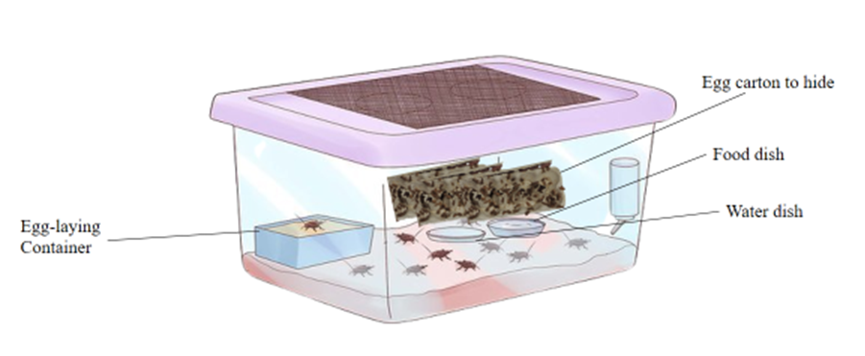

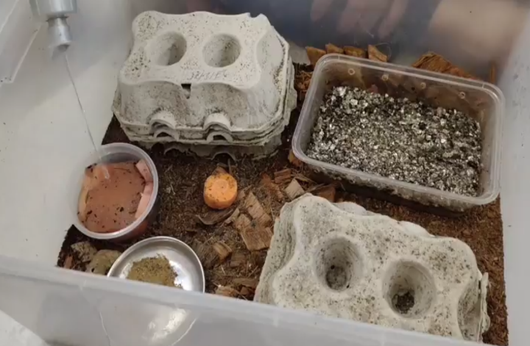

Fig. 1 Demographic representation of the experimental unit
Data analysis:
Data were subjected to analysis of variance (ANOVA) to determine the significance of differences in weight gain between the different dietary treatments with statistical significance determined at p < 0.1.
RESULTS
Table 1: Average weight gain (g) of Acheta domesticus according to different diets.
Week | HPD | BD | HCD | LND | Control
1 | 0.10 ± 0.02 | 0.08 ± 0.01 | 0.07 ± 0.01 | 0.04 ± 0.01 | 0.09 ± 0.02
2 | 0.21 ± 0.03 | 0.18 ± 0.02 | 0.15 ± 0.02 | 0.08 ± 0.01 | 0.20 ± 0.03
3 | 0.33 ± 0.04 | 0.28 ± 0.03 | 0.22 ± 0.02 | 0.12 ± 0.02 | 0.31 ± 0.03
4 | 0.45 ± 0.05 | 0.37 ± 0.04 | 0.28 ± 0.03 | 0.15 ± 0.02 | 0.40 ± 0.04
5 | 0.57 ± 0.06 | 0.46 ± 0.04 | 0.33 ± 0.03 | 0.18 ± 0.02 | 0.50 ± 0.05
6 | 0.70 ± 0.07 | 0.55 ± 0.05 | 0.38 ± 0.04 | 0.20 ± 0.02 | 0.60 ± 0.06
Mean | 0.525 | 0.471 | 0.395 | 0.21 | 0.405
SD | 0.22 | 0.18 | 0.12 | 0.06 | 0.19
SEM | 0.0917 | 0.0716 | 0.0472 | 0.0248 | 0.0773
Coefficient | 0.05 | 0.03 | -0.01 | -0.04 | -0.01
p-value | 0.058 | 0.121 | 0.372 | - | 0.325

Descriptive statistics show differences in weight gain between the diets during a 6-week duration. The high-protein diet (HPD) had the greatest mean weight gain of 0.525 g, pointing to the significant impact of a diet high in protein on growth. Conversely, the balanced diet (BD) had moderate and steady weight gain, though with some fluctuation, indicating steady but less significant effects than the HPD. The high-carbohydrate diets yielded reduced growth, demonstrating the marginal value of carbohydrates by themselves. The low weight gain on the nutrient-poor diet (NPD) demonstrated the paramount role of a diet that is full of nutrients. The control diet provided a reference point, suggesting good but not optimal growth in comparison to the high-protein and balanced foods.
Regression analysis, with control diet as the standard, also shows that time made a significant contribution to the gain in weight, by 0.062 g per week. The treatment of high-protein diet had the strongest effect, increasing by 0.05 g per week relative to the control. The balanced diet (BD) treatment gave medium effects, increasing each week by 0.03 g over the control, whereas the high-carbohydrate diet (HCD) treatment was a shade worse, decreasing weight gain by 0.01 g per week over the control. The low-nutrient diet (LND) treatment was the most negative and reduced each week's weight gain by 0.04 g over the control. Mean weight gains between the dietary treatments were compared with one-way ANOVA. Statistically significant differences were established at p < 0.1, and Tukey's HSD was applied for post-hoc comparisons. The high-protein diet (HPD) had significantly greater weight gain than the low-nutrient diet (LND) (p = 0.058), but no other pairwise comparisons were statistically significant.
DISCUSSION
The present study highlights the crucial role of diet composition in the growth and development of A. domesticus, with particular emphasis on the superior performance of high protein diets (HPD). The weight gain observed with HPD is consistent with the findings of Oonincx et al. (2015), who reported that high protein diets improve protein, fat, and mineral content in crickets, contributing to superior growth and nutritional quality. Furthermore, Duffield et al. (2020) discovered that macronutrient consumption, especially protein, has a strong impact on life history traits in crickets regardless of environmental stressors like simulated infection threats, further supporting the central role of diet composition in insect development.
Our findings show that a high-carbohydrate diet (HCD) supports moderate growth, while a low-nutrient diet (NPD) is related to extreme weight loss. These findings are in accordance with Miech (2018), which reported that high-protein diets, such as those with cassava tops, yielded better growth performance in field crickets than diets with reduced protein. Similarly, Ashiq et al. (2024) emphasize the nutritional value of protein-enriched insect-based foods for healthy insect growth. Raubenheimer and Simpson (2020) also support this postulation by showing that an imbalance of macronutrients, especially a protein deficiency, adversely affects cricket development and fertility.
From a sustainability perspective, Lundy and Parrella (2017) highlighted the potential of using agricultural by-products as animal feed, which helps maintain growth rates while reducing environmental impact. These results provide practical guidance for profitable and environmentally friendly cricket farming. Furthermore, the studies by Belluco et al. (2013) and Hartwell et al. (2020) reinforce the importance of optimized feeding strategies to ensure sustainable farming practices, including improved feed-to-protein conversion ratios.
Finally, micronutrient supplementation has also been shown to be a determining factor. van Raamsdonk et al. (2017) demonstrated that adding vitamins and minerals to diets improves growth and reduces mortality, highlighting the importance of a holistic approach to optimizing rearing conditions. Taken together, these results confirm the importance of a nutrient-rich diet to maximize the growth, health, and sustainability of cricket rearing systems.
CONCLUSION
The study highlights the potential of breeding Acheta domesticus as a sustainable solution to global food security challenges. A balanced, protein-rich diet significantly promotes cricket growth, making cricket farming an environmentally friendly alternative to traditional farming, requiring fewer resources such as land, water, and feed. Using agricultural by-products in cricket feed also promotes sustainability and resource efficiency, contributing to a circular economy.
Future research will focus on improving feed formulas, optimizing productivity, and investigating the environmental impacts of cricket farming throughout its life cycle. Supportive measures, including incentives for sustainable practices and the promotion of alternative proteins, can encourage the adoption of cricket farming as part of broader strategies aimed at achieving the United Nations Sustainable Development Goals, particularly those related to food security and climate action.
Disclaimer (Artificial intelligence)
Author(s) hereby declare that generative AI technologies such as Large Language Models, etc. have been used during the writing or editing of manuscripts. This explanation will include the name, version, model, and source of the generative AI technology and as well as all input prompts provided to the generative AI technology
Details of the AI usage are given below:
1. ChatGPT was used in editing of the introduction

REFERENCES
- Ashiq, A., Bodlah, M. A., Bodlah, I., Gul-E-Fareen, A., & Tahir, M. B. (2024). Insect-Based Value-Added Products: Current Scenario and Future Scope. In Insect Diversity and Ecosystem Services (pp. 79-145). Apple Academic Press.
- Bawa, M., Songsermpong, S., Kaewtapee, C., & Chanput, W. (2020). Effect of diet on the growth performance, feed conversion, and nutrient content of the house cricket. Journal of Insect Science, 20(2), 10.
- Belluco, S., Losasso, C., Maggioletti, M., Alonzi, C. C., Paoletti, M. G., & Ricci, A. (2013). Edible insects in a food safety and nutritional perspective: a critical review. Comprehensive reviews in food science and food safety, 12(3), 296-313.
- Duffield, K. R., Hampton, K. J., Houslay, T. M., Rapkin, J., Hunt, J., Sadd, B. M., & Sakaluk, S. K. (2020). Macronutrient intake and simulated infection threat independently affect life history traits of male decorated crickets. Ecology and Evolution, 10(20), 11766–11778.
- Hartwell, H., Bray, J., Lavrushkina, N., Rodrigues, V., Saulais, L., Giboreau, A., Perez-Cueto, F. J. A., Monteleone, E., Depezay, L., & Appleton, K. M. (2020). Increasing vegetable consumption out-of-home: VeggiEAT and Veg+ projects. Nutrition Bulletin, 45(4), 424–431. https://doi.org/10.1111/nbu.12464
- Lundy, M. E., & Parrella, M. P. (2015). Crickets are not a free lunch: Protein capture from evolving secondary organic streams via high-density populations of Acheta domesticus. PLOS ONE, 10(4), e0118785. https://doi.org/10.1371/journal.pone.0118785
- Mekonnen, M. M., & Hoekstra, A. Y. (2012). A global assessment of the water footprint of farm animal products. Ecosystems, 15(3), 401–415. https://doi.org/10.1007/s10021-011-9517-8
- Mendez Benitez, K. N. (2022). The meat industry: A link between global pandemics, climate change, and economic crisis. Revista Jurídica de la Universidad de Puerto Rico, 91, 47.
- Miech, P. (2018). Cricket farming: An alternative for producing food and feed in Cambodia (Doctoral dissertation, Swedish University of Agricultural Sciences). Retrieved from https://pub.epsilon.slu.se/15388/
- Nguyen, M. H., & Vuong, Q. H. (2024). Nutrition from insects: An age-old Vietnamese view versus the modern world's perspective. SSRN. https://doi.org/10.2139/ssrn.4913393
- Oonincx, D. G., Van Broekhoven, S., Van Huis, A., & Van Loon, J. J. (2015). Feed conversion, survival and development, and composition of four insect species on diets composed of food by-products. PloS one, 10(12), e0144601.
- Raubenheimer, D., & Simpson, S. J. (2020). Nutritional Ecology and Human. Integrative and Functional Medical Nutrition Therapy: Principles and Practices, 40(4.2), 39.
- Rumpold, B. A., & Schlüter, O. K. (2013). Nutritional composition and safety aspects of edible insects. Molecular Nutrition & Food Research, 57(5), 802–823. https://doi.org/10.1002/mnfr.201200735
- van Huis, A. (2013). Potential of insects as food and feed in assuring food security. Annual Review of Entomology, 58, 563–583. https://doi.org/10.1146/annurev-ento-120811-153704
- van Huis, A., van Itterbeeck, J., Klunder, H., Mertens, E., Halloran, A., Muir, G., & Vantomme, P. (2013). Edible insects: Future prospects for food and feed security (FAO Forestry Paper No. 171). Food and Agriculture Organization of the United Nations. https://www.fao.org/3/i3253e/i3253e.pdf
- van Raamsdonk, L. W. D., van der Fels-Klerx, H. J., & de Jong, J. (2017). New feed ingredients: the insect opportunity. Food Additives & Contaminants: Part A, 34(8), 1384–1397. https://doi.org/10.1080/19440049.2017.1306883

