**Original Research Article**

**Transforming Abandoned Sand Pits into Sustainable Aquaculture Ponds in Purba Medinipur, West Bengal, India**

**ABSTRACT**

The present study was based on aquaculture possibilities in abandoned sand pits through scientific pond preparation and management. The research work was conducted at Depal, Purba Medinipur, West Bengal. In the district of Purba Medinipur sand mining activity were primarily carried out for the purpose of house construction and for land filling. In this district about 100 ha abandoned sand mining pits are present. Generally, ponds are manmade impoundments mainly used for water harvesting and for aquaculture. Pond preparation is the basic and utmost important step in freshwater aquaculture to enhance the fish production. After sand mining activity abandoned low laying pits are filled by rain water and creates pond environment. Following APHA (American Public Health Association) guideline, the physico-chemical parameters of soil and water were analysed every 30 days interval to ascertain how the parameters change with change with the season. Here scientific managements and higher percentage of organic manures like cow dung and mohua oil cakes were applied to increase the water holding capacity and fish production of the pond. This treatment helps to increase the average values of NPK from 16.52 mg/100gm, 1.93 mg/100gm and 1.50 mg/100gm to 28.69 mg/100gm, 5.61 mg/100gm and 11.92 mg/100gm respectively. Organic Carbon (%) and Specific Conductivity (µS/cm) was also increased. Lime was also applied in higher amount to correct the pH of both soil and water and to kill parasites. Soil pH and Free Calcium Carbonate (%) was corrected and become ideal for aquaculture.

**Key words:** Abandoned sand pits, aquaculture, pond preparation, pond management, scientific method, fish production

**INTRODUCTION**

India has huge potentiality for aquaculture development as it is blessed with vast and diverse inland fisheries resources comprising 0.28 million km of rivers and canal, 1.2 million ha of flood plain lakes, 2.45 million ha of ponds and tanks and 3.15 million ha of reservoirs. These are the backbone of our country in fisheries sector, making India 2nd largest producer in the world (Department of Fisheries Govt. of India, 2025). Fish is an essential food for millions of people in developing countries and a vital source of animal protein, vitamins, and micronutrients. It is particularly important for providing protein to economically disadvantaged populations. Water serves as the physical foundation for fish to perform their life functions, including feeding, swimming, breeding, digestion, and excretion. Fish are also significant cash crop and an affordable source of protein in many parts of the world (Bronmark and Hansson, 2005).

The inland fisheries in India include both the capture and culture of fisheries. Capture fisheries have been the major source of inland fish production till mid-eighties. But, the fish production from natural waters like rivers, lakes, canals etc. followed a declining trend, primarily due to proliferation of water control structure, indiscriminate fishing and habitat degradation (Katiha, 2000). The depleting resources, energy crisis and resultant high cost of fishing etc. have leading to the increased realization of the potential and versatility of aquaculture as a viable and cost effective alternative to capture fisheries. At the same time rapid rise in urbanization and construction of large-scale infrastructure projects are driving increasing demands for construction materials globally. United Nations Environment Programme estimated that between 32 and 50 billion tonnes of sand and gravel are extracted globally each year with demand increasing, especially in developing countries (Schandl et al., 2018). Environmental issues, namely ecological damage resulting from adverse effects in the form of the quantity of land harmed after mining operations are conducted (Sari and Buchori, 2015; Rizqan et al., 2016; Gavriletea, 2017). In order to decide on the optimum use of reclaimed mining sites and if these artificial water bodies are suitable for commercial or recreational aquaculture, public input is essential (Roberts and Veiga, 2001).

One of the most significant steps in establishing a habitat that is ideal form IMCs (Indian Major Carps) is pond preparation. It entails giving careful thought to elements including liming, water source, soil quality, and pond design. In addition to increase IMC growth and survival, properly prepared pond reduces disease risk and promotes water quality (Suresh et al., 2014). The pH, water retention, texture, total organic carbon, available nitrogen, available phosphorous and other aspects of the soil all affect pond production. There are lime is used to clean the pond bottom release soil-bound phosphorous into the water, mineralize organic materials, and change the pH of the soil. The pH ideal range for a carp pond is 6.5 to 8.5. Lime products including quicklime, agricultural lime, can be used in modest quantities, typically 200-500 kg/ ha (Pandey, 2010; Kumar, 2015). Pond fertilization rate varies with temperature, pond nutrient composition and water quality. Fertilization and manuring should be carried out every month to increase the productivity of the pond. The primary considerations for choosing a pond are that the soil should retain water, that there should be a sufficient supply of high quality water, and that the pond should not be located in an area that is prone to flooding. But here the abandoned ponds after sand mining are converted to cultivable ponds to use them for aquaculture.

**MATERIALS AND METHODS**

**Site selection:**

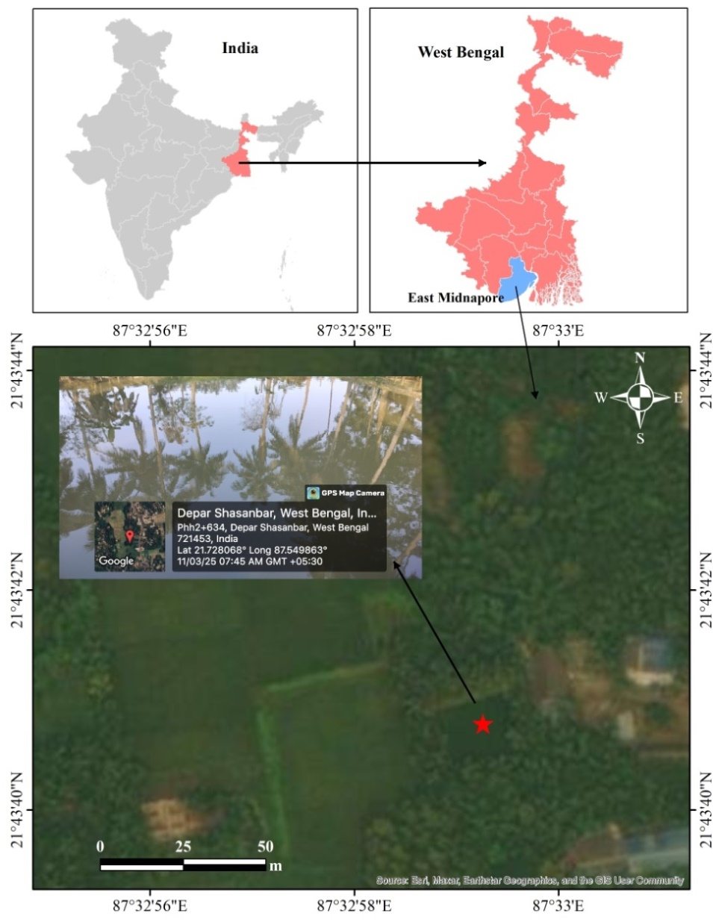The site selection is one of the most important factors that determine the success of the fish farming. Before the selection of the pond, the water holding capacity and fertility of the soil was considered to be the most crucial step in this regard as these factors influence the response to the organic and inorganic fertilization in the farming ponds. As per report by the Telegraph newspaper dated 05.1.2021 in West Bengal there are about 900 sand mines. The sand mines, are locally called as bali khadan. The bali khadan areas in Purba Medinipur district around 100 hectares. The major areas are CD-Block of Ramnagar I (about 25.08 hectare), Ramnagar - II (about 62.71 hectare), Egra - I (about 12.54 hectare) and Haldia (about 12.54 hectare). These Bali khadans are under the clutches private ownership but mining activities are regulated by the State govt. These areas after sand mining the abandoned lands are filled by rainwater and converted into ponds or Dighi. Present investigation was carried out in abandoned sand pit or bali khadan (Lat- 21.728068o and Long- 87.549863o) located at Depal under community development block of Ramnagar – II, Purba Medinipur. Total area of the experimental pond was approx. 500 m2. Fig 1: Study site

**Soil and water quality assessment:**

The abandoned sand mining pond waters was unproductive as the nutrient load was poor, unsuitable for planktonic production. Therefore, the soil and water parameters of the abandoned sand mining ponds were transformed into productive ones through the periodic application of organic manures (cow dung and mohua oil cake) and continuous quality assessment. The physico-chemical characteristics of soil and water parameters were analysed in every 30 days interval to determine the variations of parameter with the change of season until the end of the experiment, following the APHA guidelines.

**RESULTS AND DISCUSSION**

**Pond bottom management:**

Most of the abandoned sand mining ponds remain unused and few of them are used as cultivable ponds, but scientific management are not there. So, if we scientifically manage them and put some efforts, covert the abandoned sand mining ponds into highly profitable cultivable fish ponds. In this study the selected pond was leased for two years. At first the sand mining pond water was completely dried up. After completely draining the pond water, bottom soil samples were collected. The organic carbon, NPK and percentage of soil particles were tested in the laboratory (Table 1). As these ponds are located in the areas where major particle of the soil is sand. So, naturally water holding capacity of the pond is poor. Cow dung was applied @100kg (in two equal instalments) to increase the water holding capacity of the pond. Then Mohua Oil Cake @ 100kg and CuSO4 @ 500 gm (in two equal instalments) were applied to kill the parasites, molluscs and weed fish. Lime (Cao) was applied @ 30kg (in two equal instalments) to increase the pH and make the pond bottom suitable for fish culture. After that further soil samples were tested and parameters were recorded (Table 1). The soil texture (percentage of clay, silt and sand) was tested recorded both before and after the application of organic manures (Table 2).

**Table 1: Soil parameters before and after application of organic manures:**

|  |  |  |  |  |  |  |
| --- | --- | --- | --- | --- | --- | --- |
| **Soil parameters** | **Results** | | | | | |
| **Sample -1** | | **Sample-2** | | **Sample - 3** | |
| **Before** | **After** | **Before** | **After** | **Before** | **After** |
| Soil pH | 7.36 | 7.59 | 7.0 | 7.61 | 6.96 | 7.37 |
| Organic Carbon (%) | 0.03 | 0.85 | 0.06 | 1.10 | 0.09 | 1.20 |
| Available Nitrogen (mg/100gm) | 30.24 | 48.21 | 11.27 | 18.15 | 8.05 | 19.72 |
| Available Phosphate (mg/100gm) | 1.46 | 3.34 | 2.9 | 6.10 | 1.62 | 7.40 |
| Available Potassium (mg/100gm) | 1.14 | 11.92 | 2.27 | 12.39 | 1.09 | 11.46 |
| Free Calcium Carbonate (%) | 4 | 4.3 | 5 | 4.80 | 2.5 | 3.90 |
| Specific Conductivity (µS/cm) | 448 | 452 | 436 | 431 | 427 | 443 |

**Table 2: Soil texture before and after application of organic manures:**

|  |  |  |  |  |  |  |
| --- | --- | --- | --- | --- | --- | --- |
| **Soil texture** | **Results** | | | | | |
| **Sample -1** | | **Sample -2** | | **Sample -3** | |
| **Before** | **After** | **Before** | **After** | **Before** | **After** |
| Clay (%) | 1.5 | 5.8 | 2.0 | 5.5 | 1.0 | 4.0 |
| Silt (%) | 5.5 | 9.2 | 6.0 | 8.5 | 4.0 | 9.0 |
| Sand (%) | 93.0 | 85.0 | 92.0 | 86.0 | 94.0 | 87.0 |

**Water quality management:**

**Table 3: Comparison of water quality parameters between untreated and treated water**

|  |  |  |
| --- | --- | --- |
| **Experimental Details** | **Results** | |
| **Untreated (before)** | **Treated (after)** |
| pH | 7.24 | 7.15 |
| Temp (oC ) | 29.2 | 29.9 |
| Free O2 (mg/lit) | 4.3 | 5.86 |
| Free CO2 (mg/lit) | 5.55 | 4.02 |
| Alkalinity(mg/lit) | 110 | 90 |
| Total ammonia (mg/lit) | 0.48 | 0.04 |
| Nitrite (mg/lit) | 0.04 | 0.02 |

In order to get maximum production from aquaculture pond both the pond water and soil should be slightly alkaline to neutral. One of the most elements that significantly influence pond production is the soil’s hydrogen ion concentration. Similar kind of research was conducted by Mandal et.al. (2008), they found that the soil from China clay mines had a pH range of 7.5 to 9.5, which was advantageous for IMC culture. According to Patra and Roy (1988) and Patra (1993) the optimum pH range should be 7.0 to 8.5 and low pH has adverse effects on the growth and production of fish. It affects the availability of the nutrients in the soil-water interface in addition to bacterial activity (Radheyshyam, 1988). Before treatment the soil pH was neutral to slide acidic thus lime was applied @ 30 kg to increase the pH and make the pond more familiar for culture (Fig 2).

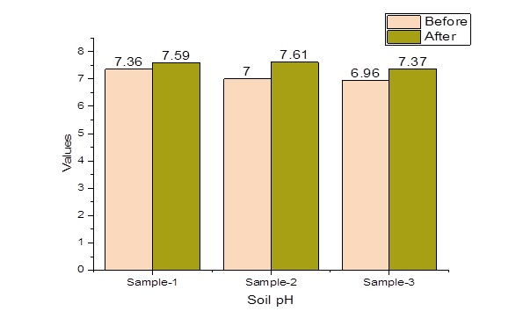

Fig 2: Comparison of soil pH before and after treatment

Organic carbon is considered as one of the most significant parameter which can influence the productivity of aquatic ecosystem. Obtained organic carbon values were coincides with the findings of Borkar (2015) in Katol Taluka District of Nagpur were 0.3% to 1.5%. Dutta (2011) documented the organic carbon value of 0.32 % in the sediment of Namsang stream of Arunachal Pradesh, India. The pond sediment below 0.5% are unproductive, 0.5 to 1.5 % are productive and above 2.5% are not suitable for fish culture. After the treatment of organic manures the value of soil Organic Carbon increases significantly and become suitable for fish culture (Fig 3).

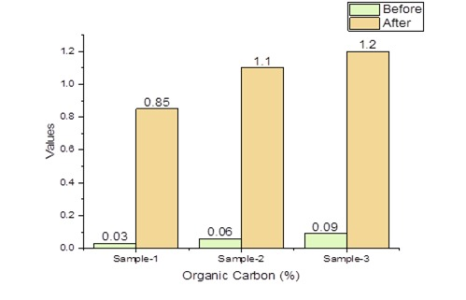

Fig 3: Comparison of soil Organic Carbon (%) before and after treatment

The optimal growth and disease resistance of fish culture pond depend upon the availability of certain elements such as Nitrogen, Phosphorus, Potassium, Calcium and Magnesium. Phosphorus and nitrogen are very important for algal growth. Phosphorus is the major nutrient for the increased level of phytoplankton in freshwater pond (Adhikari et al., 2017). The NPK values were significantly increases after the treatment of organic manures and becoming suitable for fish culture (Fig 4). The free Calcium Carbonate (%) and Specific Conductivity (Micro Siemens/cm) was relatively ideal for culture purpose and after treatment the values are more or less stable and ideal for fish culture (Fig 5 and Fig 6 respectively).

The texture of the soil is determined by the characteristics and composition of the parent materials that forms it. The exact proportion of various size fraction of the soil has a significant impact on a number of physico-chemical parameters that affect fish pond fertility. Optimum pond soil is neither too clayey to retain all of the nutrients absorbed in it nor too sandy to permit nutrient leakage. Applying large amount of organic manures is essential to prevent water seepage while building a pond on sandy soil (Adhikari et al., 2017). In this experiment after application of organic manures the percentage of clay, silt and sand considerably changes and the water holding capacity of the abandoned sand mining pond was greatly increased (Fig 7).



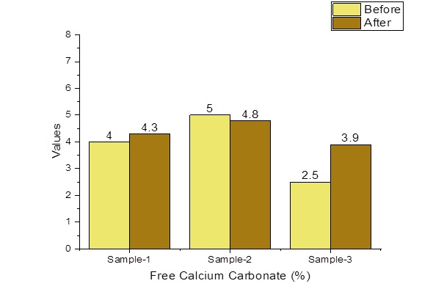

Fig 5: Comparison of free Calcium Carbonate (%) before and after treatment

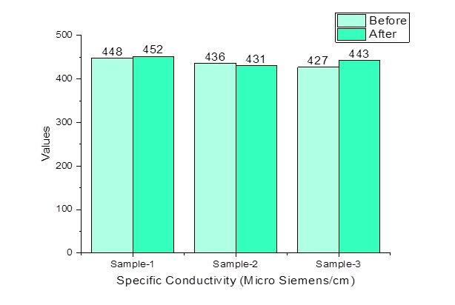

Fig 6: Comparison of Specific Conductivity (Micro Siemens/cm) before and after treatment



**CONCLUSION**

The most affordable and readily digested protein is fish, which can be farmed artificially. Maintaining ideal water quality with suitable water depth is the goal of this investigation in order to achieve the highest possible yield in the abandoned sand pit ponds. Around the world, aquaculture is considered as a lucrative business endeavour associated with agriculture. With varying degrees of success, Indian major carp and exotic carp rearing and breeding are practiced in India. Successful pond culture operation depends on maintaining a healthy aquatic environment and producing enough fish food organisms in the pond. The present study was taken up to convert over 100 ha of abandoned sand pit pond into cultivable aquaculture ponds in the district of Purba Medinipur. Thus initiative was taken in one experimental pond (approx. 500 m2) to prepare it and manage scientifically and make it suitable for fish culture. Results obtained in this investigation were quite satisfactory for fulfilling the objectives of the study. After successful transformation of the abandoned sand pits into aquaculture ponds we can produce considerable amounts of fish in near future to meet the local demands. At the same time employment opportunity for local people can be created significantly. The local villagers may adopt this culture technique as a livelihood. A new model may be established for the aquaculture sector in these abandoned sand mining ponds or “Bali Khadan”.

**DISCLAIMER (ARTIFICIAL INTELLIGENCE)**

Author(s) hereby declare that NO generative AI technologies such as Large Language Models (ChatGPT, COPILOT, etc.) and text- to-image generators have been used during writing or editing of this manuscript.

Competing interests

Authors have declared that no competing interests exist.

**REFERENCES:**

Borkar, A. D. (2015). Studies on Some Physico-chemical Parameters of Soil Samples in Katol Taluka District Nagpur (MS), India. *Research Journal of Agriculture and Forestry Science.,* Vol. 3(1), 16-18.

Brönmark, C. & Hansson, L. A.(2005). *The Biology of Lakes and Ponds*, 2nd ed. Oxford, UK: Oxford University Press, pp285.

Department of Fisheries, Ministry of Fisheries, Animal Husbandry & Dairying (2025). [*https://dof.gov.in/inland-fisheries*](https://dof.gov.in/inland-fisheries)*.*

Dutta, R.(2011) Hydrobiology and fishery potential of namsang (Chatju) stream in Arunachal Pradesh. Gauhati University, Guwahati, Assam, India. Ph.D. Thesis; 2011.

Gavriletea, M.D. (2017). Environmental impacts of sand exploitation: analysis of sand market. *Sustainability* , 9(7): 118, doi: 10.3390/su9071118.

Katiha, P. K. (2000). Freshwater aquaculture in India: Status, potential and constraints. In: Proceedings of the Aquaculture Development in India: Problems and Prospects Workshop (eds M. Krishnan & P.S. Birthal), pp 98–108. National Centre for Agricultural Economics and Policy Research, New Delhi.

Mandal, B., Patra, B. C. & Chand, B. K. (2008). Possibilities of sustainable aquaculture practice in abandoned china clay mines of West Bengal, India. *Research Journal of Fisheries and Hydrobiology* (INSI net Publication), 3(2): 36-40.

Pandey, A. K. (2010). Handbook on Fisheries Statistics. ICAR National Bureau of Fish Genetic Resources (NBFGR); c2010.

Patra, B.C. & Roy, A. K. (1988). Observations on the influence of three organic manures on the growth and yield of Indian major carps under pond culture. *J. Inland. Fish. Soc. India*. 20 (2): 61 – 63.

Patra, B.C. (1993). A report on the effect of organic manures and supplementary feeding on the production of Indian major carps in rural areas of West Bengal. *J. Freshwat. Biol*. 5(4): 347– 357.

Rizqan, A., Mahyudin, I., Rahman, M. & Hadie, J. (2016). Status of river water quality around the sand mining area in Batang Alai River, Wawai Village, South Kalimantan. *EnviroScienteae* ,12 (1): 1-6.

Roberts, S. A. & Veiga, M. M. (2001). Planning for closure in the post industrial Age: A proposed framework for building more sustainable mining communities. Proceedings of the 24th Annual B.C. Mine Reclamation Symposium, 24–27 September 2001, Campbell River, BC.

Sari, D. P. & Buchori, I. (2015). The effectiveness of the post tin mining reclamation program in Merawang District, Bangka Regency. *Journal of Urban Area Development* ,11(3): 299-312.

Schandl, H., Fischer-Kowalski, M., West, J., Giljum, S., Dittrich, M., Eisenmenger, N., Geschke, A., Lieber, M., Wieland, H., Schaffartzik, A., Krausmann, F., Gierlinger, S., Hosking, K., Lenzen, M., Tanikawa, H., Miatto, A. & Fishman, T. (2018). Global material flows and resource productivity forty years of evidence. *J. Ind. Ecol*., 22 (4) (2018), pp. 827-838.

Suresh, A., Sundaray, J. K. & Rout, P. (2014). Pond Preparation and Its Importance in Aquaculture. *J Fish* , 2(3):125-132.