STUDY ON FEED MANAGEMENT AND GROWTH PERFORMANCE OF MAGUR (Clarias batrachus) FRY
ABSTRACT
Clariasbatrachus, widely known as the Asian walking catfish, is a commercially valuable freshwater species in Asia. However, the success of such ventures depends largely on the application of proper culture and management practices.The present studyevaluated different protein level on the growth performance of C. batrachusseed over a period of 21 days. Feed ingredients including fish meal, yeast, egg yolk, wheat bran and vitamin-mineral premix were formulated using pearson square method to produce three diets; Diet A (30% crude protein), Diet
B (35% crude protein), and Diet C (40% crude protein). Fish seeds fed Diet A reported 25.4 mm length and 125.6 mg weight; seed fed Diet B reached 27.21 mm length and 137.7 mg weight: while Diet C displayed 34.66 mm length and 174.1 mg weight. Statistical analysis reported significant difference in growth performance among the three diets. The result suggested Diet C containing 40% crude protein had the most pronounced positive effect on seed growth and can be recommended for improved production outcomes.
Keywords:Feedingredients,PearsonSquaremethod,Growthperformance,Length-Weight,ANOVA.
INTRODUCTION
Aquaculture has emerged as a critical component in meeting the global demand for protein-rich food, with fish farming playing a vital role in enhancing food security and rural livelihoods (FAO, 2022). Among freshwater species, Clariasbatrachus, commonly known as Magur, is widely cultivated across South and Southeast Asia due to its high market value, fast growth rate, and resistance to harsh environmental conditions (Rahman et al., 2018). This species is also known for its high protein content and medicinal value, which makes it a preferred choice among consumers (Kumar et al., 2022).A common problem faced by fish farmers is the need to strike a balance between rapid fish growth and optimal use of the feed provided. The growth of fish biomass in intensive and semi-intensive culture systems depends on a variety of factors, of which feeding frequency is an important factor for fish survival and growth.Feed management is a decisive factor influencing growth performance, production efficiency, and overall profitability in aquaculture (Tacon & Metian, 2015). Feed cost reduction can be a key factor for aquaculture success where the economic viability of the aquaculture operation depends on feed and feeding frequency.In the culture of C. batrachus, effective feeding strategies—including feed type, frequency, and ration size—play a crucial role in optimizing growth and minimizing feed waste. Improper feed management can lead to suboptimal growth, increased production costs, and environmental degradation due to nutrient loading (Boyd et al., 2022).Several studies have evaluated the growth response of C. batrachus under different feeding regimes and feed formulations. For instance, the use of formulated pelleted feeds with balanced protein and lipid content has been shown to significantly enhance weight gain and feed conversion efficiency in this species. Furthermore, the frequency of feeding also influences growth, with bi-daily feeding often yielding better results compared to irregular or single daily feeding (Singh & Sharma, 2021).Given the economic importance of Clariasbatrachus, it is imperative to develop sustainable feed management practices that not only improve growth performance but also reduce production costs. This study aims to evaluate the effects of different feed management practices on the growth performance of C. batrachus, thereby contributing to the development of efficient aquaculture practices tailored to local farming systems.
MATERIALS AND METHODS
For this experiment, a total of 18 brodstock were collected from village fish pond of Kalindi region under Purba Medinipur district, W.B., India - 4 male and 2 female fish for each tray. For a total of 3 trays, 12 male fish and 6 female fish were needed.A total of 270 healthy Clarias batrachus fry (mean initial weight: 3.1 mg; mean length: 7.0 mm) were procured after successful breeding of brooder fish from a local hatchery in the Kalindi region, Purba Medinipur district, West Bengal, India. The fry were acclimatized for 7 days in FRP tanks under controlled conditions before the start of the experiment. During acclimatization, fish were fed a commercial diet containing 30% crude protein twice daily and were subjected to partial water exchange every alternate day to maintain water quality. Each treatment group was stocked with 30 fry per tank (30 fry × 3 replicates = 90 fry per treatment), totaling 270 fry. Fish were fed four times daily at 10% body weight, and feeding rates were adjusted based on visual biomass observations every five days.
Locally available feed ingredients including fishmeal, yeast, eggs, powdered milk, wheat flour etc were used for the formation of C. batrachus diet using pearson square method.The feeds were divided into Diet A consisting of 30% crude protein; Diet B consisting of 35% crude protein; and Diet C consisting of 40% crude protein respectively. The three diets were fed to C. batrachus fry for 21 days. The growth and length of the experimental fish were calculated using the scale.(Data generated were statistically analyzed using One-way analysis of variance (ANOVA) to determine significant.
Water Quality Monitoring
Water quality parameters were monitored daily using standard procedures. The following ranges were maintained across all experimental units:
- Temperature: 28–30 °C
- Dissolved oxygen: 5.2–6.8 mg/L
- pH: 6.8–7.2
- Ammonia (NH₃-N): <0.05 mg/L
Regular aeration and 50% daily water exchange ensured stable culture conditions.
CrudeProteinestimationinDietA(30%CP)withPearsonSquaremethod:
Ingredients–
- Fishmeal(Protein60%)
- Powdermilk(Protein27%)
- Boiledeggyolk(Protein16%)
Groupofingredients–
- 1stGroup–Proteinsupplementaryfeed(Protein>20%)
- 2ndGroup–Basalfeed(Protein<20%)
Averageof1stGroup=$60\%$
Averageof2ndGroup=$\frac{27+16}{2}=21.5\%$
30%
8.5%
60%
30%

21.5%
Total=38.5%
Percentageof1stGroup=$\frac{8.5}{38.5}X100=22.08\%$
Percentageof2ndGroup=$\frac{30}{38.5}X100=72.92\%$
RequirementofFishMealforfeedpreparation=$\frac{22.08}{1}=22.08\%$
RequirementofPowdermilkforfeedpreparation=$\frac{72.92}{2}=38.96\%$
RequirementofBoiledeggyolkforfeedpreparation=$\frac{72.92}{2}=38.96\%$
CrudeProtein(CP)estimation:
CPinFishMeal=$\frac{22.08 X 60}{100}=13.25\%$
CPinPowderMilk=$\frac{38.96 X 27}{100}=10.52\%$
CPinBoiledeggyolk=$\frac{38.96 X 16}{100}=6.23\%$
So,TotalCrudeProteincontainedinDietA=13.25%+10.52%+6.23%=30%(Proved)
CrudeProteinestimationinDietB(35%CP)withPearsonSquaremethod:
Ingredients–
- Fishmeal(Protein60%)
- Yeast(Protein44.75%)
- Boiledeggyolk(Protein16%)
- Wheatflour(Protein18%)
Groupofingredients–
- 1stGroup–Proteinsupplementaryfeed(Protein>20%)
- 2ndGroup–Basalfeed(Protein<20%)
Averageof1stGroup=$\frac{60+44.75}{2}=52.38\%$
Averageof2ndGroup=$\frac{16+18}{2}=17\%$
52.38%
18%
17%

35%

17.38%
Total=35.38%
Percentageof1st Group=$\frac{18}{35.38}X100=50.88\%$
Percentageof2ndGroup=$\frac{17.38}{35.38}X100=49.12\%$
RequirementofFishMealforfeedpreparation=$\frac{50.88}{2}=25.44\%$
RequirementofYeastforfeedpreparation=$\frac{50.88}{2}=25.44\%$
RequirementofBoiledeggyolkforfeedpreparation=$\frac{49.12}{2}=24.56\%$
RequirementofWheatflourforfeedpreparation=$\frac{49.12}{2}=24.56\%$
CrudeProtein(CP)estimation:
CPinFishMeal=$\frac{25.44 X 60}{100}=15.26\%$
CPinYeast=$\frac{25.44 X 44.75}{100}=11.38\%$
CPinBoiledeggyolk=$\frac{24.56 X 16}{100}=3.93\%$
CPinWheatflour=$\frac{24.56 X 18}{100}=4.42\%$
So,TotalCrudeProteincontainedinDietA=15.26%+11.38%+3.93%+4.42%=34.99%≈35%(Proved)
CrudeProteinestimationinDietC(40%CP)withPearsonSquaremethod:
Ingredients–
- Fishmeal(Protein60%)
- Yeast(Protein44.75%)
- Wholeegg(Protein12.6%)
Groupofingredients–
- 1stGroup–Proteinsupplementaryfeed(Protein>20%)
- 2ndGroup–Basalfeed(Protein<20%)
Averageof1stGroup=$\frac{60+44.75}{2}=52.38\%$
Averageof2ndGroup=12.6%
27.4%
52.38%

40%

12.6%
12.38%
Total=39.78%
Percentageof1stGroup=$\frac{27.4}{39.78}X100=68.88\%$
Percentageof2ndGroup=$\frac{12.38}{39.78}X100=31.12\%$
RequirementofFishMealforfeedpreparation=$\frac{68.88}{2}=34.44\%$
RequirementofYeastforfeedpreparation=$\frac{68.88}{2}=34.44\%$
RequirementofWholeeggforfeedpreparation=$\frac{31.12}{1}=31.12\%$
CrudeProtein(CP)estimation:
CPinFishMeal=$\frac{34.44 X 60}{100}=20.66\%$
CPinYeast=$\frac{34.44 X 44.75}{100}=15.41\%$
CPinWholeegg=$\frac{31.12 X 12.6}{100}=3.92\%$
So,TotalCrudeProteincontainedinDietA=20.66%+15.41%+3.92%=39.99%≈40%(Proved)
Table1:FeedComposition
Ingredients | Diets
 | A | B | C
Fishmeal(%) | 22.08 | 25.44 | 34.44
Baker’syeast | 0 | 25.44 | 34.44
Powdermilk | 38.96 | 0 | 0
Boiledchickeneggyolk(%) | 38.96 | 24.56 | 0
Wholeegg(Albumin+Yolk) | 0 | 0 | 31.12
Wheatflour(%) | 0 | 24.56 | 0
Vitaminpremix | 2.0 | 1.5 | 1.0
Mineralpremix | 2.0 | 1.5 | 1.0
Crudeprotein | 30.00% | 35.00% | 40.00%

Chart1:Piechartshowing%offeedingredientsandvitaminmineralpremix inDietA,BandC,andClusteredcolumnshowingcrudeproteinlevelinallthreediets.
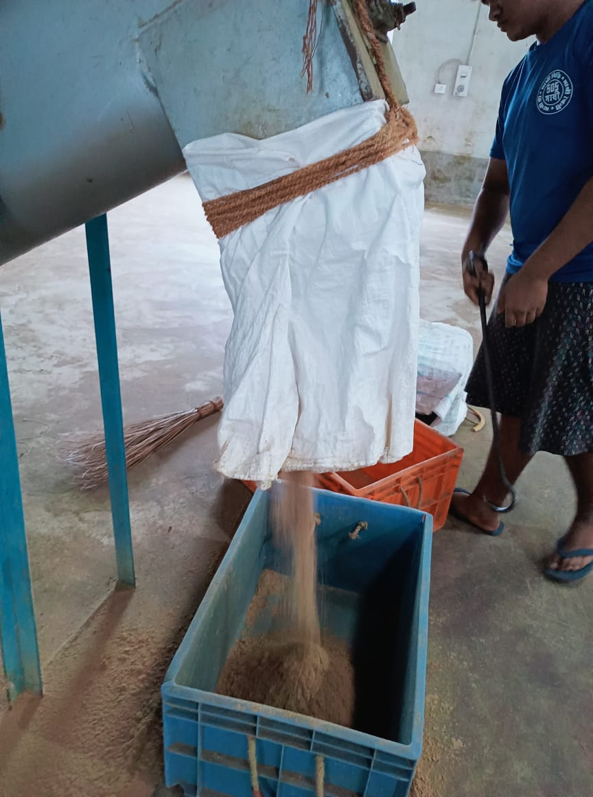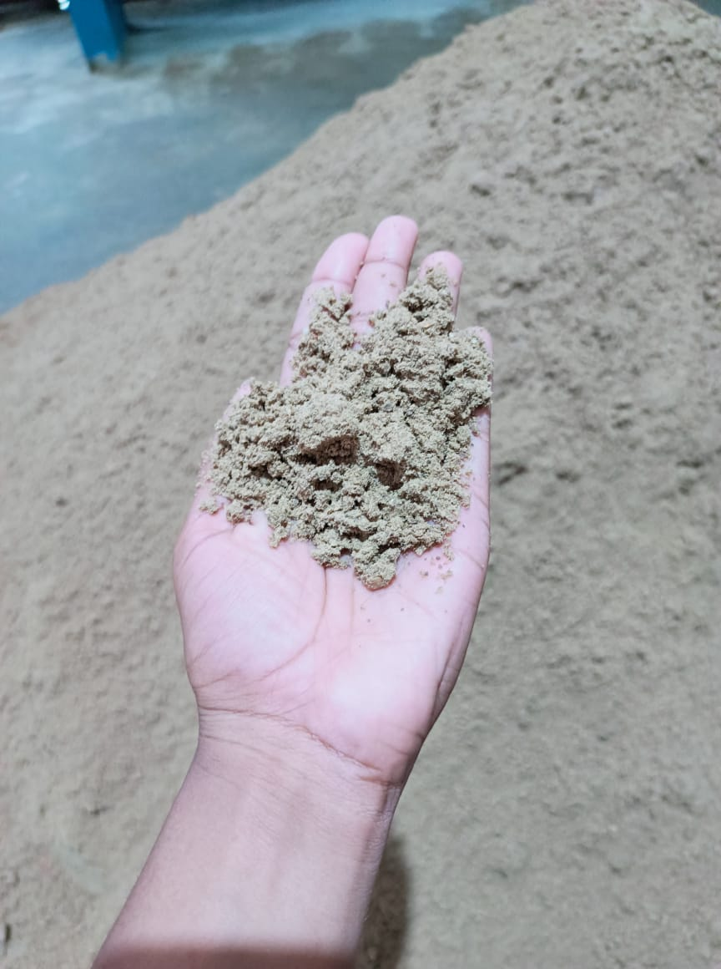
B
A
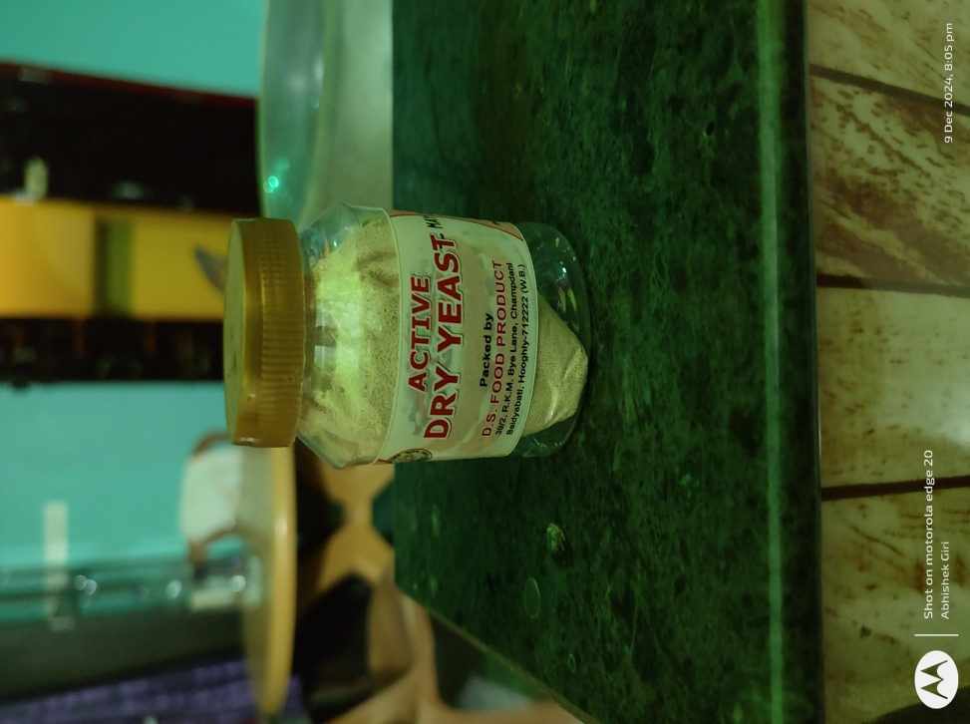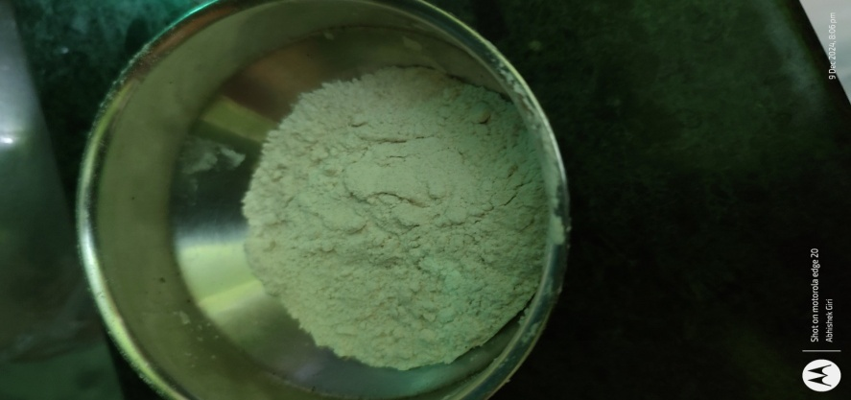
C
D
Fig. 1:Varioustypesoffeedingredients(A,B=FishMeal,C=Yeast,D=Wheatflour)
RESULT
InterpretationofTable1:FeedComposition.
The outcomes of applying the Pearson Square Method to the feed composition system are shown in Table 1. The following table provides information on the precise quantities used in fish diet(including fishmeal, baker's yeast, powdered milk, and whole eggs) required to meet the dietary needs. For the purpose of catering to the particular dietary needs of broodstock, the crude protein percentage of each diet is separately modified to 30%, 35%, and 40%. The data illustrates how different components may be combined to fulfill the protein needs of each diet, which contributes to the enhancement of the nutritional content of the feed. By going about things in this manner, we can be certain that the fish in the brooder will get all of the nutrients that they need in order to flourish.

GrowthPerformance
Table2:GrowthPerformance (Mean ± SE)
Sampling | DietA |  | DietB |  | DietC
Days | Length(mm) | Weight(mg) | Length(mm) | Weight(mg) | Length(mm) | Weight(mg)
(Initial)  5days | 7.0±22.46 | 3.1±22.46 | 7.0±24.62 | 3.1±24.62 | 7.0±30.11 | 3.1±30.11
10 | 12.0±22.46 | 35.6±22.46 | 15.31±24.62 | 57.6±24.62 | 18.40±30.11 | 83.9±30.11
15 | 18.6±22.46 | 95.1±22.46 | 24.44±24.62 | 115.4±24.62 | 28.55±30.11 | 128.6±30.11
(Final)21days | 25.4±22.46 | 125.6±22.46 | 34.21±24.62 | 140.8±24.62 | 41.66±30.11 | 177.2±30.11
Totalgrowth | 18.4±22.46 | 122.5±22.46 | 27.21±24.62 | 137.7±24.62 | 34.66±30.11 | 174.1±30.11
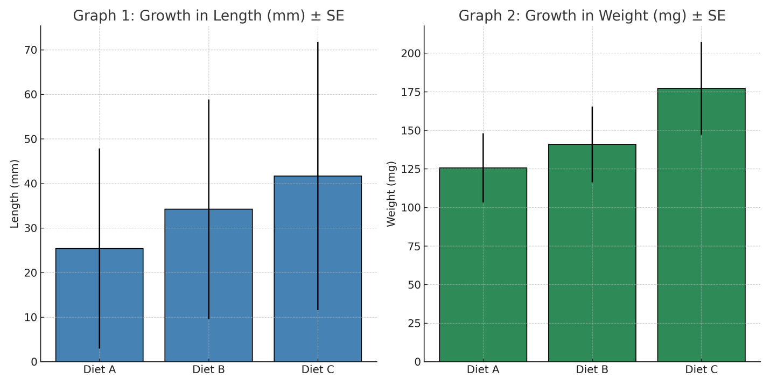
Graph1 and 2:Both the graph showing growth of Clarias batrachus in terms of length and weight.

Graph3:Clusteredcolumnshowinggrowthofseedsinweight(mg)afterusingDietA,BandCfor21days.
In terms of growth, the fish that were fed Diets A, B, and C are compared in Table 2. This comparison was made over 21 days. From the beginning, all of the fish were measured precisely the same, beginning with the same starting weight 3.1 mgand length of 7.0 mm. After five days, the fish adhered to all of the diets, but Diet C showed the greatest growth in both length and weight across the board. By the tenth day, the fish had grown to a length of 18.4 mm and weighed 83.9 mg, further proving that Diet C remained to be superior to the other two diets. At the same point in time, the growth rates of those following Diets A and B were slower. At the 15th day, Diet C, which consisted of fish that measured 28.55 mm in length and weighed 128.6 mg, was once again in the lead. In order to demonstrate that Diet C is more effective, the fish attained a final weight of 177.2 mg and a length of 41.66 mm by the 21st day of the experiment. Fish on Diet B reached a weight of 27.21 mm and 137.7 mg, whereas fish on Diet A achieved a weight of 18.4 mm and 122.5 mg, respectively. In this experiment, Diet C was the most successful diet for supporting the growth of the fish. It resulted in the greatest overall increase in length (34.66 mm) and weight (174.1 mg), making it the most effective diet for overall development.
Table3:ANOVA-GrowthPerformanceonlengthandweightwhenusingDietA
SOURCE | DF | SS | MS | F
Betweengroups | 1 | 9030.03 | 9030.03 | 5.96**
Withingroups | 8 | 12130.56 | 1516.32 | 5.96**
Total | 9 | 21160.58
Table4:ANOVA – GrowthPerformanceonlengthandweightwhenusingDietB
SOURCE | DF | SS | MS | F
Betweengroups | 1 | 11932.19 | 11932.19 | 6.56**
Withingroups | 8 | 14555.92 | 1819.49 | 6.56**
Total | 9 | 26488.1
Table5:ANOVA – GrowthPerformanceonlengthandweightwhenusingDietC
SOURCE | DF | SS | MS | F
Betweengroups | 1 | 19064.58 | 19064.58 | 7.01**
Withingroups | 8 | 21767.81 | 2720.98 | 7.01**
Total | 9 | 40832.38
Diet-A Diet-B Diet-C
Chart1:BoxPlotshowingrelationbetweenlengthandweightwhenusingDietA,BandC.
The growth response of fish fed experimental diets were reported in Table 3, 4 and 5. Diet A reportedtotal of 12130.56 squares within each group, with a mean square value of 1516.32. When all of the groups are considered together, the total squares (SS) and mean square (MS) amount to 9030.03 respectively. The F-value, which was calculated to be 5.955, demonstrates statistical significance at the 5% level, indicating that the results are significant. On the other hand Diet Breporteda total of 14555.92 squares (SS) within each group, with a mean square (MS) value of 1819.49. When all of the groups are considered together, the total squares (SS) and mean square (MS) amount to 11932.19 respectively. The F-value, which was calculated to be 6.558, demonstrates statistical significance at the 5% level, indicating that the results are significant. Diet C, reporteda total of 21767.81 squares (SS) within each group, with a mean square (MS) value of 2720.98. When all of the groups are considered together, the total squares (SS) and mean square (MS) amount to 19064.58 respectively. The F-value, which was calculated to be 7.007, demonstrates statistical significance at the 5% level, indicating that the results are significant.
Observation:
It was observed that the calculated F-value is more than the critical F-value, thereby rejected the null hypothesis. It means the diets (A, B, and C) had significant effects on growth performance of magur seeds. This result the concept that the nutritional conditions are responsible for the observable changes in fish growth because of the high F-value. Therefore, the analysis of variance (ANOVA) conclusively demonstrates that Diet C had a major impact on the growth performance of Clarias batrachus length and weight, with highly significant differences.
DISCUSSION
The present study evaluated the growth response of Clarias batrachus fry fed three diets formulated with varying levels of crude protein: 30% (Diet A), 35% (Diet B), and 40% (Diet C). Over the 21-day culture period, a clear trend was observed wherein increased dietary protein levels led to significantly enhanced growth performance, both in terms of length and weight. Among the three diets, Diet C consistently resulted in the highest growth, indicating that a 40% crude protein content is optimal for early-stage development in C. batrachus.
This finding is consistent with previous literature, which highlights the essential role of dietary protein in fish growth, especially for carnivorous species like C. batrachus that require higher protein intake for muscle development and metabolic functions (Naeem & Salam, 2023; Verreth et al., 1993). Fish meal and yeast, which were key components of Diet C, are known to provide high-quality protein and essential amino acids necessary for rapid tissue accretion, explaining the superior performance of this group (Jindal et al., 2023).
The statistically significant F-values obtained from the ANOVA across all diets confirm that protein levels had a considerable impact on fish growth. These values also indicate that the null hypothesis, which assumed no significant difference among diets, could be rejected. The results further align with Rahman et al. (2018), who reported improved weight gain in C. batrachus when diets were supplemented with protein-rich ingredients.
Notably, although Diet B (35% protein) performed better than Diet A (30%), it still fell short of the outcomes achieved with Diet C. This suggests a positive correlation between protein level and growth performance up to a certain threshold. However, caution must be exercised beyond this level, as excessive protein not utilized for growth may contribute to nitrogenous waste, potentially impacting water quality and increasing production costs (Boyd et al., 2017; Tacon & Metian, 2015). Hence, 40% crude protein appears to be the most efficient and sustainable level for enhancing early fry growth without risking environmental degradation (Dhawan & Kaur, 2022).
The use of the Pearson Square method for diet formulation proved to be both practical and effective, allowing the incorporation of locally available ingredients while maintaining precise nutritional targets. This approach supports small-scale aquaculture operations by offering a low-cost yet nutritionally balanced feed solution. According to Mishra & Mukhopadhyay (2011), well-formulated diets using this method can lead to efficient feed utilization and higher growth rates.
Moreover, feeding frequency and uniform ingredient mixing likely played supportive roles in growth outcomes. Frequent feeding ensures a continuous nutrient supply and minimizes stress due to hunger or competition, further contributing to growth efficiency. While the current study focused primarily on protein levels, future research could explore the synergistic effects of feeding frequency, water quality management, and micronutrient inclusion on the overall health and yield of C. batrachus (Tiwary et al., 2013).
In summary, this study demonstrates that a protein-rich diet, particularly one containing 40% crude protein, significantly improves the growth performance of Clarias batrachus fry. The results validate the need for protein optimization in feed formulations and provide practical insights for cost-effective and sustainable aquaculture practices.
CONCLUSION

The findings of this study confirm that Clarias batrachus, being a carnivorous species, requires a protein-rich diet to achieve optimal growth during early developmental stages. Among the three formulated diets tested, Diet C—containing 40% crude protein—consistently supported the highest growth in both length and weight over the 21-day period. Statistical analysis using ANOVA demonstrated significant differences in growth performance across the three dietary treatments, with Diet C showing the most pronounced effect. These results reinforce the importance of providing a high-protein feed to enhance seed quality and productivity in C. batrachus culture. Furthermore, the use of the Pearson Square method proved effective in formulating balanced diets using locally available ingredients. Based on the findings, it is recommended that diets with approximately 40% crude protein be administered four times daily for improved growth outcomes in C. batrachus fry.

COMPETING INTERESTS DISCLAIMER:
Authors have declared that they have no known competing financial interests OR non-financial interests OR personal relationships that could have appeared to influence the work reported in this paper.
Disclaimer (Artificial intelligence)
Author(s) hereby declare that NO generative AI technologies such as Large Language Models (ChatGPT, COPILOT, etc.) and text-to-image generators have been used during the writing or editing of this manuscript.
REFERENCE
- FAO. (2022). The State of World Fisheries and Aquaculture 2022: Towards Blue Transformation. Food and Agriculture Organization of the United Nations. https://www.fao.org/publications/sofia/2022/en/
- Ab Rahman, S. F. S., Singh, E., Pieterse, C. M., & Schenk, P. M. (2018). Emerging microbial biocontrol strategies for plant pathogens. Plant Science, 267, 102-111.
- Kumar, R., Hegde, A. S., Sharma, K., Parmar, P., & Srivatsan, V. (2022). Microalgae as a sustainable source of edible proteins and bioactive peptides–Current trends and future prospects. Food Research International, 157, 111338.
- Tacon, A. G. J., & Metian, M. (2015). Feed matters: Satisfying the feed demand of aquaculture. Reviews in Fisheries Science & Aquaculture, 23(1), 1–10. https://doi.org/10.1080/23308249.2014.987209
- Boyd, P. W., Bach, L. T., Hurd, C. L., Paine, E., Raven, J. A., & Tamsitt, V. (2022). Potential negative effects of ocean afforestation on offshore ecosystems. Nature ecology & evolution, 6(6), 675-683.
- FAO. (2021). National aquaculture sector overview: India. Food and Agriculture Organization of the United https://www.fao.org/fishery/en/countrysector/naso_india Nations.
- FAO. (2022). The State of World Fisheries and Aquaculture 2022: Towards Blue Transformation. Food and Agriculture Organization of the United Nations.
https://doi.org/10.4060/cc0461en
- Mishra, S., & Mukhopadhyay, P. K. (2011). Effects of some formulated diets on growth, feed utilization and essential amino acid deposition in Clarias batrachus fry. Indian Journal of Fisheries, 43(4), 333–339. https://epubs.icar.org.in/index.php/IJF/article/view/8901
- Sarkar (Paria), D. (2021). Effect of dietary feed composition on the different growth parameters of Clarias batrachus (Magur) at various stocking densities in captive environment. Uttar Pradesh Journal of Zoology, 42(15), 75–82. https://mbimph.com/index.php/UPJOZ/article/view/2301
- Tiwary, C. B., Thakur, K., & Tiwary, S. K. (2013). Effect of unconventional diets on growth and survival of Clarias batrachus (Linn.). Journal of the Inland Fisheries Society of India, 45(1), 1–6. https://epubs.icar.org.in/index.php/JIFSI/article/view/117044
- Verreth, J., Eding, E. H., Rao, G. R. M., Huskens, F., & Segner, H. (1993). A review of feeding practices, growth and nutritional physiology in larvae of the catfishes Clarias gariepinus and Clarias batrachus. Journal of the World Aquaculture Society, 24(2), 135–144. https://doi.org/10.1111/j.1749-7345.1993.tb00002.x
- Naeem, M., & Salam, A. (2024). An approach to optimizing dietary protein to growth and body composition in walking catfish, Clarias batrachus (Linnaeus, 1758). Aquaculture Reports, 27, 101234. https://doi.org/10.1371/journal.pone.0301712

