Assessment of Three Fish Species Stock for Conservation and Management Policy in River Imo, Nigeria"

Abstract
The rates of Growth, recruitment, mortality, and exploitation of three important fish species of the River Imo, Nigeria, were investigated, aimed at providing information on their conservation status and management policies for their sustainability. These species are big-sized and fleshy, and they are Gymnarchus niloticus (Cuvier 1829), Clarias gariepinus (Burchell 1822) and Distichodus notratus (Gunther 1864). Assorted fishing gears were used to catch the species fortnightly from January to July 2023, and data on their standard length were taken to the nearest centimeter (cm). 503,129 specimens were examined and measurements analyzed with the Electronic Length Frequency Analysis (ELEFAN II) fitted into the von Bertalanffy Growth Model (VBGM) of L_{(t)} = L∞[1 – e ^{–k(t-t0)}] with FAOICLARM (FISAT) tools software. Asymptotic length (L∞) for G. niloticus = 210cm, C. gariepinus = 94.50cm and D. rostratus = 68.25cm. Comparing the stock parameters of total mortality (Z), Fishing Mortality (F), Exploitation rate (E) and length of sexual maturity (Lm), G. niloticus was observed to be over-exploited (E = 0.84), D. rostratus was near optimal level of exploitation (E = 0.51) while C. gariepinus was not over- exploited (E = 0.24). Recommended management policies are restriction on the use of small mesh sizes (≤ 3cm); prohibition of the catches of sexually immature individuals (for G. niloticus sizes ≤ 140.0cm, C.gariepinus ≤ 63.0cm and D. rostratus ≤ 45.5cm) and enforcement of closed fishing season on the observed peak of recruitment: April – May – June – July in River Imo.
Keywords: River Imo, Fish Species, Exploitation, Mortality

Introduction
Fish represents one of the most affordable sources of animal protein for people living in riverine communities globally (Ugwumba and Ugwumba, 2013; Taiwo, 2010). The sustainable harvesting of fish enhances the economic benefits for fishermen in these areas, leading to improved livelihoods (Izah et al., 2018). The conservation status of fish species is reflected in their abundance, distribution, and diversity, which are regularly impacted by both internal and external factors (Januchowski-Hartley, 2011). External factors are exacerbated by climate change and various human activities, which can originate from nearby or distant locations (Vorosmarty, 2010; Ogueri, 2018). Additionally, the growing human population and its corresponding demand for fish have created ongoing pressure on fish stocks due to overfishing and harmful fishing practices, particularly in developing nations like Nigeria. Internal factors influence fish populations through the feeding relationships among different fish groups. These interactions are crucial for maintaining various trophic levels that support a balanced fish population and a stable environment (Abdul, 2016). The dynamics of fish populations are regulated by their feeding relationships, which can vary seasonally based on the availability of food. Moreover, the physical and chemical characteristics of the water, especially temperature, affect food consumption alongside the presence of food organisms like plankton (Yem, 2009).
Fish stock assessment tends to provide valuable information on growth rates, mortality and sustainable long-term yield using different models. According to Hilborn &Walters (2013), Fisheries managers create good understanding of the Fish stock dynamics using the models as database of knowledge acquired over the years. River Imo is a very important River in Nigeria). Located in the south eastern Nigeria with Length of 240km, it transverses four different states of Imo, Akwa Ibom, Abia and Rivers states. Arising from Isuochi in okigwe (5°50’56” N, 7°14’20”E), it flows into the Atlantic Ocean at Queen’s town, Opobo (4°53’33” N, 7°51’67” N). Being a great large river, it is a source of domestic freshwater fish supply to the surrounding communities and beyond. The other River’s socio-economic significance is elaborated in Afigbo (2005).
Stock assessment provides information on the abundance of a fish stock, whether it is below or above a given target point (Yonga & Outa 2016) which will further predict a catch level that will maintain or change the abundance of the stock. According to Vetter (2007), different types of information are used in stock assessment to give managers advice about the status of a fishery and the possible outcomes of management strategies. These actions are related to the resource abundance and also other important aspects of fish population dynamics such as the current levels of Mortality (Zhang & Megrey, 2006). The most important role of stock assessment is to understand the dynamics of fisheries, as the biological resources; fishermen and the environment are dynamic entities that change from time to time (Uneke & Nwani, 2013).
Stock assessment of fisheries resources has developed rapidly in the last two decades in particular through the works of Moreau et. al. (2008), Hilborn & Walters (2013), David (2014), Abobi & Ekau (2013), etc. Besides the above-mentioned works, the rapid introduction of special software for fish stock assessment, especially that based on length. Frequency data, such as the packages of Electronic Length Frequency Analysis (ELEFAN) of FISAT II (Grayanilo et. al., 2005) mean that fishery scientists are placed in a position where they are using methods and models to analyze large data, which was cumbersome in the past. What is much needed is to get a metre rule and measure as many samples as possible in fish landing sites (NOAA, 2013). The scientist calibrates the model by using observed data from fishery catch, fish abundance survey, and fish biology (Pope, 2002).
The description of fishery consists of three basic elements; the input (the fishing effort) the output (the fish landed) and the processes that link the first two (the biological processes and the fishing operations (David & Bell, 2011). Fish stock assessment aims to describe the link between the input data and output with the use of tools known as models (ICES, 2011). Major habit of the teeming population proximate to River Imo is their Preference for big fleshy fish species. In this category are Gymnarchus niloticus (Cuvier 1829), Clarias gariepinus (Burchell, 1822) and Distichodus rostratus (Gunther 1864). Obvious importance of these fish species and River Imo ecosystem notwithstanding, scanty published works are available on their stock assessment and conservation status making it challenging in the provide of management policies for their sustainability.
This paper, aims to investigate the status of Growth rates, mortality, recruitment and Exploitation rates of the aforementioned species that will provide a database for formulation of conservation and management policies in River Imo, South Eastern Nigeria.

Materials and Methods
Four areas along the main course of the River Imo were designated as sampling stations (Fig. 1). The stations were chosen based on their proximity to landing sites. Sampling was done with assorted fishing gears: gill nets (mesh sizes 15- 25mm), beach seine (mesh sizes 2.3 – 10mm), cast nets (mesh sizes 15 – 25mm), and basket/traps, employing skilled fishers. Fish were also obtained from local fishmongers. The catches were sorted into their different species using identification keys of Paugy(2003) and Adesulu & Sydenham (2007). The standard length of each fish specimen was measured to the nearest centimeter (cm). The data obtained was grouped into 1-cm class intervals, monthly, with Excel Microsoft 365 and fitted in Von Bertalanffy Growth Model (VBGM) using ELEFAN II of (FISAT) FAOICLARM Stock Assessment tools in Gayanilo et al (2005). The VBGM has the equation:
L_{(t)} = L∞[1 – e^{-k(t – to)} ]
Where L_{(t)} = Length at age, t.
L∞ = the asymptotic length (maximum Length)
k = the growth rate coefficient
t = the age of fish
t_{o} = the theoretical age at which the fish had zero length
The total Fish Mortality rate (Z) was estimated by length-converted catch curve (Pauly, 1984).the natural mortality (M) was also calculated by using Pauly’s empirical formula while the Fishing Mortality (F) was estimated by the difference: Z – M.
The Age-at-length and growth rates were established with the length-converted curve of ELEFAN II.
The Probability of capture of the specific fish was estimated with the probability of capture Selectivity Curves as L25 = Probability at 25% capture, L50 = Probability of 50% capture and L75 = Probability of 75% capture.
The Length at first maturity (Lm) is calculated:
$\frac{2 * L∞}{3}$ (Hoggarth et al. (2006)).
The Exploitation Rate was estimated by the quotient F and Z( Pauly (1984): E = F/Z
Relative Yield per recruit (Y/R) was computed with Beverton & Holt (1966) incorporated in the FisAT software.
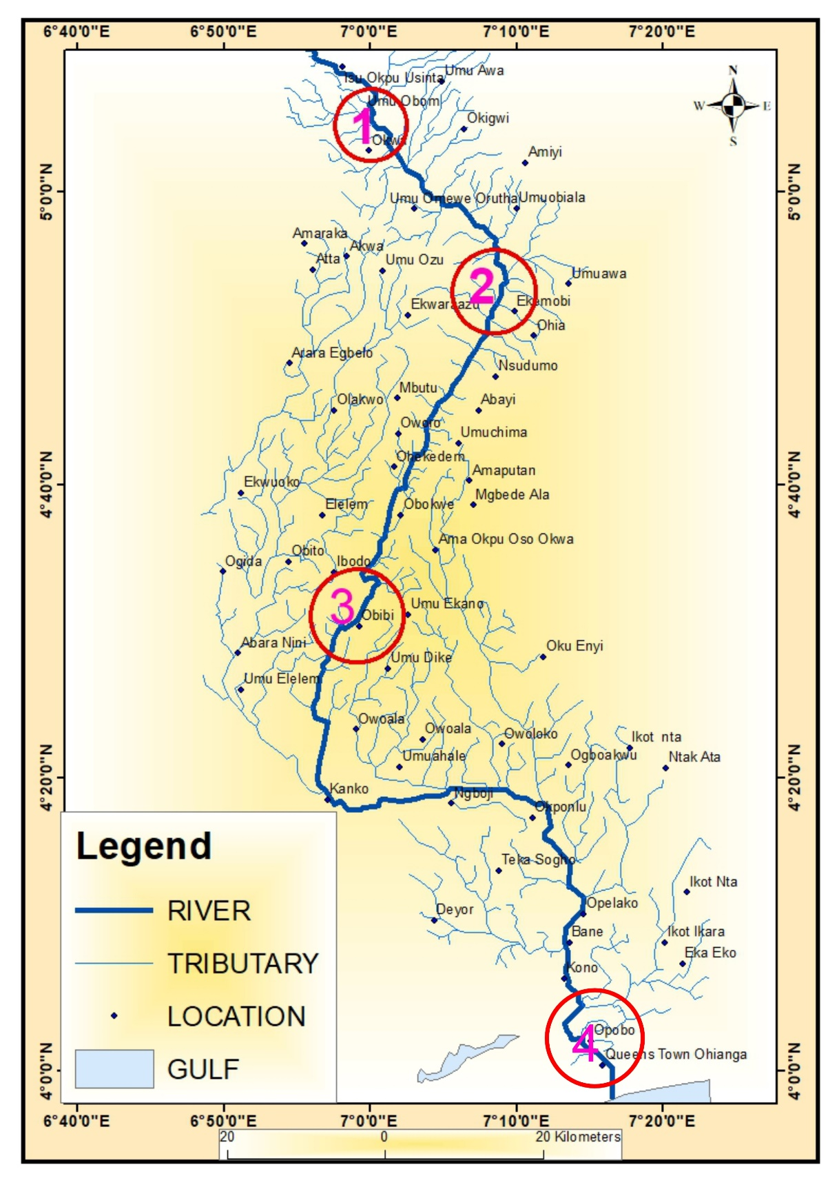
Fig. 1. Map of River Imo showing the sampling stations with numbers.

Results
A total of 503,129 specimens were examined, comprising of G. niloticus (139,341), C. gariepinus (246,285) and D. rostratus (117,503). Details of the parameters are presented according to the three different species.
G. niloticus.
This species ranges in size in the catches from 9 to 200cm, with a mean ± (130.68 ± 68.68). The length Frequency distribution in ELEFAN II is shown in Fig. 2. The VBGM was:
L_{(t)} = 210[1 – e^{-0.24(t – 0.096)} ]
Total mortality (Z) was 2.29. Fishing mortality (F) was 1.94, Natural Mortality (M) was 0.35, and Exploitation rate = 0.84. Length at first capture (LC) = 9.0cm (Fig .3)
The probability of capture is presented on Fig.4: showing L25 = 80, L50 = 88, and L75 = 98. Computed Lm was 140.0cm. Note that: Lm > L50. Table 1 presents the length at age and Growth rates of the three species in the River. G. niloticus grew fastest within the first year, followed by C. gariepinus.
C. gariepinus
The range in size was from 7 to 90cm in the catches, with a mean ± (48.50 ± 2.66. The ELEFANT II growth curve is shown in Fig. 6. The VBGM was:
L_{(t)} = 94.50[1 – e^{-0.24(t – 0.9)} ]
Z = 0.60, F = 0.14, M = 0.46 and E = 0.24. The L50 = 39.57, L25 = 37.72 and L75 = 58.78 as shown in Fig. 8. Computed Lm = 63.0cm. Note that Lm > L50. The stock status of C. gariepinus is shown in Fig 9. and the length-converted catch curve in Fig. 7.
D. rostratus
In the catches, the range in size was from 9 to 65cm with mean ± s.d (37.5 ±15.81). The ELEFAN II plot is shown in Fig. 10. The VBGM was:
L_{(t)} = 68.25[1 – e^{-0.23(t – 0.40)} ]
Z = 2.00, M = 0.98, F = 1.02 and E = 0.51. In Fig. 12 is shown the probability of capture with L25 = 32.85, L50 = 44.14 and L75 = 47.85, Lm = 45.5cm. Note that Lm > L50.
The stock status is shown in Fig.13 while the length-converted curve is presented in Fig.11

Discussion
Tesfaye (2016) posits that scientific fish stock assessments are the key to fisheries management, which provides information required for the conservation and management of fish stocks and also policies for their sustainable use. The present study focused on the three most sought-after fish species in the River Imo, as a result of the fish’s relative abundance, robust flesh, and market value.
G. niloticus had an asymptotic length (L∞) of 210cm and growth curvature (K) of 0.160 per year, an indication that the fish is in a slow growth condition in the River. Komolafe & Arowomo (2011) assert that K – value lower than 1 indicates slow growth. The total mortality of G. niloticus was 2.29, while the Fishing Mortality (F) was 1.94 and natural mortality (M) was 0.35. This means that of the total mortality of the species in the River per year, 15.28% comes from natural mortality, while a whopping 84.27% comes from fishing mortality. This calls for a serious conservation concern. The Exploitation rate (0.84) is above the recommended optimum level of 0.5. According to Chukwu & Deekae (2010), increased levels of exploitation may lead to a stage where there may be no more productivity. Higher values of these parameters have been reported elsewhere (Kwarfor–Apeyyah et al. 2009 and Uneke & Nwani, 2013), corroborating the fact that G. niloticus stocks were over-exploited. The Length at first capture was 9.0cm with a length∞ of 210cm. Compared with Morgan's (2008) indices, the ratio Lc/L∞ at 0.428 in the River for G. niloticus implies that the smaller fish are caught at a higher effort level. The single recruitment peak (July) per year observed in this investigation tallies with the position of Pope(2002) that a single recruitment pulse per year are also a general feature of tropical fish species. In support of the above, Ahmad et al (2018) reported higher values of Z(1.91/yr), M(0.23/yr, F(1.31/yr), and E(0.68/yr) for G. niloticus from the Challawa Gorge dam, Kano State. Kwarfo-Apegya et al (2009) also reported higher values of Z=2.54/yr, M=0.42/yr, F=1.74/yr, and E=0.70/yr. In Uneke & Nwani (2013), Z=3.34/yr, M=0.60/yr, F=2.12/yr and E= 0.63/yr. All these values are an indication that, whatever the habitat, niloticus stocks are over-exploited. The reason for the over-exploitation is not far from the fact that this species is highly priced as it is used exclusively for some elite ceremonies by the indigenous communities, also it is also known for its delicacy. As the stock declined, the fisher folks tend to reduce the mesh size of the nets as well as double their efforts and also utilize more efficient gears that are not size selective, such as purse seine and beach seine (Njiru et al.,2004). Evidence by Okogwu(2008) has shown that some fishermen now fish regularly in the lakes; such activities and the targeting of migrant stocks on their way to spawning sites in lakes will undoubtedly lead to a decline in productivity and will imperil recruitment. Observations by Okogwu & Ugwumba(2009) and Okogwu (2010) showed that the spawning of G. niloticus synchronized with low food will lead to a decelerated growth rate of the juveniles. As they recruit into adult stock in the water body, where food is limited in supply and competition for food intensifies, there is a tendency that growth may slow down (Ogueri,2004). The M/K of 1.8 estimated in the present study lies within the range 1.5 and 2.5 proposed by Vetter(2007). The estimated exploitation rate was 0.84/yr, which is higher than the predicted maximum exploitation rate (Emax) of 0.70(Fig.5), which further lends credence to the fact that G. niloticus is under severe fishing pressure in River IMO.
To avert unsustainable fishing and recruitment failure, there should be a rational and well-articulated management strategy to salvage the G. niloticus fishery in River Imo. Part of the strategy should be the formation of community-based fishery management and groups of stakeholders. The government institutions, Fishery scientists, non-governmental organizations, fishers, folks, and community leaders should be entrusted with the responsibility of managing the depleting stocks.
In C. gariepinus, the L∞ was 94.50cm with K as 0.24 per year, indicating that the fish takes a longer time to approach the asymptotic length in the River Imo. In Buntanga Reservoir, Ghana, Kwarfor-Apegya et al (2009) recorded greater values (L∞ = 98.5cm and K = 1.5), indicating faster growth. Also in River Imo, the Exploitation rate (E) of C. gariepinus was 0.24. Based on Hilborn & Walters' (2013) assumptions, stock is optimally exploited when F = M or E = 0.5, which shows that the current exploitation rate is tending towards the maximum level of 0.5. The estimated length at 50% probability capture (L50) of C. gariepinus was 39.57cm. This value falls within the range of the length (30 to 50cm), implying that medium sizes of C. gariepinus are most likely to be caught, which is termed “growth over-fishing”: that describes a situation where fishes are captured at average/medium size (ISSF, 2024). This could be as a result of the use of small mesh sizes. However, the observation that natural mortality (0.46) was greater than the fishing Mortality (F = 0.14) indicated that C. gariepinus was not over – exploited within the period of study. The reason could be attributed to the fact that C. gariepinus is the most cultured stock by the fisher-folks in neighboring communities. A good measure in Fishery management policies: notably: depleting stock should be massively cultured. The growth pattern amongst the species followed a known Biological concept. The growth rates (cm per year) were faster at younger ages than at older ages.
In the present study, C. gariepinus had an asymptotic length of 94.5cm, a growth curvature of 0.24 per year, which shows that it was fast-growing. Kwarfo-Apegya et al.(2009) reported a lesser value of asymptotic length (91.5cm) and a greater value of growth curvature (1.5 per year) in the Bontanga reservoir, Ghana, indicating it reaches asymptotic length faster. Abowei & Hart(2009) on the other hand recorded lower growth curvature (k) value of 0.26per year for C. gariepinus in the Niger Delta, Nigeria. Abobi & Ekai(2013) revealed high values of K=1.1/yr and asymptotic length of 97.5cm in Volta-Yapei, Ghana. In Tanguiga, Burkina Faso, Baijot &Moreau(2007)recorded an asymptotic length of 96 cm and k=0.90/yr. Ogueri (2004) observed a Male asymptotic length of 68cm with k =0.22/yr, while the female was the asymptotic length of 66cm and k 0.11/yr in River Katsina-Ala, Benue state, Nigeria. The predicted Emax of the selective Ogive procedure for C. gariepinus, 0.421/yr in Fig.9, was higher than their current exploitation rate, 0.24/yr, showing that the species is not over-exploited. Uneke & Nwani(2012) and Kwarfo-Apegya (2009) made similar observations. In the Challawa Gorge dam, Kano State, Emax =0.65/yr, E50=0.20/yr and E10= 0.24/yr for C. _gariepinus_(Ahmad et al.,2018)
For D. rostratus, which appeared lesser in the catches, unlike the other two previous species. L∞ observed was 68.25cm with- value of 0.22, indicating slow growth in the habitat, like the other two species. With K at 0.1 per year, Fish grow 9.5% closer to L∞ , while with K of 1.0 per year, they grow 63% closer to L∞ (Hoggarth et. al., 2006). For estimated asymptotic length, Oguta Lake, the tratus from Oguta Lake is 68.25 cm and k value=0.230/yr, which is similar to that of Koka reservoir and Kaptai reservoir in Yobe state with k value=0.25/yr(Ahmad et al, 2003). However, it was relatively lower than the estimates for Victoria reservoir in Plateau State (0.60/yr). The estimated k value for D. rostratus investigated by Moreau et al.(2012)was within the range of that in Oguta Lake, an indication of slightly slow growth. Previous studies indicated growth parameters differ between species and may also vary between stocks within the same species (Shinkafi et al. 2013), with differences possibly attributable to variation in geographical locations (Amponsah et al.,2016). According to Tesfaye & Wolf(2015), the growth parameters (Linfinity and k values) were shown to be less meaningful since they can vary even for the same species from the same areas. Growth and mortality rates were very much interrelated. Growth affects the fish's vulnerability to both predation and fishing and also largely determines the food requirements of each fish(Allen & High tower, 2010). The fishing mortality (F=1.02/yr) in the present study was almost equal to the natural mortality (M=0.98/yr), contrary to estimates reported by Tesfaye & Wolf(2015) for Lake Koka(F=0.65/yr and M=0.82/yr) as well as being in agreement with estimates reported by Yongo and Outa(2016) in Kenyan side of Lake Victoria. The greater value of fishing mortality in Oguta Lake coincides with the fact that the D. rostratus stock is more susceptible to fishing than natural mortality conditions.
David (2014) opined that long-lived fish species approach their largest size with slow growth constant values, usually with low natural mortalities and vice versa. Getabu (2002) also observed a low M of 0.0260 of D. rostratus in Nyanza Gulf of Lake Victoria. The exploitation rate for D. rostratus in River Imo was 0.51, equivalent to E = 0.5, which shows the exploitation is at an optimal level; moreover, as the F = 1.02 was almost equal to M = 0.98. There is a need to impose management measures before the fishery is torpedoed by over-exploitation. The risk of over-exploitation is that fisher folks will most likely be catching too many fish from the River, impacting negatively on the sustainability of the fish stock. Hoggarth et. al. (2006) positioned that “all Fisheries require responsible management now to sustain their potential benefits to society”.
Conclusion
On the over-all assessment, there should be restriction on the catch of the sexually immature fishes of the Rives by not using small mesh sizes. For instance, Length at maturity (Lm) of G. niloticus was 140.0cm while the L50 was 88.04cm; In C. gariepinus (Lm = 63.0cm and L50 = 39.57), D. rostratus (Lm = 45.5cm and L50 =44.14cm): meaning that there is 50% probability of capture of most individuals before they attain the age of sexual maturity. It is hereby recommended that fishing should be closed during the identified recruitment period of April – May – June – July in River Imo.

Table 1. Length at Age and Growth rates of G. niloticus, C. gariepinus and D. rostratus of River Imo from January to July 2023

 | G .niloticus |  | C. gariepinus |  | D.rostratus
Age  (year) | Length  (cm) | Growth rate  (cm/year) | Length  (cm) | Growth rate  (cm/year) | Length  (cm) | Growth rate  (cm/year)
1 | 40.80 |  | 34.6 |  | 10.14
 |  | 36.11 |  | 12.70 |  | 29.34
2 | 76.90 |  | 47.30 |  | 34.48
 |  | 28.40 |  | 7.90 |  | 26.34
3 | 105.30 |  | 57.43 |  | 53.23
 |  | 22.34 |  | 6.22 |  | 7.18
4 | 127.61 |  | 65.34 |  | 60.41
 |  | 17.57 |  | 5.80 |  | 3.13
5 | 145.21 |  | 71.56 |  | 64.15
 |  | 13.83 |  | 2.90
6 | 159.04 |  | 77.45
 |  | 10.87 |  | 2.70
7 | 169.91 |  | 80.36
 |  | 8.55
8 | 178.47
 |  | 6.73
9 | 185.19
 |  | 5.29
10 | 190.49

Disclaimer (Artificial intelligence)

Option 1:
We declare that NO AI technologies was used in writing this work.

REFERENCES
Abobi, S. M., & Ekau, W. (2013). Growth, Mortalities and Exploitation Rates of Alestes baremoze(joannis, 1835), Brycinus nurse (Ruppell, 1832) and schilbe intermedius (Ruppel 1832) from the lower reaches of the White Volta River (Yapei), Ghana. Journal of Agriculture and Biodiversity Research, 2(1), 1 – 10.
Abowei F.N.& Hart, AL(2009). Some morphometric parameters of frofich species from the lower Nun River, Niger Delta, Nigeria. Research _Journal_ of Biological Sciences, 4(3): 282 - 288.
Ahmad, IM, Yola, ID and Suleiman, N(2018). Mortality and Exploitation rates of Challawa Gorge Dam fishes, Kano State, Nigeria. _Journal of Fisheries and Livestock production_ , 6:262, doi:10.4172/2332-2608.1000262
Amponsah, Sk., Ofori-Danson, PK and Nunoo, FK.(2016). Fishing regime growth, mortality, and Exploitation rates of Scomber japonicus from catches landed along the Eastern coastline of Ghana. International Journal of Fisheries and Aquatic Research, 1(1), 05-10.
Allen, M.S & High tower J.E.(2010). Fish population dynamics: mortality, growth, and recruitment. IN: Inland Fisheries Management in North America (3rd ed, pp 43-79).
Baijot,E & Moreau, J.(2007). Biology and demographic status of the main Fish species in the reservoirs of Burkina Faso. In: Baijot, E, Moreau, J and Bouda, S (Eds). Hydrobiological aspects of Fisheries in small reservoirs in the Sahel region.
Adesulu, E. A, & Sydenham, D. H. J. (2007). The Freshwater and Fisheries of Nigeria. Macmillan Nigeria Publishers, Lagos, Nigeria. 397 pp.
Afigbo, Adiele Eberechukwu (2005). Toyin Falola (ed.) Nigerian History, Politics and affairs. The collected essays of Adiele Afigbo. Africa World Press. P. 95. ISBN: 1-59221-324-3
Chukwu, K.O & Deekae, S. N. (2010). Growth, Mortality and recruitment of Periphthalmus barbarous (Linnaeus, 1766) in New Calabar River, Nigeria. Agriculture and Biology Journal of North America, 2(7), 1066 – 1068.
David, T. (2014). Population parameter for six commercial species in Lake Kainji, Nigeria, using Length Frequency data sampled from artisanal fish catches. In M.L.D. Palomares, B. Samb, T. Drout, J.M. Vakily and D. Pauly (Ed). Fish biodiversity: Local studies as basis for global interferences (pp 31 – 45) ACP – EU.
David, W. F. and Bell K. V., (2011). Biological statistics of the pacific halibut fishery. 2. Effects of changes in intensity upon total yield and yield per unit of gear. Rep. Int. Fish (Pacific halibut) Comm. 8. 49 p.
Dhimmar, S.N,, Lende, S.R., Vala, S.R., Gamit, S.A.(2024) Conservation Status of Fishes Reported from Tapi District of Gujarat, India. J. Sci. Res. Rep. [Internet]. 2024 Oct. 31 [cited 2025 Apr. 21];30(11):270-7. Available from: https://journaljsrr.com/index.php/JSRR/article/view/2554
Gayanilo, F. C., Sparre, P and Pauly, D. (2005). FAOICLARM stock Assessment Tools II (FiSAT). User’s guide. FAO computerized information series (Fisheries) Mi. 8 Revised Version, FAO, Rome, 168pp.
Getabu, A. (2002): Growth parameters and total mortality in D. rostratus from Nyanza Gulf. Lake Victoria. Hydrobiologia, 232 (1), 91 – 97 https://DOI.org./10.1007/BF00014617.
Hilborn, R. & Walters C. J. (2013). Quantitative Fisheries Stock Assessmentpublished by springer, New York, NY. DOI https://doi.org/wio.1007/ E ISBN 978-4615-3598-0 pp xv, 570
Hilborn, R., Maguire, J. J., Parma, A and Rosenberg, A. (2001). The precautionary approach and risk management: can they increase the probability of successes in Fishers management? Can. J. Aquat. Sc. 58:99 – 107.
Hoggarth, D. D. Abeyasekera, S., Arthur, P., Beddington J. R., Burn, R. W., Halls, A. S. Kirkwood, G. P., McAllister, M., Medley., D., Mees, C. C. Pilling, G. M., Wakeford, R. and Welcomme, R. L. (2006). Stock assessment and Fishery management: - A framework guide to the FMSP stock assessment tools, FAO Fisheries Technical Paper No. 487, Rome, Italy, 261 pp.17.
ICES (2011). International Council for the Exploration of the sea. Report of the working Group on Fisheries Acoustics Science and Technology meeting held in Reykyavik, Iceland, May 10-13, 2011.
ISSF (2024): International Seafood Sustainability Foundation. Info @ ISS – foundation.org.
Komolafe, O. O. & Arowomo, G. A. O (2011). Observations in the composition, Physiological condition and Fisheries in Erinle Lake, Osun state, Nigeria. West African Journal of Applied Ecology, 18, 71 – 78.
Kwarfo – Apegyah, K., Ofori – Danson, P. K., and Nanou, F. K. E. (2009). Exploitation rates and management implication for the fisheries of Bontanga Reservoir in the Nothern region of Ghana. West African Journal of Applied Ecology, 14, 1 – 7.
.Moreau, J., Amarasinghe, U. S., & Ajith Kumara, P. (2008). Population dynamics of non-exploited and under – exploited fish species in three Sri Lankan reservoirs. In F. Schiemer, D. Simon, U. S. Amarasinghe, J. Moreau (Eds.), Aquatic ecosystem and development: Comparative Asian perspectives (pp. 285 – 294).
Morgan, M.J. (2008). Integrating reproductive biology into Fisheries Management. Marine Ecology Progress Series, 357, 291-302.
NOAA (2013) National Oceanic and Atmospheric Administration Review in Fish Biology and Fisheries 2(2), 177 - 178
Njiru M.P., Nzungi, A ., Getabu, E., Wakwabi, A., Othina, T., and Wekesa,S.(2004). Are Fisheries management measures in Lake Victoria successful? The case of Nile Perch and Nile tilapia fishery. Afr. J. Ecol.45:315-323.
Ogueri, C.(2004). Physico-chemical parameters, Fish fauna and Fisheries of River Katsina-Ala, Benue state, Nigeria. PhD Thesis, University of Ibadan, Ibadan. 378pp
Okogwu, O.I.(2010). Seasonal variations of species composition and abundance of G.niloticus in Ehioma Lake, Nigeria. Rev. Biology. Trop. 58: 171-182q
Pauggy. D. (2003). Alestidae. In: Pauggy, D., Leveque, C. and Teugels, G. G. (Eds). The fresh and brackish water fishes of West Africa. Vol 1. Coll. Feane et Hore tropicales 40. Institute de recherché de development, Paris, France, Maseamnational d’hidtoire Paris, France and Muyee Nigal de L’Afrique Central, Tervaren Belgium, 457 pp.
Pauly, D. (1983). Some simple methods for the assessment of tropical fish stocks. FAO Fisheries Technical Paper, 234.52p
Pauly, D. (1984). Fish population dynamics in tropical waters: a manual for use with programmable calculators. ICLARM stud. Rev.., (8), 325.
Pauly, D. & Soriano, M. L. (1986). Some practical extensions to Beverton and Holt’s relative yield per recruit mode. In: Mac bean, J. L., DIzon, L. B., Hosillos. L. U (Eds). The First Asian Fisheries, Asian Fisheries Society, Manila Philippines, pp. 491 – 496.
Pope,J.G>(2002). Estimation of fishing mortality, its precision and implications for the management of Fisheries, p63-76. In J.H. Steele (ed.), Fisheries Mathematics. Academic press, London, UK.
Shinkafi, BA., Salim AM., and Yusuf MA(2013). Some aspects of the biology of Distichodus rostratus in River Rima, North Western Nigeria. Greener J. Biology.sci.2013;3: 136-45.
Tesfaye, G. (2016). Population and Ecosystem–based Fisheries Assessment of the Rift Valley Lake Koka, Ethiopia. Ph.D Dissertation, Universität Bremen, Germany. P. 228
Uneke, B. I., & Nwani, C. D. (2013). Stock assessment of Brycinus nurse (Characiformes: Alestidae) in a tropical flood river basin. Cont. J. Fish and Aqua. Sc. 7(3), 22 – 33.
Vetter, E.F. (2007). Estimation of natural mortality in fish stocks: A review. Fishery Bulletin, 86: 25 – 43.
Yongo, E., & Outa, N. (2016). Growth and population parameters of D. rostratus in the open waters of Lake Victoria, Kenya. Lakes of Reservoirs: Research & Management, 21(4), 375n-379.
Zhang, C. I., & Megrey, B. A. (2006). A revised Alverson and Carney model for estimating the instantaneous rate of natural mortality. Transactions of American Fisheries Society, 135(3), 620 – 633.
Ugwumba A O and Ugwumba A A A. (2013)“Poverty alleviation through aquaculture” In poverty alleviation for Biodiversity Management (Eds Ivbijahro M. F. A) Book builders edition Africa, Ibadan (2013): 431.
Taiwo Y F. (2010)“Fish diversity in two reservoirs in southwest Nigeria”. Proceedings of Fisheries Society of Nigeria (FISON) ASCON, Badagry 25th-29th October (2010): 258- 265.
Januchowski-Hartley SR., (2011) “Fresh Waters and Fish Diversity: Distribution, Protection and Disturbance in Tropical Australia”. PLoS ONE 6.10 (2011): e25846.
Vorosmarty C J., (2010) “Global threats to human water security and river biodiversity”. Nature 468 (2010): 334-334.
Ogueri C.(2018) “Assessment of heavy metals in fish species and some physico-chemical parameters of Oguta lake, Oguta, Imo state, Nigeria”. International Journal of Hydrology
Abdul W O., (2016)“Food And Feeding Habits of Some Fish Species in Ogun State Coastal Estuary, Ogun State, Nigeria”. Journal of Agricultural Science and Environment 16.1 (2016): 6174. 10.
Yem, I.Y., (2009). “Food habit of the catfish Chrysichthys nigrodigitatus (Geoffrey Saint Hilaire, 1808) in Kainji Lake, Nigeria”. Nature and Science 7 (2009): 17-22.

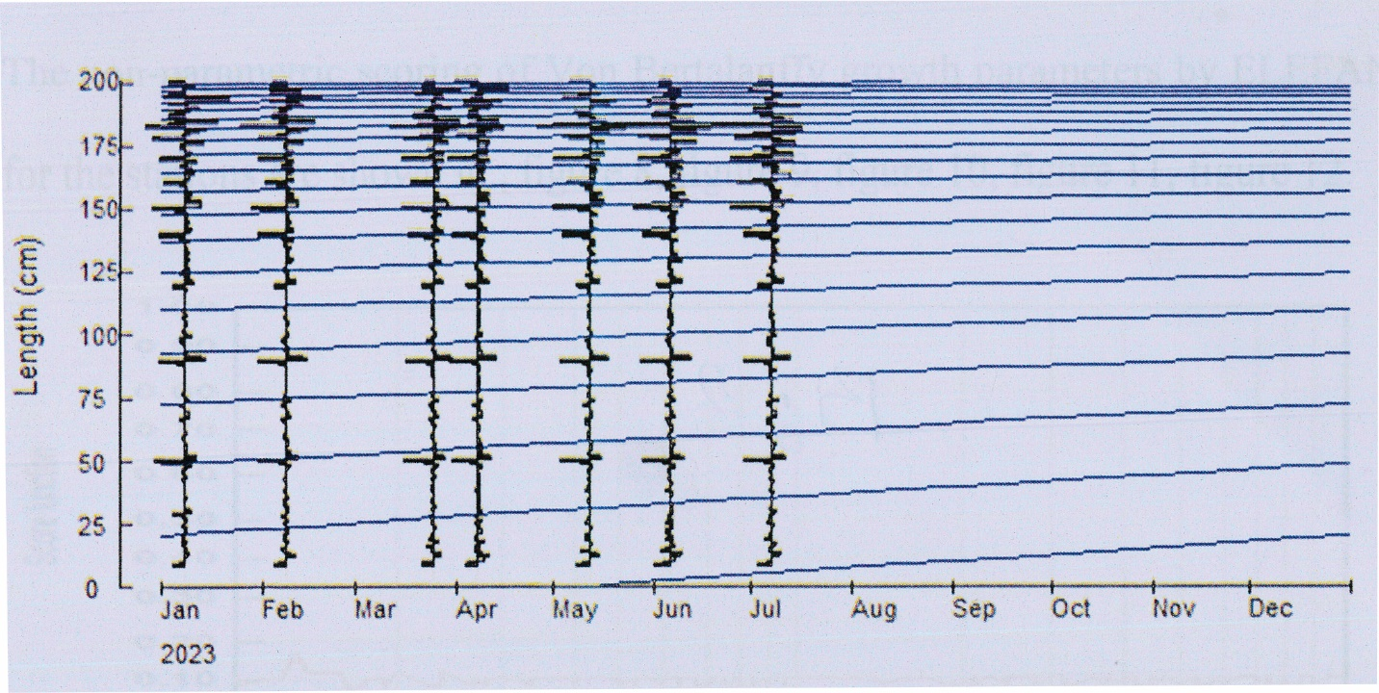
Fig. 2. ELEFAN II plot of G. niloticus in River Imo from January to July, 2023.

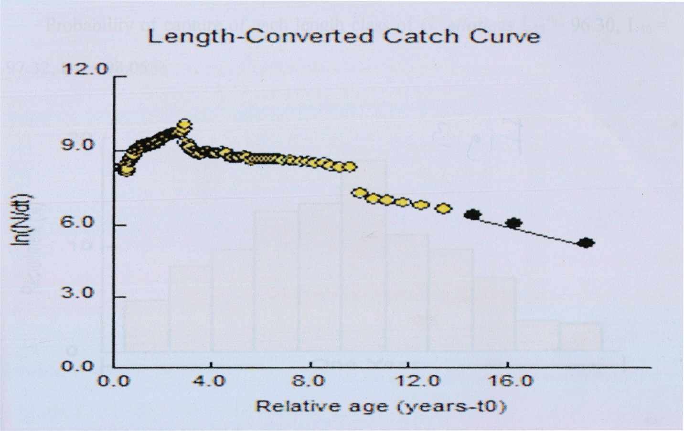

Fig. 3. Length-converted catch curve of G. niloticus in River Imo
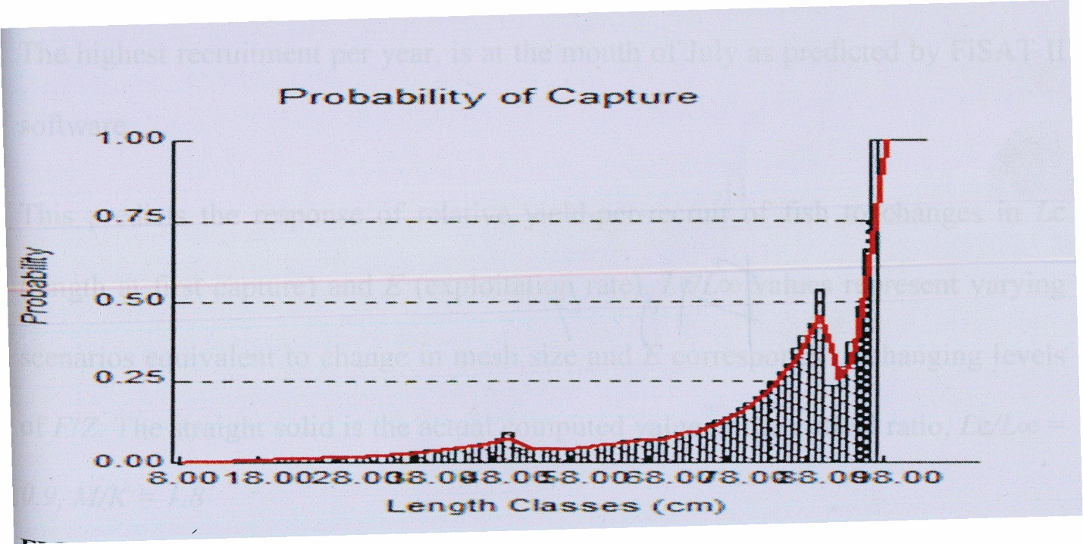
Fig. 4. Probability of capture of G. niloticus in River Imo

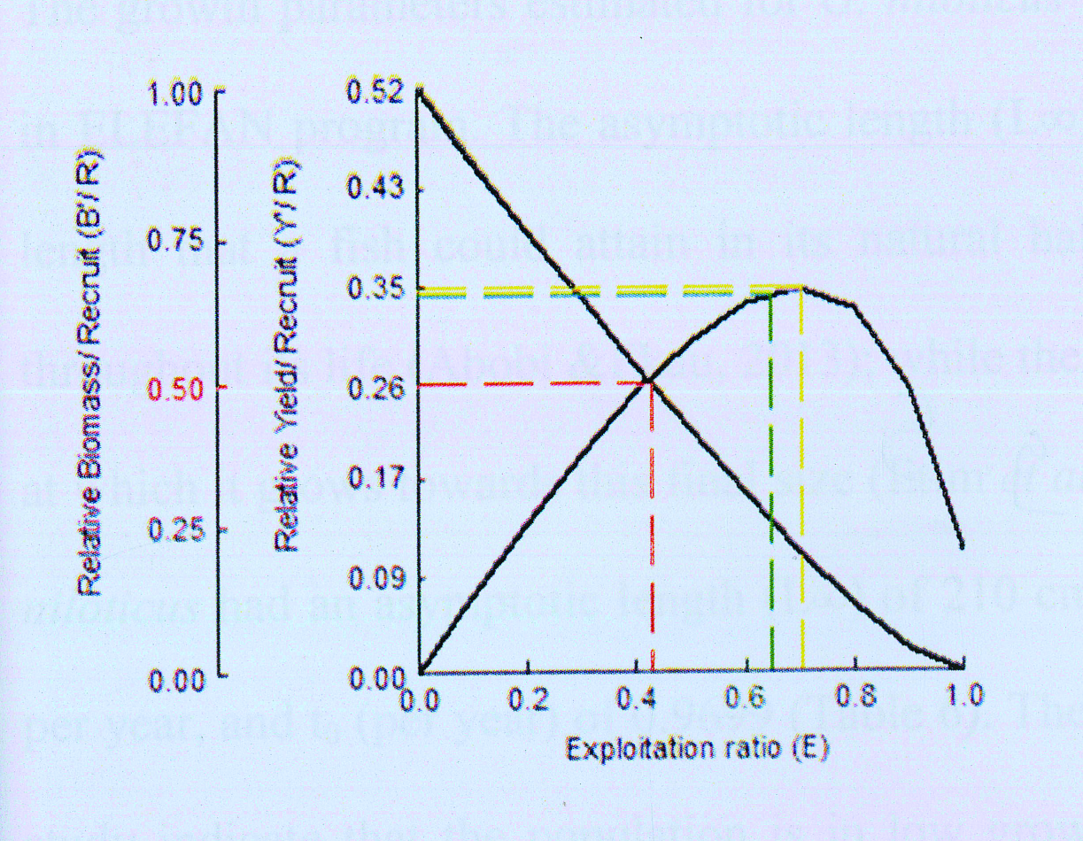
Fig. 5. Stock status of G. niloticus in River Imo

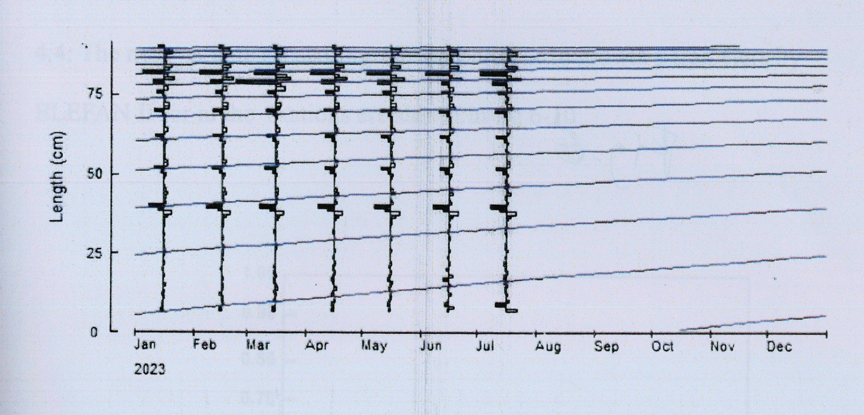
Fig. 6. ELEFAN II Plot of C. gariepinus in River Imo

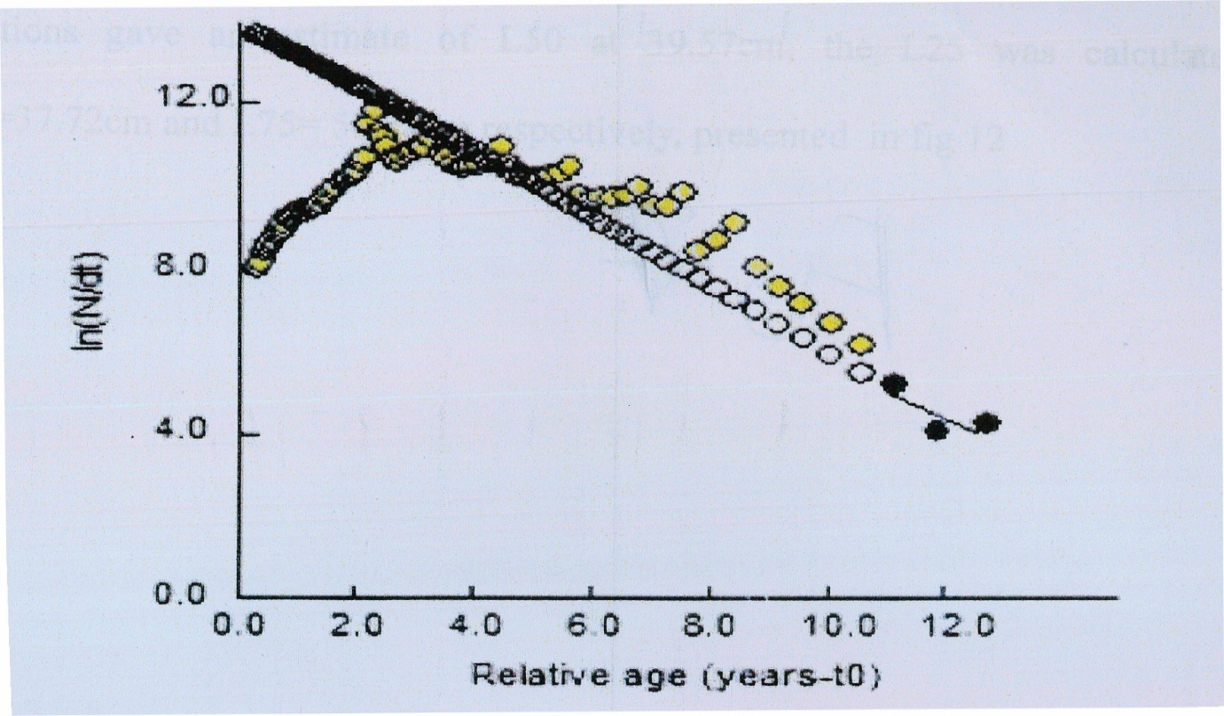
Fig.7. Length-converted catch curve of C. gariepinus in River Imo

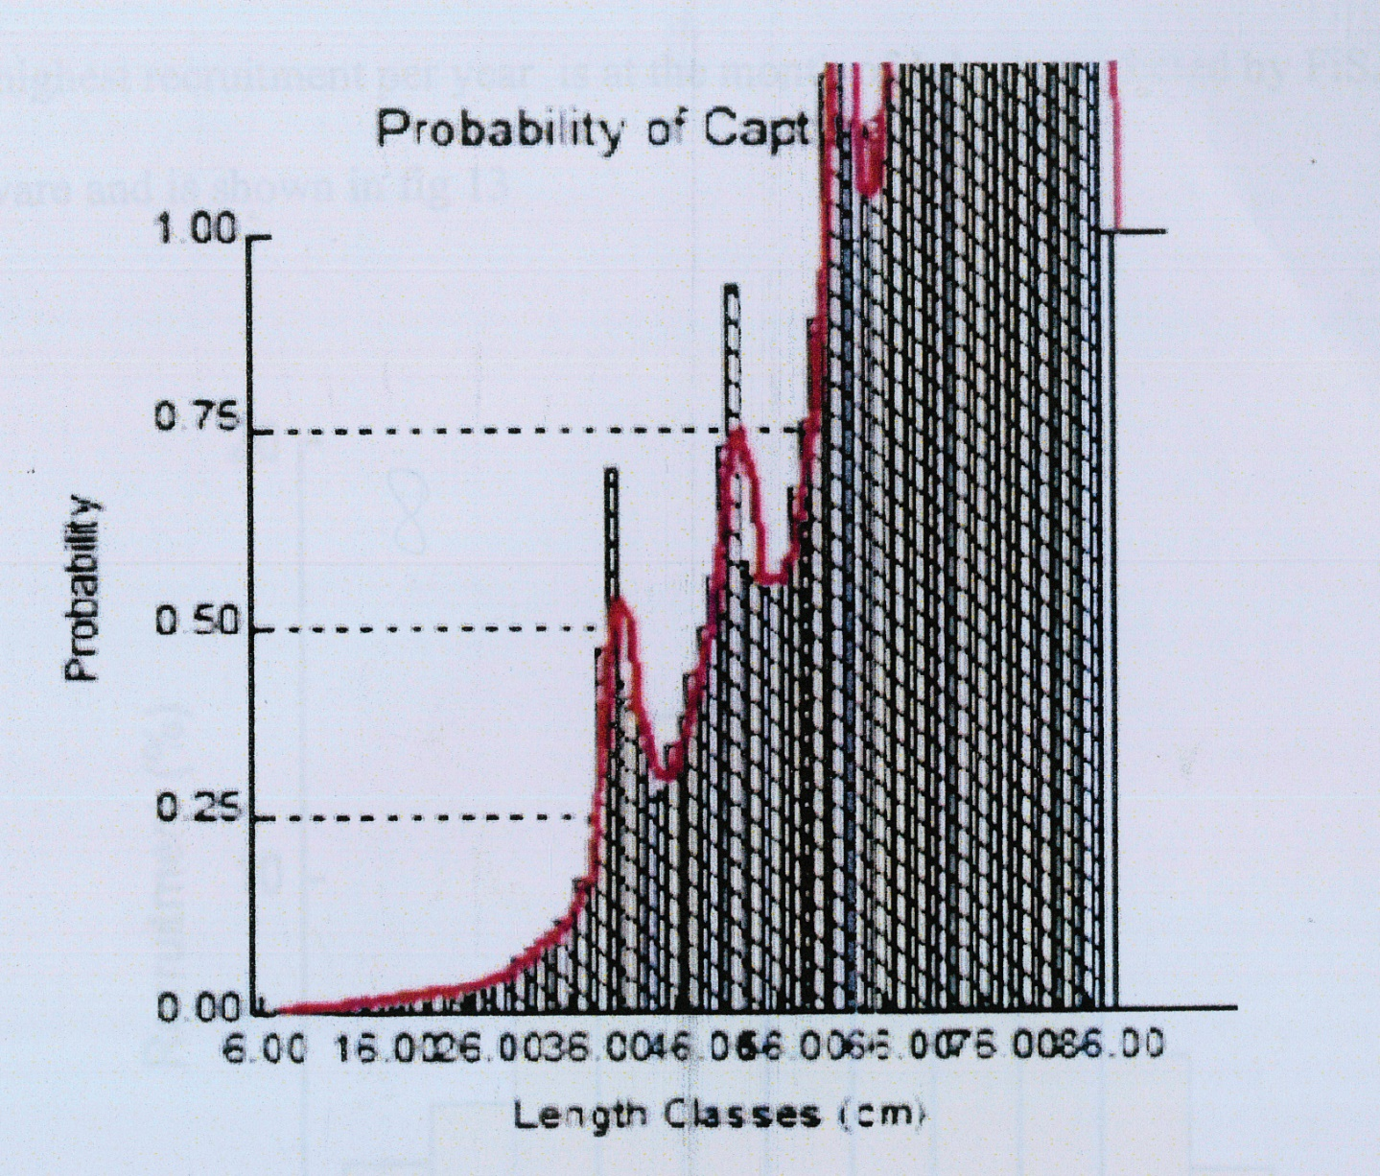
Fig.8. Probability of capture of C. gariepinus in River Imo

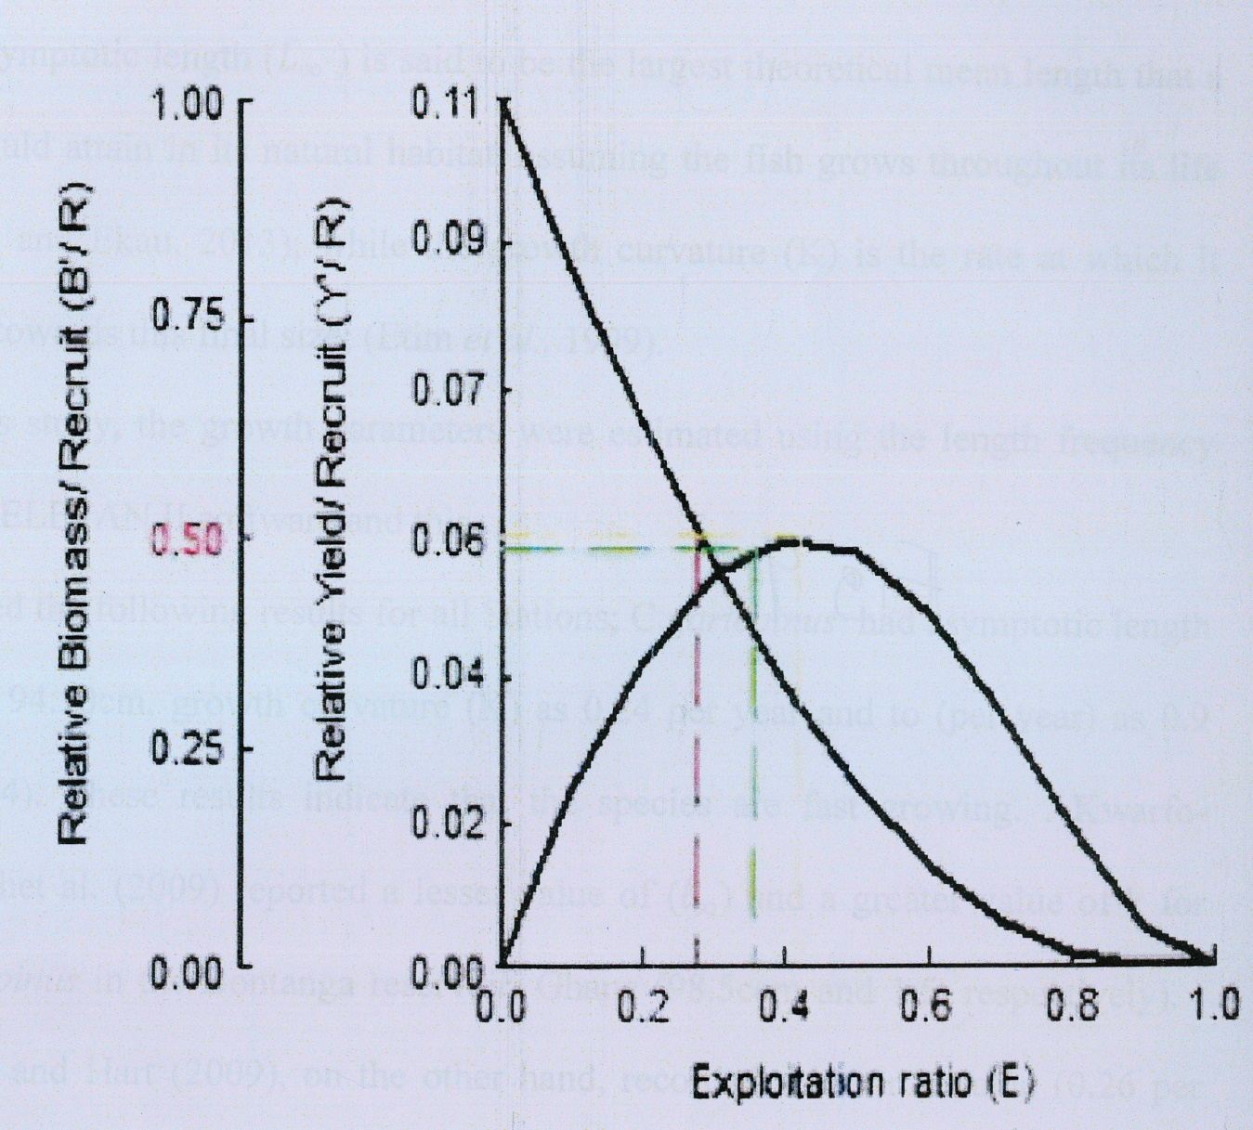
Fig.9. Stock status of C. gariepinus in River Imo

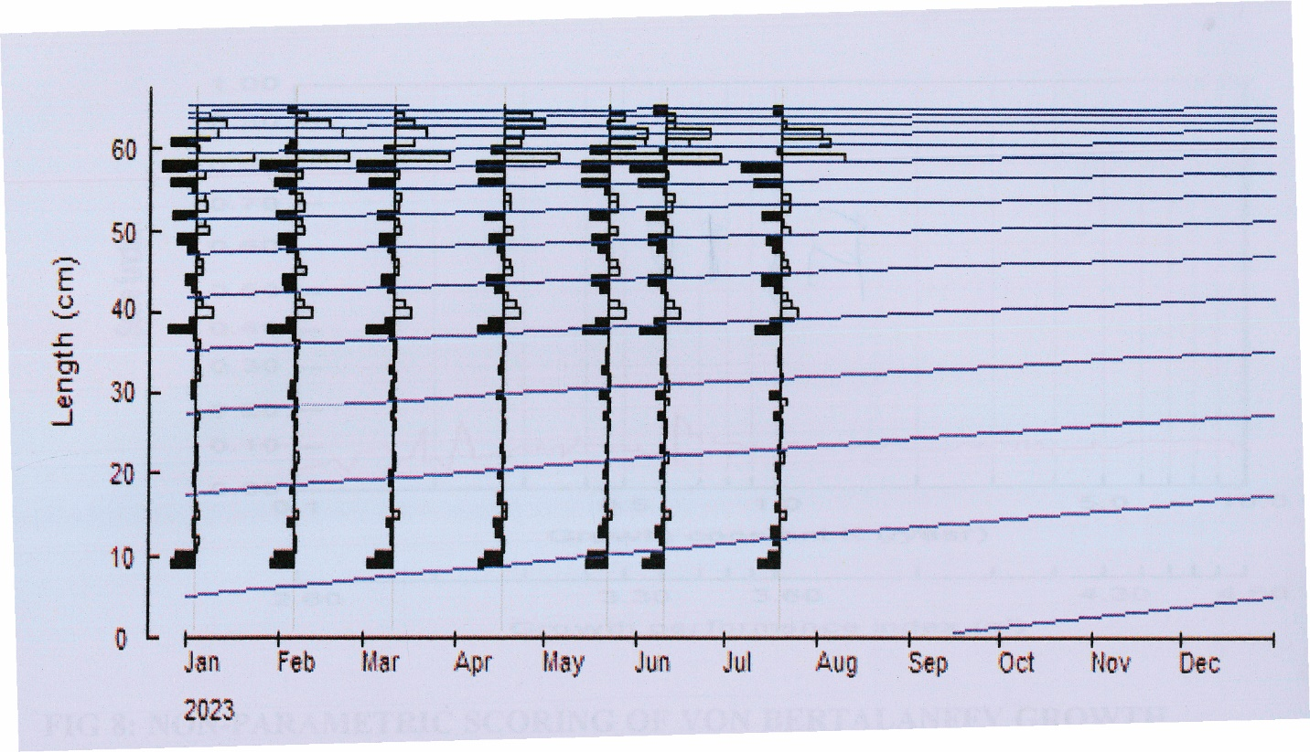

Fig. 10. ELEFAN II Pot of D. rostratus in River Imo from January to July , 2023

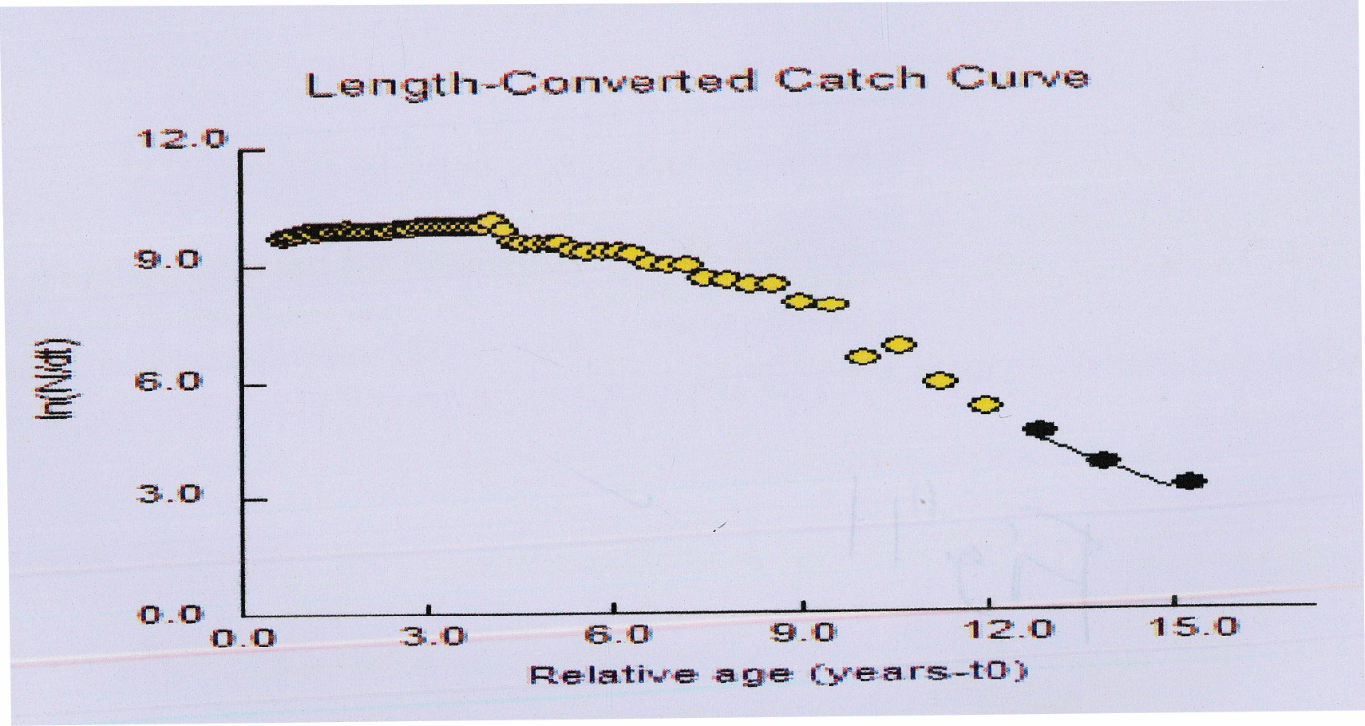

Fig. 11. Length-converted catch curve of D. rostratus in River Imo
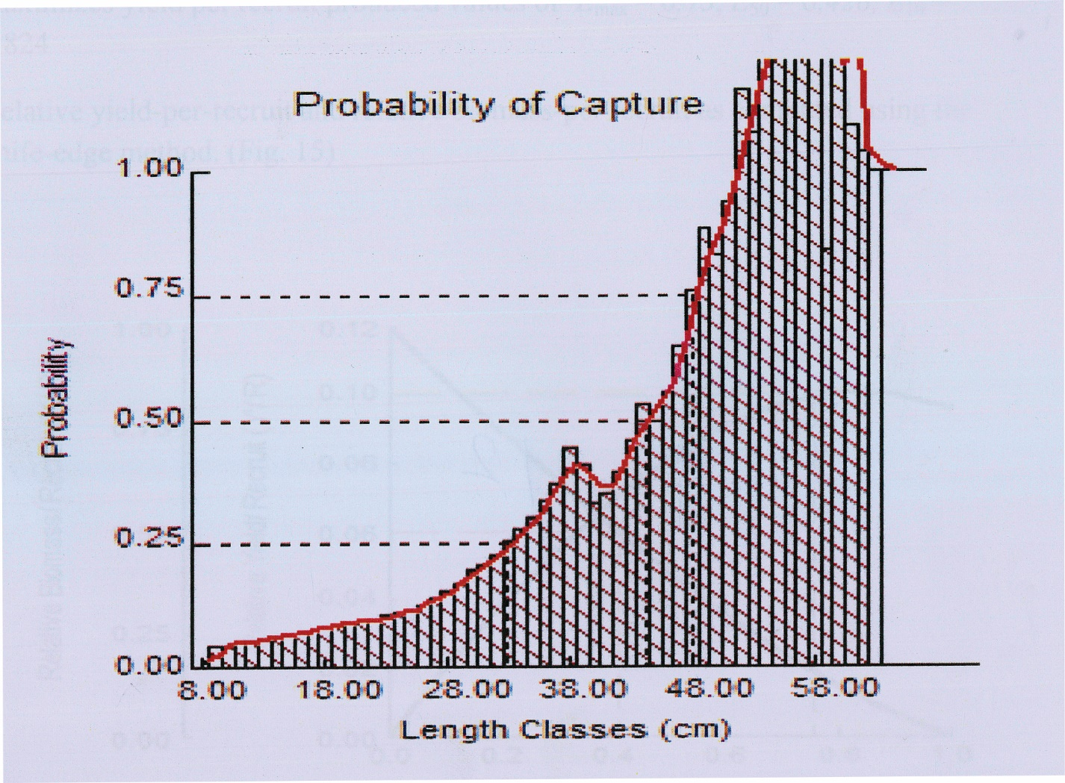
Fig.12. Probability of capture of D. rostratus in River Imo

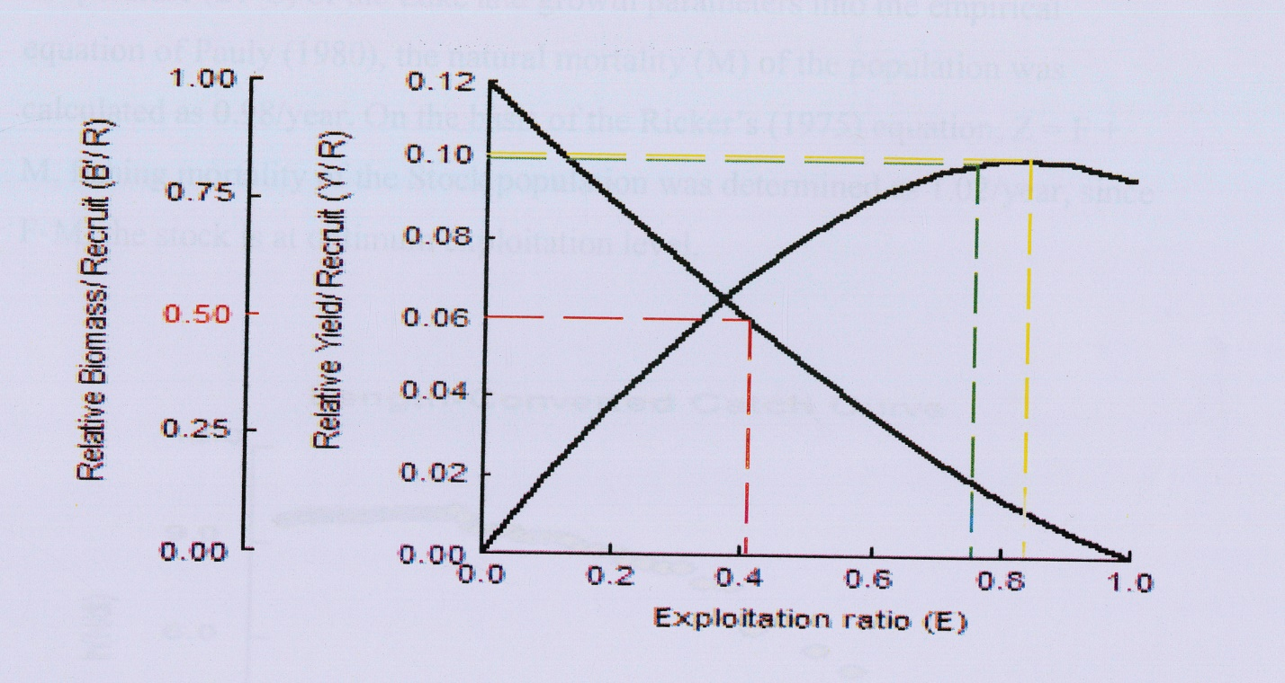
Fig. 13. Stock status of D. rostratus in River Imo

