Toad venom: A key component in the drug development with promising prospects

ABSTRACT

Toad venom, a complex mixture of bioactive molecules, has been utilized for centuries in traditional medicine due to its diverse pharmacological properties, including antimicrobial, antipyretic, and anticancer activities. Comprising biogenic amines, bufadienolides, steroids, and peptides, this natural secretion has shown promise in treating various disorders by ancient people. Recent studies substantiate its potential as a complementary therapeutic agent in combination with existing ones in the future, particularly in combating multidrug-resistant microbes. This review highlights the medicinal properties of specific toad venom components, demonstrating efficacy against congestive heart failure, atrial fibrillation, breast carcinoma, and improved circulation. Further research is warranted to harness the full potential of toad venom-derived compounds, offering prospects for developing novel, multifunctional drugs that surpass existing treatments.

Keywords: Toad, Toad Venom, Bufotoxins, Bufonidae, Bufo, Rhinella, Parotoid glands

- INTRODUCTION
Amphibians, serving as an evolutionary bridge between fish and higher tetrapods, possess unique skin secretions with significant pharmaceutical potential. Toads, specifically, have dry skin and rely on glandular secretions for defence against disease-causing pathogens(Xie et al., 2002). The Parotoid glands, large glands located adjacent to the tympanum, differ from the small prominences on multi-layered toad skin called warts, and produce a milky alkaloid substance known as Parotoid secretion, a neurotoxin that causes itchy irritations on human skin. Gland secretion is associated with defence against predators and microbes. If we consider defence against predators, these glands lack an inoculatory apparatus. Unlike active defence mechanisms, toads employ a passive mode of defence, where predators are poisoned through contact with toxins via biting or mouth exposure(Mailho-Fontana et al., 2018).
The Parotoid gland secretion, primarily composed of biogenic amines, bufadienolides (Figure 1. H), alkaloids, steroids, peptides and proteins (Figure 1. A)(Garg et al., 2007; Qi et al., 2018; Thirupathi. K et al., 2019), plays a crucial role in defence against predators and microbes. Those contents are responsible for antifungal, antibacterial, antioxidant, antiprotozoal, larvicidal, antidiabetic, anticancerous and other therapeutic properties. Hence, it had several numbers of traditional usages as discussed below.
Toad venom, known as Chansu in Chinese and Somso in Korean(Xie et al., 2002), has been utilized in traditional Chinese medicine (TCM) for centuries to treat various diseases. Modern studies have elucidated the molecular mechanisms supporting its use in cancer and inflammatory disease treatments(Qi et al., 2018). In China, toad venom is administered in diverse forms, including pills, powders, injections, liquids, oils, tinctures, etc. (Xie et al., 2002).
Due to these uses, toad venom remains important. Given the increasing research focus on toads and toad venom, this study aims to analyse the pharmacological applications of toad venom through a review of recent studies (primarily from 2000 onwards). Antimicrobial and antifungal studies from various toad species, such as Duttaphrynus melanostictus, Rhinella jimi, etc., will be examined.
- COLLECTION OF TOAD VENOM
The collection of toad venom is crucial for this research and medicinal purposes. Four primary methods are employed: electrical stimulation, chemical stimulation, skin harvesting(Govender et al., 2012) and applying pressure(de Medeiros et al., 2019). Electrical stimulation involves administering a mild shock of approximately 30V for 3 seconds, which does not harm the toads, but high voltage can be lethal. Chemical stimulation involves giving them chemicals or injecting norepinephrine to stimulate the parasympathetic system, but this method may result in the toad's death after several trials. Applying pressure is a gentler approach, where squeezing the gland carefully does not harm the animal. Skin harvesting, however, is not advisable as it is fatal (Govender et al., 2012). Toads face threats from predators and habitat destruction, making ethical considerations essential.
2.1 Extraction and Storage Methods:
After collection, the venom was stored on ice cubes to prevent protein degradation. The yield was typically low, requiring a large number of organisms which raising ethical concerns. Most studies utilize gentle pressure to extract toad venom. Mechanical shearing can mix highly viscous venom with distilled water(Garg et al., 2007). For the Parotoid gland studies, the gland will be removed and frozen immediately(Felsemburgh et al., 2013). Anuran skin’s glandular secretion is collected by manual stimulation(Trindade et al., 2014). To achieve the desired concentration, the venom can be mixed with distilled water and undergo further assessments(Gadelha et al., 2014). The same procedure applies to protein profile activities(Zahari et al., 2015).
Various storage methods exist. Toad venom can be treated with 70% ethanol, then lyophilized and refrigerated at 10°c after collection by applying pressure(Sales et al., 2017). Alternatively, crude extract can be pooled and undergo dialysis against distilled water for 48 h at 8°C by using 8000 Da cut-off membranes, followed by lyophilisation(Freitas et al., 2017). Later lyophilized, it is called protein from the gland can be used for experiments. Another approach involves preserving collected venom by lyophilizing at -20°C in the freezer at the venom banks(de Medeiros et al., 2019; Mariano et al., 2019).
Methanol treatment of Toad venom (50 mL for three days at room temperature) followed by lyophilisation is also effective(R. S. Oliveira et al., 2020). In addition to these methods, mild electric stimulation can stimulate toads and gentle pressing allows the production of venom(Schmeda-Hirschmann et al., 2020). Washing the dorsal surface with deionized water is better and storage is followed by steriflip filtration and lyophilisation at -86°C is recommended (Trindade et al., 2021). Instead of this, we can use the venom after the air has dried(Wells et al., 2022).
- COMPONENTS OF TOAD VENOM
Toad venom, specifically Parotoid gland secretion, comprises various bioactive compounds. These include peptides, indole alkaloids (Figure 1. C), bufogargarizanines (Figure 1. L), organic acids (Figure 1. B), steroids and others. The primary beneficial compounds are Indolealkylamines (Figure 1. D) and Bufadienolides. However, guanine alkaloids are found in species from the genus Atelopus; meanwhile, lipophilic alkaloids are detected in the genus Melanophryniscus(Rodríguez et al., 2017).
Moreover, toad venom contains derived steroids such as bufotoxins (Figure 1. P) and bufadienolides and biogenic amines like epinephrine (Figure 1. G), norepinephrine (Figure 1. I), serotonin (Figure 1. E), dehydrobufotenine (Figure 1. J) and bufotenine (Figure 1. F)(Gadelha et al., 2014). Additionally, peptides and proteins with antimicrobial and anticancerous properties have also been found in the intestinal tract of some Bufo species. The first pharmacologically active compound was found in the venom of Rhinella marina(Abel & Macht, 1912). However, some species produce more than a hundred steroidal compounds. Variation in feeding also influences the secretion composition(de Medeiros et al., 2019).
Cardiotonic steroids (CTS) were initially reported nearly 3000 years ago by ancient Egyptians (El-Seedi et al., 2022). Those are steroid hormones that circulate in the blood of amphibian species. Bufadienolides, a subgroup of Cardiotonic steroids, exhibit activity against congestive heart failure and atrial fibrillation(El-Seedi et al., 2022). Protein analysis of the toad venom of Anaxyrus boreas identified bufadienolides, including arenobufagin, gamabufotalin, and telocinobufagin (Barnhart et al., 2017). Compounds like resibufogenin, bufalin and gamabufotalin improve circulation by increasing myocardinal contractility, while cinobufagin (Figure 1. N) acts as a potent surface anaesthetic(Xie et al., 2002).
- PHARMACOLOGICAL USAGES
4.1 Traditional and Cultural Significance:
Toad species, primarily from the family Bufonidae, have been utilized in traditional medicine due to their Parotoid glands' significance in passive defence mechanism(Rodríguez et al., 2017; Sales et al., 2017). In Traditional Chinese Medicine (TCM), toad venom is called ‘Chansu’ and is used to cure pain and inflammation rather than using other medicines. In Chinese studies and trials, ‘Huachansu’, a Chinese medicine derived from dried toad venom of Bufo gargarizans or B. melanostictus, has demonstrated anti-cancerous properties with fewer side effects(Meng et al., 2009).
Due to the presence of Bioactive contents in Rhinella sp toads, it is reported to have been used in ancient culture in Peru(Schmeda-Hirschmann et al., 2020). Asian and American tribes have employed toad skin and Parotoid gland secretion of several common toads to treat various ailments, including haemorrhages, disorders of the skin, stomach issues, venomous animal stings and bites and also to cure cancers(Rodríguez et al., 2017). Furthermore, Multiple toad parts, for example, bones, belly, meat, venom, skin etc., mainly from bufonid species, are used for such treatments(Pradhan et al., 2014). Therefore, the cytotoxic, biomedical and curing potential of toad venom is vast.
4.2 Bioactive Compounds and Therapeutic Potential
Toad venom contains bioactive compounds with antimicrobial, anti-inflammatory, anticancerous, analgesic, and protease inhibitor activities, as well as neuromuscular effects. Studies have confirmed the anti-nociceptive effect of the protein fraction of Rhinella schneideri toad venom (Freitas et al., 2017). Additionally, toad venom can produce hallucinogenic effects (Qi et al., 2018). Mesoamerican people used a few toads as hallucinogens by licking their skin(Qi et al., 2018). However, infections and inflammations were reported in animals with toad venom. Higher concentrations of venom might cause macroscopic lesions in the liver, heart and other areas in both humans and animals(Gadelha et al., 2014). Therefore, Research focuses on understanding the components and properties of toad venom is essential to ensure safe usage.
4.3 Antimicrobial and Larvicidal Activities:
Research studies have been focusing on the components of toad venom to understand the reason behind its properties. It is essential to know about the contents before usage. In India, Bufo melanostictus, also called Duttaphrynus melanostictus (Figure 2. Q), is a very common species. Some studies have proved the antimicrobial activity of toad venom of this species against gram-negative bacilli Escherichia coli(Garg et al., 2007) and in other three different bacterial strains(Thirupathi. K et al., 2019). Former studies focused on MacConkey agar-based and Eosin methylene blue (EMB) agar-based assays and got results of growth restriction on the media after 24 hr incubation under 37°c. In later studies, bacterial strains were Escherichia coli, Klebsiella pneumonia, Proteous vulgaris and Staphylococcus aureus

PUBMED CID 176
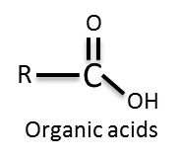

A
B
Organic acids
Peptides
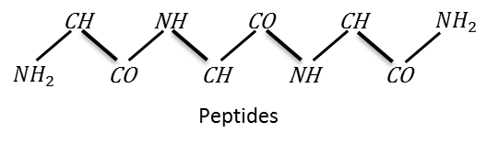

PUBMED CID 798
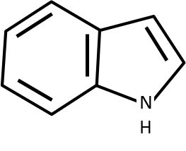

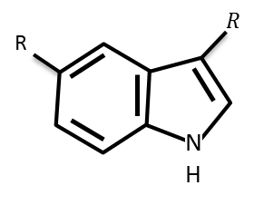
PUBMED CID 5202
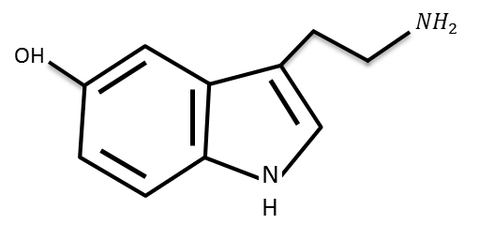
C
Indole alkaloids
Indolealkylamines
Serotonin
D
E

PUBMED CID 10257
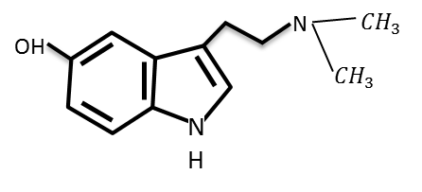
PUBMED CID 5816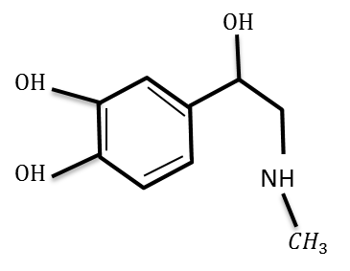

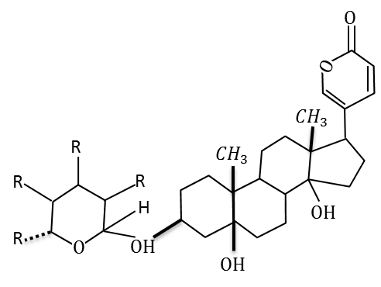
H
G
F
Epinephrine
Bufotenine
Bufadienolids

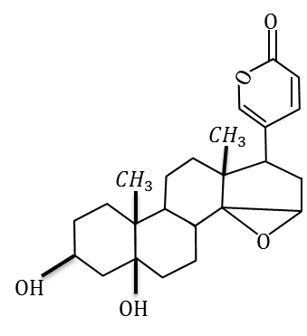
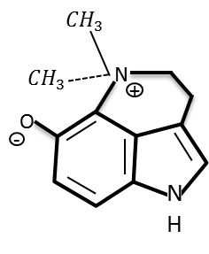
PUBMED CID 439260
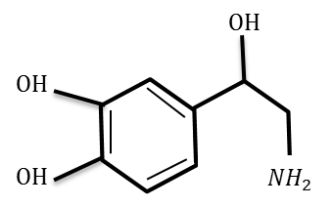
I
J
K
Marinobufagin
Dehydrobufotenine
Noradrenaline

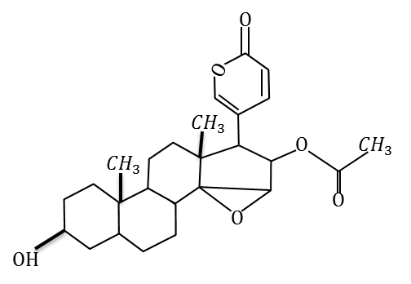
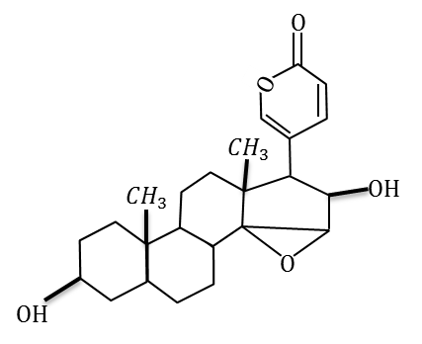
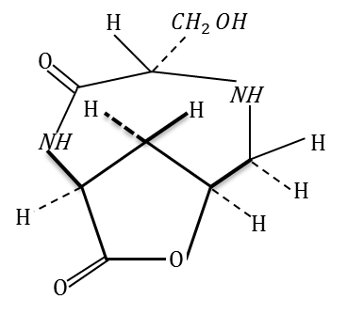
Cinobufagin
Bufogargarizanine B

Desacetylcinobufagin
M
N
L

PUBMED CID 43217
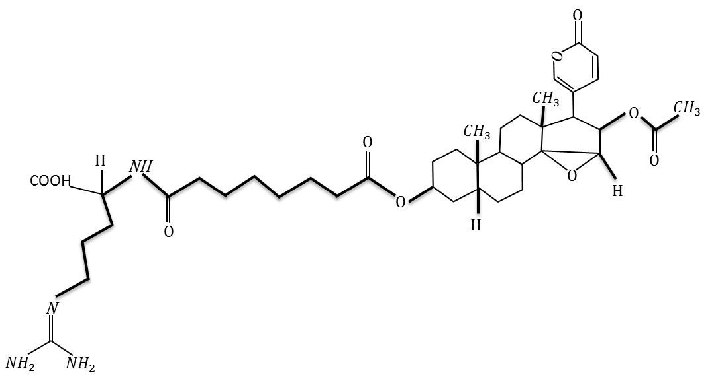
PUBMED CID 20054854
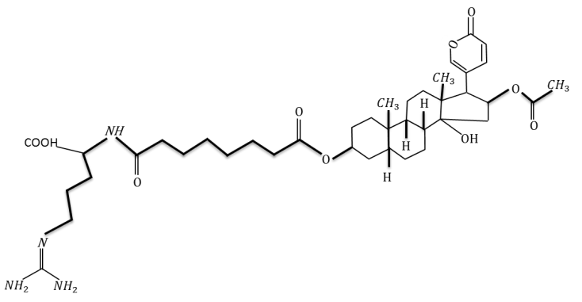

O
P
Cinobufotoxin
Bufotoxin

Figure 1: Components of toad venom. D was adopted from(Yu, 2008), H from(El-Seedi et al., 2022), J,K & N from(Qi et al., 2018) and L&M from(Wang et al., 2011)

and used the agar well diffusion method. The result obtained was 24-38mm of the zone of inhibition of toad venom, even the zone of inhibition of gland extract was 28-34mm.
The world is facing another menace from mosquitoes due to incremental stagnant water from different sectors. It plays the role of being an important vector of some diseases, including malaria, chikungunya etc. Chemical insecticides contribute to pollution. Hence studies have proven the effect of Rhinella marina and Rhaebo guttatus toad venom in larvicidal activity against Anopheles darlingi, a malaria vector(Trindade et al., 2021).
4.4 Antiplasmodial Potential and Insecticidal Effects and its Toxicity Studies:
The antiplasmodial potential was demonstrated in the Swiss albino mice by the venom of Bufonidae(Jo, 2021). In the same study, high concentrations of toad venom caused the death of mice by hyperactivity and other symptoms. Therefore, after a detailed investigation, there will be a chance to develop a drug that can effectively treat malaria. According to WHO, nearly 4.2 million cases and 3000 deaths have already occurred in 79 countries globally in 2023 due to Dengue. Therefore, finding out a potential multi-resistant drug is essential.
A similar insecticidal potential has been checked in cockroaches, in which the South American common toad Rhinella schneideri Parotoid secretion was used. Its venom can inhibit Acetylcholine esterase activity as well as induce less locomotion, depending upon the dose(Leal et al., 2020). Bioinsecticides have been researched very effectively due to fewer side effects. Moreover, the lack of proper use of chemical insecticides caused multi-resistant vectors(Hemingway et al., 2016). However, toad venom seems to show such insecticidal activities against mosquitoes.
As a part of evolution, pathogens are seen to be acquiring multiple resistance against a vast variety of drugs. Therefore, studies have revealed that toad venom is a potential source of drugs. In addition to anti-bacterial activity against multi-resistant bacterial strains, it could be used to treat infections effectively using combination with existing drugs(Sales et al., 2017). In that study, Rhinella jimi (Figure 2. R)(Jared et al., 2009) was used to study the toxicity level in Drosophila melanogaster and Artemia salina and in vitro model with the liver of mice(Sales et al., 2017). Scientists have been considering the Rhinella genus because of various properties of venom. Rhinella jimi (Stevaux,2002) venom has the ability can produce physio-pathological changes(Gadelha et al., 2014). In this study, clinical signs of toxicity were less, but necrosis, splenomegaly, lesions, internal bleeding, etc., in different parts of the body occurred in chicks during experiments.
4.5 Pharmacological Significance of Family Bufonidae
Family Bufonidae is scientifically significant due to the potential of the venom. Traditional medicines in America, China, Japan, Asia, etc., mostly belong to this group. Many studies have specified the pharmacologically important components belonging to the family Bufonidae (Freitas et al., 2017; Qi et al., 2018; Rodríguez et al., 2017; Zahari et al., 2015). The main components in skin and Parotoid secretion are alkaloids, bufadienolides, peptides, proteins, organic acids, steroids etc. These components exhibit properties like anticancerous, anti-inflammatory, anti-nociceptive(Freitas et al., 2017). Bufadienolides and bufotoxins inhibit the Na+/K+ ATPase pump in the heart muscle cells (Gadelha et al., 2014). Moreover, selective cytotoxicity of cancerous cells among normal cells and insignificant DNA damage has also been noticed (de Medeiros et al., 2019). Here, each component has its specific properties and effects (Qi et al., 2018).
4.6 Morphological, Biochemical Characterization & Identification of Bioactive Compounds
Years ago, toad venom was used in America, Asia and Europe as an ancient medicine to treat various diseases like HIV(Raquel Soares Oliveira et al., 2020). They use toads for hallucinogenic effects via licking(Davis & Weil, 1992), and later studies have proved that the effect is due to indolealkylamines (IAAs) in toad skin(Weil & Davis, 1994). It can be used for treating neuropsychiatric disorders(Qi et al., 2018). Ongoing studies in this field reveal the capacity of different species of toad venom. Morphological and biochemical characterizations have been also done by several studies(Mailho-Fontana et al., 2018). Here, Parotoid glands are distinguishable from other glands in their irregularly structured dorsal skin due to size. The internal longitudinal view of the Parotoid gland is a honeycomb structure with secretory units. The gland has a dense syncytium with fewer nuclei which also has three layered Structures(Mailho-Fontana et al., 2018). Those are the external layer, internal layer and central portion. Using the HPLC-MS/MS technique, 55 compounds were isolated and identified from Rhinella horribilis venom for the first time(Schmeda-Hirschmann et al., 2020).
High chemical complexity venom of Rhinella marina contains two steroids below 10 kDa namely marinobufagin (Figure 1. K) and desacetylcinobufagin (Figure 1. M)(de Medeiros et al., 2019). Biological activities such as anti-microbial assay, Anti- parasitic activity, Leishmanicidal Assay, In Vitro Antitumoral Assays, MTT Assay, Comet Assay, Mutagenesis in Saccharomyces cerevisiae, and various In Vivo Assays in mice have been performed of crude and/or fraction(de Medeiros et al., 2019) and the results were favourable. The De novo peptide analysis result was striking due to the ability related to apoptosis, catalysis, cellular structures and transport processes in Duttaphrynus melanostictus(Mariano et al., 2019). Such component identification studies helped to understand the properties and biological as well as physiological roles of glands.
4. 7 Therapeutic Potential of Toad Venom in Rhinella and Bufo genus:
In Bufonidae, the Rhinella genus is a highly studied genus, evident from previous studies. Species from this genus have specific properties. For instance, four chromatographic fractions of Rhinella icterica Parotoid secretion can inhibit junctional acetylcholinesterase (AChE) activity(R. S. Oliveira et al., 2020). Progressively, it leads to neuronal Na+/K+-ATPase inhibition and neuromuscular blockage. In addition, stoppage of voltage-dependent Ca2+ channels occurs in chick biventer cervicis neuromuscular preparations. R. horribilis Parotoid secretion has inhibited the proliferation and migration of the A549 lung cancer cell line and etoposide-induced apoptosis(Schmeda-Hirschmann et al., 2020). Rhinella marina’s venom has the antimalarial property tested against Plasmodium falciparum in laboratory conditions(Wells et al., 2022). Crude extracts of Parotoid gland secretions (PGS) of Rhaebo guttatus and R.marina showed toxic effects on rat breast carcinoma (A. F. D. Oliveira et al., 2019) and Bufo relgularis (Figure 2. S(Conradie et al., 2015)) venom against Ehrlich ascites carcinoma (EAC) bearing mice (El-Naggar et al., 2023).
A nitrogen-containing substance called marinobufotoxin from Bufo marinus which is chemically related to cinobufotoxin (Figure 1. O (Jensen & Chen, 1930)), exhibits Pharmacological activities exactly similar to cinobufotoxin. All these studies have proved the enormous potential of toads in various therapeutic fields than the existing ones(Ibarra-Vega et al., 2023). The huge range of anti-microbial properties of toad venom is demanding, especially since we have been facing a potential problem of ‘multidrug resistance’. Another study dealt with the uncontrolled growth of cane toads (Bufo marinus )in Australia and how were they destructive in the community(Phillips et al., 2007). Initially, cane toads were useful to control pests in agricultural fields, but they now turned into a threat to other species due to less number of predators and a fast reproduction rate (Phillips et al., 2007). It means that we can use them for good without affecting the ecosystem.
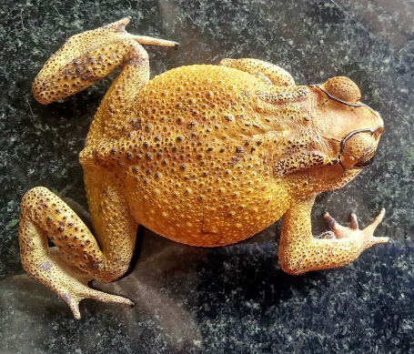  Q | 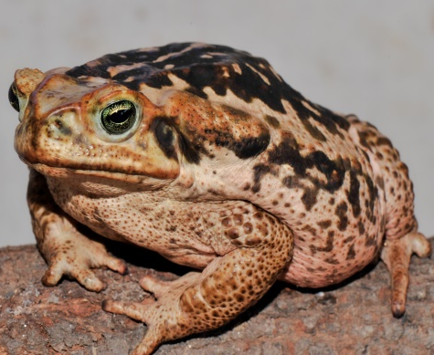  R | 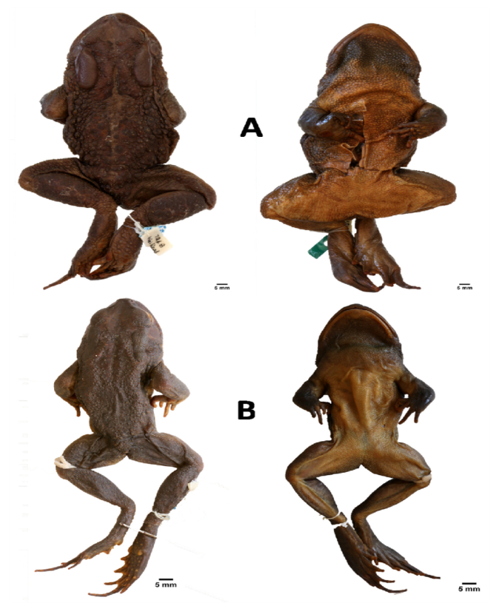  S
Duttaphrynus melanostictus | Rhinella jimi | Bufo regularis

Figure 2: Few species of toads
4.8 Beyond Venom: Exploring Toad Gut Microbiota and Future Directions
The complex composition of chemicals, which is unique to each species, and the complex mechanism to avoid diseases and microbes possibly controlled by environmental factors underlie the potential of toad venom (R. S. Oliveira et al., 2020). Recent technological advancements have enabled the development of techniques to reduce the proliferation of tumours. Cancer seems to take more lives than ever before. Cisplatin (Cis) is the most commonly used drug for cancer. Given the limitations of existing cancer treatments, such as cisplatin (Cis), which has adverse side effects, including both allergic reactions and kidney problems(Aldossary, 2019). Therefore, toad venom offers a promising avenue for effective cancer treatment.
Duttaphrynus melanostictus has an unique reservoir of chitinolytic bacteria in the gut, indicating potential therapeutic applications (Dhole et al., 2022). The waste of the seafood production industry is vast. The main component of this kind of waste is chitin, an insoluble bio-polysaccharide. This discovery is particularly significant in addressing the vast waste generated by the seafood production industry, primarily composed of chitin(Dhole et al., 2022). Hence, the gut microbiota of D. melanostictus is helpful to mitigate the situation. This study highlights the potential of toads beyond their venom, demonstrating the breadth of their therapeutic applications.
- RESEARCH CHALLENGES AND LIMITATIONS
Research on toad species is not easy, which poses significant challenges encompassing both ethical and methodological issues, from collection to experimentation. Today, Numerous toad species are under threat. According to the National Wildlife Federation, several toad species are listed as endangered category due to habitat destruction and invasive species. Environmental pollution exacerbates this issue(Lötters et al., 2023), damaging their skin and inhibiting respiration.
5.1 Ethical Considerations
Therefore, the primary concern is ethical, emphasizing the need for researchers to obtain ethical clearance from conservation organizations. Large-scale species collection can disrupt other species and ecosystems. Toads are seen to play crucial roles as controllers of the population of lower prey species as well as being food for predators(Jared et al., 2020). Hence, toads play a significant role in the ecosystem. Their removal can have far-reaching consequences.
5.2 Methodological Challenges
Another problem is the preservation of toads. Toads are extremely sensitive animals, requiring natural conditions to thrive. That means it cannot be grown in laboratory conditions. Moreover, long-term live specimen preservation is not feasible for long-term studies. Venom collection is another hurdle, yielding minimal quantities from individual toads when compared to the venom from other species. To do experiments, this is not enough. This necessitates repeated collections, increasing the risk of harm to the toads.
Three main methods primary methods exist to collect venom. Those are manual stimulation by applying pressure, chemical stimulation by chemical or by the nervous system and skin harvesting. While manual stimulation is harmless, the other two are harmful and probably kill the toads (Govender et al., 2012). And the lack of proper equipment is another issue, highlighting the need for innovative solutions. In conclusion, researching toad species requires careful consideration of ethical and methodological challenges. Addressing these concerns is crucial for advancing our understanding of these ecologically vital species and unlocking their potential therapeutic applications
- CONCLUSION
The cumulative evidence from various studies unequivocally demonstrates the capability of toad venom as a therapeutic agent. Nowadays, natural products have been receiving more attention than ever before in this field as the world grapples with the escalating issue of multidrug-resistant microorganisms. Hence, scientists are working hard to find a potential solution. Toad venom, particularly from the Genus Rhinella and Bufo, has been extensively investigated, revealing a broad spectrum of pharmacological activities, including anti-bacterial, antiplasmodial, Leishmanicidal, larvicidal, anticancerous, and insecticidal, and other pharmacologically important assays have been performed in mice, bacteria, etc. Furthermore, the microbiota present in the intestine of toads has been found to possess polysaccharide-degrading capabilities, underscoring their potential to address various biomedical challenges
Collection of Parotoid secretion can be done by four methods. In which the application of pressure by squeezing is the safest approach. Despite the promising prospects, ethical concerns surrounding amphibian research remain paramount. As ecosystem stabilisers, amphibians play a vital role, necessitating ethical clearance for continued studies. The sensitivity of these animals renders long-term laboratory preservation impossible, highlighting the need for careful consideration.
A vast variety of potentials led the toads to become a pharmacologically important organism, the compelling solution to overcome multidrug-resistant bacterial strains. To overcome multi-resistant bacterial strains, we need a potential drug. While detailed investigations are required to mitigate toxicity concerns at higher concentrations.
- DISCLAIMER (ARTIFICIAL INTELLIGENCE)
Author(s) hereby declare that NO generative AI technologies such as Large Language Models (ChatGPT, COPILOT, etc.) and text-to-image generators have been used during the writing or editing of this manuscript.
REFERENCES
Abel, J. J., & Macht, D. I. (1912). Two Crystalline Pharmacological Agents Obtained from the Tropical Toad, Bufo Agua. Journal of Pharmacology and Experimental Therapeutics, 3(3), 319–377.
Aldossary, S. A. (2019). Review on Pharmacology of Cisplatin: Clinical Use, Toxicity and Mechanism of Resistance of Cisplatin. Biomedical and Pharmacology Journal, 12(1), 07–15. https://doi.org/10.13005/bpj/1608
Barnhart, K., Forman, M. E., Umile, T. P., Kueneman, J., McKenzie, V., Salinas, I., Minbiole, K. P. C., & Woodhams, D. C. (2017). Identification of Bufadienolides from the Boreal Toad, Anaxyrus boreas, Active Against a Fungal Pathogen. Microbial Ecology, 74(4), 990–1000. https://doi.org/10.1007/s00248-017-0997-8
Conradie, W., Branch, W. R., & Watson, G. (2015). Type specimens in the Port Elizabeth Museum, South Africa, including the historically important Albany Museum collection. Part 1: Amphibians. Zootaxa, 3936(1), 42–70. https://doi.org/10.11646/zootaxa.3936.1.2
Davis, W., & Weil, A. T. (1992). Identity of a New World Psychoactive Toad. Ancient Mesoamerica, 3(1), 51–59.
de Medeiros, D. S. S., Rego, T. B., Dos Santos, A. P. de A., Pontes, A. S., Moreira-Dill, L. S., Matos, N. B., Zuliani, J. P., Stábeli, R. G., Teles, C. B. G., Soares, A. M., Sperotto, A. R. de M., Moura, D. J., Saffi, J., Caldeira, C. A. da S., Pimenta, D. C., & Calderon, L. A. (2019). Biochemical and Biological Profile of Parotoid Secretion of the Amazonian Rhinella marina (Anura: Bufonidae). BioMed Research International, 2019, 2492315. https://doi.org/10.1155/2019/2492315
Dhole, N. P., Phuge, S., Dar, M. A., & Pandit, R. S. (2022). Screening of chitin degrading bacteria from the gut of Asian common toad Duttaphrynus melanostictus: Implication for valorization of chitin rich seafood waste. Environmental Technology & Innovation, 28, 102929. https://doi.org/10.1016/j.eti.2022.102929
El-Naggar, S., Basyony, M., El-Feki, S., & Kandyel, R. (2023). Parotoid gland secretions of the Egyptian toad (Bufo relgularis): In vivo antitumor effect on Ehrlich ascites carcinoma bearing mice. Journal of Bioscience and Applied Research, 9, 33–45. https://doi.org/10.21608/jbaar.2023.284928
El-Seedi, H. R., Yosri, N., El-Aarag, B., Mahmoud, S. H., Zayed, A., Du, M., Saeed, A., Musharraf, S. G., El-Garawani, I. M., Habib, M. R., Tahir, H. E., Hegab, M. M., Zou, X., Guo, Z., Efferth, T., & Khalifa, S. A. M. (2022). Chemistry and the Potential Antiviral, Anticancer, and Anti-Inflammatory Activities of Cardiotonic Steroids Derived from Toads. Molecules (Basel, Switzerland), 27(19), 6586. https://doi.org/10.3390/molecules27196586
Felsemburgh, F. A., Siqueira-Francisco, J., Branco, M. T. L., Almeida, M. V. M. D., Ferreira-Pereira, A., & Brito-Gitirana, L. D. (2013). The Parotoid Gland Secretion of Bufonids Inhibits the Activity of the Multidrug Resistance Target Pdr5p from Yeast Plasma Membranes. Annual Research & Review in Biology, 4(2), 378–391. https://doi.org/10.9734/ARRB/2014/4066
Freitas, C. D. T. D., Sousa-Filho, L. M., Lima, M. S. C. S., Pereira, A. C. T. C., Ferreira, G. P., Lopes, F. E. S., Silva, R. O., Barbosa, A. L. D. R., & Oliveira, J. S. D. (2017). Proteins from the Rhinella schneideri parotoid gland secretion exhibit anti-nociceptive effect against nociception induced by inflammation. Biomedicine & Pharmacotherapy, 93, 705–708. https://doi.org/10.1016/j.biopha.2017.06.104
Gadelha, I. C. N., de Lima, J. M., Batista, J. S., Melo, M. M., & Soto-Blanco, B. (2014). Toxicity effects of toad (Rhinella jimi Stevaux, 2002) venom in chicken (Gallus gallus domesticus). TheScientificWorldJournal, 2014, 851473. https://doi.org/10.1155/2014/851473
Garg, A. D., Kanitkar, D. V., Hippargi, R. V., & Gandhare, A. N. (2007). Antimicrobial activity of skin secretions isolated from Indian toad, Bufo melanostictus Schneider 1799. Nature Precedings. https://doi.org/10.1038/npre.2007.1204.1
Govender, T., Dawood, A., Esterhuyse, A. J., & Katerere, D. R. (2012). Antimicrobial properties of the skin secretions of frogs. South African Journal of Science, 108(5/6), 6 Pages. https://doi.org/10.4102/sajs.v108i5/6.795
Hemingway, J., Ranson, H., Magill, A., Kolaczinski, J., Fornadel, C., Gimnig, J., Coetzee, M., Simard, F., Roch, D. K., Hinzoumbe, C. K., Pickett, J., Schellenberg, D., Gething, P., Hoppé, M., & Hamon, N. (2016). Averting a malaria disaster: Will insecticide resistance derail malaria control? The Lancet, 387(10029), 1785–1788. https://doi.org/10.1016/S0140-6736(15)00417-1
Ibarra-Vega, R., Galván-Hernández, A. R., Salazar-Monge, H., Zataraín-Palacios, R., García-Villalvazo, P. E., Zavalza-Galvez, D. I., Valdez-Velazquez, L. L., & Jiménez-Vargas, J. M. (2023). Antimicrobial Compounds from Skin Secretions of Species That Belong to the Bufonidae Family. Toxins, 15(2), 145. https://doi.org/10.3390/toxins15020145
Jared, C., Alexandre, C., Mailho-Fontana, P. L., Pimenta, D. C., Brodie, E. D., & Antoniazzi, M. M. (2020). Toads prey upon scorpions and are resistant to their venom: A biological and ecological approach to scorpionism. Toxicon, 178, 4–7. https://doi.org/10.1016/j.toxicon.2020.02.013
Jared, C., Antoniazzi, M. M., Jordão, A. E. C., Silva, J. R. M. C., Greven, H., & Rodrigues, M. T. (2009). Parotoid macroglands in toad (Rhinella jimi): Their structure and functioning in passive defence. Toxicon, 54(3), 197–207. https://doi.org/10.1016/j.toxicon.2009.03.029
Jensen, H., & Chen, K. K. (1930). CHEMICAL STUDIES ON TOAD POISONS. Journal of Biological Chemistry, 87(3), 755–759. https://doi.org/10.1016/S0021-9258(18)76850-6
Jo, A. (2021). The Antiplasmodial Activities of Bufonidae (Toad) Venom Crude Extract on Plasmodium Berghei in Swiss Albino Mice. Open Access Journal of Biogeneric Science and Research, 8(2). https://doi.org/10.46718/JBGSR.2021.08.000190
Leal, A., Karnopp, E., Barreto, Y. C., Oliveira, R. S., Rosa, M. E., Borges, B. T., Goulart, F. L., Souza, V. Q. D., Laikowski, M. M., Moura, S., Vinadé, L., Rocha, J. B. T. D., & Dal Belo, C. A. (2020). The Insecticidal Activity of Rhinella schneideri (Werner, 1894) Paratoid Secretion in Nauphoeta cinerea Cocroaches. Toxins, 12(10), 630. https://doi.org/10.3390/toxins12100630
Lötters, S., Plewnia, A., Catenazzi, A., Neam, K., Acosta-Galvis, A. R., Alarcon Vela, Y., Allen, J. P., Alfaro Segundo, J. O., De Lourdes Almendáriz Cabezas, A., Alvarado Barboza, G., Alves-Silva, K. R., Anganoy-Criollo, M., Arbeláez Ortiz, E., Arpi Lojano, J. D., Arteaga, A., Ballestas, O., Barrera Moscoso, D., Barros-Castañeda, J. D., Batista, A., … La Marca, E. (2023). Ongoing harlequin toad declines suggest the amphibian extinction crisis is still an emergency. Communications Earth & Environment, 4(1), 412. https://doi.org/10.1038/s43247-023-01069-w
Mailho-Fontana, P. L., Antoniazzi, M. M., Sciani, J. M., Pimenta, D. C., Barbaro, K. C., & Jared, C. (2018). Morphological and biochemical characterization of the cutaneous poison glands in toads (Rhinella marina group) from different environments. Frontiers in Zoology, 15, 46. https://doi.org/10.1186/s12983-018-0294-5
Mariano, D. O. C., Messias, M. D. G., Spencer, P. J., & Pimenta, D. C. (2019). Protein identification from the parotoid macrogland secretion of Duttaphrynus melanostictus. Journal of Venomous Animals and Toxins Including Tropical Diseases, 25, e20190029. https://doi.org/10.1590/1678-9199-jvatitd-2019-0029
Meng, Z., Yang, P., Shen, Y., Bei, W., Zhang, Y., Ge, Y., Newman, R. A., Cohen, L., Liu, L., Thornton, B., Chang, D. Z., Liao, Z., & Kurzrock, R. (2009). Pilot study of huachansu in patients with hepatocellular carcinoma, nonsmall-cell lung cancer, or pancreatic cancer. Cancer, 115(22), 5309–5318. https://doi.org/10.1002/cncr.24602
Oliveira, A. F. D., Castoldi, L., Vieira Junior, G. M., Monção Filho, E. D. S., Chaves, M. H., Rodrigues, D. D. J., & Sugui, M. M. (2019). Evaluation of antimutagenic and cytotoxic activity of skin secretion extract of Rhinella marina and Rhaebo guttatus (Anura, Bufonidae). Acta Amazonica, 49(2), 145–151. https://doi.org/10.1590/1809-4392201801751
Oliveira, R. S., Borges, B. T., Leal, A. P., Lailowski, M. M., Bordon, K. D. C. F., Souza, V. Q. D., Vinadé, L., Santos, T. G. D., Hyslop, S., Moura, S., Arantes, E. C., Corrado, A. P., & Dal Belo, C. A. (2020). Chemical and Pharmacological Screening of Rhinella icterica (Spix 1824) Toad Parotoid Secretion in Avian Preparations. Toxins, 12(6), 396. https://doi.org/10.3390/toxins12060396
Phillips, B. L., Brown, G. P., Greenlees, M., Webb, J. K., & Shine, R. (2007). Rapid expansion of the cane toad ( Bufo marinus ) invasion front in tropical Australia. Austral Ecology, 32(2), 169–176. https://doi.org/10.1111/j.1442-9993.2007.01664.x
Pradhan, S., Mishra, D., & Sahu, K. ram. (2014). Herpetofauna used as traditional medicine by tribes of Gandhamardan Hills Range, Western Orissa, India. International Journal of Research in Zoology, 4, 32–35.
Qi, J., Zulfiker, A., Li, C., Good, D., & Wei, M. (2018). The Development of Toad Toxins as Potential Therapeutic Agents. Toxins, 10(8), 336. https://doi.org/10.3390/toxins10080336
Rodríguez, C., Rollins-Smith, L., Ibáñez, R., Durant-Archibold, A. A., & Gutiérrez, M. (2017). Toxins and pharmacologically active compounds from species of the family Bufonidae (Amphibia, Anura). Journal of Ethnopharmacology, 198, 235–254. https://doi.org/10.1016/j.jep.2016.12.021
Sales, D. L., Morais-Braga, M. F. B., Santos, A. T. L. D., Machado, A. J. T., Araujo Filho, J. A. D., Dias, D. D. Q., Cunha, F. A. B. D., Saraiva, R. D. A., Menezes, I. R. A. D., Coutinho, H. D. M., Costa, J. G. M., Ferreira, F. S., Alves, R. R. D. N., & Almeida, W. D. O. (2017). Antibacterial, modulatory activity of antibiotics and toxicity from Rhinella jimi (Stevaux, 2002) (Anura: Bufonidae) glandular secretions. Biomedicine & Pharmacotherapy, 92, 554–561. https://doi.org/10.1016/j.biopha.2017.05.098
Schmeda-Hirschmann, G., De Andrade, J. P., Soto-Vasquez, M. R., Alvarado-García, P. A. A., Palominos, C., Fuentes-Retamal, S., Mellado, M., Correa, P., & Urra, F. A. (2020). The Parotoid Gland Secretion from Peruvian Toad Rhinella horribilis (Wiegmann, 1833): Chemical Composition and Effect on the Proliferation and Migration of Lung Cancer Cells. Toxins, 12(9), 608. https://doi.org/10.3390/toxins12090608
Thirupathi. K, Shankar.Ch, Chandrakala.G, Krishna.L, & Venkaiah.Y. (2019). Anti-Bacterial Activity of Parotoid Gland Secretion and It’s Extract of the Toad Bufo melanostictus. International Journal of Advanced Scientific Research and Management, 4(Issue 2,), 59–63.
Trindade, F. T., Soares, A. A., de Moura, A. A., Rego, T. B., Soares, A. M., Stábeli, R. G., Calderon, L. A., & E Silva, A. de A. (2014). Insecticidal activity of Leptodactylus knudseni and Phyllomedusa vaillantii crude skin secretions against the mosquitoes Anopheles darlingi and Aedes aegypti. The Journal of Venomous Animals and Toxins Including Tropical Diseases, 20, 28. https://doi.org/10.1186/1678-9199-20-28
Trindade, F.T.T., Lucena, I.V., Rodrigues, M.M.S., Stábeli, R.G., Moreira-Dill, L.S., Soares, A.M., Calderon, L.A., Silva, A.A.E. (2021). Larvicidal activity of the skin secretion of Rhinella marina and Rhaebo guttatus (Anura: Bufonidae) against the Brazilian malaria vector, Anopheles darlingi (Diptera: Culicidae). Tropical Biomedicine, 38(4), 505–510. https://doi.org/10.47665/tb.38.4.096
Wang, D.-L., Qi, F.-H., Tang, W., & Wang, F.-S. (2011). Chemical constituents and bioactivities of the skin of Bufo bufo gargarizans Cantor. Chemistry & Biodiversity, 8(4), 559–567. https://doi.org/10.1002/cbdv.201000283
Weil, A. T., & Davis, W. (1994). Bufo alvarius: A potent hallucinogen of animal origin. Journal of Ethnopharmacology, 41(1–2), 1–8. https://doi.org/10.1016/0378-8741(94)90051-5
Wells, M., Fossépré, M., Hambye, S., Surin, M., & Blankert, B. (2022). Uncovering the antimalarial potential of toad venoms through a bioassay-guided fractionation process. International Journal for Parasitology. Drugs and Drug Resistance, 20, 97–107. https://doi.org/10.1016/j.ijpddr.2022.10.001
Xie, jing-tian, Maleckar, spring A., & Yuan, chun-su. (2002). Beneficial and adverse effects of toad venom, a traditional Oriental medicine. Oriental Pharmacy and Experimental Medicine, 2(1), 28–35. https://doi.org/10.3742/OPEM.2002.2.1.028
Yu, A.-M. (2008). Indolealkylamines: Biotransformations and potential drug-drug interactions. The AAPS Journal, 10(2), 242–253. https://doi.org/10.1208/s12248-008-9028-5
Zahari, M. S. A., Darnis, D. S., & Hamid, T. H. T. A. (2015). Protein profiles and Antimicrobial Activity of Common Sunda Toad, Duttaphrynus melanostictus Paratoid Secretions. 3rd International Conference on Biological, Chemical and Environmental Sciences (BCES-2015) Sept. 21-22, 2015 Kuala Lumpur (Malaysia), 56–58. https://doi.org/10.15242/IICBE.C0915069

