**Comparative review on Antibacterial Potentiality of *Ruellia tuberosa* and *Andrographis paniculata* extracts from medicinal garden of St. Ann’s campus, Visakhapatnam.**

**Abstract:**

The increasing prevalence of antibiotic-resistant bacterial infections has intensified the search for alternative therapeutic agents from natural sources. This study investigates the phytochemical composition and antimicrobial activity of *Ruellia tuberosa* and *Andrographis paniculate,* two medicinal plants known for their therapeutic properties. Phytochemical screening from both plants was performed using standard tests to identify the presence of bioactive compounds. Both plants exhibited significant antibacterial activity. E.coli growth are mostly inhibited than *S. aureus* and *K. pneumoniae* The antibacterial potentiality of all three solvent extracts shown against Gram positive and Gram negative bacterial cells. while *Andrographis* showed broader-spectrum activity, particularly against positive both negative bacterial strains when compared with *Ruellia tuberosa.*

**Key-words:** *Andrographis paniculata*, *Ruellia tuberosa*, Phytochemical analysis, Bioactive compounds and Antibacterial activity

**Introduction:**

Natural ingredients derived from medicinal plants, as a sources of drug. Development of chemical drugs and antibiotics during the 20th century, natural form of plant resources still constitute major sources of drugs in the modern and traditional system of medicine throughout the world. In traditional medicine, it has been used as anti-diabetic, anti-inflammatory, antinociceptive, antipyretic, analgesic antihypertensive, antioxidant, insecticidal, anticancer, and antidotal toxic agents [1,2]. *Ruellia tuberosa* and *Andrographis paniculata* are both notable plants, each with its own unique characteristics and medicinal uses. The annual herb Andrographis paniculata are found in different habitats including forests, plains, hill area and wetlands. It abundantly grows up to 1 m height with dark green slender stem, glabrous leaves in lanceolate arranged and tiny, hairy, white to pink small flowers. It is very abundant in South East Asia, India and Sri Lanka. Especially, In India, Andrographis paniculata are found in southern part such Karnataka, Andhra Pradesh, Tamil Nadu, Uttar Pradesh, and Madhya Pradesh. The plant's leaves and other parts, including the root, have been used medicinally [23] The plant is reported to contain phytochemicals such as Coumarin, phenolic compounds, Oleic acid, methyl esters, steroids, terpenoids, long-chain aliphatic compounds, and flavonoid etc.[3,4]*.* Phytochemical compounds are secondary metabolite groups in living organisms that have a certain function for humans[5]. *Ruellia tuberosa* is commonly known as the mineral plant, sky flower or cracker plant. It is a species of flowering plant in the family *Acanthaceae.* *Ruellia tuberosa* (Menow weed) commonly known as cracker plant [7] . Native to tropical America, it has spread to various parts of the world, including Asia and Africa, often in disturbed areas like roadsides and agricultural fields. The plant is characterized by its attractive purple or blue trumpet-shaped flowers and long, narrow leaves. It can grow as a perennial herb or shrub. It typically reaches a height of 30–90 cm. The plant has a tuberous root system, from which it gets its species name "tuberosa." Traditionally, various parts of the plant, especially the root, are used in folk medicine for their purported anti-inflammatory, diuretic, and antimicrobial properties. It has been used to treat conditions like fever, urinary tract infections, and skin issues. It is a small, herbaceous plant in the *Acanthaceae* family. It typically grows to about 30–110 cm in height, with lance-shaped leaves and small white to purple flowers. *A. paniculata* belongs to the family Acanthaceae and is commonly known as the 'king of bitterness’ [10]. It has a long history of use in Ayurvedic and traditional Chinese medicine. The plant is primarily known for its powerful anti-inflammatory, antiviral, and immune-boosting properties. Its leaves and stems are often used in the treatment of fever, liver disorders, respiratory infections, and digestive problems. Andrographolide, the active compound in the plant, is largely responsible for its therapeutic effects. *Andrographis* is known for its ability to grow in a variety of environments, from tropical to subtropical climates, and is often cultivated for its medicinal value. From previous literature various phytochemicals were identified in the tuber ethanolic extract of *R.tuberosa* [9]. The liver governs essential biochemical pathways necessary for proper bodily function. It plays a crucial role in detoxifying harmful substances and preventing them from causing damage to the body [24]

Both plants have rich cultural and medicinal significance, offering a wide array of health benefits while also contributing to their respective ecosystems. Chemical analyses have unveiled a range of bioactive constituents within the plant, including alkaloids, flavonoids, saponins, and phenolic compounds, suggestive of its therapeutic potential [6]. The different measurement types of *A. paniculata* that can be used as therapeutic dosage forms are as follows: juice for about 5-10 mL, powder for about 1-3 g, decoction for up to 20-40 mL, and liquid extract for up to 0.5-1 mL. The *A. paniculata* plant possesses activities like antimalarial [14], antioxidant and anti- inflammatory [15], anti-hepatic [16], antihyperglycemic [17], antibacterial[18] antipyretic[19],antihypertensive [20], anti-HIV [21], and anticancer [22], which are expected to be used for cholera, typical cold, influenza, poisons from the body, acidity, piles, dysentery, liver problems, gonorrhoea, bite, fertility.

**Materials and Methods:**

**Sample collection:** Samples are collected from medicinal garden, St. Ann’s College for Women, Malkapuram, Visakhapatnam. Different parts of plant were separated from whole plant aseptically and brought to microbiology laboratory for further analysis **(Fig 1)**

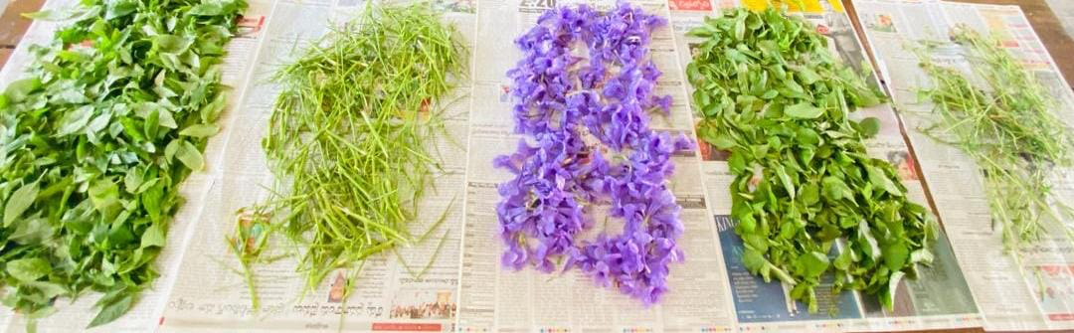

**Fig 1 : Freshly collected** *Ruellia tuberosa* **( stem, leaf and flower) and** *Andrographis paniculata* **(stem and leaf)**

**Powder preparation and extracts:**

Freshly collected plant parts of both *Ruellia tuberosa* and *Andrographis paniculata* washed thrice, dried in a shady place and coarsely powdered and weight was noted **( Fig 2 - Fig 3).** Extraction was done using Soxhlet method, approximately 15g of the powdered plant material was introduced into the extraction chamber of the, using ethanol, methanol and chloroform as solvent. At the end of the extraction, the extracts *Ruellia tuberosa* and *Andrographis* paniculata were concentrated using rotary evaporator and concentrated extract was carefully stored for further analysis.

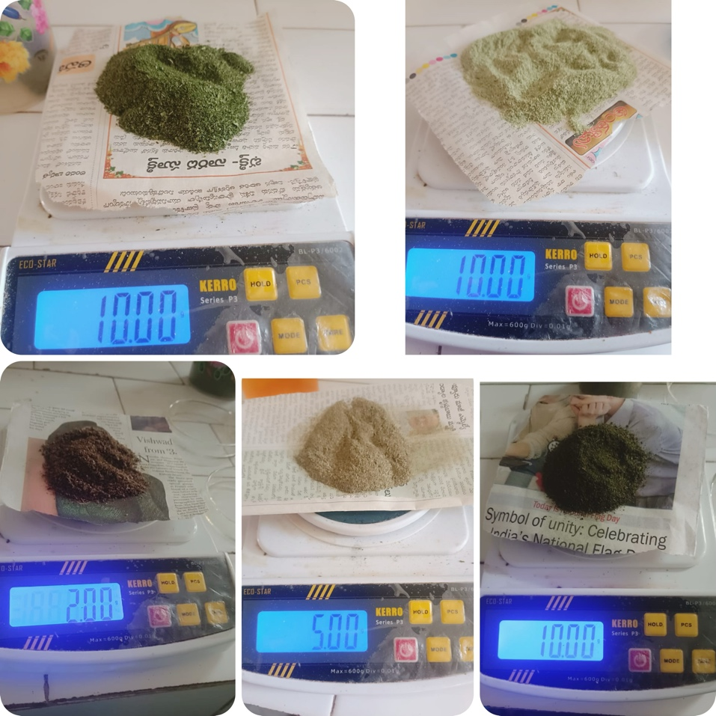

**Fig 2:** Weighing the dry powder of plant parts of *Ruellia tuberosa* ( stem, leaf and flower) and *Andrographis paniculata* (stem and leaf)

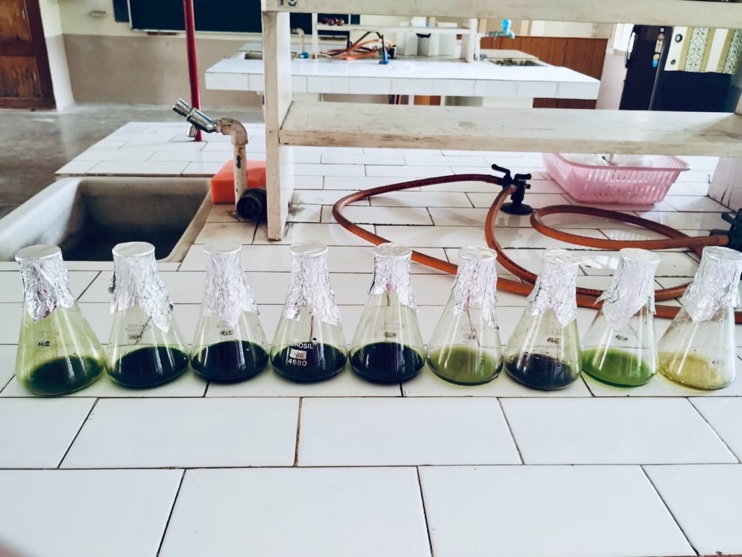

**Fig 3:** Solvent Extracts of *Ruellia tuberosa* **( stem, leaf and flower) and** *Andrographis paniculata* **(stem and leaf)**

**Phytochemistry:**

Three solvent extract was used to investigate for the presence of various phytochemical analysis constituents alkaloids, flavonoids and tannins using standard methods

Test for flavonoids:   The stock solution (1ml) of ethanol extract of Ruellia and Andrographis was taken in a test tube and added a few drops of dilute 2% NaoH solution. An intense yellow colour appeared in the test tube. It became colourless in addition to a few drops of dil. Acid.

Test for alkaloids: One gram of ethanol extract of  Ruellia and Andrographis was taken in a test tube and added a few drops of Hager's reagent. A yellow precipitate is

formed.

Test for tannins: One gram of ethanol extract of Ruellia and Andrographis was taken in a test tube and added a few drops of lead acetate solution. A white precipitate is formed.

**Antibacterial activity:**

Bacterial strains:

        The antimicrobial potency of each extract was evaluated using three bacterial strains. One strain of Gram-positive *Staphylococcus aureus* and two strains of Gram-negative *Escherichia coli* and *Klebsiella pneumoniae*.

**Inoculum preparation:**

   Each bacterial strain was sub-cultured overnight at 37o C in Mueller- Hilton agar slants. The microbial growth was harvested using 5 ml of sterile broth kept overnight in an orbital shaker at 37 degrees Celsius for 24 hours.

**Antibacterial activity:**

   The well diffusion method is used to evaluate antibacterial activity of each extract. Bacterial lawn plates were prepared by inoculating fresh broth by using spread plate technique on solidified Mueller-Hilton. Well are made by using sterile puncher to do extracts. The extract residues were then loaded in the well on the lawn of bacterial culture plates. The plates were kept in an incubator at 37  for 24 hours. The presence of inhibition zones was measured by using Hi - media zone scale, recorded and considered as indication for antibacterial activity.

**Result:**

The presence phytochemicals like flavonoids, alkaloids and tannins were observed in solvent extracts of *Ruellia tuberosa* **( stem, leaf and flower) and** *Andrographis paniculata* **(stem and leaf)**. The flavonoids and alkaloids were observed in leaf extracts of *Ruellia tuberosa.* The presence of alkaloid and tannins was seen in stem extract, where as only alkaloids were seen in flower extract of Ruellia tuberosa. Flavonoids were not observed in stem . Yellow colour reaction represent the positive result of flavonoids **[Table 1& Fig 4].** The presence of flavonoids, alkaloids and tannins were observed in leaf extracts of *Andrographis paniculata whereas* flavonoids, alkaloids and tannins was not observed in stem extracts**[ Table 2 & Fig 5]**

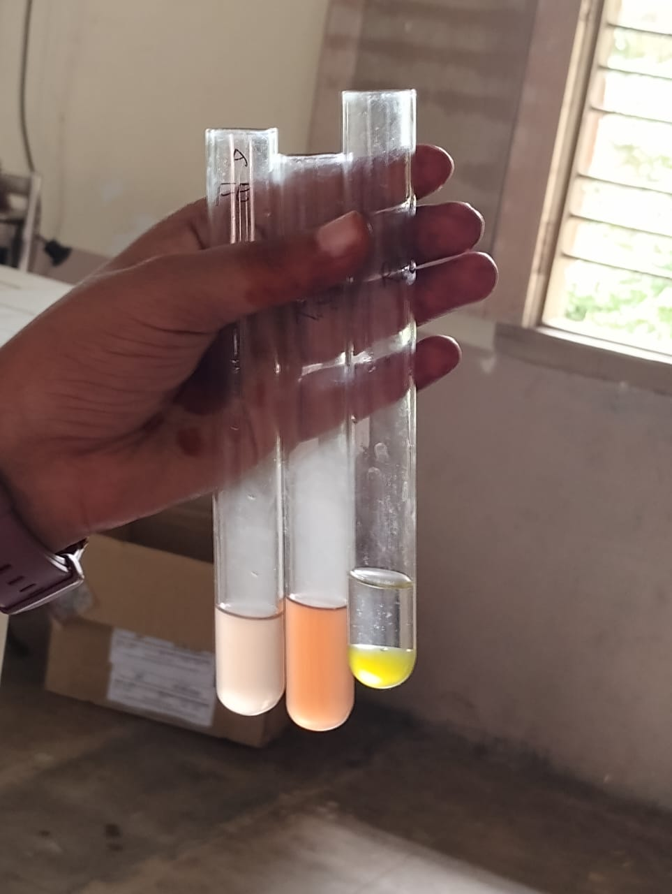 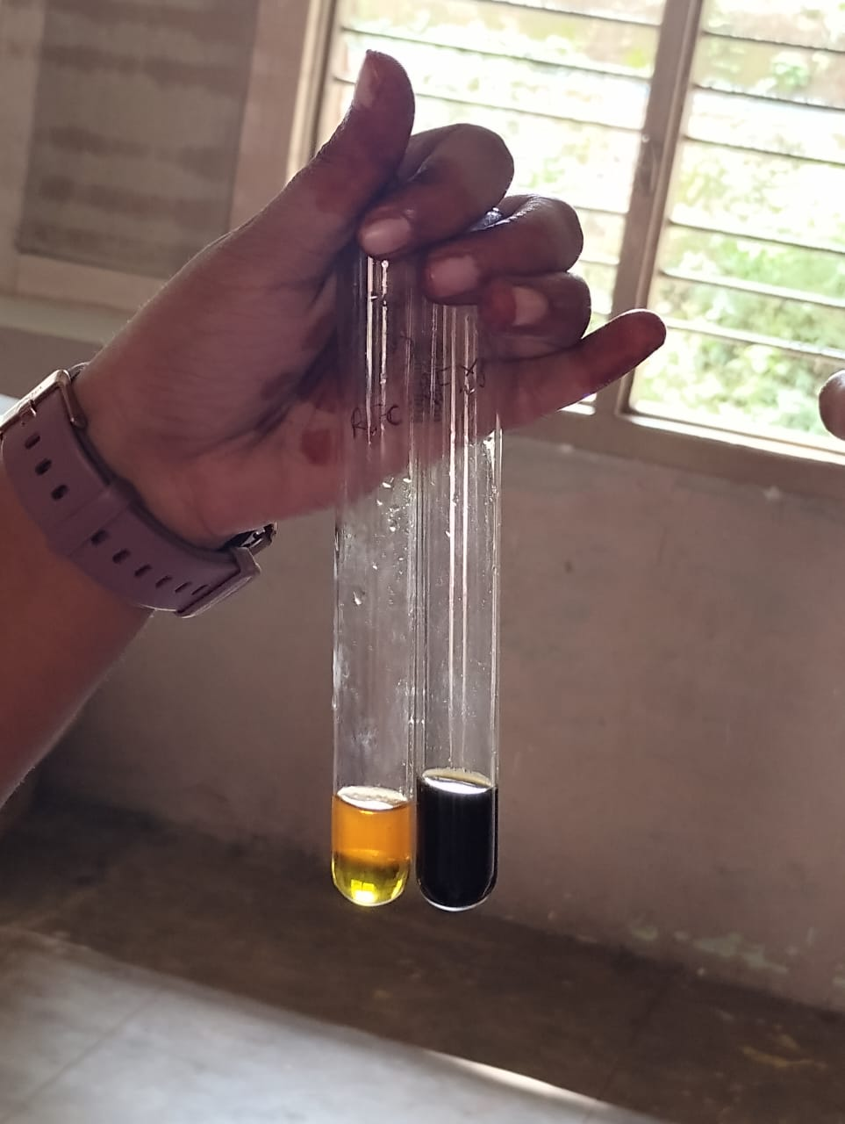

**Fig 4:** Positive reaction of phytochemical in . **Fig 5:** Positive reaction of phytochemical in

*Ruellia tuberosa* ( Flavonoids, Alkaloids and *Andrographis paniculata*( Flavonoids & Alkaloids and Tannins) Tannins)

|  |  |  |
| --- | --- | --- |
| **S.No** | **Phytochemical** | **Result** |
| 1. | Flavonoids | Leaf- Positive  Stem- Negative  Flower- Positive |
| 2. | Alkaloids | Leaf – Positive  Stem- Positive  Flower - Negative |
| 3. | Tannins | Leaf – Positive  Stem – Positive  Flower - Negative |

**Table 1:** Phytochemical ( Flavonoids, Alkaloids and Tannins) screening of *Ruellia tuberosa*

**( stem, leaf and flower)**

|  |  |  |
| --- | --- | --- |
| **S.No** | **Phytochemical** | **Result** |
| 1. | Flavonoids | Leaf – Positive  Stem - Negative |
| 2. | Alkaloids | Leaf – Positive  Stem - Negative |
| 3. | Tannins | Leaf – Positive  Stem – Negative |

**Table 2:** Phytochemical ( Flavonoids, Alkaloids and Tannins)screening result of *Andrographis paniculata* **(stem and leaf)**

**Antibacterial Activity:**

Antimicrobial activity was studied using well diffusion method to know the potentiality of extracts of *Ruellia tuberosa* ( stem, leaf and flower) and *Andrographis paniculata* (stem and leaf) under sterile conditions. The methanol and ethanol extracts of *Ruellia tuberosa* stem had antibacterial activity against *S. aureus* and *E.coli.* Antibacterial activity was not reported towards *K. pneumoniae*. The result of antibacterial activity was studies by zone of inhibition in culture plates. Extracts of *Andrographis paniculata* have the potential antibacterial activity against *S. aureus* and *E.coli* . The growth of *K. pneumoniae* was also inhibited by leaf extract of *Andrographis paniculata* . The results were reported in [**Table 3&4]**

|  |  |  |  |
| --- | --- | --- | --- |
|  | **Stem** | **Leaf** | **Flower** |
| **Bacterial sample** |  |  |  |
| *S. aureus* | 0.1nm (M+E+C) | 0.1nm (M+E+C) | No Zone (M+E+C) |
| *E. coli* | 0.2nm (M+E+C) | No Zone (M+E+C) | 0.2nm (M+E) |
| *K. pneumoniae* | No Zone (M+E+C) | No Zone (M+E+C) | No Zone (M+E+C) |

**Table 3**: Antibacterial potentiality of *Ruellia tuberosa* **( stem, leaf and flower)**extract

|  |  |  |
| --- | --- | --- |
|  | **Stem** | **Leaf** |
| **Bacterial sample** |  |  |
| *S. aureus* | 0.2nm (M+E+C) | 0.2nm (M+E+C) |
| *E. coli* | 0.2 nm(M+E+C) | 0.2nm (M+E+C) |
| *K. pneumoniae* | No Zone(M+E+C) | 0.1nm (M+E+C) |

**Table 4**: Antibacterial potentiality of *Andrographis paniculata* **(stem and leaf)**

**Note: Abbreviations of solvent M-Methanol, E-Ethanol and C-Chloroform**

**Discussion :**

*Ruellia tuberosa* and *Andrographis paniculata* both are traditional use in folk medicine. All parts of this plant are used to extract the active photochemical. Active components mainly isolated from ethanol or methanol extract of leaves, stems, roots, and whole plant of Andrographis paniculata, which include diterpenes, lactones, flavonoids, and xanthones [22] . The presence of flavonoids, alkaloids, and tannins in these plants correlates with their observed antimicrobial activity. Methanol, ethanol and chloroform extracts of *Andrographis paniculata* have shown positive sense of presence of bioactive compound in both stem and leaf parts. The extracts of *Ruellia* also have antibacterial activity but less spectrum when compared with *Andrographis*, while *Andrographis* exhibited broader-spectrum activity, particularly against both Gram-positive and Gram-negative bacterial strains. Solvent chloroform has less potentiality of extracting compound from samples because of its evaporation and adsorption nature. E.coli growth are mostly inhibited than *S. aureus* and *K. pneumoniae*. The results suggest that *Andrographis*  could be a valuable source of bioactive compounds with potential therapeutic applications, especially in the treatment of bacterial infections. Various nations, the death rate is elevated because of irresistible bacterial illnesses. Salmonella, Clostridium, *Staphylococcus aureus*, *Escherichia coli*, Pseudomonas, and other microbes are some of the different pathogens that cause the infrequent contaminations of bacterial infections [12]. In Siddha system of medicine, leaves are given with liquid copal as remedy for gonorrhoea and ear diseases [8]. *Andrographis paniculata* has the potential to treat liver disorders, including cancer, and established its anti-inflammatory, antitumor, anti-fibrotic, antiviral potential, and hepatic protection activity through experimental and clinical studies [25]Concentration toward natural items for  
new antimicrobial stains. Root, stem, and leaf extraction can be utilized to hinder the development of all bacteria. The crucial constituent present in Kalmegh is andropholide -- Andrographolide, a lactone diterpene [13]. herbal medication therapy protects cells while also smoothing out fluctuations in glucose levels. In general, there is limited scientific understanding about the precise mechanisms of action in the treatment of diabetes [26]. For various conditions, some outcomes enriched with extracts and outlying substances have been seen in the public and worldwide business sectors. The isolated chemicals derived from extract have exhibited significant efficacy as agents for cancer prevention, relaxing effects, anti-inflammatory activity, parasite activity, antioxidant activity, antidiabetic effects, and anti- hypoglycaemic effects[11]. Further research, including isolation and identification of active compounds, as well as clinical trials, was needed to evaluate the potentiality of these plants in medical applications and to explore their full pharmacological activity.

**Conclusion:**

Worldwide, around 80,000 plant species have been recognized and utilized as medicines. In India, 7500 medicinal plants have been recognized. From ancient times, medicinal plants have been used to treat various ailments and disorders. Rural population depends on treatments with medicinal plants to meet their healthcare needs for several reasons, including for therapeutic use for curing different diseases. Bioactive compounds derived from various parts of plants—including roots, stems, leaves, flowers, fruits, and seeds—play a crucial role in health promotion and disease prevention. Each plant part contains unique phytochemicals such as alkaloids, flavonoids, phenolics, tannins, terpenoids, and saponins, which contribute to a range of biological activities including antioxidant, anti-inflammatory, antimicrobial, anticancer, and cardioprotective effects. The diversity and distribution of these compounds are influenced by plant species, environmental factors, and the part of the plant used. Literature review and experimental data analysis suggest that *Ruellia tuberosa* and *Andrographis paniculata* are traditionally used for treating fever and several infections. The plant improves the activities of the heart and liver by treating cardiovascular illness and preventing liver damage. This comparative review understanding highlights the importance of utilizing parts of the plant in pharmaceutical, nutraceutical, and cosmetic applications, promoting sustainable use of plant resources. Future research should focus on the isolation, characterization, and mechanism of action of these bioactive compounds to unlock their full therapeutic potential and support their integration into modern medicine. Clinical trials without any negative effects, proving that these plant has a valuable and safe medical resource. Combined form of solutions of *Ruellia tuberosa* and Andrographis paniculata under research to be studied to know there potentiality. More research is still required to learn more about the novel bioactive compounds and improve the bioactivity of the original chemicals.

Disclaimer (Artificial intelligence)

Disclaimer (Artificial intelligence)

Option 1:

Author(s) hereby declare that NO generative AI technologies such as Large Language Models (ChatGPT, COPILOT, etc.) and text-to-image generators have been used during the writing or editing of this manuscript.

Details of the AI usage are given below:

1: I didn’t used any AI Technologies to write up the paper

2. I truly referred literature to frame up the work and done this review work accordingly

**References:**

1. Alam MA, Subhan N, Awal MA, Alam MS, Sarder M, Nahar L, Sarker SD. Antinociceptive and anti-inflammatory properties of *Ruellia tuberosa*. Pharmaceutical biology 2009; 47(3):209-214.
2. Kader MA, Parvin S, Chowduri MA, Haque ME. Antibacterial, antifungal and insecticidal activities of Ruellia tuberosa (L.) root extract. Journal of Bio-Science. 2012; 20:91-7.
3. Samy MN, Sugimoto S, Matsunami K, Otsuka H, Kamel MS. Chemical constituents and biological activities of genus Ruellia. International Journal of Pharmacognosy. 2015; 2(6):270-9.
4. Harika MNLC, Radhika P. Phytochemical Analysis of Ruellia tuberosa Tuber Ethanolic Extract Using UV-VIS, FTIR and GC-MS Techniques. International Journal of Pharmacy and Biological Sciences. 2019; 9(1):889-892.
5. Prasanthi, C., Kumari, S. P., Jahnavi, K., Swapna, D., Omkari, D., Rupa, D., Mounika, K., Jayasri , D., Shanmuki, K., Madhushalini, G., Vasavi, B., & Yamini, P(2024). Studies on Ulva fasciata and Chaetomorpha antennina from Tenneti Park, Visakhapatnam Coastal Area, India. UTTAR PRADESH JOURNAL OF ZOOLOGY,45(6),94-101,https://doi.org/10.56557/upjoz/2024/v45i63954
6. Akanksha Sharma, Adarsh Kumar, Ankit Kumar Singh, K. Jayaram Kumar, Balasubramanian Narasimhan, Pradeep Kumar. Ethnomedicinal Uses, Phytochemistry, Pharmacology, and Toxicology of Ruellia tuberosa L.: A Review,https://doi.org/10.1002/cbdv.202400292
7. Pandey C. N., Medicinal plants of Gujrat, Gujrat Ecological Education and Research Foundation. Gujrat, India 2005.
8. Rehman R., Ibrar M., Hameed., Hussain F., Short Communication: Pharmacognostic and Pharmacological evaluation of *Ruellia tuberosa*. Pak J Pharm Sci, 29 (6): 2099-2102, (2016)
9. Rajendra kumar N., Vasantha K., Mohan V.R., GC-MS analysis of bioactive components of tubers of *Ruellia tuberosa* L. (Acanthaceae). Am J Phytomed Clin Ther, 2 (2): 209-216, (2014)
10. Jayakumar T, Hsieh CY, Lee JJ, et al.: Experimental and clinical pharmacology of Andrographis paniculata and its major bioactive phytoconstituent andrographolide. Evid Based Compl Alternat Med. 2013, 2013:846740. 10.1155/2013/846740
11. Bhaisare S, Pathak S, Ajankar V V (August 15, 2023) Physiological Activities of the King of Bitters (Andrographis paniculata): A Review. Cureus 15(8): e43515. DOI 10.7759/cureus.43515
12. Mamun MdAA, Akhter R, Rahman MA, et al.: Efficient in vitro micro propagation of Andrographis paniculata and evaluation of antibacterial activity from its crude protein extract. Eur J Med Plants. 2015, 10:231-241. 10.9734/EJMP/2015/15663
13. Kumar A, Naidu L, Rao R: In vitro antibacterial activity in the extracts of Andrographis paniculata Burm. F. . Int J Pharm Tech Res. 2010, 2:1383-1385.
14. Mishra K, Dash AP, Swain BK, et al.: Anti-malarial activities of Andrographis paniculata and Hedyotis corymbosa extracts and their combination with curcumin. Malar J. 2009, 8:26. 10.1186/1475-2875-8-26
15. Sheeja K, Shihab PK, Kuttan G: Antioxidant and anti-inflammatory activities of the plant Andrographis paniculata Nees. Immunopharmacol Immunotoxicol. 2006, 28:129-140. 10.1080/08923970600626007
16. Singh RP, Banerjee S, Rao AR: Modulatory influence of Andrographis paniculata on mouse hepatic and extrahepatic carcinogen metabolizing enzymes and antioxidant status. Phytother Res. 2001, 15:382-390. 10.1002/ptr.730
17. Zhang XF, Tan BK: Antihyperglycaemic and anti-oxidant properties of Andrographis paniculata in normal and diabetic rats. Clin Exp Pharmacol Physiol. 2000, 27:358-363. 10.1046/j.1440-1681.2000.03253.x
18. Sah SK, Rasool U, Hemalatha S: Andrographis paniculata extract inhibit growth, biofilm formation in multidrug resistant strains of Klebsiella pneumoniae. J Tradit Compl Med. 2020, 10:599-604. 10.1016/j.jtcme.2019.02.006
19. Dey YN, Kumari S, Ota S, et al.: Phytopharmacological review of Andrographis paniculata (Burm.f) Wall. ex Nees. Int J Nutr Pharmacol Neurol Dis. 2013, 3:3-10.
20. Verma T, Sinha M, Bansal N, et al.: Plants used as antihypertensive . Nat Prod Bioprospect. 2021, 11:155-184. 10.1007/s13659-020-00281-x
21. Nanduri S, Nyavanandi VK, Thunuguntla SS, et al.: Synthesis and structure-activity relationships of andrographolide analogues as novel cytotoxic agents. Bioorg Med Chem Lett. 2004, 14:4711-4717. 10.1016/j.bmcl.2004.06.090
22. WangCH,LiW,QiuRX,JiangMMandLiGQ:Anew diterpenoid from the aerial parts of Andrographis paniculata. Nat. Prod. Commun 2014; 9(1): 13–14.
23. Samy PR, Thwin MM and Gopal krishnakone P: Phytochemistry, Pharmacology and Clinical Use of Andrographis paniculata. Natural Product Communications 2007; 2(5): 607-18.
24. Corsini, A., & Bortolini, M. (2013). Drug-induced liver injury: The role of drug metabolism and transport. Journal of Clinical Pharmacology, 53(5), 463–474. https:// doi.org/10.1002/jcph.23
25. Sunil Kumar, Kshirod Kumar Ratha, Sheetal Jaiswal, Meda Mruthyumjaya Rao, Rabinarayan Acharya, Exploring the potential of andrographis paniculata and its bioactive compounds in the management of liver diseases: A comprehensive food chemistry perspective, Food Chemistry Advances,Volume 4, 2024
26. Alam F, Amin R, Islam M, Borgohain R, Judder MI, Sethi A kumar. A Comprehensive Study of Medicinal Plants with Antidiabetic Properties. J. Pharm. Res. Int. [Internet]. 2021 Jun. 29 [cited 2025 May 15];33(33B):81-96. Available from: <https://www.journaljpri.com/index.php/JPRI/article/view/2621>