**Unusual wingspan records in two congeneric Pierid butterfly species *Catopsilia pomona* (Fabricius, 1775)and *C. pyranthe* (Linnaeus, 1758) from Rajgir Wildlife Sanctuary, Bihar, India**

**Abstract**

The Common Emigrant *Catopsilia pomona* (Fabricius, 1775) and the Mottled Emigrant *Catopsilia pyranthe* (Linnaeus, 1758) occur together throughout the Indian subcontinent in several forms. They are on the wing almost throughout the year in tropical evergreen forests and are absent during periods of water stress or cold in other parts of their distribution range, such as in the Himalaya or the Gangetic plains. Current study was conducted on butterflies during 2023-2025 in and around Rajgir Wildlife Sanctuary in Nalanda district, Bihar. During this study we recorded largest *Catopsilia pomona* (Common Emigrant) form84 mm and the smallest *Catopsilia pyranthe* (Mottled Emigrant) 42 mm were found in Mukti-Dham Rajgir, Nalanda, Bihar. Mean size of specimens from the population of *Catopsilia pomona* was X̄ = 79.9 mm (SE ± 0.90 mm, N=10) and *Catopsilia pyranthe* was X̄ = 48.3 mm (SE ± 0.98 mm, N=13).

**Keywords**

Butterflies, Common Emigrant, Mottled Emigrant, Morphometric, Nalanda, Rajgir Wildlife Sanctuary

**Introduction**

Exploring the factors that drives the body shape and size variations across the living forms is a fundamental question in understanding the evolution of biodiversity (Sarah et al., 2019). The size of individuals within the same species may vary due to multiple factors, including environmental conditions, habitat fragmentation (Warzecha et al., 2016), genetic differences, and developmental stages (Singh et al., 2020). Size variation at a specific location and time may also differ among individuals based on categories such as sex, age, phenotype and developmental conditions (Stevens et al., 2010). Morphological traits, such as wing length and shape in butterflies, are expected to influence the dispersal abilities of populations within a species (Berwaerts et al., 2002). In certain instances, the extent of size variation can be considerable enough to create challenges and confusion in accurately identifying species.

The genus *Catopsilia* Hüebner, [1819] is an Afro-Asian genus widespread in the tropics. Since the host plant, *Cassia fistula*, is used as an avenue tree, both species are common in urban as well as rural areas. Often, they are found in hundreds or even thousands, gathered at mud puddling sites for mineral salts.

The Common Emigrant *Catopsilia pomona* (Fabricius, 1775) and the Mottled Emigrant *Catopsilia pyranthe* (Linnaeus, 1758) congeneric, sympatric species distributed throughout the Indian subcontinent. They are on the wing almost throughout the year in tropical evergreen forests and are absent during period of water stress or cold in other parts of their distribution, such as in the Himalaya or the Gangetic plain (Bell, 1909-1927; Wynter-Blyth, 1957; Kehimkar, 2016).

Both species occur in several forms/ sub-species, which were considered different species until 1976, when Naito and Imamura demonstrated through breeding experiments that *Catopsilia pomona* (Fabricius, 1775) and *Catopsilia crocale* (Cramer, 1775) are actually the same species (Yata, 1985). A similar relationship is assumed for *C. pyranthe* and what was earlier referred to as the Indian population of *C. florella* (Fabricius, 1775), an African species. In the literature published earlier to 1976, the current two species were treated as four species and measurement of their wingspan was also different. For example, Evans (1932) and Wynter-Blyth (1957) mentioned an expanse of 55-80 mm for *C. pomona*, 55 – 75 mm for *C. crocale*; 50-70 mm for *C. pyranthe* and 50-70 mm for *C. florella*. Smetacek (2016), Kehimkar (2016) and Bhakare and Ogale (2018) did not specifically mention *Catopsilia crocale* or *Catopsilia florella*; instead, the measurements for these two species were incorporated under those of *Catopsilia pomona* and *Catopsilia pyranthe*, respectively. Similarly, Tshikolovets and Pagès (2016) did not report wingspan measurements for the specimens they examined. Recently, Panthee and Smetacek (2020) reported the smallest known specimen of *C. pomona* with a wingspan of 46 mm, in the collection of the Butterfly Research Centre, Bhimtal, India.

In this article, we reported the variation wingspan size of two congeneric Pierid butterfly species populations of *Catopsilia pomona* and *Catopsilia pyranthe* from Rajgir, Bihar, India. We also documented the mean size of few individuals from these populations.

**Material and Methods**

**Study Area**

Nalanda district is situated in the state of Bihar in India. The various sub divisions of the district are Bihar Sharif, Rajgir and Hilsa. The rivers Phalgu and Mohane flows through the district of Nalanda. Rajgir Wildlife Sanctuary (WLS) is a protected area situated between 24º 55ꞌ and 25º 05ꞌ N latitude and 85º 6ꞌ and 85º 30ꞌ E longitude in Rajgir town in the south of the Nalanda district in Bihar. Administratively, it falls in Nalanda Forest Division encompassing an area of 35.84 km2 (Figure 1). The Rajgir WLS is encompassed by five peaks of the Rajgir hills (Baibhavgiri, Ratnagiri, Sonagiri, Udaigiri and Vipulgiri) and that constitute a natural topographic boundary dividing the sanctuary from the surrounding landscape of agricultural fields, roads, settlements and villages.

Forest types in and around Rajgir WLS consist of Dry Peninsular Sal Forest, Dry Deciduous Scrub Forests, Boswellia forest, Northern Dry Mixed Deciduous Forests, Cane breaks and plantations (Champion & Seth, 1968; Manjula et al., 2024).

**Butterfly Sampling**

A study was conducted on butterflies during 2023-2025 in and around Rajgir WLS in Nalanda district, Bihar. While surveying butterflies in the area we noted that in summer season, both *C. pomona* and *C. pyranthe* gathered in large numbers to mud-puddle at wet mud and sand in river beds and seepages. It was possible to study them easily because they were settled for long periods of time.

It was observed that some specimens varied greatly in size from the general population. We collected some of the unusually sized ones for further study from near the Mukti Dham, the local cremation site. The specimens were papered and taken to the Butterfly Research Centre, Bhimtal Nainital, Uttarakhand, India and entomological collection at Department of Zoology of S.N. Sinha College, Warisaliganj, Nawada, Bihar, where they were pinned, measured and labelled.

We measured morphometric characters of specimens. For morphometric measurements we employed the same method as used by Evans (1932) to measure the specimens, that is, to measure from the apex of the forewing to the center of the thorax and double the result, assuming that the specimen is perfectly bilaterally symmetrical.

All photographs were taken using Nikon Coolpix P900 camera and GPS locations were recorded using Garmin etrex® 10 GPS. The map was created using the Free and Open Source QGIS 3.32.1-Lima software.

**Results and Discussion**

Mean size of collected specimens from the populations of *Catopsilia pomona* was X̄ = 79.9 mm (SE ± 0.90 mm, N=10) and *Catopsilia pyranthe* was X̄ = 48.3 mm (SE ± 0.98 mm, N=13) (Table 1). The collected specimens showing morphometric variations are provided in Table 1. However, measurements for largest and smallest *Catopsilia pomona* (Fabricius, 1775) and *Catopsilia pyranthe* (Linnaeus, 1758) respectively is presented as below:

*Catopsilia pomona* female form *catilla* (Figure 2) Forewing length: 40 mm; wingspan 84 mm; 29.vii.2023 Mukti Dham, Rajgir, Nalanda, Bihar.

*Catopsilia pyranthe* male form *pyranthe* (Figure 3) Forewing length: 20 mm; wingspan 42 mm; 29.vii.2023 Mukti Dham, Rajgir, Nalanda, Bihar.

*Catopsilia pomona*: The largest specimen of *C. pomona* recorded so far was by Evans (1932), who examined specimens in the collection of the Natural History Museum, London, as well as several private and public collections in India and Europe. Therefore, we do not know which collection contained the 80 mm specimen of *C. pomona*. In the present study, the specimen examined above measures 84 mm. Mean size of ten specimens of *Catopsilia Pomona* was X̄ = 79.9 mm (SE ± 0.90 mm, N=10) (Table 1).

*Catopsilia pyranthe*: Similarly, the smallest specimen of *C. pyranthe* reported so far measures 50 mm. As for *C. pomona*, this figure was presented by Evans (1932) and it is not known in which collection this small specimen is stored.

In the present study, we collected a specimen measuring 42 mm, as mentioned above. It is also deposited in the collection of the Butterfly Research ente, Bhimtal, as mentioned above. Mean size of 13 specimens of *Catopsilia pyranthe* was X̄ = 48.3 mm (SE ± 0.98 mm) (Table 1). This is, therefore, the smallest known specimen of *C. pyranthe* from India and, likely, globally.

Therefore, even though recently Smetacek (2016) a measurement of 55-80 mm for *C. pomona*, latest research has shown that the minimum size is 46 mm (Panthee & Smetacek 2020) and the specimen examined in the present study has recorded that this species can grow to a size of 84 mm. Therefore, future works mentioning the wingspan of *C. pomona* should mention a size of 46-84 mm for the species, not 55-80 mm as has been hitherto mentioned.

In the case of *C. pyranthe*, Smetacek (2016) measured a size of 50-70 mm. The specimen examined in the present study measures 42 mm, so further studies on the subject should mention a wingspan of 42-70 mm for this species.

It is of great interest that both the largest specimen of *C. pomona* and the smallest specimen of *C. pyranthe* were recorded at the same place and on the same day. The smallest specimen may suggest that the specimen collected did not get enough food during its larval stage. However, the largest specimen of *C. pomona* was also present, suggesting that there was sufficient food available, since *C. pomona* and *C. pyranthe* share the same larval host plants in the area. Thus, other factors may also be responsible for size variations along with resource availability. Both specimens are good in condition and there is no superficial indication of genetic or other abnormality or aberration in the specimens examined (Figure 2 and 3).

Variations in body size among living species are often explained by factors such as Bergmann’s rule, resource availability, nutritional conditions, local selection pressures, and sexual size dimorphism (Plavcan et al., 2012). The size variations among individuals in these species populations of Rajgir WLS may be attributed to the drivers such as geographical factors such as, isolation due to hills arrangements in landscape features, availability of resources (host plants, shelter and habitat etc.) (Bhardwaj et al., 2012) and climatic factors such as extreme variation in temperature, prolonged dry seasons and fluctuations in monsoon timings etc (Thomas & Hanski, 1997; Bhardwaj, 2013; Schulz et al., 2018). We expect that conducting a detailed study on these populations may highlight significant findings on size variations in butterfly metapopulations, as Rajgir WLS represents a relatively small insular forest fragment, covering an area of 35.84 km² (Figure 1: inset illustrating the green forest cover within Bihar), and is completely surrounded by a severely degraded agricultural matrix, largely lacking tree cover on any side (Kumar et al., 2023). Moreover, the populations are isolated due to arrangement of five hills (*viz*., Baibhavgiri, Ratnagiri, Sonagiri, Udaigiri and Vipulgiri), which creates geographical barrier and thus isolation of butterfly populations inside the sanctuary. The Rajgir WLS is geographically isolated (surrounded by 5 five hills on all side), devoid of ecological link or corridor to other protected regions or any adjacent natural forests (Kumar et al., 2023). This significant isolation presents a substantial risk of inbreeding and morphometric variations in especially small size local animal populations, highlighting the necessity for monitoring of species. This vigilance is essential for the enduring preservation of biodiversity in this fragile and isolated natural forest remnant.

**References**

Bell, T.R. (1909-1927). The common butterflies of plains of India (including those met within the hill stations of Bombay Presidency), 19(1)-31(4).

Berwaerts, K., Van Dyck, H., & Aerts, P. (2002). Does flight morphology relate to flight performance? An experimental test with the butterfly *Pararge aegeria*. *Functional Ecology*, 16, 484-491.

Bhakare, M., & Ogale, H. (2018). *A Guide to butterflies of the Western Ghats India includes butterflies of Kerala, Tamilnadu, Karnataka, Kerala, Goa, Maharashtra and Gujarat state*. Privately published, Satara, India, 496 pp.

Bhardwaj, M. (2013). Diversity and structure of butterfly assemblages along atitudinal gradient in Tons valley, western Himalaya. PhD Thesis. Wildlife Institute of India: Saurashtra University, Rajkot, India.

Bhardwaj, M., Uniyal, V.P., Sanyal, A.K., & Singh, A.P. (2012). Butterfly communities along an elevational gradient in the Tons Valley, Western Himalayas: Implications of rapid assessment for insect conservation. *Journal of Asia-Pacific Entomology*, 15(2), 207-217. Available: <https://doi.org/10.1016/j.aspen.2011.12.003>

Champion, H.G., & Seth, S.K. (1968). A Revised Survey of the Forest Types of India. The Manager of Publications, Delhi-6., India, 404 pp.

Evans, W.H. (1932). *The Identification of Indian Butterflies.* 2nd ed. Bombay Natural History Society, Bombay, India, 454 pp.

Kahilainen, A., van Nouhuys, S., Schulz, T., & Saastamoinen, M. (2018). Metapopulation dynamics in a changing climate: Increasing spatial synchrony in weather conditions drives metapopulation synchrony of a butterfly inhabiting a fragmented landscape. *Global Change Biology*, 24(9), 4316-4329. Available: <https://doi.org/10.1111/gcb.14280>

Kehimkar, I. (2016). *Butterflies of India*. Bombay Natural History Society, Mumbai, India. 528 pp.

Kumar, R., Manjula, M. and Bhardwaj, M. (2023). Partial albinism in Red-vented Bulbul *Pycnonotus cafer* (Linnaeus, 1766) from Rajgir Wildlife Sanctuary, Nalanda, Bihar, India. *Journal of Entomology and Zoology Studies,* 11(5), 89-93. Available: <https://doi.org/10.22271/j.ento.2023.v11.i5b.9234>

Manjula, M., Kumar, R., Bhardwaj, M. (2024). Confirmation of Lesser Swirled Hawkmoth *Marumba indicus* (Lepidoptera: Sphingidae) In Bihar, India. 26(3), 250-251.

Panthee, S., & Smetacek, P. (2020). Modifications to the known expanse of Indian butterflies. *Bionotes,* 22(2), 69-74.

Plavcan, J.M. (2012). Body Size, Size Variation, and Sexual Size Dimorphism in Early *Homo. Current Anthropology,* 53(6), 409-423*.* Available: <https://doi.org/10.1086/667605>

Sarah, T.F., Christopher, M.M., Samantha, A.P., & Peter, C.W. (2019). The influence of size on body shape diversification across Indo-Pacific shore fishes, *Evolution*, 73(9)1, 1873-1884. Available: <https://doi.org/10.1111/evo.13755>

Singh, V.K., Joshi, P.C., & Gupta, S.K. (2020). Molecular and morphometric divergence of four species of butterflies (Nymphalidae and Pieridae) from the Western Himalaya, India. *Molecular Biology Reports,* 47, 8687–8699. Available: <https://doi.org/10.1007/s11033-020-05913-6>

Smetacek, P. (2018). *A Naturalist`s Guide to the Butterflies of India, Pakistan, Nepal, Bhutan, Bangladesh and Sri Lanka*. Reprinted edition. John Beaufoy publishing Ltd. Oxford, UK, 176 pp.

Stevens, V.M., Pavoine, S., & Baguette, M. (2010). Variation within and between closely related species uncovers high intra-specific variability in dispersal. *PLoS One,* 15,5(6). e11123. Available: <https://doi.org/10.1371/journal.pone.0011123>

Thomas, C.D., & Hanski, I. (1997). Chapter 15- Butterfly Metapopulations, In: I. Hanski, and M.E. Gilpin, M.E., (Eds). *Metapopulation Biology*. Academic Press. pp. 359-386. Available: <https://doi.org/10.1016/B978-012323445-2/50020-1>

Warzecha, D., Diekötter, T., & Wolters, V. (2016). Intraspecific body size increases with habitat fragmentation in wild bee pollinators. *Landscape Ecology,* 31, 1449–1455. Available: <https://doi.org/10.1007/s10980-016-0349-y>

Wynter-Blyth, M.A. (1957). *Butterflies of the Indian Region*. Bombay Natural History Society, Bombay, xx + 72pl + 523pp**.**

Yata, O. **(**1985**)**. Pieridae, pp 206-438, In: E, Tsukada E (Eds). *Butterflies of South East Asian Islands*. Plapak Co., Tokyo. Japan, 438 pp.

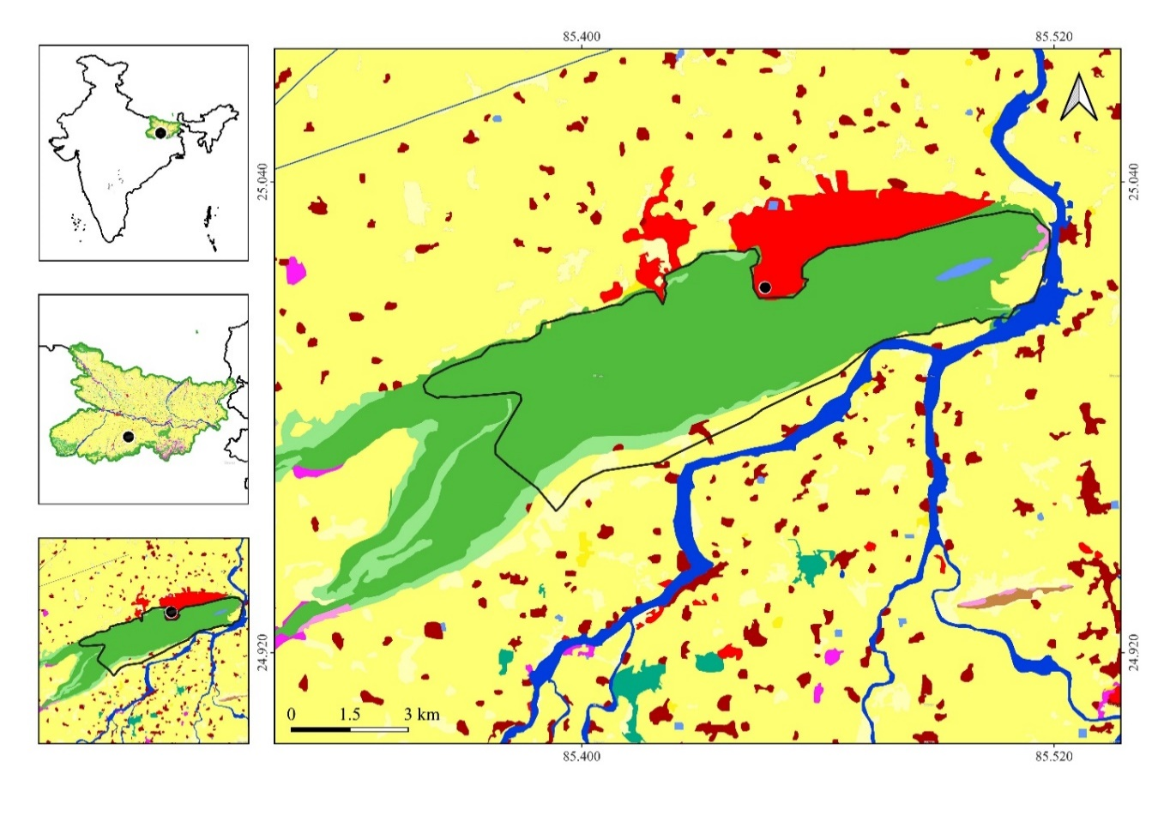

**Figure 1. Map of the study area of Rajgir Wildlife Sanctuary, Nalanda, Bihar, India.**

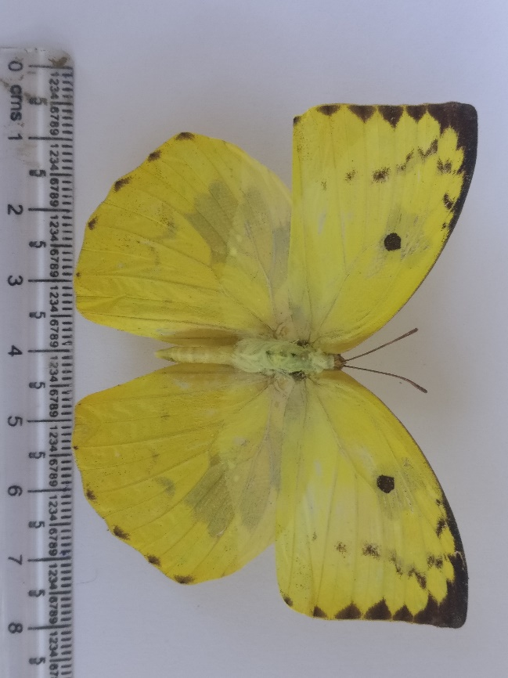

**Figure 2. Common Emigrant *Catopsilia pomona* (Fabricius, 1775).**

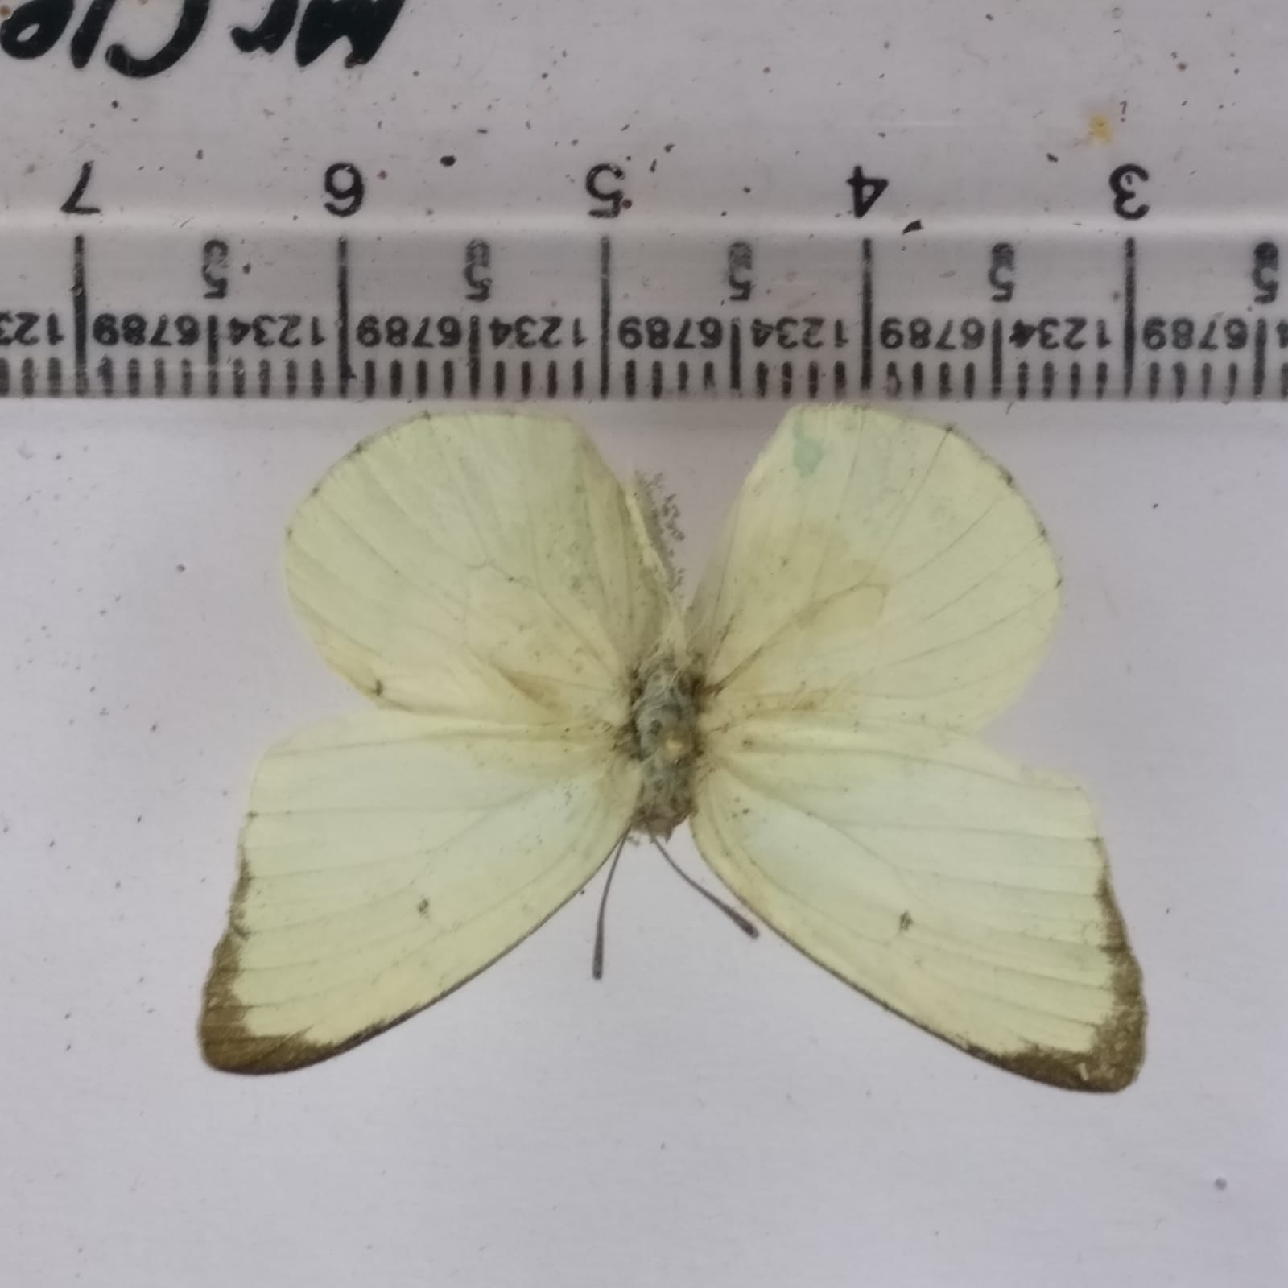

**Figure 3. Mottled Emigrant *Catopsilia pyranthe* (Linnaeus, 1758).**

**Table 1. Wingspan Measurements individuals of *Catopsilia pomona* (Fabricius, 1775)and *Catopsilia pyranthe* (Linnaeus, 1758) from Rajgir Wildlife Sanctuary, Bihar, India**

|  |  |  |  |  |
| --- | --- | --- | --- | --- |
| **S.No.** | **Individual id** | **Species name** | **Sex** | **Wingspan (mm)** |
| **1** | CE4-23 | *Catopsilia Pomona* | Male | 75 |
| **2** | CE4-23 | *Catopsilia Pomona* | Female | 78 |
| **3** | CE5-23 | *Catopsilia Pomona* | Male | 80 |
| **4** | CE6-23 | *Catopsilia Pomona* | Male | 82 |
| **5** | CE6-23 | *Catopsilia Pomona* | Female | 76 |
| **6** | CE7-23 | *Catopsilia Pomona* | Male | 80 |
| **7** | CE723 | *Catopsilia Pomona* | Female | 84 |
| **8** | CE6-24 | *Catopsilia Pomona* | Male | 80 |
| **9** | CE7-24 | *Catopsilia Pomona* | Male | 82 |
| **10** | CE4-25 | *Catopsilia Pomona* | Male | 82 |
| **11** | ME4-23 | *Catopsilia pyranthe* | Female | 50 |
| **12** | ME4-23 | *Catopsilia pyranthe* | Male | 55 |
| **13** | ME5-23 | *Catopsilia pyranthe* | Male | 48 |
| **14** | ME5-23 | *Catopsilia pyranthe* | Male | 46 |
| **15** | ME6-23 | *Catopsilia pyranthe* | Female | 48 |
| **16** | ME7-23 | *Catopsilia pyranthe* | Male | 52 |
| **17** | ME7-23 | *Catopsilia pyranthe* | Male | 44 |
| **18** | ME7-23 | *Catopsilia pyranthe* | Female | 50 |
| **19** | ME7-23 | *Catopsilia pyranthe* | Male | 44 |
| **20** | ME4-24 | *Catopsilia pyranthe* | Female | 48 |
| **21** | ME5-24 | *Catopsilia pyranthe* | Male | 46 |
| **22** | ME6-24 | *Catopsilia pyranthe* | Male | 48 |
| **23** | ME7-24 | *Catopsilia pyranthe* | Female | 50 |
| **24** | ME7-24 | *Catopsilia pyranthe* | Male | 42 |
| **22** | ME4-25 | *Catopsilia pyranthe* | Male | 48 |
| **23** | ME4-25 | *Catopsilia pyranthe* | Female | 54 |