Population ecology of Vermitechnologically Suitable Earthworm, Perionyx sansibaricus (Michaelsen) in Ranchi, Jharkhand.

Abstract
The paper discusses the rate of reproduction, population growth, and density of the earthworm, Perionyx sansibaricus. The key findings are as follows: 1. Perionyx sansibaricus exhibited bimodality in its reproductive strategy, with two peaks observed in December 2021 and July 2022, recording values of 1.06 and 1.28, respectively. 2. The rate of population growth peaked at +3.202 in July 2022, when environmental resistance was at its lowest, and reached a minimum of -0.875 in June 2022. 3. Population density was highest at 9045/m² in August 2022 and lowest at 345/m² in June 2022, with juvenile proportions ranging from 8.33% to 27.70%, immature proportions from 44.50% to 100%, and mature proportions from 16.21% to 31.89%. 4. The biomass of Perionyx sansibaricus peaked at 2111.18 g live weight/m² in August 2022 and dropped to a minimum of 60.38 g live weight/m² in June 2022
Key Words: Population, Ecology, Vermitechnology, Earthworm.
- INTRODUCTION:
Soil fauna is impacted by environmental factors, and their numbers and distribution patterns change in response to alterations in soil's physical and chemical properties (Rossi 2003). Life history traits, such as growth, size at maturity, offspring number and size, and lifespan, are influenced by variations in resource availability (Stearns 1992).
Earthworms are a significant group within the soil fauna, and abiotic factors play a crucial role in determining their numbers and biomass (Edwards and Bohlen, 1996). Different earthworm species exhibit varying ecological preferences, which means that the influence of environmental factors on population dynamics differs among species belonging to different ecological categories (Rozen, 1988). Earthworm activity is particularly affected by two soil conditions: moisture and temperature. Changes in these environmental factors have a more significant impact on epigeic worms compared to endogeic and anecic worms.
Vermicomposting is an eco-biotechnological process through which earthworms can convert complex organic substrates into vermicompost. The earthworm P. sansibaricus shows great potential for vermicomposting (Suthar, 2007; Suthar and Singh, 2008; Suthar, 2009).
Perionyx sansibaricus is an epigeic species commonly found in soils rich in organic matter. A review of the literature reveals that Perionyx sansibaricus (Michaelsen) is a vermitechnologically suitable and locally available earthworm species that has not been studied to date (Julka & Mukherjee, 1986; Dash, 1999; Sinha et al., 2001). Due to the lack of information on this species, the current investigation aims to explore the Population Ecology of Perionyx sansibaricus.
- MATERIALS AND METHODS:
  - Earthworm Collection
Sampling of earthworms was conducted using the Monolith method described by Dash and Patra (1977) at an organically rich garbage site near the Ranchi University hostel, Morabadi Campus, Oxygen Park, Dhurwa, Kanke, Edalhatu Road, Zilla School Maidan, Namkum, Near Ranchi station location shown in Fig1 at an average elevation of 666 meters above sea level.
Earthworms were sampled and hand-sorted monthly from October 2021 to September 2022, as per Dash and Patra (1972) and Ali et al. (1973), from a 20 x 20 x 20 cm area during morning hours.
Based on length and clitellar development, Perionyx sansibaricus was categorized into three age classes: (i) Juvenile (<3cm, non-clitellate), (ii) Immature (3cm to 6cm, non-clitellate), and (iii) Adult (>6 cm, clitellate). The population of earthworm was expressed as no. of individual/square metre.
  - Estimation of Population Density
Earthworm population density (EPD) was determined according to Subin et al. (2015) with slight modifications.
$$EPD=\frac{Total number of earthworm collection in sampling area}{Sampling area (0.04)}$$
  - Estimation of Biomass
Three replicates of freshly collected worms from each size group were weighed separately after gut clearance. Gut clearance was achieved by keeping the worms partially immersed in distilled water (with water changed every 12 hours) in glass Petri dishes for about 3 to 4 days.
  - Rate of Reproduction
When the collection of cocoons was not feasible then the alternative rate reproduction is calculated Juvenile/Adult (Sahu et al. 1988).
  - Soil Characteristics
Soil samples of each study location were air-dried at ambient temperature, crushed, and sieved through a 1 mm mesh. The soil pH was measured using a pH meter. Organic carbon content was determined according to Walkley and Black (1934), while soil nitrogen was analyzed using the Kjeldahl method (1974). Soil phosphorus and potassium were assessed following the methods prescribed by Misra (1973).
  - Study Area
The study area for sampling Perionyx sansibaricus spanned various locations within the Ranchi district of Jharkhand state. A study area map was created using QGIS (Version 3.24) software. Sampling GPS locations are marked with red dots on the Ranchi district map.
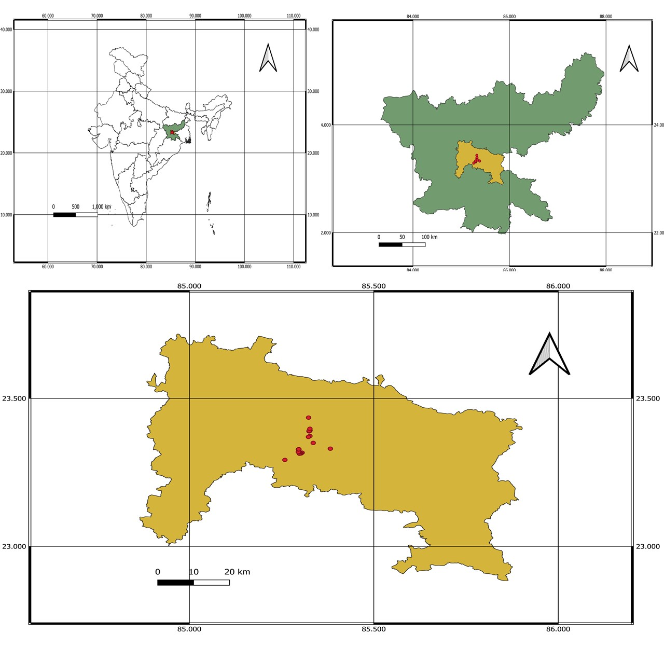Fig1: Map showing study area of Ranchi with India and Jharkhand.
- RESULTS
  - Physico-chemical Characteristics
Table 1: major Physico-chemical Characteristics soil
Physico-chemical characteristics of soil
pH | Moisture level (%) | Organic Carbon (%) | Nitrogen (%) | C/N Ratio | Phosphorous (%) | Potassium (%)
6.63 ± 0.21 | 37 ± 25 | 1.02 ± 0.23 | 0.058 ± 0.013 | 17.57 ± 1.9 | 0.14 ± 0.005 | 0.45 ± 0.03

  - Population Density and Biomass
The total number of worms on the site varied from 345 to 9045 per square meter, with a biomass ranging from 60.38 to 2111.18 grams of live weight per square meter. The highest count of 9045 worms per square meter was recorded in August 2022, while the lowest count of 345 worms per square meter was observed in June 2022 in Table 2 (Supplementary data). The average monthly worm population during the study period was 3295 worms per square meter, with an average biomass of 827.35 grams of live weight per square meter.

Fig2: Population dynamics of earthworm of different age group (number/ square meter) at an interval of a month

Fig3: Variation in Wet biomass [g (wet weight/square meter)] at an interval of a month
  - Rate of Reproduction (RR) and Rate of Population Growth (RPG)

Fig 4: Variation in Rate of Reproduction and Rate of Population Growth at an interval of a month.

- DISCUSSION:
The population density of earthworms varies significantly across different habitats and geographical regions. This variation is primarily influenced by habitat suitability and prevailing climatic conditions. Data presented in Table 3 (supplementary data) illustrates the diverse habitats and geographical areas where earthworms are found; they are notably absent only in regions of extreme cold or drought, and typically make up the majority of the biomass of soil animals.
The maximum earthworm density is generally observed in base-rich grasslands and mull woodland soil humus (Raw 1959, Reynoldson et al. 1955, Svendsen 1957, Reynolds 1969, Dash and Patra 1977). Notable high populations have been recorded by Reynoldson (1955) in grassland soils of Bangor, North Wales; by Barley (1959) in Australian pasture soil; by Raw (1959) in an orchard in Cambridge; and by Dash and Patra (1977) in a tropical grassland in India. In Sambalpur woodland, which experiences a tropical climate, earthworm density was higher than the values reported by Bornebusch (1930) for Danish Forest soil, Reynoldson (1955) for Bangor Forest soil, and Madge (1969) for Nigerian grassland. Differences in population density across various sites can be attributed to factors such as earthworm species, soil type, climate, and altitude. Several researchers (Dowdy 1944, Grants 1956, Evans and Guild 1947, Gerard 1967, Nakamura 1968, Dash and Patra 1977) have emphasized the significance of soil moisture and temperature on earthworm activity. For instance, Evans and Guild (1947) studied earthworm populations in an old pasture field in England over a year and confirmed that soil moisture and temperature were critical conditions affecting their activity.
This study, -, focused solely on a garbage site, where only the earthworm species P. sansibaricus was found, with density ranging from 345/m² to 9045/m². Elvira et al. (1998) reported a population density of 14,600/m² for E. fetida. Sahu et al. (1988) examined Dichogaster bolaui in upland grazed pastures receiving kitchen waste and dung, reporting maximum populations of 8030/m² in pasture and 12,617/m² in dung deposit sites. The population density reported by Sahu et al. (1988) was either very low or nonexistent from November to June, whereas the present study found a substantial population throughout the year, likely due to consistent rainfall during the study period. Among the two critical environmental factors—moisture and temperature—that affect population density, moisture does not appear to have been a limiting factor in this investigation. However, higher population peaks were associated with increased rainfall. Mishra and Dash (1984) noted that earthworm activity in Indian conditions is typically restricted to the rainy and post-rainy seasons, but Perionyx sansibaricus showed activity throughout the year, possibly due to sufficient moisture availability at the garbage site.
The biomass of Perionyx sansibaricus was found to be between 60 and 2111 g live weight/m² (Table 2) in the present study. This recorded biomass significantly exceeds the findings of Dash & Patra (1977), Lavelle (1978), and Senapati & Dash (1981) regarding tropical pastures. Sahu et al. (1988) reported biomass levels of 0-66.2 g live weight/m² from a pasture receiving kitchen waste and 0-51.4 g live weight/m² from a dung deposit site, which represented the highest biomass recorded for Dichogaster bolaui. While Dichogaster bolaui is a small epigeic species characterized by high population density, rapid reproduction, and sudden emergence patterns, Perionyx sansibaricus is a larger species that maintained a stable presence throughout the study period without showing signs of stress. Notably, a rebuilding of population biomass was not observed, which likely contributed to the exceptionally high biomass recorded for P. sansibaricus in this study.
Sahu et al. (1988) noted that the ratio of total cocoons to adults and total juveniles to adults across all sampling occasions did not show a significant difference at the 0.05 level (t = 0.22, n = 16). This suggests that the juvenile-to-adult ratio can serve as an alternative method for calculating reproduction rates in the absence of cocoon data, a method employed in the present study. The reproduction rate varied from 0.43 to 1.28. In contrast, the alternative method (J/A) for Dichogaster bolaui at the dung deposit site yielded reproduction rates of 2.18 in December and 2.95 in July, indicating a bimodal peak pattern.
In this study, a similar bimodal peak pattern was observed, with distinct peaks in juvenile reproduction and overall population growth. The estimated duration for the completion of the life cycle of P. sansibaricus at the garbage site is approximately 5 to 6 months. The expected lifespan of an individual corresponds to the duration of the life cycle. Given that the P. sansibaricus population reached zero levels and exhibited annual colonization, the life cycle duration may equal the lifespan. This finding is currently under verification through laboratory culture experiments.
Environmental resistance negatively impacts population growth by increasing mortality rates; thus, greater environmental resistance corresponds to lower population growth. After accounting for the effects of environmental resistance, the population growth rate can be assessed. As shown in Figure 4, the reproduction rate of the P. sansibaricus population is generally higher, except in July, when it dips below the population growth rate. This decline may be attributed to lower environmental resistance during that month, as previously discussed. Two environmental variables, temperature and moisture, are particularly favourable in July.
- CONCLUSION
Perionyx sansibaricus exhibited a bimodal reproductive pattern with peaks in December 2021 and July 2022. Population growth and density peaked in July and August 2022, respectively, when environmental resistance was lowest. Biomass also followed this trend. Seasonal variations significantly influenced the worm’s reproduction, growth, and survival, highlighting its adaptive strategies in fluctuating environmental conditions.
DISCLAIMER (ARTIFICIAL INTELLIGENCE)
Author(s) hereby declare that NO generative AI technologies such as Large Language Models (ChatGPT, COPILOT, etc) and text-to-image generators have been used during writing or editing of this manuscript.
REFERENCES:
Ali, M.K., Dash, M.C. and Patra, U.C. (1973). Estimation of Lampito mauritii (Oligochaeta) population by chemical methods. Science and Culture. 39: 558 – 560.
Barley, K.P. (1959). The influence of earthworms on soil fertility. 1. Earthworm populations found in agricultural land near Adelaide. Aust. J. Agric. Res. 10: 171-178.
Bornebusch, C.H. (1930). The fauna of forest soil Forstle. For Soksv. Danm. 11: 1-224.
Dash, M.C. and Patra, U.C. (1972). A comparison of extraction methods for megascolecidae (Olig.) and Ocnerodrilidae (Olig.) from Agricultural soils of Berhampur, Orissa. Curr. Sci. 41: 54-55.
Dash, M.C. (1999). Earthworm diversity and Ecophysiology to Vermitechnology for sustainable development. Presidential Address as sectional president of Zoology, Entomology and Fisheries. 86th session of Indian Science Congress Association page – 33.
Dash, M.C. and Patra, U.C. (1977). Density, biomass and energy budget of tropical earthworm population from a grassland site in Orissa, India. Rev. Ecol. Biol. Sol. 14(3): 461-471.
Dowdy, W.W. (1944). Influence of temperature on vertical migration. Ecology, 25 (4) : 449-60.
Edwards, C. A., & Bohlen, P. (1996). Biology and ecology of earthworms. Springer Science & Business Media.
Elvira, C., Sampedro, L., Benítez, E., & Nogales, R. (1998). Vermicomposting of sludges from paper mill and dairy industries with Eisenia andrei: A pilot-scale study. Bioresource Technology, 63(3), 205-211. https://doi.org/10.1016/s0960-8524(97)00145-4
Evans, A.C. and W.J. Mc.L. Guild (1947). Studies on the relationships between earthworms and soil fertility I. Biological studies in the field. Ann. Appl. Biol. 34(3): 307-330.
Gerard, B.M. (1967). Factors affecting earthworms in pasture. J. Ani. Ecol. 36: 235-252.
Grant, W.C. (1956). An ecological study of the peregrine earthworm, Pheretima hupeiensis in the Eastern United States. Ecology 37(4): 648-658.
Rossi, J.P. (2003) The spatiotemporal pattern of a tropical earthworm species assemblage and its relationship with soil structure, Pedobiologia (Jena) 47 497–503.
Julka J. M. and Mukherjee R. N. (1986) Preliminary observations on the effect of Amynthas diffringens (Oligochaeta: Megascolecidae) on the C/N ratio of the soil. In Verms and Vermicomposting, Proceedings of the National Seminar on Organic Waste Utiliration and Vermicomposting Part B (M. C. Dash, B. K. Senapati and P. C. Mishra, Eds), pp. 66-68. Five Star Printing Press, Burla.
Kjeldahl, J. (1883). New Method for Determination of Nitrogen. Chem. News, 48, 101−102.
Lavelle, P. (1978). Ivoire Les Ver de teree de la savana de Lamto (Cote d Ivoire): peuplements, populations et functions dans 1 ecosystem; Publ. Lab. Zool. E.N. S. 12: 301.
Madge D.S. (1969). Field and laboratory studies on the activities of two species of tropical Earthworms. Pedobiologia, 9: 188-214.
Mishra, P.C. and M.C. Dash (1984). Population dynamics and Respiratory metabolism of earthworm population in a subtropical dry woodland of western Orissa, India. Trop Ecol. 25: 103-116.
Misra, R. (1973). Ecology work book. Oxford and IBH Publ.Co. New Delhi, pp. 243.
Nakamura, Y. (1968). Studies on the ecology of terrestrial Oligochaetae. 1. Seasonal variation in the population density of earthworms in alluvial soil grassland in Sapporo. Jap. J. appl. Ento. Zool. 3: 89-95.
Raw, F. (1959). Estimating earthworm populations by using formaline. Nature, 184: 1661-1662.
Reynolds, J.W. (1969). The relationship of earthworm distribution and biomass to soil type in grassland and forest habitats at Oak Ridge National Laboratory, Unpubl., Report. 13 p. ORNL.
Reynoldson, T.B. (1955). Observation on the earthworms of North Wales. N. West. Nat. 3: 291-304.
Reynoldson, T.B., F.B. O’Connor and W.A. Kelley 1955. Observations on the earthworms of Bardsey. Obs. Rep. 9 1955.
Rozen, A. (1988). The annual cycle in populations of earthworms (Lumbricidae, Oligochaeta) in three types of oak-hornbeam of the Niepolomicka forest. II. Dynamics of population numbers, biomass and age structure. Pedobiologia 31: 169-178.
Sahu S.K., S.K. Mishra and B.K. Senapati (1988). Population biology and reproductive strategy of Dichogaster bolaui (Oligochaeta: Octochaetidae) in two tropical agroecosystems. Proc. Indian Acad. Sci. (Anim. Sci.) 97(3): 239-250.
Senapati, B.K. and Dash, M.C. (1981). Effect of grazing on the elements of production in the vegetation of oligochaete components of a tropical pasture land; Rev. Ecol. Biol. Sol. 18: 457-505.
Sinha, M.P., Rohit Srivastava, S.R. Ghosh and A.K. Choudhary (2001). Distributional pattern of Ocnerodrilus occidentalis - A dominant earthworm of grassland ecosystem.
Stearns, S.C. (1992). The evolution of life histories. Oxford University Press, Oxford.pp???

Subin, K., Madan, K., & Udhab, R. K. (2015). Earthworm population in relation to different land use and soil characteristics. Journal of Ecology and The Natural Environment, 7(5), 124-131. https://doi.org/10.5897/jene2015.0511
Suthar, S (2007) vermicomposting potential of Perionyx sansibaricus (Parrier) in different waste material. Bioresour Technol 98: 1231-1237.
Suthar, S (2009) Growth and fecundity of earthworm: Perionyx excavates and Perionyx sansibaricus in cattle waste solids. Environmetalist 29: 78-84
Suthar, S, Singh S (2008) Vermicomposting of domestic waste by using two epigeic earthworms (Perionyx excavates and Perionyx sansibaricus). Int J Environ Sci Technol 5(1): 99-106
Svendsen, J.A. (1957). The distribution of Lumbricidae in an area of Penine moorland (Moor House Nature Reserve) J. Anim. Ecol. 26(2): 411-421
Walkley, A., & Black, I. A. (1934). An examination of the Degtjareff method for determining soil organic matter and prepared modification of the chronic acid titration method. Soil Science, 34, 29−38.

JOURNAL NAMES IN THIS REFERENCE SECTION IS NOT UNIFORM FORMAT

Supplementary data

Table 2. Population density (Number/m²) and Biomass (g live wt/m²) of Perionyx sansibaricus.
Months | Population density (No/m²) |  |  | Total worms (No/m²) | Total Biomass  (g live wt/m²)
Months | Juvenile worms | Immature worms | Mature worms | Total worms (No/m²) | Total Biomass  (g live wt/m²)
Oct.’ 2021 | 1023 | 1790 | 1209 | 4022 | 1132.952
Nov.’ 2021 | 405 | 1373 | 833 | 2611 | 793.355
Dec.’ 2021 | 423 | 799 | 400 | 1622 | 414.322
Jan.’ 2022 | 404 | 713 | 475 | 1592 | 446.906
Feb.’ 2022 | 279 | 744 | 326 | 1349 | 351.351
Mar.’ 2022 | 159 | 956 | 341 | 1456 | 393.446
Apr.’ 2022 | 91 | 614 | 137 | 842 | 199.364
May’ 2022 | 69 | 598 | 161 | 828 | 211.186
Jun.’ 2022 | 0 | 345 | 0 | 345 | 60.375
Jul.’ 2022 | 2350 | 4301 | 1833 | 8484 | 2026.61
Aug.’ 2022 | 2025 | 5310 | 1710 | 9045 | 2111.175
Sep.’ 2022 | 1473 | 4370 | 1496 | 7339 | 1787.117

Table – 3. Population density and Biomass of Earthworms in selected habitats from various parts of the world.
Habitat | Location | Population density No/m² | Biomass g live wt/m² | Extraction Method | References
Savana
Tropical Savannas | Ivory Coast | 230 | 49 | H & WS | Lavelle (1974)
Grass Savana | Lamto (Ivory coast) | 202 | - | H | Lavelle (1978)
Shrub Savana | Lamto, Africa | 350 | - | H | Lavelle (1978)
Grasslands
Sown Pasture | South Australia | 460-625 | 62-78 | H | Barley 1959
Old Pasture | England | 390-470 | 52-110 | H | Svendsen (1955)
Pasture (base rich grassland) | Bardsey Island | 390 | 56 | H | Reynoldson et al. 1955
Pasture (lowland protected) | Berhampur, Orissa, India | 64-800 | 6-60 | H | Dash & Patra (1977)
Pasture (upland grazed) | Sambalpur, Orissa, India | 75-272 | 12-70 | H & WS | Senapati & Dash (1981)
Pasture (upland grazed) | Ranchi, Jharkhand, India | 35-2650 | 1.1-50.14 | H | Sinha et. al. (2001) communicated.
Pastures with heavy rates of fertilizers | Ireland | 400-500 | 100-200 | H | Cotton and Curry (1980)
Organic waste deposit sites
Farmyard  manure garden | Bangalore  Karnataka, India | 15-625 | - | H | Kale & Krishnamoorthy (1982)
Pasture receiving  kitchen waste | Jyotivihar  Orissa, India | 0-8038 | 0-66.2 | H & WS | Sahu & Senapati (1986)
Wash basin waste receiving site | Orissa, India | 50-500 | - | H | Julka & Senapati (1987)
Garbage site | Ranchi, Jharkhand, India | 345-9,045 | 60.38 -2111.18 | H | Present work.
H = Hand sorting WS = Wet sieving.

