STUDY ON FEED MANAGEMENT AND GROWTH PERFORMANCE OF Clarias batrachus.

ABSTRACT
Clarias batrachus, widely known as the Asian walking catfish, is a commercially valuable freshwater species in Asia. In Purba Medinipur district of West Bengal, the market value of its seed is approximately ₹5 per piece. With appropriate breeding and rearing techniques, this species offers considerable profitability to small-scale farmers. However, the success of such ventures depends largely on the application of proper culture and management practices. The present study evaluated different feed protein level on the growth performance of C. batrachus seed over a period of 21 days. experimental period aimed to evaluate the effects of different protein levels in feed on the growth performance of C. batrachus seed over a 21-day experimental period. Feed ingredients including fish meal, yeast, egg yolk, wheat bran and vitamin-mineral premix were formulated using pearson square method to produce three diets; Diet A (30% crude protein), Diet B (35% crude protein), and Diet C (40% crude protein). Fish seeds fed reported 25.4 mm length and 125.6 mg weight; seed fed Diet B reached 27.21 mm length and 137.7 mg weight: while Diet C displayed 34.66 mm length and 174.1 mg weight. Statistical analysis reported significant difference in growth performance among the three diets. The result suggested Diet C containing 40% crude protein had the most pronounced positive effect on seed growth and can be recommended for improved production outcomes.

Locally available ingredients—including fish meal, yeast, egg yolk, wheat bran, along with added vitamins and minerals—were used to formulate three experimental diets. The Pearson Square method was applied to ensure balanced feed compositions, resulting in Diet A (30% crude protein), Diet B (35% crude protein), and Diet C (40% crude protein). Growth results demonstrated a clear trend: higher dietary protein levels contributed to increased growth. Seeds fed with Diet A exhibited an average growth of 25.4 mm in length and 125.6 mg in weight. Those fed with Diet B reached 27.21 mm in length and 137.7 mg in weight, while Diet C showed the most significant growth at 34.66 mm and 174.1 mg. Statistical analysis using ANOVA revealed that the calculated F-values exceeded the critical values, indicating a significant difference in growth performance among the three diets. These results suggest that Diet C, with 40% crude protein, had the most pronounced positive effect on seed growth and can be recommended for improved production outcomes.
Keywords: Feed ingredients, Pearson Square method, Growth performance, Length-Weight, ANOVA
INTRODUCTION
Aquaculture has emerged as a critical component in meeting the global demand for protein-rich food, with fish farming playing a vital role in enhancing food security and rural livelihoods (FAO, 2022). Among freshwater species, Clarias batrachus, commonly known as Magur, is widely cultivated across South and Southeast Asia due to its high market value, fast growth rate, and resistance to harsh environmental conditions (Rahman et al., 2018). Thise species is also known for its high protein content and medicinal value, which makes it a preferred choice among consumers (Kumar et al., 2020). Feed management is a decisive factor influencing growth performance, production efficiency, and overall profitability in aquaculture (Tacon & Metian, 2015). In the culture of C. batrachus, effective feeding strategies—including feed type, frequency, and ration size—play a crucial role in optimizing growth and minimizing feed waste. Improper feed management can lead to suboptimal growth, increased production costs, and environmental degradation due to nutrient loading (Boyd et al., 2017). Several studies have evaluated the growth response of C. batrachus under different feeding regimes and feed formulations. For instance, the use of formulated pelleted feeds with balanced protein and lipid content has been shown to significantly enhance weight gain and feed conversion efficiency in this species (Islam et al., 2019). Furthermore, the frequency of feeding also influences growth, with bi-daily feeding often yielding better results compared to irregular or single daily feeding (Singh & Sharma, 2021). Given the economic importance of Clarias batrachus, it is imperative to develop sustainable feed management practices that not only improve growth performance but also reduce production costs. This study aims to evaluate the effects of different feed management practices on the growth performance of C. batrachus, thereby contributing to the development of efficient aquaculture practices tailored to local farming systems.
MATERIALS AND METHODS
To make a complete diet for C. batrachus we uses various types of feed ingredients which are locally available, such as fFish meal, yYeast, eEggs, pPowder milk, Wwheat flour etc. to and make a suitable feed for C. batrachus. The feed were divided into Diet A consist of 30% crude protein; Diet B consist of 35% crude protein; and Diet C consist of 40% crude protein respectively. The three diets were fed to C. batrachus fry for 21days. The growth and length of experimental fish were calculated using pearson square method.

We divided the feed in 3 categories, such as – Diet A, Diet B and Diet C and each diet contain several protein level, Diet A contain 30% crude protein, Diet B contain 35% crude protein and Diet C contain 40% crude protein. For 21 days we use these 3 types of diets on the fry of C. batrachus and observe the growth in length and weight condition. Noted that Diet C gives a lot of effect on the growth performance rather than Diet A and Diet B. To make the diet, we follow the Pearson square method. The Pearson Square Method is a simple and effective tool used in animal nutrition including fish feed formulation, to mix two feed ingredients or more than two feed ingredients to achieve a desired nutrient level. It’s especially useful when we want to mix two or more feeds of known nutritional composition (e.g., a high-protein feed and a lower-protein feed) to achieve a specific target nutrient concentration. Also use ANOVA for statistical analysis on feed management and growth performance of C. batrachus.
Crude Protein estimation in Diet A (30% CP) with Pearson Square method:
Ingredients –
- Fish meal (Protein 60%)
- Powder milk (Protein 27%)
- Boiled egg yolk (Protein 16%)
Group of ingredients –
- 1st Group – Protein supplementary feed (Protein>20%)
- 2nd Group – Basal feed (Protein<20%)
Average of 1st Group = $60\%$
Average of 2nd Group = $\frac{27+16}{2}=21.5\%$
30%
8.5%
60%
30%

21.5%
Total = 38.5 %
Percentage of 1st Group = $\frac{8.5}{38.5}X100=22.08\%$
Percentage of 2nd Group = $\frac{30}{38.5}X100=72.92\%$
Requirement of Fish Meal for feed preparation = $\frac{22.08}{1}=22.08\%$
Requirement of Powder milk for feed preparation = $\frac{72.92}{2}=38.96\%$
Requirement of Boiled egg yolk for feed preparation = $\frac{72.92}{2}=38.96\%$
Crude Protein (CP) estimation:
CP in Fish Meal = $\frac{22.08 X 60}{100}=13.25\%$
CP in Powder Milk = $\frac{38.96 X 27}{100}=10.52\%$
CP in Boiled egg yolk = $\frac{38.96 X 16}{100}=6.23\%$
So, Total Crude Protein contained in Diet A = 13.25%+10.52%+6.23% = 30 % (Proved)
Crude Protein estimation in Diet B (35% CP) with Pearson Square method:
Ingredients –
- Fish meal (Protein 60%)
- Yeast (Protein 44.75%)
- Boiled egg yolk (Protein 16%)
- Wheat flour (Protein 18%)
Group of ingredients –
- 1st Group – Protein supplementary feed (Protein>20%)
- 2nd Group – Basal feed (Protein<20%)
Average of 1st Group = $\frac{60+44.75}{2}=52.38\%$
Average of 2nd Group = $\frac{16+18}{2}=17\%$
52.38%
18%
17%

35%

17.38%
Total = 35.38 %
Percentage of 1st Group = $\frac{18}{35.38}X100=50.88\%$
Percentage of 2nd Group = $\frac{17.38}{35.38}X100=49.12\%$
Requirement of Fish Meal for feed preparation = $\frac{50.88}{2}=25.44\%$
Requirement of Yeast for feed preparation = $\frac{50.88}{2}=25.44\%$
Requirement of Boiled egg yolk for feed preparation = $\frac{49.12}{2}=24.56\%$
Requirement of Wheat flour for feed preparation = $\frac{49.12}{2}=24.56\%$
Crude Protein (CP) estimation:
CP in Fish Meal = $\frac{25.44 X 60}{100}=15.26\%$
CP in Yeast = $\frac{25.44 X 44.75}{100}=11.38\%$
CP in Boiled egg yolk = $\frac{24.56 X 16}{100}=3.93\%$
CP in Wheat flour = $\frac{24.56 X 18}{100}=4.42\%$
So, Total Crude Protein contained in Diet A = 15.26%+11.38%+3.93%+4.42% = 34.99 % ≈ 35% (Proved)
Crude Protein estimation in Diet C (40% CP) with Pearson Square method:
Ingredients –
- Fish meal (Protein 60%)
- Yeast (Protein 44.75%)
- Whole egg (Protein 12.6%)
Group of ingredients –
- 1st Group – Protein supplementary feed (Protein>20%)
- 2nd Group – Basal feed (Protein<20%)
Average of 1st Group = $\frac{60+44.75}{2}=52.38\%$
Average of 2nd Group = 12.6%

27.4%
52.38%

40%

12.6%
12.38%
Total = 39.78 %
Percentage of 1st Group = $\frac{27.4}{39.78}X100=68.88\%$
Percentage of 2nd Group = $\frac{12.38}{39.78}X100=31.12\%$
Requirement of Fish Meal for feed preparation = $\frac{68.88}{2}=34.44\%$
Requirement of Yeast for feed preparation = $\frac{68.88}{2}=34.44\%$
Requirement of Whole egg for feed preparation = $\frac{31.12}{1}=31.12\%$
Crude Protein (CP) estimation:
CP in Fish Meal = $\frac{34.44 X 60}{100}=20.66\%$
CP in Yeast = $\frac{34.44 X 44.75}{100}=15.41\%$
CP in Whole egg = $\frac{31.12 X 12.6}{100}=3.92\%$
So, Total Crude Protein contained in Diet A = 20.66%+15.41%+3.92% = 39.99 % ≈ 40% (Proved)
Table 1: Feed Management (Pearson Square Method) Feed composition
Ingredients | Diets
 | A | B | C
Fish meal (-----) | 22.08 | 25.44 | 34.44
Baker’s yeast | ------- | 25.44 | 34.44
Powder milk | 38.96
Boiled chicken egg yolk () | 38.96 | 24.56 | ------
Whole egg (Albumin+Yolk) |  |  | 31.12
Wheat flour ( ) |  | 24.56
Vitamin premix | 2.0 | 1.5 | 1.0
Mineral premix | 2.0 | 1.5 | 1.0
Crude protein | 30.00 % | 35.00 % | 40.00 %

Graph 1: Pie chart showing % of feed ingredients in Diet A, B and C, and Clustered column showing crude protein level in all three diets.
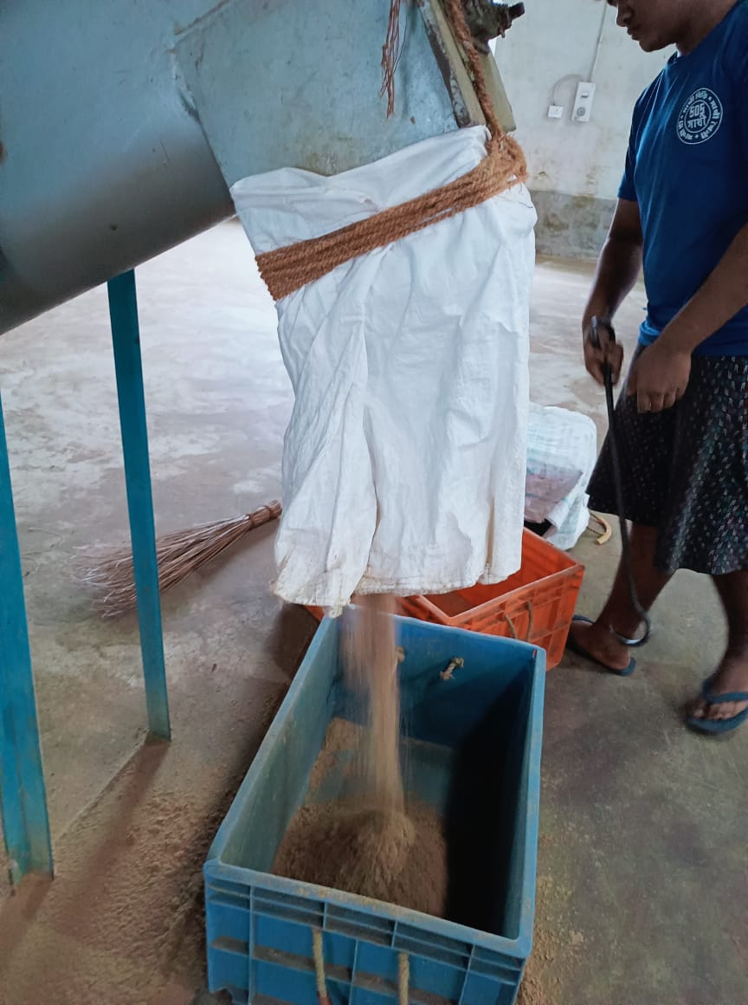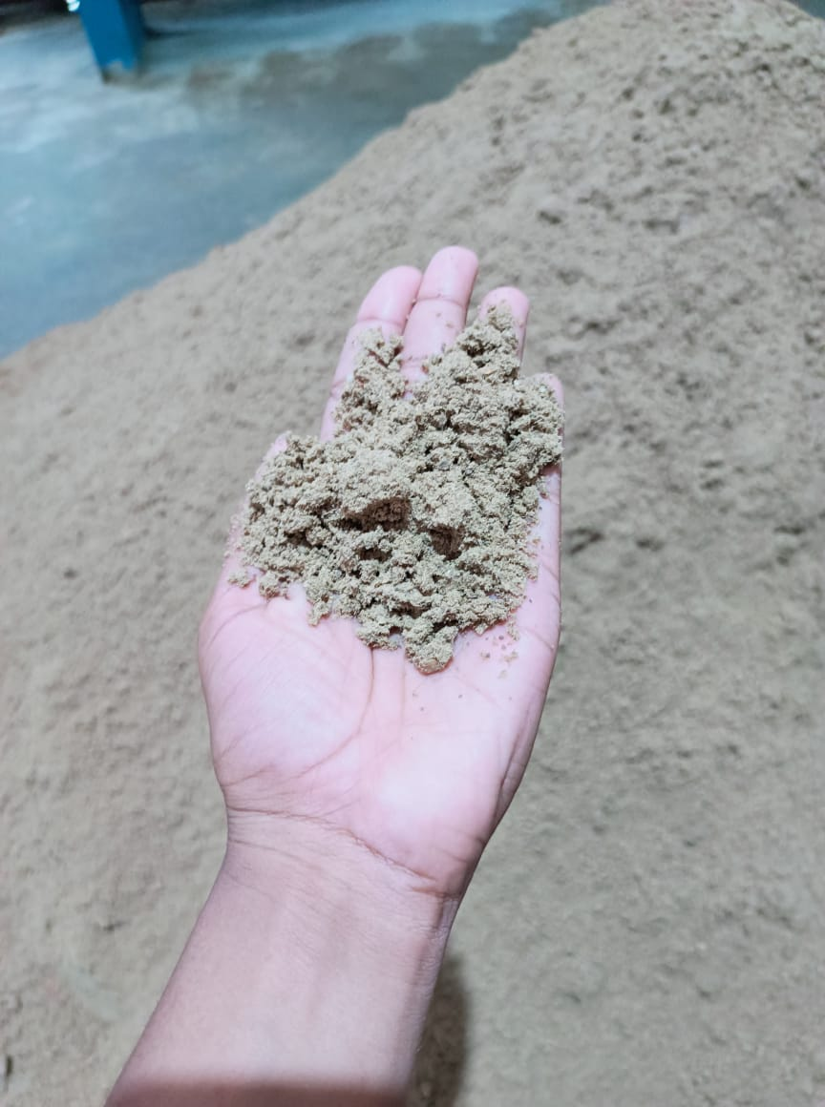
B
A
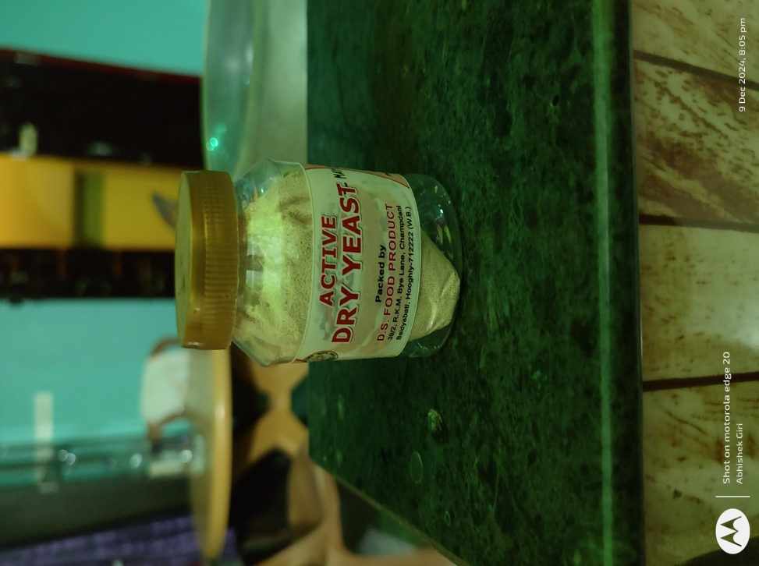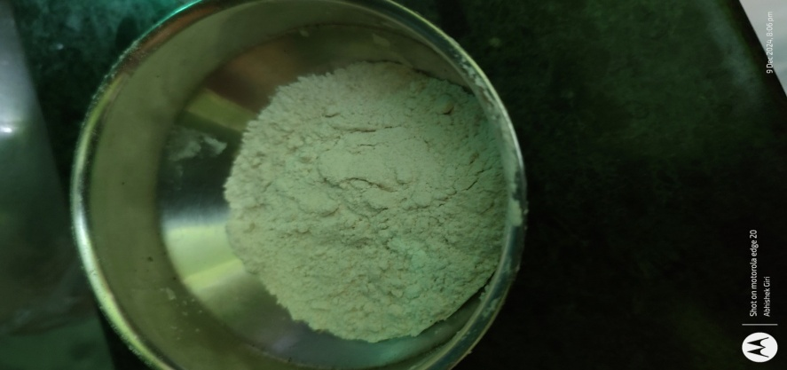
C
D
Fig1: Various types of feed ingredients (A, B = Fish Meal, C = Yeast, D = Wheat flour)
I want to suggest the materials and methods should be section e.g preparation of the feed, formulation of the experimental diet, calculation of feed ingredient using pearson formula etc for proper structure and neatness of the work

RESULT AND DISCUSSION
Interpretation of Table 1: Feed Management - Pearson Square Method
The outcomes of applying the Pearson Square Method to the data included in the feed management system are shown in Table 1. The following table provides information on the precise quantities of different things (including fish meal, baker's yeast, powder milk, and whole eggs) that are required to meet the dietary needs of each individual for each of the three kinds of feed (A, B, and C). For the purpose of catering to the particular dietary needs of brooder fish, the crude protein percentage of each diet is separately modified to 30%, 35% and 40%. The data illustrates how different components may be combined to fulfill the protein needs of each diet, which contributes to the enhancement of the nutritional content of the feed. By going about things in this manner, we can be certain that the fish in the brooder will get all of the nutrients that they need in order to flourish.
Probably if the material and method part is section, it will make result to be more arrange and meaningful
Growth Performance
Table 2: Growth Performance
Sampling | Diet A |  | Diet B |  | Diet C
Days | Length (mm) | Weight (mg) | Length (mm) | Weight (mg) | Length (mm) | Weight (mg)
(Initial) 5 days | 7.0 | 3.1 | 7.0 | 3.1 | 7.0 | 3.1
10 | 12.0 | 35.6 | 15.31 | 57.6 | 18.40 | 83.9
15 | 18.6 | 95.1 | 24.44 | 115.4 | 28.55 | 128.6
(Final) 21 days | 25.4 | 125.6 | 34.21 | 140.8 | 41.66 | 177.2
Total growth | 18.4 | 122.5 | 27.21 | 137.7 | 34.66 | 174.1

Graph 2: Clustered column showing growth of seeds in length (mm) after using Diet A, B and C for 21 days.

Graph 3: Clustered column showing growth of seeds in weight (mg) after using Diet A, B and C for 21 days.
Table 2: Growth Performance
Sampling | Diet A |  | Diet B |  | Diet C
Days | Length (mm) | Weight (mg) | Length (mm) | Weight (mg) | Length (mm) | Weight (mg)
(Initial) 5 days | 7.0 | 3.1 | 7.0 | 3.1 | 7.0 | 3.1
10 | 12.0 | 35.6 | 15.31 | 57.6 | 18.40 | 83.9
15 | 18.6 | 95.1 | 24.44 | 115.4 | 28.55 | 128.6
(Final) 21 days | 25.4 | 125.6 | 34.21 | 140.8 | 41.66 | 177.2
Total growth | 18.4 | 122.5 | 27.21 | 137.7 | 34.66 | 174.1
In terms of growth, the fish that were fed Diets A, B, and C are compared in Table 2. This comparison was made over the period of 21 days. From the beginning, all of the fish were measured precisely the same, beginning with the same starting weight and length of 7.0 mm. After five days, the fish adhered to all of the diets, but Diet C showed the greatest growth in both length and weight across the board. By the tenth day, the fish had grown to a length of 18.4 mm and had a weight of 83.9 mg, further proving that Diet C remained to be superior to the other two diets. At the same point in time, the growth rates of those following Diets A and B were slower. At the 15th day, Diet C, which consisted of fish that measured 28.55 mm in length and weighed 128.6 mg, was once again in the lead. In order to demonstrate that Diet C is more effective, the fish attained a final weight of 177.2 mg and a length of 41.66 mm by the 21st day of the experiment. Fish on Diet B reached a weight of 27.21 mm and 137.7 mg, whereas fish on Diet A achieved a weight of 18.4 mm and 122.5 mg, respectively. In this experiment, Diet C was the most successful diet for supporting the growth of the fish. It resulted in the greatest overall increase in length (34.66 mm) and weight (174.1 mg), making it the most effective diet for overall development.
Table 3: ANOVA - Growth Performance on length and weight when using Diet A
SOURCE | DF | SS | MS | F
Between groups | 1 | 9030.03 | 9030.03 | 5.96**
Within groups | 8 | 12130.56 | 1516.32 | 5.96**
Total | 9 | 21160.58
Table 4: ANOVA - Growth Performance on length and weight when using Diet B
SOURCE | DF | SS | MS | F
Between groups | 1 | 11932.19 | 11932.19 | 6.56**
Within groups | 8 | 14555.92 | 1819.49 | 6.56**
Total | 9 | 26488.1
Table 5: ANOVA - Growth Performance on length and weight when using Diet C
SOURCE | DF | SS | MS | F
Between groups | 1 | 19064.58 | 19064.58 | 7.01**
Within groups | 8 | 21767.81 | 2720.98 | 7.01**
Total | 9 | 40832.38
Diet - A Diet - B Diet - C
Chart 1: Box Plot showing relation between length and weight when using Diet A, B and C.
All of the results of the analysis of variance (ANOVA) that was performed on the growth performance data that was collected over the course of the 21-day period are shown in Table 2. When I use Diet A, there are a total of 12130.56 squares within each group, with a mean square value of 1516.32. When all of the groups are considered together, the total squares (SS) and mean square (MS) amount to 9030.03 respectively. The F-value, which was calculated to be 5.955, demonstrates statistical significance at the 5% level, indicating that the results are significant. On the other hand when I use Diet B, there are a total of 14555.92 squares (SS) within each group, with a mean square (MS) value of 1819.49. When all of the groups are considered together, the total squares (SS) and mean square (MS) amount to 11932.19 respectively. The F-value, which was calculated to be 6.558, demonstrates statistical significance at the 5% level, indicating that the results are significant and also when I use Diet C, there are a total of 21767.81 squares (SS) within each group, with a mean square (MS) value of 2720.98. When all of the groups are considered together, the total squares (SS) and mean square (MS) amount to 19064.58 respectively. The F-value, which was calculated to be 7.007, demonstrates statistical significance at the 5% level, indicating that the results are significant.
Decision:
I observe that in the three cases i.e. Diet A, Diet B and Diet C, the calculated F value is more than the critical F value. So, null hypothesis can be rejected. That means there is an effect of various diets (Diet A, B and C) in the growth performance of magur seeds. Rather of being the result of random chance, this adds support to the concept that the nutritional conditions are responsible for the observable changes in fish growth that are seen between diets A, B, and C. Because of the high F-value, it is clear that diet plays a substantial role in the growth of fish. Therefore, the analysis of variance (ANOVA) conclusively demonstrates that Diet C had a major impact on the growth of the fish's length and weight, with highly significant differences. The conclusion that can be drawn from all of this is that, out of the three diets, Diet C is the one that is most beneficial to development.
CONCLUSION
It is concluded that, Magur is a carnivorous species, that’s why need high amount of protein for their development. In this experiment all three diets plays a crucial role in the development of fish growth. Observed that Diet C which contain 40% crude protein shows a higher rate of growth performance in terms of length and weight. ANOVA analysis on these three diets gives a higher rate of F value than tabulated F value, means there is significant difference on growth performance when using Diet A, B and C. Feed should be prepare by the help of Pearson Square method and gives four times in a day.

COMPETING INTERESTS DISCLAIMER:
Authors have declared that they have no known competing financial interests OR non-financial interests OR personal relationships that could have appeared to influence the work reported in this paper.

REFERENCE
- FAO. (2022). The State of World Fisheries and Aquaculture 2022: Towards Blue Transformation. Food and Agriculture Organization of the United Nations. https://www.fao.org/publications/sofia/2022/en/
- Rahman, M. A., Hossain, M. Y., & Fatematuzzohura, M. (2018). Growth and production performance of Clarias batrachus in different culture systems: A review. International Journal of Fisheries and Aquatic Studies, 6(1), 325–330.
- Kumar, R., Saini, V. P., & Mandal, R. N. (2020). Nutritional and therapeutic properties of Clarias batrachus (Linnaeus, 1758): A review. Journal of Applied and Natural Science, 12(2), 214–220. https://doi.org/10.31018/jans.v12i2.2297
- Tacon, A. G. J., & Metian, M. (2015). Feed matters: Satisfying the feed demand of aquaculture. Reviews in Fisheries Science & Aquaculture, 23(1), 1–10. https://doi.org/10.1080/23308249.2014.987209
- Boyd, C. E., Tucker, C. S., McNevin, A. A., Bostick, K., & Clay, J. (2017). Guidelines for aquaculture environmental performance. World Wildlife Fund (WWF). https://www.worldwildlife.org/publications/guidelines-for-aquaculture-environmental-performance
- Islam, M. S., Akter, M. N., & Hossain, M. A. (2019). Growth performance and feed utilization of Clarias batrachus fed on different formulated feeds. Asian Journal of Medical and Biological Research, 5(1), 64–69. https://doi.org/10.3329/ajmbr.v5i1.40983
- Singh, R. K., & Sharma, J. (2021). Effect of feeding frequency on the growth performance of Clarias batrachus (Linnaeus, 1758). Journal of Aquatic Biology & Fisheries, 9(2), 111–116.

