Effect of Dietary Protein Levels on the Growth Performance and Feed Utilization in Clarias batrachus
ABSTRACT
Clarias batrachus, widely known as the Asian walking catfish, is a commercially valuable freshwater species in Asia. However, the success of such ventures depends largely on the application of proper culture and management practices. The present study evaluated different protein level on the growth performance of C. batrachus seed over a period of 21 days. Feed ingredients including fish meal, yeast, egg yolk, wheat bran and vitamin-mineral premix were formulated using pearson square method to produce three diets; Diet A (30% crude protein), Diet B (35% crude protein), and Diet C (40% crude protein). Fish seeds fed Diet A reported 25.4 mm length and 125.6 mg weight; seed fed Diet B reached 27.21 mm length and 137.7 mg weight: while Diet C displayed 34.66 mm length and 174.1 mg weight. Statistical analysis reported significant difference in growth performance among the three diets. The result suggested Diet C containing 40% crude protein had the most pronounced positive effect on seed growth and can be recommended for improved production outcomes.
Keywords: Feed ingredients, Pearson Square method, Growth performance, Length-Weight, ANOVA
INTRODUCTION
Aquaculture has emerged as a critical component in meeting the global demand for protein-rich food, with fish farming playing a vital role in enhancing food security and rural livelihoods (FAO, 2022). Among freshwater species, Clarias batrachus, commonly known as Magur, is widely cultivated across South and Southeast Asia due to its high market value, fast growth rate, and resistance to harsh environmental conditions (Rahman et al., 2018). This species is also known for its high protein content and medicinal value, which makes it a preferred choice among consumers (Kumar et al., 2020). A common problem faced by fish farmers is the need to strike a balance between rapid fish growth and optimal use of the feed provided. The growth of fish biomass in intensive and semi-intensive culture systems depends on a variety of factors, of which feeding frequency is an important factor for fish survival and growth. Feed management is a decisive factor influencing growth performance, production efficiency, and overall profitability in aquaculture (Tacon & Metian, 2015). Feed cost reduction can be a key factor for aquaculture success where the economic viability of the aquaculture operation depends on feed and feeding frequency. In the culture of C. batrachus, effective feeding strategies including feed type, frequency, and ration size play a crucial role in optimizing growth and minimizing feed waste. Improper feed management can lead to suboptimal growth, increased production costs, and environmental degradation due to nutrient loading (Boyd et al., 2017). Several studies have evaluated the growth response of C. batrachus under different feeding regimes and feed formulations. For instance, the use of formulated pelleted feeds with balanced protein and lipid content has been shown to significantly enhance weight gain and feed conversion efficiency in this species (Islam et al., 2019). Furthermore, the frequency of feeding also influences growth, with bi-daily feeding often yielding better results compared to irregular or single daily feeding (Singh & Sharma, 2021).Given the economic importance of Clarias batrachus, it is imperative to develop sustainable feed management practices that not only improve growth performance but also reduce production costs. This study aims to evaluate the effects of different feed management practices on the growth performance of C. batrachus, thereby contributing to the development of efficient aquaculture practices tailored to local farming systems.
MATERIALS AND METHODS
For this experiment, a total of how many brooder fish broodstock were collected from where ? 4 male and 2 female fish for each tray. For a total of 3 trays, 12 male fish and 6 female fish were needed.
To make a complete diet for C. batrachus, we use various types of feeding ingredients which are locally available, such as fishmeal, yeast, eggs, powdered milk, wheat flour etc., to make a suitable feed for C. batrachus.
Locally available feed ingredients including fishmeal, yeast, eggs, powdered milk, wheat flour e.t.c were used for the formation of C. batrachus diet using pearson square method. The feeds were divided into Diet A consisting of 30% crude protein; Diet B consisting of 35% crude protein; and Diet C consisting of 40% crude protein respectively. The three diets were fed to C. batrachus fry for 21 days. The growth and length of the experimental fish were calculated using the ………….. Pearson Square method. Also use ANOVA for statistical analysis (Data generated were was statistically analyzed using One-way analysis of variance (ANOVA) to determine significant. differences in data on feed management and growth performance of C. batrachus. Values were considered statistically significant when p<0.05.
Crude Protein estimation in Diet A (30% CP) with Pearson Square method:
Ingredients–
- Fish meal (Protein 60%)
- Powder milk (Protein 27%)
- Boiled egg yolk (Protein 16%)
Group of ingredients–
- 1st Group – Protein supplementary feed (Protein >20%)
- 2nd Group – Basal feed (Protein <20%)
Average of 1st Group = $60\%$
Average of 2nd Group = $\frac{27+16}{2}=21.5\%$
30%
8.5%
60%
30%

21.5%
Total=38.5%
Percentage of 1st Group = $\frac{8.5}{38.5}X100=22.08\%$
Percentage of 2nd Group = $\frac{30}{38.5}X100=72.92\%$
Requirement of Fish Meal for feed preparation =$\frac{22.08}{1}=22.08\%$
Requirement of Powder milk for feed preparation =$\frac{72.92}{2}=38.96\%$
Requirement of Boiled egg yolk for feed preparation =$\frac{72.92}{2}=38.96\%$
Crude Protein (CP) estimation:
CP in Fish Meal = $\frac{22.08 X 60}{100}=13.25\%$
CP in Powder Milk = $\frac{38.96 X 27}{100}=10.52\%$
CP in Boiled egg yolk = $\frac{38.96 X 16}{100}=6.23\%$
So, Total Crude Protein contained in Diet A = 13.25%+10.52%+6.23% = 30% (Proved)
Crude Protein estimation in Diet B (35% CP) with Pearson Square method:
Ingredients–
- Fish meal (Protein 60%)
- Yeast (Protein 44.75%)
- Boiled egg yolk (Protein16%)
- Wheat flour (Protein 18%)
Group of ingredients–
- 1st Group – Protein supplementary feed (Protein >20%)
- 2nd Group – Basal feed (Protein <20%)
Average of 1st Group = $\frac{60+44.75}{2}=52.38\%$
Average of 2nd Group = $\frac{16+18}{2}=17\%$
52.38%
18%
17%

35%

17.38%
Total=35.38%
Percentage of 1st Group = $\frac{18}{35.38}X100=50.88\%$
Percentage of 2nd Group = $\frac{17.38}{35.38}X100=49.12\%$
Requirement of Fish Meal for feed preparation = $\frac{50.88}{2}=25.44\%$
Requirement of Yeast for feed preparation = $\frac{50.88}{2}=25.44\%$
Requirement of Boiled egg yolk for feed preparation = $\frac{49.12}{2}=24.56\%$
Requirement of Wheat flour for feed preparation = $\frac{49.12}{2}=24.56\%$
Crude Protein (CP) estimation:
CP in Fish Meal = $\frac{25.44 X 60}{100}=15.26\%$
CP in Yeast = $\frac{25.44 X 44.75}{100}=11.38\%$
CP in Boiled egg yolk = $\frac{24.56 X 16}{100}=3.93\%$
CP in Wheat flour = $\frac{24.56 X 18}{100}=4.42\%$
So, Total Crude Protein contained in Diet A = 15.26%+11.38%+3.93%+4.42% = 34.99% ≈ 35% (Proved)
Crude Protein estimation in Diet C (40% CP) with Pearson Square method:
Ingredients–
- Fish meal (Protein 60%)
- Yeast (Protein 44.75%)
- Whole egg (Protein 12.6%)
Group of ingredients–
- 1st Group – Protein supplementary feed (Protein >20%)
- 2nd Group – Basal feed (Protein <20%)
Average of 1st Group = $\frac{60+44.75}{2}=52.38\%$
Average of 2nd Group = 12.6%
27.4%
52.38%

40%

12.6%
12.38%
Total=39.78%
Percentage of 1st Group = $\frac{27.4}{39.78}X100=68.88\%$
Percentage of 2nd Group = $\frac{12.38}{39.78}X100=31.12\%$
Requirement of Fish Meal for feed preparation=$\frac{68.88}{2}=34.44\%$
Requirement of Yeast for feed preparation = $\frac{68.88}{2}=34.44\%$
Requirement of Whole egg for feed preparation = $\frac{31.12}{1}=31.12\%$
Crude Protein (CP) estimation:
CP in Fish Meal = $\frac{34.44 X 60}{100}=20.66\%$
CP in Yeast = $\frac{34.44 X 44.75}{100}=15.41\%$
CP in Whole egg = $\frac{31.12 X 12.6}{100}=3.92\%$
So, Total Crude Protein contained in Diet A = 20.66%+15.41%+3.92% = 39.99% ≈ 40% (Proved)
Table1: Feed Composition
Ingredients | Diets
 | A | B | C
Fishmeal (%) | 22.08 | 25.44 | 34.44
Baker’s yeast | 0 | 25.44 | 34.44
Powder milk | 38.96 | 0 | 0
Boiled chicken egg yolk (%) | 38.96 | 24.56 | 0
Wholeegg (Albumin+Yolk) | 0 | 0 | 31.12
Wheat flour (%) | 0 | 24.56 | 0
Vitamin premix | 2.0 | 1.5 | 1.0
Mineral premix | 2.0 | 1.5 | 1.0
Crude protein | 30.00% | 35.00% | 40.00%

Graph1: Pie chart showing % of feed ingredients and vitamin mineral premix in Diet A, B and C, and Clustered column showing crude protein level in all three diets.
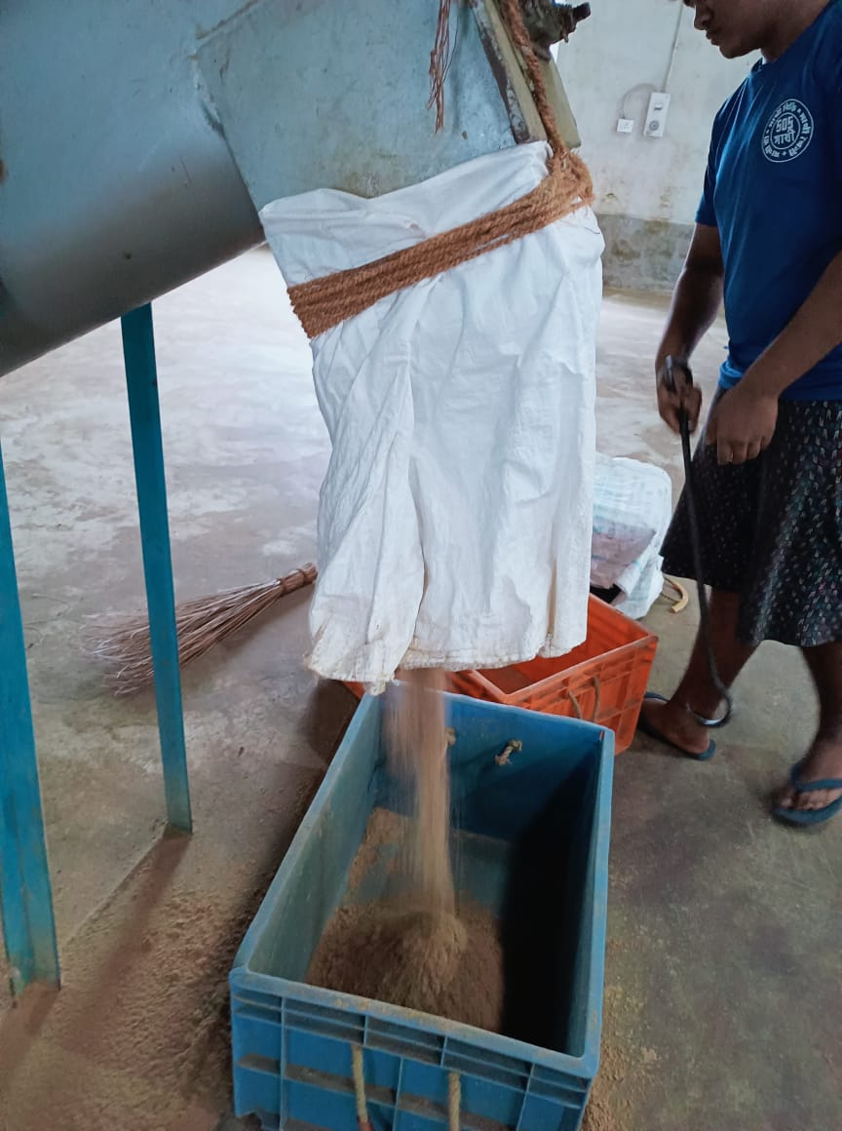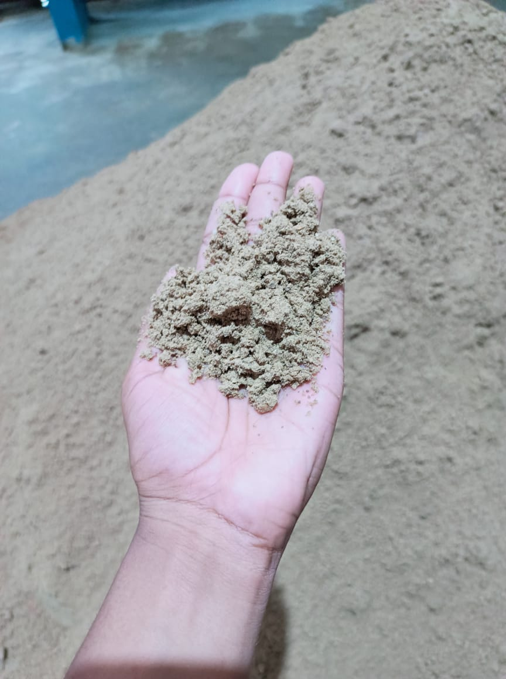
B
A
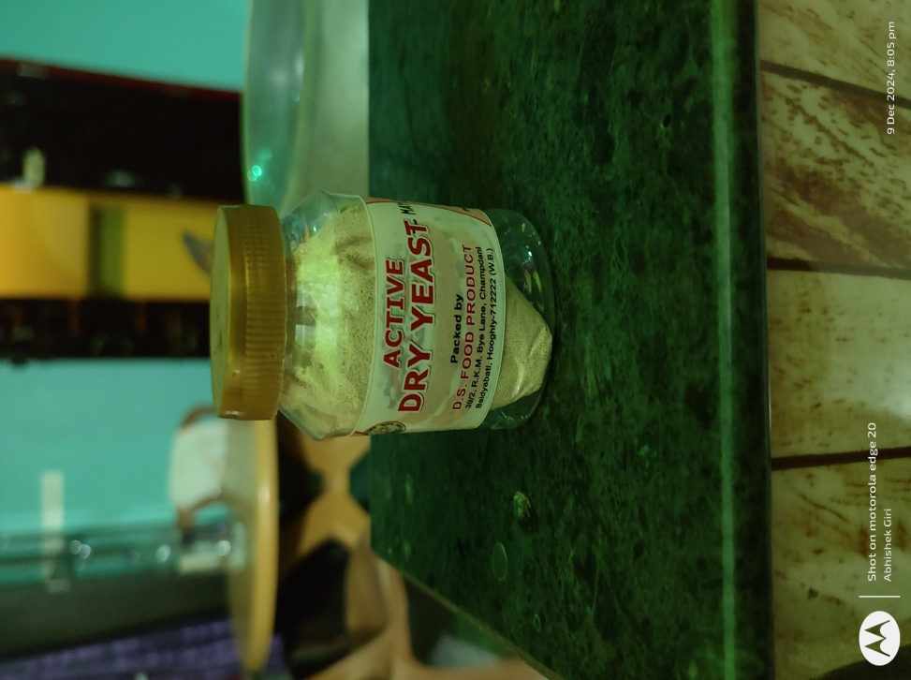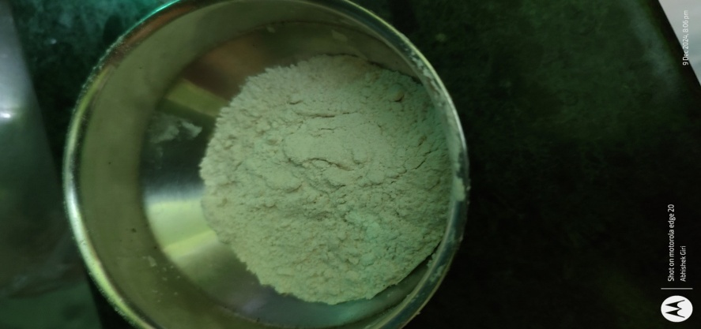
C
D
Fig1: Various types of feed ingredients (A, B = Fish Meal, C = Yeast, D = Wheat flour)
RESULT AND DISCUSSION
Interpretation of Table1: Feed Management – Pearson Square Method
The outcomes of applying the Pearson Square Method to the data included in the feed management system are shown in Table 1. The following table provides information on the precise quantities used in fish diet different food items (including fishmeal, baker's yeast, powdered milk, and whole eggs) that are required to meet the dietary needs. of each individual for each of the three kinds of feed (A, B, and C). For the purpose of catering to the particular dietary needs of broodstock brooder fish, the crude protein percentage of each diet is separately modified to 30%, 35%, and 40%. The data illustrates how different components may be combined to fulfill the protein needs of each diet, which contributes to the enhancement of the nutritional content of the feed. By going about things in this manner, we can be certain that the fish in the brooder will get all of the nutrients that they need in order to flourish.
Growth Performance
Table2: Growth Performance
Sampling | Diet A |  | Diet B |  | Diet C
Days | Length(mm) | Weight(mg) | Length(mm) | Weight(mg) | Length(mm) | Weight(mg)
(Initial)  5 days | 7.0 | 3.1 | 7.0 | 3.1 | 7.0 | 3.1
10 | 12.0 | 35.6 | 15.31 | 57.6 | 18.40 | 83.9
15 | 18.6 | 95.1 | 24.44 | 115.4 | 28.55 | 128.6
(Final) 21 days | 25.4 | 125.6 | 34.21 | 140.8 | 41.66 | 177.2
Total growth | 18.4 | 122.5 | 27.21 | 137.7 | 34.66 | 174.1

Graph2: Clustered column showing growth of seeds in length (mm) after using Diet A, B and C for 21 days.

Graph3: Clustered column showing growth of seeds in weight (mg) after using Diet A, B and C for 21 days.
In terms of growth, the fish that were fed Diets A, B, and C are compared in Table 2. This comparison was made over 21 days. From the beginning, all of the fish were measured precisely the same, beginning with the same starting weight and length of 7.0 mm. After five days, the fish adhered to all of the diets, but Diet C showed the greatest growth in both length and weight across the board. By the tenth day, the fish had grown to a length of 18.4 mm and weighed 83.9 mg, further proving that Diet C remained to be superior to the other two diets. At the same point in time, the growth rates of those following Diets A and B were slower. At the 15th day, Diet C, which consisted of fish that measured 28.55 mm in length and weighed 128.6 mg, was once again in the lead. In order to demonstrate that Diet C is more effective, the fish attained a final weight of 177.2 mg and a length of 41.66 mm by the 21st day of the experiment. Fish on Diet B reached a weight of 27.21 mm and 137.7 mg, whereas fish on Diet A achieved a weight of 18.4 mm and 122.5 mg, respectively. In this experiment, Diet C was the most successful diet for supporting the growth of the fish. It resulted in the greatest overall increase in length (34.66 mm) and weight (174.1 mg), making it the most effective diet for overall development.
Table3: ANOVA- Growth Performance on length and weight when using Diet A
SOURCE | DF | SS | MS | F
Between groups | 1 | 9030.03 | 9030.03 | 5.96**
Within groups | 8 | 12130.56 | 1516.32 | 5.96**
Total | 9 | 21160.58
Table4: ANOVA – Growth Performance on length and weight when using Diet B
SOURCE | DF | SS | MS | F
Betweengroups | 1 | 11932.19 | 11932.19 | 6.56**
Withingroups | 8 | 14555.92 | 1819.49 | 6.56**
Total | 9 | 26488.1
Table5: ANOVA – Growth Performance on length and weight when using Diet C
SOURCE | DF | SS | MS | F
Betweengroups | 1 | 19064.58 | 19064.58 | 7.01**
Withingroups | 8 | 21767.81 | 2720.98 | 7.01**
Total | 9 | 40832.38
Diet-A Diet-B Diet-C
Chart1: Box Plot showing relation between length and weight when using Diet A, B and C.

The growth response of fish fed experimental diets were reported in Table 3, 4 and 5. Diet A reported All of the results of the analysis of variance (ANOVA) that was performed on the growth performance data that was collected throughout the 21-day period are shown in Table 3, 4 and 5. When I use Diet A, there are a total of 12130.56 squares within each group, with a mean square value of 1516.32. When all of the groups are considered together, the total squares (SS) and mean square (MS) amount to 9030.03 respectively. The F-value, which was calculated to be 5.955, demonstrates statistical significance at the 5% level, indicating that the results are significant. On the other hand when I use Diet B reported , there are a total of 14555.92 squares (SS) within each group, with a mean square (MS) value of 1819.49. When all of the groups are considered together, the total squares (SS) and mean square (MS) amount to 11932.19 respectively. The F-value, which was calculated to be 6.558, demonstrates statistical significance at the 5% level, indicating that the results are significant. and also when I use Diet C, there are reported a total of 21767.81 squares (SS) within each group, with a mean square (MS) value of 2720.98. When all of the groups are considered together, the total squares (SS) and mean square (MS) amount to 19064.58 respectively. The F-value, which was calculated to be 7.007, demonstrates statistical significance at the 5% level, indicating that the results are significant.
Observation:
It was observed that the calculated F-value is more than the critical F-value, thereby rejected the null hypothesis. It means the diets (A, B, and C) had significant effects on growth performance of magur seeds. This result the concept that the nutritional conditions are responsible for the observable changes in fish growth because of the high F-value. Therefore, the analysis of variance (ANOVA) conclusively demonstrates that Diet C had a major impact on the growth performance of Clarias batrachus length and weight, with highly significant differences.
I observe that in the three cases i.e., Diet A, Diet B, and Diet C, the calculated F-value is more than the critical F-value. So, the null hypothesis can be rejected. That means there is an effect of various diets (Diet A, B, and C) on the growth performance of magur seeds. Rather than being the result of random chance, this adds support to the concept that the nutritional conditions are responsible for the observable changes in fish growth that are seen between diets A, B, and C. Because of the high F-value, it is clear that diet plays a substantial role in the growth of fish. Therefore, the analysis of variance (ANOVA) conclusively demonstrates that Diet C had a major impact on the growth of the fish's length and weight, with highly significant differences. The conclusion that can be drawn from all of this is that, out of the three diets, Diet C is the one that is most beneficial to development.
Discussion
According to many studies that Protein utilization and fish growth can be optimized by providing the right protein energy ratio. Protein utilization depends on the availability of non-protein energy sources in the feed which will affect growth, feed conversion, nutrient retention efficiency and body composition.
Excess protein in the feed is used as energy for amino acid deamination and nitrogen excretion that is wasted into the aquaculture environment. The process of excretion and catabolism of amino acids requires more energy so that the allocation of protein energy to retain protein in the body will be reduced. Retention. Protein requirements vary by fish species and the utilization of feed protein for fish growth is also influenced by fish size, protein quality, feed energy content, nutrient content balance and feeding rate.
The use of high-protein and low-protein diets resulted in higher fat retention than the full use of high-protein diets. The high fat in the body is thought to be due to other nutrient components such as carbohydrates being converted by the body to fat. Fat in the body increases due to the accumulation of fat in the liver caused by low protein feed and excess energy from feed carbohydrates. Low protein feed has high carbohydrates. protein sparing effect which means that there is a utilization of carbohydrates and fats to become alternative energy in fish to meet energy
CONCLUSION
It is concluded that Magur is a carnivorous species, that’s why it needs a high amount of protein for its development. In this experiment, all three diets play a crucial role in the development of fish growth. It was observed that Diet C, which contains 40% crude protein, shows a higher rate of growth performance in terms of length and weight. ANOVA analysis on these three diets gives a higher rate of F-value than the tabulated F-value, meaning there is a significant difference in growth performance when using Diet A, B, and C. Feed should be prepared with the help of the Pearson Square method and given four times a day.

COMPETING INTERESTS DISCLAIMER:
Authors have declared that they have no known competing financial interests OR non-financial interests OR personal relationships that could have appeared to influence the work reported in this paper.
Disclaimer (Artificial intelligence)
Option 1:
Author(s) hereby declare that NO generative AI technologies such as Large Language Models (ChatGPT, COPILOT, etc.) and text-to-image generators have been used during the writing or editing of this manuscript.
REFERENCE
- FAO. (2022). The State of World Fisheries and Aquaculture 2022: Towards Blue Transformation. Food and Agriculture Organization of the United Nations. https://www.fao.org/publications/sofia/2022/en/
- Rahman, M. A., Hossain, M. Y., &Fatematuzzohura, M. (2018). Growth and production performance of Clariasbatrachus in different culture systems: A review. International Journal of Fisheries and Aquatic Studies, 6(1), 325–330.
- Kumar, R., Saini, V. P., & Mandal, R. N. (2020). Nutritional and therapeutic properties of Clariasbatrachus (Linnaeus, 1758): A review. Journal of Applied and Natural Science, 12(2), 214–220. https://doi.org/10.31018/jans.v12i2.2297
- Tacon, A. G. J., & Metian, M. (2015). Feed matters: Satisfying the feed demand of aquaculture. Reviews in Fisheries Science & Aquaculture, 23(1), 1–10. https://doi.org/10.1080/23308249.2014.987209
- Boyd, C. E., Tucker, C. S., McNevin, A. A., Bostick, K., & Clay, J. (2017). Guidelines for aquaculture environmental performance. World Wildlife Fund (WWF). https://www.worldwildlife.org/publications/guidelines-for-aquaculture-environmental-performance
- Islam, M. S., Akter, M. N., & Hossain, M. A. (2019). Growth performance and feed utilization of Clariasbatrachus fed on different formulated feeds. Asian Journal of Medical and Biological Research, 5(1), 64–69. https://doi.org/10.3329/ajmbr.v5i1.40983
- Singh, R. K., & Sharma, J. (2021). Effect of feeding frequency on the growth performance of Clariasbatrachus (Linnaeus, 1758). Journal of Aquatic Biology & Fisheries, 9(2), 111–116.
- Singh, A., Das, R., & Mahapatra, B. (2023). Innovative aquaculture practices and the future of Indian fisheries. Just Agriculture, 4(2), 56–60.
- Baruah, D., & Das, P. (2021). Feed management in aquaculture: A review on recent practices. Journal of Fisheries and Aquatic Studies, 9(2), 1–6.
- Das, B., Mishra, D., & Pradhan, R. (2023). Export of fishery products from India: Status, challenges, and the way https://www.researchgate.net/publication/369657475 forward. ResearchGate.
- FAO. (2021). National aquaculture sector overview: India. Food and Agriculture Organization of the United https://www.fao.org/fishery/en/countrysector/naso_india Nations.
- Mukherjee, S., Ghosh, T., & Iyer, R. (2022). Fisheries as ecosystem services: A case study of the Cauvery River. Frontiers in Environmental Science, 10, 892012. https://doi.org/10.3389/fenvs.2022.892012
- Nath, S., Sharma, A., & Barman, D. (2023). Small indigenous fishes as a potent bioresource of Northeast India. https://www.researchgate.net/publication/376686982 ResearchGate.
- PMF IAS. (2023). Fisheries sector in India: Significance & challenges. https://www.pmfias.com/indias-fisheries-sector/
- Singh, A., Das, R., & Mahapatra, B. (2023). Innovative aquaculture practices and the future of Indian fisheries. Just Agriculture, 4(2), 56–60.
- Singh, R., Das, M., & Thakur, K. (2022). Aquaculture as a sustainable livelihood in rural India: A socio-economic analysis. International Journal of Fisheries and Aquatic Studies, 10(1), 45–50.
- Khan, M. M. R., Mollah, M. F. A., & Ahmed, G. U. (2000). Development of a farmer-proven induced breeding and seed production system for Clarias batrachus (magur) using a low-cost hatching apparatus in Assam. ARIASP (World Bank).

