Review Article

Why should Fireflies (Coleoptera: Lampyridae) be understood and conserved?

Abstract

Fireflies are well known for their bioluminescent capabilities and play an important role in various ecosystems, human culture, and scientific innovation. Ecologically, they serve as critical bioindicators and contribute to the food chain as predators. Economically, fireflies support ecotourism. In the field of biomedicine, they are useful in cancer treatment.
Culturally, fireflies are deeply embedded in folklore, traditions, and indigenous knowledge systems. This review highlights current research and ethnological narratives that underscore the need for firefly conservation.

Introduction
Because of their capacity to generate light, fireflies are captivating and impressive natural phenomena. However, they are beetles, with over 2500 species identified worldwide, 144 genera, and 11 sub-families (Riley et al., 2021; Keller, 2023). Fireflies, sometimes called glow flies, blinkers, flying embers, or lightning bugs, are some of Earth's most valuable and practical insects. They lack legal protection and are not entirely understood, nevertheless. A thorough assessment of fireflies' biology and signaling mechanism has been conducted (Lewis & Crastley, 2008).
According to Lewis (2016), fireflies are highly significant in ecology, economy, the environment, and culture. As predators, fireflies serve crucial roles in maintaining the stability of the food chain (Liesch, 2018). The larvae of fireflies prefer to consume termites, snails, slugs, mites, and other phytophagous pests, lowering crop production expenses for growers. They are the main focus of well-established ecotourism endeavors in many places (Khoo et al., 2012). Others still have untapped potential, which necessitates environmental consciousness. Tribal and native cultures may have a close cultural bond with fireflies, as seen in Manipur (Singh, 2023). The northern temperate zone is home to about 15% of insect species, whereas the remaining 85% are found in the tropics and Southern temperate regions, of which South East and South West Asia are crucial areas. The Australasian and Indo-Malayan regions' species count may be more than 1.5 million (Stork, 2018).

Ecological role of fireflies
Fireflies have diverse life cycles interacting with biotic and abiotic elements in an ecosystem. For instance, the Selangor River estuary, Malaysia, is well known for a large population of synchronously flashing fireflies, Pteroptyx tener, which congregate mainly on mangroves with Sonneratia caseolaris growing on edges of the riverbank (Khoo et al., 2012). Similarly, in Thailand, the congregating firefly, Pteroptyx Olivier, represents an important economic insect for ecotourism. Tourism in Thailand significantly contributes to the national economy, and fireflies are an important tourist attraction (Chaikaew, 2005; Jaikla et al., 2020). (Jusoh and Hashim 2012) conducted a land use spatial analysis of the satellite images of Rembau –Linggi estuary, Malaysia. The analysis revealed that mangroves were highly modified and converted for agriculture, aquaculture, and infrastructure. Only 50% of firefly display trees remained in the reserve forest for two decades. Aquaculture was practiced within 100m of the buffer zone. These changes have endangered the firefly and Pteroptyx tener populations. (Faudzi et al.

2021) found that river water quality influences the firefly population, Pteroptyx, at Pahang, Malaysia. Water temperature, dissolved oxygen, ammonia nitrogen, and biological oxygen demand influenced the firefly population.
Fireflies are indicators of climax vegetation (Juliana et al., 2012). Fireflies contribute to the food-web stability, playing roles as predator and prey. Larvae are carnivorous, feeding on invertebrates (Fig. 1) and keeping the ecosystem balanced. Fireflies are in focus since they are key indicators of soil, water, and air quality changes. As a climax community represents the final stage of succession, remaining stable unless interfered with by upheaval events, the presence of fireflies in an ecosystem indicates optimum levels of productivity, stability, high species diversity, and transfer of energy in the form of complex relationships and interactions established over decades (Lewis, 2016, 2023). Fireflies dwell in climax forests such as the evergreen tropical forests of the Western Ghats, South India, constituting actual forests representing the end of a dynamic ecological cycle. Evergreen tropical forests are highly complex and are critical for environmental quality (carbon sinks), livelihoods, and biodiversity.
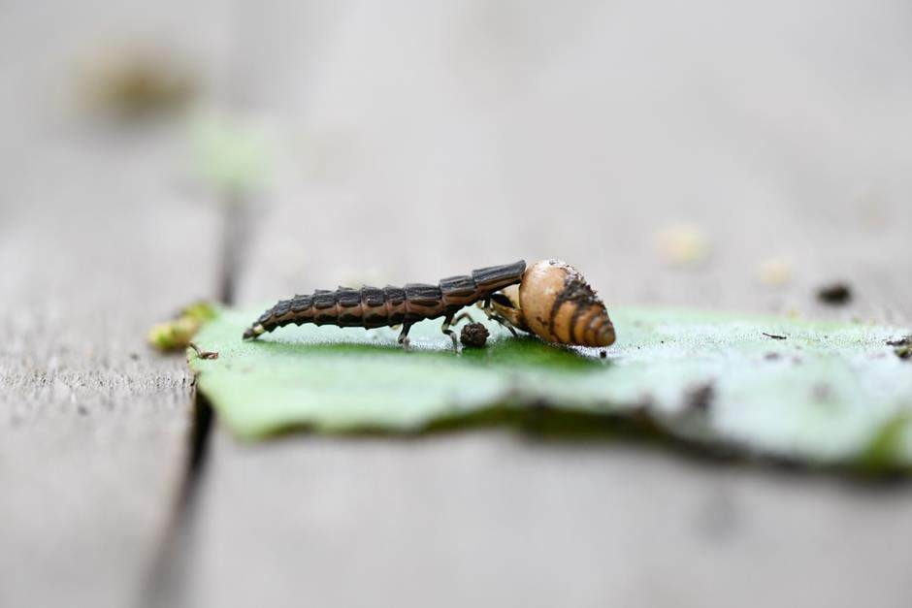

Fig1. Firefly larva - a predator on snail

This might not be ecological, something like diversity, but to SE Asia.
Thailand, Malaysia, Cambodia, Indonesia, the Philippines, New Guinea, and Sulawesi are tropical countries where fireflies are extensively spread, and many species exist (Ballantyne et al., 2019). In Southeast Asia and the Indo-Pacific region, over 400 species have been identified (Ballantyne et al., 2019), but large areas remain unexplored for fireflies, as in India. In 18 Southeast Asian countries, 493 firefly species belonging to 52 genera have been identified (Oliver Keller, 2023). Data on firefly species found in many areas, such as the Philippines, Indonesia, Cambodia, Myanmar, Singapore, Sri Lanka, Laos, and Vietnam, is outdated as no

recent studies have been conducted (Ballantyne et al., 2019). A similar situation exists concerning the Indian subcontinent. These are some countries where most species are endemic. For instance, in India, out of 86 species described, 58% are endemic \; in Indonesia, of about 50 species, 51% are endemic; in Srilanka in which 22 species are known, 38% are endemic; in Vietnam, where 70 species are known, 71% are endemic; Malaysia 62 species, 71% are endemic and Myanmar of 26 species, 54% are endemic (Keller, 2023). Unfortunately, there has been a decline in the distribution and abundance of numerous firefly species during the past few decades (Lloyd, 2018). Fireflies have specific habitat requirements and patchy distributions, so they are often at greater risk of endangerment (Lewis, 2016). Fireflies and climax forests are closely associated. However, studies are required in the South West and East Asia to provide data and establish the link between plant and firefly species.

Economic
Certain fireflies can produce spectacular synchronized flashes of light when congregating in large colonies on certain tree species of trees (Lewis, 2016; Khoo, 2012). In the evergreen tropical forest of the Western Ghats, South India, fireflies prefer trees such as the Indian almond (Terminalia catappa), Red silk cotton tree (Bombax ceiba), Areca (Areca catechu), Rubber (Hevea brazilliensis), and Ficus spp for courtship displays. In Malaysia, fireflies are commonly seen in Mangrove apple trees (Sonneratia caseolaris) (Nada & Kirton, 2004), and the most well-known genus recognized for synchronized flashing is Pteroptyx fireflies. These are native to coastal areas and riverbanks in Southeast Asia (McKenna & Farrell, 2009; Hasim, 2010; Jusoh et al., 2012; Lewis, 2021). Several studies on firefly congregations have been conducted in Malaysia, Indonesia, Thailand, and other Asian countries, but they have limitations. Specific factors and ecological requirements influencing congregations need in-depth investigations. Regretfully, a decline in the populations of fireflies and their habitats is being increasingly recorded globally. For instance, in the ten years since 2007, the firefly population in Kampung Kuantan, Selangor, Malaysia, has reduced by 42% due to river bank cleaning, conversion of river banks to oil palm and rubber plantations, and commercial use of riverbank beaches (Jusoh et al., 2010 and Lewis et al. 2021). EMPRI firefly team identified congregations of fireflies in the Charmadi Ghats, Mudigere, Chikmangalur in Karnataka; Purushwadi, Samrad, in Maharashtra ( Patil, 2023); Annamalai in Tamilnadu and Munnippara, Thumburmuzhi, Palappilly and Karikulam that are moist deciduous forests in Kerala (Jose, 2023). These localities are some of the firefly ecotourist destinations attracting large numbers of visitors to South India. Fireflies are a popular tourist attraction at Ubad, on the Indonesian island of Bali. Southeast Asia's most popular sites feature congregation fireflies in the genus Pteroptyx, which visitors watch from boat tours along Mangrove Rivers. Firefly ecotourism in Thailand annually attracts more than 19,200 and 100 400 tourists, respectively (Lewis, 2020). Besides Southeast Asia and Mexico, 285 firefly species and 50 firefly sighting sites have been identified. Local communities under social property rights manage firefly-watching sites, and each site receives 20,000 to 1 20,000 visitors each season. Entry fee per person is USD 10-20 (Ishwari, 2023).

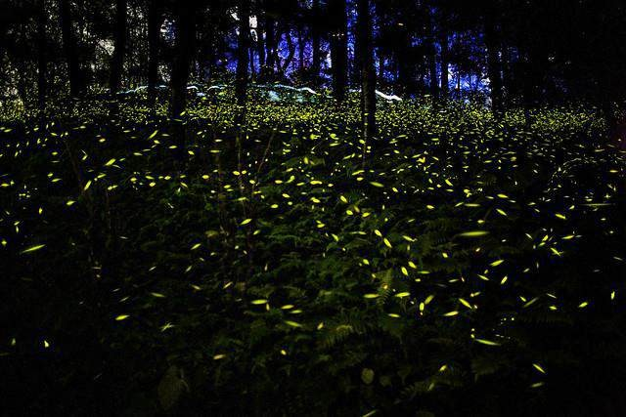

Fig 2. Firefly ecotourism-sustaining livelihoods

Congregating fireflies must be conserved in the Western Ghats at Karnataka, Tamil Nadu, Kerala, and Maharashtra. They inhabit broad landscapes and ecologically sound and healthy ecosystems, including woodlands, meadows, marsh, and other undisturbed habitats for a sufficiently long time (at least 2 to 3 years) during which the fireflies complete their lifecycle. The Indian government’s Western Ghats notifications declared 20,668 sq. km of Karnataka as an eco-sensitive area. However, researchers from IISC (Indian Institute of Science), Bengaluru, have identified that over 90,000 km of Western Ghats is ecologically fragile. This delineation of the ecologically sensitive region aims at integrating biological, geological, climatic, ecological, environmental, and social variables to develop and implement conservation strategies (Kulkarni, 2023). The general population in the Western Ghats may not be fully aware of the importance of preserving the species and habitats. In addition to these charismatic beetles, jewel beetles, stag beetles, dung beetles, tiger beetles, scarabeid beetles, and longhorn and chrysomelid beetles co-exist in the same or similar habitats. The livelihoods of rural people in and around Western Ghats are closely linked to the sustenance and perpetuation of keystone species such as the firefly beetles. Their public appeal makes them an ideal flagship for conservation.
Firefly larvae are voracious feeders of snails, slugs, termites, mites, and other soft-bodied invertebrates that feed on cultivated plants and wild vegetation (Ballantyne. 2019; Lewis, 2023). In Karnataka, South India, snails, and slugs cause economic damage to areca, pepper, betel leaves, and several vegetables and fruit crops under favorable conditions, especially in the hill and coastal regions. So, there is potential for them to be control agents. The gene for the enzyme luciferase, which allows fireflies to make these lights, is a crucial scientific tool,

spanning agricultural fields to biomedicine. The enzyme has enabled humans to develop drugs against cancer and generate drought-resistant crops (Lewis, 2023).
Fireflies secrete a group of proteins, bufagins, with cancer-curative properties (Lewis, 2016). Many species of fireflies protect themselves from predators with chemicals called lucibufagins (Lewis, 2016), toxins synthesized from the diet. Inserting the firefly gene into the cancerous cells activates bioluminescent light into the cancerous cells. Dr. Theodosis Theodossion stimulated reactions that fight the disease. This photodynamic therapy is effective against cancer tumors (Science Daily, 2003). Some species of fireflies, like Ellychina corrusca, feed on pollen and plant sap (Cranshaw, 2009). So, in certain situations, fireflies serve as pollinators.

Environmental
Many biotic factors, such as the presence of snails, vegetation health, courtship display trees, mangrove assemblages, and habitat connectivity, influence fireflies' diversity and population size. Rain, wind speed, wind direction, soil conditions, air temperature, pollution, humidity, and water quality, among others, are abiotic factors influencing fireflies. Light pollution is the greatest firefly threat (Lewis, 2016). To determine the occurrence and status of fireflies in Bangalore city, the (EMPRI), Bangalore initiated a project on fireflies in January 2022. A series of surveys were conducted to identify fireflies in Bangalore. The EMPRI team found the fireflies in 12 locations. This kindled the hope that firefly populations in the city could be revived with more marsh, wet green patches, water bodies, meadows, and trees with appropriate conditions. Small firefly populations were seen where the remnants of original, pristine habitats with green vegetation, shade, relatively safe water, and coolness abound. Most of the traditional firefly habitats have been rendered fragmented and developed. No doubt, the environment of Bangalore city has changed rapidly and drastically (Chakravarthy et al., 2023). Workers have mentioned that Pteroptyx congregations do not need a specific tree for displays in Malaysia. However, the tree should have a big leaf size, a particular arrangement of leaves, density, and location (Wong, 2004). Firefly conservation efforts will contribute to carbon benefits, as has been found with tiger conservation. Researchers analyzed 45 Tiger Reserves in India and found carbon benefits worth Rs.769 crores (Deccan Herald, 2023), suggesting restoration and habitat conservation for flagship species like fireflies would accrue carbon benefits.

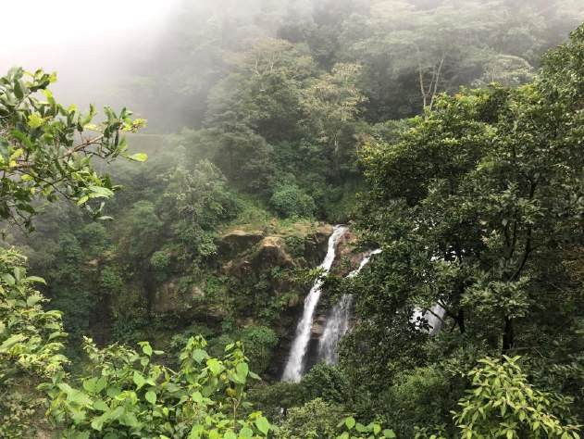

Fig 3. Fireflies: An indicator of climax vegetation
Several biological taxa interact with fireflies. For instance, in Melkote, Mandya (12⁰31’270012”, N 76⁰53’44.998 E 679m MSL) toward South Bangalore, Karnataka, South India, foresters have sighted fireflies during the post-monsoon period (i.e. after October- November) in and around paddy fields, marsh and at edges but not deep into the forest in small numbers (>10) at a spot at about 10-20m from ground. It was found that the Indian Jungle Nightjar (Caprimulgus indicus) launched aerial sallies to catch the glowing fireflies. Bills are used to handle the beetles, and the birds take the beetles to the nest site crevices in rocky edges or hill slopes. The bird has no actual nest structure and is a well-defined nest (Ali & Ripley, 1983). Females lay eggs on bare stones in a well-hidden niche near or on rocks or along stony slopes. The dark nest site gets lit by firefly lighting, enabling the mother bird to incubate eggs, rear the nestlings, and clean the nest (Chakravarthy et al., 2023). Foresters have also observed the Spotted Owlet (Athene brama) issuing out in the dark to associate with the flying firefly and locate and pounce on the unwary insect.
At the outskirts of Bangalore city (12⁰58’, 20.7912” N and 77⁰ 34’50.3148” E, 962m an Msl) during the 1960s and 1970s, quite a few pools, wells, marsh, paddy fields, and wetlands existed. A visit to these patches would invariably accompany a chorus of chi….chee…chee, the noisy singing chorus of the male weaver birds, Ploceus philippinus (Ali & Ripley, 1983). These birds in flocks breed in colonies on bulrush (Typha sp.), grass reeds in marsh, or on trees at edges of wetlands. Males, year-round, engage in nest-building activity. The nest- a dome-shaped purse with a long, down-hanging entrance tube is usually made of finely woven strips of leaves from rice plants, weeds, or grasses. Stuck inside this dome-shaped structure would be blots of wet clay mud. The Baya would catch the fireflies and glue them onto these clay blots. The firefly glows would help the mother bird tend and rear the chicks by protecting them from snakes and other predators and maintaining hygiene in the nests. Even the Baya-streaked weaver birds (Plreceus manyar), who co-inhabited with the Bayas, were found using fireflies to light their homes! (Chakravarthy et al., 2023). Fireflies as a group exhibit diverse lifecycles in terrestrial, semi-aquatic, and aquatic ecosystems, requiring a myriad of habitat niches like marsh, wetlands, caves, deserts, forests, green, moist patches, grasslands, river banks, and mangroves.

Cultural
The EMPRI firefly team, during 2022-2023, interacted with more than a thousand persons from urban, semi-urban, and rural areas on the sightings of fireflies in their backyards. All persons affirmed with conviction that the populations of fireflies dwindled over the past 4-5 decades. “Earlier, we used to commonly come across these enigmatic beetles in the open, but not now,” they asserted. In their childhood days, i.e., during the 1960s, it was fun-catching, collecting, and watching these insects glow. Children would collect these beetles in empty match-boxes, plastic containers, and pickle-glass bottles, and if nothing was accessible/available, fireflies were held in hand-kerchief or shirt pockets. The glowing fireflies raised a great deal of inquisitiveness, surprising everyone (Chakravarthy et al., 2023). In several countries, people associate with large numbers of fireflies via their synchronous switch-on and switch-off flashes in massive numbers. Fireflies are appreciated aesthetically; foresters and natives celebrate the event as Firefly Day, Firefly Count, Firefly Walk, etc. There is a need to develop a location- specific bio-cultural resource-based adaptive strategy to enhance the livelihood of local inhabitants. Culturally conscious programs for the conservation of bio-diversity should pay attention to the links between the values of bio-diversity and the cultural values within indigenous and non-indigenous communities. In specific Japanese human communities, marriage rituals are related to the emergence of fireflies. There are mythological stories interwoven with the firefly flashes in the history of human civilization in Manipur, India (Singh, 2023).
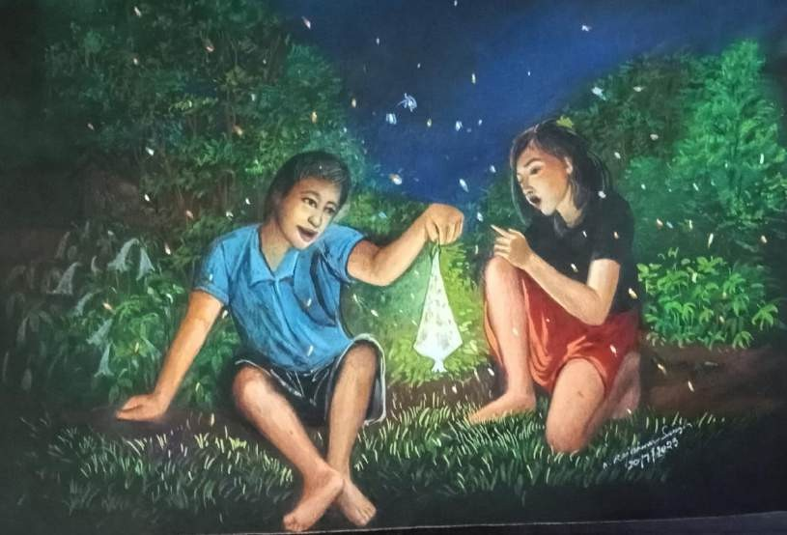

Fig 4. Firefly-a tool for biocultural Diversity ( Singh, 2023)
There is much yet to learn about fireflies’ life cycle, identity, in-depth role in niche, tropics, and Bioluminescence. Nevertheless, firefly populations across the world are fast depleting. In 2018, a study found that the extinction rate among insects is eight times that of mammals and birds (Lewis et al., 2020). Fireflies. So, what can we do about it? Countries should accord legal protection to fireflies. For instance, the Government of India on 26-07-2023 passed the Forest

Conservation Amendment Bill, 2023. This implemented central government laws for the conservation of forests in the country. Forests constitute vital habitat niches for many firefly species. The bill also added new activities, viz., ecotourism, zoos, and safari, into the array of forestry activities for the cause of conservation of forests (Ministry of Environment, Forest, Climate change, 26-07-2023, New Delhi). Hopefully, this will promote firefly conservation as well. Additionally, forests contribute to carbon sinking in a significant way. Dense, diverse forests are crucial, not only as carbon sinks but also as habitats for wildlife like fireflies. A balanced and sustainable forest policy is needed (Times of India, 2023). Let us attempt to maintain the pristine habitats of fireflies, like forests, marshes, and green vegetation, intact without disturbance. Maintaining refugia along fringe areas of farms, healthy and functional wetland ecosystems, reducing the use of toxic chemicals, and lessening light pollution in areas of suitable firefly habitats can be practically feasible.

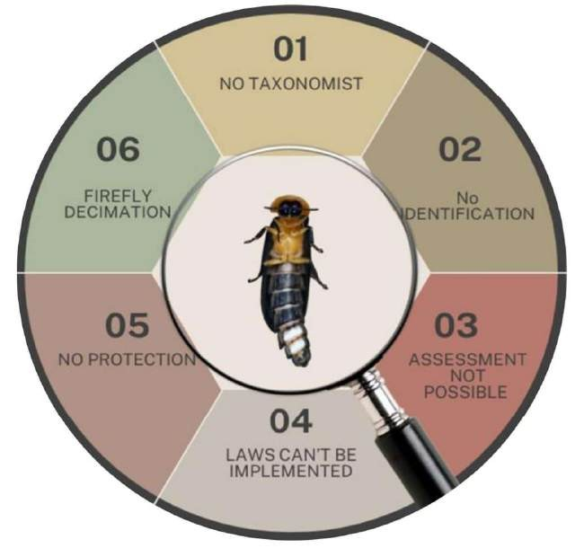

Fig 5. A schematic representation of impediments needs to be worked out for fireflies of India.
The schematic illustration highlights a number of significant obstacles to firefly conservation in India. The main obstacles are insufficient identification efforts (No Identification), a lack of taxonomic knowledge (No Taxonomist), and the inability to determine population status because of a lack of data (Assessment Not Possible). The application of legislative frameworks (Laws Can't Be Implemented) intended to safeguard firefly populations and habitats is severely hampered by these restrictions. Additionally, the problem is made worse by the lack of legal protection (No Protection), which results in habitat loss and population declines (Firefly Decimation).

This complex issue necessitates a methodical strategy to close taxonomic gaps, create thorough identification procedures, and produce baseline data for evaluation. The long-term survival of fireflies and their ecosystems will be guaranteed by incorporating these initiatives into regulatory frameworks. Comparable challenges have been noted globally, underscoring the need for coordinated research and policy interventions (Lewis et al., 2020; Gupta & Venkatraman, 2021).

References:
- Ali. S., and Dillon S. Ripley. Handbook of the birds of India and Pakistan: Together with those of Bangladesh, Nepal, Bhutan, and Sri Lanka. Second edition. Oxford Univ.press.pp.884.
- Ballantyne, L.A. & Mclean, M.R., (1970). Revisional studies on the firefly genus pteroptyx coleoptera lampyridae luciolinae lucioliniTransaction of the
American Entomological Society 96(2): 223–305.
- Chaikaew, P. (2005). Local people participation in firefly ecotourism management: a case study in Ban Samaechi, Thailand. M.Sc. Thesis. Mahidol University, Bangkok.
- Chakravarthy, A.K., Parvez, Dey, A and Das, A. (2023). Companions of the ‘fun- loving’ fireflies in the wild: friends or foes? Indian Entomologist. 4(2): 7–8.
- Cranshaw, W. (2009). Fireflies (Lightningbugs). Colorado insects of interest.
- Deccan Herald, 14/07/2023.Over 90K sq.km of Western Ghats Ecologically fragile: IISC Analysis.
- Dictionary.com. https://www.dictionary.com//climax communities 2023.
- Encyclopedia.com https://www.enyclopedia.com//environmental studies.2018.
- Firefly light helps destroy cancer cells. https://www.sciencedaily.com releases.2003/04.
- Faudzi. R, Abbas. A, Othman N.W and Mazlan S.M (2021). Effect of Water quality on the abundance of firefly populations at Cherating River. Pachang, Malaysia. Environment Asia 14(1): 69–79.
- G., Ishwari (2023). Fireflies from Mexico: Inclusive taxonomy with local communities. International Webinar on Fireflies. EMPRI, Bengaluru.
- Gupta, A., & Venkatraman, C. (2021). Status of firefly research in India: Challenges and opportunities. Indian Journal of Ecology, 48(1), 95-102.
- Jaikla.S, Lewis. S, Thancharoen. A and Pnikaew. N (2020). Distribution of the congregation fireflies Pteroptyx Olivier in Thailand. Journal of Asia-Pacific Biodiversity 13(3): 358–366.
- Jose, J (2023). Study of habitat & behaviour of congregating fireflies. International webinar on fireflies.EMPRI, Bengaluru.
- Juliana W.W. Shahril M.M, Rahman N.N and other (2012). Vegetation profile of the profile of the firefly habitat along the riparian ones of Selangor, Kuala Selangor. Malaysian Applied 13101. pp. 41(1): 55–58.
- Jusoh W.F, Hasim. N.R. and Ibrahim Z.Z. (2010). Firefly distribution and abundance in mangrove vegetation assemblages in Sepetany Estuary, Malaysia, Wetland Ecology & M. 18: 367–373.
- Jusoh W.F., and Hasim N.R. (2012). The effect of habitat modification on firefly population at the Rembau-Lingqi estuary, Peninsular Malaysia. Lampyrid; 2:
149- 155.
- Keller, O (2023). Distribution of fireflies in Southwest and Southeast Asia. International webinar on fireflies. EMPRI, Bengaluru.

- Khoo. V. Nada. B, Kirton. L.G and Phon. C.K (2012). Monitoring the population of the firefly, Pteroptyx tener, along the Selangor River, Malaysia, for conservation and Sustainable ecotourism. Lampyridae Vol. 2: 162-173.
- Kulkarni. C, Over 90,000 sq. km of Western Ghats ecologically fragile: IISc analysis T V Ramachandra noted that the study's importance was in going to the grid level to highlight the village-wise sensitivity, Deccan Herald, 13 July 2023, 22:23 IST
- Lewis, S. M., (2016). Silent Sparks: The Wondrous World of Fireflies. Princeton University Press. pp. 240.
- Lewis, S. M., (2023). From its enzymes to its role in the food chain, the little firefly is a big part of the cycle of Life. The Time of India (daily) 02/09/2023. P. 17.
- Lewis, S. M., and Christopher K. Cratsley (2008). Flash signal Ecolution, mate choice and predation in Fireflies, Ann. Rev. Ent. 53: 293-321.
- Lewis, S. M., Wong, C. H., Owens, A. C., Fallon, C., Jepsen, S., Thancharoen, A. & De Cock, R. (2020). A global perspective on firefly extinction threats. BioScience, 70(2), 157-167.
- Lewis, S., Wong, C.H., Owens, A.C., Fallon, C.E., Jepsen, S.J., Thancharoen, A.,
Wu, C., De Cock, R., Novák, M., López-Palafox, T., Khoo, V., & Reed, J.M. (2020). A Global Perspective on Firefly Extinction Threats. BioScience.
- Lloyd, J.E. 2018. A naturalist’s long walk among shadows: of North American
Photuris. Bugguide. 13(2): 191–192.
- Mckenna, D.D. & Farrell, B.D. Beetles (2009): In S.B. Hedges & S. Kumar (Eds). The time tree of life.PP.278–289.Oxford Univ. Press.
- zzati Osman, N., Jaafar Sidik, N., & Awal, A. (2017). Ethnobotanical Profiles and Phytochemical Constituents of Barringtonia racemosa L. for Potential Scrutiny of Bioactive Compounds through Plant Biotechnology. Journal of Natural Remedies, 17(2), 57–68. https://doi.org/10.18311/jnr/2017/15945
- Patil, s. (2023). Rolle of ecotourism in fireflies conservation. International webinar on fireflies July 21st and 22nd, 2023. EMPRI, Bengaluru.
- Riley WB, Rosa SP, Lima da Silveira LF. 2021. A comprehensive review and call for studies on firefly larvae. PeerJ 9:e12121.
- Singh, O.k.(2023). The Bio- -culture Diversity and the Tandan, Firefllies. International webinar on fireflies.,. EMPRI, Bangalore.
- Stork, N.E (2018). How Many Species of Insects and Other Terrestrial Arthropods Are There on Earth? Annual review of entomology. 63:31-45.
- Tiger Conservation Efforts bring carbon benefits worth Rs.769 crores. Deccan Herald. June 12, 2023.
- Times of India. Bugs and bees are dying; therefore, so will be. December 30.2022.
- Times of India. Forest for trees. July 15, 2023.
- Liesch, P.J. (2018). Five things everyone should know about … Fireflies. Grow Magazine. College of agriculture and life sciences, University of Wisconsin Madision.

