***Original Research Article***

**Evaluation of Multimodal Anesthesia using** **Butorphanol-Ketamine-Diazepam with and without Lumbosacral Epidural Block in Cesarean Sections in Pigs**

**Abstract**

This study evaluated two anesthetic protocols for cesarean sections in pigs: butorphanol-ketamine-diazepam (BKD) alone versus BKD combined with lumbosacral epidural block (BKDE). Twelve sows were divided into BKD (n=6; IV butorphanol 0.2 mg/kg, ketamine 10 mg/kg, diazepam 5 mg/kg) and BKDE (n=6; half systemic dose plus epidural lidocaine 2%, 1 mL/10 kg). Results showed BKDE provided superior analgesia (105±8 vs 75±6 min, p<0.01) with 50% less ketamine while maintaining surgical anesthesia, better hemodynamic stability (MAP 85±5 vs 72±8 mmHg, p<0.05), faster recovery (standing time 45±5 vs 75±10 min, p<0.01), and improved neonatal outcomes (Apgar 8-9 vs 6-7, p<0.01) with no stillbirths compared to two in BKD. The study concludes that BKDE offers enhanced surgical conditions, reduced systemic drug requirements, and better maternal-fetal outcomes, making it a superior choice for porcine cesarean sections**.**

**Keywords**: Butorphanol, Cesarean section, Epidural anesthesia, Ketamine , Neonatal viability, Pig.

**1. Introduction**

Cesarean section in sow is a rare operation to relieve from dystocia (Ghosh, 2007). Lack of adequate exercise during pregnancy may significantly influence the farrowing process and contribute to fetal mortality at birth in multiparous animals such as pigs (Nath *et al.,* 2013). In swine, a cesarean section is usually carried out when there is a pelvic obstruction caused by a mismatch between the size of the fetus and the maternal pelvis (Callan *et al.,* 2017). A decision for/ against cesarean section must be based on condition/ value of sow, onset of labor, type of dystocia and potential number of live fetuses remaining (Leman *et al.,* 1986). The available literature regarding cesarean section in swine for the resolution of dystocia is limited, and, to the best of the authors' knowledge, there are no published reports in English (Dimigen, 1972). Achieving optimal anesthesia is essential not only for minimizing maternal stress and pain but also for ensuring the safety and viability of the neonates. The anesthetic management of cesarean sections in pigs presents unique challenges due to their physiological responses, anatomical features, and sensitivity to anesthetic agents. In dissociative anaesthesia, vital reflexes such as corneal, palpebral, laryngeal, pharyngeal, and swallowing reflexes, along with jaw tone, are preserved, and the eyes typically remain open (Dugassa *et al.,* 2018; Hampton *et al.,* 2019). Lumbo-sacral epidural administration of analgesic or local anaesthetic agents is widely used in hospital-based surgery in several species to improve intra- and postoperative analgesia of the abdomen and the hind limbs (Almeida *el al.,* 2010). Local anaesthetics, for example lidocaine, administered epidurally provide desensitisation of the caudal abdomen and the hind limbs for up to 60 min (Tendillo *et al.,* 1995).

**2. Materials & Methods**

Twelve pregnant sows were randomly divided to two groups (n = 6). Group I (BKD) received intravenous administration of butorphanol (0.2 mg/kg), ketamine (10 mg/kg), and diazepam (5 mg/kg). Group II (Epidural) received half the intravenous dose of the BKD combination—i.e., butorphanol (0.1 mg/kg), ketamine (5 mg/kg), and diazepam (2.5 mg/kg)—along with a lumbosacral epidural injection of 2% lidocaine at a dose of 1 mL/10 kg body weight. Preoperative radiography and ultrasonography were performed to assess fetal viability (Fig.1a&b). Heart rate (HR) was measured using a stethoscope, respiratory rate (RR) was determined by thoracic excursions, and rectal temperature was recorded using a digital thermometer. Systolic arterial pressure (SAP), diastolic arterial pressure (DAP), and mean arterial pressure (MAP) were measured using an oscillometric blood pressure monitor. These clinico-physiological parameters were recorded at baseline (0 min), 5 minutes after administration of atropine, and subsequently at 10-minute intervals throughout the peri-operative period until 105 minutes. Hematological and biochemical parameters were evaluated at baseline, 30, 60, 90, and 105 minutes after drug administration. Additional peri-operative variables assessed included total anesthetic requirement, depth and duration of surgical anesthesia, intraoperative analgesia, maternal recovery profile (including time to extubation, sternal recumbency, and standing), neonatal viability using APGAR scores, and any intraoperative or post-operative complications. Surgery was performed in right lateral recumbency with an incision made on the lower flank in both groups (Fig. 2). All data were analyzed using IBM SPSS Statistics software. Parametric data were expressed as mean ± standard error (SE). For within-group comparisons of parametric variables, the paired t-test was employed. For non-parametric variables, the Wilcoxon signed-rank test was utilized to assess within-group differences. A p-value of less than 0.05 was considered statistically significant, while a p-value of less than 0.001 was considered highly significant.

**3. Result**

The BKDE group (Group II) required **50% less systemic ketamine** (5 mg/kg vs. 10 mg/kg) while maintaining adequate surgical anesthesia and **duration of anesthesia** was sufficient in both groups to perform complete surgical procedure , but group II (BKDE) exhibited **longer analgesia duration** (105 ± 8 min vs. 75 ± 6 min in Group I, p < 0.01). **Intraoperative response** in group II showed **minimal reflex movements** (1/6 sows vs. 4/6 in Group I, p < 0.05), indicating superior analgesia.  **Blood Pressure** in group II maintained **more stable MAP** (85 ± 5 mmHg vs. group I: 72 ± 8 mmHg, p < 0.05) and **Heart Rate (HR)** in Group I had **tachycardia (**HR: 120 ± 10 bpm) post-induction, while Group II remained near baseline (95 ± 6 bpm, p < 0.05). **Respiratory Rate (RR)** in Group II had **less respiratory depression** (18 ± 3 breaths/min vs. Group I: 12 ± 2 breaths/min, p < 0.05). **Time to Standing** on feet is higher in group II recovered **faster**(45 ± 5 min vs. Group I: 75 ± 10 min, p < 0.01). **Postoperative Complications**: Group I had **2 cases of regurgitation**, while Group II had **none.Group II Piglets** had higher viability scores (Apgar 8–9/10 vs. Group I: 6–7/10, p < 0.01) and **stillbirth Rate** was **zero in Group II** vs. 2 piglets in Group I.(Fig.3-6)

### ****4. Discussion****

This study evaluated the anesthetic efficacy and clinical outcomes of two protocols in swine cesarean sections: a systemic administration of butorphanol, ketamine, and diazepam (BKD) versus the same combination supplemented with a lumbosacral epidural block using lidocaine (BKDE). The findings indicated that the BKDE protocol offers significant advantages over BKD alone in terms of anesthetic efficiency, maternal recovery, and neonatal viability. BKDE group required a 50% reduction in systemic ketamine dosage while maintaining adequate surgical anesthesia. This supports the findings of the Ketamine Working Group, which pointed out that ketamine alone isn’t enough to provide adequate surgical anesthesia in pigs. They emphasized that combining it with other drugs helps achieve a deeper and more stable level of anesthesia. Liu et al.(2009) demonstrated that combining low-dose ketamine with pentobarbital resulted in superior hemodynamic and respiratory indices compared to pentobarbital alone in miniature pigs undergoing cardiopulmonary bypass procedures. The addition of a lumbosacral epidural block provided superior intraoperative analgesia, as evidenced by reduced reflex movements and prolonged analgesia duration. Ekstrand et al (2005) reported that lumbo-sacral epidural anesthesia, when combined with dissociative anesthesia, improved analgesia during scrotal herniorrhaphy in pigs, facilitating better surgical conditions . In our study, the BKDE group exhibited faster recovery times, with shorter durations to extubation, sternal recumbency, and standing, indicating a reduced anesthetic burden and improved physiological recovery. Neonatal viability, assessed using Apgar scores, was significantly higher in the BKDE group. This suggests that the reduced systemic anesthetic exposure in the BKDE protocol may minimized transplacental drug transfer, thereby enhancing neonatal outcomes. De Roth and Downie (1976) suggested the importance of evaluating neonatal viability in swine and the potential impact of maternal anesthesia on neonatal outcomes. The incorporation of a lumbosacral epidural block into the anesthetic regimen for porcine cesarean sections offers multiple benefits like minimizing potential drug-related side effects facilitating quicker return to normal physiological functions. potentially due to decreased fetal exposure to anesthetic agents.

### ****5. Conclusion****

**BKDE protocol (Group II)** demonstrated **superior anesthetic efficiency, enhanced hemodynamic stability, faster recovery,** and**better neonatal outcomes**compared to BKD alone**.** The **epidural block reduced systemic drug requirements** while improving surgical conditions, making it the **preferred technique** for porcine cesarean sections

**6. Disclaimer (Artificial Intelligence)** Author(s) hereby declare that NO generative AI technologies such as Large Language Models (ChatGPT, Deepseek, etc) and text-to-image generators have been used during writing or editing of this manuscript.

**References**

Almeida, R. M., Escobar, A., & Maguilnik, S. (2010). Comparison of analgesia provided by lidocaine, lidocaine-morphine or lidocaine-tramadol delivered epidurally in dogs following orchiectomy. Veterinary Anaesthesia and Analgesia, 37(6), 542–549.

Boschert, K., Flecknell, P. A., Fosse, R. T., et al. (1996). Ketamine and its use in the pig: Recommendations of the Consensus Meeting on Ketamine Anaesthesia in Pigs, Bergen 1994. Laboratory Animals, 30(3), 285–293.

Callan, R. J., Hackett, R. P., & Fubini, S. L. (2017). Surgery of the swine reproductive system and urinary tract. In S. L. Fubini & N. G. Ducharme (Eds.), Farm Animal Surgery (2nd ed., pp. 629–630). Elsevier.

De Roth, L., & Downie, H. G. (1976). Evaluation of viability of neonatal swine. Canadian Veterinary Journal, 17(11), 275–279.

Dimigen, J. (1972). Cesarean secretion in market pigs. Deutsche Tierärztliche Wochenschrift, 79(10), 235–237.

Dugassa, J., & Fromsa, A. (2018). Review on dissociative anaesthetics and compatible drug combinations in veterinary clinical practice. Open Journal of Veterinary Medicine, 3, 21–30.

Duffield, K. R., Hampton, K. J., Houslay, T. M., Rapkin, J., Hunt, J., Sadd, B. M., & Sakaluk, S. K. (2020). Macronutrient intake and simulated infection threat independently affect life history traits of male decorated crickets. Ecology and Evolution, 10(20), 11766–11778.

Ekstrand, C., Sterning, M., Bohman, L., & Edner, A. (2015). Lumbo-sacral epidural anaesthesia as a complement to dissociative anaesthesia during scrotal herniorrhaphy of livestock pigs in the field. Acta Veterinaria Scandinavica, 57, 33.

Ghosh, S. K. (2007). Cesarean section in a crossbred pig. Indian Journal of Animal Reproduction, 28, 96–97.

Hampton, C. E., Riebold, T. W., LeBlanc, N. L., Scollan, K. F., Mandsager, R. E., & Sisson, D. D. (2019). Effects of intravenous administration of tiletamine-zolazepam, alfaxalone, ketamine-diazepam, and propofol for induction of anesthesia on cardiorespiratory and metabolic variables in healthy dogs before and during anesthesia maintained with isoflurane. American Journal of Veterinary Research, 80, 33–44.

Leman, A. D., Straw, B., Glock, R. D., Mengeling, W. L., Penny, R. H. C., & Scholl, E. (1986). Diseases of Swine (6th ed., pp. 866–873). Iowa State University Press.

Liu, D., Hu, J., Zhang, M., et al. (2009). Low-dose ketamine combined with pentobarbital in a miniature porcine model for a cardiopulmonary bypass procedure: A randomized controlled study. European Journal of Anaesthesiology, 26(5), 389–395.

Nath, P. J., Deuri, B., & Choudhury, M. (2013). Caesarean section in Hampshire crossbred sow due to uterine inertia. Pashudhan, 39, 7.

Tendillo, F. J., Pera, A. M., Mascias, A., Santos, M., Desegura, I. A. G., & Roman, F. S., et al. (1995). Cardiopulmonary and analgesic effects of epidural lidocaine, alfentanil, and xylazine in pigs anesthetized with isoflurane. Veterinary Surgery, 24, 73–77.

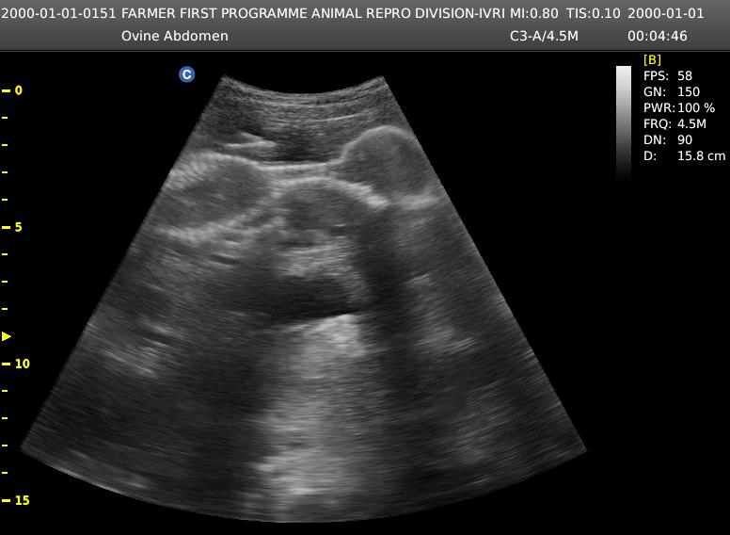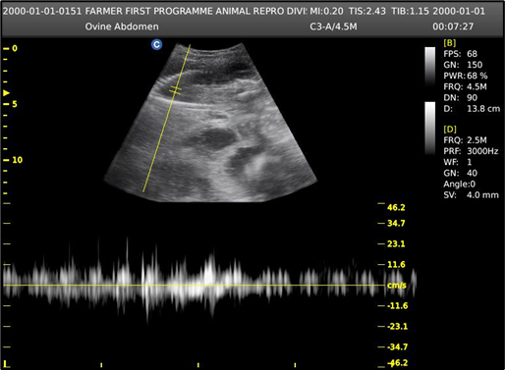

(Fig .1a&b) Ultrasonographic image demonstrating foetal viability, with pulse wave Doppler indicating blood flow to the foetus

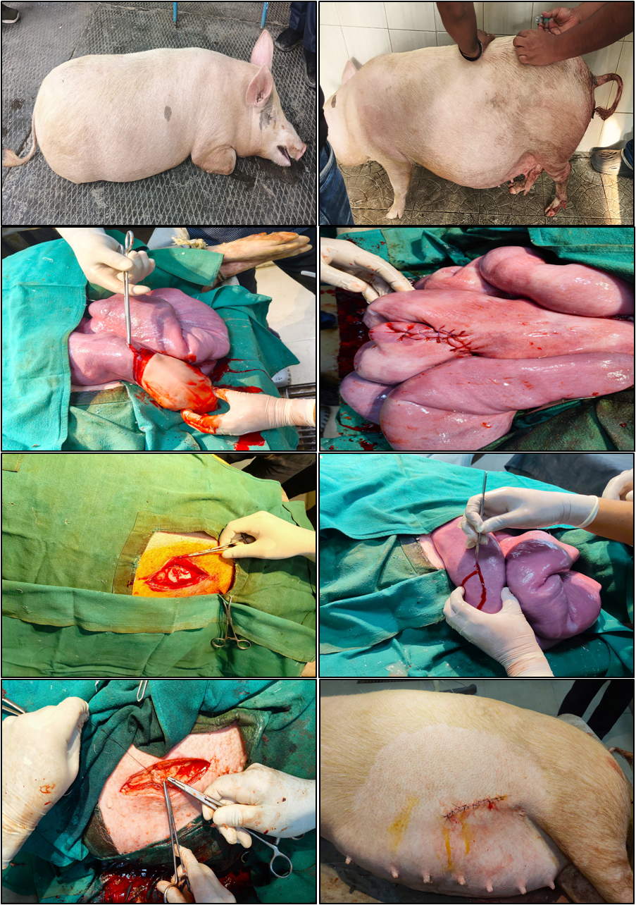

Fig.2 **(Fig. 2)** Epidural lumbosacral block administration and aseptic preparation, followed by surgical incision, uterine suturing, and skin closure.

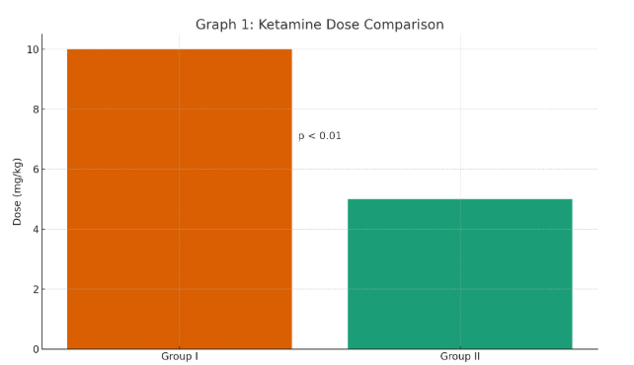

Fig 3 This graph illustrates the comparison of ketamine dosage administered in both groups.

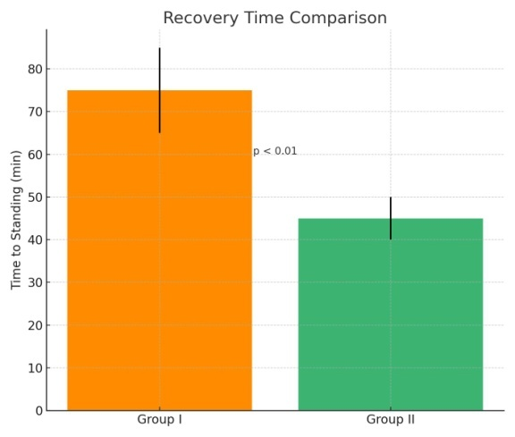

(Fig.4) This graph illustrates the comparison of recovery time in both groups.

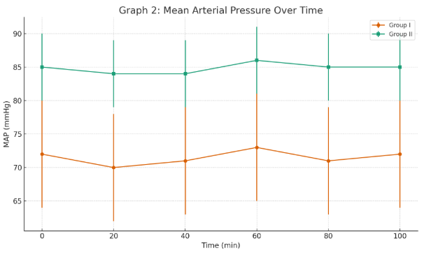

(Fig.5) This graph illustrates the comparison of mean arterial pressure over time in both groups.

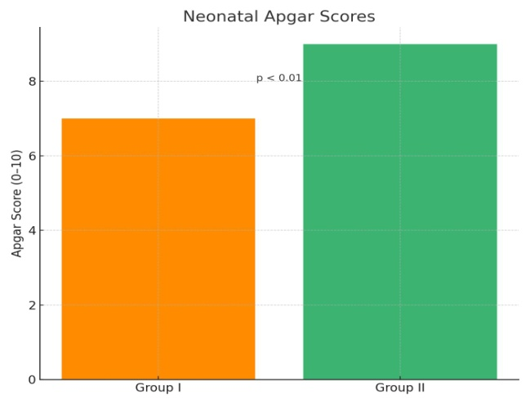

(Fig.6) This graph illustrates the comparison of neonatal Apgar scores in both groups.