**Diversity and abundance of Butterfly fauna (Insecta: Lepidoptera) in Vicinity of Shimla Kalibari, Shimla, Himachal Pradesh, India**

**Abstract**

The current study was conducted in and around the Shimla Kalibari, Shimla district, Himachal Pradesh, India, in the month of April, 2025 in order to assess the butterfly composition at high altitudes of India. During the course of the study, 39 species of butterflies belonging to five different families were recorded. Percentage composition analysis of the five families illustrated that family Pieridae (56.54%) had the highest percentage, followed by Nymphalidae (24.08%), Lycaenidae (14.11%), Hesperiidae (4.70%) and lastly Papilionidae (0.56%). Based on the sightings of butterflies at the study site, it was found that 39.51% belonged to the not rare category, 34.71% to the very common, 17.31% to the rare, 8.18% to the common and 0.28% to the very rare category. Among the recorded butterfly species, 7 of them were found to be protected under various Schedules of the Wildlife Protection Act, 1972. Values of various diversity indices such as Shannon diversity index (H'=3.19) signified the high species richness of the butterfly community. Pielou’s evenness index (j=0.87) depicted the evenly distributed nature of the butterflies in the studies butterfly community and Simpson's index of diversity (D=0.94) indicated the persistence of high species abundance in the sampled butterfly community. Therefore, the information from this preliminary survey will prove to be beneficial for implementing necessary conservation strategies required for the persistence of butterfly fauna in the hilly terrain.

**Keywords:** Butterfly community, diversity indices, high altitudes, Pieridae, Shimla Kalibari, species richness.

**1. INTRODUCTION**

Butterflies are fascinating creatures which occupy an important position in ecosystem since their diversity acts as an efficient indicator in determining the health status of a particular terrestrial biotope (Atluri & Rao, 2001). Butterflies belong to the taxonomically well explored group among insects and have caught much attention of entomologists worldwide (Ghazoul, 2002). The diversity as well as distribution of any particular butterfly species is dependent on geography of the area, flying ability and the ecological demands of the particular species (Khan et al., 2011). Studies on butterfly fauna and their characters provide crucial information regarding the ecology and habitat of a specific area (Sudheendrakumar et al., 1999). Apart from occupying a vital position in the food chain, these winged hexapods also play an important role in pollination (Watt & Boggs, 2003). Therefore, butterflies are considered as the potential taxa for the assessment of biodiversity which is important for biological conservation as well as for assessing environmental conditions (Simonson et al., 2001).

Nearly 18,768 species of butterflies have been reported worldwide (Van Nieukerken et al., 2011), while 1504 various species from India (Tiple, 2011) and approximately 288 species from Himachal Pradesh (Bogtapa, 2015). The distribution of butterflies in mountain ecosystem is regulated by its habitat and its climatic stability (Storch et al., 2003). Avery little comprehensive work has been carried out on biosystematics and ecology of butterflies from the Himalayan region (Mani, 1986; Mehta et al., 2002; Rose et al., 2003; Arora et al., 2005). Few prior survey based studies documented diversity, distribution or relative abundance from different regions of Himachal Pradesh which includes Pong dam wetland (Mehta et al., 2002) and Great Himalayan National Park (Uniyal & Mathur, 1998), sub-alpine area of Chanshal Valley (Kumar et al., 2016) and Chail Wildlife Sanctuary (Gangotia & Kumar,2018) of Shimla district, Nahan of Sirmaur District (Thakur et al.,2021), Chail Chowk of Mandi district (Gunjan et al., 2024), around Renuka Ji Lake of Sirmaur district (Sharma & Kumar, 2015) and around Govind Sagar Lake of Una district (Sharma et al., 2020).

Shimla district situated in the northern Indian state Himachal Pradesh, is home of a rich diversity of flora and fauna owing to its varied altitudes and diverse ecosystems. The elevation of the district ranges from 3238 feet to 14,764 feet. Shimla city, which falls under Shimla district experiences a subtropical highland climate with predominantly cold winters and moderately warm summers. Snowfall in this region takes place in January or early February every year. Shimla Kalibari temple is situated on Bantony hill, one of the seven hills. Th altitude of Shimla Kalibari temple and its adjoining areas is approximately 7238 feet above sea level and are predominantly surrounded by coniferous and broad-leaved forests, along with a mix of pine, oak, cedar, rhododendron, maple and horse chestnut. The vegetation typically varies with altitude exhibiting altitudinal zonation, ranging from dry scrub forests at lower elevations to alpine pastures at higher elevations. Therefore, it can be assumed that these forests provide an excellent habitat for the assemblage of large number of butterflies, which has not been documented previously. The present study was undertaken to explore the diversity and abundance of butterfly fauna in Shimla Kalibari and its adjoining areas to get an idea on the butterfly composition at high altitudes.

**2. MATERIALS AND METHODS**

**2.1. Study Area**

The entire survey was conducted in and around the Shimla Kalibari which lies at 31.10611°N"N and 77.16687"E in Shimla district of Himachal Pradesh. The study area covered a distance of approximately 4200 m. Shimla Kalibari and its adjoining area experiences a subtropical highland climate with average temperature ranging from 16°C to 25°C during summers, and 3°C to 11°C during winters. Monsoon approaches the city in the month of June and the average total annual precipitation is 1487 mm.

**2.2. Survey Technique**

The process of data collection was carried out in the month of April, 2025 when the climatic conditions were moderate and pleasant. Observations were conducted via naked eyes or via photographs and binocular. Butterfly sampling was carried out by implementing the line transect method (Hossain & Aditya, 2016). The entire survey path of 4200 m divided into 12 transects each comprised of 350 m, were surveyed every day. The sampling process was carried out for twelve consecutive days with each and every sampling following the same transect path in order to minimize the number of variables (Pyle, 1992). The butterfly species that were observed during the sampling period were recorded together with their number. Identification of maximum butterfly species were done via direct observation in the field or in few cases, photographs were clicked for the purpose. Identification was done by following the keys of Kunte et al. (2014), Kehimkar (2016) and Dey et al. (2017). During the survey period, none of the butterflies were collected or captured. The common English names and scientific names followed in the study are in correspondence with Varshney and Smetacek (2015).

**2.3. Statistical data Analysis**

To understand the community structure of the butterfly species in the sampled site, all the recorded data were used to estimate the diversity indices with the help of Microsoft Excel 2019 software. Species richness, abundance and evenness were determined through Shannon index (Shannon & Weaver, 1963), Simpson index (Simpson, 1964) and Pielou’s index (Mulder et al., 2004)respectively. To explain species richness and evenness a rank abundance curve was prepared (Whittaker, 1965).

Shannon diversity index (H’) = - Σ pi ln pi

Shannon Hmax= Log1 (N)

Dominance index (DBP)= ni/N (Berger and Parker, 1970)

Simpson’s diversity index (Ds)= ΣSi-1[ni (ni-1)/N(N-1)]

Simpson's index of diversity (D)= 1-ΣSi-1[ni (ni-1)/N(N-1)]  
Simpson's reciprocal index (Dr)= 1/ ΣSi pi2

Pielou’s evenness index (J’)= H’/ln N

Here, pi is the proportion of the ith species in the butterfly community. N is the number of species present in a butterfly fauna. ni is the number of individuals of ith species

**3. RESULTS**

The map of India highlighting Himachal Pradesh, satellite image of the study site and its vegetation is represented in figure 1. Table 1 illustrates a checklist of the butterfly species that were recorded during the survey period, along with their scientific name, the family to which they belong, their relative abundance and WPA Schedule (Wildlife Protection Act, 1972). A total number of 39 species of butterflies belonging to five families and 35 different genera were recorded from the sampled site. Among the five families of butterflies, Nymphalidae was documented as the most dominant family (13 species, 11 genera). Family Pieridae was recorded with 8 genera and 9 species, family Lycaenidae with 7 genera and 8 species and family Hesperiidae with 6 genera and 6 species, while family Papilionidae with 3 genera and 3 species. A number of butterfly species were found highly abundant in the study area those include Large Cabbage White (*Pieris brassicae*; RA=12.98), Himalayan Cabbage White (*Pieris canidia*; RA=12.23), Dark Clouded Yellow (*Colias fieldii*; RA=9.50) and Bath White (*Pontia daplidice*; RA=8.18). Relative abundance of the remaining butterfly species ranged from 3.95 to 0.09. The butterfly species whose relative abundance laid between 3.95 to 1, were Painted Lady (*Vanessa cardui*), Sorrel Sapphire (*Heliophorus sena*), Indian Tortoiseshell (*Aglais caschmirensis*), Mottled Emigrant (*Catopsilia pyranthe*), Small Copper (*Lycaena phlaeas*), Striped Albatross (*Appias libythea*), Common Grass Yellow (*Eurema hecabe*), Pioneer (*Belenois aurota*), Queen Of Spain Fritillary (*Issoria lathonia*), Great Blackvein, Himalayan Sergeant, Himalayan Jester (*Symbrenthia hypselis*), Silverstreak Blue (*Iraota timoleon*), Indian Red Admiral (*Vanessa indica*), Indian Fritillary (*Argyreus hyperbius*), Common Wall (*Lasiommata schakra*), Plain Tiger (*Danaus chrysippus*), Common Castor (*Ariadne merione*), Large Hedge Blue (*Celastrina argiolus*), White Bordered Copper (*Lycaena pavana*), Common Sailer (*Lycaena pavana*), Pea Blue (*Lampides boeticus*), Lemon Pansy (*Junonia lemonias*) and Dusky Hedge Blue (*Oreolyce vardhana*). The relative abundance of the remaining butterfly species were found less than 1.

While considering family Nymphalidae, Painted Lady (*Vanessa cardui*) was found to be the most abundant species, followed by Indian Tortoiseshell (*Aglais caschmirensis*) whereas Chocolate Pansy was the least abundant species. Species belonging to family Papilionidae were counted in very less numbers. When family Pieridae was taken into consideration, Large Cabbage White (*Pieris brassicae*) was counted in maximum number followed by Himalayan Cabbage White (*Pieris canidia*), whereas Great Blackvein (*Aporia agathon*) was recorded with least number. While considering family Lycaenidae, Sorrel Sapphire (*Heliophorus sena*) was found to be the most abundant species followed by Small Copper (*Lycaena phlaeas*), whereas Dark Grass Blue (*Zizeeria karsandra*) was recorded with least number. Lastly, Chestnut Bob (*Iambrix salsala*) under Hesperiidae family was recorded with higher number whereas Indian Dart (*Potanthus pseudomaesa*) with least number.

Analysis of percentage composition of the five butterfly families illustrated that maximum number of butterflies belonged to family Pieridae (56.54%), followed by Nymphalidae (24.08%), Lycaenidae (14.11%), Hesperiidae (4.70%) and lastly Papilionidae (0.56%) (figure 2).

Results of Genus proportion analysis (figure 3) revealed that maximum number of genera were observed in the family Nymphalidae constituting 31.43%, followed by family Pieridae with 22.86%, family Lycaenidae with 20.00%, family Hesperiidae with 17.14% and family Papilionidae with 8.57%. While evaluating the species proportion analysis, the maximum number of species were observed from the family Nymphalidae (33.33%), followed by the family Pieridae (23.08%), Lycaenidae (20.51%), Hesperiidae (15.38%) and the least number of species were observed from the family Papilionidae (7.69%).

The butterflies recorded from the survey site were categorized into five different classes on the basis of their prevalence, namely very common (VC), common (C), not rare (NR), rare (R) and very rare (VR). The result was displayed in figure . The study portrayed that among the total number of butterfly species documented from the study site, 39.51% belonged to NR category, 34.71% belonged to VC category, 17.31% belonged to R category, 8.18% belonged to C category and lastly 0.28% belonged to VR category (figure 4).

Most of the butterfly species sampled at the study site were ‘common’ and ‘generalist species’ and none of them were universally threatened according to IUCN Red List (Ver. 3.1). Only 7 butterfly species observed at the study site, were found to be protected under various Schedules of the Wildlife Protection Act, 1972. Among these butterfly species, five of them are protected under Schedule II namely, Indian Tortoiseshell (*Aglais caschmirensis*), Himalayan Jester (*Symbrenthia hypselis*), White Bordered Copper (*Lycaena pavana*), Pea Blue (*Lampides boeticus*), Silverstreak Blue (*Iraota timoleon*). The remaining two are protected under Schedule IV namely, Great Blackvein (*Aporia agathon*) and Striped Albatross (*Appias libythea*).

Figure 5 illustrates the species richness of various butterfly genera observed at the study site. It was found that genus *Vanessa* and *Junonia* of Family Nymphalidae, along with *Pieris* of Family Pieridae and *Lycaena* of Family Lycaenidae were the dominant genera, all comprised of 2 species namely, *Vanessa indica* and *Vanessa cardui* under genus *Vanessa*, *Junonia lemonias* and *Junonia iphita* under genus *Junonia*, *Pieris brassicae* and *Pieris canidia* under genus *Pieris* and *Lycaena phlaeas* and *Lycaena pavana* under genus *Lycaena*. The remaining 31 genera were recorded with one species each. Species Genus ratio was 1.11.

Table 2 illustrates the species diversity and evenness of the butterfly community of the study site which were expressed by the diversity indices such as Shannon diversity index (H'), Pielou’s evenness index (j), Simpson's diversity index (Ds) and Simpson's index of diversity (D). The Shannon diversity index (H') value (3.19) signified that the species richness and diversity of the butterfly fauna at the study site was very high. The abundance of the butterfly community was evaluated by the Simpson’s diversity index (Ds) whose value was more inclined towards 0 indicating the prevalence of high species abundance within the butterfly community. Again, the value of Simpson's index of diversity (D=0.94) indicated that the observed butterfly community had high abundance. The value of Pielou’s evenness index (j=0.87) was inclined towards 0 which depicted the persistence of more evenness among the butterfly species of the studied butterfly community. All these values expressed the butterfly community was highly diverse with high abundance and high evenness, thus implying the community was in the direction of an ideal natural community.

Table 3 represents the family-wise values of various biodiversity indices, such as Shannon diversity index (H'), Shannon Hmax, Pielou’s evenness index (j), Simpson's diversity index (Ds), Simpson's index of diversity (D) and Simpson's reciprocal index (Dr). The Shannon diversity index (H') value of the recorded five butterfly families ranged from 1.01 to 2.47. In this case, the family Nymphalidae was noted with the highest value as the maximum number of species were recorded from this family, followed by Pieridae, Lycaenidae, Hesperiidae whereas, the least value was observed from the Papilionidae family. Moreover, the highest value of Shannon Hmax was obtained from the family Pieridae (2.78), followed by Nymphalidae (2.41), Lycaenidae (2.18), Hesperiidae (1.7) and Papilionidae (0.78). The values of Pielou’s evenness index (j) determine whether a community is evenly distributed or not. This value was highest in case of Hesperiidae (0.99), followed by Nymphalidae (0.96), and Papilionidae and Lycaenidae with the same value (0.92) whereas the least value was observed from the family Pieridae (0.9). In the current study, the value of Simpson's reciprocal index (Dr) indicated that higher diversity of butterfly was observed in the family Nymphalidae (10.68).

Figure 6 demonstrated the Whittaker plot i.e., species-wise rank abundance curve that explains the species abundance with evenness and family-wise rank abundance curve (figure 7) that illustrated the species abundance and evenness among the six families. The Whittaker plot’s curve showed a steep inclination up to the first five butterfly species that were documented in the surveyed community, five butterfly species occurred in high abundance with less evenness in comparison to the remaining species. Species rank twelfth onwards the abundances of the observed butterfly species were reduced accordingly with increased evenness among the recorded species in the butterfly community.

While considering the family-wise rank abundance curve, it was clearly observed that more evenness was in family Hesperiidae, followed by family Nymphalidae and, Papilionidae and Lycaenidae whereas, family Pieridae showed relatively less evenness.

**4. DISCUSSION**

Butterflies belonging to order Lepidoptera, are well known ecologically as well as taxonomically and are considered as efficient ecological indicators (Mihoci et al., 2011). They are one of the most taxonomically analyzed group of insects (Kumar et al., 2016). Butterflies play a significant role in maintaining equilibrium among various aspects of nature by providing ecosystem services. Shimla district is situated in Himachal Pradesh, the north Indian state which is deemed as one of the richest reservoirs of biological diversity in the world. Varied vegetation in the state is a result of the precipitation and elevation. Shimla Kalibari and its surrounding areas, situated in Shimla district are predominantly mountainous region harbouring a wide variety of flora and fauna. The diverse vegetation at varying altitudes thus provides a suitable habitat for the assemblage of wide variety of butterflies.

A total of 39 different species of butterflies belonging to five different families were documented from the study site. Nymphalidae was found to be the dominant family at the study site comprised of 13 species, whereas Gangotia and Kumar (2018) recorded the presence of 23 butterfly species belonging to family Nymphalidae at Chail Wildlife Sanctuary and Kumar et al. (2016) recorded the presence of 10 butterfly species belonging to family Nymphalidae, at Chanshal valley of Shimla district. Family Pieridae was comprised of 9 species which is similar to the findings of Kumar et al. (2016) obtained from Chanshal valley, whereas Gangotia and Kumar (2018) recorded the presence of 12 species from Chail Wildlife Sanctuary, Shimla .8 species belonging to Lycaenidae family were documented from the study site which was similar to the findings of Kumar et al. (2016)from Chanshal valley, whereas Gangotia and Kumar (2018)recorded the presence of 11butterfly species belonging to Lycaenidae family from Chail Wildlife Sanctuary. A total number of 6 species of the family Hesperiidae were recorded from the sampled area of the present study, while only 3 species belonging to Hesperiidae were found from Chail Wildlife Sanctuary of Shimla district by Gangotia and Kumar (2018). Only 3 butterfly species were recorded from Papilionidae family from the current study site. This observation was in the similar line as documented in prior studies where only 2 butterfly species of Papilionidae family was noted from Chanshal valley and 4 butterfly species from Chail Wildlife Sanctuary of Shimla district by Kumar et al. (2016) and Gangotia and Kumar (2018) respectively.

While considering the values of Shanon-Wiener diversity index of the observed butterfly community, family Nymphalidae had the highest value (2.47) which was pretty similar to the findings of Kumar et al. (2016)from Chanshal Valley where family Nymphalidae had the highest value (1.96), but contradicted with the findings of Gangotia and Kumar (2018) from Chail Wildlife Sanctuary where Lycaenidae family had the highest value (2.31). At the study site, maximum species evenness was observed in family Hesperiidae (0.99), whereas in Chanshal Valley and Chail Wildlife Sanctuary of district Shimla, it was stated maximum in the family Papilionidae (0.87) and family Nymphalidae (7.77) by Kumar et al. (2016)and Gangotia and Kumar (2018) respectively.

The high species abundance and richness of the butterfly community of the study area was largely due to the diverse vegetation throughout, varying from thorny bushes to large trees which attract a considerable number of butterflies. Butterflies like Large Cabbage White (*Pieris brassicae*) were found either near prickly Sow thistle plant (*Sonchus asper*) or the pink flowers of apple tree (*Malus domestica*) whereas Painted Lady (*Vanessa cardui*), Pea Blue (*Lampides boeticus*) and Dark Clouded Yellow (*Colias fieldii*) were found nectar feeding on Tridax Daisy (*Tridax procumbens*). Therefore, Shimla Kalibari and its surrounding areas provide a suitable habitat for the conglomeration of butterfly community. Although, increased infrastructure development in the recent years have led to destruction of several natural aspects which might have a negative impact on diversity and abundance of these aesthetic indicator species. The study recommends systematic surveys of butterfly fauna of this high foot fall landscape to speculate the habitat health and ecosystem functioning, and if required, conservation initiatives have to be implemented in order to safeguard the existing flora and fauna along with their peaceful co-existence in this mountain ecosystem.

**5. CONCLUSION**

Thus, the present study has documented the existence of a diverse butterfly community in and around the Shimla Kalibari. The mountains along with its diverse vegetation, had provided a suitable habitat for a large number of butterflies those were found dwelling at the study site. However, increased tourism and infrastructure development has led to degradation of the natural habitats which might have caused migration or local extinction of the butterfly species that originally existed in this region in past. Therefore, necessary conservation strategies have to be implemented in order to conserve the flora and fauna residing in this region. The data recorded from the study site will prove to be beneficial as a source of reference for future systematic survey-based studies.

**DISCLAIMER (ARTIFICIAL INTELLIGENCE)**

Authors hereby declare that NO generative AI technologies such as Large Language Models (ChatGPT, COPILOT, etc.) and text-to-image generators have been used during the writing or editing of this manuscript.

**REFERENCES**

Arora, G. S., Mehta, H. S., & Walia, V. K. (2005). Fauna of Western Himalaya (Part 2). Himachal Pradesh: Director, Zoological Survey of India Kolkata, 1, 359-416.

Atluri, J. S. R., & Rao, S. P., (2001). Psychophily and evolution consideration of *Cadaba fructicosa* (Capparaceae). *Journal of the Bombay Natural History Society*, 99(1), 59-63.

Berger, W. H., & Parker, F. L. (1970). Diversity of planktonic foraminifera in deep sea sediments. *Science*, 168, 1345-1347.

Bogtapa, S. (2015). Diversity of Butterflies from District Solan, Himachal Pradesh, India. *Journal on New Biological Reports*, 4(2), 139-148.

Dey, P. K., Payra, A., & Mondal, K. A. (2017). Study on butterfly diversity in Singur*. e-planet*, 15(1), 73-77.

Gangotia, R., & Kumar, P. (2018). Preliminary Studies on Butterfly Fauna of Chail Wildlife Sanctuary, Shimla, Himachal Pradesh*. International Journal of Science and Research*, 7(9), 1648-1651.

Ghazoul, J. (2002). Impact of logging on the richness and diversity of forest butterflies in a tropical dry forest in Thailand. *Biodiversity and Conservation*, 11, 521-541.

Gunjan, Harshlata, Bharti, V., & Sharma, N. (2024). Butterfly Biodiversity (Nougraun village, Chail Chowk, Mandi, H.P.). *Journal of Entomology and Zoology Studies*, 12(4), 41-52.

Hossain, A., & Aditya, G. (2016). Avian Diversity in Agricultural Landscape: Records from Burdwan, West Bengal, India. *Proceedings Society*, 69(1), 1-14.

Kehimkar, I. (2016). Butterflies of India, Bombay Natural History Society. Mumbai: Oxford University Press.

Khan, Z. H., Raina, R. H., Dhar, M. A., & Ramamurthy, V. V. (2011). Diversity and Distribution of Butterflies from Kashmir Himalayas. *Journal of insect science*, 24(1), 45-55.

Kumar, P., Devi, R., & Mattu, V. K. (2016). Diversity and abundance of Butterfly fauna (Insecta: Lepidoptera) of Subalpine area of Chanshal Valley of District Shimla (Himachal Pradesh). *Journal of Entomology and Zoology Studies*, 4(4), 243-247.

Kunte, K., Zhang, W., Tenger-Trolander, A., Palmer, D. H., Martin, A., Reed, R. D, et al. (2014). Double sex is a mimicry supergene. *Nature*, 507, 229-232.

Mani, M. S. (1986). Butterflies of the Himalaya. Janpath, New Delhi: Oxford & IBH Publication Co, 181.

Mehta, H. S., Thakur, M. S., Sharma, R. M., & Mattu, V. K. (2002). Butterflies of Pong dam wetland, Himachal Pradesh, India. *Bionotes*, 4(2), 37-38.

Mihoci, I., Hrsak, V., Kucinic, M., Micetic-Stankovic, V., Delic, A., & Tvrtkovic, N. (2011). Butterfly diversity and biogeography on the Croatian karst mountain biokovo: Vertical distribution and preference for altitude and aspect. *European Journal of Entomology*, 108(4), 623-633.

Mulder, C. P. H., Bazeley-White, E., Dimitrakopoulos, P. G., Hector, A., Scherer-Lorenzen, M., & Schmid, B. (2004). Species evenness and productivity in experimental plant communities. *Oikos*, 107, 50–63.

Pyle, R. M. (1992). Handbook for butterfly watchers, Boston: Houghton Mifflin Harcourt.

Rose, H. S., Walia, V. K., & Mehta, H. S. (2003). Studies on the butterflies of Sukhna and Catchment area in Chandigarh, India. *Journal of Entomological Research*, 30(2), 175-178.

Shannon, C. E., & Weaver, W. (1963). The Mathematical Theory of Communication. Urbana: The University of Illinois Press.

Sharma, K. L., & Kumar, R. (2015). Diversity of Butterflies in Renuka Lake and its Vicinity of Himachal Pradesh. *International Journal of Science and Research*, 4(9), 1628-1634.

Sharma, K., Kumari, V., & Lakhanpal, D. (2020). A Preliminary Study of Diversity of Butterflies Around Goving Sagar lake in District Una, Himachal Pradesh*. Uttar Pradesh Journal of Zoology*, 41(9), 123-127.

Simonson, S. E., Opler, P., & Stohlgren, T. J. (2001). Rapid assessment of butterfly diversity in a montane landscape. *Biodiversity and Conservation*, 10, 1369-1386.

Simpson, G. G. (1964). Species density in North American recent mammals. *Systematic Zoology*, 3, 57–73.

Storch, D., Konvicka, M., Benes, J., Martinkova, J., & Gaston, K. J. (2003). Distribution patterns in Butterflies and birds of the Czech Republic: Separating effects of habitat and geographical position. *Journal of Biogeography*, 30, 1195-1205.

Sudheendrakumar, V. V., Binoy, C. F., Suresh, P. V., & Mathew, G. (1999). Habitat association of butterflies in the Parambikulum Wildlife Sanctuary, Kerala, India. *Journal of the Bombay Natural History Society*, 92 (2), 193-202.

Thakur, S., Bahrdwaj, S., & Singh, A. P. (2021). Diversity Pattern of butterfly communities (Lepidoptera) in different habitat types of Nahan, Himachal Pradesh, India. *Journal of Threatened Taxa*, 13(8), 19137-19143.

Tiple, A. D., Deshmukh, V. P., & Dennis, R. L. H. (2006). Factors influencing nectar plant resource visits by butterflies on a University campus: implications for conservation. *Nota Lepidopteralogica*, 28, 213-224.

Tiple, A. D. (2011). Butterflies of Vidarbha region Maharashtra, India; a review with and implication for conservation. *Journal of Threatened Taxa*, 3(1), 1469-1477.

Uniyal, V. P., & Mathur, P. K. (1998). Diversity of butterflies in Great Himalayan National Park, Western Himalaya. *Indian Journal of Forestry*, 21(2), 150-155.

Van-Nieukerken, E. J., Kaila, L., Kitching, I. J., Kristensen, N.P., Lees, D.C., Minet, J., et al. (2011). Order Lepidoptera. In Z. Q. Zhang (Eds.), Animal Biodiversity: An outline of higher-level classification and survey of taxonomic richness. Zootaxa, 3148, 212-221.

Varshney, R. K., Smetacek, P. (2015). A Synoptic Catalogue of the Butterflies of India. New Delhi: Indinov Publishing.

Watt, W. B. & Boggs, C. L. (2003). Synthesis: butterflies as model system in ecology and evolution-present and future. In C.L. Boggs, W. B. Watt & P. R. Ehrlich (Eds.), Butterflies Ecology and evolution taking flight. The University of Chicago Press: Chicago and London, 603-613.

Whittaker, R. H. (1965). Dominance and diversity in land plant communities: numerical relations of species express the importance of competition in community function and evolution. *Science*, 147(3655), 250–260.

Table 1: Checklist of butterfly species along with their family, relative abundance, status and WPA Schedule recoded in the study area.

|  |  |  |  |  |  |  |
| --- | --- | --- | --- | --- | --- | --- |
| **Sl. No.** | **Family** | **Common Name** | **Scientific name** | Relative Abundance | **Status** | **WPA  schedule** |
| 1 | Nymphalidae | Plain Tiger | *Danaus chrysippus* | 1.32 | NR |  |
| 2 |  | Indian Fritillary | Argyreus hyperbius | 1.69 | VC |  |
| 3 |  | Queen of Spain Fritillary | *Issoria lathonia* | 2.35 | R |  |
| 4 |  | Indian Red Admiral | *Vanessa indica* | 1.79 | NR |  |
| 5 |  | Painted Lady | *Vanessa cardui* | 3.95 | VC |  |
| 6 |  | Indian Tortoiseshell | *Aglais caschmirensis* | 3.29 | R | Schedule II |
| 7 |  | Lemon pansy | *Junonia lemonias* | 1.03 | R |  |
| 8 |  | Chocolate Pansy | *Junonia iphita* | 0.94 | NR |  |
| 9 |  | Common Sailor | *Neptis hylas* | 1.13 | NR |  |
| 10 |  | Common Wall | *Lasiommata schakra* | 1.41 | C |  |
| 11 |  | Common Castor | *Ariadne merione* | 1.22 | R |  |
| 12 |  | Himalayan Sergeant | *Athyma opalina* | 2.07 | C |  |
| 13 |  | Himalayan Jester | *Symbrenthia hypselis* | 1.88 | NR | Schedule II |
| 14 | Papilionidae | Common Mormon | *Papilio polytes* | 0.19 | NR |  |
| 15 |  | Common Rose | *Pachliopta aristolochiae* | 0.09 | NR |  |
| 16 |  | Common Bluebottle | *Graphium sarpedon* | 0.28 | R |  |
| 17 | Pieridae | Common Grass Yellow | *Eurema hecabe* | 2.92 | NR |  |
| 18 |  | Dark Clouded Yellow | *Colias fieldii* | 9.50 | NR |  |
| 19 |  | Large Cabbage White | *Pieris brassicae* | 12.98 | R |  |
| 20 |  | Himalayan Cabbage White | *Pieris canidia* | 12.23 | R |  |
| 21 |  | Bath White | *Pontia daplidice* | 8.18 | NR |  |
| 22 |  | Great Blackvein | *Aporia agathon* | 2.07 | NR | Schedule IV |
| 23 |  | Pioneer | *Belenois aurota* | 2.35 | R |  |
| 24 |  | Mottled Emigrant | *Catopsilia pyranthe* | 3.20 | NR |  |
| 25 |  | Striped Albatross | *Appias libythea* | 3.10 | VR | Schedule IV |
| 26 | Lycaenidae | Small Copper | *Lycaena phlaeas* | 3.20 | C |  |
| 27 |  | White Bordered Copper | *Lycaena pavana* | 1.22 | R | Schedule II |
| 28 |  | Sorrel Sapphire | *Heliophorus sena* | 3.86 | R |  |
| 29 |  | Dark Grass Blue | *Zizeeria karsandra* | 0.66 | NR |  |
| 30 |  | Dusky Hedge Blue | *Oreolyce vardhana* | 1.03 | VR |  |
| 31 |  | Large Hedge Blue | *Celastrina argiolus* | 1.22 | VC |  |
| 32 |  | Pea Blue | *Lampides boeticus* | 1.13 | NR | Schedule II |
| 33 |  | Silverstreak Blue | *Iraota timoleon* | 1.79 | NR | Schedule II |
| 34 | Hesperiidae | Indian Dart | *Potanthus pseudomaesa* | 0.56 | VR |  |
| 35 |  | Grass Demon | *Udaspes folus* | 0.85 | R |  |
| 36 |  | Chestnut Bob | *Iambrix salsala* | 1.03 | NR |  |
| 37 |  | Spotted Small Flat | *Sarangesa purendra* | 0.66 | NR |  |
| 38 |  | Fulvous Pied Flat | *Pseudocoladenia dan* | 0.75 | R |  |
| 39 |  | Indian Palm Bob | *Suastus gremius* | 0.85 | R |  |

VC - very common (>100 sightings), C – common (51 to 100 sightings), NR – nor rare (16 to 50 sightings), R – rare (3 to 15 sightings), VR – very rare (1 to 2) to indicate the rarest to the most common butterfly species (Tiple et al., 2006)  
WPA- Species enlisted in Indian Wildlife Protection Act, 1972.

Table 2: Values of different biodiversity indices of butterfly population of the study area

|  |  |  |  |
| --- | --- | --- | --- |
| **Shannon diversity index (H')** | **Pielou’s evenness index (j)** | **Simpson's diversity index (Ds)** | **Simpson's index of diversity (D)** |
| 3.19 | 0.87 | 0.06 | 0.94 |

Table 3: Values of different biodiversity indices of five butterfly families of the study area.

|  |  |  |  |  |  |  |
| --- | --- | --- | --- | --- | --- | --- |
| **Family** | **Shannon diversity index (H')** | **Shannon Hmax** | **Pielou’s evenness index (j)** | **Simpson's diversity index (Ds)** | **Simpson's index of diversity (D)** | **Simpson's reciprocal index (Dr)** |
| **Nymphalidae** | 2.47 | 2.41 | 0.96 | 0.09 | 0.91 | 10.68 |
| **Papilionidae** | 1.01 | 0.78 | 0.92 | 0.27 | 0.73 | 2.57 |
| **Pieridae** | 1.98 | 2.78 | 0.90 | 0.16 | 0.84 | 6.22 |
| **Lycaenidae** | 1.91 | 2.18 | 0.92 | 0.17 | 0.83 | 5.84 |
| **Hesperiidae** | 1.77 | 1.7 | 0.99 | 0.16 | 0.84 | 5.79 |

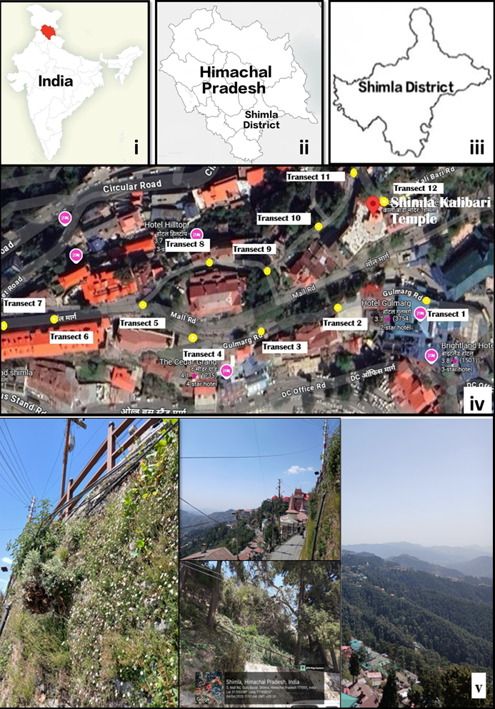

Figure 1. Map of India (i), Himachal Predesh (ii), Shimla district (iii) and satellite image (iv) and vegetation of study area (v).

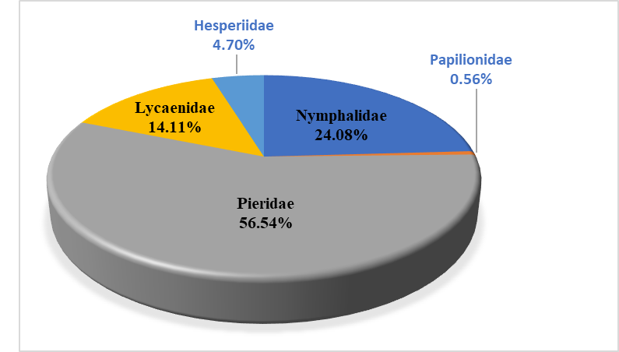

Figure 2. Percentage composition of five families of butterflies in the study area.

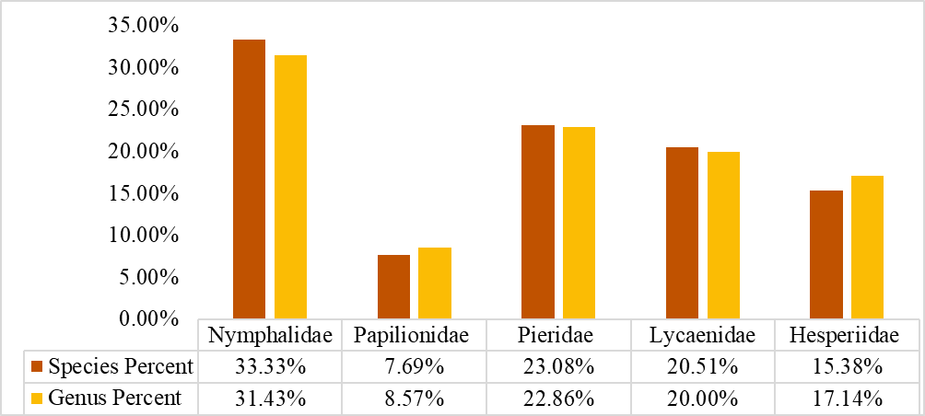

Figure 3. Genus to species proportion of butterflies of five families.

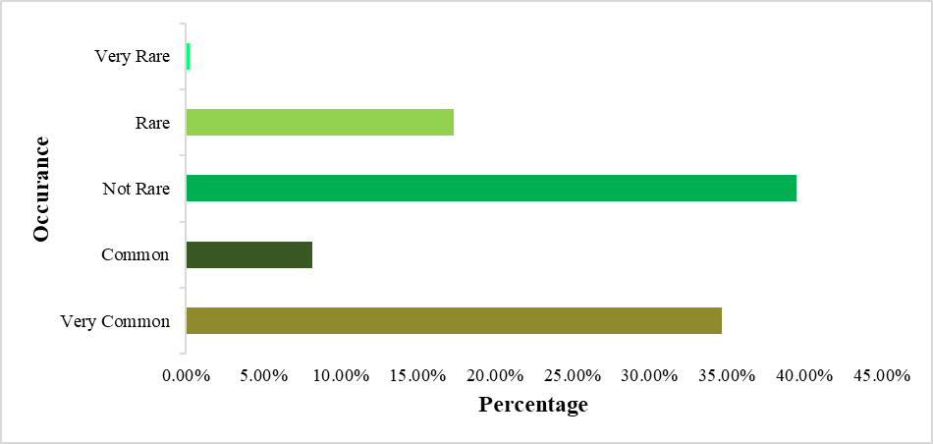

Figure 4. Occurrence of different butterfly species in the study area.

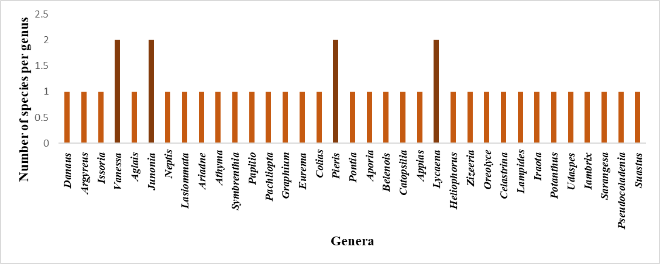

Figure 5. Species richness of the recorded butterfly genera of the study site.

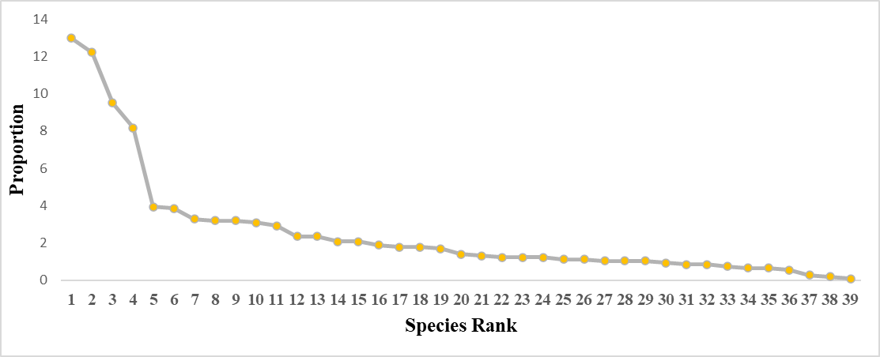

Figure 6. Rank abundance curve of 39 species of butterfly in the study area.

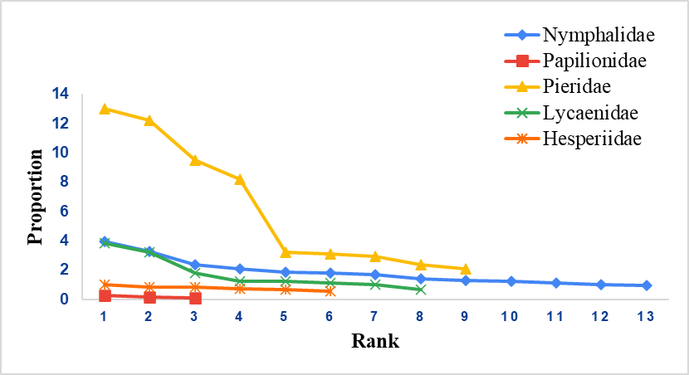

Figure 7. Rank abundance curve of five families of butterfly in the study area

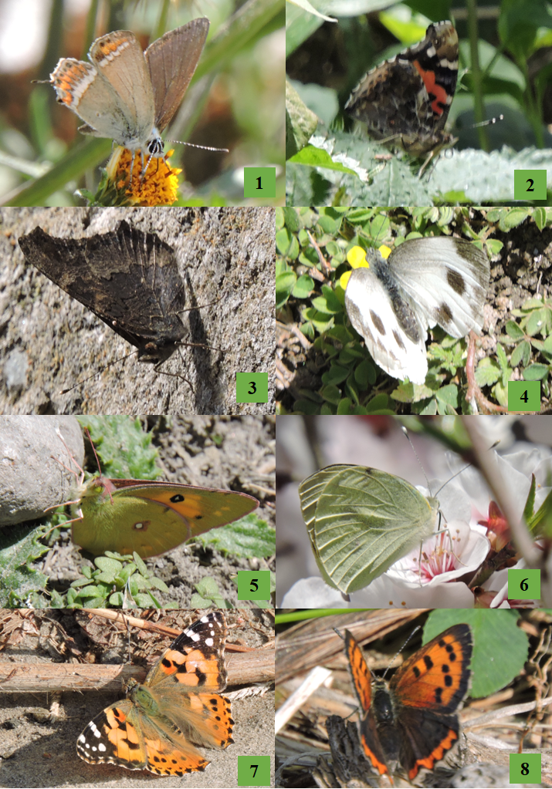

Figure 8. Photographs of different butterfly species recorded in the study area  
1) *Heliophorus sena*, 2) *Vanessa indica*, 3) *Aglais caschmirensis*, 4) *Pieris canidia*, 5) *Colias fieldii*, 6) *Pieris brassicae*, 7) *Vanessa cardui*, 8) *Lycaena phlaeas.*