CONCENTRATION-DEPENDENT EFFECTS OF CuO NANOPARTICLES ON SURVIVAL, BIOMASS AND REPRODUCTION IN DRAWIDA WILLSI

Abstract
The increasing use of copper oxide nanoparticles (CuO NPs) in agriculture and consumer products has raised concerns regarding their environmental impact, particularly on soil-dwelling organisms. This study evaluates the ecotoxicological effects of CuO NPs on Drawida willsi (Michaelsen), a dominant earthworm species in Indian croplands and a vital indicator of soil health. Earthworms were exposed to varying concentrations of CuO NPs (0, 200, 400, 600, 800, and 1000 mg/kg soil) for 28 days.Observations were recorded at 7-day interval throughout the exposure period. Results revealed a significant, concentration-dependent decline in survival, biomass, and reproduction rate. While lower concentrations (≤400 mg/kg) exhibited minimal toxicity, higher concentrations caused substantial reductions in cocoon production and led to complete mortality at 1000 mg/kg. These findings highlight the potential ecological risks associated with CuO NP contamination in agricultural soils and emphasize the need for cautious application and disposal practices.
Keywords: CuO nanoparticles, Drawida willsi, earthworm toxicity, reproduction, biomass, soil ecotoxicology, nanoparticle exposure
INTRODUCTION
Nanotechnology is revolutionizing multiple sectors due to the unique properties of nanoparticles (NPs), which typically range from 1 to 100 nanometers in size. Their high surface-area-to-volume ratio enhances chemical reactivity, making them valuable in fields like medicine, agriculture, and materials science. Nanoparticles can be broadly categorized into several types, including fullerenes, ceramic NPs, polymeric NPs, and metal-based NPs. Among these, metal nanoparticles are of particular concern due to their persistence in the environment and potential long-term ecotoxicological effects (Royal Society and The Royal Academy of Engineering 2004). With the increasing application of metal nanoparticles, including copper oxide nanoparticles (CuO NPs), it is estimated that thousands of tonnes are released into the environment annually through industrial discharge, agricultural practices, and waste mismanagement (Keller 2021; McGillicuddy et al., 2017; Bundschuh et al., 2018). These particles accumulate in soil ecosystems and may interact with soil organisms, potentially disrupting ecological balance. The toxicity of nanoparticles is influenced by factors such as concentration, exposure duration, particle stability, and bioaccumulation within tissues.
CuO nanoparticles are widely used in agriculture due to their strong antimicrobial properties. They are incorporated into fertilizers, insecticides, fungicides, herbicides, and soil amendment agents to enhance crop yield and manage pests (Kora 2022). These applications lead to the unintentional release of CuO NPs into the soil, where they may interact with beneficial soil organisms and alter key biological processes.
Earthworms play a fundamental role in maintaining soil health. Through burrowing and feeding, they improve soil aeration, enhance nutrient cycling, and stimulate microbial activity (Blouin et al., 2013; Boyle et al., 1997). Their castings improve soil structure and fertility, supporting plant growth and soil biodiversity (Nahmani and Rossi 2003). As they inhabit the upper layers of the soil and consume large amounts of organic matter, earthworms are often exposed to contaminants and are considered reliable bioindicators in ecotoxicological studies (Edwards 2004; Sinha et al., 2010; Kale 1998; Nainawat and Nagendra 2001; Srivastava et al., 2013).
Drawida willsi (Michaelsen) is a dominant native earthworm species in Indian agricultural systems, comprising more than 80% of both the population and biomass in many cultivated soils (Srivastava et al., 2013). It thrives in organically rich environments such as crop fields, compost pits, and drainage zones. Given its ecological importance and prevalence, D. willsi serves as an ideal model for assessing the impact of pollutants, including metal-based nanoparticles, on soil fauna.
Although several studies have examined the effects of pesticides and heavy metals on earthworms(Pani and Senapati 1986), limited attention has been paid to the impact of nanoparticles—especially CuO NPs—on D.willsi. To date, no comprehensive study has evaluated the toxicity of CuO nanoparticles on this species. The present research addresses this gap by assessing the effects of CuO NPs on the population growth and reproductive rate of D. willsi, providing novel insights into their potential ecotoxicological risks in soil ecosystems.
MATERIALS AND METHODS
Test Organism
Drawida willsi, a dominant native earthworm species found in croplands, grasslands, and organic waste-rich habitats, was selected as the test organism for this study. Specimens were collected using the hand-sorting method from different areas of Ranchi . The collected earthworms were classified into three age groups based on body length and the development of the clitellum. Juvenile earthworms were identified by their body length of less than 2 cm and the absence of a clitellum. The immature stage included earthworms with a body length between 2 cm and less than 4 cm, also lacking a developed clitellum. Mature individuals measured 4 cm or more and exhibited a fully developed clitellum.
Soil Preparation
Artificial soil was prepared by mixing finely powdered cow dung (organic matter content: ~15%), decomposed sawdust (particle size: 2 mm; commercial supplier), and garden soil (pH: 6.6) in a 1:1:1 ratio. The mixture had an organic carbon content of 1.34% and a pH of 6.8, both suitable for earthworm survival and growth (Sahu and Senapati 1988).Soil moisture was adjusted to approximately 40–60% of the soil’s water holding capacity (WHC), following OECD Guideline 222(OECD 2008) for earthworm reproduction tests. This corresponds to a moisture content of about 25 ± 2%, providing optimal conditions for the survival and activity of Drawida willsi. Temperature was maintained at 22 ± 3°C throughout the experiment.
Earthworm Acclimatization
Before the experimental exposure, collected earthworms were gut-cleared by partial submersion in a glass Petri dish containing 30 mL of tap water at 25 ± 2°C for 24 hours. After gut evacuation, they were transferred to prepared artificial soil and acclimatized under laboratory conditions for one week to minimize handling stress and adapt to the experimental environment.
Experimental Design and Exposure Method
Following acclimatization, ten healthy, gut-evacuated earthworms were introduced into each experimental plastic container containing 1 kg of treated soil. Each treatment was replicated five times to ensure statistical reliability. The containers were covered with perforated lids to facilitate adequate gaseous exchange. CuO nanoparticles (>50 nm), obtained from Sigma-Aldrich, were thoroughly mixed into the soil at concentrations of 200, 400, 600, 800, and 1000 mg/kg dry soil. Control groups received soil without nanoparticles, treated only with distilled water. Earthworms were exposed to the treated soil for a total period of 28 days using the soil-contact exposure method.
Data Collection
Earthworm survival and population were monitored daily throughout the exposure period. At weekly intervals, individuals were carefully removed from the soil, gut-cleared by placing them on moistened filter paper at 25 ± 2°C and approximately 80% humidity for 24 hours, and then weighed. The experiment evaluated survival, biomass, and reproductive responses of earthworms to CuO nanoparticle exposure.
Reproduction Rate Assessment
The reproductive rate was determined by calculating the number of cocoons produced per adult earthworm during the 28-day exposure period, following the method described by Sahu and Senapati (1988).
Biomass Measurement
Earthworm biomass was evaluated using both wet weight (WW) and dry weight (DW) methods. Wet weights were recorded for live, gut-evacuated earthworms at 7-day intervals. For dry weight measurements, gut-cleared individuals were oven-dried at 60°C for 48 hours and then weighed, following the procedure of Dash and Patra (2015). This approach ensured a more accurate estimation of biomass by accounting for moisture variations.
Statistical Analysis
All data were subjected to two-way ANOVA to assess the effects of CuO nanoparticle concentration and exposure duration on survival, biomass, and reproduction of Drawida willsi. The statistical analysis was performed using Microsoft Excel (with the Data Analysis Toolpak). Differences were considered significant at p < 0.05.
RESULTS
Earthworms in the control group exhibited 100% survival and no significant loss in biomass over the 28-day exposure period (p > 0.05). In contrast, soil treated with CuO nanoparticles displayed a clear concentration-dependent toxic effect on Drawida willsi. At the lower concentrations of 200 mg/kg and 400 mg/kg, survival remained comparable to the control, with no significant reduction in biomass (p > 0.05). However, at 600 mg/kg, moderate toxicity became evident after 14 days, reflected in a significant reduction in biomass (p < 0.01). Higher concentrations, namely 800 mg/kg and 1000 mg/kg, resulted in complete mortality (100%) by the end of the 28-day period.
Biomass analysis, presented in Tables 1 and 2 and illustrated in Fig.1 and Fig.2, showed both wet and dry weight reductions with increasing CuO NP concentrations. The most pronounced biomass loss occurred at 1000 mg/kg, suggesting severe physiological stress or damage.
Table 1. Wet weight biomass of Drawida willsi at various CuO NP concentrations (mg/kg soil) in treated and control groups from 0 to 28 days at 7-day intervals.
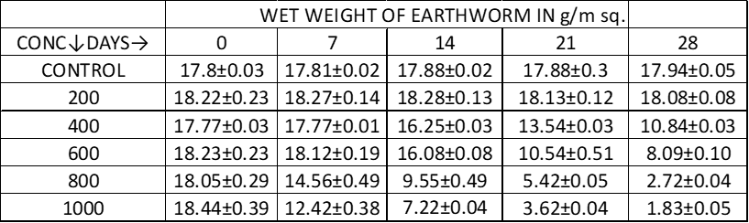

Fig1- Biomass (wet weight) of Drawida willsi at different concentration from 0 to 28 days at 7-day intervals
Table 2. Dry weight biomass of Drawida willsi at various CuO NP concentrations (mg/kg soil) in treated and control groups from 0 to 28 days at 7-day intervals.
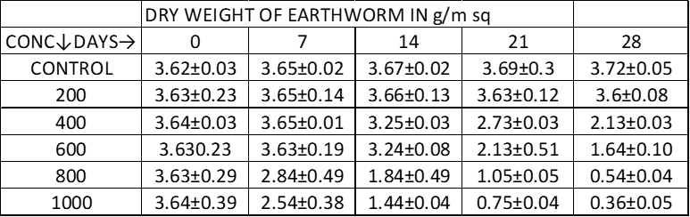

Fig2- Biomass (dry weight) of Drawida willsi at different concentration from 0 to 28 days at 7-day intervals.
Reproductive performance was also adversely affected. In the control group, an average of four cocoons per adult were recorded during the study period. In contrast, no cocoon production was observed in any of the CuO NP-treated groups, including at the lowest concentration of 200 mg/kg (Fig.3), indicating strong sub-lethal reproductive toxicity. Fig. 4 depicts image of Cocoon in control soil.

Fig3-Graphical representation of rate of reproduction of Drawida willsi in control and treated soil at 0 ,14 and 28th day.

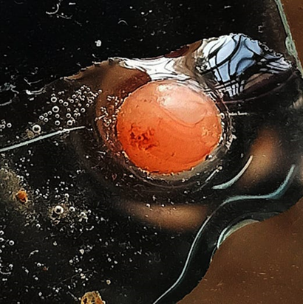
Fig-4 Image of Cocoon in control soil(20x magnification)
Survivability trends are depicted in Table.3 and Fig5, which clearly depicts a dose-dependent decline in earthworm survival, especially beyond 600 mg/kg.
Table 3. Suvivability percentage table of Drawida willsi at different concentration from 0 to 28 days at 7-day intervals.
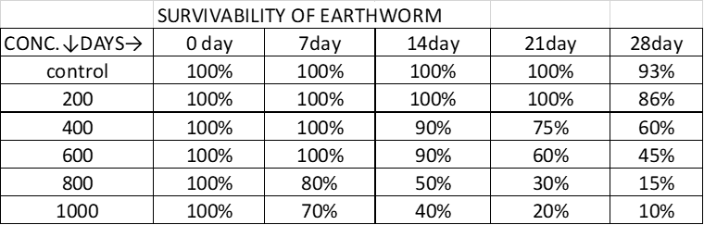

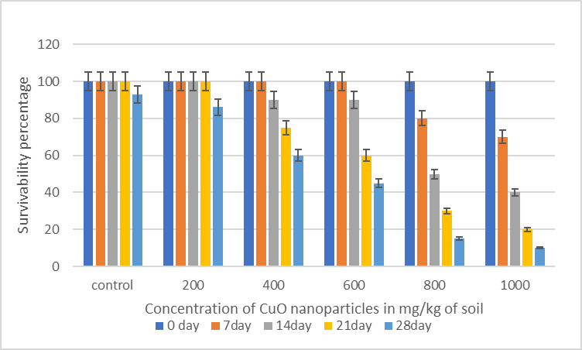
Fig 5. Graphical representation of Suvivability of Drawida willsi at different concentration from 0 to 28 days at 7-day intervals.
At concentration above 400 mg/kg, the earthworms exhibited notable morphological alterations, including body swelling, discoloration, and tissue rupture. Additionally, behavioral changes were observed, as the earthworm avoided feeding and burrowing activities at these higher concentrations.
DISCUSSION
The results of this study demonstrate that CuO nanoparticles exert significant toxic effects on Drawida willsi, impacting survival, biomass, and reproduction in a concentration-dependent manner. Although lower concentrations (200–400 mg/kg) did not result in immediate mortality, they completely inhibited cocoon production, indicating pronounced sub-lethal effects. These findings suggest that even minimal exposure to CuO NPs can disrupt the reproductive biology of D. willsi, likely due to physiological stress or reproductive interference.
Comparable effects have been observed in other earthworm species exposed to metal or metal oxide nanoparticles. For instance, exposure to CuO nanoparticles significantly affected growth, survival, and cocoon production in Eisenia fetida (Bicho et al., 2022). Similarly, Lumbricus terrestris exhibited adverse effects when exposed to metal-based nanoparticles, including decreased viability and phagocytic activity (Mosleh et al., 2023). Perionyx excavatus showed genotoxic effects upon exposure to heavy metals like Pb and Cd (Das and Gupta 2021), while Metaphire posthuma demonstrated immunotoxic responses to Cu nanoparticles and CuSO₄ (Gautam et al., 2017). These findings align with our study and confirm the general sensitivity of earthworms to nanoparticle contamination in soil.
However, the current study is the first to evaluate CuO NP toxicity in Drawida willsi, a dominant species in Indian agricultural ecosystems. Given its ecological importance, abundance, and sensitivity, D. willsi could serve as a valuable model organism and bioindicator for nanoparticle pollution in tropical soil environments.
CONCLUSION
This study provides clear evidence of the toxic effects of copper oxide (CuO) nanoparticles on the earthworm Drawida willsi, with a particular focus on growth and reproductive parameters. A significant, concentration-dependent decline in biomass and cocoon production was observed, indicating both lethal and sub-lethal impacts. While lower concentrations exhibited limited toxicity, higher concentrations resulted in severe adverse effects, including complete mortality. These findings underscore the potential ecological risks posed by CuO nanoparticle contamination in soil ecosystems. Given the widespread agricultural use of CuO-based products, the study emphasizes the need for stricter environmental monitoring, responsible usage, and safe disposal practices to mitigate unintended harm to non-target soil organisms such as earthworms.
REFERENCES
- Bicho R C, Ribeiro T, Rodrigues N P, Scott-Fordsmand J J and Amorim M J B 2022. Full life cycle test with Eisenia fetida—copper oxide NM toxicity and recovery. Environmental Toxicology and Chemistry 41(9): 2147–57.
- Blouin M, Hodson M E, Delgado E A, Baker G, Brussaard L, Butt K R, Dai L, Dendooven L, Peres G, Tondoh J E and Cluzeau D 2013. A review of earthworm impact on soil function and ecosystem services. European Journal of Soil Science 64(2): 161–82.
- Boyle K, Curry J and Farrell E 1997. Influence of earthworms on soil properties and grass production in reclaimed cutover peat. Biology and Fertility of Soils 25(1): 20–26.
- Bundschuh M, Filser J, Lüderwald S, McKee M S, Metreveli G, Schaumann G E, Schulz R and Wagner S 2018. Nanoparticles in the environment: Where do we come from, where do we go to? Environmental Sciences Europe 30(1): 6.
- Das S and Gupta P 2021. Genotoxicity of two heavy metals, Pb and Cd, on Perionyx excavatus, an epigeic earthworm. Environmental Science and Pollution Research 28: 12345–54.
- Das S and Patra R C 2015. Effect of heavy metals on earthworm biomass in contaminated soils of Joda region, Odisha, India. Environmental Monitoring and Assessment 187: Article 262.
- Edwards C A 2004. Earthworm Ecology. CRC Press, 456 pp.
- Gautam R K, Gautam P K, Banerjee S, Chattopadhyaya M C and Pandey J D 2017. Immunotoxicity of copper nanoparticle and copper sulfate in a common Indian earthworm. Ecotoxicology and Environmental Safety 144: 430–38.
- Kale R D 1998. Earthworm: Cinderella of Organic Farming. Prism Book Pvt. Ltd., Bangalore, India, 88 pp.
- Keller A A 2021. Incidence of metal-based nanoparticles in the conventional wastewater treatment process. Water Research 189: 116603.
- Kora A J 2022. Copper-based nanopesticides. In: Abd-Elsalam K A (Ed.), Nanobiotechnology for Plant Protection (pp. 133–53). Elsevier. ISBN 9780128238332.
- McGillicuddy E, Murray I, Kavanagh S, Morrison L, Fogarty A, Cormican M, Dockery P, Prendergast M, Rowan N and Morris D 2017. Silver nanoparticles in the environment: Sources, detection and ecotoxicology. Science of The Total Environment 575: 231–46.
- Mosleh Y Y, Paris-Palacios S and Coulaud R 2023. Toxicological effects of engineered nanoparticles on earthworms (Lumbricus rubellus) in short exposure. Environmental Toxicology and Pharmacology 98: 103414.
- Nainawat R and Nagendra B 2001. Density and distribution of earthworms in different localities of Jaipur. Journal of Eco-physiology 4: 9–13.
- Nahmani J and Rossi J-P 2003. Soil macroinvertebrates as indicators of pollution by heavy metals. Comptes Rendus Biologies 326(4): 295–303.
- OECD 2008. OECD Guidelines for the Testing of Chemicals. Test No. 222: Earthworm Reproduction Test (Eisenia fetida/Eisenia andrei). Organisation for Economic Co-operation and Development, Paris.
- Pani S C and Senapati B K 1986. Effect of malathion on population dynamics, reproductive biology, and secondary production of Drawida willsi, Michaelsen, from upland irrigated paddy field soil of Orissa, India. In: Dash M C, Senapati B K and Mishra P C (Eds.), Proceedings of the National Seminar on Organic Waste Utilization and Vermicomposting (pp. 97–110). Five Star, Burla, India.
- Royal Society and The Royal Academy of Engineering 2004. Nanoscience and Nanotechnologies: Opportunities and Uncertainties. London, UK.
- Sahu M P and Senapati B K 1988. Differential growth and reproduction of earthworms in organic wastes. Pedobiologia 32(5): 331–39.
- Sinha R, Heart S, Valani D B and Chauhan K A 2010. The environmental engineers: A review of vermiculture technologies for environmental management and resource development. International Journal of Global Environmental Issues 10(3/4): 274–88.
- Srivastava R, Gupta D K, Choudhary A K and Sinha M P 2013. Biomass and secondary production of earthworm Drawida willsi (Michaelsen) from a tropical agroecosystem in Ranchi, Jharkhand. Nature Environment and Pollution Technology 12(1): 179–82.

