**Interrelation between Aquatic Insect Diversity, Vegetation and Physicochemical Parameters in Four Different Lakes on Kaas Plateau, World Natural Heritage Site, Western Ghats, MS.**

**Abstract:** Aquatic biodiversity plays a major role in maintaining the health of the ecosystem. The present study investigated interrelation between aquatic insect diversity and physiochemical parameters in four different lakes namely Kas Lake, Gay Talav, Sarwar/Kumudini Talav, and Bhadar Talav on the Kass Plateau. Total 75 species belonging to three orders. Odonata is being most dominant order with 42 species followed by order coleoptera 25 species and order hemiptera accounting 8 species. The water bodies also showing presence of aquatic plants foster environment. Additionally, physiochemical parameters of water such as temperature, pH, electrical conductivity, dissolved oxygen, hardness, turbidity, total dissolved solids (TDS) and alkalinity were recorded. The result concluded that, unpolluted water bodies significantly contributed to richness of aquatic insects.

**Key Words:** Aquatic insects, Physiochemical parameters, Kass Plateau, Ecological Indicators, Aquatic plants.

**Introduction:**

Aquatic biodiversity plays a major role in maintaining the health of the ecosystem. Aquatic insects stand out vital component thereby contributing to the cycling of nutrients, supplying food webs, and serving as bioindicators of water quality. It comprises order Trichoptera, Ephemeroptera, Odonata, Hemiptera, Coleoptera (Achuthan *et al.,* 2015). Around the world, aquatic insects inhibit variety of aquatic habitat such as rivers, fast- flowing streams, ponds and lakes (Chainey, 2004; Alkhayata *et al*., 2024). The insects are sensitive to change, alterations in chemical and physical factors in their habitat structure can impact their diversity (Borale *et al*., 2023). In western ghats various studies on aquatic insects have been carried out. The recent literature records of 33 species of Trichoptera (Pandher *et al.,* 2020), 3 species of Plecoptera (Babu and Subramanian 2020) and 17 species of Ephemeroptera (Sivaramakrishnan *et al.,* 2020), 63 species of aquatic and semi-aquatic hemiptera (Jehamalar and Chandra, 2020) were reported to Maharashtra. Some researchers studied aquatic bugs and beetles in Maharashtra. A study conducted by (Sheth *et al*., 2018) reviewed genus *Copelatus* in Maharashtra and reported 3 species from Kass Plateau. (Sheth *et al*., 2024) studied aquatic coleoptera of Northern Western Ghats in which they recorded 69 species out of which 25 species were enlisted to Satara district so far. (Pawar *et al*., 2024) observed prey-predator diversity of paddy field, and recorded *Cybister sugillatus* Erichson, 1834 as a predator. (Kulkarni and Zade, 2020) investigated 16 different species of insects and their feeding habitat in Ramala reservoir, Chadrapur. (Thaware *et al*., 2022) studies role of aquatic insects in balancing food web and enlisted 11 insects from Karadkhed Dam, Nanded. (Bhandare *et al*., 2022), recorded 16 species of insects belonging to 6 different orders from Ingale Pazar Lake, Sangali. (Rathod, 2022) observed ecological role of aquatic insects in Vasant Sagar Reservoir in Yavatamal district showcasing into 7 species of aquatic insects. (Garg, 2022) investigated role of physiochemical parameters in diversity of coleopteran and hemipteran insects. (Deb *et al*., 2023) investigated aquatic beetles along with physiochemical parameters of Khadkwasla dam, Pune and enlisted 15 species of aquatic beetles. (Deb *et al.,* 2023) recorded 31 aquatic beetles along with water quality parameters of Indrayani River, Pune. Whereas, Maharashtra comprising 109 species of odonates out of 203 reported from western ghats (Subramanian *et al*., 2020). In Satara district (Sayyed, 2016) recorded 10 species of odonates belonging to 2 families. (Bhakare *et al*., 2021) discovered two new species of the damselfly of genus Euphaea from Thoseghar, Satara also observed by them in Kass Lake.

Kass plateau is one of the major biodiversity hotspots in the western ghats. It is an example of unique ecological niche famous for its seasonally blooming flowers. The plateau is an ideal grassland and higher elevated volcanic plateau formed of lateritic rock found in Western Ghats supporting natural as well as man-made waterbodies. The plateau showcases one perennial Kass reservoir with capacity of 1.2 TMC water storage which is used for domestic, drinking and irrigation purposes (Pawar and Sonawane, 2012) and several seasonal reservoirs such as Sarwar Talav, Bhadar Talav and Gay Talav along with some water bodies formed during monsoon. Previous studies have highlighted the importance of these water bodies as (Pawar and Sonawane 2012; Yadav, 2015) studied zooplankton diversity of Kass reservoir. These hydrological landscapes contributed to aquatic freshwater diversity of Kass. (Shinde *et al*., 2014) recorded environmental issues regarding Kass plateau and lake. Despite this there is no studies has been done aquatic across various habitats of Kass plateau. On that account aim of this study is to assess diversity of insects.

**Material And Methods**:

**Study area:** Kass Plateau is situated in the ranges of Sahyadri, 22 kms away from Satara district. It is one of the important Sada’s at an average elevation of 1000 m between 17°43′12″N longitude 73°49′22″E latitude. The total area of 1,792 hectares.

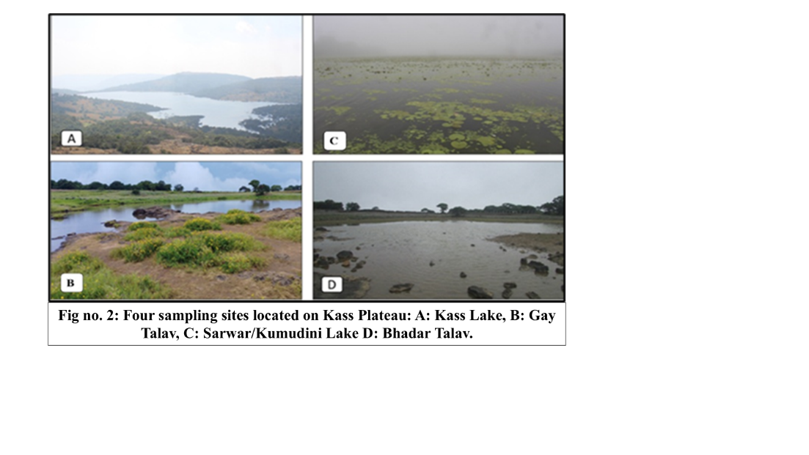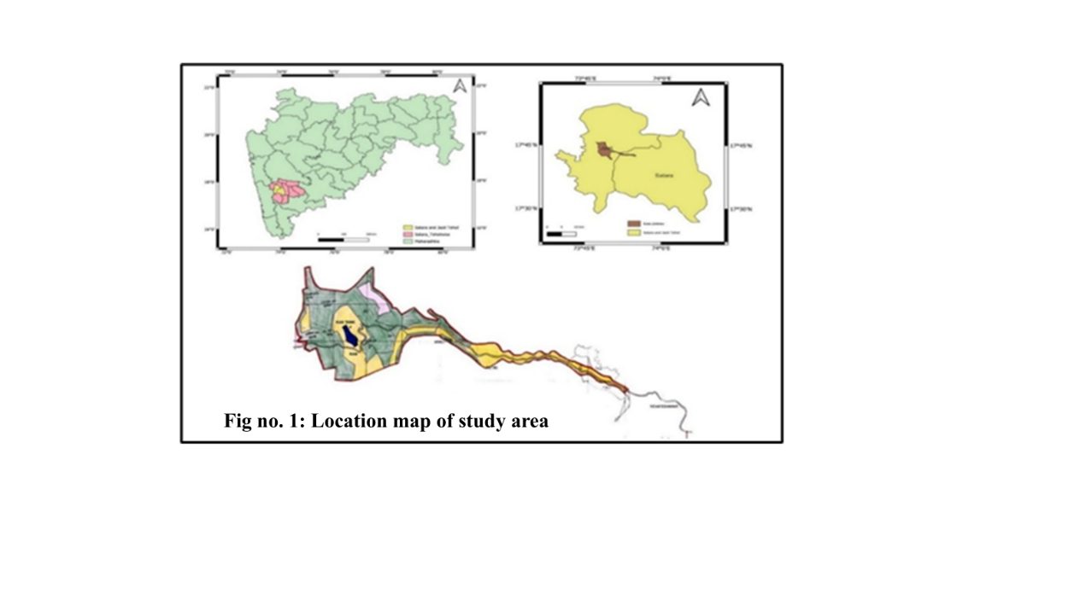

Material examined:Aquatic insect samples were collected from four locations namely Kass Lake (17°43'21.19"N & 73°48'39.49"E; Altitude 1153m). Gay Talav (17°44'33.10"N & 73°47'43.42"E; Altitude 1280m), Sarwar/Kumudini Talav (17°44'8.09"N & 73°48'47.46"E; Altitude 1260 m), Bhadar Talav (17°43'9.92"N & 73°49'26.13"E; Altitude 1265m) of Kass Plateau thought the year 2024. The hand net with a dimension of 30 × 30 cm, 50 cm length and 200μm mesh was used for sampling of aquatic insects. Many of them only photographed during field visits. After the collection the insects were preserved and identified using taxonomic identification keys (Pederzani, 1995; Gulati, 2012; Nasserzadeh and Komarek 2017, Subramanian, 2018).

**Water quality parameter analysis:** Physiochemical parameters of four different lakes located on Kass plateau were studied during this time. The parameters of water quality like temperature, pH, electrical conductivity, dissolved oxygen, hardness of water, turbidity, Total Dissolved Solids (TDS) and alkalinity tests were analysed using standard methods and procedures.

**Observation tables:**

**Table no. 1:** Checklist of aquatic insects found in four different locations of Kass Plateau.

|  |  |  |  |  |  |
| --- | --- | --- | --- | --- | --- |
| **Family** | **Scientific Name** | **(A)** | **(B)** | **(C)** | **(D)** |
| Order: Coleoptera | | | | | |
| Dytiscidae | *Hydaticus vittatus* (Fabricius, 1775) | **+** | **+** | **-** | **-** |
| *Hydaticus satoi* Wewalka, 1975 | **-** | **-** | **+** | **-** |
| *Hydaticus luczonicus* Aubé, 1838 | **-** | **+** | **-** | **+** |
| *Hydaticus incertus* Régimbart, 1888 | **-** | **-** | **-** | **+** |
| *Hydaticus fabricii* (W.S. MacLeay, 1825) | **-** | **+** | **-** | **-** |
| *Cybister sugillatus* Erichson, 1834 | **+** | **-** | **-** | **-** |
| *Cybister tripunctatus* (Olivier, 1795) | **+** | **+** | **-** | **+** |
| *Cybister (Meganectes) cognatus* Sharp, 1882 | **-** | **-** | **-** | **+** |
| *Cybister (Melanectes) convexus* Sharp, 1882 | **-** | **+** | **-** | **-** |
| *Sandracottus dejeani* (Aube, 1838) | **-** | **-** | **+** | **-** |
| *Sandracottus festivus* (Illiger, 1802) | **-** | **+** | **-** | **-** |
| *Sandracottus mixtus* (Blanchard, 1843) | **+** | **-** | **-** | **+** |
| *Peschetius toxophorus* Guignot, 1942 | **-** | **+** | **-** | **-** |
| *Copelatus neelumae* Vazirani, 1973 | **-** | **-** | **+** | **-** |
| *Laccophilus sharpi* Régimbart, 1889 | **+** | **+** | **-** | **-** |
| *Laccophilus flexuosus* Aubé, 1838 | **-** | **-** | **+** | **-** |
| *Eretes sticticus* (Linnaeus, 1767) | **+** | **-** | **-** | **+** |
| Hydrophilidae | *Sternolophus rufipes* (Fabricius, 1792) | **-** | **+** | **-** | **-** |
| *Coelostoma sp.* | **+** | **-** | **-** | **-** |
| *Hydrophilus olivaceous* (Fabricius, 1781) | **+** | **+** | **-** | **-** |
| Gyrinidae | *Dineutus indicus* Aube, 1838 | **-** | **+** | **-** | **-** |
| *Dineutus (Cyclous) unidentatus* Aubé, 1838 | **+** | **-** | **+** | **-** |
| *Orectochilus discifer* (Walker, 1859) | **+** | **-** | **-** | **+** |
| *Patrus limbatus* (Regimbart, 1883) | **-** | **+** | **-** | **+** |
| *Patrus sp.* | **-** | **-** | **-** |  |
| Order: Hemiptera | | | | | |
| Notonectidae | *Notonecta glauca* (Linnaeus, 1758) | **+** | **+** | **+** | **+** |
| Nepidae | *Laccotrephes griseus* (Guérin-Méneville, 1835) | **+** | **-** | **-** | **-** |
| *Laccotrephes ruber* (Linnaeus, 1764) | **-** | **+** | **-** | **-** |
| *Ranatra elongata* Fabricius, 1790 | **+** | **-** | **-** | **+** |
| Gerridae | *Ptilomera sp.* | **+** | **-** | **+** | **-** |
| *Limnogonus sp.* | **-** | **-** | **+** | **-** |
| Belostomatidae | *Diplonychus rusticus* (Fabricius, 1781) | **+** | **+** | **+** | **-** |
| *Diplonychus annulatus* (Fabricius, 1781) | **-** | **+** | **-** | **-** |
| Order: Odonata | | | | | |
| Lestidae | *Lestes elatus* Hagen in Selys, 1862 | **-** | **+** | **+** | **+** |
| *Lestes umbrinus* Selys, 1891 | **+** | **-** | **-** | **-** |
| *Lestes viridulus* Rambur, 1842 | **-** | **-** | **+** | **+** |
| Coenagrionidae | *Aciagrion occidentale* Laidlaw, 1919 | **+** | **-** | **-** | **-** |
| *Aciagrion pallidum* Selys, 1891 |  | **+** | **-** | **-** |
| *Agriocnemis splendidissima* Laidlaw, 1919 | **+** | **+** | **-** | **+** |
| *Ceriagrion coromandelianum* (Fabricius, 1798) | **-** | **-** | **+** | **-** |
| *Ischnura aurora* (Brauer, 1865) | **+** | **+** | **-** | **-** |
| *Pseudagrion decorum* (Rambur, 1842) | **-** | **+** | **-** | **-** |
| *Pseudagrion indicum* Fraser, 1924 | **+** | **-** | **-** | **+** |
| *Pseudagrion microcephalum* (Rambur, 1842) | **-** | **+** | **-** | **+** |
| *Pseudagrion rubriceps* Selys, 1876 | **-** | **+** | **-** | **-** |
| Platystictidae | *Protosticta hearseyi* Fraser, 1922 | **+** | **-** | **-** | **-** |
| Calopterygidae | *Vestalis apicalis* Selys, 1873 | **-** | **-** | **+** | **+** |
| *Vestalis gracilis* (Rambur, 1842) | **+** | **-** | **-** | **+** |
| Chlorocyphidae | *Heliocypha bisignata* (Hagen in Selys, 1853) | **+** | **-** | **-** |  |
| *Libellago lineata* (Burmeister, 1839) | **-** | **+** | **+** | **+** |
| Platycnemididae | *Polycanthagynancura ramburi* (Fraser, 1922) | **+** | **-** | **-** | **-** |
| *Copera marginipes* (Rambur, 1842) | **-** | **+** | **-** | **+** |
| Aeshnidae | *Anax immaculifrons* Rambur, 1842 | **+** | **-** | **-** | **-** |
| Gomphidae | *Ictinogomphus rapax* (Rambur, 1842) | **-** | **-** | **+** | **-** |
| Libellulidae | *Acisoma panorpoides* Rambur, 1842 | **-** | **+** | **-** | **+** |
| *Brachythemis contamata* (Fabricius, 1793) | **-** | **-** | **+** | **-** |
| *Bradinopyga geminata* (Rambur, 1842) | **-** | **+** | **-** | **+** |
| *Cratilla lineata* (Brauer, 1878) | **+** | **-** | **-** | **-** |
| *Crocothemis servilia* (Drury, 1770) | **+** | **-** | **-** | **-** |
| *Diplacodes trivialis* (Rambur, 1842) | **+** | **-** | **+** | **-** |
| *Indothemis carnatica* (Fabricius, 1798) | **-** | **+** | **-** | **-** |
| *Neurothemis fulvia* (Drury, 1773) | **-** | **-** | **+** | **+** |
| *Neurothemis intermedia* (Rambur, 1842) | **+** | **+** | **-** | **-** |
| *Orthetrum chrysis* (Selys, 1891) | **+** | **-** | **-** | **-** |
| *Orthetrum glaucum* (Brauer, 1865) | **-** | **+** | **-** | **+** |
| *Orthetrum luzonicum* (Brauer, 1868) | **+** | **-** | **-** | **-** |
| *Orthetrum sabina sabina* (Drury, 1770) | **-** | **-** | **+** | **-** |
| *Orthetrum taeniolatum* (Schneider, 1845) | **-** | **+** | **-** | **-** |
| *Tramea limbata* (Desjardins, 1832) | **+** | **-** | **-** | **+** |
| *Trithemis aurora* (Burmeister, 1839) | **+** | **-** | **+** | **-** |
| *Trithemis festiva* (Rambur, 1842) | **-** | **-** | **-** | **+** |
| *Trithemis kirbyi* Selys, 1891 | **+** | **-** | **+** | **-** |
| *Trithemis pallidinervis* (Kirby, 1889) | **+** | **-** | **-** | **-** |
| Macromiidae | *Epophthalmia vittata* Burmeister, 1839 | **+** | **-** | **-** | **+** |
| *Macromia cingulata* Rambur, 1842 |  | **+** | **-** | **-** |

**(Four sampling sites located on Kass Plateau: A: Kass Lake, B: Gay Talav, C: Sarwar/Kumudini Lake D: Bhadar Talav.**

**Table no. 2: Physiochemical parameters of four different lakes located on Kass plateau**

|  |  |  |  |  |
| --- | --- | --- | --- | --- |
| **Parameters** | **Kass Lake** | **Gay Talav** | **Sarwar/Kumudini Lake** | **Bhadar Talav** |
| **Mean ± SD** | **Mean ± SD** | **Mean ± SD** | **Mean ± SD** |
| Water Temperature (°C) | 18.58 ± 1.45 | 19.26 ± 2.75 | 18.33 ± 1.15 | 19.84 ± 1.11 |
| pH | 7.17 ± 0.06 | 6.7 ± 0.37 | 6.40 ± 0.43 | 6.49 ± 0.28 |
| Electrical Conductivity (μs/Cm) | 352.21 ± 0.70 | 402.18 ± 0.27 | 442.66 ± 2.04 | 357.07 ± 0.88 |
| Dissolved Oxygen (Mg/L) | 6.37 ± 0.32 | 6.24 ± 0.35 | 4.38 ± 0.45 | 6.13 ± 0.25 |
| Total Hardness of water | 79.66 ± 1.52 | 66.33 ± 2.08 | 52.36 ± 4.54 | 78.03 ± 1.15 |
| Turbidity | 0.30 ± 0.03 | 0.97 ± 0.43 | 2.9 ± 0.04 | 0.63 ± 0.047 |
| Total Dissolved Solids (TDS) (Ppm) | 139.79 ± 0.6 | 177.33 ± 2.0 | 198.34 ± 0.9 | 243.02 ± 0.65 |
| Alkalinity (Mg/L) | 40.01± 0.32 | 44.65± 0.70 | 38.90± 0.35 | 41.34± 0.08 |

**Result and discussion:**

The present study recorded the diversity of aquatic insects found in four different aquatic habitats of Kass Plateau. The total 75 species (Table no. 1, Fig no. 1) recorded belonging to three orders such as Odonata, Coleoptera and Hemiptera. The site A, Kaas Lake recorded highest richness with 36 species of aquatic insects (12 odonata, 5 hemiptera, 10 coleoptera). Followed by Site B Gay Talav listed 32 species (8 odonata, 4 hemiptera, 12 coleoptera). Site D Bhadar Talav harboured 26 species (8 odonata, 2 hemiptera, 8 coleoptera). while site C Sarwar/Kumudini Lake represents less diversity with just 21 species (7 odonata, 4 hemiptera, 5 coleoptera). In addition to observing the diversity, this study also analysed several water parameters such as temperature, pH, electrical conductivity, dissolved oxygen, hardness, turbidity, total dissolved solids (TDS) and alkalinity (Table no. 2). In research lab at Lal Bahadur Shastri College of Arts, Science and Commerce during Study period some of the above tests were carried out. These parameters insights to current status of water quality from four sites of Kass Plateau. The temperature was observed in between 18.33oC to 19.84 oC, pH was recorded as 6.40 to 7.17, electrical conductivity was recorded in between 352.21 μs/Cm to 442.66 μs/Cm. The dissolved oxygen varies over 139.79 mg/L to 243.02 mg/L, total hardness ranged from 52.36 mg/L to 79.66 mg/L and turbidity was ranging within 0.30 to 2.9, total dissolved solids values vary in between 139.79 ppm to 243 ppm whereas alkalinity was ranged from 38.90 mg/L to 44.65 mg/L. The Kass lake experiencing some serious anthropogenic activities thought the year by tourist from worldwide like plastic waste and food waste disposal. Physiochemical parameters of given four lakes are within the permissible limit from the observed data (Table no. 2). It might significantly contribute to richness of aquatic insect diversity. Order Odonata is dominant amongst all comprising 10 families, 27 genera and 42 species. The dominance of populations of damselflies and dragonflies indicates good health of ecosystem. As odonates are known for their sensitivity to environmental changes, thrives only in unpolluted water. Odonates are carnivore species helps in regulation of small aquatic organisms including aquatic beetles and bugs essential for maintaining balance of food webs within aquatic habitat. Followed by order Coleoptera comprising 3 families, 13 genera and 25 species. The beetle species included are naturally adapted to various feeding habitats such as they are carnivores which act as predators for smaller invertebrates, scavengers consuming dead and decaying material whereas some of them are herbivores and benthivores an unique adaptation specializing feeding on substrate organisms. This dietary behaviour allows them to be an integral part of nutrient cycling. These aquatic beetles help in regulating populations of small dipterans. This habit overlapping dietary niches of odonates creating competition between them. And order hemiptera showing less diversity comprising 4 families, 6 genera and 8 species. Unlike water beetles water bugs also shows different feeding habits from predation to herbivores. In addition to this they do different respiratory strategies like plastron formation which helps them to survive in submerged environments. This study we also identified presence of some aquatic plants such as *Persicaria glabra, Asclepias curassavica, Sphaeranthus indicus, Rotala floribunda (*Vulnerable*), Rotala ritchiei* (Endangered), *Phyla nodiflora, Cyathocline purpurea,* found in all the 4 water bodies whereas *Nymphoides indica*, *Aponogeton satarensis* (Endangered) and *Pogostemon deccanensis* were found in all locations except kaas lake. These aquatic plants play pivotal role in shaping these water bodies by making favourable breeding ground, shelter and hiding spots from predators for these insects. They also act as food source for various insects including some bugs and beetles as they feed on plant saps and tender leaves. Furthermore, these plants also contribute to organic matter of water bodies enhancing habitat quality making them favourable for thriving aquatic organisms whereas the insects felicitate propagation and pollination of plants which reflects mutual relationships between them.

**Conclusion:** The present study concludes that, presence of aquatic insects along with diverse vegetation creates dynamic balance for clean, well balanced aquatic ecosystem. These might foster the mutual relationship between the organism and their environment which collectively contribute in maintaining ecological balance can sustain resilient aquatic ecosystem.

**References**:

1. Alkhayata, F. A., Ahmada, A. H., Rahim, J., Imran, M., & Sheikh, U. A. A. (2024). Distribution and diversity of aquatic insects in different water bodies of Qatar. *Brazilian Journal of Biology, 84*, e255950. https://doi.org/10.1590/1519-6984.255950
2. Babu, R., & Subramanian, K. A. (2020). Insecta: Plecoptera. In K. Chandra (Ed.), *Faunal Diversity of Biogeographic Zones of India: Western Ghats* (pp. 257–260). Zoological Survey of India, Kolkata.
3. Bhakare, S. D., Nair, V. P., Pawar, P. A., Bhoite, S. H., & Sadasivan, K. (2021). Two new species of *Euphaea* Selys, 1840 (Odonata: Zygoptera: Euphaeidae) from northern Western Ghats, India. *Journal of Threatened Taxa, 13*(5), 18200–18214. https://doi.org/10.11609/jott.6579.13.5.18200-18214
4. Bhandare, P. S., Pawar, S. M., Khabade, S. A., & Teli, P. B. (2022). Freshwater aquatic insect diversity of Ingale Pazar Lake, Taluka-Palus, Dist-Sangli (MS), India. *Journal of Bio. Innovation, 11*(1), 150–156.
5. Borale, R. P., Nandwalkar, A. H., & Khairnar, K. B. (2023). Correlation of aquatic entomofauna, order Hemiptera and water properties of Akkalpada Dam: Site Chinchkheda, in North Maharashtra, India. *International Journal of Advanced Research in Science, Communication and Technology (IJARSCT), 3*(19).
6. Chainey, J. (2004). *Freshwater Invertebrates of the Malaysian Region* (pp. 786–790). Kuala Lumpur: Academy of Sciences Malaysia.
7. Chandra, K., Raghunathan, C., Sureshan, P. M., Subramanian, K. A., Babu, R., & Rizvi, A. N. (2020). Faunal diversity of Western Ghats biogeographic zone – An overview. In K. Chandra (Ed.), *Faunal Diversity of Biogeographic Zones of India: Western Ghats* (pp. 1–22). Zoological Survey of India, Kolkata.
8. Deb, R., Takawane, P., & Subramanian, K. A. (2023). Sacred river of Pune: Boon or bane for the diversity of aquatic beetles (*Insecta*: Coleoptera). *Journal of Threatened Taxa, 15*(10), 24043–24053. https://doi.org/10.11609/jott.8514.15.10.24043-24053
9. Deb, R., Takawane, P., Morey, R., Pokale, S., Baidya, B., & Bagade, A. (2023). Diversity of aquatic beetles in relation to water quality from Khadakwasla Dam, Pune. *Indian Journal of Entomology.* https://doi.org/10.55446/ije.2023.1513
10. Garg, S. (2022). Role of physico-chemical parameters in biodiversification of aquatic insects (*Coleopteran* and *Hemipteran*) in Konkan, Maharashtra, India. *International Journal of Entomology Research, 7*(4), 45–49.
11. Gulati, P. (2012). Handbook of Aquatic Insects. New Delhi: Bio-Green Books Publication.
12. Jehamalar, E. E., & Chandra, K. (2020). Insecta: Hemiptera: Heteroptera (Aquatic and Semiaquatic). In K. Chandra (Ed.), Faunal Diversity of Biogeographic Zones of India: Western Ghats (pp. 307–315). Zoological Survey of India, Kolkata.
13. Kulkarni, R. R., & Zade, S. B. (2020). Role of aquatic insects in the enhancement of biodiversity of a freshwater reservoir, Ramala, Chandrapur, Maharashtra. Environment Conservation Journal, 21(3), 89–92. https://doi.org/10.36953/ecj.2020.21310
14. Nair, G. A., Morse, J. C., & Marshall, S. A. (2015). Aquatic insects and their societal benefits and risks. Journal of Entomology and Zoology Studies, 3(3), 171–177.
15. Nasserzadeh, H., & Komarek, A. (2017). Taxonomic revision of the water scavenger beetle genus Sternolophus Solier, 1834 (Coleoptera: Hydrophilidae). Zootaxa, 4282(2), 201–254. https://doi.org/10.11646/zootaxa.4282.2.1
16. Pandher, M. S., Kaur, S., & Garima, D. (2020). Insecta: Trichoptera. In K. Chandra (Ed.), Faunal Diversity of Biogeographic Zones of India: Western Ghats (pp. 509–517). Zoological Survey of India, Kolkata.
17. Pawar, G. N., Bendre, N. N., & Bhoite, S. H. (2024). Entomofaunal diversity and prey-predator relationship associated with organic paddy field at Mahadare Conservation Reserve, Satara District, Maharashtra. Journal of Entomology and Zoology Studies, 12(3), 20–28.
18. Pawar, S., & Sonawane, S. (2012). Zooplankton diversity in three water bodies of Satara District (M.S.) India. Environment Conservation Journal, 13(1), 129–132. https://doi.org/10.36953/ecj.2012.131224
19. Pawar, S. M., & Sonawane, S. R. (2012). Water quality profile of Kas Reservoir of Satara District, Maharashtra, India. Nature Environment and Pollution Technology, 11(1), 173–176.
20. Pederzani, F. (1995). Keys to the identification of the genera and subgenera of adult Dytiscidae (sensu lato) of the world (Coleoptera: Dytiscidae). Atti Dell’Accademia Roveretana degli Agiati: Contributi della Classe di Scienze Matematiche, Fisiche e Naturali, 7(4B), 5–83.
21. Rathod, S. D. (2022). Aquatic insects and their ecological role in Vasant Sagar Reservoir, Pusad, Dist. Yavatamal, Maharashtra (MS). International Journal of Creative Research Thoughts, 10(2). ISSN: 2320-2882.
22. Sayyed, A. (2016). Faunal diversity of Satara District, Maharashtra, India. Journal of Threatened Taxa, 8(13), 9537–9561. https://doi.org/10.11609/jott.3162.8.13.9537-9561
23. Sheth, S. D., Ghate, H. V., & Hájek, J. (2018). Copelatus Erichson, 1832 from Maharashtra, India, with description of three new species and notes on other taxa of the genus (Coleoptera: Dytiscidae: Copelatinae). Zootaxa, 4459(2), 235–260.
24. Sheth, S. D., Padhye, A. D., & Ghate, H. V. (2024). Faunal inventory and illustrated taxonomic keys to aquatic Coleoptera (Arthropoda: Insecta) of the Northern Western Ghats of Maharashtra, India. Journal of Threatened Taxa, 16(3), 24854–24880. https://doi.org/10.11609/jott.5821.16.3.24854-24880
25. Shinde, M. S. (2014). Environmental issue: Kas Plateau and Kas Lake: Role of NGOs in environmental protection and conservation. Indian Journal of Applied Research, 4(6). ISSN: 2249-555X.
26. Sivaramakrishnan, K. G., Selvakumar, C., & Subramanian, K. A. (2020). Insecta: Ephemeroptera. In K. Chandra (Ed.), Faunal Diversity of Biogeographic Zones of India: Western Ghats (pp. 211–225). Zoological Survey of India, Kolkata.
27. Subramanian, K. A., Babu, R., & Emiliyamma, K. G. (2020). Insecta: Odonata. In K. Chandra (Ed.), Faunal Diversity of Biogeographic Zones of India: Western Ghats (pp. 227–242). Zoological Survey of India, Kolkata.
28. Subramanian, K. A. (2018). India - A Lifescape: Dragonflies of India – A Field Guide. Vigyan Prasar. ISBN: 978-81-7480-192-0.
29. Thaware, V. H. (2023). Study of aquatic insects, their role in improving biodiversity and balancing the food web of a freshwater ecosystem at Karadkhed Dam in Nanded, Maharashtra. Journal of Entomology and Zoology Studies, 11(1), 173–176.
30. Yadav, P. P. (2015). Studies on biodiversity of zooplankton in Kass Lake during rainy and winter seasons. International Journal of Researches in Biosciences, Agriculture and Technology, 3(II), 399–402.

**Fig. no 1: Aquatic insects found in four different lakes of Kass plateau**

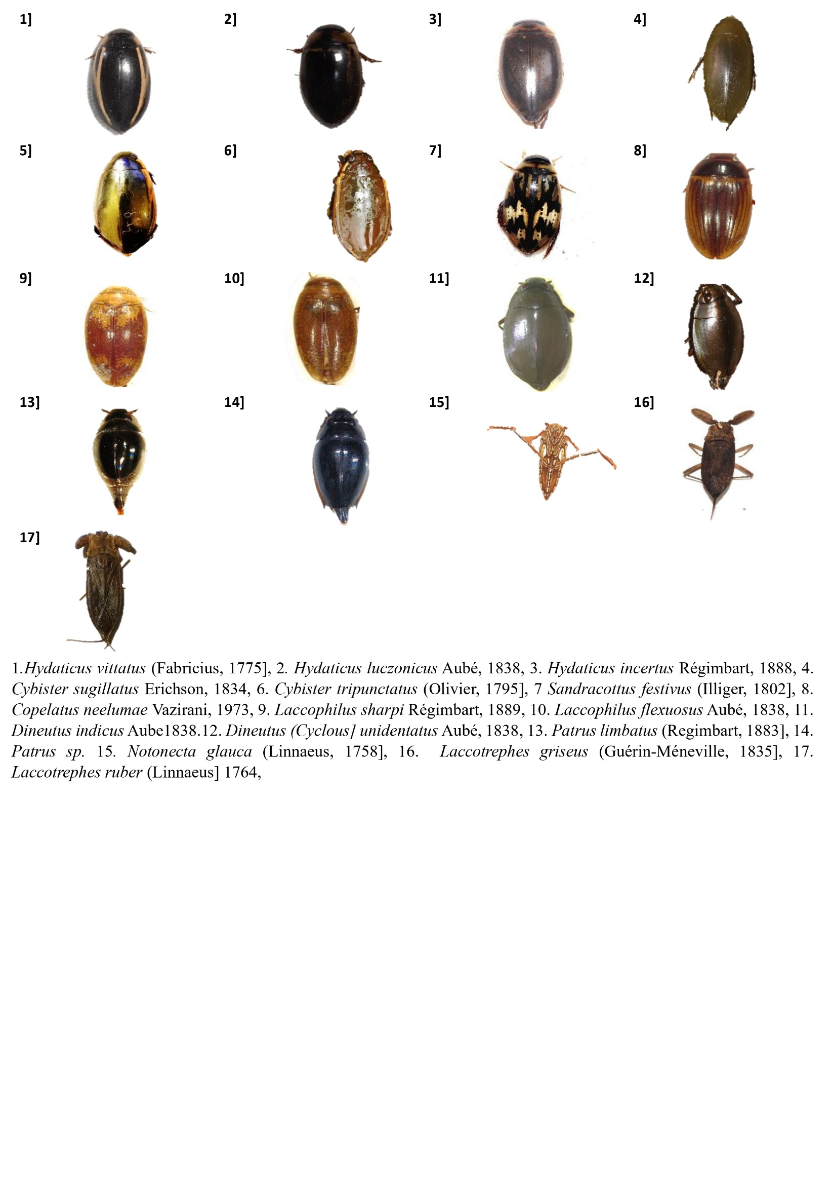

Plate 1 : Microphotographs of insects

