Successful Therapeutic Management of Babesiosis in a Suckling Calf
ABSTRACT
Haemoprotozoan infections are extensively present in livestock. Babesiosis occurs as the second most prevalent diseases among haemoprotozoan conditions being in cattle in India. The present paper presents a case of Babesiosis infection in a 13-days old crossbred female calf and its treatment. A 13 days old crossbreed female calf was presented to the Department of Veterinary Clinical Complex, Veterinary College Bidar with a complaint of not taking milk from past 3 days, constipation and passing red tinged urine since morning. Around 5 ml of blood was collected aspectically from jugular vein of calf for estimation of hemato-biochemical parameters and blood smear (Giemsa stain) examination. Upon clinical examination, animal showed rectal temperature of 102.4⁰F, conjunctiva and vulval mucous membrane were icteric. Haematological investigation revealed anemia accompanied with thrombocytopenia. Biochemical parameters showed elevation of BUN, Creatinine, SGOT, total bilirubin, Indirect bilirubin, Globulin with a decrease in total protein, albumin and A:G ratio. Stained blood smear examination under oil immersion revealed presence of intraerythrocyte piroplasm stage of Babesia bigemina. Haemoglobinuria was evident on urinalysis by using centrifugation method. Based on the haemato-biochemical and characterstic morphological features of pear shape with an acute angle in the erythrocytes confirmed the case as Babesiosis caused by B. bigemina. Based on the results, the calf was immediately treated with Imidocarb diproprionate @ 3 mg/kg BW deep IM single dose alongwith supportive therapy and the calf recovered uneventually.
Key words: Babesia, anemia, hemoglobinuria, imidocarb
1. INTRODUCTION
Haemoprotozoan infections are extensively present in livestock. Babesiosis occurs as the second most prevalent diseases among haemoprotozoan conditions being in cattle in India (Vahora et al., 2012). Babesia bigemina and Babesia bovis are diseases of the tropics and subtropics (Radostits et al., 2010). In India, Babesia bigemina is the main species affecting bovines (Ruprah, 1985). The disease is transmitted under natural conditions from affected to healthy animals through ticks Riphicephalus microplus and Riphicephalus annulatus (Murrell et al., 2001). The disease has been recognized as a severe problem of major economic importance in bovines, and the financial losses in India due to babesiosis are INR 580.16 crore annually (Narladkar, 2018). Indigenous cattle breeds from Babesia endemic regions often have a certain degree of natural resistance to these diseases, and the consequences of infection are not as serious as observed in exotic Bos taurus breeds (Bock et al., 2004). Young calves are found to be resistant to babesiosis due to reverse age resistance. Further, the present paper presents a case of Babesiosis infection in a 13-days old crossbred female calf.
2. MATERIALS AND METHODS
A 13 days old crossbred female calf was presented to Department of Veterinary Clinical Complex, Veterinary College Bidar in recumbent position with a complaint of not taking milk from past 3 days, constipation and passing red tinged urine since morning. A detailed clinical examination was done and around 5 ml blood was collected aspectically from Jugular vein for estimation of hemato-biochemical parameters and blood smear (Giemsa stain) examination. The Giemsa stained blood smears were examined under oil immersion lens of microscope (100×) for the detection of haemoprotozoan organisms.
3. RESULTS & DISCUSSION
Upon clinical examination, calf showed rectal temperature of 102.4⁰F, haemoglobinuria (Fig. 1), icteric conjunctival and vulval mucous membrane (Fig. 2). Haematological investigation revealed anemia accompanied with thrombocytopenia, biochemical parameters showed elevation of BUN, Creatinine, SGOT, Indirect bilirubin, Globulin with a decrease in total protein, albumin and A:G ratio (Table 1). Microscopic examination of the blood smears (Giemsa stained) showed the presence of intraerythrocytic piroplasm of Babesia organisms. Based upon the morphological features i.e., elongated, rounded dividing forms, pear shape with an acute angle in the erythrocytes confirmed B. bigemina organisms. Based on the clinical findings, haemato-biochemical and blood smear examination the case was confirmed as Babesiosis caused by B. bigemina.
The calf was immediately treated with Imidocarb diproprionate @ 3 mg/kg BW deep IM single dose along with fluid therapy, antipyretic (inj. Meloxicam @ 0.5 mg/kg BW IM) and antihistamine (inj chlorpheneramine maleate @ 0.5 mg/kg BW IM). Supportive treatment included oral hematinics and liver tonics for 15 days. The animal was able to stand up on day 2 post treatment and showed complete clinical recovery on 4th day of treatment with blood smear negative for Babesia organisms. Haemato-biochemical parameters post treatment (15th day) showed values within the normal range (Table 1).
Babesiosis infection in young calves has been previously documented by various authors in India (Mallick et al., 1980; Karunakaran et al., 2011; Vairamuthu et al., 2012; Venu et al., 2015); Saravanan et al., 2020. Yeruham et al. (2003) reported a case of B. bovis infection in a 2-day-old calf in Israel. In the present case, the infected crossbred calf was 13 days old. A strong innate immunity is exhibited in young calves compared to adult cattle to primary infections of B. bovis and B. bigemina (Riek, 1963; Trueman and Blight, 1978; Goff et al., 2001). Typically, the infection rate in cattle increases between 6 to 12 months of age. In enzootic areas, calves are usually infected by 11 weeks of age, but at this early stage, clinical signs and pathological changes will be generally mild and short-lived (Radostits et al., 2010).
In the current case, the mother of the calf had been brought into the farm during the advanced pregnancy from a known source. According to the history, she had neither shown signs of babesiosis nor had she been infested with ticks. However, three months prior another cow on the same farm had been diagnosed with B. bigemina infection, which was successfully treated. It is likely that the source of infection in this case occurred after the calf's birth, rather than from the mother. A similar observation was made by Mallick et al. (1980), who reported B. bigemina infection in a 14-day-old indigenous calf. Additionally, Karunakaran et al. (2011) described the same infection in a 20-day-old Jersey calf and suggested that intrauterine transmission could be the cause, especially since the mother had been treated for babesiosis during the third trimester of pregnancy.
The common clinical signs observed in babesiosis affected calf were fever, icteric mucous membranes, haemoglobinuria and straining during defecation. Similar findings were noted in babesiosis by numerous workers (Bhikane et al., 2001; Tufani et al., 2009; Shinde et al., 2019 and Abd ElHamed et al., 2016). Coffee colored urine in ailing animals could be attributed to elevated intravascular haemolysis (Shinde et al., 2019). In treated calf the urine color was restored to normal straw color in 24-48 hours after treatment showing the clearance of haemoprotozoan infection and intravascular haemolysis. Imidocarb dipropionate is considered the drug of choice for treating bovine babesiosis followed by Dimenazene aceturate with a cent per cent and 90 per cent efficacy on 10th day post treatment (Ukwueze and Orajaka, 2014).
Table 1: Haematological and Biochemical parameters in babesiois affected calf
Haematological Parameters | Day 0 | Day 10 | Day 15
Haemoglobin (g/dL) | 4.8 | 6.9 | 10.6
Total Erythrocyte Count (10⁶/mm³) | 2.91 | 4.1 | 5.2
Packed Cell volume (%) | 28 | 30 | 41
Total leucocyte count (10³/mm³) | 8.8 | 8.4 | 8.5
Neutrophils (%) | 35 | 33 | 32
Lymphocytes (%) | 64 | 60 | 63
Monocytes (%) | 2 | 3 | 3
Eosinophils (%) | 2 | 2 | 1
Basophils (%) | 1 | 2 | 1
Platelets (10³/mm³) | 24 | 252 | 387
Biochemical parameters
SGOT (U/L) | 152 | 81 | 65
Blood Urea Nitrogen  (mg/dL) | 52.4 | 30.2 | 25.6
Creatinine (mg/dL) | 2.2 | 1.7 | 0.9
Total Bilirubin | 2.2 | 0.6 | 0.5
Direct Bilirubin | 0.4 | 0.2 | 0.2
Indirect Bilirubin (mg/dL) | 1.8 | 0.4 | 0.3
Total protein (g/dL) | 6.1 | 7.2 | 7.4
Albumin (g/dL) | 1.8 | 3.7 | 4.2
Globulin (g/dL) | 4.3 | 3.5 | 3.2
A:G ratio | 0.42 | 1.06 | 1.31
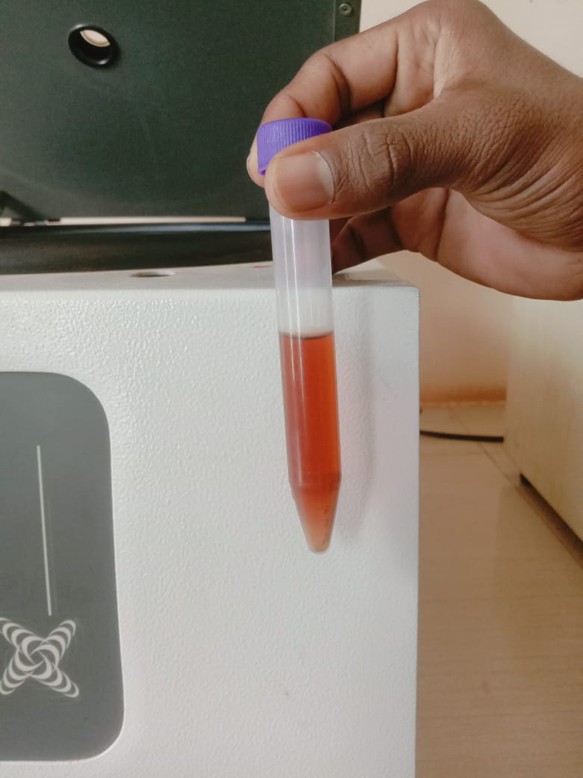
Fig. 1: Haemoglobinuria in babesiosis calf (Day 0)
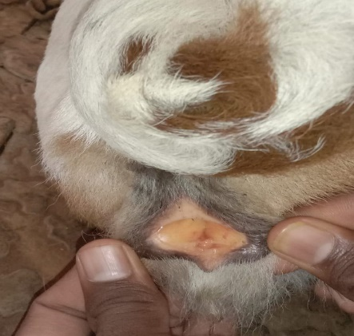

Fig. 2: Icteric vulval lips of babesiosis calf (Day 0)

4. CONCLUSION
In conclusion, although inverse and innate age resistance for babesiosis is observed in young calves, the clinical disease has been reported in a suckling calf which can be even fatal without specific treatment. Periodical monitoring of herd for ticks infestation, screening of the cattle at risk by conventional microscopy and institution of early and specific treatment would help in the control of babesiosis.

DISCLAIMER (ARTIFICIAL INTELLIGENCE)
Author(s) hereby declare that no generative AI technologies such as Large Language
Models (ChatGPT, COPILOT, etc.) and text-to-image generators have been used during
the writing or editing of this manuscript.

REFERENCES
- Abd-El-Hamed, HAA; Salem, SM and Ibrahim, HN (2016). Haemato-biochemical alterations in cattle suffering from anaemia and their effect on quality of some meat. Egyptian Journal of Chemistry and Environmental Health., 2(2): 232- 249.
- Bhikane, AU; Naraladkar, BW; Anantwar, LG and Bhokare, AP (2001). Epidemiology, clinico-pathology and treatment of babesiosis in cattle. Indian Vet. J., 78: 726-729.
- Bock, R; Jackson L; De Vos, A and Jorgensen, W (2004). Babesiosis of cattle. Veterinary Parasitol., 129: 247–269.
- Goff, WL; Johnson, WC; Parish, SM; Barrington, GM; Tuo, W and Valdez, RA (2001). The age-related immunity in cattle to Babesia bovis infection involves therapid induction of interleukin-12, interferon-gamma and inducible nitric oxide synthase mRNA expression in the spleen. Parasite Immunology., 23: 463–471.
- Karunakaran, S; Pillai, UN; Kuriakose, AM and Aswathy G (2011). Babesia bigemina infection in a 20 day old calf. J. of Indian Vet. Assoc. Kerala., 9(1): 49–50.
- Mallick, KP; Dwivedi, SK and Malhotra, MN (1980). Babesiosis in a new born indigenous calf. Indian Vet. J., 57(8): 686–687.
- Murrell, A; Campbell, NJH and Barker, SC (2001). A total evidence phylogeny of ticks provides insights into evolution of life cycles and biogeography. Mol. Phylogenet. Evol., 21: 244-258.
- Narladkar, BW (2018). Projected economic losses due to vector and vector-borne parasitic diseases in livestock of India and its significance in implementing the concept of integrated practices for vector management. Veterinary World., 11(2): 151.
- Radostits, OM; Gay, CC; Hinchcliff, KW and Constable, PD (2010). Veterinary Medicine. A textbook of the diseases of cattle, horses, sheep, pigs and goats. 10 th Edn., PP: 2045- 2050.
- Riek RF (1963). Immunity to babesiosis. In: Garnham, PCC; Pierce, AE and Riott, I (Eds), Immunity to protozoa. Oxford: Blackwell. PP: 160–179.
- Ruprah, NS (1985). Text Book of Clinical Protozoology. Oxanian Press Pvt. Ltd. New Delhi. PP: 287-304.
- Vahora, SP; Patel, JV; Patel, BB; Patel, SB and Umale, RH (2012). Seasonal incidence of Haemoprotozoal diseases in crossbred cattle and buffalo in Kaira and Anand districts of Gujarat, India. Veterinary World., 5(4): 223-225
- Venu, R; Sailaja, N; Srinivasa Rao, K; Jayasree, N and Vara Prasad, WVLN (2015). Babesia bigemina infection in a 14-day old Jersey crossbred calf: a case report. J. Parasit. Dis., 39(2): 264–265.
- Saravanan, S; Mohanapriya, T; Ponnuswamy, KK and Ramprabhu, R (2020). Babesiosis in A Suckling Crossbred Jersey Calf - A Case Report. Haryana Vet., 59(2): 303-304
- Shinde, RM; Bhikane, AU; Narladkar, BW and Masare, PS (2019). Antioxidants as adjunct therapy in clinical management of babesiosis. Ruminant Science., 8(1): 93-100.
- Trueman, KF and Blight, GW (1978). The effect of age on resistance of cattle to Babesia bovis. Aust. Vet. J., 54: 301–305.
- Tufani, NA; Hafiz, A; Makhdoomi, DM; Malik, HU; Peer, FU and Shad, FI (2009). Clinico Therapeutic Management of Severe Anaemia in Crossbred Cow. Intas Polivet., 1: 53-55.
- Ukwueze, CS and Orajaka, CF (2014). Babesiosis in a calf: A case report. IOSR J. Agri. And Vet. Sci., 7(11) Ver. II; 72-74.
- Vairamuthu, S; Pazhanivel, N; Suresh, RV and Balachandran (2012). Babesia bigemina in a 20 day old non-descript calf: a case. Indian J of Field Vet., 7(4):69.
- Yeruham, I; Avidar, Y; Aroch, I and Hadani, A (2003). Intra-uterine infection with Babesia bovis in a 2-day-old calf. J. of Vet. Med. Series B., 50(2):60–62.

