ASSESSMENT OF ACUTE TOXIC EFFECTS OF TETRABROMOBISPHENOL A ON BRINE SHRIMP AND CHLORELLA sp.

ABSTRACT

Environmental pollutant (EP’s) has proliferated markedly due to the extensive use of pharmaceuticals, personal care items, antibiotics, and hormones for aesthetic and health purposes. Sometimes it referred to as contaminants, have become a significant worry for the entire population due to their substantial environmental and human health risks. A number of studies addressing the vulnerability of early life stages of invertebrates to pollutants have been documented in the literature. It is still unclear how aquatic organisms brine shrimps and Chlorella sp. react ecologically to Tetrabromobisphenol A (TBBPA) and how it causes toxicity. We chose Chlorella sp. as a model organism to address this environmental concern, and we examined the toxicological effects of environmentally relevant TBBPA concentrations at the physiological and biochemical individual levels. The results indicated that the addition of TBBPA markedly inhibited the growth of Chlorella sp., with inhibition rates between 40 at the concentration of 6 mg/L. Additionally, TBBPA disrupted the intracellular chloroplast structure at the individual level. The reduction in photosynthetic pigments, were observed. Subsequently, Artemia salina was treated with TBBPA, which resulting a moderate mortality rate of 58% after 24 hours. The LC₅₀ and LC₉₀ were measured as 128.21 μg/mL (range: 107.86–182.17 μg/mL) and 189.58 μg/mL (range: 150.43–299.35 μg/mL), respectively. The changes in brine shrimp morphology were photo documented. These results showed that although Chlorella sp. might show first resistance at low levels, both test species suffer negative consequences with more TBBPA exposure, hence stressing the ecological danger of the pollutant. Brine shrimp lethality test revealed norathyriol to be moderately hazardous.
Key words: - Brine shrimp, TBBPA, Emerging pollutant, Chlorella sp.

1. Introduction
Emerging pollutants are synthetic or naturally occurring chemicals that are not commonly monitored in the environment but have the potential to enter into the human body and cause adverse ecological and human health effects (Pereira et al., 2015). The world is facing problems with a wide variety of pollutants and contaminants from various developmental activities. The population explosion in the world has resulted in more widespread water pollution. The concern about the quantity and quality of waste generated and discharged into natural water bodies has recently indicated the need for different strategies to address water quality challenges in the regions (Akhtar et al., 2021). Pollutants enter the environment from different human activities and spread across environmental matrices. Significant progress has been reached in the detection and analysis of trace pollutants in recent decades, due to the ongoing development and refinement of specific techniques. However, there are many different harmful substances that we still haven't found, and we need to identify and measure them in different parts of the environment and in living organisms. These pollutants can be movable and persistent in water, air, soil and sediments, even at low concentrations. Comprehensive data regarding their destiny and behavior in the ecosystem, together with dangers to ecological and human health, remain insufficient. Moreover, the ecotoxicological significance of some emerging micropollutants like Tetrabromobisphenol A (TBBPA) are remains largely unknown, because satisfactory data to determine their risk often do not exist (Gavrilescu et al., 2015).
Pharmaceuticals, pesticides, flame retardant, veterinary and personal care products, nanoparticles (NPs), and nanomaterials (NMs) all fall under the broad category of emerging pollutants. These are commonly derived from municipal, agricultural, and industrial wastewater sources and pathways. They pose a growing threat to both surface and groundwater quality, and there is an urgent need to better understand their environmental behaviors. Significant research has been performed worldwide in attempts to obtain information regarding their occurrence, fate, and effects on health (Rasheed et al., 2019). Statistics published by EUROSTAT in 2013 revealed that, between 2002 and 2011, over 50% of the total production of chemicals is represented by environmentally harmful compounds. Over 70% of these are chemicals with significant environmental impact (Duarte et al., 2021). Furthermore, human activities have resulted in contamination of water resources with biological micropollutants, such as viruses and bacteria. These agents, known as emerging or reemerging pathogens, have sparked renewed awareness due to their potential pathogenicity. Biological micropollutants, such as enteric bacteria, mycoplasmas, viruses, and protozoa, are the source of many waterborne diseases and remain a major cause of death worldwide (Olaolu et al., 2014).
The European Commission (ECB, 2006) and the WHO (1995) have previously deemed exposure to TBBPA to be insignificant. Produced in massive quantities and used in many consumer goods, TBBPA is an unregulated brominated flame retardant. TBBPA exposure is thought to be very lower the calculated no-effect limits (Colnot et al., 2014). Many studies have revealed that small amounts of TBBPA can disrupt the, thyroid hormones and endocrine system (Yu et al., 2019). The National Toxicology Program (NTP) conducted a recent two-year cancer bioassay of chronic TBBPA treatment in female Wistar Han rats and found a link between TBBPA exposure and an increased frequency of uterine epithelial cancers (NTP, 2014). Based on significant evidence of cancer development in experimental animals, the International Agency for Research on Cancer (IARC) has lately reclassified TBBPA as category 2A, meaning it is "Probably carcinogenic to humans" (IARC, 2018). Studies have thus raised questions about the possible negative effects of TBBPA exposure on people and animals. This study aimed to look at the physical and chemical changes in Chlorella sp. and brine shrimp after being exposed to TBBPA, and to uncover how TBBPA causes harm to their structure. Assesses the ecotoxicological impacts of TBBPA on primary producers in a thorough and integrated manner.
2. Materials and Methods
2.1 Chemicals and Glassware’s
Tetrabromobisphenol A (TBBPA) (>99%) was purchased from Sigma ALDRICH®. Glass wares used for this work, like conical flasks and test tubes (7 mL and 15 mL), were purchased from Glassco®. Centrifugation Falcon tubes (15 mL) and microfuge tubes (1.5 mL and 2 mL) were purchased from TARSONS®. Other glasswares like Petri dishes and conical flasks were purchased from BOROSIL®. All the other chemicals used in this study were analytical grade.
2.2 Sample collection
Algal samples were gathered in clean glass containers using collection bags with knives and forceps, along with growth media like Chu10 for Chlorella sp., from the Kaveri River in Erode, where much factory wastewater is released.
2.3 Isolation and identification of Chlorella sp.,
The algal samples were gathered in clean bags filled with chu10 medium and then the samples were spun in a centrifuge at 10,000 rpm for 10 minutes to collect the cell pellet. A small amount of the sample, about 100 µL, was taken with a micropipette and spread over the Chu 10 media in a petri dish while keeping everything clean in the Laminar Air Flow chamber (Rippka et al., 1979). The petri dishes were then placed in the Germplasm (DMBB laboratory) to grow under a light and dark cycle of 16 hours of light and 8 hours of dark using white fluorescent tubes. The plates were checked after 2-3 days for algae growth, examined under a microscope, and the single pure algal colonies were picked with sterile toothpicks and inoculated into sterile glass test tubes that contained about 1 mL of sterilized Chu's 10 medium. Then again, the inoculated tubes were incubated in germplasm for 3–4 days and checked under a microscope for purity, and the same culture was transferred to fresh, sterile tubes to maintain its purity. All the isolated pure cultures were photo-documented under an inverted light microscope (Micros-MCX300LED, Austria).
2.4 Artemia hatching
The Department of Marine Science, Bharathidasan University, provided the Artemia salina eggs. The hatching of Artemia salina eggs was done by creating the culture medium having seawater with salinity range from 32-35 ppt. Furthermore, weighing A. salina cysts as much as 0.5 g and was put into sea water and that functioned as a culture medium for the eggs to hatch (pH 8.4; light 16:8 h; temperature 26 ± 2 °C). Mixing was done carefully to avoid the harm of the cysts. Aerator and the light have been installed to increase the light and dissolved oxygen in the culture container.
2.5 Preliminary toxicity assay
A preliminary cytotoxic assay is also called the Artemia salina lethality assay. In this test, brine shrimp larvae, or nauplii, are exposed to different concentrations of a substance, and their death is tracked over a predetermined period of time. Artemia salina cysts were cultured in salt-water under ideal circumstances with constant aeration in order to perform the experiment. Twenty-Five healthy nauplii were moved to separate 24-well plate with varying concentrations of the compound (in this case, 20 to100 µg/mL of TBBPA) after they had hatched from the cysts. After 24 h, the mortality rate was recorded. Abbott's formula, first presented in 1925, was used to determine the assay's fatality %.
Mortality (%) = X/Y*100
Y denotes the quantity of deceased larvae post-treatment, while X signifies the count of viable larvae in the control group.
2.6 Acute toxicity of TBBPA to Chlorella sp.
The experiment was conducted using a 250 mL sterile conical flask. The experimental flasks were sterilized, and 90 mL of Chus 10 medium was added to each flask. Subsequently, 10 mL of Chlorella sp. was inoculated into each flask, including their triplicates, at a ratio of 1:10. Upon reaching an optical density of 0.2, TBBPA pollutant was introduced in varying doses (2, 4, 6, 8, and 10 mg) to assess toxicity by Chlorella sp. at regular intervals (0, 3, 6, 9, 12, and 15 days). Everyday samples were taken to assess the growth rate.
3. Results and Discussion
3.1 Sample Collection & Identification
Isolation and identification of Chlorella sp. from the Kaveri River bed (11.358668, 77.747271) in Erode, Tamil Nadu (Fig 1). The cells were isolated, non-motile, and spherical, measuring around 4–6 µm in diameter, and included a conspicuous cup-shaped chloroplast. The cell walls consisted of a singular smooth layer. The strain displayed morphology characteristic to the genus Chlorella. Morphological characterization using microscopic images of the pure strain has verified the species of Chlorella sp. (Fig 2).
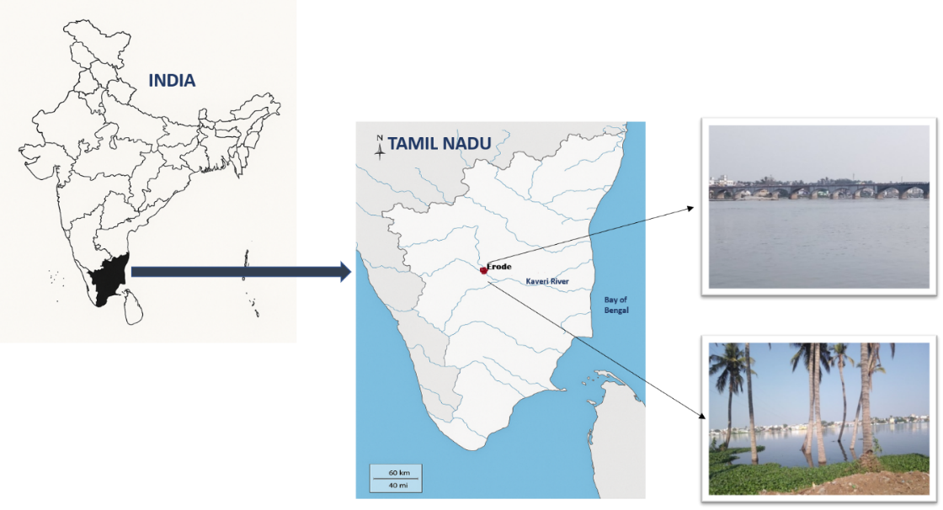

Fig 1. Sample collection from River Kaveri at Erode.
A pure culture was subsequently cultured to a volume of 1L using Chu 10 media. From the biomass the culture was taken for the experimental setup. After obtaining an optical density of 0.2, 100 ml of culture was inoculated into a series of flasks, including their triplicates, at a ratio of 1:10 for toxicity analysis.
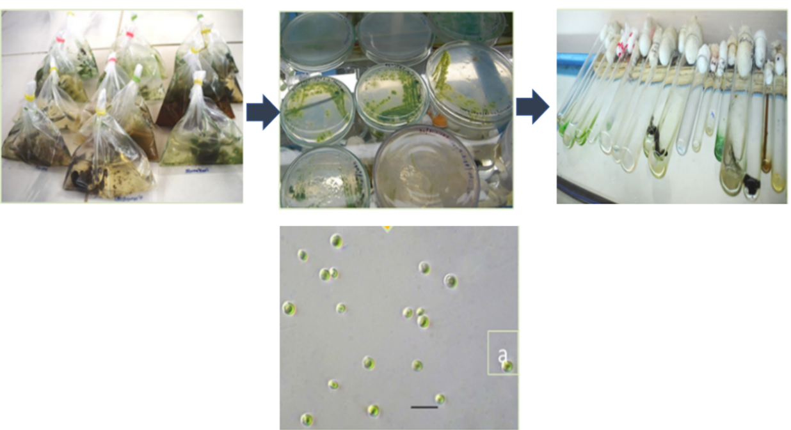

Fig. 2 Process of Isolation and Microscopic images of isolated strains of Chlorella sp., (Photomicrograph of 40X magnification)

3.2 Acute toxicity of TBBPA pollutant against Chlorella sp.
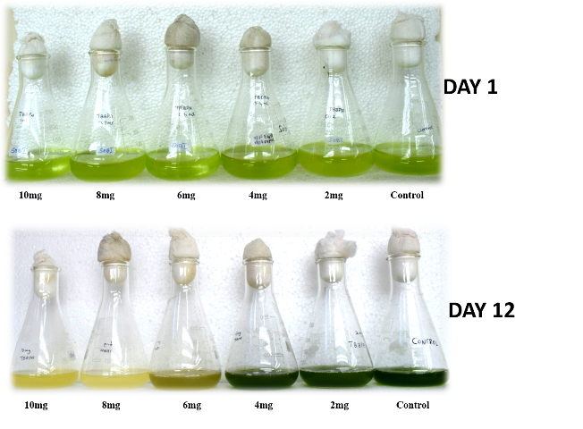
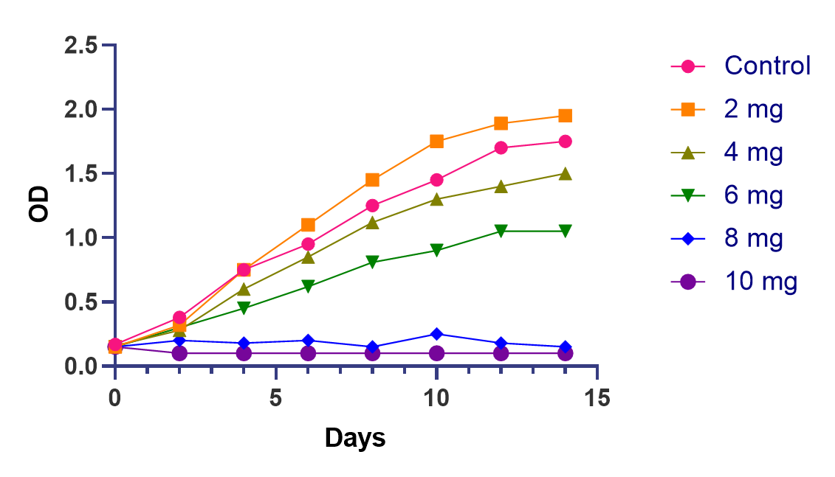
The most noticeable indication of physiological damage brought on by pollution is the suppression of microalgal growth (Zhao et al., 2017). Over a 15-day cultivation period, this work looked at how TBBPA affected Chlorella sp. growth. The increase of TBBPA concentration gradually impeded the growth of Chlorella sp., indicating that TBBPA negatively influences the proliferation of Chlorella sp. Remarkably, although TBBPA was absent, the growth of Chlorella sp. stayed unchanged as the TBBPA concentration rose from 2 to 10 mg/L (Fig. 3). Chlorella sp. growth was entirely suppressed. The growth of Chlorella sp. showed more proliferation than the control sample at a lower dose of TBBPA (2 mg/L). (Bingxin Fang et al.,2017). These findings align with prior observations that low concentrations of ibuprofen enhance the development of the freshwater diatom Navicula sp. (Ding et al., 2017). Similarly, Kurade et al. (2016). Reported that from day two today ten, the number of cells increased, showing that C. vulgaris and DBP affect each other positively at low doses (5, 10, and 20 mg/L). According to these findings, C. vulgaris growth was reduced at high DBP doses (50 and 100 mg/L) but stimulated at low concentrations (5, 10, and 20 mg/L).

Fig 3. Dose–response growth curve of the Chlorella sp. to TBBPA with different concentration.

3.3 Morphological change in Chlorella Sp.
The culture started to decline and the medium's color reduced by the second day following the addition of TBBPA. From the third day onwards, growth was observed only at lowest concentration (2 mg, 4 mg, and 6 mg) of TBBPA applied. However, at higher concentrations (8 mg and 10 mg), the culture color diminished by the second day post-inoculation in all culture flasks containing TBBPA. Under the light microscope (Micros-MCX300LED, Austria), the cell morphology (Chlorella Sp.) in the 2 mg/L flask remained unchanged. The pyrenoid organelle was clearly visible under the microscope, in all the pollutant added culture at various concentrations respectively. At 1 mg/L, we observed dead cells with no chlorophyll content and a ruptured cell structure. The chlorophyll content dispersed around the cell was also observed under the microscope, where a few cells were about to fade and the pyrenoid structure got messed up. At a higher concentration of 10 mg/L TBBPA, the culture medium was totally faded, the cells were dead and ruptured, and no chlorophyll content was detected in all the high concentrations (8mg and 10mg) of TBBPA. (Fig 4)
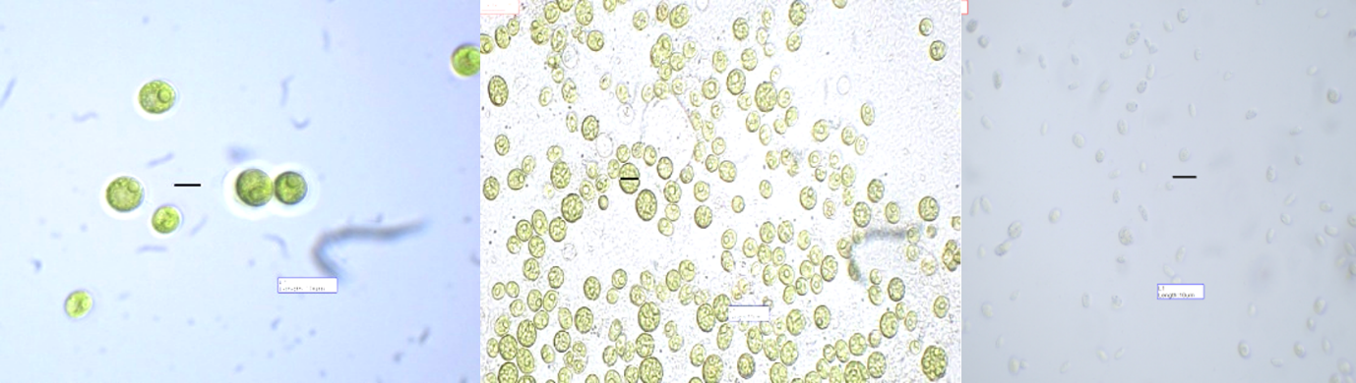
10 mg/L
6 mg/L
Control
Fig 4. Cell morphology of Chlorella sp. After exposed to TBBPA with different concentrations

3.4 Toxicity assay
The toxicity assay on Artemia salina demonstrated moderate mortality rates of 58% after 24 hours. No structural damage was detected in the nauplii (Fig. 5). The mortality of brine shrimp after a 24-hour treatment yielded LC₅₀ and LC₉₀ values of 128.21 μg/mL (range: 107.86–182.17 μg/mL) and 189.58 μg/mL (range: 150.43–299.35 μg/mL) (Table 1). After 24 h of treatment, Aravinth et al. (2023) reported in Artemia toxicity assay employing TBBPA compound only low toxicity rate with the LC₅₀ value of 198.93 μM. Similarly, Ntomi et al., (2025) recently revealed compound against Artemia salina, when compounds high to moderate toxicity with LC₅₀ values (μM) of 87.82, 139.18 and 336.44 accordingly.

Table 1. Non-toxicity bioassay of TBBPA on Artemia salina (Brine shrimp
Animal name | Sample | LC₅₀ µg/mL  (LCL – UCL) | LC₉₀ µg/mL  (LCL – UCL) | χ ²
Artemia salina | TBBPA | 128.21  107.86 – 182.17 | 189.58  150.43 – 299.35 | 2.907

LCL lower confidence limit, UCL upper confidence limit, χ² Chi square test, p<0.05, level of significance, values are mean ± SD of three replicates.

Fig 5. Toxicity bioassay of TBBPA on Artemia nauplii (A. salina).
4. Conclusion
The present study brings attention to the toxicological effects of TBBPA as an emerging environmental pollutant, on Chlorella sp. and Brine shrimp (Artemia salina). Initially Chlorella sp. demonstrated TBBPA tolerance at a concentration of 2 mg/L, even displaying increased growth as the concentration increased. Further cellular morphology significantly altered, suggesting a dose-dependent harmful effect. The photodocumented morphological alterations further confirm the stress responses of Chlorella sp. to increased TBBPA concentrations, emphasizing its susceptibility to pollutant accumulation beyond a critical threshold. The brine shrimp bioassay confirmed the hazardous characteristics of TBBPA, exhibiting moderate mortality after 24 hours of exposure, with computed LC₅₀ and LC₉₀ values indicating substantial acute toxicity. The described abnormalities in Artemia salina corroborate the observed mortality rates and offer visible indications of physiological distress. In combination, these findings highlight the ecological risk posed by TBBPA in aquatic ecosystems and underscore the necessity for ongoing surveillance and management of such emergent pollutants. Furthermore, the findings indicate that Chlorella sp. and Brine shrimp may function as an effective bioindicator for environmental risk evaluation, particularly in the preliminary assessment of brominated substances.
DISCLAIMER (ARTIFICIAL INTELLIGENCE)
Author(s) hereby declares that NO generative AI technologies such as Large Language Models (ChatGPT, COPILOT, etc) and text-to-image generators have been used during writing or editing of this manuscript.
COMPETING INTERESTS
Authors have declared that no competing interests exist.

Ethical Approval
Not Applicable

Data Availability Statement
The data that support the findings of the study are available from the corresponding author upon responsible request

References
Abbott, W. S. (1925), “A Method for Computing the Effectiveness of an Insecticide,” Journal of Economic Entomology, 18, 265–267. https://doi.org/10.1093/jee/18.2.265a
Akhtar, N., Syakir Ishak, M. I., Bhawani, S. A., & Umar, K. (2021). Various natural and anthropogenic factors responsible for water quality degradation: A review. Water, 13(19), 2660. https://doi.org/10.3390/w13192660
Aravinth, A., Perumal, P., Rajaram, R., Dhanasundaram, S., Narayanan, M., Maharaja, S., & Manikumar, A. (2023). Isolation and characterization of 2, 4-di-tert-butyl phenol from the brown seaweed, Dictyota ciliolata and assessment of its anti-oxidant and anticancer characteristics. Biocatalysis and Agricultural Biotechnology, 54, 102933. http://dx.doi.org/10.1016/j.bcab.2023.102933
Colnot, T., Kacew, S., & Dekant, W. (2014). Mammalian toxicology and human exposures to the flame retardant 2, 2′, 6, 6′-tetrabromo-4, 4′-isopropylidenediphenol (TBBPA): implications for risk assessment. Archives of toxicology, 88, 553-573. https://doi.org/10.1007/s00204-013-1180-8
Ding, T.; Yang, M.; Zhang, J.; Yang, B.; Lin, K.; Li, J.; & Gan, J (2017). Toxicity, degradation and metabolic fate of ibuprofen on freshwater diatom Navicula sp. J. Hazard. Mater, 330, 127–134. https://doi.org/10.1016/j.jhazmat.2017.02.004
Duarte, B., Gameiro, C., Matos, A. R., Figueiredo, A., Silva, M. S., Cordeiro, C., ... & Cabrita, M. T. (2021). First screening of biocides, persistent organic pollutants, pharmaceutical and personal care products in Antarctic phytoplankton from Deception Island by FT-ICR-MS. Chemosphere, 274, 129860. https://doi.org/10.1016/j.chemosphere.2021.129860.
Fang, B., Shi, J., Qin, L., Feng, M., Cheng, D., Wang, T., & Zhang, X. (2018). Toxicity evaluation of 4, 4′-di-CDPS and 4, 4′-di-CDE on green algae Scenedesmus obliquus: growth inhibition, change in pigment content, and oxidative stress. Environmental Science and Pollution Research, 25, 15630-15640. https://doi.org/10.1007/s11356-018-1749-0
Gavrilescu, M., Demnerová, K., Aamand, J., Agathos, S., & Fava, F. (2015). Emerging pollutants in the environment: present and future challenges in biomonitoring, ecological risks and bioremediation. New biotechnology, 32(1), 147-156. https://doi.org/10.1016/j.nbt.2014.01.001
Kurade MB, Kim JR, Govindwar SP, & Jeon BH (2016). Insights into microalgae mediated biodegradation of diazinon by Chlorella vulgaris: microalgal tolerance to xenobiotic pollutants and metabolism. Algal Res 20:126–134. https ://doi.org/10.1016/j. algal.2016.10.003
Ntomi, D. D., Sime, G. D., Nyemeck II, N. M., Zintchem, A. A. A., Yousouf, S., Ihsan, U. H., ... & Pegnyemb, D. E. (2025). In vitro antioxidant activity and toxicity assay of some chemical constituents from Landolphia violaceae lianas (Apocynaceae). Fitoterapia, 183, 106483. http://dx.doi.org/10.1016/j.fitote.2025.106483
Olaolu, D. T., Akpor, O. B., & Akor, C. O. (2014). Pollution indicators and pathogenic microorganisms in wastewater treatment: implication on receiving water bodies. International Journal of environmental protection and policy, 2(6), 205-212. doi: 10.11648/j.ijepp.20140206.12
Pereira, L. C., de Souza, A. O., Bernardes, M. F. F., Pazin, M., Tasso, M. J., Pereira, P. H., & Dorta, D. J. (2015). A perspective on the potential risks of emerging contaminants to human and environmental health. Environmental Science and Pollution Research, 22, 13800-13823. https://doi.org/10.1007/s11356-015-4896-6
Rasheed, T., Bilal, M., Nabeel, F., Adeel, M., & Iqbal, H. M. (2019). Environmentally-related contaminants of high concern: potential sources and analytical modalities for detection, quantification, and treatment. Environment international, 122, 52-66. https://doi.org/10.1016/j.envint.2018.11.038
Rippka, R.; Deruelles, J.; Waterbury, J.B.; Herdman, M.; & Stanier, R.Y. (1979). Generic assignments, strain histories and properties of pure cultures of cyanobacteria. J. Gen. Microbiol,111, 1–61. https://doi.org/10.1099/00221287-111-1-1
Yu, Y., Yu, Z., Chen, H., Han, Y., Xiang, M., Chen, X., ... & Wang, Z. (2019). Tetrabromobisphenol A: disposition, kinetics and toxicity in animals and humans. Environmental pollution, 253, 909-917. https://doi.org/10.1016/j.envpol.2019.07.067
Zhao, Y., Wang, Y., Li, Y., Santschi, P.H., & Quigg, A., (2017). Response of photosynthesis and the antioxidant defense system of two microalgal species (Alexandrium minutum and Dunaliella salina) to the toxicity of BDE-47. Mar. Pollut. Bull. 124, 459–469. https://doi.org/10.1016/j.marpolbul.2017.07.038.

